An anti-diffusive VOF method for computational modelling of sloshing in an LNG tank
Y.G. Chen, W.G. Price and P. Temarel
Ship Science, School of Engineering Sciences, University of Southampton,
Southampton SO17 1BJ, UK

Abstract
A new VOF method is presented comprising of a combination of the first order limited downwind scheme with other high order accurate schemes. The method developed is characterized by keeping a sharp interface but avoids complicated geometrical reconstruction as occurs in most volume tracing algorithms. To demonstrate the accuracy and robustness of the method, a selection of numerical experiments are presented involving a pure advection problem, a water wave impact caused by a dam breaking and liquid sloshing in a partially filled tank.
Keywords
VOF method; interfacial flow; high order anti-diffusive scheme; water wave impact; liquid sloshing

Introduction
Since its first introduction by Hirt and Nichols (1981) for free surface flow computations, the volume of fluid (VOF) method has been widely used to capture the interface in multi-fluid flow systems. In the VOF method, the description of interface is determined from the solution of a transport equation describing the evolution of a fluid volume fraction in an Eulerian coordinate system. The accurate representation of the interface is one of the most important issues in multi-fluid flow computations. In the case of advection, it is expected that the designed numerical schemes meet two incompatible features. Namely, stable but allowed to display a certain amount of numerical dissipation, or almost no numerical dissipation in order to keep sharp profiles for discontinuities but unstable. It is noted that regular upwind schemes including some total variation diminishing (TVD) schemes (e. g., Vincent and Caltagirone 1999) used for interfacial flow calculations, more or less smear the interface due to numerical diffusion, whereas downwind schemes, although numerically unstable, have the advantage of keeping sharp interfaces. Zalesak’s flux-corrected scheme (Zalesak 1979) with an anti-diffusive flux correction, similar to Hirt’s donor and acceptor method which uses a combination of the first-order upwind and downwind schemes to ensure numerical stability and to minimize diffusion, still has the problem of numerical smearing of interfaces (Rudman 1997). Furthermore, in the original method of Hirt and Nichols and the method proposed by Youngs (1982), the complicated geometrical reconstruction of an interface is needed to evaluate the net flux flowing out of each cell.
A new technique called limited downwind scheme was introduced by Despres and Lagoutiere (2001) and the approach extended by Xu and Shu (2005) to high order numerical accuracy based on weighted essentially non-oscillatory (WENO) schemes to capture a contact discontinuity in linear degenerate fields of hyperbolic systems. The most important feature of the limited downwind scheme is its ability to perform an exact resolution of a single travelling discontinuity.
In this investigation the RANS equations combined with a new VOF technique are used to compute two-phase (i.e. water-air) fluid flows assuming both fluids incompressible. By employing an artificial compressibility method (Chorin 1967), the governing equations in terms of primitive variables are solved for both fluids in a unified manner. The convective fluxes in the dual time formulation are evaluated by the approximate Riemann solver developed by Roe (1981). Attention is focused on an interface-capturing strategy in which a combination of the limited downwind scheme with other high order accurate schemes is used to reduce numerical diffusion near the air-water interface and thus avoiding the complicated geometrical reconstruction of the interface.
To develop the proposed numerical approach, a brief review of a limited downwind scheme is given in section 2 with high-order extensions of the scheme discussed in section 3. The efficiency of the method is demonstrated by examination of numerical tests for a simple advection problem in section 4. In section 5, the method is illustrated through application to two water wave impact problems, namely, a 2D dam breaking flow and a liquid sloshing flow in a LNG (model) tank subject to longitudinal and transverse translational motions. Predictions of pressure and wave height time histories at different locations inside the tank are compared with experimental data and discussed.

First-Order Limited Downwind Scheme for Advection Equation
In this paper we begin with the linear scalar conservation law expressible in the one-dimensional case as
$C_{t}+f(C)_{x}=C_{t}+{\text{aC}}_{x}=0$. (1)
We assume a uniform spatial grid,$x_{j}=jΔx$, and equation (1) is discretized by a finite volume or finite difference method given by
${\bar{C}}_{j}^{n+1}={\bar{C}}_{j}^{n}−λ({\hat{f}}_{j+\frac{1}{2}}^{n}−{\hat{f}}_{j−\frac{1}{2}}^{n})={\bar{C}}_{j}^{n}−λa({\hat{C}}_{j+\frac{1}{2}}^{n}−{\hat{C}}_{j−\frac{1}{2}}^{n})=0\text{.}$ (2)
Here ${\bar{C}}_{j}^{n}=\frac{1}{Δx}\int_{x_{j−\frac{1}{2}}}^{x_{j+\frac{1}{2}}}{C(x,t^{n})}$ is the approximation at the n-th time step to the cell average of $C(x,t)$, $λ=\frac{Δt}{Δx}$and ${\hat{f}}_{j+\frac{1}{2}}^{n}$is the numerical flux at the cell interface. For the sake of simplicity, we will omit superscript index n and denote by ${\bar{C}}_{j}^{\text{new}}$ the updated value ${\bar{C}}_{j}^{n+1}$ in equation (2).
The main idea behind the first-order limited downwind scheme of Despres and Lagoutiere (2001) is to construct a conditional downwind scheme which is nonlinearly stable in the sense that it satisfies the maximum principle and total variation diminishing (TVD) property as discussed by Harten (1984). We assume the scheme in equation (2) satisfies the maximum principle
$m_{j}=\text{min}({\bar{C}}_{j},{\bar{C}}_{j+1})≤{\bar{C}}_{j}^{\text{new}}≤M_{j}=\text{max}({\bar{C}}_{j},{\bar{C}}_{j+1})$. (3)
It is obvious that equation (2) subject to the condition imposed in equation (3) is TVD and stable as equation (3) can be rewritten in the form
${\bar{C}}_{j}^{\text{new}}=α_{j}{\bar{C}}_{j}+(1−α_{j}){\bar{C}}_{j+1}={\bar{C}}_{j}+(1−α_{j})({\bar{C}}_{j+1}−{\bar{C}}_{j})$,
where the coefficient $1−α_{j}∈[0,1]$satisfies Harten’s TVD criterion (Harten 1984).
By replacing ${\bar{C}}_{j}^{\text{new}}$in equation (3) by equation (2), we obtain an equivalent condition to equation (3) in the form
$m_{j}≤{\bar{C}}_{j}−λa({\hat{C}}_{j+\frac{1}{2}}−{\hat{C}}_{j−\frac{1}{2}})≤M_{j}$.
That is,
${\hat{C}}_{j+\frac{1}{2}}−\frac{1}{λa}({\bar{C}}_{j}−M_{j})≤{\hat{C}}_{j−\frac{1}{2}}≤{\hat{C}}_{j+\frac{1}{2}}−\frac{1}{λa}({\bar{C}}_{j}−m_{j})$, (4)
where only the case of $f^{'}(C)=∂f/∂C=a<0$ is considered and it is similar for case$f^{'}(C)=a>0$.
Let us define the set A as
$A=[m_{j−1},M_{j−1}]∩[M_{j}−\frac{1}{λa}({\bar{C}}_{j}−M_{j}),m_{j}−\frac{1}{λa}({\bar{C}}_{j}−m_{j})]$.
If we can prove A is not empty, i.e.$A≠Φ$, the following two conditions will be sufficient to satisfy the condition stated in equation (4), namely,
$m_{j−1}≤{\hat{C}}_{j−\frac{1}{2}}≤M_{j−1}$, (5)
and
$M_{j}−\frac{1}{λa}({\bar{C}}_{j}−M_{j})≤{\hat{C}}_{j−\frac{1}{2}}≤m_{j}−\frac{1}{λa}({\bar{C}}_{j}−m_{j})$, (6)
where the first inequality in equation (5) comes from the consistency condition in equation (3). In order to construct a practical numerical scheme, ${\hat{C}}_{j+\frac{1}{2}}$at left and right hand sides in the inequality in equation (4) are replaced by $M_{j}$and$m_{j}$, respectively, and the interval defined in equation (6) is a subset of equation (4).
Actually,$A≠Φ$ is true as there exists at least one point ${\bar{C}}_{j}∈A$ assuming the following Courant–Friedrichs–Lewy (CFL) condition holds
$0<λa≤1$. (7)
So the stability conditions in equations (5) and (6) can be used to construct a numerical scheme to evaluate the numerical flux.
In order to guarantee a sharp interface, it is well known that the numerical flux should be chosen as close as possible to the downwind value of the numerical solution. Combining conditions in equations (5) and (6) with the downwind scheme, we derive a first-order, anti-diffusive limited downwind scheme for the numerical flux${\hat{C}}_{j−\frac{1}{2}}$expressible as
$\left\{\begin{matrix}m_{j−1}≤{\hat{C}}_{j−\frac{1}{2}}≤M_{j−1}, \\ M_{j}−\frac{1}{λa}({\bar{C}}_{j}−M_{j})≤{\hat{C}}_{j−\frac{1}{2}}≤m_{j}−\frac{1}{λa}({\bar{C}}_{j}−m_{j}), \\ \left|{\hat{C}}_{j−\frac{1}{2}}−{\bar{C}}_{j−1}\right|\text{ is minimum}\text{.}\end{matrix}\right.$ (8)
A more general form of this numerical flux formula in equation (8) has been derived by Bouchut (2004) for scalar conservation laws and further rewritten by Xu and Shu (2005) in the explicit form
${\hat{f}}_{j+\frac{1}{2}}^{\text{anti}}={\hat{f}}_{j+\frac{1}{2}}^{\text{diss}}+\text{minmod}({\hat{f}}_{j+\frac{1}{2}}^{l}−{\hat{f}}_{j+\frac{1}{2}}^{\text{diss}},{\hat{f}}_{j+\frac{1}{2}}^{r}−{\hat{f}}_{j+\frac{1}{2}}^{\text{diss}})$, (9)
where the dissipative flux ${\hat{f}}_{j+\frac{1}{2}}^{\text{diss}}$ is the classical upwind flux, and ${\hat{f}}_{j+\frac{1}{2}}^{l}$ and ${\hat{f}}_{j+\frac{1}{2}}^{r}$are the extremal left-wind and right-wind fluxes. They are respectively defined as
${\hat{f}}_{j+\frac{1}{2}}^{\text{diss}}=f({\bar{C}}_{j+1})$,${\hat{f}}_{j+\frac{1}{2}}^{l}=f({\bar{C}}_{j})$, ${\hat{f}}_{j+\frac{1}{2}}^{r}=\frac{{\bar{C}}_{j+2}−{\bar{C}}_{j+1}}{λ}+f({\bar{C}}_{j+2})$ for $f^{'}(C)<0$, (10)
${\hat{f}}_{j+\frac{1}{2}}^{\text{diss}}=f({\bar{C}}_{j})$,${\hat{f}}_{j+\frac{1}{2}}^{l}=\frac{{\bar{C}}_{j}−{\bar{C}}_{j−1}}{λ}+f({\bar{C}}_{j−1}),$ ${\hat{f}}_{j+\frac{1}{2}}^{r}=f({\bar{C}}_{j+1})$ for $f^{'}(C)>0$. (11)
In the above equation the minmod function is defined as
$$\text{minmod}(\text{b,c})=\left\{\begin{matrix}0 & \text{bc}≤0, \\ b & \text{bc}>0,\left|b\right|≤\left|c\right|, \\ c & \text{bc}>0,\left|c\right|<\left|b\right|\text{.}\end{matrix}\right.$$
The scheme expressed in equation (2) with the limited downwind flux defined in equation (9) has the very important feature of keeping its shape for all time for a single travelling discontinuity under the CFL condition$λ\left|a\right|≤1$, and furthermore, the scheme is essentially three-point, that is to say, for any piece-wise constant initial condition the numerical solution will not have more than one transition point between two constant pieces assuming that there are at least three grid points for each piecewise constant.
It is noted that the limited downwind scheme is equivalent to the classical first-order Ultra-Bee flux limiter scheme described by Despres and Lagoutiere (2001). However, in the presented form here it is easier to extend to high order accuracy.

High Order Extensions of First-Order Limited Down-Wind Scheme
High resolution Godunov-type schemes have been routinely applied to numerical discretisation for hyperbolic conservation laws (Toro 1999). These schemes approximate the fluxes at cell interfaces to high order accuracy in a smooth region and at the same time avoid spurious oscillations in the vicinity of large gradients such as near shocks. The simplest way to construct a second order accurate scheme is to replace the piecewise constant cell average$\left\{{\bar{C}}_{j}\right\}$in equation (2) by conservative, non-oscillatory, piecewise linear functions
$C_{j}(x)={\bar{C}}_{j}+(C_{x})_{j}(x−x_{j})$,$x∈I_{j}=[x_{j−\frac{1}{2}},x_{j+\frac{1}{2}}]$, $∀j$, (12)
where $(C_{x})_{j}$ is a suitably chosen slope of $C_{j}(x)$ in cell $I_{j}$, and the second order accuracy of the interpolation in equation (12) is guaranteed provided $(C_{x})_{j}$ is at least a first order approximation to the derivative $C_{j}(x)$.
A simple and effective way to define $(C_{x})_{j}$ is given by $(C_{x})_{j}=\text{minmod}(\frac{{\bar{C}}_{j+1}−{\bar{C}}_{j}}{Δx},\frac{{\bar{C}}_{j}−{\bar{C}}_{\text{j-1}}}{Δx})$, (13)
and applying equations (12) and (13) to equations (9) to (11) results in a second order limited downwind scheme expressible in the compact form of
${\hat{f}}_{j+\frac{1}{2}}^{\text{anti}}={\hat{f}}_{j+\frac{1}{2}}^{+}+\text{minmod}(\frac{{\bar{C}}_{j+2}−{\bar{C}}_{j+1}}{λ}+{\hat{f}}_{j+\frac{3}{2}}^{+}−{\hat{f}}_{j+\frac{1}{2}}^{+},{\hat{f}}_{j+\frac{1}{2}}^{−}−{\hat{f}}_{j+\frac{1}{2}}^{+})$ for $f^{'}(C)<0$, (14)
${\hat{f}}_{j+\frac{1}{2}}^{\text{anti}}={\hat{f}}_{j+\frac{1}{2}}^{−}+\text{minmod}(\frac{{\bar{C}}_{j}−{\bar{C}}_{j−1}}{λ}+{\hat{f}}_{j−\frac{1}{2}}^{−}−{\hat{f}}_{j+\frac{1}{2}}^{−},{\hat{f}}_{j+\frac{1}{2}}^{+}−{\hat{f}}_{j+\frac{1}{2}}^{−})$ for $f^{'}(C)>0$, (15)
where the interface fluxes ${\hat{f}}_{j+\frac{1}{2}}^{+}$ and ${\hat{f}}_{j+\frac{1}{2}}^{−}$ at $x=x_{j+\frac{1}{2}}$ are defined as
${\hat{f}}_{j+\frac{1}{2}}^{+}=f(C_{j+1}(x_{j+\frac{1}{2}}))$,${\hat{f}}_{j+\frac{1}{2}}^{−}=f(C_{j}(x_{j+\frac{1}{2}}))$. (16)
By combining the first order limited downwind scheme with a TVD scheme similar to the MINBEE limiter Lax-Wendroff scheme (Sweby 1984), a second order accurate scheme is developed by replacing the interface fluxes in equation (16) by
${\hat{f}}_{j+\frac{1}{2}}^{+}=a{\bar{C}}_{j+1}−\frac{1}{2}φ_{j+\frac{3}{2}}(1+c_{f}){aΔ}_{j+\frac{3}{2}}$, ${\hat{f}}_{j+\frac{1}{2}}^{−}=a{\bar{C}}_{j}+\frac{1}{2}φ_{j+\frac{1}{2}}(1−c_{f}){aΔ}_{j+\frac{1}{2}}$, (17)
where$Δ_{j+\frac{1}{2}}={\bar{C}}_{j+1}−{\bar{C}}_{j}$,$c_{f}=\frac{aΔt}{Δx}$and $φ_{j+\frac{1}{2}}=\text{max}[0\text{,min}(r,1)]$ with $r={Δ_{j−\frac{1}{2}}}/{Δ_{j+\frac{1}{2}}}$.
Higher order anti-diffusive schemes can be constructed when coupled with essentially non-oscillatory (ENO) scheme as described by Harten et al (1987), and Shu and Osher (1989) or the WENO scheme of Jiang and Shu (1996).
Given discrete values $h(x_{j})$at grid nodes $x=x_{j}(j=1,2,3,\text{.}\text{.}\text{.})$of a piecewise smooth function$h(x)$, we can construct an rth degree polynomial using the following recursive algorithm
(1) $H_{j+\frac{1}{2}}^{h,\text{ 1}}(x)=h[x_{j}]=h(x_{j})$, $k_{1}(j)=j$;
(2) If $k_{m}(j)$ and $H_{j+\frac{1}{2}}^{h,\text{ m}}(x)$are already known, we define
$a_{m+1}=h[x_{k_{m}(j)},\text{.}\text{.}\text{.},x_{k_{m}(j)+m}]$, $b_{m+1}=h[x_{k_{m}(j)−1},\text{.}\text{.}\text{.},x_{k_{m}(j)+m−1}]$,
and then consider the smoothest stencil between two candidates as the next higher degree polynomial
$H_{j+\frac{1}{2}}^{h,\text{ m}+1}(x)=H_{j+\frac{1}{2}}^{h,\text{ m}}(x)+c_{m+1}\prod_{i=k_{m}(j)}^{k_{m}(j)+m−1}{(x−x_{i}})$. (18)
Here $h[\text{.},\text{.}\text{.}\text{.}\text{, }\text{.}]$ denotes the usual Newton divided differences, and if$\left|a_{m+1}\right|≥\left|b_{m+1}\right|$, then $c_{m+1}=b_{m+1}$, $k_{m+1}(j)=k_{m}(j)−1$, otherwise $c_{m+1}=a_{m+1}$, $k_{m+1}(j)=k_{m}(j)$. Alternatively, $c_{m+1}$ can be evaluated from $c_{m+1}=\text{minmod}(a_{m+1},b_{m+1})$.
Using the described process we can now extend the numerical scheme described in equation (14) or (15) to higher order accuracy by defining the interface flux as
${\hat{f}}_{j+\frac{1}{2}}^{−}=f(H_{j+\frac{1}{2}}^{C,\text{ m}}(x_{j+\frac{1}{2}}))$, ${\hat{f}}_{j+\frac{1}{2}}^{+}=f(H_{j+\frac{3}{2}}^{C,\text{ m}}(x_{j+\frac{1}{2}}))$. (19)
In the case of two dimensions or three dimensions the direction splitting method is adopted to calculate the numerical flux in each direction (Puckett et al 1997; Toro 1999). For example, corresponding to equation (10) the interface flux at the interface $x=x_{j+\frac{1}{2},k,l}$ in the x-direction is defined by
${\hat{f}}_{j+\frac{1}{2},k,l}^{\text{diss}}=f({\bar{C}}_{j+1,k,l})$, ${\hat{f}}_{j+\frac{1}{2},k,l}^{l}=f({\bar{C}}_{j,k,l})$,
${\hat{f}}_{j+\frac{1}{2},k,l}^{r}=\frac{{\bar{C}}_{j+2,k,l}−{\bar{C}}_{j+1,k,l}}{3λ}+f({\bar{C}}_{j+2,k,l})$ for $f^{'}(C)<0$,
and the numerical fluxes in the other two directions are calculated similarly.
For simplicity, we call the first order anti-diffusive scheme in equation (9) with the numerical fluxes defined by equation (10) or (11) as LD1, and the numerical scheme described in equation (14) or (15) with fluxes defined by equations (16) and (17) as LD-ENO2 and LD-LW2, respectively. The numerical scheme in equation (14) or (15) with fluxes defined by equation (19) all denoted by as LD-ENO3, LD-ENO4, and so on.

Simple Advection Test
We consider the advection of a circle in a rotational velocity field specified by
$u(x,y)=\text{sin}(x)\text{cos}(y)$, $v(x,y)=−\text{cos}(x)\text{sin}(y)$,
where$x,y∈[0,π]$, and the circle of radius $r=π/5$ is centred at x=π/2 and y=(π+1)/5.
A uniform mesh of 200×200 and Courant number CFL=0.25 are used for all numerical experiments in this section. Fig.1 (a1-e1 and b2-e2) present the calculated results of contours at C=0.05 and C=0.95 using different schemes when time is advanced for 5000 steps (red, thick curve with spiral shape in each figure), and then the velocity field reversed and calculations continued for a further 5000 steps (black, thin curve in each figure). At the end of this process, a perfect scheme would return to the initial C configuration for each run (i.e. the black, thin curve should coincide with the blue, dotted circle). C, in general, is defined as the volume fraction of a cell occupied by a particular fluid. It is also known as the color function indicating the volume fraction in a cell occupied by a particular color. Accordingly it can be assumed that the boundary of the circle encloses a color and outside the circle, there is no color.
In the first order upwind scheme, because of excessive diffusion, Fig.1 (a1) shows a serious dislocation of the contour of C=0.05 between red and blue curves, whereas for C=0.95 we fail to plot the contour due to the fact that all values are below 0.95 in the computational domain. The spines in Fig. 1 (b1-d1, b2-d2) after a long time run have broken down because the shearing velocity field has started to stretch the circle into thin filaments near the spinal tail but the second order extension of the limited downwind scheme (LD-ENO2) employed in Fig. 1(c1 & c2) shows a good recovery to the original circle. The LD-LW2 scheme shown in Fig 1 (e1 & e2) results in a poor recovery due to a bit smearing where the spines do not break. Based on its abilities of keeping sharp interface and good recovery, we conclude that scheme LD-ENO2 performs more accurately than others. Unless otherwise stated, the scheme will be adopted for the numerical computations henceforth.

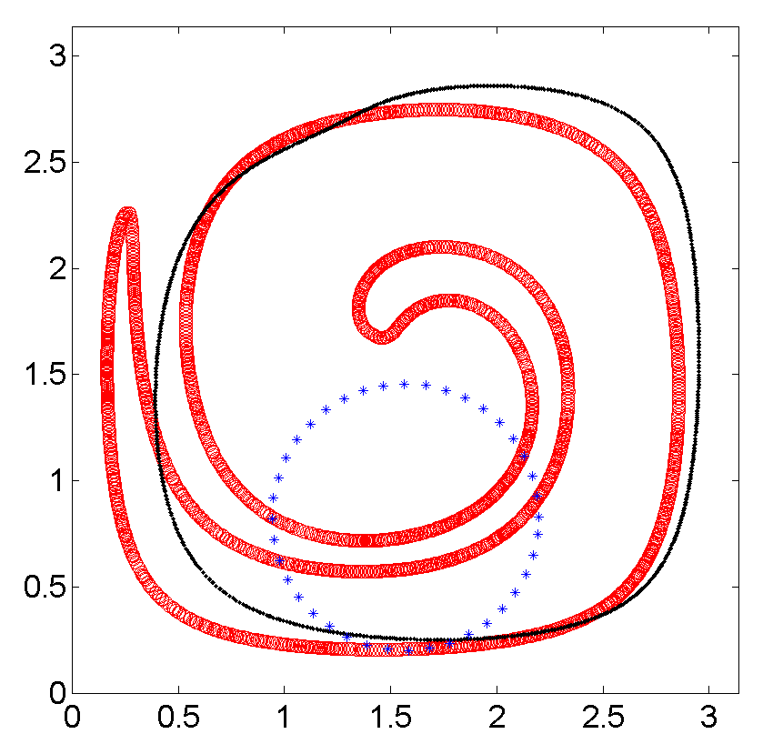
(a1) First-Order Upwind Scheme (C=0.05)
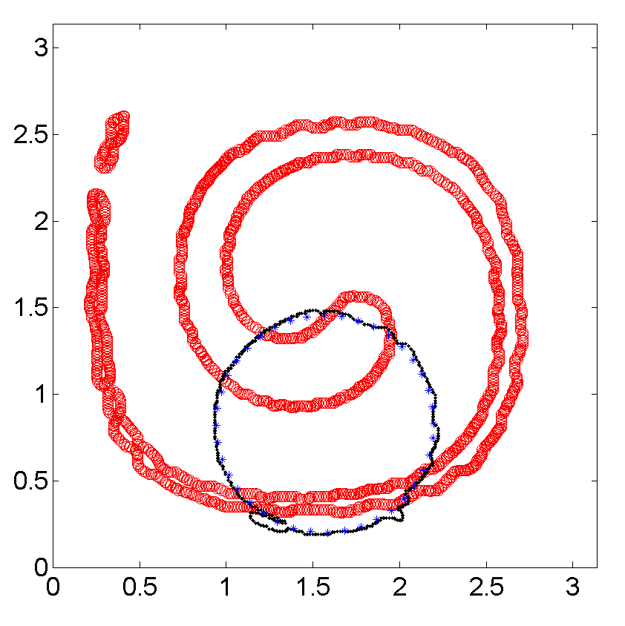 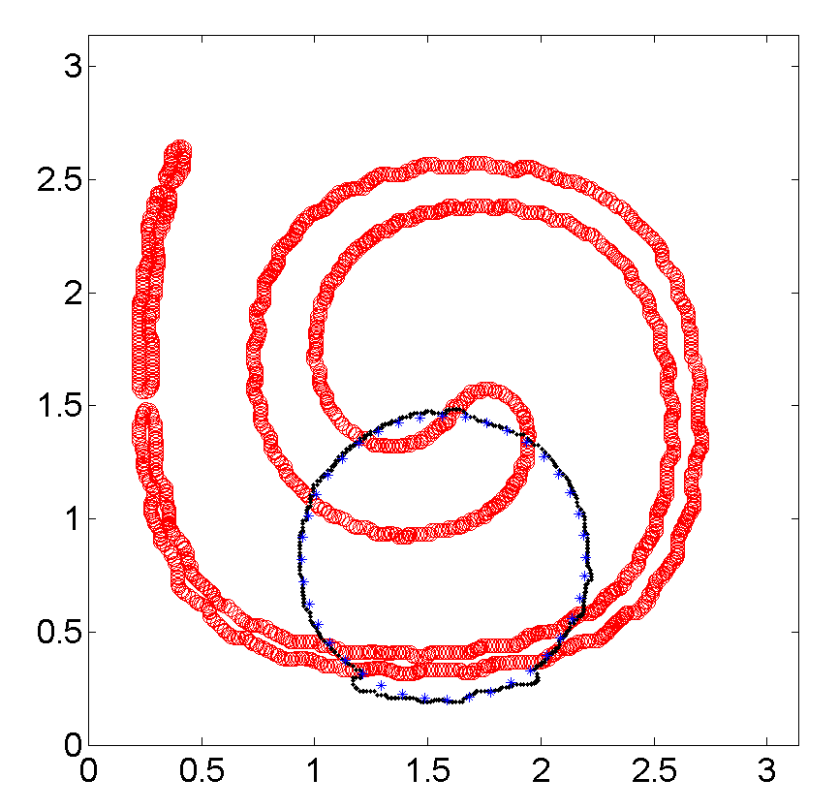 (b1) LD1 (C=0.05) (c1) LD-ENO2 (C=0.05)
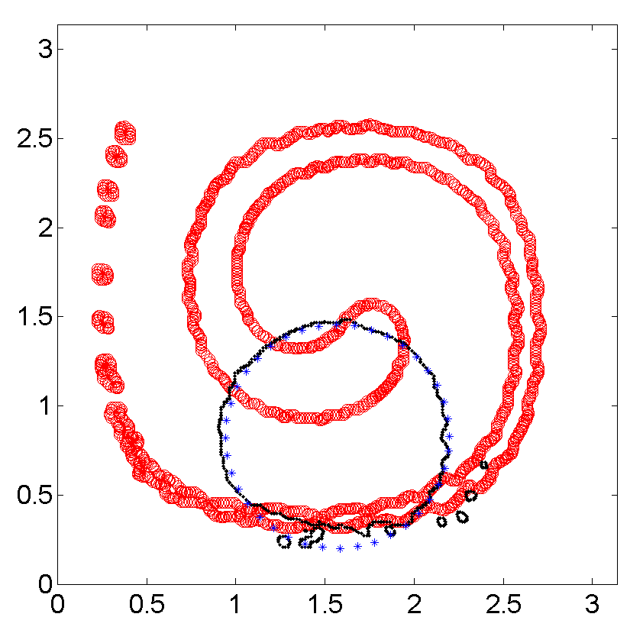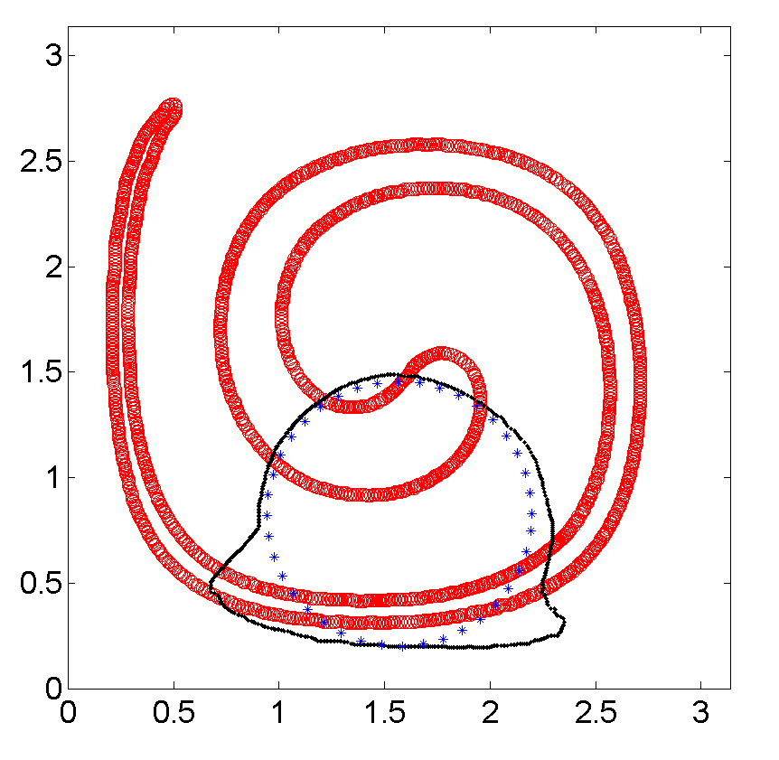
(d1) LD-ENO3 (C=0.05) (e1) LD-LW2 (C=0.05)

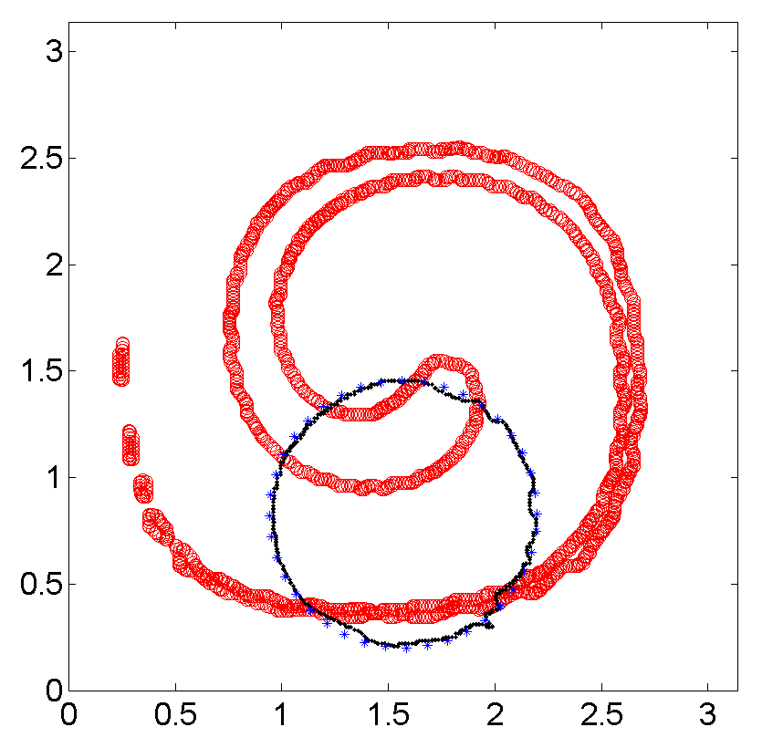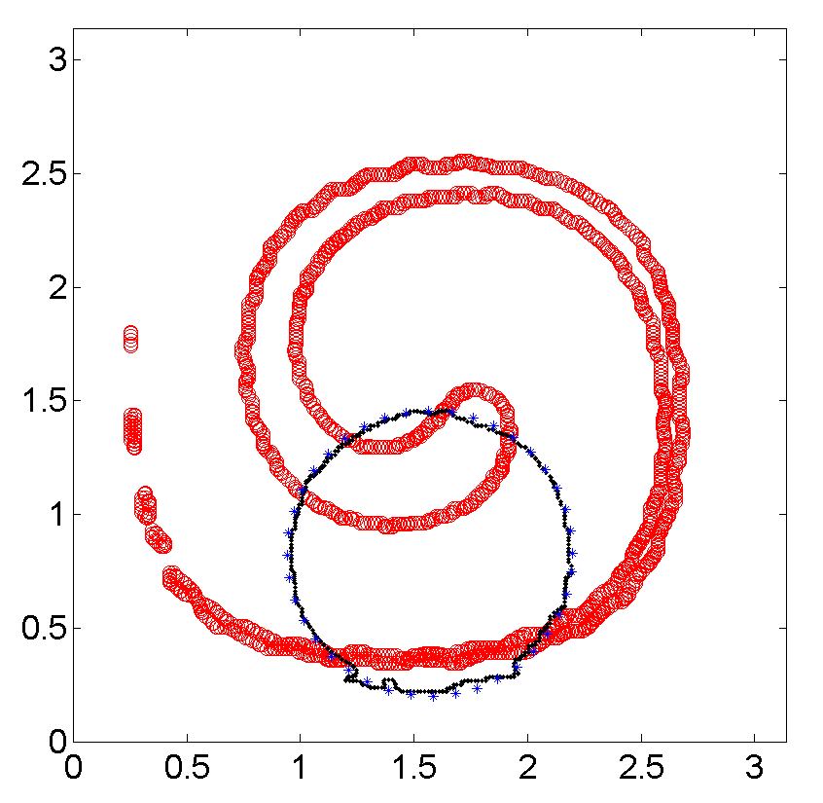
(b2) LD1 (C=0.95) (c2) LD-ENO2 (C=0.95)

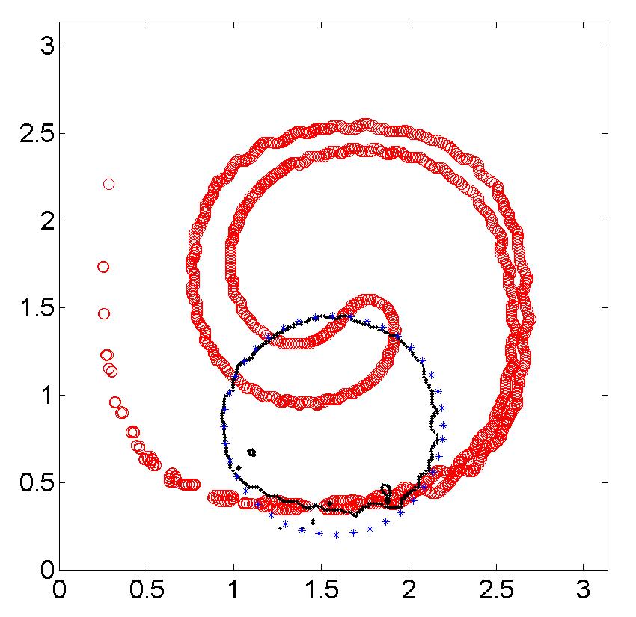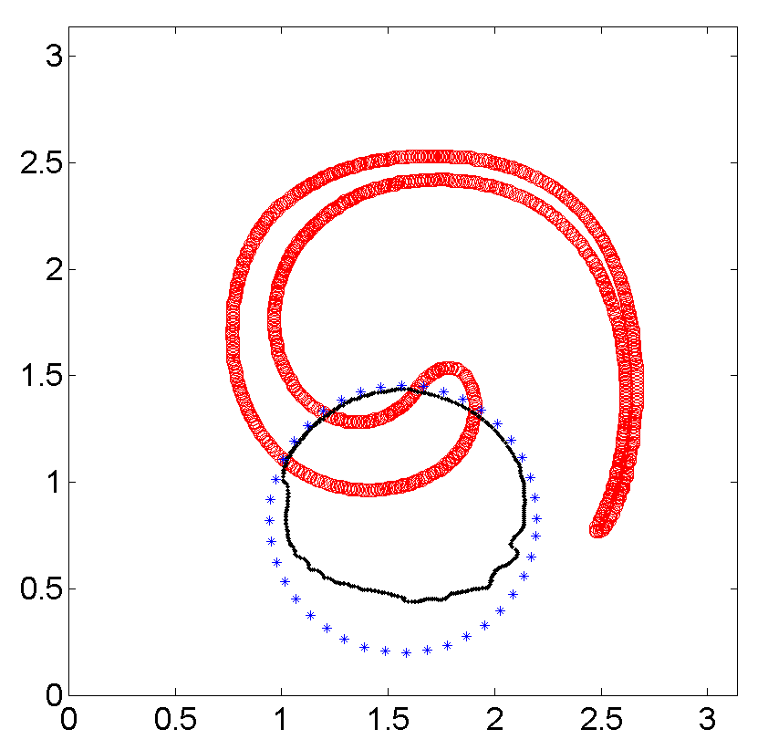
(d2) LD-ENO3 (C=0.95) (e2) LD-LW2 (C=0.95)

Fig. 1 Advection of a circle in a shearing velocity field (red thick spinal shape: after 5000 time steps forward; black thin line: further 5000 time steps backward with the velocity field reversed; blue dotted line: initial circle; a1-e1: C=0.05; b2-e2: C=0.95)
Numerical Simulation of Water Wave Impacts
To further validate the proposed numerical scheme of study, two real free surface wave problems are presented and, where available, the predicted values are compared with those measured in experiments. The first one relates to the numerical simulation of a 2D dam breaking flow. The second test example concerns liquid sloshing in a 1:25 LNG (model) tank with a water depth of 20% of the tank’s height. The tank is subject to both longitudinal and transverse translational motions. Before presenting calculations, we describe the integration of the current proposed VOF approach with a flow solver developed by the authors (Price and Chen 2006; Chen et al 2009) for incompressible two-fluid flows in which the free surface is implicitly captured by a level set formulation.
To construct an effective numerical scheme of study to solve the incompressible two-fluid flow system, an artificial compressibility technique developed by Chorin (1967) is introduced by adding a pressure derivative term with respect to the pseudo-time τ to the continuity equation. The governing equations of the incompressible, immiscible two-fluid system in a Cartesian coordinate system are described as
$\frac{∂p}{β∂τ}+\frac{∂u_{j}}{∂x_{j}}=0,$ (20)
$ρ\frac{∂u_{i}}{∂t}+ρ\frac{∂(u_{i}u_{j}+δ_{\text{ij}}p)}{∂x_{j}}−\frac{μ}{\text{Re}}\frac{∂}{∂x_{j}}(\frac{∂u_{i}}{∂x_{j}}+\frac{∂u_{j}}{∂x_{i}})+\frac{{ρg}_{i}}{{\text{Fn}}^{2}}+{ρf}_{i}=0,$ (21)
where β denotes the artificial compressibility factor and a conventional Cartesian tensor notation is used to sum repeated indices. The spatial coordinates$x_{i}$, velocity components $u_{i}$and projection components of the gravitational acceleration in the axis directions$g_{i}$, respectively, have been non-dimensionalised for each specific problem in terms of a characteristic length L, a characteristic velocity U₀ and gravitational acceleration$g$. The fluid density $ρ$ and viscosity $μ$ (for example, the respective water and air densities are denoted by $ρ_{w}$and$ρ_{a}$, and viscosities$μ_{w}$and$μ_{a}$), are made non-dimensional by the equivalent water values $ρ_{w}$and$μ_{w}$, respectively; the time t and the pressure $p$ by L/U₀ and$ρ_{w}U_{0}^{2}$, respectively.
In equation (21) Re and Fn represent Reynolds and Froude numbers, respectively, which are defined as
$\text{Re}={{\text{LU}}_{0}}/{ν_{w}}$,$\text{Fn}={U_{0}}/{\sqrt{\text{Lg}}}$. (22)
Except for the gravitational force, the external forces include the translational and rotational inertia forces; hence, $f_{i}$ takes the following form:
$f_{i}=a_{i}+ε_{\text{ijk}}\frac{{dω}_{j}}{\text{dt}}x_{k}+ε_{\text{ijk}}ε_{\text{klm}}ω_{j}ω_{l}x_{m}+2ε_{\text{ijk}}ω_{j}u_{k}$, (23)
where $a_{i}$ represents the translational acceleration components and $ω_{i}$ the rotational angular velocity components. $ε_{\text{ijk}}$denotes the Levi-Civita symbol with repeating subscripts indicating summation.
In the VOF method the scalar function C is the volume fraction of a cell occupied by a particular fluid, for example, water. A unit value of C corresponds to a cell full of water, while a zero value indicates that the cell contains no water. Cells with C value between zero and unity must then contain the free surface. Differentiating $C(x,y,z;t)=0$ with respect to t, an advection equation is derived to describe the free surface motion in the form
$\frac{∂C}{∂t}+u_{i}\frac{∂C}{∂x_{i}}=0$, (24)
where $u_{i}$ is the local fluid velocity and, at any time, moving the interface is equivalent to updating C by solving equation (24).
Using the above volume fraction function, the corresponding density function $ρ$ and viscosity function $μ$ can be defined as
$ρ=(1−C){ρ_{a}}/{ρ_{w}}+C$, (25)
$μ=(1−C){μ_{a}}/{μ_{w}}+C$. (26)
In terms of generalized coordinates, equations (20) and (21) can be rewritten in a vector form, expressible as
$Γ_{τ}\frac{∂q}{∂τ}+Γ_{t}\frac{∂Q}{∂t}+\frac{∂F_{j}}{∂ξ_{j}}+\frac{∂F_{j}^{ν}}{∂ξ_{j}}=S\text{.}$ (27)
Here $Γ_{τ}$ and $Γ_{t}$ represent the two diagonal matrices,
$Γ_{τ}=\text{diag}[1/β,0,0,0]$ ,$Γ_{t}=\text{diag}[0,1,1,1]$,
and vectors $q$, $Q$, $F_{j}$,$F_{j}^{v}$and $S$are expressed as
$q=J^{−1}{\left(p,u,v,w\right)}^{T}$, $Q=J^{−1}{\left(p/β,ρu,ρv,ρw\right)}^{T}$,
$F_{j}=J^{−1}\left[\begin{matrix}{ρU}^{j} \\ {ρu}_{1}U^{j}+\frac{∂ξ^{j}}{∂x_{1}}p \\ {ρu}_{2}U^{j}+\frac{∂ξ^{j}}{∂x_{2}}p \\ {ρu}_{3}U^{j}+\frac{∂ξ^{j}}{∂x_{3}}p\end{matrix}\right]$, $F_{j}^{ν}=J^{−1}\frac{μ}{\text{Re}}\frac{∂ξ_{j}}{∂x_{m}}(0,\frac{∂ξ_{k}}{∂x_{m}}\frac{∂u}{∂ξ_{k}}+\frac{∂ξ_{k}}{∂x}\frac{∂u_{m}}{∂ξ_{k}},\frac{∂ξ_{k}}{∂x_{m}}\frac{∂v}{∂ξ_{k}}+\frac{∂ξ_{k}}{∂y}\frac{∂u_{m}}{∂ξ_{k}},\frac{∂ξ_{k}}{∂x_{m}}\frac{∂w}{∂ξ_{k}}+\frac{∂ξ_{k}}{∂z}\frac{∂u_{m}}{∂ξ_{k}})^{T},$$S=J^{−1}ρ(0,f_{1}+{g_{1}}/{{\text{Fn}}^{2}},f_{2}+{g_{2}}/{{\text{Fn}}^{2}},f_{3}+{g_{3}}/{{\text{Fn}}^{2}})^{T}$.
Here$J=∂(ξ,η,ζ)/∂(x,y,z)$ is the Jacobian of the transformation and the contra-variant velocity component $U^{j}$is defined as $U^{j}=\frac{∂ξ_{j}}{∂x_{m}}u_{m}$.
By approximating the pseudo-time derivative by an implicit Euler back-forward difference formula and the time derivative by a second-order, three-point, backward-difference implicit formula in equation (27), one obtains
$Γ_{τ}\frac{q^{m+1,n+1}−q^{m,n+1}}{Δτ}+Γ_{t}\frac{1\text{.}5Q^{m+1,n+1}−2Q^{n}+0\text{.}5Q^{n−1}}{Δt}+δ_{ξ}F^{m+1,n+1}=0\text{.}$ (28)
Here, the superscript n denotes the nth physical time level, the superscript m the level of the sub-iteration and $δ_{ξ}$ represents a spatial difference. For the sake of simplicity, only the convective flux derivative in one direction is presented, and the viscous and source terms in equation (27) are omitted. For example, $F$denotes the convective flux $F_{1}$ in the$ξ$- direction.
After linearizing terms at the (m+1)th time level and involving some simple algebraic manipulation, equation (14) becomes
$(\frac{1}{Δτ}Γ_{τ}+\frac{1\text{.}5}{Δt}Γ_{t}+A_{q}δ_{ξ})Δq+δ_{ξ}F^{m,n+1}=r^{m,n+1}$, (29)
where$A_{q}=\frac{∂F}{∂q}$,$r^{m,n+1}=−\frac{1\text{.}5Q^{m,n+1}−2Q^{n}+0\text{.}5Q^{n−1}}{Δt}$and $Δq=q^{m+1,n+1}−q^{m,n+1}$.
In this study Roe’s approximate Riemann solver, introduced by Roe (1981), is employed to calculate the numerical fluxes. Let us define$Γ_{d}=\frac{1}{Δτ}Γ_{τ}+\frac{1\text{.}5}{Δt}Γ_{t}$. The flux Jacobian matrix and the Roe numerical flux expression in terms of vector q are respectively given by
$a_{q}=Γ_{d}^{−1}A_{q}$,
${\tilde{F}}_{j+\frac{1}{2}}=\frac{1}{2}(F^{L}+F^{R})−\frac{1}{2}{\hat{Γ}}_{d}\left|{\hat{a}}_{q}\right|Δq$. (30)
Here${\tilde{F}}_{j+\frac{1}{2}}$represents the numerical flux at the cell interface and the tilde over each term implies they are evaluated using the Roe-averaged variables.
In the present investigation there is no special treatment required for the free surface as a two-fluid approach is used to solve the RANS equations in both water and air regions in a unified manner and the interface is only treated as a shift in fluid properties.
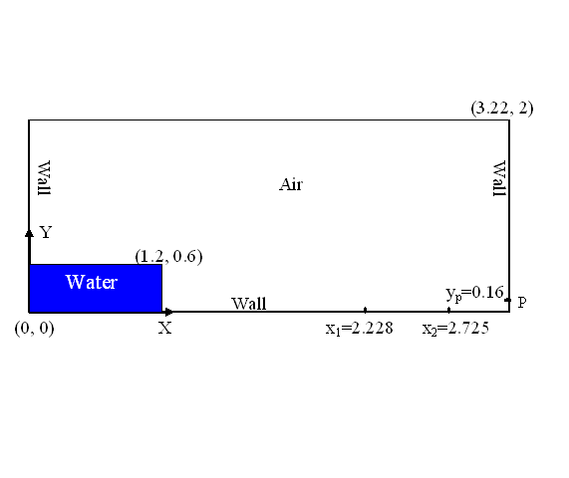

Fig. 2 Layout of dam breaking problem and measurement positions (Units: m)

Simulation of 2D Dam-Breaking Flows
Fig. 2 shows a schematic view of the dam breaking model. The volumes of tank and water column, the measurement positions of impact pressure on the downstream wall and the wave elevations at positions x₁ and x₂ are selected for comparison purposes to the studies of Zhou et al (1999), Abdolmaleki et al (2004), and Ferrari et al (2009). The numerical test was performed using a resolution of 201×121 uniform grid discretisation and a non-dimensional time step of ΔT=5×10⁻², where $T=t/{\sqrt{H/g}}$, g is gravity acceleration and H the initial water height. In this investigation only inviscid flow model is conducted. Fig. 3 shows a selection of free surface flows at different instants. These figures are plotted at a value of volume fraction C=0.5. Fig. 4 presents the time histories of the total height of water at the two locations (a) x₁=2.228m and (b) x₂=2.725m. The variations between predictions and experimental results may be associated with wave overturning and merging which are very complicated physical phenomena to model as well as compressibility and viscosity. Similar discrepancies between measured data and numerical modelling results are obtained from different numerical approaches such as BEM, VOF, level set and SPH methods (see, for example, Zhou (1999), Abdolmaleki et al (2004), Park et al (2009), Ferrari et al (2009)). The pressure time history at a position y_{b}=0.16m on the right hand wall is illustrated in Fig. 5. After the wave hits the right hand wall, a large air entrapment region with small bubbles and air pockets is observed in both experiments and numerical simulation. Further investigations are needed to evaluate how air compressibility, viscosity and turbulence affect the process of wave impact.

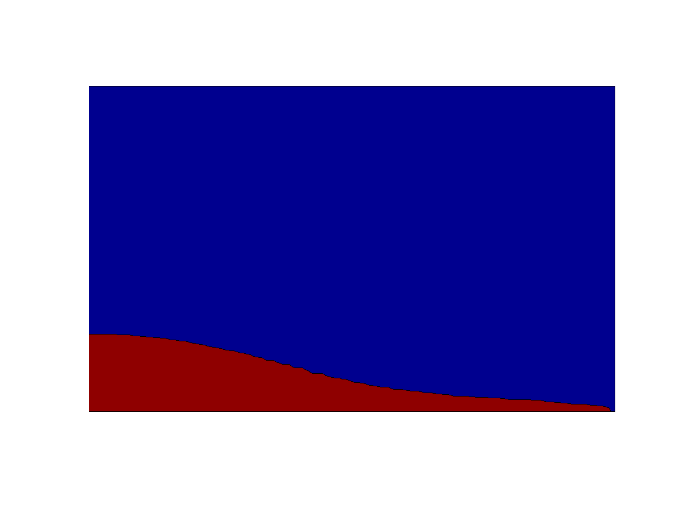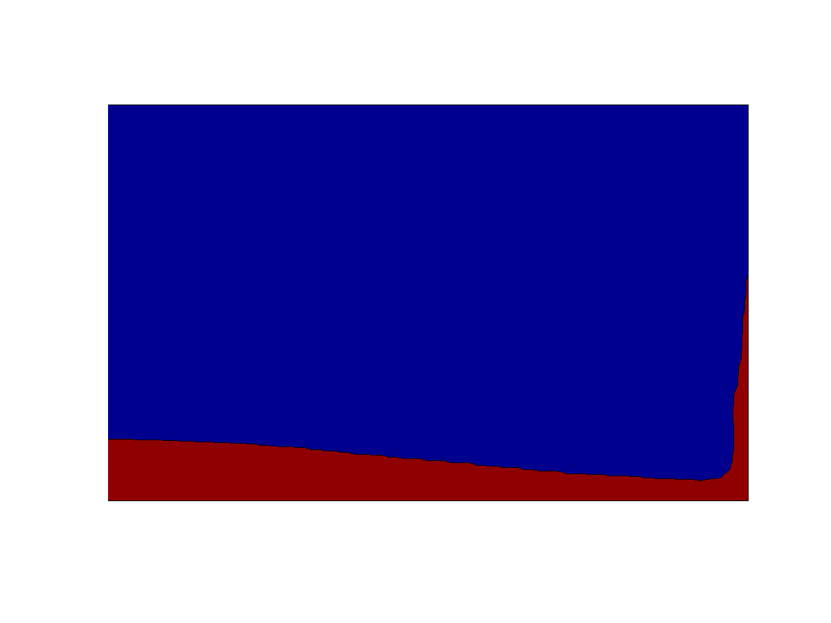
(a) T=2.425 (b) T=4.050
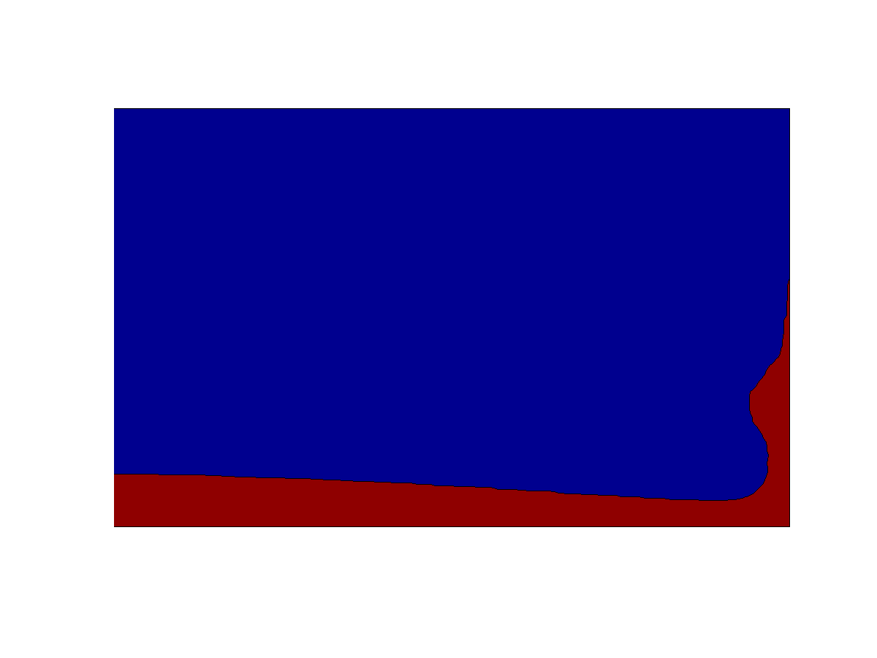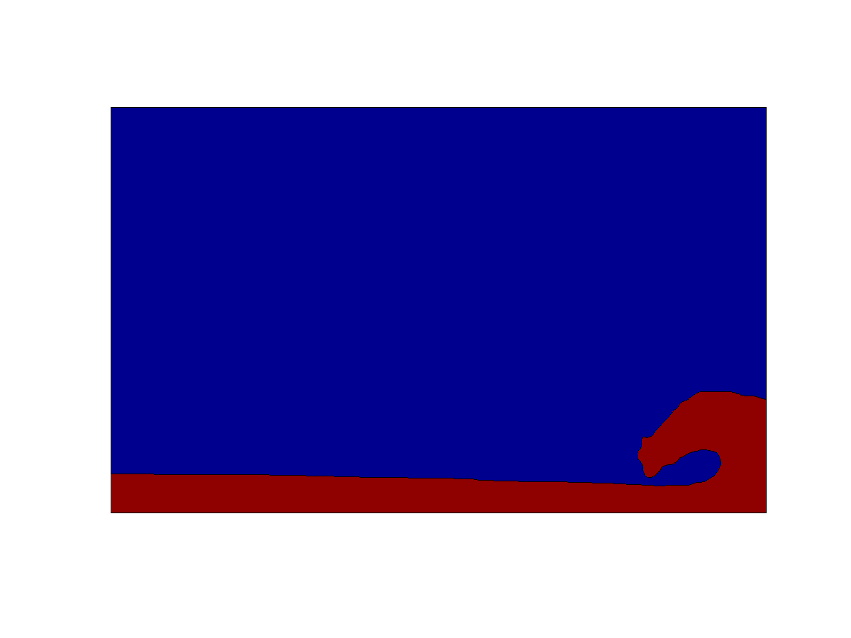
(c) T=4.850 (d) T=6.075

(e) T=7.075 (f) T=8.075
Fig. 3 Dam breaking flow against a wall in several
different non-dimensional times

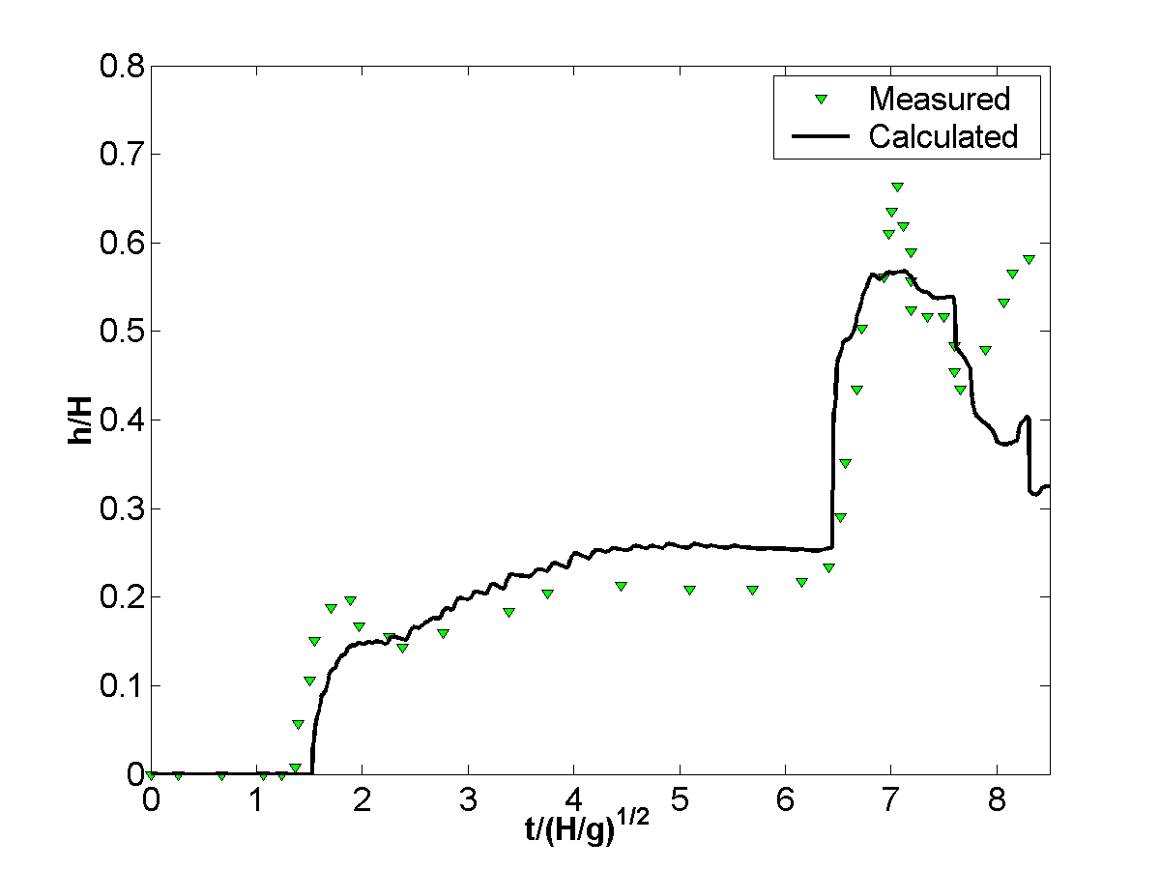
(a) x=2.228m
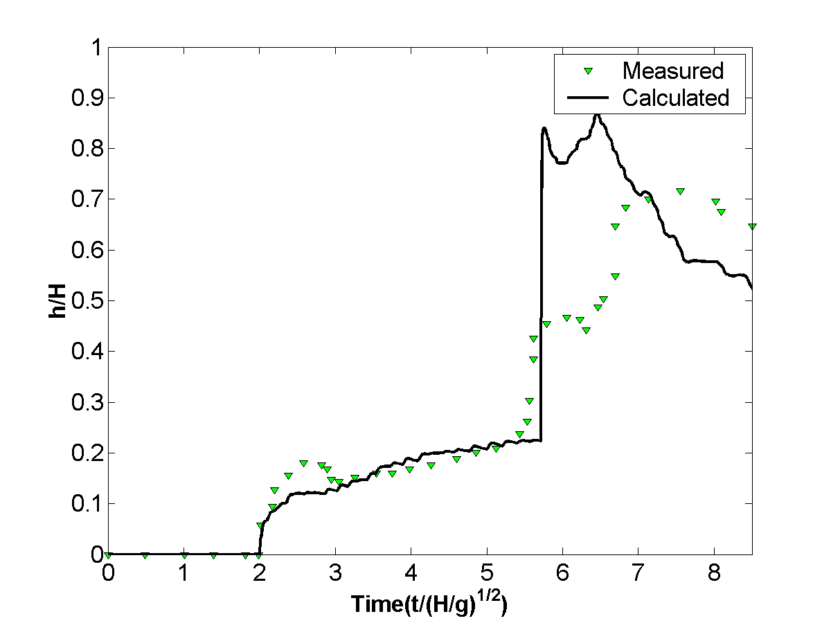
(b) x=2.725m
Fig. 4 Time histories of calculated total height of water at two different locations on the floor
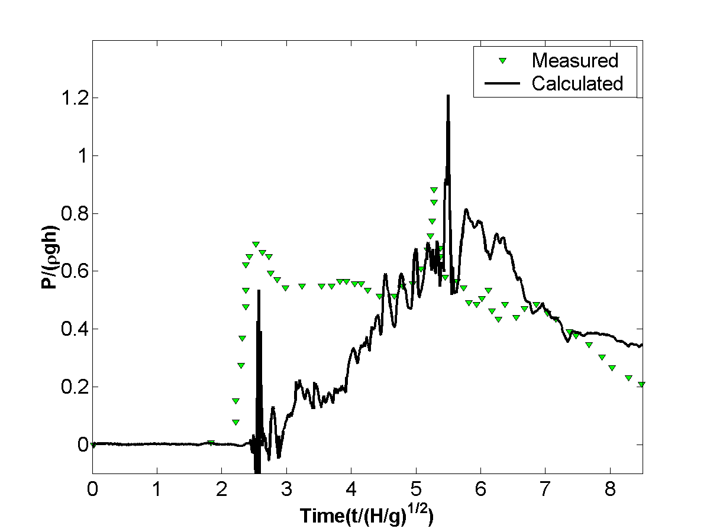
Fig. 5 Time history of calculated pressure on the right hand side wall at y_{p}=0.16m

Liquid Sloshing in a Partially Filled Tank
In this section, a 1:25 LNG tank, which was chosen by the ISOPE-2009 Technical Program Committee for a comparative study in the Sloshing Dynamics Symposium (Kim et al 2009), is used to simulate liquid sloshing. The transverse and longitudinal cross sections of this LNG tank were selected to carry out 2D experiments. That is to say two tanks were constructed, a “transverse” model tank, shown in Fig. 6(a) and a “longitudinal” model tank, shown in Fig. 6(b). Both tanks are subject to sway motions, denoting a translation along the width (or length) of each tank. After the conference, the experiments were repeated to correct some errors found in the previous experimental tests. The revised distributions of pressure sensors in the longitudinal and transverse directions are shown in Fig.6 and the dimensions of the two tanks are given in Table 1.
The calculated results only for water depth of 20% of tank’s height i.e. 20%H are presented here. The frequencies of sway motion for transverse and longitudinal models are 0.4632Hz and 0.4046Hz, respectively, and the amplitudes are both set to 10%L (i.e. 151.6mm and 174.88mm). The sway motions at the start of the tests are in the opposite direction to the side where the sensors are located. The calculations are carried out for inviscid and incompressible flow.

Table 1 Dimensions (tank inner surface) of model tanks (Units: m)
Model Tank  ID | L  (Length) | B  (Breadth) | H  (Height) | UC  (Upper chamfer height) | LC  (Lower chamfer height)
PNU-DSME-TRANS | 1.5160 | 0.1400 | 1.0703 | 0.3455 | 0.1511
PNU-DSME-LONGI | 1.7488 | 0.1400 | 1.0703 | - | -

(a) Transverse tank

(b) Longitudinal tank

Fig. 6 Centre locations of pressure sensors (Model a: 28mm for Sensors #1, #3 and #5, and 8mm for Sensors #2, #4 and #6 along the tank median line from its closest edge marked by (1), (2) or (3); Model b: 60mm, 20mm, 140mm, 615mm, 930mm and 970mm away from line (1) for Sensors #1 to #6)

Results for Transverse Tank
In the idealization of the tank, i.e. water and air, the mesh size used is 81×81 and a time step increment of 5×10⁻⁴s is chosen. The simulation data acquisition frequency of 2 kHz is lower than the experimental sampling rate of 20 kHz. Hence the numerical test may miss some peak values compared with the experiments. A comparison of the time histories of calculated pressure at sensor #3, #5 and #6 are shown in Fig. 7. At rest, all pressure sensors are set to zero, so hydrostatic pressure is added to the measured data. The calculated impact pressures for sensors #5 and #6, near the mean free surface, are in line with experimental data although the biggest pressure peak over a period of 70s is underestimated. The impact pressure signals are consistent with experimental measurements for sensor #3 located on the left upper chamfer but its amplitude is much lower than recorded. In the numerical simulation on the tank roof the pressure is set to zero for this low filling case assuming water does not reach the roof.

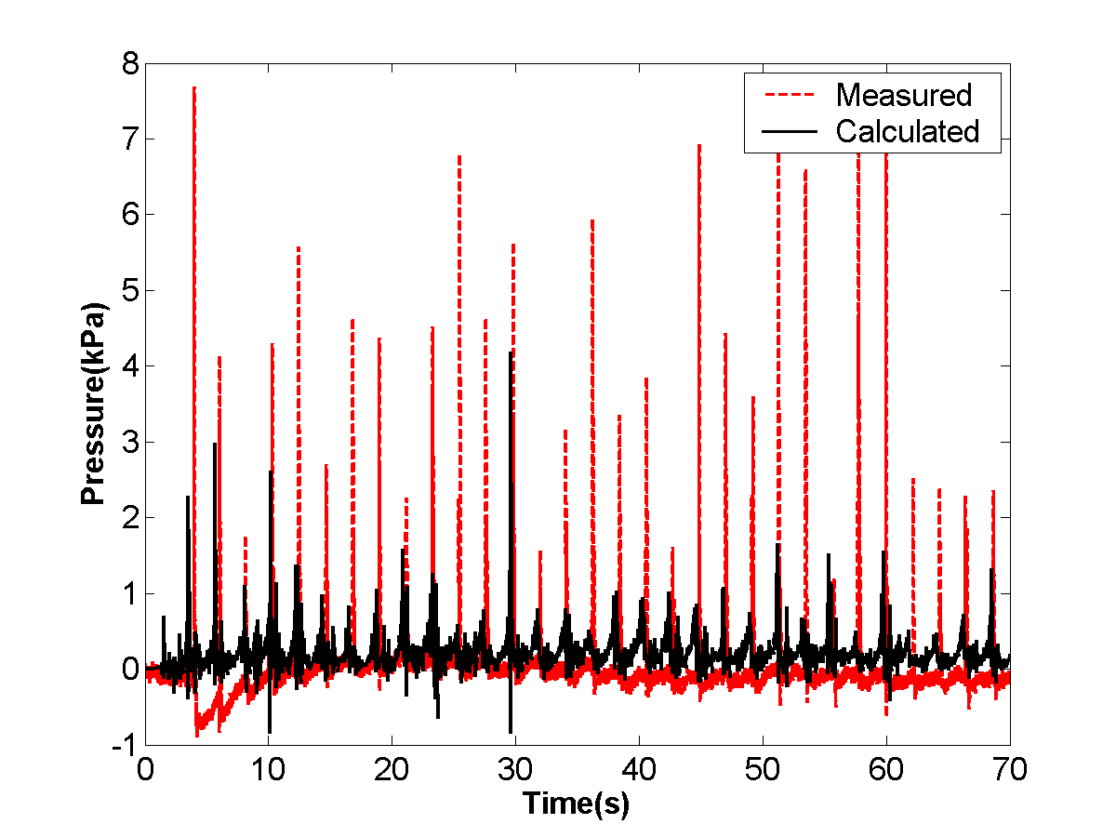
(a) Sensor #3

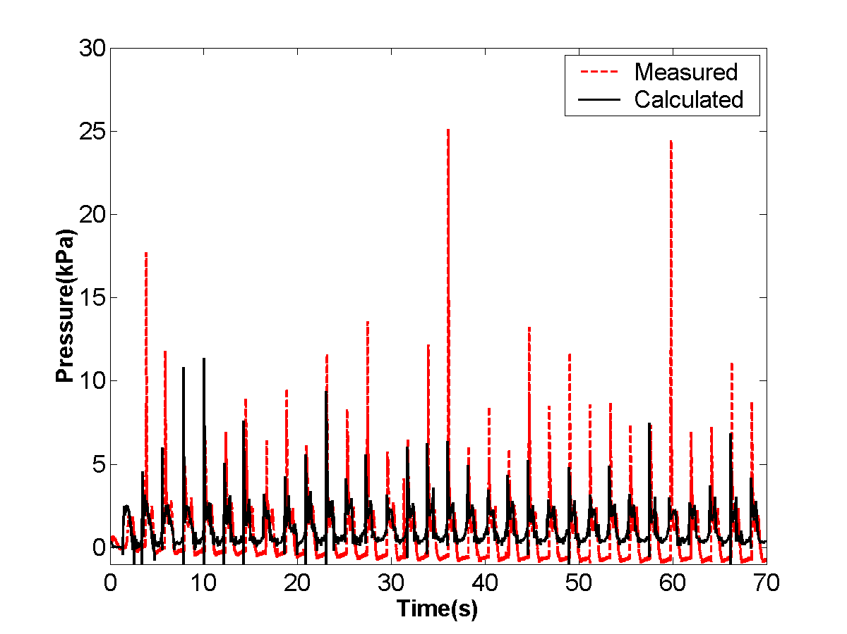
(b) Sensor #5

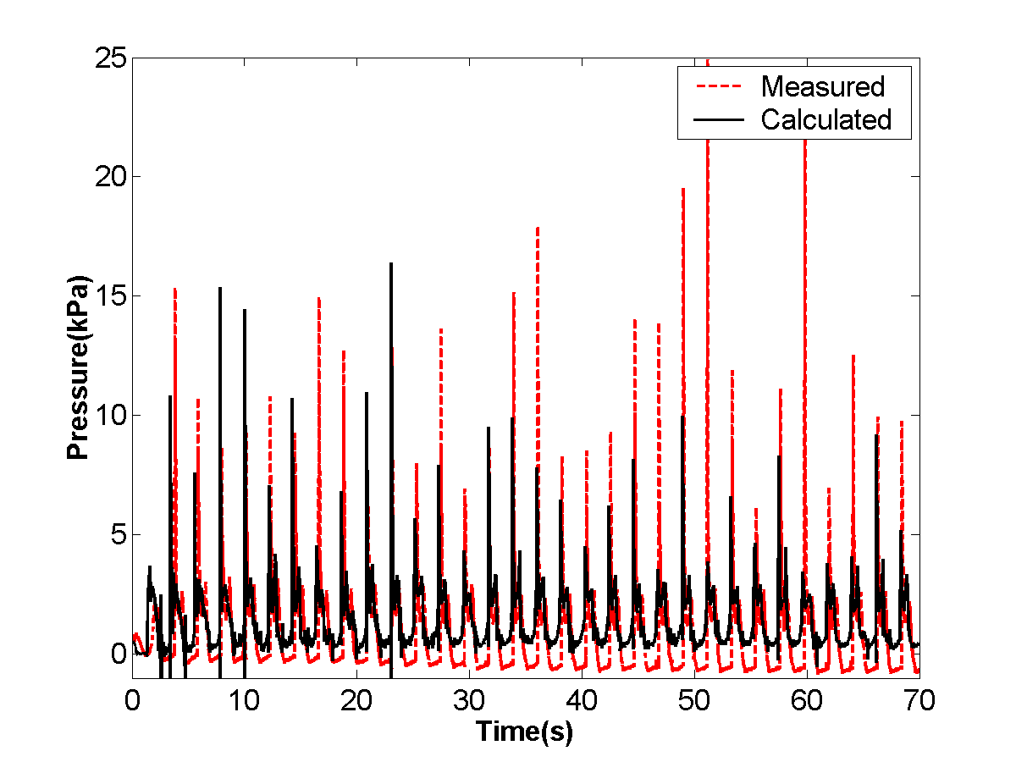
(c) Sensor #6
Fig. 7 Comparisons of time history of pressure at sensors #3, #5 and #6 (Transverse tank)

Results for Longitudinal Tank
The chosen time step increment is 5×10⁻⁴s again and the mesh size for this case is 121×81. Fig. 8 presents a comparison of the time histories of calculated pressure at sensor #5 and #6. The calculated impact pressures are closer to the measured data than in the previous test.

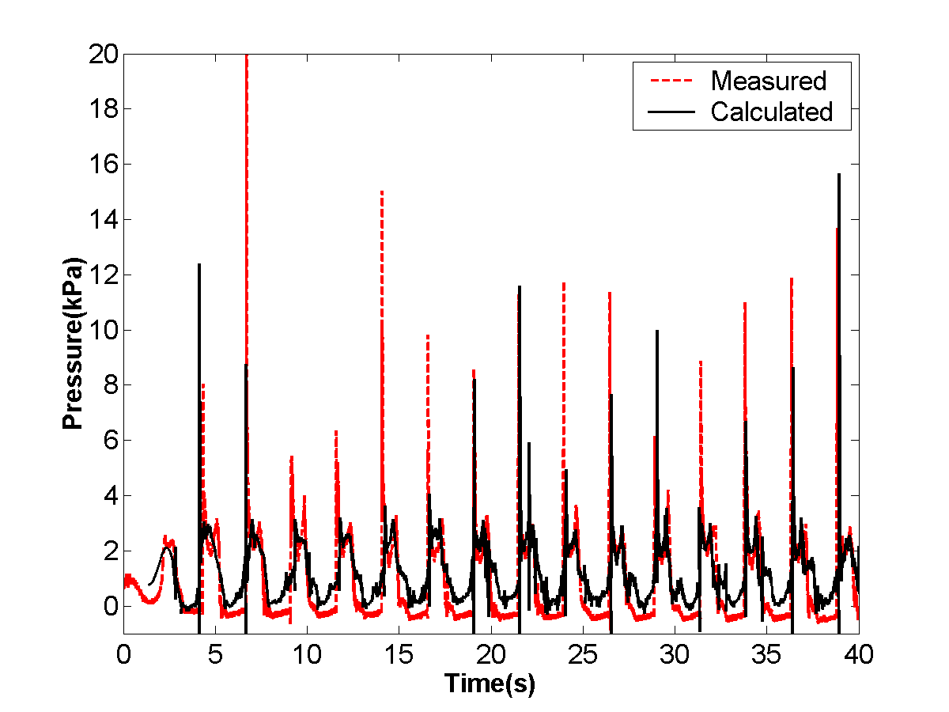
(a) Sensor # 5

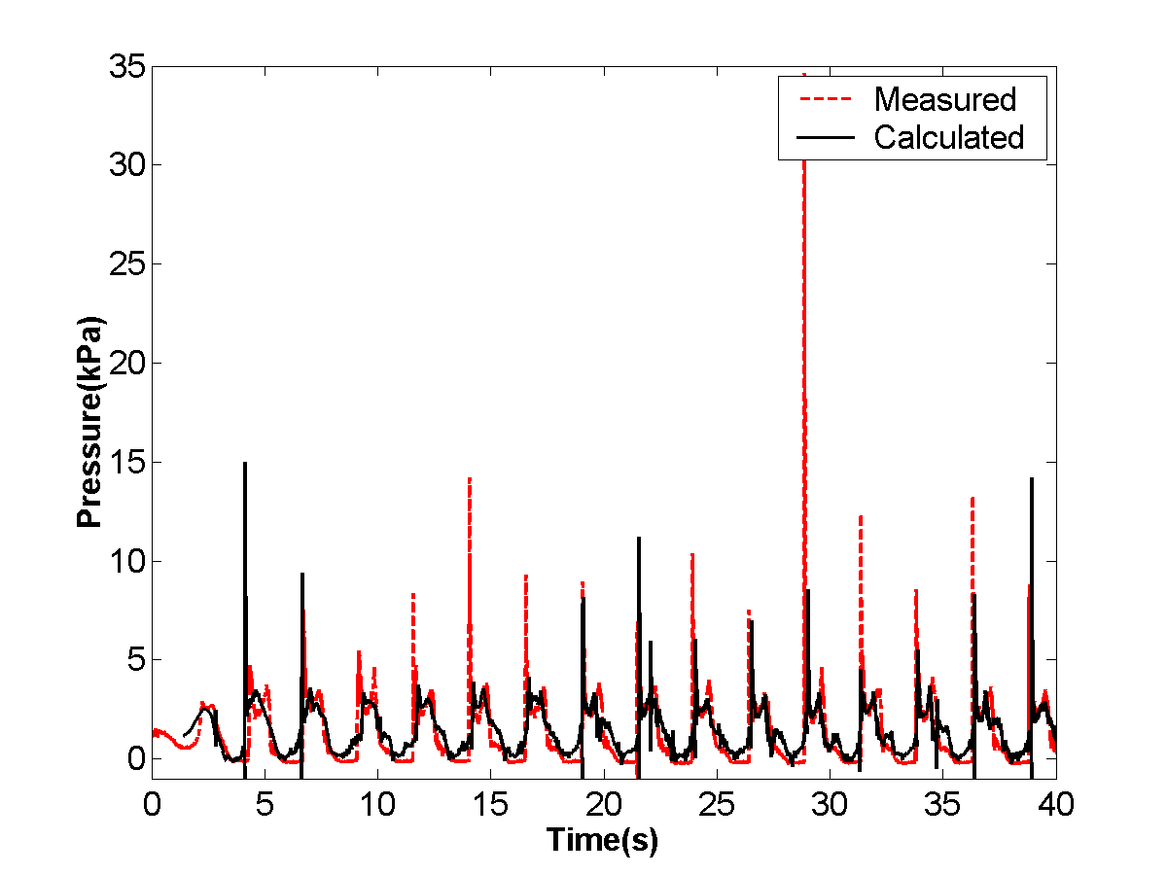
(b) Sensor # 6
Fig. 8 Comparisons of time history of pressure at sensors #5 and #6 (Longitudinal tank)
Conclusions
In this investigation an anti-diffusive VOF method is presented for interfacial flow computations. The combination of the original limited downwind method with other high order schemes shows the advantages of less numerical diffusion and stability whilst updating the fluid volume fraction used in the VOF method for describing the evolution of the interface. The numerical technique developed is validated against a benchmark test of a pure advection problem of a circle in a rotational velocity field. The method (i.e. LD-ENO2) was incorporated into an incompressible two-fluid flow solver and its capabilities demonstrated through water wave impact problems, treated using inviscid flow, in the studies of dam breaking flows involving in wave breaking, overturning and merging, and in liquid sloshing computations in a LNG model tank subjected to longitudinal and transverse motions.
Acknowledgements
The authors would like to acknowledge the support of Lloyd’s Register Educational Trust, through its University Technology Centre at the University of Southampton.
References
Abdolmaleki K, Thiagarajan, KP, and Morris-Thomas, MT (2004). “Simulation of the dam break problem and impact flows using a Navier-Stokes solver,” 15th Australian Fluid mechanics Conference, The University of Sydney, Sydney, Australia.
Bouchut, F (2004). “An antidiffusive entroy scheme for monotone scalar conservation law,” J. of Scientific Computing, 21, pp1-30.
Chen, YG, Djidjeli, K, and Price, WG (2009). “Numerical simulation of liquid sloshing phenomena in partially filled containers,” Comput. Fluids 38, pp830-842.
Chorin, AJ (1967). “A numerical method for solving incompressible Navier – Stokes equations,” J. Comput. Phys. 2, pp12-26.
Despres, B, and Lagoutiere, F (2001). “Contact discontinuity capturing schemes for linear advection, compressible gas dynamics,” J. Scientific Computing 16, pp 479-524.
Ferrari, A, Dumbser, M, Toro, EF, and Armanini, A (2009). “A new 3D parallel SPH scheme for free surface flows, ” Comput. Fluids 38, pp1203-1227.
Harten, A (1984). “On a class of high resolution total-variation-stable finite-difference schemes,” SIAM J. Numer. Anal. 21, pp1-23.
Harten, A, Engquist, B, Osher, S, and Chakravarthy, SR (1987). “Uniformly high order accurate essentially non-oscillatory schemes, III,” J. Comput. Phys. 71, pp231-303.
Hirt, CW, and Nichols, BD (1981). “Volume of fluid (VOF) methods for the dynamics of free boundaries,” J. Comput. Phys. 39, pp201-225.
Jiang, G, and Shu, CW (1996). “Efficient implementation of weighted ENO schemes,” J. Compt. Physs. 126, pp202-228.
Kim, HI, Kwon, SH, Park, JS, Lee, KH, Jeon, SS, Jung, JH, Ryu, MC, and Hwang, YS (2009). “An experimental investigation of hydrodynamic impact on 2-D LNGC models,” Proceedings of 19th International Offshore and Polar Engineering Conference, Osaka, Japan.
Park, R, Kim, KS, Kim, J, and Van, SH (2009). “A volume-of-fluid method for incompressible free surface flows,” Int. J. Numer. Meth. Fluids 61, pp1331-1362.
Price, WG, and Chen, YG (2006). “A simulation of free surface waves for incompressible two-phase flows using a curvilinear level set formulation,” Int. J. Numer. Meth. Fluids 51, pp305-330.
Puckett, EG, Almgren, AS, Bell, JB, Marcus, DL, and Rider, WJ (1997). “A high-order projection method for tracking fluid interfaces in variable density incompressible flows,” J. Comput. Phys. 130, pp269-282.
Roe, PL (1981). “Approximate Riemann solvers, parameter vectors and difference schemes,” J. Comput. Phys. 43, pp357-372.
Rudman, M (1997). “Volume-Tracking methods for interfacial flow calculations,” Int. J. Numer. Meth. Fluids 24, pp671-691.
Shu, C, and Osher, S (1989). “Efficient implementation of essentially non-oscillatory shock-capturing schemes, II,” J. Comput. Phys. 83, pp32-78.
Sweby, PK (1984). “High resolution schemes using flux limiter for hyperbolic conservation laws,” SIAM J. Numer. Anal. 21, pp995-1011.
Toro, EF (1999). “Riemann Solvers and Numerical Methods for Fluid Dynamics --- A Practical Introduction,” 2nd edition, Springer – Verlag, Berlin Heidelberg.
Vincent, S, and Caltagirone, J (1999). “Efficient solving method for unsteady incompressible interface flow problems,” Int. J. Numer. Meth. Fluids 30, pp795-811.
Xu, Z, and Shu, C (2005). “ Anti-diffusive flux corrections for high order finite difference WENO schemes,” J. Comput. Phys.205, pp458-485.
Youngs, DL (1982). “Time-dependent multi-material flow with large fluid distortion,” in K. W. Morton and M. J. Baines (eds), Numerical Methods for Fluid Dynamics, Academic, New York, pp. 273–285.
Zalesak, ST (1979). “Fully multi–dimensional flux corrected transport algorithms for fluid Flow,” J. Comput. Phys. 31, pp335-362.
Zhou, ZQ, De Kat, JO, and Buchner, B (1999). “A nonlinear 3-D approach to simulate green water dynamics on deck,” 7th Int. Conf. Numer. Ship Hydrodynamics, Nantes, France.

