Development of a web based, collaborative working environment for maritime computational fluid dynamics

S.R. Turnock⁽¹⁾, A.M. Wright⁽²⁾, D.A. Hudson⁽¹⁾

¹. School of Engineering Sciences.
^{2.} Wolfson Unit for MTIA.
University of Southampton.
Southampton. SO17 1BJ. UK
Tel No: 023 80592488
Fax No: 023 80593299
Email: steve@ship.soton.ac.uk

Abstract

A report is given on the developments so far on a DtI/Wolfson Unit funded projects to use GRID technologies to facilitate CFD analysis of marine vessels. A web enabled front end allows remote access to appropriate CFD tools and facilities. The user is guided through the process of solid model creation, mesh generation, quality assessment, CFD analysis, result interpretation, and visualisation of the computed solution. Issues such as
data security, appropriate access to commercially sensitive calculations and automated access to cost-effective computational platforms are discussed. Examples will be
given of calculations for the seakeeping assessment of the Series 60 hull form and the upwind performance of a fully appended IACC hull.

Introduction and Overview

The industrial use of Computational Fluid Dynamics for design as opposed to calculations carried as a diagnostic or research tool requires a working environment, which facilitates access to large amounts of computer processing and storage. In effect it is a problem of data management and resource allocation. The individual design engineer wants to be able to concentrate on the practical design issues and not in how to ensure that all the required evaluations are carried out or in where the output log files are archived.

Recent advances in web-based technologies can provide a suitable environment that effectively isolates the design/engineer from the underlying computer science. A number of projects are currently underway at the University of Southampton, managed through the Escience centre. These are funded through the Department of Trade and Industry with industry input from the Wolfson Unit for Marine Technology and Industrial Aerodynamics. The purpose of these is to demonstrate the viability of such an approach; allowing access to a suite of maritime CFD flow solvers. At present these include a three dimensional frequency domain seakeeping code, a general purpose surface panel code and a non-linear free surface panel code. Future additions will include commercial RANSE flow solvers and in-house LES/DES codes.
The advantages of the independence of the user from the specific numerical engines, which carry out the evaluation and the data archival, are that no longer do members of project teams need to sit side by side to access the same problem; and that appropriate expertise can be called upon when needed and in the same on-line environment. Such virtual working needs to be protected by suitable data security and is essential for commercial take-up of such systems.

The project members are housed in the Escience centre. Two ones of particular interest are G-Yacht and G-Ship. These are concerned with evaluating high performance multi-appended yacht geometries and in predicting seakeeping performance of ships.

The projects are going through a number of development phases. Last autumn a trial service was introduced for use by Ship Science students who used a general purpose surface panel code to carry out a control surface validation and design exercise. In recent weeks it ha become possible to submit a range of wave frequency test cases for a ship hull at specified sinkage and trim. Each particular frequency is evaluated on an available process and the results collated into a database for user inspection.

The productivity gains possible with such an approach rely on easy manipulation of the geometries for carrying out parametric studies. This requires input from standard CAD suites and suitable control of how the inherent data complexity is managed into a form suitable for generating a surface mesh of sufficient quality. At present this process is controlled through a suitably modified in-house grid-generation tool that can take a variety of data formats and transform them into the required subset necessary for a particular flow solver.

The following sections describe the overall architecture and user interface. Control of the whole process is maintained using an xml scripting approach which allows user input and datafile manipulation and transfer.

Architecture

An outline architecture for the service is shown in the figure below. The key features of this includes:

- Portal: User interface to the system. Entry point for design geometry and analysis parameters
- Mesh Generator & Solver Repository: Collection of CFD solvers and mesh generation tools
- Computational Resource: Internal or External CPU cycles which can be utilised to create computation meshes and/or solve a model
- Analysis Archive: Keeping previous results, solution methodologies, and experimental data.
- Visualisation Engine: uses industry standard tools, which gives the potential of overlaying results with the CAD geometry, thus acting as a template for subsequent design iterations.
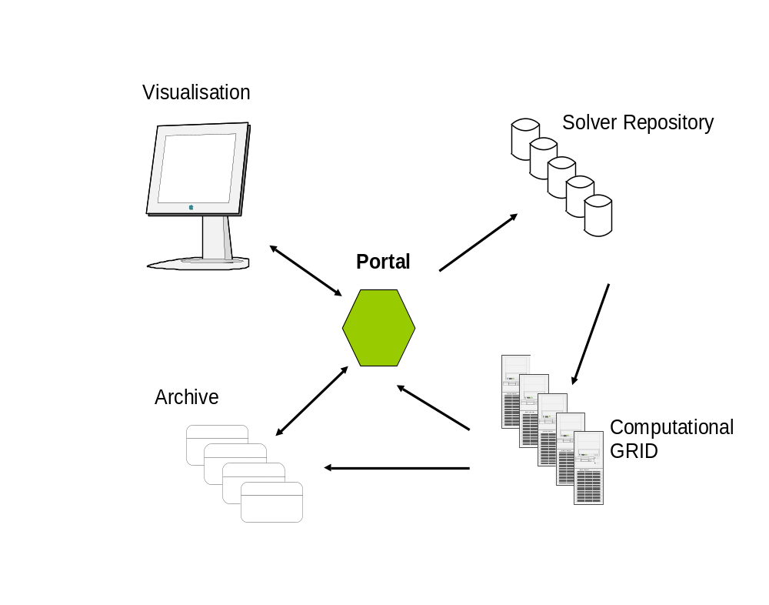
A data flow and user interaction schematic is shown below.

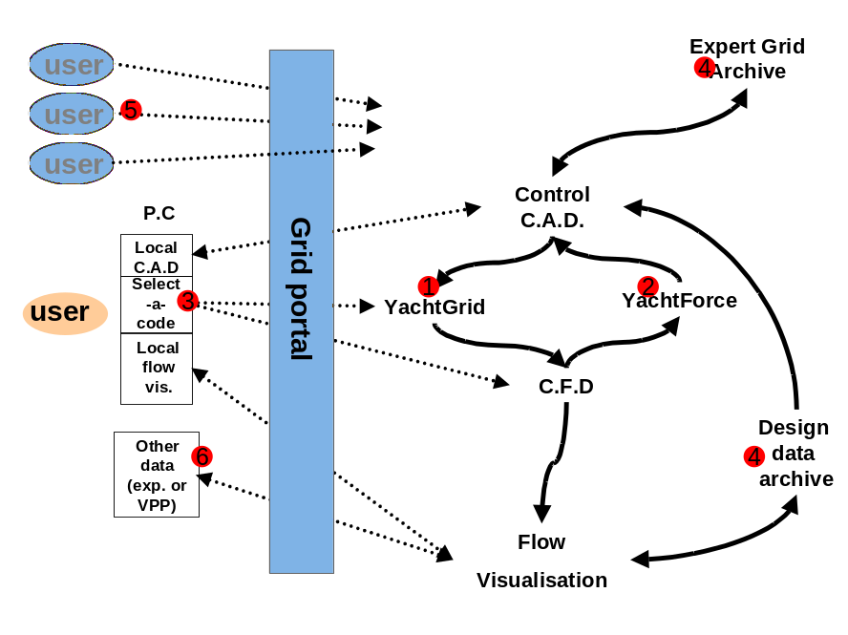

User Perspective

From a users point of view the tool will be a Web service through which CAD generated geometries can be sent, along with operating conditions (vessel speed and orientation, sea state, etc.). The user will be guided to select from a range of meshing and solution options, and advised on their effect on accuracy, speed and the cost of solution. The user will be aware of where in the process the solver is, and will have the basics of job control (ability to stop or reschedule jobs).

Interim or completed results will be accessible by the user via the portal, to either visualise upon a dedicated processor off-site, or on a local machine. The results should also be able to be superimposed upon the existing CAD model to provide greater design insight.

Conclusion

Although in its early days the web environment based approach is already showing the possible productivity gains from using it to carry out detailed parametric studies using an appropriate or more commonly a range of CFD tools adapted for a specific task

Acknowledgements

The authors which to acknowledge the contributions of software engineers Ben.Rogers and Sam Gould at the University of Southampton Escience centre.

