Enabling the reusability of scientific data: Experiences with designing an open access infrastructure for sharing datasets.

S. Coles^{a*}, J. Freyª, M. Hursthouseª, A. Milstedª, L. Carr^{b}, C. Gutteridge^{b}, L. Lyon^{c}, R. Heery^{c}, M. Duke^{c}, T. Koch^{c} and M. Day^{c}.
ªSchool of Chemistry and ^{b}School of Electronics and Computer Science, University of Southampton, Southampton, UK, ^{c}UKOLN, University of Bath, Bath, UK.

Introduction

This paper outlines an institutional repository approach to the dissemination of experimental data for the purposes of sharing and reuse. A demonstrator repository for crystallography data collected at the UK National Crystallography Service has been developed as part of the eBank-UK project (http://www.ukoln.ac.uk/projects/ebank-uk/).

In crystallography in the 1960s, a doctoral student might have investigated three or so structures, now this number can be analysed in a single morning, yet the publishing protocols for reporting this work are essentially unchanged. Across the scientific domain, only a small percentage of data generated by many scientific experiments appears in, or is referenced by, the published literature (Hey, 2003). In addition, publication in the mainstream literature still offers only indirect (and often expensive) access to this data. Moreover, the reuse of this data, in e.g. structural informatics studies, relies on mining as large a collection of crystallographic structure data as possible. As the access to and reuse of this data is dependent on it being released to the public domain in the traditional fashion, chemoinformatics and related fields are currently not as powerful as their potential suggests. As a consequence the user community is deprived of valuable information and funding bodies get a poor return on investments.

For the research chemist just 450,000 crystal structures are available in subject specific databases that have harvested their content from the published literature. It is estimated that 1.5 million structures have been determined in research laboratories worldwide and hence less than 20% of data generated in crystallographic work is reaching the public domain (Allen, 2002 & 2004). This shortfall is entirely due to current publication mechanisms. As high-throughput technologies, automation and e-science become embedded in chemical and crystallographic working routines, the publication bottleneck can only become more severe (Hursthouse, 2004). These facts are exemplified by the NCS statistics shown in figure 1, where over the last six years the number of crystal structures deposited in structural databases has remained roughly constant, despite a rising output, and comprises only ca 15% of the annual crystal structure turnover.
Figure 1. Publication and turnover statistics for NCS (1999-2004).
Requirements

The requirements for such a system are primarily: capture of all electronic files generated during the course of a crystal structure determination; the ability to validate the result; the ability to easily add value to the dataset by generating different file formats and chemical identifiers for the result; an archival system that allows bibliographic and chemical metadata to be attached to the dataset; automatic generation of a structural report based on the dataset; generation of a metadata schema and OAI protocols for the publication and dissemination of the dataset.
The eBank UK project has addressed this issue by establishing an institutional repository that supports, manages and disseminates metadata relating to crystal structure data. As part of the larger picture eBank is investigating the role of aggregator services in linking data-sets from Grid-enabled experiments to open data archives contained in digital repositories through to peer-reviewed articles as resources in portals.

Dissemination of crystal structure data via the Open Archive Initiative

The workflow for determining a crystal structure is represented in figure 2 as a stepwise illustration of the digital files generated as the experiment progresses. For publication purposes the CIF file is currently perceived to be the final result of a crystallographic experiment, but in eBank value is added. For example CHECKCIF (http://checkcif.iucr.org/) is a web-based structure validation program, which produces an
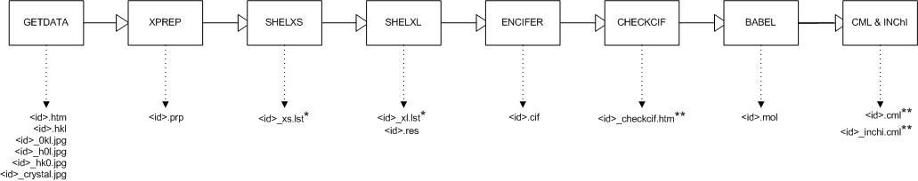
The Figure 2. The crystal structure determination workflow

output file formatted as HTML and represents the validation stage of the process. In addition a CML file is generated (Chemical Markup Language) (Murray-Rust, 2001) that enables the exchange of this chemical structure information to be automatic in addition to being platform and software independent. The InChI identifier (http://www.iupac.org/projects) is included as a unique text representation of the molecule and has been shown to assist in the linking and aggregating processes (Coles, 2005).

The schema employed in the archive contains the unique file extensions associated with the appropriate part of the process and therefore is able 'recognise' a particular file when it is presented. This enables a simple deposition process whereby the depositor supplies core bibliographic information and some chemical metadata, which is marked up as a combination of regular and qualified dublin core (http://dublincore.org), along with a ZIP file containing the digital output from the experiment. In addition to making the files available, 'quality indicators' are extracted from a number of these files. This key information is presented alongside the files for download, the author input metadata and a rendered version of the CML file, which is made interactive through the use of an applet. When a stylesheet is applied to this data an entry in the archive is displayed as shown in Figure 3.

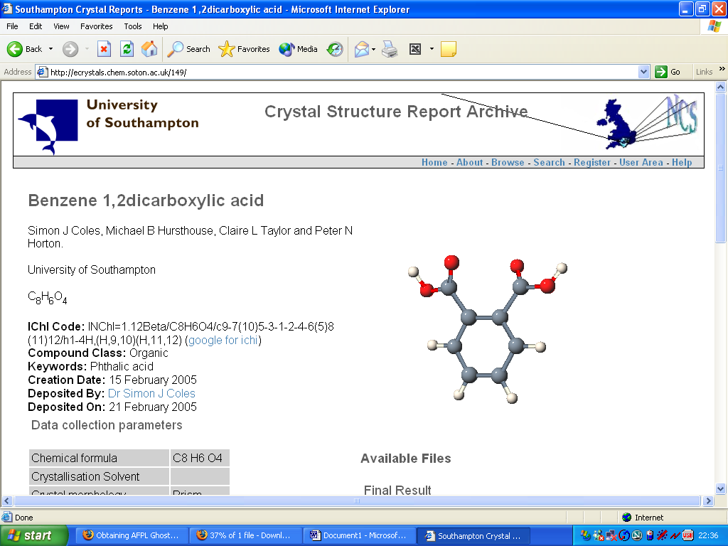
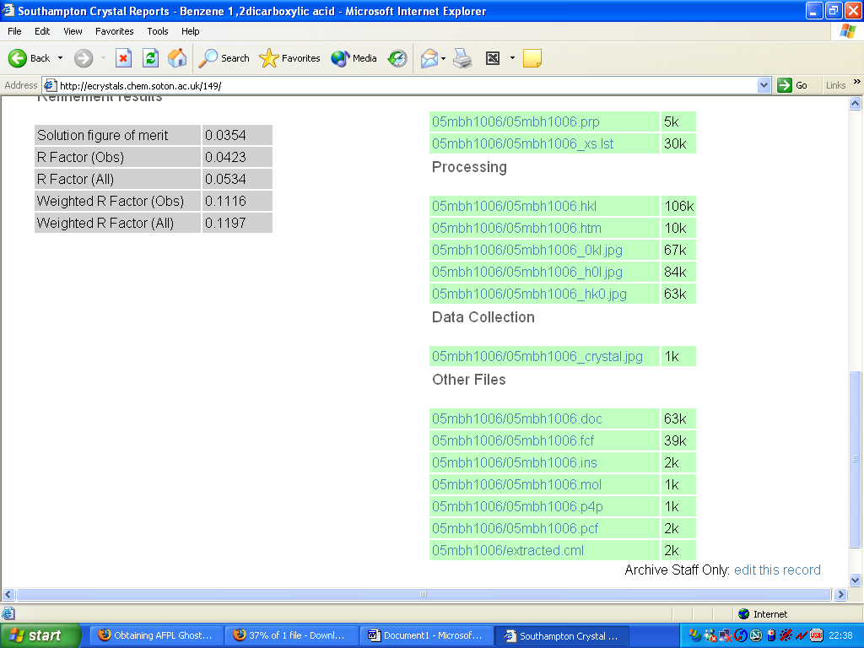

Figure 3. The local interface to the crystal structure repository

The repository publishes this metadata according to the Open Archive Initiative – Protocol for Metadata Harvesting (OAI-PMH) (http://www.openarchives.org/OAI/openarchivesprotocol.html) the model for which has already been extensively described (Heery, 2004, Lyon, 2004). This metadata is intended to be used by service providers in the OAI-PMH model as a basis for building value-added services and a demonstrator for a crystal structure data aggregator service has been built (http://www.ukoln.ac.uk/projects/ebank-uk/docs/technical/aggregator-description.html).

Useability

The 'eCrystals' repository has the potential to be an extremely powerful tool for facilitating the management, dissemination and reuse of crystallographic data. There are however, a number of usability issues that have had to be addressed in order for such a new protocol to be adopted by the crystallographic community. These problems arise from both the aspect of depositing data and that of enabling its efficient reuse. The issues and approach taken to handling them is outlined below.

- Quality and uniformity of deposited data:

There are many different instruments for collecting data and numerous software packages or collections for processing it. In addition different laboratories operate different protocols and procedures. This situation leads to a very heterogeneous body of data that the archive must be capable of processing, managing and presenting to the public. To ensure a uniformity across all entries in an archive, and indeed across all archives it was deceided that all repositories publish data according to one schema ONLY. For this schema to be able to cope with a wide variety of data types a 'toolbox' was developed to prepare data for presentation to the archive. This toolbox (figure 4) requires only two mandatory files to be uploaded, which are common to all crystallographic experiments (the CIF standard being one of them). The toolbox is capable of performing file format transformations and running code or subscribing to web services that generate the value added files.

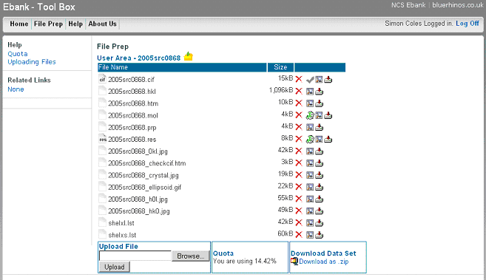
Figure 4. The interface to the toolbox, which ensures uniformity of archive content.

- Ease of data deposition:

In order to reduce input error and ensure ease of upload for depositors a minimal number of metadata items are required (by the schema) to be input by hand. Moreover, there has been extensive documentation prepared to assist the depositor. In-line help and annotation of the deposition pages provide guidelines as to content and format of an entry. A number of items have default values that may be permanently configured for the system, e.g. name of institution and where possible restrained lists are provided for selection by the depositor, e.g. keywords.

- Quality of metadata and report generation:

Much of the metadata required for an individual report and the OAI interface is generated automatically, thus reducing errors introduced from manual editing by the depositor. The archive software is capable of performing this, due to the extensive description of datasets, by the schema. Quality indicators and assignment of files to a particular stage of the experiment are performed according to the schema and data values are automatically harvested from the presented files.

- Persistent address for citation:

It is important that a dataset that is publically available has a persistent address to enable sustainable citation. A unique address is provided in that the URL of the archive contains the institution domain name and each entry bears a unique numerical identifier within the repository. This however does not guarantee a persistent address. The University of Southampton ePrints service has been adopted by the institution and it is maintained by the Library and Information Systems Support services, which assures that the repository and its content will remain at the same address for the perceivable future. As the eCrystals repository is built on the same software and philosophy it is our intention to strive for similar institutional support, which will provide persistent addresses for citation.

- Persistent identifier for dataset:

In addition to the benefits of a persistent address outlined above there are similar benefits to registering the datasets themselves with a central agency and assigning persistent identifiers. The eBank team are collaborating with a project at TIB Hanover (http://www.std-doi.de/front_content.php) to develop the assignment of Digital Object Identifiers (DOI: http://www.doi.org) to datasets in the eCrystals archive. A mapping has been made between the schema in the archive and the metadata elements required by the TIB registry. Code is currently being written to automatically generate these metadata elements and select an associated DOI and deposit them with TIB. The TIB will maintain the metadata registry and ensure that the DOI will always resolve to its associated dataset.

- Value added services - validation:

A scientist looking for data for reuse in his/her research would normally want an assurance of its integrity, completeness and validity. With current publishing protocols this is ensured through the peer review process. With author self deposition in an openly accessible archive this guarantee is removed and users will need to be assured that a dataset is of sufficiently high quality for reuse. For this purpose the eCrystals workflow contains a validation stage. Fortunately the field of crystallography is reasonably mature when it comes to standards for electronic formats and a service is made available by the IUCr (International Union of Crystallography; http://www.iucr.org) whereby a CIF may be uploaded and a series of checks performed. An HTML report is generated and this is captured for inclusion in the eCrystals archive. In addition the archive software automatically extracts a number of quality indicators (such as statistics of fit) from the dataset and presents them as part of the report so that anyone wishing to reuse the data can assess its quality at a glance. Further procedures for validation of the dataset are under investigation or development.

- Data dissemination and aggregation services:

Full details of the metadata elements in the schema used for the OAI dissemination of each repository entry have been discussed elsewhere (http://www.nesc.ac.uk/talks/ahm2005/398.ppt) and is to be the subject of a different publication. The schema has been designed such that a number of different communities can harvest the metadata and build a variety of different services with it. Usual bibliographic terms are provided, which enable conventional 'digital libraries' aggregator services to be constructed. The eBank-UK project has developed a demonstrator service for the aggregation of eCrystals datasets with corresponding occurrences in the chemical literature (see: http://eprints-uk.rdn.ac.uk/ebank-demo/). A number of other metadata items are included to give the dataset some chemical context in order to provide subject specific services. The InChI and other chemical classifications and keywords are provided so that chemical and crystallographic services may be built. With the eCrystals archive now populated projects such as these are being considered with the Cambridge Crystallographic Data Centre and the IUCr.

- Value added services - automation:

It is desireable, from a reuse point of view, for data to be not only easily discovered, but also easily processed. The toolbox seamlessly generates a CML file, containing the corresponding InChI identifier. The purpose of this file is to allow automated machine processing of repository items and has been shown to be of great value and has been described elsewhere (Coles et al, 2005). As part of this study the entire content of the repository was automatically downloaded and subjected to further study by calculation of physical properties for each molecule represented by a CML file. It is also envisaged that eCrystals entries can be automatically harvested by CCDC and entries in the CSD generated without human intervention.

- Endorsement:

The eCrystals archive has been developed with institutions such as the IUCr in mind and their publishing arm has given development feedback during the entire course of the project. Their expertise in the crystallographic publishing arena has provided feedback into the design of the schema. This will facilitate building subject specific services based on this new approach to disseminating data. There is now an overlap with other data based projects in the new JISC-funded Digital Repositories Program (http://www.jisc.ac.uk/index.cfm?name=programme_digital_repositories). This has led to an agreement whereby the SPECTRa project (http://www.jisc.ac.uk/index.cfm?name=project_spectra&src=alpha) will adopt this approach and install versions of the eCrystals archive. This will aid in the development of this new dissemination protocol for data and provide a basis on which aggregator services can be built. The eCrystals archive has been presented to the executive committee of the IUCr and the initial indications are that they will support this approach.

This prototype archive has been primarily designed and constructed by a team working at the NCS after considerable consultation with the digital libraries and open access communities. As such, constant feedback has been given by the crystallographic community, which has fed back into the design. Further feedback has been given by research students in the School of Chemistry, University of Southampton, who have been responsible for populating the database and bug reporting. Several stages of evaluation have been performed by the International Union of Crystallography, which have fed back into the design and construction. Further evaluation by the chemistry community is about to commence as this software is due to be rolled out and tested in a select number of crystallography laboratories in UK universities.

Conclusions

This approach, along with other recent technological advances, highlights a shortfall in the current publication and dissemination process in the field of crystallography. This problem has been addressed by designing an open access repository for crystallographic data. The operation of an OAI-PMH compliant crystal structure data repository has demonstrated the ability to open up access to research data by improving dissemination routes for the associated metadata. The usability issues for both depositors and those wishing to access and reuse the data have been identified and addressed. The usability, and indeed reusability of content, of the archive has been proven through adoption by the community and endorsement by international standard setting organisations.

References

Allen, F. H. The Cambridge Structural Database: a quarter of a million crystal structures and rising. Acta Cryst., B58, (2002), 380-388.
Allen, F. H. High-throughput crystallography: the challenge of publishing, storing and using the results. Crystallography Reviews, 10 (2004), 3-15.
Coles, S.J., Day, N.E., Murray-Rust, P., Rzepa, H.S., Zhang, Y., Org. Biomol. Chem., 2005, (10), 1832-1834. DOI: 10.1039/b502828k
Duke, M., Day, M., Heery, R., Carr, L.A., and Coles, S.J. Enhancing Access to Research Data: the Challenge of Cystallography, JCDL 2005, Digital Libraries: Cyberinfrastructure for Research and Education, Denver, Colorado, USA June 7-11, 2005.
Hey, T. and Trethethen, A. The data deluge: an e-science perspective. In Berman, F., Fox, G. and Hey, A. J. G., eds., Grid computing: making the global infrastructure a reality. Wiley, Chichester, 2003, 809-824.
Heery, R., Duke, M., Day, M., Lyon, L., Hursthouse, M. B., Frey, J. G., Coles, S. J., Gutteridge, C. and Carr, L. A. Integrating research data into the publication workflow: the eBank UK experience. PV-2004: Ensuring the Long-Term Preservation and Adding Value to the Scientific and Technical Data (Frascati, Italy, October 5-7 2004).
Hursthouse, M. B. High-throughput chemical crystallography (HTCC): meeting and greeting the combichem challenge. Crystallography Reviews, 10, (2004), 85-96.
Lyon, L., Heery, R., Duke, M., Coles, S., Frey, J., Hursthouse, M., Carr, L. and Gutteridge, C. eBank UK: linking research data, scholarly communication and learning. Third UK e-Science Programme All Hands Meeting (AHM 2004) (Nottingham, UK, August 31 - September 3 2004).
Murray-Rust, P., Rzepa, H.S. and Wright, M. , Development of Chemical Markup Language (CML) as a System for Handling Complex Chemical Content, New J. Chem., 2001, 618-634.

