ANALYSIS OF COSTS AND BENEFITS OF COMPRESSING

DATA ON THE USENET

*Paul Garratt ARCS, BSc, DIC, PhD and Simon Warde BSc
Department of Electronics and Computer Science
University of Southampton
Highfield
Southampton SO17 1BJ
*Email: pwg@ecs.soton.ac.uk

ABSTRACT

USENET TRAFFIC OCCUPIES A GROWING VOLUME OF DATA COMMUNICATIONS CAPACITY. THE NEWS SERVERS DEVOTE GROWING DISC SPACE. NNTP (NETWORK NEWS TRANSFER PROTOCOL) DEALS WITH TEXT THAT IS UNCOMPRESSED AND SO WASTES INTERNET RESOURCES. WE IMPLEMENTED TWO COMPRESSION ALGORITHMS IN JAVA AND C ON THE INTRANET AT THE UNIVERSITY OF SOUTHAMPTON. WE CHOSE WELL-KNOWN ALGORITHMS ZLIB AND BZIP2 AND APPLIED THEM UNDER CONTROLLED CONDITIONS ON REAL USENET TRAFFIC. WE ANALYSED THE BENEFITS OF APPLYING COMPRESSION IN TERMS OF SAVINGS IN DATA COMMUNICATIONS LOAD AND DISC STORAGE SPACE. WE FOUND SIGNIFICANT IMPROVEMENTS IN EFFICIENCIES FOR BOTH RESOURCES. DISC SPACE ON THE NEWS SERVERS HELD 30%-40% MORE USEFUL DATA. DATA LINKS TRANSFERRED 30% MORE USER DATA. ZLIB COMPRESSION WAS MORE EFFECTIVE FOR LARGE TEXT FILES AND BZIP2 WAS MORE EFFECTIVE FOR TRAFFIC COMPRISING SHORTER MESSAGES. ZLIB PERFORMANCE WAS VERY DEPENDENT ON THE DICTIONARY USED TO INITIALISE THE COMPRESSOR. OUR IMPLEMENTATION IS AVAILABLE TO WRITERS OF JAVA NEWS READERS.

KEYWORDS

Performance of distributed applications.

INTRODUCTION

The USENET comprises the infrastructure within the Internet to support the set of newsgroups. As newsgroups grow and proliferate USENET traffic occupies a growing volume of data communications capacity.

Whilst a considerable percentage of this traffic is made up from the binary newsgroups (groups primarily used in the posting of binary files, such as pictures or computer programs), there are still volumes in the order of gigabytes transferred per day consisting of uncompressed text messages. Within a typical intranet supporting a representative subset of newsgroups the news servers storing the messages and files devote a correspondingly large amount of disc space. The aim of the research reported in this paper was to investigate the possibility of compressing and decompressing the textual messages posted to newsgroups; to implement a software system to perform the compression and decompression and finally to test the compression and decompression under controlled conditions to assess its effect on efficiency.

TECHNICAL CONTEXT

The Network News Transfer Protocol (NNTP) (Kantor 1986), specifies a protocol for the distribution and retrieval of news articles using a TCP (Transmission Control Protocol) (Tannenbaum 1996) client/server model.
News in this case consists of general bulletins, questions, answers and other types of publicly available information.
The USENET news system sets out to act as a central database of articles at a particular host, rather than a copy in each subscriber’s mailbox. It also comprises of a set of client programs that allow a subscriber to select articles he/she wishes to read. Other facilities are also provided, such as cross references and expiring of old messages. Distribution of news between servers is achieved by a network of feeding servers. Each host will send all its new messages to each host it feeds, which in turn will feed its list of hosts. NNTP defines a way to avoid re-sending an article a fed server already has.
Many compression algorithms could be applicable in improving USENET loadings. Two of the best performing algorithms in the public domain are ‘Zlib’ and ‘Bzip2’ (Gilchrist 1999). Zlib is used in the popular compressed file formats Zip and Gzip, and the Portable Network Graphics (PNG) format. It is available in source code form in C that is portable to different computer architectures. It is also available as part of the java.util.zip classes forming part of the standard Java distribution. The Zlib standard is documented in RFC1950 (Deutsch 1996).
Bzip2 is emerging as a popular replacement of Gzip for use compressing file archives for transmission over the Internet. It is an implementation of an algorithm invented by Burrows and Wheeler (Fenwick 1996) with a few modifications. It has higher memory and processing requirements than Zlib but yields better compression for large files.
We did preliminary tests on the algorithms (Gilchrist 1999) and Tables 1 and 2 show relative performance of Zlib and Bzip2 for USENET text traffic.

Table 1 – Comparison of Zlib and Bzip2 compression for small messages

Gzip | 570181 (63.1%)
Bzip2 | 622194 (68.9%)

The percentage values indicates the output size as a percentage of the input size (903,500 bytes).
From this fairly simple test Zlib seems to provide better compression of small messages. As a comparison, by a compressing all of the messages joined into a single file, the following results are achieved:

Table 2 – Comparison of Zlib and Bzip2 compression for large text files

Gzip | 265526 (29.4%)
Bzip2 | 233168 (25.8%)

In these circumstances Bzip2 compression yields a better compression result. This is due to the algorithms used in Bzip2 which are used to predict certain characteristics of the data. The larger the input file the more accurate these ‘context statistics’ become (Atkins et al 1996).
The choice of algorithm for the research reported in this paper however is not determined by these tests alone. Zlib has a large advantage over Bzip2 in that it is actually in the form of a programming library. Not only is it portable across a wide number of computer architectures, but it is also useable from a range of programming languages: C and C++ are directly supported, and there is an implementation for Java in the standard Java Development Kit. Also, Win32 platform languages such as Visual Basic and Delphi can call Zlib functions.

Messages posted to newsgroups must comply to a specific set of rules to ensure that they can be transmitted reliably across the Internet. This specification is detailed in a document called RFC822 (Crocker 1982). There are a number of important rules that must be obeyed, but most importantly the body of the message must be encoded in 7-bit ASCII. Therefore the 8 bit binary format generated by compression algorithms must be modified so that it does not break the 7-bit rule. Two solutions exist. The first is MIME (Freed et al 1996) Multipurpose Internet Mail Extensions and is intended to be a standard for sending any kind of information in an RFC822 compliant message. The second format is more popular in newsgroups due to its simplicity and is heavily used for posting graphics and executable files. It is called uuencoding, Unix to Unix encoding.
The USENET system is split into a hierarchy of newsgroups and there are some 17,000 newsgroups in general circulation, with many being created every day. As a whole each news server will be connected to at least one other server, forming a network around the Internet ensuring that a message will eventually propagate to all servers. Many groups can have upwards of 300 messages per day. There are enormous potential benefits from lessening the load that newsgroups impose on the Internet links and server disc space. Data compression software integrated with the USENET program libraries and compatible with USENET standards could achieve load lessening.

IMPLEMENTATION

To deploy software to compress and decompress newsgroup traffic a version of the programming library was written so that current news reading software could be easily modified to support compressed messages. The library must be callable from C and C++ since this is the language of the majority of news client software. Newsreaders written in other languages may still be able to use this library if the language they are written in can call C library functions.
The software implementation has two publicly accessible functions:

- A ‘compressMessage’ function which takes as its argument a string containing the complete message body and returns a string containing the compressed version of the message ready for transmission to the news server.
- A ‘decompressMessage’ function which performs the exact opposite of compressMessage.

These functions must provide sensible defaults to the programmer so that by using only these functions effective compression can be achieved. There are three ways to support compressed newsgroups: in the news server, in the client, or in a proxy. News servers are already heavily loaded handling traffic and any extra processing should be avoided. The second choice, support through the client, is something that will happen after a standard has been defined. Client support is the most natural place for the compression and decompression to occur because all the benefits of the smaller message size are realised: less data is transferred between the server and the client – something that would be especially beneficial over slow modem links. Also, the client already performs processing on messages, coping with MIME attachments and more recently HTML messages. Adding support for compressed messages would fit with this architecture.
In the mean time a proxy must be used to provide the compression/decompression service. This will allow users to keep their current software until an upgraded version is available, providing direct support for the message format. A proxy can be deployed on the same computer as the client, or as a central resource tied to one news server. Employing a central proxy would relieve the user of the job of configuring the proxy. This setup would be of particular benefit to a LAN based setup such as a university or company. In this case everyone would use a locally chosen news sever (which may or may not be actually on the local network) but would still use their own choice of client software.
The language of implementation had to be portable across a range of platforms. C and C++ are reasonable choices – using standard C/C++ without relying on specific operating system features would allow a BSD socket program to be run at the very least on Unix and Windows NT platforms, and other POSIX compliant systems. Java is by definition a portable language. All major computer platforms have a version of the Java Virtual Machine. There is very good support for socket based networking built into the language. Another feature of Java is its ability to support native methods that allow calling of functions coded in another language (Horstman 1998). This would enable, for example, the compression algorithm (being the most computationally intensive part of the proxy) to be written in C.

Scripting languages such as Perl present an alternative to compiled languages such as C/C++ and Java. Perl provides support for socket communications and also has support for calling external functions, such as the compression algorithm. Processing speed is more of a concern with scripting languages, but for a small number of concurrent users the network speed will be the most limiting factor, and if an external compression algorithm is used the scripting language’s performance would not be the bottleneck. Java is therefore the language of choice for the proxy even though the compression library must also be written in Java. This has the benefit that the classes will be available to writers of Java newsreaders, increasing the range of languages supported.
Features implemented include logging the use of the proxy. It would be useful to see the performance of the proxy, any errors that may occur , statistics such as the compression rate of a particular article along with which group, as well as the time taken to perform all the processing relating to message and any misuse of the system.
The basic class structure of the proxy follows a simple client/server model. The newsproxy class waits listening on a specified port (normal NNTP servers use port 119) for connections from news clients. Then it spawns a new thread to deal with that particular connection. When the client quits the proxy-handler thread for that connection is destroyed.
This model allows for essentially an unlimited number of connections.

newsproxy |  |  | Proxy_handler
Server_name  Server_port |  |  | Server_name  Server_port
main |  |  | run

Figure 1 – Overview of the class structure for the Proxy

TESTING AND RESULTS

Software routines acted on real USENET traffic on the intranet of the University of Southampton.
The benefits and costs of the compression algorithms are principally compression rate and resource usage.

- Compression Rate. This is the most important attribute of algorithm performance. This feature describes the relationship between the number of bytes of memory required to store the original message and the compressed version.
- Resource requirements. All compression algorithms require a buffer of memory which is used in the compressing and decompressing process. In general this is used to spot repetition in the input data. The larger buffer allows the algorithm to refer further back in the input data which increases the probability that a repeated item is found. Algorithms differ widely on the memory overhead depending on the compression method. In addition to memory requirements different algorithms require widely varying amounts of processing time to achieve often similar compression rates [Deutsch, P., et al., 1996]. Newsgroup messages are in general small.

The first method of compressing text uses the default settings of Zlib, and uuencoding the resulting binary stream. This is the simplest possible combination, with no overhead due to extra message headers, or even headers around the uuencoded block of data. A program tests that compression and decompression has not corrupted the data. Figure 2 shows the performance of Zlib.
Table 3 indicates the distribution of message lengths in a typical newsgroup.

Table 3 – Sample output of the frequency data for a newsgroup

Message size (bytes) | Frequency
0-160 | 20
160-320 | 50
320-480 | 32

Therefore, ignoring overheads from the message format, it can be assumed that an overage message can be compressed by around 30 to 40 percent. Whilst this is a noticeable difference in message size it is not really enough to warrant the extra processing required to generate the message.
However, another feature of Zlib is its support for ‘dictionaries’. Dictionaries in this case refer to a single string containing frequently used words and symbols which are stored separately from the actual compressed information. When compressing data, the compression algorithm within Zlib keeps track of repeated information, but has to store the data that is repeated at least once. By storing information that is likely to be heavily repeated externally, and letting Zlib continue to store any extra repetition in the normal way it is possible to remove the overhead of storing some data in the compressed output. Zlib dictionaries are simply strings of words and phrases concatenated together, with the most frequently occurring item at the end. For example ‘toandthe’ would represent ‘to’, ‘and’ and ‘the’ with ‘the’ being the most likely to occur.
A dictionary generated for use with Zlib using only 1000 of the most popular words would hold a very large proportion of the frequently used words.any words not in a dictionary, such as specific technical terms, names and other unusual words are likely to be repeated more than expected.
There are two ways to maximise the effectiveness of any dictionaries that are used in the final compressions system.

- The first is to sample a very wide range of newsgroups, counting words in as many messages as possible from as wide a range of groups as possible. This would generate one dictionary that is fairly effective over a large number of messages.

- The second solution is to generate a dictionary specific to a particular hierarchy of newsgroups. For example, the ‘comp’ set of groups will have a very high occurrence of computer related words that will not occur elsewhere. A table mapping a newsgroup to a dictionary file could be used with compression library.

The best compromise is to generate a dictionary along the lines of the first solution, but build in a way of supporting multiple dictionaries to ensure that in the future the second solution could be implemented.
The test showed that a useful amount of compression can be achieved by using Zlib , however the performance is very dependant on the dictionary used to initialise the compressor. When a simple dictionary is used a 10% increase in compression is achieved on sample data.

CONCLUSIONS

Using real newsgroup traffic generated by the population of subscribers in a typical Intranet, we found significant increases in the efficiency of data communications between the news clients and news servers. In some cases useful traffic increased by 30% on the data links. Also the occupancy of data storage on the new servers was more efficient with generally 30% and in some cases 40% more useful data stored in the equivalent disc space. In general the improvements in system performance depended on the characteristics of the newsgroup traffic being compressed and decompressed. In particular the average length of the messages in the newsgroup traffic determined the potential performance improvements. Traffic with a higher average message length enjoyed a higher increase in efficiency. We compared the two compression algorithms and discovered that their relative performance depended on the characteristics of the newsgroup traffic. Alib is more effective than Bzip2 for large text files, whereas Bzip2 is more effective than Zlib for traffic comprising shorter messages.
We investigated the effect of the Zlib dictionary on the effectiveness of our system and found that the performance of Zlib is very dependent on the dictionary used to initialise the compressor. When a simple dictionary is used an increase in compression from 30% to 40% is achieved on sample data. We found that the nature of the optimum dictionary varied between newsgroups because of differing word patterns in each newsgroup’s traffic. An implementation comprising multiple dictionaries is therefore the key to optimum performance by Zlib and further work is needed to investigate this approach.
We have conceived, built and used an effective compression and decompression system for newsgroup traffic. Our system is compatible with the NNTP standard and with current architectural infrastructure of news servers and clients. The results of our analysis of data compression under controlled USENET usage indicates that the design approach is widely applicable. Similar implementations on local Intranets could lead to widespread efficiencies in data storage and data transmission.

REFERENCES

Crocker, D. 1982. rfc822 Standard for the Format of Arpa Internet Text Messages. (August 13)
Deutsch, P. and Gailly, J-L. 1996. rfc1950 ZLIB Compressed Data Format Specification version 3.3. (May)
Fenwick, PM. 1996. “The Burrows-Wheeler transform for block sorting text compression: Principles and improvements.” Computer Journal, Vol 39, No. 9: 731-740.
Freed, N. and Borenstein, N. 1996. rfc2045 Multipurpose Internet Mail Extensions – (MIME) Part One: Format of Internet Message Bodies. (November)
Freed, N. and Borenstein, N. 1996. rfc2047 Multipurpose Internet Mail Extensions – (MIME) Part Three: Message Header Extensions for Non-ASCII Text. (November)

Gilchrist, J. Archive comparison Text (ACT 2.0). http://act.by.net/
Horstmann, CS.; Cornell, G. 1998. Core Java 1.1 volume 2 – Advanced Features. Sun Microsystems Press, California
Kantor, B. 1986. rfc977 Network News Transfer Protocol. (Feb)
Kucera, H. and Francis, WN. 1967. Computational Analysis of Present-Day American English. Brown University Press
Tanenbaum, AS. 1996. Computer Networks. Prentice Hall, 3rd Edition, New Jersey

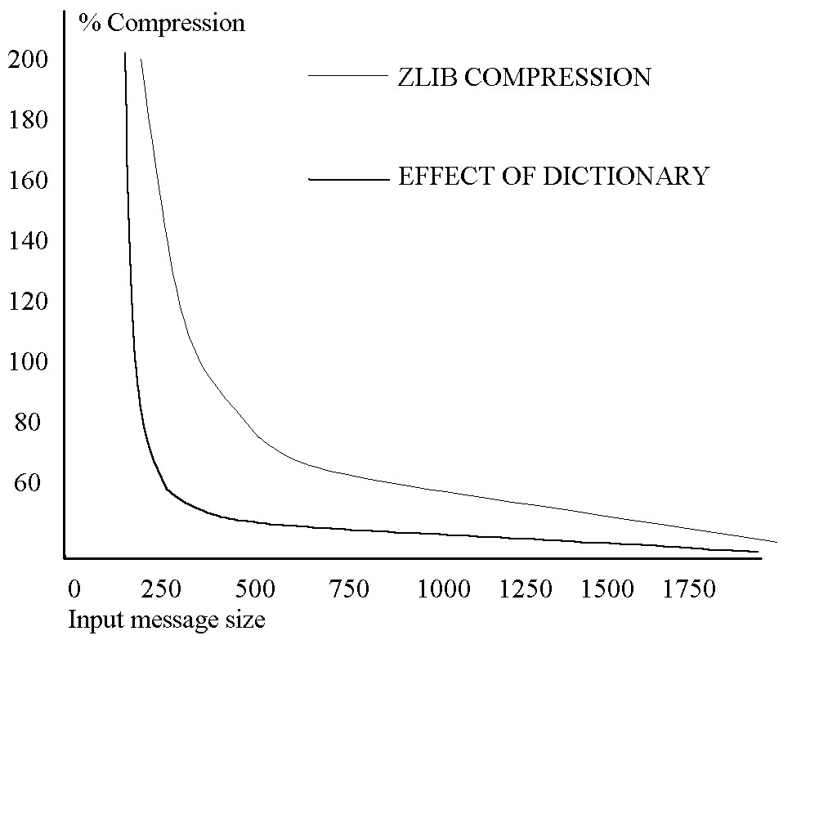
Figure 2 Effects of Compression

Dr Paul Garratt lectures in Computer Science at the University of Southampton. He has been working with computers since 1965 and contributed to the early development of the Internet while with IBM and as a consultant in Europe, the Middle East and the USA. The new applications in everyday life for the Internet and microprocessors as they support pervasive computing are a source of fascination. Paul Garratt enjoys seeing ideas from science fiction becoming reality round the world through rigorous engineering combined with creativity.

