Proceedings of ESDA’04
7th Biennial ASME Conference Engineering Systems Design and Analysis
Manchester, UK, July 19-22, 2004
ESDA2004-58027
DESIGN AND DEVELOPMENT OF INTERGRATED THICK-FILM SENSORS FOR PROSTHETIC HANDS

D.P.J. Cotton, A. Cranny , N.M. White , P.H. Chappell, S.P. Beeby,
University of Southampton, School of Electronics and computer science, Building 59, Southampton, S017 1BJ

Key words: Thick-film sensors, prosthetic hands, finite element analysis, force measurement, slip measurement.

Abstract
The majority of prosthetic hands lack an intelligent feedback control system requiring the user to rely on either visual feedback to detect whether an object is slipping out of the hand or if an unnecessarily large force is being applied. Screen printed thick film piezoresistive resistors and piezoelectric dynamic sensors offer a cheap and compact solution for detecting grip force and slip of an object from a prosthesis. This paper investigates the surface strain produced on two different fingertip designs with different attachment and loading methods in an attempt to optimise sensor position for maximum measurement sensitivity.

introduction
The use of an intelligent control system into a prosthetic hand design requires the fabrication of suitable sensors, otherwise the user has to rely on visual feedback to detect whether an object is being crushed or if it is slipping out of the hand. The Southampton Hand has been developed over a number of years [1,2,3,4] and has previously incorporated optical based force sensors and microphones to detect slip on the fingertips (Figure 1). However, there are a number of problems using these types of sensor, including erroneous hand closure when an external sound is detected and relatively high power consumption of the force sensor [5]. The Southampton hand is a myoelectrically driven device (control signals are derived from a flexor tensor muscle pair) with the independently driven fingers and two axis thumb allowing the hand 6 degrees of freedom. The palm of the hand and fingers are made of a light weight epoxy carbon fibre making the total assembly weight less than 500g.
A new type of fingertip for the Southampton Hand has been developed to allow direct screen printing of thick-film sensors onto the surface [6]. The fingertip has an array of thick-film sensors deposited on it to measure the grip force exerted by the independent fingers and also to detect the onset of slippage of an object held in the hand. There are two types of sensors used: piezoresistive thick-film sensors arranged to detect the force on the finger and piezoelectric thick-film sensors to detect the onset of slip.
Commercial myoelectric hands currently produce grip forces of 100N [7]. Our design aim is to match this capability whilst increasing dexterity of the hand thus reducing the overall need for large grip forces [8]. We have therefore chosen to limit the maximum force to 100N [9]. Allowing for a suitable safety margin, the thick-film resistors have a maximum operational strain of 1×10⁻³. These constraints therefore dictate the dimensions used for the fingertip for optimal sensitivity.
Several different designs of fingertip have been modelled using the ANSYS finite element programme (FEA) to find the optimal position of the sensors. The FEA was used to investigate the strain distributions on the surface of the alternative fingertip designs when attached to the finger using different methods and when loaded at various points.
This paper describes the finite element analysis of the different types of fingertip and compares them to the results obtained through experimental testing.

Thick-film sensor technology
Screen printing is essentially a process by which a thick-film paste is deposited though a patterned wire mesh screen by the passage of a squeegee. A thick-film sensor may be made from a number of individually printed layers, each of which requires a separate screen with the pattern image.
The piezoresistive sensors used on the fingertip are made from a commercially available thick film resistor paste ESL3914. This particular paste has a resistance of approximately 10kΩ/square. There is usually a 5% tolerance in the obtainable resistance values, which, are dependent upon the thickness of the film produced [10].
The PZT sensor paste is formulated in house from PZT-5H powder (supplied by Morgan electro ceramics) and a glass binder, mixed together with a solvent to make it printable. Both the piezoresistive and piezoelectric sensors have to be fired or cured at a temperature of around 950°C. The PZT sensors also have to undergo an electrical poling process after firing before they become active [11].

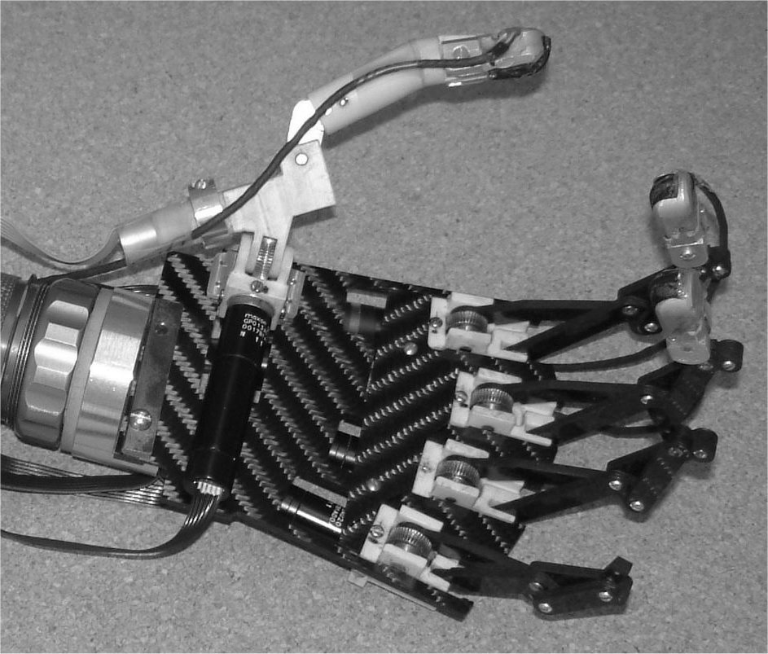
Figure 1: Southampton Remedi Hand.

Prototype fingertip 1
Figure 2 (a) shows a diagram of the first prototype fingertip fabricated on 3mm thick type 304 stainless steel. The piezoresistive thick film resistors that act as strain sensors are shown located to the left of the cantilever shape (A, B, C, D) and the piezoelectric sensor produced from PZT is shown located towards the tip of the fingertip (E). Figure 2 (b) Shows the array of screen printed resistors A, B, C and D with the connecting tracks, as well as the area where the PZT is to be printed over an interdigital electrode pattern. The four resistors are hard-wired by the printed interconnecting conductive tracks into a classic half Wheatstone bridge circuit, with resistors A and C located in a region expected to show constant strain when the beam is loaded, and resistors B and D positioned in a region where maximum strain changes are anticipated. For the purpose of the ANSYS modelling, the fingertip was divided into its lowest form of symmetry, as defined by the line X-X in Figure 2. Only half of the fingertip was then modelled; the other half being simulated using a symmetry function to reduce the processing time.
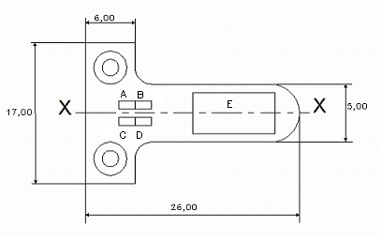
(a)
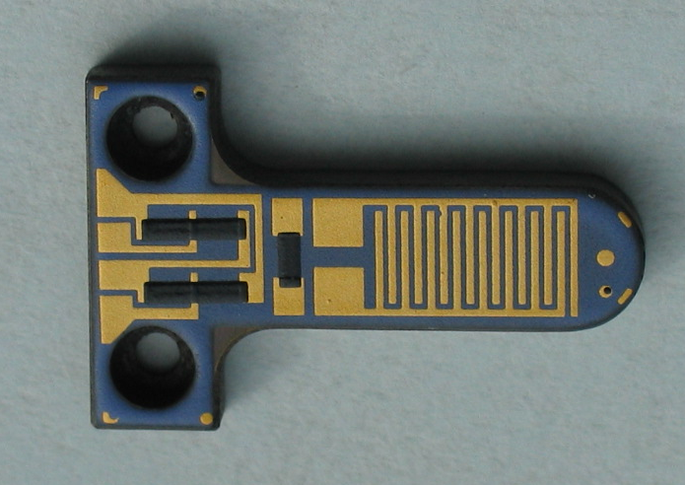 (b)

Figure 2: (a) Diagram of fingertip prototype1, showing line of symmetry X-X. All dimensions in mm.
(b) Picture of fingertip prototype 1 without PZT layer.

Three separate models were investigated, the first studying the effects of the bolt torque on the surface strain of the fingertip. In this model the following assumptions and constraints were made:
- The thick film sensors have no contribution to the substrate stiffness.
- The force is transmitted through the bolts to the surface of the finger tip.
- The bottom surface of the fingertip is constrained in the Z-plane.
- The bolt hole line “A” in figure 3 is displaced by 2.6µm and 2µm in the z-plane simulating the forces applied by the bolt to the surface of the fingertip of 500N and 400N respectively (see appendices for calculations).
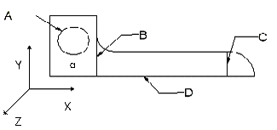
Figure 3: Fingertip model showing the location of constraints.

The second model concentrated on the effects of the fingertip being loaded whilst being firmly attached by the bolts. With reference to Figure 3, the following assumptions and constraints were made in this model:
- The thick film sensors have no contribution to the substrate stiffness.
- The bolt hole line “A” is constrained on the top surface of the fingertip in the X,Y and Z planes with zero displacement.
- The line “B” (beam pivot axis) is constrained on the bottom surface of the fingertip in all directions.

- The line “C” is displaced on the top surface of the fingertip by 150µm in the Z-plane simulating the tip deflection for 100N load see appendices for calculations.

The third model compared the effects of the fingertip being loaded when it was securely clamped down instead of being bolted down. The following assumptions and constraints were made in this model (c.f. Figure 3):
- The thick film sensors have no contribution to the substrate stiffness.
- The area “a” is constrained on both the top and bottom of the fingertip with zero displacement in the X,Y and Z directions.
- The line “C” is displaced by 150µm in the Z-plane simulating the tip deflection for 100N load.

The strain concentration gradients were plotted using the Von Mises strain distribution model which simulates the strain contribution from the X, Y and Z directions. Results are shown in figures 4, 5 and 6.
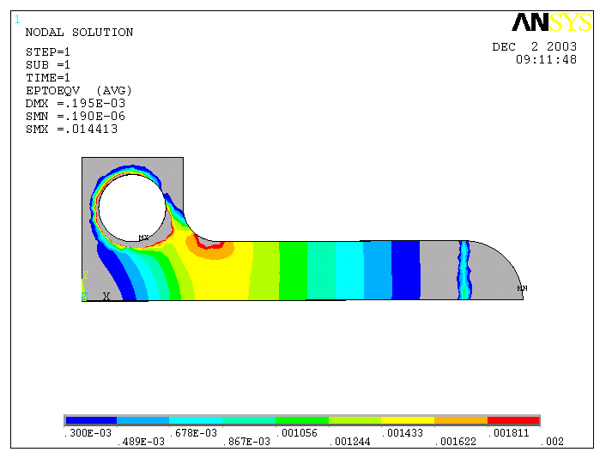

Figure 4: Von Mises Strain distribution when fingertip is constrained by the bolt holes and displaced across Line C.

From the Von Mises plot in Figure 4 it can be seen that there is a significant strain concentration around the chamfer of the finger exceeding 1.8 milli strain. This is 6% higher than that calculated using beam theory (see appendices for calculations). Other strain raisers were not taken into account by beam theory such as the bolting fixture method and no allowance was made for the chamfer next to the strain gauges or curved beam tip. It is also evident that the strain concentrations below the bolt hole where the dummy strain gauges are to be placed are significantly large, ranging from approximately 1.2 milli strain to 0.5 milli strain. The average strain over the area occupied by the dummy gauge (approximately 0.85 milli strain) is about 60% of the maximum strain experienced by the active gauge. This configuration would therefore greatly reduce the sensitivity of the finger. The relatively uniform strain distribution shows that the use of bolts to fix the beam is a viable technique.

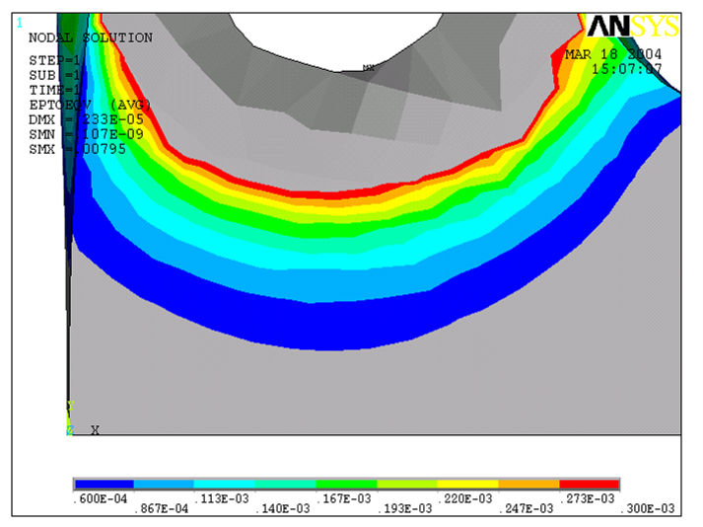
Figure 5 (a) Von Mises Strain distribution of displacing the bolt hole (line “A”) with the equivalent of a 400N force.

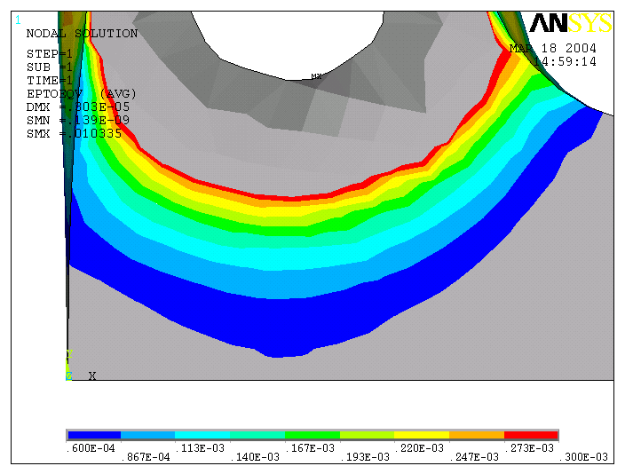

Figure 5 (b): Von Mises Strain distribution of displacing the bolt hole (line “A”) with the equivalent of a 500N force.

Figures 5 (a) and (b) show that the torque produced by the bolt will affect the strain distribution over the surface of the finger tip and hence offset the piezoresistive sensors. They also show that there is a significant change in strain when a small increase in torque of 0.4Nm is applied to the bolts.

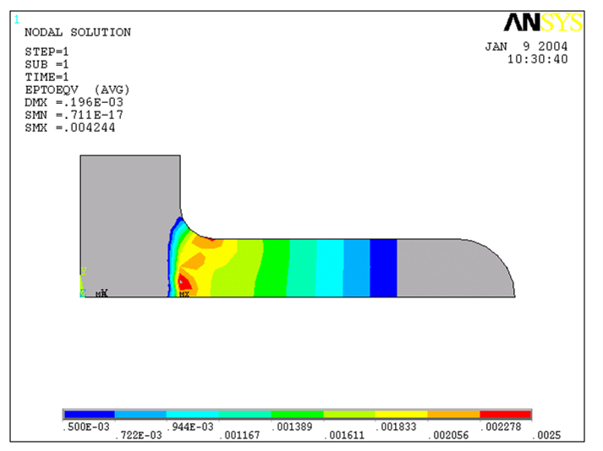

Figure 6: Detailed view of Von Mises strain distribution of beam clamped across area a.

Figure 6 shows the strain distribution for a fingertip that has been firmly clamped at its fixed end. There is negligible strain distribution across the clamped area, thereby increasing the sensitivity of the finger and eliminating the problem of applying an accurate torque to the bolts. Furthermore it can also be seen from Figure 6 that for the same displacement of fingertip, a larger strain is produced in the region occupied by the active gauges. The chamfer on the fingertip however, still affects the strain distribution and it can be seen from Figure 6 that this is not uniform over the active gauge areas. Clamping the fingertip produces a more evenly distributed strain across the fingertip and eliminates any changes in strain where the dummy gauges are to be placed, however this does not allow the fingertip to be easily serviced. Furthermore clamping would produce a protrusion on the fingertip which could increase the chance of loading occurring in a position were this device cannot measure the applied force.

Figure 7: Graph of amplified sensor response as a function of deflection of the fingertip prototype 1.

The fingertip was subsequently built and tested on a purpose built test rig to characterise the change in resistance of the thick film resistors. This was achieved by connecting the resistors in a half Wheatstone bridge configuration and applying a series of 100g masses across line C (Figure 3) resulting in a force range between 1N to 10N. For characterisation of larger forces, a micrometer was used to displace the fingertip across the same line. From both loading methods a linear change in resistance was found. From Figure 7 it can be seen that measurements taken on the prototype fingertip indicated that the static (unloaded) values of the resistors changed when the fingertip was re-inserted into the test rig, resulting in a change in offset. This confirms the results of the ANSYS analysis, which show a change in the level of distribution of the strain around the bolt holes when the torque securing the bolts is changed.

Unfortunately, although the force sensors worked well, the piezoelectric sensors exhibited adhesion problems with the steel used (stainless steel type 304) to produce the fingertip. This was thought to be caused by a thermal mismatch between the piezoelectric paste and the steel. An alternative substrate steel was therefore chosen (type 430S17) which has been successfully used with piezoelectric thick film sensors before [13]. Type 430S17 stainless steel was not available in 3mm thick sheet and so 2mm plate was chosen instead. As a consequence, a new design had to be implemented to maintain the second moment of area of the fingertip and hence the same surface strain for an applied load.
The location of the force sensors for prototype fingertip2 have been moved away from the bolt holes in order to eliminate the change in starting value when the fingertip is unbolted and then re-bolted on the finger. It is therefore desirable to investigate the strain distribution across the new fingertip design when loaded in different positions in order to find out the effect the loading position has on strain distribution and hence determine the optimal position for each sensor. This has been undertaken again using the ANSYS finite element package.

prototype fingertip 2
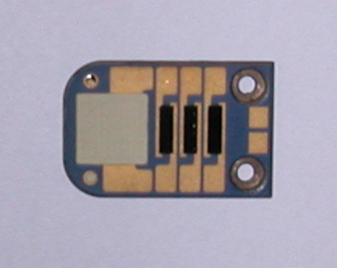
Figure 8: Photograph of the 2nd prototype fingertip.

Figure 8 shows prototype fingertip 2 with an alternative array of resistors and the printed PZT layer.
As with the previous analysis, the fingertip was divided into its lowest form of symmetry for analysis and a block was drawn underneath the fingertip to model the securing point of a real fingertip (Figure 9).

Three similar models were then created, each having the same constraints but different loading points. The following assumptions and constraints apply to all three models (c.f. Figure 10):
- The thick-film sensors have no contribution to the substrate stiffness.
- The block at the bottom of the fingertip is fixed in the same position. (The area “a” at the bottom of the block is constrained so as not to move in any direction.)
3. The strain around the edge of the bolt hole caused by the torque of the bolt is negligible but the bolt does constrain the fingertip in all directions. (Line “D” is constrained in the X, Y and Z planes with zero displacement.)
4. Line “C” is constrained by symmetry.
5. The fingertip is free to move away from the upper surface of the block. (Contact constraints between the surface of the block and the bottom of the fingertip were used.)

With reference to Figure 10, the following displacement constraints were applied to the separate models.

Model (a) A displacement of 120 microns was applied across line “B”.
Model (b) A displacement of 120 microns was applied at point “F”.
Model (c) A displacement of 120 microns was applied at point “E”.
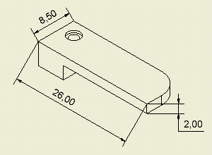

Figure 9: Cross-section through line of symmetry of 2nd fingertip with connecting block. All dimensions in mm.

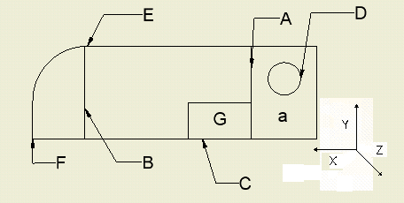
Figure 10: Diagram of the 2nd prototype fingertip.

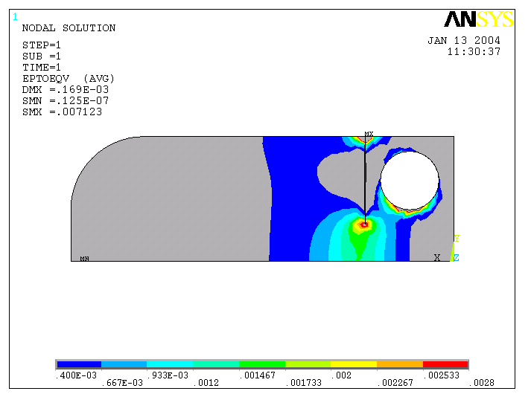
Figure 11: Concentrated view of Von Misses strain distribution of 2nd fingertip loaded across line B.

From the Von Mises plot in Figure 11 it can be seen that when the fingertip is loaded evenly there is a large strain distribution over a small area below the bolt hole. This is expected and is thought to be caused by the arcing at the centre of the fingertip due to the constraints of the bolt attachments. The strain distribution only becomes uniform, as with a standard cantilever beam, approximately half way up the fingertip length towards the loaded end. This, however, is not a concern as there is a relatively uniform change in strain below the bolt hole.

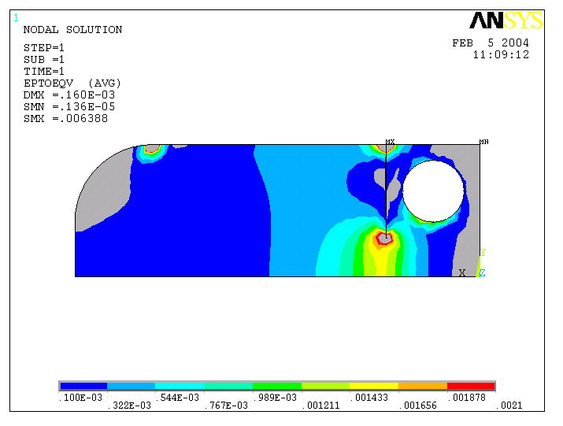
Figure 12: Von Mises strain distribution for 2nd fingertip loaded at point E.

Figure 12 shows that the strain distribution obtained from a displacement applied at the side of the fingertip is approximately the same as that obtained from a uniform load across the centre of the beam and the point loaded model (Figure 13), with the strain below the bolt holes of all three loading modes showing similar values.

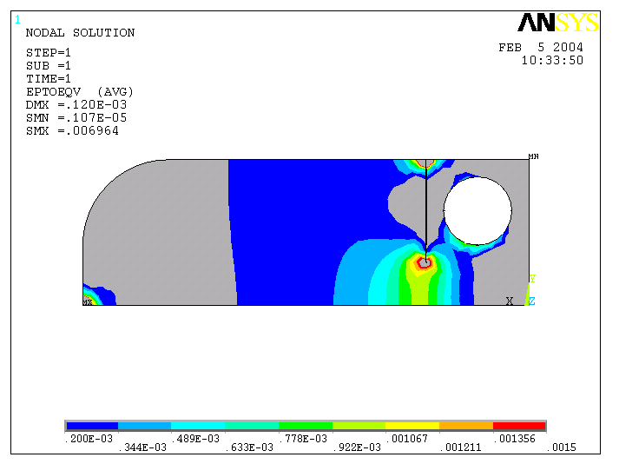
Figure 13: Von Mises strain distribution for 2nd fingertip loaded at point F.

All three different loading methods produced similar strain distributions across the surface of the fingertip. There is an area of uniform strain distribution with large strains below the bolt holes to place the force sensors.
Figure 14 shows the response from the PZT dynamic force sensor printed on type 430S17 stainless steel (connected to a simple charge amplifier) when a small object (mass approximately 100g) was dropped onto the top surface of the sensor and allowed to roll off. The figure clearly shows the initial moment of impact and the acoustic vibration as the object ‘slips’ over the surface of the sensor a short time later. This demonstrates the potential for this sensor to detect the onset of slip.
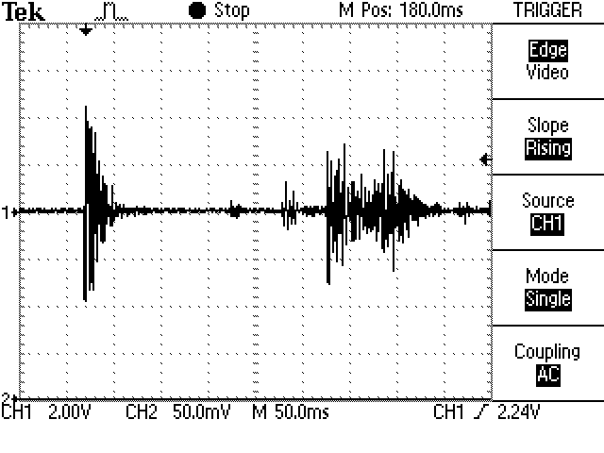
Figure 14: Recorded response of piezoelectric sensor from an initial impact followed by slip across the surface of the sensor.

Conclusions
The initial analysis on fingertip 1 indicated there may be a change in initial value of the force sensor depending upon the torque used to secure the fingertip, which proved to be the case when testing. The analysis also showed that there would be a change in the dummy strain gauges of approximately 60% compared to that of the active gauges. This will reduce measurement sensitivity of the configuration, although initial results from testing prototype fingertip 1 show that a linear response over a load range of 1N to 10N maintains linearity with a tip deflection of up to 100µm. The PZT sensor exhibited adhesion problems with type 304 stainless steel and hence could not be tested on this prototype.

Using the results obtained from testing prototype 1, the piezoresistive sensors were relocated on the 2nd prototype to reduce the effect of the bolt torque uncertainty. The modelling also suggested that the strains produced should be similar for different loading positions across the fingertip. The PZT sensor was also successfully printed on to the fingertip. Future work will include the testing of the prototype fingertip to characterise force sensitivity and linearity as well as the capabilities of the PZT sensor to detect slip. This sensor array has the potential to be integrated into commercially available prosthetic devices and robotic applications.
Acknowledgments
The authors wish to thank the Engineering and Physical Science Research Council (EPSRC) for their financial support under grant number GR/R95470.
We are grateful to Russel Torah for his assistance in formulating the PZT thick-film paste.
References
[1] Light, C.M. Chappell, P.H. “Development of a light weight and adaptable multiple axis hand prosthesis” ,Medical Engineering and Physics, Vol 22, 679-684, (2000).

[2] Light, C.M. “An intelligent hand prosthesis and evaluation of pathological and prosthetic hand function” PhD Thesis,
[3] University of Southampton, 2000
Barkhorder, M. “The control of a multi function hand” prosthesis PhD Thesis, University of Southampton, 1988
[4] Moore, D. “Development of a multifunctional hand prosthesis”, PhD Thesis, University of Southampton, 1980
[5] Kyberd, P.J. Chappell, P.H. “Characterisation of an optical and acoustic touch sensor for autonomous manipulation” ,Measurement and science technology, V3, No.10, 969-75, (1992).
[6] Glyynne-Jones, P. Beeby, S.P. Dargie, P. Papakostas, T. “An investigation into the effect of modified firing profiles on the piezoelectric properties of thick-film PZT layers on silicon” ,Measurement and science technology, V11 526-531, (2000).
[7] http://www.ottobockus.com/products/upper_limb _prosthetics/myoelectric_hands_sensorhand.asp 24/03/2004
[8] Carrozza, M.C. Micera, S. Massa, B. Zecca, M. Lazzarini, R. Canelli, N. Dario P. “The development of a novel biomechatronic hand – ongoing research and preliminary results” ,International conference on advanced intelligent mechatronics proceedings, 8-12, ( 2001).
[9] Chappell, P.H. Elliott, J.A. “Contact force sensor for artificial hands with a digital interface for a controller”
,Measurement and science technology, Vol 14, 1275-1279, (2003).
[10] White, N.M. Cranny, A.W.J. “Design and fabrication of thick film sensors” ,Hybrid circuits, Vol 12, 32-35 (1987).
[11] P. Dargie, P. Sion, R. Atkinson, J. White, N.M. “An investigation of the effect of poling conditions on the characteristics of screen-printed piezoceramics”,
Microelectronics International, Vol 15/2, 6-10 (1998)
[12] W.C.Young “Roark’s formulas for stress & strain” 6th edition, Mcgraw-hill, Singapore.
[13] Yan, T. Jones, B.E. Rakowski, R.T. Tudor, M.J. Beeby, S.P. White, N.M. “Metallic Triple Beam Resonator with Thick-film Printed Drive and Pickup”, 17th European Conference on Solid State Transducers, 10-13, (2003).

Appendices
For this analysis a comparison between a 400N and 500N force applied to the surface of the fingertip by each bolt was assumed (a total of 800N and 1000N respectively for the two bolts, 8 and 10 times the maximum load applied to the tip of the finger of 100N.) Equation 1 shows that the levels of torque required by the two securing M2 bolts to achieve these forces are approximately 0.15Nm and 0.19Nm respectively.

$T≈\frac{\text{Fd}}{5}$ (1)
Where: T = torque (Nm), F = bolt tension load (N) and d = outer diameter of bolt (m).

For an ANSYS model it is necessary to consider a force being applied to a single node, so to simplify the model a displacement at the bolt reception hole was used to model the applied force.
The bolts used to secure the fingertip are socket head cap screws and have a flat circular contact area (Figure A1). The contact area of the bolt can be calculated using equation (2).

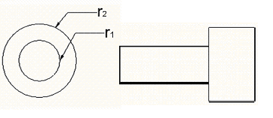

Figure A1: Side and end view of M2 securing bolt.

The contact area between the screw and the cantilever when tightened is equivalent to the area of the annulus bounded by the radii $r_{1}$ and $r_{2}$ (Figure A1) Thus:
$A=π(r_{1}^{2}−r_{2}^{2})$ (2)
Where r₁ = 2.75 mm and r₂ = 1.92 mm for a metric M2 socket head cap screw. Hence the contact area is:

$$⇒A=3\text{.}\text{09}×{\text{10}}^{−6}m^{2}$$

The definition for Young’s modulus, E, is:
$E=\frac{σ}{e}$ ${\text{Nm}}^{−2}$ (3)
Where the stress, σ, is given by:
$σ=\frac{F}{A}$${\text{Nm}}^{−2}$ (4)
and the strain ,e, by:
$e=\frac{ΔL}{L}$ (5)

Substituting equations (3) and (4) into (5) yields an expression for the deflection in the surface of the steel caused by the bolt, thus:

$ΔL=\frac{\text{FL}}{\text{EA}}$ (6)

Taking the Young’s modulus for the steel cantilever, E, to be $\text{190}×{\text{10}}^{9}{\text{Nm}}^{−2}$ and the thickness, L, of the steel beneath the bolts contact area to be $3×{\text{10}}^{−3}m$gives the change in length,$ΔL$, (or deflection) for a 500N force to be:

$$=\frac{\text{500}×3×{\text{10}}^{−3}}{\text{190}×{\text{10}}^{9}×3\text{.}\text{09}×{\text{10}}^{−6}}=2\text{.}\text{55}×{\text{10}}^{−6}m$$
$$2\text{.}6μm$$

For a 400N force applied to the bolt holes the change in length $ΔL$is:

$$=\frac{\text{400}×3×{\text{10}}^{−3}}{\text{190}×{\text{10}}^{9}×3\text{.}\text{09}×{\text{10}}^{−6}}=2\text{.}\text{04}×{\text{10}}^{−6}m$$
$$2μm$$

These calculated values for deflection were used in the ANSYS model to simulate the strain distribution across the cantilever surface when the securing bolts were tightened to give force equivalents of 500N and 400N.

Beam theory calculations
From simple beam theory it can be shown that the strain produced for a given deflection of a cantilever beam is given by [12]:

$e=\frac{3{\text{hy}}_{\text{max}}}{2L^{2}}$ (7)

Where e = the maximum strain produced, L = the length from the loading point to the point of fixture and h = the thickness of the beam, as shown in Figure A2.
y
W
L
h
x
Q
Figure A2: Cantilever beam diagram.

PROTOTYPE FINGERTIP 1
For prototype fingertip 1, an arbitrary maximum beam tip deflection of y = 150µm was used. The fingertip thickness (h) was 3mm and the length at which the beam was loaded (L) from the pivot point was 20mm, thus giving a strain of:

$$e=\frac{3×3×{\text{10}}^{−3}×\text{150}×{\text{10}}^{−6}}{2×(\text{20}×{\text{10}}^{−3})^{2}}$$
= 1.69 milli strain

PROTOTYPE FINGERTIP 2
For prototype fingertip 2 an arbitrary maximum beam deflection of y = 120µm was used. The fingertip thickness (h) was 2mm and the length at which the beam was loaded from the pivot point was 20mm, thus giving a predicted strain of:

$$e=\frac{3×2×{\text{10}}^{−3}×\text{120}×{\text{10}}^{−6}}{2×(\text{20}×{\text{10}}^{−3})^{2}}$$
= 0.9 milli strain

