Stiff Load Cell With High Overload Capability and Direct Frequency Output

T. Yan¹, B. E. Jones¹, J. Astrup², R. T. Rakowski¹, M. J. Tudor³, S. P. Beeby³ and N. M. White³

¹The Brunel Centre for Manufacturing Metrology, Brunel University, Uxbridge, Middlesex UB8 3PH, UK
²Applied Weighing International Ltd, Caversham, Reading RG4 5AF, UK
³Department of Electronics and Computer Science, University of Southampton, Southampton, Hampshire SO17 1BJ, UK

Summary: This paper reports on the design, construction and characteristics of a novel load cell having stiffness and potential overload capability some 10 times that of a resistive strain gauge load cell. The experimental cell loaded up to 600 kg gives a direct output frequency change of 870 Hz (safety factor of 5). It uses recently developed metallic triple beam resonators with thick-film PZT drives and pickups.

Keywords: load cell, thick film PZT, metallic resonator

1 Introduction
Existing resistive strain gauge based load cells have serious problems, such as relatively low overload capability and small analog signal outputs. A technology to overcome these problems has recently been proposed [1]. The screen printing process has been successfully used to deposit piezoelectric materials onto metallic substrates for fabrication of triple-beam tuning-fork resonators. Figure 1 shows a photograph of the resonator. The device is 15.5 mm long, 0.25 mm thick, 2 mm wide for centre beam and 1 mm wide for outer beams. It has a load capacity of 100 N, with a safety factor of over 2. The piezoelectric thick-film elements in current formation can operate up to 120 ºC. The resonator substrate is photochemically etched from 430S17 stainless steel. The thick-film PZT elements are screen-printed onto the centre beam for driving and detecting the tuning fork resonance. A feedback closed-loop electronic circuit has been designed to maintain the resonator in resonance while loads are applied to the resonator, resulting in changes in its resonant frequency. The circuit outputs a digital frequency signal for measurement. This paper describes the integration of the resonators into a stiff load cell design.

2 Load cell design
Figure 2 shows the design of the load cell. It has been made from a 17-4PH stainless steel rod with slots milled at two sides and the central slot section of the rod machined throughout. Two resonators are mounted into the slots with one on each side using epoxy-phenolic adhesive. Pinholes have been drilled at 90 degree to each other at the ends of the rod for applying the load.

Figure 3 shows the cross-sectional area of the load cell in relation to the cross-sectional areas of the resonators. The load (F) distributions can be calculated as follows:
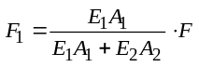 (1)

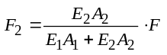 (2)
where is the load distributed to the load cell structure, 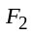 the load distributed to the resonators in total, 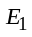 the Young’s modulus for the load cell material 17-4PH stainless steel, 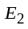 the Young’s modulus for the tuning fork material 430S17 stainless steel,  the section area of the load cell, and 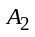 the section area of the resonators in total.
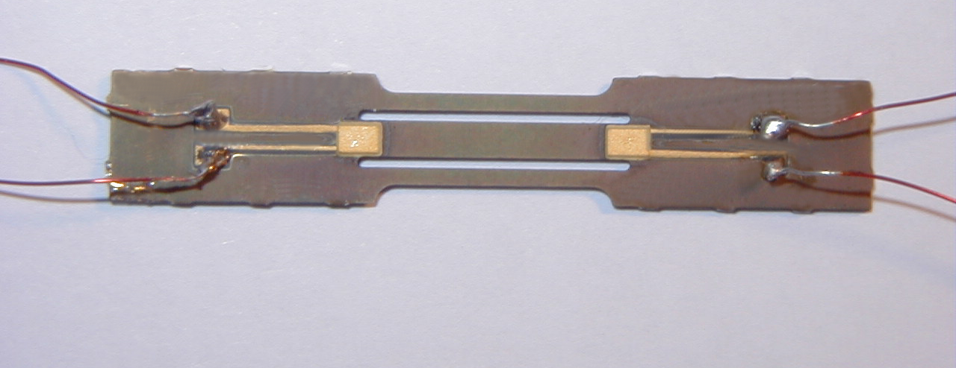
15.5mm
Fig. 1. Thick-film PZT-metallic resonator.
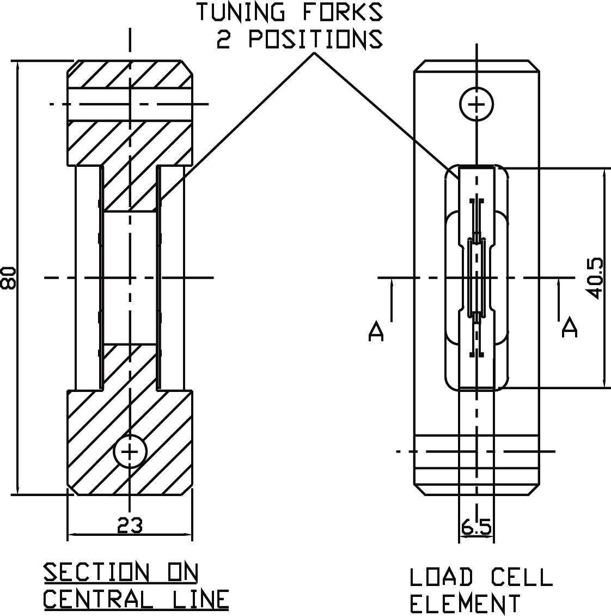
F
Fig. 2. Load cell design (dimensions in mm).
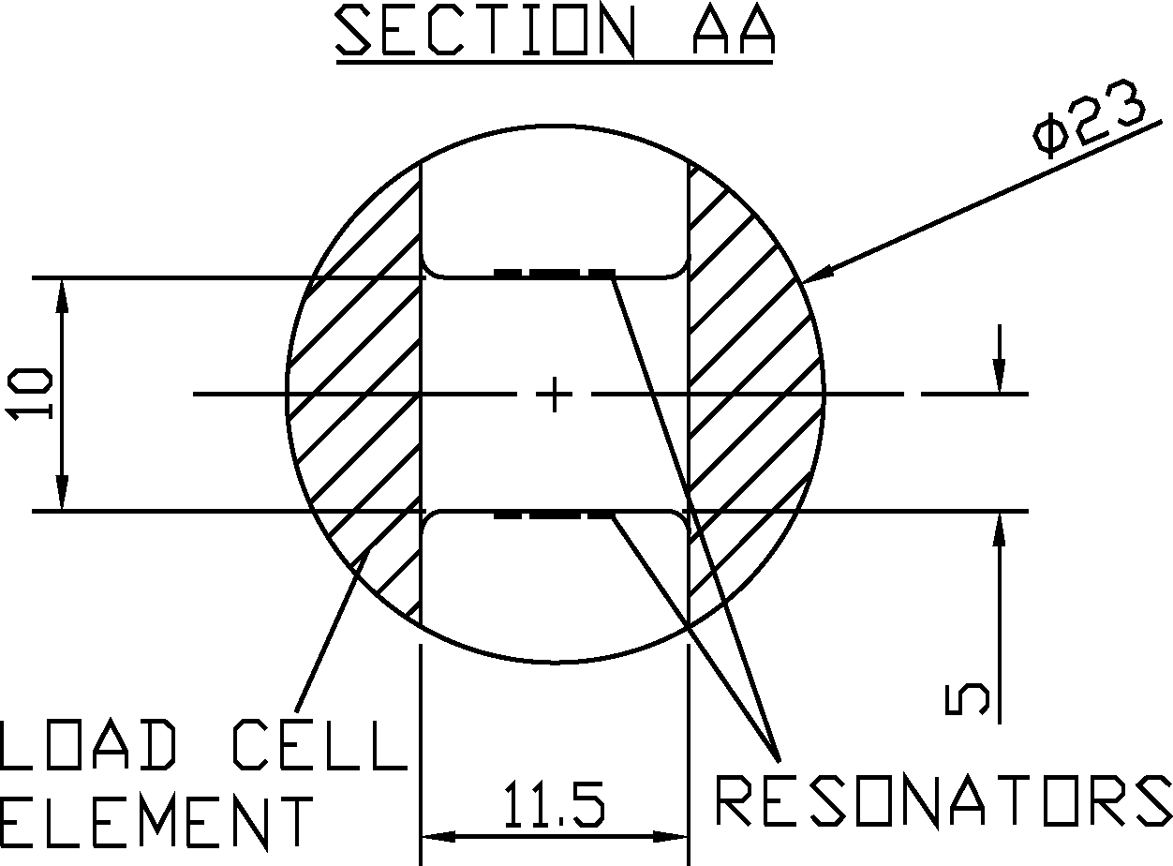
Fig. 3. Section areas of load cell and resonators (dimensions in mm).

3 Results
The load cell was calibrated on an industrial calibration machine at Applied Weighing International Ltd. for loads up to 600 kg. Most of the load is distributed to the load cell structure itself, calculated using equations (1) and (2) to be 98.75%. At the full load of 600 kg, the load distributed to each resonator is calculated to be 3.75 kg (37 N). This corresponds to 180 microstrain in the resonator beams and the load cell.

The cell was loaded and unloaded with 100 kg steps for 3 cycles of operation. The frequency outputs from the electronic circuits for the resonators were recorded. Figure 4 plots the averaged frequency readings against the applied loads for one of the resonators and the line shows a linear least squares fit to the calibration data. The sensitivity of one embedded resonator to load has been measured to be 1.45 Hz/kg, and the other embedded resonator showed a sensitivity of 0.91 Hz/kg. There is variability in the fabrication of the resonators and in mounting arrangements so that load sensitivity from resonator to resonator will be different. Two resonators have been used to achieve mechanical balance of the load cell. The characteristics of the load cell are taken from the resonator having highest sensitivity. Table 1 summarises the main characteristics of the load cell (in terms of maximum variations). The temperature coefficient of the load cell will be determined by several material and mechanical factors. A thick film resistive temperature sensor can be printed onto the resonator for load cell compensation in a manner to minimise resistance change with stress.

It should be noted that the performance of the load cell presented in Table 1 is principally limited by the material of the resonator and the adhesion method of mounting. A better elastic material for the resonator would be beryllium copper or 17-4PH stainless steel. Means of mechanical attachment methods to incorporate the resonators to the load cell structures are very important in order to obtain the full potential of the resonators [2]. The authors have now re-designed the resonator to have pads with holes at each end to bolt the device into the load cell for ease of mounting.
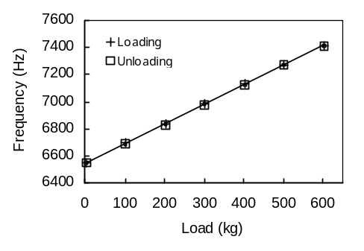
Fig. 4. Response of the load cell.
Table 1. Summary of the load cell characteristics.
Initial frequency | 6547 Hz
Load sensitivity | 1.45 Hz/kg
Full load scale | 600 kg
Non-linearity | 0.7% of full scale
Repeatability | 0.1% of full scale
Hysteresis | 1.2% of full scale
Stability (at 300 kg for 30 mins) | 0.05% of full scale
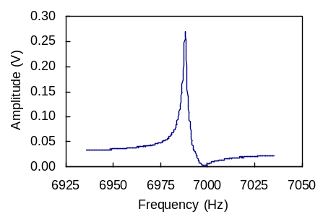
Fig. 5. Resonant frequency of the resonator.

Figure 5 shows the resonant frequency of the resonator operating in air, measured in an open loop by using a HP 89410A Vector Signal Analyser. The Q-factor was calculated to be 3100 and the measured minimum Q-factor under loads was 1640, which is very favourable when compared to the Q-factors of other metallic resonators [3].

4 Conclusions
A load cell employing the recently developed thick-film PZT-metallic tuning fork resonators and the associated electronics has been demonstrated. A resistive strain gauge load cell uses strain levels up to approximately 1800 microstrain, whereas the resonator load cell only needs about 180 microstrain or less, i.e., the new load cell is some 10 times stiffer than existing load cells. This is a major advantage for many weighing applications, where large overload capability is required, for example a 10 times overload capability would result if the applied load to each resonator is 20 N giving a frequency change of about 400 Hz. The new approach to design load cells should therefore result in far more robust weighing systems than those using resistive strain gauges. Resonant sensing also offers many other advantages, such as direct digital frequency output compatible with digital microelectronics, low power consumption, better long-term stability and greater resolution.

Acknowledgements
The authors wish to acknowledge the support of EPSRC (GR/R51773) and industrial collaborators.

References

T. Yan, B. E. Jones, et al. Eurosensor XVII, Portugal, September 2003, pp.10-13.

M. W. Ford. UK Patent GB2270565B, 1996.

C. Barthod., Y. Teisseyre, C. Gehin and G. Gautier. Sens. Actuators A 104 (2003) 143-150.

