The Language Box: Re-imagining Teaching and Learning Repositories

David E. Millard¹, Yvonne Howard¹, Patrick McSweeney¹, Miguel Arrebola³,
Kate Borthwick², Julie Watson²
¹School of ECS, University of Southampton, {dem, ymh, pm}@ecs.soton.ac.uk,
²School of Humanities, University of Southampton, {K.Borthwick, J.Watson}@soton.ac.uk
³School of Languages and Area Studies, University of Portsmouth, Miguel.Arrebola@port.ac.uk

Abstract

In this paper we describe the Language Box, a teaching and learning repository for language teachers based on the EPrints framework. Language Box differs from other content repositories in that it is designed as a living space, where teachers and lecturers can keep and manage working documents. It is focused around three key services: Hosting materials online, Organizing materials into collections, and Sharing them with the community so that they can be exploited, remixed and extended through activities. We believe that our novel approach may help to solve the problem of low user interest in teaching and learning repositories, and can inform others working on teaching and learning repositories in other domains.

1. Introduction

Digital content is increasingly important to teachers and lecturers who commonly develop and deliver their teaching resources digitally. Much of this content is in the form of online notes and downloadable slides, but there is an increasing amount of richer material being used, in the form of online articles, podcasts and interactive exercises.
At present much of this content is held inside Virtual Learning Environments (VLEs), or hosted on public websites (such as YouTube). Neither of these situations is ideal. VLEs lock content away, associate it tightly with internal course structures, and make it difficult for practitioners to share quality materials (even with colleagues in the same institution). Public websites have the advantage of wide dissemination, but the institution has no control – over either the consistency of provision or quality of content.
Teaching and Learning Repositories offer a potential solution. However, a lot of repository design has been based around heavyweight content delivery (in the form of Learning Objects), or they have inherited their approach from research repositories (such as EPrints and DSpace). The result is that many existing Teaching and Learning repositories have failed to capture the enthusiasm of their users.
In this paper we describe our experience over the last few years of building teaching and learning repositories, and explain the lessons that have resulted in a radical rethink of what they should offer. We present the Language Box as an example of our new approach, which results in a different type of repository that doesn’t depend on the altruism of users for its success. Our hope is that other developers and e-learning managers can learn from our experience, and may draw inspiration from our novel approach.

2. Background

Learning objects are described by the IEEE as “any entity, digital or non-digital, that may be used for learning, education or training” [5]. In technology there is a formal definition in the IEEE LOM [6] standard.
The idea of a learning object is to create a unit of reusable and independent teaching. In order to encourage learning object reuse, a method of distributing them is required. The most common way to do this is using a learning object repository [8]. Learning object repositories exist in a symbiotic relationship with learning objects. Without good learning objects a repository has no purpose and without a mechanism for distribution learning objects will not be reused [3].
The uptake of learning objects has not been as widespread as learning object proponents would like. Some of the barriers contributing to the slow uptake of learning objects include:
- Technical/opaque vocabulary associated with learning objects [7]
- The time and technical knowledge required to build learning objects [1]
- Pedagogical problems, including that the Learning Object concept is too ambiguous, lacks pedagogical guidance, and enforces a limited scope for learning [4, 9].
While Learning Objects represent a useful way for professional developers of learning materials to package their work, the barriers can make them inaccessible for ordinary teaching practitioners, even though they may also have useful material to share.
The goal of the Language Box is to encourage teaching practitioners to share the materials they use in their everyday teaching in such a way that it can be reused and repurposed by other people in their teaching community [2]. It aims to present the concept of sharing in the familiar context of Web 2.0 sharing sites in order to lower the barrier to ordinary practitioners.

3. Motivation

3.1. CLARe and CLAReT

The authors have been involved in repositories for teaching and learning for many years. Our first repository was called CLARe, a simple EPrints installation with a Learning Object schema, deployed for the Language teaching community. Our evaluations of CLARe showed that people were disappointed with the plain repository interface, and described the experience as ‘flat’ (it was hard to navigate and nothing was interlinked) and ‘dead’ (there was no information on how people had used the Learning Objects, or what people thought of them). It was clear that the Web 2.0 systems that were appearing at the time (such as Flickr) were changing people’s expectations of what a repository should offer.
We ran a follow up project called CLARe Tools (CLAReT) that tried to address these issues, introducing comments and ratings and additional navigation support in the form of a flash browser (shown in Figure 1). Adding Web 2.0 features is a popular approach to improving repository design and we expected CLAReT to solve our usability problems. However, in our evaluation workshops we found that while the superficial problems had been addressed, deeper issues emerged. Comments we received included:

“I recognise the zip file, but when I open it up I don’t know what to run to make it work.”
“I don’t know what half of these terms mean.”
“I don’t have digital resources to share. I print out my handouts and if I need them again I photocopy them or type them in again.”
It became clear to us that the problem wasn’t just an interface issue, it concerned long held assumptions about the way in which teachers thought about their digital teaching materials. Our experience also questioned the need for lots of meta-data and content packaging, suggesting that simplicity was more important than completeness. The use of Web 2.0 features was not sufficient, what was required was a rethink of the whole approach.
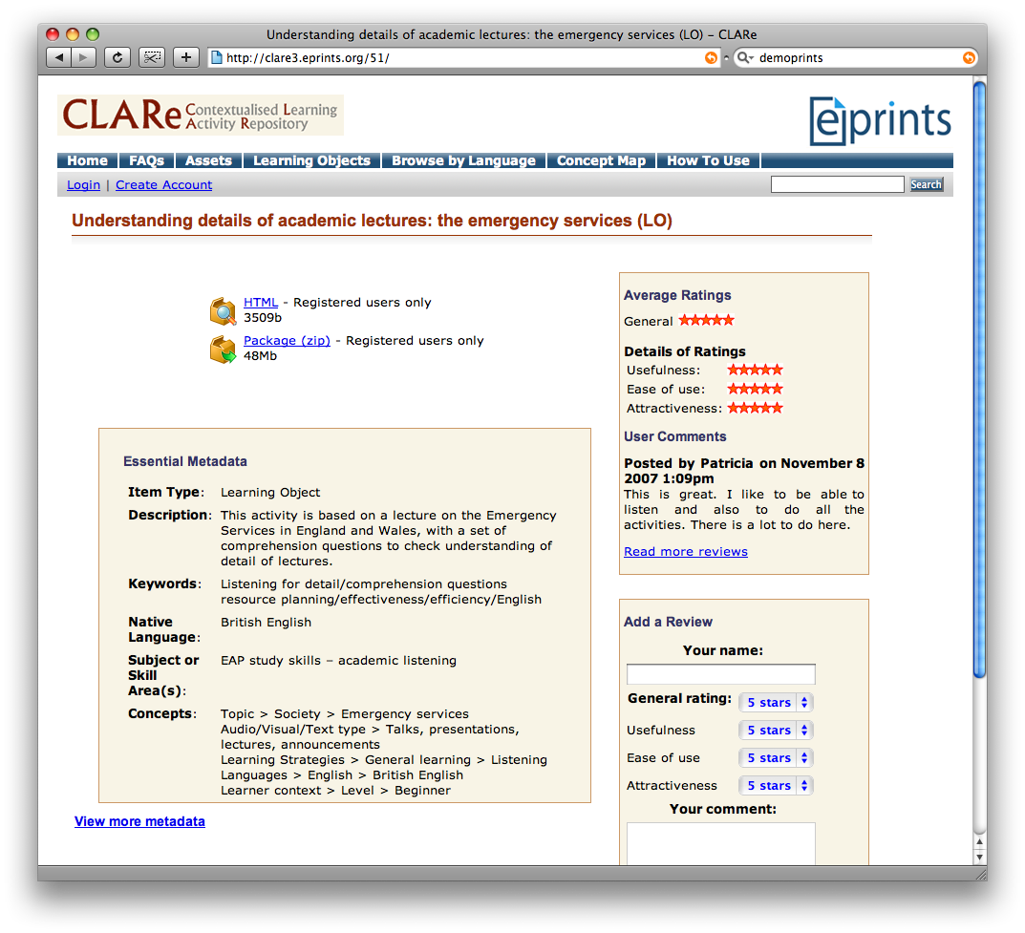

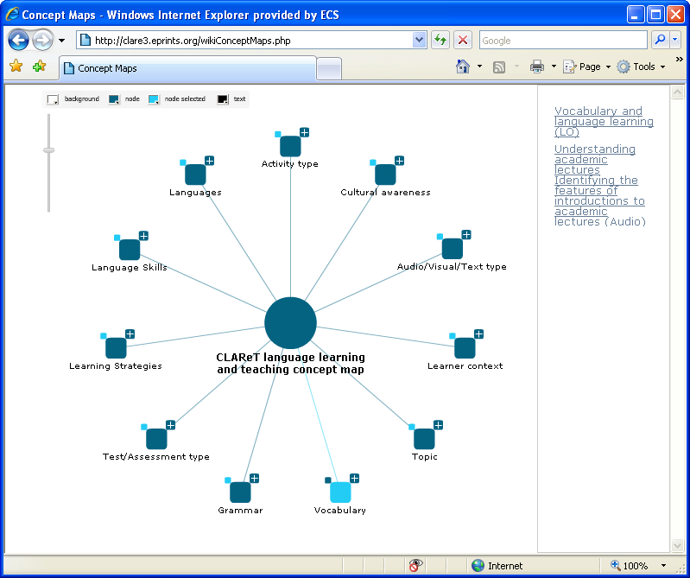

Figure 1: The CLAReT Repository

3.2. Service-Oriented Design

In light of our experience with CLAReT we turned to popular Web 2.0 sharing sites in order to try and analyse what it is that has made them successful. Why are people keen to upload their photos to Flickr, but not to upload handouts to a teaching repository?
We believe that the key to understanding the difference is to look at what services the sites offered their users. Research repositories succeed because the service they offer is one of Archiving, recording research outputs for posterity. The problem is that no one wants to archive their teaching resources. In comparison the popular Web 2.0 sites offer a different set of services, most prominent of which are:
- Hosting: storing digital content online, and making it public via a page with its own URL.
- Organisation: allowing the creation of composite structures (such as channels or albums), which are also available via a page with its own URL.
- Community: creating awareness of the site’s community, through comments, recommendations and explicit profiles that give users their own public page.
A key observation is that Sharing is not a key service; where sharing occurs it is through building community, or as a way to communicate (for example, putting photos online so that family and friends can access them). This means that these sites do not function because of altruism, but because they offer a tangible benefit to their users.

4. The Language Box

Our experiences with CLARe and CLAReT, and our observations about the key services offered by Web 2.0 sites has led us to our most recent repository. It is called the Language Box, and represents a radical rethink of teaching and learning repository design.

4.1. Requirements

We listed 3 key objectives based on the services of Hosting, Organisation and Community:

- Ability to preview online
- Ability to create public collections
- More prominent user presence through profiles

We also drew 6 objectives based on the need for simplicity and openness:

- Simple atomic resources (no content packaging)
- A minimum set of manual metadata
- A maximum set of automatic metadata
- No need to download (usable from a URL)
- Interlinked metadata (click on values to search)
- An open policy (default permissions are open)

4.2. Design

Our data model consists of three elements:
Resources are an atomic unit of teaching content such as a set of slides or a video. The resource has a simple set of metadata. There is no information about how the Resource should be used. This makes it easy to repurpose Resources without modifying them.
Activities encourage reuse. An Activity is a set of instructions or files that describe the use of a specific Resource or Collection. For example: “Watch the video and then answer these questions”. Resources can support multiple Activities, and while Resources can only be edited by their authors, anyone can annotate a Resource with their own Activity.
Collections are a means of organizing any number of Resources and Activities. Users can create collections containing both their own material and items uploaded by others.
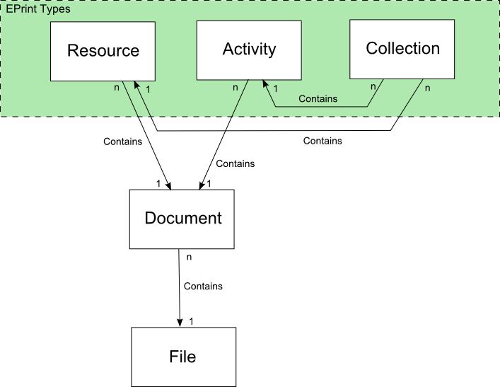

Figure 2: Language Box Data Model

Figure 2 shows an entity relation model of the elements, they are implemented as EPrints types and use the standard EPrints Document/File model. There are no rules governing what constitutes a Resource, Activity or Collection. Language Box submissions are unmediated to allow the Language Box community to develop their own practices and preferences about how to use them. For example, some users will choose to use collections to group resources for a specific class, while others may choose to group by topic.

4.3. Implementation

Language Box is built on the EPrints repository framework. This framework provides a flexible but mature foundation for development. The aim of the Language Box implementation was to support the key objectives by making people and resources, not metadata, the focus of the site.
Figure 3 shows a Language Box Resource, Profile and Management page.
Resource pages display metadata in a simple, clear way using hyperlinks where appropriate to connect users to other material they may be interested in. The primary focus is the PageFlow flash preview tool where users can see live previews of the Resource. The PageFlow allows users to watch videos, listen to music, display power point slides, word documents, PDF and images in one single control without having to explicitly download any files.
Once a user has used some of the Resources they may wish to register with the site in order to create content of their own. At this point the user is entering the community and they can create a profile page to tell other users in the community about themselves and how they have been using Language Box.

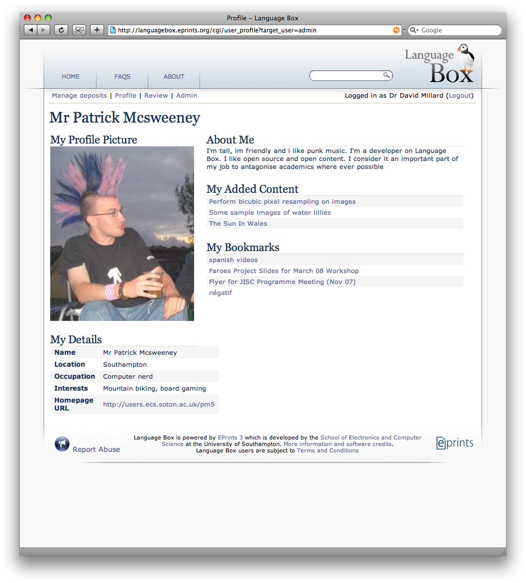
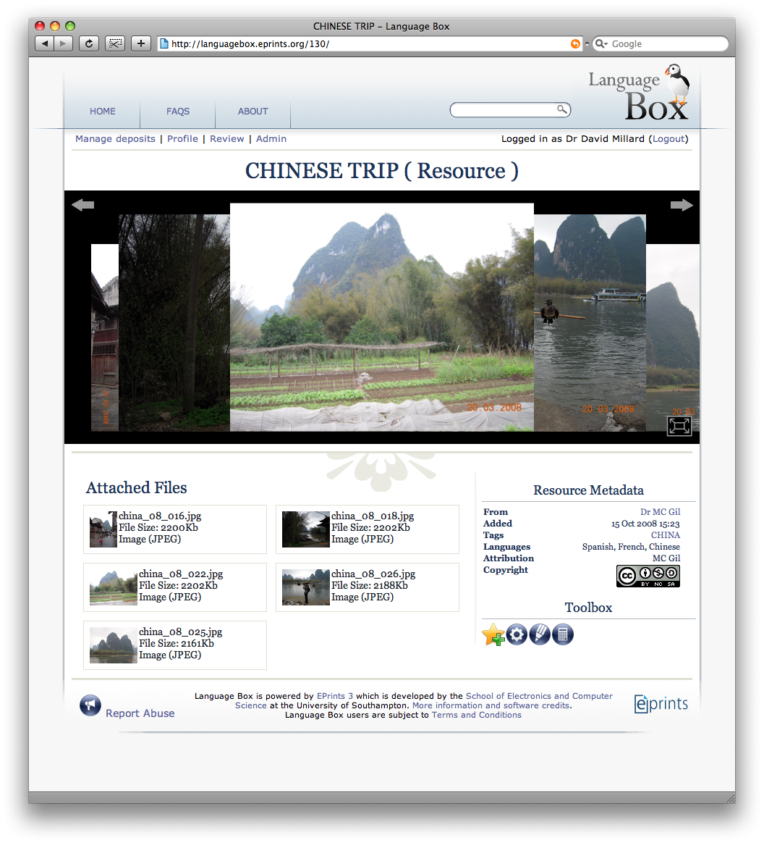

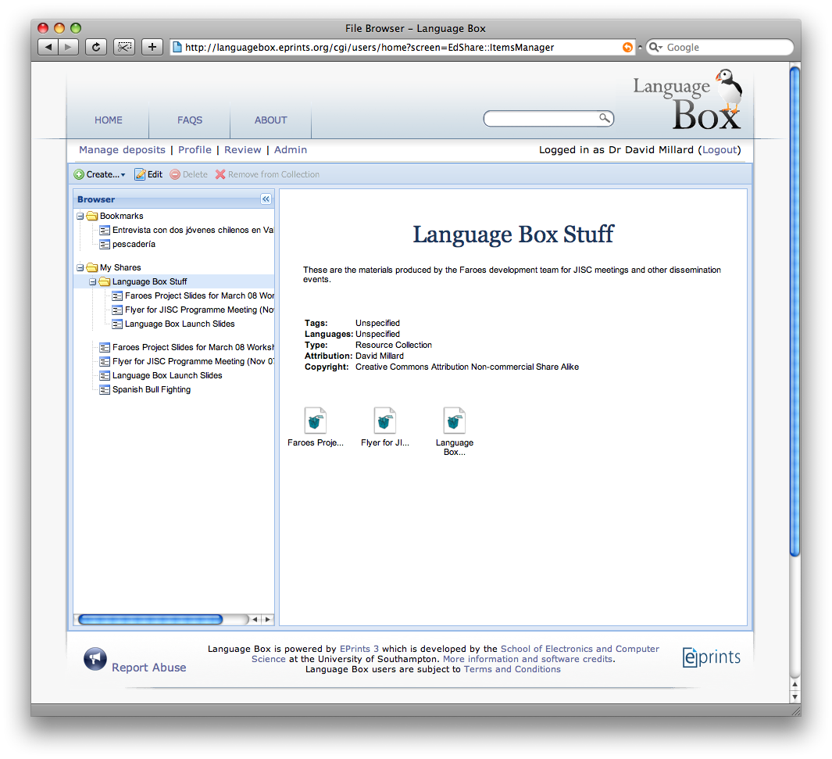

Figure 3: Language Box Resource Page (left), Profile Page (right), and Management Page (inset)

The deposit manager is where the user can manage their content. We chose a typical file-browser-style interface found on most operating systems. This gives the user a sense of their digital space and how their materials are structured, and allows them to use a drag and drop interface to manage their collections.

5. Community Reaction

5.1. Workshops and Qualitative Evaluation

A key part of our design approach was to hold workshops with the community right from the start of the project. At each workshop our fledgling users explored new Language Box features and discussed our concepts for the next stage; we tested their reactions and gathered feedback to direct our next steps. The workshops were set up to be practical, hands-on explorations, in this way users could feel that the Language Box was designed around the teaching and learning services that they needed.
The progression of the workshop content followed our ‘perpetual beta’ release cycle. At our first workshop we showed storyboards and technology mock-ups to focus discussions about potential features, as well as the look and feel.
Our first workshops also confirmed our focus on simplicity, in particular the reaction to metadata: ‘How much is too much?’ The answer from our users suggests that seven items is their limit, and of those seven the system should derive three. Our community is astute in their use of time: large amounts of metadata where too many decisions have to be made appeared to deter them from uploading resources into repositories. A large amount of metadata seemed to be about other people’s needs rather than their own.
At a later workshop, coinciding with the first beta release, users needed no encouragement and little support to start uploading the digital resources they had brought with them. This endorsed our approach to provide the simplest, most direct workflows.
Working in the co-design spirit, we captured feedback using post-it notes, which our users stuck on a whiteboard for general discussion. It was clear from this exercise that the in-line preview tool was extremely popular, however people were hesitant about profiles. We are waiting to see if, as community features are released and the personal benefits become more obvious, this reticence will diminish.
We also discovered that user’s attitudes towards copyright are changing (there is less worry than we saw with our earlier projects), but users were still concerned about their ability to confidently deal with questions of copyright and licensing both in relation to using existing digital resources created by others and their own resources in relation to their institution.

5.2. Issues and Challenges

The community reaction to the Language Box has been very positive, and we have received interest from a number of Higher Education institutions on installing their own local versions of the system. We believe that our approach has been a successful one, although it will take a few years to see if we have done enough to persuade ordinary teachers and lecturers to use the system in the course of their normal work. However, we have also noted some higher-level challenges to the take-up of teaching and learning repositories.
The first challenge is to address the issue of copyright. Our intention with the Language Box was to create an online haven of work licensed under Creative Commons. However teachers and lecturers are unsure whether their institutions allow them to release resources created through their jobs, and also unsure as to the copyright status of items in their own resources (such as pictures included in PowerPoint slides). In addition we have encountered a reluctance to release what are seen as valuable assets created at personal or institutional expense.
Current efforts in the UK to promote open content for teaching may change attitudes, but our experience is that practitioners are confused about copyright and genuinely concerned that they may be breaking the law when downloading or depositing content. Clear guidelines from institutions, and guarantees of support, are needed in order to fully overcome the problem.
The second challenge is concerned with integration with existing systems, in particular Virtual Learning Environments (VLE) such as Blackboard or Moodle. When we surveyed the language community, we found that 89% used the VLE as one way to deliver digital content to their students. Integration with the VLE has also been raised at our evaluation workshops, several people asked if it was possible for items in a VLE to be imported to an open repository, or if it would be possible to develop a simultaneous depositing process.
We believe that it is not sensible to replicate the functionality of the VLE in a repository; VLEs are about managing live courses, while repositories are about managing content during and between courses. In our view this relationship needs to be further explored, and tools developed to manage content between the systems with minimum user overhead.

6. Conclusion

Teaching and learning repositories offer a good way for the teaching community to collect and share their collective assets. However, existing approaches have been based around delivering an archiving service, which is appropriate for research papers, but not for teaching and learning materials.
In this paper we have proposed that it is time to rethink our approach to teaching and learning repositories, learning from successful Web 2.0 sharing sites like Flickr and YouTube – not by copying their user interface elements in a facile way, but by re-examining the core purpose and focus of the system.
As a result we have developed the Language Box, a new type of teaching and learning repository, based around three key services – hosting, organisation and community. It is our hope that our approach and experiences will inform others working to develop repositories in other domains.

7. Acknowledgements

The Language Box was produced as part of the JISC funded Faroes Project.

8. References

[1] Bratina T., Hayes D., and Blumsack S. 2002, "Preparing Teachers To Use Learning Objects" The Technology Source
[2] Busetti, E. Forcheri, P. Ierardi, M.G. Molfino, M.T. 2004, “Repositories of learning objects as learning environments for teachers”, IEEE International Conference on Advanced Learning Technologies, pg 450- 454 (2004)
[3] Downes S., 2001, “Learning Objects: Resources for distance education worldwide”, The International Review of Research in Open and Distance Learning, Vol 2, No 1
[4] Freisen N., 2004, “Three Objections to Learning Objects”, McGreal, R. (Ed.). Online Education Using Learning Objects. London: Routledge. Pg. 59-70.
[5] IEEE LTSC, 2003, "IEEE standard for learning technology-learning technology systems architecture (LTSA)," IEEE Std 1484.1-2003 , vol., no., pp. 0_1-97
[6] IEEE LOM, 2005 "The learning object metadata standard," IEEE, Tech. Rep.
[7] Morrison I., and Currie M., 2000, “What is a learning object, technically?”, Proceedings of WebNet.
[8] Neven, F. and Duval, E. 2002. “Reusable learning objects: a survey of LOM-based repositories”. In Proceedings of ACM Multimedia 02, pg 291-294.
[9] Polsani P., 2003 “Use and Abuse of Reusable Learning Objects”, Journal of Digital Information, Art’ 164, Vol 3 (4)

The Language Box is a repository for the language teaching community. It can be found at: http://languagebox.eprints.org
EPrints homepage: http://www.eprints.org/
In fact all the public resources in the Language Box are listed under either the CC-NASA or CC-NCSA license.

