A CONCEPTUAL MODEL FOR LEARNING OUTCOMES IN THE MOTOR SKILL DOMAIN

Yulita Hanum P Iskandar, Lester Gilbert, Gary B Wills
Learning Societies Lab
School of Electronics and Computer Sciences, University of Southampton
SO17 1BJ, Southampton, UK.
{yhpi07r, lg3, gbw}@ecs.soton.ac.uk

ABSTRACT
Instructional design usually begins with the specification of behavioural objectives or intended learning outcomes. The field of educational psychology has long been sensitive to the desirability of establishing learning objectives for instruction. Computer-processable learning objectives in the motor skill domain, however, seem to have remained the silent partner of objectives in both the cognitive and affective domains. This paper presents a conceptual model of learning objectives in the motor skill domain for the implementation of web-based training. The heart of this model is to treat athlete’s skill as a contextualized space of capability either actual or potential. Rowing is the sport chosen as a study source.

KEY WORDS
Web-based training, instructional design, intended learning outcomes, educational objectives, competency, motor skill domain.

1. Introduction

The central question addressed in this paper is the appropriate formal representation of learning outcomes in the motor skill domain so they can be interpreted and manipulated by computers as well as humans for the implementation of web-based training. This paper extends our previous work [1] which proposed a framework for pedagogical feedback in the motor skill domain.

Web-based training has been introduced into the sport domain and is used to record athletes’ performance whilst they interact with the system. Thus, web-based training in the sport domain serves as both a stimulus towards and a method for the study of choices that athletes make during athlete-controlled training opportunities.

The defining characteristics of web-based training tradition are: [2]
- the identification of clear learning outcomes in terms of the subject matter or skill to be mastered.
- the use of instructional methods which achieve the learning outcomes in a hierarchical ‘bottom-up’ development of the domain skill.

The development of web-based training in the sport domain has made it possible to augment and improve the feedback that athletes receive during training. Feedback systems incorporate embedded sensors and devices into the sports equipment and use sensors attached to the athlete to acquire information about learning processes and the achievement of intended outcomes. Through feedback, athletes recognize areas of deficiency in their knowledge and skills which they seek to remedy.

The remainder of the paper is structured as follows: Sections 2 and 3 review of some previous work in learning outcomes. Section 4 introduces the concept of competency and Section 5 expands on how the competency model can be used to model learning outcomes in the motor skill domain. Finally, Section 6 presents some conclusions and suggestions for future work.

2. Learning Outcomes and Instructional Design

Instructional designers and other educators point to behaviourism as the source for the practice of writing explicit objectives. Objectivist conceptions of instructional design include the analysis, representation and re-sequencing of content and tasks in order to make them more predictably and reliably transmittable. Behaviourism and cognitivism both support the practice of analyzing a task and breaking it down into manageable chunks, establishing objectives, and measuring performance based on those objectives [3, 4]. Cognitive science has broadened the concept of task analysis to include an analysis of the content itself. Such an analysis aims at determining the relationship between, and relative importance of, individual concepts within a body of subject matter content.

Advocates of the constructivist model of instructional design take the issue with the pre-definition of learning objectives. Their position is that objectives can only partially represent what we know, and therefore expressing them as the content of instruction might act to constrain what the learner will seek to learn. In constructivist learning environments, the student is often a participant in determining goals and directions for learning, which can be a somewhat fluid process. As the objectives evolve, the intention is that instruction is adapted for the learner until it meets his or her needs.

Bloom and colleagues [5] developed a taxonomy that is widely used to categorize types of learning outcomes for the cognitive domain. Their work has provided a common language for educators and has become the standard for identifying and classifying learning outcomes and activities [6]. They identified three domains relevant to educational outcomes [7]. These are the cognitive, knowledge of and ability to work with information and ideas; the affective, ability to organise, articulate, and live and work by a coherent value system; and the motor skills. Motor skills objectives fall into the general area of muscles development and coordination [8, 9]. Krathwohl [7] addressed the issues of affective objectives in education, and provided a hierarchy of kinds of capability in each of these domains that could be used as evidence of achievement. Anderson & Krathwohl revised the original Bloom taxonomy of the cognitive domain to incorporate new knowledge and thought since its introduction in 1956.

Performance objectives are defined as a precise statement of a capability that, if possessed by the learner, can be observed as a performance. Objectives guide the learner. The rationale is that students will use objectives to identify the skills and knowledge they must master [10].

Three principles of instruction identified by Gagné in the analysis of training tasks were (1) providing instruction on the set of component tasks that build toward the final task, (2) ensuring that each component task is mastered, and (3) sequencing the component tasks to ensure optimal transfer to the final task [11]. In his earlier work Gagné stressed that in order to achieve fully mastery of a skill a pupil should master each sub-skill in order up the hierarchy

In Component Display Theory (CDT), Merrill [12] proposes a means of determining the instructional strategy to use to support learning of an objective. CDT [12] provided a variant on Gagne’s taxonomy, where tasks were separated from content [13]. In CDT the four types of subject matter content (‘fact’, ‘concept’, ‘procedure’, and ‘principle’) are distinguished from three levels of performance (‘finding’, operationally equivalent to Bloom’s ‘synthesis’; ‘using’, equivalent to ‘evaluation’, ‘analysis’, ‘application’, and ‘comprehension’; and ‘remembering’, equivalent to ‘recall’). Given a particular combination of content and performance, CDT provides a set of prescriptions for an appropriate instructional strategy [14].

Two particular instructional design models seem to have a direct value and easy application for teaching motor skills [15]. Mastery learning [16] is based on the premise that learners must acquire skills in incremental, sequential progression, with pre-requisite skills being learned (mastered) prior to attempting more difficult and complex tasks. In such an approach, time is allowed to vary. That is, teachers do not hold the amount of content stable, but allow individual learners their own needed time to acquire skills. Keller developed his Personalized System for Instruction [15] at the same time. It is based on mastery learning principles in that students progress through a syllabus only after acquiring pre-requisite skills.

3. Current Learning outcomes in the Motor Skill Domain

The analysis and training of motor skills seems to be somewhat divorced from the mainstream of educational research and development [17-19]. Bloom and his research team [7] did not complete detailed work in the motor skill domain as they claimed lack of experience in teaching these skills.

Several taxonomies of learning objectives exist in the literature [20-22] for the Psychomotor Domain. Three of these are presented in Figure 1. Despite apparent neglect, however, several fruitful lines of research and instructional models for the development of psychomotor exist in the literature. In general, these various taxonomies describe a progression from simple observation to mastery of physical skills.

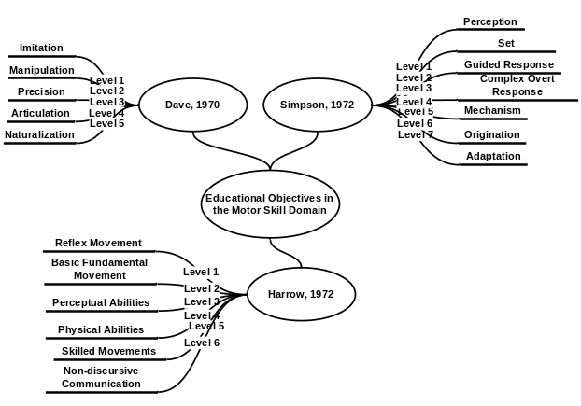
Figure 1: Categorization of Learning Outcomes in the Motor Skill Domain

Although no taxonomy is universally accepted for this domain, Dave’s taxonomy, based on the degree of coordination that is applicable to many sport applications [10], is adopted in this paper.

4. Competency Model

Competency can be defined as a measurable skill in reference to a given context. A competency model supports the storing, organizing and sharing of learners’ performance data in order to seek and interpret evidence for where the learners are in their learning, where they want to go, and how they can get there [23]. A development of current ideas surrounding competencies suggests a conceptual model of ILOs augmented by contextual factors, as illustrated in Figure 2. Such augmented ILOs are competency in this paper. While an ILO may be reasonably constrained by an agreed ontology of capability terms (e.g. Dave’s taxonomy) and an agreed subject matter topics list, context is in principle limitless and dependent upon particulars (if not peculiarities) of the target students, teachers, locations, times, tools, required mastery levels, available services, etc [24]. This model focuses on the representation of competency as a rich data structure.

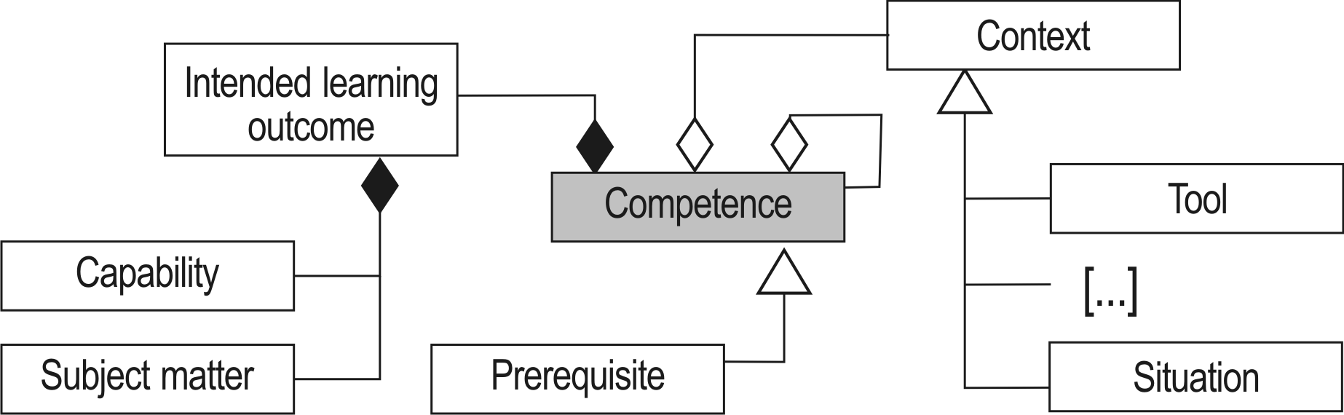
Figure 2: A Conceptual Model of Competency [25]

5. Implementing the Competency Model in the Design of Learning Outcomes

Motor skills can be conceptualised as components of procedures, involving choices between alternative movements, sequences of movements, and iterations of sequences. Motor skills can usually be divided into a series of steps or separate skills that constitute the total performance, occurring either simultaneously or in a temporal order. Learning to integrate skills that were previously learned separately has been recognized by researchers as a highly significant aspect of the total learning required [26].

To develop a conceptual model of educational objectives, a learning task must be broken down through analysis into specific measurable tasks. In teaching any new behaviour, a closer approximation to the goal should not be reinforced until the previous one has been firmly established. If too large a gap between previously learned skills and currently expected skills is presented to the learner, their behaviour may break down and training may have to resume at the point where the learner has repeatedly demonstrated success. An example of a rowing procedure task analysis is depicted in Figure 4. The task analysis is based upon a knowledge representation model and can be directly represented using an XML schema.

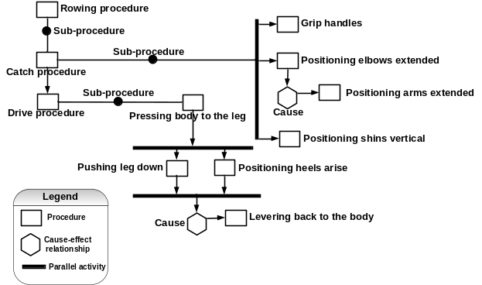
Figure 4: Task analysis of rowing procedure

We adopt Dave’s taxonomy to represent the capability ontology (Table 2).

Level | Capability | Capability Verb | Description
1 | Imitation | Copy | Observing and patterning behaviour after someone else. Performance may be of low quality.
2 | Manipulation | Perform | Performing certain actions by following instructions and practicing.
3 | Precision | Demonstrate | Perform a skill or movement sequence independently and emphasis on accuracy, proportion, and exactness.
4 | Articulation | Articulate | Combine more than one skill in sequence with harmony and consistency.
5 | Naturalization | Perform automatically | Having high level performance become natural, without needing to think much about it.
Table: 2: Dave’s taxonomy

A learning outcome in the motor skill domain is conceptualised as comprising two components: a statement of a capability, and a statement of the subject matter to which the capability applies. Figure 3 and Table 3 represents some rowing learning outcomes based on the competency model.

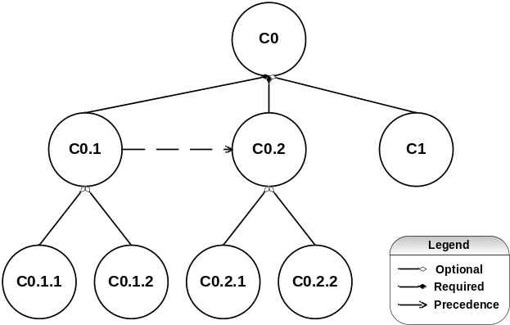
Figure 3: Conceptual Model of Learning outcomes in the Motor Skill Domain

Competency No | Capability | Subject Matter
C0 | Perform automatically | Rowing
C1 | Articulate | Rowing
C0.1 | Perform automatically | Catch
C0.1.1 | Perform automatically | Grip handles
C0.1.2 | Perform automatically | Positioning shins
C0.2 | Perform automatically | Drive
C0.2.1 | Perform automatically | Pushing leg down
C0.2.2 | Perform automatically | Pressing body to the leg
Table 3: Some example rowing competencies represented in the competency model

The proposed learning outcomes describe a statement of a capability, and a statement of the subject matter to which the capability applies. These descriptions represent what the learner is able to do and whose achievement is capable of verification when learning has been accomplished.

The simplest competency structure consists of a pair of procedural skills, one subordinate to the other. The competency structure describes what the learner must be able to do before something else can be learned. The learning relation is identified by the following sentence: “A learner must be able to do ’X’ in order to be able to do ’Y’”. For example, in order to achieve C0 (athletes are able to perform automatically rowing), it is strongly required for the athletes to achieve C0.1 (athletes are able to perform automatically catch), C0.2 (athletes are able to perform automatically drive), and C1 (athletes are able to articulate rowing). In order to achieve C0.1 (athletes are able to perform automatically catch), athletes should be able to demonstrate either C0.1.1 (athletes are able to perform automatically grip handles) or C0.1.2 (athletes are able to perform automatically positioning shins). The achievement of C0.1 (athletes are able to perform automatically catch) proceed to C0.2 (athletes are able to perform automatically drive). This shows that we can map effectively these more complicated learning outcomes using the competency model
The theoretically predicted consequence of a subordinate skill that has been previously mastered is that it will facilitate the learning of the higher level skill to which it is related. The superordinate competency will be more readily learned if the subordinate competency have been previously acquired and are readily available for recall. In contrast, if the subordinate skill has not been previously mastered, there will be no facilitation of the higher level skill. Each subordinate competency has been identified as such because it is known to contribute positive transfer to the learning or the superordinate competency.

A competency structure depicts these pre-requisites in an ordered hierarchical relationship. The lowest skills on the structure will be learned before the higher-ranking ones, up to the highest level objective. The lower-level skills are pre-requisite to the higher level skills. The structure represents what is expected to be a general pattern to be followed by the student: making sure that relevant lower-order skills are mastered before the learning of the related higher-order skill. Competency analysis is often referred to as pre-requisites analysis, and can be used to diagnose failures in learning by identifying the pre-requisites that learners failed to master.

6. Conclusion

In this paper, we propose a conceptual approach to the structuring of learning outcomes for the implementation of web-based training. The design of learning outcomes is based on Gagné’s Learning Hierarchies by [27] and Merrill’s Performance Content Matrix [28].

We provide a machine-processable representation of learning outcomes, and statements of competency that are machine-readable. Machine processing can offer interoperable and reusable resources and applications that are pedagogically effective for e-training. A competency statement which can be read, processed, and interpreted by machine contributes to the automatic generation of feedback, and offers a semantic structure for further processing.

The semantic, conceptual model of learning outcomes in the motor skill domain has been expressed as a series of UML models, from which several bindings may be generated automatically. For the conceptual model of learning outcomes, a XML schema can be derived that keeps the semantics in the tag-names. However other bindings (RDF Schema/OWL, Topic Maps, SGML schema's, relational database schemas) could in principle is generated as well.

Besides a machine processable representation, a further major advantage of conceptual model is that it allows determining a person’s current competency level by personalized, adaptive competency testing; furthermore individual learning paths can be defined on the competency level. The result of the conceptual model of learning outcomes in the motor skill domain partitions the athlete’s skill state into:
- where to start
- what’s next
- what does the athlete need to do
- what does the athlete need to know, and
- where is the athlete currently positioned in the structure?

The core deliverables of the research will be a simulator demonstrating the delivery of effective feedback, and of effective engineering and pedagogic processes for motor skill competency development. Future work includes implementing a prototype of the conceptual. The system will map competency in generating a gap analysis of an athlete's performances. This involves assessment of current competency and a comparison of competency. We believe the proposed approach assists athletes in finding a starting point and an efficient route through the structure that will foster competency building.

References

