Analysis for Library members
Federico De Luca. Postgraduate Researcher, Faculty of Social and Human Sciences, University of Southampton

Descriptive Analysis
* Time of questionnaire completion.
N | Valid | 22
 | Missing | 0
Mean |  | 1029.59
Median |  | 965.00
Std. Deviation |  | 617.874
Minimum |  | 258
Maximum |  | 2497
The questionnaire took an average of almost 17 minutes (17:09) to be completed, with a minimum of 4:18 and a maximum of 41:37.
* Generate an overall index of confidence for "Planning data management".
N | Valid | 22
 | Missing | 0
Mean |  | 11.2273
Std. Error of Mean |  | 1.95394
Median |  | 10.0000
Std. Deviation |  | 9.16480
Minimum |  | .00
Maximum |  | 29.00
Percentiles | 25 | 3.0000
 | 50 | 10.0000
 | 75 | 18.0000
The index was built in order to go from 0 (minimum confidence) to 36 (maximum confidence) with a mean value of 18. More than 75% of respondents had a confidence of 18 or less, and the overall mean was only slightly higher than 11, thus implying that the confidence of the respondents over the items that define “Planning data management” is quite low. Moreover, the bottom 25% of respondents have an incredibly low confidence in these items (<=3).
The same conclusions can be drawn watching the graph reported in the following page, even if it emerges how there is a small group of respondents who are much more confident than the rest.
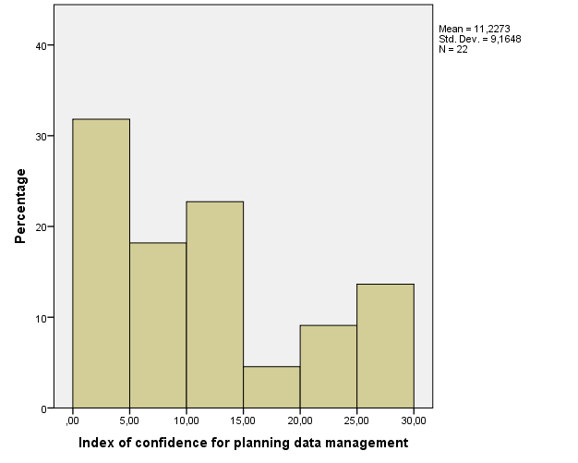

* Descriptive statistics of each component regarding Planning data management
 |  | PDM-S1.Q1.1 | PDM-S1.Q1.2 | PDM-S1.Q1.3 | PDM-S1.Q1.4 | PDM-S1.Q1.5 | PDM-S1.Q1.6
N | Valid | 22 | 22 | 22 | 22 | 22 | 22
 | Missing | 0 | 0 | 0 | 0 | 0 | 0
Mean |  | 3.05 | 2.82 | 2.86 | 3.14 | 3.14 | 2.23
Median |  | 3.00 | 2.00 | 2.50 | 3.00 | 3.00 | 1.50
Std. Deviation |  | 1.812 | 1.842 | 1.612 | 1.885 | 1.807 | 1.660
Minimum |  | 1 | 1 | 1 | 1 | 1 | 1
Maximum |  | 6 | 6 | 6 | 6 | 6 | 6
Percentiles | 25 | 1.75 | 1.00 | 1.00 | 1.75 | 1.00 | 1.00
 | 50 | 3.00 | 2.00 | 3.00 | 2.50 | 3.00 | 1.50
 | 75 | 5.00 | 4.25 | 5.00 | 4.00 | 5.00 | 3.25

* Generate an overall index of confidence for "Data Management during the research process".
N | Valid | 22
 | Missing | 0
Mean |  | 7.7273
Std. Error of Mean |  | 1.17915
Median |  | 6.0000
Std. Deviation |  | 5.53071
Minimum |  | .00
Maximum |  | 19.00
Percentiles | 25 | 4.0000
 | 50 | 6.0000
 | 75 | 11.2500
The index was built in order to go from 0 (minimum confidence) to 24 (maximum confidence) with a mean value of 12. More than 75% of respondents had a confidence of 11.25 or less, and the overall mean was only slightly lower than 8, thus implying that the confidence of the respondents over the items that define “Data Management during the research process” is quite low. Moreover, the bottom 25% of respondents have an incredibly low confidence in these items (<=4).
The same conclusions can be drawn watching the graph reported below.
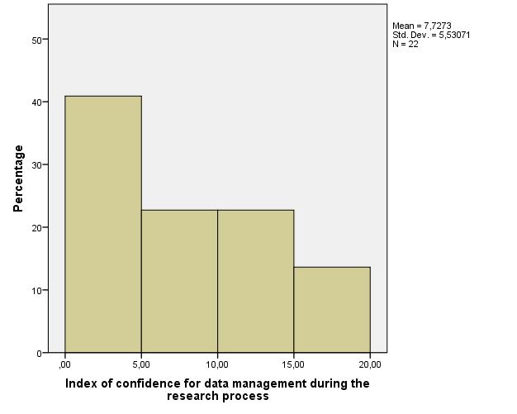
* Descriptive statistics of each component regarding Data Management during the research process.
 |  | DMRP-S1.Q2.1 | DMRP-S1.Q2.2 | DMRP-S1.Q2.3 | DMRP-S1.Q2.4
N | Valid | 22 | 22 | 22 | 22
 | Missing | 0 | 0 | 0 | 0
Mean |  | 2.55 | 2.73 | 3.27 | 3.18
Median |  | 2.00 | 3.00 | 3.00 | 3.00
Std. Deviation |  | 1.792 | 1.638 | 1.453 | 1.468
Minimum |  | 1 | 1 | 1 | 1
Maximum |  | 6 | 6 | 6 | 6
Percentiles | 25 | 1.00 | 1.00 | 2.00 | 2.00
 | 50 | 2.00 | 3.00 | 3.00 | 3.00
 | 75 | 4.00 | 4.00 | 4.00 | 4.00

* Generate an overall index of confidence for "Post Research Data Management".
N | Valid | 21
 | Missing | 1
Mean |  | 7.8095
Std. Error of Mean |  | 1.56086
Median |  | 5.0000
Std. Deviation |  | 7.15276
Minimum |  | .00
Maximum |  | 20.00
Percentiles | 25 | 1.5000
 | 50 | 5.0000
 | 75 | 16.0000
The index was built in order to go from 0 (minimum confidence) to 30 (maximum confidence) with a mean value of 15. More than 75% of respondents had a confidence of 16 or less, and the overall mean was only slightly lower than 8, thus implying that the confidence of the respondents over the items that define “Post Research Data Management” is slightly low. Moreover, the bottom 25% of respondents have an incredibly low confidence in these items (<=1.5). However, there also are about 30% of respondents who have a confidence of 15 or higher. a data which is encouraging.
The same conclusions can be drawn watching the graph reported in the following page.
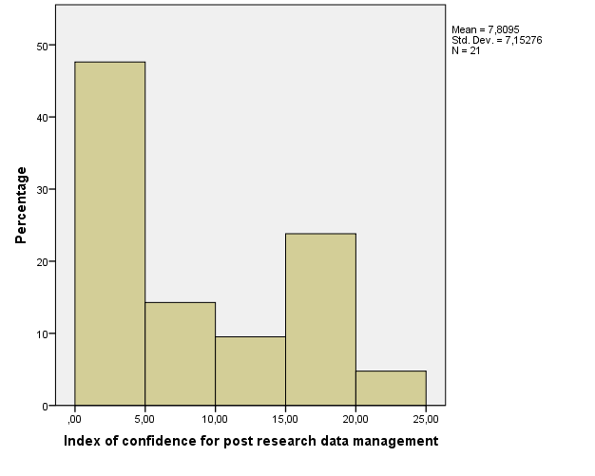
* Descriptive statistics of each component regarding Data Management during the research process.
 |  | PRDM-S1.Q3.1 | PRDM-S1.Q3.2 | PRDM-S1.Q3.3 | PRDM-S1.Q3.4 | PRDM-S1.Q3.5
N | Valid | 22 | 22 | 22 | 22 | 21
 | Missing | 0 | 0 | 0 | 0 | 1
Mean |  | 2.86 | 2.32 | 2.45 | 1.95 | 2.95
Median |  | 3.00 | 1.50 | 2.00 | 1.00 | 2.00
Std. Deviation |  | 1.754 | 1.756 | 1.405 | 1.397 | 1.774
Minimum |  | 1 | 1 | 1 | 1 | 1
Maximum |  | 6 | 6 | 5 | 5 | 6
Percentiles | 25 | 1.00 | 1.00 | 1.00 | 1.00 | 1.00
 | 50 | 3.00 | 1.50 | 1.00 | 2.00 | 2.00
 | 75 | 5.00 | 3.25 | 3.00 | 4.00 | 4.50

* Generate an overall index of confidence for "Directing researchers to the right person: Planning data management".
N | Valid | 22
 | Missing | 0
Mean |  | 3.6939
Std. Error of Mean |  | .39791
Median |  | 3.4167
Std. Deviation |  | 1.86637
Minimum |  | 1.00
Maximum |  | 7.00
Percentiles | 25 | 2.1375
 | 50 | 3.4167
 | 75 | 5.3750

The index was built in order to go from 1 (minimum confidence) to 7 (maximum confidence) with a mean value of 4. The overall mean was only slightly lower than 4, implying that the confidence of the respondents over the items that define “Directing researchers to the right person: Planning data management” is average.
The same conclusions can be drawn watching the graph reported below. Moreover, it can be seen that there are two big groups of respondents: fairly confident and extremely unconfident.
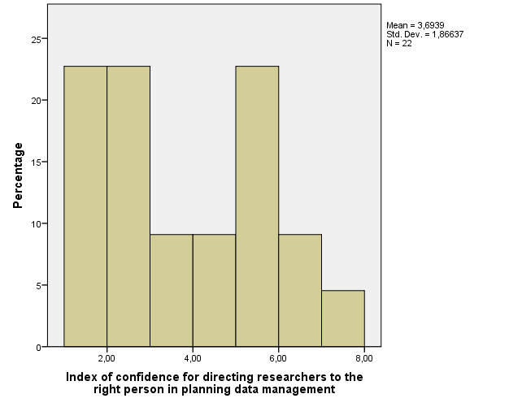
* Descriptive statistics of each component regarding Directing researchers to the right person in planning data management.
 |  | PDM-S2.Q1.1 | PDM-S2.Q1.2 | PDM-S2.Q1.3 | PDM-S2.Q1.4 | PDM-S2.Q1.5 | PDM-S2.Q1.6
N | Valid | 19 | 19 | 22 | 22 | 18 | 20
 | Missing | 3 | 3 | 0 | 0 | 4 | 2
Mean |  | 3.6316 | 3.5789 | 4.0000 | 3.4545 | 4.1667 | 3.7500
Median |  | 4.0000 | 4.0000 | 5.0000 | 3.0000 | 5.0000 | 3.5000
Std. Deviation |  | 1.92095 | 1.89490 | 2.09307 | 1.99350 | 2.17607 | 2.46822
Minimum |  | 1.00 | 1.00 | 1.00 | 1.00 | 1.00 | 1.00
Maximum |  | 7.00 | 7.00 | 7.00 | 7.00 | 7.00 | 7.00
Percentiles | 25 | 2.0000 | 2.0000 | 2.0000 | 1.7500 | 2.0000 | 1.0000
 | 50 | 4.0000 | 4.0000 | 5.0000 | 3.0000 | 5.0000 | 3.5000
 | 75 | 5.0000 | 5.0000 | 5.2500 | 5.0000 | 6.0000 | 6.0000
* Descriptive statistics of how many people replied that a single item identified their role.
 |  | PDM-S2.Q1.1 | PDM-S2.Q1.2 | PDM-S2.Q1.3 | PDM-S2.Q1.4 | PDM-S2.Q1.5 | PDM-S2.Q1.6
N | Valid | 22 | 22 | 22 | 22 | 21 | 22
 | Missing | 0 | 0 | 0 | 0 | 1 | 0
Mean |  | .1364 | .1364 | .0000 | .0000 | .1429 | .0909
More than 10% of respondents identified as their role items 1, 2 and 5. None of the respondents identified themselves in items 2 and 3.
FREQUENCIES VARIABLES=myrole1
N | Valid | 22
 | Missing | 0
Mean |  | .5000
Median |  | .0000
Minimum |  | .00
Maximum |  | 4.00

* Descriptive statistics of areas respondents should be aware of in Planning data management.
 |  | PDM-S2.Q2.1 | PDM-S2.Q2.2 | PDM-S2.Q2.3 | PDM-S2.Q2.4 | PDM-S2.Q2.5 | PDM-S2.Q2.6
N | Valid | 22 | 22 | 22 | 22 | 22 | 22
 | Missing | 0 | 0 | 0 | 0 | 0 | 0
Mean |  | .68 | .59 | .82 | .68 | .68 | .55
Sum |  | 15 | 13 | 18 | 15 | 15 | 12
More than 60% of respondents believe they should be aware of items 1. 3. 4. and 5.

* Generate an overall index of confidence for "Directing researchers to the right person: Data management during the research process".
N | Valid | 22
 | Missing | 0
Mean |  | 3.8068
Std. Error of Mean |  | .36668
Median |  | 3.5000
Std. Deviation |  | 1.71986
Minimum |  | 1.50
Maximum |  | 6.75
Percentiles | 25 | 2.0000
 | 50 | 3.5000
 | 75 | 5.5000
The index was built in order to go from 1 (minimum confidence) to 7 (maximum confidence) with a mean value of 4. The overall mean was only slightly lower than 4, implying that the confidence of the respondents over the items that define “Directing researchers to the right person: Data management during the research process” is average. However, the bottom 25% of respondents have an extremely low confidence in these items (<=2).
The same conclusions can be drawn watching the graph reported below. Moreover, it can be seen that there are basically two different types of respondents: fairly confident and unconfident.
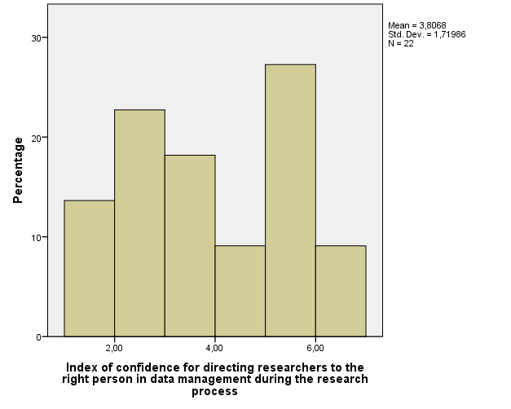
* Descriptive statistics of each component regarding Directing researchers to the right person in data management during the research process.
 |  | DMRP-S2.Q3.1 | DMRP-S2.Q3.2 | DMRP-S2.Q3.3 | DMRP-S2.Q3.4
N | Valid | 22 | 22 | 19 | 19
 | Missing | 0 | 0 | 3 | 3
Mean |  | 3.6364 | 3.4091 | 4.1053 | 4.0000
Median |  | 4.0000 | 3.0000 | 4.0000 | 4.0000
Std. Deviation |  | 2.12794 | 2.15272 | 1.59495 | 1.73205
Minimum |  | 1.00 | 1.00 | 2.00 | 1.00
Maximum |  | 7.00 | 7.00 | 7.00 | 7.00
Percentiles | 25 | 1.7500 | 1.0000 | 3.0000 | 3.0000
 | 50 | 4.0000 | 3.0000 | 4.0000 | 4.0000
 | 75 | 6.0000 | 6.0000 | 5.0000 | 5.0000
* Descriptive statistics of how many people replied that a single item identified their role.
 |  | DMRP-S2.Q3.1 | DMRP-S2.Q3.2 | DMRP-S2.Q3.3 | DMRP-S2.Q3.4
N | Valid | 22 | 22 | 22 | 22
 | Missing | 0 | 0 | 0 | 0
Mean |  | .0000 | .0000 | .1364 | .1364
More than 10% of respondents identified as their role items 3 and 4. None of the respondents identified themselves in items 1 and 2.

FREQUENCIES VARIABLES=myrole2
N | Valid | 22
 | Missing | 0
Mean |  | .2727
Median |  | .0000
Minimum |  | .00
Maximum |  | 2.00

* Descriptive statistics of areas respondents should be aware of in Planning data management.
 |  | DMRP-S2.Q4.1 | DMRP-S2.Q4.2 | DMRP-S2.Q4.3 | DMRP-S2.Q4.4
N | Valid | 22 | 22 | 22 | 22
 | Missing | 0 | 0 | 0 | 0
Mean |  | .50 | .59 | .73 | .68
Sum |  | 11 | 13 | 16 | 15
More than 60% of respondents believe they should be aware of items 3 and 4.

* Generate an overall index of confidence for "Directing researchers to the right person: Post research data management".
N | Valid | 22
 | Missing | 0
Mean |  | 3.0523
Std. Error of Mean |  | .39990
Median |  | 2.5000
Std. Deviation |  | 1.87569
Minimum |  | 1.00
Maximum |  | 7.00
Percentiles | 25 | 1.4000
 | 50 | 2.5000
 | 75 | 4.8500
The index was built in order to go from 1 (minimum confidence) to 7 (maximum confidence) with a mean value of 4. The overall mean was only about 3, implying that the confidence of the respondents over the items that define “Directing researchers to the right person: Post research data management” is slightly low. However, the bottom 25% of respondents have an extremely low confidence in these items (<=1.4).
The same conclusions can be drawn watching the graph reported below.
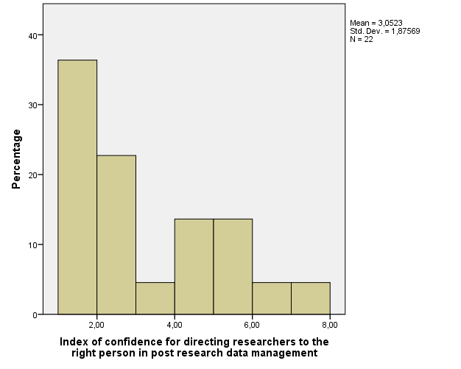
* Descriptive statistics of each component regarding Directing researchers to the right person in post research data management.
 |  | DMRP-S2.Q5.1 | DMRP-S2.Q5.2 | DMRP-S2.Q5.3 | DMRP-S2.Q5.4 | DMRP-S2.Q5.5
N | Valid | 20 | 21 | 21 | 22 | 20
 | Missing | 2 | 1 | 1 | 0 | 2
Mean |  | 3.0000 | 3.2857 | 3.2381 | 2.5909 | 3.4500
Median |  | 2.5000 | 3.0000 | 3.0000 | 2.0000 | 3.0000
Std. Deviation |  | 1.97351 | 2.12468 | 1.94691 | 1.81683 | 2.06410
Minimum |  | 1.00 | 1.00 | 1.00 | 1.00 | 1.00
Maximum |  | 7.00 | 7.00 | 7.00 | 7.00 | 7.00
Percentiles | 25 | 1.0000 | 1.0000 | 1.5000 | 1.0000 | 2.0000
 | 50 | 2.5000 | 3.0000 | 3.0000 | 2.0000 | 3.0000
 | 75 | 4.7500 | 5.0000 | 5.0000 | 4.0000 | 5.0000

* Descriptive statistics of how many people replied that a single item identified their role.
 |  | DMRP-S2.Q5.1 | DMRP-S2.Q5.2 | DMRP-S2.Q5.3 | DMRP-S2.Q5.4 | DMRP-S2.Q5.5
N | Valid | 22 | 21 | 22 | 22 | 22
 | Missing | 0 | 1 | 0 | 0 | 0
Mean |  | .0909 | .0000 | .0455 | .0000 | .0909
Most of respondents did not identify themselves in any of these items. None of the respondents identified themselves in items 2 and 4.

FREQUENCIES VARIABLES=myrole3
N | Valid | 22
 | Missing | 0
Mean |  | .2273
Median |  | .0000
Minimum |  | .00
Maximum |  | 3.00

* Descriptive statistics of areas respondents should be aware of in Planning data management.
 |  | PRDM-S2.Q6.1 | PRDM-S2.Q6.2 | PRDM-S2.Q6.3 | PRDM-S2.Q6.4 | PRDM-S2.Q6.5
N | Valid | 22 | 22 | 22 | 22 | 22
 | Missing | 0 | 0 | 0 | 0 | 0
Mean |  | .77 | .64 | .77 | .45 | .64
Sum |  | 17 | 14 | 17 | 10 | 14
More than 70% of respondents believe they should be aware of items 1 and 3.

String Analysis

String analysis variable S2.FG.
* Descriptive statistics of the questionnaire's final section.
AY-S3.Q1
Unit to which respondent belongs |  | Frequency | Percent | Valid Percent | Cumulative Percent
Valid | Library | 22 | 100.0 | 100.0 | 100.0

String analysis variable AYS3.Q2.
Involved in carrying out research as a researcher
 |  | Frequency | Percent | Valid Percent | Cumulative Percent
Valid | No | 15 | 68.2 | 68.2 | 68.2
 | Yes | 7 | 31.8 | 31.8 | 100.0
 | Total | 22 | 100.0 | 100.0

Involved in carrying out research as part of an advanced postgraduate research degree
 |  | Frequency | Percent | Valid Percent | Cumulative Percent
Valid | No | 21 | 95.5 | 95.5 | 95.5
 | Yes | 1 | 4.5 | 4.5 | 100.0
 | Total | 22 | 100.0 | 100.0
Was never involved in carrying out research
 |  | Frequency | Percent | Valid Percent | Cumulative Percent
Valid | No | 8 | 36.4 | 36.4 | 36.4
 | Yes | 14 | 63.6 | 63.6 | 100.0
 | Total | 22 | 100.0 | 100.0

Asked for help related to research data management in the last 6 months
 |  | Frequency | Percent | Valid Percent | Cumulative Percent
Valid | No | 16 | 72.7 | 72.7 | 72.7
 | Yes between 2-5 times | 1 | 4.5 | 4.5 | 77.3
 | Yes more than 5 times | 2 | 9.1 | 9.1 | 86.4
 | Yes once only | 3 | 13.6 | 13.6 | 100.0
 | Total | 22 | 100.0 | 100.0

String analysis variable AYS3.Q4.1a.
Most essential area of training
 |  | Frequency | Percent | Valid Percent
Valid | Data Management Plans | 5 | 22.7 | 22.7
 | Describing your data | 6 | 27.3 | 27.3
 | Funder requirements for research data | 1 | 4.5 | 4.5
 | Legal issues and research data | 3 | 13.6 | 13.6
 | Making data available for re-use | 2 | 9.1 | 9.1
 | Other please specify | 1 | 4.5 | 4.5
 | Security and storage of data | 4 | 18.2 | 18.2
 | Total | 22 | 100.0 | 100.0

