Investigation and Improvement of the Dispenser Printing of Electrical Interconnections for Smart Fabric Applications
Z. Ahmed, R.Torah, K. Yang, S. Beeby, J.Tudor

Abstract
Electrical interconnections are essential for the integration of electronic functions in a fabric. These interconnects can be dispenser printed on a fabric; however printing directly on a breathable woven fabric surface is challenging due to the high surface variation and porosity defined by the weave. This paper, for the first time, experimentally shows that fabric surface variation leads to inconsistent printed structures which adversely affects the electrical properties of printed conductive tracks.
It investigates a solution of overcoming the fabric surface variation in the form of dispenser printing an interface layer between the conductive ink and the fabric surface. Four dielectric inks DuPont 5018, Electra EFV4/4965, Fabinks-UV-IF-1004 and Fabinks-UV-TC0233 are quantitatively evaluated, as interface materials, in terms of surface consistency, thickness consistency, repeatability, flexibility, thermal stability and the electrical characteristics of conductive tracks printed on them.
All four of the evaluated interface materials significantly reduced the fabric surface variation by more than 95% and provided a suitable low variation surface for printing subsequent electronic layers. Conductive tracks, dispenser printed on the four interface materials, produced ̴90% lower electrical resistivity compared to tracks printed directly on the fabric and similar resistivity to dispenser printed tracks on Kapton, a traditional printed electronic substrate. An increased focus on low powered electronics especially for wearables requires the electrical interconnections to dissipate minimum power. The innovative interface layer approach allows fabrication of low resistance electrical interconnections on fabric substrates reducing interconnect power dissipation, making this approach highly suitable for smart fabric applications.
Reported details of dispenser printing of interface materials can be used for replicating these results on a range of fabric substrates. The paper also reports a novel thermal imaging based method of analysing resistance distribution within a printed conductive track to assess the geometrical consistency of printed electrical interconnections.

1 Introduction
Fabrics find applications in many distinct areas which makes them an appealing medium for wearable computing. The drive to ubiquitously integrate electronics in everyday life through fabrics has led to an increased focus on the research and development of smart fabrics. Smart fabrics are able to sense and react to the various stimuli in their environment []. They also have added functionality such as interactive and computing capabilities. Smart fabrics have a wide range of applications in diverse sectors such as healthcare, sports and wellness, fashion, defence and automotive []. Examples of smart fabrics include those from the ProeTEX project [], the Klight dress [] and the intelligent carpet []. Electrical interconnections are fundamental to any electronic functionality in a smart fabric device. These interconnections are essential to incorporate power transfer, data transfer and communication functions.
Printing is a widely used process in the textile and electronics industry. It is used for adding passive coloured patterns to fabrics and conductive tracks to printed electronic devices. It can also be used for fabricating conductive tracks on fabrics to form electrical interconnections. Traditional printed electronic substrates such as Kapton and FR4 present a smooth and low porosity surface where an ink can be uniformly deposited. Comparatively, printing on fabrics is more challenging as fabrics generally have significantly higher surface variation. Breathable fabrics such as polyester cotton and cotton, in addition to high surface variation, can have a loose structure and high surface porosity which causes ink deposits to form inconsistent printed structures which can adversely affect the electrical properties of printed electronic layers.
Karaguzel et al [] used thermoplastic urethane lamination as a method of overcoming fabric surface variation. Lamination completely covers a fabric surface reducing the breathability and flexibility of the fabric and adds to the number of processes required for producing electrical interconnections. A fabric can be selectively laminated by cutting individual pieces of laminating material and applying it; however it is difficult to align individual pieces in a pattern and this method is less suitable for mass production. A screen printed polyurethane based ink (Fabinks-IF-UV-1004) developed at the University of Southampton has been used previously as an interface between a fabric surface and conductive tracks. The interface layer reduced variation within fabric surface for printing of conductive tracks [,]. The interface ink can be selectively printed in a specific pattern however each design requires a specific screen which limits design freedom. In addition to being design specific, screens are also material and layer specific and therefore two different screens would be required to print the interface and the subsequent electronic layer. Suh et al [] coated fabric surfaces with polyurethane, silicone and acrylic resin using brushing to improve surface quality for printed antennas. Brushing as a coating method offers limited control of the coating pattern and the amount of a material coated on a surface. Our previous work [] reported the optimisation process of dispenser printed Fabink-IF-UV-1004 interface ink. It was shown that the fabric surface variation can be improved by 74% by printing a two layered interface.
Although [6, 7, 9] mention that lamination, screen printing and coating can be used to improve the fabric surface for printing conductive tracks, they do not characterize the fabric surface variation before or after treatment so the effectiveness of the employed approaches cannot be analysed. In [8, 10] the fabric surface has been characterised which shows the extent of improvement in surface variation but the significance of the improvement in fabric surface is not shown.
This paper demonstrates the effect of fabric surface variation on the electrical properties of dispenser printed silver conductive tracks on untreated polyester cotton 65/35 blend fabric. A novel method of assessing resistance distribution of printed conductive tracks using thermal imaging is also presented in the paper. It reports evaluation of four different dielectric inks DuPont 5018, Electra EFV4/4965, Fabinks-IF-UV-1004 and Fabinks-UV-TC0233 dispenser printed on the untreated fabric to produce an interface layer for the subsequent printing of electronic layers. These dielectric inks as potential interfaces on fabrics are quantitatively evaluated in this paper in terms of surface consistency, thickness consistency, repeatability, flexibility, thermal stability and the electrical characteristics of silver tracks printed on them. Dispenser printing is a novel direct-write process where an ink is directly deposited on a substrate in a custom computer defined pattern. It is a superior process to lamination, coating and screen printing as it is a digital process which allows custom patterning of an ink without additional methods, materials or processes. A comparison of the electrical properties of dispenser printed silver tracks on Kapton, a PVC coated fabric, polyester cotton 65/35 blend and prints of the four interface inks is also presented in this paper. The substrates were chosen in order of increasing surface porosity and variation with Kapton, a low variation surface, at one end of spectrum and polyester cotton, a high porosity and high variation surface at the other.
2 Fabrication Technology
Dispenser printing is a rapid prototyping digital process where an ink is additively deposited on a substrate. For fabrication of smart fabric devices using functional inks, it is a novel state of the art process developed at the University of Southampton in the EU project CREATIF []. It can print multi-layered, multi-material structures in a computer defined custom pattern. It is a drop on demand process which minimizes material wastage as the ink is only deposited where required. It offers a greater design freedom than screen printing because no screens are required and new designs can be printed immediately rather than waiting for new screens for each layer. It can print a range of ink rheologies covering the spectrum of both screen (2-500 Pa.s) and inkjet printing (1-30 mPa.s) allowing it to print a wider range of materials. Dispenser technology uses pressure to dispense a specific quantity of material on a substrate.
This work uses a pneumatic dispenser which connects to a syringe containing the ink and linear XYZ movement stages. The movement stages and pressure controller are connected to a PC which controls the printer parameters: applied dispense pressure, dispense time, movement resolution, gap between nozzle and substrate, vacuum and movement speed. Figure 1 shows the dispenser printer used in this work. It offers a printing area of 25 cm² and a maximum printing resolution of 2 µm. The maximum resolution refers to the minimum distance between two consecutive printed droplets or adjacent printed lines.
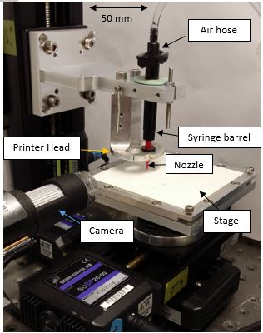
Figure 1: Dispenser Printer used in this work
The current printer is programmed to print in the following three modes.
- Droplet mode: An ink is deposited on the substrate in the form of successive droplets in straight lines.
- Continuous mode: An ink is deposited on a substrate in the form of continuous filaments as adjacent straight lines.
- Bitmap mode: A print pattern is defined as a bitmap image is printed in the form of droplets.
An ink deposited on a substrate using any of the three modes coalesces to form a printed layer. Droplet mode allows carefully controlled volume of an ink to be deposited on a substrate. It is slower than continuous mode and is not suitable for printing inks that have a tendency to bleed. Bleeding refers to spreading of ink outside the designated print area. Continuous mode is the fastest printing mode, it reduces the time duration for which the uncured inks are present on the substrate which reduces bleeding.
3 Surface Topography Characterisation
Surface topography can be characterised by measuring the roughness and waviness of a surface. Surface roughness can be defined as fine irregularities of a surface compared to its ideal form []. Waviness is widely spaced deviations of a surface compared to its ideal form [11]. Figure 2 below represents surface roughness and waviness in the form of a diagram. A surface topography is reflected by its primary form which is the combination of the roughness and waviness of a surface.
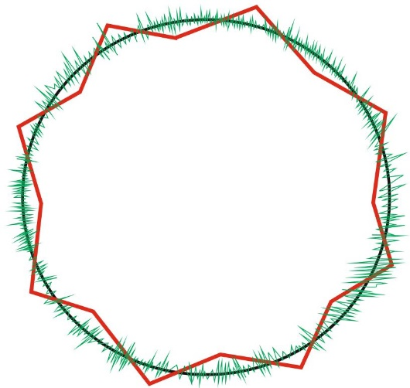
1- Ideal form of a Surface
2- Surface Roughness
3- Surface Waviness

1
2
3
Figure 2: Diagrammatic explanation of surface roughness and waviness
This work uses an Alicona Infinite Focus microscope (IFM) to characterise surface topography. It is an optical profiler which relies on focus variation to measure a 3-D data set. The non-contact optical profiler is an improvement over the contact profiler used in our previous work [10] as the topography measurements are not affected by lay of a print. Lay refers to the direction of the dominant pattern of a surface, it is diagrammatically presented in figure 3 below and in this study is defined by the printing in the X direction when using continuous mode. The optical profiler allows the measurement of larger surface areas compared to the contact profiler used in previous work. A surface topography parameter ‘Sa or Pa’ can be used to quantify surface variations. Sa and Pa parameters are the arithmetic mean of absolute values of surface variations as shown by equations 1 and 2. Sa represents areal 3-D surface measurements where Pa represents 2-D profile measurements.
Equation 1 [12]: $Sa= \frac{1}{A}\iint_{A}^{ }{\left|z(x,y)\right|dxdy}$ where A = Measurement Area, z = surface displacement
Equation 2 []: $Pa=\frac{1}{l}\int_{0}^{l}{\left|z(x)\right|dx}$ where l = Measurement Length, z = surface displacement
The Sa and Pa measurements in this work represent the primary form of the measured surface which includes the variations due to both roughness and waviness.

Lay (Direction of dominant pattern)

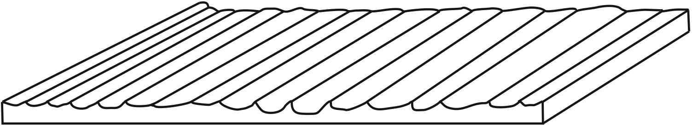
Figure 3: Diagrammatic representation of lay

3.1 Fabric Surface Topography
Woven polyester cotton blend (65/35) supplied by Klopman International is selected as the fabric substrate. They are widely used in clothing, furnishings and art as exhibition canvases. Polyester cotton blends combine the durability and tear resistance of polyester with the breathability and comfort of cotton. The polyester cotton surface was scanned three times at 5x magnification and the results were averaged. The scans produced an average Sa value of 34 µm. The fabric was first glued to an alumina tile to hold it flat during the scanning process to avoid measurement error due to folding and creasing. This gluing process is also followed for the same reasons when printing, therefore scanning the same way produces a more directly relevant result. Figure 4 below shows the 3-D image of the fabric.
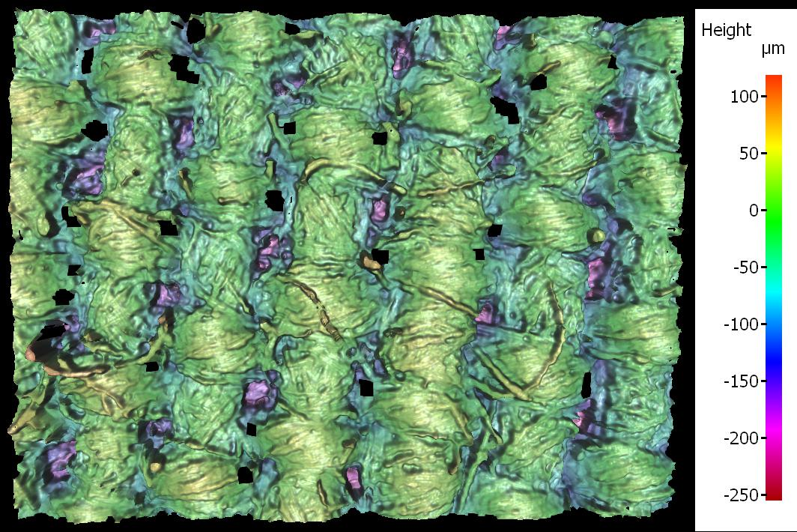
Warp Direction
Weft Direction
0.7 mm
Figure 4: 3-D image of polyester cotton 65/35 blend surface
Polyester cotton (65/35) has a loose weave structure and relatively high surface variation as shown in figure 4. This makes it a challenging surface for dispenser printing, however the advantage of using it is that any solution overcoming this large surface variation can be replicated on a wide range of fabrics with lower or similar surface variations.
4 Conductive Tracks Printed on Kapton and Fabric
Ten 30 mm x 2 mm silver conductive tracks were dispenser printed on Kapton and the fabric substrate to analyse the impact of surface variation on electrical resistance of the tracks. Kapton, a traditional printed electronics substrate, is used as a reference because it has a contrasting surface to the fabric. It has a non-porous structure with considerably lower surface variation of 1.30 µm compared to the fabric. Surface variation of the Kapton was measured using a Tencor P-11 contact surface profiler because it could not be scanned using the optical profiler due to its glossy and reflective surface. It was glued to an alumina tile to hold it flat during the profiling process and to make the result directly relevant to the practical printing process. The Kapton surface Pa value of 1.30, ± 0.59 µm was calculated by averaging scans of five different sheets of Kapton glued to alumina tiles. AFM measurements, from the literature, of Kapton films without the glue produced root mean square (RMS) surface roughness values of 1 nm []. Therefore, the majority of the variation in the Kapton surface measured here is introduced by the layer of glue. The standard deviation of ± 0.59 µm of the Kapton surface Pa values is therefore believed to represent variation in the gluing process.
Fabinks TC-C4001 silver ink was used for printing the tracks. The substrates were glued to alumina tiles to hold them flat during the printing process. Table 1 below shows the properties of Fabinks TC-C4001 ink.
Resistivity (Ω.m) | ≤ 3.81 E-07
Viscosity (Pa.S) | 3.5-16.0
Curing Temperature (°C) | 120
Curing Time (mins) | 8-10
Table 1: Properties of Fabinks TC-C4001 silver ink
The dispenser printer settings used for printing the tracks in droplet mode are shown in table 2 below.
Pressure (kPa) | 52.5
Dispense Time (ms) | 11.0
X-resolution (mm) | 0.50
Y-resolution (mm) | 0.40
Nozzle Height (µm) | 150
Vacuum (kPa) | 1.5
Speed (mm/s) | 1
Table 2: Dispenser printer settings for printing Fabinks TC-C4001 tracks
Figure 5 shows dispenser printed silver tracks on Kapton and directly on the fabric substrate with no interface layer. The ink droplet coverage was more consistent and uniform on Kapton which is shown by the more even deposition of silver on Kapton than fabric.
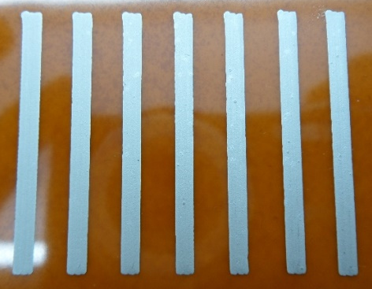
(a) (b)
Figure 5: Silver conductive tracks on (a) Kapton (b) Untreated polyester cotton fabric
Track thickness was measured using a Mitutoyo micrometer which can measure thickness down to 1 micron. Track width was measured down to 1 micron using Nikon eclipse microscope. Each track was measured at five equidistant points along its length and the result was averaged. Track resistance is measured using a Wayne Kerr 6500 B precision impedance analyser. It offers a four point probe measurement method, the probe spacing is not fixed and can be used to measure the resistance of a track. Resistance of each track is an average of five resistance measurements. All of the resistance measurements were performed at room temperature. Table 3 below shows average track thickness, average track widths and the resistance of the tracks printed on Kapton and the fabric along with the Sa/Pa values of the two surfaces.
 | Kapton Plastic Film | Polyester Cotton Fabric
Avg. Sa/Pa Value (µm) | 1.30 | 34.00
Avg. Track Thickness (µm) | 14.5 | 18.6
Avg. Track width (µm) | 2211 | 1945
Avg. Track Resistance (mΩ) | 483 | 2036
Table 3: Average Sa/Pa values, track thickness and track resistance of tracks on Kapton and polyester cotton fabric
The results show that tracks printed on the fabric have about 422 % higher average resistance than tracks on Kapton. The tracks on fabric, on average, are 28% thicker and 12% narrower. The resistance of a printed track is a function of the resistivity of the constituent material and the physical dimensions of the track as shown by equation 3.
Equation 3: $R=ρ\frac{l}{A}$ R = Resistance, ρ= resistivity, l= length, A = Crossectional area
According to equation 3 thicker tracks of the same width are expected to produce lower resistance. For the fabric experimetal results shown in table 3, the larger thickness is partially compensated by the narower width for the same volume of dispensed material. For constant silver volume the area of the printed tracks should also be constant, but, in case of fabric, the irregular deposition caused by the surface variation means it is not. If the silver layer on fabric was uniform, as in case of kapton, the thickness difference would be fully compensated by the width difference.
The tracks were further analysed to confirm if the electrical resistance distribution was uniform throughout the physical geometery of the tracks. The resistance distribution is analysed by assessing heat distribution of the tracks. 0.50 A current is passed through a track for 50 seconds which produces resistive heating. A thermal image is then captured using a Testo 875 thermal imager to acquire heat distribution data. Figure 6 below shows the heat distribution from 10 separate thermal images of tracks on Kapton and fabric. The silver tracks produced varying amounts of resistive heating due to their different resistances leading to varying maximum temperatures. The scale shown in figure 6 indicates relative temperature within a track for assessing heat distribution rather than the absolute temperature.
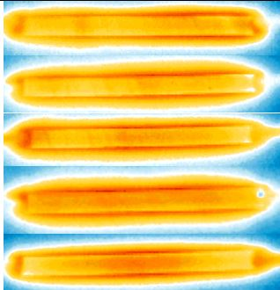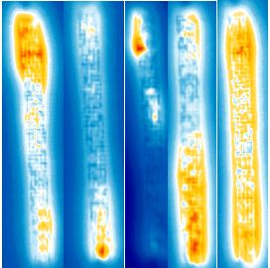
Increasing Temperature
(a) (b)
Figure 6: Heat distribution of silver conductive tracks on (a) Kapton and (b) polyester cotton fabric
It can be seen that the heat is relatively uniformly distributed for the tracks on Kapton whereas heat is concentrated in specific regions for the fabric tracks which show non-uniform resistance distribution within the tracks. The printed tracks were further analysed using cross-sectional SEM images of silver tracks printed on Kapton and the fabric shown in figure 7.
Printed silver layer
Fabric
Kapton
Printed silver layer
- (b)
Figure 7 : Cross-section of silver track printed on (a) Kapton (b) untreated polyester cotton fabric
The SEM images show that silver ink particles conformed to the surface pattern of the substrate on which they were printed. The printed silver layer on Kapton formed a geometrically consistent structure whereas the printed silver layer on fabric produced a non-uniform structure. Variation in geometry and thickness of the silver layer on fabric caused resistance variation within the tracks. The inconsistent printing of silver tracks on fabric can be attributed to high surface variation and the loose porous structure of the fabric. By comparison, the tracks printed using the same printing parameters and method on Kapton resulted in uniform silver layer, significantly lower average resistance and uniform resistance distribution. This result confirms that the printing process produces fairly uniform prints and that it is the substrate which dominates any variation seen in the final printed layers.
4.1 Impact of Fabric Structure Orientation on Printed Conductive Tracks
The polyester cotton fabric surface has a dominant pattern in one direction as shown in figure 4 which is called the weft direction with the warp direction being orthogonal. Two sets of five 30 mm x 2 mm Fabinks TC-4001 silver tracks were printed on the fabric using the settings shown in table 2 to assess the impact of fabric orientation on the resistance of printed tracks. The first set of tracks was printed with print direction along the dominant weft pattern and second set of tracks was printed with print direction orthogonal to the dominant pattern. Table 4 below shows the average thickness and resistance of both sets of tracks along with their standard deviation.
Print Direction | Weft | Warp
Avg. Track Thickness (µm) | 27.8 ± 4.2 | 26.0 ± 1.6
Avg. Track Resistance (mΩ) | 1658 ± 375 | 2045 ± 322
Table 4: Average track thickness and track resistance of tracks printed in fabric weft and warp directions
The results show that tracks printed in the fabric weft direction produce about 19 % lower resistance than tracks printed across the weft direction. The two sets of tracks resulted in similar resistance variation, shown by the standard deviation, however the thickness variation was higher in tracks printed in the weft direction. The impact of the fabric structure orientation was further analysed using planar SEM images of tracks printed in the weft and warp directions as shown in figure 8.
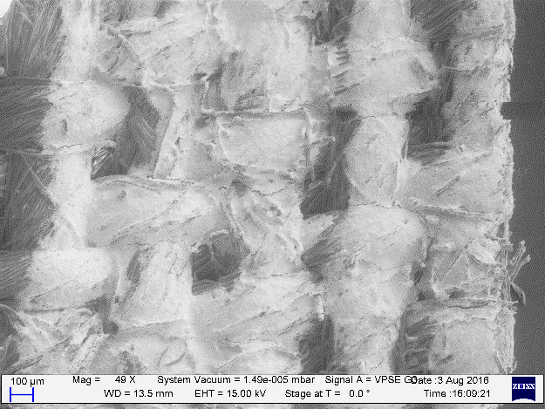
(a)
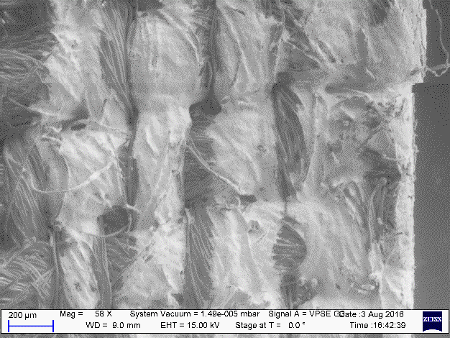
(b)
Figure 8 : Planar view of a printed silver track (a) following the weft direction (b) following the warp direction
(Lighter regions represent silver layer, darker regions show the original fabric surface)
The SEM images show that the track printed in the weft direction has a larger section of surface covered with silver than the track printed in the warp direction. The fabric surface profile varies more across the dominant pattern than along it which leads to higher thickness variation in the printed silver layer causing the tracks to a produce higher average resistance.
4.2 Conductive Tracks Consisting of Multiple Print Passes on the Fabric
Five 30 mm x 2 mm Fabinks TC-C4001 silver tracks were printed directly on the fabric surface using the settings shown in table 2; this was repeated 3 times. Each of the five tracks was printed with an increasing number of print passes starting from one pass up to five passes. Each print was cured once the required number of print passes was reached. Figure 9 below shows one set of tracks consisting of increasing number of print passes alongside its thermal image and figure 10 relates the number of print passes with track thickness and resistance.
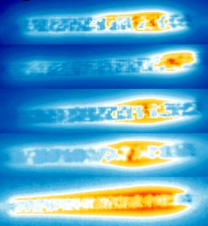
Increasing Temperature
1 2 3 4 5 1 2 3 4 5
Number of print passes in the track Number of print passes in the track
- (b)
Figure 9: Multiple print passed tracks printed directly on fabric (a) image (b) thermal image
- (b)
Figure 10: Change in average (a) resistance (b) thickness of tracks with increasing number of printed silver layers
The results show that increasing the number of print passes increases the thickness of the tracks which reduces the resistance of the tracks. The reduction in resistance is attributed to increased thickness and improved silver coverage instead of improved uniformity, which is shown by the heat distribution of non-uniform resistance of the tracks in figure 9. The heat distribution doesn’t show any specific relationship with the number of layers although the track consisting of five layers produced better heat distribution than the other tracks. The results also show that approximately three passes of silver are required on fabric to achieve a similar resistance to the average resistance of tracks on Kapton. Three times the quantity of expensive silver ink is required on fabric, as defined by the number of print passes, to produce a track with similar resistance to that on Kapton.
An increased focus on low powered electronics especially for wearables due to wireless power source limitations requires the electrical interconnections to dissipate the minimum of power. Any amount of current passing through a resistance would dissipate power as resistive heating; therefore it is important to fabricate and design the interconnections with the lowest possible resistance. This shows that it is vital to reduce fabric surface variation to improve the uniformity and consistency of printed electronic layers to produce low resistance electrical interconnections.
5 Evaluation of Dispenser Printing of Interface Inks to Improve Fabric Surface
An interface layer can be dispenser printed on the fabric surface to reduce its surface variation and strengthen its loose structure to provide a platform for subsequently printed layers. Four dielectric inks DuPont 5018, Electra EFV4/4965, Fabinks-IF-UV-1004 and Fabinks-UV-TC0233 are evaluated for dispenser printing process to produce interface layers. DuPont 5018 and Electra EFV4/4965 were identified as suitable interface inks during the EU FP7 Microflex project [] by the University of Southampton. Fabinks-IF-UV-1004 and Fabinks-UV-TC0233 are developed by University of Southampton as interface inks to overcome fabric surface variation. All four inks are UV curable, compatible with fabrics, produce flexible dielectric films and are suitable for screen printing. PVC and silicone based inks were considered but when cured these materials produce very low surface energy films and thus present a significant challenge for subsequent printed layers. Therefore, the chosen four inks are ideal choices for investigating their use in dispenser printing and as potential interface materials.
The four inks are assessed for surface consistency, thickness consistency, repeatability, flexibility and thermal stability. The five criterion represent parameters that would directly affect printing of electrical interconnections on a fabric substrate. The best interface ink would have the most consistent surface, lowest thickness variation, and highest repeatability to provide a reliable platform for printing of electronic layers. It would also be most flexible to avoid fabric becoming rigid. Interface is also required to have high thermal stability to suit thermally curable inks such as the silver ink used in this work. However none of the evaluated inks may be the best in every category, in which case the best interface ink will be selected based on requirements of specific smart fabric application.
The first step in this investigation was to find the optimum print settings for the four dielectric inks. The target parameters for the optimisation process are as follows.
- Sa between 0.71 µm to 1.89 µm
- Thickness of print ≤ 300 µm
The target Sa was chosen for the printed interface to produce similar surface to Kapton film glued to an alumina tile as this presents the ideal surface for printed electronics. The target thickness was chosen to be more than the peak to peak variation of the fabric structure which is 270 µm as shown in figure 4. All of the interface inks were printed in continuous mode as it is the fastest printing mode. The fastest option was chosen to reduce the amount of time an interface ink deposition remained uncured on the fabric surface which reduced the bleeding of the printed pattern via wicking into the fabric. All of the dielectric inks are UV curable and prints were cured using a Panacol-Elosol UV-P 280 ultraviolet point source with a 400 W Hg Bulb. The prints were exposed to the UV radiation of 2000mW/cm² for 60 seconds to cure.
The optimisation scheme used for the prints consisted of the following steps.
- Firstly a set of printer settings that result in the thinnest layer of ink completely filling the designated print area was obtained through varying dispense pressure and resolution parameters. Pressure was varied in the range of 5 kPa to 80 kPa whereas Y-axis resolution was varied between 0.2 mm to 0.4 mm.
- The layer thickness was then increased by increasing the pressure and resolution in steps of 0.5 kPa and 0.01 mm till the Sa target was met.
- The first layer was visually examined for ink absorption in the fabric structure. If parts of the print were absorbed in the fabric a second layer was printed on top of the cured first layer to improve surface homogeneity.
- The second layer was initially printed using the same settings as the first layer. The layer thickness was then increased or decreased based on the Sa and thickness of the prints till the Sa value and thickness targets were reached.
Table 5 below shows optimum settings and number of layers for each of the four interface inks.
 | DuPont 5018 |  | Electra 4965 | Fabinks-IF-UV 1004 |  | Fabinks-UV-TC0233
Layer Number | 1 | 2 | 1 | 1 | 2 | 1
Pressure (kPa) | 6.0 | 6.0 | 20.0 | 17.5 | 15.0 | 40.0
Y-resolution (mm) | 0.20 | 0.38 | 0.20 | 0.40 | 0.25 | 0.26
Nozzle height (µm) | 100 | 100 | 200 | 200 | 200 | 150
Vacuum (kPa) | 0.5 | 0.5 | 1.5 | 0.4 | 0.4 | 1.0
Speed (mm/s) | 5 | 5 | 5 | 5 | 5 | 5
Table 5: Optimum dispenser printer settings and number of layers for the four interface inks
Twenty 20 mm x 20 mm samples of each ink were printed using the optimised settings shown in table 5. The volume of ink in the syringe was maintained throughout the printing process by regularly refilling it after each print. All of the interface prints for each ink were printed on the same 20 mm x 20 mm area of the printer stage to keep the printer stage variation constant for each print. Figure 11 below shows each of the four interface inks printed on the fabric.
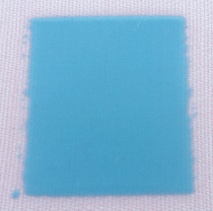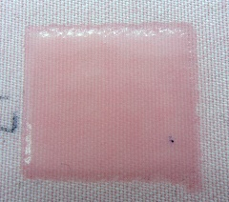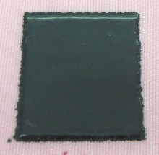
(a) (b) (c) (d)
Figure 11: Interface prints on polyester cotton (a) DuPont 5018 (b) Electra EFV4/4965 (c) FB-IF-UV-1004 (d) FB-UV-TC0233
5.1 Consistency of the Printed Surface
The surface topography of all the prints was measured at 10x magnification using the Alicona optical profiler. Each print was scanned at the four corners (2mm from the boundaries of the print) and at the centre of the print. The five spots were chosen to maintain consistency of measurements across the 20 prints of each of the four inks. The surface topography measurement of each print (Sa₁) was obtained by averaging the five Sa measurements. Surface consistency was assessed in terms of the following.
- Average Sa₁ across the 20 prints of each interface ink.
- Average Sa variation per print for the 20 prints of each interface ink (Sa_{sd}).
Average Sa variation per print (Sa_{sd}) is calculated by first calculating the standard deviation of the five Sa measurements for each print and then averaging it for the 20 prints. Smaller Sa₁ and Sa_{sd} values show that a surface has a smoother topography with lower deviations.
5.2 Consistency of the Printed Thickness
An interface print is not entirely uniform and can have thickness differences within it. Thickness of each interface print (T₁) is calculated as the average of five thickness measurements taken at the same positions on the printed layer as the surface topography scans. Thickness is measured using a Mitutoyo micrometer. Thickness consistency is measured by calculating the average of T₁ for the 20 prints and average thickness variation per print for the 20 samples of each ink (T_{sd}). It is calculated using the same method as Sa_{sd}. It reflects the degree of thickness variation within each interface print on average.
5.3 Repeatability of Printed Surface and Thickness
The repeatability of the process analyses surface topography and thickness variation across the 20 interface prints of each ink when the printing parameters are kept constant. It is defined by calculating the following.
- Standard deviation of Sa₁ for 20 prints of each ink
- Standard deviation of T₁ for 20 prints of each ink
The higher the value of the two parameters the lower the repeatability and vice versa.
5.4 Flexibility Comparison of the Interface Prints
A fabric cantilever test is used to measure flexibility of the interface prints of the four inks. Flexibility of the prints was assessed by measuring the bending angles produced by a cantilever structure consisting of a strip of fabric with a printed interface when a mass was attached to them. Figure 12 below shows a schematic of the fabric cantilever test.
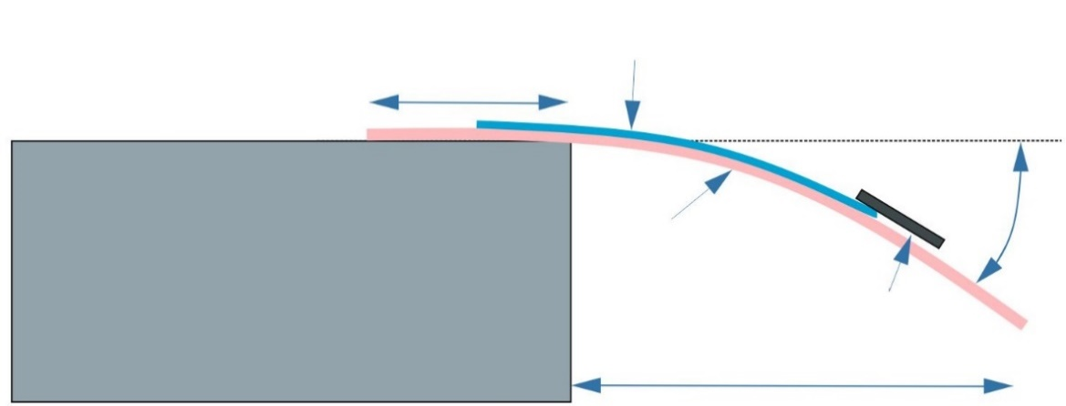
Bending Angle
Ɵ – Bending angle
Interface Print
Mass
10 mm
Fabric
29 mm
Figure 12: Schematic of the fabric cantilever test
Ten prints of each ink were used for these flexibility tests. The fabric containing the interface prints was cut into strips of 39 mm x 20 mm in the format shown in figure 13 below. One end of the fabric was taped to an aluminium stand and the other end was suspended with two 4.7 g magnets attached to it. The suspended prints would flex producing a bending angle which was recorded; the higher the bending angle the more flexible the printed layer.
12 mm
20 mm
Magnets
Fabric
Interface print
3 mm
7 mm
Figure 13: Format of the fabric strips containing the interface prints for flexibility testing
5.5 Thermal Stability of the Interface Prints
Five prints of each of the four inks were cut into the strips shown in figure 13. Thermal stability of the prints was analysed by heating the prints on a hotplate at 100°C for 10 minutes and measuring any change in mass using an Ohaus voyager pro balance which can measure mass down to 1 mg. The prints didn’t produce any change in mass although the prints twisted when heated as shown in figure 14 below. When heated to 120°C for 8 minutes, to represent the Fabinks TC-C4001 silver ink curing conditions, the prints twisted to varying degrees with three corners of the strips in contact with the hot plate and one corner rising which can be observed in figure 14b. The displacement of the highest corner was measured and is presented in the results section as a reflection of thermal stability of the prints. The prints returned to their initial state after they were cooled down to room temperature.
(a)
Hot plate
Fabric strips with interface prints
(b)
Figure 14: Interface prints of the four inks (a) before being heated (b) heated to 120°C for 5 minutes
5.6 Results of the Interface Evaluation
The results of the interface evaluation are shown in table 6 below. The results table in addition to surface consistency, thickness consistency, repeatability, flexibility comparison and thermal stability includes viscosity and a percentage fabric surface improvement comparison of the interface inks. Viscosity of the inks was compared to identify any correlation it has with the above mentioned parameters. It was measured using a Brookfield CAP1000+ viscometer. The fabric surface improvement parameter defines the improvement in fabric surface topography characterised by the Sa values of fabric and interface surfaces.
 | DuPont | Electra | Fabinks 1004 | Fabinks TC0233
Number of Layers of Optimum Print | 2 | 1 | 2 | 1
Viscosity of the Inks (Pa.s) | 2.24 | 11.02 | 6.00 | 14.32
Spindle | 1 | 1 | 1 | 2
Surface Consistency
Average Sa₁ for 20 prints (µm) | 0.96 | 1.12 | 1.28 | 1.42
Sa_{sd} (µm) | ±0.27 | ±0.16 | ±0.29 | ±0.24
Thickness Consistency
Average T₁ for 20 prints (µm) | 262 | 232 | 199 | 194
T_{sd} (µm) | ±13 | ±14 | ±08 | ±11
Repeatability
Standard Deviation S₁ (µm) | ±0.20 | ±0.13 | ±0.18 | ±0.20
Standard Deviation T₁ (µm) | ±33 | ±10 | ±19 | ±07
Flexibility
Avg. Bending Angle of optimum print (°) | 13.6 | 13.7 | 19.9 | 44.0
Thermal Stability
Displacement of highest corner (mm) | 02 | 03 | 07 | 10
Fabric Surface Improvement (%) | 97.2 | 96.7 | 96.2 | 95.8
Table 6: Results of the interface ink evaluation
The results show that all the interface prints significantly improve the fabric surface. DuPont 5018 prints have the least surface variation but its surface has comparatively lower consistency both within a print surface and across the 20 prints shown by the higher Sa_{sd} and standard deviation of Sa₁ respectively. The Electra prints have the most consistent surface with the best repeatability. Fabinks IF-UV-1004 shows the least thickness variation within a print despite having a higher thickness variation across the 20 prints. Fabinks-UV-TC0233 has the most repeatable thickness and its optimum prints were the most flexible but the least thermally stable. The results showed the following two trends.
- The higher the viscosity of the ink the better the thickness repeatability of an ink.
- The higher the flexibility of prints the lower the thermal stability.
Although all the interfaces significantly improve fabric surface topography none of the four inks produced an interface layer with the best results in each category. Therefore an interface ink can be selected using the results of this evaluation to suit the requirements of an application e.g. for high flexibility Fabinks-UV-TC0233 can be used and, for a highly uniform surface, Electra can be used. Figure 15 below shows the 3-D Alicona scans of one of the prints of each of the four interface inks.
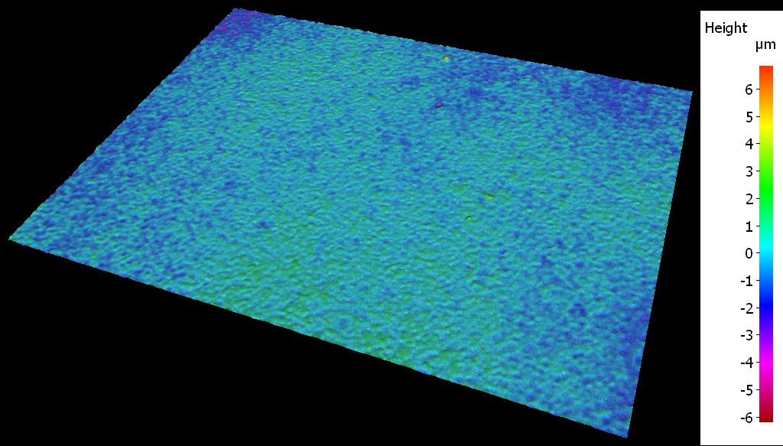
1.4 mm
DuPont 5018

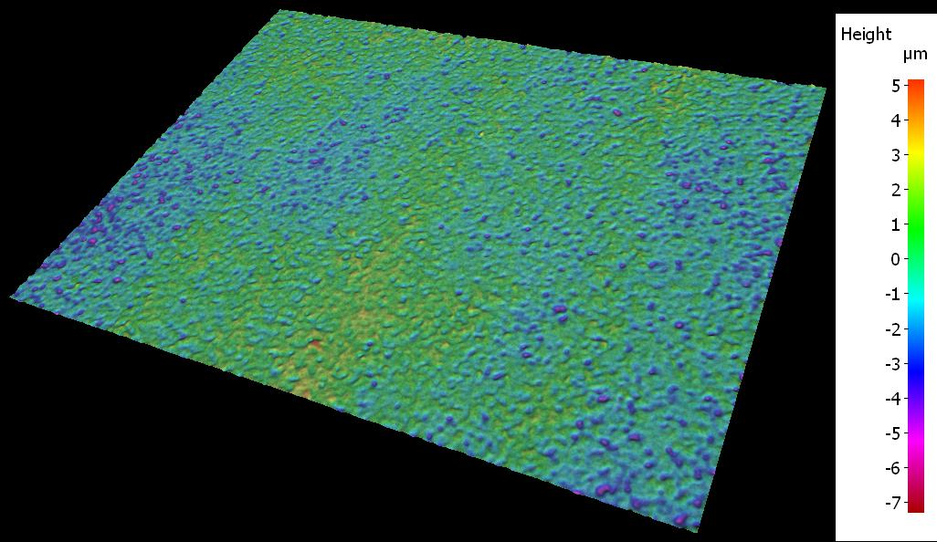
1.4 mm
Electra EFV4/4965

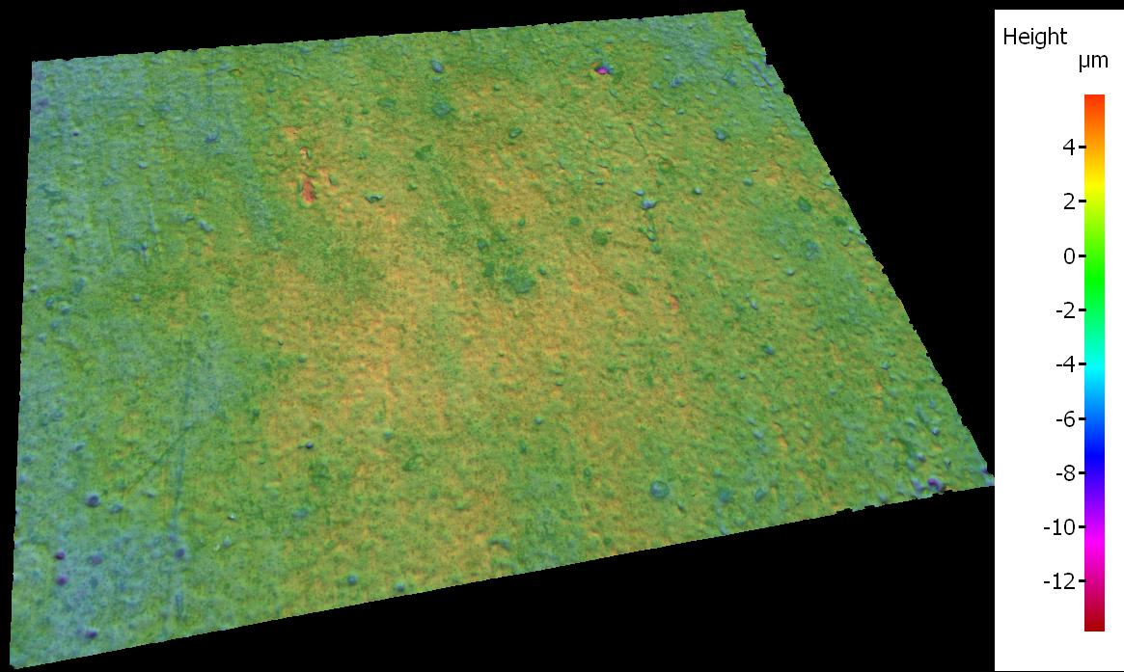
1.4 mm
Fabinks-IF-UV-1004

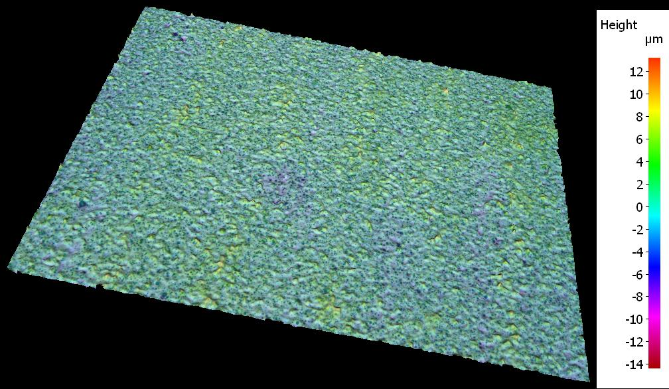
1.4 mm
Fabinks-UV-TC0233
Figure 15: 3-D scans of the four interface inks print on polyester cotton 65/35
The Alicona results show that majority of the peak to peak variation with the prints has reduced to 3-5 µm for DuPont, Electra and IF-UV-1004 and 10-12 µm for IF-UV-TC0233 which is a considerable improvement over fabric surface variation of 250-300 µm. The interface layers were printed using continuous mode where the printing nozzle continuously moves in a straight line as the ink is dispensed. The dispensed ink often trails the printing nozzle so it is possible to print slightly thicker layers than the nozzle height. However it should be noted that 2 layers of DuPont 5018 were printed to achieve a thickness of 262 microns. The first layer was cured before printing the second layer and the nozzle height for the second layer is set off the surface of cured first layer so there is already an offset of 100 -140 microns. The results and the 3-D images show that the four printed interface inks substantially reduce the fabric surface variation; however it is important to analyse how these results translate into consistent printing of electronic layers on fabrics.
6 Conductive Tracks Printed on Interface Surfaces
The printed interface layers provide a low variation surface as a reliable platform for printing electrical interconnections. Ten 30 mm x 2 mm Fabinks TC-C4001 tracks were printed on the interface prints of the four inks and a PVC coated fabric (Mehler Frontlit II Standard FR) to assess the impact of fabric surface improvement on the electrical properties of the printed conductive tracks. A PVC coated fabric was chosen as an alternative to interface printed fabric as it offers a non-porous surface with significantly lower surface variation than polyester cotton fabric. Figure 16 shows Alicona 3-D scan of the PVC coated fabric.
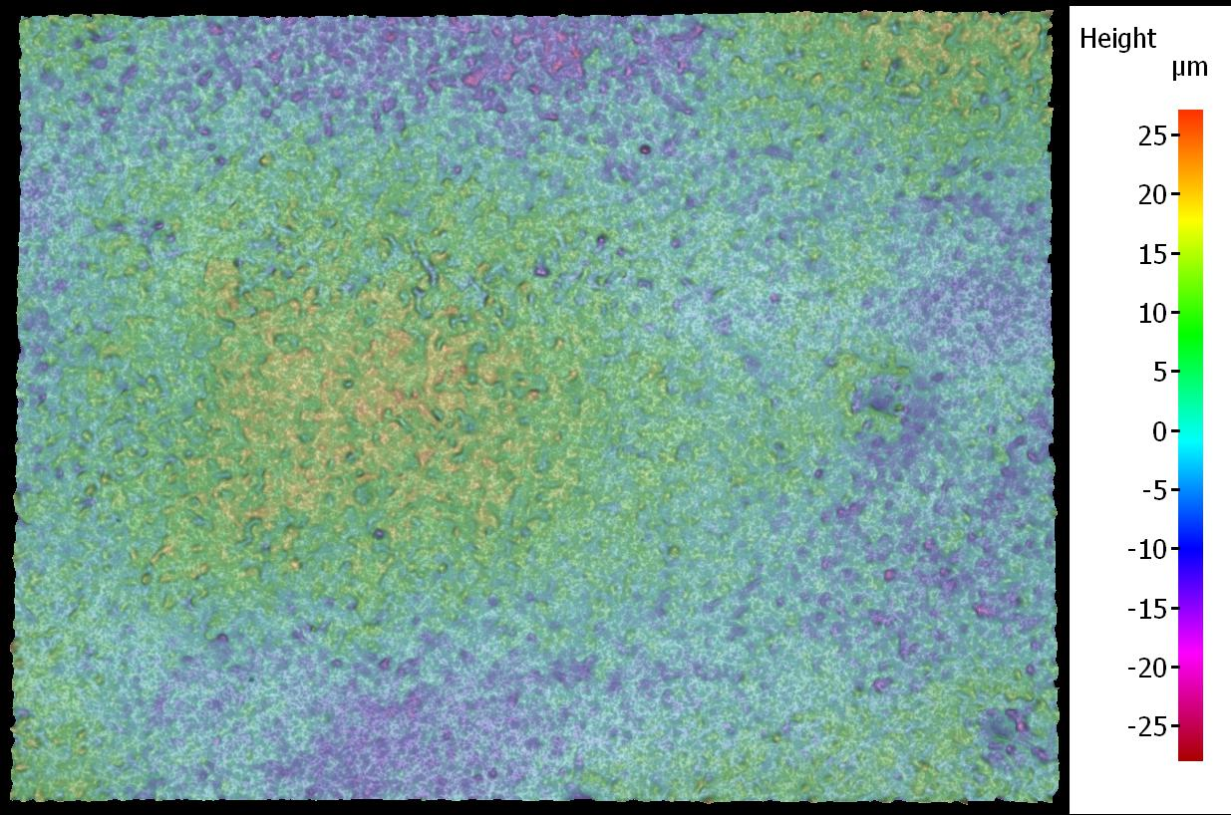
1.4 mm
Figure 16: 3-D image of the PVC coated fabric at 5x magnification
It can be seen from figure 16 that the PVC coated fabric has lower surface variation than the polyester cotton and higher variation than the printed interface coated fabric. Table 7 below shows the average Pa of Kapton and Sa of polyester cotton fabric, prints of four interface inks and the PVC coated fabric.
Substrate | Poly Cotton | Kapton | Dupont | Electra | IF-1004 | IF-TC0233 | PVC coated fab.
Avg. Sa/Pa (µm) | 34.00 | 1.30 | 0.96 | 1.12 | 1.28 | 1.42 | 2.85
Table 7: Sa/Pa values of the substrates used for conductive track printing
Two 37 mm x 40 mm interface prints of the four inks were printed on the polyester cotton fabric to print multiple tracks on each interface print. The conductive tracks were printed on the interfaces using the settings shown in table 2; however these settings did not produce a complete print on the PVC coated fabric. A different set of printer settings with a higher Y-resolution, shown in table 8, were used for printing conductive tracks on the PVC coated fabric.
Pressure (kPa) | 40.0
Dispense Time (ms) | 10.0
X-resolution (mm) | 0.50
Y-resolution (mm) | 0.30
Nozzle Height (µm) | 150
Vacuum (kPa) | 1.3
Speed (mm/s) | 1
Table 8: Dispenser printer settings used for printing conductive tracks on PVC coated fabric
Figure 17 below shows conductive tracks printed on the four interface prints and the PVC coated fabric.
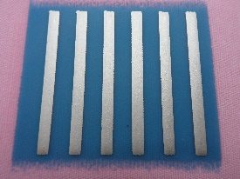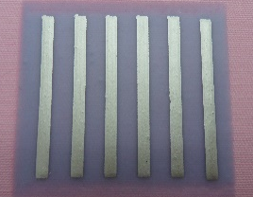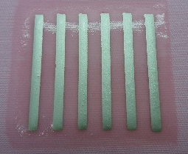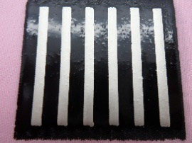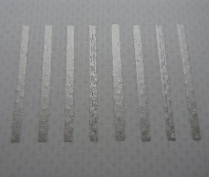
- (b) (c) (d) (e)
Figure 17: Silver tracks printed on (a) DuPont 5018 (b) Electra 4965 (c) Fabinks IF-UV-1004 (d) Fabinks-UV-TC0233 (e) PVC coated fabric
The resistance and the thickness of the tracks was measured using the methods described earlier. Comparing the track resistivity is a more suitable way of comparing the tracks as the resistance and thickness of the tracks vary on the same surface and across the different surfaces. Resistivity of the tracks on a specific surface was an average of the resistivity of each individual track on that surface. Figure 18 below shows the comparison of conductive tracks printed on polyester cotton fabric, Kapton, DuPont, Electra, IF-1004, IF-TC0233 and PVC coated fabric.

Figure 18: Average resistivity of conductive tracks on seven different surfaces
The error bars in the bar chart represent ± 1 standard deviation of the resistivity of tracks. The results show that tracks printed directly on the fabric surface have significantly higher resistivity and variation compared to tracks on other surfaces. It is assumed in the resistivity calculation that the track thickness is uniform and is represented by average track thickness. A track with a higher thickness variation would therefore produce a higher resistivity value and vice versa. The higher resistivity of the fabric tracks is caused by non-uniform thickness of the printed tracks due to high fabric surface variation. Figure 19 below shows cross-section SEM image of silver tracks printed on PVC coated fabric and DuPont 5018 interface layer on polyester cotton fabric.
Printed silver layer
Fabric
Printed interface layer
PVC coated fabric
Printed silver layer
- (b)

Figure 19 : SEM image cross-section of silver track printed on (a) PVC coated fabric and (b) an interface layer (DuPont 5018) on polyester cotton fabric

Figure 19 shows that the tracks printed on the PVC coated fabric and the fabric printed with interface layer produced a uniform deposition of silver ink as was the case with Kapton. The SEM images also show that the PVC coated fabric provides a sufficiently smooth platform for directly printing silver ink whereas an interface layer is necessary on the fabric surface to overcome the fabric surface variation. The interface ink deposition can be seen in the SEM image to conform to the fabric surface variation forming a smooth homogenous platform for the silver ink layer. Resistance distribution of the tracks printed on the four interfaces and the PVC coated fabric was analysed using thermal imaging technique. These tracks like printed tracks on Kapton, shown in figure 6, produced fairly uniform heat distribution. The thermal imaging technique can easily differentiate between uniform and non-uniform tracks, however is less suited to a comparison of the degree of uniformity between two uniform tracks especially if the difference in uniformity between the tracks is very small as is the case in this experiment. A more suitable method is to analyse the resistivity of the individual tracks and present it as average resistivity used in this experiment. Figure 20 below shows the resistivity of the tracks on all the surfaces omitting the polyester cotton tracks so the results of the remaining surfaces can be compared more easily.

Figure 20: Average resistivity and variation of conductive tracks on Kapton, four interface materials and PVC coated fabric
Figure 20 shows that the tracks on Kapton, the four interfaces and the PVC coated fabric have very similar resistivity although Kapton tracks show the least variation in the resistivity. PVC coated fabric tracks show higher resistivity than the four interface inks which confirms the hypothesis that it is due to the higher surface variation established by the average Sa values. The difference between average Sa values of the four interfaces and the Kapton is very small which shows they have very similar surface variation; therefore the track resistivity of tracks printed on these surfaces do not produce an accurate reflection of their Sa values. The resistivity of the tracks on all the surfaces except the fabric matches the expected resistivity shown in table 1. The results have proved that reducing the surface variation is vital for consistent printing of electronic layers especially if the electrical properties of the layers are dependent on the homogeneity of their physical geometry.
7 Conclusions
This paper has investigated a range of methods to significantly improve the performance of printed smart fabrics. It identifies and highlights substrate surface variation as a key parameter affecting the electrical properties of subsequent printed electronic layers. In context of smart fabrics incorporating electronic functions, it was demonstrated that fabric surface variation leads to higher resistance of printed electrical interconnects. A novel thermal imaging based method of analysing resistance distribution of the printed conductive tracks showed that the track resistance distribution was non-uniform and it was caused by inconsistent physical geometry of the tracks. The higher resistance of the interconnections makes them unsuitable for use in battery powered smart fabric devices as high resistance increases power loss. In addition, these variations would interfere with any analogue signals being measured or transmitted as well as potentially causing false triggering for digital signals.
The paper shows that a fabric surface can be made more suitable as a printed electronic substrate by dispenser printing an interface layer on top of it. The interface layer forms a low variation surface on top of the fabric allowing subsequent electronic layers to be uniformly printed. This innovative approach offers a printable low cost method of overcoming the fabric surface variation. The use of a state of the art dispenser printing method to employ this approach allows the interface layer to be printed selectively in any pattern to suit an interconnection design offering complete design freedom. The four interface materials evaluated in this paper are shown to reduce the fabric surface variation by more than 95%, forming flexible low variation surfaces.
It was shown that the improvement in fabric surface translated into printing of conductive tracks as tracks printed on the four interface materials resulted in ̴90% lower resistivity compared to tracks printed directly on fabric and showed similar resistivity to tracks on Kapton, a traditional printed electronics substrate. By printing an interface layer between the fabric surface and the conductive tracks a network of electrical interconnections with substantially lower resistance and improved performance can be fabricated. It was also shown that tracks printed directly on fabric required about 3 times more silver to produce comparable resistance to tracks printed on the four interfaces and Kapton. Therefore, in addition to better performance, printing an interconnection design on interface layer instead of the fabric surface saves the expensive silver ink thus reducing the cost of fabrication.
The properties of the four interface materials and the associated dispenser printing procedures reported in this paper enable fabrication of suitable platforms for printing electronic layers for smart fabric applications.

Acknowledgements
This work has been supported by the European Commission under the ‘Technologies and Scientific Foundations in the field of Creativity’ theme in the 7th Framework Programme for Research and Technological Development as part of the CREATIF project (Grant No.: CP-FP-INFSO-FP7-610414).
We would like to thank Christophe Mercier from ARDEJE for his comments on improving this paper.
Data supporting this study is openly available from the University of Southampton repository at: http://dx.doi.org/10.5258/SOTON/390074

References

. Tao, X. M. (Ed.). (2001). Smart fibres, fabrics and clothing: fundamentals and applications. Elsevier.
. Cherenack, K., & van Pieterson, L. (2012). Smart textiles: challenges and opportunities. Journal of Applied Physics, 112(9), 091301.
. Magenes, G., Curone, D., Caldani, L., & Secco, E. L. (2010, September). Fire fighters and rescuers monitoring through wearable sensors: The ProeTEX project. In Conf Proc IEEE Eng Med Biol Soc (pp. 3594-3597).
. Vieroth, R., Loher, T., Seckel, M., Dils, C., Kallmayer, C., Ostmann, A., & Reichl, H. (2009, September). Stretchable circuit board technology and application. In Wearable Computers, 2009. ISWC'09. International Symposium on (pp. 33-36). IEEE.
. Schwarz, A., Van Langenhove, L., Guermonprez, P., & Deguillemont, D. (2010). A roadmap on smart textiles. Textile progress, 42(2), 99-180.
. Karaguzel, B., Merritt, C. R., Kang, T., Wilson, J. M., Nagle, H. T., Grant, E., & Pourdeyhimi, B. (2009). Flexible, durable printed electrical circuits. The Journal of The Textile Institute, 100(1), 1-9.
. Torah, R., Yang, K., Beeby, S. P., & Tudor, M. J. (2012). Screen-printed multilayer meander heater on polyester cotton.
. Komolafe, A. O., Torah, R. N., Yang, K., Tudor, J., & Beeby, S. P. (2015, May). Durability of screen printed electrical interconnections on woven textiles. In Electronic Components and Technology Conference (ECTC), 2015 IEEE 65th (pp. 1142-1147). IEEE.
. Suh, M., Carroll, K. E., Grant, E., & Oxenham, W. (2013). Effect of fabric substrate and coating material on the quality of conductive printing. Journal of the Textile Institute, 104(2), 213-222.
. Ahmed, Z., Torah, R., & Tudor, J. (2015, April). Optimisation of a novel direct-write dispenser printer technique for improving printed smart fabric device performance. In Design, Test, Integration and Packaging of MEMS/MOEMS (DTIP), 2015 Symposium on (pp. 1-5). IEEE.
. http://www.creatif.ecs.soton.ac.uk/index.html last accessed on 05.08.2016
. Alicona Infinite focus IFM Manual, IFM 2.1.5 EN 30.06.2008
. Tafesse, M. (2015). Surface Metrology and the National Science Foundation (Doctoral dissertation, WORCESTER POLYTECHNIC INSTITUTE).
. Bollero, A., Andrés, M., Garcia, C., Abajo, J. D., & Gutiérrez, M. T. (2009). Morphological, electrical and optical properties of sputtered Mo thin films on flexible substrates. Physica status solidi. A, Applied research, 206(3), 540.
. http://microflex.ecs.soton.ac.uk/home.html last accessed on 15.02.2016.

