A Hybrid Knowledge Based System for Cost Modelling applied to Aircraft Gas Turbine Design
S.V.Tammineni, A. R. Rao, J. P. Scanlan, A. J. Keane, P.A.S.Reed,
University of Southampton, Southampton, SO17 1BJ United Kingdom
This paper presents a novel technique for representing cost information for a candidate design. The underlying principle involves the use of a knowledge based system for cost modelling that makes the cost implications of design decisions more visible and available to the designer at the concept design stage.
The development of a hybrid between hierarchical trees and an object-oriented knowledge representation of cost and manufacturing knowledge is given.
The representation of cost and manufacturing information as an abstract product structure and reusable object libraries is shown. The extraction of key geometric information needed from a CAD system is discussed and demonstrated.
The tool is intended to provide a clear and easily audited response to incremental changes in component geometry and the product definition. The tool is also capable of modelling stochastic quantities present in cost models and can therefore analyse cost risk.
A case study demonstrating the research applied to a Rolls-Royce aircraft gas turbine engine component is presented. This case study also demonstrates how the tool is deployed using web technologies through a client running standard browser software.

Nomenclature
ρ = correlation coefficients
y = objective function
x_{1,} x₂,…x_{p} = set of independent design variables

1. Introduction
Cost estimation for the manufacturing of aerospace components rose to prominence during the Second World War[1].Stewart defined costs as being related to the economic resources (manpower, equipment, real facilities, supplies and all other resources) necessary to accomplish work activities or to produce work outputs[2] It is widely accepted that the opportunity to reduce unit cost of the product lies largely within the design stage, which itself is typically 10% of the product costs but commits or fixes 70% of product cost[3-6]. The design stage itself can be broadly divided into: conceptual design phase, preliminary design phase, and detailed design phase. Among these three phases in design, it is widely accepted that decisions taken during the conceptual-design phase, in the product development cycle, influence the cost most. Decisions taken at a conceptual design phase may be based on several criteria. Ever improving CAD and analysis capabilities have provided designers with powerful tools on their desktop to evaluate the performance of a design with considerable accuracy at this phase of design.
Asiedu points out that costs have been employed as an evaluation criterion in design in the past in two ways: It was used either in a design-to-cost [7]or design-for cost [8]context. While the aforementioned methodologies have on the most part proven successful in reducing cost, the design evaluation criterion in most of these methodologies is not cost[9]. This emphasises the need for methodologies that directly address the issue of providing cost information to the designer irrespective of the design context in which the cost information is used. It is evident from this that there is a need to build a knowledge based system for cost modelling. This will provide the designer with cost information which previously was not accessible and initiate the designer in building cost models that support the costing of alternative product definitions at the concept phase of design.
Typically current costing systems:
          - Rarely predict incremental cost fluctuations in terms of changes in product definition and also lack the capability to support detailed rapid model building activity.
          - Do not capture detailed manufacturing and cost knowledge and are unable to integrate this with the relevant stages of product definition.
          - Do not present cost information in a format that gives the designer a deep understanding of drivers and sensitivities.
          - Do not take into account uncertainty associated with product definition and manufacturing cost information at early stages of design.
This paper presents a novel methodology for representing manufacturing, cost, and design information captured in a hybrid knowledge representation environment that can be coupled to product definition hence making the costing process more visible and accessible to the designers. The cost estimating method adopted here effectively combines both generative and manufacturing feature based estimation approaches. The cost model developed is then linked to a product definition through a parametric CAD model. Incorporation of sensitivity analysis and Monte Carlo simulation into the cost modelling environment takes into account uncertainty and risk involved in early design. Furthermore, the cost model developed for a product can be gradually refined during the design process to reflect the evolution of design, through the creation of new Tree objects, reflecting increasing certainty in a product definition. A case study on a turbine disc from a Rolls-Royce aircraft gas turbine engine is presented in the developed representation and modelling techniques.

2. Cost Estimating Methods
Cost estimation as defined in the Federal Aviation Administration (FAA) life cycle cost estimation handbook is the process of predicting the cost of manufacturing a product before any stages of the product development cycle have been executed[10]. These estimates are based on information available or collected about the resource requirements. A reliable manufacturing cost estimate is an essential element in the conceptual design decision making process because it can help designers determine the optimal course of action necessary to meet design requirements. Current cost estimation methods broadly fall into four categories as given below.
- Analogy Based Cost Estimation method[11, 12]
- Parameteric Cost Estimation method[3, 13, 14]
- Feature-Based Cost Estimation method[15-17]
- Bottom-up Cost Estimation method[18]
Several authors have presented literature surveys on these estimating methodologies[4, 19] and further reading about these estimating methods can be obtained from the references provided.

2.1 Generative cost estimating method based on manufacturing features
As presented in the literature review there are a number of cost estimation techniques. One of the major disadvantages with many of the existing cost estimation methods is the inability to handle multiple layers of abstract design definition. They are restricted to specific stages in the design process and the user has to make a trade off between the accuracy of the resulting estimate and the level of detail given as input. Detailed process information must be pushed upstream so that accurate yet quick estimates can be made in the conceptual design phase as shown in Figure 1[20]. However there are no instances in the literature available where this has yet been successfully accomplished.
Fig.1 Need for detailed information in early design [20]

Taking into consideration the need for detailed cost information to be made available at the concept phase of design a generative cost estimation technique based on manufacturing features has been employed. The generative approach uses the emerging product definition to infer a manufacturing sequence and to estimate individual process times. In most respects, this approach is equivalent to generative process planning and requires the same computational algorithms[21]. The generative approach can be further subdivided into feature-based and feature-recognition methods. The feature-recognition approach is required when the product model is expressed in terms of design features [22]. Conversion algorithms are required to derive a product model that is expressed in terms of manufacturing features.
The manufacturing feature-based approach requires the product definition to be constructed using a predefined set of features that have a direct mapping to manufacturing processes hence the term manufacturing features [23, 24]. The cost of a manufacturing feature is the cost of resources expended in making the transition from state n-1 to n as shown in Figure 2.
Fig .2 State transition and manufacturing feature costs

Chep and Tricarico [25] proposed representing manufacturing feature as an object by object-oriented analysis and design method used for process planning. Influenced by this work, this research work has employed the technique of representing manufacturing features, processes and materials as “Tree objects” to support the hybrid cost estimating technique. Manufacturing features are represented by objects in a tree structure carrying data that identify it through a set of properties, functions those define its behavior through appropriate methods, and links to other process and material tree objects to form their respective cost models. A composition of a set of manufacturing feature cost models will provide the cost of the component. This composition will be continued until the whole system level is reached.
The hybrid cost estimating technique developed will support the action of adding design detailed attached to these manufacturing features as the design process is getting refined through different phases. Its integration with the hybrid knowledge representation technique developed for providing a knowledge based system that allows in rapid model building is seen as very advantageous. The next section presents the hybrid knowledge representation technique that yield in tree objects.

3. Knowledge Based System for Cost modelling
Knowledge management (KM) refers to the ways organizations gather, manage, and use the knowledge that they acquire[26]. In the context of this paper it has become important to manage cost knowledge for supporting design decision making. Rush has pointed out that costing is knowledge intensive and that it requires the skills and knowledge capture from a number of disparate disciplines[27]. Thus costing requires a knowledge based system for capturing and representing cost information (i.e. manufacturing, cost, design information) for the function of cost estimation of products.
Rush and Roy have pointed out that Knowledge-Based Systems (KBS) help to formalize specialized knowledge so that it can be reused, thus supporting the Knowledge management activity [28].
This activity of knowledge capture and representing in the costing process is called cost modeling. Bench- Capon states that knowledge representation as a set of syntactic and semantic conventions that makes it possible to describe things[29]. Representational principle states that Knowledge must be encoded in an intelligent program explicitly, in a manner that allows other programs to reason about it[30, 31]; [32]. Several Knowledge representation paradigms have been developed to cater for the needs of projects in the past. Here are some of the key paradigms grouped from the literature survey[29, 33, 34],
- Object-Oriented
- Trees
- Rules
- Frames
- Semantic networks
- Procedural knowledge
- Logic
- Statistical knowledge
It is known that all of these paradigms satisfy the criteria of adequacy, at least with regard to metaphysical, epistemic and computational adequacy, but there are differences between them which means that they rate rather differently on the more subjective, or application-oriented criteria[29].
There is a growing awareness in many aerospace organisations of the importance of knowledge management for cost estimating purpose. This has led the research community to look at the employment of spreadsheets for costing process attached with different functions in an organisation. Evidence from experiments, field audits, and surveys of several researchers [35-38] and consultancies such as KPMG[39], Cooper & Lybrand[39] have shown that there are a number of different types of errors that occur in spreadsheets. These errors may occur in any other software tool as well but the cell representation technique in spreadsheets makes it difficult to point out at those errors.
In taking into account the disadvantages of spreadsheets and an extensive search into costing tools, the DATUM (Design Analysis Tool for Unit Cost Modelling) project, sponsored by Rolls Royce Plc has developed a costing tool. The DATUM team procured in the initial stage of this project a general modelling tool called DecisionPro developed by the Vanguard Software Corporation. This tool is written in Dscript programming language which is an implementation of ECMA (European Computer Manufacturers Association) Javascript with extensions. The tool was modified in order to allow application of a hybrid Knowledge Representation scheme (i.e. combination of object oriented and tree representation paradigms) to build a knowledge-based system for costing. A comprehensive suite of functions have been developed as part of this research to suit costing of aircraft gas turbine engine components.

3.1 Hybrid knowledge representation paradigm

Hybrid knowledge representation is a combination of Tree KR and Object-oriented KR paradigms. A brief introduction to these methods and the approach used in producing the hybrid system is provided below.

3.1.1 Tree Knowledge representation paradigm. A hierarchical tree structure is a way of representing the hierarchical nature of a structure in a graphical form. Every finite tree structure has a member that has no superior. This member is called the "root" or in our case root node, this is the starting node. The lines connecting elements are called "branches" the elements themselves are called "nodes." Nodes without children are called "end-nodes" or "leaves". A node is a "parent" of another node if it is one step higher in the hierarchy and closer to the root node. In a tree structure there is one and only one path from any point to any other point. The root node represents the solution sought and each branch provides increasingly more detailed cost information about how that solution is derived as shown in Figure 3.
Fig.3.Tree structured knowledge representation

3.1.2 Object-oriented Knowledge Representation paradigm. Many authors have mentioned the advantages of OO methods employed in modelling and simulation [40-43]. The OO methods employed in modelling and simulation in the past were seen as more software programming prone, where heavy coding was required and therefore lacked appeal for other communities. The object oriented environment developed as part of this research enables in creating of objects in a visual manner. The creation and use of these objects does not require expert programming skills.
Figure 4 represents an object, with the information flow in and out of it. The Object acts as a function as shown in the diagram, it has a set of declared individual data elements known as input and output properties that can be exposed. The source of an object contains the logic behind the object, which varies outputs as the inputs change. Access is provided to the source of the object for navigating and auditing.
Fig.4. Object diagram

An object performs an operation when it receives a request (message) from another object. This type of object-oriented programming was defined by Hewitt[44]. Crucial to OO modeling is its capability to represent the various relations between objects, such as aggregation, , encapsulation, generalization and inheritance[45]. These features are explained in detail below:
- Aggregation is the ‘is_part_of’ relationship in which objects representing the components of something are associated with an object representing the entire assembly. The aggregation tree is composed of object instances that are all parts of a composite object[46].
- Encapsulation (or information hiding) is the separation of the external aspects of an object, which are accessible to other objects, from the internal implementation details of the object, which are hidden from other objects[46].
- Generalization forms a higher level general entity class (called a superclass) by grouping similar lower level classes (called subclasses). A generalization is an abstraction which enables a class of individual objects to be thought of as a single named object[46].
- Inheritance allows us to reuse the behavior and the properties of a class in the definition of new classes. Subclasses of a class inherit the operations of their superclass and may have new operations and new instance variables[46].
Object composition is an alternative to class inheritance with composition; new functionality is obtained by assembling an object from other objects. An important design requirement of object composition is that the objects being composed have well-defined interfaces which allow one object to work with other objects, because objects are accessed only through their interfaces, encapsulation is not broken[47].
3.1.3 Hybrid paradigm. The hybrid scheme employed is a combination of tree and object-oriented KR paradigms for cost modeling. This will represent structured hierarchical trees as objects called “Tree Objects”. The nodes present in the tree structure can be exposed as input/output properties and the information present in the tree structure as a source of the object as shown in Figure 5.

Fig.5.Tree structure with exposed properties

Information about a complex problem that is to be solved can be represented by simply dividing the information to be representable by two or more tree objects. These tree objects can be saved in a library and reused to be instantiated in a tree belonging to higher level of model abstraction as shown in Figure 6.These trees providing the composition of tree objects can themselves be saved as tree objects, this process is recursive and depends on the model resolution required. This is a more natural and productive way of working with complex problems. The Problem-solving abilities are based on the Divide and Conquer concept where a large problem can be divided into smaller ones represented by tree objects. These can be combined by the composition approach previously mentioned.
In the costing context these tree objects represent cost models of manufacturing processes, materials, and work centers. These sets of tree objects will be used for building cost models of an aircraft gas turbine (i.e. whole system component, sub-system components, components and manufacturing features).
Fig.6.Tree object instantiated in tree structure

These tree objects that are developed are populated in the libraries for reuse. The library is the knowledge base for the knowledge based system. This library of tree objects will help support the cost modeling activity employing generative feature based cost estimating technique. As shown in Figure 7 the user can actually access the libraries and thus reuse the tree objects to build further higher level abstract models.

Fig.7. Illustration of library functionality

Population of these libraries has been achieved by using information coming from several sources such as production systems, databases etc employed in Rolls Royce Plc as shown in the information flow Figure.8.

Fig 8. Cost control and information flow structure

3.2 Hierarchical Model Abstraction
Object composition, tree structuring and library functionality provides powerful mechanisms to represent the physical topology of an aircraft gas turbine engine for cost modeling. From a structural viewpoint, an aircraft gas turbine is a whole system component made up of several sub-system components:
- inlet,
- fan,
- compressors,
- combustor,
- duct,
- turbine,
- shafts
- and nozzle.
These sub-system components will be made of components such as blades, discs, blisks which in turn will be made of manufacturing features.
Cost models of these sub-systems, components and manufacturing features are built using the manufacturing process tree objects and material tree objects. If the interfaces between the tree objects are correctly specified, they may be aggregated without restriction to form various derivative system configurations and obtain their respective costs. These cost models are organized in a hierarchical tree structure which reflects the actual physical structure of the aircraft gas turbine engine. Cost models for components at the highest level of the hierarchy show the least detail and each succeeding level reveals more detail until a fundamental set of manufacturing features are reached. This process can be extended based on the level of resolution required in the given model.
This hybrid knowledge representation paradigm which incorporates generative cost estimation based on manufacturing features provides detailed cost information to designers in a structured, quick and modular form which can be directly related to the geometry being built. In the long term, this hierarchy can be made accessible either directly through a standard web-browser or via an interface to a CAD tool.
A case study is presented in this paper in section IV on the disc component from a Rolls- Royce aircraft gas turbine engine to demonstrate the representation and estimating techniques developed.

3.3. Parametric CAD and Cost Estimation
In conceptual design, various alternatives are evaluated, candidate geometries may bear little resemblance to each other and the decision-making is based on the designer’s intuition and experience combined with results tabulated from pilot analyses. Since the number of design variables being considered at this stage is relatively few, the process of manual change of design is still viable. As the design matures into the next stage, increasing complexity and a steep rise in the number of design variables demands an automated approach to geometry modification and manipulation in response to results obtained from computational analyses. One of the methods to achieve the above automation is to parameterise the geometry and have external control of the parameters describing the component.
Component geometry can be parameterized in many different ways. Samareh [48] reviewed seven different methods of geometry parameterisation. Computer Assisted Design (CAD) tools are routinely used for representing and building geometry, storing design information and pre-processing for computational analyses. A feature based solid modelling approach adopted within a CAD engine gives adequate control for creating and modifying dimension driven objects[48]. Parameterization is achieved by a combination of geometric constraints and Boolean expressions. In the aerospace industry, parameterisation is often carried out specifically to assist structural and aerodynamic optimization but until now has never been coupled to cost estimation. There is no published work on using an accurate cost model to respond to design geometry in a similar manner to that of analysis codes. Using the cost modelling methodology and tool described in sections II and III, it is now possible for the designer to set up and use cost versus performance trade-offs. Section IV (A) presents an example of a parametric CAD model coupled to cost estimation in NX3 (Unigraphics PLM solutions).

4. Turbine Disc Case study

4.1Geometry Development using NX3
A disc component from a Rolls-Royce aircraft engine has been modelled using Unigraphics NX3. The solid model geometry is shown in Figure 9. The aim was to represent important geometric features influencing cost by a minimal number of design variables. This is a paradoxical situation as increasing detail and number of design variables reduces the extent to which geometry can be modified without errors in the regeneration process whereas simplifying geometry to retain flexibility might make it unrealistic. In this component, the outer geometry was parameterised in 2D using geometric and dimensional constraints, and parametric relationships between different design variables and the component dimensions. Some features such as firtree roots, holes and slots were modelled by using Boolean expressions in three dimensions. Figure 10 shows the axisymmetric 2D section of the component and the design variables. Non Uniform Rational B-Splines (NURBS) are used to represent the curved surfaces a, b, c, d, e and f, where the disc diaphragm merges with the front and rear drive arms. (See Figure 10) NX3 permits the exporting of expressions, component dimensions, design variables and model measurements into a text or a comma separated values (CSV) file. The control points for the NURBS sections are also exported as variables and modified externally through this file in batch mode. The same file is also utilised as input for the cost model. The cost model uses some of the inputs such as number of firtree roots, drive-arm lengths and volume for its calculations. Figure 11 shows the different geometries possible by modifying the design variables in the CAD file.

Fig.9 3D views of disc

Fig.10 Two dimensional representation of the disc and design variables

Fig .11 Range of geometries achieved by modifying the design variables

4.2 Cost Model Development
The cost model for a turbine disc component is developed in a hybrid KR within a DecisionPro tool. Employing the hybrid estimating method the cost model of the disc will be a composition of cost models of the manufacturing features. These manufacturing features represent the state transitions between the initial bulk material states to the final finished disc state. As mentioned previously, cost models for processes and materials are modelled and stored in the library. A manufacturing feature cost model is a composition of the material and process employed in its creation. In this case the disc has a set of manufacturing features that define the transition states such as diaphragm; front and rear drive arms etc as shown in Figure 12.

Fig.12The tree object Rim Cylinder being added to the disc component model

Each manufacturing feature has a set of input and output geometric properties. These properties are exposed to the designer to be varied at every composition level as shown in Figure 13. As explained in the geometry development .csv files can be used to export input (i.e. design parameters) from NX3 to the cost model. This connects the geometry model and the cost model at their level of abstraction. The designer also has the added advantage, where information is scarce, of specifying a default value or a distribution for the input parameters whose values may vary in the next design phase. The cost model in total contains 20 tree objects and 10 random variables. The model is gradually refined during the design process to reflect the evolution of the design, through the creation of new design tree objects and attributes, through increasing certainty in attribute values and through increasing certainty in relationships between tree objects. The uncertain parts present in the model are the design attributes, cost information and the varying product definition. This shows the ease with which the designer can assemble from a set of manufacturing feature tree objects a cost model for a turbine component

Fig.13 The input parameters for the tree object Front Drive Arm manufacturing feature

4.2.1 Risk Anlaysis. As mentioned previously cost information and design attributes in the model may have some uncertainty attached to them. It is necessary in this case to model the uncertainty in order to consider the risk involved in the cost model. The cost model developed in this case employs a distribution to evaluate the randomness occurring in these uncertain quantities. The different distributions made available to the user are uniform, discrete, triangular, normal, lognormal, gamma, Weibull, beta, custom, Bernoulli, binomial and Poisson. Depending on the uncertainty involved and information available, a suitable distribution can be chosen from the list mentioned.
Further risk analysis can be carried out by employing sensitivity analysis, Monte Carlo simulations and correlation. The incorporation of these two functionalities into an object oriented modelling environment is another novel contribution of this research. Sensitivity analysis is the task of computing the kth order partial derivatives of y with respect to the vector of independent variables x[49]. In our case it is the first order derivatives that are of interest as represented by Eq.(1),

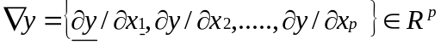 (1)

In the cost model developed for the turbine disc, sensitivity analysis is employed to estimate the degree of sensitivity of each design parameter on the output cost of the model. In Table 2 relative and absolute sensitivity are calculated for the inputted design parameters on output cost, relative sensitivity shows the percentage change in the output that is caused by a 1% change in the input parameters and absolute sensitivity shows the output change for a unit change in the input. From this it can be identified which parameters have the least impact on the design and therefore, highlight where most of the effort should be targeted in making decisions that influence the cost.

Table.1 Sensitivity of design parameters

Thurston[50]; Thurston and Tiefu [51]; Ullman and Herling [52]; Carnahan[53] et al proposed decision support techniques for design evaluation under uncertainty. It has been seen that risk is of the highest order predominantly in some of the cost issues during the early stages of product development and definition. Rather than focusing on the actual management of risk, the focus should be on combining statistical analysis with cost estimation in order to predict the cost estimation uncertainty to be attributed. Curran et al states that it is more realistic to have a range of cost estimates rather than a discrete value, and this is more likely to be accurate in modelling the effect of cost variance, which is a reality for any product [19].
Monte Carlo simulation allows understanding of the effect of distribution fit to the uncertain quantities within the model on the output. The analysis of cumulative distribution and frequency distribution, as shown in Graph 2a and Graph 2b obtained after running Monte Carlo simulations on the model, shows the bounds on the output of the model. It also provides the most probabilistic value that can be expected .It has to be noted that all the numbers presented in the simulation and analysis studies are morphed in order to preserve confidentiality of Rolls Royce plc proprietary data. The cumulative distribution function graph shows that it is 18% likely that the cost of the component will be less than £52400, which is useful in reading specific probabilities. The best estimate cost is the mode, which is £54000, this value subtracted from value of the 70th percentile cost £54788.41 gives a risk that is £788.41. Similarly, the frequency distribution provides a range of possible outcomes for the cost of the component. This not only gives the designer the opportunity to model uncertainty but also provides information about the risk involved with these uncertain quantities in the model.

(a) (b)
Graph.1 a) Cumulative distribution function graph b) Probability Density function graph

The statistics computed by the Monte-Carlo simulations may vary to a large extent depending on the correlation between the random variables. So, in the absence of real-time model data, we may obtain misleading statistics if the correlation between the random variables is ignored. Thus a correlation of ρ_{optimum} = 0.2 has been assumed to compute the desired statistics. The value for ρ_{optimum} has been obtained from Steve Book’s rule of thumb. Book et al [54] plotted the theoretical underestimation of standard deviation when the correlation is assumed to be zero rather than its true value, ρ. As shown in Graph 3 the “Knee” of the plots by Book lies at about 0.2, which means that the percentage underestimation remains almost constant with varying correlation values and thereby providing the least loss of accuracy. This fact is illustrated in Table 3 and 4. Where the percentage error in standard deviation and 70th percentile are shown for the assumed correlations zero and ρ_{optimum}.

Graph.2 Book’s Knee curve graph[54]

Table.2 Percentage error in computation of standard deviation and 70th percentile when the assumed correlation is ρ = 0

Table.3 Percentage error in computation of standard deviation and 70th percentile when the assumed correlation is ρ = ρ_{optimum} =0.2

This case study shows that the Tree Object knowledge representation with added risk functionalities contained within the tool can provide a way forward in the cost modelling world in reducing effort in modelling and understanding the risk involved.

5. Conclusions and future work
The Hybrid representation paradigm and Hybrid estimating method developed within the Knowledge based system provides access to cost information for the design community to understand the implications of their design decisions on cost. It will allow the representation of previous solutions and historical data using Tree objects and support their subsequent re-use, which accords well with design practice and facilitates rapid model building activity. The ability to produce tree objects and employ the composition method on a hierarchical tree structure, as detail is added to the design, reflecting in the constructive and incremental nature of the design process is another advantage of the representation technique. It can also be seen that the incorporation of sensitivity analysis, Monte Carlo simulations and correlation into a hybrid representation environment is highly conducive for risk studies. These functionalities help the user in dealing with uncertainty attached to early stage design.
As the DATUM research is an ongoing project further studies on sub-system and whole system level models are being carried out in order to understand in detail the importance of this hybrid representation paradigm in model building, scaleability and risk presented by employing Monte Carlo, sensitivity and assessing correlations at these levels of abstraction. Efficient and robust geometry parameterisation schemes must be derived to seamlessly integrate design with cost. Future work in this sphere concerns integration of optimization algorithms and performance analysis tools within a scripting environment. This will enable multidisciplinary design optimization to produce cost driven, realistic and manufacturable designs at acceptable performance levels.

Acknowledgments
The Authors would like to thank Rolls-Royce and DATUM project members for supporting this research work and allowing this information to be released for publication.

References

1. Wright, T., P., Factors Affecting the Cost of Airplanes. Journal of Aeronautical Sciences, 1936. 3: p. 122-128.
2. Stewart, R., D.,Wyskida,R.,M.,and Johannes,J.,D.(eds.), ed. Cost Estimator's refernce manual. 2 ed. Johan Wiley & sons Inc. 1995a: New York.
3. Stewart, R., Wyskidsa,R.,Johannes,J., Cost Estimator’s reference manual. 2nd ed. 1995: Wiley Interscience.
4. Rush, C., and Roy,R. Analysis of cost estimation processes used within a concurrent engineering enviroment throughout a product life cycle. in Seventh ISPE international conference on concurrent engineering:research and application. 2000. Lyon,France: Technomic,Pennsylvania,USA.
5. Taylor, I., M. Cost engineering- a feature based approach. in 85th meeting of the AGARD structures and material panel. 1997. Aalborg,Denmark.
6. Boothroyd, G., Dewhurst, P., and Knight, W., Product Design for Manufacture and Assembly :Manufacturing Engineering and Materials Processing. 2001, New York: Marcel Dekker.
7. Dean, E., B. The Design-to-Cost Manifold. in International Academy of Astronautics symposium on Space Systems Cost Methodologies and Applications. 1990. San Diego,California,U.S.A.
8. Dean, E., B.,and Unal,R., Design For Cost, in Conference of the American Association of Cost Engineers. 1991.
9. Asiedu, Y., and Gu,P., Product life cycle cost analysis:state of the art review. International Journal of Production Research, 1998. 36(4): p. 883-908.
10. FAA, FAA life cycle cost estimation handbook. 2002, Investment cost analysis branch of the federal aviation administration.
11. Boehm, B., W., Software engineering economics. 1981, Englewood Cliffs,N.J.: Prentice-Hall.
12. Huges, R., T., Expert judgement as an estimating method. Information and software technology, 1996. 38(2): p. 67-75.
13. Ostwald, P., Engineering cost estimating. 1992, Englewood Cliffs,NJ: Prentice-Hall. 576.
14. DOD, Parametric estimation handbook, Defence, Editor. 1999.
15. Catania, G., Form-features for Mechanical design and Manufacturing. Journal of Engineering Design, 1991. 2(1): p. 21-43.
16. Wierda, L., S., Linking design,process planning and cost information by feature-based modelling. Journal of Engineering Design, 1991. 2(1): p. 3-19.
17. Bronsvoort, W., F.,and Jansen,F.,W., Multi-view feature modelling for design and assembly, in Advances in feature based manufacturing. 1994. p. 315-329.
18. Younossi, O., Arena,M.,V.,Moore,R.,M.,Lorell,M.,Mason,J.,and Graser,J.,C., Military Jet Engine Acquisition:technology basics and cost-estimating methodology, U.S.A. Force, Editor. 2002, RAND. p. 153.
19. Curan, R., Raghunathan,R.,and Price,M., Review of aerospace engineering cost modelling:The genetic causal approach. Progress in Aerospace Sciences, 2004. 40(8): p. 487-534.
20. Marx, J., W.,Mavris,N.,D.,and Schrage,D.,P., A Hierarchical aircraft life cycle cost analysis model. American Institute of Aeronautics and Astronautics, 1995.
21. Shah, J., and Mantyla ,M. , Parametric and Feature-based CAD/CAM. 1995, New York: John Wiley.
22. Hill, T., M. . Knowledge based strategies in design automation. in Proceedings of the 4th International Conference on Flexible Automation and Integrated Manufacture (FAIM 94). 1994. Virginia Polytechnic and State University,Blacksburg, VA.
23. Hill, T., M., Colmer, G., Forster, R. A knowledge based design for manufacture system for aerospace design. in Proceedings of the 31st International MATADOR Conference. 1995. UMIST, UK.
24. Jung, J., Y., Manufacturing Cost estimation for machined parts based on manufacturing features. Journal of Intelligent Manufacturing, 2002. 13(4): p. 227-238.
25. Chep, A., and Tricaico,L., Object-oriented analysis and design of a manufacturing feature representation. International Journal of Production Reasearch, 1999. 37(10): p. 2349-2376.
26. Zorn, T., E. and Taylor, J., R., Knowledge management and/as organizational communication in Key Issues in Organizational Communication, D. Tourish, Hargie, O., Editor. 2003, Taylor&Francis: Routledge:London p. 98-99.
27. Rush, C., and Roy, R. Capturing quantitative & qualitative knowledge for cost modelling within a CE environment. in ISPE international conference on concurrent engineering: research and applications. 2001. Anaheim, Los Angeles,Pennsylvania, USA: CETEAM.
28. Rush, C., and Roy,R., Expert judgement in cost estimating:modelling the reasoning process. Concurrent Engineering Research Application, 2001. 9(4).
29. Bench-Capon, T., J.,M., Knowledge Representation:An approach to Artificial Intelligence. The A.P.I.C Vol. 32. 1990, London: Academic Press Limited.
30. Winograd, T. Frame representations and the procedural/declarative controversy. in Representation and understanding:Studies in cognitive Science. 1975. New York:Academic.
31. McCarthy, J. Programs with common sense. in Symposium in Mechanism of Thought. 1958: Nat.Phys.Lab.
32. McCarthy, J., and Hayes,P. Some philosophical problems from the standpoint of artificial intelligence. in Machine Intelligence. 1969. Edinburgh: Edinburgh Univ. Press.
33. Mylopoulos, J. An overview of Knowledge representation. in Proceedings of the 1980 workshop on Data abstraction databases and conceptual modeling. 1981. United States
34. Brachman, R., and Levesque,H., Knowledge Representation and reasoning. 2004: Elsevier.
35. Butler, R., J. Is this Spreadsheet a Tax Evader? How H. M. Customs & Excise Test Spreadsheet Applications. in Proceedings of the Thirty-Third Hawaii International Conference on System Sciences. 2000 Maui, Hawaii.
36. Paine, J. Spreadsheet structure discovery with logic programming in Proceedings of Spreadsheet Risk Symposium (European Spreadsheet Risk Interest Group). 2005.
37. Panko, R., P. Spreadsheet Errors: What We Know, What We Think We Can Do in Proceedings of Spreadsheet Risk Symposium (European Spreadsheet Risk Interest Group). 2000.
38. Floyd, B., D., and Pyun, J., Errors in Spreadsheet Use(Working Paper 167). 1987, Information Systems Department, New York University, New York, October, Center for Research on Information Systems.
39. Panko, R., P., What We Know About Spreadsheet Errors Journal of End User Computing's:Special issue on Scaling Up End User Development, 1998. 10(2): p. 15-21.
40. Olugbenga , O., M. Object-oriented simulation using model builder. in Proceedings of the 1993 Winter Simulation Conference 1993.
41. Zeigler, B., P., Hierarchical, Modular, Discrete Event Modelling in an Object-oriented Environment. Simulation 1987. 49(5): p. 219-230.
42. Ulgen, O., M.,and Thomasma, T. Simulation Modeling in an Object Oriented Environment using Smalltalk-80. in Proceedings of the 1986 winter Simulation Conference. 1986. San Diego, California: The Society for Computer Simulation.
43. Joel , J., L. Hierarchical modular concepts applied to an object-oriented simulation model development enviroment. in Proceedings of the 1992 Winter Simulation Conference. 1992.
44. Hewitt, C., Viewing control structures as patterns of passing messages. journal of Artificial Intelligence, 1977. 8(3): p. 323-364.
45. Marc , J., Arons,H.,D.,S, An Object-Oriented model of an industrial enterprise and its environment. 1992, Dept. of Computer Science, Erasmus University Rotterdam.
46. Cheolhan , K., Kwangsoo, K., and Injuj ,C., An Object-oriented information modeling methodology for manufacturing information systems. Computers and Industrial .Engineering, 1993. Vol. 24(3): p. pp.337-353.
47. Reed, J., A.,and Afjeh,A.,A. Computational Simulation of Gas Turbines:Part1-Foundations of Component-Based Models. in Transactions of the ASME. 2000.
48. Samareh, J., A., Survey of shape parameterization techniques for high-fidelity multidisciplinary shape optimization AIAA Journal, 2001. 39(5): p. 877-884.
49. Andy , J., K.,and Prasanth ,B.,N., Computational Approaches for Aerospace Design: The Pursuit of Excellence 2005: John Wiley &Sons Ltd.
50. Thurston, D., L., A formal method for subjective design evaluation with multiple attributes Research in Engineering Design, 1991. 3(2): p. 105-122.
51. Thurston, D., L,and Tiefu,L., Design evaluation of multiple attributes under uncertainity. International Journal System Automation : Research and Application(SARA), 1991. 1(2): p. 143-159.
52. Ullman, D., G.,and Herling,D. Engineering decision support system. in In:Proceeding of international conference engineering design. 1995. Praha,Czech Republic.
53. Carnahan, J., V.,Thurston,D.,L., and Liu,T., Fuzzy ratings for multiattribute design decision-making. Journal mechanical Design, 1994. 116: p. 511-521.
54. David , R., G. What is Cost Risk? in NASA risk management conference. 2005.

List of Figures

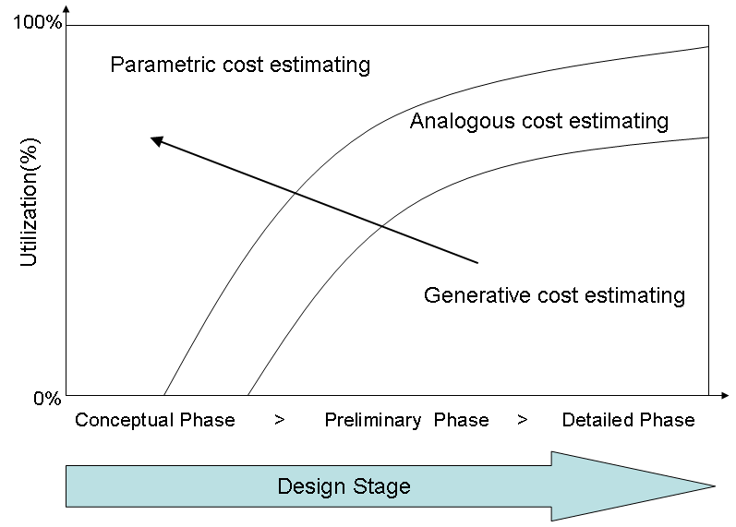

Fig.1 Need for detailed information in early design [20]

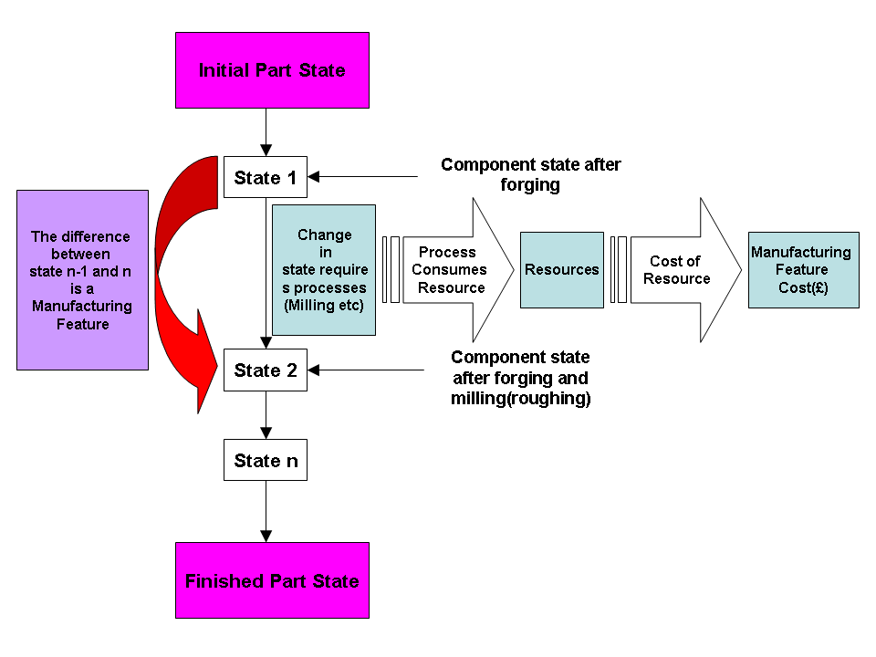

Fig .2 State transition and manufacturing feature costs

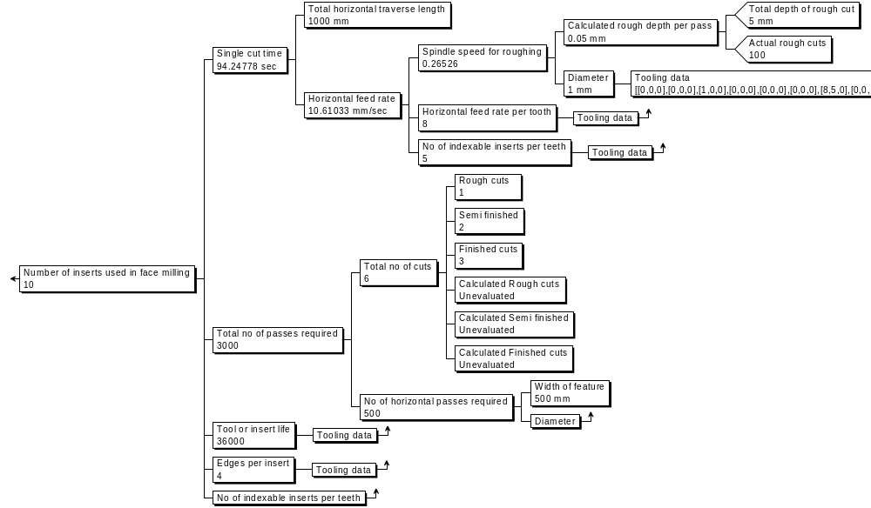

Fig.3.Tree structured knowledge representation

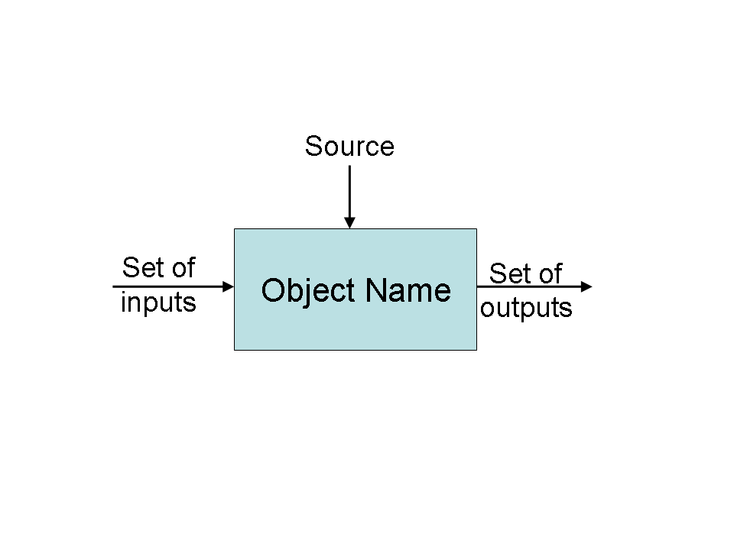

Fig.4. Object diagram

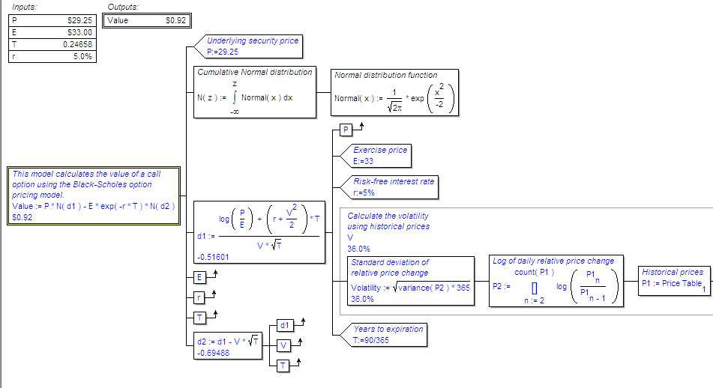
Fig.5.Tree structure with exposed properties

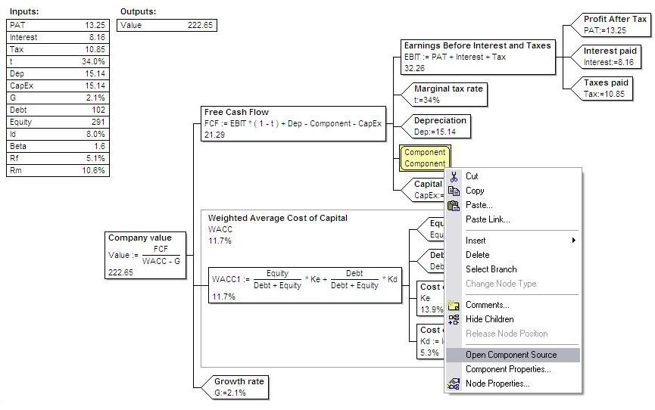
Fig.6.Tree object instantiated in tree structure

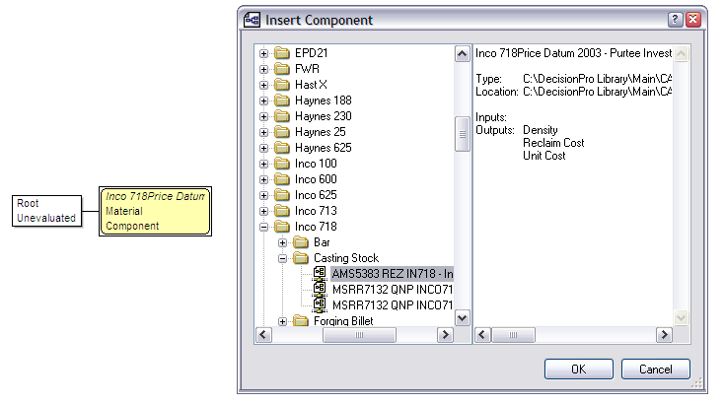
Fig.7. Illustration of library functionality

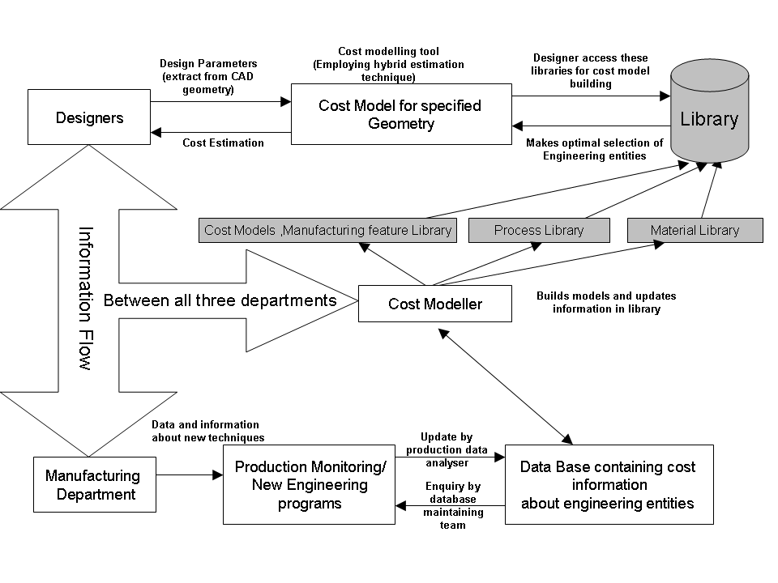
Fig 8. Cost control and information flow structure

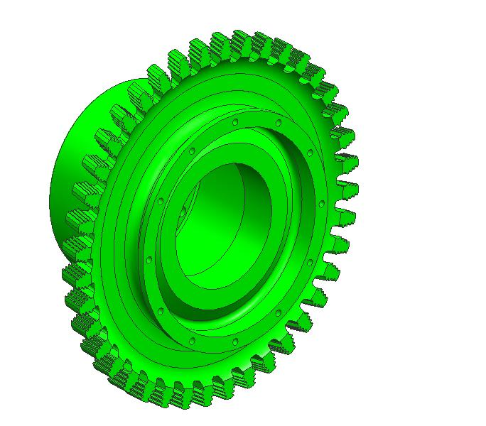
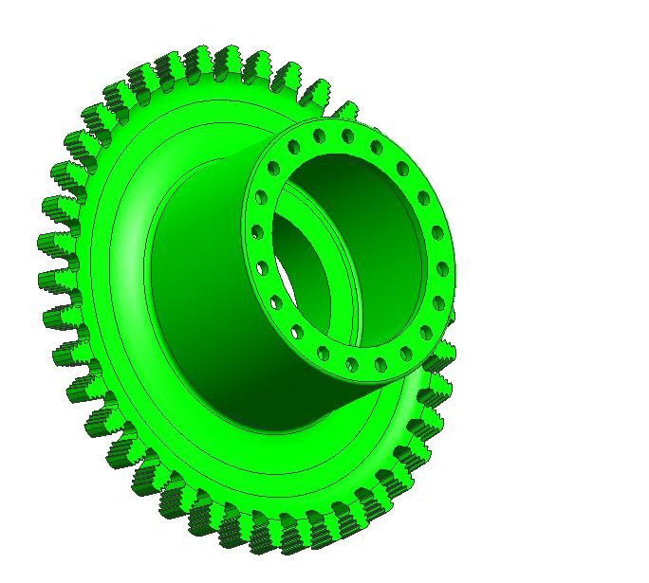
Fig.9 3D views of disc

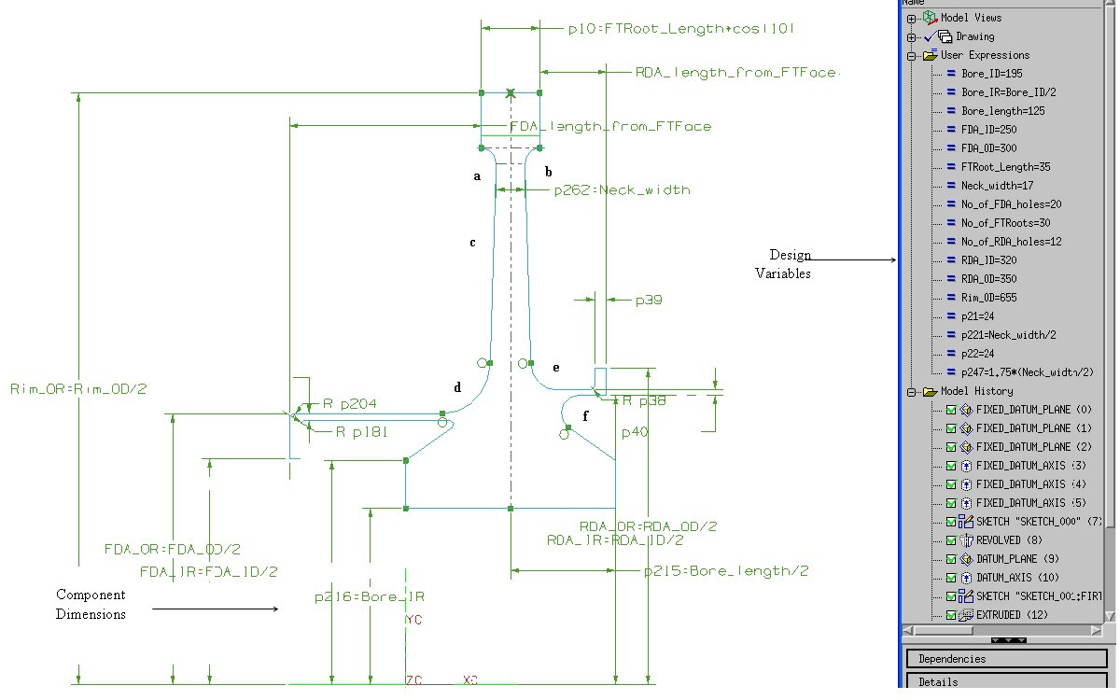

Fig.10 Two dimensional representation of the disc and design variables

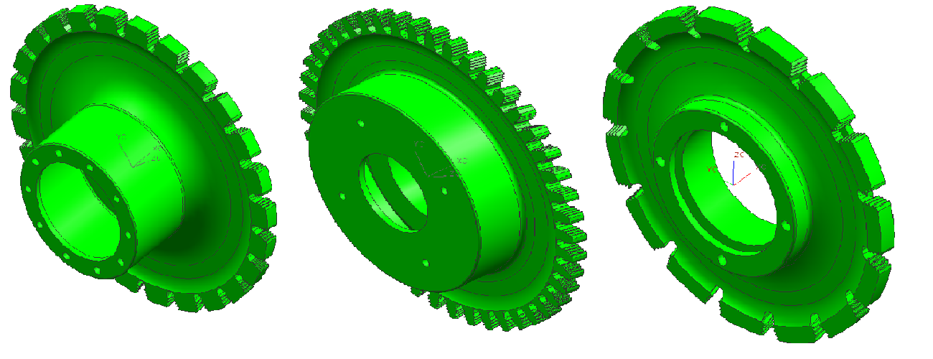

Fig .11 Range of geometries achieved by modifying the design variables

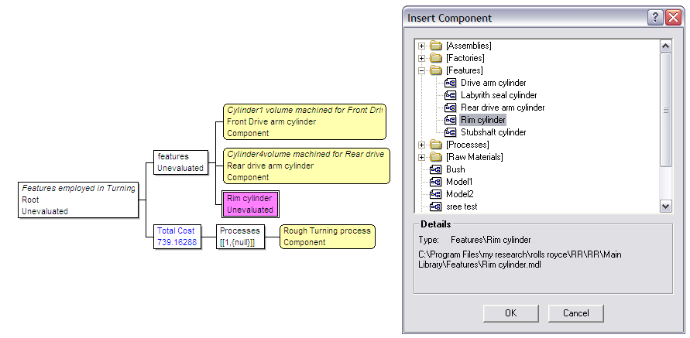
Fig.12The tree object Rim Cylinder being added to the disc component model

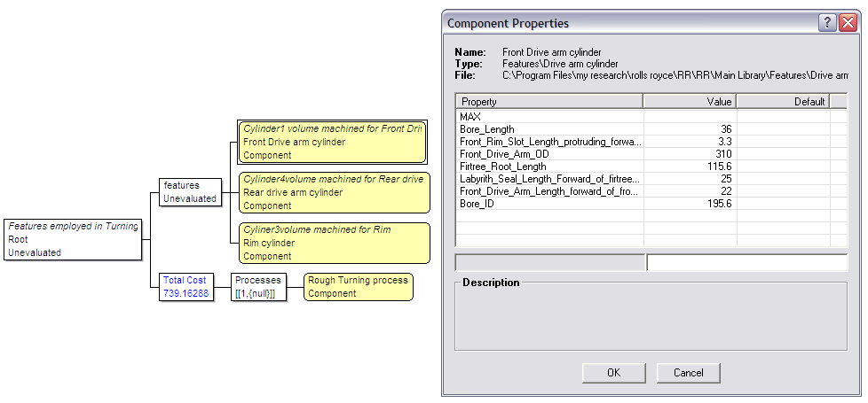
Fig.13 The input parameters for the tree object Front Drive Arm manufacturing feature

List of Graphs

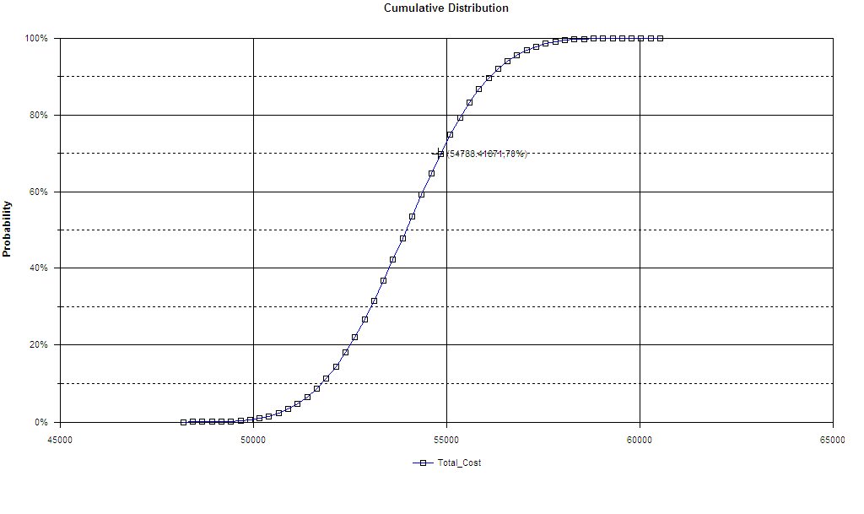

Graph.1 a) Cumulative distribution function graph

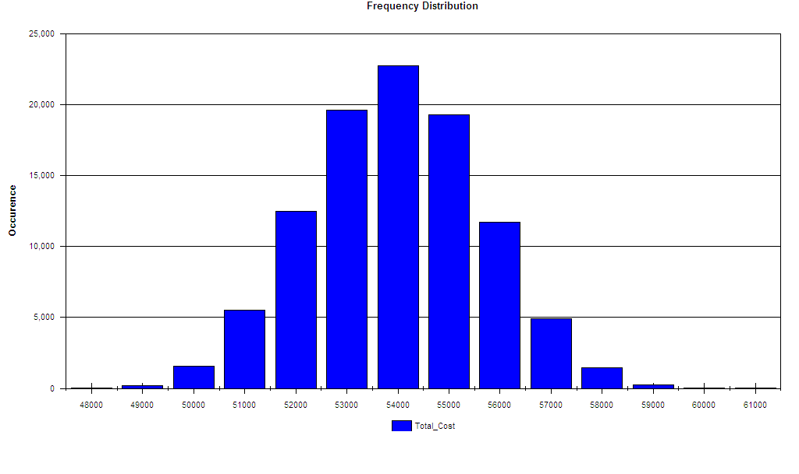

Graph.1 b) Probability Density function graph

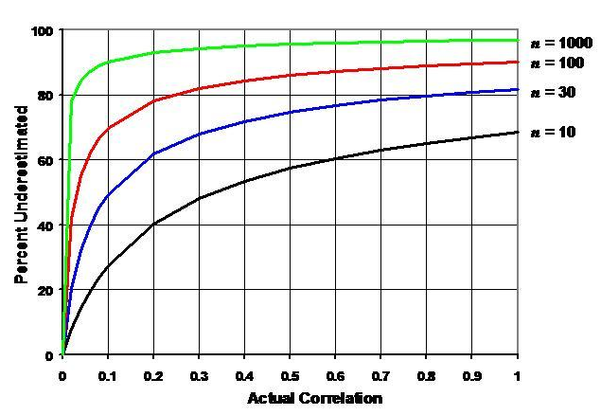

Graph.2 Book’s Knee curve graph[54]

List of Tables

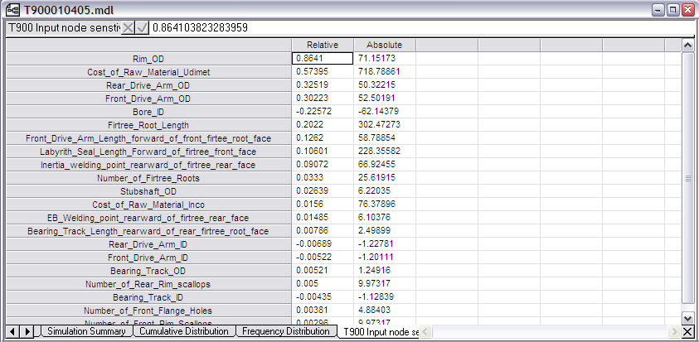

Table.1 Sensitivity of design parameters

Actual Correlation | Standard Deviation | 70th Percentile | Error in standard deviation (%) | Error in 70th Percentile (%)
0.3 | 1697.915 | 54839.156 | 0.95 | 0.09
0.5 | 1709.590 | 54847.161 | 1.63 | 0.1
0.7 | 1721.846 | 54868.995 | 2.33 | 0.14
0.9 | 1734.330 | 54890.826 | 3.03 | 0.18
1 | 1741.590 | 54912.663 | 3.44 | 0.22

Table.2 Percentage error in computation of standard deviation and 70th percentile when the assumed correlation is ρ = 0

Actual Correlation | Standard Deviation | 70th Percentile | Error in standard deviation (%) | Error in 70th Percentile (%)
0.3 | 1697.915 | 54839.156 | 0.33 | 0.02
0.5 | 1709.590 | 54847.161 | 1.01 | 0.03
0.7 | 1721.846 | 54868.995 | 1.71 | 0.07
0.9 | 1734.330 | 54890.826 | 2.42 | 0.11
1 | 1741.590 | 54912.663 | 2.83 | 0.15

Table.3 Percentage error in computation of standard deviation and 70th percentile when the assumed correlation is ρ = ρ_{optimum} =0.2

Ph.D. Student, Computational Engineering Design Research Group, School of Engineering Sciences, svt@soton.ac.uk.
Ph.D. Student, Computational Engineering Design Research Group, School of Engineering Sciences, arr@soton.ac.uk.
Professor of Design, Computational Engineering and Design Research Group, School of Engineering Sciences, jps7@soton.ac.uk.
Professor of Design, Chair of Computational Engineering and Design Research Group, School of Engineering, Sciences,ajk@soton.ac.uk
Professor of Structural Materials, Material Research Group, School of Engineering Sciences, pasr1@soton.ac.uk.

