A micro-mechanistic approach to lifing of thermal barrier coatings for gas turbine blades
Research Engineer: | Stewart Everitt Email: stewart@soton.ac.uk, severitt@qinetiq.com
School: |   Engineering Sciences
Sponsor: | QinetiQ Ltd
Industrial Mentor(s): | Dr Jeffery Brooks, Dr Hector Basoalto
Academic Supervisor(s): | Professor Philippa Reed, Professor Marco Starink
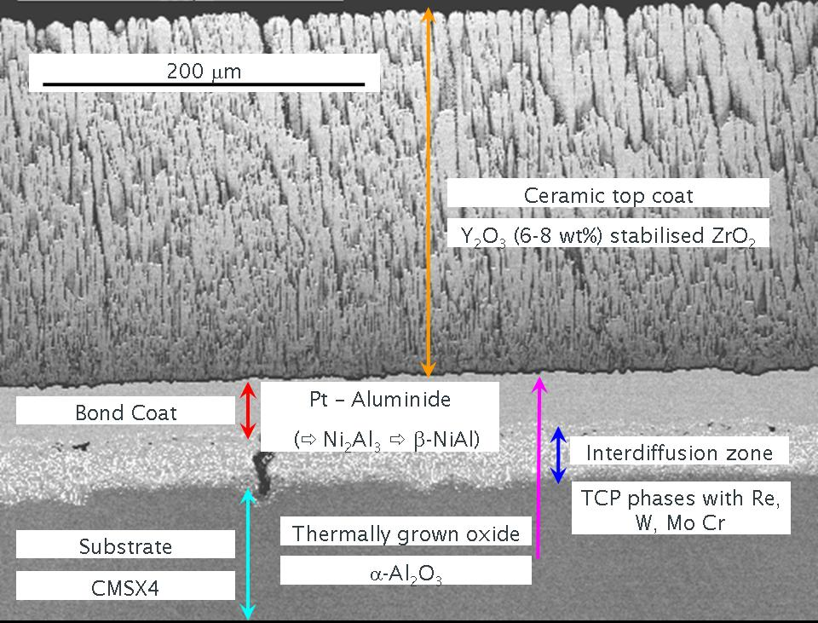
Introduction – Gas turbine engine operating temperatures can be increased by the application of a thermal barrier coating (TBC) system to the turbine blades with an attendant increase in efficiency and / or substrate lifetime. Fig. 1 shows a typical TBC applied by Electron Beam Physical Vapour Deposition (EBPVD).
Figure 1 EBPVD Thermal Barrier Coating System
TBC Lifing – The dominant failure mechanisms in this type of TBC arise from: (1) Thermal mismatch between the Thermally Grown Oxide (TGO) layer and the Bondcoat / substrate due to differences in thermal expansion coefficients; (2) Growth of the TGO layer both in thickness and laterally via diffusion, both these mechanisms lead to an increase in internal stresses; and (3) Morphological evolution of the TGO / Bondcoat interface (also known as rumpling) leading to changes in location of local stress concentrations. The internal stresses developed by all three mechanisms are believed to lead to subsequent crack initiation and propagation. Undulation kinetics are faster under thermal cycling rather than isothermal conditions. Current lifing methods generally use lifetime data gathered from isothermal and thermal cyclic testing of the TBC system with spallation of the top coat being used as the failure criterion. Due to the brittle nature of the ceramic top coat and variations associated with processing, a large amount of scatter is obtained in these tests and hence a reduction in the life that may be safely used.
Aim of current work - The aim of the current project is to develop a model for TBC lifetimes that predicts the physical changes occurring in terms of morphology and physical properties of the materials involved and combines these to predict failure lifetime under thermo-mechanical fatigue (TMF) conditions.
Test matrix and method - The test matrix has been designed to isolate the effects of the various damage mechanisms. Testing included: (a) isothermal exposures between 950˚C and 1150˚C from 30 to 3000 hours. (b) Single step thermal exposures at similar temperatures and a second exposure at 950˚C (c) Thermal cyclic tests (d) a creep test to assess the effect of stress, and (e) TMF tests with some specimens pre-damaged by prior oxidation. Tests (a), (b) and (c) were carried out using “buttons” of CMSX4 coated with a CN91 type bond coat and a partially stabilized Zirconia topcoat applied by EBPVD. Test (d) was carried out in a standard creep test rig. Test (e) was designed to be representative of the TMF in terms of stress and temperature cycle that a
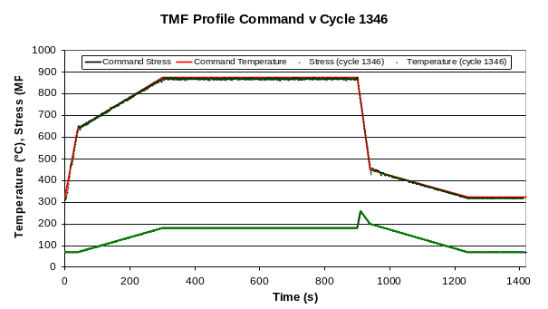
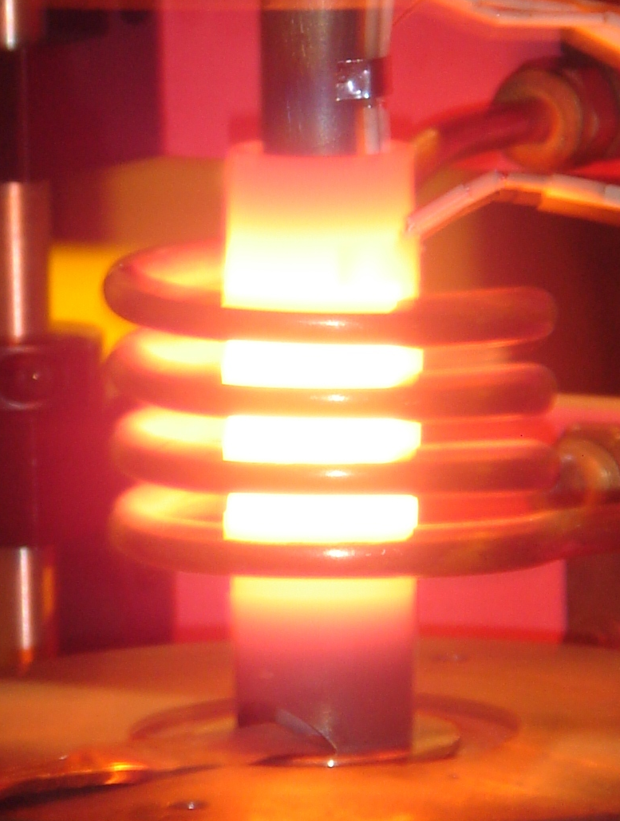
current high pressure turbine blade sees in service, as defined by previous work carried out by QinetiQ. Development of the TMF test method was non-trivial as direct induction heating generates an inverse temperature gradient across the TMF specimen when compared to that seen in service. A temperature profile representative of in service temperature conditions (i.e. top coat at higher temperature than substrate) was created by using a susceptor (figure 2) to heat the test specimen and cooling the bore of the specimen with air. Figure 3 shows that the commanded TMF cycle is achieved, the command cycle being obscured by the actual results on the black and white graph.
Fig. 2 Induction heated susceptor
Figure 3 TMF test profile command v achieved
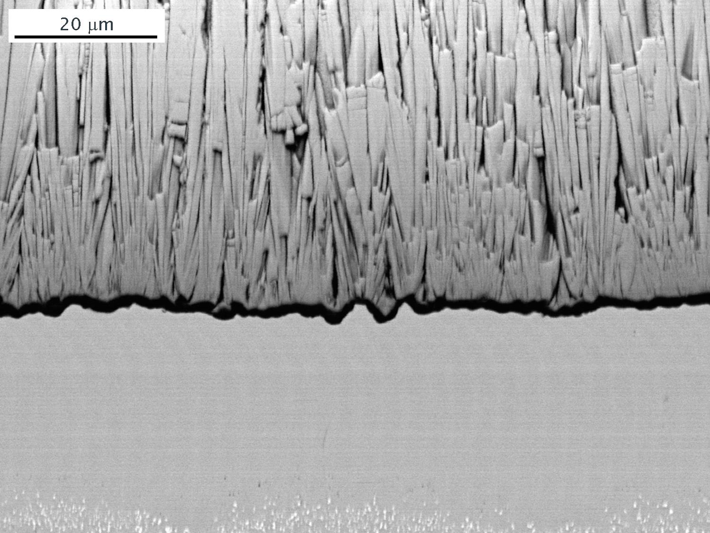
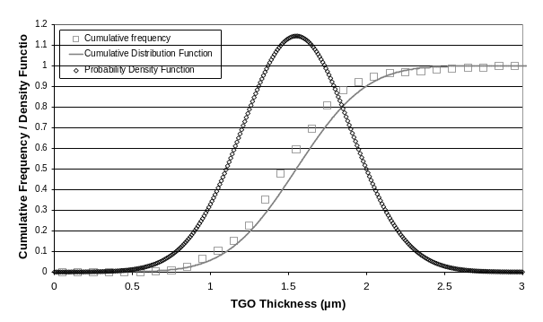
Results - Initial results of the TGO growth after isothermal exposure are shown in Figure 4, after measurement of the TGO thickness, a cumulative distribution function (CDF) (Fig. 5) can be used to describe the thickness and hence a probability density function (PDF) derived for the model.
Figure 5 Cumulative distribution, CDF and PDF of TGO thickness after isothermal exposure
Figure 4 TGO thickness after isothermal exposure FEG SEM BEI mode
Model - A finite element (FE) model is currently in development that takes account of the microstructural changes, morphological evolution and stress states arising from the combined exposure to cyclic stress and cyclic temperatures seen during TMF.
Summary - (1) TBCs provide increased temperature operation or increased life for turbine components. (2) Determining the effects of TMF on microstructure evolution is critical to understanding failure in TBCs (3) A microstructure informed FE model is being developed with the aim of predicting life. (4) A TMF test capability for TBCs that simulates conditions seen in service has been demonstrated.
Further work - (1) Following completion of the model, correlation of model with current TMF tests, (2) Development of TMF testing equipment for higher temperatures (3) Measurement of strain during TMF testing.
Acknowledgements - UK MOD Contract TA/N05507

