IDENTIFICATION OF IMPACT DAMAGE IN CFRP LAMINATES USING THE NDT APPROACH

M.T.H.Sultan¹, K. Worden¹, J.M. Dulieu-Barton², W.J.Staszewski¹, A.Hodzic¹, S.G. Pierce³,
¹Department of Mechanical Engineering, University of Sheffield, Mappin Street, Sheffield, S1 3JD, United Kingdom
²School of Engineering Sciences, University of Southampton, Highfield, Southampton, SO17 1BJ, United Kingdom
³Department of Electronic and Electrical Engineering, University of Strathclyde, Royal College Building, 204 George Street, Glasgow, G1 1XW, United Kingdom
E-mail: K.Worden@Sheffield.ac.uk
ABSTRACT
The motivation for this work is to identify impact damage in structures made from composite material. The composite material chosen for this research was Carbon Fibre Reinforced Polymer (CFRP) prepreg with a MTM57 epoxy resin system with CF2900 fabric. This material was fabricated to produce laminated plate specimens of 250 mm × 150 mm with 11, 12 and 13 layers of thickness. PZT sensors were placed at three different points on each of the plate specimens to record the responses from impact events. The impact test was performed using an instrumented drop test rig and the impact energies were set to range from 2.61 J to 41.72 J. All the signals captured from the impact test were recorded using a LMS data acquisition system and the impacted plate specimens were later examined using X-rays to evaluate the damage area. The correlation between the damage area in terms of the impact energy and the force detected is presented and discussed.

1. INTRODUCTION
Many of our present technologies especially those materials used in the aerospace industry require an unusual combination of properties that cannot be met by conventional metal alloys, ceramic and polymeric materials. For example, aerospace engineers are increasingly searching for structural materials that have low densities and are strong, stiff and not easily corroded. Therefore since the early 1950’s, composites have been used by the aerospace industry [1-3]. Composites are defined as a material which has two or more different elements that when combined, produce a stronger, stiffer, tougher and more durable material than the individual elements. The most common man-made composites can be divided into three main categories: Polymer Matrix Composites (PMC’s), Metal Matrix Composites (MMC’s) and Ceramic Matrix Composites (CMC’s) [4]. The most commonly-used and the ones discussed here are the Polymer Matrix Composites, also known as Fibre Reinforced Polymers, FRP (or Plastics). A fibre reinforced composite material is a type of structural system which consists of a matrix reinforced with a fibrous form of another material [4-5]. This material has proven to be highly favourable material for aerospace applications [6]. Such materials usually have a brittle epoxy matrix, making them susceptible to internal damage caused by impact which affects the structural integrity and stiffness of the material [7, 8]. This paper is part of on-

going research investigating the damage caused by impacts on composite structures. The material considered in this study is a woven fabric composite which is considered to be more competitive compared to the unidirectional composites in terms of impact resistance;. numerous studies have reported their excellent impact response and extensive experimental data has been reported [9, 10].
The goal of the current research is to conduct an experimental investigation to detect and quantify impact damage in structures made from CFRP plates of different layer thicknesses, under varying impact energy levels. The composite material chosen for this research is a Carbon Fiber Reinforced Polymer (CFRP) composite with 2 × 2 twill woven fabric prepreg with a MTM57 epoxy resin system. Large panels were manufactured from the CFRP material and later were cut to produce laminated plate specimens of 250 mm × 150 mm with 11, 12 and 13 layers.
PZT sensors were located at three different points of each test specimen in order to record the responses from impact events. To perform the impact tests, an instrumented drop test rig was used and the impact energy was set to range from 2.61 J to 41.72 J. More specific objectives are to examine the impact load, impact energy, impact resistance, penetration behavior and the effect of low-velocity loading corresponding to different layer thickness and velocity.

2. WOVEN COMPOSITE OVERVIEW
From the point of a composite, fabrics are defined as long fibres of carbon and/or glass which are used to produce a flat sheet consisting of one or more layers of fibres [11]. Woven fabric (WF) composites have been widely used and have been recognized as more competitive than the unidirectional composites in impact resistance [12]. These woven fabrics are produced by interlacing the warp and weft fibres in a regular pattern and weave style. Commonly used woven fibres are plain or square weave, twill weave, satin weave and basket (hopsack) weave. Among these, the most commonly used in engineering applications is the plain or square weave. This type of fabric is symmetrical, has a good structural integrity, exhibiting optimum fibre stability, with reasonable porosity [13]. Many studies have been carried-out concerning the impact response of woven composites [14-16]. Atas and Sayman [17] conducted a study mainly on woven fabric composite plates made of E-glass to look at the impact response of this material. To fabricate the composite panel, two different types of resin and hardener were chosen from type SC-15A resin and SC-15B hardener. The fabricated composite test plates had four layers of laminate with dimensions of 100 mm × 100 mm × 2.2 mm. The composite was first cured at 60ºC for about 2 hours and later at about 93ºC for 4 hours with a constant pressure of 0.35 MPa. To conduct the impact test, an instrumented drop test machine equipped with a 12.5 mm impactor and a 22.24 kN load cell were used and the impact energy was varied between 4 J and 45 J. It was found that, as the impact energy increased, the damage developed at the test specimen increased proportionally. The type of damage found on the test specimens were fiber breakage, fiber pullout and finally indentation, which was found at the impact energy of 38 J. The cited paper concluded that, the radius of impactor nose to plate thickness ratio plays an important role in identifying and determining the penetration threshold, penetration range and perforation threshold of the impacted specimen.

3. FABRICATION OF TEST SPECIMEN
CFRP Prepreg was chosen for this research and was supplied by the Advanced Composites Group (ACG). The material used was a MTM epoxy resin system (42%RW) with CF2900 fabric (280 g/m², 12K, 2×2 twill fabric) supplied in a 1.25 m × 16 m roll. Initially four large panels were produced with dimensions of 0.625 m × 0.625 m. The panels were fabricated using a standard vacuum-bagging procedure by applying both heat and pressure to the composite components in a controlled approach (cured for 30 minutes at 120ºC at 5.8 bar). An approximate equation for the thickness of the layers is as follows:
Cured ply thickness (cpt) =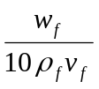 (1)
where w_{f} = fabric weight (280 g/m²), ρ_{f} = fibre density (1.8g/m³) and v_{f} = fibre volume fraction (49%). Equation (1) indicated that 12 layers would produce a specimen of approximately 3 mm in thickness. Therefore three of the panels were formed with 12 layers of prepreg in which all layers were oriented in the same 0º-direction. The fourth panel was initially laid-up with 11 layers and then a further two more layers were placed on half of the panel (bounded by the edge and the centerline).
The purpose of fabricating the fourth panel was to investigate the effect of the number of layers on the extent of impact damage. Each panel was later cut into 8 test specimens with the dimensions 250 mm × 150 mm using a diamond saw. To identify a test specimen with a particular number of layers, a simple nomenclature was defined. For 12-layer plates, each panel was labeled with A, B and C and were cut into 8 specimens which were named accordingly (for example, the plate B samples were labeled 12LB1 to 12LB8). The final plate which has 11 layers at one end and 13 layers at the other end was cut into 4 samples on each side. In total, this procedure gave 24 impact test samples with 12 layers, and 4 samples each with 11 and 13 layers.
To record the impact responses, PZT sensors of type SONOX ® P5 were chosen. These sensors were soldered to the surface with two connecting wires at one end and with a pin connecter at the other end. All sensors were attached to the plate using X60 adhesive (manufactured by HBM, Germany). The PZT sensors were placed at three different positions on each test specimen in order to sample responses along different directions of the ply. The total number of sensors used was therefore 96 while the impact energy for the whole test was set to range from 2.6 J to 41.72 J.

4. EXPERIMENTAL OVERVIEW
For this study, an instrumented drop test rig was used to perform the impact tests (see Figure 1). This device was connected to a LMS Data Acquisition System to record the responses from the impact test. The basic features of the laboratory impact rig were as follows:
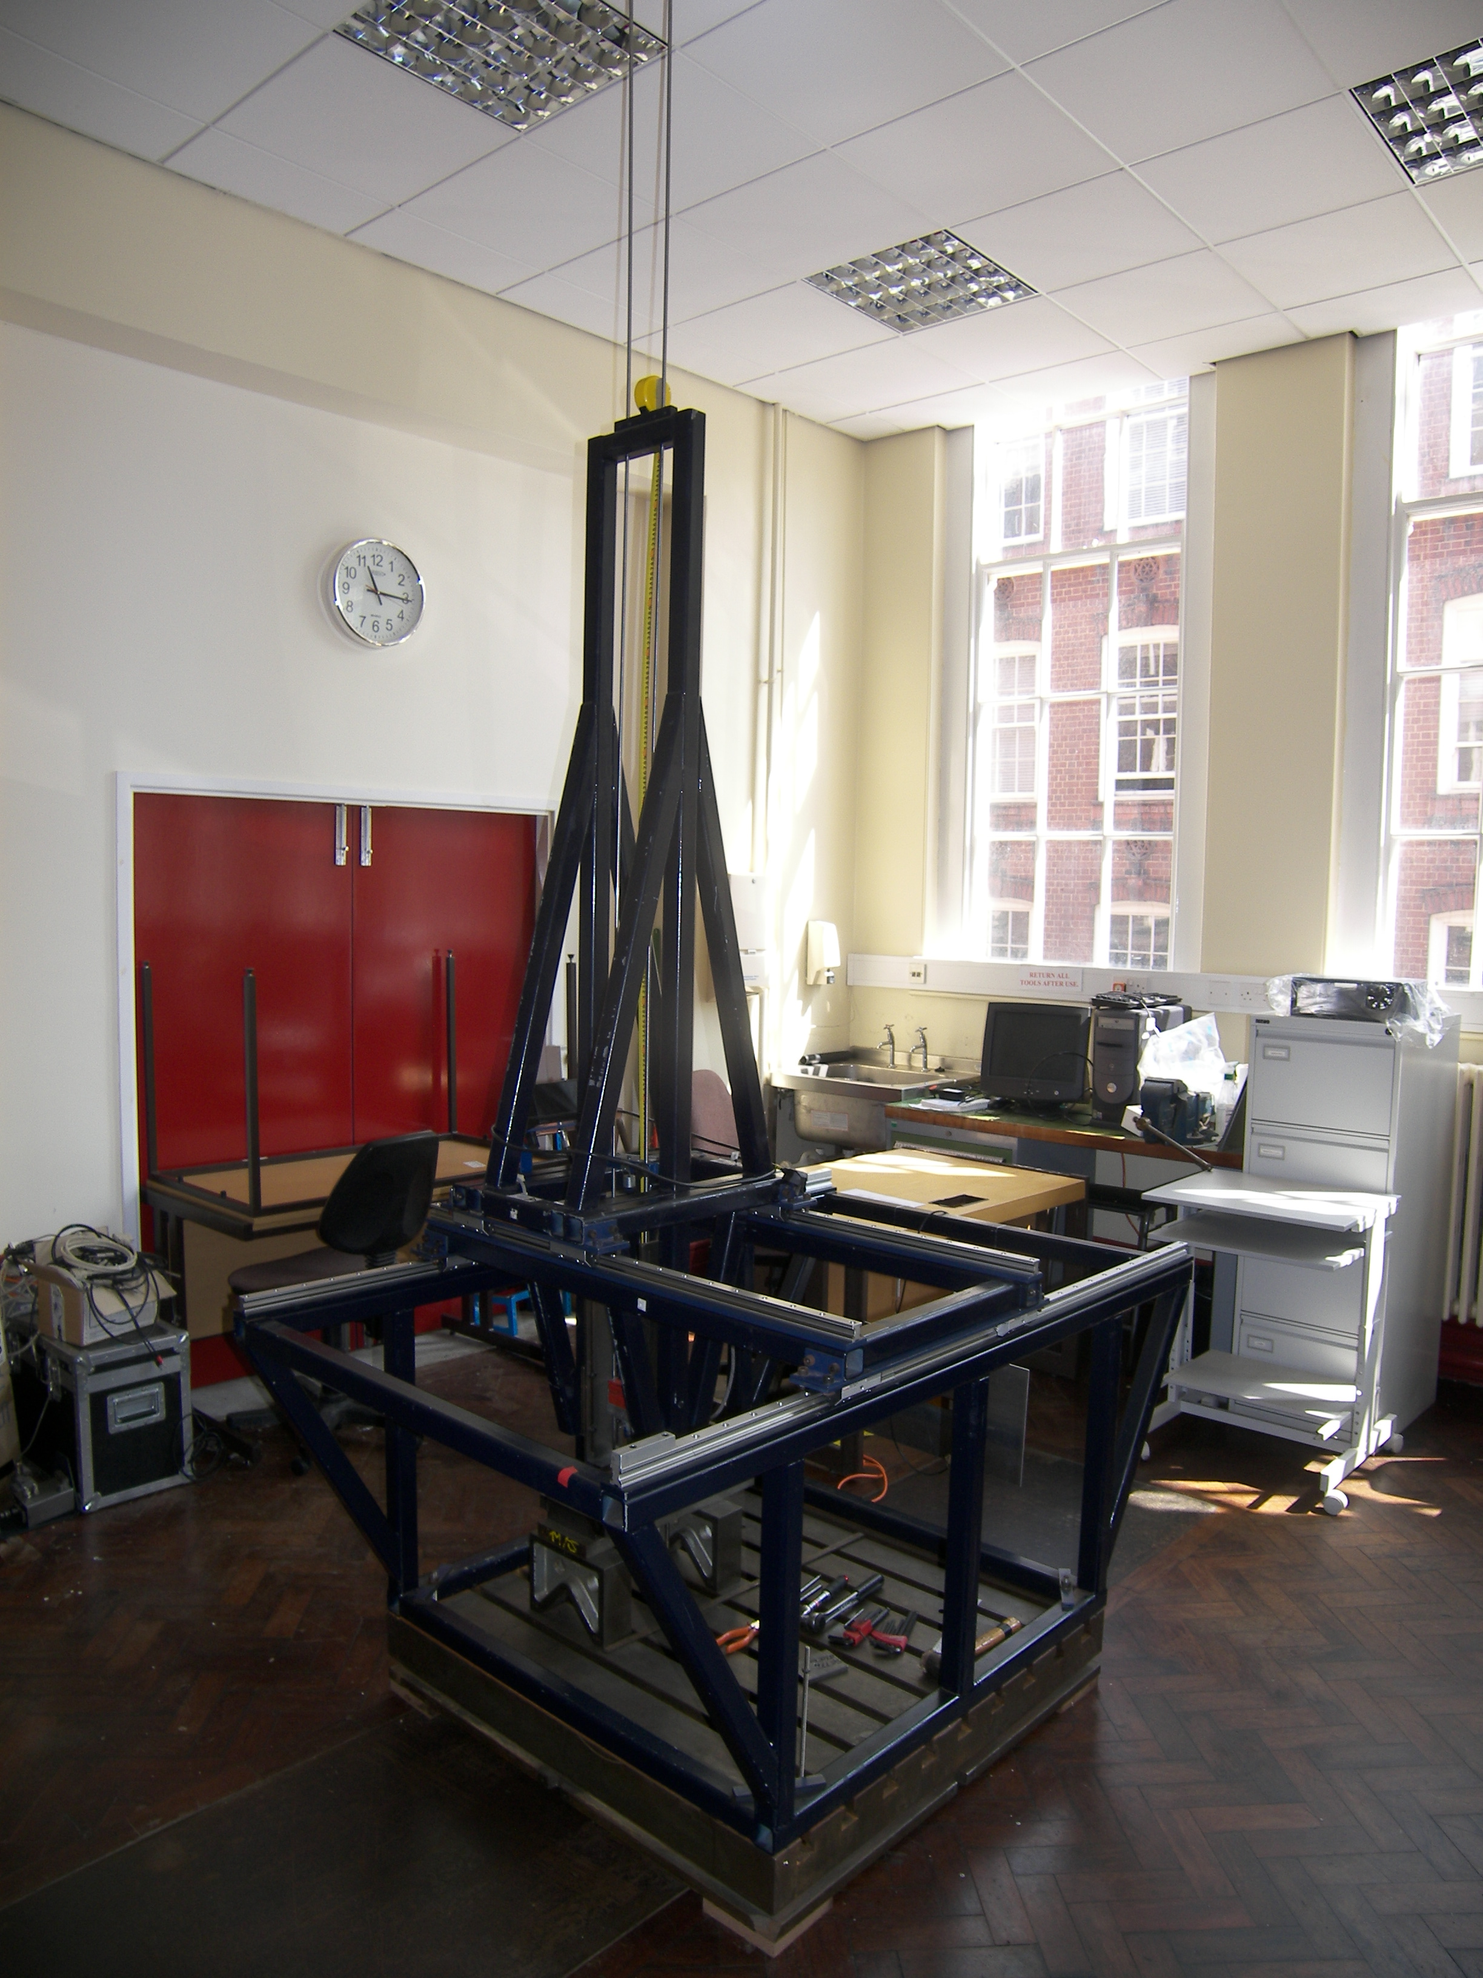
2 units of silver steel
railing
Drop test
rig

Figure 1. Laboratory instrumented drop test rig.

- The railing units were made of silver steel (BS 1407) with 8 mm diameter and 3 m in length as shown in Figure 1. The railing system enables the impactor to slide and hold it in position during the impact event.
- The impactor used in this test was hemispherical with a 13 mm diameter and was attached with a mass of 2.25 kg and a Force Ring Sensor of 0.0562 mV/N sensitivity (see Figure 2). The impactor unit also has two linear bearings built in on both sides to enable the impactor to slide and impart the damage.

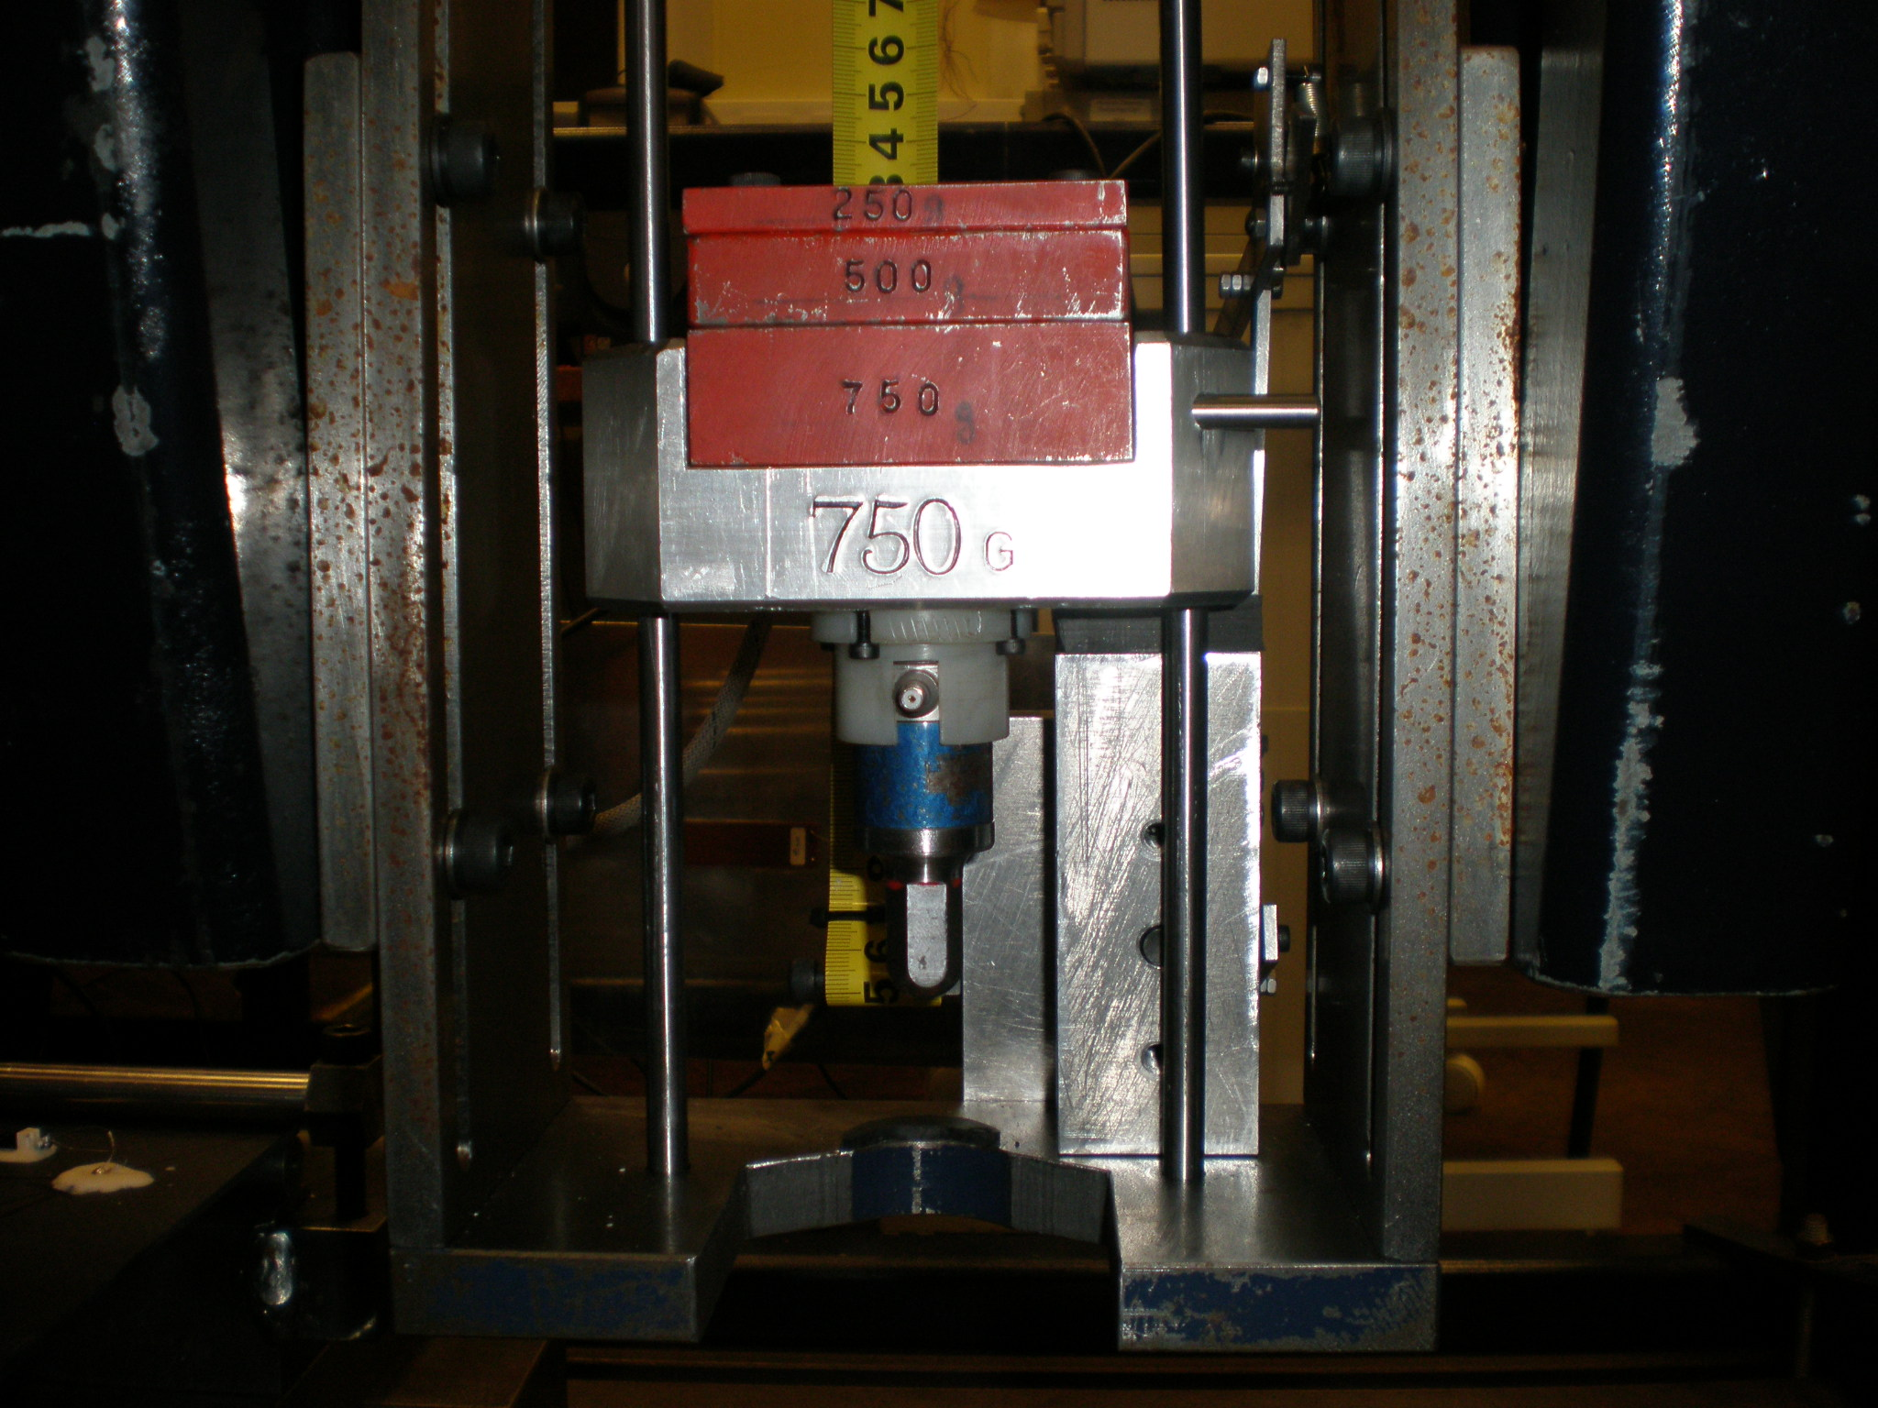
Bass mass of 2.25 kg
Hemispherical
impactor
Force ring sensor

Figure 2. The impactor unit.

(c) The catcher system is shown in Figure 3 and was used to capture the impactor once it hit and rebounded from the specimen.

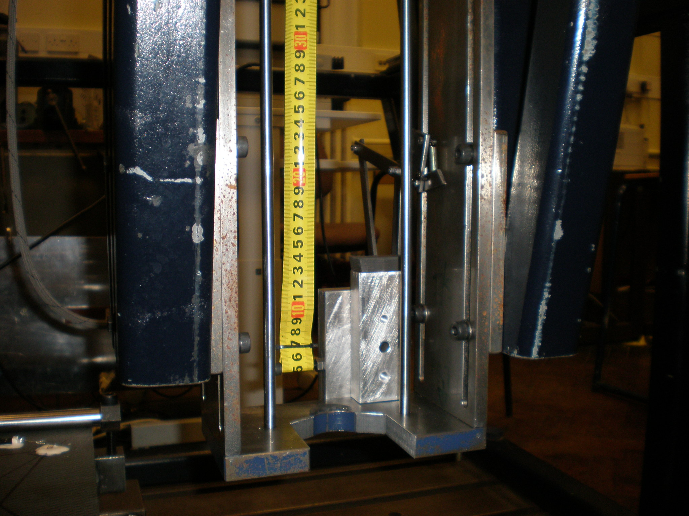
Drop height

Catcher unit

Drop tower base

Figure 3. The catcher unit.

(d) The clamping mechanism used in the impact rig was designed to hold the specimen in position and to prevent it from moving.
Figure 4 shows the clamping mechanism used in this test. The test specimens were held by two bars at both ends with a nominal load, to avoid the surface from being damaged. The locations of those sensors fixed onto the test specimens were within the bounds of the clamping unit as seen in Figure 4 (b).

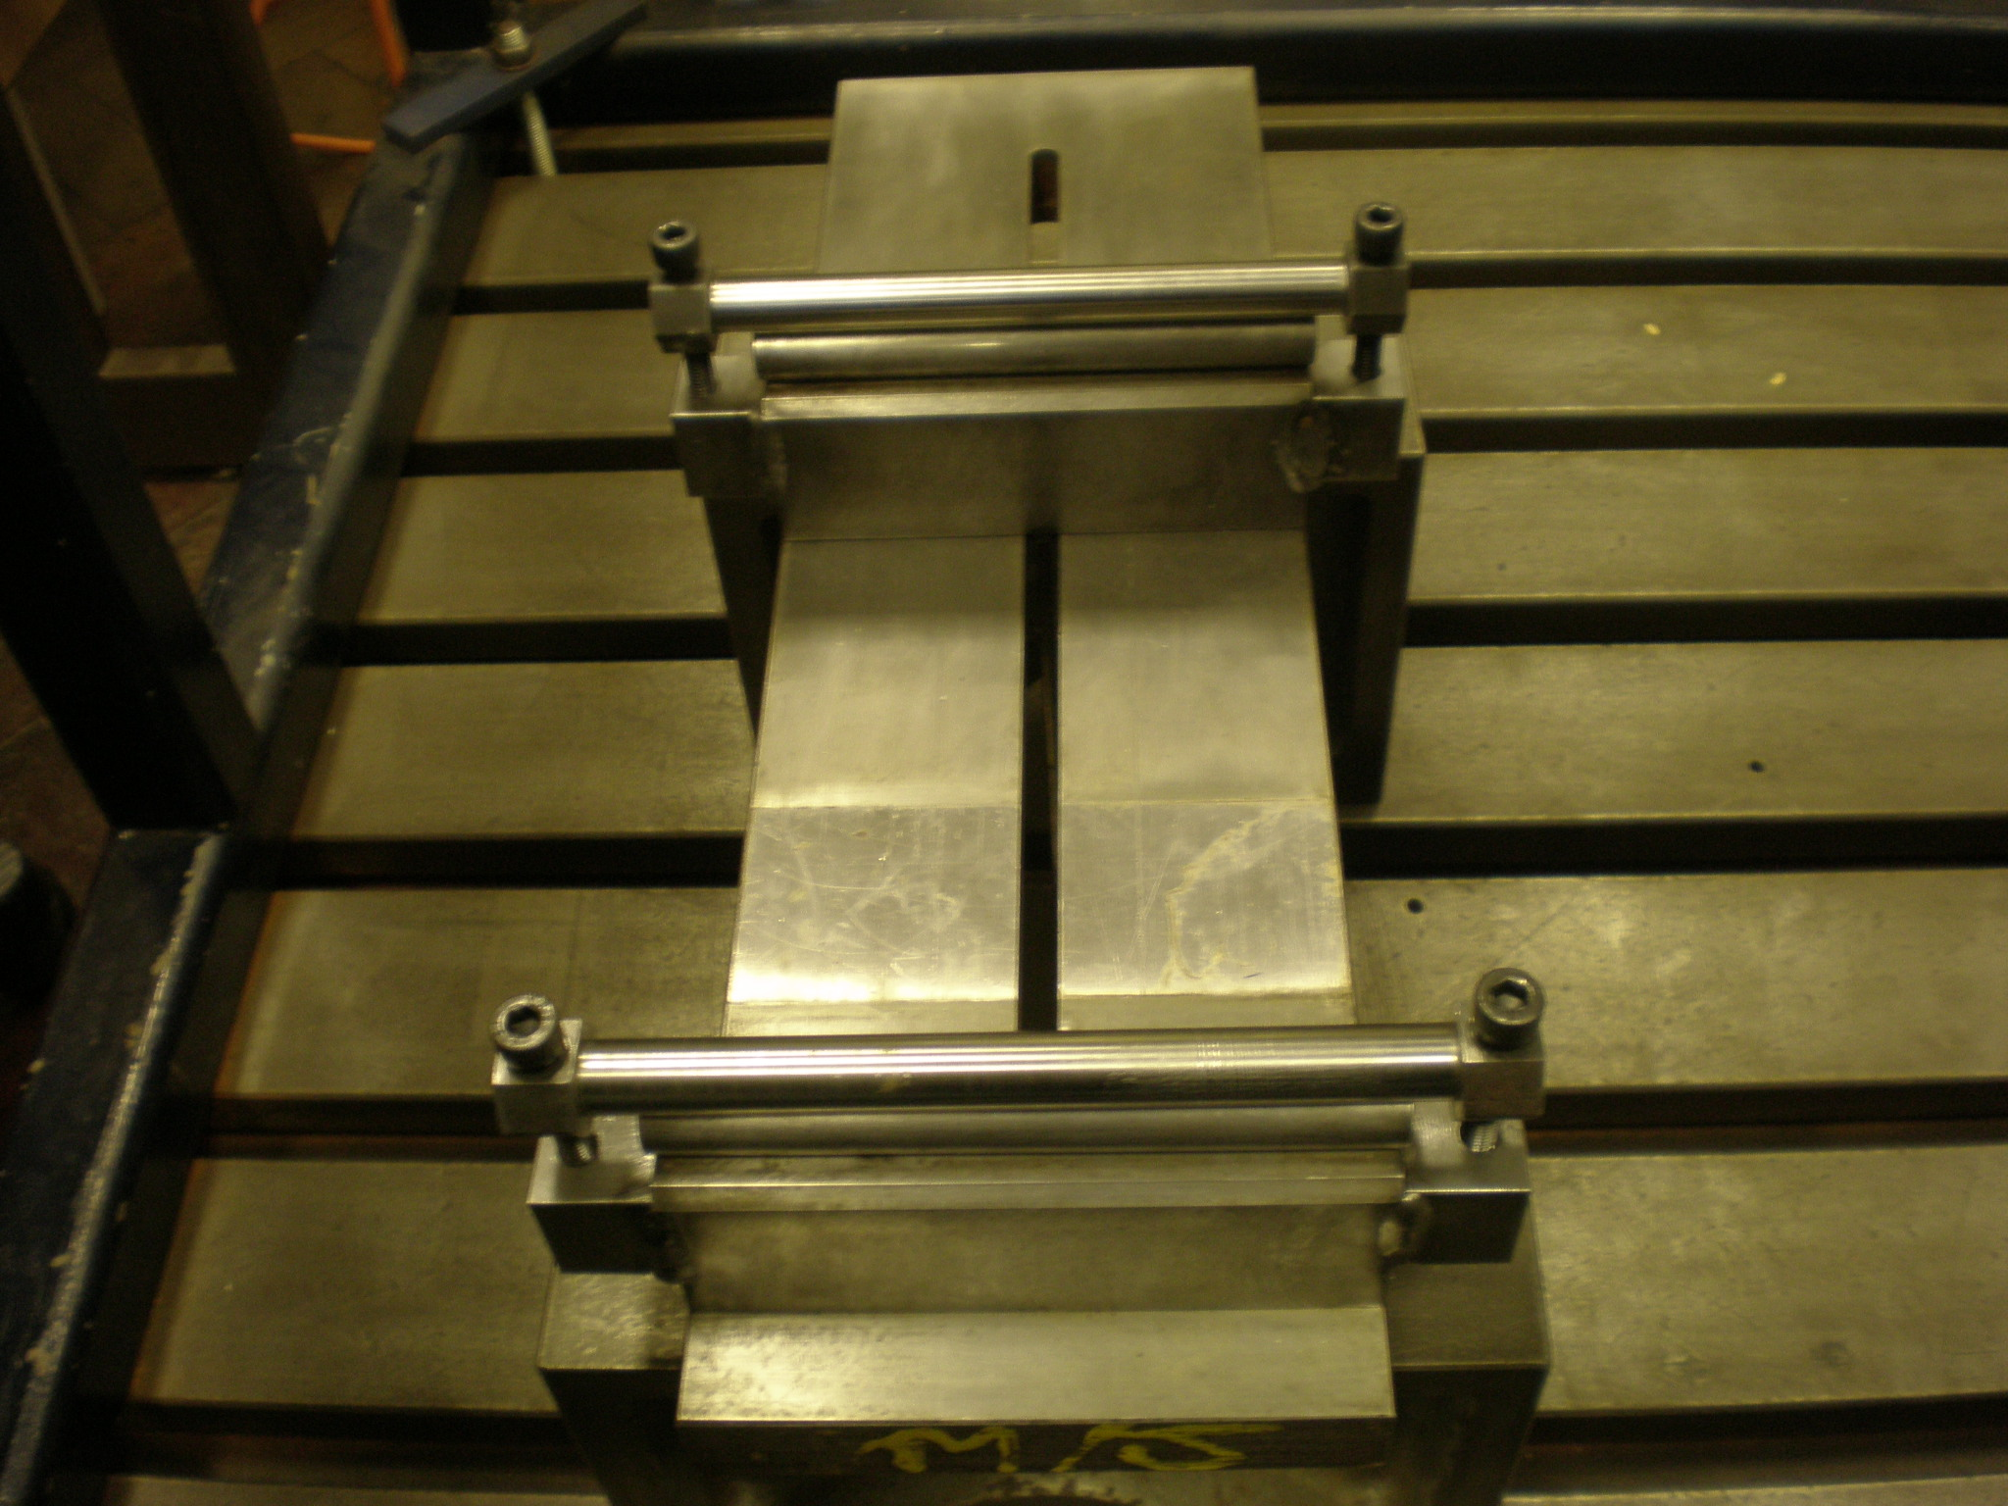
Clamping mechanism
(a)

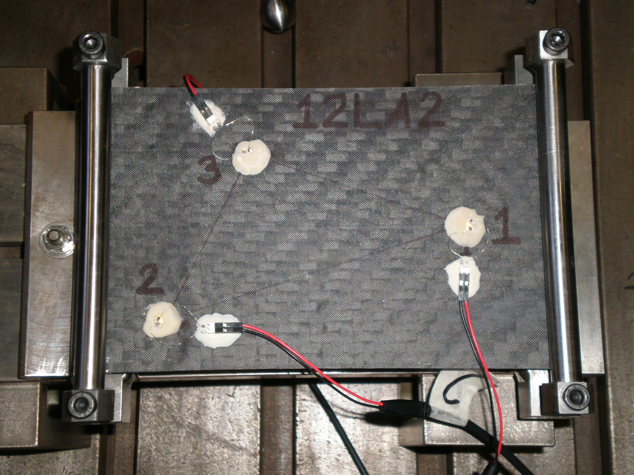
PZT sensor
with 5 mm diameter

(b)
Figure 4. Sample arrangement: (a) without clamping, (b) with clamping.

The LMS SCADAS III is a system that has built in data acquisition and signal conditioning facilities; it has been used widely in many applications involving impacts e.g. [18]. Four channels were used for this test. The first channel was used for the force ring and the remaining channels were used for the three PZT sensors. The signal processing parameters for this test were: the frequency range of 2000 Hz, the number of spectral lines of 3200, the resolution of 0.625 Hz and finally the sampling frequency of 5120 Hz. While the samples were held into position on the drop test rig, a few non-damaging impacts (up to 20 N) were made by using an instrumented hammer. Both the responses from the impact hammer and PZT were recorded using the LMS system.
To estimate the damage areas of the impacted specimens, X-ray images were acquired. The technique is based on absorption of a penetrant by the impacted or damaged surface. As a result, the presence of cracks and delaminations can be determined. However, there are some limitations that make acquiring satisfactory X-Ray images difficult. This is because the penetrant used only absorbs well in areas where damages are optically visible. For damages that are not severe or only occur at the upper surface of a specimen, it is hard to produce an X-ray image since the penetrant is not absorbed. The damages due to the lower energy impact did not allow sufficient entry of the penetrant into the samples; as a result, the X-Ray radiation would not pass through them and no images were recorded.

5. RESULTS FROM THE IMPACT EVENTS
To achieve the highest energy of 41.72 J, a mass of 2.25 kg with a drop height of 1.89 m was used. A total of three test specimens were used in the first damaging test. Those specimens were 11LD1, 12LA1 and 13LE1. The maximum peak force recorded on these specimens using the force ring transducers were 3256.4 N (11LD1), 3589.7 N (12LA1) and 3922.4 N (13LE1). From Figure 5 there is a clear correlation between the measured peak force and the number of layers of the plates. It is not surprising that the plates with more layers can absorb more energy. This observation was also true at the three other (lower) energy levels although the trends are not as markedly linear as with the greatest impact energy test.
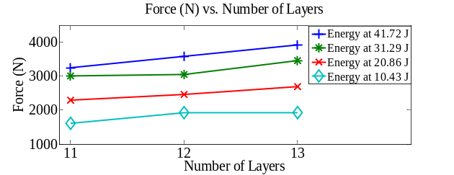
Figure 5. Highest peak force recorded for 11, 12 and 13-layer specimens at different impact energies.

Table 1 summarises the tests conducted on the 12-layer specimens. A total of 16 different impact energies were recorded, while the remaining 8 samples were used to check repeatability by carrying out two further tests at four selected energies (41.72 J, 31.29 J, 20.86 J and 10.43 J). The tests were found to be highly repeatable in terms of peak force. The results from the full test set show excellent correlation between the measured peak force and the impact energy. This observation is true for the specimens with 11, 12 and 13 layers, and is summarised in Figure 6.

TABLE 1. RESULTS OF IMPACT TEST (12-LAYER SPECIMEN)
CRFP | Energy (J) | Force (N)  Hit 1 | Force (N)  Hit 2 | Force (N)  Hit 3
12LA1 | 41.72 | 3589.7 | 3591.3 | 3587.5
12LA5 | 39.11 | 3562.2 | - | -
12LA6 | 36.50 | 3555.0 | - | -
12LA7 | 33.89 | 3235.0 | - | -
12LA2 | 31.29 | 3059.9 | 3058.6 | 3058.3
12LA8 | 28.68 | 3022.9 | - | -
12LB1 | 26.07 | 2848.4 | - | -
12LB2 | 23.47 | 2656.3 | - | -
12LA3 | 20.86 | 2470.2 | 2468.7 | 2470.1
12LB3 | 18.25 | 2205.9 | - | -
12LB4 | 15.64 | 2069.0 | - | -
12LB5 | 13.04 | 1958.2 | - | -
12LA4 | 10.43 | 1927.2 | 1927.1 | 1926.4
12LB6 | 7.82 | 1187.2 | - | -
12LB7 | 5.21 | 1064.2 | - | -
12LB8 | 2.60 | 810.0175 | - | -

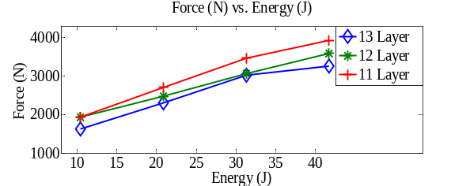
Figure 6. Positive correlation between impact energy and peak force measured at 11, 12 and 13 layers.
There were two different methods used to estimate the extent of the damage. The first method measured the damage size using a vernier calliper. The second method used the developed X-ray films. On the test specimen, the damage was found to be circular in shape but on the X-ray film the damage was estimated to be rectangular (see Figure 7). Figure 8 shows the X-ray images produced for 11, 12 and 13 layers at the highest energy level.

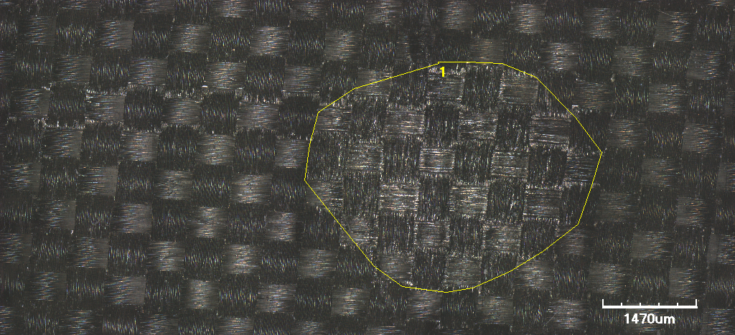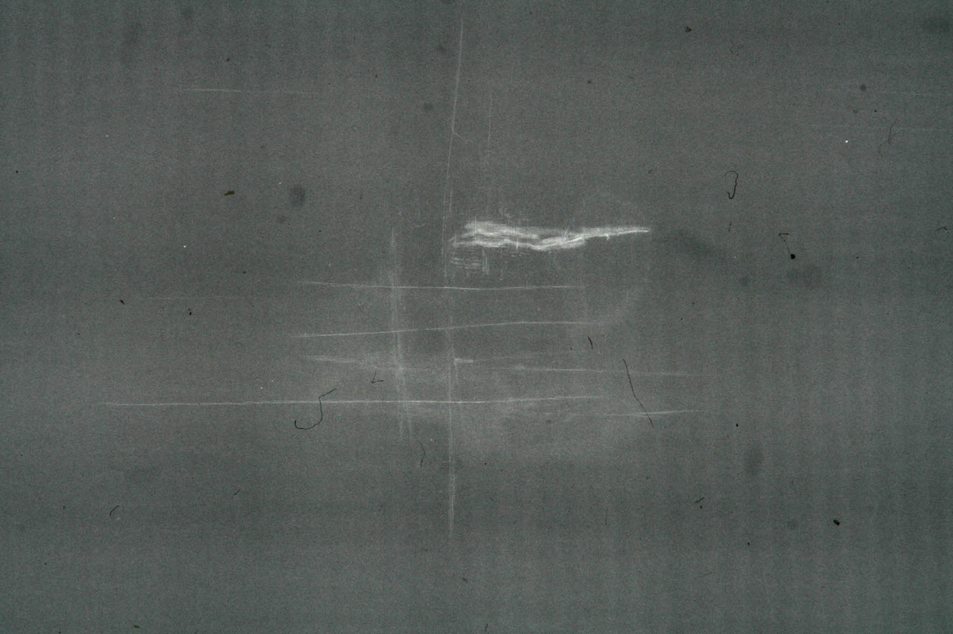
(a) (b)
Figure 7. Examples of images used to estimate damage areas: (a) visible, (b) X-ray.

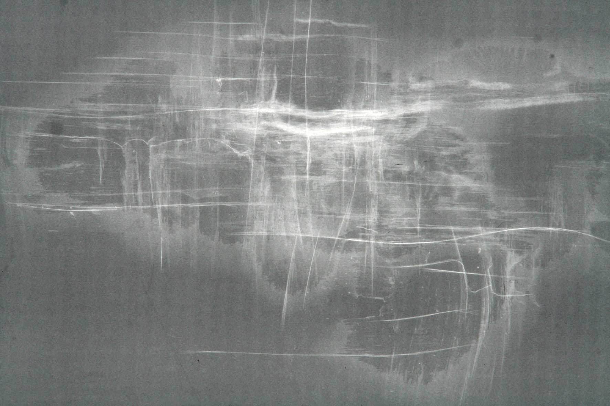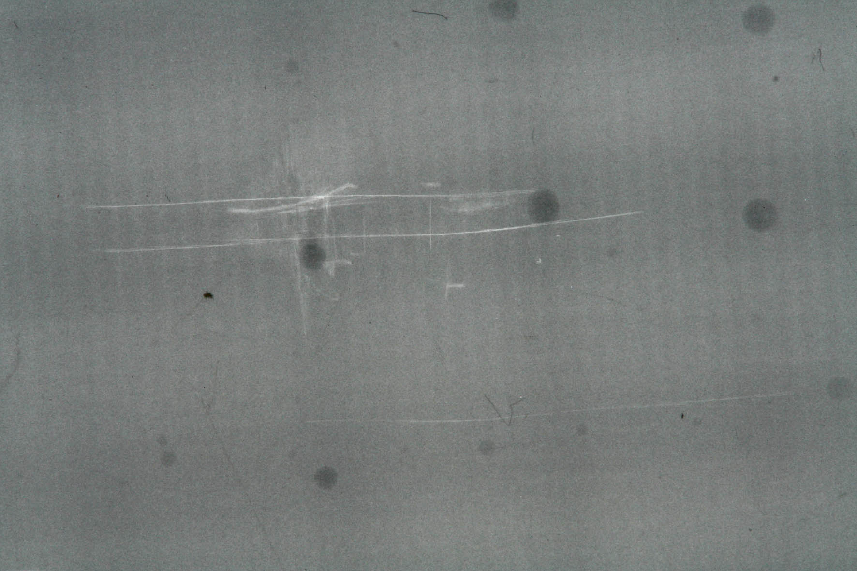
(a) (b) (c)
Figure 8. Examples of X-ray images produced at the highest energy level for: (a) 11, (b) 12 and (c) 13 layers.

TABLE 2. ESTIMATED VALUES FOR DAMAGE AREAS (12-LAYER SPECIMENS)
CFRP | Energy  (J) | Force  (N) | Damage  Area (mm²)  from  Test Specimen | Damage  Area (mm²)  from  X-Ray  Film
12LA1 | 41.72 | 3589.7 | 15.90 | 195
12LA5 | 39.11 | 3562.2 | 15.21 | 180
12LA6 | 36.50 | 3555.0 | 13.86 | 144
12LA7 | 33.89 | 3235.0 | 13.20 | 100
12LA2 | 31.29 | 3059.9 | 12.57 | 70
12LA8 | 28.68 | 3022.9 | 11.95 | 60
12LB1 | 26.07 | 2848.4 | 11.34 | 54
12LB2 | 23.47 | 2656.3 | 10.18 | 40
12LA3 | 20.86 | 2470.2 | 9.62 | 30
12LB3 | 18.25 | 2205.9 | 8.55 | ND
12LB4 | 15.64 | 2069.0 | 8.04 | ND
12LB5 | 13.04 | 1958.2 | 7.55 | ND
12LA4 | 10.43 | 1927.2 | 7.07 | ND
12LB6 | 7.82 | 1187.2 | 6.16 | ND
12LB7 | 5.21 | 1064.2 | 4.52 | ND
12LB8 | 2.60 | 810.0175 | 3.80 | ND

Table 2 summarises the estimated damage areas for the 12-layer specimens as a function of impact energy. Note that for the damage estimation method using X-ray, the notation ND given in the table means 'Not Detected'. This is because for damages that were not severe or that only occurred at the upper surface of a specimen, an X-ray image could not be produced as the penetrant was not sufficiently absorbed. C-Scan and Scanning Electron Microscopy is therefore needed to determine the damages more precisely. From Table 2, one can conclude that the damaged area estimated from the test specimen and X-ray film produces a positive linear correlation between the impact energy and force. This is clearly shown in Figure 9. The same trend was found for the 11 and 13 layered specimens.
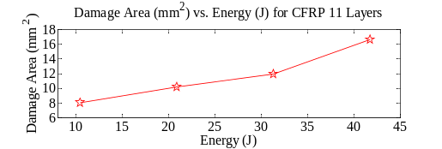
(a)
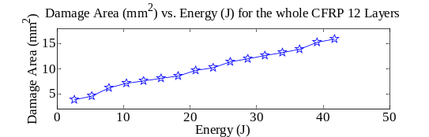
(b)
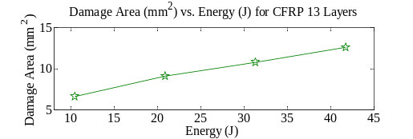
(c)
Figure 9. Positive linear correlation between (visible surface) damage area and impact energy for: (a) 11 layers, (b) 12 layers, (c) 13 layers.

6. CONCLUSION
From the tests conducted it was found that as the number of layers is increased, the amount of force increases. This is because the more layers the sample has, the more energy it can absorb. Therefore, the force detected for 13 layers has a higher force compared to 11 and 12 layers. In term of force detected by the force ring transducers, it was found that, as the amount of impact energy increased, the amount of force detected also increased. To conclude, the general trend that was observed indicates that, as the plate thickness increases, the damage detected on the specimens decrease. Moreover, it was also found that as the plate thickness increases, the maximum impact load and impact energy increase proportionally.

6. REFERENCES
1.Williams, J.C. and Starke, E.A. Progress in structural materials for aerospace systems. Acta Materialia, 2003, 51(19), 5775-5799.
2.Bannister, M. Challenges for composites into the next millennium - a reinforcement perspective. Composites Part A: Applied Science and Manufacturing, 2001, 32(7), 901-910.
3.Lubin, George (Ed.), Handbook of Composites, New York: Van Nostrand Reinhold Company Inc., 1982.
4.D.A. Bond, MSc Lecture Notes on Composites, University of Manchester, School of Mechanical, Aerospace and Civil Engineering Composites, United Kingdom.
5.Foster, Glenn C. Tensile and Flexure Strength of Unidirectional Fiber-Reinforced Composites: Direct Numerical Simulations and Analytic Models: MSc Thesis, Virginia Polytechnic Institute and State University, 1998.
6.Mangalgiri, P. Composite materials for aerospace applications. Bulletin of Materials Science, 1999, 22(3), 657-664.
7.Naik, N.K., Chandra Sekher, Y. and Meduri, S. Damage in woven-fabric composites subjected to low-velocity impact. Composites Science and Technology, 2000, 60(5), 731-744.
8. Siow, Y.P. and Shim, V.P.W. An Experimental Study of Low Velocity Impact Damage in Woven Fiber Composites. Journal of Composite Materials, 1998, 32(12), 1178-1202.
9. Winkel JD and Adams DF. Instrumented drop weight impact testing of cross-ply and fabric composites. Composites 1985; 16(4):268-278.
10. Siow YP and Shim VPW. An experimental study of low velocity impact damage in woven fibre composites. Journal of Composite Materials 1998; 32(12):1178-1202.
11. Acar, M. and Harper, J.F. Textile composites from hydro-entangled non-woven fabrics. Computers & Structures, 2000, 76(1-3), 105-114.
12. Atas, C. and Sayman, O. An overall view on impact response of woven fabric composite plates. Composite Structures, 2008, 82(3), 336-345.
13. P.Morgan. Carbon fibers and their composites. Publisher: CRC Press, 2005: 865-870.
14.J.D. Winkel and D.F. Adams, Instrumented drop weight impact testing of cross-ply and fabric composites, Composites 16 (1985), pp. 268–278.
15.G.A.O. Davies, D. Hitchings and G. Zhou, Impact damage and residual strengths of woven fabric glass/polyester laminates, Composites Part A 27A (1996), pp. 1147–1156.

16.N.K. Naik, Y.C. Sekher and S. Meduri, Polymer matrix woven fabric composites subjected to low velocity impact: Part I—Damage initiation studies, Journal of Reinforced Plastic Composite 19 (2000), pp. 912–954.
17.Atas, C. and Sayman, O. An overall view on impact response of woven fabric composite plates. Composite Structures., 2008, 82(3), 336-345.
18.W.J.Staszewski, K.Worden, R.Wardle and G.R.Tomlinson, Fail-safe sensor distributions for impact detection in composite materials. Smart Material Structure 9 (2000), 298-303.

