A MODEL OF FAN BROADBAND NOISE DUE TO ROTOR-STATOR INTERACTION

P. Joseph
Institute of Sound and Vibration Research, University of Southampton, Highfield, Southampton SO17 1BJ, ENGLAND
pfj@isvr.soton.ac.uk

K. Britchford and Pierre Loheac
Rolls-Royce plc, PO Box 31, Derby, DE24 8BJ. ENGLAND

abstract
This paper describes an analytic model for the prediction of the broadband spectrum of the sound power generated by the interaction between the turbulent wake from the rotor impinging onto the stator. Predictions are compared to experimental power spectra obtained by Boeing.

introduction
Broadband fan noise in turbofan engines can be generated through a number of different interaction processes. One of the dominant mechanisms is through the interaction of the turbulence generated in the rotor wake with the downstream stator vanes. This paper describes a model for predicting the spectral density of the sound power generated by this process.

AN AEROACOUSTIC MODEL OF ROTOR-STATOR INTERACTION
Consider a single unswept stator with stagger angle β_{L} , as shown below in Fig 1.

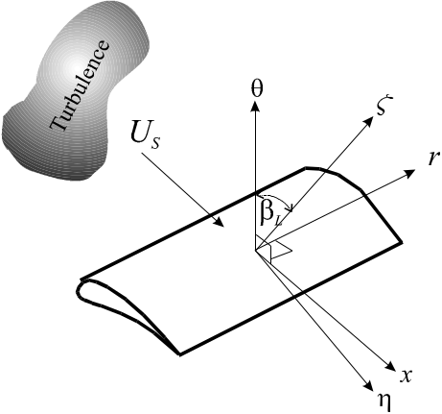
Figure 1. Airfoil in a Cartesian co-ordinate system 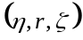 and its relationship to duct co-ordinate system (x,r,θ)

The acoustic pressure 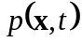 radiated by an unsteady force distribution 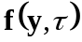 acting over the blade surface S_{b} may be calculated from

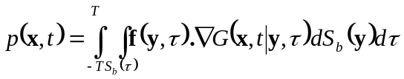 (1)

where 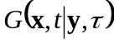 is a Green function that specifies the response at a point receiver located at 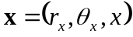, due to an impulsive point source at 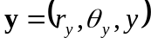. It is assumed that volume-quadrupole sources present within the turbulent boundary layer and in the stator-wake can be neglected. The Green function G appropriate to an infinite hard walled cylindrical duct is of the form

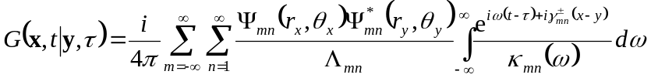 (2)

where Ψ denotes the non-normalized hard-walled duct mode shape function given by 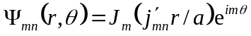, 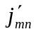 is the n^{th} turning point of the Bessel function of the first kind of order m, and a is the duct radius. Plus and minus signs are used to signify sound propagation opposite to the flow direction, and in the direction of the flow, respectively. The terms Λ_{mn} are constants introduced to ensure the normalisation condition 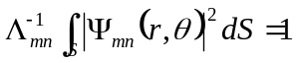, and κ and γ are the mode wavenumbers 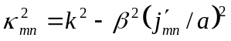 and 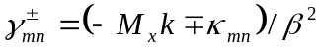. Here, 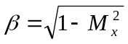 and M_{x} is the mean axial flow Mach number and k = ω/c₀. Only the propagating duct modes for which 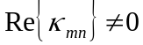 are included in the modal summation. For blades of negligible thickness, the vector dipole moment equals the pressure jump Δp across the blade acting in the direction n normal to the blade chord, 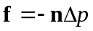. Substituting Eq. (2) into (1), taking the Fourier Transform wrt to time, summing over V equally spaced identical vanes, and comparing the result with the modal expansion 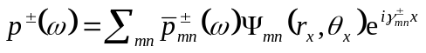, yields the expression for the mode amplitudes due to turbulence arriving at the stators in an annulus of inner radius r - δr/2 and outer radius r + δr/2
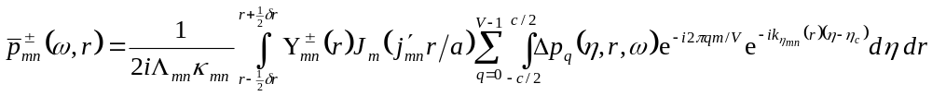
(3)
where 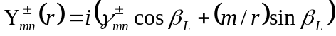, c is the blade chord and S_{b} denotes the wetted surface of a single stationary blade and Δp_{q} is the single-frequency pressure jump across the q^{th} airfoil, where the origin of η along the blade chord is taken to be along the centre-line η _{c}.

Following a similar approach to that presented by Amiet [1] an unsteady aerodynamic transfer function g is introduced such that the pressure-jump Δp_{q} due to an upwash velocity distribution 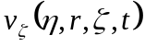 convected over the stator vanes at the mean flow speed U_{S} is deduced from

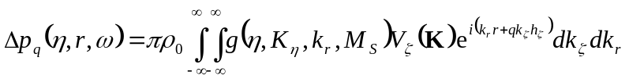 (4)

where 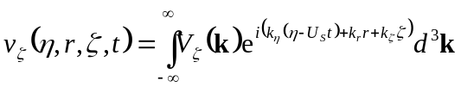, 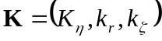, 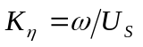 and h_{ζ} is the distance between adjacent blades in the direction normal to the blade chord. For broadband noise sources the mode amplitudes are stochastic quantities, most suitably expressed as spectral density functions. They are defined here as the mean squared pressure (amplitude) per unit radian frequency 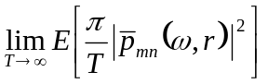, where E denotes the expectation value. Writing this quantity in full yields the expectation 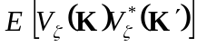. Simplification of this expression is obtained by making the usual assumption of statistically independent wavenumber components 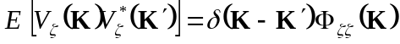, where 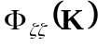 is the upwash velocity wavenumber spectral density for homogenous turbulence measured. It is defined by 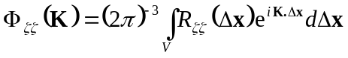, where 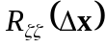 is the upwash velocity spatial correlation function. Equations (3) and (4) form the basis for our model of broadband rotor-stator interaction. Full details of the derivation are presented in [2]; the final result of which for the spectral density of the total transmitted sound power is of the form,

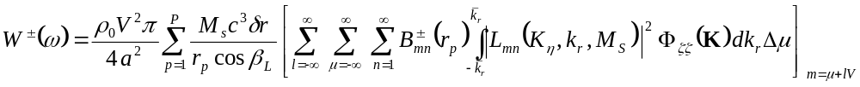
(5)
where

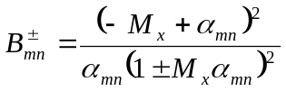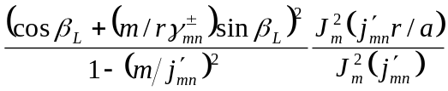 (6)

Here,

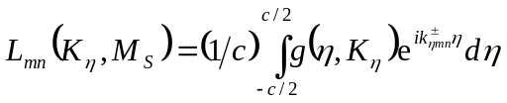 (7)
(8)
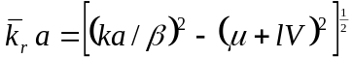 (9)

In Eq. (9), 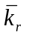 denotes the maximum radial wavenumber, for a specified μ and l value, that can excite propagating duct modes, where μ are Fourier series components of the upwash turbulence velocity in the azimuthal-θ direction and l is a scattering index. In the strip theory approximation all parameters to the right of the summation over p are allowed to vary across adjacent annuli. The term 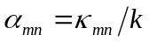 is a modal cuton ratio; it equals zero precisely at the cutoff frequency, tending to infinity at frequencies well above cutoff. Note that to prevent 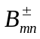 from going to infinity at 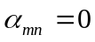 (the modal cutoff frequency) a small amount of modal damping is introduced in the form 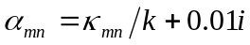. Note also that satisfactory convergence of Eq. (5) is obtained with a lower and upper limit of the scattering index equal to 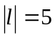.

Airfoil Wake Turbulence Characteristics for the Prediction of Broadband Fan Noise
In this section the available experimental wake data is combined into a consistent model for the upwash turbulence spectrum 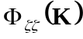. The two main parameters for specifying the mean velocity wake profiles are the centre-line (maximum) velocity wake defect u₀, and the wake width W. These are defined below in figure 2.

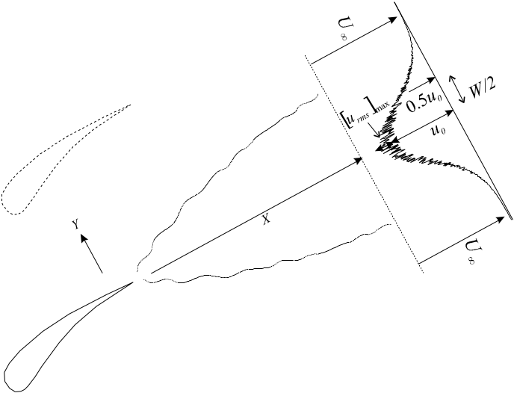

Figure 2. Parameters defining the characteristics of an airfoil turbulent wake.

In this section we summarise the main correlation results that allow the turbulent wake parameters of turbulence velocities and length-scales to be predicted from the input parameters of mean aerodynamic parameters of free-stream velocity 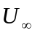 and trailing edge momentum thickness θ.

Correlations between and 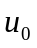
Measurements by Gliebe et al of GE (General Electric) [3] of the maximum rotor wake mean velocity deficit made in the near-wake region, 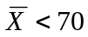, have been shown to closely follow the classical scaling law of Wygnanksi et al [4], of the form

, (10)

where 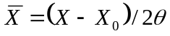 and X₀ is the virtual centre of the wake

Correlations between and rms turbulence velocities u, v and w
Ganz, Joppa, Patten and Scharpf [5] have obtained linear regression curves for the rms streamwise (u), radial (v) and circumferential (w) velocities based on turbulence measurements made at three different throttle settings and four downstream positions. Their results are of the form

These results provide evidence for isotropy in turbomachinery rotor wakes (as does the ratio of length-scales presented in Eq. (13) below). Thus, we make the assumption of isotropy for which a general isotropic wavenumber spectrum with streamwise length-scale L_{η} is of the form,

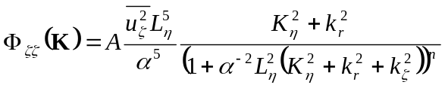 (11)

The two most common examples of Eq. (37) are those by von-Karman and by Liepman whose parameters are 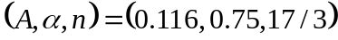 and 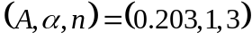, respectively. In this investigation all predictions have been obtained using the Liepman spectrum, which has been found to give best fit to experimental data.

Correlations between and rms centre-line turbulence velocity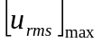
Wygnanski et al have measured the maximum, centre-line rms streamwise turbulence velocity produced by a single airfoil in the fully developed far wake region 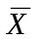 > 390. Ganz et al [5] have obtained corresponding data in the near wake region, 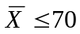. The function in Eq. (12) is proposed to provide a good fit to both sets of experimental data, that also allows for their values to be extrapolated into the mid-range of -values for which no experimental data is available.

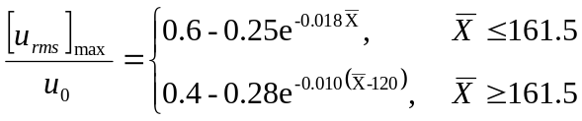 (12)

Correlations between turbulence integral length-scales and momentum thickness
Gliebe et al [3] have produced linear regression curves for turbulent length-scales in the streamwise direction in typical turbomachinery wakes. The curves were obtained from measurements made at three different throttle setting and four downstream positions (in the near-wake ). The results, non-dimensionalised on θ, are given by,

(13)

USE OF ‘PERCH’ TO PREDICT MEAN THROUGH-FLOW PARAMETERS
The blade span is divided into 19 strips with radius r_{p}, (p = 1 . . 19). The width of the p^{th} strip is calculated from 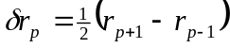 for p = 2 . .18, and 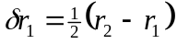 and 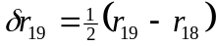 for the hub and tip. For each fan condition, the parameters 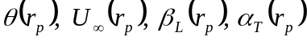 were deduced at each radial position from through-flow predictions supplied by Boeing from their PERCH code. The wake turbulence is assumed to convect along the streamlines identified by the PERCH program. The non-dimensional convection distance 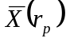 was calculated from (r_{p},x_{p}) values at the rotor trailing edge and stator leading edge connected by a streamline, and the predictions of θ_{p} .

RESULTS
The model is now used to predict the broadband noise sound power spectral density due to rotor-stator interaction measured by Ganz et al [5].

Comparison between measured and predicted sound power spectra
Comparison between the predicted and measured spectral densities of the sound power in the duct inlet and exhaust for five different percentage fan speeds and two loading conditions is shown below in figure 3.

Inlet | Exhaust
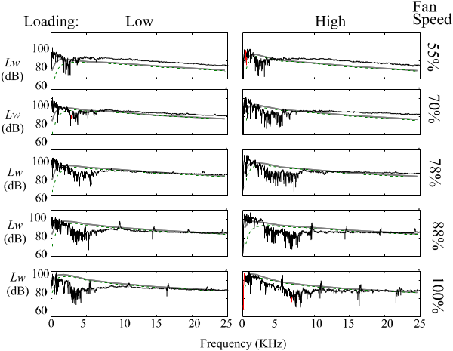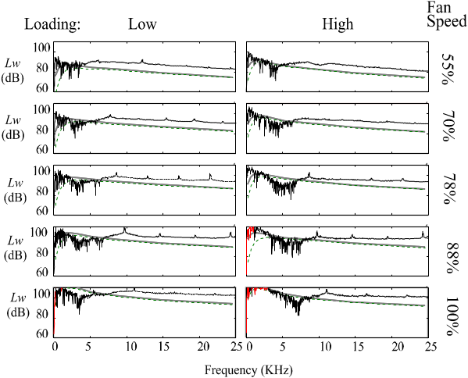

Figure 3. Comparison of predicted and measured spectral densities of the sound power in the duct inlet and exhaust for two loading conditions and five fan speeds.

Note that predictions include a bandwidth correction to ensure consistency with the 15.625Hz frequency resolution of the measurement. Measured spectra below about 4kHz are due to background noise sources, such as the jet. Above this frequency, however, agreement is reasonably good with the rate of high-frequency roll-off being closely predicted. The difference between the two predictions is only significant at low frequencies. The actual power flow in the duct inlet is higher than that obtained by far field measurements since blockage effects by the rotor, and also reflections at the duct terminations (neither of which are included in the model), reflect sound power back downstream. When these effects are included, agreement is poorer as shown in the comparison between predicted and measured power spectra in the rear arc, where no rotor blockage effects are present. The theoretical predictions in the rear arc are observed to consistently underestimate the measured values by between 5 and 8dB. Spectral shape is reasonably well predicted, however. Trends with loading, number of stator vanes and fan speed are investigated below.

Effects of loading

By changing throttle settings to the fan rig Ganz et al [5] have measured the effects of loading on the broadband power spectrum due to rotor – stator interaction. The difference in spectral level ΔL_{W} (in dB) between the low loading and high loading measurement is presented in figure 4 for the five fan speeds.

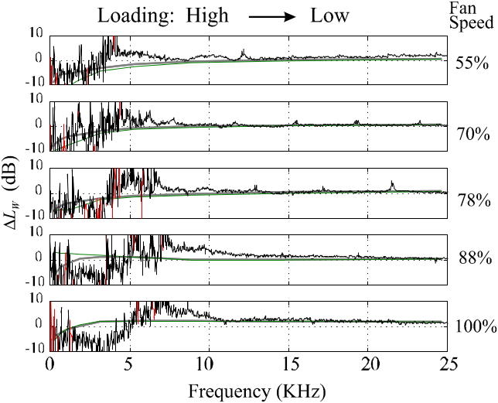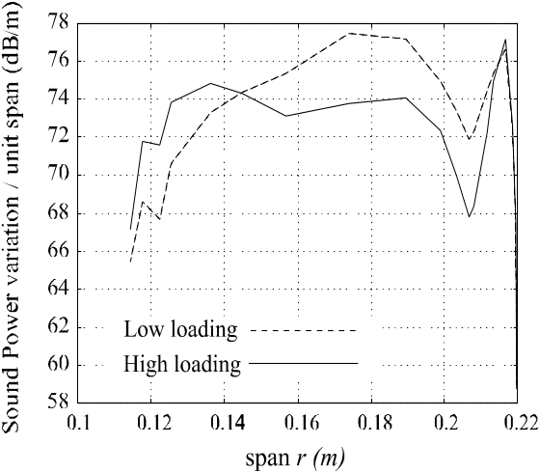

Figure 4. Difference in power spectral level ΔL_{W} in changing from high to low loading for the five fan speeds. Predictions denoted by the smooth grey curve. | Figure 5. Sound power sound power contribution per unit span for the case of high and low loading in the rear arc, at 78% fan speed.

The predicted increase in overall sound power due to reduced loading is not uniform along the entire blade span as shown in figure 5. It compares the predicted variation of power generated per unit span at 78% fan speed for the low and high loading conditions. Increased power due to reduced loading is only predicted to occur along the mid-span, with the reverse trend being predicted close to the hub, and no change being predicted near the tip. At any position along the span the net change in power is the result of a number of different contributions ‘moving’ the prediction in different directions. Figure 6 shows the predicted spanwise variation at the stator of momentum thickness, mean velocity on the stator, mean square upwash velocity and streamwise length-scale.

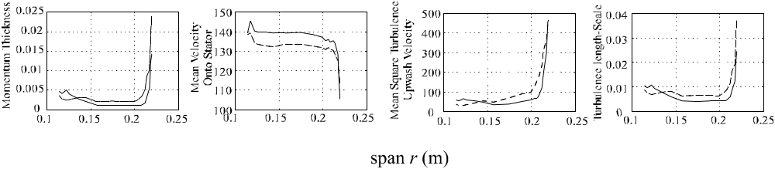

Figure 6. Predicted variation along the blade span of momentum thickness, mean velocity onto the stator, rms upwash velocity and streamwise length-scale at the stator (high loading – solid line, low loading – dashed line).

In the mid-span region, the mean velocity onto the stators is lower for the low loading case whilst the turbulence velocity is higher. When these variations are included in the model and the result integrated along the blade span, a small net increase in overall sound power is predicted. It is conceivable that, for other fans, this balance of contributions may be different and that working-line effects differ from that observed above for the Boeing rig.

Effects of Number of Stator Vanes
Ganz et al [5] have measured the effect on transmitted sound power of increasing the number of stator vanes from 60 to 30, and from 60 to 15 but doubling the blade chord. A comparison between these measured results and their theoretical predictions for the five fan speeds are plotted in figure 7.

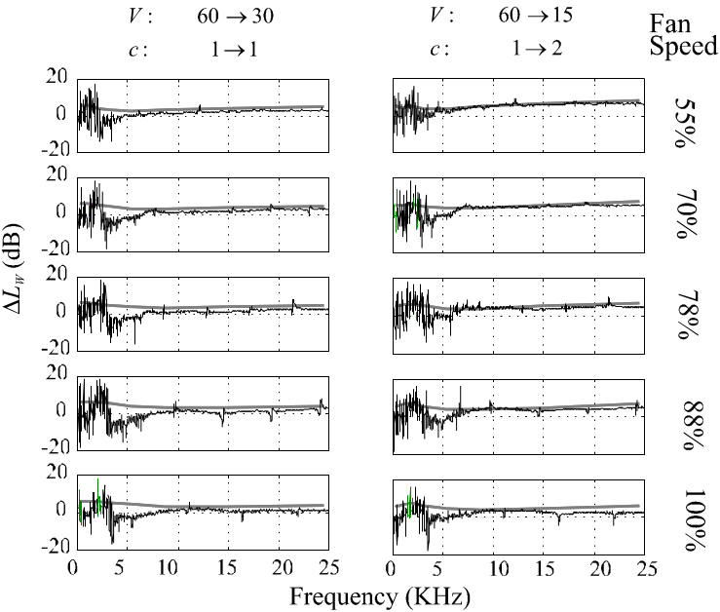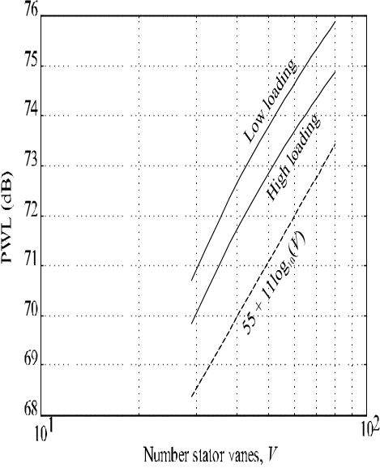
Figure 7. Comparison of predicted and measured increase in rear-arc sound power versus frequency for the case when the number of vanes is increased from 60 to 30, and from 60 to 15, but doubling the chord. | Figure 8. Predicted rear-arc sound power versus number of stator vanes for 78% fan speed at 12 kHz, with high and low loading.

At frequencies above about 5kHz, agreement is generally good, with the frequency-trend being closely predicted. The predicted and measured increase in high frequency power spectra in the case when V is doubled and quadrupled is roughly 3dB and 6dB, respectively. This result suggests that radiation from individual stator vanes is approximately additive, and that blade chord has only a small effect. Below 5KHz agreement is poor, with the predictions indicating a consistent increase in power while the measurements indicate a power reduction. The predicted dependence of rear-arc sound power at 12kHz on the number of stator vanes V between 28 and 80 is shown in figure 8 for the 78% fan speed case at high and low loading. A dependence of V^{1.1} is observed in both cases, suggesting that at this frequency the unsteady blade loading between adjacent blades have a small residual correlation whereby the radiation from neighbouring vanes is very nearly incoherent.

Overall sound power dependence on fan speed

The overall transmitted sound power in the proportional frequency bandwidth 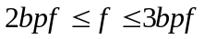 (BB3) versus fan speed for the low loading case was obtained by numerical integration of the spectral results presented earlier. The comparison between predicted and measured sound power plotted against log₁₀ of the normalised fan speed FS (fan speed divided by design speed), for the rear arc is plotted in figure 9 below.

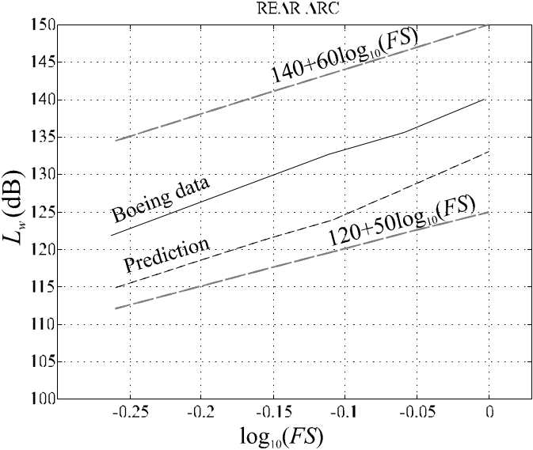

Figure 9. Comparison between measured and predicted rear-arc overall sounds power in the proportional frequency band BB3, versus normalised fan speed for the low loading example. Curves proportional to FS⁵ and FS⁶ are shown for comparison.

The predicted and measured sound powers follow similar behaviour in the rear arc whereas less satisfactory agreement is observed in the forward arc. A frequency dependent blockage effect is one explanation for this difference. Overall, however, a fan speed dependence of between FS⁵ and FS⁶ is predicted, consistent with measurement.

CONCLUSIONS
A model is described that allows predictions of the broadband noise spectrum due to the interaction between the turbulent wake from a rotor and downstream stator vanes. A typical prediction by the model under-predicts the measured spectral levels. Spectral shape is reasonably well predicted, although levels are under-predicted by about 6dB. The model has been shown to provide acceptable predictions of the effects on transmitted sound power of working line, the number of stator vanes V, and overall sound power transmission.

ACKNOWLEDGEMENTS

The authors are grateful to U. Ganz, P. Joppa, J. Patten and D. Scharpf of Boeing for allowing access and publication of their spectral noise data, as well as their PERCH though-flow predictions for their fan rig

references

[1] Amiet, R. K. Acoustic Radiation from an Airfoil in a Turbulent Stream. J. Sound Vib 41, 407 – 420. 1975.

[2] Joseph, P., Britchford, K., and Loheac, P. A Model of Fan Broadband Noise due to Rotor-Stator Interaction. ISVR Contract Report No. 02/05, 2002.

[3] Gliebe, P., Mani, R., Shin, H., Mitchell, B., Ashford, G., Salamah, S., and Conell, S. Aeroacoustic Prediciton Codes. NASA/CR – 2000-210244, 2000.

[4] Wygnanski, I., Champagne, F., and Marasli,. B. On the structures in two-dimensional, small deficit turbulent wakes. J. Fluid Mech, Vol 168, 31 – 71, 1986.

[5] Ganz, U. W, Joppa, P .D, Patten. J. T and Scharpf. D. Boeing 18-inch Fan Rig Broadband Noise Test. NASA/ CR-1998 – 208704.

