FULL PAPER
DOI: 10.1002/chem.xxxxxxxx

Amide functionalised diindolylureas: anion complexation and anion-anion proton transfer
Jennifer R. Hiscock,^{[a]} Stephen J. Moore,^{[a]} Claudia Caltagirone,^{[b]} Michael B. Hursthouse,^{[a]} Mark E. Light^{[a]} and Philip A. Gale*^{[a]}
[a] J.R. Hiscock, S.J. Moore, Prof. M.B. Hursthouse, Dr M.E. Light and Prof. P.A. Gale
School of Chemistry,
University of Southampton,
Southampton, SO17 1BJ, UK.
Fax: +44 23 8059 6805
E-mail: philip.gale@soton.ac.uk
[b] Dr C. Caltagirone,
Dipartimento di Chimica Inorganica ed Analitica, Università degli Studi di Cagliari, S.S. 554 Bivio per Sestu, 09042, Monserrato, CA, Italy.
Supporting information for this article is available on the WWW under http://dx.doi.org/ xxxxxxxxx

Abstract: Four 1,3-diindolylureas have been synthesised containing carboxamide substituents at the 2-position of the indole rings. The receptors have high affinity for oxo-anions in DMSO-d₆/water mixtures however frequently titrations with dihydrogen phosphate could not be fitted adequately to a 1:1 or 2:1 anion: receptor binding model. NMR studies have shown that dihydrogen phosphate is deprotonated by free dihydrogen phosphate in solution with the resultant formation of a monohydrogen phosphate receptor complex. X-ray crystallographic studies confirm monohydrogen phosphate complex formation in the solid state.
Keywords: supramolecular chemistry, anions, NMR, crystallography

Introduction
Anion complexation, and in particular anion recognition with neutral hydrogen bond donor receptors, has attracted much interest in recent years with a variety of receptors containing amide, urea and pyrrole shown to have high affinities and selectivities for anionic guests.^{[1]} Contrastingly, indole groups have only recently begun to be explored as hydrogen bond donor groups in synthetic anion receptor systems.^{[2]} Indole, like pyrrole, contains a single NH hydrogen bond donor group and in DMSO solution is slightly more acidic than pyrrole.^{[3]} In biological systems indole, in the form of tryptophan, is employed to bind anions such as chloride^{[4]} and sulfate.^{[5]} We recently reported that 1,3-diindolylureas form particularly stable complexes with oxo-anions in DMSO-d₆/water mixtures.^{[6]} This work led from an initial collaborative project with Albrecht and Triyanti on 2,7-disubstituted indoles containing urea substituents in the 7-position and amide substituents in the 2-position that were found to bind oxo-anions strongly.^{[7]} Proton NMR titration studies on these compounds in DMSO-d₆/0.5% water showed that the indole and urea groups were participating in hydrogen bonding interactions with the bound oxo-anions but that the amide group in the 2-position did not interact significantly with the guest species. This was also observed in X-ray crystal structures of anion complexes of these systems. The design of the second generation diindolylurea compounds built on these findings by removing the amide group in the 2-position and adding an extra indole moiety to produce a symmetrical receptor containing four hydrogen bond donor groups. These compounds were found to be selective receptors for dihydrogen phosphate anions in DMSO-d₆/water mixtures over carboxylates and chloride. Single crystal X-ray diffraction of crystals obtained from a DMSO-d₆/water solution of the receptor in the presence of excess tetrabutylammonium dihydrogenphosphate showed that three of these receptors could assemble around a single phosphate PO₄³⁻ anion in the solid state binding it via twelve hydrogen bonds.^{[6b]} Similarly crystallisations with tetraethylammonium bicarbonate and a diindolylurea resulted in the crystallization of deprotonated carbonate bound by two diindolylureas via eight hydrogen bonds. As part of a programme of research on the complexation of bicarbonate^{[8]} we have synthesised a new series of compounds which contain amide groups attached to the 2-positions on the indole rings of the diindolylurea skeleton. We made these compounds to assess whether the amides could play a role in anion complexation for anions such as bicarbonate and phosphate as shown in Figure 1 (the proposed binding modes are based on X-ray crystal structures of the interaction of carbonate, phosphate and benzoate with diindolylureas).^{[6b]} Additionally amides in the 2-position might prove useful in future studies as a point of attachment for other functionality to these receptors.
Results and Discussion
Compounds 1-4 were synthesised by a simple three step synthesis. Commercially available 7-nitroindole-2-carboxylic acid was coupled to an amine (benzylamine or pyridin-2-ylmethanamine) using CDI to afford 2-carboxamido-7-nitroindole derivatives in 90 and 80 % respective yields. Coupling with n-butylamine or aniline was performed using our previously published procedures.^{[7]} The nitro-derivatives were reduced using H₂/ Pd/C 10% affording the amines which were coupled with triphosgene in a two phase CH₂Cl₂/sat NaHCO_{3(aq)} mixture to afford the urea derivatives 1-4 in 49, 30, 56 and 55% respective yields (Scheme 1).

Figure 1 Proposed binding modes of bicarbonate, dihydrogen phosphate and a carboxylate with a bis-amide functionalised diindolylurea.
Scheme 1 Synthesis of receptors 1-4.
The stability constants of compounds 1 – 4 with a range of anionic guests were determined by ¹H NMR titration techniques in DMSO-d₆/0.5% water or DMSO-d₆/10% water. The results are shown in Tables 1 - 4. The stability constants for carboxylates generally show good agreement between those determined by the shift of the urea NH protons and those determined by the shift of the indole CH protons in the 6-position of the indole ring (the indole NH broadens upon addition of anions in many cases). The receptors were found to have a low affinity for chloride but to bind the oxo-anions studied strongly. Whilst the binding isotherms for carboxylates fit to a 1:1 binding model, the binding of dihydrogen phosphate is more complex and in many cases could not be adequately fitted. In the case of compound 1, the NMR titration with dihydrogen phosphate shows both fast and slow exchange processes. Examination of the shifts of the urea NH, amide NH and indole C6 CH protons show that across the series of compounds, upon addition of carboxylates, the amide NH and indole CHs shift down field and in 0.5% water solution reach a plateau at one equivalent of anion indicating strong binding. However the amide NH groups either do not shift at all or shift downfield continuously and do not reach a plateau (see Figure 2 for compound 1 and benzoate). These results are evidence that supports the hypothesis that carboxylates bind strongly to the receptors as shown in Figure 1c. The amide NH groups do not interact with the bound anion. The continuous downfield shift of the amide NH group in some cases may be due to the amide NH pointing out of the binding cavity of the receptor and weakly binding further aliquots of carboxylates weakly via a single hydrogen bond as was observed with the 2,7-disubstituted indoles studied previously.^{[7]}
Table 1. Apparent stability constants determined by ¹H NMR titration techniques with compound 1 in DMSO-d₆/water mixtures at 298K following urea NH and indole CH (6-position) groups. Errors < 15% except where noted.
Anion^{[a]} | CH (0.5% water) | Urea NH (0.5% water) | CH (10% water) | Urea NH (10% water)
Cl⁻ | 166 | 22 | n.d. | n.d.
BzO⁻ | > 10⁴ | > 10⁴ | 1020 | 1100
AcO⁻ | > 10⁴ | > 10⁴ | 462 | b
H₂PO₄⁻ | c | c | > 10⁴ | 2310
HCO₃⁻ | > 10⁴ | 2468 | 809 | 395
[a] Anions added as tetrabutylammonium salts except bicarbonate which was added as the tetraethylammonium salt. [b] NMR spectrum indicates conformational changes during the titration (see supplementary information). [c] Fast and slow exchange. n.d. = not determined.
Table 2. Apparent stability constants determined by ¹H NMR titration techniques with compound 2 in DMSO-d₆/water mixtures at 298K following urea NH and indole CH (6-position) groups. Errors < 15% except where noted.
Anion^{[a]} | CH (0.5% water) | Urea NH (0.5% water) | CH (10% water) | Urea NH (10% water)
Cl⁻ | 79 | <10 | n.d. | n.d.
BzO⁻ | > 10⁴ | d | 639 | 481
AcO⁻ | > 10⁴ | 8460 | c | 1422
H₂PO₄⁻ | 107 | d | b | b
HCO₃⁻ | 2250 (± 17%) | d | 728 | d
[a] Anions added as tetrabutylammonium salts except bicarbonate which was added as the tetraethylammonium salt. [b] Isotherm could not be fitted to a 1:1 or 1:2 binding model. [c] A shoulder appears a urea NH resonance possibly indicating the formation of an unsymmetrical complex. [d] Peak broadening prevented a stability constant from being obtained in these cases. n.d. = not determined.
Table 3. Apparent stability constants determined by ¹H NMR titration techniques with compound 3 in DMSO-d₆/water mixtures at 298K following urea NH and indole CH (6-position) groups. Errors < 15% except where noted.
Anion^{[a]} | CH (0.5% water) | Urea NH (0.5% water) | CH (10% water) | Urea NH (10% water)
Cl⁻ | b | d | n.d. | n.d.
BzO⁻ | 1490 | 1580 | 303 | 284
AcO⁻ | > 10⁴ | > 10⁴ | 278 | 293
H₂PO₄⁻ | c | d | 2960 | 812
HCO₃⁻ | 1420 | d | 319 | d
[a] Anions added as tetrabutylammonium salts except bicarbonate which was added as the tetraethylammonium salt. [b] No shift. [c] Isotherm could not be fitted to a 1:1 or 1:2 binding model. [d] Peak broadening. n.d. = not determined.
Table 4. Apparent stability constants determined by ¹H NMR titration techniques with compound 4 in DMSO-d₆/water mixtures at 298K following urea NH and indole CH (6-position) groups. Errors < 15% except where noted.
Anion^{[a]} | CH (0.5% water) | Urea NH (0.5% water) | CH (10% water) | Urea NH (10% water)
Cl⁻ | b | < 10 | n.d. | n.d.
BzO⁻ | 2430 (±19%) | 4760 | 298 | 304
AcO⁻ | > 10⁴ | > 10⁴ | 485 | 544
H₂PO₄⁻ | c | d | 256 | 245
HCO₃⁻ | 7660 | d | 149 | d
[a] Anions added as tetrabutylammonium salts except bicarbonate which was added as the tetraethylammonium salt. [b] No shift. [c] Isotherm could not be fitted to a 1:1 or 1:2 binding model. [d] Peak broadening. n.d. = not determined.
However, in contradistinction to the results with carboxylates, addition of bicarbonate or dihydrogen phosphate caused downfield shifts of the amide NH groups (see Figure 3 for compound 1 and bicarbonate) in addition to the urea NH, C6 indole CH groups. These results are evidence to support the binding modes proposed for bicarbonate and dihydrogen phosphate shown in Figures 1(a) and (b) in that these oxo-anions can bind to all the NH groups in the receptor. However, the extra hydrogen bonding interaction to bicarbonate vs. carboxylates is not reflected in a higher affinity of these receptors for HCO₃⁻ than for carboxylates.
We further investigated the apparent slow exchange process observed upon addition of dihydrogen phosphate to receptor 1. We observed shifts of the amide NH groups up to 1.0 equivalents of added anion followed by the emergence of new peaks in the ¹H NMR spectrum as further aliquots of dihydrogen phosphate were added. One possible explanation for this behaviour is the formation of a 1:1 complex at low anion concentrations which is fast on the NMR timescale and at higher concentrations of dihydrogen phosphate, the formation of a 2:1 anion: receptor complex which is slow on the NMR timescale. However, we noted that the new proton resonances which appeared in the ¹H NMR spectrum were shifted downfield by a considerable margin to those present in the presumed 1:1 complex (in one case by over 2 ppm). This led us to consider other possible processes. Diindolylureas have previously been shown to deprotonate anions upon crystallisation with the formation of a 3:1 diindolylurea:PO₄³⁻ and a 2:1 diindolylurea: CO₃²⁻ complexes in the solid state upon crystallisation with tetrabutylammonium dihydrogen phosphate and tetraethylammonium bicarbonate respectively. ^{[6b]} In these cases the anions were bound by 12 and 8 hydrogen bonds respectively which presumably has the effect of decreasing the pK_{a} (increasing the acidity) of the bound anion thus facilitating the loss of protons. In these cases, solution studies showed that 1:1 complexes formed in DMSO-d₆/water mixtures. Compound 1 contains six hydrogen bond donors and thus potentially has a greater ability to modulate the pK_{a} of a bound anionic guest species than simple diindolylureas if all six hydrogen bond donors complex an anionic guest. The results discussed above with dihydrogen phosphate lead us to suggest that this is indeed the case. Consequently we considered whether the new peaks that appear after addition of 1.0 equivalents of H₂PO₄⁻ could be due to a proton transfer between the bound dihydrogen phosphate and the more basic free dihydrogen phosphate, resulting in the formation of a monohydrogen phosphate complex in solution. The double negative charge on this anion would result in the formation of a stronger complex and in a greater downfield shift of the NH groups as compared to the dihydrogen phosphate complex. In order to confirm that the new peaks corresponded to the HPO₄²⁻ complex, tetrabutylammonium hydroxide was titrated into a solution of the receptor in the presence of 1.4 equivalents of dihydrogen phosphate (Figure 4). The new peaks were found to increase in intensity, a finding consistent with the formation of a greater proportion of the monohydrogen phosphate complex in solution. A model experiment conducted in the absence of dihydrogen phosphate did not result in the formation of these NH resonances (see ESI). New peaks were not observed upon addition of dihydrogen phosphate to solutions of compounds 2, 3 or 4. It’s possible that steric interactions in these complexes reduce the degree of stabilisation of monohydrogen phosphate as compared to that in the complex with receptor 1. However, the fact that either broadening of the NH resonances upon addition of dihydrogen phosphate or a binding isotherm that could not be fitted to either 1:1 or 2:1 anion:receptor binding models in these cases suggests that proton transfer processes may also be occurring but that the equilibrium between the mono- and dihydrogen phosphate complexes is not slow on the NMR timescale. For example, a titration with dihydrogen phosphate followed by addition of hydroxide with compound 4 in DMSO-d₆/10% water shows that hydroxide causes further downfield shifts of the NH proton resonances rather than the evolution of new resonances (see ESI). Discrepancies between stability constants determined using 1:1 binding models following different proton resonances in the cases of dihydrogen phosphate and bicarbonate complexation may be due to proton transfer processes occurring in these systems.
Further evidence for proton transfer comes from solid-state single crystal X-ray diffraction studies. Crystals of receptor 2 were grown by slow evaporation of a DMSO solution of the receptor in the presence of excess tetrabutylammonium dihydrogen phosphate. Interestingly, the receptor crystallised as the hydrogen phosphate (HPO₄²⁻) complex as shown in Figure 5 with three of the phosphate oxygen atoms hydrogen bonded to the six NH groups with bonds N1…O5 2.734(5)Å, N2…O5 2.668(5)Å, N3…O7 2.804(4)Å, N4…O7 2.842(5)Å, N5…O6 2.660(5) and N6…O6 2.763(4)Å.
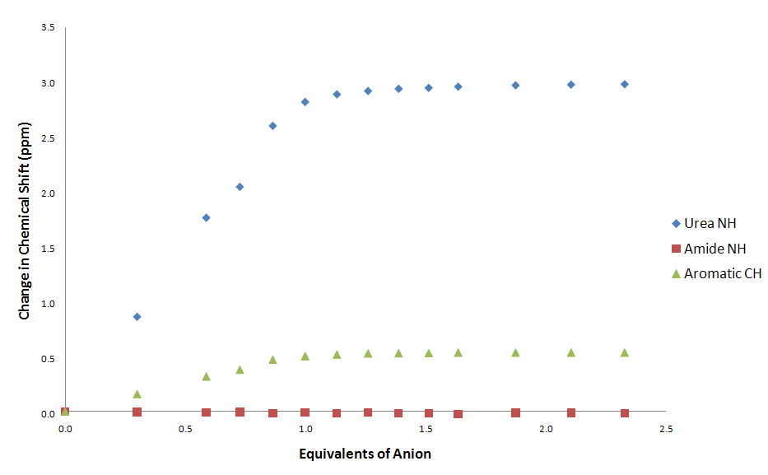
Figure 2 ¹H NMR titration of compound 1 with tetrabutylammonium benzoate following amide NH, urea NH and the aromatic CH in the 6-position of the indole ring

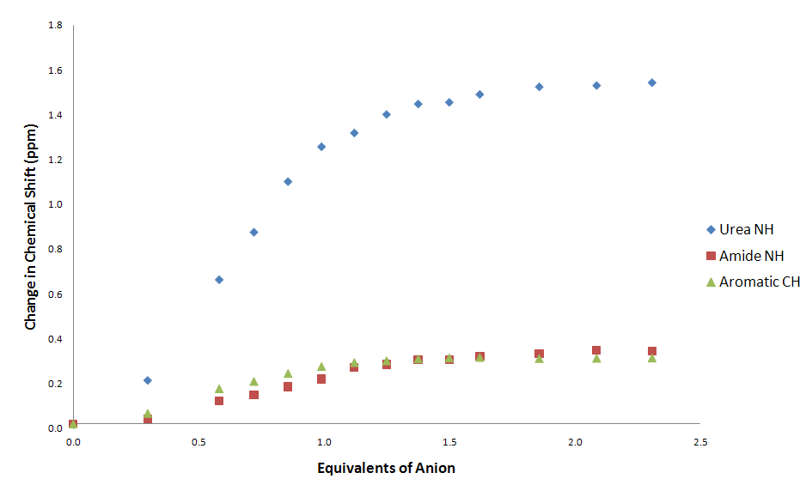
Figure 3 ¹H NMR titration of compound 1 with tetraethylammonium bicarbonate following amide NH, urea NH and the aromatic CH in the 6-position of the indole ring

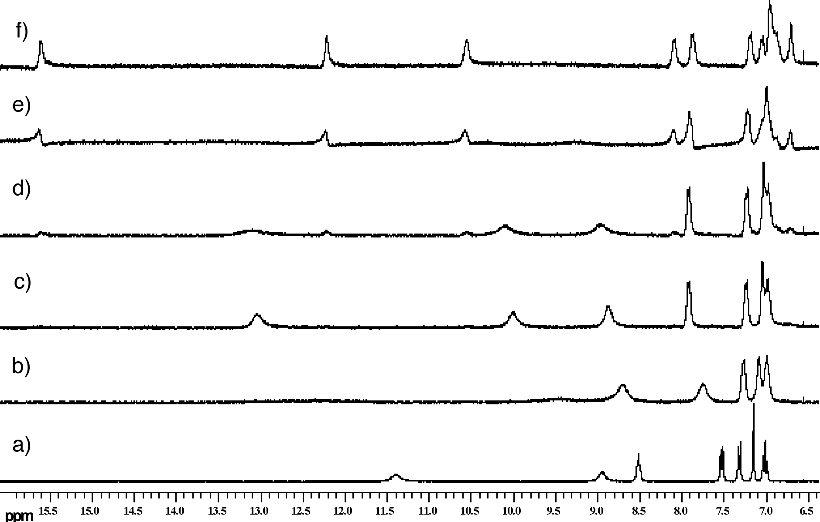
Figure 4 ¹H NMR titration with compound 1 in DMSO-d₆/0.5% water. a) Free receptor; b) 0.6 equivalents TBA H₂PO₄; c) 1.0 equivalents TBA H₂PO₄; d) 1.4 equivalents TBA H₂PO₄; e) 1.4 equivalents TBA H₂PO₄ + 0.7 equivalents TBA OH; f) 1.4 equivalents TBA H₂PO₄ + 1.4 equivalents TBA OH.

Scheme 2 Addition of dihydrogen phosphate to the dihydrogen phosphate complex of receptor 1 causes deprotonation of the bound anion and the formation of a monohydrogen phosphate complex
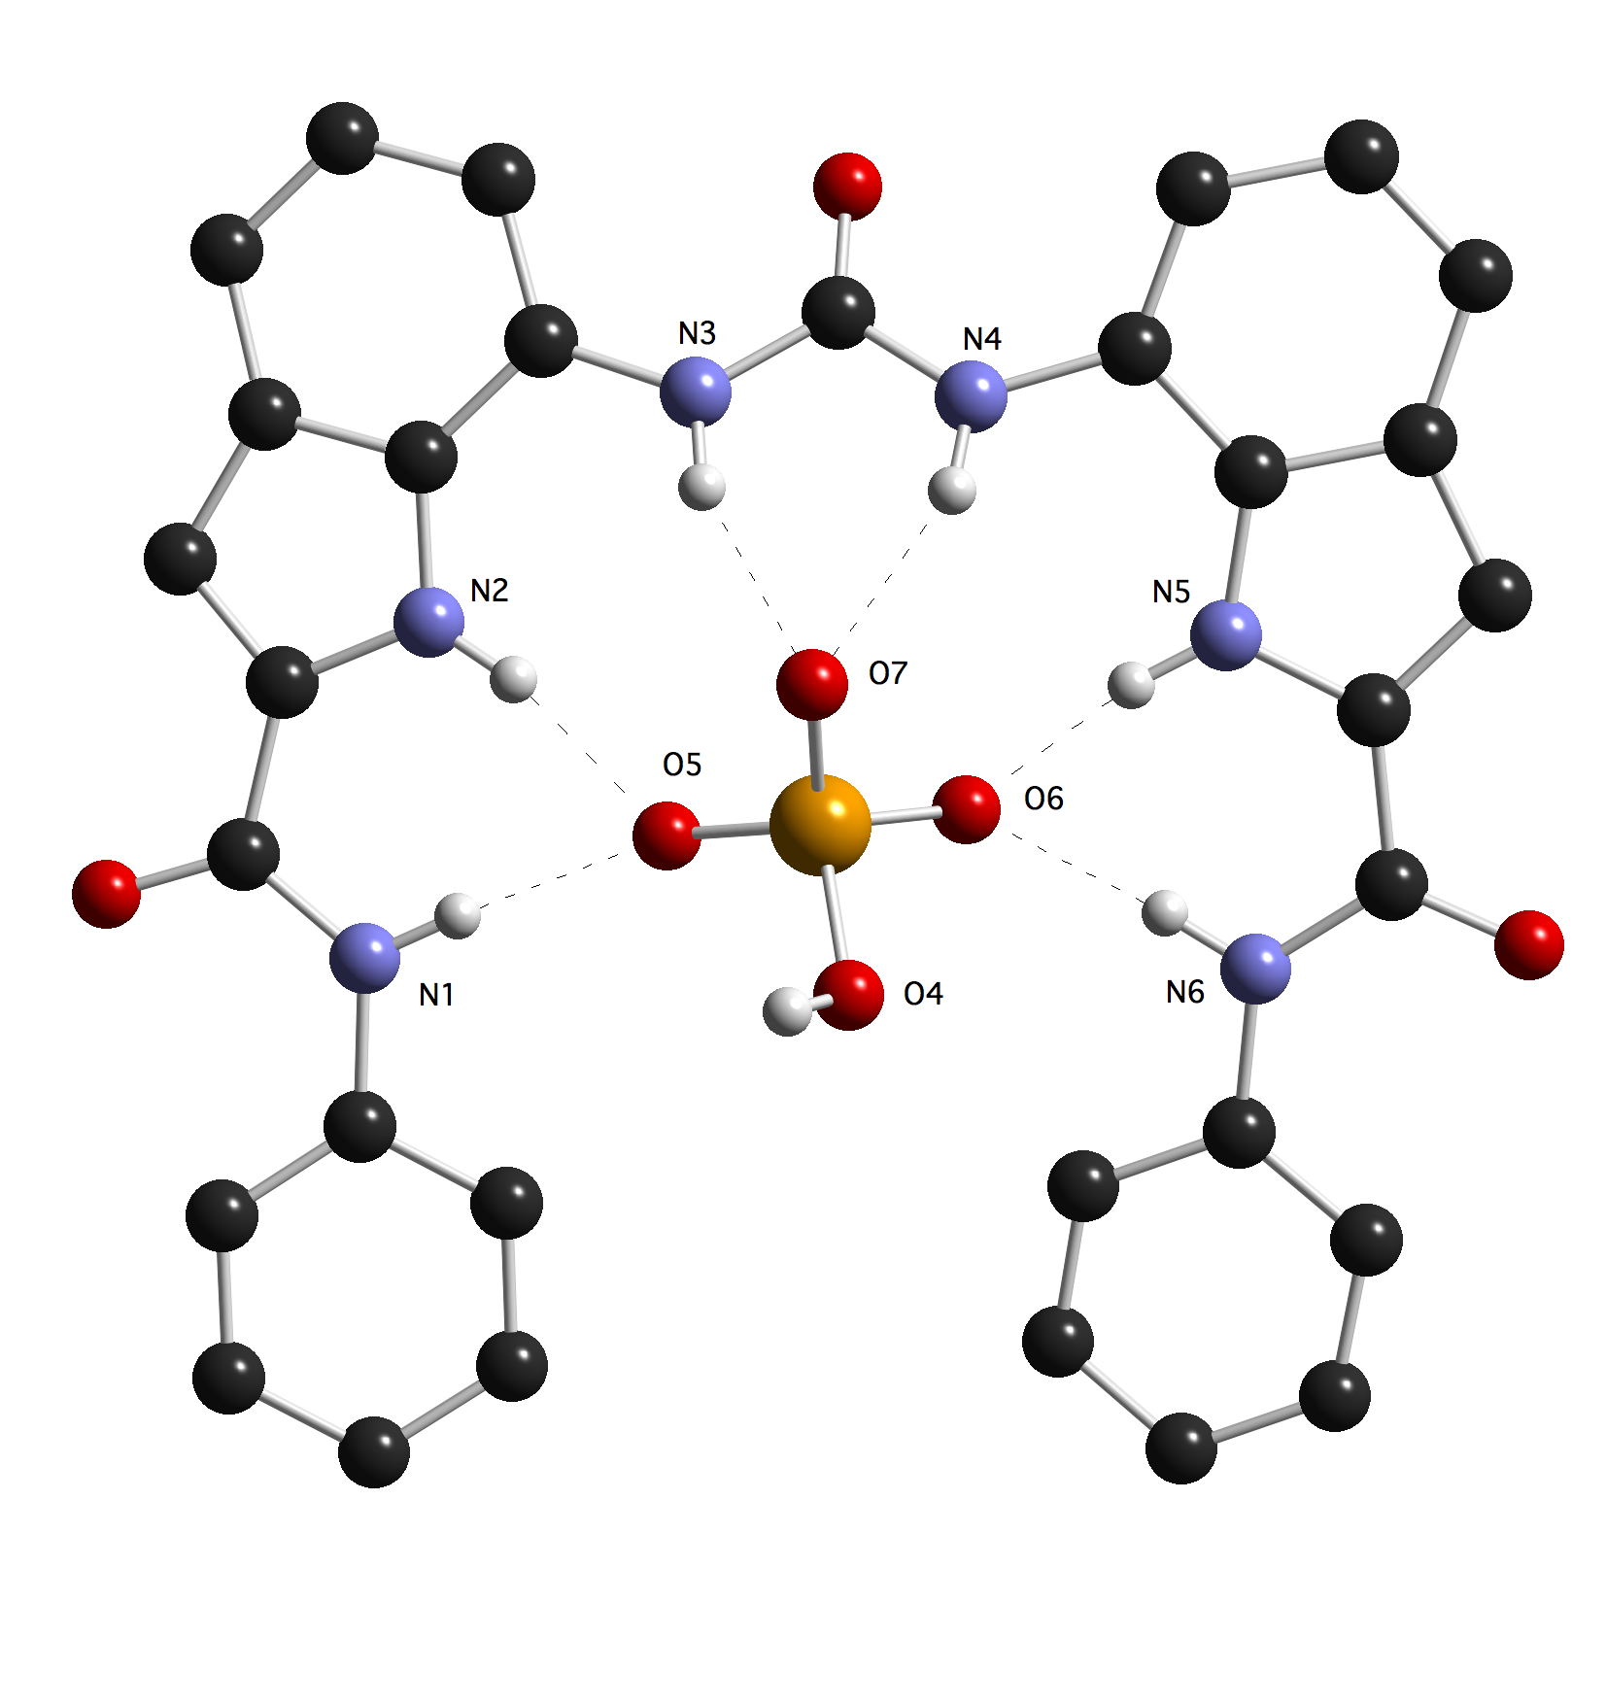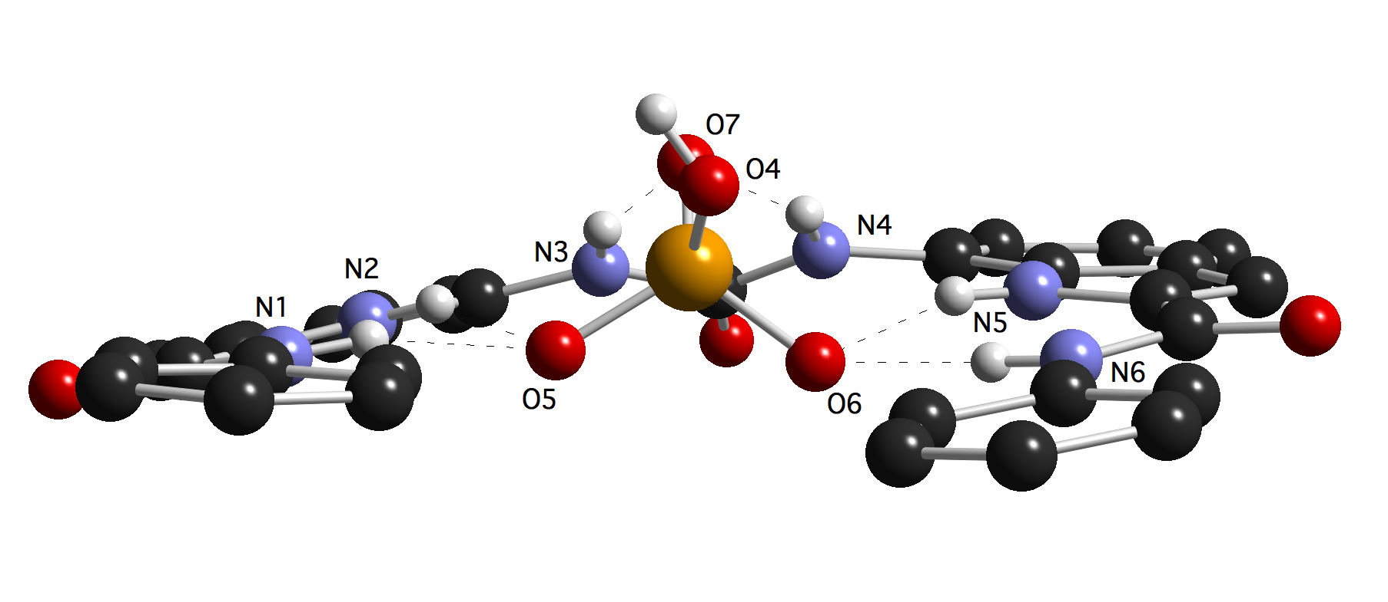
Figure 5. Top and side views of the hydrogen phosphate complex of compound 2. Tetrabutylammonium counter cations, water and non-acidic hydrogen atoms have been omitted for clarity.
Conclusions
Compounds 1 – 4 form stable complexes with oxo-anions such as carboxylates but with dihydrogen phosphate and compound 1, a proton transfer process takes place between bound and free dihydrogen phosphate in solution resulting in the formation of a monohydrogen phosphate complex that is slow on the NMR timescale. Crystallisation of compound 2 with tetrabutylammonium dihydrogen phosphate results in the formation of the monohydrogen phosphate complex of the receptor with the anion bound by six NH…O hydrogen bonds. Presumably the fact that these receptors are able to form multiple hydrogen bonding interactions with the bound guest reduces the pK_{a} of the oxo-anion resulting in proton transfer to unbound anion in solution. We are currently investigating this aspect of the chemistry of diindolylureas in relation to organocatalysis. The results of these studies will be reported in due course.
Experimental Section
General remarks: All reactions were performed using oven-dried glassware under slight positive pressure of nitrogen/argon (as specified). ¹H NMR (300 MHz) and ¹³C{¹H} NMR (75 MHz) spectra were determined on a Bruker AV300 spectrometer. ¹H NMR (400 MHz) and ¹³C{¹H} NMR (100 MHz) spectra were determined on a Bruker AV400 spectrometer. Chemical shifts for ¹H NMR are reported in parts per million (ppm), calibrated to the solvent peak set. The following abbreviations are used for spin multiplicity: s = singlet, d = doublet, t = triplet, m = multiplet. Chemical shifts for ¹³C{¹H} NMR are reported in ppm, relative to the central line of a septet at δ = 39.52 ppm for deuterio-dimethylsulfoxide. Infrared (IR) spectra were recorded on a Matterson Satellite (ATR). FTIR are reported in wavenumbers (cm⁻¹). All solvents and starting materials were purchased from chemical sources where available. NMR titrations were performed by adding aliquots of the putative anionic guest (as the TBA or TEA) salt (0.15 M) in a solution of the receptor (0.01M) in DMSO-d₆ to a solution of the receptor (0.01M).
¹H NMR spectroscopic titrations: A Bruker AV300 NMR spectrometer was used to measure the ¹H NMR shifts of the NH protons of the receptors. NMR titrations were performed by adding aliquots of the putative anionic guest (as the TBA , TEA salt in the case of bicarbonate) salt (0.15 M) in a solution of the receptor (0.01M) in DMSO-d₆ to a solution of the receptor (0.01M). The titration data was plotted Δppm vs. concentration of guest and fitted to a binding model using the EQNMR computer program.^{[9]}
N-benzyl-7-nitro-1H-indole-2-carboxamide 7-nitroindole-2-carboxylic acid (0.410g, 1.99mM) and CDI (0.405g, 2.50mM) were dissolved in chloroform (50mL). The reaction mixture was heated at reflux for 3 hrs under argon. Benzylamine (0.10mL, 1.90mM) was dissolved in dry chloroform (20mL) and then added dropwise to the stirring reaction mixture. The reaction mixture was heated at reflux for 72 hrs under argon. The reaction mixture was diluted with DCM (30mL), washed with water (2x15mL) and then dried with magnesium sulphate. The reaction mixture was reduced in vacuo and then purified by column chromatography (5% ethyl acetate/DCM) to yield a yellow solid (0.511g). Yield 90%; mp. 173°C; ¹H NMR (300 MHz, DMSO-d₆): δ: 4.55 (d, J=5.85Hz, 2H), 7.24-7.40 (m, Ar CH, 6H), 7.44 (s, 1H), 8.22 (t, J=8.40Hz, 2H), 9.50 (t, J=5.67Hz, NH, 1H), 11.38 (s, NH, 1H); ¹³C NMR (75MHz, DMSO-d₆): δ: 42.5 (CH₂), 106.6 (ArCH), 119.9 (ArCH), 121.1 (ArCH), 127.0 (ArCH), 127.5 (ArCH), 128.4 (Ar CH), 128.8 (ArC), 130.6 (ArCH), 130.9 (ArC), 133.1 (ArC), 134.5 (ArC), 139.0 (ArC), 159.5 (CO); IR (film): v = 3457, 3380, 3085, 2963, 1650 cm⁻¹; LRMS (ES⁻):m/z 294.2 [M-H]⁻ HRMS (ES+): m/z: exp: 318.0855 [M+Na]⁺ cal: 318.0848 [M+Na]⁺
N-(2-pyridin-2-yl)-7-nitro-1H-indole-2-carboxamide 7-nitroindole-2-carboxylic acid (0.200g, 0.970mM) was dissolved in dry chloroform. CDI (0.193g, 1.19mM) was added to the stirring reaction mixture. The reaction mixture was heated at reflux for 2 hrs under argon. A solution of 2-aminopyridine (0.092g, 0.967mM) in chloroform (5mL) was added dropwise to the stirring reaction mixture. The reaction mixture was heated at reflux for 22 hours. The reaction mixture was washed with water (2 x 15mL) and then dried with magnesium sulphate. The reaction mixture was then reduced in vacuo and purified by column chromatography (10% ethyl acetate/ DCM) to yield a yellow solid. Yield 80%; mp. 194°C; ¹H NMR (300 MHz, DMSO-d₆): ∂: 7.20 (ddd, J=7.29Hz, 4.74Hz, 0.92Hz, 1H), 7.35 (t, J=8.04Hz, 1H), 7.71 (s, 1H), 7.88 (dt, J=7.32Hz, 1.83Hz, 1H), 8.20-8.31 (m, 3H), 8.43 (dd, J=2.39Hz, 1.11Hz), 11.57 (s, NH, 1H), 11.97 (s, NH, 1H); ¹³C NMR (75MHz, DMSO-d₆): ∂: 109.2 (ArCH), 114.7 (Ar CH), 120.0 (2 ArCH), 121.7 (ArCH), 129.3 (ArC), 130.7 (ArCH), 130.8 (ArC), 133.2 (ArC), 134.1 (ArC), 138.3 (ArCH), 148.0 (ArCH), 151.9 (ArC), 158.4 (CO); IR (film): v = 3382, 3345, 1671 cm⁻¹; LRMS (ES⁻): m/z: 281.2 [M-H]⁻ HRMS (ES+): m/z: exp: 283.0831 [M+H]⁺ cal: 283.0831 [M+H]⁺
7,7'-carbonylbis(azanediyl)bis(N-butyl-1H-indole-2-carboxamide) (1) The synthesis of 7-nitro-N-butyl-1H-indole-2-carboxamide is taken from a method described by Bates et. al.⁷ N-butyl-7-nitro-1H-indole-2-carboxamide (0.25 g, 0.96 mM) a Pd/C 10% catalyst (0.03 g) were suspended in ethanol (25mL). The flask was evacuated and the mixture placed under a hydrogen atmosphere and stirred vigorously for 3 hrs. After this time the palladium catalyst was removed by filtration through celite and the filtrate taken to dryness and placed under reduced pressure. This gave a white solid. Assumed yield 100%. The white solid was dissolved in a two phase solution of sat. NaHCO₃ (20 mL) and DCM (20 mL). This solution was stirred vigorously under nitrogen at room temperature and triphosgene (0.30 g, 1.00 mM) added in two equal aliquots. The solution was allowed to stir overnight. The two phase solution was then filtered and a white solid sonicated in water (250 mL) for 30 mins. A white solid was then collected by filtration and washed with DCM (20 mL) and diethyl ether (20 mL). Yield 49 %; mp. 138 ºC; ¹H NMR (300 MHz, DMSO-d₆): δ: 0.92 (t, J = 7.32 Hz, 3H), 1.36 (dd, J₁ = 6.93 Hz, J₂ = 13.53 Hz, 2H), 1.54 (t, J = 6.96 Hz, 2H), 3.33 (m, 2H), 7.01 (t, J = 7.68 Hz, 1H), 7.16 (s, 1H), 7.32 (d, J = 8.04 Hz, 1H), 7.51 (d, J = 7.32 Hz, 2H), 8.51 (s, NH, 1H), 8.88 (s, NH, 1H), 11.37 (s, NH, 1H); ¹³C{¹H} NMR (75 MHz, DMSO-d₆): δ: 13.7 (CH₃), 19.6 (CH₂), 31.3 (CH₂), 38.4 (CH₂), 102.8 (ArCH), 113.7 (ArCH), 116.0 (ArCH), 120.2 (ArCH), 124.9 (ArC), 128.0 (ArC), 128.6 (ArC), 131.7 (ArC), 153.1 (CO), 160.8 (CO); IR (film): ν = 3340, 3270, 1640, 1560 cm⁻¹; LRMS (ES⁻):m/z: 487.4 [M-H]⁻; HRMS (ES⁺): m/z: exp: 489.2604 [M+H]⁺ cal: 489.2609 [M+H]⁺.
7,7’-carbonylbis(azanediyl)bis(N-phenyl-1H-indole-2-carboxamide (2) The synthesis of 7-nitro-N-phenyl-1H-indole-2-carboxamide is taken from a method described by Bates et. al.⁷ 7-Nitro-N-phenyl-1H-indole-2-carboxamide (0.2 g, 0.71 mM) and a Pd/C 10% catalyst (0.02 g) were suspended in ethanol (25 mL). The flask was then evacuated and the mixture placed under a hydrogen atmosphere and stirred vigorously for 3 hrs. After this time the palladium catalyst was removed by filtration through celite and the filtrate taken to dryness and placed under reduced pressure affording a white solid. 7-Amino-Nphenyl-1H-indole-2 carboxamide (0.18 g, 0.71 mM) was dissolved in a mixture of DCM (20 mL) and a saturated aqueous solution of NaHCO₃ (20 mL). Triphosgene (0.28 g, 0.95 mM) was added in portions to the two phase solution and the mixture was left stirring under a nitrogen atmosphere overnight. The organic layer was diluted with DCM (100 mL), washed with water, dried over MgSO₄, filtered and concentrated in vacuo. The pure product was isolated by sonication in MeOH (5 mL) for 3 mins and removed by filtration. The product was isolated as a white solid. Yield 30%; mp. 174˚C; ¹H NMR (300 MHz, DMSO-d₆): δ: 7.05-7.15 (m, 4H), 7.36-7.43 (m, 6H), 7.51 (d, J = 1.83 Hz, 2H), 7.60 (d, J = 7.68 Hz, 2H), 7.84 (d, J = 7.68 Hz, 4H), 8.97 (s, urea NH, 2H), 10.30 (s, amide NH, 2H), 11.62 (s, indole NH, 2H); ¹³C{¹H} NMR (75 MHz, DMSO-d₆): δ: 104.5 (ArCH), 114.3 (ArCH), 116.3 (ArCH), 120.3 (ArCH), 120.5 (ArCH), 123.7 (ArCH), 125.0 (ArC), 128.6 (ArC), 128.8 (ArCH), 131.3 (ArC),138.9 (ArC), 153.2 (CO), 159.7 (CO); IR (film): ν = 3289, 1661 cm⁻¹; LRMS (ES⁻):m/z: 527.5 [M-H]⁻; HRMS (ES⁺): m/z: exp: 551.1794 [M+Na]⁺ cal: 551.1802 [M+Na]⁺
Bis(benzyl-7-nitro-1H-indole-2-carboxamine)-urea (3) N-benzyl-7-nitroindole-2-carboxamide (0.243g, 0.824mM) was dissolved in ethanol (20mL). Palladium on carbon 10% (0.025g) was added. The reaction vessel was evacuated and placed under a hydrogen atmosphere and stirred at room temperature for 6hrs. The reaction mixture was then filtered through celite and reduced in vacuo to yield a white solid. Assumed yield 100%. The white solid and triphosgene (0.051g, 0.171mM) were dissolved in a two phase solution of DCM (50mL) and saturated sodium bicarbonate solution (50mL) and stirred at room temperature for 2 hours. The two phase solution was then filtered. The resulting grey solid was sonicated in water (500mL) for 1hr. A white solid was collected by filtration and washed with water (2 x 25mL), DCM (10mL) and diethyl ether (2 x 25mL). Yield 56%; mp 162°C; ¹H NMR (300 MHz, DMSO-d₆): δ: 4.53 (d, J=5.85Hz, 4H), 7.02 (t, J=7.88Hz, 2H), 7.20-7.38 (m, J=7.68Hz, 14H), 7.52 (d, J=7.68Hz, 2H), 8.89 (s, NH, 2H), 9.13 (t, J=5.85Hz, NH, 2H), 11.46 (s, NH, 2H); ¹³C{¹H} NMR (75MHz, DMSO-d₆): δ: 42.2 (CH₂), 103.4 (ArCH), 113.3 (ArCH), 115.9 (ArCH), 120.3 (ArCH), 125.2 (ArCH), 126.8 (ArC), 127.3 (ArCH), 128.1 (ArC), 128.3 (ArCH), 128.5 (ArC), 131.4(ArC), 139.6 (ArC), 153.2 (CO), 161.0 (CO); IR (film): v = 3290, 1635, 1575 cm⁻¹; LRMS (ES⁻): m/z: 555.3 [M-H]⁻; HRMS (ES+): m/z: exp: 557.2294 [M+H]⁺ cal: 557.2301 [M+H]⁺
Bis((2-pyridin-2-yl)-7-nitro-1H-indole-2-carboxamine)-urea (4) (2-pyridinyl-2-yl)-7-nitroindole-2-carboxamide (0.179g, 0.635mM) was dissolved in ethanol (50mL). Palladium on carbon 10% (0.030g) was added. The reaction vessel was evacuated and then supplied with hydrogen and stirred at room temperature for 6 hrs. The reaction mixture was then filtered through celite and reduced in vacuo to yield a white solid. Assumed yield 100%. The white solid and triphosgene (0.037g, 0.125mM) were dissolved in DCM (50mL) and saturated sodium bicarbonate solution (50mL) and stirred at room temperature for 2 hrs. The organic phase was separated and reduced in vacuo. The resulting brown solid was sonicated in water (500mL) for 1 hr. The solid was filtered and washed with water (2 x 25mL) and diethyl ether (2 x 25mL). This yielded a white solid. Yield 55%; mp. 219˚C; ¹H NMR (300 MHz, DMSO-d₆): δ: 7.06 (t, J=7.68Hz, 2H), 7.17 (dd, J=6.57Hz,4.77Hz, 2H), 7.38 (d, J=8.04Hz, 2H), 7.59 (d, J=7.68Hz, 2H), 7.70 (s, 2H), 8.25 (d, J=8.40Hz, 2H), 8.41 (d, J=3.66Hz, 2H), 8.97 (s, NH, 2H), 10.95 (s, NH, 2H), 11.65 (s , NH, 2H) ¹³C{¹H} NMR (75MHz, DMSO-d₆): δ: 105.8 (Ar CH), 114.6 (ArCH), 116.6 (ArCH), 119.5 (ArCH), 119.7 (ArCH), 120.5 (ArCH), 125.0 (ArC), 128.6 (ArC), 129.0 (ArC), 130.6 (ArC), 138.2 (ArCH), 148.0 (ArCH), 152.0 (ArC), 153.1 (CO), 160.0 (CO); IR (film): v = 3269, 1644, 1539 cm⁻¹; LRMS (ES⁻):m/z: 529.2 [M-H]⁻; HRMS (ES+): m/z: exp: 531.1879 [M+H]⁺ cal: 531.1893 [M+H]⁺
Crystallisations: Crystallisations were performed by dissolving ca. 0.05 mmol of receptor 1 in 2 mL of DMSO followed by addition of approximately 0.25 mmol tetrabutylammonium dihydrogen phosphate and allowing the solution to stand.
X-ray structure determinations. Data were collected on a Bruker Nonius KappaCCD with a Mo rotating anode generator (λ=0.71073) employing phi and omega scans; standard procedures were followed. Lorentz and polarisation corrections were applied during data reduction with DENZO^{[10]} and multi-scan absorption corrections were applied using SADABS.^{[11]} The structure was solved and refined using the SHELX suite of programs.^{[12]}
Crystal data for the monohydrogen phosphate complex of compound 2.TBA₂HPO₄.2H₂O: C₆₃H₁₀₁N₈O₉P, 0.18 × 0.05 × 0.02 mm³, Mr = 1145.49, T = 120(2) K, Triclinic, space group P−1, a = 13.9084(5), b = 16.5116(5), c = 16.5971(4) Å, α = 65.864(2)°, β = 72.349(2)°, γ = 71.014(2)°, V = 3224.48(17) Å³, ρ_{calc} = 1.180 Mg / m³, μ = 0.102 mm⁻¹, T_{min} = 0.9818 T_{max} = 0.9980, Z = 2, reflections collected: 48032, independent reflections: 11275 (R_{int} = 0.0900), 2θmax = 25.00°, Parameters = 768, largest difference peak and hole = 0.748 and −0.753 e Å⁻³, final R indices [I > 2σI]: R1 = 0.0931, wR2 = 0.1597, R indices (all data): R1 = 0.1586, wR2 = 0.1914. CCDC 734479.
Acknowledgements
PAG thanks the EPSRC for funding and for access to the crystallographic facilities at the University of Southampton. CC would like to thank Italian Ministero dell’Istruzione, dell’Università e della Ricerca Scientifica (MIUR) for financial support (Project PRIN-2007C8RW53).
[1] a) C. Caltagirone, P.A. Gale, Chem. Soc. Rev. 2009, 38, 520-563; b) S. Kubik, Chem. Soc. Rev. 2009, 38, 585-605; c) J.W. Steed, Chem. Soc. Rev. 2009, 38, 506-519; d) P.A. Gale, S.E. García-Garrido, J. Garric, Chem. Soc. Rev. 2008, 37, 151-190; e) P. Prados and R. Quesada, Supramol. Chem. 2008, 20, 201-216; f) G.W. Bates, P.A. Gale, Structure and Bonding, 2008, 129, 1-44; g) J.L. Sessler, P.A. Gale, W.S. Cho, Anion Receptor Chemistry (Monographs in Supramolecular Chemistry) Ed. J.F. Stoddart; Royal Society of Chemistry, Cambridge, 2006; h) Katayev, E.A., Ustynyuk, Y.A., Sessler, J.L. Coord. Chem. Rev. 2006, 250, 3004-3007; i) P.A. Gale, R. Quesada, Coord. Chem. Rev. 2006, 250, 329-3244; j) P.A. Gale, Acc. Chem. Res. 2006, 39, 465-475; k) K. Bowman-James, Acc. Chem. Res. 2005, 38, 671-678; l) K. Bowman-James, Angew. Chem. Int. Ed. 2006, 45, 7882-7894; m) P.A. Gale, Chem. Commun. 2005, 3761-3772; n) P.A. Gale, Coord. Chem. Rev. 2003, 240, 191-221; o) P.D. Beer, P.A. Gale, Angew. Chem. Int. Ed. Engl., 2001, 40, 486-516; p) P.A. Gale, Coord. Chem. Rev., 2001, 213, 79-128; q) F.P. Schmidtchen, M. Berger, Chem. Rev. 1997, 97, 1609-1646.
[2] For an overview see: a) P.A. Gale, Chem. Commun. 2008, 4525-4540. For key papers see: b) P. Piatek, V.M. Lynch, J. L. Sessler, J. Am. Chem. Soc. 2004, 126, 16073-16076; c) M.J. Chmielewski, M. Charon, J. Jurczak, Org. Lett. 2004, 6, 3501-3504; d) D. Curiel, A. Cowley, P.D. Beer, Chem. Commun. 2005, 236-238; e) K.-J. Chang, D. Moon, M.S. Lah, K.S. Jeong, Angew. Chem. Int. Ed. 2005, 44, 7926-7929; f) F.M. Pfeffer, K.F. Lim, K.J. Sedgwick, Org. Biomol. Chem. 2007, 5, 1795-1799; g) G.W. Bates, P.A. Gale, M.E. Light, Chem. Commun. 2007, 2121-2123; h) J.O. Yu, C.S. Browning, D.H. Farrar, Chem. Commun. 2008, 1020-1022; i) J.-m. Suk, M. K. Chae, N.-K. Kim, U.-l Kim, K.-S. Jeong, Pure Appl. Chem. 2008, 80, 599-608; j) M.J. Chmielewski, L. Zhao, A. Brown, D. Curiel, M.R. Sambrook, A.L. Thompson, S.M. Santos, V. Felix, J.J. Davis, P.D. Beer, Chem. Commun. 2008, 3154-3156; k) U.I. Kim, J.M. Suk, V.R. Naidu, K.-S. Jeong, Chem. Eur. J. 2008, 14, 11406-11414; l) C. Caltagirone, P.A. Gale, J.R. Hiscock, M.B. Hursthouse, M.E. Light, G.J. Tizzard, Supramolecular Chem., 2009, 21, 125-130.
[3] F.G. Bordwell, G.E. Drucker, H.E. Fried, J. Org. Chem. 1981, 46, 632-635.
[4] K.H.G. Verschueren, F. Seljee, H.J. Rozeboom, K.H Kalk, B.W. Dijkstra, Nature, 1993, 363, 693-698.
[5] J.J. He, F.A. Quiocho, Science, 1991, 251, 1479-1481.
[6] a) C. Caltagirone, P.A. Gale, J.R. Hiscock, S.J. Brooks, M.B. Hursthouse and M.E. Light, Chem. Commun. 2008, 3007-3009; b) C. Caltagirone, J.R. Hiscock, M.B. Hursthouse, M.E. Light and P.A. Gale, Chem. Eur. J. 2008, 14, 10236-10243.
[7] G.W. Bates, Triyanti, M.E. Light, M. Albrecht, P.A. Gale, J. Org. Chem. 2007, 72, 8921-8927.
[8] J.T. Davis, P.A. Gale, O.A. Okunola, P. Prados, J.C. Iglesias-Sánchez, T. Torroba and R. Quesada, Nature Chem. 2009, 1, 138-144.
[9] M.J. Hynes, J. Chem. Soc., Dalton Trans. 1993, 311-312.
[10] DENZO: Z. Otwinowski ,W. Minor, Methods Enzymol., 1997, 276, 307-326.
[11] G.M. Sheldrick, SADABS - Bruker Nonius area detector scaling and absorption correction - V2.10
[12] SHELX97: Programs for Crystal Structure Analysis (Release 97-2). G. M. Sheldrick, Institüt für Anorganische Chemie der Universität, Göttingen, (Germany) 1998.

Received: ((will be filled in by the editorial staff))
Revised: ((will be filled in by the editorial staff))
Published online: ((will be filled in by the editorial staff))

Amide functionalised dindolylureas: anion complexation and anion-anion proton transfer
Jennifer R. Hiscock, Stephen J. Moore, Claudia Caltagirone, Michael B. Hursthouse, Mark E. Light and Philip A. Gale*
[a] J.R. Hiscock, S.J. Moore, Prof. M.B. Hursthouse, Dr M.E. Light and Prof. P.A. Gale
School of Chemistry,
University of Southampton,
Southampton, SO17 1BJ, UK.
Fax: +44 23 8059 6805
E-mail: philip.gale@soton.ac.uk
[b] Dr C. Caltagirone,
Supporting information for this article is available on the WWW under http://www.chemeurj.org/ or from the author.))
Amide functionalised diindolylureas: anion complexation and anion-anion proton transfer

Amide functionalised diindolylureas can donate six hydrogen bonds to a single dihydrogen phosphate anion resulting in an increase in acidity of the bound phosphate guest.

Amide functionalised diindolylureas: anion complexation and anion-anion proton transfer
Jennifer R. Hiscock,^{[a]} Stephen J. Moore,^{[a]} Claudia Caltagirone,^{[b]} Michael B. Hursthouse,^{[a]} Mark E. Light^{[a]} and Philip A. Gale*^{[a]}
[a] J.R. Hiscock, S.J. Moore, Prof. M.B. Hursthouse, Dr M.E. Light and Prof. P.A. Gale
School of Chemistry,
University of Southampton,
Southampton, SO17 1BJ, UK.
Fax: +44 23 8059 6805
E-mail: philip.gale@soton.ac.uk
[b] Dr C. Caltagirone,
Dipartimento di Chimica Inorganica ed Analitica, Università degli Studi di Cagliari, S.S. 554 Bivio per Sestu, 09042, Monserrato, CA, Italy.

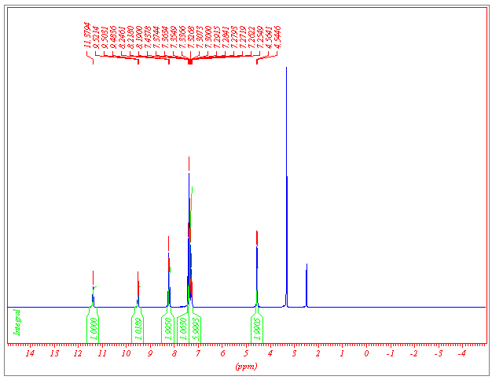
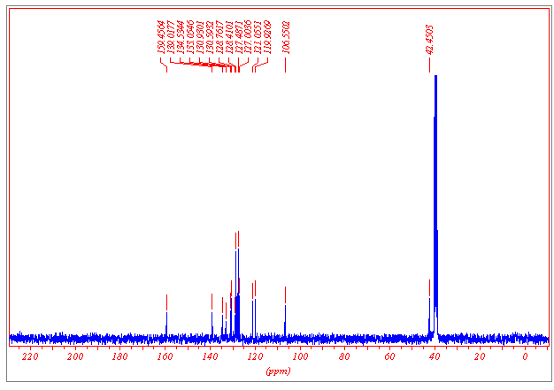
Figure S1 ¹H NMR spectrum of N-benzyl-7-nitroindole-2-carboxamide in DMSO-d₆.
Figure S2 ¹³C NMR spectrum of N-benzyl-7-nitroindole-2-carboxamide in DMSO-d₆.
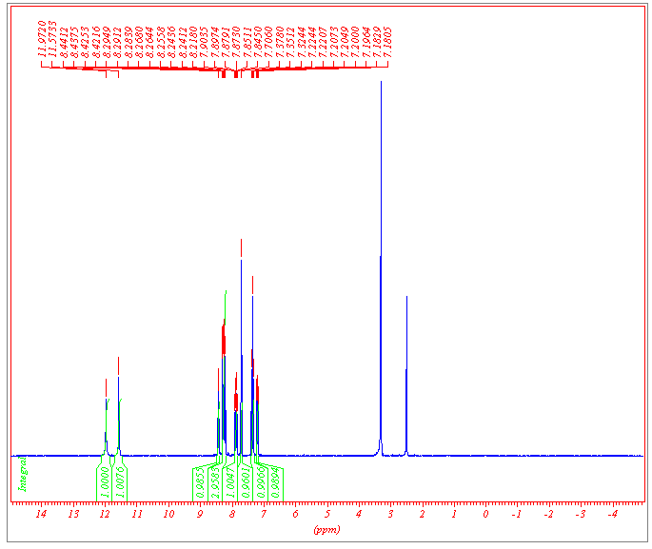Figure S3 ¹H NMR spectrum of N-(2-pyridin-2-yl)-7-nitroindole-2-carboxamide in DMSO-d₆.
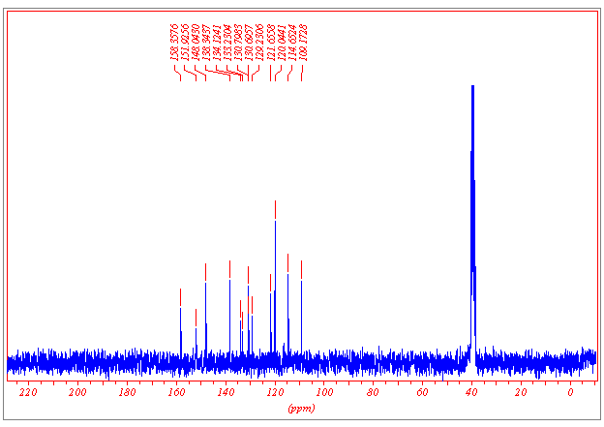Figure S4 ¹³C NMR spectrum of N-(2-pyridin-2-yl)-7-nitroindole-2-carboxamide in DMSO-d₆.

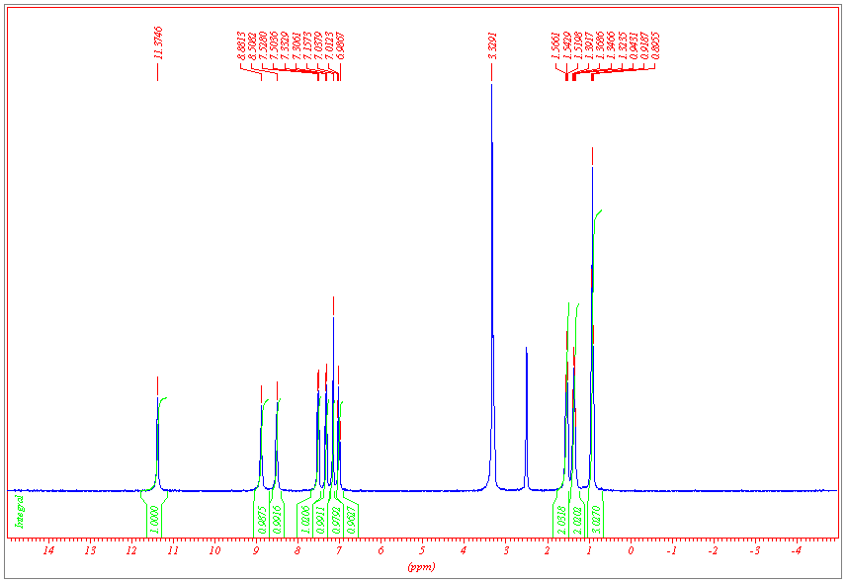
Figure S5 ¹H NMR spectrum of compound 1 in DMSO-d₆.
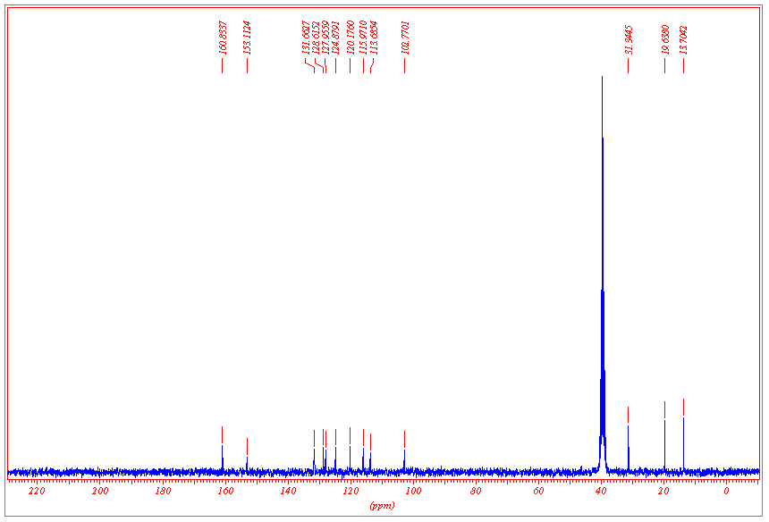
Figure S6 ¹³C NMR spectrum of compound 1 in DMSO-d₆.

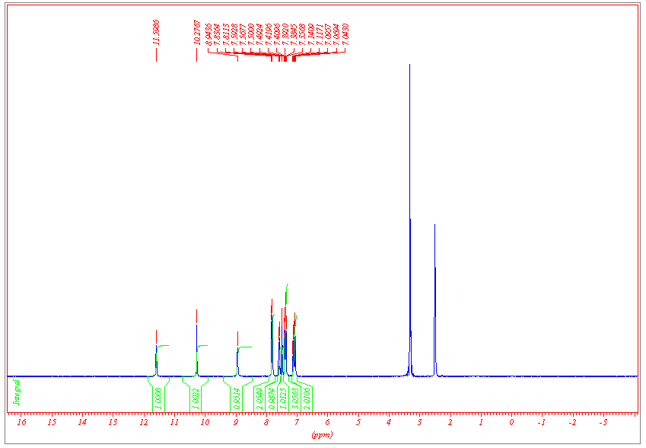
Figure S7 ¹H NMR spectrum of compound 2 in DMSO-d₆.
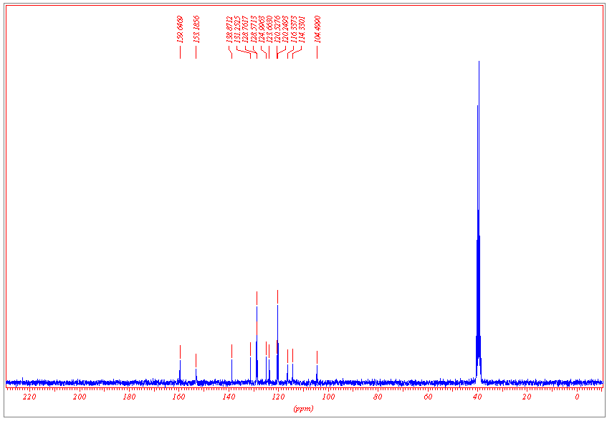
Figure S8 ¹³C NMR spectrum of compound 2 in DMSO-d₆.
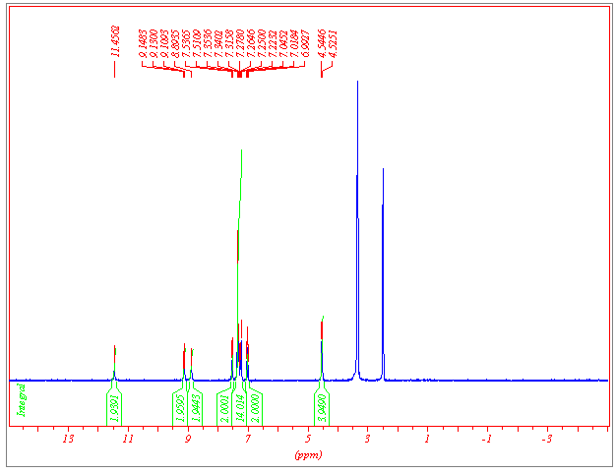Figure S9 ¹H NMR spectrum of compound 3 in DMSO-d₆.
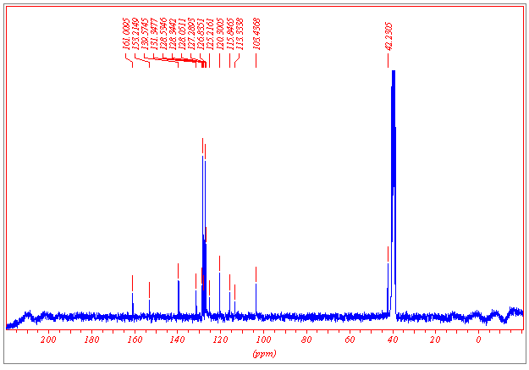Figure S10 ¹³C NMR spectrum of compound 3 in DMSO-d₆.
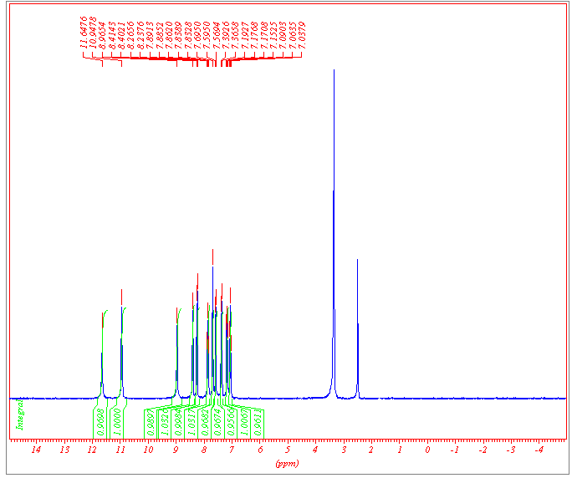Figure S11 ¹H NMR spectrum of compound 4 in DMSO-d₆.
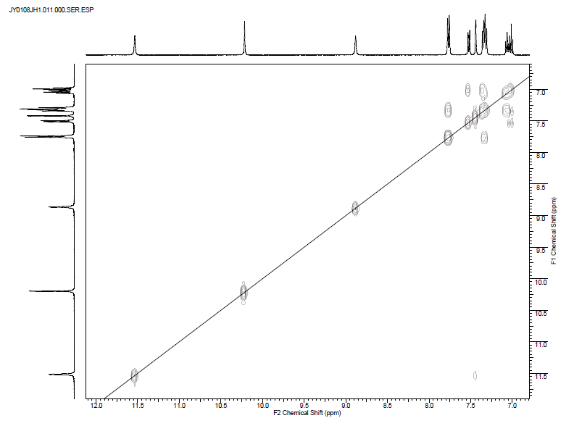
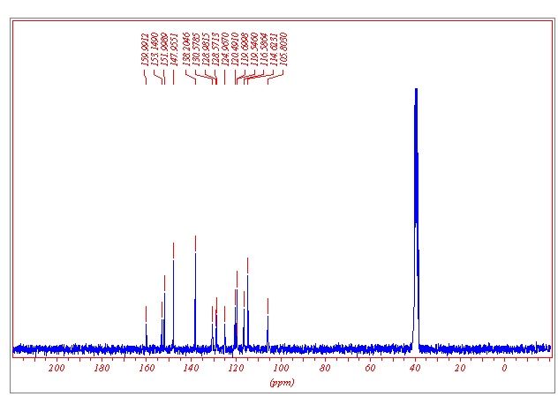Figure S12 ¹³C NMR spectrum of compound 4 in DMSO-d₆.
Figure S13 ¹H COSY NMR spectrum of compound 2 in DMSO-d₆.
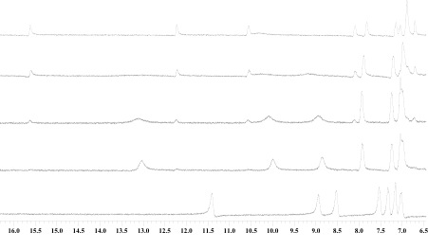
Figure S14: Stack plot of compound 1 with tetrabutylammonium dihydrogen phosphate showing the emergence of new resonances above 1.0 equivalents of H₂PO₄⁻. From the bottom: 0.0 eq, 1.0 eq., 1.4 eq., 2.2 eq. and 5.9 eq. H₂PO₄⁻.

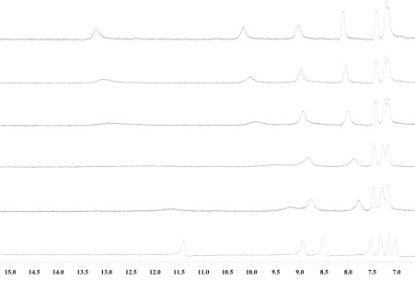
Figure S15: Stack plot of compound 1 with tetrabutylammonium dihydrogen phosphate depicting a binding event. From the bottom: 0.0eq., 0.3eq, 0.6 eq., 0.8 eq, 0.9 eq. 1.0 eq. H₂PO₄⁻.

Figure S16: Stack plot of compound 1 with tetrabutylammonium acetate.

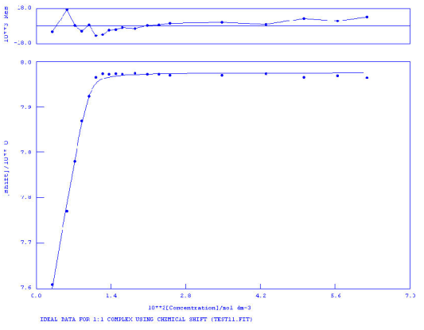
K_{a} = > 10⁴ M⁻¹
Figure S17 NMR titration of compound 1 vs. TBAOAc in DMSO-d₆/H₂O 0.5%. Following the aromatic CH.

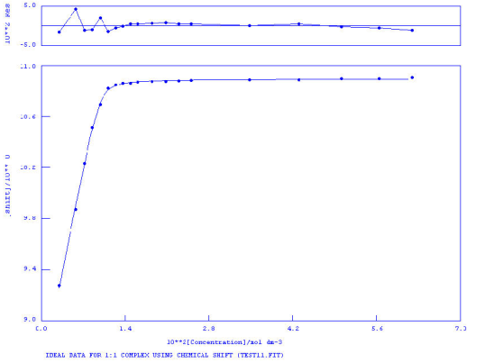
K_{a} = > 10⁴ M⁻¹
Figure S18 NMR titration of compound 1 vs. TBAOAc in DMSO-d₆/H₂O 0.5%. Following the urea NH.

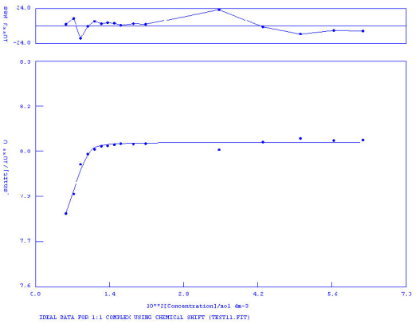
K_{a} > 10⁴ M⁻¹
Figure S19 NMR titration of compound 1 vs. TBAOBz in DMSO-d₆/H₂O 0.5%. Following the aromatic CH.

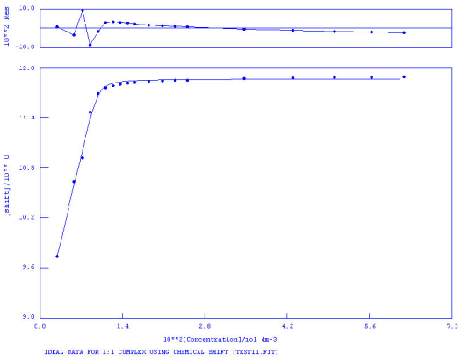
K_{a} = > 10⁴ M⁻¹
Figure S20 NMR titration of compound 1 vs. TBAOBz in DMSO-d₆/H₂O 0.5%. Following the urea NH.

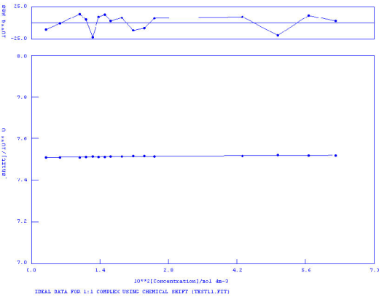
K_{a} = 166 M⁻¹ Error = 1 %
Figure S21 NMR titration of compound 1 vs. TBACl in DMSO-d₆/H₂O 0.5%. Following the aromatic CH.

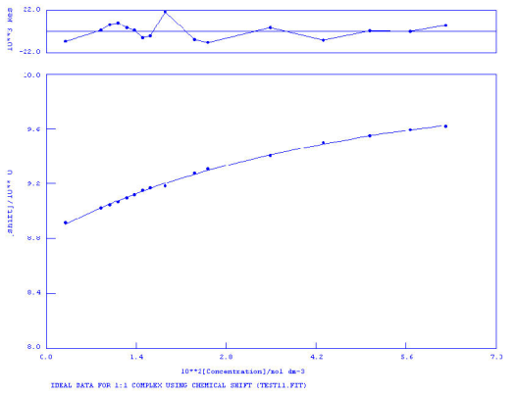
K_{a} = 22 M⁻¹ Error = 9 %
Figure S22 NMR titration of compound 1 vs. TBACl in DMSO-d₆/H₂O 0.5%. Following the urea NH.

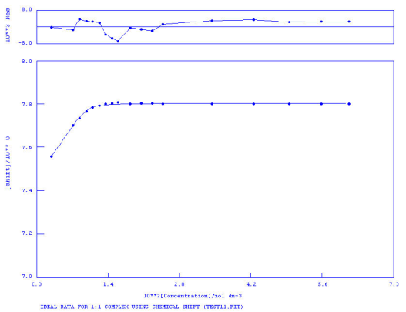
K_{a} > 10⁴ M⁻¹
Figure S23 NMR titration of compound 1 vs. TEAHCO₃ in DMSO-d₆/H₂O 0.5%. Following the aromatic CH.

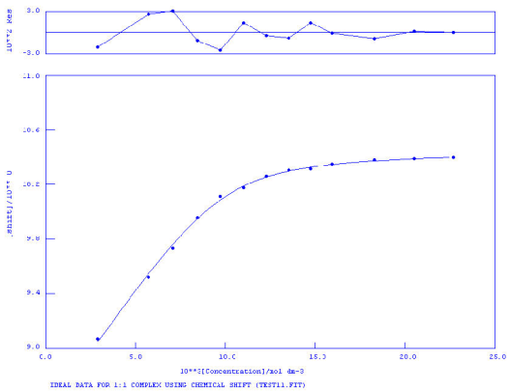
K_{a} = 2468 M⁻¹ Error = 14 %
Figure S24 NMR titration of compound 1 vs. TEAHCO₃ in DMSO-d₆/H₂O 0.5%. Following the urea NH.

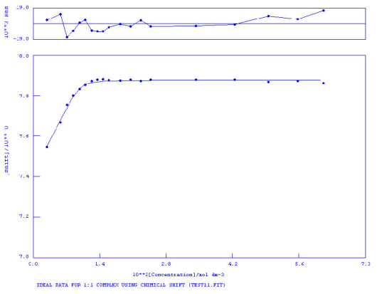
K_{a} > 10⁴ M⁻¹
Figure S25 NMR titration of compound 1 vs. TBAH₂PO₄ in DMSO-d₆/H₂O 10%. Following the aromatic CH.

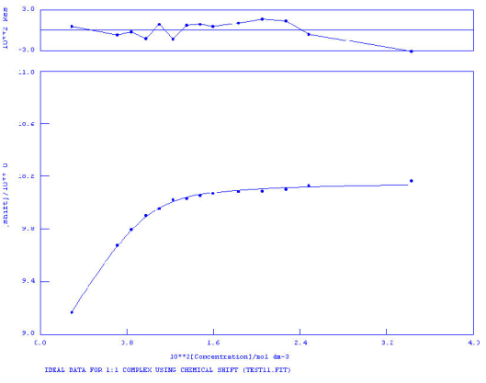
K_{a} = 2314 M⁻¹ Error = 4 %
Figure S26 NMR titration of compound 1 vs. TBAH₂PO₄ in DMSO-d₆/H₂O 10%. Following the urea NH.

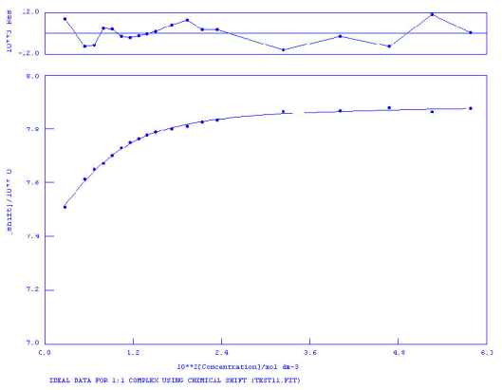
K_{a} = 462 M⁻¹ Error = 7 %
Figure S27 NMR titration of compound 1 vs. TBAOAc in DMSO-d₆/H₂O 10%. Following the aromatic CH.

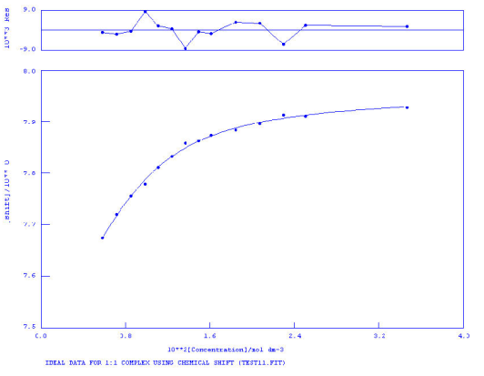
K_{a} = 1016 M⁻¹ Error = 8 %
Figure S28 NMR titration of compound 1 vs. TBAOBz in DMSO-d₆/H₂O 10%. Following the aromatic CH.

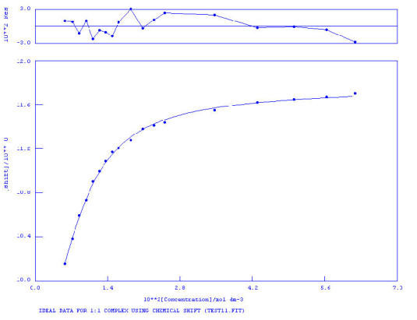
K_{a} = 1099 M⁻¹ Error = 4 %
Figure S29 NMR titration of compound 1 vs. TBAOBz in DMSO-d₆/H₂O 10%. Following the urea NH.

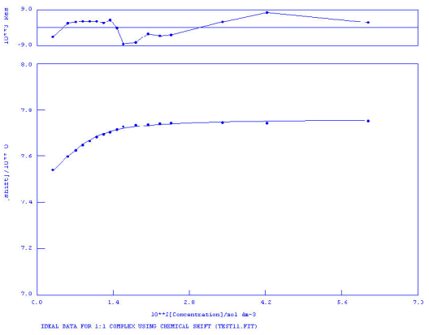
K_{a} = 809 M⁻¹ Error = 3 %
Figure S30 NMR titration of compound 1 vs. TEAHCO₃ in DMSO-d₆/H₂O 10%. Following the aromatic CH.

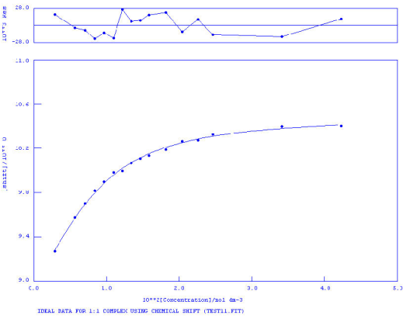
K_{a} = 395 M⁻¹ Error = 9 %
Figure S31 NMR titration of compound 1 vs. TEAHCO₃ in DMSO-d₆/H₂O 10%. Following the aromatic CH.

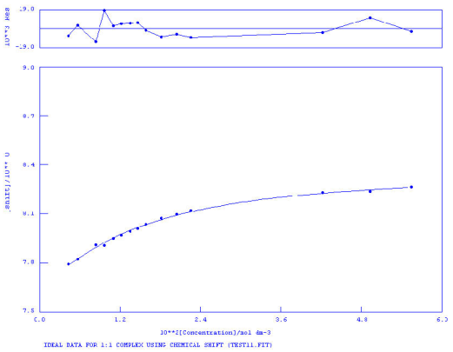
K_{a} = 107 M⁻¹ Error = 8 %
Figure S32 NMR titration of compound 2 vs. TBAH₂PO₄ in DMSO-d₆/H₂O 0.5%. Following the aromatic CH.

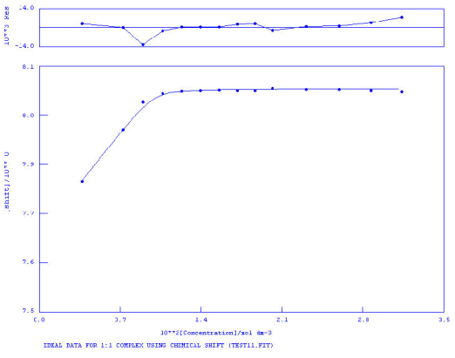
K_{a} = > 10⁴ M⁻¹
Figure S33 NMR titration of compound 2 vs. TBAOAc in DMSO-d₆/H₂O 0.5%. Following the aromatic CH.

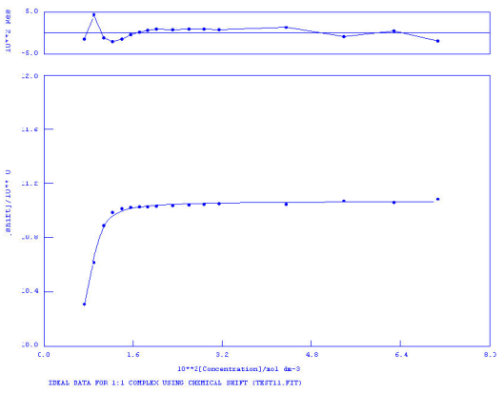
K_{a} = 8456 M⁻¹ Error = 12 %
Figure S34 NMR titration of compound 2 vs. TBAOAc in DMSO-d₆/H₂O 0.5%. Following the urea NH.

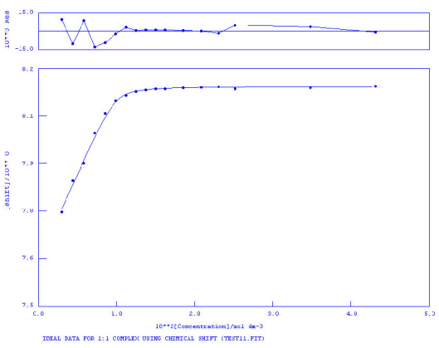
K_{a} = > 10⁴ M⁻¹
Figure S35 NMR titration of compound 2 vs. TBAOBz in DMSO-d₆/H₂O 0.5%. Following the aromatic CH.

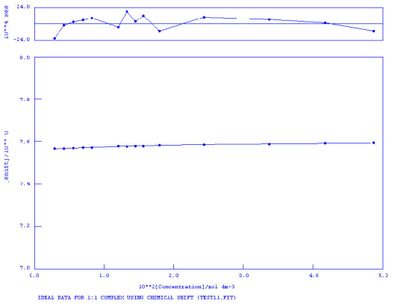
K_{a} = 79 M⁻¹ Error = 5 %
Figure S36 NMR titration of compound 2 vs. TBACl in DMSO-d₆/H₂O 0.5%. Following the aromatic CH.

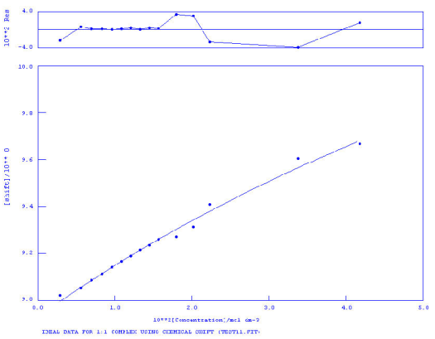
Figure S37 NMR titration of compound 2 vs. TBACl in DMSO-d₆/H₂O 0.5%. Following the urea NH.

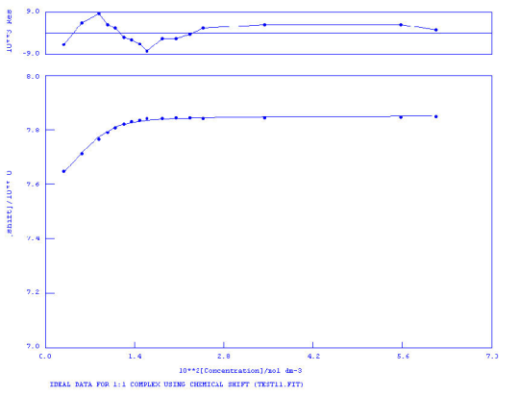
K_{a} = 2247 M⁻¹ Error = 17 %
Figure S38 NMR titration of compound 2 vs. TEAHCO₃ in DMSO-d₆/H₂O 0.5%. Following the aromatic CH.

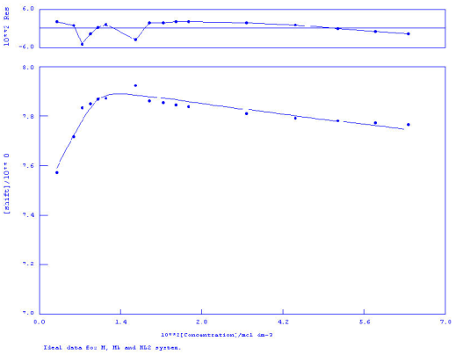
Figure S39 NMR titration of compound 2 vs. TBAH₂PO₄ in DMSO-d₆/H₂O 10%. Following the aromatic CH.

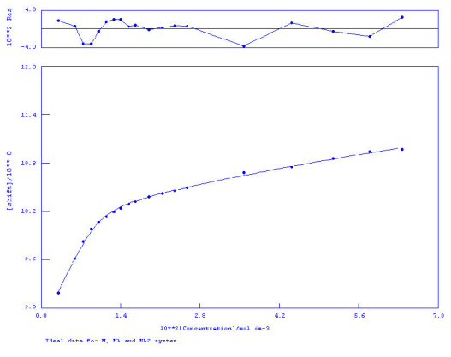
Figure S40 NMR titration of compound 2 vs. TBAH₂PO₄ in DMSO-d₆/H₂O 10%. Following the urea NH.

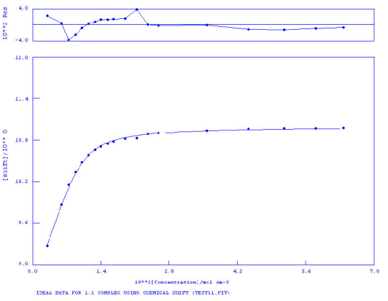
K_{a} = 1804 M⁻¹ Error = 7 %
Figure S41 NMR titration of compound 2 vs. TBAOAc in DMSO-d₆/H₂O 10%. Following the urea NH.

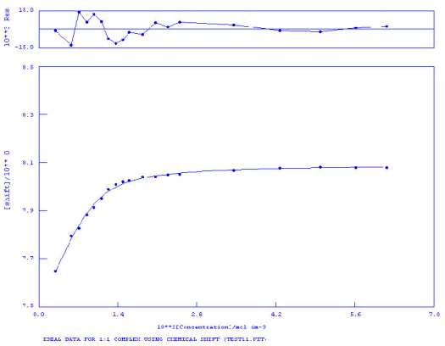
K_{a} = 639 M⁻¹ Error = 3 %
Figure S42 NMR titration of compound 2 vs. TBAOBz in DMSO-d₆/H₂O 10%. Following the aromatic CH.

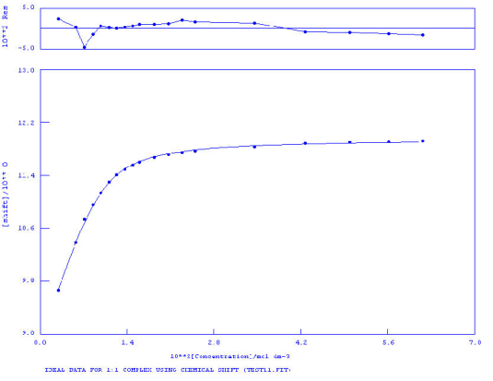
K_{a} = 481 M⁻¹ Error = 5 %
Figure S43 NMR titration of compound 2 vs. TBAOBz in DMSO-d₆/H₂O 10%. Following the urea NH.

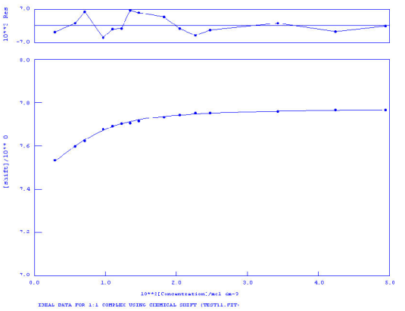
K_{a} = 728 M⁻¹ Error = 7 %
Figure S44 NMR titration of compound 2 vs. TEAHCO₃ in DMSO-d₆/H₂O 10%. Following the aromatic CH.

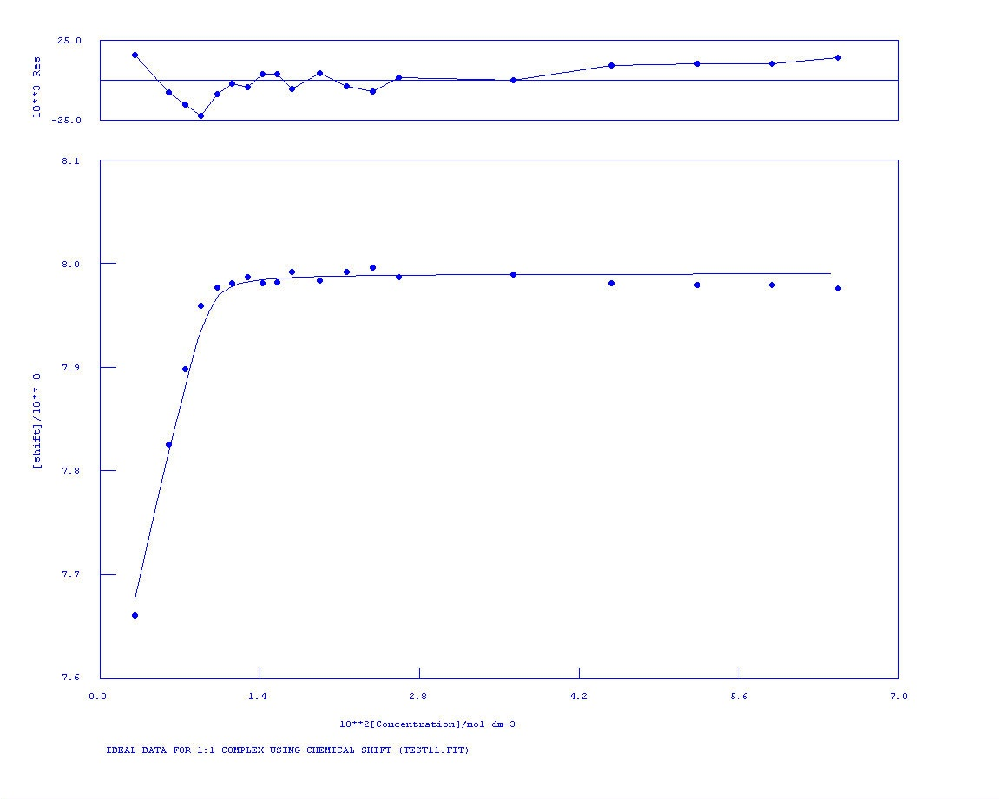
K_{a} >10⁴ M⁻¹
Figure S45 NMR titration of compound 3 vs. TBAOAc in DMSO-d₆/H₂O 0.5%. Following the aromatic CH.

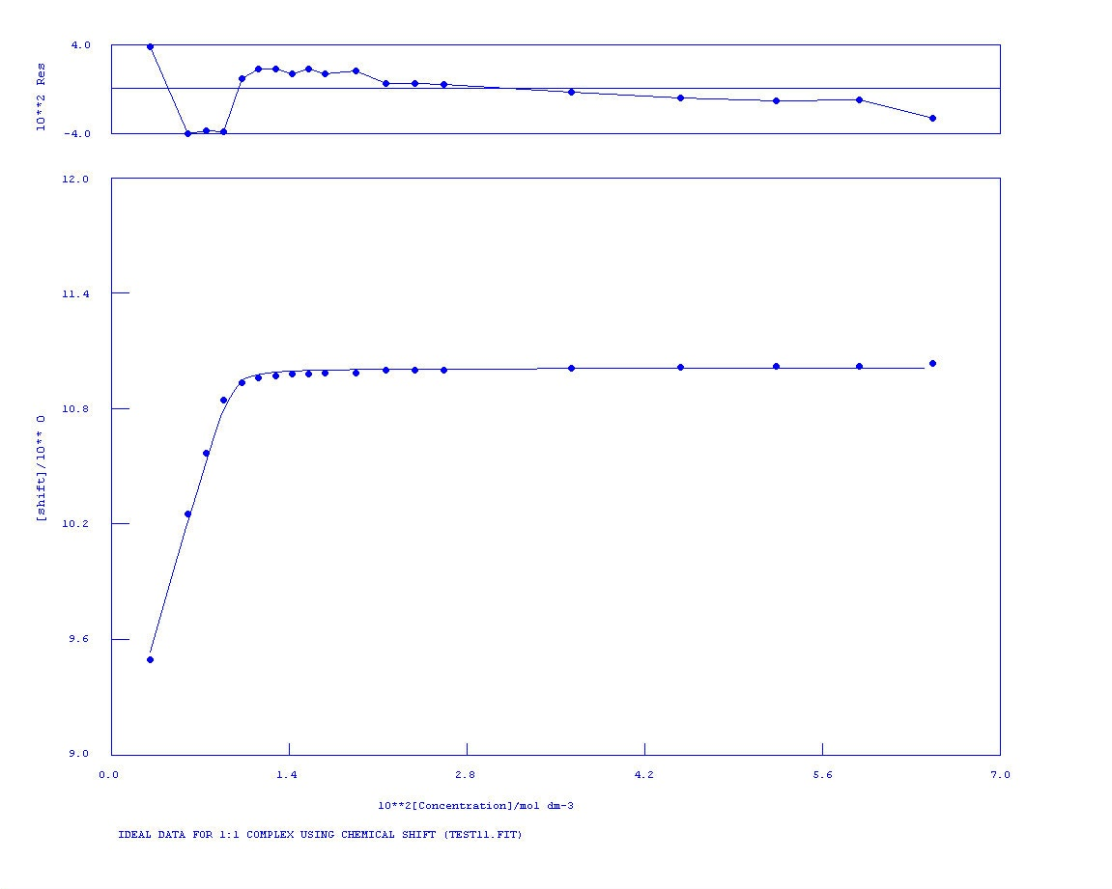
K_{a} > 10⁴ M⁻¹
Figure S46 NMR titration of compound 3 vs. TBAOAc in DMSO-d₆/H₂O 0.5%. Following the urea NH.
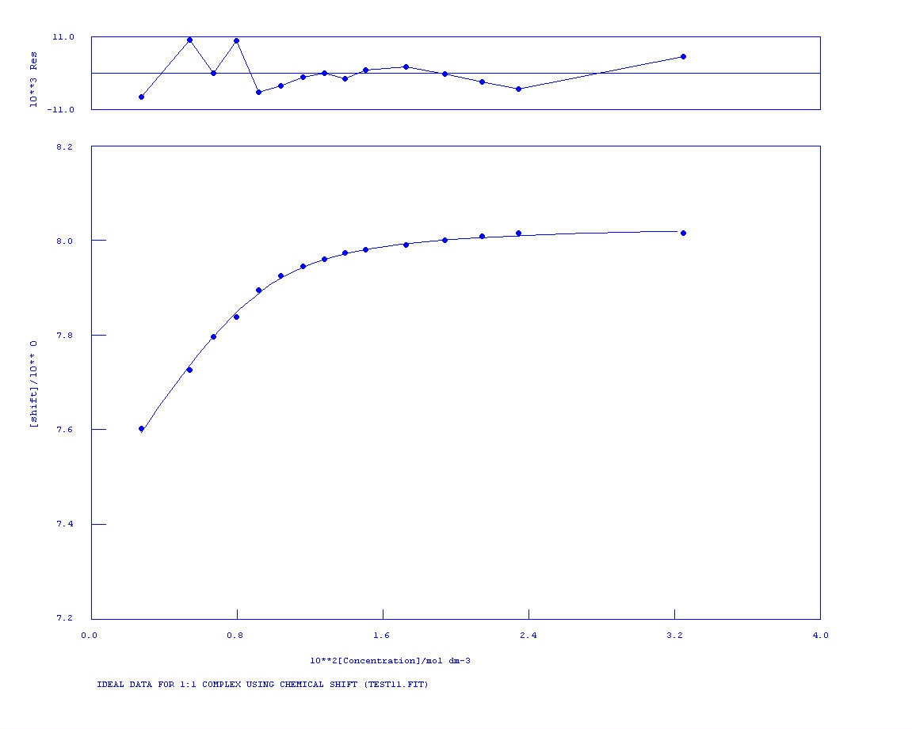
K_{a} = 1488 M⁻¹ Error = 9%
Figure S47 NMR titration of compound 3 vs. TBAOBz in DMSO-d₆/H₂O 0.5%. Following the aromatic CH.

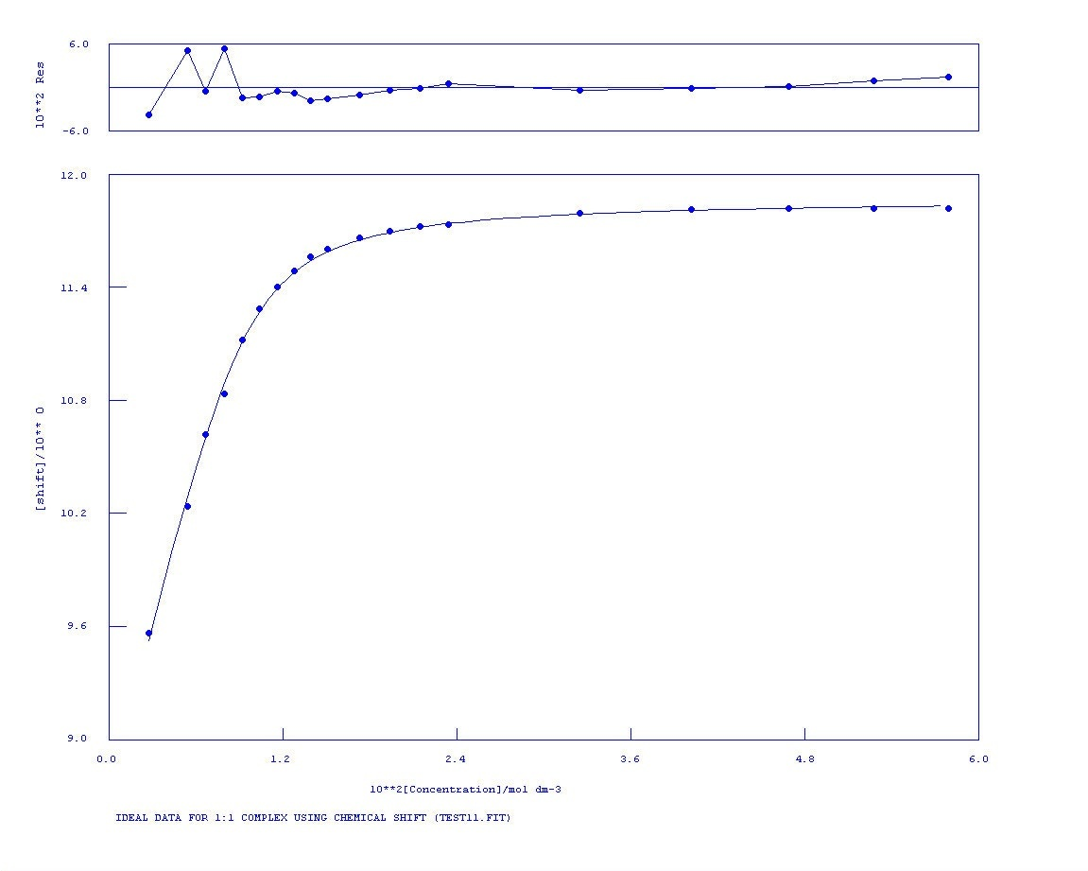
K_{a} = 1584 M⁻¹ Error = 5%
Figure S48 NMR titration of compound 3 vs. TBAOBz in DMSO-d₆/H₂O 0.5%. Following the urea NH.

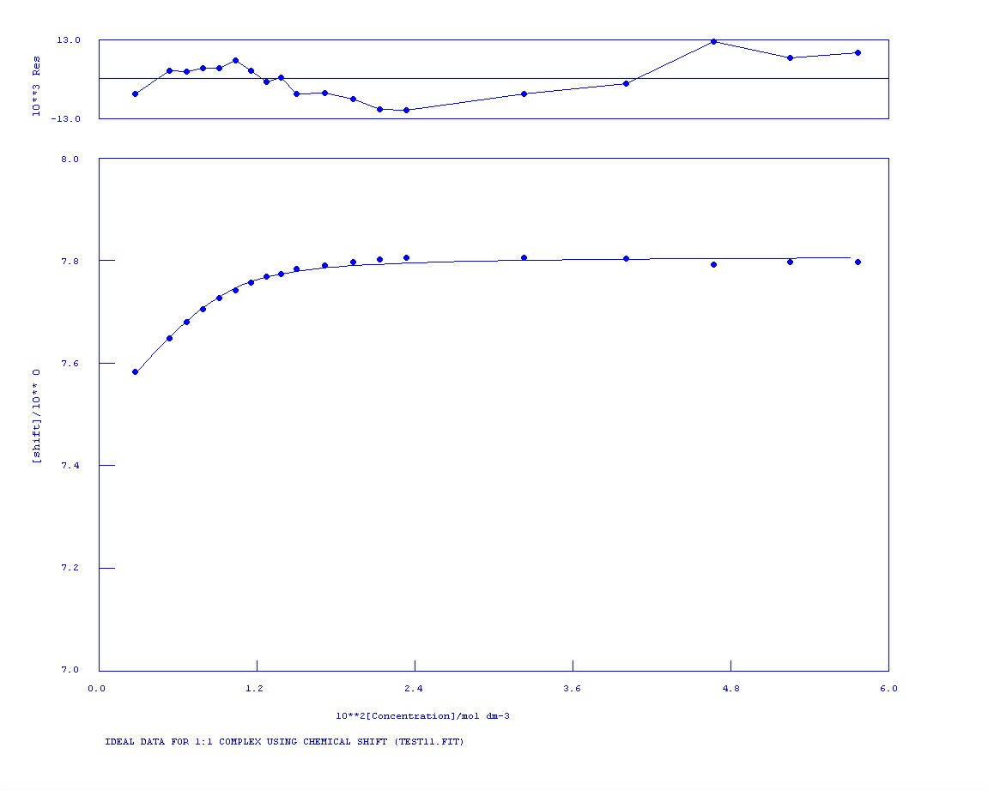
K_{a} = 1422 M⁻¹ Error = 4%
Figure S49 NMR titration of compound 3 vs. TEAHCO₃ in DMSO-d₆/H₂O 0.5%. Following the aromatic CH.

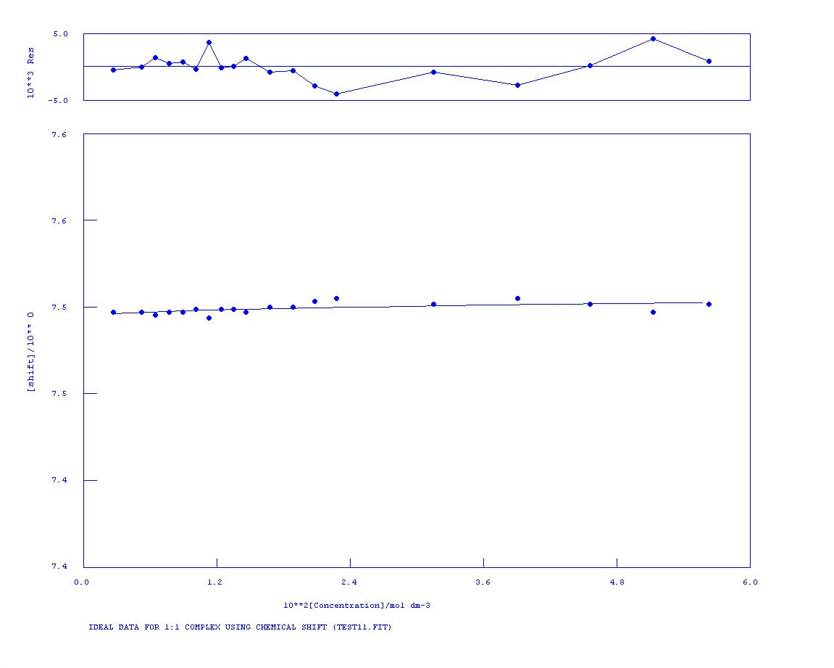
No binding
Figure S50 NMR titration of compound 3 vs. TBACl in DMSO-d₆/H₂O 0.5%. Following the aromatic CH.

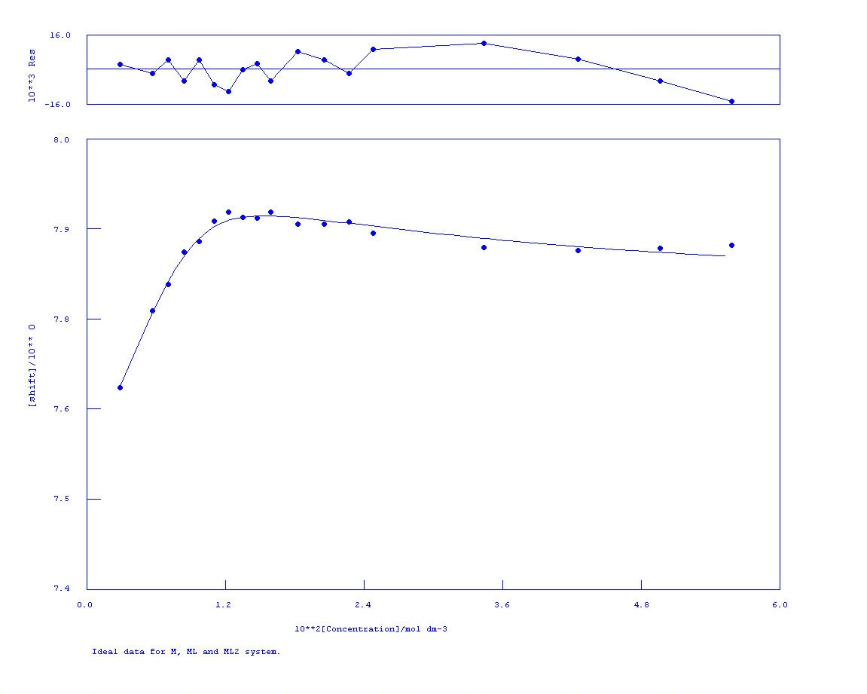
Figure S51 NMR titration of compound 3 vs. TBAH₂PO₄ in DMSO-d₆/H₂O 0.5%. Following the aromatic CH.

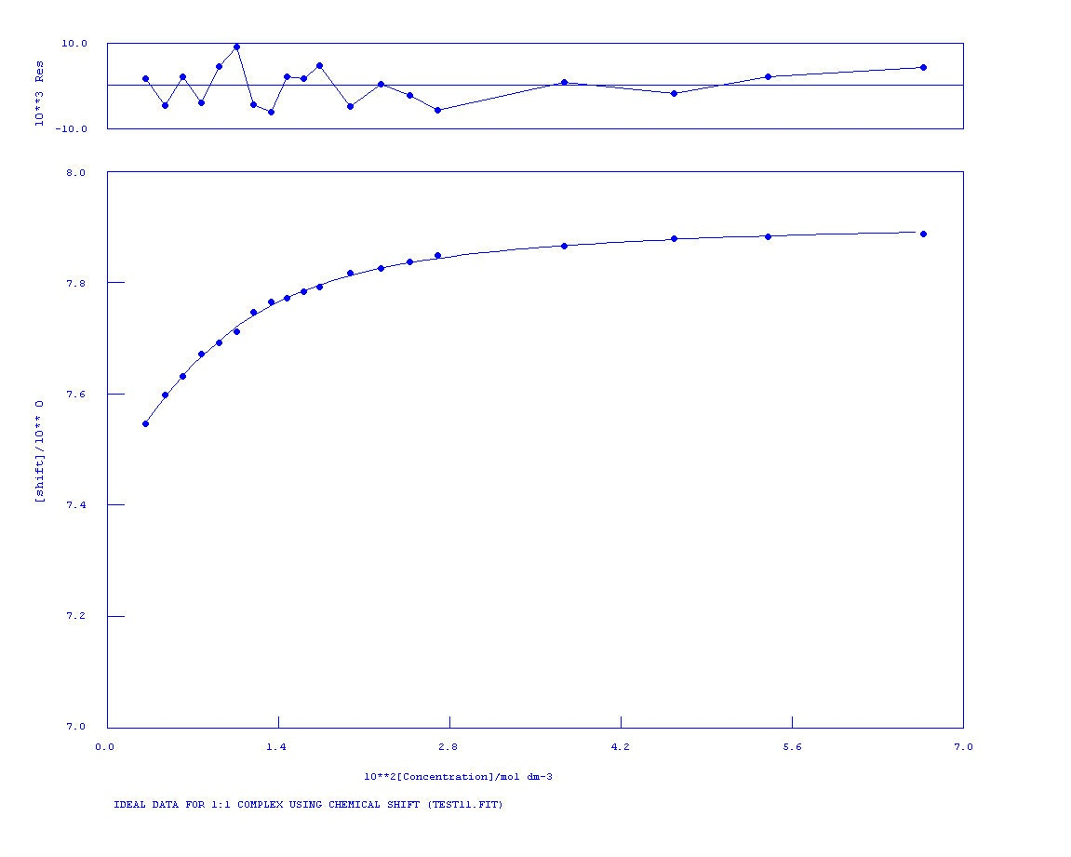
K_{a} = 278 M⁻¹ Error = 5%
Figure S52 NMR titration of compound 3 vs. TBAOAc in DMSO-d₆/H₂O 10%. Following the aromatic CH.
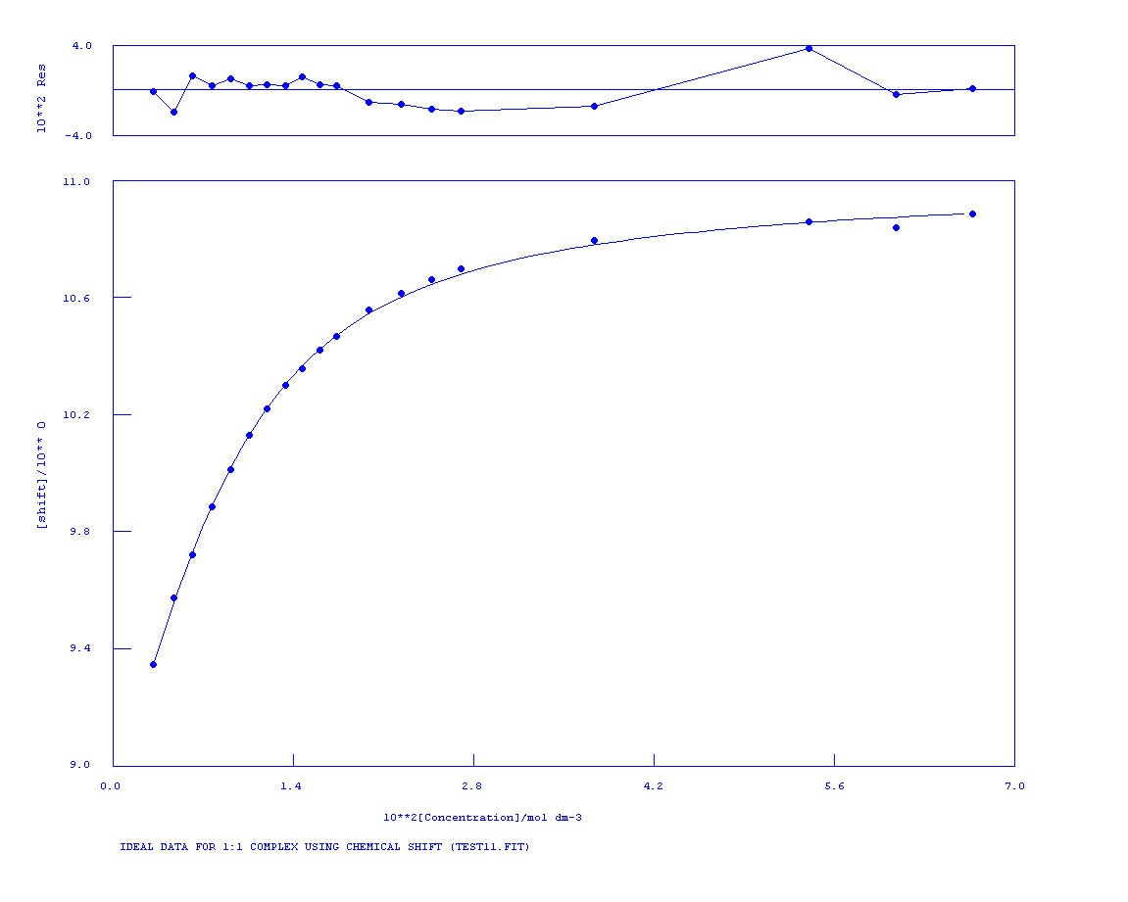
K_{a} = 293 M⁻¹ Error = 4%
Figure S53 NMR titration of compound 3 vs. TBAOAc in DMSO-d₆/H₂O 10%. Following the urea NH.

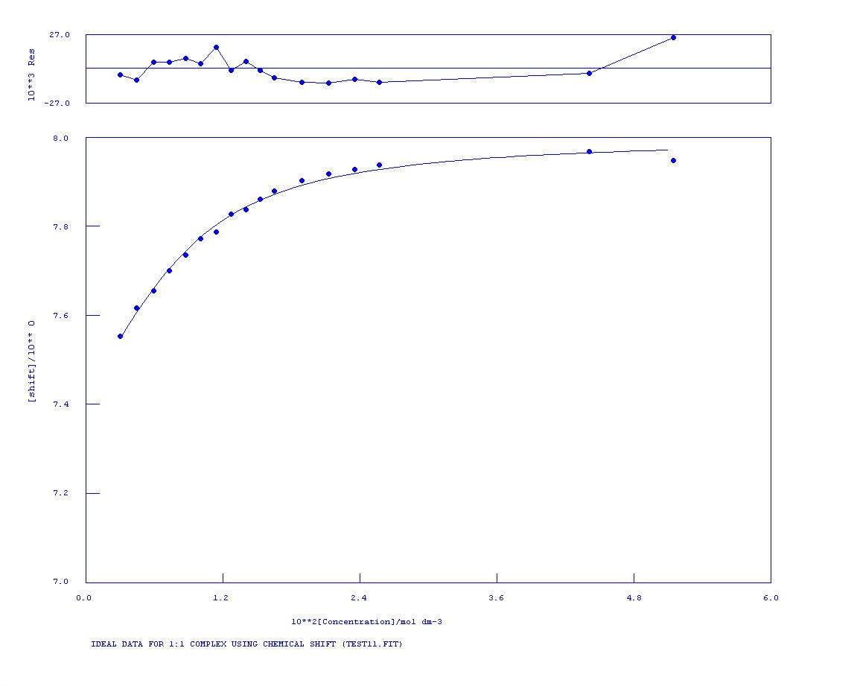
K_{a} = 303 M⁻¹ Error = 10%
Figure S54 NMR titration of compound 3 vs. TBAOBz in DMSO-d₆/H₂O 10%. Following the aromatic CH.

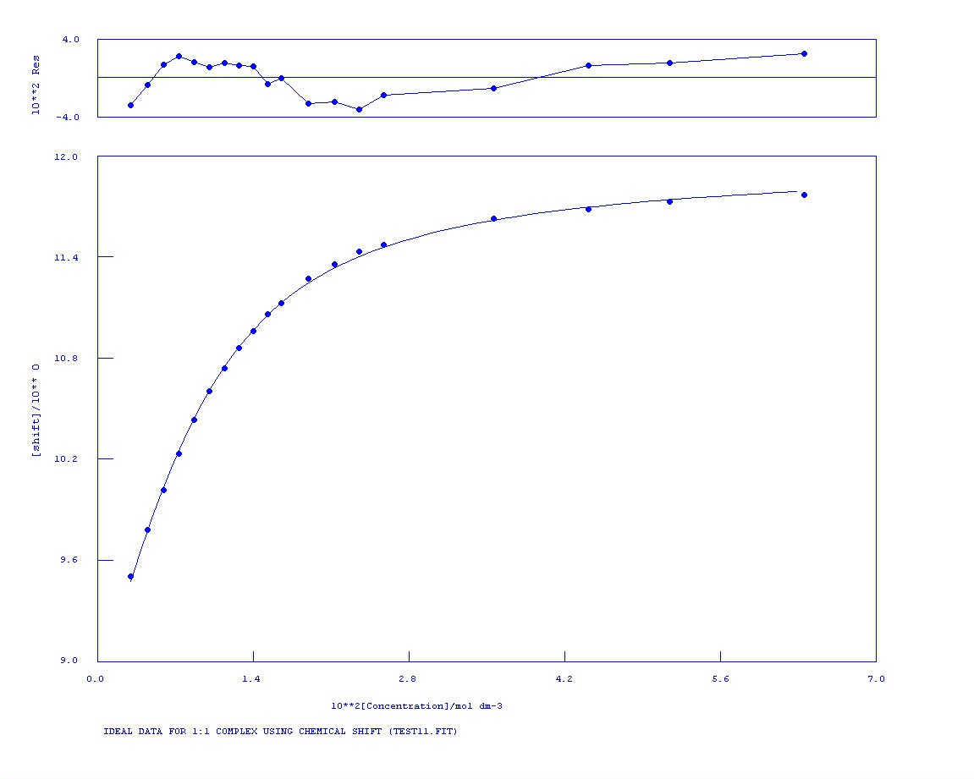
K_{a} = 284 M⁻¹ Error = 4%
Figure S55 NMR titration of compound 3 vs. TBAOBz in DMSO-d₆/H₂O 10%. Following the urea NH.
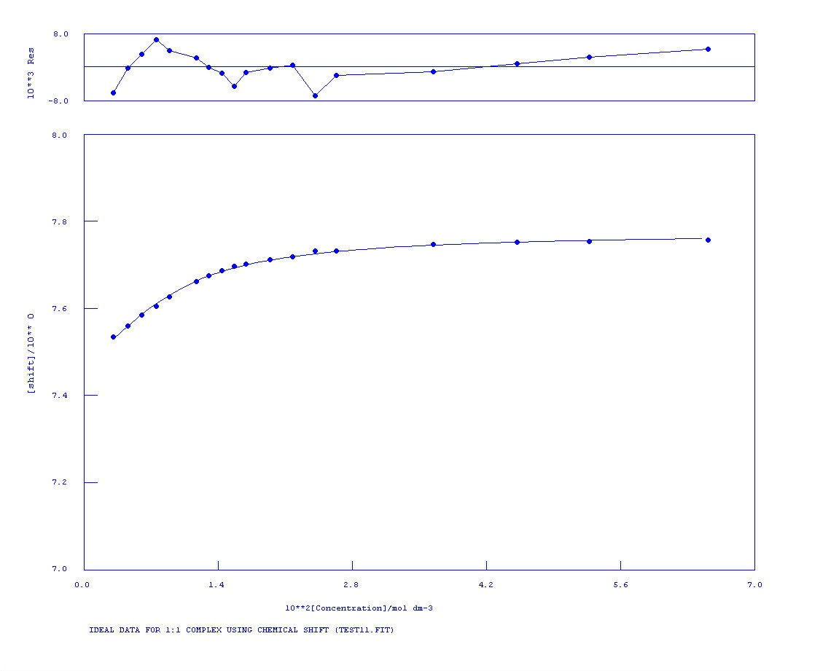
K_{a} = 319 M⁻¹ Error = 7%
Figure S56 NMR titration of compound 3 vs. TEAHCO₃ in DMSO-d₆/H₂O 10%. Following the aromatic CH.

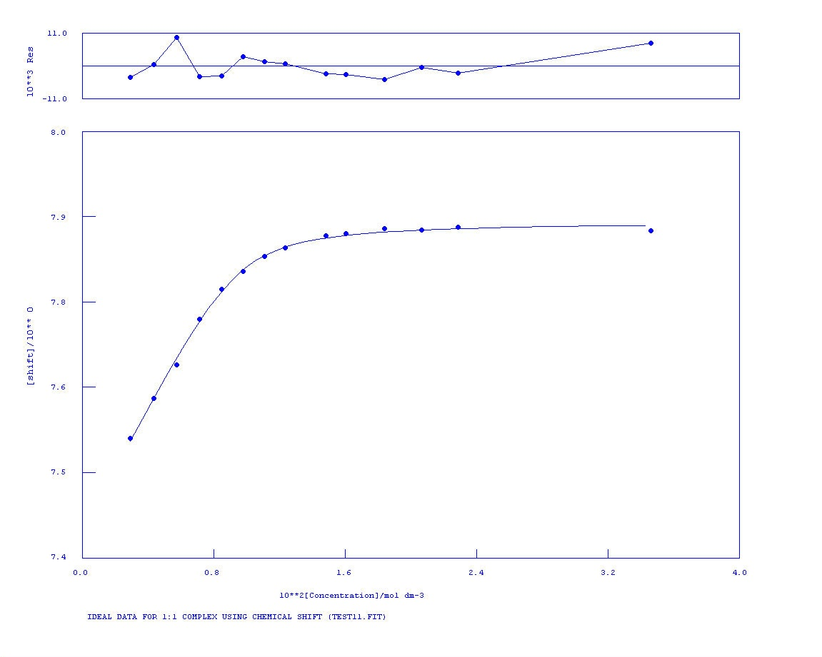
K_{a} = 2960 M⁻¹ Error = 13%
Figure S57 NMR titration of compound 3 vs. TBAH₂PO₄ in DMSO-d₆/H₂O 10%. Following the aromatic CH.

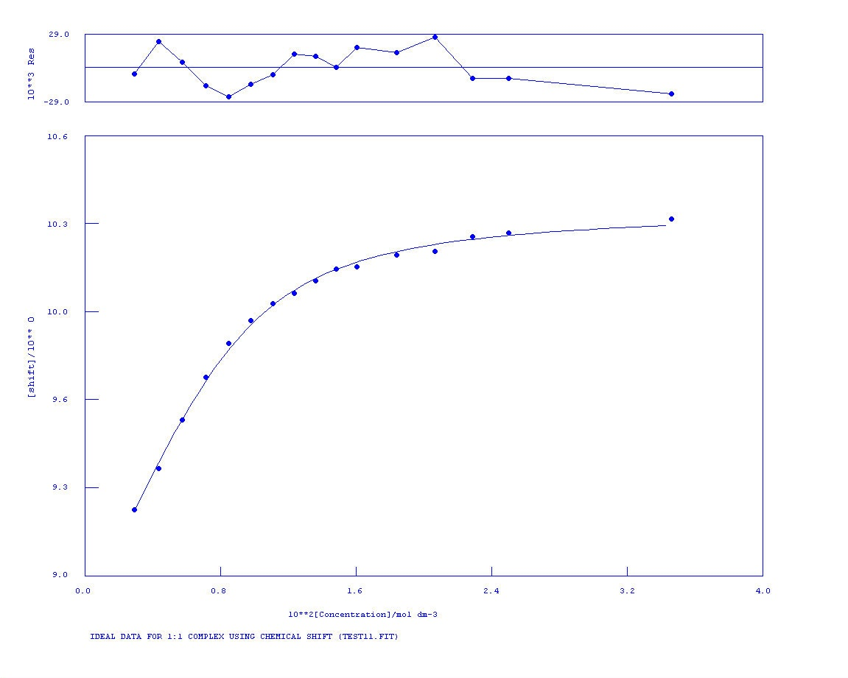
K_{a} = 812 M⁻¹ Error = 10%
Figure S58 NMR titration of compound 3 vs. TBAH₂PO₄ in DMSO-d₆/H₂O 10%. Following the urea NH.
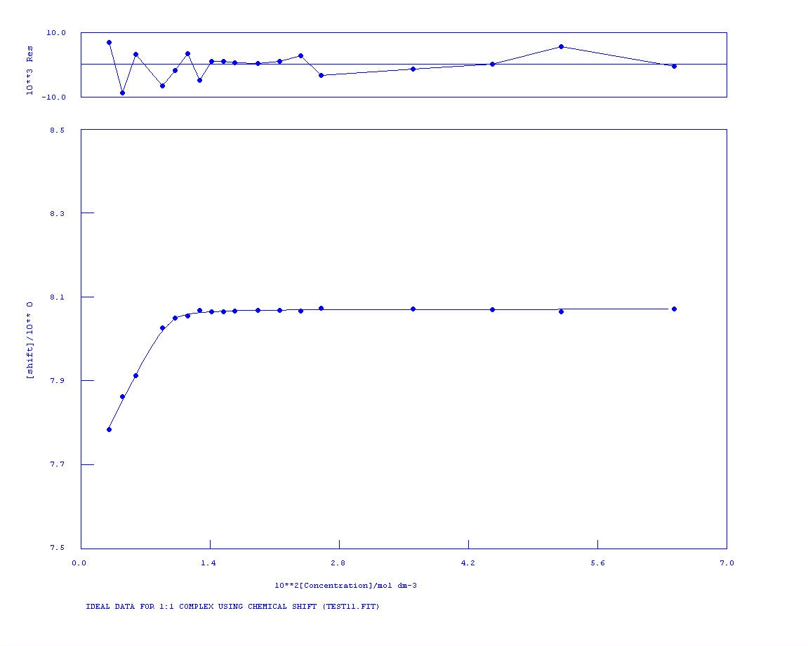
K_{a} = >1x10⁴ M⁻¹ Error = NA
Figure S59 NMR titration of compound 4 vs. TBAOAc in DMSO-d₆/H₂O 0.5%. Following the aromatic CH.

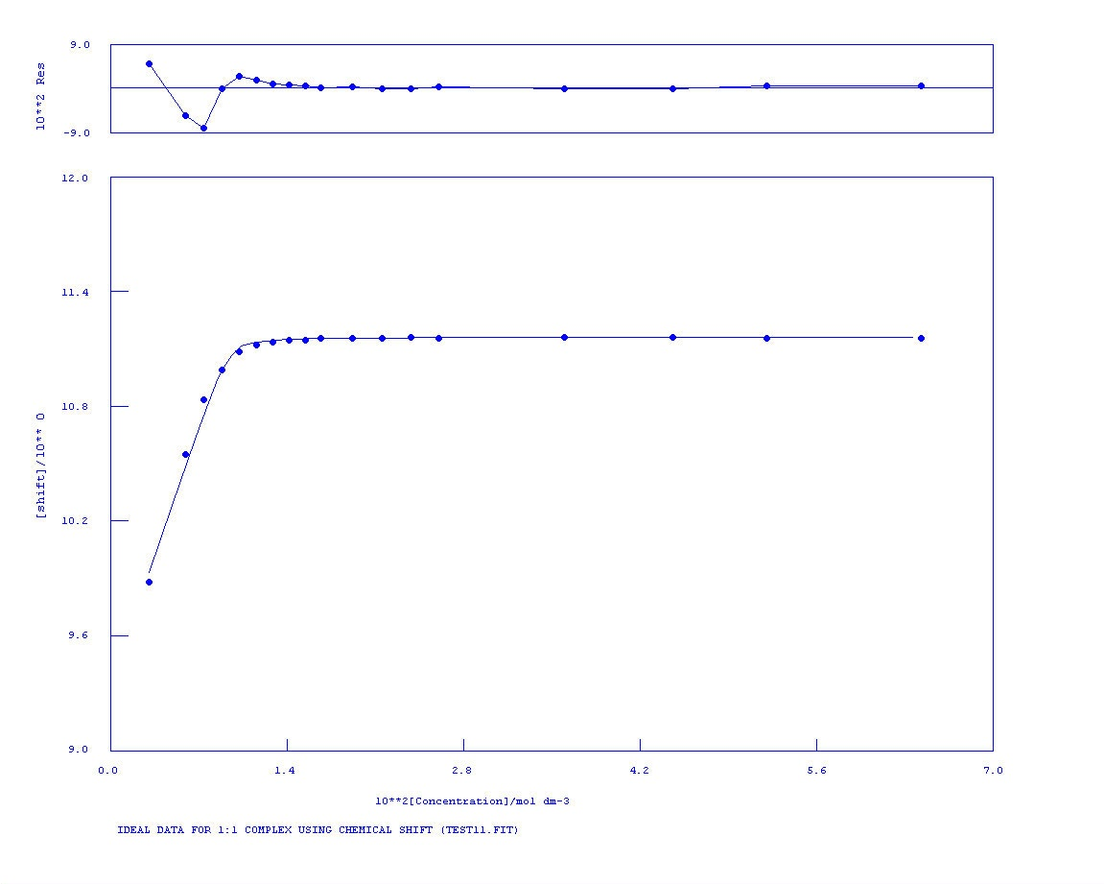
K_{a} = >1x10⁴ M⁻¹ Error = NA
Figure S60 NMR titration of compound 4 vs. TBAOAc in DMSO-d₆/H₂O 0.5%. Following the urea NH.

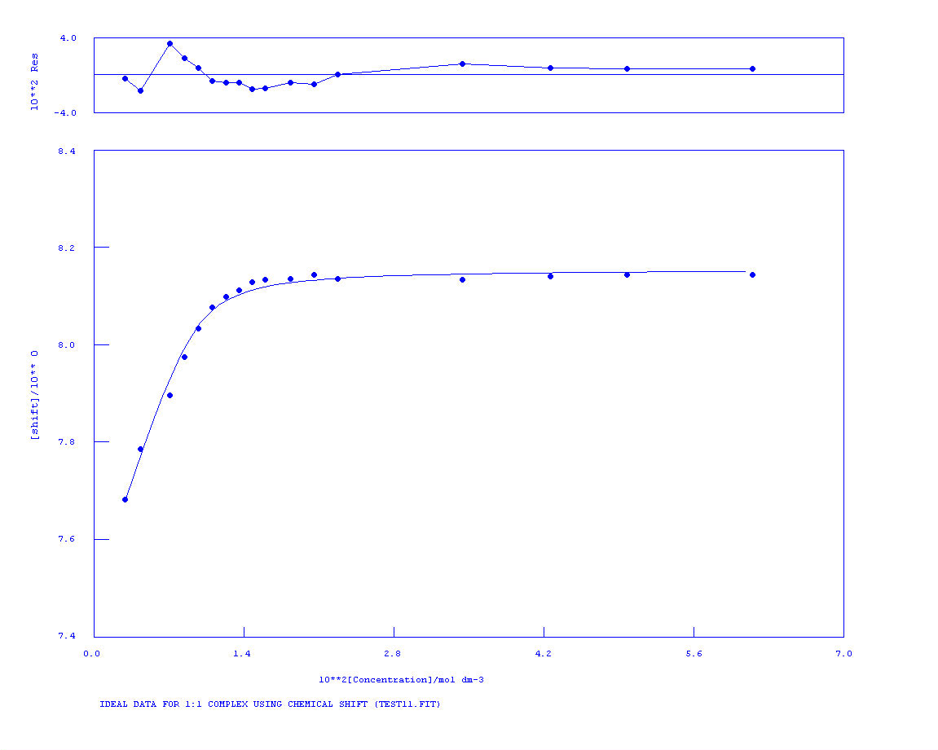
Figure S61 NMR titration of compound 4 vs. TBAOBz in DMSO-d₆/H₂O 0.5%. Following the aromatic CH.
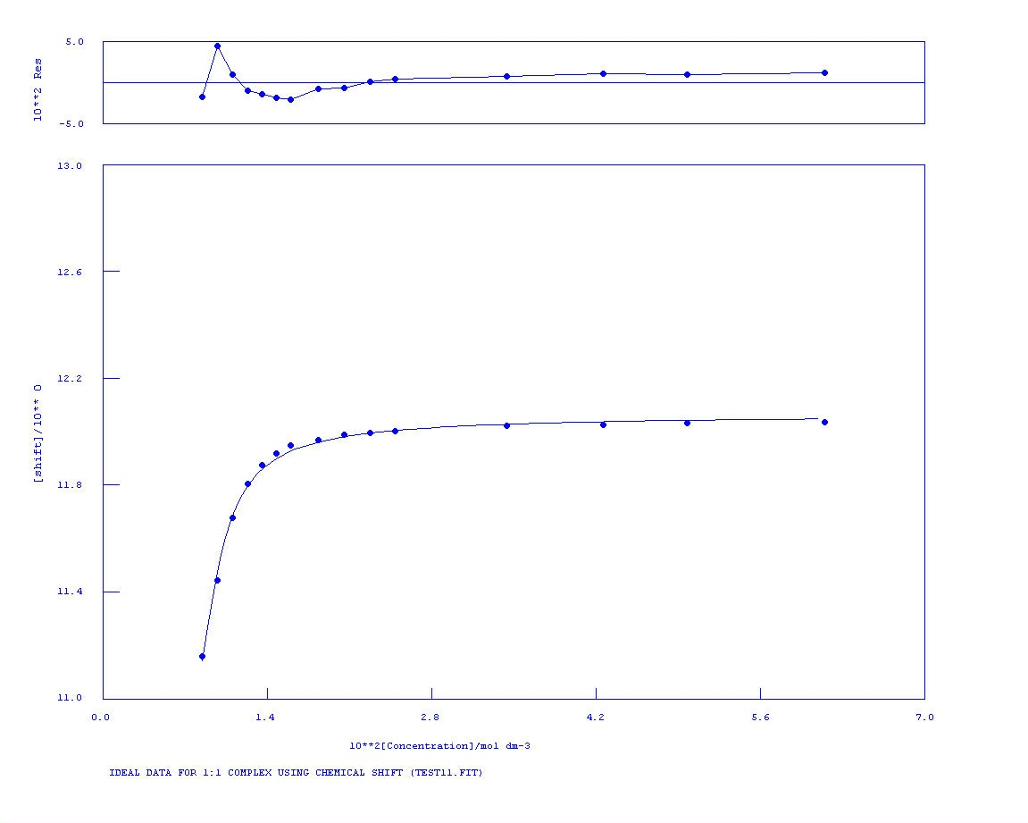
K_{a} = 4762 M⁻¹ Error = 1%
Figure S62 NMR titration of compound 4 vs. TBAOBz in DMSO-d₆/H₂O 0.5%. Following the urea NH.

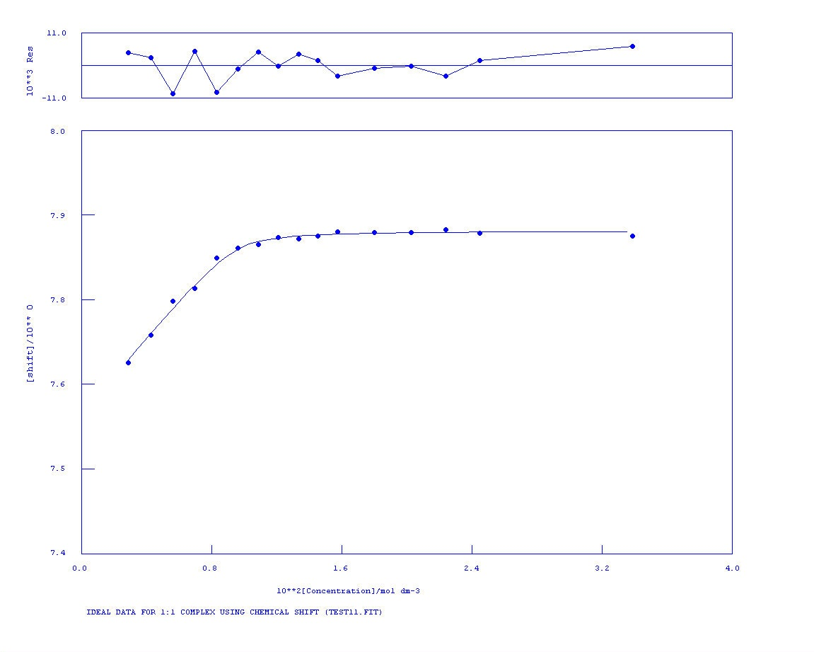
K_{a} = 7655 M⁻¹ Error = 13%
Figure S63 NMR titration of compound 4 vs. TEAHCO₃ in DMSO-d₆/H₂O 0.5%. Following the aromatic CH.

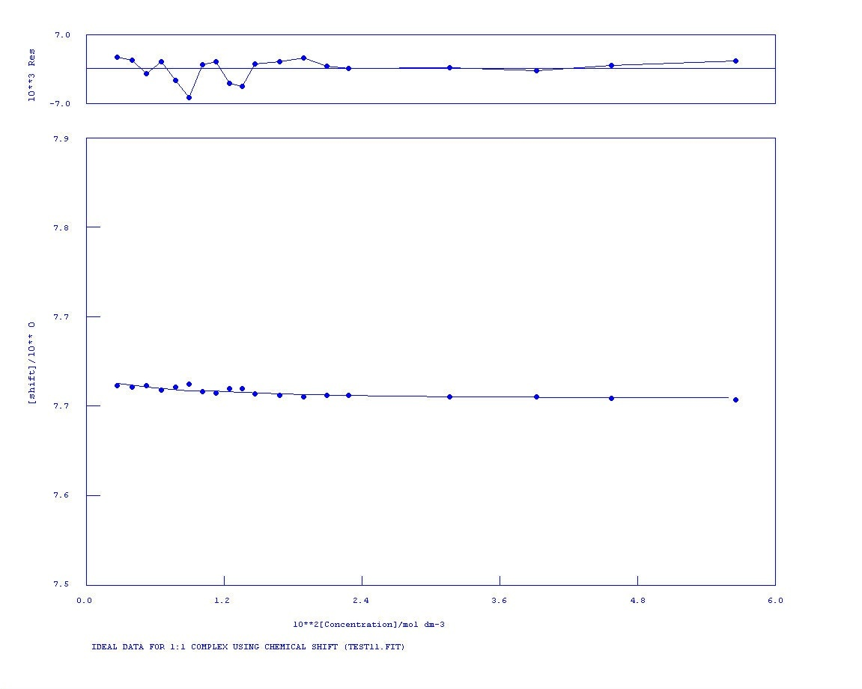
No binding
Figure S64 NMR titration of compound 4 vs. TBACl in DMSO-d₆/H₂O 0.5%. Following the aromatic CH.
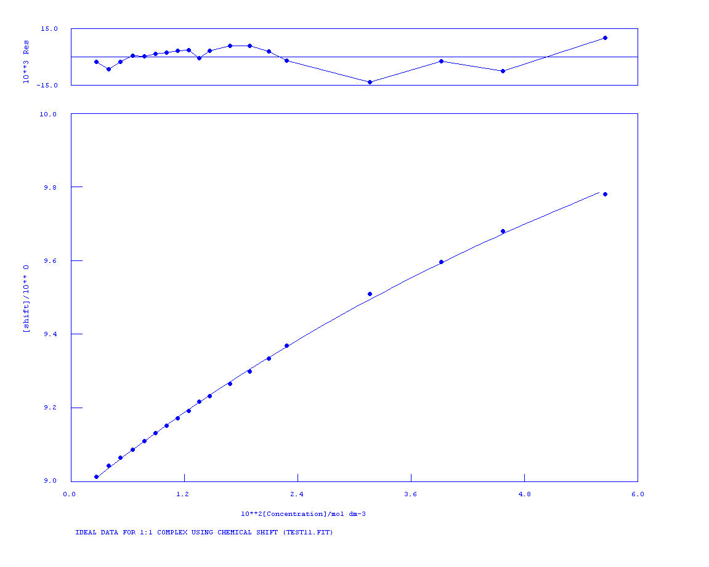
K_{a} = 9 M⁻¹ Error = 9%
Figure S65 NMR titration of compound 4 vs. TBACl in DMSO-d₆/H₂O 0.5%. Following the aromatic CH.

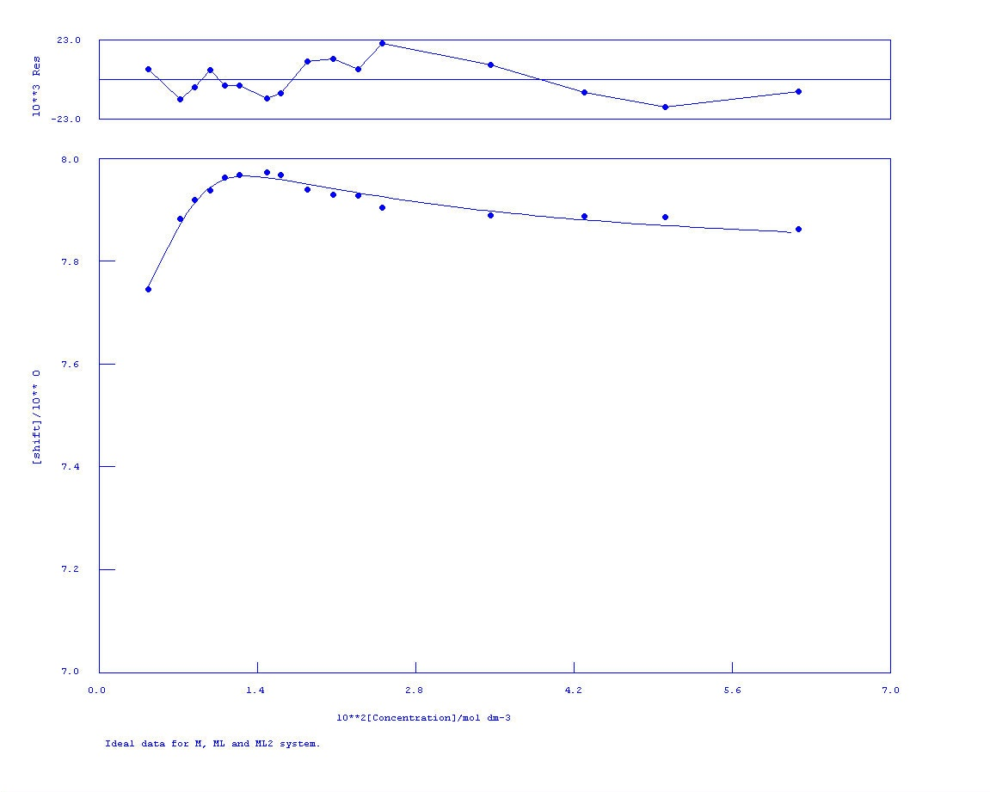
Figure S66 NMR titration of compound 4 vs. TBAH₂PO₄ in DMSO-d₆/H₂O 0.5%. Following the aromatic CH.

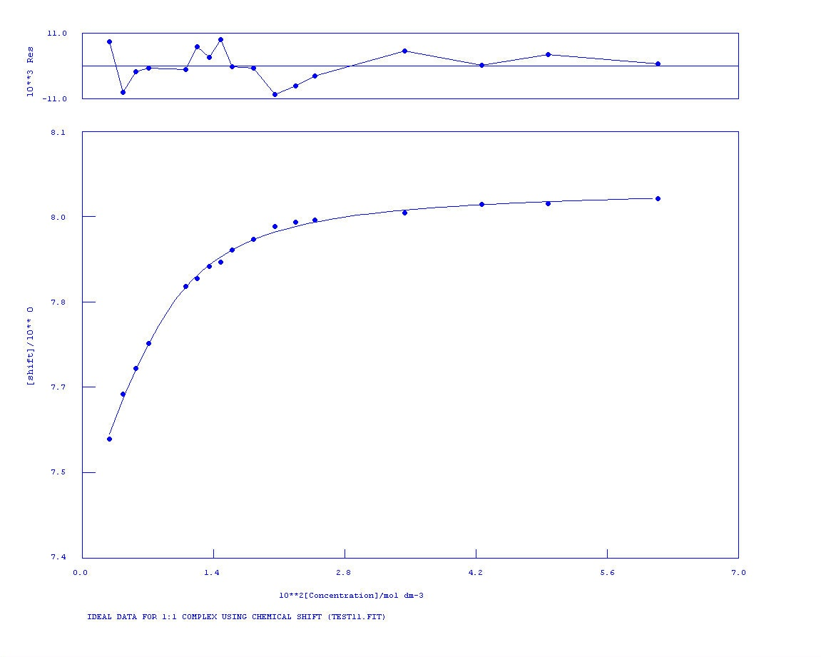
K_{a} = 485 M⁻¹ Error = 7%
Figure S67 NMR titration of compound 4 vs. TBAOAc in DMSO-d₆/H₂O 10%. Following the aromatic CH.
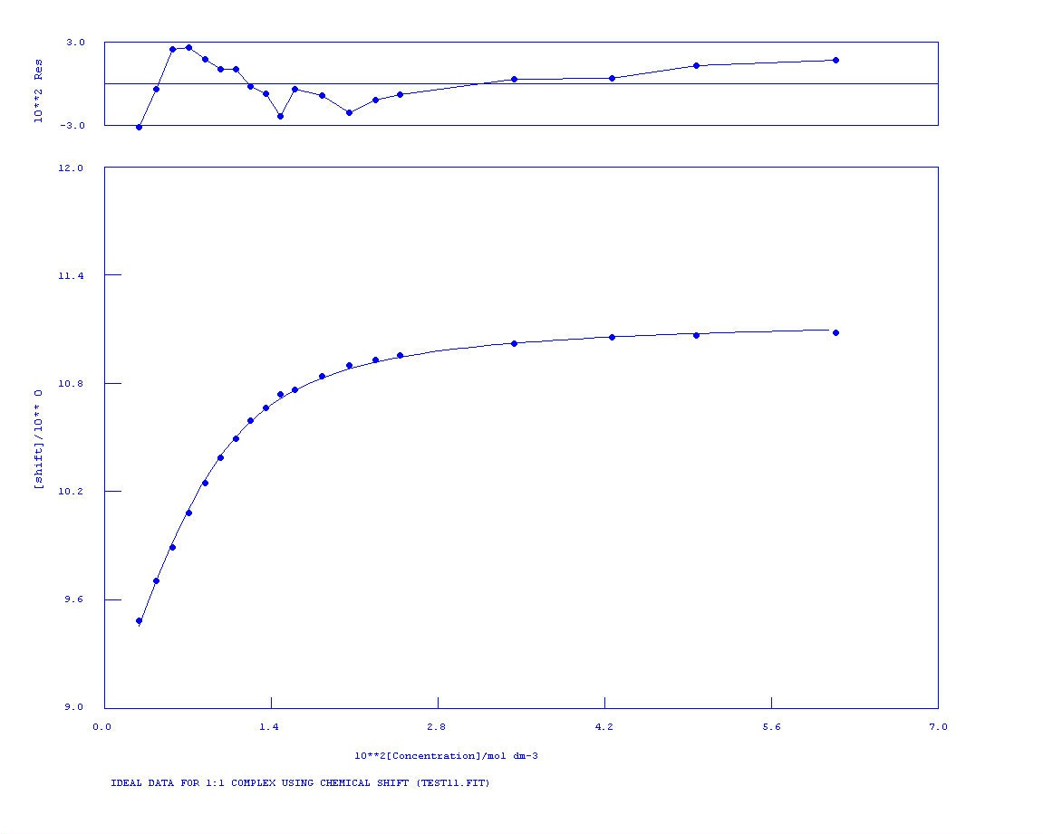
K_{a} = 544 M⁻¹ Error = 5%
Figure S68 NMR titration of compound 4 vs. TBAOAc in DMSO-d₆/H₂O 10%. Following the urea NH.

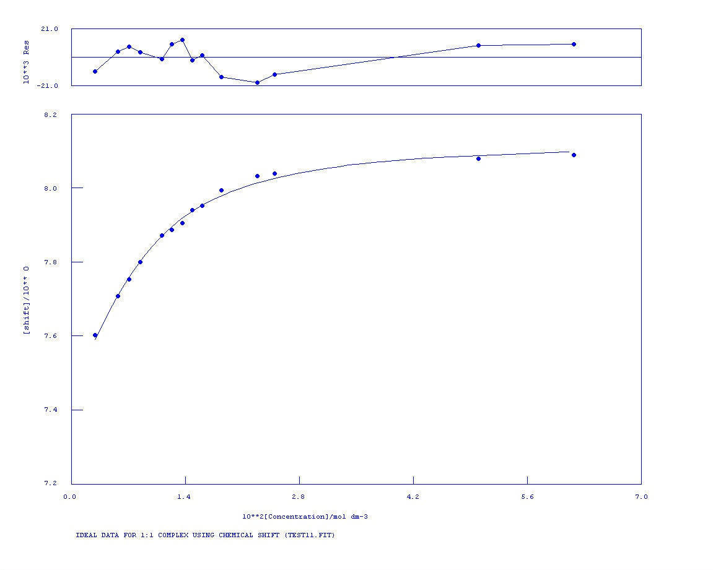
K_{a} = 298 M⁻¹ Error = 9%
Figure S69 NMR titration of compound 4 vs. TBAOBz in DMSO-d₆/H₂O 10%. Following the aromatic CH.

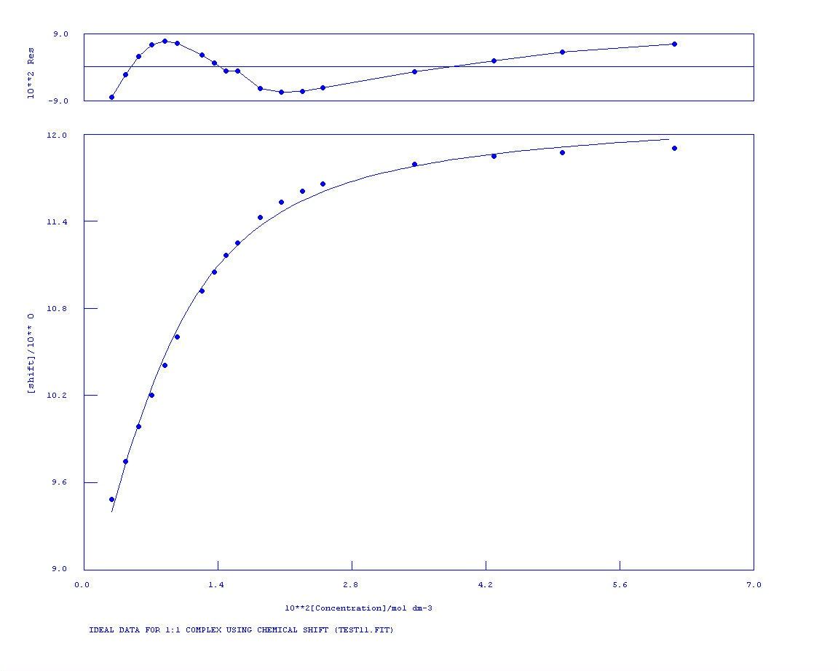
K_{a} = 304 M⁻¹ Error = 9%
Figure S70 NMR titration of compound 4 vs. TBAOBz in DMSO-d₆/H₂O 10%. Following the urea NH.
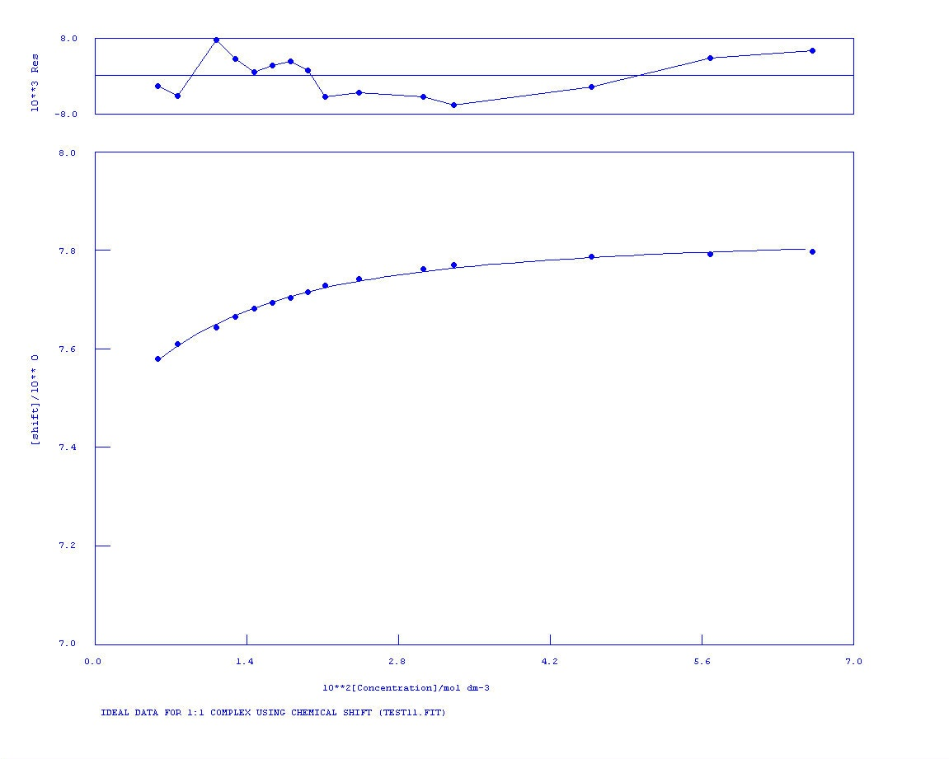
K_{a} = 149 M⁻¹ Error = 9%
Figure S71 NMR titration of compound 4 vs. TEAHCO₃ in DMSO-d₆/H₂O 10%. Following the aromatic CH.

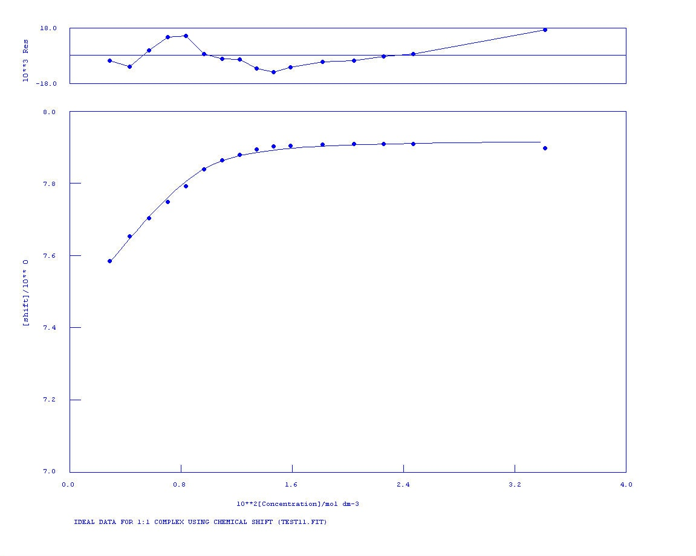
K_{a} = 256 M⁻¹ Error = 14%
Figure S72 NMR titration of compound 4 vs. TBAH₂PO₄ in DMSO-d₆/H₂O 10%. Following the aromatic CH.

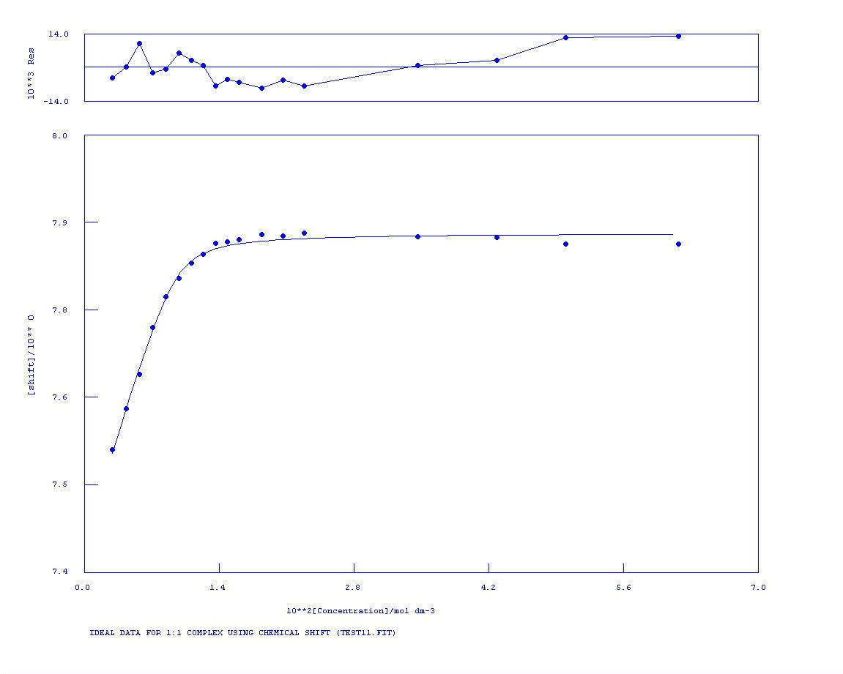
K_{a} = 245 M⁻¹ Error = 6%
Figure S73 NMR titration of compound 4 vs. TBAH₂PO₄ in DMSO-d₆/H₂O 10%. Following the urea NH.

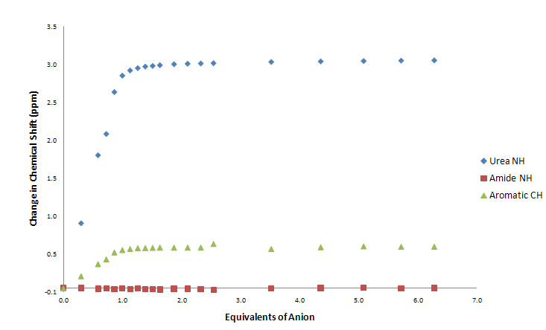
Figure S74 Comparison of change in chemical shift of compound 1 vs. TBAOBz in DMSO-d₆/H₂O 0.5%.

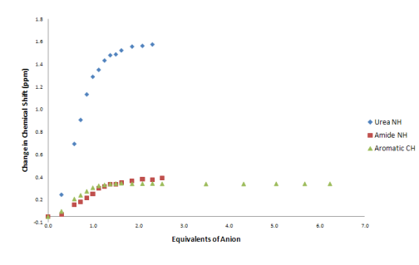
Figure S75 Comparison of change in chemical shift of compound 1 vs. TEAHCO₃ in DMSO-d₆/H₂O 0.5%.

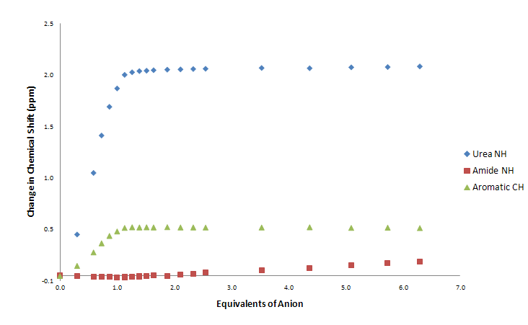
Figure S76 Comparison of change in chemical shift of compound 1 vs. TBAOAc in DMSO-d₆/H₂O 0.5%.

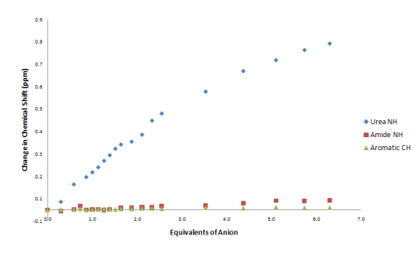
Figure S77 Comparison of change in chemical shift of compound 1 vs. TBACl in DMSO-d₆/H₂O 0.5%.

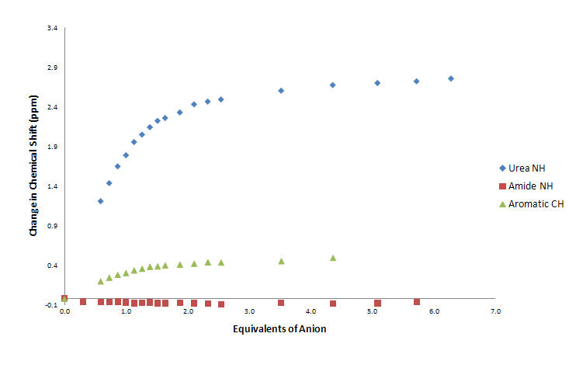
Figure S78 Comparison of change in chemical shift of compound 1 vs. TBAOBz in DMSO-d₆/H₂O 10%.

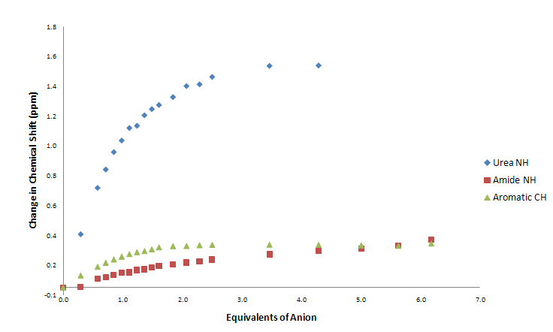
Figure S79 Comparison of change in chemical shift of compound 1 vs. TEAHCO₃ in DMSO-d₆/H₂O 10%.

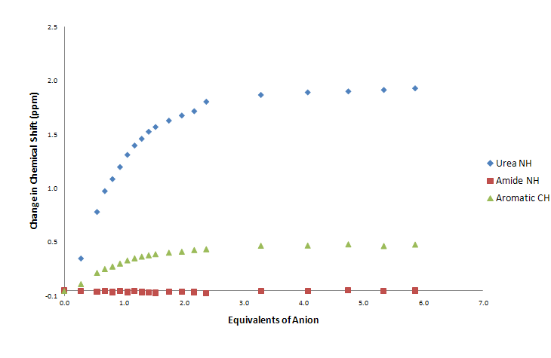
Figure S80 Comparison of change in chemical shift of compound 1 vs. TBAOAc in DMSO-d₆/H₂O 10%.

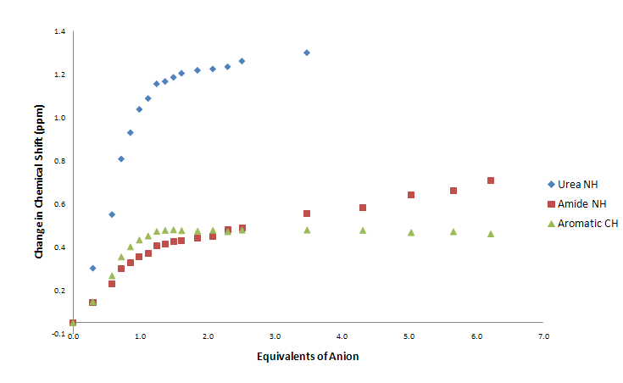
Figure S81 Comparison of change in chemical shift of compound 1 vs. TBAH₂PO₄ in DMSO-d₆/H₂O 10%.

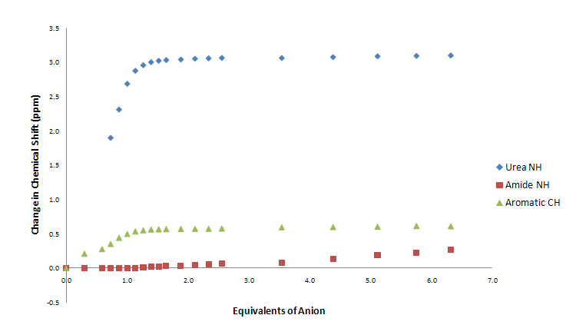
Figure S82 Comparison of change in chemical shift of compound 2 vs. TBAOBz in DMSO-d₆/H₂O 0.5%.

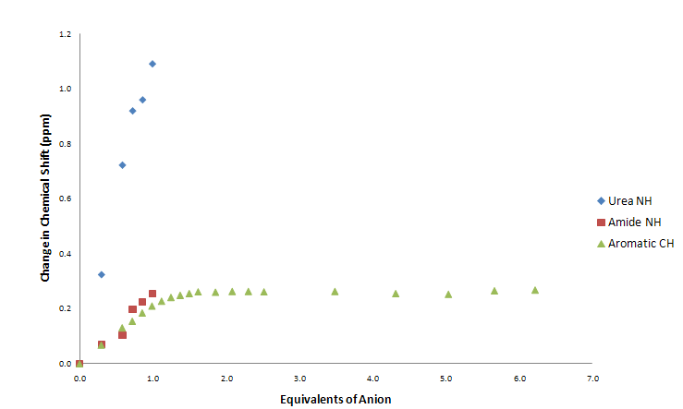
Figure S83 Comparison of change in chemical shift of compound 2 vs. TEAHCO₃ in DMSO-d₆/H₂O 0.5%.

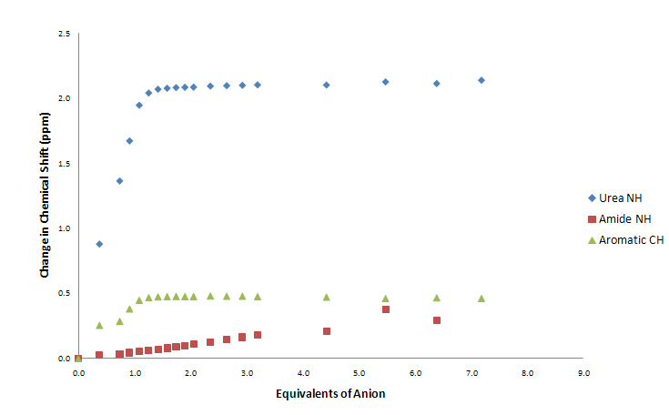
Figure S84 Comparison of change in chemical shift of compound 2 vs. TBAOAc in DMSO-d₆/H₂O 0.5%.

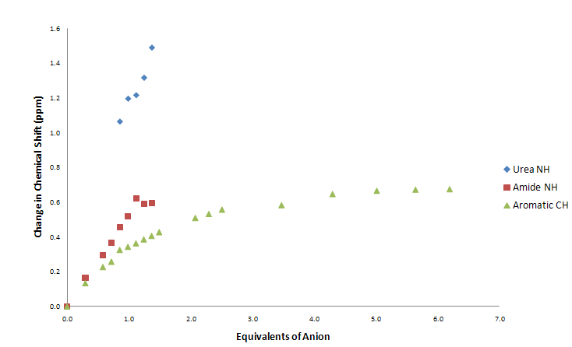
Figure S85 Comparison of change in chemical shift of compound 2 vs. TBAH₂PO₄ in DMSO-d₆/H₂O 0.5%.

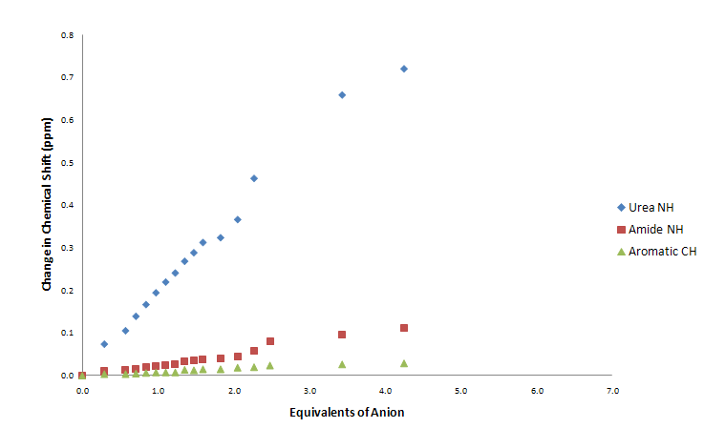
Figure S86 Comparison of change in chemical shift of compound 2 vs. TBACl in DMSO-d₆/H₂O 0.5%.

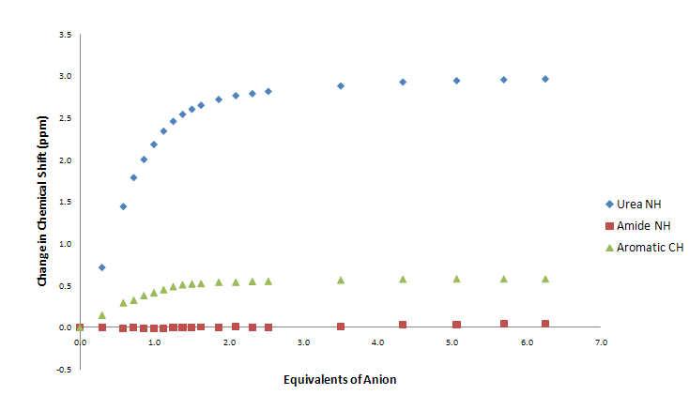
Figure S87 Comparison of change in chemical shift of compound 2 vs. TBAOBz in DMSO-d₆/H₂O 10%.

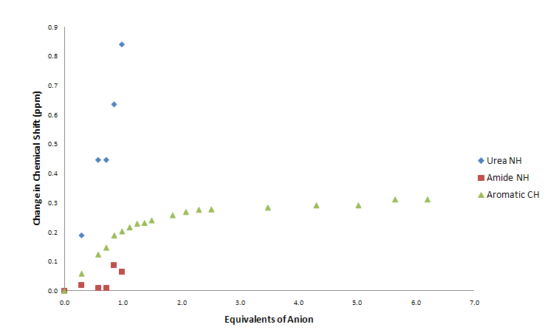
Figure S88 Comparison of change in chemical shift of compound 2 vs. TEAHCO₃ in DMSO-d₆/H₂O 10%.

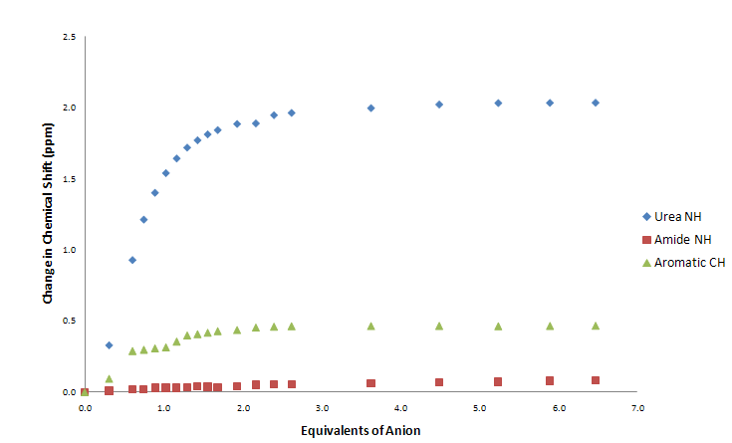
Figure S89 Comparison of change in chemical shift of compound 2 vs. TBAOAc in DMSO-d₆/H₂O 10%.

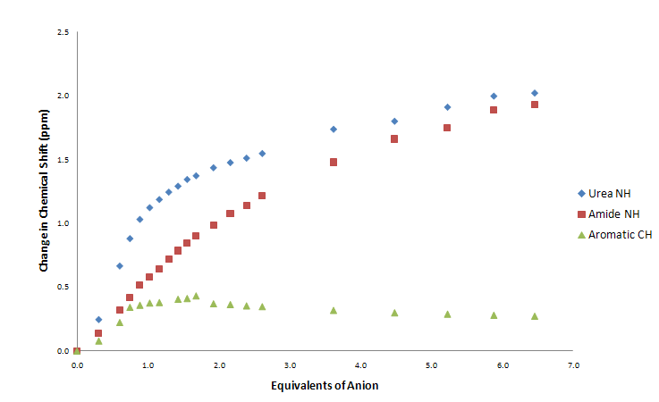
Figure S90 Comparison of change in chemical shift of compound 2 vs. TBAH₂PO₄ in DMSO-d₆/H₂O 10%.
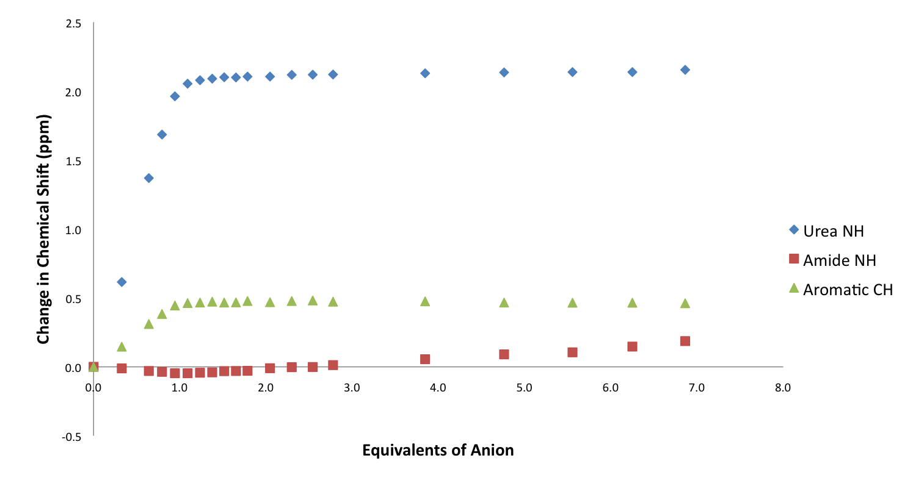
Figure S91 Comparison of change in chemical shift of compound 3 vs. TBAOAc in DMSO-d₆/H₂O 0.5%.

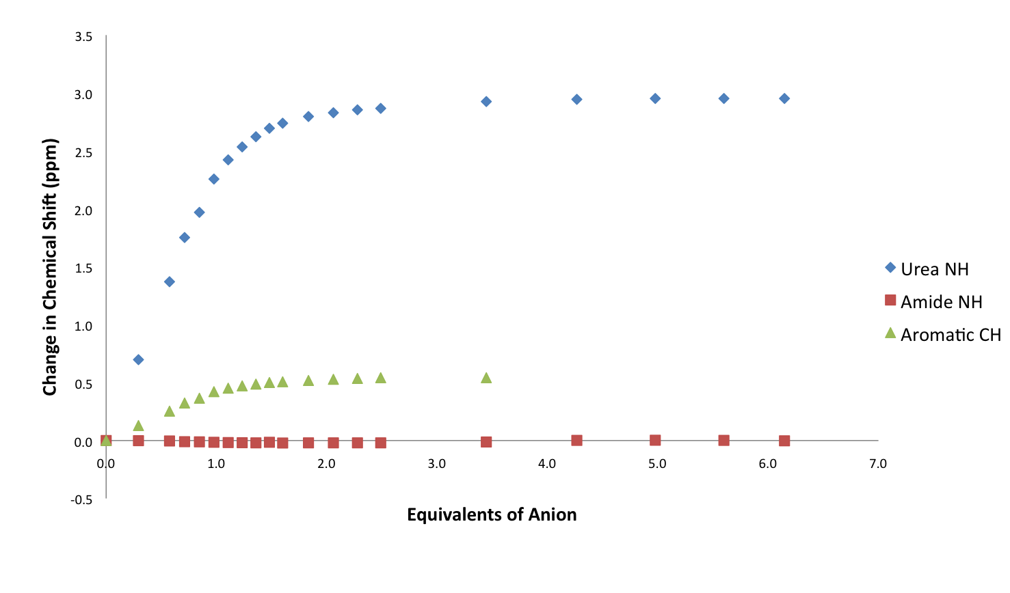
Figure S92 Comparison of change in chemical shift of compound 3 vs. TBAOBz in DMSO-d₆/H₂O 0.5%.

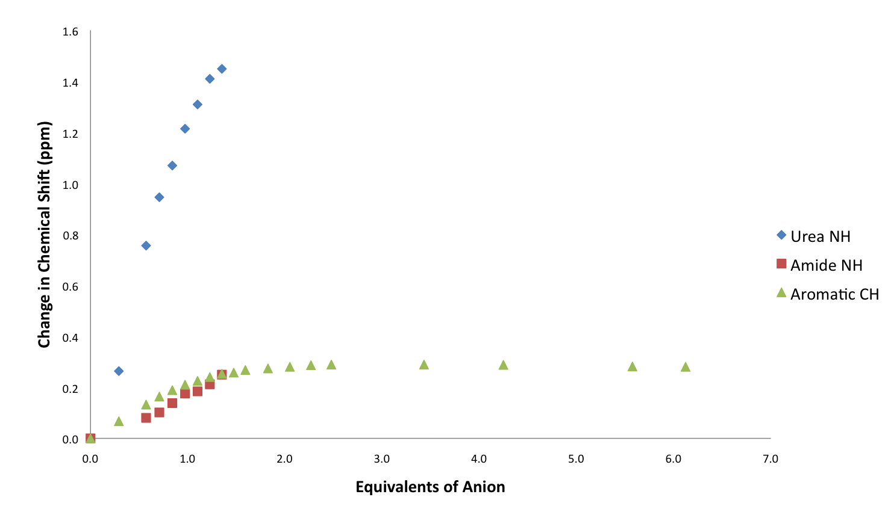
Figure S93 Comparison of change in chemical shift of compound 3 vs. TEAHCO₃ in DMSO-d₆/H₂O 0.5%.

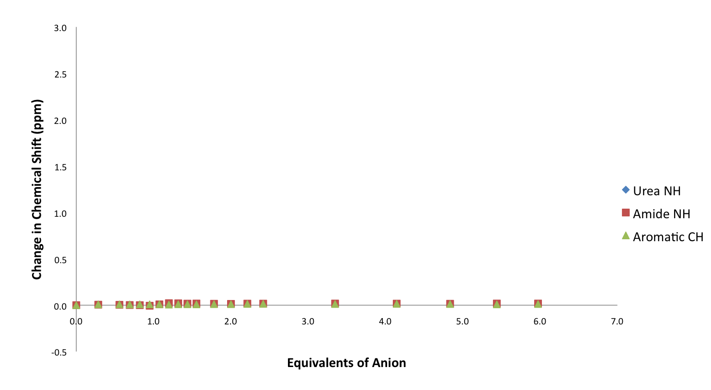
Figure S94 Comparison of change in chemical shift of compound 3 vs. TBACl in DMSO-d₆/H₂O 0.5%.

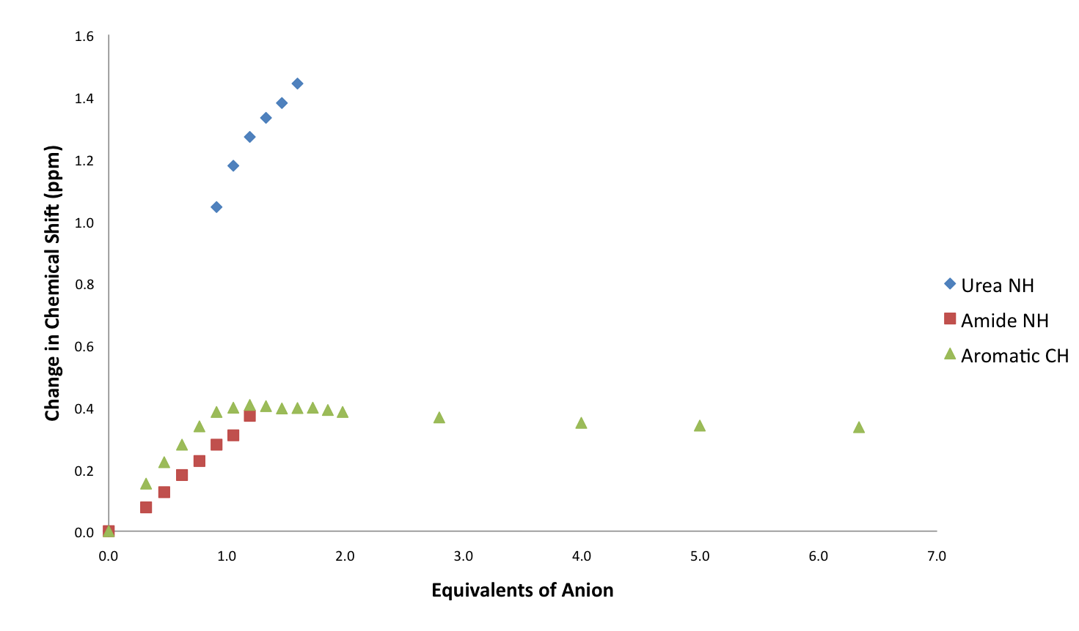
Figure S95 Comparison of change in chemical shift of compound 3 vs. TBAH₂PO₄ in DMSO-d₆/H₂O 0.5%.

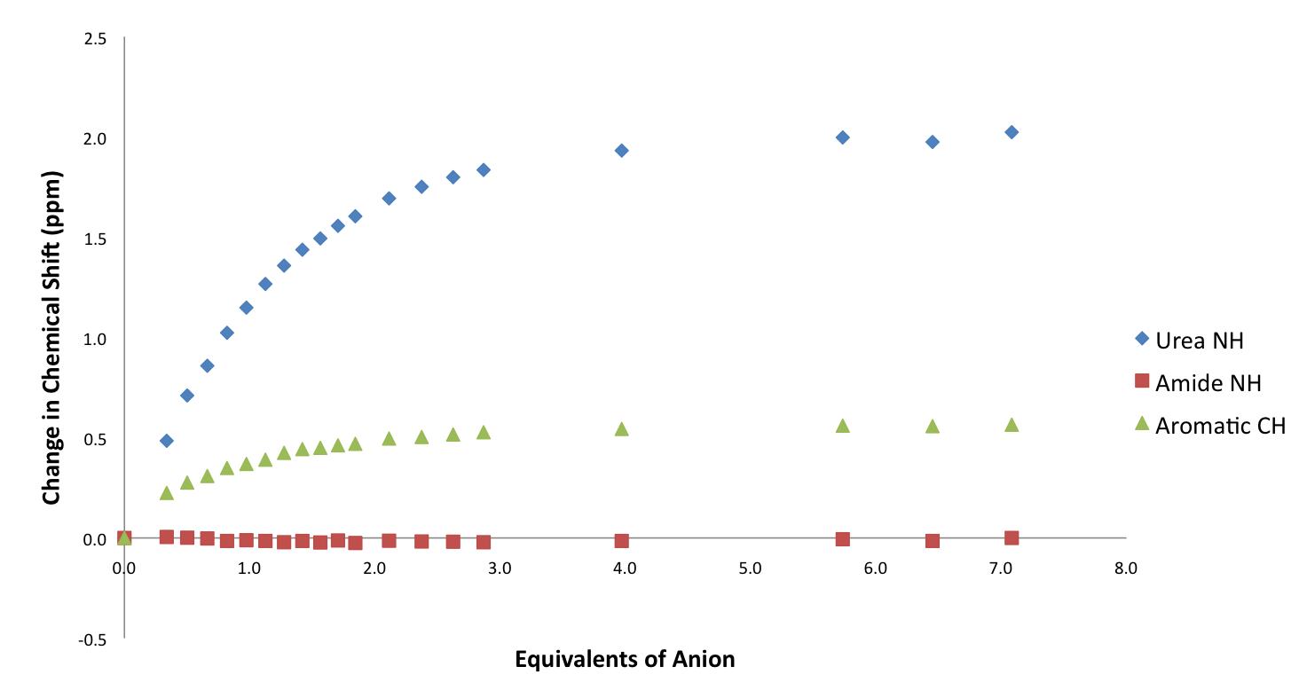
Figure S96 Comparison of change in chemical shift of compound 3 vs. TBAOAc in DMSO-d₆/H₂O 10%.

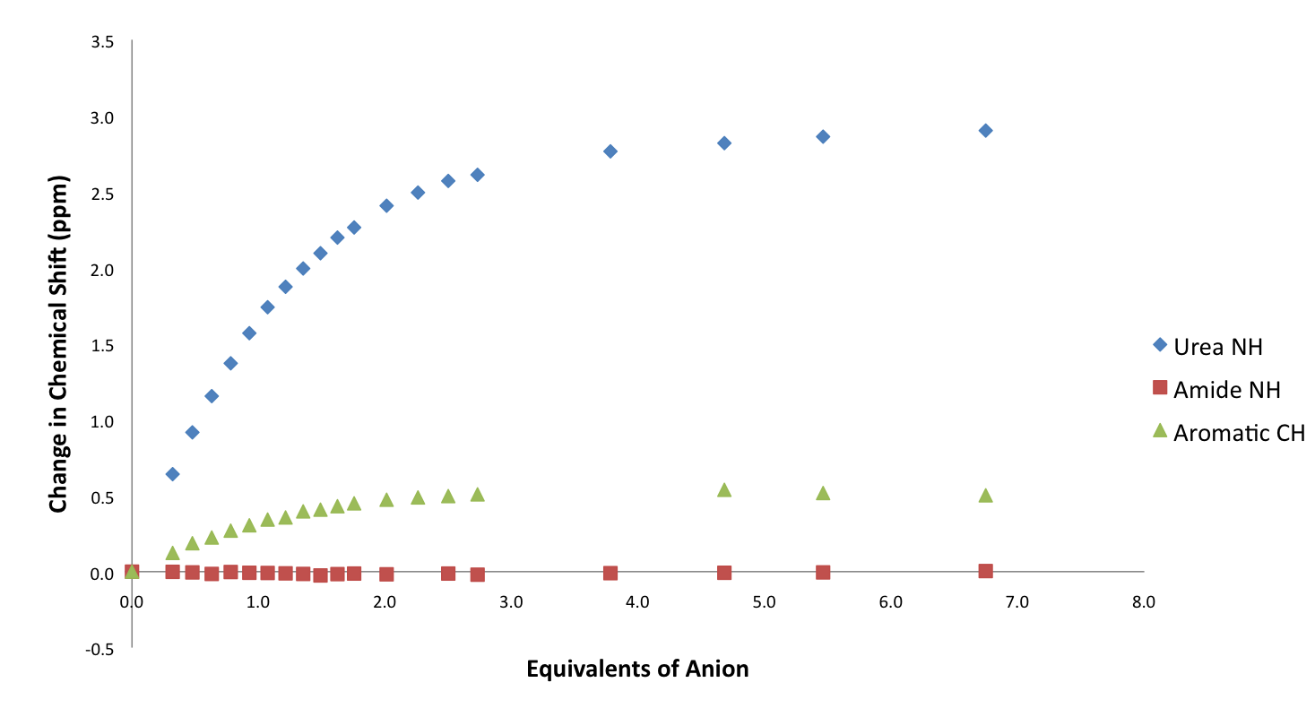
Figure S97 Comparison of change in chemical shift of compound 3 vs. TBAOBz in DMSO-d₆/H₂O 10%.

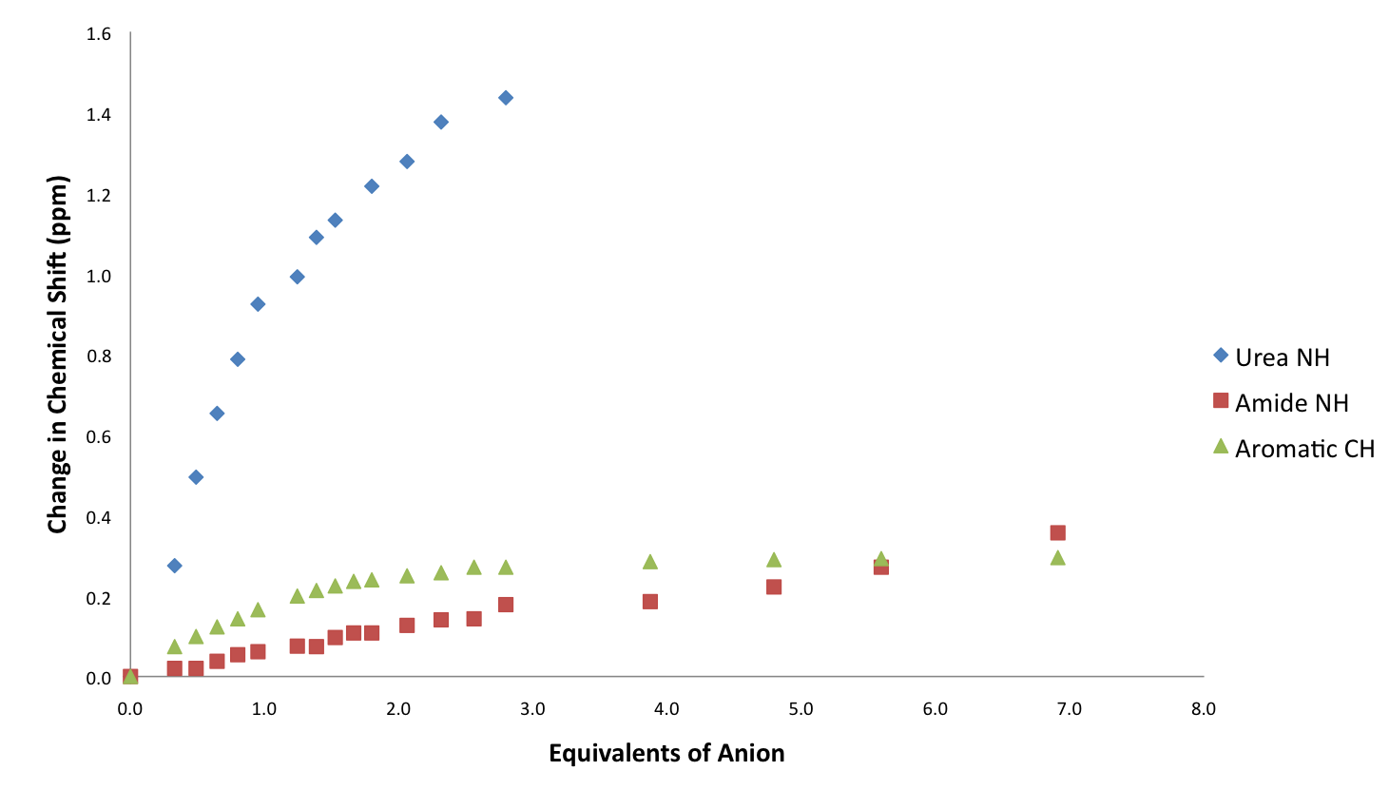
Figure S98 Comparison of change in chemical shift of compound 3 vs. TEAHCO₃ in DMSO-d₆/H₂O 10%.

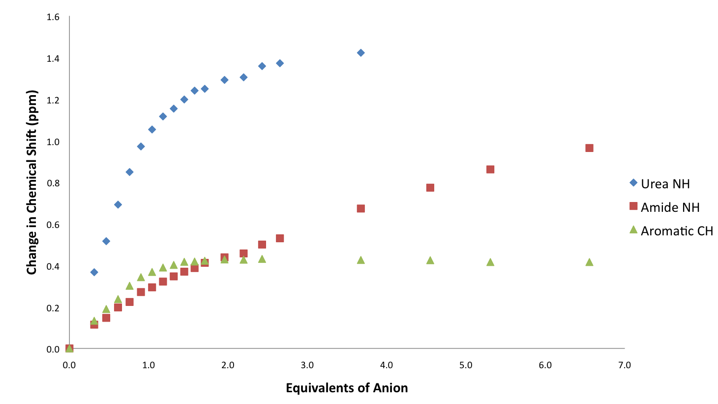
Figure S99 Comparison of change in chemical shift of compound 3 vs. TBAH₂PO₄ in DMSO-d₆/H₂O 10%.

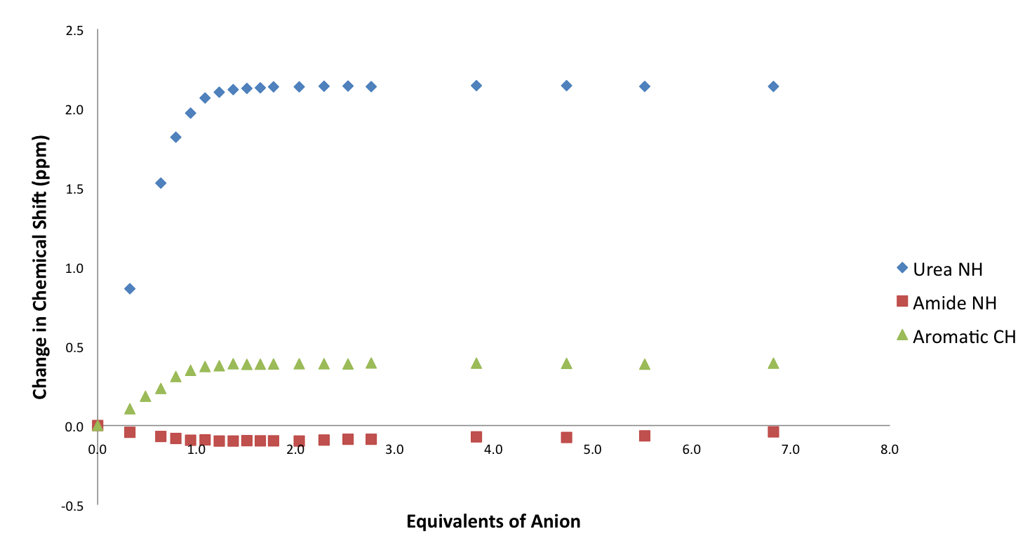
Figure S100 Comparison of change in chemical shift of compound 4 vs. TBAOAc in DMSO-d₆/H₂O 0.5%.

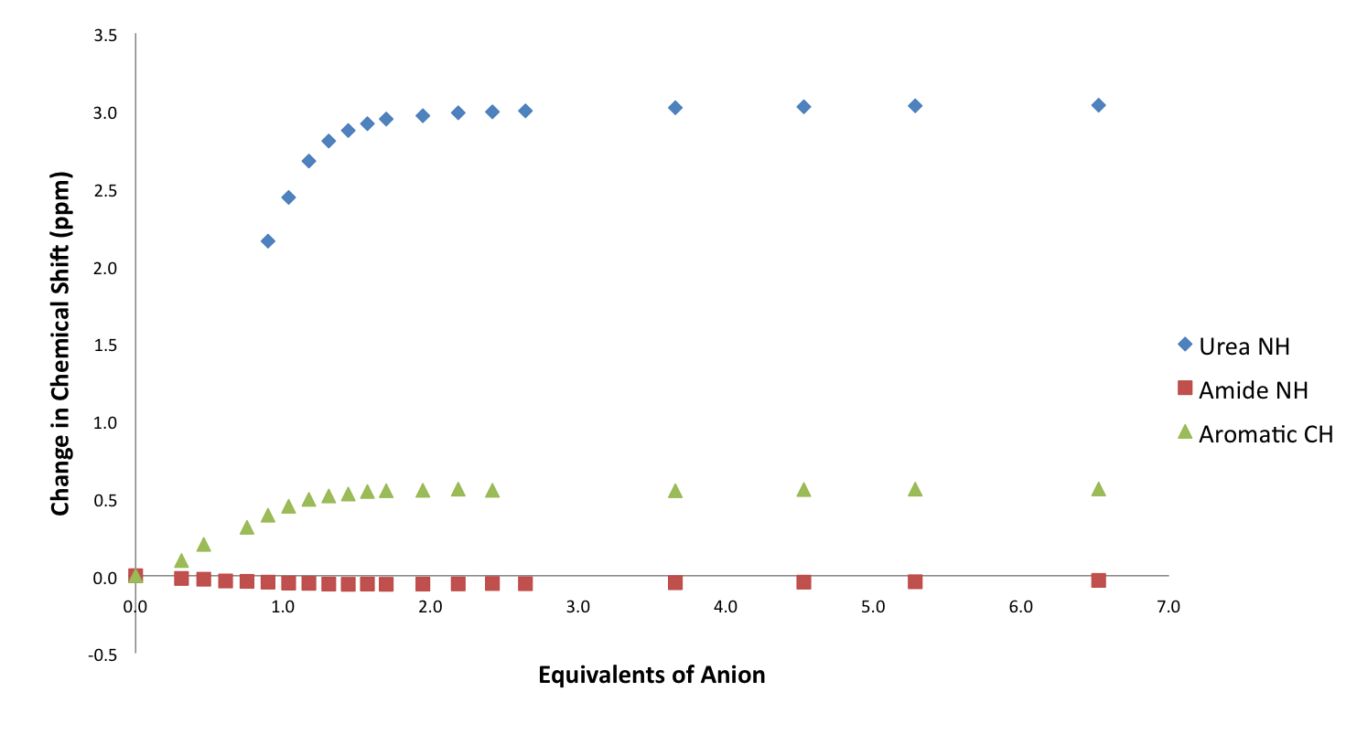
Figure S101 Comparison of change in chemical shift of compound 4 vs. TBAOBz in DMSO-d₆/H₂O 0.5%.

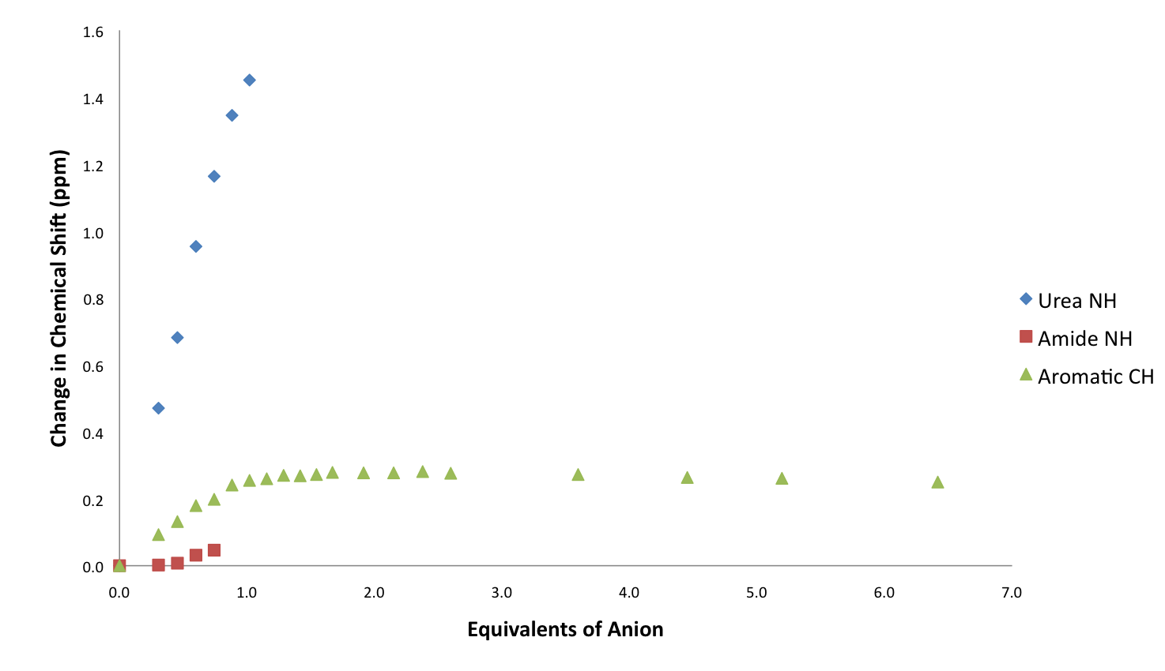
Figure S102 Comparison of change in chemical shift of compound 4 vs. TEAHCO₃ in DMSO-d₆/H₂O 0.5%.

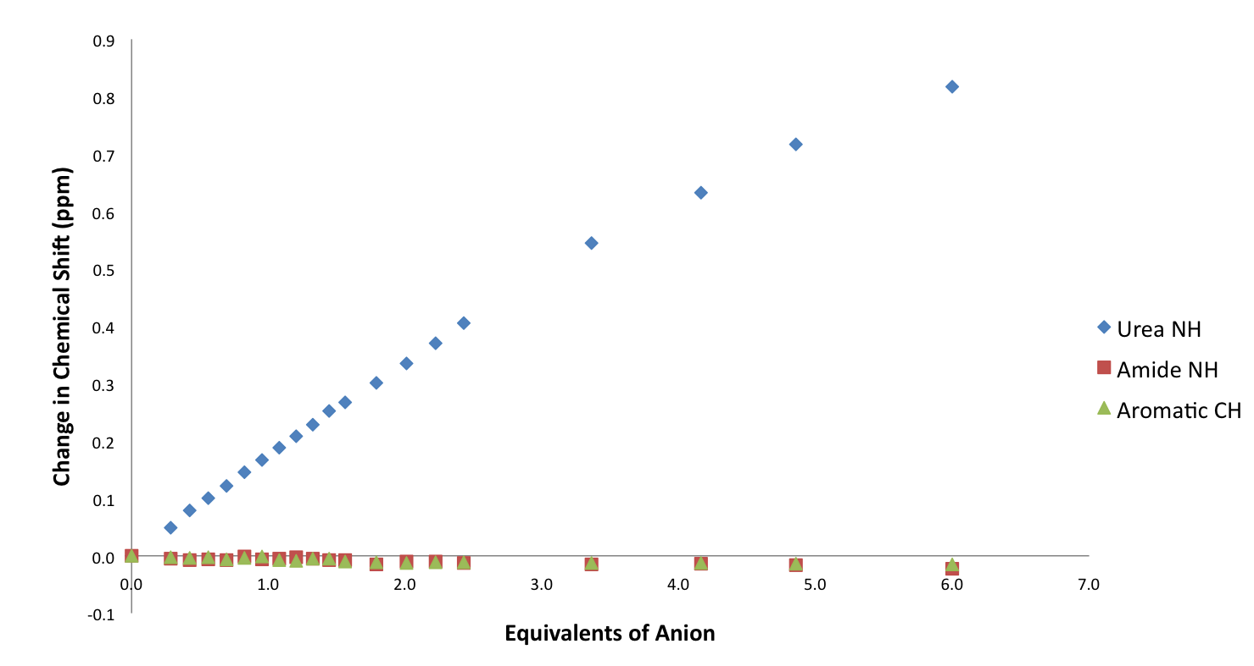
Figure S103 Comparison of change in chemical shift of compound 4 vs. TBACl in DMSO-d₆/H₂O 0.5%.

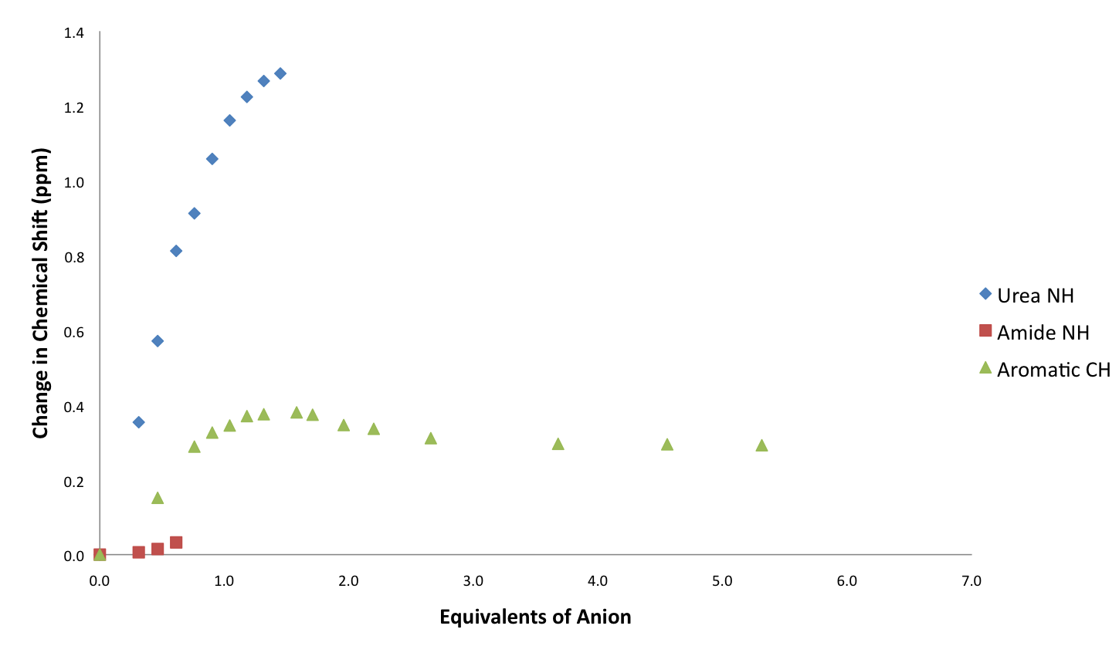
Figure S104 Comparison of change in chemical shift of compound 4 vs. TBAH₂PO₄ in DMSO-d₆/H₂O 0.5%.

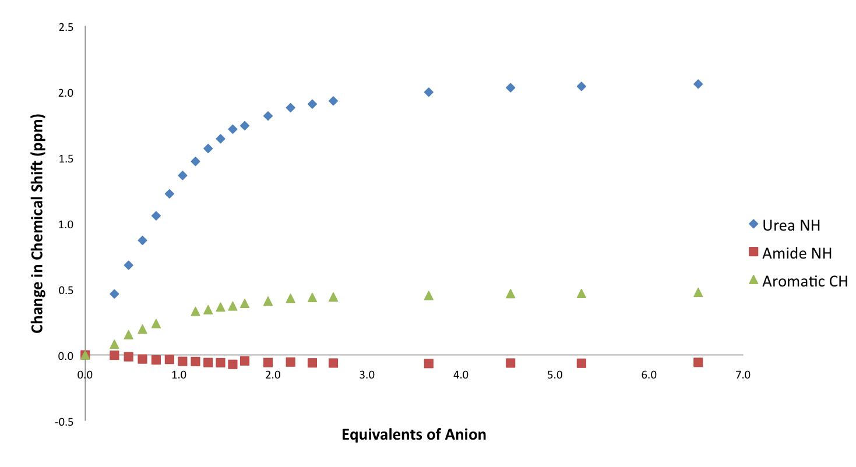
Figure S105 Comparison of change in chemical shift of compound 4 vs. TBAOAc in DMSO-d₆/H₂O 10%.

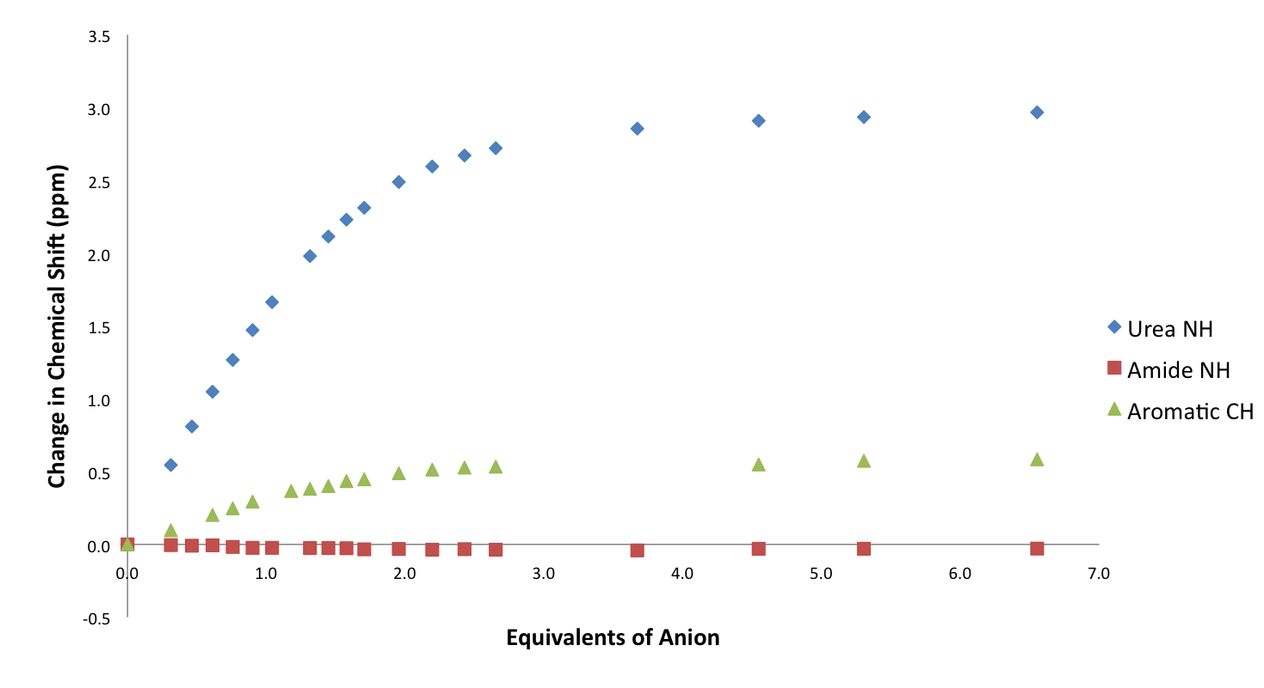
Figure S106 Comparison of change in chemical shift of compound 4 vs. TBAOBz in DMSO-d₆/H₂O 10%.

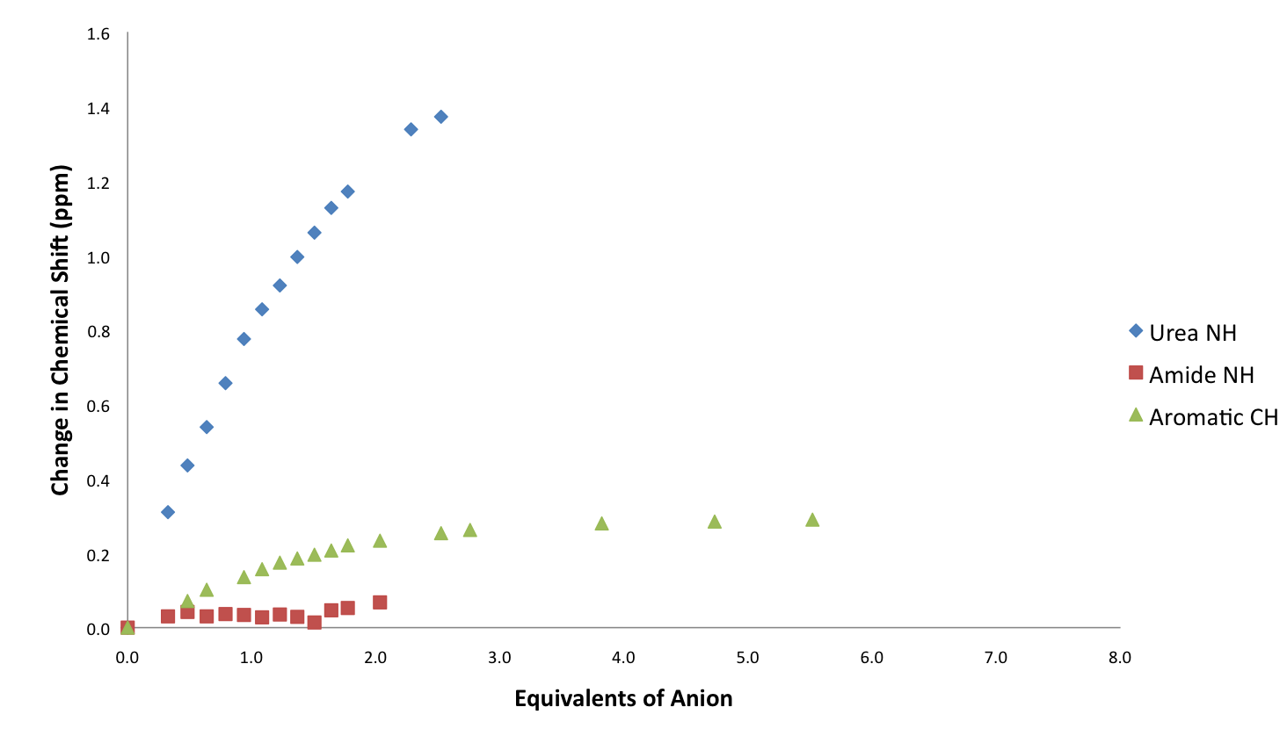
Figure S107 Comparison of change in chemical shift of compound 4 vs. TBAHCO₃ in DMSO-d₆/H₂O 10%.

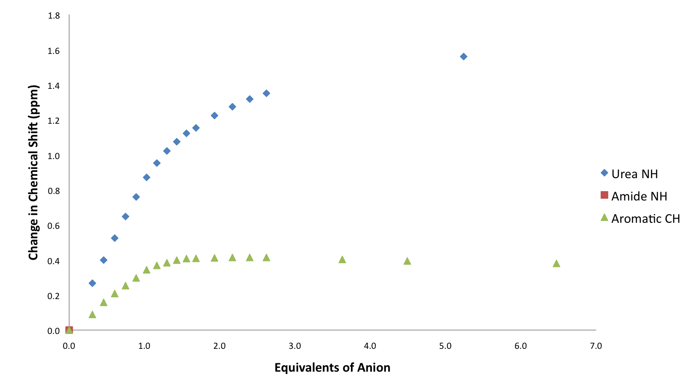
Figure S108 Comparison of change in chemical shift of compound 4 vs. TBAH₂PO₄ in DMSO-d₆/H₂O 10%.

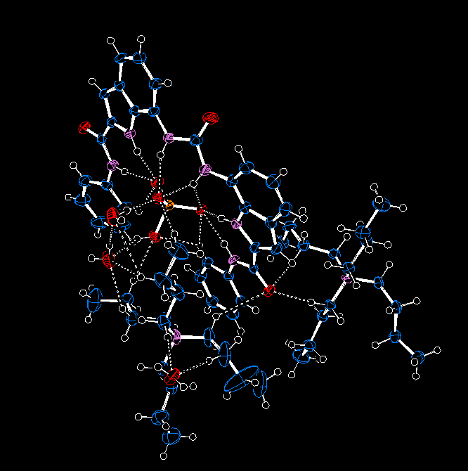

Figure S109 Ortep diagram of compound 2 bound to TBA hydrogen phosphate.

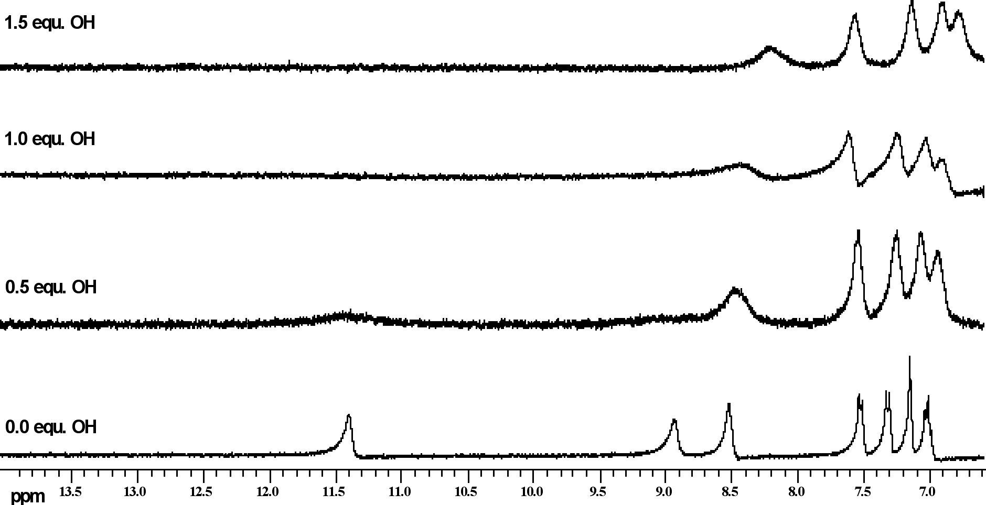
Figure S110 ¹H NMR titration of compound 1 with TBA OH in DMSO-d₆/0.5% water
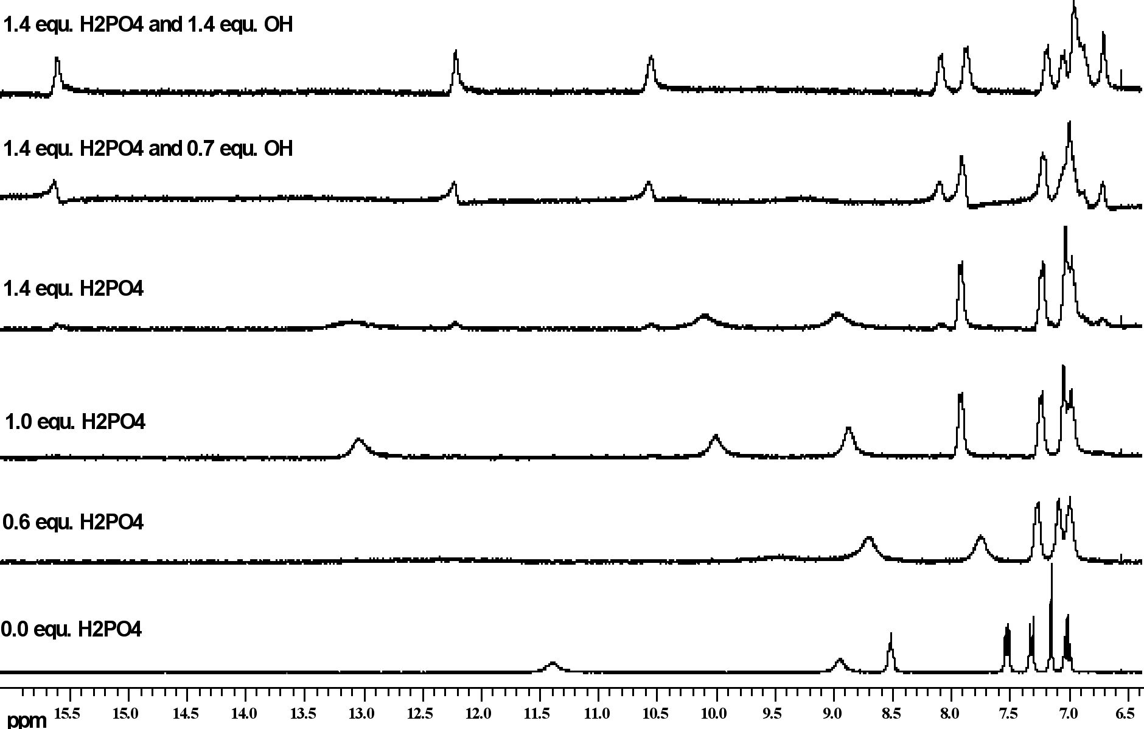
Figure S111 ¹H NMR titration of compound 1 with TBA H₂PO₄ and then TBA OH in DMSO-d₆/0.5% water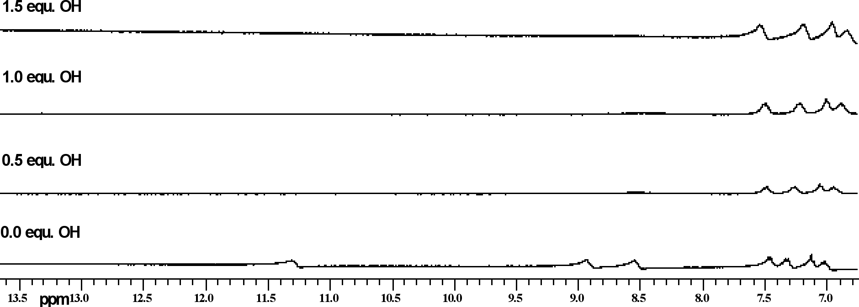
Figure S112 ¹H NMR titration of compound 1 with TBA OH in DMSO-d₆/10% water
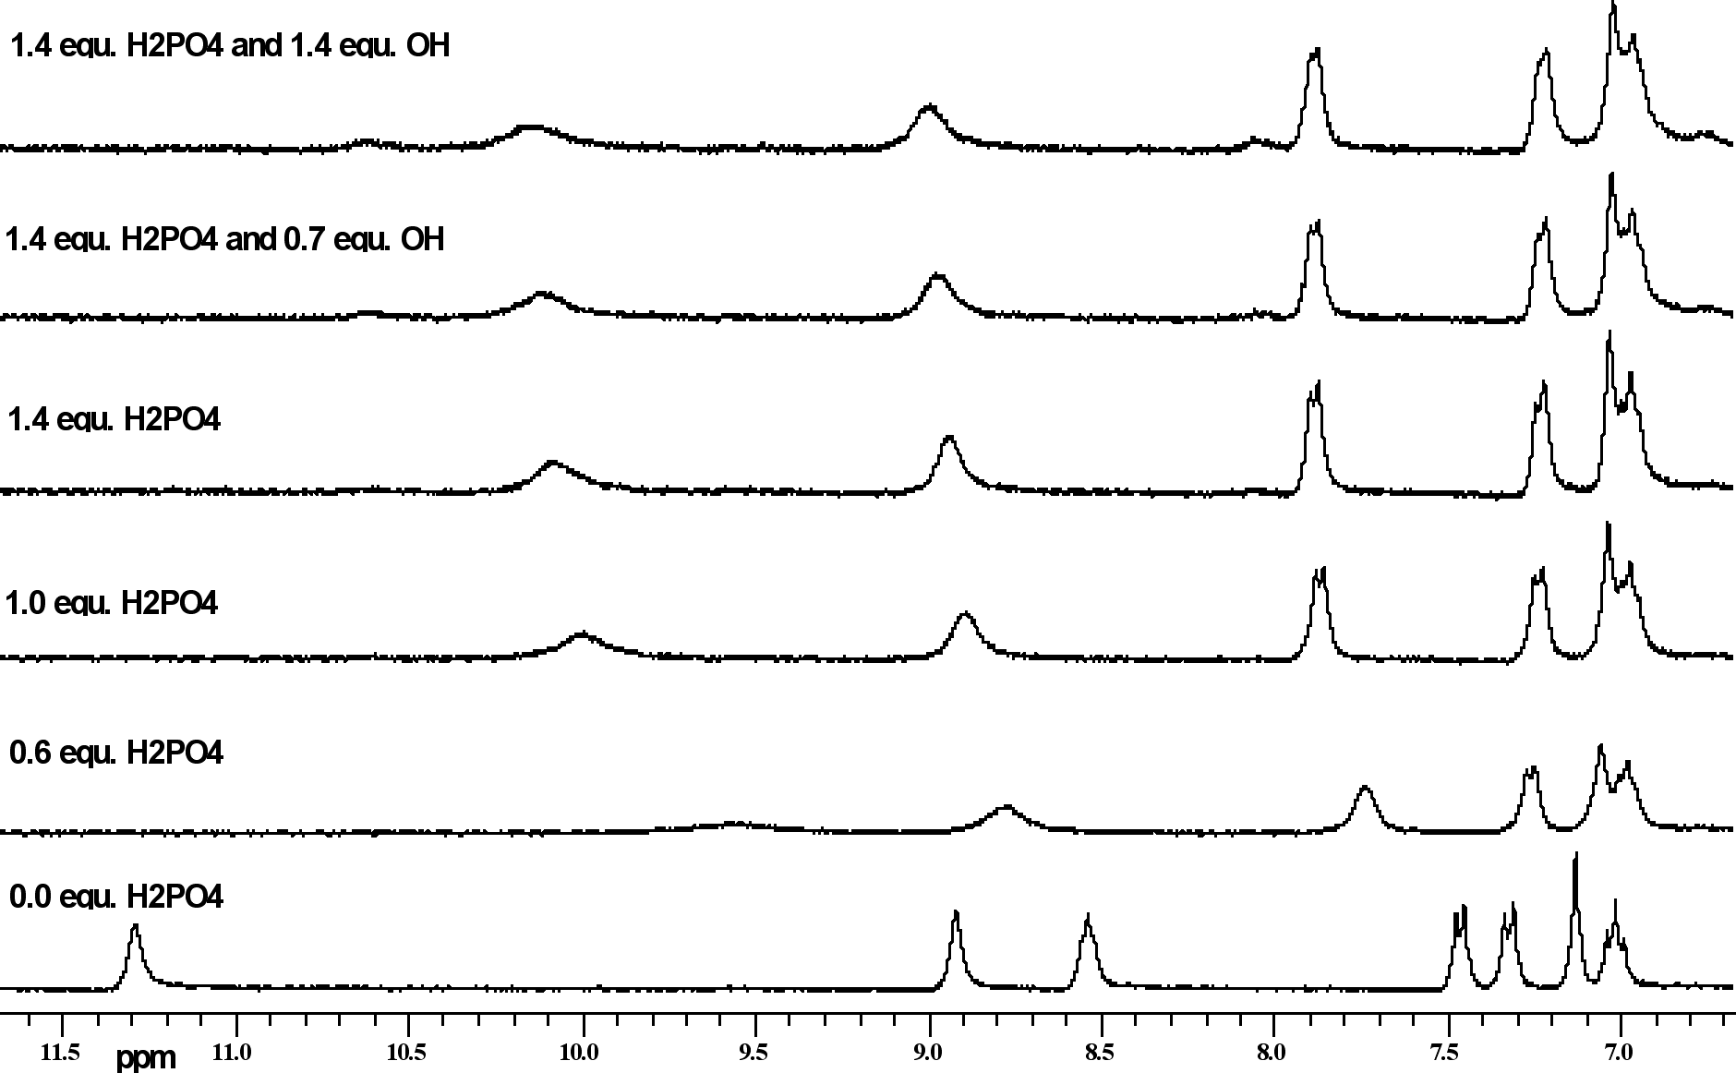
Figure S113 ¹H NMR titration of compound 1 with TBA H₂PO₄ and then TBA OH in DMSO-d₆/10%
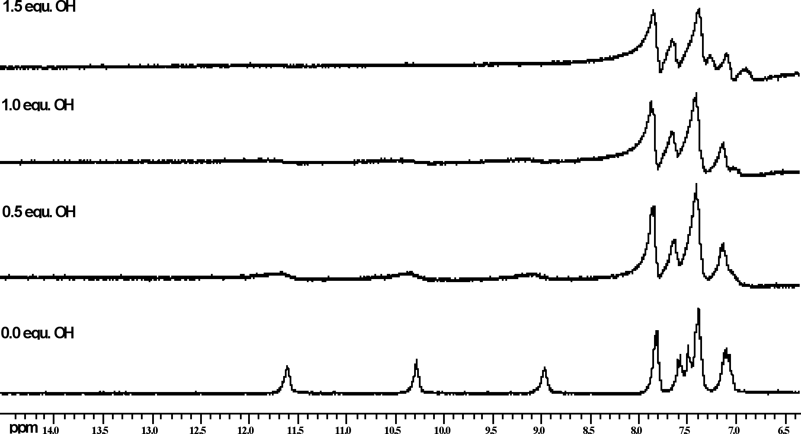
Figure S114 ¹H NMR titration of compound 2 with TBA OH in DMSO-d₆/0.5% water
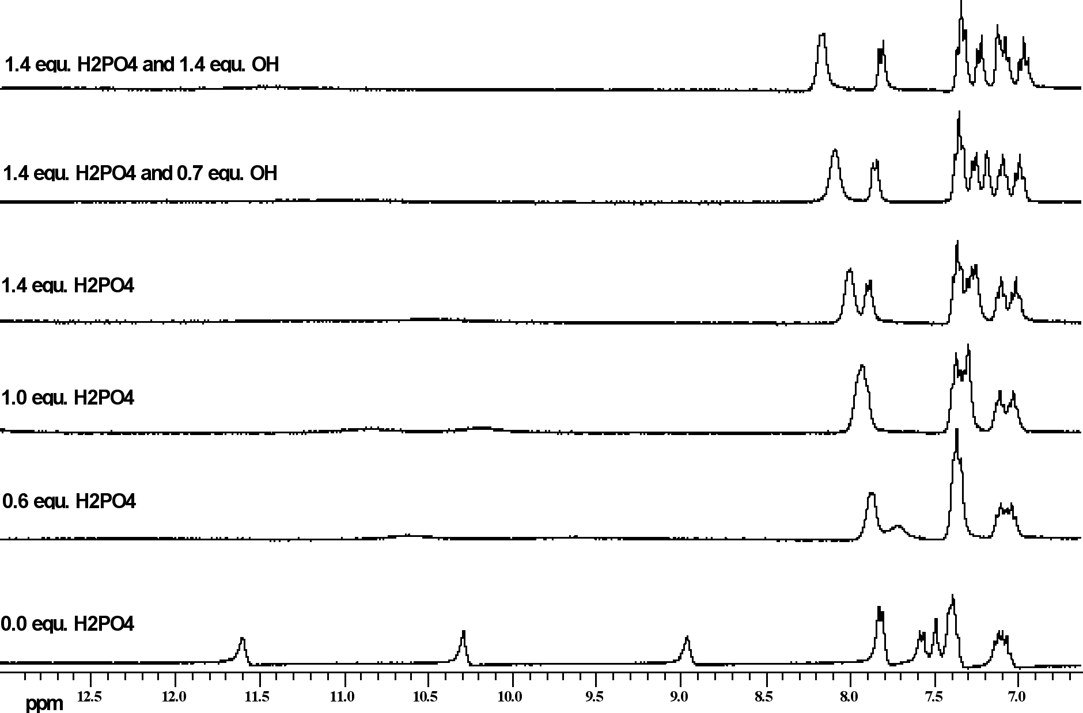
Figure S115 ¹H NMR titration of compound 2 with TBA H₂PO₄ and then TBA OH in DMSO-d₆/0.5%
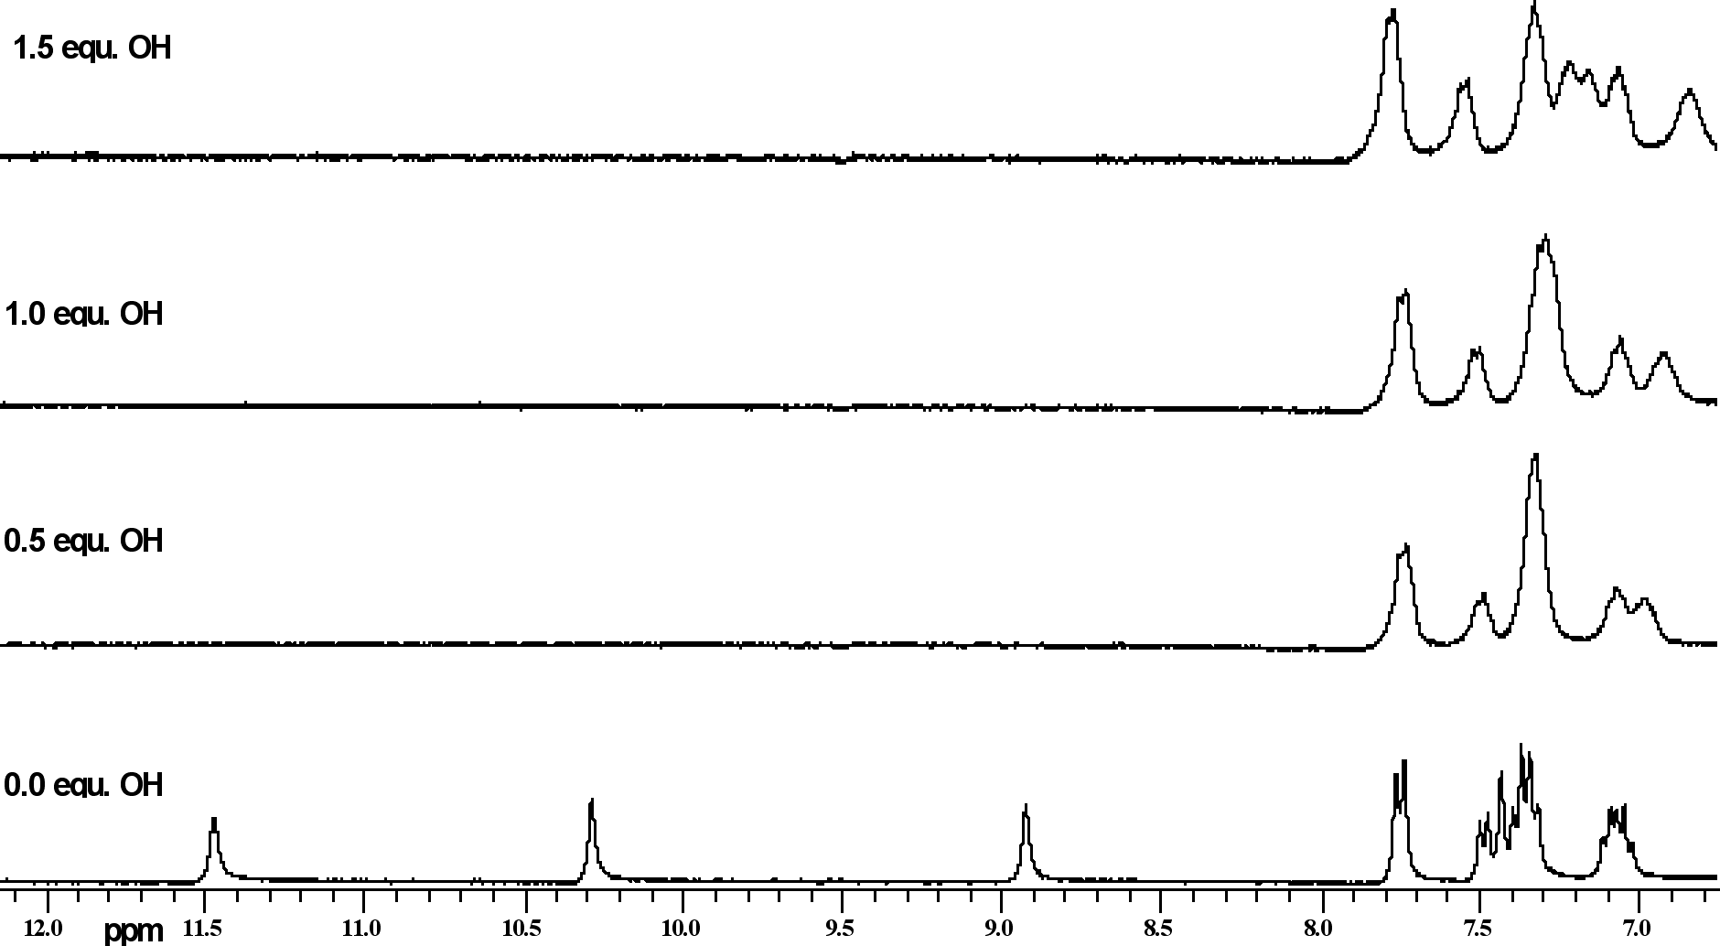
Figure S116 ¹H NMR titration of compound 2 with TBA OH in DMSO-d₆/10% water
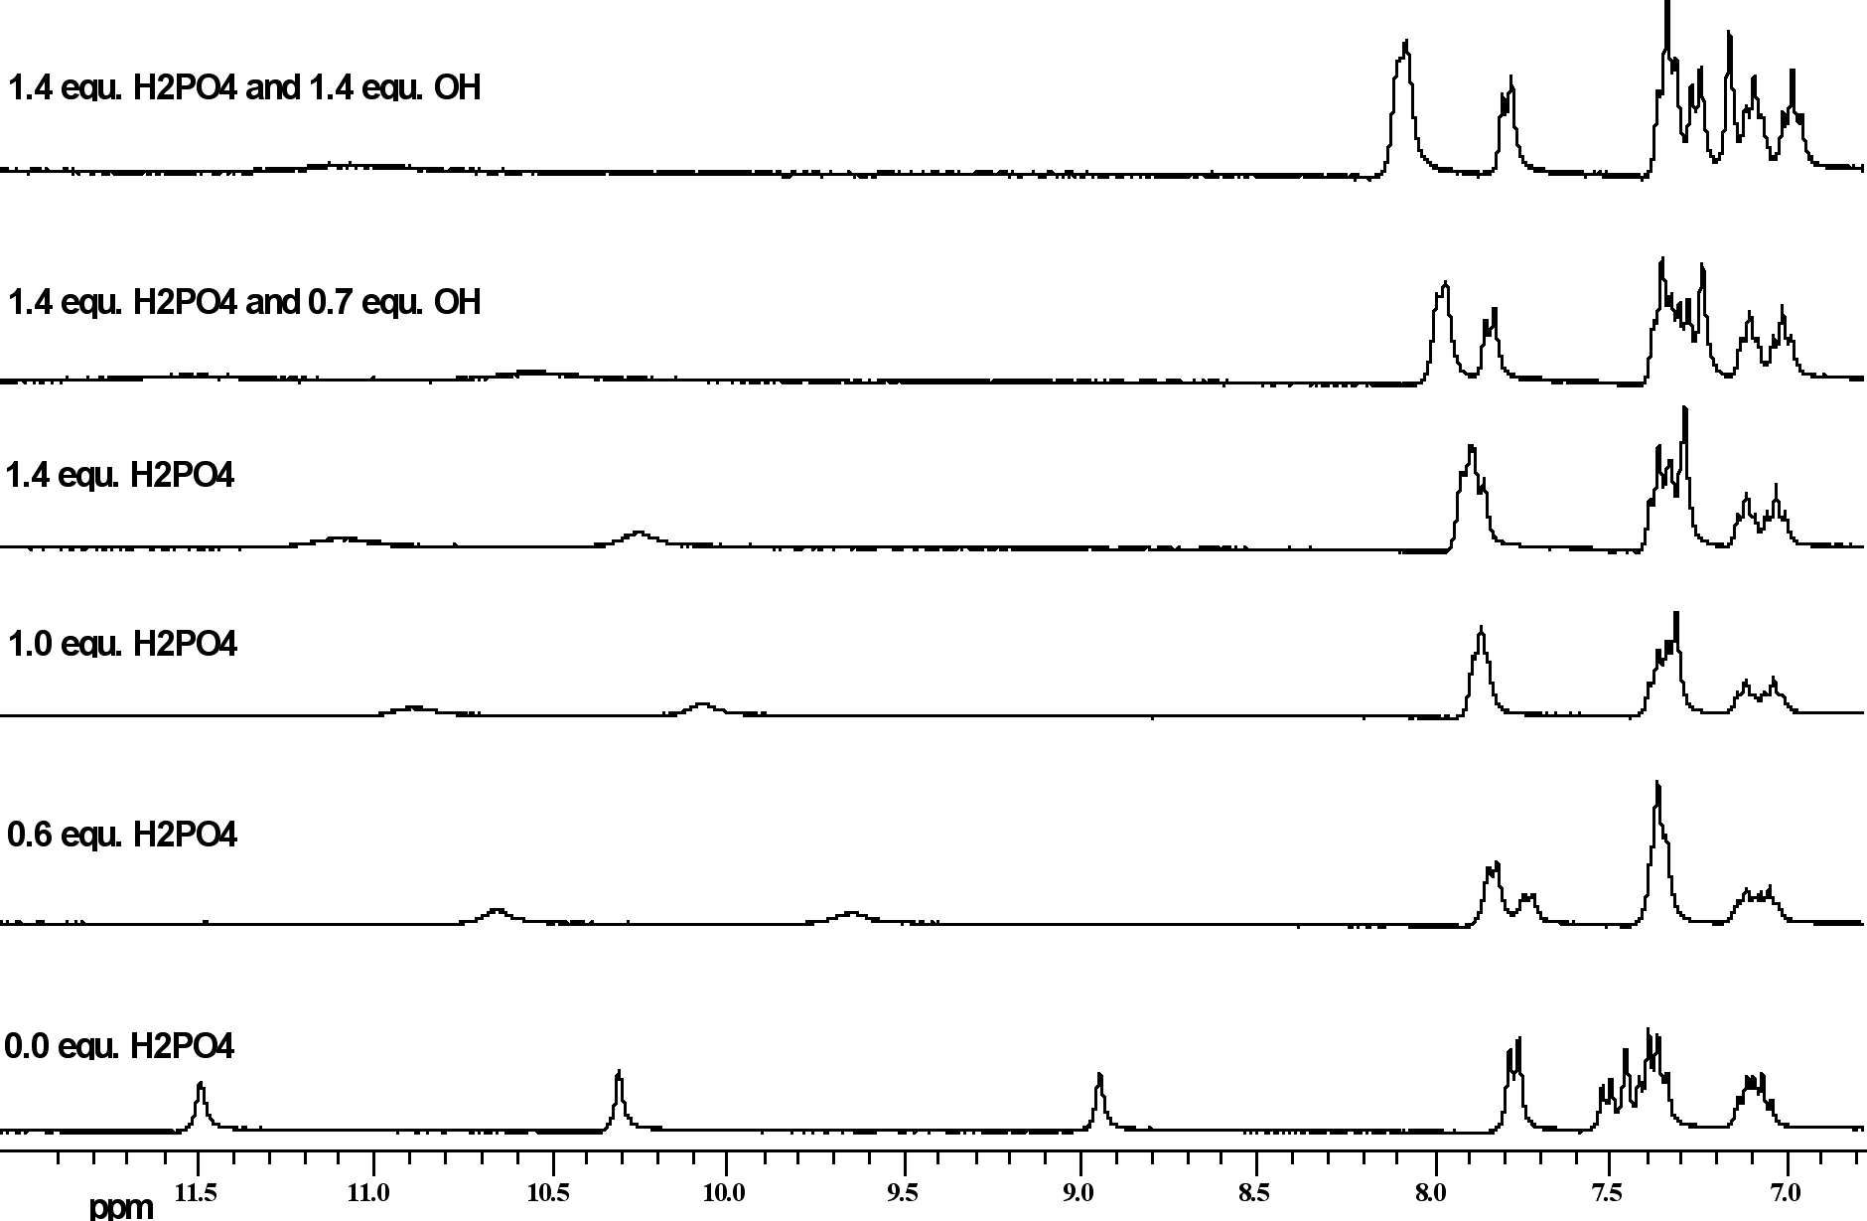Figure S117 ¹H NMR titration of compound 2 with TBA H₂PO₄ and then TBA OH in DMSO-d₆/10%
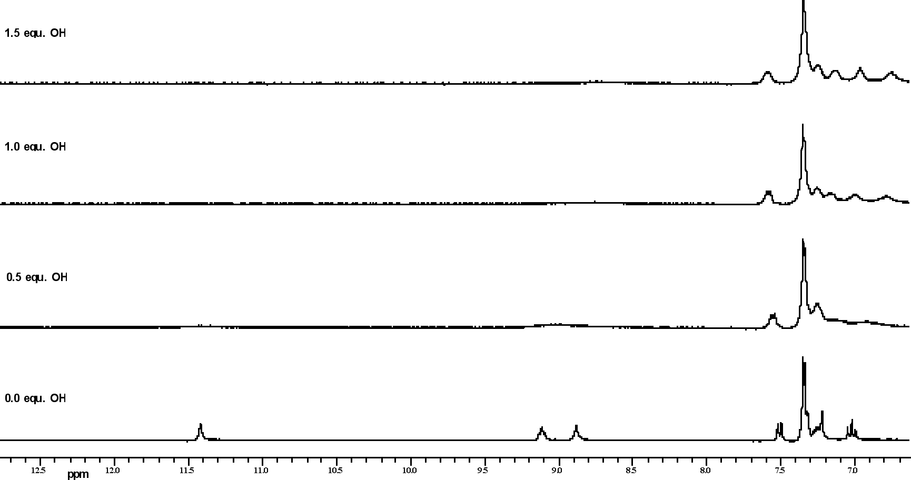
Figure S118 ¹H NMR titration of compound 3 with TBA OH in DMSO-d₆/0.5% water
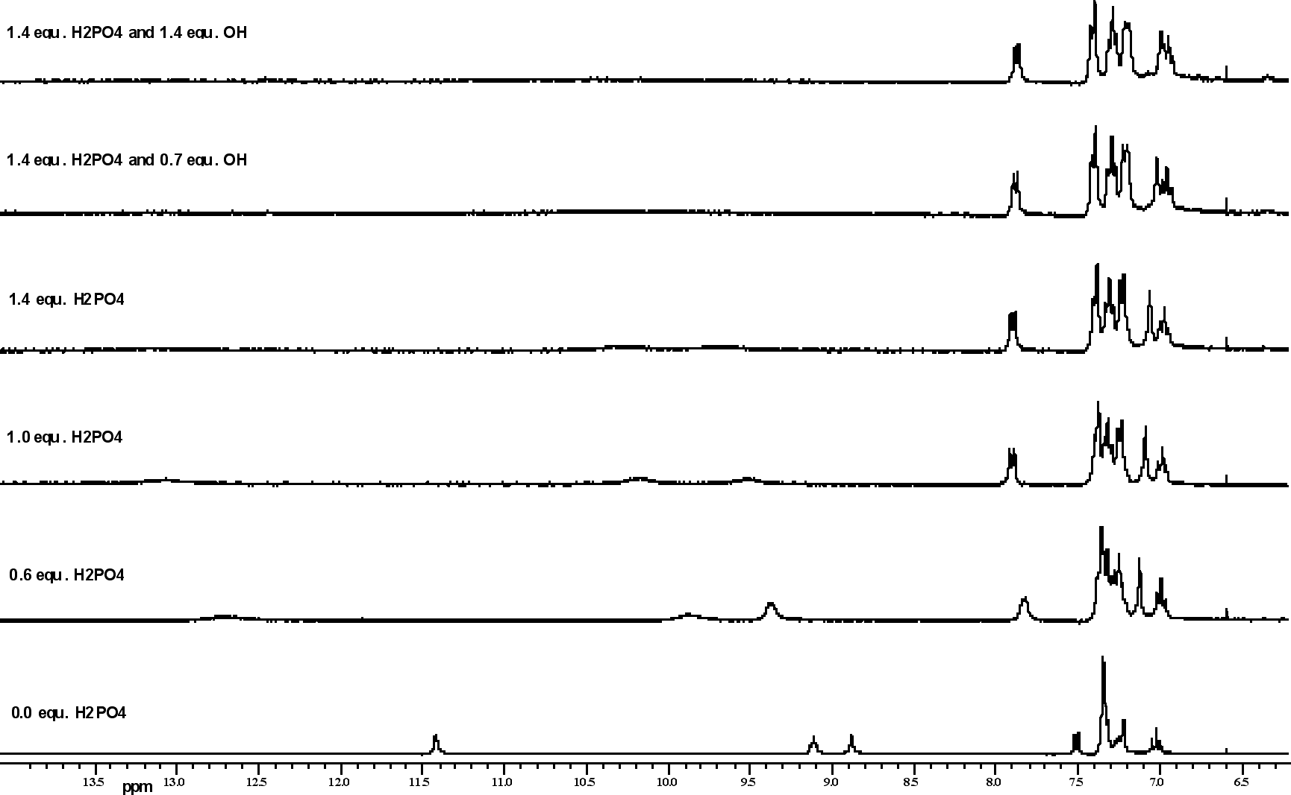
Figure S119 ¹H NMR titration of compound 3 with TBA H₂PO₄ and then TBA OH in DMSO-d₆/0.5%
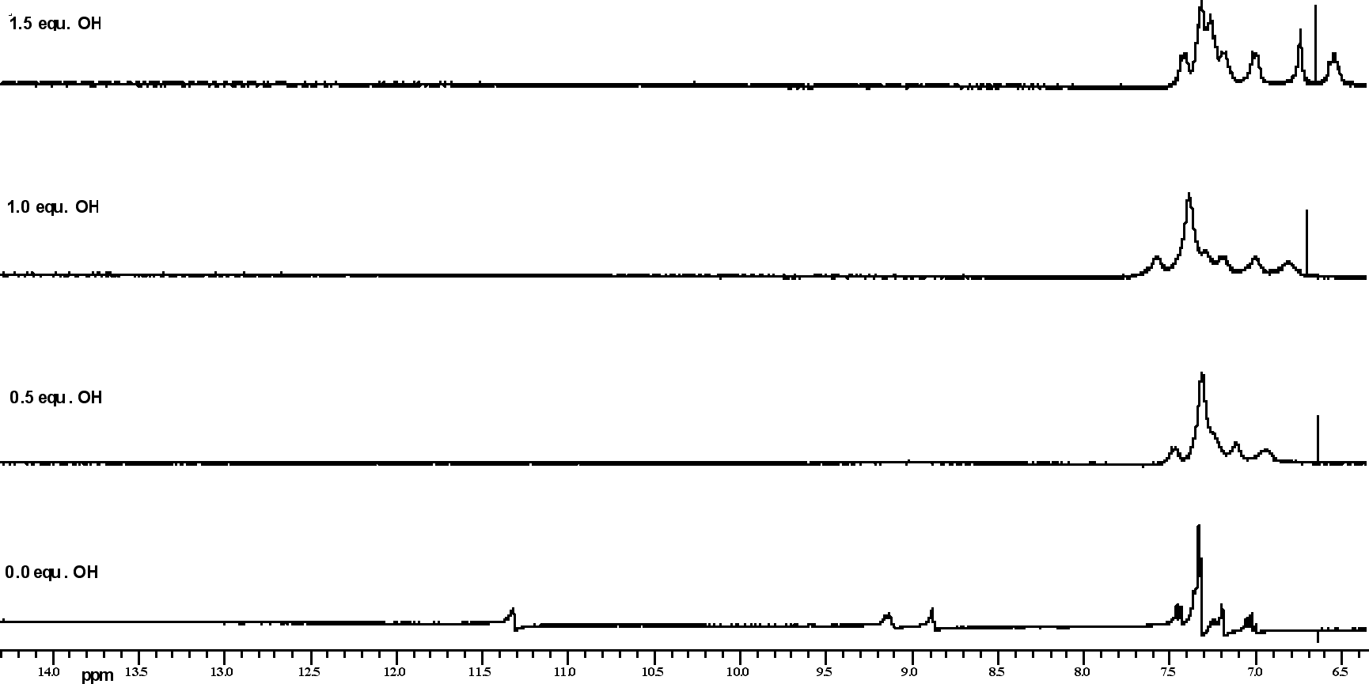
Figure S120 ¹H NMR titration of compound 3 with TBA OH in DMSO-d₆/10% water

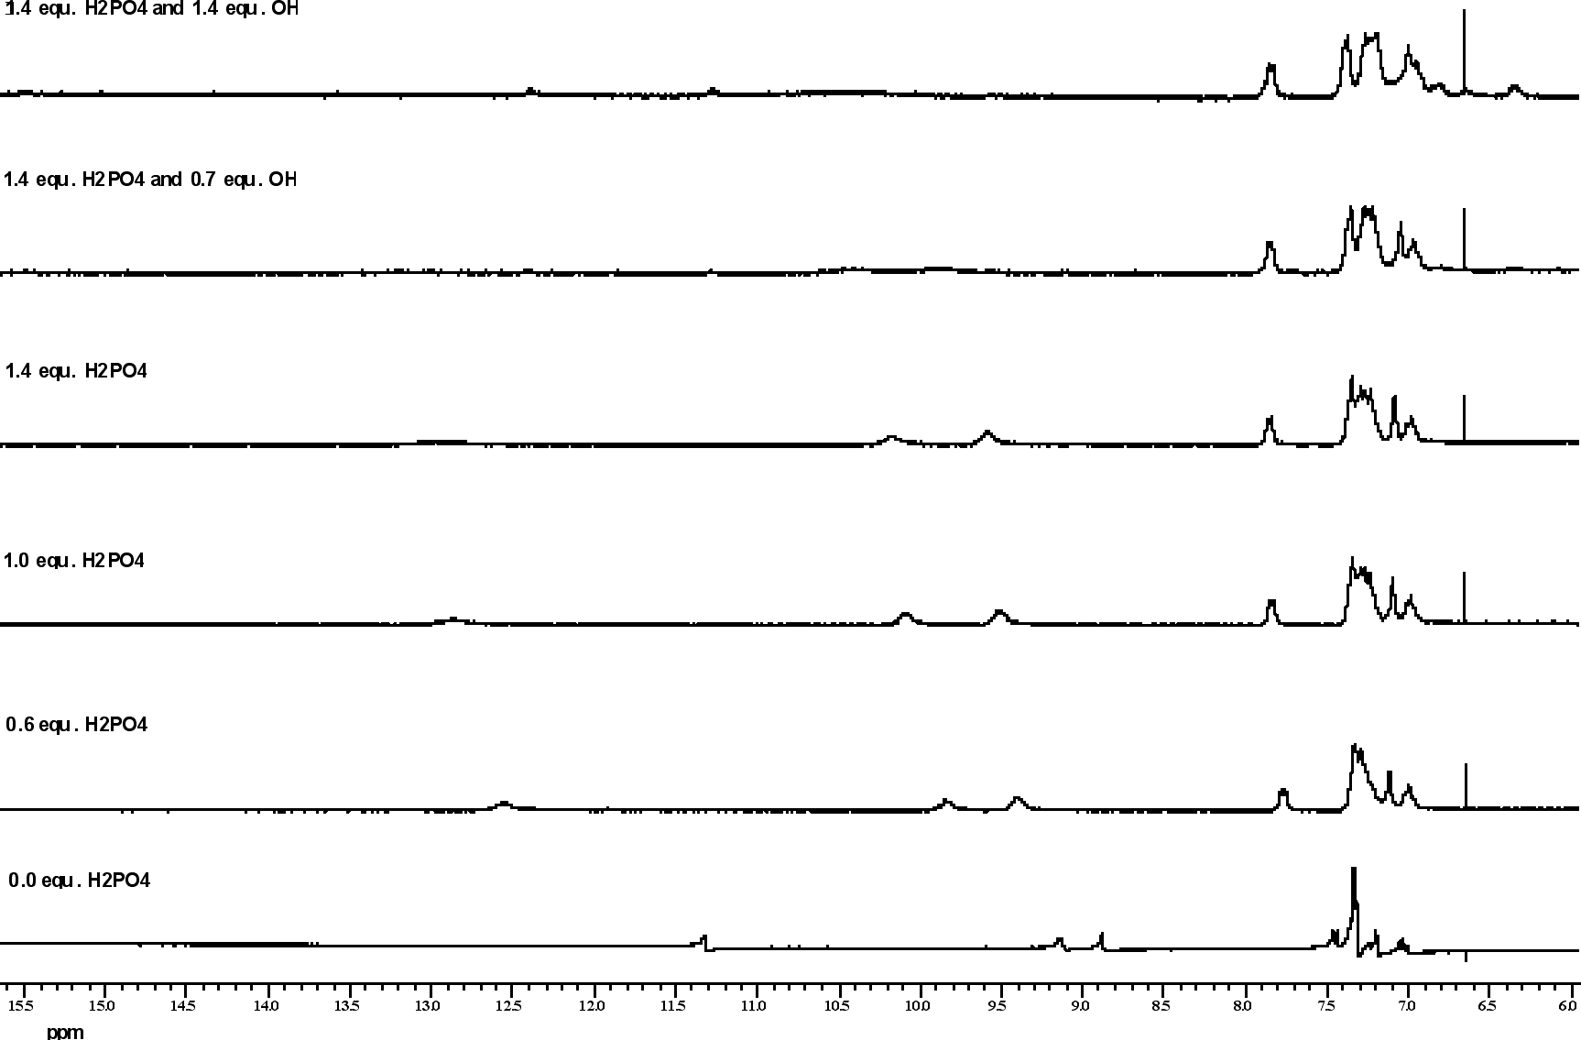
Figure S121 ¹H NMR titration of compound 3 with TBA H₂PO₄ and then TBA OH in DMSO-d₆/10%
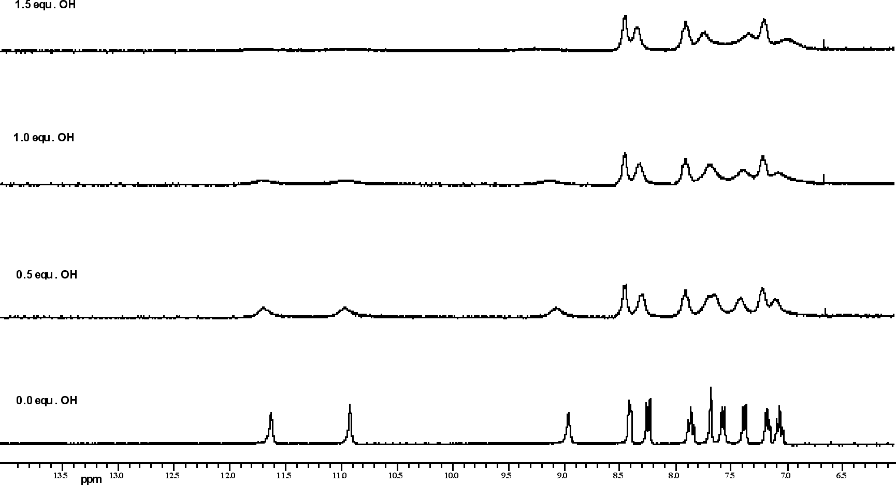
Figure S122 ¹H NMR titration of compound 4 with TBA OH in DMSO-d₆/0.5% water
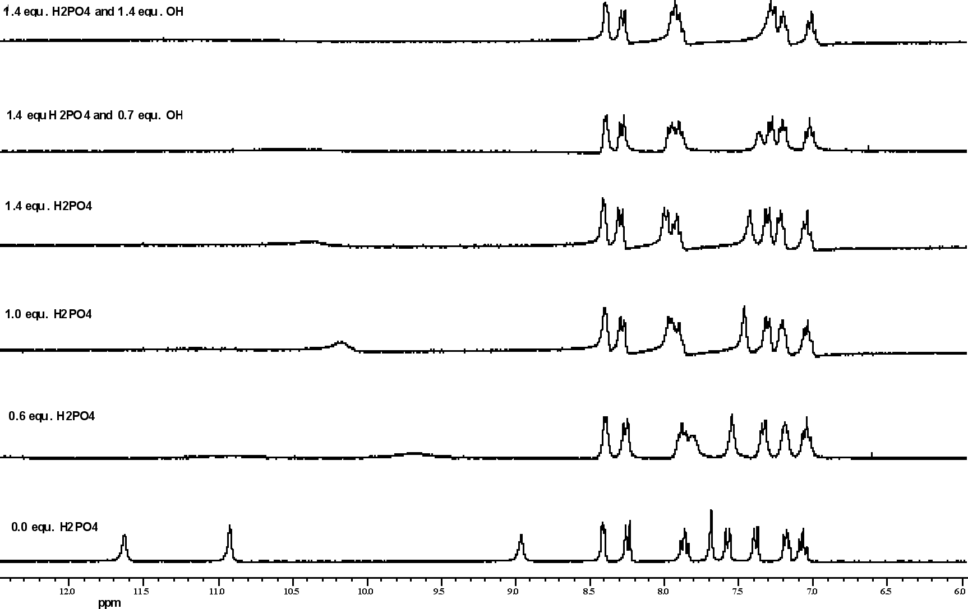
Figure S123 ¹H NMR titration of compound 4 with TBA H₂PO₄ and then TBA OH in DMSO-d₆/0.5%

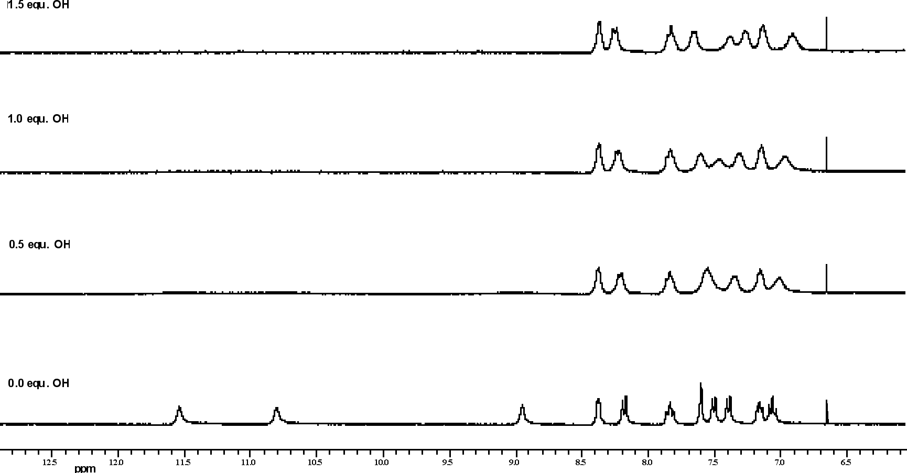
Figure S124 ¹H NMR titration of compound 4 with TBA OH in DMSO-d₆/10% water

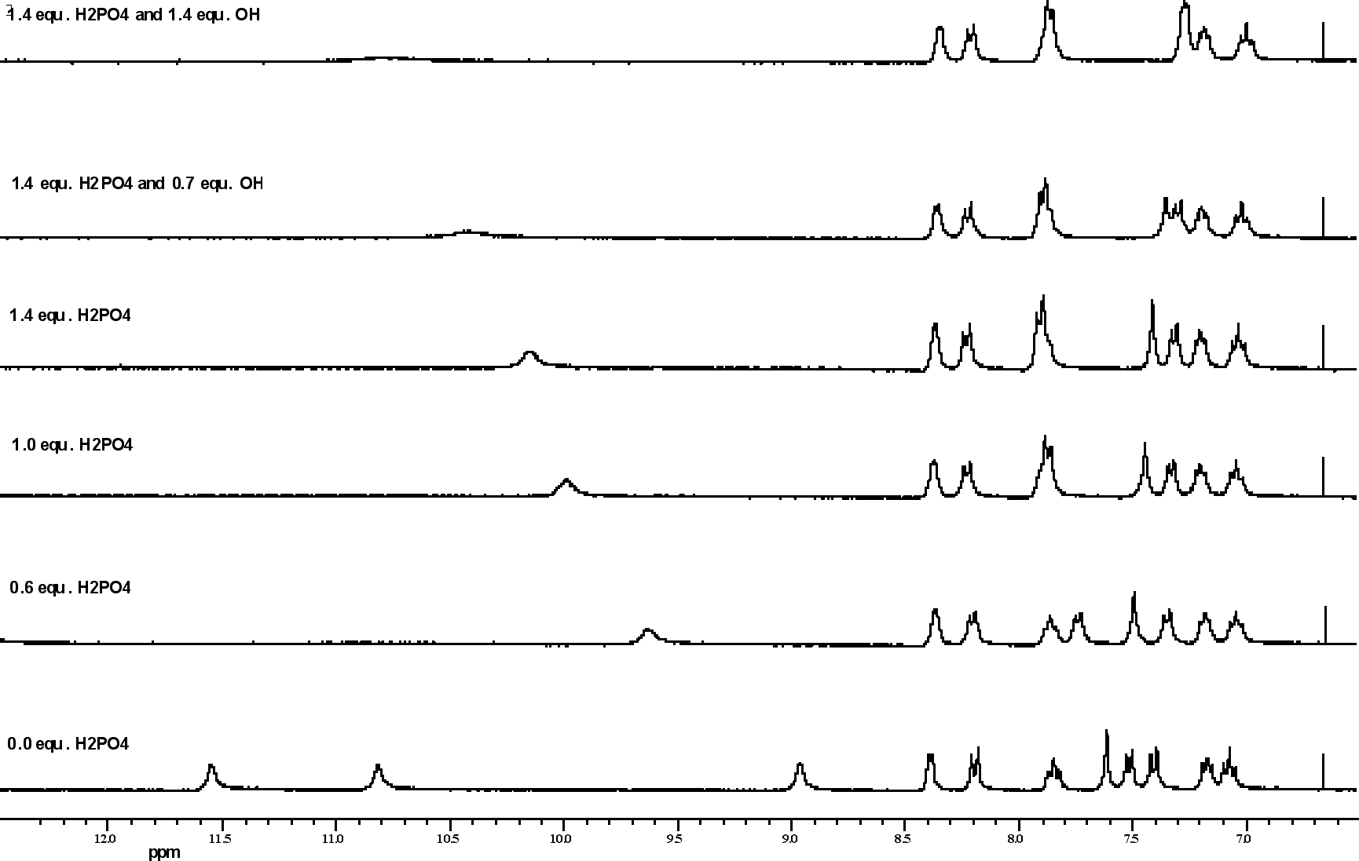
Figure S125 ¹H NMR titration of compound 4 with TBA H₂PO₄ and then TBA OH in DMSO-d₆/10%

