A Study of Pentafluoroethane and its Thermal Decomposition

using u.v.photoelectron spectroscopy and ab initio molecular orbital calculations

by

G.Copeland^{(a)}, E.P.F.Lee^{(a,b,c)}, J.M.Dyke^{(a)*}, W.K.Chow^{(c)},
D.K.W.Mok^{(b)}, and F.T.Chau^{(b)*}

a) School of Chemistry, University of Southampton, Highfield,
Southampton SO17 1BJ, UK

b) Dept. of Applied Biology and Chemical Technology, The Hong Kong Polytechnic University, Hung Hom, Hong Kong

c) Dept. of Building Services Engineering, The Hong Kong Polytechnic University, Hung Hom, Hong Kong

* Authors for correspondence

Abstract

The u.v. photoelectron spectrum of CF₃CHF₂ has been recorded and assigned using EOM-CCSD calculations. For the first band, the adiabatic ionization energy (AIE) and vertical ionization energy (VIE) have been measured as (12.71 ± 0.05) and (13.76 ± 0.02) eV respectively. The measured AIE is higher than the recommended value from state-of-the-art ab initio calculations of (12.26 ± 0.02) eV because of a large geometry change on ionization, mainly arising from a significant increase in the C-C bond length, which results in poor Franck-Condon factors in the adiabatic region. The experimental VIE also shows poor agreement with the computed value of 14.05 ± 0.06 eV because, in the higher energy region of the first photoelectron band, dissociation of CF₃CHF₂⁺ to CHF₂⁺ + CF₃ occurs. This has a calculated thermodynamic onset of (12.89 ± 0.20) eV. Recommendations are made for the heats of formation, ΔH_{f,298}∅, of CF₃CHF₂ and CF₃CHF₂⁺ , based on the results of the ab initio calculations.
Pyrolysis of flowing CF₃CHF₂ diluted in argon shows evidence of production of C₂F₄ and HF at lower temperatures and CF₂ and CF₃H at higher temperatures. The relative temperature dependence of the observed photoelectron bands associated with these molecules is interpreted in terms of two decomposition reactions of CF₃CHF₂ as well as the reaction C₂F₄ → 2CF₂

Introduction
New fire extinguishants are currently being sought with low ozone depletion potentials (ODPs) and low global warming potentials (GWPs). Halogenated hydrocarbons (halons) have been found to exhibit good fire suppression properties. However, bromine and chlorine containing hydrocarbons and fluorocarbons (e.g. CH₃Cl, CF₃Br, CF₂Cl₂ and CF₂Br₂), whilst exhibiting good fire suppression properties, give rise to environmental problems in that they have significant ODP and GWP values (1). As a result, hydrofluorocarbons (HFCs) are being considered as alternative fire extinguishants. Also, HFCs are replacing chlorofluorocarbons (CFCs) in industrial applications such as refrigeration and foam blowing because of their less harmful effects on stratospheric ozone (2). The use of HFCs in these areas has prompted a number of studies of their chemical and physical properties related to these applications (3-9).
Pentafluoroethane (CF₃CHF₂) (also known as HFC125 or R125) is one of the simplest HFCs. It has been studied in some detail in the gas-phase by microwave (10), infrared (11), Raman and far-infrared spectroscopy (12). However, its thermal decomposition has not been studied. As a first step towards establishing how CF₃CHF₂ suppresses and extinguishes a flame, its thermal decomposition is studied in this work in a flow system using u.v. photoelectron spectroscopy (PES). Also, information on CF₃CHF₂ obtained from its PE spectrum will be relevant to understanding the photoionization of CF₃CHF₂ in the upper atmosphere and subsequent loss of the ions produced through ion-molecule reactions. HFCs could well reach the upper atmosphere and be photoionized as their lifetimes in the lower atmosphere are very long because of their slow reaction with key free radicals such as OH. Although CF₃CHF₂ has not been studied previously by u.v. photoelectron spectroscopy, the threshold photoelectron (TPE) spectrum and ion yield curves of the observed ionic fragments obtained after photoionization have been recorded in the photon energy range 12.0-25.0 eV using synchrotron radiation as the photon source (13). Also, the fragmentation of the valence electronic states of CF₃CHF₂⁺ has been studied using the threshold photoelectron-photoion coincidence (TPEPICO) technique (13). In the TPE spectrum the first band was broad, and vibrationally unresolved, consistent with a significant geometry change on ionization. The band onset was measured as (12.70 ± 0.05) eV and the band maximum (the vertical ionization energy, VIE) was measured as (13.76 ± 0.05) eV (13). Also, in a recent vacuum ultraviolet photoionization study (14), the experimental first adiabatic ionization energy (AIE) was quoted as (12.25 ± 0.10) eV, consistent with AIE values of 12.25 and 12.26 eV computed using the G2 and G3 methods (13,14). The discrepancy of ∼0.5 eV between the experimental onset of (12.70 ± 0.05) eV from the TPE study and the computed AIEs at the G2 and G3 levels was attributed in the TPEPICO study (13) to the inability of the TPE method to obtain a measurable signal at the ionization threshold for a molecule that has small Franck-Condon factors for direct ionization near threshold. It is, however, notable in the photoionization work of reference (14), that the parent ion (CF₃CHF₂⁺) was not observed at any of the photon energies used (in the region 12.0-22.5 eV) and the value for the first AIE quoted in this paper (12.25 ± 0.10) eV appears to have been derived from analysis of v.u.v absorption spectra, although no details of this are given.
In the present study, we have recorded the u.v. photoelectron spectra of CF₃CHF₂ and its pyrolysis products as a function of temperature in a flow system. In addition, state-of-the-art ab initio calculations have been performed on CF₃CHF₂ and CF₃CHF₂⁺, and fragments obtained from CF₃CHF₂ and CF₃CHF₂⁺. These were carried out to obtain reliable AIE/VIE values in order to assist interpretation of the experimental PE spectra and also to obtain a reliable enthalpy of formation (ΔH_{f,298}∅) for CF₃CHF₂ and its cation in their ground electronic states.

Experimental
The u.v.photoelectron spectrum of pentafluoroethane (HFC125) was recorded using HeI (21.22) eV radiation with a single detector instrument, with a 20 cm mean radius hemispherical analyser, designed for high temperature pyrolysis studies (15,16). Typical operating resolution of the spectrometer throughout this work was 20-25 meV, as measured for the (3p)⁻¹ ionization of argon. PE spectra of HFC125 (Ineos Fluor, 99.7%) were recorded and calibrated by admitting the sample into the spectrometer at the same time as argon and methyl iodide (17-19). In a similar way, the HeI photoelectron spectrum of CF₃H (Aldrich, 98%), a pyrolysis product, was also recorded and calibrated.
In order to study the thermal decomposition of HFC125, a radiofrequency (r.f.) induction heating system positioned inside the ionization chamber of the spectrometer was used to heat the flowing sample vapour, diluted in argon, as described previously (15,16). A cylindrical graphite susceptor was used in the furnace assembly, of the type described in earlier work (15,16). The susceptor was machined from graphite in the form of a thin cylindrical tube with wall thickness 2mm (length 40 mm, outer diameter 10mm, exit hole diameter 2mm). The susceptor was wrapped in carbon felt and placed inside an alumina insulating tube which was positioned centrally inside copper coils, which carried the alternating r.f. current, above the photoionization region of the spectrometer.
Spectra were recorded at different furnace temperatures, obtained by increasing the heater voltage of the induction heating system. The internal furnace temperature was measured using a K-type (Ni-Cr/Ni-Al) thermocouple in contact with the internal wall of the susceptor. This procedure could be used to measure internal furnace wall temperatures up to 1300 °C. Above 1300 °C, in the range 1300-2000 °C, an optical pyrometer was used to determine the external furnace wall temperature, by viewing the outside of the furnace through a window on the ionization chamber. By separately plotting the measured temperatures from both the thermocouple and optical pyrometer as a function of the applied heater voltage, the thermocouple temperatures could be extrapolated to higher values (than 1300 °C) and the optical pyrometer values could be extrapolated to lower values. The experimental temperatures quoted in this work were the thermocouple measurements up to 1300 °C and the extrapolated thermocouple values up to 2000 °C (i.e. the internal wall temperatures of the furnace, which were compared with the temperatures measured with the pyrometer above 1300°C to check that the values were reasonable; at each heater voltage the pyrometer temperature (outer wall temperature) was always slightly lower than the thermocouple temperature (inner wall temperature) over the temperature range that both measurements could be made, approximately 750-1300 °C).

Computational Details
For CF₃CHF₂ and CF₃CHF₂⁺, geometry optimization and harmonic frequency calculations were carried out using the GAUSSIAN03 suite of programs (20), using the density functional theory (DFT) method with the B3LYP functional and the MP2 method. Single energy calculations for improved relative electronic energies were performed at the RCCSD(T) level employing the MOLPRO programs (21). Various standard basis sets were used, and extrapolation of the computed first adiabatic (AIE) and vertical (VIE) ionization energies to the complete basis set (CBS) limit was carried out using the 1/X³ formula (22). In addition, higher vertical ionization energies have been computed at the Hartree-Fock (negatives of computed orbital energies of the neutral molecule; Koopmans’ Theorem values), time-dependent density functional theory (computed TD-DFT excitation energies of the cation using the B3LYP functional plus the first VIE) and equations-of-motion coupled-cluster single and double excitations (IP-EOM-CCSD employing the ACES2 programs (23)) levels, using different standard basis sets. Zero-point energy (ZPE) corrections were made to computed AIE values (to give AIE₀ values) employing unscaled computed MP2 harmonic vibrational frequencies.
The enthalpy of formation (ΔH_{f,298K}^{Ø}) of CF₃CHF₂ was computed by considering three different reactions:
CF₃CHF₂ + CH₄ + CHF₃ → C₂H₆ + 2CF₄ ---------- (1)
CF₃CHF₂ + 5H₂ → C₂H₆ + 5HF ---------- (2)
CF₃CHF₂ + 6H₂ → 2CH₄ + 5HF ---------- (3)
Reaction (1) is isodesmic, and hence it should be the least demanding in terms of theory and it should yield the most reliable results. Nevertheless, reactions (2) and (3) were also considered in order to give some estimates of the computational uncertainties associated with the level of calculation employed. The enthalpy changes of these reactions were computed at the RCCSD(T)/cc-pVTZ//MP2/6-31++G** and RCCSD(T)/cc-pVQZ//MP2/6-31++G** levels, and extrapolated to the CBS limit using the 1/X³ formula. ΔH_{f,298K}^{Ø}(CF₃CHF₂) was then evaluated using best ΔH_{f,298K}^{Ø} values (i.e. the most reliable values and/or the values with the smallest uncertainties) available for other species involved in each of these reactions. The ΔH_{f,298K}^{Ø} values of H₂, HF, CH₄, CHF₃, CF₄ and C₂H₆ used are 0.0, -65.32 ± 0.17 (24), -17.56 ± 0.10 (25), -166.18 ± 0.05 (26), -223.0 ± 0.3 (25) and -20.03 ± 0.05 (26) kcal.mol⁻¹, respectively (vide infra).
ΔH_{f,298K}^{Ø}(CF₃CHF) was also computed by considering the following isodesmic reaction:
CF₃CHF + CH₄ + CHF₃ → C₂H₆ + CF₄ + CF₃ ------------ (4)
To evaluate ΔH_{f,298K}^{Ø}(CF₃CHF) from this reaction, ΔH_{f,298K}^{Ø} value of -111.7 ± 0.5 kcal.mol⁻¹ (26) was used for CF₃ as well as the appropriate values listed above.

Results and Discussion
(a) The photoelectron spectrum of CF₃CHF₂
The HeI photoelectron spectrum of CF₃CHF₂ shows six bands (Figure 1). The VIEs of these bands, as well as the measured onset of the first band, averaged over ten expanded spectra, are marked in Figure 1. Comparison between the PE and the TPE spectra (13) (see Figure 2) shows that the band onset and VIE for the first band measured by the two techniques are essentially the same (PE values:- onset (12.71 ± 0.05) eV, VIE (13.76 ± 0.02) eV; TPE values (12.70 ± 0.05) eV; VIE (13.76 ± 0.05) eV). However, major differences are observed at higher ionization energies. The TPE spectrum appears less well resolved than the PE spectrum particularly above 15.0 eV. In the PE spectrum, the first band is quite well separated from the second band but in the TPE spectrum (13) the high energy side of the first band has more intensity and overlaps more with the second band. Also, in the PE spectrum the second band maximum is measured as (15.67 ± 0.02) eV whereas in the TPE spectrum it is measured as (16.37 ± 0.05) eV (13). It appears that the second band maximum in the TPE spectrum, at (16.37 ± 0.05) eV, correlates best with the third band in the PE spectrum at (16.29 ± 0.05) eV, and the third band in the TPE spectrum, at (17.53 ± 0.05) eV (13), correlates best with the fifth band in the PE spectrum at (17.35 ± 0.04) eV. The band envelopes seen in the PE spectra are determined by the Franck-Condon factors for direct ionization between the neutral ground state and the relevant cationic states. In comparison, the TPE band envelopes have contributions both from direct ionization, as in the PE spectra, and autoionization from highly excited neutral states which lie above an ionization threshold. These excited states are Rydberg states which are members of series which converge to higher ionization thresholds. This is the reason, why the TPE spectrum appears less well resolved than the PE spectrum, and for the different band envelopes observed in the two types of spectra, notably on the high ionization energy side of the first band and for the bands above 15.0 eV in the TPE spectrum; see Figure 2. Relative band intensities will also be different between TPE spectra, which will depend on photoionization cross-sections close to threshold, and the PE spectra, which depend on photoionization cross-sections typically 4-5 eV above threshold.

(b) Results of electronic structure calculations
Geometry optimization calculations carried out at the B3LYP/6-31++G**, MP2/6-31++G** and MP2/6-311++G(2d,2p) levels gave C_{S} structures for both the $\tilde{X}$¹A′ state of the neutral CF₃CHF₂ molecule and the $\tilde{X}$²A′ state for the cation in agreement with previous studies (13). The computed geometry change upon ionization is mainly in the CC bond length, which increases from 1.5415, 1.5291 and 1.5250 Å in the neutral to 2.1085, 2.0103 and 2.0167 Å in the cation at the three levels of calculation, respectively. These bond lengths compare favourably with values obtained for the neutral and cation of 1.5187 and 1.9756 Å at the MP2(full)/6-31G(d) level in ref.(13).
The first adiabatic (AIE) and vertical (VIE) ionization energies have been computed at different levels of calculations and are given in Table 1. Extrapolation to the CBS limit has been carried out using four different sets of computed data (E_{CBS1} to E_{CBS4} values in Table 1), and the best estimated values were obtained via four different routes (E_{best1} to E_{best4} values). The final best computed AIE and VIE values were estimated by taking the average of the four sets of E_{best} values. Including corrections for zero-point energies (ΔZPE, using unscaled computed harmonic vibrational frequencies obtained at the MP2/6-31++G** level of calculation) of the two states involved, the best computed AIE₀ value is 12.26 ± 0.02 eV. This value is in good agreement with computed G2 and G3 values of 12.25 and 12.26 eV (13,14), but lower than the band onset of (12.71 ± 0.05) eV measured in the PE spectrum in the present study. Also, the best estimated VIE value of 14.051 ± 0.059 eV is larger than the experimental band maximum of the first band in the PE and threshold PE spectra of (13.76 ± 0.02) and (13.76 ± 0.05) eV (13) by 0.29 eV. In references (13) and (14), the MP2(full)/6-31G(d) structures for the neutral and cation were employed for energy calculations according to the G2 and G3 multilevel methods (27,28). In this present work MP2/6-31++G** structures were used for the neutral and cation in RCCSD(T) calculations using a number of increasingly large basis sets. The computed AIE and VIE values were then extrapolated to the CBS limit (see Table 1). The highest level of correlation method used in the G2 and G3 methods is the QCISD(T) method (with the 6-31G* basis set), and the largest basis set used (at the MP2 level) is of the 6-311G(2df,2p) quality (denoted as the G3 large basis set). The aim of G2 and G3 is to achieve the accuracy of the QCISD(T)/6-311++G(2df,2p) level (27,28). It has been noted in a recent paper on the G4 method that, an alternate and more accurate approach to the G1, G2 and G3 methods for the calculation of thermochemical data is based on CCSD(T) calculations using very large correlation consistent basis sets extrapolated to the complete basis set limit (29) which is employed in the present study. In this connection, the CBS results based on RCCSD(T) calculations given in Table 1 should be the most reliable.
It is clear therefore that the recommended first adiabatic ionization energy of CF₃CHF₂ is ∼ 0.5 eV below the measured band onset in both the PE and TPE spectra. This must arise from lack of intensity in the low energy region of the first band of this molecule because of a large geometry change on ionization (∼ 0.5 Å increase in the C-C bond length) and consequent poor Franck-Condon factors in the threshold region. This is supported by Franck-Condon factor calculations performed for the first photoelectron band CF₃CHF₂, by treating CF₃−CHF₂ as diatomic, using the vibrational frequencies for the C-C stretching mode in the neutral of 1484 cm⁻¹ and in the cation of 1128 cm⁻¹ computed at the MP2/6-31++G(2d,2p) level and the computed C-C bond length change on ionization.
In order to understand the discrepancy between theory and experiment in the VIE position of the first PE band of CF₃CHF₂ mentioned above, notably the apparent loss of intensity in the experimental PE band at the computed VIE region of ca. 14.05 eV, the enthalpies of ten dissociation channels of the CF₃CHF₂⁺ were considered to see whether any of these dissociation channels could affect the shape of the first PE band. To do this, some calculations were carried out to obtain the ΔH_{f,298K}^{Ø} and/or AIE₀ values of CF₃CHF₂, CF₃CHF and CHF₂ and/or their cations, because some of these values are either not available or cannot be considered as very reliable. The results of the relevant ab initio calculations are summarized in Tables 2 and 3. The best computed ΔH_{f,298K}^{Ø} values of CF₃CHF₂ and CF₃CFH are -266.3 ± 2.0 and -201.3 ± 1.7 kcal.mole⁻¹ (by considering reactions 1 and 4, both isodesmic reactions; see Table 2), respectively. It should be noted that the quoted uncertainties are the maximum uncertainties (considering values used in the evaluation, which give the largest uncertainties, and/or the largest uncertainties of the values used), and they are mainly from uncertainties in available ΔH_{f,298K}^{Ø} values of other species involved in the reactions considered. The computed uncertainties in the reaction enthalpies are only ± 0.78 and ± 0.17 kcal.mole⁻¹ (the difference between the CBS and RCCSD(T)/cc-pVQZ values), respectively Employing these ΔH_{f,298K}^{Ø} values, and the best computed AIE₀ values of 12.26 ± 0.02 and 9.571 ± 0.004 eV, for CF₃CHF₂ and CF₃CHF (Table 2), the best computed ΔH_{f,298K}^{Ø} values of their cations are estimated to be 16.4 ± 2.2 and 19.4 ± 1.8 kcal.mole⁻¹, respectively. Also, for CHF₂ employing the best computed AIE₀ of 8.70 ± 0.01 eV obtained here (see Table 3) and the best available computed ΔH_{f,298K}^{Ø} value of -57.9 kcal.mole⁻¹ from reference (30), ΔH_{f,298K}^{Ø}(CHF₂⁺) is estimated to be 142.7 ± 0.2 kcal.mole⁻¹. The quoted uncertainty of ± 0.2 kcal.mole⁻¹ is based on the uncertainty in the best computed AIE₀ value (the difference between the CBS and RCCSD(T)/aug-cc-pV5Z value; see Table 3). However, comparing the best ΔH_{f,298K}^{Ø}(CHF₂⁺) value obtained in the present work with previously available recommended values, a more realistic, maximum uncertainty is estimated to be 1.5 kcal.mole⁻¹.
Available ΔH_{f,298K}^{Ø} values of the species involved in the ten dissociation channels of the CF₃CHF₂⁺ cation considered are compiled in Table 4. The most reliable ΔH_{f,298K}^{Ø} values available for these species were used to evaluate the enthalpies of reaction for the ten dissociation reactions of CF₃CHF₂⁺ considered, which are tabulated in Table 5. It can be seen from Table 5 that, only the CF₃CHF₂⁺ → CF₂CF₂⁺ + HF dissociation channel (labelled as reaction 7 in Table 5) is exothermic. However, the barrier to the transition state on the reaction coordinate for this channel is expected to be high, because this reaction is expected to proceed via breaking of both CF and CH bonds and involves a large geometry change. In addition, the fact that no CF₂CF₂⁺ was detected in the TPEPICO study of CF₃CHF₂ (13) also suggests a fairly high reaction barrier for this dissociation channel.
Among the rest of the reaction channels given in Table 5, the CF₃CHF₂⁺ → CF₃ + CHF₂⁺ dissociation channel (labelled reaction 2) is the least endothermic. This dissociation reaction involves the breaking of the CC bond. Since the CC equilibrium bond length of CF₃CHF₂⁺ is computed to be over 2.0 Å, suggesting that the CC bond is very weak, the reaction barrier for this dissociation channel is, therefore, expected to be fairly low. In any case, based on the calculated reaction enthalpies shown in Table 5, the reaction enthalpy for this dissociation channel has a computed value of 14.6 ± 4.2 kcal.mole⁻¹ or 0.63 ± 0.18 eV. Adding this value to the best estimated AIE₀ value of 12.26 ± 0.02 eV for the first PE band of CF₃CHF₂ gives a value of 12.89 ± 0.20 eV. It is, therefore, expected that the region of the first PE band of CF₃CHF₂ with an IE larger than this value of 12.89 ± 0.20 eV could be affected by the dissociation channel of the cation to CF₃ + CHF₂⁺. This is also in reasonably good agreement with the experimental results obtained from the TPEPICO (13) study, which show that in the region of the ground electronic state of CF₃CHF₂⁺, the first fragment ion observed is CHF₂⁺ with an appearance energy of 12.75 ± 0.05 eV. Because the neutral molecule has a significantly shorter computed CC equilibrium bond length than the cation as mentioned above, vertical ionization at the computed VIE of 14.03 eV, will access a region of the repulsive wall of the cation, which is ca. 1.1 eV above the CF₃ + CHF₂⁺ dissociation limit (at a computed IE of 12.89 ± 0.20 eV). Consequently, there is a loss of intensity in the PE band at the computed VIE region of ca. 14.0 eV due to this dissociation channel. The above considerations provide a plausible explanation for the discrepancy between theory and experiment in the VIE position (or band maximum) of the first band in the PE spectrum of CF₃CHF₂, involving loss of intensity in the high IE region of this PE band, but would need a detailed knowledge of the CF₃CHF₂⁺ potential surfaces in order for this proposal to be confirmed. Another dissociation channel of CF₃CHF₂⁺, to give CF₃⁺ + CHF₂ (labelled 1 in Table 5), was observed in reference (13) at an appearance energy of (13.29 ± 0.06) eV i.e. (0.54 ± 0.11) eV above CHF₂⁺ + CF₃. This is consistent with the observed difference in computed reaction enthalpies for these two reactions of 0.38 eV (see Table 5).
Computed VIE values to low-lying cationic states of CF₃CHF₂ obtained at different levels of theory are given in Table 6. It is clear that the computed VIE values obtained at the Hartree-Fock (HF) level via Koopmans’ Theorem are too high. Computed VIE values obtained at the B3LYP level {computed time-dependent (TD-B3LYP) excitation energies of the cation plus computed or experimental first VIE value} and at the IP-EOM-CCSD level employing different basis sets are compared in Figure 3. It can be seen that basis set effects on the EOM-CCSD VIE values are small, at least with the three basis sets used. Also, the B3LYP VIE values are quite close to the EOM-CCSD values, though the former values are more spread out, and comparison of Figures 1 and 3 shows that their agreement with experiment is not as good as the EOM-CCSD VIE values. The computed EOM-CCSD/cc-pVTZ VIEs have been plotted on Figure 1. It can be seen from Figure 1 that the agreement between the EOM-CCSD VIE values and the experimental PE spectrum is very good. Particularly, the groupings of computed VIEs agree very well with the experimental band groupings and relative intensities. The comparison shown in Figure 1 of the experimental bands and computed VIEs, obtained at the IP-EOM-CCSD/cc-pVTZ level (see Table 6, column 9) allows the ionic states associated with each band to be established. The first band corresponds to ionization to the $\tilde{X}$²A′ ionic state obtained from the (18a′ )⁻¹ ionization, the second band corresponds to ionization to the ²A′, ²A″ and ²A″ ionic states obtained from the (17a′ )⁻¹,(11a″ )⁻¹ and (10a″)⁻¹ ionizations, and the third band corresponds to ionization to the ²A″ and ²A′ ionic states obtained from the (9a″)⁻¹ and (16a′)⁻¹ ionizations. The electronic structure and high-lying occupied molecular orbitals of CF₃CHF₂ have been presented and discussed in reference (13), and hence this will not be repeated here.

(c) Thermal decomposition studies of CF₃CHF₂
Spectra were recorded as a function of furnace temperature up to 1600 °C where almost complete decomposition of CF₃CHF₂ occurred. Two typical spectra, recorded at furnace temperatures of 1000 and 1200 °C, are shown in Figure 4, denoted as A and B respectively. For each pyrolysis spectrum recorded, the intensity of the first PE band of CF₃CHF₂ was normalised to the intensity of the corresponding first band observed in the pyrolysed spectrum and its overall contribution was then subtracted. Subtracting off the spectral contribution of CF₃CHF₂ from the pyrolysed spectra allowed the first band of CF₃H to be observed more clearly. Then, the calibrated spectrum of CF₃H, recorded in a separate experiment, was used to remove its contribution to the pyrolysed spectrum by matching the intensity of the first PE band to the corresponding band seen in the pyrolysed spectrum. Monitoring the observed PE band intensities at different furnace temperatures allowed a plot to be made of the normalised band intensities as a function of temperature. This is shown in Figure 5.
The molecules observed on pyrolysis of CF₃CHF₂, diluted in argon, are HF, C₂F₄, CF₂ and CF₃H. The first three of these molecules were the most straightforward to identify in spectra recorded on pyrolysis as the first band of HF is sharp at 16.04 eV VIE (31), C₂F₄ shows a broad structured first band between 10.0 and 11.5 eV (AIE 10.12 eV, VIE 10.54 eV (32-34)) and the first band of CF₂ is broad and is centred at 12.24 VIE (35,36). Both the C₂F₄ and CF₂ first bands are not overlapped with the spectrum of CF₃CHF₂ or any bands produced on pyrolysis, and although the first band of HF overlaps with the second band of CF₃CHF₂, it is sharp and easy to identify. The first band of CF₃H occurs between the first and second bands of CF₃CHF₂. Separate spectra were recorded for CF₃H. The first VIE was calibrated as (14.78 ± 0.01) eV which compares well with previous VIE values of 14.77 and 14.80 eV (37-39).
It appears that at the lowest temperatures at which decomposition occurs, 700-1000 °C, HF + C₂F₄ are produced followed by decomposition of C₂F₄ to CF₂, i.e. reaction (5) occurs followed by reaction (6)

CF₃CHF₂ → C₂F₄ + HF ----------(5), ΔH _{298K}^{Ø} = (40.5 ± 3.0) kcal.mol⁻¹
C₂F₄ → 2CF2 -----------------(6), ΔH _{298K}^{Ø} = ( 69.2 ± 1.4) kcal.mol⁻¹
At higher temperatures, above 1000 °C, it appears that reaction (7) begins to become significant, and at approximately 1200°C C₂F₄ maximises and drops in intensity at higher temperatures whilst CF₃H continues to increase. In this region CF₂ also increases as it is produced from reaction (7) and from C₂F₄ decomposition (reaction (6)).

CF₃CHF₂ → CF₂ + CF₃H --------- (7), ΔH _{298K}^{Ø} = ( 54.4 ± 2.8) kcal.mol⁻¹

Use of the most reliable ΔH_{f,298K}^{Ø} values for the reactants and products in reactions (5-7), shown in Table 4, leads to the reaction enthalpies for reaction (5),(6) and (7) shown above. Reaction (5), involving HF elimination, is the least endothermic and is observed first at the lowest temperatures. Once C₂F₄ is produced, it appears that it can decompose via reaction (6). Reaction (7) is more endothermic than reaction (5) and is observed at higher temperatures. Although reaction enthalpies have been computed for reaction (5), (6) and (7), it should be noted that no activation energies have been calculated. These studies monitor the gas-phase products as a function of temperature in a flow system and are therefore valuable in providing information of how CF₃CHF₂ decomposes on heating (e.g. in a combustion environment). However, they provide no information on the mechanism of the decomposition reactions. For example, some decomposition of CF₃CHF₂ on the heated furnace surface or decomposition via a free radical mechanism cannot be ruled out although no evidence of free radicals such as F or CF₃ was seen in the spectra; for example the first band of F atoms is expected at 17.42 eV (40) and the first band of CF₃ is expected to be broad with an AIE of ( 9.05 ± 0.01) eV and a VIE of (10.86 ± 0.01) eV (41-45).

Conclusions
The pyrolysis products of flowing CF₃CHF₂ diluted with argon have been studied as a function of temperature. The results obtained have been interpreted in terms of two decomposition reactions of CF₃CHF₂ , reactions (5) and (7), as well as the reaction C₂F₄ → 2CF₂ .
The PE spectrum of CF₃CHF₂ has been interpreted and assigned using state-of-the-art ab initio calculations. Comparison with the published TPE spectrum show good agreement for the first band but the higher energy bands appear less well resolved in the TPE spectrum. This arises because autoionization from high-lying Rydberg states, which are parts of series converging to higher ionization thresholds, contribute to the intensity in the higher ionization region (above 14.0 eV). The experimental first VIE is lower than the computed first VIE (by ~0.3 eV). This is rationalised in terms of dissociation of CF₃CHF₂⁺ in the vertical transition region from the neutral. Dissociation energies of the ground state of CF₃CHF₂⁺ to CHF₂⁺ + CF₃ and to CF₃⁺ + CHF₂ are calculated, and the values obtained support this proposal. The recommended first adiabatic ionization energy of CF₃CHF₂ is ∼ 0.5 eV below the measured band onset in both the PE and TPE spectra. This arises from lack of intensity in the low energy region of the first band of this molecule because of a large geometry change on ionization and consequent poor Franck-Condon factors in the threshold region. Reliable experimental determination of this AIE will probably only be achieved by recording a high-resolution zero-electron kinetic energy (ZEKE-PFI) spectrum of this molecule, possibly by a two-color process involving initial excitation to an excited state with an equilibrium geometry closer to that of the ion than that of the neutral ground state.

Acknowledgements
The authors thank the Research Grant Council (RGC) of the Hong Kong Special Administrative Region (HKSAR) for supporting this work (grant number: PolyU 5002/07P) and GC thanks NERC for a research studentship. Dr R.E.Low (Ineos Fluor Ltd.) is thanked for a HFC125 sample. The authors are also grateful for the provision of computational resources from the EPSRC (UK) National Service for Computational Chemistry Software.

Table 1. Computed AIE’s and VIE’s (eV) of the first ionization of CF₃CHF₂ obtained at different levels of calculations.
Methods | AIE | VIE | Nbasisª
B3LYP/6-31++G** | 12.091 | 13.303 | 139
MP2/6-31++G** | 12.324 | 13.594 | 139
MP2/6-311++G(2d,2p) | 12.187 | 13.533 | 199
RCCSD/cc-pVTZ//MP2/6-31++G** | 12.118 | 14.002 | 224
RCCSD/aug-cc-pVTZ//MP2/6-31++G** | 12.283 | 14.145 | 345
RCCSD/cc-pVQZ//MP2/6-31++G** | 12.267 | 14.179 | 415
RCCSD/aug-cc-pVQZ//MP2/6-31++G** | 12.322 | 14.226 | 606
RCCSD(T)/cc-pVTZ//MP2/6-31++G** | 12.033 | 13.720 | 224
RCCSD(T)/aug-cc-pVTZ//MP2/6-31++G** | 12.226 | 13.881 | 345
RCCSD(T)/cc-pVQZ//MP2/6-31++G** | 12.201 | 13.905 | 415
RCCSD(T)/aug-cc-pVQZ//MP2/6-31++G** | 12.266 | 14.013 | 606
E_{best1} = E_{CBS1}{1/X3:RCCSD(T)/cc-pVQZ; cc-pVTZ} | 12.324 | 14.040
E_{CBS2}{1/X3:RCCSD/cc-pVQZ; cc-pVTZ} | 12.375 | 14.309
ΔE_{(T)} {RCCSD(T); RCCSD/cc-pVQZ} | -0.066 | -0.275
E_{best2} = E_{CBS2} + ΔE_{(T)} | 12.309 | 14.034
E_{CBS3}{1/X3:RCCSD/aug-ccpVQZ; aug-ccpVTZ} | 12.349 | 14.284
ΔE_{(T)} {RCCSD(T); RCCSD/aug-cc-pVTZ} | -0.058 | -0.264
E_{best3} = E_{CBS3} + ΔE_{(T)} | 12.292 | 14.021
E_{best4}=E_{CBS}{1/X3:RCCSD(T)/aug-cc-pVQZ; aug-cc-pVTZ} | 12.295 | 14.110
Best estimate AIEe, VIE (E_{best} average) | 12.305±0.019 | 14.051±0.059
Δ(ZPE): MP2/6-311++G(2d,2p) frequencies | -0.0452
Best estimated AIE₀ (included ZPE correction) | 12.26±0.02
G2 (13) | 12.25 | 13.79
G3 (14) | 12.26
TPES (13) | 12.70±0.05 | 13.76±0.05
VUV Absorption spectrum (14) ^{b} | 12.25±0.10
Photoelectron spectrum, this work | 12.71±0.05 | 13.76± 0.02
ª Total number of contracted functions used in the calculation.
^{b} The photoionization mass-spectrometry study (14) did not detect any CF₃CHF₂⁺ and hence no photoionization efficiency (PIE) curve for CF₃CHF₂ was reported. The IE reported was derived from analysis of vacuum ultraviolet absorption spectrum. See original work (14).
Table 2. Computed enthalpies of formation (ΔH_{f,298K}^{Ø} in kcal.mole⁻¹) of CF₃CHF₂ and CF₃CHF, and their cations, and their computed AIE₀ (eV) obtained at different levels of calculation.
ΔH_{f,298K}^{Ø, a} | CF₃CHF₂ | CF₃CHF₂⁺ | CF₃CHF | CF₃CHF⁺
RCCSD(T)/cc-pVTZ//MP2/6-31++G** | -264.5 |  | -201.0
RCCSD(T)/cc-pVQZ//MP2/6-31++G** | -265.5 |  | -201.2
CBS(1/X³:cc-pVTZ;cc-pVQZ) | -266.3(20) |  | -201.3(17)
Best ΔH_{f,298K}^{Ø, b} |  | 16.4(22) |  | 19.4 (18)
AIE
RCCSD(T)/cc-pVTZ//MP2/6-31++G** | 12.033
RCCSD(T)/cc-pVQZ//MP2/6-31++G** | 12.201
CBS{1/X³:RCCSD(T)/cc-pVTZ;cc-pVQZ} | 12.324
Best AIE₀^{c} | 12.26(1)
RCCSD(T)/aug-cc-pVDZ//MP2/6-31++G** |  |  | 9.580^{d}
RCCSD(T)/aug-cc-pVTZ//MP2/6-31++G** |  |  | 9.571^{d}
CBS{1/X³:RCCSD(T)/aug-cc-pVDZ;aug-cc-pVTZ} |  |  | 9.568^{d}
Best AIE₀ |  |  | 9.571(4)^{d}
ª The ΔH_{f,298K}^{Ø} of CF₃CHF₂ and CF₃CHF were evaluated by considering the isodesmic reactions 1 and 4, respectively (see text). The ΔH_{f,298K}^{Ø} of their cations were evaluated by ΔH_{f,298K}^{Ø}(neutral) + AIE₀ (see footnote b).
^{b} The CBS value of ΔH_{f,298K}^{Ø} of the neutral plus the best AIE₀ value.
^{c} For CF₃CHF₂, see Table 1 for the evaluation of the best AIE₀ value, which is the average of four best estimated values; see text.
^{d} E. P. F. Lee private communication; unpublished results.
Table 3. Computed first AIE’s and VIE’s (eV) of the CHF₂⁺ $\tilde{X}$¹A₁ + e ← CHF₂ $\tilde{X}$²A′ ionization obtained at different levels of calculations.
Method | AIE | VIE | Nbasisª
B3LYP/6-31++G** | 8.96
MP2/6-31++G** | 8.60
RCCSD/aug-cc-pVQZ//MP2/6-31++G** | 8.661 | 10.391 | 286
RCCSD/aug-cc-pV5Z//MP2/6-31++G** | 8.667 | 10.448 | 461
RCCSD(T)/aug-cc-pVQZ//MP2/6-31++G** | 8.637 | 10.251 | 286
RCCSD(T)/aug-cc-pV5Z//MP2/6-31++G** | 8.644 | 10.267 | 461
CBS{1/X³:RCCSD(T)/aug-cc-pVQZ;aug-cc-pV5Z} | 8.65 ± 0.01 | 10.28 ± 0.01
ΔZPE (MP2) | +0.053
Best AIE₀ | 8.70 ± 0.02
UMP2/6-31G** (AIE₀) ref.(43) | 8.40
REMPI (AIE₀) ref.(43) | ~8.5
ª Total number of contracted functions used in the calculation.

Table 4. Enthalpies of formation, ΔH_{f,298K}^{Ø} (kcal.mole⁻¹) and ionization energy (IE in eV) of species used in this work, related to the dissociation of CF₃CHF₂ and CF₃CHF₂⁺.
Species | ΔH_{f,298K}^{Ø} | Method | Reference | IE
CF₃CHF₂ | -266.3(20) | CBS reaction 1ª (isodesmic) | Present work
CF₃CHF₂⁺ | 16.4(22) | Calcd. Present Work  AIE₀(CBS) | Best ΔH_{f,298K}^{Ø}(CF₃CHF₂) + IE | 12.26 (1) eV
CF₃ | -111.7(5) | Thermodynamic Network | Ref.(26)
CF₃⁺ | 97.6(22) | Average of recent publ. values | Refs.(26,41,42,47,49,50)
CHF₂ | -57.884 | Calcd.: CBS+CV+rel+SO | Ref.(30)
CHF₂⁺ | 142.7(2) | Calcd. Present Work^{b}  AIE₀(CBS) | Best ΔH_{f,298K}^{Ø}(CHF₂) + IE | 8.70(1) eV
CHF₃ | -166.18(50) | Thermodynamic Network | Ref.(26)
CHF₃⁺ | 153.2(12) | Average of recent publ. values | Refs.(37,38,51,52)
CF₂ | -45.7(3) | Thermodynamic Network | Ref.(26)
CF₂⁺ | 216.3(8) | AIE from TPES; ref.(35) | Best ΔH_{f,298K}^{Ø}(CF₂) + IE | 11.362(5) eV
CF₄ | -223.1(1) | Thermodynamic Network | Ref.(26)
CF₄⁺ | 116.4(20) | G3MP2 | Ref.(30)
CHF | 36.3(6) | Average of recent values | Refs.(30,53)
CHF⁺ | 268.3(18) | IE (REMPI) ref.(44) | Ave. ΔH_{f,298K}^{Ø}(CHF) + IE | 10.06(5) eV
CF₂CF₂ | -160.6(8) | Average of recent values | Refs.(26,30,49)
CF₂CF₂⁺ | 73.2(13) | AIE from pes; ref.(32) | Ave. ΔH_{f,298K}^{Ø}(CF₂CF₂) + IE
HF | -65.2(2) | Average of recent values | Refs.(24,54)
HF⁺ | 304.8(2) | IE from pes; refs.(31,45) | Ave. ΔH_{f,298K}^{Ø}(HF) + IE | 16.044(3) eV
F | 18.970(72) | Review 1984 | Ref.(24)
F⁺ | 420.75 | IE from ref.(38) | ΔH_{f,298K}^{Ø}(F) + IE | 17.42282 eV
CF₃CHF | -201.3(17) | Calcd.; CBS reaction 4^{c} | Present work
CF₃CHF⁺ | 19.4 (18) | Calcd ; AIE₀(CBS)^{d} | ΔH_{f,298K}^{Ø}(CF₃CHF) + IE | 9.571(4) eV
ª The value given is with reaction 1. With reactions 2 and 3, the corresponding values obtained are -264.0 and -264.5 kcal.mole⁻¹ respectively; the electron convention we are using is the zero electron energy convention.
^{b} See Table 3.
^{c} See Table 2.
^{d} See footnote d of Table 2.

Table 5. Computed reaction enthalpies of various dissociation channels of CF₃CHF₂⁺ obtained by using the most reliable ΔH_{f,298}^{Ø} values available for the species involved (see Table 4).
 | Dissociation products | ΔH₂₉₈^{RX} (kcal.mole⁻¹) | ΔH₂₉₈^{RX} (eV)
1 | CF₃⁺ + CHF₂ | 23.3 (59) | 1.01 (26)
2 | CF₃ + CHF₂⁺ | 14.6 (42) | 0.63 (18)
3 | CHF₃⁺ + CF₂ | 90.9 (37) | 3.94 (16)
4 | CHF₃ + CF₂⁺ | 33.7 (35) | 1.46 (15)
5 | CF₄⁺ + CHF | 136.3 (48) | 5.91 (21)
6 | CF₄ + CHF⁺ | 28.6 (41) | 1.24 (18)
7 | CF₂CF₂⁺ + HF | -8.4 (37) | -0.36 (16)
8 | CF₂CF₂ + HF⁺ | 127.8 (32) | 5.54 (14)
9 | CF₃CHF + F⁺ | 203.1 (40) | 8.81 (17)
10 | CF₃CHF⁺ + F | 22.0 (41) | 0.95 (18)

Table 6. Computed VIE’s (eV) to low-lying cationic states of CF₃CHF₂⁺, obtained from Hartree-Fock (by the Koopmans’ Theorem; HF-KT) and time-dependent density functional theory {B3LYP-TD; computed excitation energies (E_{ex}) of low-lying cationic states plus the first VIE} calculations employing the 6-311++G(2d,2p) basis set, and obtained from IP-EOM-CCSD calculations using different basis sets.
 | HF-KT | B3LYP-TD |  |  | IP-EOM-CCSD^{c}
(m.o.)⁻¹ | VIE | E_{ex} | VIE | VIE | (m.o.)⁻¹ | 6-31++G** | aug-cc-VDZ | VTZ
18a′ | 15.536 | 0.0 | 14.051ª | 13.76^{b} | 18a′ | 13.79 | 13.73 | 13.83
17a′ | 17.591 | 1.688 | 15.739 | 15.448 | 11a″ | 15.45 | 15.48 | 15.60
11a″ | 18.144 | 1.081 | 15.132 | 14.840 | 17a′ | 15.58 | 15.58 | 15.67
10a″ | 18.408 | 1.460 | 15.511 | 15.220 | 10a″ | 15.64 | 15.67 | 15.80
9a″ | 18.775 | 2.591 | 16.642 | 16.351 | 9a″ | 16.07 | 16.10 | 16.20
16a′ | 18.806 | 1.848 | 15.899 | 15.607 | 16a′ | 16.17 | 16.19 | 16.30
8a″ | 19.256 | 1.880 | 15.931 | 15.640 | 8a″ | 16.53 | 16.56 | 16.65
15a′ | 19.933 | 2.673 | 16.724 | 16.433 | 15a′ | 17.19 | 17.20 | 17.29
7a″ | 19.976 | 2.743 | 16.794 | 16.503 | 7a″ | 17.29 | 17.31 | 17.39
14a′ | 20.026 | 3.238 | 17.289 | 16.997 | 14a′ | 17.33 | 17.36 | 17.44
6a″ | 21.656 | 5.356 | 19.407 | 19.116 | 6a″ | 19.51 | 19.51 | 19.54
13a′ | 22.109 | 5.459 | 19.510 | 19.219 | 13a′ | 19.78 | 19.76 | 19.80
5a″ | 23.396 | 6.405 | 20.450 | 20.165 | 12a′ | 21.02 | 21.01 | 21.03
 |  |  |  |  | 5a″ | 21.07 | 21.06 | 21.08
ª Computed best First VIE from Table 1.
^{b} Experimental first VIE from the He I photoelectron spectrum.
^{c} AVDZ and VTZ are the aug-cc-pVDZ and cc-pVTZ basis sets. The total numbers of contracted basis functions of the three basis sets used in the IP-EOM-CCSD calculations are 139, 170 and 244, respectively.

Figure Captions

Figure 1
Photoelectron spectrum of CF₃CHF₂ recorded with HeI (21.22 eV) radiation. The gas sample was admitted from a lecture bottle at room temperature.
The vertical lines on this diagram are vertical ionization energies computed with EOM-CCSD/cc-pVTZ calculations.

Figure 2
Comparison of the photoelectron (PE) spectrum obtained in this work (lower diagram) with the threshold photoelectron (TPE) spectrum taken from reference (13) (upper diagram).

Figure 3
Comparison of computed VIEs of CF₃CHF₂ obtained with the IP-EOM-CCSD method using different basis sets and with B3LYP calculations (lowest panel).

Figure 4
PE spectra recorded from the thermal decomposition of CF₃CHF₂ at furnace temperatures of A. 1000 °C and B. 1200 °C respectively (see text for more details).

Figure 5
Normalised experimental band intensities of CF₃CHF₂ and observed thermal decomposition products plotted as a function of temperature. These plots were obtained, for each molecule considered, by taking the most intense first band observed during the pyrolysis and normalising all of the other first band intensities for that molecule, measured at different stages of the pyrolysis, to that value.

References

1. Chow W.K., Lee E.P.F., Chau F.T. and Dyke J.M.
Architectural Science Review 2004, 47, 223

2. Wallington T.J. and Nielson O.J.
Progress in Atmospheric Chemistry, World Scientific, Singapore 1995, Chapter 15

3. Jwo C.S., Ting C.C. and Wang W.R.
Measurement 2009, 42, 697

4. Scheutz C., Dote Y., Fredensland A.M., Mosbaek H. and Kjeldsen P.
Environmental Science and Technology 2007, 41, 713

5. Schafer D.O., Godwin D., and Harnisch J.
Energy Journal Special Issue 2006, 3, 63

6. Velders G.J.M., Fahey D.W., Daniel J.S., McFarland M. and Anderson S.O.
Proc. National Academy Sciences, USA, 2009, 106, 10949

7. http://www.gulfwidesafety.com/gws/halon_news.asp
http://www.arap.org/docs/fire.html

8. Papasawa S., Tai S., Esslinger A., Illinger K.H. and Kenny J.E.
J. Phys Chem. 1995, 99, 3438

9. Chen Y., Paddison S.J., and Tschuikow-Roux E.
J. Phys. Chem. 1994, 98, 1100

10. Onda M., Tsuda K. and Kimura T.
J. Mol. Struct. 2005, 733, 1

11. Thompson D.C., Robertson E.G., Aleksic I. and McNaughton D.
J. Mol. Spectrosc. 2005, 230, 133

12. Eltayeb E., Guirgis G.A., Fanning A.R. and Durig J.R.
J. Raman Spectroscopy 1996, 27, 111

13. Zhou W., Seccombe D.P., Tuckett R.P. and Thomas M.K.
Chemical Physics 2002, 283, 419

14. Yang B., Huang C.Q.,Yang R., Wei L.X., Wang J., Wang S.S., Shan X.B., Qi F.,
Zhang Y.W., Sheng L.S., Wang Z.Y., Hao L.Q. and Zhou S.K.
Acta Physico-Chimica Sinica 2005, 21, 539

15.Morris A., Dyke J.M., Josland G.D., Hastings M.P., and Francis P.D.
High Temp. Science 1986, 22, 95

16. Bulgin D., Dyke J.M., Goodfellow F., Jonathan N., Lee E. and Morris A.
J. Elect. Spectrosc. Rel. Phenom. 1977, 12, 67

17. Kimura K., Katsumata S., Achiba Y., Yamasaki T., and Iwata S.
Handbook of HeI Photoelectron Spectra, Japan Scientific Press, Tokyo 1981

18. Turner D.W., Baker C., Baker A.D., and Brundle C.R.
Molecular Photoelectron Spectroscopy, Wiley Interscience, London 1970

19.Lloyd D.R. J. Phys. E 1970, 3, 269

20. Frisch M.J., Trucks G.W., Schlegel H.B., Scuseria G.E., Robb M.A., Cheeseman J.R., Montgomery J.A., Jr., Vreven T., Kudin K.N., Burant J.C., Millam J.M., Iyengar S.S., Tomasi J., Barone V., Mennucci B., Cossi M., Scalmani G., Rega N., Petersson G.A., Nakatsuji H., Hada M., Ehara M., Toyota K., Fukuda R., Hasegawa J., Ishida M., Nakajima T., Honda Y., Kitao O., Nakai H., Klene M., Li X., Knox J.E., Hratchian H.P., Cross J.B., Bakken V., Adamo C., Jaramillo J., Gomperts R., Raghavachari K., Foresman J.B., Ortiz J.V., Cui Q., Baboul A.G., Clifford S., Cioslowski J., Stefanov B.B., Liu G., Liashenko A., Piskorz P., Komaromi I., Martin R.L., Fox D.J., Keith T., Al-Laham M.A., Peng C.Y., Nanayakkara A., Challacombe M., Gill P.M.W., Johnson B., Chen W., Wong M.W. Gonzalez C., and Pople J.A.. Gaussian 03, Revision E.01, Gaussian, Inc., Wallingford CT, 2004.

21. Werner H.J., Knowles P.J., Lindh R., Manby F.R., Schütz M., Celani P., Korona T., Rauhut G., Amos R.D., Bernhardsson A., Berning A., Cooper D.L., Deegan M.J.O., Dobbyn A.J., Eckert F., Hampel C., Hetzer G, Lloyd A.W., McNicholas S.J., W. Meyer, Mura M.E., Nicklass A., Palmieri P., Pitzer R., Schumann U., Stoll H.,Stone A.J., Tarroni R., and Thorsteinsson T..
MOLPRO, a package of ab initio programs, 2008.

22. Halkier A., Helgaker T., Klopper W., Jorgensen P. and Csaszar A.G.,
Chem. Phys. Letts., 1999, 310, 385-389..

23. ACES II (version 2.6.0 release 2, Jan. 2006) is a program product of the
Quantum Theory Project, University of Florida. Authors: Stanton J.F., Gauss J.,
Watts J.D., Nooijen M., Oliphant N., Perera S.A., Szalay P.G., Lauderdale W.J.,
S.A. Kucharski S.A., S.R. Gwaltney S.R., Beck S., Balková A., Bernholdt D.E.,
Baeck K.K., Rozyczko P., Sekino H., Hober C., and Bartlett R.J..
Integral packages included are VMOL (Almlöf J. and Taylor P.R.); VPROPS
(Taylor P.) ABACUS; ( Helgaker T., Aa H.J., Jensen P., Jørgensen P, Olsen J.,
and Taylor P.R.).

24. Cox J.D., Wagman D.D., and Medvedev, V.A.,
CODATA Key Values for Thermodynamics, Hemisphere Publishing Corp.,
New York, 1984, 1.

25. Lee E.P.F., Dyke J.M., Chow W.K., Chau F.T.and Mok D.K.W.
Chem. Phys. Letts. 2005, 402, 32

26. Burcat A. and Ruscic B.
"Third Millennium Ideal Gas and Condensed Phase Thermochemical Database for
Combustion with updates from Active Thermochemical (AcTc) Tables"
ANL-05/20 and TAE 960 Technion-IIT, Aerospace Engineering, and Argonne
National Laboratory, Chemistry Division, September 2005
(last update May 2008).

27. Curtis L.A., Raghavachari K., Trucks G.W. and Pople J.A.
J. Chem. Phys. 1991, 94, 7221,

28. Curtiss L.A., Raghavachari K., Redfern P.C., Rassolov V., and Pople J.A.
J. Chem. Phys. 1998, 109, 7764.

29. Curtiss, L.A., Redfern P.C. and Raghavachari K.; J. Chem. Phys. 2007, 126, 084108.

30. Bauschlicher C.W. Jr and Ricca A.
J. Phys. Chem. A 2000, 104, 4581

31. Berkowitz J.
Chem. Phys. Letts.1971, 11, 21

32. Eden S., Limao-Vieira P., Kendall P.A., Mason N.J., Delwiche J.,
Hubin-Franskin M.J., Tanaka T., Kitajima M., Tanaka H., Cho H., and Hoffman S.V.
Chemical Physics 2004, 297, 257

33. Lake R.F. and Thompson H.
Proc. Roy. Soc. A 1970, 315, 323

34. Jarvis G.K., Boyle K.J., Mayhew C.A. and Tuckett R.P.
J. Phys. Chem. A 1998, 102, 3230

35. Dyke J.M., Golob L., Jonathan N., Morris A. and Okuda M.
J.C.S.Faraday II 1974, 70, 1828

36. Innocenti F., Eypper M., Lee E.P.F., Stranges S., Mok D.K.W., Chau F.T., King G.C.
and J.M.Dyke
Chem. Eur. J. 2008, 14, 11452

37. Pullen B.P., Carlson T.A., Moddeman W.E., Schweitzer G.K., Bull W.E. and
Grimm F.A.
J.Chem. Phys. 1970, 53, 768

38. Brundle C.R., Robin M.B., and Basch H.
J.Chem. Phys. 1970, 53, 2196

39. Parkes M.A., Chim R.Y.L., Mayhew C.A.,Mikhailov V.A. and Tuckett R.P.
Mol. Phys. 2006, 104, 263

40. Moore C.E.
Natl. Stand. Ref. Data Ser., (U.S. Natl. Bur. Stand.), 1970, 34, 1.

41. Asher R.L.and Ruscic B.
J. Chem. Phys. 1997, 106, 210

42. Horn M., Oswald M., Oswald R. and Botschwina P.
Ber. Bunsenges Phys. Chem. 1995, 99, 323

43. Garcia G.A., Guyon P.M. and Powis I.
J. Phys. Chem. A 2001, 105, 8296

44. Bowman J.M., Huang X., Harding L.B. and Carter S.
Mol. Phys. 2006, 104, 33

45.Jarvis G.K. and Tuckett R.P.
Chem. Phys. Letts. 1998, 295, 145

46. Dearden D.V., Hudgens J.W., Johnson R.D. III, Tsai B.P., and Kafafi S.A.
J. Phys. Chem. 1992, 96, 585-594

47. Irikura K.K., Hudgens J.W., and Johnson, R.D., III
J. Chem. Phys. 1995, 103, 1303

48. Walker T.E.H., Dehmer P.M., and Berkowitz J.
J. Chem. Phys. 1973, 59, 4292

49. Dixon D.A., Feller D. and Sandrone G.
J. Phys. Chem. A 1999, 103, 4744

50. Ricca A.
J. Phys. Chem. A 1999, 103, 1876

51. Novak I., Potts A.W., Quinn F., Marr G.V., Dobson B., Hillier I.H., and West J.B.
J. Phys. B 1951, 18, 1581

52. Stokes S. and Duncan A.B.F.
J.A.C.S. 1958, 80, 6177

53. Lazarou Y.G., Papadimitriou V.C., Prosmitis A.V. and Papagiannakopoulos P.
J. Phys. Chem. A 2002, 106, 11502

54. Chase M.W. NIST-JANAF Thermochemical Tables 4th Edition
J. Phys. Chem. Ref. Data, 1998, Monograph 9, 1

Figure 1

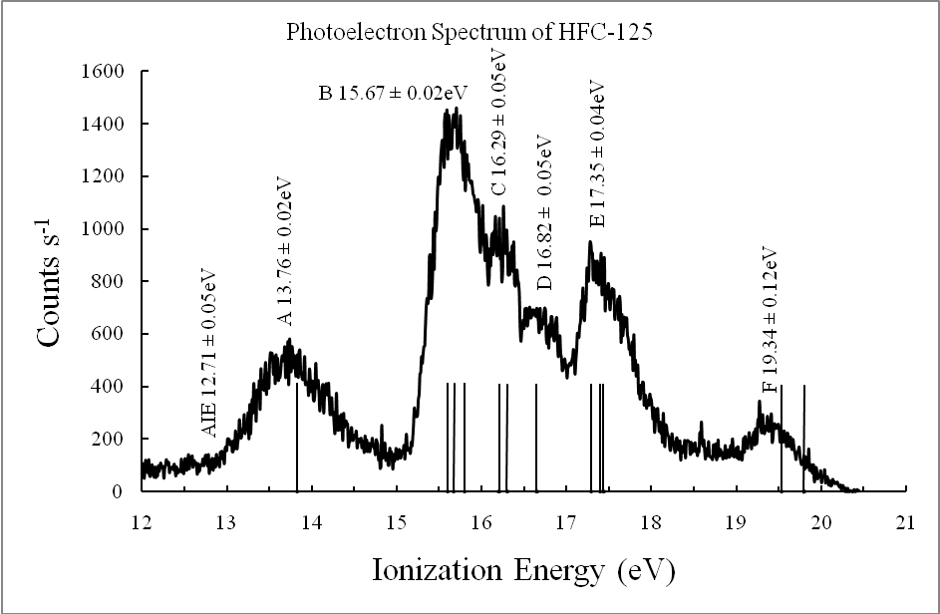

Figure 2

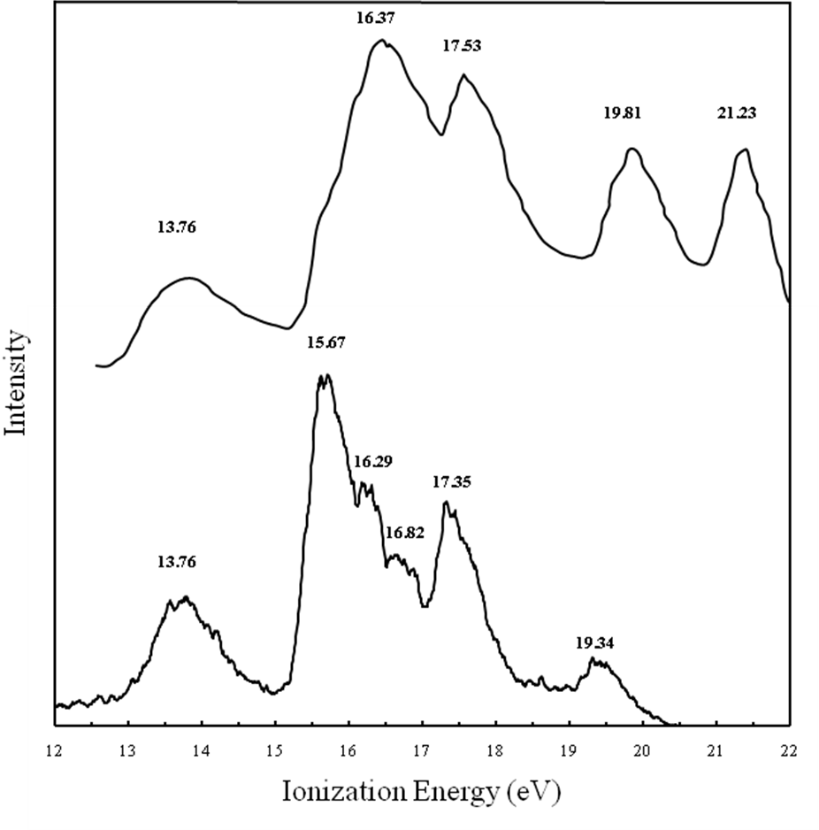

Figure 3

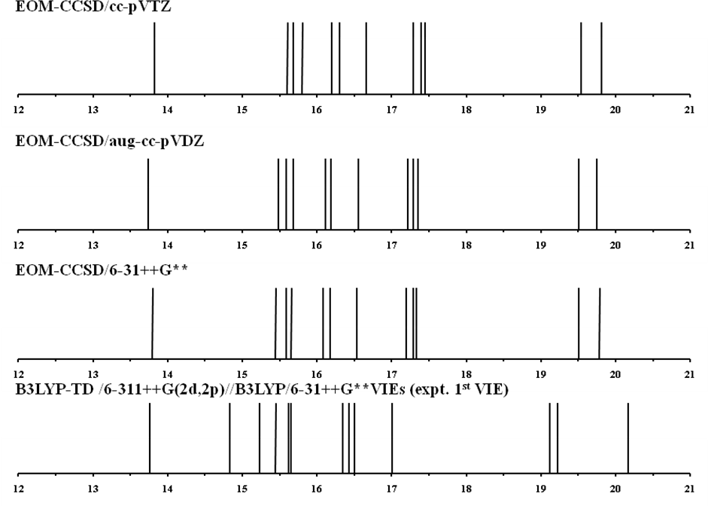

Figure 4

Figure 5

