Paper submitted to EUROSLA Yearbook 8 (2008):

SPLLOC: A new database for Spanish second language acquisition research

Rosamond Mitchell (University of Southampton)
Laura Domínguez (University of Southampton)
María Arche (University of Southampton)
Florence Myles (University of Newcastle)
Emma Marsden (University of York)

SPLLOC: A new database for Spanish second language acquisition research

Abstract

The contribution of Spanish to the field of SLA continues to grow (Lafford and Salaberry 2003, Montrul 2004), and the need for good L2 Spanish datasets is becoming increasingly evident. In this paper we introduce a newly created database titled Spanish Learner Language Oral Corpus (SPLLOC), describing the rationale underlying the database design and methodology used for its construction.
This project applying CHILDES tools to L2 Spanish follows successful creation of a collection of French L2 oral corpora (Rule et al 2003), already available at www.flloc.soton.ac.uk . Creating a successful oral corpus is costly and available corpora are often built somewhat opportunistically from available material rather than designed in a balanced way to facilitate SLA research. The SPLLOC database has been designed to fill the existing gap in Spanish L2 resources and also to support a focussed research agenda investigating learner development with respect to the verb phrase, clitic pronouns, and word order, from an interface perspective.
Introduction: Origins of corpus research in SLA
The use of electronic learner corpora is making an increasing contribution to both L1A and SLA studies, though L1A research has had a considerable head start, with the CHILDES project, for example, making large amounts of naturalistic L1A data available to the research community electronically since the 1980s (MacWhinney 2000).

In SLA, the 1980s

European Science Foundation project, titled Second Language Acquisition by Adult Migrants, collected and transcribed longitudinal oral data from 40 informants from diverse language backgrounds, as they learned a range of European languages as target L2s Perdue 1993a, 1993b). Early analyses to trace the morphosyntactic development of the so-called “Basic Variety” among these learners were conducted by hand (Feldweg 1993), and these hand done analyses formed the basis for the main project reports. However as suitable commercial software became available, a range of programs were also used for text searching, creation of frequency tables and concordances (Feldweg 1993: 117).
This was one of the first serious initiatives to use information technology to support SLA analysis on a large scale.

By the 1990s, developments in corpus linguistics such as the production of concordancing software for English such as Wordsmith Tools (Scott 1997) and Part of Speech (POS) taggers such as CLAWS (Garside and Smith 1997) were showing that a range of repetitive data analysis tasks could be automated (Hunston 2002, Conrad 2005). A

ttempts were also made at this time to create software which would address the special problems of comprehensively tagging and analyzing L2 data. The two best known projects were COALA (Pienemann 1992) and COMOLA (Jagtman and Bongaerts 1994). However they failed to attract significant numbers of users from the SLA community, and have now been discontinued.

The publication of the International Corpus of Learner English (ICLE: Granger Dagneaux and Meunier 2002) gave fresh impetus to corpus based L2 studies. This corpus contains c2.5 million words of advanced written L2 English, mainly argumentative academic writing produced by university students from 11 different L1 backgrounds. The ICLE team experimented with POS tagging (Granger 2002: 17-18; Barlow 2005: 339), though the published version of the corpus is not POS tagged. The team has however produced a semi-automated routine for tagging learner errors, which has been used in a number of error analysis studies using the corpus (e.g. Dagneaux Denness and Granger 1998). Other researchers who have carried out error tagging on learner corpora include Milton and Chowdhury (1994), Tono (2001) and Izumi et al (2004), the latter on transcriptions of oral rather than written data.

Thus ICLE and similar L2 corpora, both spoken and written, have started to popularise the idea of corpus based SLA research. (For recent reviews see Granger 2002, Barlow 2005, Myles 2005a, 2007). However the analysis tools available have been fairly limited, and much work using these corpora has relied on combinations of lexical searches, frequency counts, concordancing and hand tagging (see e.g. Hasselgren 2002, Aijmer 2002, Altenberg and Granger 2001, Nesselhauf 2003).

CHILDES-based corpora for SLA research

As can be seen from the foregoing brief account, there is a growing international awareness of the potential of learner corpora to address a range of issues in SLA, and interest/ willingness to use them. However, while there has been awareness of the great increase in usefulness of POS tagged or error tagged corpora, and a range of experiments with tagging programmes for SLA data, manual or semi-automated tagging has predominated where morphosyntactic analysis has been undertaken.

Rutherford and Thomas (2001) argued that instead of attempting to undertake independent software development, the best way forward for the SLA research community was to re-examine the procedures and tools of the L1A CHILDES project, and explore their potential for SLA corpus development and analysis. The CHILDES project already possessed a robust set of transcription conventions (CHAT), and a range of analysis software (CLAN). This software suite included POS taggers for a range of languages, which while not created to handle SLA data, could potentially be adapted to take account of interlanguage features such as neologisms, indeterminate forms, and loanwords. The CHILDES software is also freeware, so that the only condition of using it is willingness to make datasets created using CHAT and CLAN available freely to the research community via either the CHILDES or Talkbank websites. (Talkbank is a depository for corpora other than child L1A datasets, and already houses a number of L2 datasets including e.g. the ESF dataset.)

A number of researchers have started to use aspects of CHILDES in this way, including Malvern and Richards (2002), who conducted lexical analysis of a CHAT-transcribed corpus of spoken L2 French, and Housen (2002) who used a range of CLAN programs to support the analysis of verb morphology in a large cross-sectional corpus of spoken L2 English, testing the claims of the Aspect Hypothesis (Andersen and Shirai 1996). At the University of Southampton UK, a corpus of spoken beginner level L2 French had been created in the 1990s, and was initially analysed by hand to study e.g. the role of chunks in early SLA, and the emergence of verb morphosyntax (Myles et al. 1998, 1999). From 2001 onwards, this team has collected further spoken French L2 corpora from intermediate and advanced learners, all of which is now publicly available in CHAT format via the French Learner Language Oral Corpora website www.flloc.soton.ac.uk, and also via TalkBank. (These initiatives are described in Rule et al. 2003; Rule 2004; Myles and Mitchell 2005; Myles 2007). Other researchers have contributed further corpora to the FLLOC collection, which now comprises c2,000,000 words of spoken L2 French. Much of the collection has been POS tagged using a French version of the CLAN MOR program (Parisse and Le Normand 1997, 2000), and new lexical and morphosyntactic analyses of the datasets are appearing which address more theoretical issues relating to interfaces between syntax, morphology and lexis, and the acquisition of functional categories (e.g. Myles 2005b, Rule and Marsden 2006, David 2007). The use of CHAT and CLAN are allowing analyses to be undertaken on a larger scale, comparing learners at different stages of L2 development, comparing L1 and L2 speakers, and linking different types of morphosyntactic and lexical analysis. Some technical problems have been encountered, to do with levels of accuracy of automated POS tagging, and the compatibility of CLAN with alternative more powerful taggers remains to be explored. However, overall this experience has led the authors to the view that well planned oral corpora with learners undertaking a good variety of speaking tasks, can make a distinctive empirical contribution to the testing of specific claims about acquisition processes and thus to the advancement of language learning theory.

SPLLOC: A new Spanish L2 oral database

In following sections of this paper we describe the design and creation of a new database of spoken L2 Spanish, the Spanish Learner Language Oral Corpus (SPLLOC). This database is one major outcome of a two-year project (2006-2008) on the acquisition of L2 Spanish by L1 English learners, which is being undertaken as a collaboration between the universities of Southampton, Newcastle and York, UK, and funded by the UK Economic and Social Research Council (Award no. RES-00023-1609).

Spanish is widely learned as an L2, and there is an actively developing research literature on its acquisition; the language offers insights into a range of theoretically interesting issues in SLA (see recent reviews in Lafford and Salaberry 2003, Montrul 2004), especially given a number of parametric contrasts between Spanish and English, the L1 of the SPLLOC project participants. Spanish exhibits a specific cluster of properties, such as null subjects, subject-verb inversion, clitic pronouns, and rich inflectional morphology not found in English. This makes English and Spanish a valuable language pair for studying acquisition from a linguistic perspective. Publicly accessible electronic databases of child language already exist for L1 Spanish (see the CHILDES collection); an unpublished survey by Myles et al. (2004) showed that Spanish SLA researchers are aware of the potential of information technology and corpus based methodologies for studying learner Spanish. However, as yet there is no generally available resource of this type for L2 Spanish.

The new SPLLOC database will complement existing corpora of learner English and learner French, and provide a resource for L2 Spanish which will be freely available for use by the SLA research community. As well as corpus creation, the research team are undertaking a short programme of substantive research aiming to contribute to current theoretical debates about interfaces between syntax, morphology and pragmatics, and their role in second language acquisition. This work involves investigating the acquisition by English L1 learners of Spanish word order, the acquisition of Spanish clitic pronouns, development of the verb phrase, and lexical development. It will not be described in fuller detail here but other outputs are already available introducing aspects of this programme (Domínguez and Arche 2007a, 2007b, 2008,; Arche and Domínguez forthcoming; Marsden and David forthcoming).

Designing the SPLLOC database

The design of the new SPLLOC database has been guided in general terms by a) experience in building corpora/ corpus collections to support SLA research for other languages; b) a commitment to creating an open resource which would be maximally useful both to its creators, but also to a public of secondary users, for purposes not completely pre-determined; c) the need to deliver quality within the relatively limited resources of a two-year project. These general considerations led to adoption of a number of key design principles.

Principle 1: Focus on speech
It was decided the database would prioritise collection of semi-naturalistic L2 speech data, rather than written data, for the reason that spontaneous speech produced in face to face interaction is likely to provide more direct evidence about the state of the L2 learner’s underlying interlanguage system. In producing written data, L2 learners may reflect to a considerable extent on their performance and undertake self-correction, using metalinguistic knowledge including explicit ‘rule’ knowledge. In producing L2 speech under the pressure of real time face to face communication, this type of monitoring and self-correction is minimized.

Principle 2: Variety of genres
Rather than collecting L2 speech data of a single type (e.g. from oral proficiency interviews), it was decided that project participants would undertake a range of semi-naturalistic oral activities in different genres (narrative, interview and picture description, peer discussion). Learner speech is well known to contain considerable variability, e.g. in use of target language morphology, and learners are also prone to avoid in speech production areas of the target language system where they feel insecure or dysfluent. To some extent these are inescapable features of oral production data, but they create difficulties in estimating and interpreting what learners really know (Chaudron 2003: 767). In designing the SPLLOC database an attempt was made to minimize these problems both by eliciting a substantial speech sample from individual participants (40-60 minutes per learner), and by using open-ended tasks in a range of different speech genres (interview, narrative, discussion), and with varying interlocutors (research team members and fellow L2 learners). This semi-naturalistic part of the database can be defined as a learner corpus in a strict sense (Nesselhauf 2004, 2005); all of this component is being made available to the research community directly via the project web interface. The relatively small size of the database could be seen as a limitation, but the team expects to add significantly to it in successor projects, the first of which has already been funded.

Principle 3: Balance of open ended and focused tasks
In addition to the more open ended tasks described above, it was decided to have the same learners complete a small number of more focused tasks, relevant to the substantive research agenda of the project. Activities prompting learners’ production and/or interpretation are widely used in linguistically oriented SLA (see e.g. Gass and Mackey 2007: 71-107 for a recent overview). They address problems of learner avoidance of particular target structures of interest to researchers, and also allow researchers to infer “not only what learners know is correct in the second language, but also what learners know is not possible” (Gass and Mackey 2007: 73). Inclusion of focused elicitation tasks alongside more open ended tasks being undertaken by the same L2 participants also creates the possibility for triangulation across different data types, when investigating particular morphosyntactic areas. However the number of focused tasks which can be administered to participants has to be strictly limited on practical grounds. In the SPLLOC case, three focused tasks were designed, relevant to the team’s theoretical interests in the acquisition of Spanish clitic pronouns, and in word order issues relevant to the syntax/ pragmatics interface. Only one of these tasks involved oral production data, which is being included in the publicly accessible database.

Principle 4: variety of learner levels
In order to maximize the usefulness of the corpus to study development in L2 Spanish, learners at different proficiency levels were included, plus small numbers of age-matched native speakers of Spanish. Because of the short timescale of the project, it was necessary to adopt a cross sectional rather than a longitudinal design. All learner participants were L1 English speakers, undergoing formal instruction in L2 Spanish, and 20 learners were located at each of 3 levels, differentiated by age and number of years of instruction, rather than by any formal independent language test. While there is variability among the learners at each level defined in this way, in terms of their L2 Spanish proficiency, it is not sufficient to jeopardize the overall design. In addition, five age-matched native speakers of Spanish undertook the open-ended tasks at each level with larger numbers undertaking the focused tasks. Details of the learner participants are shown in Table 1.

Table 1: SPLLOC Project Participants (L2 learners)
L2 Spanish level | Typical age | Approx no hours of Spanish instruction | Educational level (English system) | Approx position on Common European Framework
Beginners N = 20 | 13-14 years | c 180 hours | Lower secondary school (Year 9) | A2
Intermediate N = 20 | 17-18 | c 750 hours | Sixth form college (Year 13) | B1-B2
Advanced N = 20 | 21-22 | C 895 hours + year abroad | University (Year 4) | C1

Principle 5: Use of CHILDES procedures
It was decided that the learners’ spoken L2 output would be captured as digital audio files, and these would be transcribed using CHAT conventions, to facilitate subsequent analyses using the CLAN suite of analysis programs. It was planned to POS tag the resulting transcripts using the relevant CLAN program, which would be adapted as necessary to take account of interlanguage features.

Principle 6: Accessibility
It was planned to make the complete oral dataset (digital audio files for open-ended tasks, CHAT transcripts, POS tagged files) available to the research community through a specially created database and web interface www.splloc.soton.ac.uk, and also eventually through Talkbank deposit.

Task development

During the early months of the project the set of tasks to be used with participants at different levels was developed, piloted and evaluated. A number of the tasks were adapted from previous SLA studies, while some were specially developed for the project. The tasks eventually selected for SPLLOC data collection are briefly described below. The oral production data from the first four tasks will be made available via the public website.

Narrative task: “A Monster Mistake”
This storytelling task was based on a sequence of pictures taken with permission from Hunt (2003), which tell the story of a family on holiday by the shores of Loch Ness, who create a fake monster and deceive the public. This picture sequence had previously been used to collect L2 French narratives (in several components of the FLLOC project: the Progression, Linguistic Development and Newcastle corpora), and was known to be suitable for learners at beginner and intermediate level.

Narrative task: “Modern Times”
Sequences from the Charlie Chaplin film “Modern Times” have been used successfully by SLA researchers to elicit narrative data from adult learners in a number of research projects including the ESF project (Perdue 1993a) and the FLLOC project (Newcastle corpus). A sequence from the film was trialled for use in SPLLOC data collection, because of concern that the “Monster Mistake” narrative might be subject to a ceiling effect (i.e. fail to show the full narrative abilities of advanced learners). However piloting showed that the “Modern Times” narrative did not work well with the relatively young beginners used in the study, and consequently it was used only with the advanced group of SPLLOC participants. These participants watched a short (5 minute) sequence from the film (the bread-stealing sequence), and then re-told it, with support from a set of still images and vocabulary list.

Picture description and interview task
All participants undertook a version of this task individually, with a member of the research team as their interlocutor. The interview was in three parts. In the first part, the intermediate and advanced learners were shown a set of stimulus photos (of young British people on holiday in Mexico) and asked to describe the various scenes and activities. In the second part they were asked to find out as much additional information as they could about the characters shown in the pictures, by asking questions. In the third part, the researcher asked the participant a range of questions about their current interests, their past activities, and their plans for the future. The interview for beginners was similar but the stimulus pictures showed British adolescents at home/on holiday in Europe.

Discussion task
This task was developed in two slightly different versions for use with intermediate and advanced learners, and took the form of a pair discussion between two learners. The task was included to elicit expressions of opinion and preferences, and also evidence of learners’ turntaking, initiation and repair skills when talking to an interlocutor of similar L2 level. The pairs were offered a choice of four discussion cards, setting out a series of claims/ arguments on different current topics. The discussion cards were modeled on a set developed by Dippold (2007), and were adapted with permission. Having chosen one topic, the pair were asked to discuss these arguments and rank them in order of importance. (An example is shown as Figure 1.)

INSERT FIGURE 1 ABOUT HERE

Clitic production task
This focussed elicitation task was designed to ‘push’ learners to produce orally a range of Spanish clitic pronouns, and consisted of 32 stimuli presented on a laptop computer. For each item, the learners saw a stimulus sequence of two pictures, and heard and read a question about the activities shown. The items were designed to elicit utterances linking the two activities in a sequence. In this way it was hoped to elicit a range of clitics varying in number and gender (both canonical and non canonical), and in different collocational contexts. This task is adapted with permission from one devised by Cadierno (1993); a sample item is included as Figure 2.

INSERT FIGURE 2 ABOUT HERE

Clitic interpretation task
This focussed task was designed to investigate learners' knowledge of clitic object pronouns. The idea for the task was adapted with permission from Franceschina (2003). It comprised 32 short multiple choice items administered on computer; a sample screen shot is included as Figure 3. Each item presented the participant with a stimulus Spanish sentence including a clitic object pronoun marked for gender and number

Each sentence was presented both orally and in writing. Four nouns of varying number/gender were offered as possible responses and the participant was asked to select the one which matched the stimulus.

INSERT FIGURE 3 ABOUT HERE

Word order task
The final focused task was a 28 item context-dependent preference test based on Hertel (2003) and Domínguez (2007) . The object of the task was to document participants' knowledge of word order variation at the syntax/ pragmatics interface. It was administered as a pencil and paper multiple choice task. Participants were offered a situation (described in English) plus a question in Spanish and three alternative responses. They had to select the response they judged felicitous in each of the situations. A sample item is included as Figure 4.

INSERT FIGURE 4 ABOUT HERE

Data collection

Suitable learner participants were identified for the project through schools, colleges and universities accessible to the research team. All participants were volunteers; because of the nature of the UK language learning population, it was necessary to visit several institutions to locate sufficient numbers of Spanish L2 learners, and it was not possible to create a gender balanced sample (most were female). The project followed the ethical procedures recommended by Talkbank and by the British Association for Applied Linguistics; informed consent was obtained from participants who signed an appropriate data release form. In the case of the beginner subjects aged 13-14, parental consent was also obtained. Data was collected in schools and colleges by trained members of the research team. The computer based tasks were administered on standalone laptops, and all speech was audiorecorded using portable digital equipment.

Suitable age matched native speaker participants were identified either in the UK (visiting Erasmus students) or in Spain through schools known to research team members, and tasks were run on school sites. The locations available for data collection in schools and colleges in the UK and in Spain varied in the degree of privacy/ soundproofing, but soundfiles of acceptable quality were obtained in all cases.

Data preparation

The soundfiles were transcribed and checked by members of the research team, following a specially produced guide on the use of the CHAT transcription system with Spanish L2 data (Arche 2007a). This process is appropriately described by Chaudron (2003: 767) as “highly labour intensive”, requiring up to 10 hours’ transcription and checking time for each hour of audio data. A sample transcription extract is included as Figure 5; summary information on the transcription procedures follows.

INSERT FIGURE 5 ABOUT HERE

In line with CHAT conventions, the SPLLOC transcriptions were created using conventional Spanish orthography to facilitate later analysis with the CLAN program suite. At times therefore the transcription is somewhat deviant from the actual phonological shape of the words produced by learners. The CHAT error tier (“%err”) has been used to indicate such cases

; future researchers interested more specifically in e.g. L2 Spanish phonology can access the soundfiles and add their own level of coding to the transcripts provided.

The standard CHAT header set was used when starting and concluding all transcriptions, and utterances were segmented at the level of main clauses, with coordinating conjunctions and adverbials ( such as y, pero, entonces, luego, o, puesto que, ya que, sin embargo, no obstante…) being used as guides to segmentation. Normal CHAT conventions were also followed regarding the representation of speech, e.g. on the use of punctuation, and markup of pauses, retracings, incomplete utterances, overlaps, direct speech etc. Specialist guidance and codes were produced for specific issues arising in the transcription of SLA data, including codeswitching into L1 English; imitations of investigator utterances; and use by learners of indeterminate forms and neologisms (see Arche 2007a 16-19 for details).

Once transcribed and checked, according to CHAT conventions, the soundfiles and transcriptions from Tasks 1-4 have been fully anonymised preparatory to public dissemination. A second stage of transcript preparation has then been undertaken, involving the part of speech tagging of the CHAT transcripts using the MOR and POST programs for Spanish available from CHILDES. The experience of the project to date has shown that these programs require some adaptation for use in SLA research with adults (e.g. additional vocabulary needs to be added to the existing word lists within MOR). More importantly, while the programs tag much of the data automatically, quite extensive final checks, disambiguations and corrections have to be conducted by hand. Again, a specialist guide has been produced (Arche 2007b), and is being followed by team members in this final stage of data preparation, which at the time of writing is not yet complete. A sample POS tagged transcript extract is included as Figure 6.

INSERT FIGURE 6 ABOUT HERE

Finally a database to house all soundfiles, CHAT transcriptions, POS tagged files, and XML versions of the CHAT transcriptions is being created at the University of Southampton . The database will be accessible through a web interface and website viewable at www.splloc.soton.ac.uk. All bona fide researchers willing to follow the CHILDES protocols regarding ethics and data-sharing will be able to access and download the material for teaching and research purposes.

Conclusion

This paper has briefly reviewed the origins and development of corpus based research in second language acquisition. We have noted the emergence of different types of learner corpus (spoken vs written) and of different approaches to computer aided data analysis. We have described the overall design of a new corpus of spoken L2 Spanish, which is being created using CHILDES tools, and which will be made freely available in spring 2008 for use by the SLA research community. The corpus has been designed so as to facilitate hypothesis-testing research, exploring a number of claims regarding the role of interfaces in second language acquisition; the team will be reporting separately elsewhere on the outcomes of this programme of substantive research using the corpus. Here we invite the research community to access the corpus and assess its usefulness for their own diverse research purposes, both hypothesis-building and hypothesis-testing. We look forward to receiving feedback from other users which will help us to improve and further develop this shared resource, so that it can make a lasting contribution to the ongoing development of Spanish SLA research.

References

Aijmer, K. 2002. “Modality in advanced Swedish learners’ written interlanguage”. In Computer Learner Corpora, Second Language Acquisition and Foreign Language Teaching. S. Granger, J. Hung and S. Petch-Tyson (eds). 55-76. Amsterdam: John Benjamins.
Altenberg, B. and Granger, S. 2001. “The grammatical and lexical patterning of MAKE in native and non-native student writing”. Applied Linguistics 22(2): 173-195.
Andersen, R. and Shirai, Y. 1996. “The primacy of aspect in first and second language acquisition: The pidgin-creole connection”. In Handbook of Second Language Acquisition. W. Ritchie and T. Bhatia (eds). 527-570. London: Academic Press.

Arche, M. J. and Domínguez, L. (forthcoming) Tracking morphology and syntax dissociation in SLA: evidence from L2 clitic acquisition in Spanish. In Morphology and Its Interfaces. A. Galani, G.Tsoulas and G. Hicks (eds). Amsterdam: John Benjamins

Arche, M. J. 2007a. SPLLOC Transcription Guidelines. Unpublished manuscript, University of Southampton. On-line access www.splloc.soton.ac.uk.doc/SPLLOCTranscriptionGuidelines.doc .
Arche, M. J. 2007b. MOR Guidelines for SPLLOC. Unpublished manuscript, University of Southampton.

Barlow, M. 2005. “Computer-based analysis of learner language”. In Analysing Learner Language. R. Ellis and G. Barkhuizen (eds). 335-354. Oxford : Oxford University Press.

Cadierno, T. 1993. Explicit Instruction in Grammar : A Comparison of Input Based and Output Based Instruction in Second Language Acquisition. PhD Thesis, University of Illinois.
Chaudron, C. 2003. “Data collection in SLA research”. In Handbook of Second Language Acquisition. C. J. Doughty and M. H Long (eds). 762-828. Oxford: Blackwell
CHILDES, Child Language Data Exchange System. Pittsburgh: Carnegie Mellon University. On-line access http://childes.psy.cmu.edu, consulted December 2007.
CLAWS Part of Speech Tagger for English. Lancaster: University of Lancaster. On-line access http://ucrel.lancs.ac.uk/claws/, consulted December 2007.

Dagneaux, E. Denness, S. and Granger, S. 1998. “Computer-aided error analysis”. System 26 (2):163-174.
David, A. 2007. “Vocabulary and morphosyntactic complexity in L2 learners”. Paper presented at EuroSLA 17, Newcastle upon Tyne, September 2007.
Dippold, D. 2007. Faces, Roles and Identities in Argumentative Discourse : The Development of Facework Strategies by L2 Learners of German. PhD Thesis, University of Southampton.
Domínguez, L. 2007. “The L2 acquisition of Spanish focus: a case of incomplete and divergent grammars”. In The Acquisition of Romance Languages. Selected Papers from The Romance Turn II. S. Baauw, J. van Kampen and M. Pinto (eds). 45-57. Utrecht: LOT (LOT Occasional Series 8).

Domínguez, L and Arche, M. J. 2008. “Optionality in L2 grammars: the acquisition of SV/VS contrast in Spanish”. In BUCLD 32: Proceedings of the 32nd annual Boston University Conference on Language Development. Somerville: Cascadilla Press.
Domínguez, L., Arche, M.J. 2007a. “Deviant optional forms in L2 Spanish: the case of word order variation”. Poster presentation at GALA, Barcelona, 6-8 September.
Domínguez, L., and Arche, M. J. 2007b. “The L2 Acquisition of SV/VS contrast in Spanish”. Paper presentation at the Hispanic Linguistic Symposium, Texas, 1-4 November.

Feldweg, H. 1993. “Transcription, storage and retrieval of data”. In Adult Language Acquisition: Crosslinguistic perspectives. Volume I: Field methods. C. Perdue (ed.). 108-130. Cambridge: Cambridge University Press.
FLLOC, French Learner Languae Oral Corpora. Southampton: University of Southampton. On-line access at www.flloc.soton.ac.uk, consulted December 2007.
Franceschina, F. 2003. The Nature of Grammatical Representations in Mature L2 Grammars: The Case of Spanish Grammatical Gender. PhD Thesis, University of Essex.

Gass, S.M. and Mackey, A. 2007. Data Elicitation for Second and Foreign Language Research. Mahwah, NJ: Lawrence Erlbaum.
Garside, R., and Smith, N. 1997. “A hybrid grammatical tagger: CLAWS4”. In Corpus Annotation: Linguistic Information from Computer Text Corpora. R. Garside, G. Leech and A. McEnery (eds.). 102-121. London: Longman, London..
Granger, S. 2002. “A bird’s eye view of learner corpus research”. In Computer Learner Corpora, Second Language Acquisition and Foreign Language Teaching. S. Granger, J. Hung and S. Petch-Tyson (eds). 3-36. Amsterdam: John Benjamins
Granger, S., Dagneaux, E. and Meunier, F. (eds). 2002. International Corpus of Learner English. Version 1.1. Université catholique de Louvain: Centre for English Corpus Linguistics, 2002.

Granger, S., Hung, J. and Petch-Tyson, S. (eds). 2002. Computer Learner Corpora, Second Language Acquisition and Foreign Language Teaching. Amsterdam: John Benjamins.
Hasselgren, A. 2002. “Learner corpora and language testing: smallwords as markers of learner fluency”. In Computer Learner Corpora, Second Language Acquisition and Foreign Language Teaching. S. Granger, J. Hung and S. Petch-Tyson (eds). 143-174. Amsterdam: John Benjamins.

Hertel, T. 2003. “Lexical and discourse factors in the second language acquisition of Spanish word order”. Second Language Research 19, 4, 273-304.

Housen, A. 2002. “A corpus-based study of the L2-acquisition of the English verb system”. In Computer Learner Corpora, Second Language Acquisition and Foreign Language Teaching. S. Granger, J. Hung and S. Petch-Tyson (eds). 77-118. Amsterdam: John Benjamins.

Hunston, S. 2002. Corpora in Applied Linguistics. Cambridge: Cambridge University Press.
Izumi, E., Uchimoto, K. and Isahara, H. 2004. “SST speech corpus of Japanese learners’ English and automatic detection of learners’ errors”. ICAME Journal 28: 31-48.

Jagtman, M. and Bongaerts, T. 1994. “Report-COMOLA: a computer system for the analysis of interlanguage data”. Second Language Research 10: 49-83.

Klein, W. and Perdue, C. (eds) 1992. Utterance Structure: Developing Grammars Again. Amsterdam: John Benjamins.

Lafford, B.A., and Salaberry, R. (eds). 2003. Spanish Second Language Acquisition: State of the Science. Washington, DC: Georgetown University Press.

MacWhinney, B. 2000. The CHILDES Project: Tools for analyzing talk. Third Edition. Volume 1: Transcription Format and Programs.. Mahwah NJ: Lawrence Erlbaum Associates.
Malvern, D. and Richards, B. 2002. “Investigating accommodation in language proficiency interviews using a new measure of lexical diversity”. Language Testing 19(1): 85-104.
Marsden, E. and David, A. forthcoming. “Comparison of lexical development in L2 French and L2 Spanish”. To appear in Language Learning Journal.
Milton, J. and Chowdhury, N. 1994. “Tagging the interlanguage of Chinese learners of English”. In Entering Text. L. Flowerdew and K.K. Tong (eds). 127-143. Hong Kong: Hong Kong University of Science and Technology.

Montrul, S. 2004. The Acquisition of Spanish: Morphosyntactic Development in Monolingual and Bilingual L1 Acquisition and in Adult L2 Acquisition. Amsterdam: John Benjamins.
Myles, F. 2005. “Interlanguage corpora and second language acquisition research”. Second Language Research 21 (4): 373-391.
Myles, F. 2005. “The emergence of morphosyntactic structure in French L2”. In Focus on French as a Foreign Language: Multidisciplinary approaches. J.-M. Dewaele (ed). Xx-xx. Clevedon, Avon: Multilingual Matters.
Myles, F. 2007. “Using electronic corpora in SLA research”. In French Applied Linguistics, D. Ayoun (ed). 377-400.
Myles, F., Hooper, J. and Mitchell, R. 1998. “Rote or rule? Exploring the role of formulaic language in classroom foreign language learning”. LanguageLearning 48: 323–363.

Myles, F. and Mitchell, R. 2005. “Using information technology to support empirical SLA research”. Journal of Applied Linguistics 1: 69–95.

Myles, F., Mitchell, R. and Hooper, J. 1999. “Interrogative chunks in French L2: a basis for creative construction?” Studies in Second Language Acquisition 21: 49–80.

Nesselhauf, N. 2003. “The use of collocations by advanced learners of English and some implications for teaching”. Applied Linguistics 24(2): 223-242.
Nesselhauf, N. 2004. “Learner corpora and their potential for language teaching”. In How to Use Corpora in Language Teaching. J. Sinclair (ed). Amsterdam : John Benjamins.
Nesselhauf, N. 2005. Collocations in a Learner Corpus. Amsterdam : John Benjamins.
Parisse, C. and Le Normand, M. T. 1997. « Etude des catégories lexicales chez le jeune enfant
à partir de deux ans à l'aide d'un traitement automatique de la morphosyntaxe ». Bulletin
d'Audiophonologie 13(6): 305-328.

Parisse, C. and Le Normand, M. T. 2000. “How children build their morphosyntax: The case of French”. Journal of Child Language 27(2): 267-292.
Perdue, C. (ed.) 1993a. Adult Language Acquisition: Cross-Linguistic Perspectives. Volume 1: Field Methods. Cambridge: Cambridge University Press.
Perdue, C. (ed.) 1993b. Adult Language Acquisition: Cross-Linguistic Perspectives. Volume 2: The Results. Cambridge: Cambridge University Press.
Pienemann, M. 1992. “COALA – a computational system for interlanguage analysis”. Second Language Research 8: 59-92.
Rule, S. 2004. “French interlanguage corpora: recent developments”. Journal of French Language Studies 14: 343–356.
Rule, S., Marsden, E., Myles, F. and Mitchell, R. 2003. “Constructing a database of French interlanguage oral corpora”. In Proceedings of the Corpus Linguistics 2003 Conference, UCREL Technical Papers16, D. Archer, P. Rayson, E. Wilson and T. McEnery (eds), 669-677. University of Lancaster.

Rule, S. and Marsden, E. 2006. “The acquisition of functional categories in early French second language grammars: the use of finite and non-finite verbs in negative contexts”. Second Language Research 22(2): 188-218.

Rutherford, W. and Thomas, M. 2001. “The Child Language Data Exchange System in research on second language acquisition”. Second Language Research 17 (2): .

Scott, M. 1997. Wordsmith Tools. Oxford: Oxford University Press. For on-line access see http://www.lexically.net/wordsmith/, consulted December 2007.
Talkbank. Pittsburgh: Carnegie Mellon University On-line access http://talkbank.org/ , consulted December 2007.
Tono, Y. 2001. “The Standard Speaking Test (SST) Corpus: A 1 million word spoken corpus of Japanese learners of English and its implications for L2 lexicography”. In Proceedings of ASIALEX 2001: 257–262.

Figure 1: Discussion Task, Sample Item
Sample task card (advanced learners):
¿Cómo podríamos mantener y mejorar los derechos de los animales?
_____ prohibiendo todos los experimentos científicos con animales
_____ prohibiendo la venta de abrigos de piel
_____ no permitiendo la caza de animale
_____ cerrando todas las granjas de animales
______________________________________________________
Puntúa estas actividades otorgando la mayor puntuación a la opción que creas ser la mejor (1), y la menor puntuación a la que creas ser la peor (5) Por favor incluye también una sugerencia propia.
Después comparte tu puntuación con tu compañero. El objetivo es que os pongáis de acuerdo y creéis una lista común. Es importante que te asegures de que tu opinión sea escuchada y siempre explica el por qué de tu elección.
Sample task card (intermediate learners):

Figure 2: Clitic Production Task, Sample Item
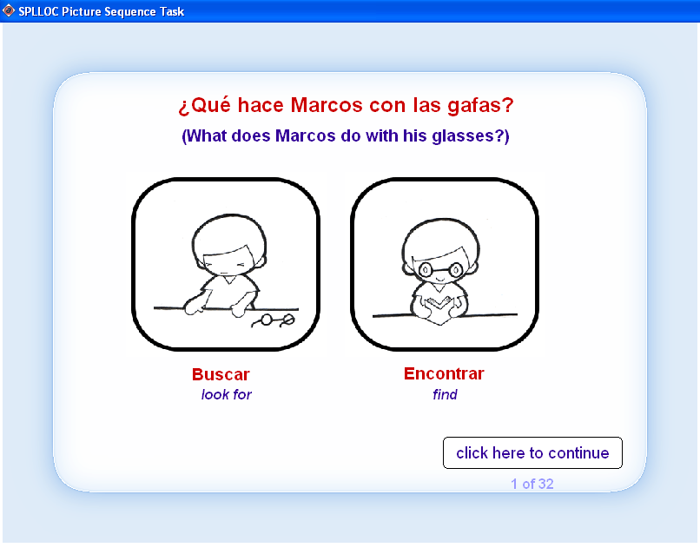

Figure 3: Clitic Interpretation task, Sample Items
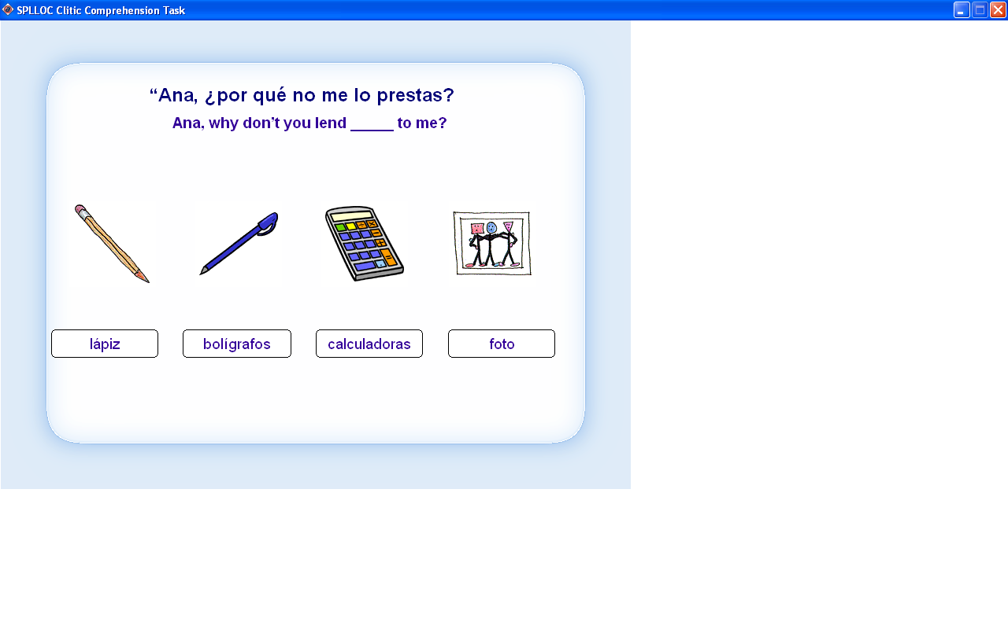

Figure 4: Word Order Task, Sample Item

You are in the cinema watching a film with some friends. One of your friends, you don't know who, sneezes very loudly so you ask Andrés: "¿Quién ha estornudado?" (Who has sneezed?)
What could Andrés say?
a. Ha estornudado Juan | b. Juan ha estornudado | c. Both sentences

Figure 5: Sample CHAT Transcription

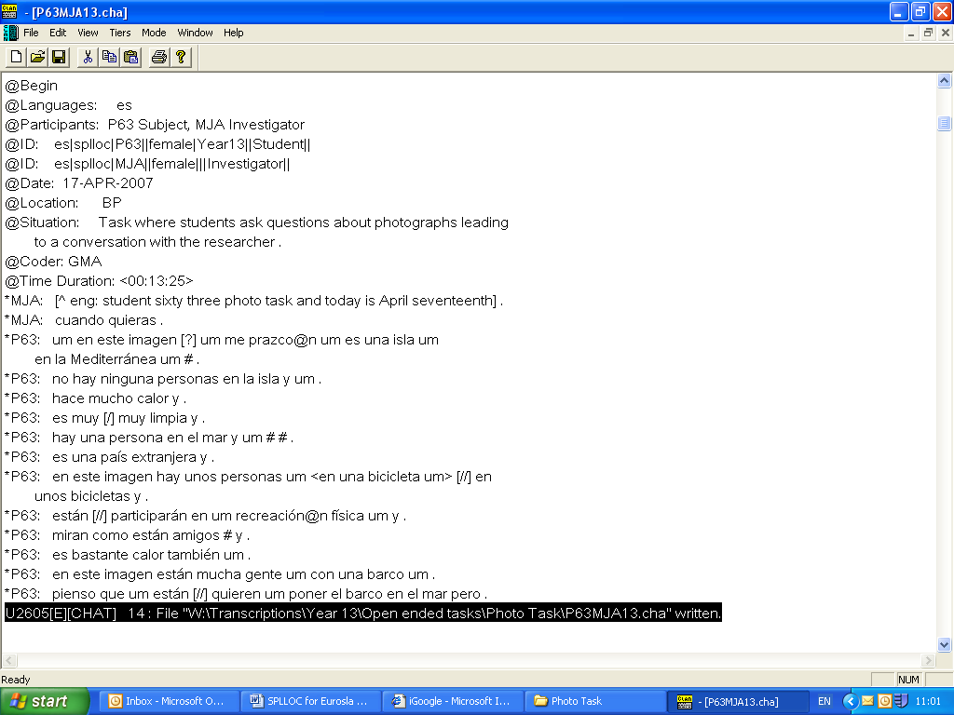
Figure 6: Sample POS Tagged File

