Lift: Drawing Between

Introduction
This paper describes Lift as a method for interpreting and working with ideas constructed through collaboration, and the complex systems of communication that are inherent in it. Lift is a tool for negotiation, for viewing and discussing links and diversity. This questioning of perception through similarity and difference is fundamental to identifying form in drawing, and it is in this capacity that Lift forms a useful framework for collaborative exchange.

fig1. Performative drawing -a methodology for the investigation and construction of place. 2007. Bould, Oldridge

We examine Lift as an open system of exchange and transfer, setting out to identify how it works between us to create a common reference point that can be used in a creative way to frame differences, and to harness divergent ideas and views. We will demonstrate how Lift can function as a method of seeing and drawing through exchange, and how it has the potential for application in trans- disciplinary practice.
Facilitating connection through difference, Lift works as a space for investigation across different ways of knowing and between different cultures or disciplines. We identify the conditions of lift as a place of transition between individuals and between different layers of experience and development. In this way we examine Lift as a method for steering and developing ideas between different people.
The value of this kind of trans-disciplinary research comes through 'studying the changes in perception that occur with the move from one description to the other, or from one disciplinary perspective to the other. It is not simply that we leave one way of shaping experience and move to another; it is the tension between the two that is decisive' (Cazeaux, 2008). The epistemological process involved here is one of movement and shift, involving particular 'decisive’ moments of change or enlightenment, and not arrival at a definitive, agreed conclusion.
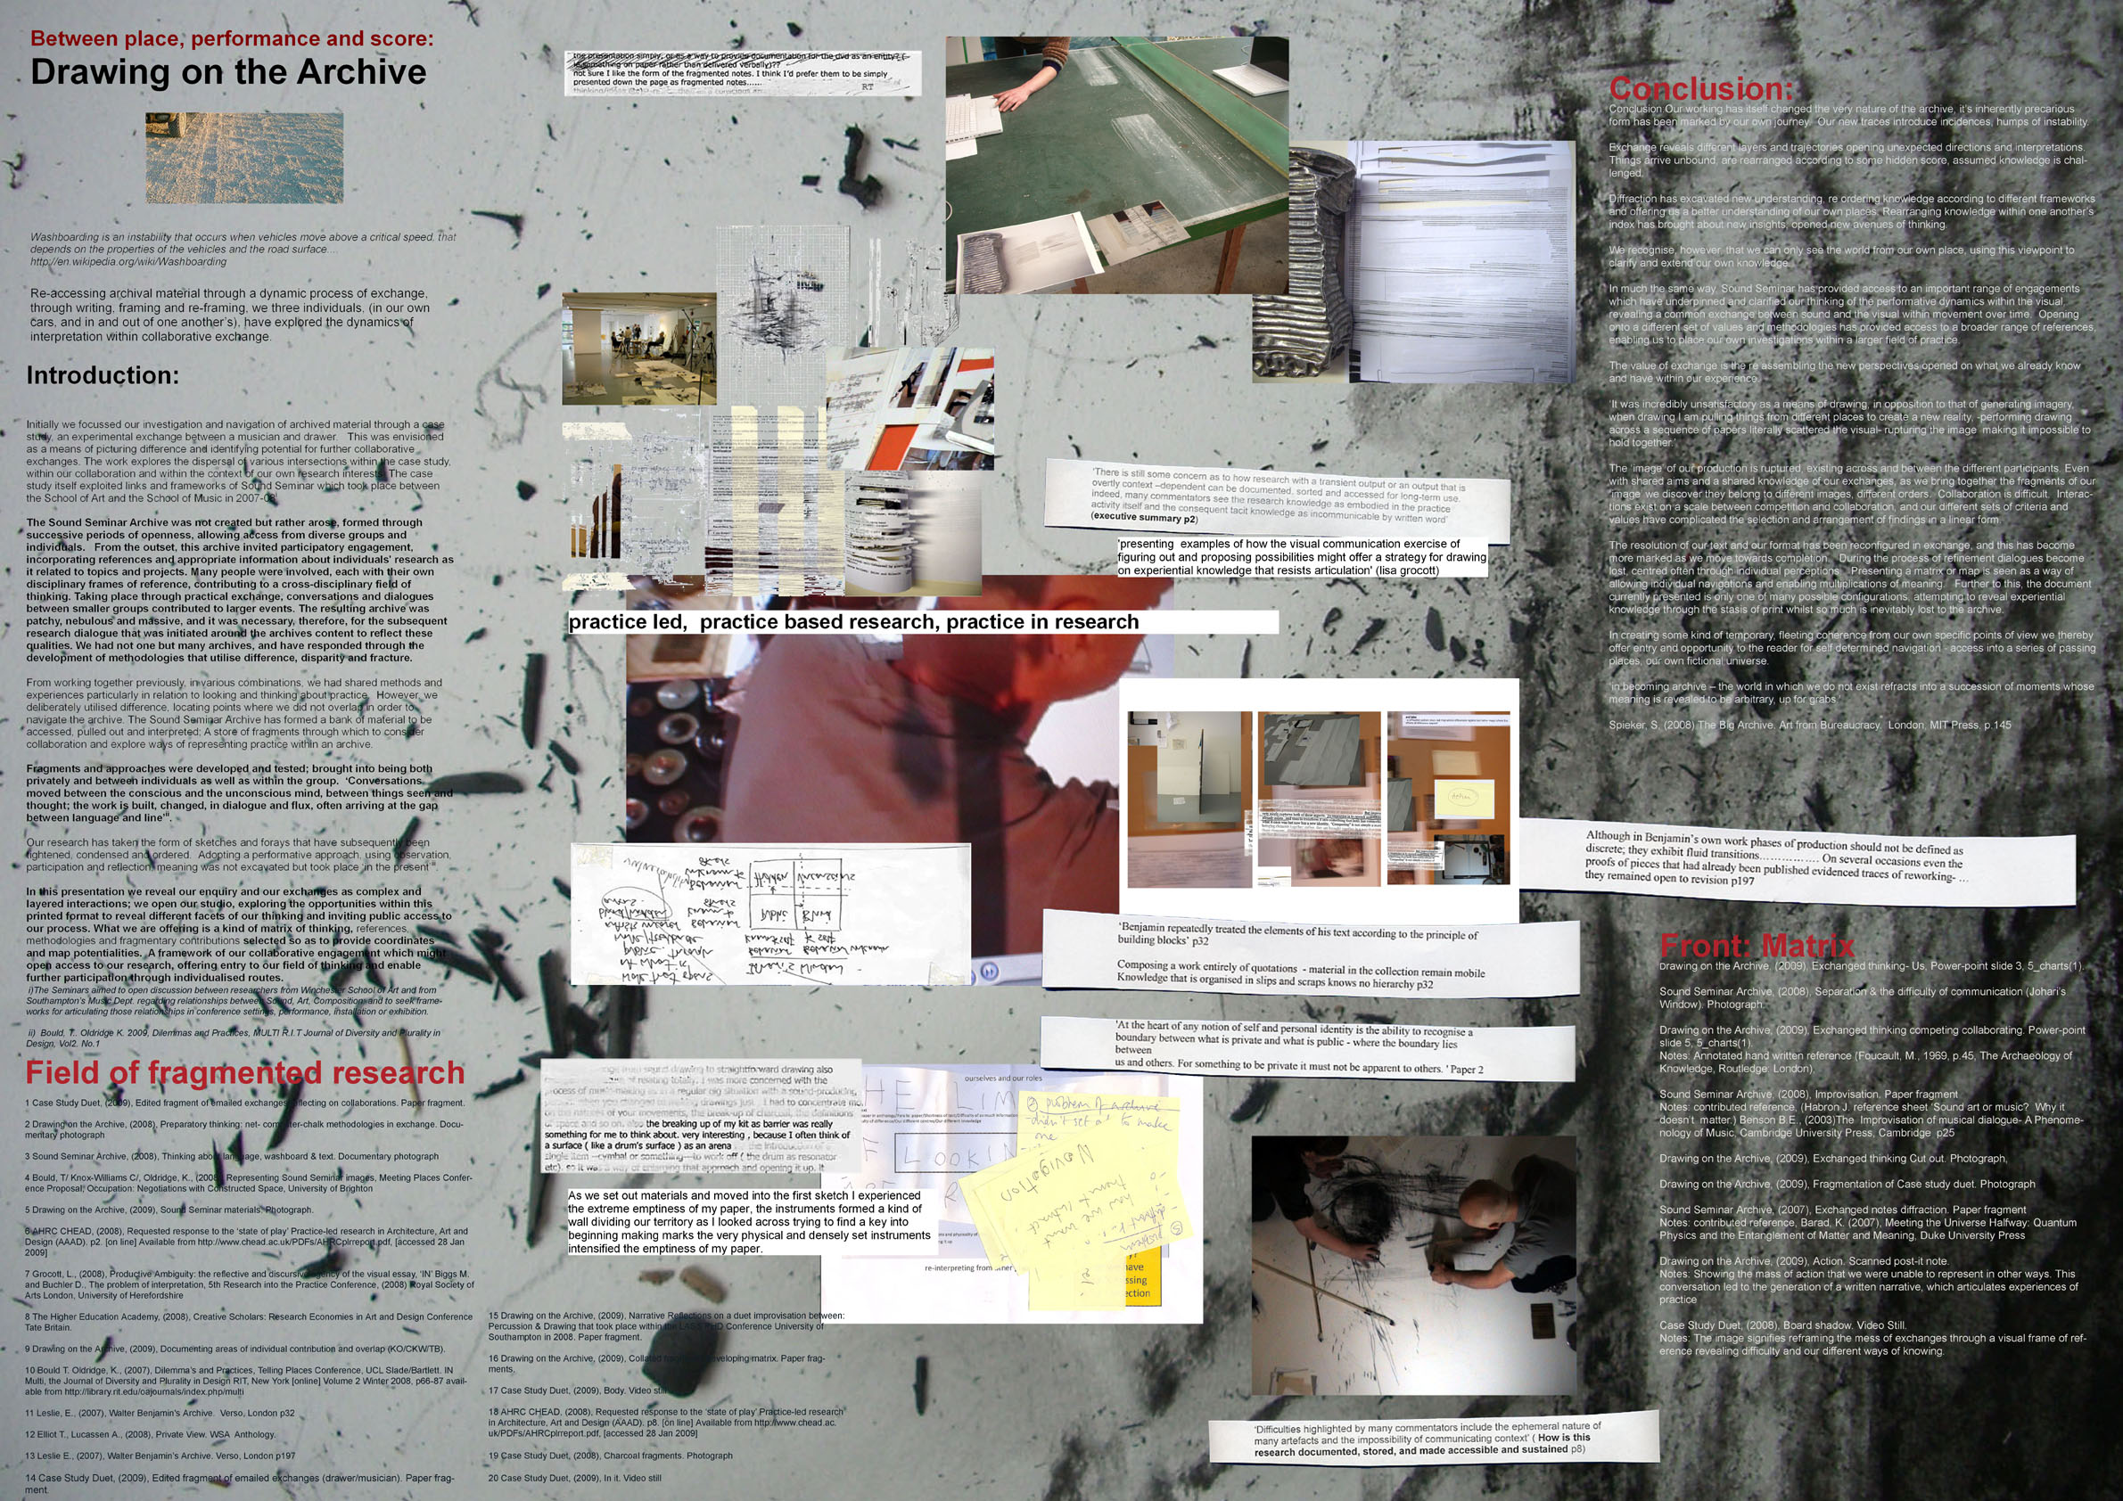
Fig. 2. Drawing generated to offer different access points to process, ‘Drawing on the Archive’ Anthology, 2009. (b) Bould, Knox-Williams, Oldridge

Background
The model of Lift has arrived through the development of a series of written papers and practical outcomes that reflect on different aspects of collaboration and drawing processes. The material used for these papers is originally rooted in Sound Seminar, (a collaboration between the School of Art and the School of Music, University of Southampton 2007-08). Previous related papers include Between Place Performance Score: Meeting Places ((a)Bould et al., 2009) and Drawing on the Archive ((b)Bould et al., 2009).

Through this sequence of work, we have come to know each other well. Initially, exploration through our particular differences was new and untested, and through time we have developed methods that in themselves rely on dissimilarity as a means of moving forward. We recognise that within lift, knowledge is found in a variety of ways; we both come to know ourselves afresh and to recognise the opportunity of the others' disparity.
At times, working in pairs can be more productive but can easily become static or lacking in objective thinking. Working in three overcomes the trap of comfort in agreement, ensuring a constant flux of order and disorder whilst also broadening perceptions and enabling greater shifts in thinking. We have found triangulation most useful as a tool for tackling particular problems where subtlety of perception and difference is valuable.

Operating in this way from disparate and separate perspectives, we have utilised triangulation in the development of lift. We have found that multiple viewpoints allow us to reflect on ideas and working methods, and to reflect upon the ways in which 'the different views either corroborate or refute our original proposition or hunch, thus making our research more rigorous and robust’ (Gray and Mallins, 2004).
This current paper builds on the work established previously to propose Lift as a methodology for exchange.
Through the following sections, Lift is described through specific indices, linkages or connection points. Under the headings Travelling through metaphor, Exploring process and Lift as framework, we trace the development of Lift through our collaborative research practice, deliberately teasing out differences of perception and separating individual frames of reference. Devised collaboratively, these sections describe the applicability of Lift within our work, and also outline its potential for wider use.
Travelling Through Metaphor

The lift started as a real experience, an event taking place both inside and outside of a lift. Part of a workshop investigating the relationships between place, performance and score through practical experiment, this shared event formed the basis of ideas developed through the written paper Meeting Places ((a)Bould et al., 2009), in which a series of different spaces were examined through collaborative engagement. Within the Meeting Places document, Lift retained its connection to actual architectural space and the specifics of this event, however, it was stretched in a particular way to form a metaphor that encapsulated certain difficulties in collaboration.
'– I have an image in my mind of someone twisting their head towards the light as the lift door opens, lifting themselves to standing after leaning on the wall, their hair in movement and head half bent eyes lifting, conscious of another presence, but not quite looking out and grazed by strands of hair.'

Fig 3. Excerpt ‘Meeting Places’, 2009. (a) Bould, Knox-Williams, Oldridge

Certain characteristics from the original event were transferred over, substituted into the context of the reflective discussion about our working methods that took place through the writing of the paper. Conditions of fracture, frustration, fleeting encounters and difficulty of entry were identified with aspects of our collaborative practice. Parallells were drawn between them and the concept of Lift became the link, in language, that formed the basis of the metaphor. Metaphor is a vital component in epistemology and language, the reassement of the categories through which we understand experience and the 'cognitive principle whereby a category is borrowed from one domain in order to be ascribed to another to which it does not literally or conventionally apply' (Cazeaux, 2005).

The experience of Lift and of a particular collaboration became fitted into, or extended to form a conceptual framework or matrix. This outline included the specific conditions of Lift as well as a method for working. Language enables the construction of conceptual frameworks that are distanced or even entirely removed from the particulars of context or experience.

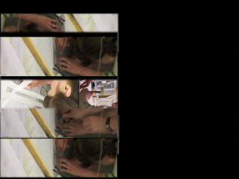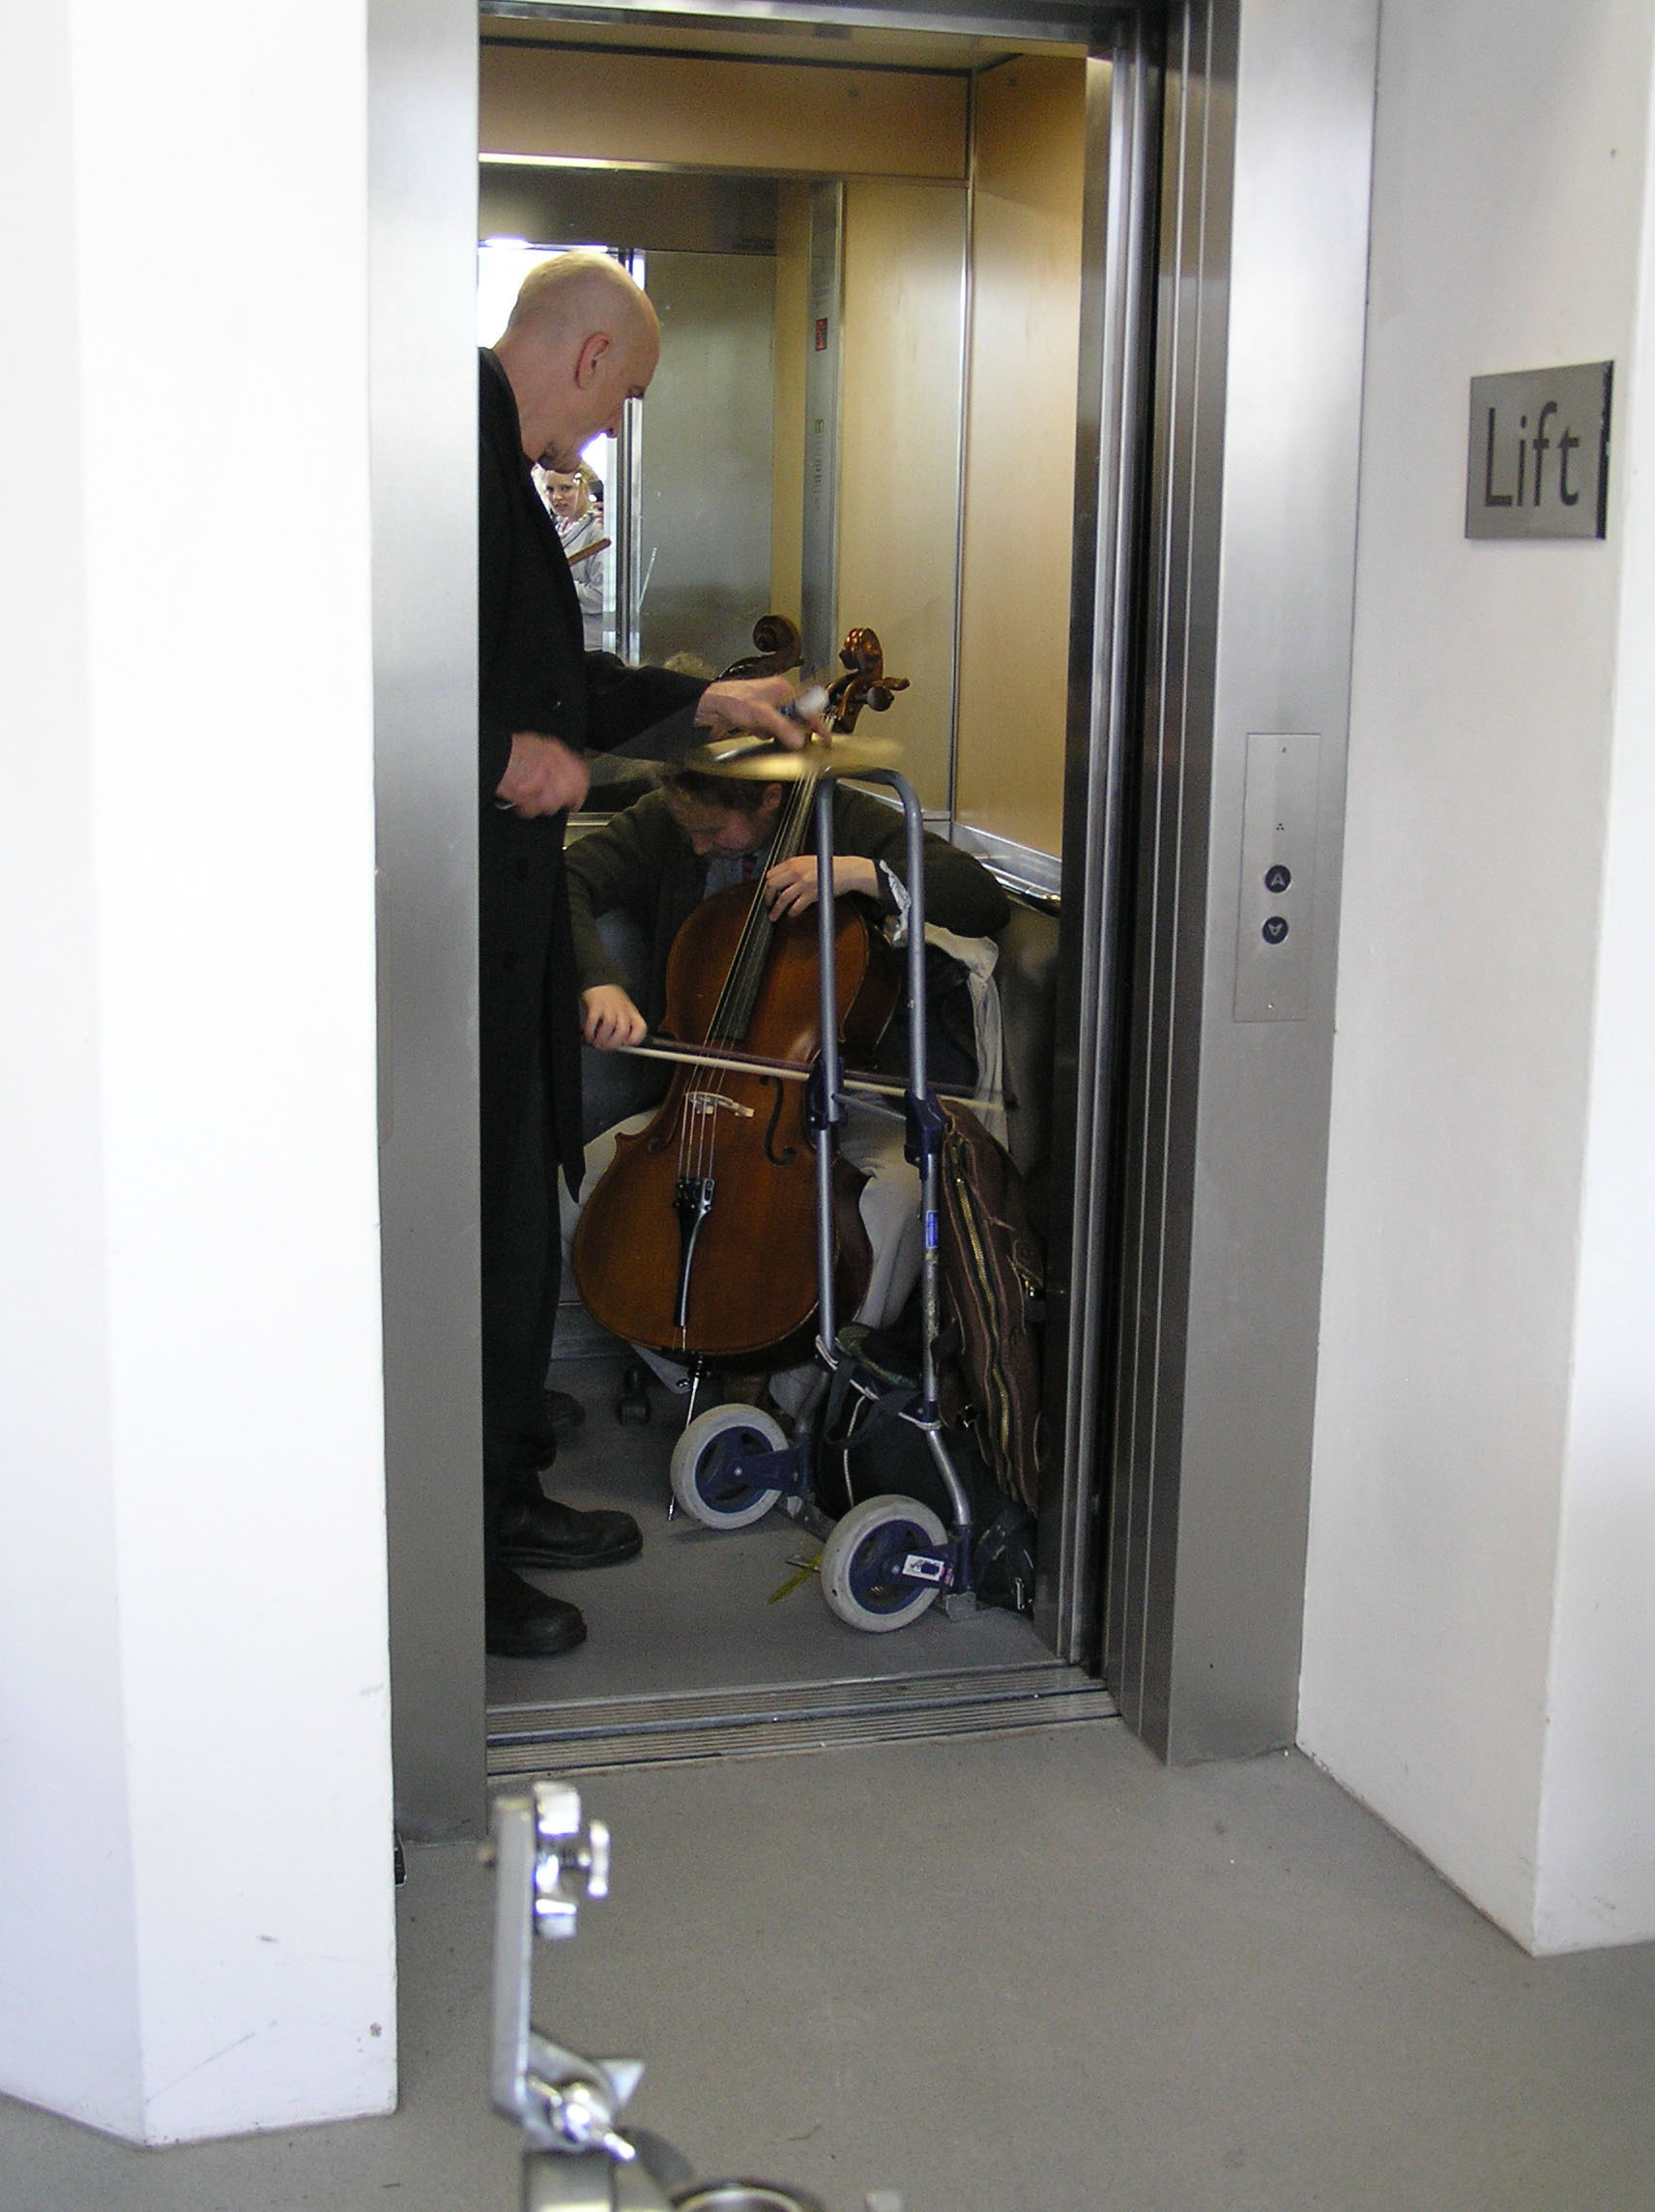

fig 4 Juxtaposition of Lift, 2010, Bould, Knox-Williams, Oldridge: Intimate space/ collaborative studio drawing, 2009. Roger in lift Place Performance Score, Sound Seminar Winchester School of Art, University of Southampton 2008.

Lift is particularly successful in making this transition from metaphor to method because of the common experience that it draws on. i.e. travelling in a lift. For this reason, it also remains useful even when the original event or experience is no longer connected with it. Lift connects the generalities of the conceptual framework to particular experiences through metaphor.

Further to this, the procedures and conditions that have been established for Lift and that form its framework are capable of even greater flexibility and extension. The versatility through which the general concept of Lift can be connected up to other particular yet shared experiences, allows for the generation of further metaphors. Although remaining spatial, these metaphors engage with the effects of time and gravity within lift. For example, it is easy to make the transfer from an ordinary Lift to a glass elevator of the kind found in Roald Dahl's famous story, (Charlie and the Chocolate Factory), or to consider the Lift transformed into Dr Who's Tardis.

Through encounters with experience and with the unexpected, frameworks are altered. Metaphor is one way of dealing with the imposition and of constructing a new framework. In this way, the framework is stretched yet again, through metaphor, indeed, another level of metaphor is established, and the connection sites for these transferrals are not fixed but multiple, and multi-pliable.

fig 5. Pulling out metaphor as framework, 2010, Knox-Williams

The implications of this further development are that the framework of Lift remains re-applicable, useful and understandable even when completely removed from the original context, and without background knowledge of the process of its development.

The ways that Lift has developed through the construction of conceptual frameworks, rendered extendable and malleable through metaphor, have been made possible precisely because of the ways in which we have utilised differences between ourselves. It is through this quality of transferability and connectability that Lift becomes useful in trans-disciplinary practice based research. 'Adopting a new perspective means that the contents of your experience will change and change in ways that may be surprising . It is what comes to light in the move from one perspective to the other that is the source of new interdisciplinary knowledge' (Cazeaux, 2008)

Exploring process
In Lift we are using drawing process as a research tool and as a 'generative space of thought', (Newman, 2003). Moving between making, doing, writing, representing and conversing, drawing collaboratively allows ideas and interpersonal experiences to be revealed, re-framed and rendered tangible within a process of constant flux. In this way, our drawing processes seek to question perception through the frame of the other; they are a means of thinking through edge.
fig 6. Reflections on edge. ‘Meeting Place’, 2009, (a) Bould, Knox-Williams, Oldridge. p.5
Within Lift, time is inherently fractured, moving in several directions at once. Lift enables temporal movement; It is a transformative processes of re-viewing, backtracking and reflection. Lift enables recognition through reframing and reorganising previous work or thinking; This process leads to a reordering and representation that sometimes belongs outside of our own understanding. Different perspectives come into view at different times in the process of exchange, sometimes arriving without warning or remaining hidden for long periods of time.

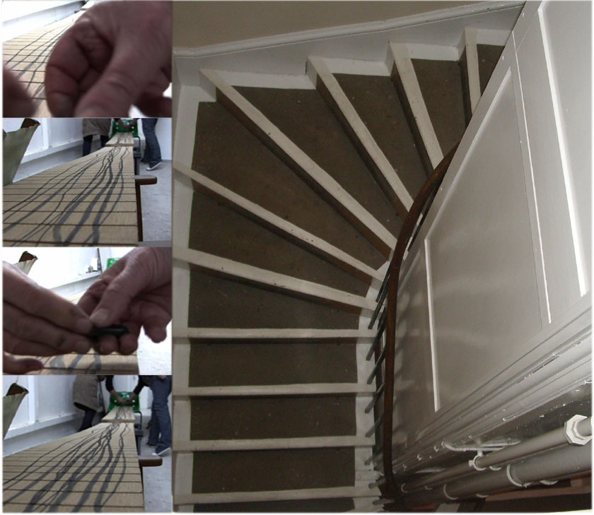

fig 7 Staircase, 2010 Bould, Knox-Williams, Oldridge

Through this system of operation we can work together and separately. In our own collaboration we recognise that at different times we are working in different ways operating separately, between two and also between three. These differences have a different function within lift and we have come to use them proactively and also to understand the dangers.

When working individually and within two there are far fewer interruptions and less unpredictability, where as between three there can be a more proactive and rigorous uncovering that is less prone to fall into the comfort of knowing/expectation. Understanding how lift works as a system of looking is fundamental. At different moments we are simultaneously looking in, looking out and looking through another’s frame, and these vantage points enable us to see and embrace the complexity of difference and to objectify our own experiences.

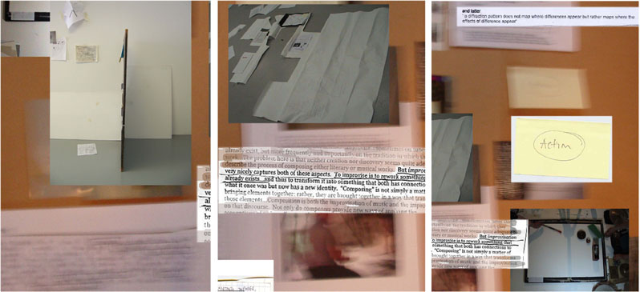

Fig. 8 Framing our different perceptions and ways of thinking related to the same event where a drawer and a musician worked together on an improvised exchange. ‘Drawing on the Archive’, Anthology 2009 (b) Bould, Knox-Williams, Oldridge

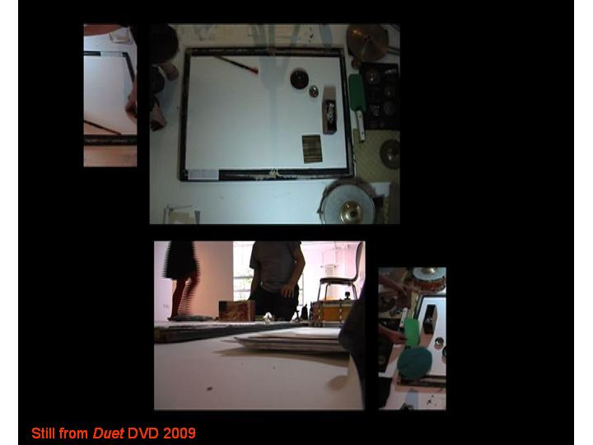

Fig.9 Framing edge. A moment when fundamental differences of the visual / auditory were revealed through exchange. Meeting Places. (a) Bould, Knox-Williams, Oldridge, 2009

In drawing it is through the familiarity of process, medium or subject that assumptions are often made, a mark or gesture can easily become shorthand for a particular expression or viewpoint- being used to stand in for, rather than enquire of it. These occurrences in drawing may become limiting, leading to formulaic approaches that operate within known territory. Lift enables us to move in and out of the process of production at speed, and demands engagement through unknown and unexpected parameters.

Lift has definite boundaries, but they are continually shifting or being moved. Lift has no fixed location, and yet it remains as a constant, even whilst its function generates continual process of flux. Seeing our exchange, through lift, as always 'in process’, allows a way of working through the conditions of change inherent in collaboration and in drawing.
As Jane Rendell suggests, ‘real engagement in interdisciplinary work is not simply procedural but demanding emotionally as well as intellectually and politically, demanding because this way of working requires us to be critical of what we do and open to change’ (Rendell, 2006)

Anticipated interruption is a fundamental component of Lift use. The experience of transition can feel partial and incomplete. Understanding Lift as a way of working prepares collaborators for the point where unfinished ideas are opened or are intersected unexpectedly. Continually departing and arriving, Lift accesses the difficulty of moving forward in collaborative practice even when shared goals are articulated in advance. Moving between strategic planning and opportunism, Lift incorporates the negotiation of objectives in shared processes of continual shift and selection. Lift requires an understanding of the value of operating within a system of partial and incomplete knowledge.
Lift as framework - applied metaphor and learning tool
This section of the paper investigates the application of ‘lift’ within the business or marketing domain. Whilst we are aware that using it in this context may raise some discrepancies in definition when compared to philosophical or academic practice we believe it is a useful exercise because it highlights its potential transferability and application in trans-disciplinary working.
Within this context a framework is defined as a conceptual tool for learning that can be used to activate problem solving of complex issues. Often presented diagrammatically, in a stripped down simplified form, it offers the user a means of gaining objectivity. Through application to specific problems or situations, facilitative use of framework enables recognition, understanding and diagnosis from a different perspective, the outside. It gives the opportunity to re-examine beliefs and assumptions, bringing improved awareness and self discovery, helping people work together in more constructive and productive ways. Thus it acts as a system that can be overlaid onto the world of experience.
‘facilitative mind sets, behaviours and tools are some of the essential ingredients of high commitment/high performance organisations. They are critical to making real what we’ve come to think of as the learning organisation’ (Doyle, 1996).
Considering the application of ‘Lift’ as a framework for understanding collaborative exchange we would assert that its usefulness is dependent on being able to access previous experiences of lift. This might take the form of both actual lifts and other methods which suggest the effect of arriving and departing (e.g. through film, image). The fact that this framework connects with reality and has been developed and identified previously in different ways helps it make sense and work when applied. However, it is unlikely that many end users outside Fine Art practice would need, or want, to understand or reference its root in drawing. This does not restrict usefulness as long as the criterion of previous experience is met.
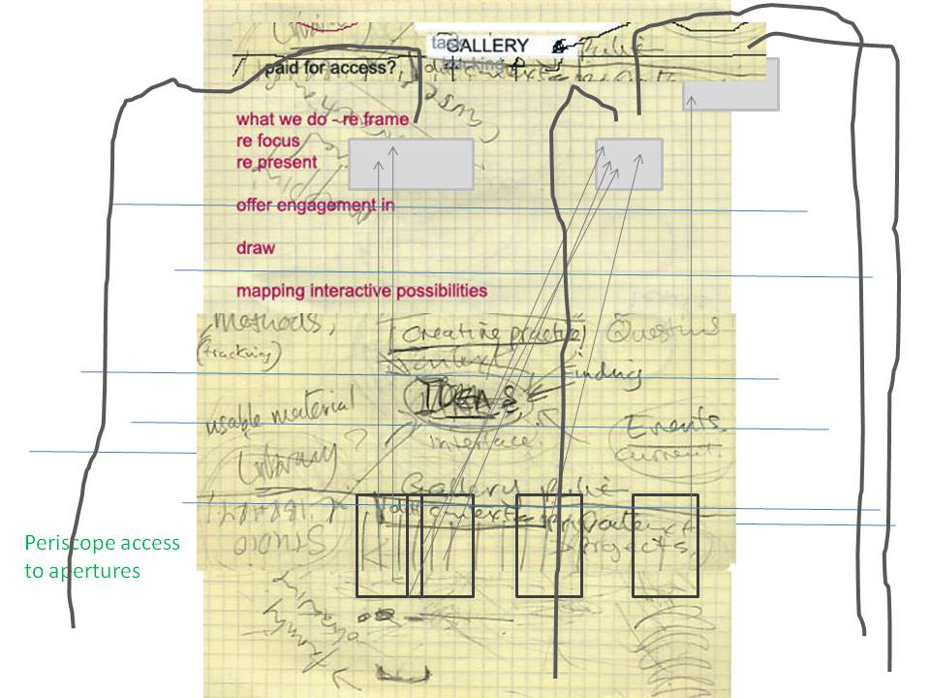
Fig. 10. Drawing generated in discussion about the design of our own website applying ideas of Lift, 2009. Bould, Knox-Williams, Oldridge
‘Lift’ as framework is one step removed from direct experience, allowing us to step out of experience. Individuals have the ability to identify the different states they move through and access ‘snapshots’/slices of experience, (which act like diagrams). Common language in relation to ‘lift’ enables shared reflection. It becomes clear that there are multiple applications off a shared framework of experience.
‘Matta-Clark’s cuts increasingly revealed a design or structural principle, an intuition about spatial relationships that complicated the perception of walls and floors in normative experience. But when he showed the ‘evidence’ of his cuts inside, he strategically would either reveal his logic clearly, or obscure it, ‘opening up views’ as he wrote, ‘to the invisible’ (Sussman, 2007).

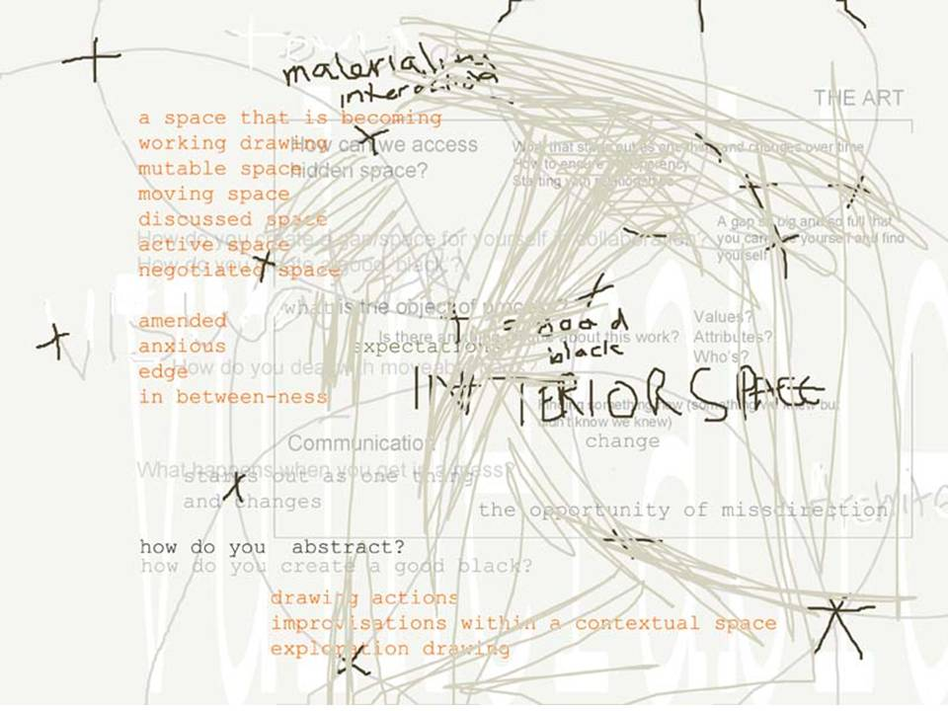

Fig. 11. Drawing ‘making a good black’, 2007. Bould, Oldridge.

In transferring through the metaphor, and using the same application of process, ‘Lift’ has potential to help people identify ‘form’ in collaboration by accessing their shared spatial experiences. These spatial references would enable recognition, understanding and diagnosis of ‘form’ in relation to social constructs, the impact of environment/circumstances and the nature and quality of exchange of the interactions within different states.

‘Increasingly, by the mid-1970’s, architecture was becoming for Matta-Clark a system onto which he could project both literally (he could draw, cut, remove, and so on) and psychologically: it was a metaphor and a social construction’(Sussman, ‘2007).

Fig 12. G. Matta Clarke Circus or The Caribbean Orange 1978 on line at http://www.artnet.com/artwork/425555953/533/circus-or-the-caribbean-orange.html (accessed 05/01/10)
In addition it would enable them to reframe their own thinking through the experience, knowledge and value systems of others. Use and familiarity of the framework would enable development of shared vision and /or shared understanding of different visions, potentially offering different perspectives on the outcome and use of knowledge.

‘Rearranging knowledge within one another’s indexes has brought about new insights, opened new avenues of thinking, offering us a better appreciation of our own place.’ ((a) Bould et al. 2009)

Thus as framework ‘Lift’ helps individuals and groups understand the mechanics of exchange in collaboration. It prepares us for and helps us understand the likelihood of both frustration and benefit in collaboration as we progress towards something that is bigger – both in terms of our own learning and the outcome of the work.

Conclusion
We have begun to establish Lift as a way of objectifying practice made collaboratively, between individuals and across discipline boundaries. Lift functions precisely as a between; this is its primary characteristic. It joins and splits simultaneously, a movement between objective and subjective viewpoints, contexts, individuals, spaces and events; ‘And even if there are only two terms, there is an AND between the two…tracing the line of flight which passes between the two sets’ (Deleuze, 1993). Thus Lift is characterised by the opening and closing of boundaries, working where one thing stops and another begins.
This paper offers a number of approaches for understanding collaborative exchange. Although in their various manifestations these approaches utilise different forms of perception they were all developed through an investigation of drawing as a means of communication. As recognised and described, the characteristics and conditions of our specific collaborative practice and the way we use drawing can be replicated amongst other groups.
fig 13 . Five x Five, 2007, © Robert Irwin © Photo Philipp Scholz Rittermann
Primaries and secondaries available on line, http://www.xymara.com/inmyx/index/inmyx408/ae-200804-index/ae-200804-robertirwin.htm (accessed 12.01.10)

Meeting points or shared spaces through which to explore the nature of difference are vital in collaboration, where something is developed through an exchange with disparate layers of experience. These points function through familiarity or common experience, and can be difficult to manufacture or arrive at. Lift forms one such meeting place whilst simultaneously offering a way of understanding why this difficulty exists.
Within our practice transfer takes place through difference; variation and not agreement is vital. These interruptions and disagreements although valuable require shared frames of reference to resolve conflict; 'Lift is a way of talking about how you can say one word, or have one term, have three different understandings of it and yet find a way of linking those up so that it’s meaningful and useable.'
Lift provides a structure through which the inherent conditions of disparity and alteration are acknowledged and become knowable, a tool which can be used both to investigate and frame difference but also to overcome the difficulties embed in working together.

However we also recognise the system is much more complex than we may be able to describe. In lift, as in collaboration, there are lifts in lifts and many lifts opening onto each other, each working at different speeds, preventing us from knowing what is open and what is hidden in lift.
Through these methods we have established contrasting as well as shared perspectives and have been able to draw out, separate and represent a methodology for working, proposing transferable knowledge for productive outcomes in future collaborative practice.
Certainly the juxtaposition of narratives we have adopted in this document emphasises the overlaps, contradictions and edges inherent in collaboration causing us to question what has been lost in the gaps. In our experience it is this collision of values systems and experience that change collaboration from a predictable way of working together into a truly transformational practice, and a means for generating new knowledge (Cazeaux, 2008).
We would argue that in collaboration as in drawing, rather than forgetting
what we know, we have changed the malleability of what we know and that through the familiarity and development of ‘lift’ we have become vigilant and expectant of change, always looking beyond.

References
Bould P., Oldridge K. 2007 ‘Dilemmas and Practices’, Multi, the Journal of Diversity and Plurality in Design RIT, New York [online] Volume 2 Winter 2008, p66-87 available from http://library.rit.edu/oajournals/index.php/multi.
(a)Bould P., Knox-Williams C., Oldridge K. 2009 'Meeting Places: Between Place, Performance and Score' Conference paper and presentation for Negotiations with Constructed Space, The University of Brighton
(b)Bould P., Knox-Williams C., Oldridge K. 2009 'Drawing on the Archive' in Winchster School of Art Research Anthology , Harland E.J., Gillett, J.R. Eds. Winchester Gallery Press
Bould P., Knox-Williams C., Oldridge K. 2010 Juxtaposition of Lift, Intimate space/ collaborative studio drawing, 2009. Roger in lift Place Performance Score, Sound Seminar Winchester School of Art, University of Southampton 2008.

Cazeaux, C 2008 'Inherently Interdisciplinary' in Journal of Visual Arts Practice Volume 7 Number 2 Intellect:London
Cazeaux, C 2005 'Interrupting the Artist' in Thinking Through Art: Reflection on Art as Research Macleod K., Holdridge L.
Dahl, R. 2007 Charlie and the Chocolate Factory Penguin: London
Doyle M. 1996 ‘Foreword’ in Facilitator’s Guide to Participatory Decision-Making Kaner S Ed. Gabriola Island: New Society Publishers
Deleuze G. 1993 The Fold: Leibniz and the Baroque Athlone Press: London
Gray C., Mallins J. 2004 Visualising Research: A Guide to the Research Process in Art and Design Ashgate:UK
Irwin R. 2008, ‘Seeing Is Forgetting the Name of the Thing One Sees’, California Press
Knox-Williams, C. 2010 Pulling out metaphor as framework

Matta Clark, G. Circus, 1978, in Gordon Matta Clark: You are the Measure, Sussman E Ed. Yale University Press: New Haven p.32
Newman A. 200 The Stage of Drawing Gesture and Act edited by Catherine De Zegher , The Drawing Centre New York , Tate Publishing
Rendell J. 2006 ‘A place between’ in Art and Architecture: A Place Between Tauris:New York
Sussman E. 2007 ‘The Mind is Vast and Ever Present’ in Gordon Matta Clark: You are the Measure, Sussman E Ed. Yale University Press: New Haven

