Modelling LGD for unsecured personal loans:
Decision tree approach
Lyn C. Thomas
Christophe Mues
Anna Matuszyk
University of Southampton
Abstract
The Basel New Accord which was implemented in 2007 has made a significant difference to the use of modelling within financial organisations. In particular it has highlighted the importance of Loss Given Default (LGD) modelling.
We propose a decision tree approach to modelling LGD for unsecured consumer loans where the uncertainty in some of the nodes is modelled using a mixture model where the parameters are obtained using regression. A case study based on default data from the in house collections department of a UK financial organisation is used to show how such regression can be undertaken.
Key words: Basel II, consumer credit, LGD

1. Introduction
The New Basel Accord allows a bank to calculate credit risk capital requirements using an internal ratings based (IRB) approach in which internal estimates of components of the credit risk are used to calculate the credit risk capital. Institutions using IRB need to develop methods to estimate the following components for each segment of their loan portfolio:
– PD (probability of default in the next 12 months);
– LGD (loss given default);
– EAD (expected exposure at default).

Modelling PD, the probability of default has been the objective of credit scoring systems for fifty years but modelling LGD has not been addressed in consumer credit until the advent of these Basel regulations. The LGD modelling previously attempted was mainly in the corporate lending market where LGD (or its opposite Recovery Rate RR, where RR=1-LGD), was needed as a part of the bond pricing formulae. Even there, for over twenty years, LGD was often set at around 40% because of some historical analysis on a subset of bonds done in the 1960s. It was only in the last decade that its dependence on economic conditions, type of loan and type of borrower were recognised as important (Altman et al: 2001).
Such modelling cannot be extended to consumer credit LGD since there is no continuous pricing of the debt as is the case of the bond market. The purpose of this paper is to model LGD in unsecured consumer credit by modelling the collections process. The idea of using the collection process to model LGD was suggested for mortgages by Lucas (2006). There, the collection process was split into whether the property was repossessed or not, with the assumption that a loss occurred only if there was repossession. A scorecard was built to estimate the probability of repossession and then a model used to estimate the “haircut” - the percentage of the estimated sale value of the house that is actually realised at sale time.
In the remaining section of the paper, we introduce a model for estimating LGD for unsecured consumer credit which is then tested using personal loans data. The model includes both the decisions made by the lender and the risk of the borrower not being willing or able to meet the debt obligations. This is important since the Basel Accord is interested in estimating LGD in an economic downturn and in such circumstances both the lenders’ collection decisions and the borrowers’ ability to repay may change. In section two we describe the overall model, while in section three we model the recovery rate for a given collection decision, by using data from an in-house collection process on personal loans debt. Section four draws some conclusions.

2. Decision tree LGD model
Default occurs when an obligor fails to meet a financial obligation (Frye 2004) and can be due to fraud, financial naivety, loss of job, marital breakdown or disputes with the lender ( McNab, Wynn 2000). For a defaulted loan, loss given default (LGD) is the proportion of exposure at default that is not recovered during the collections and recoveries process. The Basel Accord requires lenders to be able to make estimates of LGD both for loans that have already defaulted and for ones which are not in default, In the latter case, one cannot therefore using any characteristics concerning performance in collections to date.

2.1. Collection models on macro level
LGD is an outcome of a mix of uncertainty about the borrower’s ability and willingness to repay and decisions made by the lender on the collections strategy to be used. The options include whether to collect in house, give to an agent who keeps an agreed percentage of the amount recovered or sell off the debt to a third party at a fixed price. Generally, companies collect the debt mainly in house and have their own collection departments. However some companies do use outside agents and from time to time almost all lenders sell off some of their debt to third parties. Lenders will almost never pursue in house collection on debt that has already been given to an agent with unsatisfactory results. Moreover once they sell the debt they lose control over how the debtor is subsequently pursued. Accordingly, the collection process was divided into 3 phases:
- Collection process in house;
- Collection process using agent;
- Selling off the debt.
Note that these three macro-level strategies identified above put different bounds on the possible LGD values, e.g.
Collection in house if no penalties imposed ⇒ 0≤LGD ≤ 1
Collection by an agent on 40% commission ⇒ 0.4≤ LGD ≤ 1
Selling off at 5% of the face value ⇒ LGD = 0.95
One way of modelling a problem where the outcome is a mix of decisions and randomness is by a decision tree and the decision tree representing the collections process is shown in Figure 1.

The proposed tree starts with the division of the group into two sub-groups, according to whether the details of the debtor’s address and telephone number are known and accurate: trace and no trace.
If there is no trace, there is a little point in collection in house (one may wish to undertake some effort to trace the customer initially but the no trace outcome would be the result after this initial effort). The lender must decide whether to sell off the debt or use an external collection agency. If the agency is not able to recover the debt, the lender has again two choices: sell off the debt or sell to a second collection agency. The second agency will demand a higher commission for recovering debt (since it is older and more difficult to recover). Of course the debt could be then passed onto a third agent but we will assume the lender’s policy only allows at most two agents to seek to collect the debt.
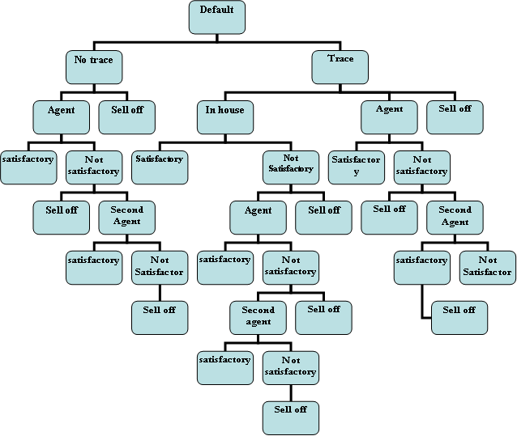

Figure 1: Decision tree of collection process

If there is a trace (i.e. the address and contact details are correct), the lender has the added option of collecting in house. Normally this decision is based on subjectively chosen rules but one could also develop models to estimate what is the likely recovery rate if collected in house, and separately what would be the recovery rate if collected by an agent. The rules used (and the model if built) can depend on several factors:
- How old is the debt,
- Amount of the debt,
- Type of the product,
- Geographic region of debtor
If the collections department is not able to recover a satisfactory amount of the debt within a given time, the lender can sell off the debt or send it to a collection agency and hence follow a similar branch to the no trace case.
2.2. Collections Model: Operational Level
A collection department has a range of tools to use in the recovery process: from the gentle to the strong. Usually it starts with contacting the debtor by telephone or letter and trying to arrange for immediate repayment of the debt or some repayment arrangements to be agreed. There are different types of letters and sending them depends on the status of the customers and the characteristics of the debt. So within the in house collection node of Figure 1 is another decision tree which seeks to identify what sequence of actions to undertake and what outcomes make one decide to change the course of action.

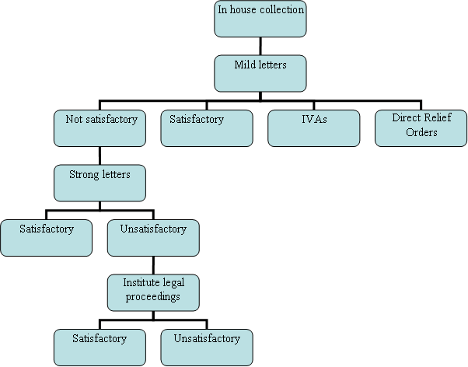

Figure 2: In house collection process: operating decisions

For example, one might have a simple decision tree on which letters to use and when to institute legal proceedings such as in Figure 2. As well as deciding which sequence of action to undertake, the operational strategy has also to decide what repayment agreement is acceptable to them. Initially the collections policy will seek to recover all the debt, but it may be that when the debt has proved difficult to recover partial repayment may be acceptable. With the advent of IVAs (Individual Voluntary Arrangements) and, from 2008, Debt Relief Orders lenders will have to make early decisions on whether such an agreement is acceptable to them.

3. Repayment model
In this section we describe a repayment model for a very simple collections process where the lender collected all debt in house and eventually wrote off (without selling off) all the unrecovered debt. Although a simple system the estimation of LGD in this case is exactly what is needed at each of the random nodes, where one is determining if the recoveries are satisfactory or not satisfactory in a complex collection process decision tree such as Figure 1. Note that by calculating the LGD (or the Recovery Rate) one makes it clear that determining whether such a recovered amount is satisfactory or not is in fact another decision by the lender.
The case study uses individual level data from almost 50K cases of defaulted personal loans granted by a UK financial organisation between 1989 and 2004.

Figure 3: Distribution of LGD in the whole sample.
Distribution of LGD for in – house collections
Figure 3 displays the LGD distribution of the 50,000 cases examines. It shows that 30% of the debtors paid in full and so had a LGD=0. Less than 10% paid off nothing. For some debtors the LGD was greater than 1 since fees and legal costs had been added. The data from agency collection processes is quite different where in some of the data sets we have examined almost 90% of the population have LGD=1. So the more attempts that have been made to collect from the debtor in the past, the higher the likely LGD will be.

3.1. Repayment model: identifying class of repayer
It is clear that a distribution like that in Figure 3 is best modelled by assuming a heterogeneous population of debtors. The simplest split would be to assume two groups – those who are able to repay the full amount and those who either will not or cannot pay the full amount owed. This would correspond to splits on the data according to whether LGD =0 or LGD >0. The choice of how many different subpopulations to have in the mixture is partly done by statistical analysis of the data using mixture models and the EM algorithm and partly by finding out what was the lender’s collections policy. In another case for example the lender had a policy of not pursuing more punitive action once 60% of the debt was recovered which would suggest splitting the population at LGD=0.4

In this case one could envisage at least three populations namely LGD=0. 0<LGD<0.4 and LGD ≥ 0.4 but the lender’s collection policy was to treat all debtors the same not matter how much had been recovered. On grounds of simplicity we therefore used only two groups of debtors.

So to model LGD, we use the characteristics of the debtor and the loan in a two stage process. The first stage was to use logistic regression to separate out the two groups LGD=0 and LGD>0. The second stage was to build regression type models for each group so as to estimate the LGD for each individual loan. In this case, it is clear that for the LGD =0 group, we predict LGD =0 for all loans in that group; for the LGD>0 group we tried a number of different approaches but as will be seen linear regression proved as successful as any.

In the scorecard developed using logistic regression to separate the two groups LGD=0 from LGD>0 the following characteristics turned out to be important
Amount of the loan at opening;
Number of months with arrears within the whole life of the loan;
Number of months with arrears in the last 12 months;
Time at current address;
Joint applicant.
Results for the LGD=0 model
- The higher the amount owned the lower the chance of LGD=0;
- The longer the client lives at the same address the higher the chance that LGD=0;
- LGD more likely to be 0 if there is a joint applicant;
But
- In general the more the customer was in arrears in the whole life of the loan the higher the chance that LGD=0. However those who were in arrears a lot i.e. triple the average rate of being in arrears had a lower chance of paying off everything;
- The more the customer was in bad arrears recently (in the last 12 months) the more chance LGD=0.

These last two results seem at first surprising but were confirmed by looking at two other data sets. It would appear that those have been often in arrears before defaulting are more likely to repay than those who have never been in arrears. In the latter case, it appears some very serious event changes their ability to repay. We liken it to “falling off a cliff”. Those who have been just keeping their “head above water” are more likely to survive if they go under the waves, than those who have never been close to the water and drop down from a considerable distance above. There is a limit to this analogy though in that, those who are persistently in arrears (more than three times the mean value) have a lower chance of paying off in full.

The resultant scorecard seems quite good at separating out the LGD=0 cases from the LGD>0 cases. Figure 4 shows the resultant ROC curve on a holdout sample. Both the Gini Coefficient and the KS statistic are above 0.3 on this data set.

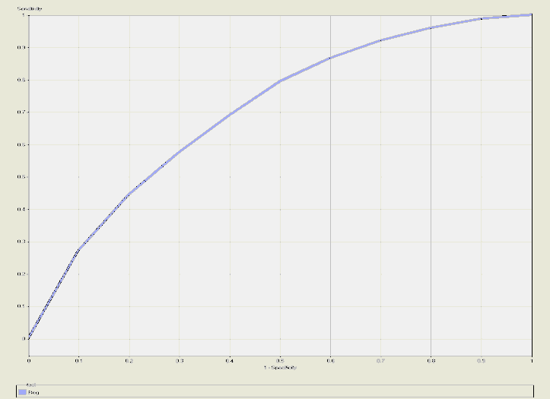

Figure 4: Receiver Operating Characteristic curve (ROC curve) for separating LGD=0 from LGD>0

3.2. Repayment model: estimate of LGD within a class
In this pilot model, it was decided that the predicted value for those in the first class should of course be LGD=0. For those in the second group (LGD>0) the LGD was estimated using a linear regression with weight of evidence approach. In the WOE approach we classified the target variable to be whether the LGD value was above or below the mean. To coarse classify the continuous characteristics, we started with ten roughly equally sized groups and combined adjacent groups with similar odds. For each characteristic we took the attribute (bin) values to be the weights of evidence value for that bin. So if $N_{a}$ and $N_{b}$are the total number of data points with LGD values above or below the mean and $n_{a}$(i) $n_{b}$(i) are the number in bin i with LGD values above or below the mean, then the bin is given the value:
$\text{log}\left(\frac{n_{a}\left(i\right)}{n_{b}\left(i\right)}/\frac{N_{a}}{N_{b}}\right)$

Using univariate analysis we identified five variables which were the strongest predictors of the LGD value for those with LGD>0.
Number of months in arrears in the whole life of the loan;
Number of months in arrears in the last 12 months;
Application score;
Loan amount;
Time of the loan until default.

In fact a number of different variations of the regression methods were examined to see which gives the best fit. These included standard linear regression, using a Beta distribution transformation before applying regression as suggested in LossCalc (Gupton and Stein 2005), using a log normal transformation, applying the Box Cox method (Box and Cox 1964) and using the weights of evidence approach with linear regression.

Table 1 Comparison of the methods
Method | $$R^{2}$$
Box Cox | 0.1299
Linear regression | 0.1337
Beta distribution | 0.0832
Log Normal transformation | 0.1347
WOE approach | 0.2274

Table 1 shows relative fits of the different approaches used with $R^{2}$ value. Note the $R^{2}$ values are not very high but such values do seem to be the types of figures that practitioners are also getting. It does seem that LGD values are difficult to predict. This is partly because there are no strong connections between the characteristics of the borrowers and the way they repay the loans before they default and their performance after default. It is also the case that the main indicator of total losses – the exposure at default – has already been factored out if one tries to estimate LGD rather than total losses.

One of the advantages of the WOE approach was that the predicted values spanned 0 to 1, while in some of the other methods, because one was trying to estimate a skewed distribution with values mainly between 0 and 1, the predictions were often all within the 0.4 to 1 range.

Results for estimating LGD for the group where LGD>0
The characteristics that had the most effect in the WOE regression used to estimate LGD for those who were not expected to pay back everything had the following trends
- The older the customer the lower the loss;
- If there is a joint applicant the lower the loss;
- The higher the application score the lower the loss;
- The longer it is from opening the account until default the lower the loss;
But
- The more the customer was in bad arrears recently (in the last 12 months) the lower the loss;
So in almost all the cases the impact of the characteristics is what might be expected. Again , as in the case when one was estimating whether full repayment would occur or not, the result that is surprising initially is that being in bad arrears ( 2 months overdue) several times in the last year is likely to result in a higher percentage of the debt being repaid than if there had been no bad arrears in the last year. The ”falling of the cliff” effect described there could also be the cause of this results.

4 Summary and Conclusions
The paper discusses a way of modelling LGD for unsecured consumer loans by modelling the collection process. There is obviously some overlap between these models and collection scoring models. However LGD models need to look at the whole collections strategy not just what to do initially, since for example failed attempts at collection will diminish the price of the debt if it is subsequently sold off. It is vital to model both the decisions by the lenders and the repayment risks of the debtors when estimating LGD. Hence a “decision tree” approach is the ideal methodology to use. We have shown how the repayment models which make up the random element in the decision tree can be built by recognising that the resultant distribution is a mixture distribution. This suggests one should use a two stage process to obtain estimates. Firstly use logistic regression (or cumulative logistic regression if more than two underlying distributions) to estimate which class a debtor is in and then a regression type approach for each class (ours is based on weight of evidence) to estimate the LGD values of debtors in that class. In the case study we presented, the collection’s policy was straightforward – only in house collections, but for other cases we would need to identify what were the rules that decided on whether to collect in house, via agents or sell off the debt. One would also need to model the sale prices and agency commission as functions of the debt portfolio being sold or managed.

The decision tree approach allows one to adjust the model in downturn conditions because of changes both to the lenders’ collection policies as well as changes in the borrowers’ ability to repay under changed economic circumstances. Although there is considerable development still needed in this area, we believe a decision tree approach addresses the fundamental difficulty in such LGD modelling of separating out the lender’s recovery policy from the debtors’ willingness and ability to repay the debt.

References
Altman E. I., Resti A., Sironi A.(2005): Recovery Risk, Risk Books, London
Andrade F., Thomas L.C. (2007): Structural models in consumer credit, European Journal of Operational Research 183, 1569-1581.
Box G.E, Cox D.R., (1964), An analysis of transformation, J. Royal Statistical Society Series B, 26, 211-246.
Claessens S., Krahnen J., Lang W.W (2005).: The Basel II Reform and Retail Credit Markets, Journal of Financial Services Research, Vol. 28 No.1-3, 5-13
Frye J.(2004): Recovery Risk and Economic Capital, in Economic Capital : A Practitioner’s Guide, ed by A. Dev, Risk Books, London, pp 49-68
Gupton G.M., Stein R.M., (2005), LossCalc v2; Dynamic Prediction of LGD, Moody KMV,
Kordichev A., Powel J., Tripe D (2005).: Structural model of revolving consumer credit risk, www.crc.man.ed.ac.uk/conference/archive/2005/papers/kordichev.pdf
Lucas A.(2006): Basel II Problem Solving, www3.imperial.ac.uk/portal/pls/portallive/docs/1/7287866.PDF
McNab H., Wynn A.,(2000): Principles and Practice of Consumer Credit Risk Management, CIB Publishing, Canterbury.

L.Thomas@soton.ac.uk; cm1@soton.ac.uk; amatuszy@soton.ac.uk; University of Southampton, Management Department, Highfield, SO17 1BJ, Southampton, UK;

