Information Systems Development: A Normalisation Process Theory perspective
R. Sooklal, T. Papadopoulos and GU. Ojiako
School of Management, University of Southampton

Abstract
Purpose – This paper utilises a case study to discuss the applicability of Normalisation Process Theory (NPT) as an alternative lens in understanding how social processes impact on the Information Systems Development (ISD) process. Normalisation Process Theory (NPT) is primarily used to examine how social processes impact on new ways of working.
Design/methodology/approach – The research was undertaken at an educational setting utilising a qualitative case approach.
Findings –The research suggests a framework based on NPT which aims at providing better insights of the normalisation process, based on the views of the development team. The research results strongly support the utilisation of NPT in a non-healthcare setting as a means to explain the factors and actions that promote the work of routine embedding of new technologies in the practice.
Practical implications – The theory has its foundations in the relative paucity of the extant ISD literature to provide a holistic approach for explaining the dynamics entailed in IS project endeavours. This is undertaken by considering the multiplicity and heterogeneity stakeholders. This paper presents a framework which aims to explain the normalisation of the ISD process based on the perceptions of the development team; it also corroborates the usefulness of NPT as a theory for exploring the challenges in embedding a new practice in current ISD endeavours..
Originality/value – NPT can assist in exploring the social production and organisation of new practices,
Keywords ISD, Normalisation Process Theory.
Paper type Research paper

1. Introduction
Companies are still investing heavily in Information Systems (IS) to achieve competitive advantage. However the high risk entailed in these investments, has led both academics and practitioners to search for factors shaping the Information Systems Development (ISD) process, including, for instance, the organisational context, end-user beliefs and expectations (Iivari et al., 2010), social interactions among users (Sawyer et al., 2010) and choice of development methods (Avison and Fitzgerald, 1999). However, despite the vast amount of literature on ISD, scholars such as Iivari et al. (2001) suggest that there is still room for a more holistic approach to explore the dynamics entailed in IS project endeavours, especially when considering the heterogeneity, complexity and diversity of user groups. The aim to understand the dynamics of embedding a practice and the difficulties of implementing and integrating this practice by looking at what people do and how they work led to the study of an ISD from a Normalisation Process Theory (NPT) perspective which was articulated by May (2006) and May and Finch (2009). NPT provides a set of tools to lend understanding and to explain the processes through which “new or modified practices of thinking, enacting, and organizing work are operationalised in healthcare and other institutional settings” (May et al., 2009: p. 2).
The paper is organised as follows: after a brief review of the literature regarding IS development and success (section 2), NPT is examined as the theoretical lens underpinning this research (section 3). It follows the discussion of the research methods adopted (section 4) and the results of the case study (section 5). Section 6 presents the discussion of the findings whereas the last section (section 7) concludes the paper.

2. Measuring ISD success
Various models have been used to measure ISD success. Amongst them DeLone and McLean’s (2003) IS Success Model and Technology Acceptance Model (TAM) which emphasised user-acceptance measured from one’s attitude towards systems which may be determined by perceived usefulness and ease of use. Further extensions of the TAM model included the Unified Theory of Acceptance and Use of Technology (UTAUT) (see Venkatesh et al., 2003) which combined elements of TAM with other user-acceptance based theories to create a theory to account for variance in a user’s acceptance, incorporating concepts such as performance expectancy, social influence, and facilitating conditions. These factors were tested for various types of systems in the ISD literature and user adoption of e-commerce. What seems to be missing, however, is a more holistic approach which does not give a snapshot of the ISD but intends “to know who the users are and further contact, sample, involve and represent them, it is vital to understand users when developing new IT applications and services” (Iivari et al., 2001: p. 111). Shifting to more interpretive approaches where social structures and interactions are unfolded, Structuration Theory (Giddens, 1986) has been used to describe the relationship between individuals where the actions of the individual are both constrained and enabled by structures and vice versa. Structuration theory has been used, for instance, to understand the relationship between IS and organisations and the “IS paradox” (Avison et al., 1999). At the same time we are aware of the sense-making framework which focuses on the actions of stakeholders involved in the ISD (see Faraj et al., 2004). It presents an interesting view of the larger context within which individuals are embedded within an organisation and how their actions can affect an organisation over time. Another approach to examining ISD is Actor Network Theory (ANT) (Latour, 2005). In IS research, ANT has been used to describe the relationships between individuals, non-human elements, IS, and organisations by providing an alternate account that sheds light upon the dynamics of the aforementioned entities that come together during ISD (Walsham, 1996). For instance, it was used by Silva and Backhouse (1997) and Cho et al. (2008) respectively to examine the introduction of technologies in both the UK and the Swedish health sectors. Although ANT provides the means to describe a network (system) in flux, it does not offer any predictive power of its constituents, and suggests that any prediction is futile. Another approach is Institution Theory (see Currie, 2009), which focuses on cultural and cognitive pressures. However, Institution Theory does not consider explicitly the way social practices are produced and re-produced through human action.
To address these issues, an alternative theory which aims to study the way new practices become integrated by considering what people do and how they work is Normalisation Process Theory, which is described in the next section.

3. Normalisation Process Theory
According to May et al. (2009), normalisation is “the work that actors do as they engage with some ensemble of activities (that may include new or changed ways of thinking, acting, and organizing) and by which means it becomes routinely embedded in the matrices of already existing, socially patterned, knowledge and practices” (p. 540). The specific concept comes into play when organisations are confronted with change and must find ways of accommodating that change. This is because changes can sometimes be perceived as disruptive and may impact the goals and operations of a business negatively. When applying the idea to the IS field, normalisation aims at developing an understanding of the process by which IS are used and accepted. To articulate the usefulness of normalisation in ISD, Normalisation Process Theory (NPT) is used (May, 2006). It is developed to look at the social processes that affect the acceptance of new ways of working, especially in the UK National Health Service (NHS). The concept of normalisation seeks to address both the internally oriented concerns of the people whose work practices are affected, and the external stakeholders who are concerned with the realisation of higher-level objectives. Primarily, NPT (see Figure 1), follows three general propositions identified by May and Finch (2009: p. 540) to include:
- “Material practices become routinely embedded in social contexts as the result of people working, individually and collectively, to implement them”. In this case, ISD is organised and organising expressions of human agency. These expressions involve dynamic and contingent interactions with the context in which organisations operate over time.
- “The work of implementation is operationalized through four generative mechanisms (coherence; cognitive participation; collective action; reflexive monitoring)”. Coherence is produced and re-produced in a new practice when actors collectively invest meaning in it; hence, they need to comprehend the practice as meaningful; Cognitive participation in a practice defines and organises the actors in a practice in terms of collectively investing commitment in it; Collective action means operationalising a practice and requires that actors collectively invest effort in it; and reflexive monitoring of a practice requires that actors collectively invest in its understanding, and organises that everyday understanding. In other words, these mechanisms state the importance of meaning, commitment and participation, effort, and understanding during the implementation of a new practice, and in this research, ISD.
- “The production and reproduction of a material practice requires continuous investment by agents in ensembles of action that carry forward in time and space”.
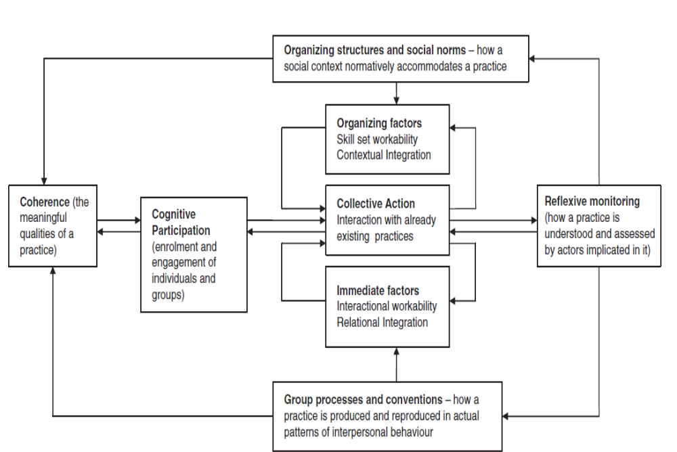
Figure 1. Normalisation Process Theory

The starting point of NPT is that the integration and embedding of a new practice goes through the work of people and their actions. Being a “theory of action” (May et al., 2009: p. 2), it is different to those theories that seek to explain how innovations are becoming routine in an organisation, focusing on individual and collective learning, and theories that shed light upon the attitudes of individuals, as well as their intentions versus the final outcomes (e.g. Structuration Theory or ANT). Moreover, the focus of the theory is on human agency and this make it distinct from other theories that adopt either ethnography or other methods to attribute agency to things as well as people; that is, ANT (e.g. Latour, 2005). NPT intends to “to build a set of sociological tools to investigate social shaping as action, and to do this in a form that permits structured comparative inquiry prospectively using a variety of methods” (May et al., 2009).
NPT has arisen from studies of complex interventions in healthcare (May, 2006; May et al., 2007). However, it has not been used extensively in the IS field. When IS are introduced into organisations, they often cause disruptions due to the novelty of the changes and the restructuring as a fundamental part of the IS change process. NPT may shed light on why some IS normalise while others do not. This is because it is concerned with the development and testing of theoretical frameworks for understanding how social processes can impact a complex intervention, and thus allows assessments to be made about how easily an implementation is ready to embed and how ready the actors or users are for the development (May and Finch, 2009). Therefore, NPT may provide limited predictive power for determining the readiness of an implementation to fit into place.
What seems to be missing from NPT is supporting literature in the ISD field, to either endorse or contradict it. Without such studies it is difficult to assess the methodological rigour and outcomes of NPT. Nevertheless, as Elwyn et al. (2008) postulate, NPT is an apparently coherent framework of propositions that may provide useful insights in the way systems become normalised within organisations. This provided the impetus for the utilisation of NPT in this research; namely, to gain insight into how IS becomes normalised in organisations by focusing on the ISD process.

4. Research methods and context
The research follows the interpretive paradigm (see Walsham, 2006). It is based on a case study (Silverman, 2001), conducted within an organisation (University A). Data was obtained mainly through interviewing the development team and through reading documentation related to the ISD. The selection of the methodology was influenced by the access limitations to participants; in particular, work schedules and time zone considerations. It has to be noted that the development team were also the users of the system and the Calendar, being staff members of University A.
The first author served as the project manager on the project. The project team comprised of six members. There were two additional individuals involved in the project (systems development), but their role was deemed peripheral since they were brought in when needed to assist with data entry and had marginal overall involvement with the project. While their insights may have been valuable when considering the normalisation of the system, staff turnover in those positions resulted in those individuals no longer being available for participation in the research. Since the focus of the study was on the perceptions and the influences of the development team in the normalisation process, five semi-structured interviews were conducted with the Administrative Manager (AM), Main Process Owner (MPO), first Lead Developer (LD1), second Lead Developer (LD2), and Technical Lead (TL) (Figure 2, Table 1). The interviews lasted 35 minutes on average. A hard copy consent form was sent to participants who agreed to take part in the study. In their majority the interviews were conducted over the telephone. There were 10 open-ended interview questions prepared in advance. The open ended questions were influenced by a review of secondary data (in the form of project documentation and emails). The questions were designed to elicit rich participant insights into the nature of the project, their perspectives on system success, the workings of the project and project team, and the view points of the ways the system fits with the overall organisational strategy. The questions varied between participants to account for their different roles and level of involvement in the project. The interviews were based on the operationalisation concepts of NPT proposed by May et al. (2009).
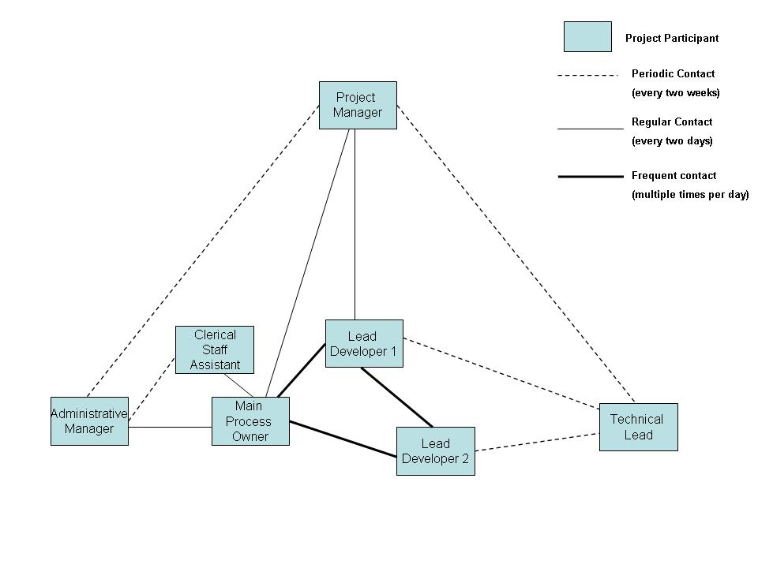
Figure 2. Diagram of project participants and lines of communication

The interviews were tape-recorded, transcribed verbatim, and subsequently coded using a series of codes developed from the literature review and secondary data. While the codes were applied, the researcher was checking if the coding scheme needed to be adapted so as to accommodate for missed ideas or to increase the precision and coding power. The analysis followed the general concepts by Miles and Huberman (2003).

Interviewee | Responsibilities
Administrative manager | Project scope, RO resources, budget, ensure the project results are in accordance with expectations, intervene when problems.  High initial involvement in conception phase but very low in the planning, implementation, and integration phases.  User of the system.
Main Process Owner | Knowledge of the processes and their interactions.  Annual updates; involved in the conception, planning, implementation, and integration phases. Primary user of the system.
Lead Developers 1 & 2 | Design, building, testing, training of users and support of the new Calendar system.  Users of the system.
Technical Lead | Ensure project objectives and timeline are realistic and achievable.  Involved in planning and periodic checks during implementation to ensure there are no unresolved technical issues.
Project Manager | Project planning and resource allocation.  Involved during conception, planning,  Monitoring and report writing.  Keep track of problems and make sure they are resolved in consensual and timely fashion.  Involved in all project phases.
Table 1. Interviewees and their responsibilities.

4.1 The context of the study
University A is a public funded university with approximately 18,000 students and 3500 staff. It is located in an area where local birth rate has been declining for the last 10 years and population data indicate that the trend is likely to continue, causing a decline in the local student applicants. This has caused University A to use the web as a marketing and recruitment tool to reach potential students internationally and create appeal to an Internet-savvy generation. The resources of University A, however, are limited by competing demands from different areas. There is competition for financial (academic, research, and administrative) resources amongst various units, but also competition for sparse resources from the Information Systems Department (IS Dept), which is the central supplier of IT and ISD, and is often inundated with requests to utilise its resources. Such a request was made from the Registrar’s Office (RO) to redesign the production system used to create and publish the “Calendar” of University A.
The Calendar is a critical document for University A, referred to regularly by potential and current students, faculty, and staff in the RO. It contains information about rules and regulations that govern the relationship between the university and its students, a listing of all academic units and programmes, detailed academic programme and course descriptions, and available scholarships. The current version is 728 pages and consists of approximately 756,000 words. This information needs to be regularly updated and published once a year. Upon publication, it forms the “contract” between students and the university since it is considered the authoritative source of academic information at University A.
The RO was responsible for the production and the publication of the Calendar. In the past it had used a word processing package and later a simple HTML editor to create both the print and web versions. When this system was first created, the Calendar was primarily for internal consumption and had only to be accurate. However, with the recent revised strategy to use IS and the web as a reforming and marketing tool, the Calendar had to be updated and its print and web forms had to be improved. This improvement could not occur with the production system which was currently used and a recent review of the system had suggested that it was in imminent danger of failing. This prompted the RO to contact the IS Dept for help in developing a new Calendar production system that would enable them to address the current threats and position them to create a better looking print and much improved web Calendar. A project was initiated to address these issues identified by the RO. The project lasted for six months. The goals were set in concise but immeasurable terms since there were no quantifiable measures of success apart from time and budget considerations. It should be stated that there was no turning back; if the Calendar was not produced on time it would have represented a disastrous failure for the RO and the ISDept, and hence University As a result, there was a great deal of pressure imposed by the university strategists on the RO for project success.

5. Normalisation of the Calendar Project
The project did not impose any prescriptive measures concerning how the system should be developed. Instead, it stated deadlines and proposed a broad approach utilising specific technologies which were unknown to the IS Dept staff involved. The project plan did not consider in detail all the features of the system, but the Core development team consisting of an RO process expert and two IS Dept developers would be left to figure that out; at the same time constrained by deadlines and guided by the knowledge of the problem they had to address (Table 2). These actors initiated (May et al., 2009) work so as to bring new practices forward.
As part of the project, Calendar data (Table 3) had to be translated from existing WordPerfect format to XML documents that then needed to have the data within each of the documents properly labelled. This would enable the successful translation of XML into appropriate print and web formats. The specific change was fundamental for the RO staff, since they had not dealt with describing data before. For the IS Dept staff, while the principles of translating to XML format were well understood, there was no experience in this scale of task or with this type of intricacy. Surprisingly, despite these problems, the IS Dept did not have to deal with any problems (Table 2).
The project proceeded with deadlines consistently met, and the deliverables often met not only the initially stated targets, but also “wish list” features. It seemed that the actors of the IS Dept worked together and were organising themselves around the objectives of the new Calendar (Table 4), aiming at participating in the new practice; that is, enrolment (May et al., 2009), although this enrolment was ‘imposed’ by the current situation of University A. The implicit imposition of the necessity of the new Calendar was legitimised by the strategy of University A. There was, hence, an implicit ‘buy-in’ to the new practice by the proponents of the Calendar who wanted better and more rapid access to the Calendar (moral ambitions). This was “in relation to institutionally shared beliefs about the propriety and value of knowledge and other existing practices” (May et al., 2009: p. 544). The project was moving according to the deadlines set at its initiation; there was no protest. The legitimation of the new Calendar system and the enrolment of users led to the activation of the system (new practice, in NPT terms). Upon completion, the new Calendar was judged an unqualified success (Tables 2, 3, 4). The system seemed to be integrated with the existing practices.
Problems to be addressed | Solution delivered
Calendar data are in proprietary format that cannot be easily converted or moved. | Calendar data are now in non-proprietary XML format and can be used by a wide range of XML editing packages.
Calendar publication tied to software and equipment that could fail at any time. | The selected XML editor can be installed on any current computer system.
There is no system in place to recover Calendar data should the MPO desktop computer fail. | Calendar data are held in a server-based version control file repository. All files will be checked out of the server and checked in via software. The Calendar system and data are backed up daily and can be replicated and recovered quickly in the event of server failure.
Labour-intensive process to create Calendar caused by:  -Errors created by using multiple data sources that are not synchronised.  -Duplication of effort caused when one set of changes undoes a prior set of changes.  -RO Staff members spend a lot of time adjusting the layout of the document for print.  -RO Staff members do not have tools, training, or background to create a better version of web Calendar that is searchable, easier to navigate, easier to use, and that is visually pleasing  -Camera-ready processing is slow and expensive and being phased out. | Reduced effort required to produce web and print Calendar, facilitated by:  -All changes are made to single data source which is accessible to R0 staff members assigned to Calendar production. This source is always up-to-date.  -The version control system handles the integration of changes to data and prevents users from working on the same file at the same time. All changes can be undone.  -Print layout is now handled automatically by back end code that handles all print layout tasks. Layout adjustments to print can be made by users via a separate system interface, if necessary. A single click will produce a file ready for print publication at any time.  -Web publishing is now handled automatically by back end code that handles the creation of a navigation menu, links, updates the Calendar search engine, and provides links to PDF versions of Calendar sections as well as the entire Calendar. A single click updates the Calendar website  -Camera ready processing is no longer necessary as the system automatically creates a final PDF version of the Calendar based on all changes to Calendar system to date.
Table 2: Problems identified and solutions delivered
 | Old Calendar System  (Approximate time) | New Calendar System  (Approximate time)
Manual formatting for print | 3-5 weeks | Not necessary
Time required to create the calendar index | 2 weeks | 7 seconds
Time required to create web version of Calendar | 4 weeks | 2 minutes and 24 seconds
Camera Ready | 3-4 weeks | Not necessary
Amount of time to create a final print version | 6-9 weeks | 2 minutes and 49 seconds
Estimated time consumed by errors integrating data from multiple sources and repeatedly | 4 weeks | Not necessary
Estimated overall time savings | 16-19 weeks

Table 3. Calendar system process improvements

 | Old Calendar System | New Calendar System
Site size | 21 HTML files | 1374 PHP files
Number of unique links | 118 | 5972
Calendar search engine | No | Yes
End user access to Calendar PDF files | No | Yes, Calendar is broken down into 21 sections, or can be downloaded as a single file
Course description pop-up windows | No | Yes, it prevents site user from the need to go to another page to get a course description.
Adherence to University Web brand standards | No | Yes
Time required to create | 4 weeks | 2 minutes and 24 seconds

Table 4. Comparison of old versus new system

The reasons .for considering the project a success, however, differed between stakeholders but all comments on initial delivery were positive – relational integration, that is, in NPT terms, since the system was “mediated and understood within the networks of people around it” (May et al., 2009). Subsequent to the release of the system, it became normalised into the daily routine of the RO production staff who were happy with it. The interactions over work and normal patterns were not affected; in NPT terms, the interactional workability of the system was not an issue (May et al., 2009). The result was surprising to IS Dept staff, since in general, past experiences with projects and systems had resulted in an initial flood of support requests after the project had been delivered. This normalisation was considered unusual for the IS Dept and the RO; it was hence referred to as a “happy fluke” within ISD.
One of the main features of the project was the excellent communication between the MPO, LD1, and LD2 as the project progressed. This contributed to the distribution of the change management work and practice – skill-set workability and the contextual integration (May et al., 2009) - of the Calendar system and incorporation into the context of University A. The interview data (MPO and LD1) along with 29 emails from the secondary data set corroborate this fact. Both the MPO and LD1 were discussing how it was possible together with the LD2 to complete the task of XML data conversion and deal with the relevant issues. This constant communication was vital: for the MPO it allowed her to build trust in the system, as well as to improve her relationship with LD1, and LD2; and for the LD1 and LD2, it allowed them to make sense of the working practices of MPO and the important data and functions to be included in the new Calendar system.
The communication was vital in establishing the system normalisation. The interview process and subsequent data analysis revealed interesting relationships when it comes to the system becoming accepted into “day to day” operations. The MPO stated that she did not really “think about the system… as long as it works”, but noted that it was a critical part of the routine; no individual or collective appraisal hence took place that would lead to reconfiguration (May et al., 2009) This description seems somewhat contradictory, since it could be argued that people would be inclined to focus on “critical” issues. Her account indicates that the Calendar system was a tool to create and publish the Calendar, and that the only importance is getting the Calendar published. As long as the tool (Calendar System) works and gets the job done, the user is unlikely to worry about it. This is the “end” for the user, and that “end” is important for the organisation. Repeated achievement of that end is depent upon the ability of a user to use available tools to meet their objectives in a consistent way. This idea of consistent, long-term use is normalisation, since the production and reproduction of this practice required the collective investment of the actors involved in its understanding (May et al., 2009).
During the interviews, all the participants stressed the importance of having users who are not resistant to or sceptical of changes and who are willing to adopt new practices if a new system will be continually used. This point was brought up with respect to concerns with turnover in the RO positions to assist the MPO with getting calendar data. While the task required was still the data entry those data had to be categorised and tagged in addition to the traditional routine of typing data into a computer. Choosing staff with the right mindset to support the new Calendar and be motivated to act as change agents was especially noted by the MPO and AM. It appeared that the staff were not really interested in why they had to do specific tasks; rather, they were following what they had been told so that they get the tasks done quickly and easily.
The research findings also show that the acceptance of the Calendar by the users had to be not only user-friendly, but, as LD1 postulated, it had to be “not user-scary”. AM, TL, and LD1 made reference to the other projects where the ability for users to learn a new system interface was a key factor for initial adoption and long term acceptance. Moreover, LD1 and TL mentioned that control over the system is invaluable in the long term success of the system. TL suggested that it was a good way of reducing unnecessary support calls since users would fix their own problems. LD1 suggested that users “…were more self regulating since… users having more control were likely to use less functionality. As opposed to who felt they didn’t have enough…were more likely to try… and …break things”. Both stated that users who felt empowered were likely to be happier with the system in the long run. However, as interpreted from TL and LD1, system support was still essential. Therefore, supporting systems in the long run was one of the findings through interviewing AM, TL, and LD1 that was essential for the operation of Calendar and its successful adoption and acceptance.
From the research findings it can be inferred that normalisation goes through the fact that the “system must do the job”. No matter if this was too obvious (as stated by the interviewees); it was mentioned by all interviewees and this struck the researcher. All the participants felt that the system of “getting the job done” was important, since failure in this regard would result in undermining the point of having a system. While the job of developing and integrating the new Calendar (action) was influenced by the goal (integration of the new Calendar), the MPO and LD1 felt that the job could also influence the goal by presenting a set of physical constraints or potentials. Whereas with the old Calendar system there was a danger of not being able to produce the print Calendar version, with the new system, a variety of distribution methods reduced the time to print and improved the Calendar content (Table 2). Moreover, the users’ understanding of the system or performing a task was a unanimous point of collective agreement for system normalisation. In particular, the MPO and LD1 collectively agreed about the usefulness of the system and felt that this understanding would enable others to build a personal commitment since they could see how they were contributing to the “big picture”. This collective consensus relating to the goals the goals with regards to the goal of the system allowed them to contribute (act) by further operationalising the purpose or goal for the system due to their in-depth knowledge.
The functionality of the old Calendar system had to be secured in the new system; it was important not to take away any functionality from the old system considered important by the users. Apart from the possible alienation of some of the user base, it can be inferred from the interviews that it was highly likely that a new developed system could easily miss important aspects of the old Calendar system, especially if they were not familiar with the business processes being used. The AM, TL, and LD1 felt that the new system had to show a tangible clear benefit when compared to the old system; and that making incremental improvements to systems over time was a good way to achieve user “buy-in”. But improvements could come in both tangible and intangible terms, such as being faster, easier to use, more efficiently utilising resources, or creating a better quality end product: a new system that could show a clear and continuous improvement in accordance with the organisational strategy to value the work being done enough to invest resources to improve it and to make users feel “… better about their jobs” (MPO). Additionally, interspersed with the interview transcripts were comments from all users about organisational impediments that could undermine long term system use and acceptance, including political conflicts between units, staffing issues, sudden shifts in management priorities and organisation change issues.

5.1 A framework of the Calendar normalisation process
Based on the interviews and secondary data, a framework is developed to help in understanding the normalisation process of the new Calendar. The framework is based on the insights and perceptions of the development team as depicted in the interviews and provides an alternative view of acceptance when confronted with ongoing use of an IS. It consists of three types of elements: “people”, “system characteristics”, and “ideas”. The “people” or “person” element embodies the sum of the attitudes the user may have towards the system. In the framework, the only person being considered is a single user. “System characteristics” refer to the qualities of the system and its attendant support. “Ideas” represent more intangible factors which however exert influence on whether or not a system can move towards normalisation. Finally, the arrows signify relationships of cause and effect; for instance, a clear purpose and goal of the suggested new Calendar system promotes user willingness to accept it and subsequently reduces scepticism, expressed as few or none organisational impediments in Figure 3.
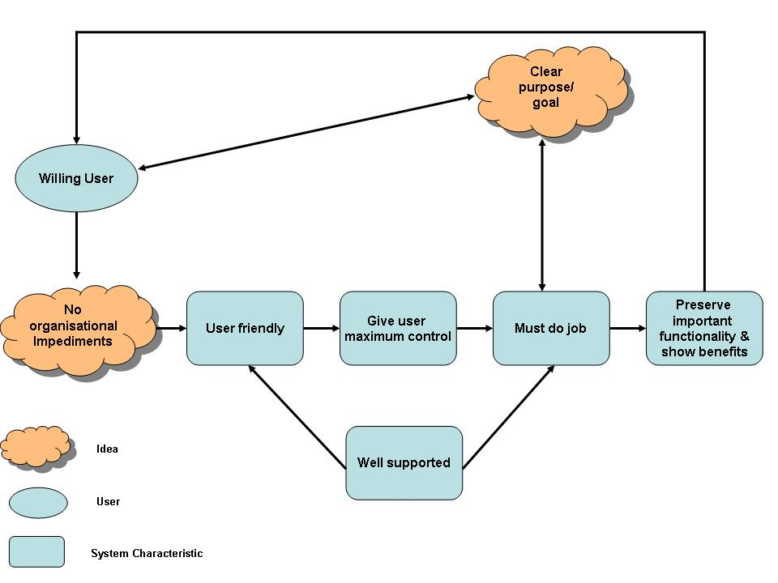

Figure 3. A framework of system normalisation based on the Calendar system

Given the relative lack of established literature in the area of ISD and NPT, this framework represents an early step in developing a better understanding of how systems become normalised within an operational environment, and can be used as a sense-making device towards the normalisation process. A project manager, hence, could use the specific framework as to judge whether a suggested new practice (and in this case, the new Calendar system) would be normalised and integrated with current working practices. One should be able to develop plausible images of what people are doing during the implementation process, discuss the interplay of their actions and interpretations, and gauge whether these actions lead these actions lead to normalisation (Weick et al. 2005). In essence, the NPT framework suggested allows for ‘predictions’ of the trajectory of a practice as a social process based on the interactions of specific actors. However, it is not supported that the NPT is absolute predictive theory; following May et al. (2009), the suggested framework contributes to understanding the trajectory of a practice within certain limits. Accurate predictions of the outcome of a complex and emergent process such as ISD are impossible (May et al. 2009).
When examining the results of the case in relation to NPT, there is support for the propositions that May and Finch (2009) suggest. In particular, the results of the study corroborate the first proposition that people work actively o incorporate systems into their daily routine –in this case the new Calendar system. In essence, the ongoing intent of the individual – that is, the development team members as described in the suggested normalisation framework – plays an important part in the normalisation, by providing strong motivation – sometimes imposed by the strategic intentions of the organisation – to make the calendar succeed, as in the case of the MPO. Contrasting literature which discusses the stakeholder scepticism towards accepting new IS (e.g. Pan, 2005) and although the system was “imposed” by university strategists, it did not meet resistance. Despite the fact that one can suggest that this result can be attributed to the fact that interviewees stemmed from the development team, a closer look reveals that the development team were amongst the people who would use the Calendar themselves; for instance the MPO and the LD1 and LD2, and not separate users (e.g. Henfridsson and Lindgren, 2010; Millerand and Baker, 2010).
The results of this study corroborate the second proposition as described by May and Finch (2009). In particular, normalisation is influenced by individuals seeing value or meaning in the work being done; understanding their place in the bigger picture; actually doing the work; and continuously performing the three aforementioned processes. The MPO, for instance, did not only participate in the development because it was imposed by the university strategists; rather, she could have the new Calendar on time, with less effort; the Calendar would be more printer-friendly and information-accurate. Moreover, the third proposition is also corroborated; namely, that the creation of a routine requires a consistent and ongoing effort by individuals. This can be demonstrated by the results of this study in that the MPO is using the new Calendar system (tool) on a daily basis to assist her in her daily working practices which she feels adds value (Table 4).
NPT Propositions | Results of the study
People work actively to to incorporate systems into their daily routine.  . The ongoing intent of the individual plays a major role | -The development team worked actively and collectively to develop and implement the new Calendar system. Strong motivation –sometimes imposed by the strategic intentions of the organisation - played a major role
Normalisation is influenced by individuals seeing value or meaning in the work being done; understanding their place in the bigger picture; actually doing the work.  Characteristics:  Coherence is produced and re-produced in a new practice when actors collectively invest meaning in it.  -Cognitive participation: actors in a practice collectively invest commitment in it.  -Collective action: operationalising a practice - actors collectively invest effort in it.  -Reflexive monitoring: actors collectively invest in its understanding, and organise that everyday understanding. | -The development team perceived the system as meaningful, since, being amongst the potential users, they would have access to the new Calendar on time and with less effort. The Calendar would be more printer-friendly and information accurate.  -The development team found the new Calendar as meaningful (less time, effort, more accurate).  -University A and the development team invested time and resources. There was no resistance to the system; however they committed collectively to its success. The project had to succeed: there was no alternative.  -Since the development team committed to the project, they devoted time and effort in making it a success (e.g. MPO acting as change agent)  -To act collectively, the development team and users understood its importance for their working practices and University A.
The creation of a routine requires a consistent and ongoing effort by individuals. | The MPO is using the new Calendar system (new routine) on a daily basis to assist her in her daily working practices which she feels adds value.

Table 4: NPT and the results of the study

6. Discussion
Normalisation refers to the process of making a system adapt to the organisational processes, i.e. to make it “normal”. In this case, the Calendar system was chosen because of the unusually rapid nature of normalisation, according to the standards of the IS Dept of University A. The literature, apart from a few exceptions such as May and Finch (2009) has not fully acknowledged the role of NPT in explaining the success of IS implementation and development. Literature in these fields such as Hussain and Cornelius (2009) and Kim and Kanhanhalli (2010) has yielded models that refer to theories of user acceptance; however these theories are in their majority ‘problematic’ since they focus on measuring User Acceptance at a given point in time. Unfortunately, in most cases, they do not provide a detailed discussion of the development and implementation trajectory. Moreover, missing from User Acceptance is a broader understanding of the factors that influence longer-term usage decisions. To address these issues, NPT in this research allowed for the construction of a framework which informs current normalisation theory applications in IS development, can be used as a sense-making (Weick et al. 2005) tool to study normalisation processes, and expands its use from the healthcare context (May, 2006; May et al., 2007). It does not focus on the relationships between individuals, non-human elements, IS, and organisations, but provides a richer understanding of project success and focuses on the way social practices (such as the ISD in question) are produced and become normalised through human action rather than a collection of “nice quotes” of what people said or did at specific points in time. Furthermore, instead of giving prominence to the behaviour of organisations or collectives as basic units of analysis (e.g. Structuration Theory), it complements these perspectives by focusing on the micro-level components of a complex process (May, 2006), in this case, ISD.
The study is in accordance with Elwyn et al. (2008) and postulates that normalisation is inextricably related to the collective work of IS Dept and WPO involved in the development process and the operationalisation of the system. As stated in the case study, the system was perceived as a tool for improving the working practices of the employees; it was not perceived as threatening, and this had a positive impact in its normalisation. The results also support the basic tenets of NPT since the study was concerned with the social organisation of bringing a practice (the new Calendar System) into action: the study explored the way a practice (the Calendar) was incorporated in everyday work of individuals and University A groups; and integration, that is, the processes by which the practice (the Calendar) is sustained among the social matrices of the organisation (University A) (May et al., 2007; 2009).
Therefore, the results of the case study suggest that there seems to be support for NPT application in a non-healthcare setting. However, that support is based on the statements of the development team who were interviewed and the secondary data sources. Does this provide a strong confirmation of what May and Finch (2009) suggest regarding the propositions of NPT? The author does not intend to statistically generalise the findings in a wider population. Such an attempt would not be in accordance with the interpretive paradigm and qualitative case study strategy adopted. Interpretive case studies are based on the belief that reality cannot be captured by a few variables; but rather focus on the “the validity of specific phenomena, an understanding of which depends on nuanced descriptions of the phenomena themselves, the processes which define them, and the (changing) contexts in which they are situated” (Ahrens and Chapman, 2006: p. 834). Instead, the focus is on “the plausibility and cogency of the logical reasoning used in describing the results from the cases, and in drawing conclusions from them” (Walsham, 1993: p. 15). Therefore, the study did not look for ways of applying the results of the study to a wider population; rather, the focus was to produce new insights about a phenomenon as it unfolds over time and on the plausibility of the inductive reasoning used in analysing the case study findings and drawing conclusions from them (Lincoln and Guba, 1985).

7. Conclusions
This research focused on the ISD process, based on the argument expressed in the current literature (e.g. Iivari et al., 2001) for an approach that will provide a holistic overview of the dynamics of embedding a practice and the difficulties of implementing and integrating this practice by looking at what people do and how they work led to the study of an IS development project, under the NPT lens (May, 2006; May and Finch, 2009; May et al., 2009).
The results presented in the case study confirm the applicability of NPT as a theory to understand these dynamics and stress the importance of stakeholder action in normalising the IS as new practice with the already existing ones. People worked actively, both individually and collectively, to accomplish congruence and disposal and to incorporate the system into their daily routine; these expressions of human agency included interactions with the organisational context. Coherence, cognitive participation, and collective action were achieved during the implementation process, and consistent and ongoing efforts were initiated by change agents as part of this process, triggered by motivation. The latter was manifested in the willingness of the individuals to help in making a successful system. Moreover, this research suggested a framework which depicts the factors to be considered on the “road to normalisation”. The specific framework does not intend to cover all factors necessary to achieve normalisation; it also does not aim at any generalisations to other contexts. Such an attempt would be against the research paradigm adopted (Lincoln and Guba, 1985). However, what the framework aims at is to be used as a sense-making device and inform current NPT theory about factors that need to be taken into consideration during the normalisation journey.
This research does present a number of potential opportunities for future research in the form of comparing a number of different systems and organisations in a larger case study, so as to come up with more in-depth explanations of normalisation and the ability of NPT to explain stakeholder actions during the process. The role of ongoing secondary support during the implementation process has been highlighted as being important and hence further research into this area could lead to insights into how to best optimise the allocation of existing support resources to support the normalisation process.

References
Ahrens, T. and Chapman, C. (2006), “Doing qualitative field research in management accounting: positioning data to contribute to theory”, Accounting, Organizations and Society, Vol. 31 No. 8, pp. 819-841.
Avison, D., Cuthbertson, C. and Powell, P. (1999), “The paradox of information systems: strategic value and low status”, Journal of Strategic Information Systems, Vol. 8 No. 4, pp. 419-445.
Avison, D. and Fitzgerald, G. (1999), “Information systems development”, In Currie, W.L., Galliers, R.D. (Eds.), Rethinking Management Information Systems, Oxford University Press, Oxford, pp. 250-78.
Carter, L. and Belanger, F. (2005), “The utilization of e-government services: citizen trust innovation and acceptance factors”, Information Systems Journal, Vol. 15 No. 1, pp. 5-25.
Cho, S., Mathiassen, L. and Nilsson, A. (2008), “Contextual dynamics during health information systems implementation: an event-based actor-network approach”, European Journal of Information Systems, Vol. 17, pp. 614-630.
Currie, W. (2009), “Contextualising the IT artefact: towards a wider research agenda for IS using institutional theory”, Information Technology & People, Vol. 22 No. 1, pp. 63-77.
DeLone, W. and McLean, E. (2003), “The DeLone and McLean Model of Information Systems Success: A Ten-Year Update”, Journal of Management Information Systems, Vol. 19 No. 4, pp. 9-30.
Elwyn, G., Legare, F., Edwards, A., van der Weijden, T. and May, C. (2008), “Arduous implementation: does the normalisation process model explain why it is so difficult to embed decision support technologies in routine clinical practice”, Implementation Science, 3: 57.
Faraj, S., Kwon, D. and Watts, S. (2004), “Contested artifact: technology sensemaking, actor networks, and the shaping of the Web browser”, Information Technology & People, Vol. 17 No. 2, pp. 186-209.
Giddens, A. (1986), The Constitution of Society: Outline of the theory of structuration, Berkeley, CA: University of California Press.
Henfridsson, O. and Lindgren, R. (2010), “User involvement in developing mobile and temporarily interconnected systems”, Information Systems Journal, Vol. 20, pp. 119-135.
Hussain, Z. and Cornelius, N. (2009), “The use of domination and legitimation in information systems implementation”, Information Systems Journal, Vol. 19, pp. 197-224.
Iivari, J., Hirschheim, R. and Klein, H. (2001), “A dynamic framework for classifying information systems development methodologies and approaches”, Journal of Management Information Systems, Vol. 17, pp. 179–218.
Iivari, J., Isomäki, H. and Pekkola, S. (2010), “Editorial: The user – the great unknown of systems development: reasons, forms, challenges, experiences and intellectual contributions of user involvement”, Information Systems Journal, Vol. 20, pp. 109-117.
Kim, H.-W. and Kankanhalli, A. (2009), “Investigating User Resistance to Information Systems Implementation: A Status Quo Bias Perspective”, MIS Quarterly, Vol. 33 No. 3, pp. 567-582.
Latour, B. (2005), Reassembling the Social: An Introduction to Actor-Network- Theory, Oxford: Oxford University Press.
Liang, H., Saraf, N., Hu, Q. and Xue, Y. (2007), “Assimilation of Enterprise Systems: The effect of institutional pressures and the mediating role of top management”, MIS Quarterly, Vol. 31 No. 1, pp. 59–87.
Lincoln, Y. and Guba, E. (1985), Naturalistic inquiry, Newbury Park, CA: Sage.
May, C., and Finch, T. (2009), “Implementation, embedding, and integration: an outline of Normalization Process Theory”, Sociology, Vol. 43, pp. 535-554.
May, C., Finch, T., Mair, F., Ballini, L., Dowrick, C., Eccles, M., Gask, L., MacFarlane, A., Murray, E., Rapley, T., Rogers, A., Treweek, S., Wallace, P., Anderson, G., Burns, J. and Heaven, B. (2007), “Understanding the implementation of complex interventions in health care: the normalization process model”, BMC Health Services Research, Vol. 7 No. 148, http://www.biomedcentral.com/1472-6963/7/148, accessed 15/07/10.
May, C., Mair, F., Finch, T., Macfarlane, A., Dowrick, C., Treweek, S., Rapley, T., Ballini, L., Ong, B.N., Rogers, A., Murray, E., Elwyn, G., Legare, F., Gunn, J. and Montori, V. (2009), “Development of a theory of implementation and integration: Normalization Process Theory”, Implementation Science, Vol. 21, pp. 4-29.
May, C. (2006), “A rational model for assessing and evaluating complex interventions in health care”, BMC Health Services Research, Vol. 6 No. 86, pp. 1-11.
Millerand, F., and Baker, K. (2010), “Who are the users? Who are the developers? Webs of users and developers in the development process of a technical standard”, Information Systems Journal, Vol. 20, pp. 137-161.
Miles, M. and Huberman, A. (2003), Qualitative Data Analysis: An Expanded Sourcebook, Thousand Oaks, CA: Sage.
Pan, G. (2005), “Information systems project abandonment: a stakeholder analysis”, International Journal of Information Management, Vol. 25 No. 2, pp. 173-184.
Sawyer, S., Guinan, P., and Cooprider, J. (2010), “Social interactions of information systems development teams: a performance perspective”, Information Systems Journal, Vol. 20 No. 1, pp. 81-107.
Silva, L., and Backhouse, J. (1997), “Becoming part of the furniture: the institionalization of information systems”, In: Lee, A.S, Liebenau, J. and DeGross, J.I. (Eds.), Information systems and qualitative research, London: Chapman and Hall, pp. 389-414.
Silverman, D. (2001), Interpreting Qualitative Data: Methods for Analysing Talk, Text and Interaction, London: Sage.
Venkatesh, V., Morris, M., Davis, G., and Davis, F. (2003), “User acceptance of information technology: Toward a unified view”, MIS Quarterly, Vol. 27 No. 3, pp. 425-478.
Walsham, G. (1993), Interpreting information systems in organizations, Chichester-Wiley.
Walsham, G. (2006), “Doing interpretive research”, European Journal of Information Systems, Vol. 15 No. 3, pp. 320-330.
Walsham, G. (1996), “Exploring the intellectual structures of information systems development: a short critique”, Accounting, Management and Information Technologies, Vol. 6 No. ½, pp. 133-135.
Weick, K., Sutcliffe, K. and Obstfeld, D. (2005), “Organizing and the process of sensemaking”, Organization Science, Vol. 16 No. 4, pp. 409-421.
Weinberg, G. (1971), The Psychology of Programming, Van Nostrand Rheinhold, New York, NY, USA.

