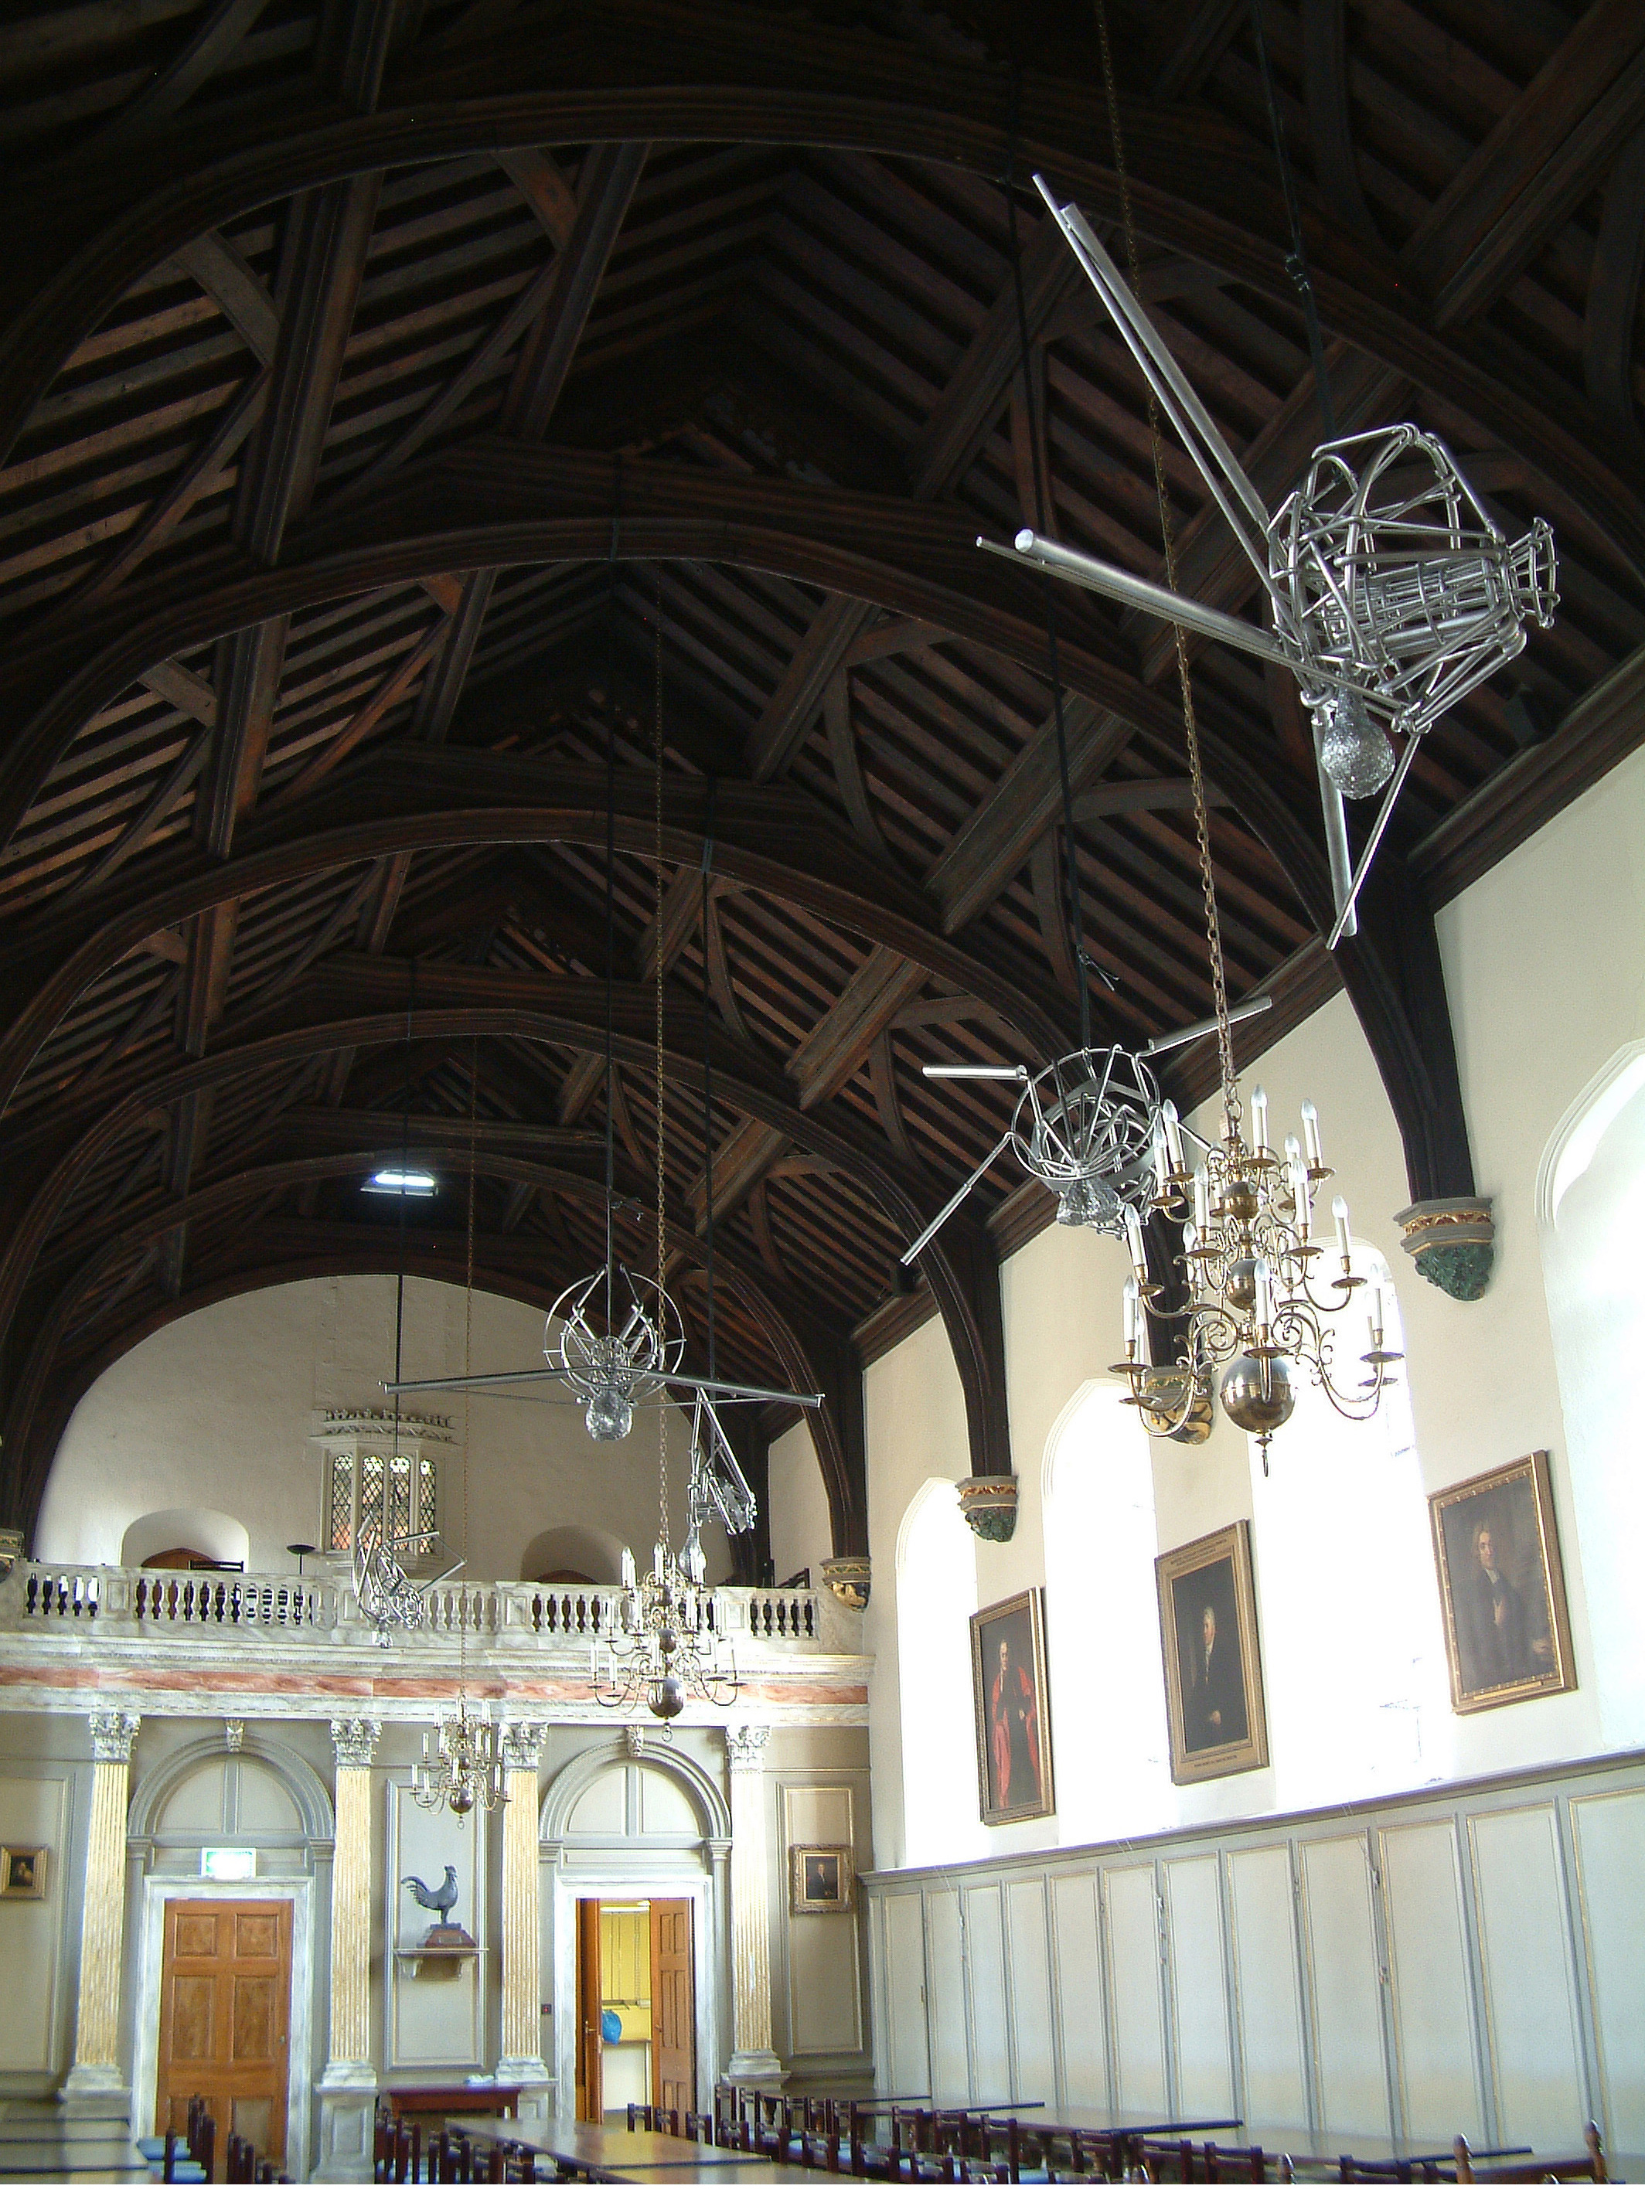

‘Host’, Angels II, VII, IV, I and V.
Jesus College, University of Cambridge 2005

