Modelling Biomimetic Moth-eye Structures for Antireflection Surfaces

Asa Asadollahbaik¹*, Stuart Boden², Marc Molinari³, Simon Cox³, Darren Bagnall²

¹Engineering Materials and Surface Engineering Group, School of Engineering Sciences, University of Southampton, Highfield, Southampton, Hampshire, SO17 1BJ, UK
²Nano Research Group, Electronics and Computer Science, University of Southampton, Highfield, Southampton, Hampshire, SO17 1BJ, UK
³Computational Engineering & Design Research Group, School of Engineering Sciences, University of Southampton, Highfield, Southampton, Hampshire, SO17 1BJ, UK
*corresponding author: aa306@soton.ac.uk
The surfaces of the eyes and wings of some species of moth are covered with pillars, approximately 200 nm high, arranged in a hexagonal lattice with a periodicity of approximately 200 nm [1]. The subwavelength features in this structure cause it to confer a gradual change in refractive index to an interface. This eliminates the discontinuity experienced by light as it passes through the interface and so reduces reflection over a broad range of wavelengths and angles of incidence. Attempts to mimic nature’s solution to unwanted reflections for applications such as antiglare surfaces, solar energy and photodetectors have led to the fabrication of many artificial moth-eye structures on semiconductors and glass.
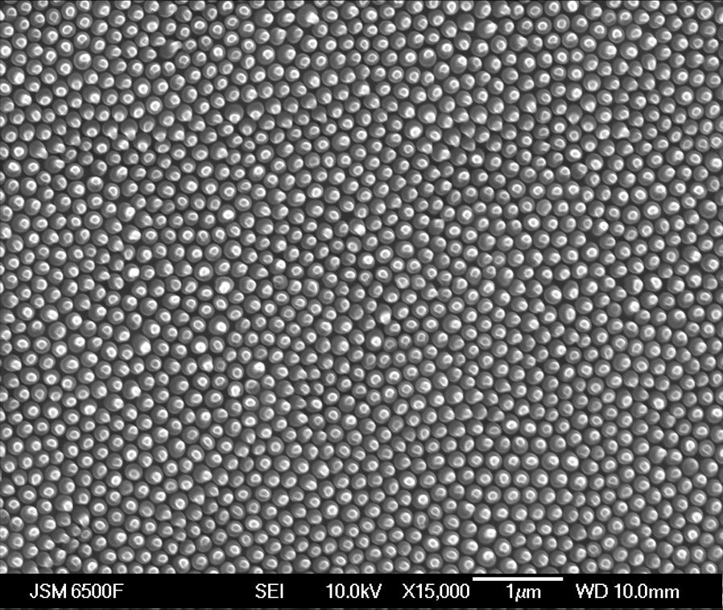
(a) | (b) | (c)
Figure 1: (a) A top view SEM image of Cryptotympana Aquila moth-wing (scale bar 1μm) (b) A unitcell of cylindrical pillars in a hexagonal lattice (c) Reflectance vs Period and wavelength for the structure in (b), calculated using DiffractMod (Rsoft).
Si moth-eye surfaces, fabricated by means of nanoimprint lithography and electron beam lithography combined with reactive ion etching, have recently been investigated for solar cell applications [2]. The shape and height of the pillars, periodicity of the lattice and also the lattice geometry have been shown to play an important role in the resulting reflectance of the silicon surface. Computational modeling of the moth-eye structure provides further insight into its properties and enables optimizations of designs for specific incident spectra. In this work, Rigorous Coupled Wave Analysis [3] and Finite Difference Time Domain [4] methods are used to model the reflection behavior of silicon moth-eye structures under white light illumination at normal incidence. The effect of changing the shape and height of the pillars and the lattice in which the pillars are arranged will be presented, leading to an optimization of the design for photovoltaic applications.
References
- C. G. Bernhard, "Structural and functional adaption in a visual system", Endeavour, 26, 79-84 (1967)
- S. A. Boden and D. M. Bagnall, “Nanostructured biomimetic moth-eye arrays in silicon by nanoimprint lithography, Proceedings of SPIE, 7401, 74010J-1-74010J-12 (2009)
- http://www.rsoftdesign.com/
- http://ab-initio.mit.edu/wiki/index.php/Meep

