Cathode Root Motion Studies of High Current Arcs using an Optical Fiber Array based Imaging System

J.W.McBride
University of Southampton
School of Engineering Sciences
Southampton, UK, SO17 1BJ

K.J Cross
Taicaan Research Ltd,
2 Venture Road,
Southampton Science Park,
Southampton, Hampshire, SO16 7NP, UK

Abstract— An integrated portable measurement system is presented for the study of high speed and high temperature unsteady plasma flows such as those found in the vicinity of high current switching arcs. The system permits direct and non-intrusive measurement of arc light emission images with a capture rate of 1 million images per second (1MHz), and 8 bit intensity resolution. Novel software techniques are reported to visualise the arc motion and to measure arc trajectories. Results are presented on high current (2kA) discharge events where the electrode and arc runner surfaces are investigated using optical surface scanning methods; such that the position of the arc roots on the runner can be correlated to the measured trajectories. The results show evidence of the cathode arc root stepping along the arc runners.
Keywords-component; Arc Imaging, cathod root motion..

Introduction
A portable 1MHz optical fiber imaging system for the analysis of high current arcing events has recently been described, [1]. In this paper the system is used to study the motion of cathode arc roots in a low voltage circuit breaker. Four types of root tracks on arc runners have been observed and used to describe the mode of the arc motion [2-5] which can be either continuous or discontinuous. In either mode, the arc can move with high or low velocity.

Continuous Arc Motion
During continuous arc motion, the two arc roots move along plain electrode surfaces differently. The cathode roots tend to run along the edges and stay on corners of an electrode, whilst the anode root runs along the flat surface of an electrode and is not attracted to the edges. The different types of arc movement have been related to the electron emission mechanism at the cathode. The length of the arc is also important. It is generally asserted that that the motion of short arcs moving under the influence of a magnetic force is dominated by the dynamics of the cathode root. In the absence of a magnetic force, the cathode root will move around the surface of a cold cathode material randomly [6].There are three types of motion related to the type of track on the arc runner; a sticking track where very severe melting occurs and the arc moves slowly, a regular track where the continuous track showed evidence of surface melting; and a high velocity arc continuous motion where the arc track has continuous branched or fern like tracks with very little surface melting.

Discontinuous Arc Motion
The arc can also move in a discontinuous manner when the cathode and/or anode root jumps from site to site along the electrode. The overall average velocity of an arc moving in the discontinuous mode may be higher or lower than the continuous mode. Discontinuous motion tends to occur with longer arcs when the arc root velocity is low. As the arc column is a region of gas plasma it is free to deform, but cannot actually displace without movement of the arc roots. When the magnetic forces are strong enough to deflect the arc sufficiently, a new arc root may be formed. This occurs when ions from the deflected arc column charge the oxide layer enough to promote oxide layer field emission at a completely new arc root site, some distance along the runner. It has also been reported that the arc column can deflect and may physically touch the electrode causing a new root, ahead of the original arc root. Alternatively, arc root plasma or vapour jets from the arc roots may impinge on the opposite electrode away from the arc, causing new arc roots to be formed. Vapour jets have a direction approximately normal to the surface of the electrode and particularly cause the arc to jump during slow arc root motion, [7].

In order to optimize the design and development of circuit breaker technology, it is essential to gain an understanding of the events that occur as the arc moves from a contact region, where the arc is initiated by opening contacts; through an arc chamber to the arc stack or splitter plates. Fig.1 shows an example system with the opening contact region at the top of the chamber and the splitter plates (arc stack) at the bottom of the chamber. In the figure the cathode is the fixed contact region on the right and the anode is the moving contact region of the left. The arc motion through chamber is the result of electro-magnetic forces driving the plasma column into the plates. The physics of the transfer process through the arc chamber is a complex multi-physics problem, and as yet to be fully solved.

The Arc Imaging System (AIS)
Fig.1. shows the test chamber, used to investigate the relationship between contact opening velocity and the cathode and anode arc root dynamics as the arc transverses the arc chamber, [5, 8-11]. The arc chamber is mounted in the horizontal plane, and is designed to simplify the geometry of a typical chamber. The anode and cathode conductors are shown with a steel backing plate to enhance the electro-magnetic influence. The circles in Fig.1 show the positions of the optical fibers in the array; referred to as the optical head. The optical head is mounted behind a quartz glass section which seals the arc chamber and connected to the data logging system using bespoke connectors. The technical specification of the system are detailed in [1], while a comparison between the old Arc Imaging system used in [8-11], and the new system used in [1], are covered in table 1. The system is further detailed in [12].

The Light Intensity Data
Fig 2 shows an image of the arc chamber in Fig.1, with the address of each fiber position; it shows the contact region on the right and the splitter plates on the left. The fiber positions along the cathode arc runner, also shaded grey in Fig.1, are labeled in sequence from the moving contact region on the right: B, E, H, L, P, U, Z, AF, AL, AS, AZ, BH and BP. Fig.3 shows an example of the calibrated light intensity data from fiber positions E, L, and U for a single test in the arc chamber discussed in the results section. The light intensity levels from fiber E in the contact region increases to 100 at 2670µs; for fiber L and U the corresponding time are respectively 2850µs and 2870µs. The peak intensity for fiber E is 150 while the corresponding values for L and U are respectively 270 and 320.

Arc Imaging
There are two modes of arc imaging; mode 1 uses dynamic thresholds; while mode 2 uses fixed thresholds. With dynamic thresholds the maximum value is the maximum light intensity across all the fibers at a given frame number or time. For the three fibers in Fig 3, at 2800µs the maximum intensity is 120 in fiber E. With fixed thresholds the maximum value is the maximum light intensity across all the fiber for all frames; for the data shown in Fig.3 the maximum value is 320. For the former the images are created with a different maximum intensity for each frame, this is best suited for viewing the arc when the light intensities are low; for example at the start of the arc. The latter is best suited for an overview of the arc process when the arc is in the chamber, as the image intensity scale will be fixed, allowing a systematic comparison of arcing events. In addition to the mode of imaging there are a number of methods for creating the images.

Method 1. Group Contours. Contours are grouped for the whole array which then creates an image of the arc. The method is ideally suited to the low intensity resolution data, [5], however with increased bit resolution from 6 to 8 (see table 1) a number of new methods of imaging have been developed.

Method 2. Point Contours. Each fiber position is illuminated with color coded concentric circles, where the color of each embedded circle is related to a percentage of the maximum light intensity level, using either mode 1 or 2 to define the maximum level. The key advantage over method 1 is that, with the increased bit resolution of the light intensity, multiple conducting paths are detectable.

Method 3. Simulated images. This allows the creation of realistic images of the arc discharge process at sample rates not possible with conventional video or photographic methods. The fiber spots are interpreted as the nodes of a planar triangulation, which is automatically produced by means of the classical Delaunay algorithm [1].

System | Old AIS [5,8-11] | NewAIS  [1,12]
Maximum Framing or sample rate | 500kHz | 1MHz
Maximum Number of Optical Fibres | 90 | 1024
Light Intensity Resolution | 6bit (0-63) | 8bit (0-255)
Memory Allocation | 4K | 512K
Data storage time at Maximum Framing rate | 8ms | 500ms
Sensitivity | No Control | x1 - x32
Table 1. System Specification

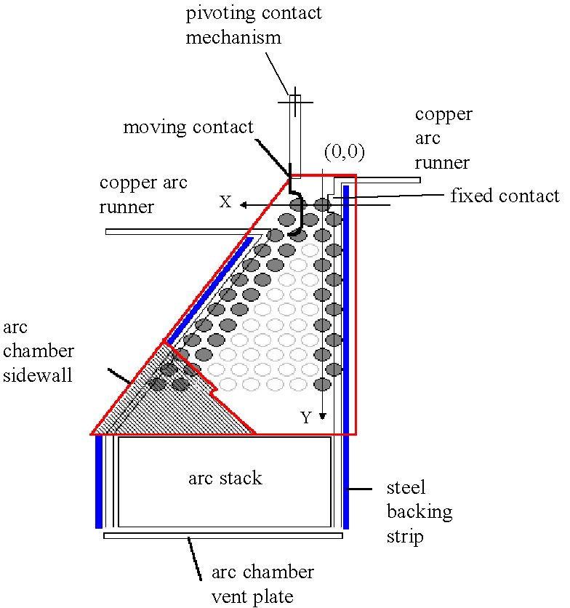
- Schematic of the arc chamber with 68 fiber positions. The shaded fiber positions correspond to the fiber selected for arc root trajectory plotting. The cathode is connected to the fixed contact runner
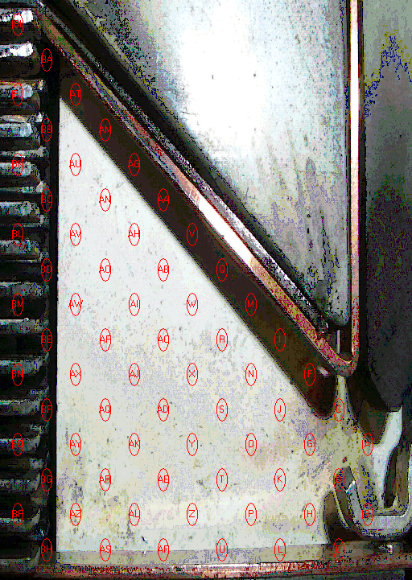
B
H
P
Z
AL
AZ
BF
3.9 mm

E
L
U
AF
AS
BH
- The addressing of fiber positions in the optical array, with expanded fiber sequence along the cathode runner.
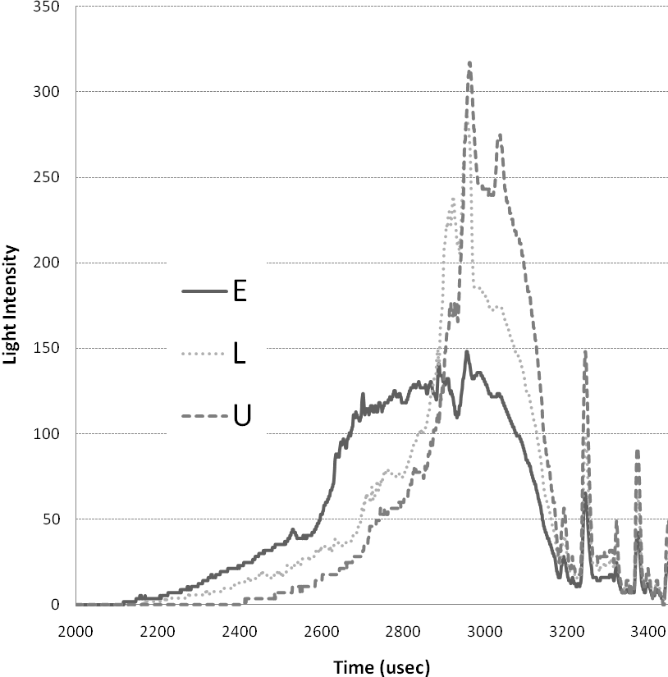
- Light intensity for selected fiber (experiment 1)

Arc Root Plotting
An established method of arc root plotting allows for the definition of parameters, for example the time taken for the arc root to transfer from the moving contact to the fixed runner; such that physical variables, for example the materials used in the chamber can be investigated and compared, [5, 8-11]. The method is based on an intensity based position averaging technique over selected fiber positions near the surface of the runners (shaded fibers in Fig 1), [1,5]. A limitation of the application of was discussed in [1], and results from the influence of low light levels when X or Y are large, see Fig.1. This results in an error in the position of the arc root. To overcome this error, and to determine the positional resolution of the arc root, the additional intensity bit resolution (0-255) allows filter values to be used such that the position of the arc root is more clearly defined. In this new approach low level intensities are filtered such that the position of the cathode arc root can be accurately determined, and then correlated to physical processes.

Experimental methods
The test system used has been described in [5]. In brief, the flexible test apparatus shown in Fig.1 is coupled with a capacitive discharge system, such that current starts to increase 2ms prior to the opening of the contacts; a peak short circuit current of approximately 2 kA occurs with a half cycle period of 10ms. New arc runners and contact materials were selected for each test. In all cases the cathode was consistent with Fig.1, the vent was 15% open, and the moving contact was connected to a high speed solenoid opening device, (>6 m/s). After a single test operation the arc runners are removed from the apparatus. To correlate the arc images with the surface interaction along the arc runner surface, an optical surface profiler is used. The optical profiler is a XYRIS4000CL; it uses a con-focal laser probe to create detailed 3D images of the surface of the arc runners, [13]. For the experiments conducted here there were three cathode runner samples. Sample 1, is shown on the right of Fig 4. It has an AgC tip, and the experiment was conducted once. Sample 2, shown in the middle of Fig 4, was used in the same conditions as sample 1, but for two consecutive tests; and sample 3 has the AgC tip imbedded in the Cu surface as shown on the left in Fig.4. Sample 3 was used for two tests.

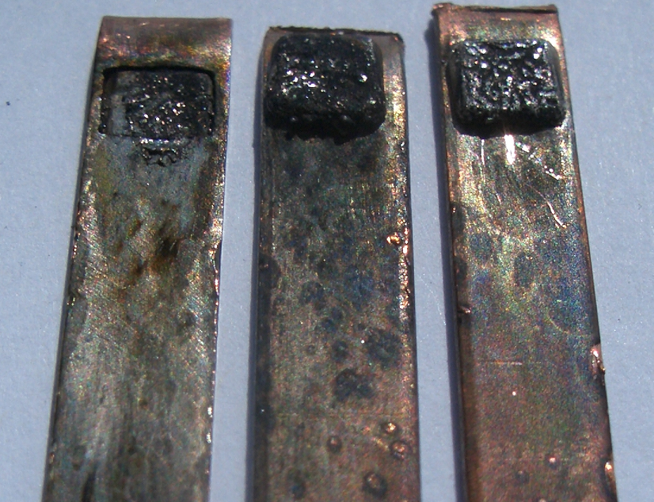
2
1
3
5 mm
- The 3 cathode arc runners: Sample 1 right, Sample 2 middle, and Sample 3, left.

Results

Sample 1
The arc voltage and current are shown in Fig.5. The time base for the data is referenced from the start of the short circuit current pulse. The cathode root position is scaled and shown on the same axis as the arc voltage. The maximum light intensity is also shown. The opening of the contacts corresponds to the step in arc voltage at 1.95ms, when the arc current is 1.3kA. The step in the arc voltage is followed by an increase in voltage as the plasma develops and is forced through the arc chamber towards the splitter plates. The arc voltage peaks at approximately 270V as it enters the splitter plates, at 3.3ms, leading to the reduction in the arc current. Fig.5 shows the maximum light intensity from the fibers selected to detect the cathode root motion (B to BF). The intensity rises after the opening of the contacts and reflects the corresponding increases in the arc power. For the same experiment, Fig 6a shows the arc column using imaging method 2, at 2.947ms having transferred from the moving contact to the anode arc runner, and conducting to the cathode runner region, outside the fixed contact region. The contour values selected are between 30-42% of the maximum light intensity from fiber U, shown to be 320 in Fig.3. Fig 6b shows the arc 12 µs later, at 2.959ms, with the arc column now in the middle of the chamber. This image shows the arc column with a single root on the cathode, but with multiple conducting paths to the anode surface.

Arc Root Motion for Sample 1 and 3
It has been reported that the evaluation of the arc root position is influenced by low light levels on fiber positions at a distance from the zero position, for example at fiber positions AS and AF in Fig.2, [1]. To overcome this limitation a filter can be applied to the calculation such that light levels below the filter value are set to zero. The influence of the filter value on the cathode root position is shown in the Fig. 7 which shows the cathode root position determined using two filter values, 0 and 90. For the filter value 0, at 2ms that cathode is shown to be 5mm from the contact region, with an erratic position. This does not correspond to the visual image, also plotted in Fig 7 where the arc is shown to be present in the region of the contacts until approximately 2.8ms. By increasing the filter value to 90, the cathode root passes the 5mm displacement line at 2.85ms.
The position of the arc root with filter value 90 is also shown in Fig 5, for direct comparison with the arc voltage; this shows that although the arc voltage increases uniformly the cathode root position is characterized by periods when the arc root is stationary.
To accommodate the variation in the filter value Fig.7 shows the cathode root motion with a linear variable filter from 0 to 90 over the time period between 2300 and 2900 µsec. The linear variation in the filter provides the closest fit to the visual interpretation of the arc motion.
For sample 3 shown in Fig. 4, the corresponding cathode root motion is shown in Fig.8. This shows that with the AgC contact region flush to the Cu runner, there is little improvement in the initial arc motion. However when the arc starts to move it does so at a higher velocity.

Wear Profiles of Arc Runner for Sample 1
To enable a correlation with arc root plotting, Fig 9 shows a detailed image of sample 1. It shows the Ag/C contact on the left and a number of regions where there is clear melting of the surface. These 4 positions are labeled a,b.c,d and are plotted as wear regions in Fig.7. They show a correlation with the periods when the cathode arc root is stationary. For the data presented after the single operation of the system the arc runners were removed for detailed analysis using optical profiling, [12]. The anode runner surface exhibits minimal surface damage, however the cathode surface exhibits significant damage. The image in Fig 9, shows the Ag/C contact surface on the left where there is substantial darkening of the Cu surface. The first region of wear is on the lower edge of the Cu runner at “a”. There then appears to be a track of arc steps moving diagonally across the runner shown by the dotted line. The arc root then appears to create a region of wear at “b”; from there the arc appears to have a preference for the upper edge of the runner, which is consistent with the thermal properties of the arc; as the arc chamber is in the horizontal plane for the experiments. Although of particular interest in this paper are the small regions for example “e” where there are a series of small surface irregularities associated with the stepping arc root. 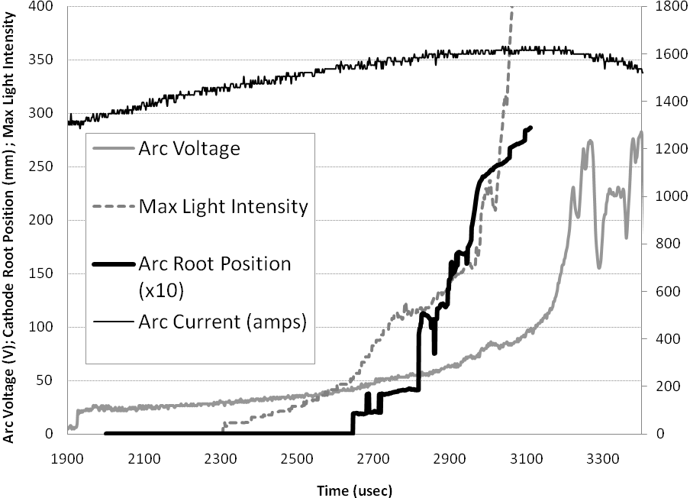
- Left Axis: Arc Voltage(V),with Maximum Light Intensity and Cathode Arc Root Position (x10mm), using a filter value of 90; Right Axis: Arc Current (A)
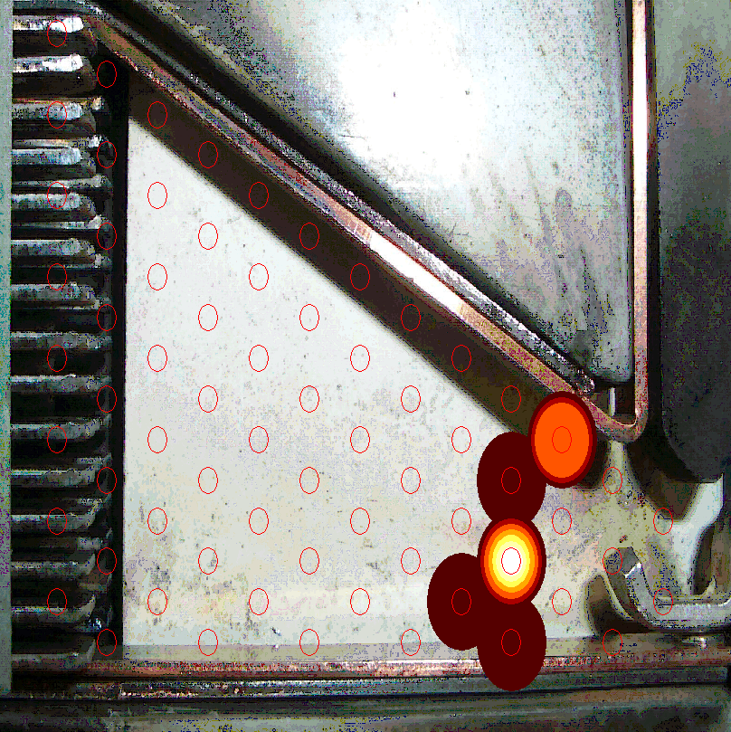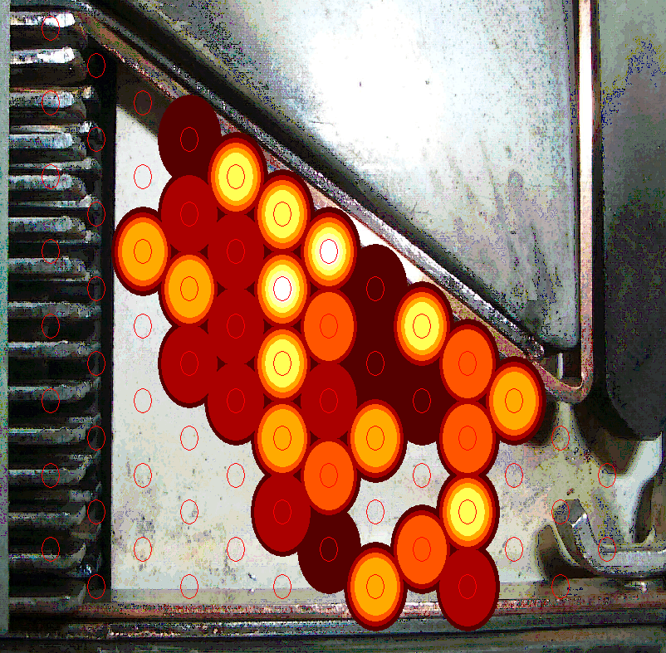
- Arc images using selected filters based on maximum value from fiber U, U(max); at a)2.947ms, and b)2.959ms, using contour values corresponding to 30,32,34,36,38,40,42%, of U(max).
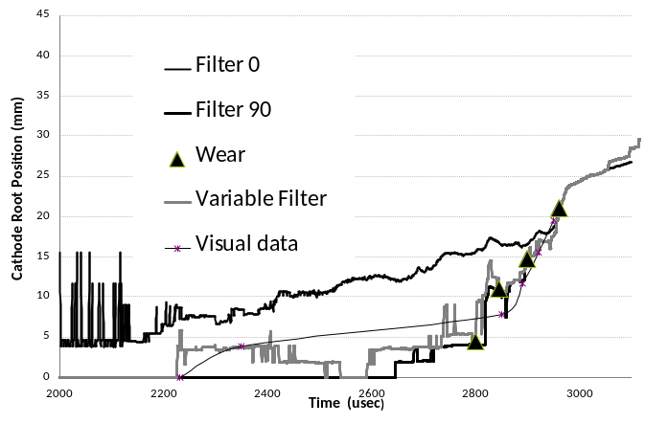
- The influence of cathode root motion with filter values.
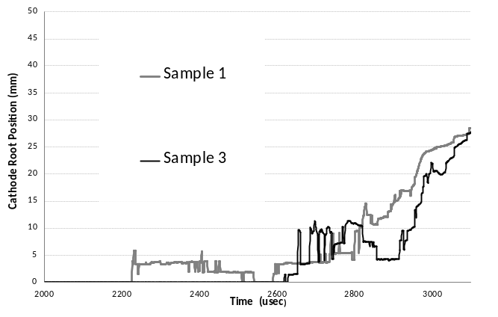
- The Variable Filter Cathode Root Motion for Sample 1 and 2
b
c
d
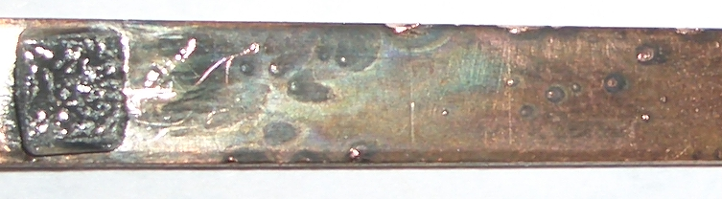
a
e
- Showing the cathode arc runner after the test shown in Fig.5, with highlighted regions where the surface has melted
Further inspection of surface area “e” is shown in Fig.10 with a CCD microscope camera view. The microscope image clearly shows the darkened area around the cathode spot. The green line and data value correspond to the vertical height in microns of the laser spot also shown as a cross-hair in the centre of the image. Fig. 11 is a 3D surface representation of the surface, where it is shown that region “e” is characterised by a melting of the surface, where the surface is depleted or cratered on the leading edge and built up on the trailing edge. Fig.11 shows the details of spot “e”. Its also shows the dotted line used to generate the 2D section in Fig.12. This shows that although the region is easy to identify in Fig 10, surrounded by the blackened areas, the surface is only slightly deformed by the cathode root. Fig 12, shows that the cathode root has melted the surface and as a result of the dynamic forces has pushed the molten metal in the direction of the cathode root motion. The rise in the surface as a result of this action is 6 microns.
There are a number of possible mechanism which could account for the observed data. A possible explanation is that the edges of the Cu runner are the main sources of the electrons once the arc moves from the contact region. This would be consistent with the electric field theory of field emission, [4,5]. The spotted regions are also apparent in sample 2 in Fig 4, however the patterns are lost as the runner has undergone 2 consecutive tests. The runner shown as sample 3 in Fig.4 again shows a different affect with the bottom and the upper edges of the runner showing equal preference for the cathode root.

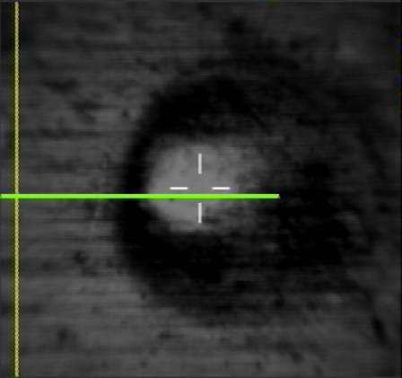
- CCD camera image of region “e”, (CCD visual area 1mmx1mm).
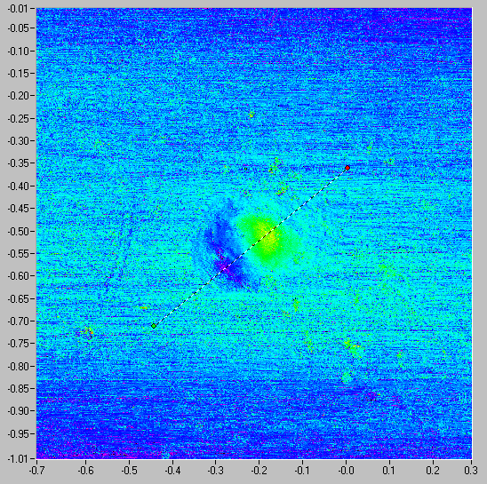
- 3D Surface 501x501data 1mm x1mm corresponding to Fig 10.
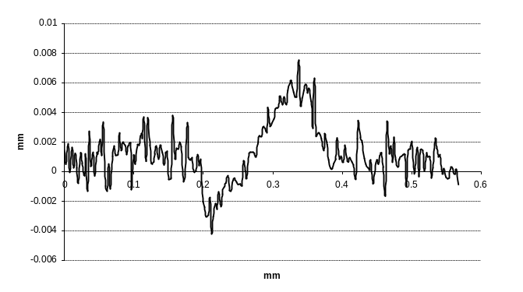
- 2D cross section of cathode root spot.
The experimental data shows strong evidence of multiple arc root and multiple arc paths for a single switching operation. This has been evidenced in the arc imaging data where multiple arc paths have been identified.

Determining the Duration of the Arc root event
Using established theory it is possible to predict the duration that the arc would have been stationary at point “e” to create the surface in Fig 10-12. If we assume:
V.I. t = q = m. C. T + m.L = v.ρ.( C. T + L)
- Where: C the specific heat of Cu is 0.39 JK⁻¹g⁻¹, and where the Latent heat of Cu is 176 Jg⁻¹; and where the temperature change corresponds to the melting temperature of Cu, 1084°C.
- Where the arc energy (q) is only associated with the cathode root fall voltage (V) of 12 Volts, and where the arc current (I) is constant during the brief period and equal to the current during the arc motion period, of 3500A in Fig 5.
- Where the volume of material melted and moved is equal to the volume of material below the datum surface in Fig.11. From the density (ρ) of Cu = 8.94 x10⁻³ g mm⁻³ and the Volume of material below the datum, v =3.745 x10⁻⁵ mm⁻³
Then the duration (t) that the arc root would need to be stationary at point “e” to melt the surface and cause the crater to be formed is 4.7 nsec.

Conclusions
The results shows that the arc imaging system is accurately able to predict the arc root motion and this has been verified with a visual record of the arc motion.
To achieve the accurate plotting of the arc root position it is necessary to use a linear filtering method in processing the arc root data positions.
There is strong evidence that with a single operation the cathode root shows multiple paths, and that these paths are mainly focused on the edges of the Cu conductors.
The 3D surface characterizations allows for the determination of the amount of material melted in a selected arc spot on the cathode. From which we are able to determine the duration of the arc on that spot to cause the melting. This shows that the arc spot are created in a rapid stepping motion of the cathode root.

References
[1] J.W.McBride, A. Balestrero, L. Ghezzi, G. Tribulato, K.J. Cross, “Optical Fiber Imaging for High Speed Plasma Motion Diagnostics: applied to Low Voltage Circuit Breakers”, Review of Scientific Instruments, 2010.
[2] Guile A.E., Sloot J.G.J., “Sudden Transitions in Velocity of Magnetically Driven Arcs”, Proc 3rd Int Conf on Gas Discharges 1974, IEE Conf Pub 118, pp544-548
[3] Secker P.E., Guile A.E., “Arc Movement in A Transverse Magnetic Field At Atmospheric Pressure”, Proceedings of IEE Vol 106 Part A, pp311-320, 1959
[4] Guile A.E., “Arc Electrode Phenomena”, Proc IEE, IEE Reviews, Vol 118, No9R, September 1971
[5] J.W. McBride and P.M. Weaver, “Review of arcing phenomena in low voltage current limiting circuit breakers”, IEE Proceedings - Science, Measurement and Technology, Vol. 148, No. 1, pp. 1-7, 2001.
[6] A. Anders, “The fractal nature of vacuum arc cathode spots”, Lawrence Berkeley National Laboratory, 05-27-2005.
[7] Lindmayer M., “The Influence of Contact Materials and Chamber Wall Materials on The Migration and The Splitting of The Arc in Exinction Chambers”, IEEE Trans on Parts Hybrids and Packaging, VOL PHP-9, No1, March 1973
[8] P.M.Weaver, K. Pechrach and J.W. McBride, “Arc root mobility on piezoelectrically actuated contacts in miniature circuit breakers”, IEEE Transactions on Components and Packaging Technologies, Vol. 28, No. 4, pp. 734-740, 2005.
[9] P.M. Weaver, K. Pechrach and J.W. McBride, “The energetics of gas flow and contact erosion during short circuit arcing”, IEEE Transactions on Components and Packaging Technologies, Vol. 27, No. 1, pp. 51-56, 2004.
[10] J.W. McBride, K. Pechrach and P.M. Weaver, “Arc motion and gas flow in current limiting circuit breakers operating with a low contact switching velocity”, IEEE Transactions on Components and Packaging Technologies, Vol. 25, No. 3, pp. 427-433, 2002.
[11] J.W. McBride, K. Pechrach, and P.M. Weaver, “Arc root commutation from moving contacts in low voltage devices,” IEEE Transactions on Components and Packaging Technologies, Vol. 24, No. 3, pp. 331-336, 2001.
[12] The commercial arc imaging system used. www.taicaanresearch.com
[13] The non-contact surface scanning instruments. www.taicaan.com

