Asynchronous Linking in a Service –Oriented Architecture

Sanjay M. Vivekanandan, Kenneth Tso, Mark K. Thompson, David C. De Roure
Department of Electronics and Computer Science
University of Southampton, UK
{smv99r,kt00r,mkt}@ecs.soton.ac.uk

ABSTRACT
In this paper, we identify research issues in the development of system infrastructure support for asynchronous linkservices in a service-oriented architecture. We explore the suitability and applicability of using MQSeries Everyplace to provide a messaging backbone for linkservices that increases reliability, fault tolerance, and scalability. We identify and discuss some important problems and research issues related to this approach.

INTRODUCTION
We take the position that breaking the traditional synchronous nature of interactions between Open Hypermedia Systems components would engender reliability and scalability of services. We suggest that a service-oriented architecture, such as that offered by Web Services, readily enables hypermedia services to be published, deployed, and invoked by other services on both a global scale on the Internet, and also in a local-area peer-to-peer and pervasive scale. To enable asynchronicity between services, we suggest that store-and-forward middleware messaging systems, such as IBM’s MQSeries Everyplace[7], provide the levels of communication decoupling required to meet this agenda.
This position paper introduces these concepts from this perspective and proposes an example implementation in a scenario where a user with a mobile device attempts to invoke linkservices whilst working in a disconnected state.
Distributed service-oriented architectures help create a distributed environment in which any number of services, regardless of physical location, can interoperate seamlessly in a platform– and language neutral manner. The success of any distributed service architecture is not only dependent on its ability to seamlessly integrate new and existing services, but also to function during periods of intermittent network connectivity.
In recent years, the Open Hypermedia Systems Working Group (OHSWG) has been working on a series of open hypermedia protocols to achieve interoperability between Open Hypermedia Systems[3]. The original Open Hypermedia Protocol (OHP)[6] effort was followed by the Fundamental Open Hypermedia Model (FOHM)[10], the latter concentrating on the link data model rather than an on-the-wire protocol. A contextual structure server, Auld Linky[9], has been developed grounded on the FOHM model and was designed to be a simple, lightweight structure server that serves according to contextual queries. The development of Auld Linky to date has not concerned security features or any level of transaction guarantee, for that has not been the focus of that group’s activity to date. Recent work at Southampton has begun to investigate mechanisms for securing Auld Linky using MQSeries Everyplace[2].
MQSeries Everyplace (MQe) is designed to meet the needs of lightweight mobile devices such as phones and PDAs. It enables mobile devices to securely exchange messages both synchronously and asynchronously using queues and queue managers. Asynchronous messaging is vital in distributed architectures, for service providers and requestors cannot always depend on the availability of each other to do their work. Through a system of queues, messages are exchanged in real time with transactional guarantee. During periods of network disconnection, messages are stored locally until a connection can be established and available for message delivery.

Service-Oriented Architecture

What is a Service-Oriented Architecture?
Service-oriented architectures (SOA) support a programming model that allows service components residing on a network to be published, discovered, and invoked by each other. Typically these services components interoperate with each other in a platform– and language independent manner.
Submission to OHS2002, UMaryland, MD

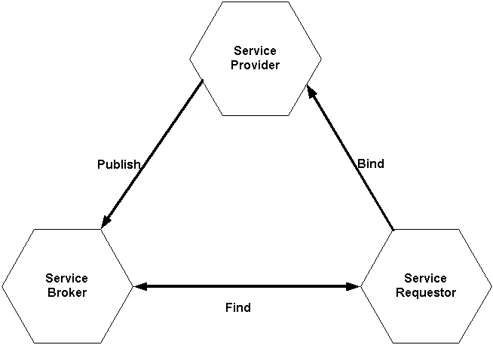
Figure 1. SOA, roles and operations.

The SOA consists of three core components: service brokers, service providers and service requesters (see Figure 1). A service broker acts as an intermediary between the service provider and the service requester, registers and categorizes published service providers and offers search services. A service provider deploys and publishes the availability of its services, and responds to requests to use its services. A service requester uses the service broker to find and bind to the desired service.

Web Services
The primary differences between a distributed service architecture and a distributed Web Service architecture is the size of the network being used and the underlying technologies involved. Web Services extend the SOA programming model into a vast networking platform that allows the publication, deployment, and discovery of service applications on Internet scale using Web technologies including SOAP[1] for inter-service communication, WSDL[4] for service description, UDDI[11] for service directories, and WSFL[5] for multi-service orchestration.
The Web Services platform is organized into the five layers of network, transport, packaging, description, and discovery, as described in Figure 2
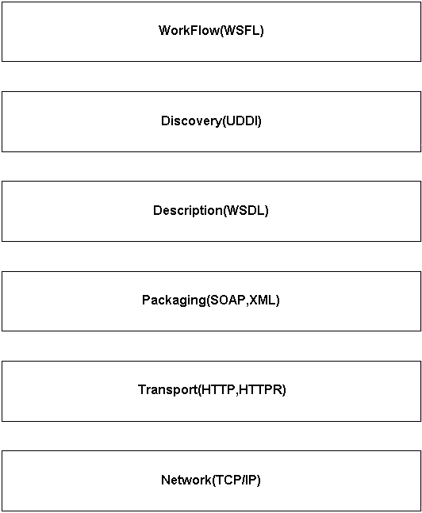
Figure 2. Web Services Technology Stack

Asynchronous Messaging in a SOA
Among the underlying requirements for SOAs to work effectively is that the network supporting the components and services need to be reliable, able to handle unpredictable loads, function during periods of intermittent network connectivity, and complete the ACID test for transactions. It can be argued that existing application connectivity models are neither sufficient nor necessarily appropriate for a pervasive computing infrastructure where participants in the architecture are not guaranteed to be available, discoverable or interact-able from moment to moment. To this end, we suggest architectures based on Message Oriented Middleware (MOM). MOM supports asynchronous messaging by using message queues as shown in Figure 3. Messages are exchanged between the service provider and service requestor through a system of queues. Messages from the service provider are sent to a queue, where the message stays until the service requestor is available and can read it from the queue.
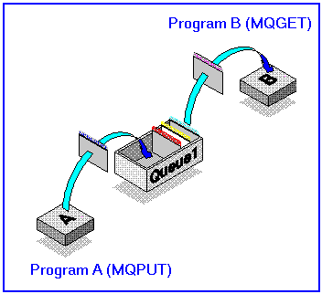
Figure 3. Message Oriented Middleware

From an OHS perspective, asynchronous service interaction readily enables selective and asynchronous link processing. When considering link resolution in a Distributed Link Service across multiple link services, where lock-stepped co-ordination between services is unlikely to be achieved, decoupling document content from resolved links is desirable. There are cases where the results of link resolution queries may no longer be required – perhaps the user is no longer reading the document – and thus the ability to propagate message cancellation on queues between application and services where the queries may not have yet been delivered to services, or the responses back to the client is desirable.

MQSeries Everyplace Capabilities
MQSeries Everyplace (MQe) has a small execution footprint and can comfortably fit into modern mobile devices. In MQe, once-only message delivery is assured. Messages that are received for a remote device by MQe Queues will be temporarily held locally until it can be delivered to its final destination (i.e. when a connection is established). The length of time for messages to remain on the queue is defined by the queue expiry interval (e.g. 5 minutes). Once the time limited is exceeded, the message is marked expired and subsequent action (e.g. deleting it, move it to a dead-letter queue or re-sending it) is determined by a configurable rule in the queue manager process. Message Listeners can be added to the application to listen for events occurring on queues, such as message arrival. MQe provides many security features to protect the confidentially and integrity of messages as well as authenticating entities (e.g. queues, queue managers and users). Using MQSeries-bridge, messages can be exchanged with other MQSeries[8] family members, enabling integration of MQe-based services with pre-existing Enterprise applications.

Discussion
We propose the addition of MQe as a messaging backbone in a SOA that increases reliability, scalability, fault tolerance, and the loose coupling of providers and requestors. In Figure 4, Service A may wish to invoke the Leaky service but the user could be on a mobile device that holds an MQe queue. The user of the client device works offline and stores the SOAP call as a message in a MQe queue on the client device. During network access, the message is sent to a separate MQSeries input queue on the server. The MQSeries proxy retrieves the data from the MQSeries input queue, translating them to HTTP requests, and subsequently forwards it to the Leaky service. The response from the Leaky service is returned to the proxy, and places it in the output queue. MQSeries later sends the result of the query to the MQe queue on the client device, using a queue synchronization process.
Figure 4. Invoking an Auld Leaky Service

Certain issues crop up with the usage of an asynchronous method of transport. The length of time a queue holds the message is among these issues. MQe queues can be defined with an expiry interval, and this function ensures that any message that has remained for a period longer then specified will be deleted. The type of service that is invoked is important in this aspect. If for example, a user queries an Auld Linky service that responds with a set of autobiographical links of an author, the issue of message expiry is not paramount. However, it may be the case that the links returned are of critical importance requiring the client to be informed with haste. This raises the question on how and when to update the links, and how to manage the liveness of asynchronous queries between client and services. MQe does facilitate the concept of filtering which allows it to perform powerful search functions, thus allowing the client to receive messages with higher priority first (or with a shorter expiry time). One drawback to this method is that the links resolved would have to be pre-tagged before being send to the MQe queue.
In a peer-to-peer model, mobile devices may act like a service provider and service requestor simultaneously. Devices using MQe cannot exchange messages without knowing the target queue manager and queue names and hence cannot readily discover each other’s services. One possible solution is to set up a server acting similar to a UDDI registry where service providers’ queue manger and queue names together with the services they provide is stored and queried.
In this position paper we have begun to explore the addition of MQe as a messaging backbone that increases reliability in a SOA, focusing initially on application to link services. The goal of this infrastructure is to provide reliable asynchronous hypermedia services, and ensures that a transaction is completed once initiated.
To conclude, we suggest three areas of research relating to asynchronous linkservices in a SOA:
- Asynchronous Link Processing
For example, how should the query results be delivered to the user? Should it be in a separate window, and should it be loosely coupled with the user’s interaction?
- Message expiry
For example, how long should the messages be stored in the queue before being deleted? How should the messages from different web services be handled?
- Service Discovery
For example, how can services provide by mobile devices in a peer-to-peer model be discovered and be invoked by each other?

REFERENCES
- D. Box, D. Ehnebuske, G. Kakivaya, A. Layman, N. Mendelsohn, H.F. Nielsen, S. Thatte, D. Winer. Simple Object Access Protocol (SOAP) 1.1, W3C Note 08 May 2000. http://www.w3.org/TR/SOAP
- D.C Roure, K. Tso, H. Lambert. Securing a Open Hypermedia System (OHS) Using MQSeries Everyplace (MQe). Submitted to OHS2002, Maryland,USA.
- DAVIS, H. C.,MILLARD, D. E., REICH, S., BOUVIN, N.,GRØNBÆK, K., N¨URNBERG, P. J., SLOTH, L.,WIIL, U. K., AND ANDERSON, K. M. Interoperability between hypermedia systems: The standardisation work of the OHSWG. In Hypertext ’99, The 10th ACM Conference on Hypertext and Hypermedia, Darmstadt, February 21-25,1999 (Feb. 1999), ACM, pp. 201–202.
- E. Christensen, F. Curbera, G. Meredith, S. Weerawarana. Web Services Description Language (WSDL) 1.1, W3C Note 15 March 2001. http://www.w3.org/TR/wsdl.html
- F. Leymann. Web Services Flow Language (WSFL 1.0),IBM Software Group, May 2001. http://www-4.ibm.com/software/solutions/Webservices/pdf/WSFL.pdf
- Hugh Davis, Siegfried Reich, and David Millard. A proposal for a common navigational hypertext protocol. Technical report, Dept. of Electronics and Computer Science, 1997. Presented at 3.5 Open Hypermedia System Working Group Meeting. Aarhus University, Denmark. September 8-11.
- IBM MQSeries Everyplace, http://www-3.ibm.com/software/ts/mqseries/library/manualsa/manuals/mqsev12.html
- IBM MQSeries Family. http://www-4.ibm.com/software/ts/mqseries/
- MICHAELIDES, D. T., MILLARD, D. E.,WEAL, M. J., AND ROURE, D. C. D. Auld leaky: A contextual open hypermedia link server. S. Reich and K. M. Anderson, Eds.
- MILLARD, D. E.,MOREAU, L., DAVIS, H. C., AND REICH, S. FOHM: A Fundamental Open Hypertext Model for Investigating Interoperability Between Hypertext Domains. In Proceedings of the ’00 ACM Conference on Hypertext, May 30 - June 3, San Antonio, TX (2000), pp. 93–102.
- Universal Description, Discovery and Integration, http://www.uddi.org

