E-Books and E-Paper: Are We Nearly There Yet?

Christopher Poulton
Department of Electronics and Computer Science, University of Southampton
University Road, Highfield
Southampton SO17 1BJ
cmp301@ecs.soton.ac.uk
http://www.ecs.soton.ac.uk/~cmp301/

Abstract
The computer, no matter how hard its designers have tried, has never replaced paper; the “paperless office” is far from paperless. We don’t like to read from a computer screen, so we print onto bulky, environmentally unsound paper. With the invention of electronic paper all that is set to change. In just a few years, one digital device could comfortably replace all our paper needs.
Keywords
eBook, ePaper, e-ink.

The Vision
In 1894 a Frenchman named Albert Robida envisioned the end of paper books through dissemination of audio books by telephone, booths in the streets and pocket-sized personal equipment [17]. 100 years on, with the written word still going strong, and still bound in books, another idea to end paper tomes was born.
Joseph Jacobson described in “The Last Book” [8] his vision of every person needing just one book – a book whose page content could be electronically changed any number of times whilst still providing the legibility, comfort and familiarity of ink on paper.
While Robida’s dream has not been met, Jacobson’s electronic book (or eBook) could be in readers’ hands by the end of next year.

The Need for Electronic Paper
In this digital age the majority of new publications, be they books, newspapers, magazines or business reports, are produced electronically on computers. Subsequently, they are printed onto paper and distributed. Why not distribute them electronically? The problem lies in display technology. Backlit pixelated screens, placed upright in front of us at landscape orientation, are a far cry from lightweight, hand-held paper books containing crisp words on a comfortably reflective paper background.
So why change from paper? The University of Southampton Hartley Library has over 8000 square metres of usable floor space [9] and is currently being extended by another third. Electronic copies of all of the books, journals, periodicals and papers that occupy that space could most likely be stored on one server placed under the head librarian’s desk, and be swiftly distributed to readers electronically as and when needed.
To overcome these problems with displays and with paper a new type of technology is needed: a sheet of paper that can be electronically reconfigured instantaneously to display any page from any book, article or document. This technology is ePaper.

Two Technologies
In the 1970s a researcher at Xerox Palo Alto Research Centre (PARC), Nicholas K. Sheridon, had the idea of embedding microscopic beads into a flexible film [15]. Each bead is half black and half white. An electric field applied beneath a bead will cause the bead to rotate in place in order to show either its white (paper) or black (ink) side, as shown in figure 1 below. Sheridon named this technology “Gyricon”, meaning “rotating image” in Greek. Some years later, Sheridon and Xerox PARC founded Gyricon Media [5] to market this idea.
Permission to make digital or hard copies of all or part of this work for personal or classroom use is granted without fee provided that copies are not made or distributed for profit or commercial advantage and that copies bear this notice and the full citation on the first page. To copy otherwise, to republish, to post on servers or to redistribute to lists, requires prior specific permission.
4th Annual Multimedia Systems, Electronics and Computer Science, University of Southampton
© 2003 Electronics and Computer Science, University of Southampton

In 1995, independent of Sheridon, Joseph Jacobson thought of transparent microcapsules containing both a dark liquid dye and particles of white titanium dioxide. An electric charge applied beneath a microcapsule would either draw the titanium oxide to the bottom, revealing the dark dye (ink) or move the titanium oxide to the top, revealing white (paper), as shown in figure 2 below. This movement of charged particles in liquid due to electric fields, called electrophoresis, resulted in Jacobson naming his technology “electrophoretic ink”, or e-ink. Following further research at Massachusetts Institute of Technology (MIT) Media Laboratory, Jacobson founded the E Ink Corporation [3].
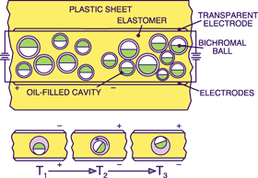
Figure 1 – Gyricon beads, set in cavities on a plastic sheet, rotate when an electric field is applied.
Source: oe magazine, Dec 2001
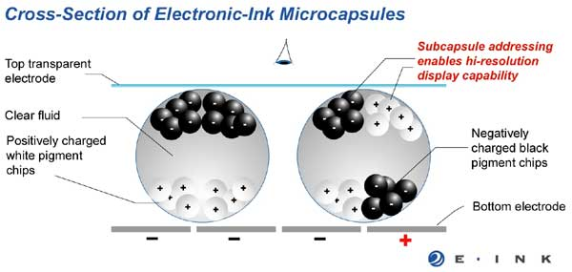
Figure 2 – The particles within E Ink microcapsules move under an electric field, changing their apparent colour.
Source: E Ink Corporation

E-Paper Production
Both Gyricon Media and E Ink Corp. have been continuing their research toward the common goal of producing a thin, flexible ‘sheet’ of high-resolution display material. The first commercial application for each company’s technology has been store signage; producing signs that can be changed electronically and that consume no power between changes. While Gyricon has continued to work in this field, E Ink has concentrated research on developing their technology for use in portable devices such as eBooks.
E Ink has generated much high profile interest, which bodes well on the future of the eBook. Lucent Technologies licensed their plastic transistor technology to E Ink, enabling flexible displays to be produced, as demonstrated in November 2000 [14]; in April 2001, using IBM’s active matrix technology, a display was produced with a size and resolution comparable to laptop displays of the time; and working with the TOPPAN Printing Company of Japan, May 2001 saw E Ink unveil a 3-bit colour display capable of eight different colours.
With all the technology and support behind them, E Ink look set to achieve their ultimate goal in as little as two years [2] – “radio paper”. Radio paper will be a flexible electronic paper capable of producing at least 12-bit colour (over 4,000 different hues) at a resolution more than comfortable for close reading. The displayed content of radio paper will be updated via a wireless data network, keeping it entirely portable.
This technology sets the scene for not only electronic books, but also electronic newspapers. Picture a double-page spread from a broadsheet newspaper that you can hold, fold and roll up like any newspaper, where, instead of turning a page, you press a button to reconfigure the entire sheet to show the latest headlines. Articles could even include moving video images. This is all in the prospective future of E Ink’s radio paper.

Back to the Present
There is much potential for the future of reading, but where do we stand now? In May this year E Ink Corporation and Royal Philips Electronics presented a prototype eBook at the Society for Information Display (SID) show in Baltimore, Maryland. It was the first time that the two companies had combined their technologies to produce a fully functional display, demonstrating their achievement of turning what they call a “game-changing technology” into a “commercially viable product” [4]. The prototype, seen in figure 3 below, is expected to be refined for commercial launch next year.
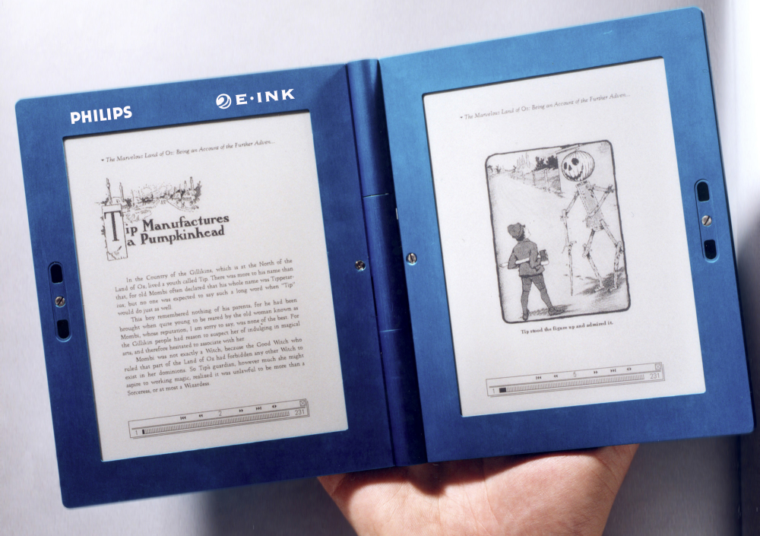
Figure 3 – The Philips/E Ink prototype.
Courtesy of Philips Electronics

Just last week, on 14 November 2003, Sony Corporation, working with 14 other companies, announced their plans to establish a distribution company for eBook media in Japan [6]. The company will be called Publishing link Ltd. This venture is due to start renting out content to eBook users in Tokyo next spring. The company plans to make available an eBook device employing E Ink’s technology that can be used to read content in Sony’s BBeB data format. Customers will rent content from Publishing link by downloading it to a PC, then transferring to the eBook where they will have a certain period of time in which to read it.

Over the First Hurdle…
At a glance, it looks as though we could have Jacobson’s dream of “The Last Book” come true next year. Look again and you will see that the technology still has a long way to go before it can replace the paperback:
- E Ink’s May prototype had a display resolution of 160 dots per inch (dpi). However, the ideal resolution for reading is thought to be at least 300dpi [13], with some magazines today being printed at 1,200dpi. E Ink would need to at least double the resolution of its displays (ie. halve the size of each dot) to be as comfortable on the eye as ink on paper. The theory exists to do this – see figure 2 above depicting ‘subcapsule addressing’ to achieve multiple dots per microcapsule – but practical application could take a few more years. Despite this, e-ink is an improvement on current computer display technology of about 100dpi. The level of detail provided by E Ink’s prototype is demonstrated in figure 4 below;
- Working with TOPPAN, E Ink has created a 3-bit, 8 colour display. Today’s computer monitors provide at least 24-bit (16 million) colour. Of course, ink on paper has no such colour limit. I suspect that ePaper will not be globally accepted until it can display some millions of colours;
- When reading a book, we turn a page to find the next instantly there to read. E-ink is capable of changing its image in 250 milliseconds, which is acceptable. However, if e-ink were to be used to display video, the ink switching speed would have to improve to 15 milliseconds [16].
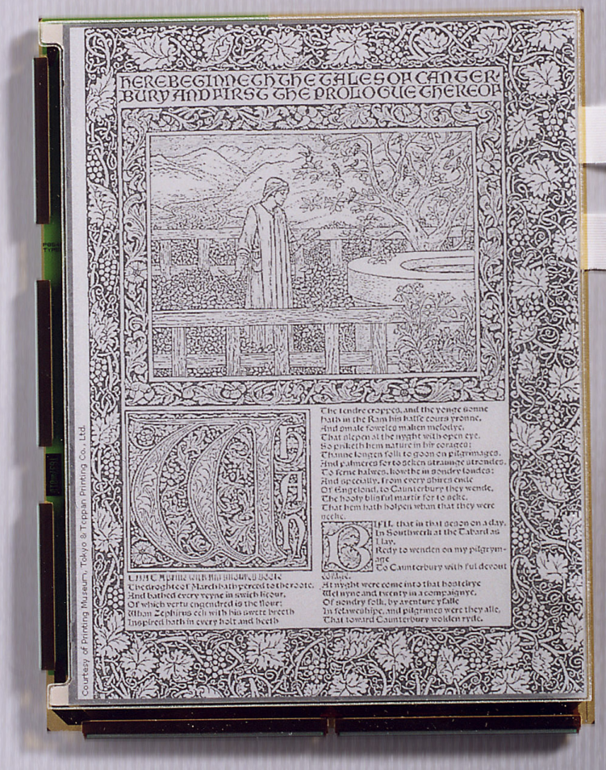
If the technology continues to develop at its current rate, it should not be long before we see these improvements. Unfortunately, technology is not the only obstacle in the eBook’s way.
Figure 4 – The resolution of E Ink’s prototype is better than that of an LCD screen.
Courtesy of Philips Electronics

…Stuck at the Last
For the eBook to replace paper books, the content that is made available to us now would have to become accessible digitally. Due to issues of copyright with electronic media, such as music and software, publishers are reluctant to make any material available in this format. Ideally, all eBook manufacturers would work together with content publishers to produce a standard document format and rights management system that respects copyright. Although work has started on such a standard, known as Open eBook [10], manufacturers are keen to use their own proprietary formats in order to capture the market.
Content availability is only one issue that will affect consumers’ acceptance of the eBook, and hence its success. There are many social, personal and market issues to consider, discussions of which can be found in a number of sources.

Beyond Reading
The majority of this writing has focused on attempting to replace paper with an electronic device possessing similar characteristics. It doesn’t stop there. The key reason for replacing paper is that with digital electronics we can do so much more. It is already understood that one eBook could be capable of containing an entire library. It is what we do with this library that must be explored.
The first extension to the eBook must be the touch screen. This technology is already advanced and readily available, so integration with E Ink’s display would be straightforward. Using a stylus, a user will be able to highlight text, make annotations and, with the aid of handwriting recognition software, even write their own documents. There are already a number of touch screen-enabled portable electronic devices that we use for a variety of tasks. It is perfectly feasible – expected even – that the functionality of these devices be incorporated into the eBook format. Your reading device could become your diary, calendar, address book and calculator.
With reading the primary purpose of the eBook, there is much that can be added from the computer world in order to better paper:
- The ability to search, sort and cross-reference alone would make the eBook stand out from the paperback;
- A dictionary, thesaurus and encyclopaedia could be made available at any time. By just selecting a word its meaning would immediately be made apparent;
- Audio would be a welcome addition to a book, especially for the blind or partially sighted. Through the use of text-to-speech software any book or document could be read to the user;
- The inclusion of translation software would allow a book to be read in any language;
- Connectivity is an important aspect of today’s computers. Providing an eBook with wired or wireless communications would allow users to exchange documents and books (although this is what publishers are afraid of) and perhaps access their email and surf the Internet.
Not all of these additions would be welcome from the start. Any extra feature would push up costs, increase physical size, and drain the batteries of eBooks. However, once the eBook has taken off, the inclusion of extra functionality would attract a wider market.

Take a Step Back
Despite all the potential and opportunity of the eBook to be extended into an all singing, all dancing personal tool, we must hold back.
The eBook as a handheld reading device has been commercially available for some years using liquid crystal display (LCD) technology, yet has not taken on popularity. For this new generation of eBook, with a physical resemblance to paper, it will hopefully be different. For use of the eBook to become ubiquitous, it must be usable by everyone. Keeping the device simple from the start will appeal to potential users who are not computer literate.
Once there is a demand and a customer base, eBooks with extended features will I am sure be welcomed.

Just Around the Corner?
With the launch of the eBook featuring E Ink’s technology set for next year, how could we not say that we are nearly there?
The technology is certainly here with, I think, enough improvements just around the corner to make an eBook device desirable. However, at this moment the eBook culture is still a long way off. The time when we each need just one eBook to replace all of our paper-based needs is not in the foreseeable future.
While we wait for the publishers to put their works up for electronic sale, and for the numerous corporations to work together on a common standard, the technological research goes on.
I can see myself by the end of next year sitting in bed with my eBook reading the latest Terry Pratchett book, having downloaded the novel from the personal website of a dedicated fan who has a scanner and a lot of time on their hands.
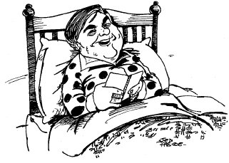
In two or three more years I hope to be buying or renting my favourite works, receiving them instantly on my eBook whilst sitting on the sofa.

Source: IEE Review, Nov 95

References
- J.M.Bryant, “The Paperless Book,” IEE Review, Vol. 41, No. 6, 16 Nov 95, pp. 245-247.
- S. Ditlea, “The Electronic Paper Chase,” Scientific American, Nov 2001.
- E Ink Corp., http://www.eink.com, last accessed 22nd November 2003.
- E Ink Corp., Press Release, 12 May 2003, http://www.eink.com/news/releases/pr69.html, last accessed 22nd November 2003.
- Gyricon LLC., http://www.gyriconmedia.com, last accessed 22nd November 2003.
- Y. Hara, “Sony leads eBook venture,” EE Times, 14 Nov 2003
- B.L. Harrison, “E-Books and the Future of Reading,” IEEE Computer Graphics and Applications, May/Jun 2000, pp. 32-39.
- J. Jacobson et al., “The Last Book,”
IBM Systems J., Vol.13, No.3, 26 Mar 1997,
pp. 457-463.
- B. Naylor and R. Chambers, “The Post-Modern Library: Between Functionality and Aesthetics,” Jan 1996, http://webdoc.gwdg.de/ebook/aw/liber96/
nayl.htm, last accessed 22nd November 2003.
- Open eBook Forum, International Trade and Standards Organisation for the eBook Industry, www.openebook.org, last visited 23rd November 2003.
- Philips Research, “Electronic Paper / E Ink,” http://www.research.philips.com/
InformationCenter/Global/FArticleSummary.asp?lNodeId=929#epaper, last accessed 23rd November 2003.
- L. Press, “From P-books to E-books,” Communications of the ACM, Vol. 43, No. 5, May 2000, pp. 17-21.
- K. Schreiner, “E-Books: It’s All in the Resolution,” Multimedia, IEEE, Vol. 7, No. 2 Apr-Jun 2000, pp. 15-17
- Semiconductor Fabtech, “E Ink and Lucent Technologies demonstrate world's first flexible electronic ink display with plastic transistors,”
21 Nov 2003, http://www.semiconductorfabtech.com/
industry.news/0011/21.04.shtml, last accessed 23rd November 2003.
- N. Sheridon et al., “Gyricon Displays and Electric Paper,” Proc. of SID, Society for Information Display, San Jose, Calif., May 1997.
- E. Smalley, “Flexible Displays Slim Down,” Technology Research News, May 21-28 2003.
- O. Uzanne and A. Robida, “Contes pour les Bibliophiles [Stories for Bibliophiles],” The Century Magazine, May 1894.

Beverly Harrison discusses in detail the differences between computer displays and paper in her article “E-Books and the Future of Reading” [7].
A detailed history of these technologies is described in Steve Ditlea’s “The Electronic Paper Chase” [2].
For a full specification of the display technology being made commercially available to companies next year, I refer you to the Philips Research website [11].
A discussion of what is required of an eBook in “The Paperless Book” [1]; an examination of the way that we like to read in “E-Books and the Future of Reading” [7]; an opinion on electronic publishing and content in “From P-books to E-books” [12].

