A Real-time Personalization Service for SCORM

Nor Aniza Abdullah and Hugh C Davis
Learning Technologies Group, School of Electronic and Computer Science
University of Southampton
naa02r{hcd}.ecs.soton.ac.uk

Abstract

Despite SCORM’s (Shareable Content Object Reference Model’s) advantages, many scholars argue that SCORM confines learners to a static pool of learning resources organized in a predefined narrative structure. Hence users are unable to explore around the current topic, for example, in order to access materials that respond to their preferred learning styles. To address these limitations, we propose an architecture to provide SCORM with an independent ‘service’ that supplies the learner with dynamic personalized links to alternative resources. We demonstrate the feasibility of our architecture by implementing a service supporting users’ Learning Styles.

1. Introduction

The Sharable Content Object Model (SCORM ) [2] is a reference model of interrelated learning resources specifications and standards prepared by standard bodies such as IMS [8], IEEE LOM [7], and AICC [3]. Recently SCORM has achieved significant acceptance among e-leaning developers because it permits Web-based content distribution and reuse across multiple learning environments and products.
However SCORM confines learners to a static pool of learning resources organized in a predefined narrative structure. Hence all learners’ will receive the same set of learning resources regardless their preferences. We intend to tackle this constraint by virtually expanding SCORM’s package with real-time external resources via an independent ‘Personalization Link Service’ (PLS). The external resources are chosen based on the learner’s learning style, to supplement the current concept being delivered by the environment.
Our proposed architecture uses Adaptive Hypermedia (AH) [6] technology which consists of three models. First, a domain model is built to provide the AH system with some knowledge about its subject domain. Secondly a user model captures the user’s static and dynamic information. Lastly an adaptation model defines how the domain model relates to the user model in order to specify adaptation. Recent development in AH research has shown progress in adaptation according to users’ learning styles [1,4] on the assumption that each individual has their own preferred approach to perceiving and processing information.
To demonstrate the feasibility of our work we have developed a prototype personalization service based on supporting the learner’s preferred Learning Style. The implementation of the PLS is an innovative approach to enrich and personalize learners’ experience with SCORM without subverting the teacher’s narrative.
In the following section we explain our proposed architecture and how it fits into the SCORM Runtime Environment. Section 3 outlines some related work. In Section 4 we conclude and describe our future work.

2. An Architecture for a Personalized Link Service

Our architecture, shown in Figure 2, is built using the AuldLinky contextual link server [9] which allows dynamic queries about structures (such as links), using the Fundamental Open Hypermedia Model (FOHM) [10]. FOHM is a data model that provides a generalized structure of hypermedia information to facilitate interoperability among hypermedia domains.
The process begins by attempting to automatically deduce a simple concept map from the SCORM manifest file which is located inside a SCORM courseware package [2]. The manifest is an XML file that describes both the resources to be used for a particular unit of learning material along with one or more organizations which by default determine the order in which these resources will be presented or sequenced [1]. Technically, the organization contains a collection of activity nodes, each given the title of a particular learning topic, and the leaf nodes are attached to the corresponding resources.
Our concept map encompasses a list of concepts each with the following attributes: concept name, its associated node id, its parent id and weight of knowledge this concept makes to its parent’s concept. The name for each concept is derived by mapping each word in the topic (from the manifest) against a manually prepared lexicon of important terms within the domain.
The map is later used as the reference point to create a “service linkbase” of links to alternative resources via our linkbase authoring tool. The linkbase is an XML-file that is composed of associations of links to the alternative resources expressed as hyper-structures in FOHM, and marked up with the concepts that they respond to, and the learning style(s) they support. This authoring process for the concept map and the linkbase is depicted in the Figure 1.
Resource

Manifest

Service Linkbase
Users Interventions
Linkbase Authoring
Mapping Process

Lexicon
Theme Extraction

Topic Names. Relation
Structure
Concept Names
Concept
Map
Concept Names
Links

Potential Keywords
The
Web
Figure 1: Pre-runtime authoring
The availability of the concept map permits the Adaptive Interface (Figure 2) to associate the resource being viewed by a user via the ADL SCORM player with a concept name. Technically we hooked the ADL SCORM RTE’s (Version 1.3) script so that each time the sequencing engine is invoked (by a user clicking the previous or the next navigational button or selecting an item from the tree menu of the SCORM RTE’s interface) we can capture the activity id of the resource to be launched.
Both the concept name and the user’s preferred learning style which is obtained from a user model are sent as a SOAP (Simple Object Access Protocol) request to our Personalized Link Service (PLS) for additional links. When the PLS receives the request, both parameters are used as context objects to query the AuldLinky server [9] as shown in Figure 2. Among the advantages of AuldLinky is that it allows more than one ‘service linkbase’ to be dynamically queried at run-time to retrieve additional links according to any given context.
URLs
Adaptive Interface

Concept Map
Service Linkbase
User Model
PLS Interface
URLs

AuldLinky
Concept, Learning Style
Concept, Learning Style
Personalized Link Service (PLS - Web Service)
Additions at LMS server
Browser (Client)
ADL
RTE

Activity ID
URLs
Figure 2: The architecture that augments SCORM at runtime with personalized links to alternative resources
The querying process results in a list of URLs to resources marked as matching the concept taught by the SCORM environment and the user’s learning style. The URLs are then channeled to the PLS Interface which later sends them to the service client as SOAP responses. At the client the SOAP messages will be interpreted and an array of URLs is derived and the description metadata for each page is displayed into a browser as a list of personalized links, as demonstrated in Figure 3.
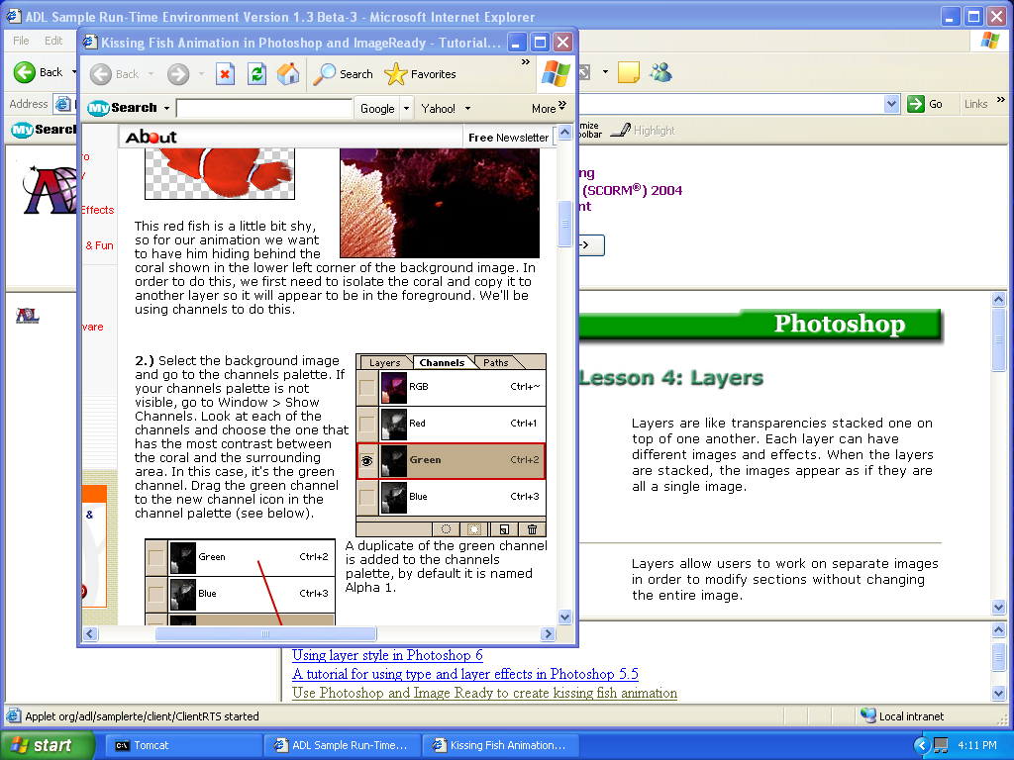
A
B
C
Figure 3: A screen shot of the modified ADL SCORM RTE with the suggested alternative links
The list of links to supplementary materials is provided in frame (B) matching the concept being displayed in the primary material in frame (A). Once a link from frame (B) is selected a pop up window displaying the content of the URL appears (C), so that the additional material does not interfere in any way with the author’s intended instructional sequence. Frame (B) is the component that we have integrated with the existing SCORM RTE environment.
The current prototype allows new users to select or change the preferred learning style stored in their user model, from a list in a dialog window, on entering the system.

3. Related Work

There are some interesting efforts being carried out to ameliorate SCORM’s inability to offer learning adapted to users’ current knowledge. Shute and Towle [11] have demonstrated a process for reassembling SCORM’s collection of learning objects on the fly to meet the learner’s current needs. Their approach categorized the collection of learning objects into three knowledge types (basic knowledge, procedural knowledge, or conceptual knowledge). Then based on the content model and learner’s current knowledge an adaptive engine will decide which learning object(s) to present, or sequence according to the characteristics and needs of the learner.
Another effort came from a group of researchers at Carnegie Mellon University who have proposed the requirements to extend the sequencing model embodied in SCORM [5]. One of the requirements recommended is to create a new sequencing rule that can identify learning objectives in each lesson to be included in the aggregated objective value, so that users’ performance data from multiple learning objectives can be aggregated.
As compared to both aforementioned efforts, ours differs in that we provide personalization in the form of supplementary links rather than by actually adapting the content or navigation of the author’s intended instructional design. The advantages of our approach are that first we virtually expand SCORM content package to include external resources based on users’ learning styles. Secondly, the service component can be situated on the web available to all and, if appropriately populated, could provide additional resources to any SCORM learner over a range of topics.

4. Conclusions and Future Work

Our work has demonstrated an architecture for the creation of a personalization service for SCORM which works by integrating with the ADL SCORM RTE 1.3 environment so that users are provided with personalized links according to some criteria within a user model. The outcome from the prototype has demonstrated how the SCORM learning environment can be augmented with links to resources that are about the same topic as the user is studying, and which appear to support the learner’s preferred learning style. However the architecture is generalizable to support any personalization based on a given user model.

Our future plans will include implementing dynamic user model, investigating approaches for automatic identification of alternative resources and improving the preparation of the lexicon, which is used to identify concept with the manifest, by using theme extraction from the resources addressed by the manifest (as shown by shaded boxes in Figure 1). But we still envisage that a degree of user intervention will be necessary to produce a reliable lexicon.

5. References

[1] Abdullah, N.A., Bailey, C.P., and Davis, H., “Augmenting SCORM Manifest with Adaptive Links”, In Proceedings of the 15th ACM Conference on Hypertext and Hypermedia, Santa Cruz, 11-13 August, 2004.

[2] ADL SCORM, http://www.adlnet.org, 22 July 2004.

[3] AICC CMI Guidelines for Interoperability Revision 4, http://www.aicc. org, 16 August 2004.

[4] Bajraktarevic, N., “Adaptive Hypermedia, Learning Styles and Strategies within the Educational Paradigm”, PhD Thesis, University of Southampton, Sept 2003.

[5] Blackmon, W., Brooks, J., Roberts, E., and Rehak, D., “The Overlap and Barriers between SCORM, IMS Simple Sequencing, and Adaptive Sequencing”, White Paper, Carnegie Mellon Learning System Architecture Lab, http://www.lsal.cmu.edu/lsal/expertise/papers, 2004

[6] Brusilovsky, P., “Adaptive Hypermedia”, in Alfred Kobsa (ed.) User Modeling and User-Adapted Interaction, Ten Year Anniversary, Issue 11, 2001, pp.87-129.

[7] IEEE LOM, http://ltsc.ieee.org/wg12, June 2002

[8] IMS, http://www.imsglobal.org, 3 March 2003

[9] Michaelides, D.T., Millard, D.E., Weal, M.J. and De Roure, D., C., “Auld Leaky: A Contextual Open Hypermedia Link Server”, In Proceedings of the 7th Workshop on Open Hypermedia Systems, ACM Hypertext 2001 Conference. Aarhus, Denmark 2001.

[10] Millard, D. E., Moreau, L., Davis, H.C., Reich, S., “FOHM: A Fundamental Open Hypertext Model for Investigating Interoperability between Hypertext Domains”, in the Proceedings of the 11th on the ACM Conference on Hypertext and Hypermedia, 2000, pp. 93-102

[11] Shute, V, and Towle, B., “Adaptive E-Learning”, in Educational Psychologist, Vol. 38, No. 2, pp 105-114, 2003

