Multi-Board FPGA Synthesis with
Asynchronous Communications Subsystems

Tack Boon YEE Mark ZWOLINSKI
Electronic Systems Design Group
School of Electronics and Computer Science
University of Southampton
Southampton SO17 1BJ
United Kingdom
@ecs.soton.ac.uk

Abstract
With the ever-increasing complexity of digital designs, design abstraction has increased from schematic to language-based, and is migrating towards abstract behavioural specifications. Partitioning of the circuit or system into a collection of smaller, manageable components has become a central and critical design task. Asynchronous techniques of data synchronisation between partitioned designs, often in different clock domains, are well-researched areas in low power, and system on chip designs. In this paper, we present a high-level synthesis system that synthesises and generates structural outputs of a multi-board FPGA system automatically without any modification of the source HDL code. The targeting of multiple prototyping boards trades off performance for improvement in prototyping time and cost. Optimised asynchronous communications channels with communications cells are inserted automatically to the multi-board FPGA implementation during synthesis, synchronising inter-FPGA data packets transferred asynchronously between the locally clocked FPGAs.

1. Introduction and motivation

Field Programmable Gate Arrays (FPGAs) are often used in logic emulation, prototyping applications, and re-configurable computing because of their programmability features, low costs and early time-to-market [1]. Sometimes the capacity of a single FPGA is too small to implement large designs or because of the input/output (I/O) pin limitation of the device, therefore, Multi-FPGA systems [2, 3] are commonly used. There are a lot of different boards and topologies for multi-FPGA systems, with the mesh and crossbar topologies being the most common [3, 4]. The other approach is to target multiple FPGAs over multiple separate prototyping boards, and connect the boards in a point-to-point manner using data cables, or connect all the boards on a backplane.
FPGA-based prototyping boards provide an ideal platform for testing and development of digital systems. There are many types of prototyping boards available, from low-cost general purpose to high-end performance, specialised boards for high-performance and computing applications like digital signal processing and image processing.
The aim of this paper is to propose a new approach of multi-FPGA system synthesis targeting a multi-board architecture, with the automatic insertion of a single or multiple optimised asynchronous communication channels between multi-board FPGAs. A two-phase enhancement was added to an existing high-level synthesis system to support multi-FPGA synthesis. Phase one is the K-way partitioning phase and phase two generates and optimises the Communications Subsystem that handles the data transfers across the communication channels. The synthesis system can target an arbitrary number of prototyping boards with heterogeneous FPGA devices, taking into consideration the area and input/output constraints of each device on each prototyping board.

2. Multi-FPGA partitioning and synthesis

Partitioning and routing are two major tasks in the synthesis of multi-FPGA systems. Partitioning of a design over multiple devices can be performed at various levels of abstraction, with a multitude and combinations of techniques in multi-FPGA partitioning. One of the best-known, most widely referred to and extended is the Kernighan and Lin (KL) algorithm [5] and its variant, the Fiduccia-Mattheyses (FM) heuristics [6]. An overview of various partitioning techniques can be found in [7]. Three main issues to be taken into account by a multi-FPGA synthesis system are 1) number of interconnects available across all the devices, 2) device area of each device, and 3) latency due to inter-chip communications. Advantages of functional partitioning over structural partitioning have been discussed in [8] and a three-step approach to functional partitioning is given in [9]. Integrating multi-FPGA partitioning within high-level synthesis is given in [10-12].
Logic utilisation of devices in a multi-FPGA system is under-utilised due to I/O limitation [1]. Methods to overcome the I/O limitation problem are presented in [13, 14]. Virtual wires in [13] are created to multiplex and pipeline inter-device signal I/O signals, through the use of shift registers. FunctionBus in [14] uses a bus-based approach for implementing function calls among FPGAs.
The rest of the paper is organised as follows. Section 3 describes the proposed synthesis and partitioning framework. Section 4 describes the partitioning methodology and the generation of optimised communication channels to address the I/O limitation problem. Section 5 presents the results of the multi-FPGA synthesis.

3. Synthesis and partitioning framework

The Multiple Objective Optimisation in Data and control path Synthesis (MOODS) High-level Synthesis System [15] is the high-level synthesis tool developed at the University of Southampton. The MOODS synthesis system synthesises and produces a structural implementation of the behavioural described design with the advantages of a rapid development time and design space exploration providing many alternative implementations (with differing area, delay, power characteristics). The MOODS synthesis and partitioning framework is shown in figure 1.
The HDL input is passed into the MOODS synthesis system and translated into a simple intermediate description, Intermediate CODE (ICODE). ICODE is a proprietary language independent description suitable for direct input into the core MOODS synthesis engine. An initial, naïve control and data path representation of the system is created by a direct translation of the ICODE input. The synthesis optimisation process involves the repeated application of small, semantic (behaviour) preserving transformations to the control path and data path graphs. Transformations are selected and applied to modify parts of these graphs under the control of simulated annealing or goal oriented optimisation algorithms. Together with technology-specific estimates fed up from low-level cell libraries, this iterative transformation-based optimisation is guided by a global cost function that evaluates a design configuration with respect to user-specified objectives on area, delay and power dissipation.
The two-phase partitioning enhancement reads in target technology information such as the number of target FPGA devices, logic capacity and I/O resources from a partitioning information file. This partitioning information file also contains optional partitioning parameters such as the starting partition for the K-way partitioning algorithm and locking of modules to partitions.
With design activity profiling, module activation can be modelled more accurately and the profile data is used to guide the partitioner in producing a multi-board FPGA system with less inter-FPGA data transfers. The temporal ‘traffic analysis’ is extracted from the simulation of the design using a typical (or likely) set of values emulating a working system. The K-way partitioner automatically partitions and maps modules to a minimal number of target FPGA devices needed to implement the system. Communication channels are optimised and inserted between target devices with inter-FPGA data transfers. Each communications channel has a communications subsystem to handle resource arbitration and synchronisation of data packets transferred between the FPGAs connected to the shared communication channel.
With the inclusion of the partitioning enhancement, multiple structural VHDL output files are generated, one for each target device in the multi-FPGA system with the interface ports that link to the structural implementation of the communications subsystem automatically inserted to the entity port list declaration of the generated structural VHDL design.
The structural VHDL outputs are taken through third-party low-level logic optimisation (Synplicity Synplify Pro 7.7.1), and layout (Xilinx Integrated Software Environment Series 5.2i) tools to generate bitstream files for the FPGA devices.

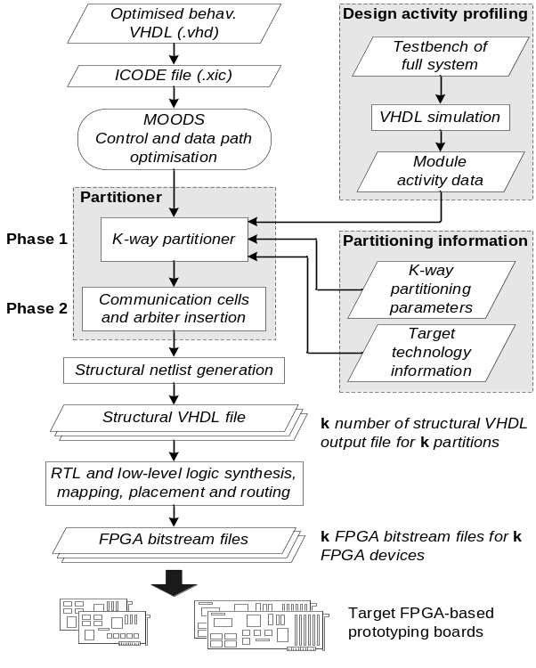
Figure 1. Synthesis and partitioning framework

4. Partitioning approach

The input behavioural specification (described in VHDL) is translated into a corresponding intermediate code (ICODE), where VHDL Processes and subprograms (functions and procedures) are translated into ICODE modules, and modelled as control and data path graphs within the synthesis core. Multi-FPGA partitioning assigns the MOODS optimised ICODE modules among k target devices.
A module call graph representation is used to model the data structures for partitioning, where each node represents an ICODE module, and each edge represents a subprogram call. This representation allows the modelling of subprogram calls from different modules in the design, with arbitrarily deep nesting of such calls.
The module call graph is a weighted directed acyclic graph CG = (N, E). Each node n_{i} ∈ N represents a module in the design, the area of each module is denoted as a(n_{i}), and the I/O pin count is denote as io(n_{i}), for i→1 to n_{total}, where n_{total} is the total number of modules in the design. Each edge e_{i} ∈ E, e_{i} = (nsrc, ndst, data_pkt, act_count), nsrc ∈ N, ndst ∈ N, nsrc ≠ ndst corresponds to one or more subprogram calls from the source module nsrc to the destination module ndst. The data packet count data_pkt is the number of data packets transferred as parameters between nsrc and ndst during each call. The activation count act_count is the number of times nsrc calls ndst.
A set of available m target devices is given by D = {d₁, d₂, …, d_{m}} where m ≥ k ≥ 2. Each device d_{i} = (d_area_{i}, d_io_{i}) where d_area_{i} and d_io_{i} denote the area capacity and number of available I/O pins of device i. The K-way partitioning problem finds a set of clusters P = {p₁, p₂, …, p_{k}} such that p_{i} ⊆ N for i→ 1 to k,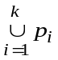 = N and p_{i} ∩ p_{j} = ∅ for i→ 1 to k, j→ 1 to k, and i ≠ j.
The partitioning solution must satisfy a set of device constraints (area and I/O) and minimise the inter-partition data transfers. The area constraint for this K-way partitioning problem is given by
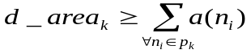
for k partitions where i→ 1 to n_{total}, n ∈ N, and p_{k} ∈ P.
Let the cut-size c_{kj} be the number of interconnects crossing the partition boundary between partitions p_{k} and p_{j}. The I/O constraint is given by
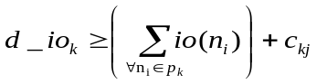
for k partitions where i→ 1 to n_{total}, n ∈ N, and p_{k} ∈ P.

4.1. Two-phase partitioning enhancement

The two-phase partitioning approach consists of the K-way partitioner in the first phase and communication cell and arbiter insertion in the second phase. Figure 2 presents the outline of the proposed K-way partitioning algorithm. The inputs to the K-way partitioning algorithm include the module call graph of the design and the area constraint of the target devices. The algorithm starts with an initialisation stage where the input call module graph CG is checked to ensure that it is properly annotated with valid parameters, and all constraints such as number of target devices are set. An initial partition is generated and this forms the starting partition of the first pass. The K-way partitioning algorithm is similar to the two-way FM algorithm [6] with slight changes in the select-and-move process and the balanced criteria.

K-way Partitioning Algorithm
CG: module call graph CG = (N, E), N is a set of nodes and E is a set of edges
DevArea[]: Device area of each target device (FPGA)

KWay ( CG, DevArea[] )
Begin
Initialise K-way partitioning parameters;
CurrentPartition ← Generate a legal initial partition;
BestPartition ← CurrentPartition;
BestCutcost ← CurrentCutcost;
improved_cutcost ← True;
/* ----- PASS MANAGER ----- */
while ( improved_cutcost ) {
/* ----- MOVE MANAGER ----- */
step_number ← 0;
while (kway_move_vertex(Gain_Array,CurrentPartition,DevArea[])){
step_number++;
Update K-way Gain_Array, and CurrentCutcost;
Update tentative_cutcost[], tentative_moves[], tentative_moved_to[];
Update size of partition and lock moved node;
if (tentative_cutcost[best_tentative_move] ≥ CurrentCutcost ) then
best_tentative_move ← step_number;
end if
} end while
for (i =1; i ≤ best_tentative_move; i++)
Permanently move nodes in tentative_moves[i] to partition specified in tentative_moved_to[i]
end for
improved_cutcost ← False;
if ( CurrentCutcost < BestCutcost ) then
CurrentPartition ← BestPartition;
CurrentCutcost ← tentative_cutcost[best_tentative_move];
Improved_cutcost ← True;
end if
} end while
return ( CurrentPartition ) /* Final partition */
end
Figure 2. Outline of the K-way partitioning algorithm

Unlike the two-way FM algorithm which only considers whether to move a node to the next partition (i.e. move the base node from partition A to B, or from partition B to A), the K-way algorithm considers K-1 possible partitions to move the base node and the Gain_Array comprising an array (K-1 in size) of gain values associated with moving a node from the current partition to another partition. A selected base node (n_{base}) move from partition p_{x} to partition p_{y} is only allowed when it satisfies the balanced criterion given by:
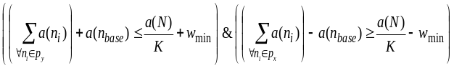
for i → 1 to n, n ∈ N, p_{x} ∈ P, p_{y} ∈ P, x ≠ y, and w_{min} is the area of the smallest unlocked node ( i.e. w_{min} = min_{1 ≤ i ≤ n} ( a(n_{i})_{unlocked} ) ).
Similar to the two-way FM algorithm, the move with the highest gain is selected and executed iteratively until all free nodes are locked. The K-way algorithm continues with the execution of this iterative select-and-move sequence until no more unlocked nodes can be moved without violating the balanced criterion. At the end of a pass, the K-way algorithm moves back to the best intermediate solution. All nodes are unlocked and the best solution forms the starting partition for the next pass. The algorithm terminates when a pass fails to improve the cutcost. The cutcost in our K-way partitioning algorithm is the total number of inter-FPGA data packets between partitions and it is given by:
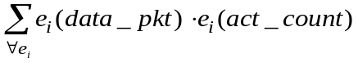
for i→1 to e_{total}, e ∈ E, p_{e(nsrc)} ∈ P, p_{e(ndst)} ∈ P, and p_{e(nsrc)} ≠ p_{e(ndst).}

The communications subsystem optimisation algorithm outlined in figure 3 creates a single or multiple communications subsystems optimised to reduce the inter-FPGA data packets sent between partitions. The assignment of new communications channels with the proposed algorithm uses a greedy-based strategy to solve the load balancing problem, taking into account the area and I/O resources of the target devices. Using a design activity profile to determine which module calls cause congestion in the communications channel. Provided that the area and I/O constraints of the FPGAs implementing the modules are met, the algorithm creates and assigns the modules responsible for the bottleneck in data transfer to a new communications subsystem. The design activity profile is obtained from a temporal analysis of the module activation in the system over a series of time steps.

Communications Subsystem Optimisation Algorithm
profile_info[]: profile information array containing information on the module call graph

Optimise_Comms_Subsys (profile_info[])
begin
Primary comms_subsys ← all modules pairs;
if ( Multiple_Comms_Subsys ) then {
Unlock all module call pairs (src,dst)
end_of_Opt ← False;
while ( end_of_Opt = False ) {
/* ----- Step 1 ----- */
profile_info_sorted[] ← Generate a sorted array of profile_info[], the generated array is sorted according to the inter-FPGA data transfers.
Calculate inter-FPGA data transfers for all unlocked module pairs in each time step.
/* ----- Step 2 ----- */
Sort time steps in order according to ‘traffic congestion’, with unlocked module pairs in each time step sorted in order according to their inter-FPGA data transfers in the time step.
if ( Area and I/O constraints not met ) then
end_of_Opt ← True;
else end_of_Opt ← False; end if
/* ----- Step 3 ----- */
bus_opt_status ← insert_comms_subsystem();
if ( bus_opt_status ) then
end_of_Opt ← False;
Update Area and I/O resources of the device that the newly created arbiter is assigned to.
else end_of_Opt ← True; end if
} end while
end if
end
Figure 3. Outline of the communication subsystem optimisation algorithm

4.2. Communication cells and arbitration

The basic building blocks of a communication subsystem are communication cells; transmit cell, receive cell, and arbiter cell. The key feature of the communications cells is in the usage of asynchronous data communication mechanism to transfer data between FPGAs. Each re-configurable device in the multi-board FPGA system is viewed as a locally clocked processing unit having an asynchronous communications interface. This alleviates clock skew problems in large multi-board FPGA systems. The communication cells are automatically inserted into the structural VHDL outputs of the multi-board FPGA system during synthesis. Transmit and receive cells handle the handshaking and synchronisation of inter-FPGA data packets between FPGAs in two independently clocked domains [16].
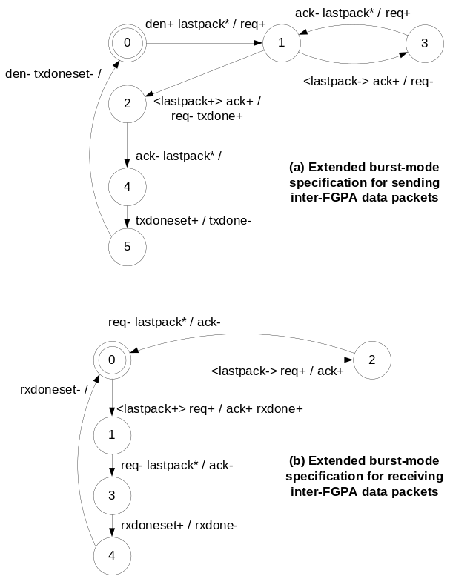
Figure 4. Extended burst-mode specification for asynchronous channel controllers

In multiple data packet transfers, the communication cells drive the appropriate multiplexor select signals to send and receive data packets. Data packets transferred asynchronously from one FPGA to another are controlled by asynchronous channel controllers specified using extended burst-mode (XBM) asynchronous state machines [17,18]. Figure 4(a) above describes the XBM specification for the asynchronous channel controller (sendXBM) that manages the protocol for sending inter-FPGA data packets, and Figure 4(b) above describes the asynchronous channel controller (receiveXBM) that manages the protocol for receiving the inter-FPGA data packets. Communication cells (transmit and receive cells) both have a pair of sendXBM and receiveXBM to send and receive data packets over the communications channel using four-phase signalling protocols. Inter-device communications channel data and control signals are synchronised (doubled-buffered) using two-flip-flop synchronisers [16] in the communication cells.
The arbiter cell serves dual functions in the communications protocol. Firstly, it handles the arbitration of the control of the shared communications channel for all transmit and receive cells that use the channel and it ensures a clean hand-over of ownership of the channel from one sender to another. Secondly, a lookup table in the arbiter provides a direct mapping of calling modules and the corresponding destination module to activate. A First In First Out (FIFO) memory stack in the arbiter is used to hold the return address of the calling module in a multi level module call (nested module calls).

4.3. Structure of generated multi-board FPGA system

With the inclusion of the communications subsystem providing the communications channel for the asynchronous transfer of data between multiple target devices, data latches (shaded in Figure 5) are used in place of data-gated registers in some parts of the design where asynchronous data transferred over the communications channel is latched in independent of the system clock. A local set of registers (A_dupl and B_dupl) and latches (C_dupl and D_dupl) is duplicated in the source module partition when it is calling a module in another partition.
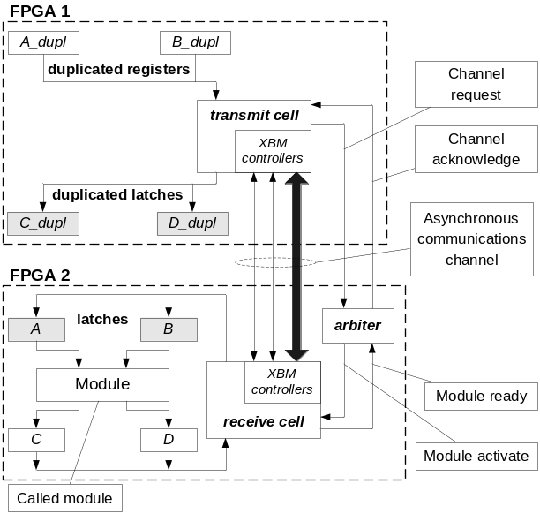
Figure 5. Latch and register duplication structure
Figure 5 illustrates the generated structure of the synthesised design for an inter-device module call. A transmit cell is inserted in the partition of the calling module (source partition) and a receive cell is inserted in the partitioned of the activated module (destination module). The values from the local set of registers and latches are sent through the transmit cell in FPGA1 and received by the receive cell in FPGA2. The receive cell loads the values into latches A and B and activates the destination module. Handshaking signals for the communications channel arbitration and data transfers are marked in the figure. The arbiter cell and bi-directional tri-state data and handshake signals in the shared communications channel allows I/O resource sharing between modules in two of more target FPGA devices on different prototyping boards.

5. Experimental results

In this section, we present the synthesis results of the multi-FPGA synthesis using the MOODS synthesis system. We examined three examples: a cubic equation solver (Cubic_eqs) with 13 modules, an Inverse Discrete Cosine Transform (IDCT) block with 3 modules, and a 256-bit AES encryption core (AES-256) with 5 modules. In all the experiments, the examples have initially been synthesised behaviourally and partitioned using the MOODS system. Subsequently, Synplicity Synplify Pro Version 7.7.1 has been used for RTL synthesis, while Xilinx Integrated Software Environment Series 5.2i was used for the final FPGA implementation. The results are shown in Tables 1 to 3.
The first and second rows (shaded) show the synthesis results of single-device implementations that fit the target device and exceeds the area constraint (*) of the target FPGA respectively. Subsequent rows list the multi-board FPGA synthesis implementations produced using various configurations of target prototyping boards with FPGA devices. The target prototyping boards used in our experiments are single-FPGA boards with a restricted number of available user interconnect pins for each board.
The first column shows the number of prototyping boards used. Target FPGA device types on the prototyping boards are given in the second column. Area (in FPGA slices), and I/O utilisation are given in columns three and four respectively. The maximum achievable frequencies (Freq) of the FPGAs are reported in column 5. Column 6 reports the area overhead (AO) of the multi-board system with respect to the corresponding un-partitioned implementations in row 1 of each example. Column 7 shows the number of passes (iterations) in the K-way partitioning algorithm (given in Figure 2) needed to obtain the optimum k partitions in each configuration. Column 8 reports the initial number of inter-device data packet transfers and the final number of inter-device data packet transfers (initial ↓ final) after the two-phase partitioning. Column 9 shows the number of communications channels (ch.) inserted during synthesis with the data width of the channels in brackets.
FPGA devices used in the Cubic_eqs example are Xilinx Virtex FPGAs (XCV400-5BG432, XCV300-5BG432, XCV150-5BG352, XCV100-5BG256, and XCV50-5BG256). The maximum I/O pins available for the V400 (XCV400) and V300 (XCV300) are restricted to 300 pins, the V150 (XCV150) is restricted to 250 pins, and the V100 (XCV100) and V50 (XCV50) are both restricted to 160 pins. FPGA devices used in the IDCT and AES-256 examples are Xilinx Spartan2 FPGAs (XC2S150-5FG456, XC2S100-5FG256, XC2S50-5FG256, XC2S30-5TQ144). The maximum I/O pins available for S150 (XC2S150) is 150 pins, the S100 (XC2S100) and S50 (XC2S50) are restricted to 150 pins, and S30 (XC2S30) is restricted to 80 pins.
Five implementation configurations for the cubic equation solver using multiple prototyping boards are shown in Table 1. Area constraints of the target FPGAs are all satisfied and excess I/O resources are used to implement multiple communication channels to distribute the inter-device data transfers. Table 1 shows a high I/O utilisation (99%) and area utilisation (99%) in at least one of the targeted devices in all five multi-board configurations.

Table 1. Synthesis results of Cubic_eqs
Boards | FPGA | Resource utilisation |  |  |  | Two-phase partitioning
Boards | FPGA | Area | I/O | Freq. (MHz) | AO | K-pass | Data  pkts | Comms ch.
1 | v400 | 3791 (78%) | 226 (75%) | 25.44 | – | – | – | –
1 | v300 | 3581* (116%)* | 226 (75%) | – | – | – | – | –
2 | v300 | 3070 (99%) | 300 (100%) | 32.17 | 915 (24.1%) | 2 | 72  ↓  30 | 2 ch.
 | v300 | 1636 (53%) | 76 (25%) | 33.76 | 915 (24.1%) | 2 | 72  ↓  30 | (32,20)
2 | v300 | 3070 (99%) | 298 (99%) | 29.45 | 1029 (27.1%) | 3 | 100 ↓  58 | 2 ch.
 | v200 | 1750 (74%) | 72 (24%) | 32.72 | 1029 (27.1%) | 3 | 100 ↓  58 | (32,16)
3 | v300 | 3070 (99%) | 300 (100%) | 42.91 | 877 (23.1%) | 2 | 192 ↓  64 | 2 ch.
 | v150 | 343 (19%) | 40 (16%) | 38.00 | 877 (23.1%) | 2 | 192 ↓  64 | (32,20)
 | v150 | 1255 (72%) | 78 (31%) | 31.91 | 877 (23.1%) | 2 | 192 ↓  64
4 | v300 | 3070 (99%) | 300 (100%) | 23.80 | 867 (22.9%) | 2 | 200 ↓  30 | 2 ch.
 | v100 | 343 (28%) | 40 (23%) | 35.88 | 867 (22.9%) | 2 | 200 ↓  30 | (32,20)
 | v100 | 588 (49%) | 60 (38%) | 42.39 | 867 (22.9%) | 2 | 200 ↓  30
 | v100 | 657 (54%) | 72 (45%) | 34.41 | 867 (22.9%) | 2 | 200 ↓  30
4 | v300 | 3070 (99%) | 300 (100%) | 25.02 | 868 (22.9%) | 3 | 72  ↓  30 | 2 ch.
 | v150 | 727 (47%) | 58 (36%) | 36.51 | 868 (22.9%) | 3 | 72  ↓  30 | (32,20)
 | v50 | 394 (72%) | 68 (43%) | 32.98 | 868 (22.9%) | 3 | 72  ↓  30
 | v50 | 468 (49%) | 42 (26%) | 73.41 | 868 (22.9%) | 3 | 72  ↓  30

Table 2 below shows the synthesis results for the IDCT block. Unlike the implementation configurations for the Cubic_eqs in Table 1, where multiple communications channels are generated for inter-board data transfers, the configurations in this example multiplexes, and sends multiple data packets for each module call through the single shared communications channel.
Table 2. Synthesis results of IDCT
Boards | FPGA | Resource utilisation |  |  |  | Two-phase partitioning
Boards | FPGA | Area | I/O | Freq. (MHz) | AO | K-pass | Data pkts | Comms Ch.
1 | s100 | 1018 (84%) | 26 (17%) | 30.34 | – | – | – | –
1 | s50 | 836* (108%)* | 26 (17%) | – | – | – | – | –
2 | s50 | 760 (98%) | 123 (82%) | 30.82 | 169 (16.6%) | 3 | 384 ↓ 192 | 1 ch.
 | s50 | 409 (53%) | 99 (66%) | 29.26 | 169 (16.6%) | 3 | 384 ↓ 192 | (91)
2 | s50 | 761 (99%) | 104 (69%) | 28.69 | 163 (16.01%) | 1 | 192 ↓ 192 | 1 ch.
 | s30 | 420 (97%) | 80 (100%) | 30.39 | 163 (16.01%) | 1 | 192 ↓ 192 | (72)
3 | s30 | 430 (99%) | 80 (53%) | 31.78 | 255 (25.1%) | 1 | 384 ↓ 384 | 1 ch.
 | s30 | 428 (99%) | 54 (68%) | 30.50 | 255 (25.1%) | 1 | 384 ↓ 384 | (46)
 | s30 | 430 (99%) | 58 (73%) | 30.06 | 255 (25.1%) | 1 | 384 ↓ 384

Table 3. Synthesis results of AES-256
Boards | FPGA | Resource utilisation |  |  |  | Two-phase partitioning
Boards | FPGA | Area | I/O | Freq. (MHz) | AO | K-pass | Data pkts | Comms Ch.
1 | S150 | 3791 (78%) | 226 (75%) | 25.44 | – | – | – | –
1 | S100 | 3581* (116%)* | 226 (75%) | – | – | – | – | –
2 | s100 | 1183 (98%) | 146 (97%) | 40.27 | 481 (33.29%) | 1 | 513 ↓ 513 | 1 ch.
 | s100 | 743 (61%) | 46 (31%) | 48.73 | 481 (33.29%) | 1 | 513 ↓ 513 | (32)
4 | s100 | 1185 (98%) | 146 (97%) | 37.32 | 457 (31.63%) | 1 | 513 ↓ 513 | 1 ch.
 | s30 | 186 (43%) | 50 (62%) | 53.51 | 457 (31.63%) | 1 | 513 ↓ 513 | (32)
 | s30 | 459* (106%)* | 40 (50%) | – | 457 (31.63%) | 1 | 513 ↓ 513
 | s30 | 72 (17%) | 40 (50%) | 83.1 | 457 (31.63%) | 1 | 513 ↓ 513
2 | s100 | 1183 (98%) | 146 (97%) | 40.27 | 481 (33.29%) | 1 | 513 ↓ 513 | 1 ch.
 | s50 | 743 (96%) | 46 (31%) | 44.47 | 481 (33.29%) | 1 | 513 ↓ 513 | (32)

Table 3 above shows three implementation configurations for the AES-256 bit core example using multiple prototyping boards. The third partition (S30 FPGA) in the 4-board configuration violates the area constraint with an area utilisation of 106%, hence making the configuration infeasible. A single 32-bit communications channel is inserted in all three multi-board FPGA configurations.
The area overheads for multi-board implementations are due to the creation of duplicated registers and latches (described in section 4.3). FPGA devices in multi-board multi-FPGA systems have higher average maximum achievable frequencies than a single-device implementation in most configurations as shown in Tables 1 to 3, however, extra clock cycles are needed to set up the shared tri-state communications channels and synchronisation of the data packets during the inter-clock domain asynchronous data transfers. Table 4 below gives the un-partitioned and partitioned performance of the example designs, in terms of system clock cycles and speed. With higher achievable maximum frequencies, the partitioned Cubic_eqs example in Table 4 has speed improvement over the un-partitioned implementation even when extra clock cycles are needed for inter-device data transfers.

Table 4. Performance of example designs
Example | Inter-device data packets | Clock cycles |  | Speed performance (us)
Example | Inter-device data packets | un-partitioned | partitioned | un-partitioned | partitioned
Cubic_eqs | 30 | 788 | 1790 | 30.98 | 30.40
IDCT | 192 | 1863 | 7943 | 61.40 | 264.41
AES-256 | 513 | 950 | 9736 | 25.78 | 218.79

6. Conclusions

In this paper, we have presented a two-phase partitioning approach in a high-level synthesis framework, which targets a multi-board FPGA system. The two-phase partitioning approach partitions a behavioural input design and automatically inserts a single or multiple optimised asynchronous communication channels to handle inter-FPGA data transfers. This approach combines high-level synthesis with asynchronous communication techniques with no additional designer effort. To the best of our knowledge, the synthesis of multi-board FPGA systems with asynchronous communications channels is explicitly automated for the first time. This partitioning approach allows the trade off between performance for flexibility and cost of implementing a system. Experimental results in section 5 have demonstrated that a system can be synthesised and partitioned to fit a selection of FPGA devices on prototyping boards, and fully utilise the I/O resources on the devices for inter-board data communications.
Future work involves the extension of partitioning to include multiple processes, which can fully capitalise on the parallelism of multiple asynchronous communications channels in a multi-board FPGA system.

7. References

[1] S. Hauck, “The Roles of FPGA’s in Reprogrammable Systems”, Proc. of the IEEE, 86(4), 1998, pp. 615-638.

[2] W. Wolf, FPGA-Based System Design, Prentice Hall PTR, 2004.

[3] S. Hauck, “Multi-FPGA Systems”, PhD Thesis, University of Washington, 1995.

[4] M.A.S. Khalid, J. Rose, “A Novel and Efficient Routing Architecture for Multi-FPGA Systems”, IEEE Trans. on Very Large Scale Integration Systems, 8(1), 2000, pp. 30-39.

[5] B.W. Kernighan, S. Lin, “An Efficient Heuristic Procedure for Partitioning Graphs”, Bell Systems Technical Journal, 49(2), 1970, pp. 291-307.

[6] C.M. Fiduccia, R.M. Mattheyses, “A Linear-Time Heuristic for Improved Network Partitions”, Proc. Design Automation Conference, 1982, pp. 241-247.

[7] F.M. Johannes, “Partitioning of VLSI Circuits and Systems”, Proc. Design Automation Conference, 1996, pp. 83-87.

[8] F. Vahid et. al., “Functional Partitioning Improvements Over Structural Partitioning for Packaging Constraints and Synthesis: Tool Performance”, ACM Trans. on Design Automation of Electronic Systems, 3(2), 1998, pp. 181-208.

[9] F. Vahid, “A Three-Step Approach to Functional Partitioning of Large Behavioural Processes”, Proc. International Symposium on System Synthesis, 1998, pp. 152-157.

[10] A.A. Duncan et. al., “An Overview of the Cobra-ABS High Level Synthesis System for Multi-FPGA Systems”, Proc. FPGAs for Custom Computing Machines, 1998, pp. 106-115.

[11] S. Govindarajan et. al., “A Technique for Dynamic High-Level Exploration During Behavioral Partitioning for Multi-Device Architectures”, Proc. 13th International Conference on VLSI Design, 2000, pp. 212-219.

[12] O. Bringmann et. al., “Target Architecture Oriented High-Level Synthesis for Multi-FPGA Based Emulation”, Proc. Design, Automation and Test in Europe, 2000, pp. 326-332.

[13] J. Babb, “Logic Emulation with Virtual Wires”, IEEE Trans. on Computer-Aided Design of Integrated Circuits and Systems, 16(6), 1997, pp. 609-626.

[14] F. Vahid, “I/O and Performance Tradeoffs with the FunctionBus during Multi-FPGA Partitioning”, Proc. International Symposium on Field-Programmable Gate Arrays, 1997, pp. 27-34.

[15] A.C. Williams, “A Behavioural VHDL Synthesis System using Data Path Optimisation”, PhD Thesis, University of Southampton, 1997.

[16] C.E. Cummings, “Synthesis and Scripting Techniques for Designing Multi-Asynchronous Clock Domains”, Proc. Synopsys Users Group Conference (SNUG), 2001.

[17] K.Y. Yun, D.L. Dill, “Automatic Synthesis of Extended Burst-Mode Circuits: Part I (Specification and Hazard-free Implementations)”, IEEE Trans. on Computer Aided Design, 18(2), 1999, pp. 101-117.

[18] K.Y. Yun, D.L. Dill, “Automatic Synthesis of Extended Burst-Mode Circuits: Part II (Automatic Synthesis)”, IEEE Trans. on Computer Aided Design, 18(2), 1999, pp. 118-132.

