Dynamic Threat Assessment for Prioritising Computer Network Security

Zia Hayat, Jeff Reeve
University of Southampton

Communications Laboratory
School of Electronics & Computer Science
Faculty of Engineering
Southampton
Hampshire S017 1BJ
UK
Zia.hayat@baesystems.com
jsr@ecs.soton.ac.uk

Chris Boutle
BAE SYSTEMS Integrated System Technologies
Frimley
Camberley
Surrey GU16 7EX
UK
Chris.boutle@baesystems.com

Abstract: Large corporations today consist of heterogeneous IT networks with many thousands of devices, which may use numerous physical and logical interfaces to communicate. Much effort has been applied in automating laborious, time-consuming and sometimes-repetitive security services such as patch management and event loggers for these networks. However such tasks can still take many hours and even days to successfully complete. Currently it is left to the systems administrators’ discretion to choose in which order to protect individual devices, which on larger networks can result in arbitrary security protection at best. In light of the rapidly decreasing time between vulnerabilities being discovered and maliciously exploited by malware, such an arbitrary method introduces an unacceptable level of risk to the security of those devices, which are critical to business processes.

An information risk management approach needs to be adopted to ensure the protection of the network with a high likelihood; this can be achieved through the prioritisation of critical devices. In this introductory paper a generic prioritisation technique for individual devices in a network is described offering a methodical alternative to the current ambiguity of a systems administrators operations. The technique is based upon compromise path analysis, which identifies critical paths in a network from a security viewpoint and is relevant in a wide range of operations from the application of security services to analysing their results. The vulnerability period metric is introduced, as a mechanism to control the risk exposure to individual devices through prioritisation.

Key Words: Computer Network Security, Malware, Information Risk Management, Prioritisation, Compromise Path Analysis, Vulnerability Period

1. Introduction
It is argued that if the current trend of reducing time scales in exploitation and increasing number of software vulnerabilities continues as reported in (CERT/CC) then, critical business processes will be exposed to unacceptably high levels of risk, even in the presence of automated security services such as path management as advocated in (Dacey 2003). Therefore the efficient and effective utilisation of available security resources is required in order to further exploit their potential. This is highlighted in (Jennings 2005) where it is suggested that many organisations fail to gain real benefit from their investments in IT systems. Prioritisation of devices to receive security servicing is an approach, which may be used to enable this, reducing the time frame within which critical assets may be compromised; we call this time frame the VP (Vulnerability Period). The VP for each susceptible device is the time between a vulnerability first being reported to the time at which that device is made secure from such vulnerability. The VP is defined as follows,

VP = P.τ + Κ (1)

where P is the priority (integer value starting from ‘1’, which is the highest priority) assigned to a given device, τ is the average time taken for a service to be successfully performed per device τ is also variable due to differences in: individual services, network latencies and dynamic characteristics of individual devices; Κ is the time taken for the developers to provide a solution to fix the vulnerability from the time of its discovery.

In (Brown et al. 2004) the authors describe a pro-active malware susceptibility testing technique, which applies a vaccine (a virus with a NULL payload) to devices on a network. An automated response is sent back from the device under investigation indicating its susceptibility to the virus and if a device is found to be susceptible it is immediately made safe. The scanning of individual devices is based upon a SETI@home (SETI@home) style setup. Using this technique networks are separated into clusters of devices with each cluster being assigned to a given scanner for inspection purposes. However this process provides the service to devices in an arbitrary sequence. From equation 1 it can be seen how prioritisation unlike an arbitrary technique can aid the owners of devices to control the risk exposure to a given device by reducing or increasing its VP accordingly. Without prioritisation the VP can be any time between one and n (number of devices under consideration) times the average time (τ) taken to service a single device. The use of prioritisation to manage information security risks in IT networks is also endorsed in (Rogers and Allen 2002) and (Monahan 2005). The question is how to develop a systematic technique for achieving such prioritisation?

This paper is organised as follows, section 2 describes a simple prioritisation strategy and highlights its limitations, section 3 details how connectivity in modern IT networks has evolved increasing security risks, resulting in the requirement for prioritisation of network security services, this is followed by an overview of how networks are modelled in this paper. In section 4 we specify and explain through an example, the algorithm developed to prioritise the order in which individual devices should receive security servicing. A brief overview of initial results from testing carried out on a software implementation of the algorithm is provided in section 5, with a summary and potential future work detailed in section 6.

2. A Simple Prioritisation Strategy
In order to develop any sort of information security risk strategy one must derive a security criticality classification system. This involves the identification and valuation of assets following which prioritisation can be derived, based upon the risks to those assets. Traditionally a classification system consists of a number of criticality levels, where individual devices are assigned to one such level. There may be a different classification system for each of the three principle security properties of confidentiality, integrity and availability however, for the purposes of the modelling described in this paper we use only one classification system, which is analogous to that commonly used by many organisations for information security purposes. The criticality levels used in this system are (from high to low criticality): VH, H, M, L and S.

A simple prioritisation strategy for security purposes would be based upon the criticality level to which a device is assigned, hence all devices with a criticality level of ‘VH’ would be assigned the highest priority for security service applications. However this may still result in a relatively arbitrary prioritisation of devices if there are a significant number of devices at the same criticality level in a network. This is illustrated in equation 2,
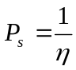 (2)
where it can be seen that as the total number of devices η at the same criticality level in a network increases, the probability of any one device (P_{s}) receiving the appropriate prioritisation decreases. Therefore the probability of every device (P_{a}) receiving servicing in the correct order at any given criticality level can be defined as,
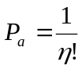 (3)
Equation 3 further highlights the limitations of an arbitrary servicing strategy when considering all devices at the same criticality level.

From equations 1 and 2 it is clear that in order to successfully prioritise, one requires a differentiating factor(s) between a set of devices at the same criticality level, otherwise the VP for assets will remain undetermined, where large numbers of devices are assigned to the same criticality level. One way of achieving such differentiation is to identify and analyse dynamic risks to individual devices and then prioritise the application of security services based upon these perceived risks. Numerous techniques such as: (Alberts and Dorofee), (Meier et al. 2003), (Schneier 1999), (Salter et al. 1998), (Surdu et al. 2003) and (Moore 2001) exist for the identification, analysis and ranking of risks in a network scenario. However a major limitation with all of these techniques is that they assume an exhaustive search of the problem space (i.e. identify individual risk(s) to device(s) and then quantify these based upon the attacker model), which can be vast and complex in the case of security vulnerabilities in modern IT networks. Other work detailing techniques to reduce the risk due to the rapid exploitation of software vulnerabilities is given in (Arora et al. 2004), however this does not consider prioritisation as a strategy.

3. Complex Risks in Complex Networks
Although IP (Internet Protocol) networking has the potential to allow ubiquitous connectivity, communications between devices are limited due to routing restrictions imposed by security services. This implies that if an attacker wants to compromise a given device(s) (victim) using a worm for example, then they must launch attacks from a device(s) which is authorised to connect to the victim otherwise the attempt to connect will be rejected, we call such paths compromise paths. Where the attacker has to systematically traverse a number of devices and overcome various security barriers (defence in depth strategy) such as IP routing rules, traffic analysis and packet inspection to compromise a specific device in a specific manner.

The realisation of ubiquitous computing and communications services has resulted in the increase of insider attacks, hence there is now a significant shift in security paradigms from that of perimeterised to de-perimiersied solutions as described by the Jericho forum (Bleech 2005). In such networks every device has the potential to become a gateway to external networks. The complexity introduced by such extended connectivity adds to the threat vector in IT networks, this is illustrated in figure 1.

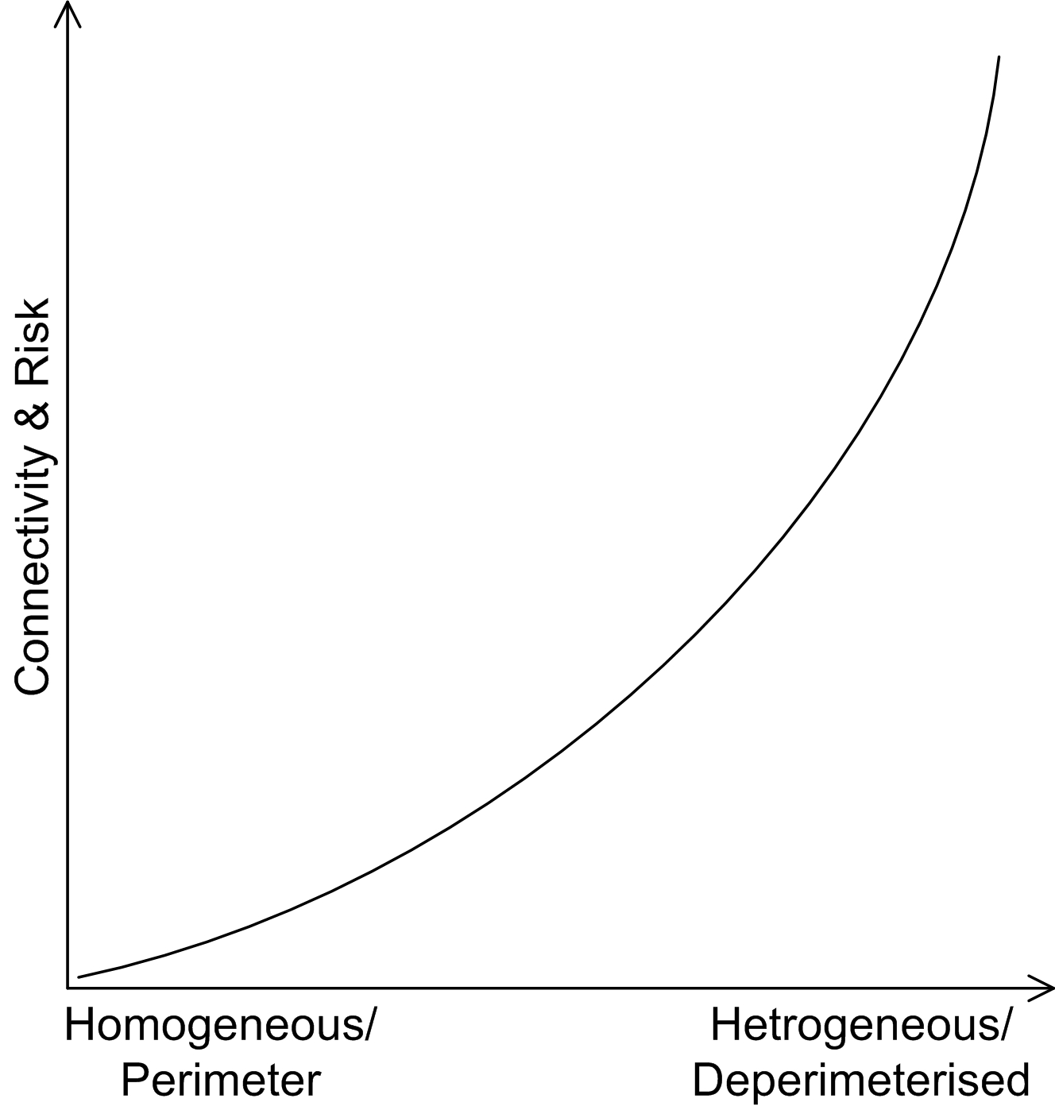
Figure 1: Increased flexibility leading to increased connectivity and risks

3.1 Network Modelling
Throughout this paper we represent network connectivity as a graph G=<D,C>.
∀d ∈ D, where d denotes a physical device and ∀c ∈ C, where c is an inter device compromise connection representing potentially exploitable flaws. We use a simplified version of semantic network modelling as described in (Monahan 2005) to represent network connectivity, where all links between devices are undirected and specific attributes such as type of protocol (e.g. http, https) are not considered.

A criticism of using such a model driven approach for the description of an IT architecture, is that the model may quickly become out-of-date particularly where mobile and ad-hoc devices are used, which have the ability to create and destroy links dynamically. However there are a number of mature standards (SNMP, CIM etc.) with corresponding tools such as Cheops-ng (Cheops), Nmap (Nmap) and HPOpenView, which provide semantically rich network topology information in real-time. These standards are capable of providing descriptions in a number of formats, which may be used by techniques such as those described in this paper for subsequent processing and analysis.

Let us first define, ∀d∈D:
- The criticality level of d, c_{r} to be the security criticality associated with the device, this attribute is referenced as d.c_{r}
- The compromise path risk level of d, p_{r} to be the compromise path associated with the device, this attribute is referenced as d.p_{r}
- The compromise path length of d, h_{o} to be the length of the compromise path associated with the device, this attribute is referenced as d.h_{o}
- The residual risk of d, r_{r} to be the residual risk associated with the device, this attribute is referenced as d.r_{r}
- The prioritisation status of d, s_{p} to be the priority for receiving security servicing associated with the device, this attribute is referenced as d.s_{p}

And, ∀c∈C:
- The risk level of c, v_{b} be the connection risk level associated with the connection, this attribute is referenced as c.v_{b}
- The distinct devices incident to c, e_{s} be the two devices associated with the connection, this attribute is referenced as c.e_{s}

3.2 Compromise Path Analysis
The technique of compromise path analysis as adopted in this work is based upon that developed by QinetiQ for their DBSy methodology as described in (Hughes 2002). In compromise path analysis, paths (series of one or more compromise connections) are identified from devices to other devices believed to pose a security risk. We use security criticalities to bound the search space, by only analysing for compromise paths to devices of equal or lower criticality. In the DBSy model, compromise paths are rated according to a technique analogous to table 1, this is part of a HMG (Her Majesty’s Government) infosec standard (Ministry of Defence 2001), for quantifying risks when connecting devices of differing security criticalities. The set of devices in a network G which are prioritised (potential victim devices) is D_{M} = {d:D | d.c_{r} ≠ ’S’}, as devices with a criticality of ‘S’ are deemed to be out of the current administrative authorities control. Therefore if for a set of devices, D_{s} ⊆ D_{M}, one is unable to prioritise between them based upon security criticality levels (c_{r}) alone (i.e. they have the same criticality level), then the highest compromise path risk (p_{r}) associated with such devices may be used to distinguish between them. Where, ∀d∈D_{s}, devices with higher compromise path risk levels are given increased priority.

Table 1: Risk levels for connected devices
Attacker  Victim | VH | H | M | L | S
VH | 1 | 2 | 3 | 4 | 5
H | - | 1 | 2 | 3 | 4
M | - | - | 1 | 2 | 3
L | - | - | - | 1 | 2
S | - | - | - | - | 1

Table 1 illustrates the risks associated with connecting devices of differing criticalities either directly or indirectly, where a level ‘5’ path is the highest risk and level ‘1’ the lowest. The lower half of table 1 is left blank highlighting that devices are only perceived to be at risk from those of an equal or lower criticality level.

3.3 Adapting Compromise Path Risk Analysis
As well as using compromise path risk levels to distinguish between a set of devices as in (Hughes and Wiseman 2005), our technique builds upon this by also using the concepts of compromise path length and residual risk. Therefore if a set of devices D_{H} ⊆ D_{M}, have the same criticality (c_{r}) and compromise path risk levels (p_{r}), then compromise path length (h_{o}) is used to distinguish between them. Where, ∀d∈D_{H}, devices with lower compromise path lengths are given higher priority. This is due to the fact that the attacker device (d∈D) is closer to the victim device (d∈D_{H}) resulting in less effort to compromise the victim on behalf of the attacker. We further extend our risk analysis by introducing the concept of residual risk (r_{r}), therefore if a set of devices, D_{R} ⊆ D_{M}, have the same criticality level (c_{r}), compromise path risk level (p_{r}) and compromise path length (h_{o}), then residual risk (r_{r}) is used to distinguish between them. Where, ∀d∈D_{R}, devices with higher residual risk are given higher priority. The residual risk (r_{r}) of a device d∈D_{R} is calculated as,

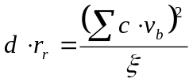 (4)

where ξ is the number of directly connected devices which have an equal or lower criticality level than the device (d), and v_{b} is the connection risk level for such connections (c∈C) and is calculated by comparing the difference in criticality levels according to table 1 of the two devices in c·e_{s}.

If for a device d∈D_{M} both p_{r} and h_{o} attributes have a value of ‘0’ this indicates no compromise path exists for d. Otherwise if a compromise path exists p_{r} takes a value, 1≤p_{r}≤5, where ‘1’ represents the lowest risk and ‘5’ the highest; and h_{o} takes a value, h_{o}>0. The r_{r} attribute is calculated to distinguish between devices, which cannot be prioritised using a combination of cr, pr, and h_{o} attributes, this is illustrated in the algorithm in section 4, where r_{r} takes a value, r_{r}≥0.

4. Algorithm Specification
For the purposes of the algorithm to be described, we will define a number of terms to aid in its understanding.

Definition 1: Let D_{M} ^{(x)} ⊆ D_{M} denote the set of devices with a security criticality of x.

Definition 2: ∀d∈D_{M}, let p(d) calculate the highest risk compromise path of device d, calculated according to table 1 using a constrained DFS (Depth First Search). If two or more compromise paths of identical risk level exist for one device then p(d) chooses the one with the smallest length , choosing any one if more than one has the same length as well as risk level. Formally p: D_{M} → {1,2,3,4,5}.

Definition 3: ∀d∈D_{M}, let h(d) calculate the length of the highest risk compromise path to d. Formally h: D_{M} → {n:Ν | n>0}, where Ν is the set of natural numbers.

Definition 4: ∀d∈D_{M}, let r(d) calculate the residual risk of the device d calculated according to equation 4. Formally r: D_{M} → {n:R | n≥0}, where R  is the set of real numbers.

Our consolidated prioritisation technique is recursive and the algorithm is:

1 ∀d∈D_{M} set d.p_{r}=0, d.h_{o}=0, d.r_{r}=0 and d.s_{p}=0
2 ∀x∈{VH,H,M,L}
3 if |D_{M} ^{(x)}|<2 then
4 ∀d∈D_{M} set priority attribute d.s_{p} attribute based upon criticality level
5 attributes d.c_{r} giving increased priority to devices (d) with higher d.c_{r} values
6 end
7 else
8 foreach x:=VH:L let D_{S}:=D_{M} ^{(x)} ⊆ D_{M}
9 if |D_{S}|>1 then
10 ∀d∈D_{S}, let d.p_{r}:=p(d) and d.h_{o}:=h(d)
11 ∀d∈D_{S}, set priority attribute d.s_{p} giving increased priority to devices (d)
12 with greater d.p_{r} values
13 D_{H}:=∅,
14 Identify d∈D_{S} which have identical p_{r} attribute values, store such devices in D_{H}
15 if (D_{H} =∅) then
16 ∀d∈D_{S}, set priority attribute d.s_{p} giving increased priority to devices with higher
17 d.p_{r} values
18 end
19 else
20 D_{R}:=∅, D_{δ}:=∅
21 Identify d∈D_{H} which have identical h_{o} attribute values, store such devices in D_{R}
22 if (D_{R} =∅) then
23 ∀d∈D_{H}, set priority attribute d.s_{p} giving increased priority to devices
24 (d) with lower d.h_{o} values
25 ∀d∉D_{H} ∧ d∈D_{S}, reassign priorities for such d accordingly
26 end
27 else
28 D_{δ}:= D_{H}\D_{R}
29 if (D_{δ} ≠ ∅)
30 ∀d∈D_{δ}, set priority attribute d.s_{p} giving increased priority to devices (d)
31 with lower d.h_{o} values
32 end
33 ∀d∈D_{R}, set d.r_{r}=r(d)
34 ∀d∈D_{R}, set priority attribute d.s_{p} giving increased priority to devices
35 (d) with higher d.r_{r} values
36 if ∃d∈D_{R}, d.r_{r} attribute values are identical then
37 assign equal priority to such d
38 end
39 ∀d∉D_{R} ∧ d∈D_{S}, reassign priorities accordingly
40 end
41 end
42 end
43 else if |D_{S}|=1 then
44 d∈D_{S}, set d.s_{p}:=1
45 end
46 else if D_{S}=∅ then
47 do nothing
48 end
49 end
50 end
51 ∀d∈D_{M} reassign priority values for d according to the c_{r} attributes

4.1 Algorithm Explanation
We will now explain the algorithm by way of an example network, which is given figure 2. The priority of each device relative to one another can be calculated according to the algorithm in section 4. In figure 2 each device d∈D is labelled along with its security criticality level which is given in brackets, each connection c∈C is also labelled on each inter-device link.

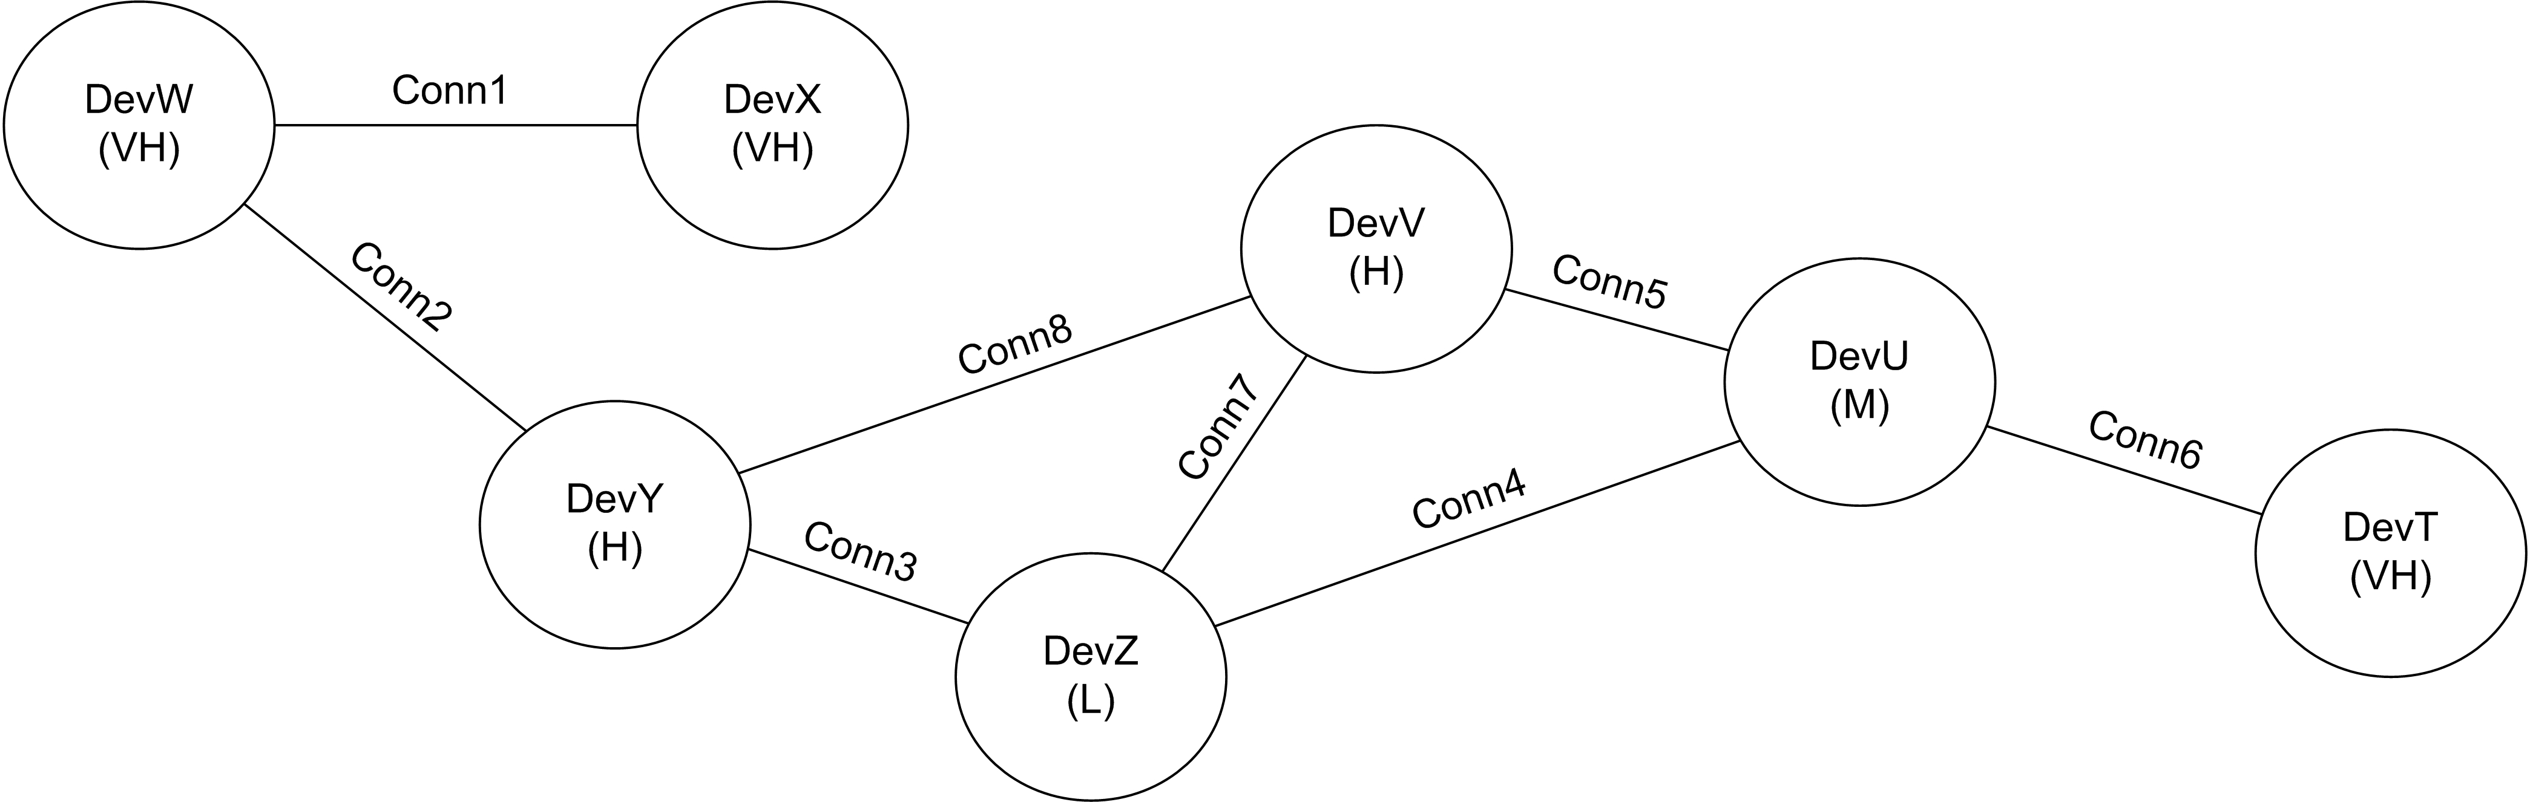
Figure 2: Example network topology

According to line 1, set:
DevT.p_{r} =0, DevT.h_{o} =0, DevT.r_{r}=0, DevT.s_{p}=0
DevU.p_{r} =0, DevU.h_{o}=0, DevU.r_{r}=0, DevU.s_{p} =0
DevV.p_{r} =0, DevV.h_{o}=0, DevV.r_{r}=0, DevV.s_{p} =0
DevW.p_{r} =0, DevW.h_{o}=0, DevW.r_{r}=0, DevW.s_{p} =0
DevX.p_{r} =0, DevX.h_{o}=0, DevX.r_{r}=0, DevX.s_{p} =0
DevY.p_{r} =0, DevY.h_{o}=0, DevY.r_{r}=0, DevY.s_{p} =0
DevZ.p_{r} =0, DevZ.h_{o}=0, DevZ.r_{r}=0, DevZ.s_{p} =0

|D_{M} ^{(VH)}|>2 and |D_{M} ^{(H)}|>2 ∴if statement on line 3 is false go to else statement on line 7

According to foreach statement on line 8 set:
x = VH ∴ D_{S}=D_{M} ^{(VH)} = {DevT, DevW, DevX}
|D_{S}|>1 ∴if statement on line 9 is true
∴ according to line 10, ∀d∈D_{S}, p_{r} and h_{o} attribute values are assigned to d according to functions p(d) and h(d) respectively:
- In the case of device DevT the highest risk compromise path (DevT.p_{r}) is of a level 4 this can be seen as the path with DevZ via DevU, this has a length (DevT.h_{o}) of 2. Other compromise paths of level 4 also exist (i.e. T,U,V,Z and T,U,V,Y,Z) however these paths are of longer length and are therefore discounted.
- The highest risk compromise path associated with DevW (DevW.p_{r}) is a risk level 4 this can be seen as the path with DevZ via DevY this has a length (DevW.h_{o}) of 2. Other paths of level 4 also exist (i.e. W,Y,V,Z and W,Y,V,U,Z) however these paths are of longer length.
- The highest risk compromise path (DevX.p_{r}) associated with DevX is a risk level 1 this can be seen as the inter-device connection with DevW and the path has a length (DevX.h_{o}) of 1.

Note the device DevX does not consider any other device as a risk as its only outward connection is via DevW, which is itself of the same criticality level (‘VH’). This is a feature of the constrained DFS, which is used to optimise the algorithm with minimal impact on security and business continuity. If a device (d_{f}∈D_{M}) has a connection with another device d_{k}∈D_{M} of the same criticality it is assumed that risks due to onward connections on such a path will be considered by d_{k} or another subsequent device of the same criticality. This reduces the redundancy in compromise path identification whilst still ensuring that any risks on paths are considered by at least one device.

The p_{r} and h_{o} attribute values for ∀d∈D_{S} are:
- DevT.p_{r} =4, DevT.h_{o} =2
- DevW.p_{r}=4, DevW.h_{o}=2
- DevX.p_{r}=1, DevX.h_{o}=1

According to line’s 11 and 12 prioritising based upon the p_{r} attribute value the priorities for ∀d∈D_{S} are as follows:
- DevT.s_{p} = 1
- DevW.s_{p} = 1
- DevX.s_{p} = 2

Line 14 is then executed to identify ∀d∈D_{S}, which (d) have non-unique p_{r} attribute values such devices (d) are stored in D_{H}  ∴ D_{H} = {DevT, DevW}

D_{H} ≠ ∅  ∴ if statement on line 15 returns false ∴ go to else statement on line 19

Line 20 is executed to initialise D_{R} and D_{δ} 

Line 21 is then executed to identify ∀d∈D_{H}, which (d) have non-unique h_{o} attribute values such devices (d) are stored in D_{R} ∴   D_{R} = {DevT, DevW}

D_{R} ≠ ∅ ∴ if statement on line 22 returns false ∴ go to else statement on line 27

Line 28 is executed to set D_{δ} to consist of all devices d∈D_{S}, which have non-unique p_{r} attribute values but unique h_{o} attribute values,  after executing line 28  D_{δ} = ∅

∴ if statement on line 29 returns false ∴ go directly to line 33

In line 33 ∀d∈D_{R}, d.r_{r} attribute values are assigned to d according to function r(d): DevT.r_{r} = 9, DevW.r_{r} = 4.5

Lines 34 and 35 are then executed to prioritise any devices d∈D_{R}, based upon r_{r} attribute values giving increased priority to those devices with higher r_{r} attribute values, so given DevT.r_{r} = 9 > DevW.r_{r} = 4.5, DevT is of higher priority than DevW
∴ the priorities for DeVT and DevW are: DevT.s_{p}=1 and DevW.s_{p}=2

The if statement on line 36 returns false as no devices d∈D_{R}, exist with identical p_{r}, h_{o} and r_{r} attribute values ∴ go directly to line 39

Line 39 states that ∀d∉D_{R} but are d∈D_{S} should be re-assigned due to the changes in priority of d∈D_{R}, ∴ DevX.s_{p}=3 due to the changes in priority made to DevT and DevW which are of a higher priority

The else if statement on line 43 returns false as |D_{S}|≠1 similarly the else if statement on line 46 also returns false as D_{S}≠∅

This process is then repeated according to the for loop on line 8, due to reasons of space we do not describe each iteration, however after the this loop has completed the following are the s_{p} (priority) attributes assigned to each device d∈D_{M} in the network G:
- DevT.s_{p} =1, DevW.s_{p}=2, DevX.s_{p}=3
- DevV.s_{p}=1, DevY.s_{p}=2
- DevU.s_{p}=1
- DevZ.s_{p}=1

Line 51 is now executed to prioritise all devices d∈D_{M} relative to all other devices not just those with the same c_{r} (criticality) attribute value. Those devices of the highest criticality set in the current network, which is ‘VH’, in this case retain their priority attribute assignments, however others with lower criticality levels are shifted down accordingly. The final attribute values for each device d∈D_{M} are given in table 2, the prioritisation levels are given in the final column (s_{p}).

Table 2: Final attribute values after execution of the algorithm
Device | e_{s} | c_{r} | p_{r} | h_{o} | r_{r} | s_{p}
DevT | Conn6 | VH | 4 | 2 | 9 | 1
DevU | Conn4, Conn5, Conn6 | M | 2 | 1 | 0 | 6
DevV | Conn5, Conn7, Conn8 | H | 3 | 1 | 12 | 4
DevW | Conn1, Conn2 | VH | 4 | 2 | 4.5 | 2
DevX | Conn1 | VH | 1 | 1 | 0 | 3
DevY | Conn2, Conn3, Conn8 | H | 3 | 1 | 8 | 5
DevZ | Conn3, Conn4, Conn7 | L | 0 | 0 | 0 | 7

5. Implementation & Testing
The algorithm described in section 4 has been developed as a C#.NET software version. Network topologies simulating compromise connectivity are automatically generated and fed into this software by a separate (network simulator) software component. The details of this simulator are beyond the scope of this paper however it is worth noting that it incorporates power-law strategies such as those developed by (Spencer and Sacks 2002), (Aiello et al. 2000), (BRITE) and (Palmer and Steffan 2000). Criticality levels are assigned randomly to each device with higher criticality levels given to critical infrastructure nodes such as routers.

To test the effectiveness of our strategy we ran 6 tests over the algorithm (described in section 4) with each test consisting of 100 networks (generated by the network simulator software) of random sizes (ranging from 10 to 1000 nodes) and connectivity. The aim of the test was to identify what percentage of devices in a network where actually prioritised by the four attributes of: criticality (c_{r}), compromise path risk level (p_{r}), compromise path length (h_{o}) and residual risk (r_{r}). The results are given in table 3.

Table 3: Comparison of metric performance for prioritisation purposes
 | Test 1 | Test 2 | Test 3 | Test 4 | Test 5 | Test 6 | Mean | S. dev
c_{r} (%) | 0.00 | 0.00 | 0.00 | 0.00 | 0.00 | 0.00 | 0.00 | 0.00
p_{r} (%) | 11.92 | 12.00 | 11.53 | 12.33 | 11.39 | 12.64 | 11.89 | 0.47
h_{o} (%) | 36.39 | 36.54 | 36.41 | 36.29 | 37.21 | 36.37 | 36.79 | 0.34
r_{r} (%) | 50.99 | 50.87 | 50.91 | 50.74 | 50.48 | 50.05 | 50.45 | 0.35
None (%) | 0.70 | 0.59 | 1.15 | 0.64 | 0.92 | 0.94 | 0.87 | 0.22

6. Conclusions & Future Work
The increase in complexity of modern computer networks has resulted in an exponential increase in the number of security vulnerabilities. This has resulted in a shift from risk prevention to risk management in computer network security aiming to minimise the likelihood and impact of such vulnerabilities. It has been shown how a dynamic threat assessment technique such as compromise path analysis can be used to identify the relative risk posed to individual nodes in a network, and how a prioritisation strategy based upon this can aid in the quest to manage such risks.

From preliminary testing the technique has delivered promising results, distinguishing between the vast majority (99.13%) of devices based upon risk analysis. However further work is required to assess the effectiveness of the technique for differing network topologies and criticality systems. It is hoped that the VP can be used as a standard metric to compare the performance of differing techniques for the reduction of risk to critical assets in a network.

7. Acknowledgements

The authors would like to thank Robert Johnston and Tim Parsons for their invaluable contribution to this work.

References
Aiello, W., Chung, F.R.K. and Lu, L. (2000) "A random graph model for massive graphs", ACM Symposium on Theory of Computing, Oregon, Portland, USA, pp171-180.

Alberts, C. and Dorofee, A. “An Introduction to the OCTAVE Method”, [Online], Software Engineering Institute Carnegie Mellon University, Available: http://www.cert.org/octave/methodintro.html#chars [17 Oct 2005].

Arora, A., Telang, R. and Xu, H. (2004) “Optimal Policy for Software Vulnerability Disclosure”, Third Workshop on Economics and Information Security, Minneapolis, Minnesota, USA.

Bleech, N. (2005) “Visioning White Paper, What is Jericho Forum?”, [Online], Available:
http://www.opengroup.org/projects/jericho/uploads/40/6809/vision_wp.pdf [17 Oct 2005].

BRITE, [Online], Available: http://www.cs.bu.edu/BRITE/ [17 Oct 2005].

Brown, R., Griffin, J., Norman, A. and Smith, R. (2004) “Why HP did not get Blastered”, HP Laboratories Technical Report HPL-2004-188, Bristol, UK.

CERT/CC, [Online], Available: http://www.cert.org/stats/cert_stats.html [17 Oct 2005].

Cheops, [Online], Available: http://cheops-ng.sourceforge.net/ [17 Oct 2005].

Dacey, R.F. (2003) “Effective Patch Management is Critical to Mitigating Software Vulnerabilities”, Testimony before the Subcommittee on Technology, Information Policy, Intergovernmental Relations, and the Census, House Committee on Government Reform,
United States General Accounting Office, [Online], Available:
http://www.iwar.org.uk/comsec/resources/worm-virus-defense/GAO-final-testimony.pdf
[17 Oct 2005].

Hughes, K.J. (2002) “Domain Based Security: enabling security at the level of applications and business processes”, QinetiQ White Paper QINETIQ/KI/TIM/CP021906, Malvern, UK.

Hughes, K.J. and Wiseman, S. (2005) “Analysis of information security risks: Policy for protection through to implementation”, 4th European Conference on Information Warfare and Security, Glamorgan, UK.

Jennings, T. (2005) ‘Developing the Role of the CIO’, Information Economics Journal, pp11-13, London, UK.

Meier, J.D., Mackman, A., Dunner, M., Vasireddy, S., Escamilla, R. and Murukan, A. (2003) “Improving Web Application Security: Threats and Countermeasures”, Microsoft Corporation Technical Library, [Online], Available: http://msdn.microsoft.com/library/default.asp?url=/library/en- us/dnnetsec/html/ThreatCounter.asp [17 Oct 2005].

Ministry of Defence (2001), Her Majesty’s Government Infosec Standard No. 3, London, UK.

Monahan, B. (2005) “Infrastructure Security Modelling for Utility Computing”, HP Laboratories Technical Report HPL-2005-04, Bristol, UK.

Monahan, B., Gittler, F., Horne, W., Shiu, S., Baldwin, A., Dalton, C.I., Goldsack, P., Taylor, R., Tofts, C. and Yearworth, M. (2005) “DBSy in a Commercial Services Context”, In Proceedings of 1st DBSY User Conference [CD], Malvern, UK.

Moore, A.P., Ellison, R.J. and Linger, R.C. (2001) “Attack Modeling for Information Security and Survivability”, Carnegie Mellon University Technical Note CMU/SEI-2001-TN-001, Pittsburgh, USA.

Nmap, [Online], Available: http://www.insecure.org/nmap/ [17 Oct 2005].

Palmer, C.R. and Steffan, J.G. (2000) “Generating Network Topologies That Obey Power Laws”, Proceedings of the Global Internet Symposium, San Francisco, USA.

Rogers, L. and Allen, J. (2002) ‘Securing Information Assets: Security Knowledge in Practice’, CrossTalk Defense Software Engineering Journal, US Air Force, [Online], Available: http://www.stsc.hill.af.mil/crosstalk/2002/11/rogers.html [17 Oct 2005].

Salter, C., Saydjari, O., Schneier, B. and Wallner, J. (1998) “Toward a Secure System Engineering Methodology”, In Proceedings of New Security Paradigms Workshop, Charlotsville, Virginia, USA.

Schneier, B. (1999) “Attack Trees: Modelling Security Threats”, Dr. Dobb's Journal, [Online], Available: http://www.schneier.com/paper-attacktrees-ddj-ft.html [17 Oct 2005].

SETI@home, [Online], Available: http://www.setiathome.ssl.berkeley.edu/ [17 Oct 2005].

Spencer, J. and Sacks, L. (2002) “Modelling IP Network Topologies by Emulating Network Development Processes”, IEEE Softcom, Split, Croatia.

Surdu, J.R., Hill, J.M.D., Dodge, R., Lathrop, S. and Carver, C.A.Jr. (2003) "Military Academy Attack/Defense Network Simulation", Advanced Simulation Technology Conference: Symposium on Military, Government, and Aerospace Simulation, Orlando, Florida, USA.

Sponsored by BAE Systems Integrated System Technologies and EPSRC, UK.

