A novel thick-film piezoelectric slip sensor for a prosthetic hand
Abstract—The ability to mimic the tactile feedback exhibited by the human hand in an artificial limb is considered advantageous in the automatic control of new multifunctional prosthetic hands. The role of a slip sensor in this tactile feedback is to detect object slip and thus provide information to a controller, which automatically adjusts the grip force applied to a held object to prevent it from falling. This system reduces the cognitive load experienced by the user by not having to visually assess the stability of an object, as well as giving them the confidence not to apply unnecessarily excessive grip forces. A candidate for such a sensor is a thick-film piezoelectric sensor.
Darryl P.J Cotton* BEng AMIMechE GSMIEEE, Paul H Chappell BSc PhD CEng MIET MIPEM MIEEE
Andy Cranny BSc PhD CPhys MInstP, Neil M White BSc PhD CEng FIET CPhys FInstP SMIEEE
Steve P Beeby BEng PhD CEng MIET CPhys MInstP

The method of fabricating a thick-film piezoelectric slip sensor on a prototype fingertip is described. The construction of experimental apparatus to mimic slip has been designed and analysed to allow the coefficient of friction between the fingertip and the material in contact with the fingertip to be calculated. Finally, results show that for a coefficient of friction between the fingertip and grade P100 sandpaper of approximately 0.3, an object velocity of 0.025 ± 0.008 ms⁻¹ was reached before a slip signal from the piezoelectric sensor was able to be used to detect slip. It is anticipated that this limiting velocity will be lowered (improved) in the intended application where the sensor electronics will be powered from a battery, connections will be appropriately screened and if necessary a filter employed. This will remove mains interference and reduce other extraneous noise sources with the consequence of an improved signal to noise ratio, allowing lower threshold values to be used in the detection software.

Index Terms— Slip sensor, Piezoelectric thick-film, Southampton Hand.
I. INTRODUCTION

The inclusion of a slip sensor in a prosthetic hand is thought to be advantageous in controlling both multiple degree of freedom (DOF) hands and conventional single DOF devices. A slip sensor would be used as part of a control system to automatically adjust the force applied to an object if it begins to slip from the hand. This would remove the need for the user to visually assess the object they are grasping as well as reduce the need to apply large forces to the object. Many different slip sensor solutions have been investigated by a number of researchers with limited success. Although today there are still no real slip sensors included in any commercially available hand the idea of including them into a design can be tracked back to the 1960s [1].

There are a range of applications throughout industry for slip detection devices, such as vehicle anti-lock braking systems (ABS), traction control, robotic grippers and object handling (specifically with hazardous materials). Some of the existing solutions to these industrial problems include a magnetic roller ball sensor or rotating encoder [2]. However the majority of these existing solutions are not suitable for inclusion in a prosthetic hand device due to the need for an anthropomorphic appearance, low weight and low power consumption.

Piezoelectric thick-film sensors are a prime candidate for a slip detection sensor. These sensors produce charge across their surfaces when mechanically deformed (for example when acted upon by a force). This is known as the direct piezoelectric effect. They have a sensitivity of up to 130 pC/N [3] compared with a PVDF sensor of only 20-30 pC/N. The thick-film printing technique also allows sensors to be repeatedly and accurately placed directly onto the mechanical structure of a prosthetic hand at a low cost. In this case, a cantilever beam fingertip has been selected. Thick-film piezoelectric sensors have proved their ability to detect the vibrations caused by slip [4, 5]. However the sensor’s ability has not previously been quantified in terms of the initiation of object slip.

A. Methods of Slip Prevention

A review of the literature reveals several different designs for preventing object slip in a prosthetic hand: one of the most popular is the piezoelectric sensor. Most of the work done with this type of sensor has used polyvinylidene fluoride strips (PVDF) [6, 7, 8], most likely because they are cheap, easily available and come ready to use. There are however a number of limitations with this type of sensor such as a low sensitivity of around 20-30 pC/N and a high sensitivity to temperature change [9]. The sensor activity changes by approximately 0.5% per °C, which in the operating temperature range of a prosthetic hand of -30°C in cold conditions to 50°C (or potentially higher) when holding a hot object means a 40% change in the activity of the sensor would occur.

Dario et al [7] developed a fingertip for use on a robotic arm, using an overlapping configuration of eight rows and eight columns of piezoresistive silk-screened ink, to create an array of 64 force sensors. A piezoelectric ceramic bimorph element was also attached to the fingertip to be used as a dynamic force sensor in an attempt to detect slip. The piezoresistors had a measuring force range of 0.1N to 8N with a maximum spatial resolution of 1mm, which is the maximum resolution that a human fingertip can differentiate between two different objects [8]. The piezoresistors were successfully used to detect the grip or normal force on an object as well as any movement of the object in the grip associated with slip. The piezoelectric dynamic force sensor was not characterised for its slip sensing capabilities in this paper.

Mingrino et al, [6] investigated a method to detect the incipient slip by monitoring the normal and shear force from a grasped object. The force sensor used comprised four piezoresistive thick-film force sensors printed on a polymer film in a square configuration with each sensor being printed in a triangular shape pointing towards the centre of the square. The force applied by gripping an object is coupled to the centre of the sensor configuration via a cylinder. This then allows the normal force and tangential force of the object to be calculated from the force ratios applied to each thick-film resistor. By monitoring the normal and tangential forces and keeping the normal to tangential force ratio above a predefined level sets the lowest coefficient of friction limit to that value. Below this value, determined by the properties of the prosthesis glove and object, slip will occur and conversely above that value no slip will occur. It is therefore advantageous to set a high safety factor, allowing a range of objects to be gripped. This is essentially the same method used in the OttoBock Sensor Hand™ Speed [10].

Cutkosky and Tremblay [8, 11] developed a slip sensor using accelerometers mounted on the inside of a silicone rubber skin. To allow the accelerometers to vibrate, a dome shaped piece of foam bulks out the skin producing a fingertip shape. The foam and the side of the rubber skin were both attached to a solid mounting base. The skin was made from a self-levelling silicon rubber 1.5mm thick with small nibs on the outside surface. This is so that when slippage occurs some of the nibs at the edge of the grasped object break contact and snap back to their original position causing local vibrations. These vibrations were then picked up by the accelerometers and PVDF strips which were attached to the underside of the skin. The signals obtained from the accelerometer have been successfully used in conjunction with a tangential normal force sensor to control a 5 linkage robotic finger, limiting the slip of an object occurring even when a sudden change in load was applied.

B. The Southampton Hand

The Southampton Hand project has been ongoing since its beginning in the 1960s investigating a range of potential improvements to prosthetic hands. These improvements include the control system, mechanical functionality and the integration of sensors for automatic control. The current mechanical design of the hand is based on the Southampton REMEDI Hand [12, 13] and can be seen in Fig. 1. The hand consists of six small electrical motors, two of which are used to actuate the extension-flexion and rotation movements of the thumb with each of the remaining four motors being assigned to individual fingers. Each finger is made from six bar linkages which when extended or flexed curl in a fixed anthropomorphic trajectory [14]. To reduce the power used to hold an object, the fingers are driven via a worm wheel gear configuration thus preventing the finger being back driven after power is removed from the motor. The worm wheel drive also increases the torque produced from the small motors to provide a 9N grip force at the end of each finger.

The hand is controlled using the Southampton adaptive manipulation scheme (SAMs) control system in conjunction with a three DOF myo-classifier developed at the University of New Brunswick [15]. This controller allows up to four different grip postures to be pre-programmed into the hand and uses information provided by sensors in the hand to control the force applied to an object by each of the fingers and the thumb. For example, if an object begins to slip from the hand an increase in force will be applied until slip is no longer detected. Or if a high temperature is detected which may damage the prosthesis, the hand could alert the user to take appropriate action. This automatic control further removes the mental strain or concentration required to operate the hand.

Previous work has investigated the potential of optical and capacitive based force sensors, with microphones to detect slip at the fingertips [16, 17, 18]. The work reported here represents an alternative method for producing these types of sensor.

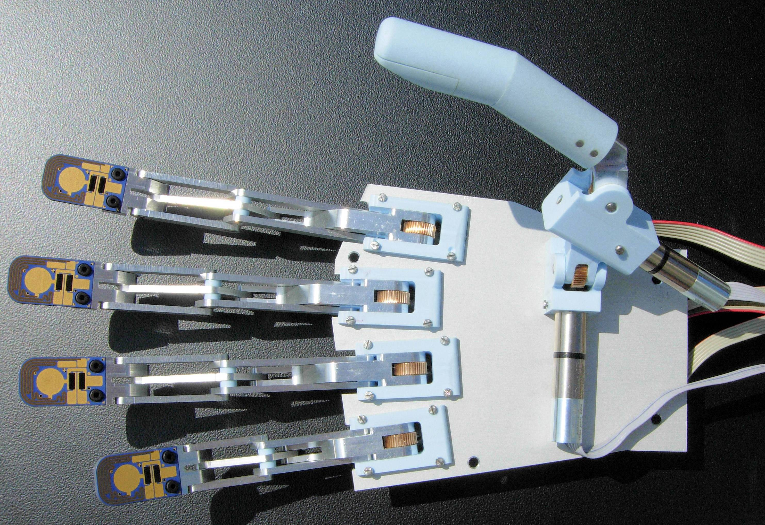
Fig. 1. The Southampton Hand.

II. FINGERTIP DESIGN

Recent research at Southampton has concentrated on producing an array of sensors on a fingertip shaped beam. This has been accomplished using thick-film printing techniques [19]. Fig. 2 illustrates a prototype fingertip with three types of printed sensor. Each sensor replicates a type of sensor found in the natural human hand [20]. The piezoelectric dynamic force sensor is used to detect slip in a similar manner to the fast adapting mechanoreceptive afferent units. So for example, when a step input is applied, a signal is generated which decays with time. The sensor is thus used to detect vibrations across the fingertip associated with slip.

The piezoresistive strain sensors act as slow adapting mechanoreceptive afferent units. The fingertip is modelled on a cantilever beam structure with the piezoresistors located close to the root where the maximum strain is produced [21]. When a force is applied to the end of the fingertip the structure bends and the resistance of the piezoresistors change in proportion to the applied force and the output remains at a constant value until the force changes. The piezoresistors are also arranged in such a manner as to allow an accurate force to be calculated independently of the position of the load (as long as the force is applied distal to the resistors location on the beam) using resistance ratios. This technique and experimental results are described in more detail in [5] along with the characteristics of the force and temperature sensors.

The temperature sensor (formed from a thermistor paste) represents the thermosensitive units found in the human hand and can be used for temperature compensation of the other sensors, which could range from -30˚C in cold climates to over 50˚C when holding hot objects. The temperature sensor can also be used to detect if an object gripped by the hand is too hot or too cold and thus prevent damage to the prosthesis by automatically releasing the object.
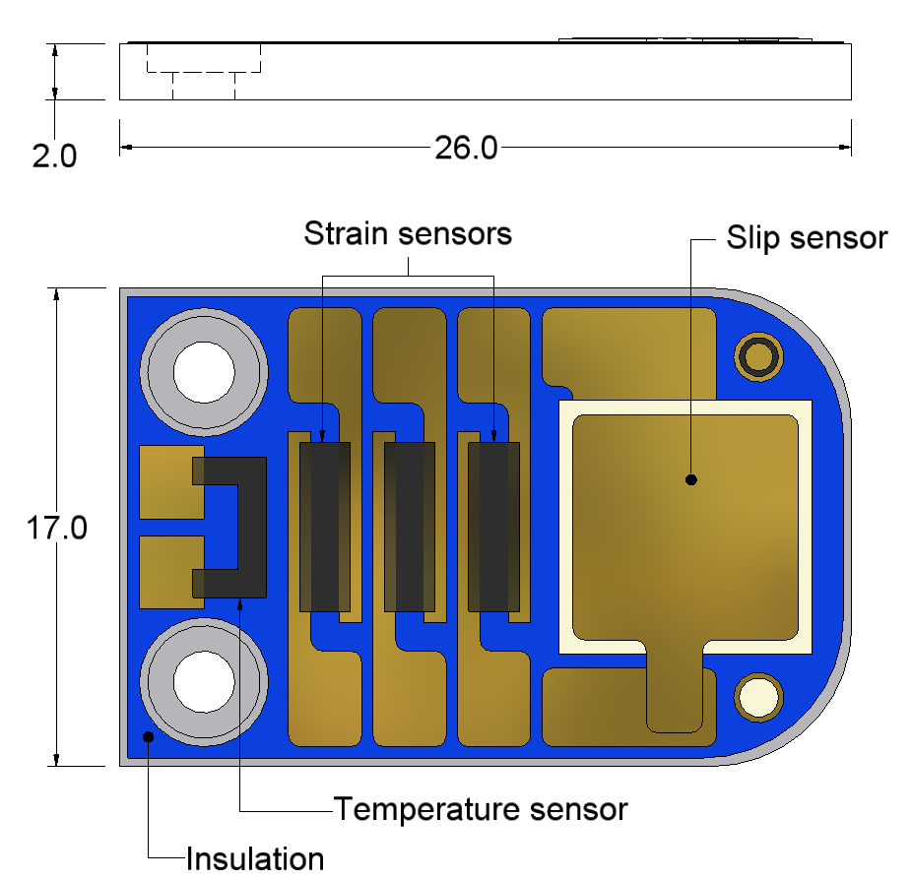
Fig. 2. Prototype fingertip (all dimensions in mm).

A. Sensor Fabrication

Fingertip shapes were cut from a 2mm thick stainless steel (type 430S17) plate then degreased using acetone and subsequently rinsed in deionised water to remove any potential contaminants which could affect the print quality. To isolate the sensors electrically from the stainless steel substrate three layers of dielectric paste (ESL 4986) were successively printed, left for 10 minutes to level out before being dried using an IR heater for 10 minutes at approximately 150ºC and then fired in a belt furnace for approximately 60 minutes, reaching a peak temperature of 850°C. A single layer of gold paste (ESL 8836) was then printed on top of the dielectric, left to level, dried and fired (using the same parameters used to create the dielectric layer) to form the bottom electrodes for each of the sensors. The piezoresistors (ESL 3914) and thermistor (ESL PTC-2611) were subsequently printed and fired in a further two stages using the same parameters. The PZT paste composition used in this application was developed at the University of Southampton. The paste comprises a mixture of two different sized PZT-5H powder grains of 2µm (72% total wt) and 1µm (18% total wt) in a 4:1 mixture weight ratio, mixed with 10% by total weight powdered glass binder (CF7575) and a solvent (ESL 400) to make it screen printable. Details of the paste preparation and optimised processing parameters can be found in [22]. The piezoelectric layer was printed and left to level for approximately 10 minutes before being dried in an IR drier at 150ºC. A second layer was then printed on top of the first, left to level for 10 minutes before again being dried at 150ºC in an IR drier. The two layers were then co-fired at a peak temperature of 950ºC, producing a film thickness of approximately 100µm. Finally a top gold electrode (ESL 8836) was printed, left to level, dried and fired using the same parameters used to define the gold bottom electrodes. Fig. 3 illustrates the printed layers on the fingertip.

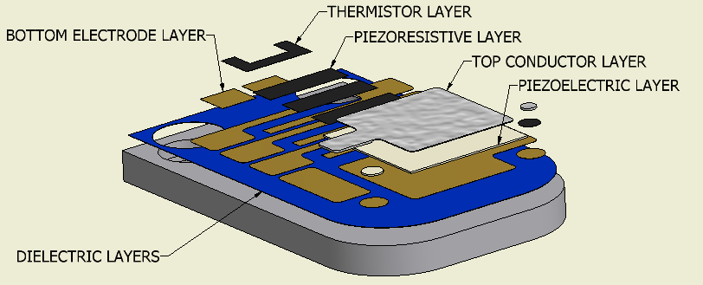
Fig. 3. Printing layers required to create prototype fingertip.

To activate the piezoelectric sensor a poling process was used, whereby a poling field of 4MVm⁻¹ (approximately 400V) was applied across the piezoelectric layer for 30 minutes at 150ºC. The sample was then allowed to cool to room temperature before the voltage was removed. The d₃₃ (sensitivity of the samples) was measured using a Take Control PM35 piezometer [23] and revealed a sensitivity value of around 46 ± 2 pC/N.

B. Experimental Setup

In order to quantify the ability of the piezoelectric sensor to detect slip it must be compared in some way to the real slip of an object. To achieve this, a slip apparatus was designed and built. It incorporated a rotary encoder to monitor object movement and acceleration, thus allowing a comprehensive comparison of the object’s movement with that of the slip sensor signal.

Fig. 4 illustrates the slip test equipment used throughout the experiments. The test equipment comprises a sliding block made from aluminium with four nylon headed screws attached to the bottom and two nylon screws attached to the side of the block. These screws allow the block to slide more freely against the side and the bottom of the aluminium angle base.

The fingertip is bolted to a plastic block held up by two studs in the same manner as it would be connected to the end of a prosthetic finger. To allow different forces to be applied to the fingertip two compression springs were placed over the studs so that when the nuts are tightened the springs apply a force to the block, which is then coupled through the end of the fingertip and onto the sliding block. This feature allows a range of applied fingertip forces to be analysed.

To replicate slip, weights are attached to the front of the aluminium block via a metal cable and hung over a pulley attached to the base. When the weight is released it drops to the floor causing the “sliding block” to slip past the fingertip.

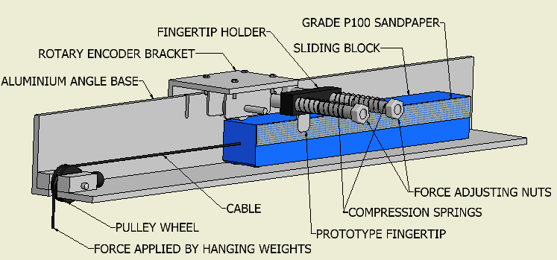

Fig. 4. Slip test apparatus.

A HEDS-5540 three channel rotary encoder with a resolution of 500 pulses per revolution (ppr) was mechanically coupled to the top of the block via a wheel using the bracket shown in Fig. 4. The wheel has a 44mm diameter and a circumference of approximately 138mm. With 500 pulses per revolution from the encoder, a linear resolution of 0.276mm per pulse is obtained.

C. Calibration of Applied Force

In order to calibrate the force applied by the fingertip a Mecmesin Compact Gauge [24] force measuring device was used to measure the force at the fingertip holder block whilst the nuts were tightened together one full turn at a time. The Compact Gauge force measuring device is a hand held force gauge with a digital readout capable of measuring compression and tension forces up to 50N with a resolution of 0.25N. Fig. 5 shows that the springs obey Hooke’s law:

F = kx (1)

where F is the force on the spring, k is the spring constant and x is the change in length of the spring, and that for a full turn on both bolts the fingertip force increased by approximately 1.26N.

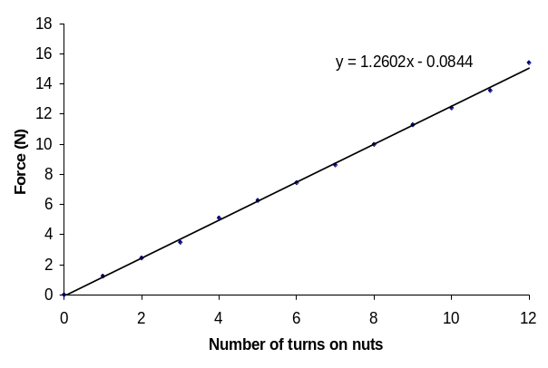
Fig. 5. Force calibration of springs.

D. Data Collection

In order to easily manipulate and analyse the signals, data was collected using a National Instruments 6036E data acquisition card (DAQ) and a purpose built program written in LabVIEW™ 7.1. The 6036E is a 16-bit card with 16 analogue inputs, 2 analogue outputs and a maximum sampling rate of 200kS/s. The slip sensor and encoder signals were sampled at a rate of 10kS/s throughout each trial to allow all signals up to 5 kHz to be accurately represented in a digital form [25].

E. Electrical Circuit Design

The charge output from all piezoelectric materials is generally very low and traditionally measured in pC/N. This signal has to be converted to a voltage and amplified so it can be accurately recorded. Fig. 6 illustrates the process used to amplify and filter the signal before the data was recorded. Initially the charge from the sensor was converted into a voltage and amplified using a charge amplifier. The charge amplifier is built around the MXL1007 operational amplifier. The capacitances of the piezoelectric sensors differ between samples due to slight variations in sample thickness and are typically in the range of 1-7 nF (C_{s}). The gain of the charge amplifier was kept as near to unity as possible by selecting a feedback capacitor with a similar value (C₁). A second amplifier provides further gain. To avoid aliasing issues an anti-aliasing filter was incorporated into the circuit to allow frequencies above half of the sampling rate to be rejected thus allowing an accurate digital picture of the signal to be generated. For this purpose a Maxim 291 switched capacitor low pass 8 pole Butterworth filter was selected.
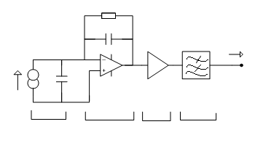
SLIP SENSOR
CHARGE
AMPLIFIER
VARIABLE GAIN AMPLIFIER
BUTTERWORTH FILTER

Xn
TO DAQ

R1
C1
I

Cs
Fig. 6. Charge amplifier with gain
control and 8-pole Butterworth filter.

The value of the feedback resistor R1 in the initial stage of the charge amplifier is very important since it controls the decay time and amplitude of the output from the piezoelectric sensor. A high value resistor will produce a longer decay time with a high signal output whilst a small value resistor will produce a faster decay time with a low signal output. For this particular application a 1MΩ resistor was found to produce an optimal response.

F. Analysis of the Forces Acting on the Slip Test Apparatus

Analysing the forces acting upon the test rig components and performing some simple experiments allowed the coefficient of friction between the fingertip and the sandpaper adhered to the sliding block to be calculated. Using similar methods the coefficient of friction between the test rig base and the nylon screws was also obtained. The coefficient of friction between the fingertip and contacting surface is important to enable a comprehensive evaluation of the sensor’s capabilities when detecting slip on everyday objects as there is expected to be a limit at which the coefficient of friction is too low to produce a signal. This limit is not expected to affect the use of the sensor as the user may be able to visually assess an object before deciding upon the grasp pattern they will use to pick up or hold that object. For example, most people would cup an ice cube in the palm of their hand whilst holding it rather than use their fingers and thumb.

The slip test apparatus has been modelled in Fig. 7 with all of the forces acting upon the test rig during its operation denoted. For ease of analysis Fig. 7 has been divided into smaller free body diagrams (FBD) shown in Figs. 8-10, where the following notation is used:

A₁ is the linear acceleration of the ‘sliding block’ (m s⁻²);
A₂ is the linear acceleration of the ‘falling mass’ (m s⁻²);
F₁ is the normal force produced by the mass of the block (N);
F₂ is the force applied by the fingertip (N);
F₃ is the inertial and frictional forces from the encoder (N);
F₄ is the inertial and frictional forces from the pulley (N);
M₁ is the mass of the ‘sliding block’ (kg);
M₂ is the mass of the ‘falling mass’ (kg);
T₁ and T₂ are the tension forces in the cable (N);
µ₁ is the coefficient of friction between the nylon screws and the aluminium base;
µ₂ is the coefficient of friction between the fingertip and the material adhered to the sliding block;
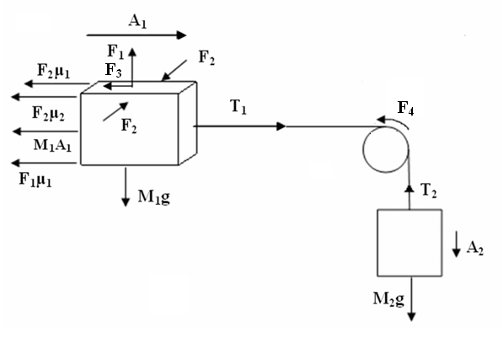
Fig. 7. Test rig system with forces and accelerations
labelled during normal operation.

I) Analysis of the Sliding Block:
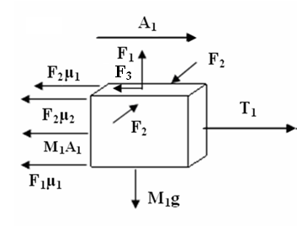
Fig. 8. Free body diagram of sliding block.

Resolving forces horizontally:

T₁– M₁A₁ – F₃ – F₁µ₁ – F₂µ₂ – F₂µ₁ = 0 (2)

The tension force in the metal cable T₁ is opposed by the friction forces created between the nylon screws on the sliding block and the bottom (F₁µ₁) and side (F₂µ₁) of the aluminium base. Friction forces created between the fingertip and material adhered to the sliding block (F₂µ₂) as well as inertia forces from the sliding block itself (M₁A₁) and the inertia and fictional forces from driving the motor encoder (F₃) also oppose the tension force in the metal cable.

Resolving forces vertically:

F₁ – M₁g = 0 (3)

II) Analysis of the Falling Mass:
M₂g
A₂
T₂

Fig. 9. Free body diagram of falling mass.
There are no forces acting in the horizontal plane, therefore resolving forces vertically:

T₂ – M₂g – M₂A₂ = 0 (4)

Assuming negligible inertia and negligible frictional losses of the pulley and encoder assembly and that the coupling wire is inextensible provides the following linking equations.

F₃ = 0 (5)
F₄ = 0 (6)
T₁ = T₂ (7)
A₁ = A₂ (8)
Substituting (3) to (8) into (2) yields the expression:

A₁[M₁ – M₂] + µ₁[F₂ + F₁] + µ₂F₂ – M₂g = 0 (9)

This expression leaves three unknowns µ_{1,} µ₂ and A₁, which can all be found experimentally.

III) Experimentally Determining µ₁: To determine the sliding coefficient of friction µ₁ the sliding block was pulled along the base of the test rig at an approximate constant velocity by hanging weights on the metal cable, suspended over the pulley, and without the fingertip in contact with the block. The force T₁ was then calculated from the weight required to make the block slide (c.f. Fig. 10).
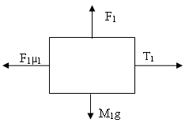
Fig. 10. Free body diagram of sliding block
being pulled along at a constant velocity.

Resolving forces horizontally:

T₁ – F₁µ₁ = 0 (10)

The experiment was conducted six times and an average T₁ value of approximately 2.7N was recorded (c.f. Table 1). The mass of the sliding block M₁ was 1.336kg and taking the acceleration due to gravity to be 9.81 ms⁻² allows the coefficient of friction between the nylon screws and aluminium test rig base to be calculated by substituting (3) into (10).

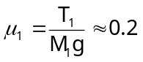 (11)

The value determined for μ₁ of 0.2 is comparable with that found in the literature, giving confidence in this experimental method. For example, Carvill quotes the coefficient of friction for Nylon on steel under low pressure and with no lubrication as lying within the range 0.3 to 0.5 [21].

IV) Experimentally Determining µ₂: The same procedure was then applied to the test rig to calculate the sliding coefficient of friction between the fingertip and the grade P100 sandpaper adhered to the sliding block (µ₂), with a known force (F₂) applied to the sliding block by the fingertip (c.f. Fig. 8).

Resolving forces horizontally:

T₁ – F₂µ₁ – F₂µ₂ – F₁µ₁ = 0 (12)

Rearranging (12) allows µ₂ to be calculated.

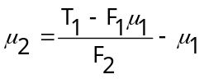 (13)

F₂ Value (N) | Average T₁ Value (N) | Average µ₂ Value
0 | 2.70 ± 0.00 | N/A
1 | 3.15 ± 0.05 | 0.27 ± 0.05
2 | 3.65 ± 0.05 | 0.29 ± 0.03
3 | 4.20 ± 0.00 | 0.31 ± 0.00
4 | 4.75 ± 0.05 | 0.32 ± 0.01

Table 1: Average coefficient of friction values recorded at different applied forces.

In order to determine the coefficient of friction value the force applied by the finger tip was increased from 0 to 4 N in 1N increments. At each force increment three T₁ force values were taken using the hanging weight method described earlier. The fingertip force was then reset and the experiment was repeated. The average of six runs was used to calculate an average µ₂ value at each force. These average values were then used to calculate an overall average µ₂ value of approximately 0.3. This compares favourably with published values of friction coefficients between similar types of materials (e.g. 0.2 for metal on metal, 0.4 for leather on metal and 0.5 for Acrylic on metal) [21].

III. DATA COLLECTION AND ANALYSIS

The compression springs on the slip test apparatus were adjusted so that the fingertip applied approximately 1.25N of force to a sheet of grade P100 sandpaper (with a similar surface roughness to that found on the striking surface of a match box), adhered to the side of the “sliding block” with double sided tape. A small stainless steel washer was glued to the back of the fingertip to prevent it being damaged by the sandpaper; this then couples any vibration forces to the sensor. Supported weights were attached to the cable connected to the “sliding block” (c.f. Fig. 4). When released, this caused the block to accelerate past the fingertip, simulating slip. This experiment was subsequently repeated a number of times and the results analysed in terms of the acceleration and velocity at which an initial slip signal was detected.

A. “Sliding Block” Acceleration

Calculating the acceleration and velocity of the “sliding block” allowed a direct comparison to be made between trials when the conditions of slip were the same and when they were not, and if this had any affect on the output signal. To obtain the acceleration of the block the cumulative encoder count was plotted with respect to the square of the time, as shown in Fig. 11. The value of the acceleration can then be determined by multiplying the gradient of the graph by twice the encoder resolution (from s = ut + ½at²). Fig. 11 shows the encoder response to be linear indicating that the block is accelerating at a constant rate as expected. Similar responses were obtained for each of the trials, showing constant acceleration of the block in each case.

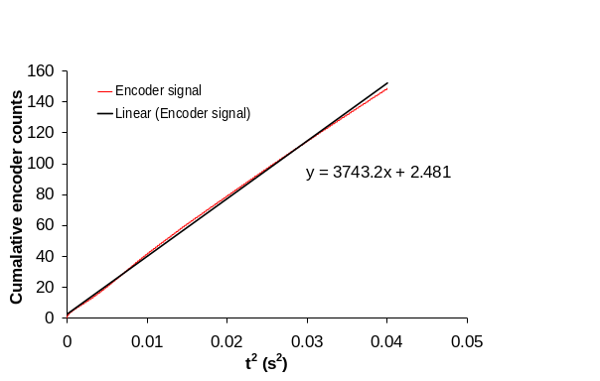
Fig. 11. Integrated encoder signal.

B. Setting a Threshold Level to Detect Slip Signal

A background noise reading was measured and rectified while the block was stationary. This revealed a peak noise level of 60 mV, allowing a suitable threshold of 100 mV to be selected for validating when the PZT signal was considered to be active. For each trial the PZT and encoder signals were recorded simultaneously. The recorded PZT sensor signals were post-processed in software. This involved firstly converting the digitised bi-polar signals into their uni-polar equivalents, in effect performing simple rectification. The resultant data set was then scanned in chronological order with each component of the data set being compared to the preset threshold level. Whenever the former exceed the latter, a threshold crossing event was recorded.
IV. RESULTS

Fig. 12 shows a typical signal obtained from the encoder and piezoelectric sensor when the block slides across the aluminium base with approximately 1.25N of force being applied to the block by the fingertip. The encoder signals shown in plots (a) and (b) are 90° out of phase and both show a narrowing in pulse width with time. This indicates that the block is accelerating. Section (c) illustrates the output from the piezoelectric sensor. It is interesting to note that the amplitude of the sensor signal tends to increase as the block accelerates. Finally (d) shows the rectified piezoelectric sensors output with a superimposed threshold level of 100 mV.

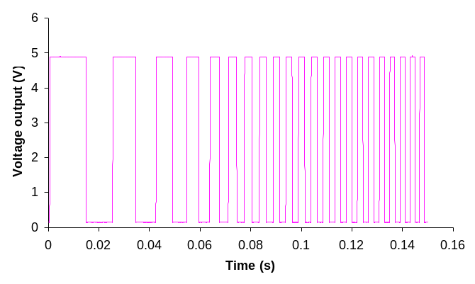
a) Encoder signal 1 from sliding block.
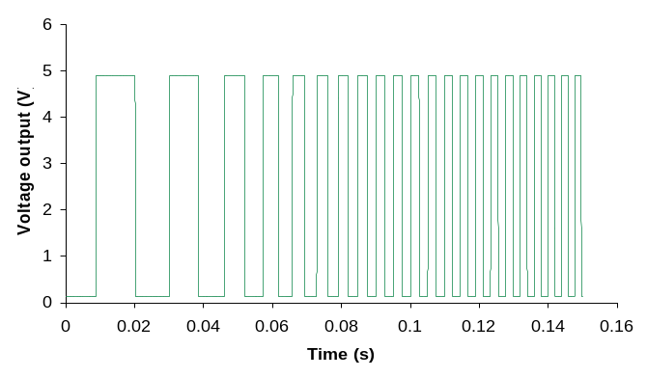
b) Encoder signal 2 from sliding block.
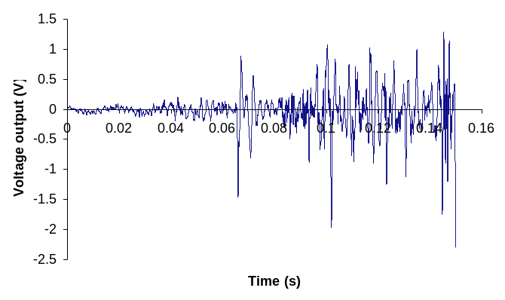
c) Slip signal from PZT sensor.
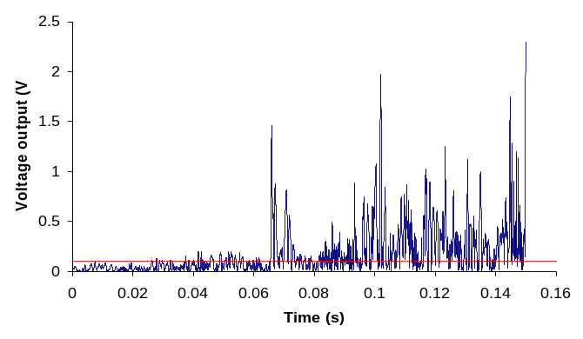
d) Rectified slip signal from PZT sensor
with superimposed 0.1V threshold.

Fig. 12. Encoder and PZT signals before and after rectification.

Fig. 13 shows the cumulative number of post-processed threshold crossing events, for different threshold levels, from a single PZT sensor when a fingertip force of 1.25N was applied to the block. The encoder signal recorded during the acquisition of the sensor data is also shown in the figure. Because the encoder has a fixed resolution (1 count is 0.276mm) then the sum of the encoder counts is a direct measure of the distance travelled by the “sliding block”. The encoder and PZT sensor signals are sampled at a fixed rate, therefore the gradient of the encoder signal represents velocity. It can be seen from the Fig. 13 that the gradient of the encoder signal increases over the duration of the experiment which implies that the velocity increases with time (left to right across the graph) i.e. the block is accelerating. This is confirmed in plots (a) and (b) of Fig. 12 where the period of the encoder signals is shown to decrease over the duration of the experiment. The processed PZT signal for each threshold level bisects the x-axis at different times and hence at different velocities. Fig. 12 (d) shows that at higher threshold levels, threshold crossing events are not recorded until later on in the experiment (i.e. at higher velocities). Conversely, at lower threshold values, threshold crossing events are observed much earlier in the experiment when the PZT sensor exhibits larger magnitude signals (i.e. at lower velocities). Thus there is a limiting velocity before which slip can not be detected, and the value of this velocity is proportional to the magnitude of the threshold used when counting threshold crossing events. Ideally slip should be detected at the lowest velocity possible but this is where a trade off exists: setting a threshold level too low means that extraneous noise could register as a threshold crossing event giving the impression that slip had occurred when it hadn’t.

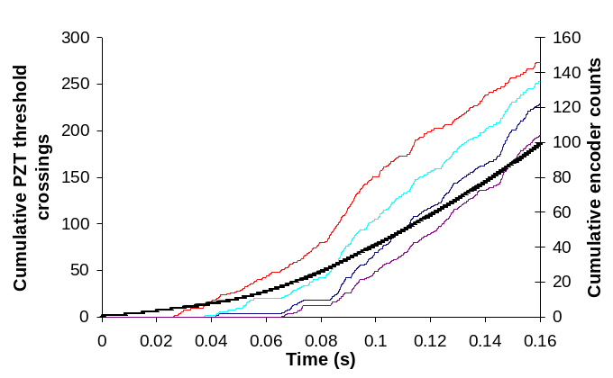
Threshold
100 mV
250 mV
Encoder signal
Fig. 13. Comparison of encoder signal to PZT slip signal for different threshold values ranging from 100mV to 250mV in 50 mV intervals.

Fig. 14 shows the cumulative PZT sensor threshold crossing events recorded over the distance travelled by the sliding block (determined from the encoder count and encoder resolution) for four trials with a fingertip force of approximately 1.25N on grade P100 sandpaper and with a sensor signal threshold value of 100 mV. The values of the linear regression coefficients (displayed in the legend) show the highly linear fit for each trial. At a threshold of 100 mV, slip was detected after the block had moved a distance between 1.10mm – 1.66mm. Table 2 shows that the velocity (determined from the encoder signals recorded simultaneously for each trial and from the sampling rate) at which the initial slip was detected was similar for the first three trials with an average value across all four trials of approximately 0.025 ± 0.008 ms⁻¹

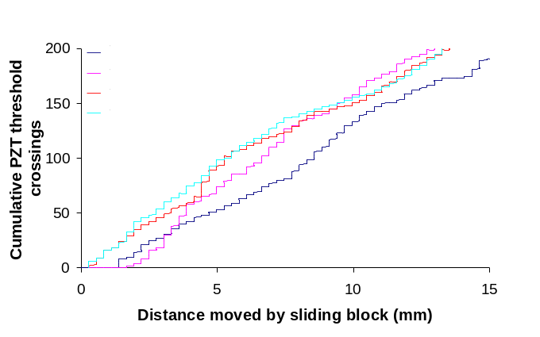
Fig. 14. Indication of sensor repeatability.

Trial | Velocity (ms⁻¹) | Acceleration (ms⁻²)
1 | 0.0280 | 2.06
2 | 0.0334 | 1.55
3 | 0.0304 | 1.85
4 | 0.0176 | 1.44

Table 2: Velocity and acceleration at which slip was first detected.

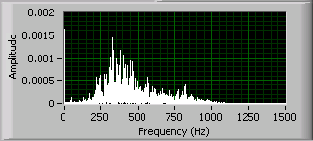

Fig. 15. Linear power spectrum FFT of trial 1.

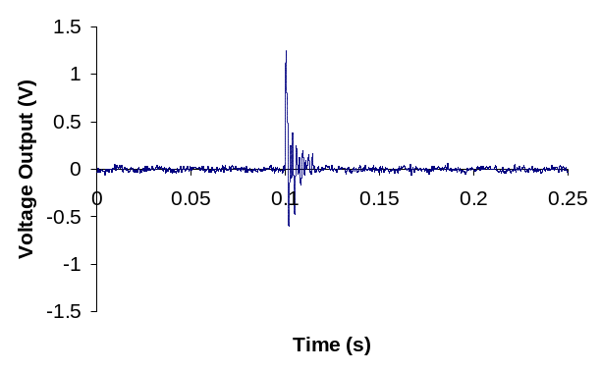
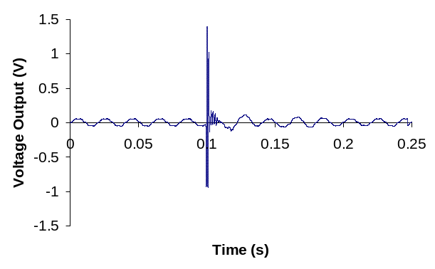
Fig. 15. shows a linear power spectrum FFT for a typical trial and reveals that the frequency content of the slip signal for this particular material combination is contained in the approximate range of 200-1000 Hz. This frequency range is likely to be dependant upon the type of material in contact with the fingertip and more tests on alternative materials are required before the application of filtering the sensor signal can be considered. However, if it is possible to filter out all of the lower frequencies up to around 150 Hz, then this would eliminate the mains noise (50Hz) and allow a higher gain to be applied to the sensor output for improved signal to noise ratios. In the real application noise will be reduced by locating the charge amplifier next to the sensor, which was not possible in this case due to the size of the prototype electronics - the signal being transferred through a 20cm length of shielded cable. The circuit will also be powered by a battery which will also reduce noise levels. Fig. 16 (a) and (b) show the output signal of the PZT sensor when it is lightly tapped. Fig. 16 (a) shows the signal when the amplifier circuit is powered by a mains source whilst Fig. 16 (b) shows the output of the signal when the circuit is powered by a battery source. This reduced the peak noise level from 60mV to approximately 30mV. Both signals show a high initial output when tapped, which decays quickly with time and is notably different to that of the slip signal shown in Fig. 12. This characteristic could be utilised within a control system in the hand to avoid erroneous closure, for example if the user accidentally bumps into an object or taps the table. The signal can also be used to indicate the first contact with an object when the hand is closing.
(b)
(a)
Fig. 16. Sensor output when the prototype fingertip is lightly tapped for (a) amplifier circuit powered from a mains source, (b) amplifier circuit powered from a battery source.

V. DISCUSSION

Fig. 12 (c) shows evidence of a slip signal superimposed over background noise level (in this case 50Hz mains noise). However, the piezoelectric sensor’s signal is much smaller than the noise signal and so a threshold cannot be accurately applied to it at an object velocity below 0.034 ms⁻¹. This suggests that if the 50Hz noise is reduced by placing the electronics closer to the sensor and powering the electronics with a battery source then the slip signal may be detectable at a lower velocity, and possibly before the object has moved 1mm. The rejection of the 50Hz noise would also allow a much higher amplifier gain to be applied, allowing the slip signals to be investigated in greater detail.

Fig. 14 shows an approximately linear relationship between the cumulative encoder counts and cumulative piezoelectric sensor’s threshold crossing events. Since the encoder signal is a direct representation of the distance the object has moved, then it is reasonable to assume that the processed PZT signal also represents the distance moved by the object. The processed PZT signal therefore represents movement of the block, hence slip.

During everyday use there are a number of sources potentially producing erroneous signals from the slip sensor. These include bumping into an object or simply scratching your leg. For this reason the sensor is intended to be used in conjunction with force sensors, motor encoders for finger tip position and an intelligent control system. It is clear from comparing the piezoelectric sensor’s response when lightly tapped to that of an object sliding that they are different and hence the tapping signals could be ignored. However actions such as scratching your leg are likely to produce a similar response to a slip signal, so to avoid erroneous hand closure the position of the fingers and force applied to them can be taken into account, only allowing the signals from the slip sensor to be acted upon when the hand is in a grip mode.

It is likely that the surface properties (e.g. surface roughness, geometry, coefficient of friction between object and prosthesis) of a held object are related to the frequency and amplitude output of the piezoelectric sensor with respect to the velocity the object is travelling. If correct, then an FFT analysis maybe useful alongside other tactile information such as grip force in determining these characteristics. However this type of analysis would still not be useful in controlling the force applied to an object within a prosthetics application. This is because a number of samples would have to be recorded before the surface properties could be determined. In real terms this would mean the user of the prosthesis would have dropped the object they were holding before the surface properties and hence the force required to be applied to the object was determined. It is however a useful analysis in determining the frequencies which may be filtered out of the signal and also the minimum sampling rate which would be required in a prosthetics application to cover a range of surface geometries, coefficients of friction and velocities.

The analysis of the signal frequency content for different materials and surface geometries is important to enable an optimal frequency range to be selected for use in a prosthesis. This particular material combination shows very usable frequency content with no low frequencies thus enabling mains noise to be removed and allowing enough characteristic data to be collected in a short period of time so that object slip can be detected quickly. The higher end of the frequency range is also not too high as to require a fast sampling device.

Other limitations will include low coefficients of friction not producing a large enough signal to define an object’s slip, the damping effects of different glove types worn and the position of the slip sensor in the prosthetic hand.

VI. CONCLUSIONS AND FUTURE WORK

With a coefficient of friction of approximately 0.3 between the fingertip and sandpaper, a velocity of 0.025 ± 0.008 ms⁻¹ was reached before a slip signal above the background noise was able to be used to detect slip. By reducing the threshold value used in the detection of threshold crossing events from 250mV to 100mV it has been shown that the velocity at which the initial slip detection occurs is decreased. It is also evident that the slip signal from the PZT sensor began before it was detected at the threshold of 100mV. There is therefore scope to reduce the background noise signal and use a much lower threshold value or increase the output gain, which would then allow the accurate detection of slip at lower velocities. This is the first experimental evidence that this type of thick-film piezoelectric sensor can be used to detect slip. The slip signal is a measure of relative velocity between the object and finger surface. It can be processed to obtain an estimate of the relative distance that an object has slipped.

This investigation has also proved the suitability of the apparatus to simulate slip under a range of conditions e.g. acceleration, coefficient of friction and fingertip force.

Further work is therefore required to investigate the lowest possible coefficient of friction required to trigger the signal at an acceptable object velocity with an optimal fingertip design

REFERENCES

[1] D. S. Childress, “Historical aspects of powered limb prosthesis,” Clinical prosthetics and orthotics, vol. 9, pp. 2-13, 1985.
[2] H. R. Nicholls, Advanced Tactile Sensing for Robotics, World Scientific Publishing Co. Pte. Ltd., 1992.
[3] R. N. Torah, “Optimisation of the piezoelectric properties of thick-film piezoceramic devices,” PhD Thesis, University of Southampton, 2004.
[4] A. Cranny, D. P. J. Cotton, P. H. Chappell, S. P. Beeby and N. M. White, “Thick-film force, slip and temperature sensors for a prosthetic hand,” Meas. Sci. Technol.,.vol. 16, pp.1-11, 2005.
[5] A. Cranny, D. P. J. Cotton, P. H. Chappell, S. P. Beeby and N. M. White, “Thick-film force and slip sensors for a prosthetic hand,” Sensors and Actuators A: Physical,. vol. 123-124, pp 162-171, 2005.
[6] A. Mingrino, A. Bucci, R. Mangni and P. Dario, “Slippage control in hand prosthesis by sensing grasping forces and sliding motion,” in IROS '94. IEEE/RSJ/GI Proc. Int. Conf. on Intelligent Robots and Systems, Advanced Robotic Systems and the Real World, vol. 3(3), pp.1803-1819, 1994.
[7] P. Dario, R. Lazzarini, R. Magni and S. R. Oh, “An integrated miniature fingertip sensor,” in IEEE Seventh Inter. Symp. on Micromachines and Human Science, pp. 91-97,1996.
[8] R. D. Howe and M. R. Cutkosky, “Sensing skin acceleration for slip and texture perception,” in Proc. IEEE Inter. Conf. on Robotics and Automation, pp. 145-150, 1989.
[9] P. Ueberschlag, “PVDF piezoelectric polymer,” Sensor Review, vol. 21, pp.118-125, 2001.
[10] www.ottobock.co.uk [Accessed on 3/4/06]
[11] M. R. Tremblay and M. R. Cutkosky, “Estimating Friction using incipient slip sensing during a manipulation task,” in IEEE Inter. Conf. on Robotics and Automation, vol. 1, pp. 429-434, 1993.
[12] C. M. Light, “An intelligent hand prosthesis and evaluation of pathological and prosthetic hand function,” PhD Thesis, University of Southampton, 2000.
[13] C. M. Light and P. H. Chappell, “Development of a light weight and adaptable multiple axis hand prosthesis,” Medical Engineering and Physics, vol. 22, pp. 679-684, 2000.
[14] G. Guo and W. A. Gruver, “Optimal design of a six bar linkage with 1 DOF for an anthropomorphic three jointed finger mechanism,” in Proc. Inst. Mech. Eng.,vol. 207, pp. 185-190, 1993.
[15] C. M. Light, P. H. Chappell, B. Hudgins and K. Engelhart, “Intelligent myoelectric control of hand prosthesis,” Journal of Medical Engineering and Technology, vol. 26 (4), pp. 139-146, 2002.
[16] C. M. Light and P. H. Chappell, “Development of a light weight and adaptable multiple axis hand prosthesis,” Medical Engineering and Physics, vol. 22, pp. 679-684, 2000.
[17] P. H. Chappell and J. A. Elliott, “Contact force sensor for artificial hands with a digital interface for a controller,” Measurement and science technology, vol. 14, pp. 1275-1279, 2003.
[18] P. J. Kyberd and P. H. Chappell, “Characterisation of an optical and acoustic touch sensor for autonomous manipulation,” Measurement and Science Technology, vol. 3(10), pp. 969-75, 1992.
[19] P. J. Holmes and R.G. Loasby, Handbook of thick-film technology, Electrochemical publications Limited, 1976.
[20] R. S. Johansson and A. B. Valbo, “Tactile sensory coding in the glabrous skin of the human hand,” Trends in Neurosciences, vol. 27-32, 1983.
[21] J. Carvill, Mechanical engineer’s data handbook, 2005, ISBN 0 7506 1960 0.
[22] R. Torah, S. P. Beeby and N. M. White, “An improved thick-film piezoelectric material by powder blending and enhanced processing parameters,” IEEE Transactions on Ultrasonics, Ferroelectrics, and Frequency Control, vol. 52(1), pp. 10-16, 2005.
[23] www.piezotest.co.uk/d33piezometer.html (Accessed on 23/08/06).
[24].www.mecmesin.com/ucm/home/product_view.asp?proID=101&range=39 (Accessed on 23/08/06).
[25] S. W. Smith, The scientists and engineer’s guide to digital signal processing, 2nd edition, California Technical Publishing, Electronic version, 1997-1999, ISBN 0-96601-6-8.

BIOGRAPHIES

D.P.J. Cotton graduated from the Mechanical Engineering department at Newcastle University in 2003, receiving a BEng (Hons) degree. He is currently undertaking a PhD in the School of Electronics and Computer Science at the University of Southampton, investigating the potential for integrating thick-film sensors into prosthetics. He has a number of publications in the field of thick-film sensors. He is a graduate student member of the IEEE and an associate member of the Institute of Mechanical Engineers.
PLACE PHOTO HERE

Paul H Chappell graduated from the University of Sussex with a first-class honours degree in electronics and was awarded a PhD degree in control engineering from the University of Southampton. He is a senior lecturer in the Electronics Systems Design Research Group within the School of Electronics and Computer Science at Southampton. His research interests are in Medical Engineering, particularly Prosthetics and Functional Electrical Stimulation. He has also designed Power Electronic Converters for industrial applications. He is an author of over 90 publications (journal papers, conference proceedings, chapters in books and a patent). Paul is a Chartered Engineer, a Member of the Institution of Engineering and Technology, a Member of the Institute of Physics and Engineering in Medicine, and a Member of the Institute of Electrical and Electronics Engineers.
PLACE PHOTO HERE

Andy Cranny graduated from the University of Coventry in 1985 with an honours degree in applied physics. He is currently employed as a research fellow within the School of Electronics and Computer Science at the University of Southampton where he was awarded his PhD in 1992 for a thesis on sensor array signal processing for cross-sensitivity compensation in non-specific organic semiconductor gas sensors. He has been employed at various times at the University, both in his present position and also within the School of Engineering Sciences, for over 15 years. He has also had industrial experience, working on fibre optic preform analysis with GN NetTest for 15 months in the post of Senior Measurement Engineer and has held directorships with two technology orientated companies. He has a number of publications in the field of thick-film sensors for both physical and chemical parameters and is a co-inventor on a number of patents. He is a member of the Institute of Physics and is a Chartered Physicist.
PLACE PHOTO HERE

Neil M White holds a personal chair in the School of Electronics and Computer Science, University of Southampton He has been active in sensor development since 1985. In 1988 he was awarded a PhD from the University of Southampton. He has considerable experience in the design and fabrication of a wide variety of sensors, formulation of novel thick-film sensing materials and intelligent sensor systems. Professor White is Director and co-founder of the University of Southampton spin-out-company Perpetuum Ltd. He has over 200 publications in the area of instrumentation and advanced sensor technology. His professional qualifications include Chartered Engineer, Fellow of the IET, Fellow of the IOP, Chartered Physicist and Senior Member of the IEEE.
PLACE PHOTO HERE

Steve P Beeby graduated from the University of Portsmouth in 1992 with BEng (Hons) in Mechanical Engineering. He obtained a PhD from the University of Southampton in 1998. In 2001 he was awarded a prestigious EPSRC Advanced Research fellowship to continue his research into active thick-film materials development and their combination with micromachined devices. His other research interests include energy harvesting for remote wireless sensor networks and he is the project co-ordinator of an EU funded STREP project entitled ‘Vibration Energy Scavenging (VIBES)’. He is also interested in human biometric systems. He has over 120 publications in the field and is co-author of a book entitled ‘MEMS Mechanical Sensors’ published by Artech House. He is a member of the EPSRC peer review College, reviewer for numerous journal publications, a Chartered Engineer and Chartered Physicist and has provided consultancy services to several companies.
PLACE PHOTO HERE

