Thick-film piezoelectric slip sensors for automatic grip control in prosthetic hands
Cotton, D.P.J, Cranny, A, Chappell, P.H, White, N.M,
School of Electronics and Computer Science, University of Southampton, UK

Introduction
Piezoelectric sensors produce a charge when mechanically deformed (for example through the action of an applied force). This charge decays with time dependant upon the connected electronics. This makes piezoelectric sensors an ideal candidate for detecting the vibrations (change in surface forces) associated with object slip from a prosthetic hand. Most previous work undertaken with piezoelectric sensors to detect object slip from upper limb prosthetics has used polyvinylidene fluoride strips (PVDF) (Dario 1996) (Howe 1989). This type of sensor has a low sensitivity of around 20-30 pCN⁻¹ and comes in a sheet format so would have to be adhered manually to a hand. Thick-film piezoelectric sensors offer a superior alternative for this application with a much higher sensitivity than PVDF of around 130pCN⁻¹ (Torah et al 2005) and the thick-film fabrication technique allows the sensors to be accurately printed onto the flat surface of a prosthesis finger or fingertip.

Method
A piezoelectric thick-film sensor was screen printed onto a pre-fabricated fingertip shaped piece of stainless steel (type 430S17). In order to replicate slip, a test apparatus was designed and built as illustrated in Figure 1. The apparatus is set up so that the fingertip is pushed against the sliding block via the compression springs and by applying weights to the end of the cable the sliding block is forced to slide past the fingertip simulating slip. The applied fingertip forces can be altered by shortening the compression springs via the force adjusting nuts and the coefficient of friction can be changed by changing the material adhered to the sliding block. The rotary encoder module was incorporated to allow distance, velocity and acceleration of the sliding block to be calculated and compared to the signals produced by the thick-film piezoelectric slip sensor.
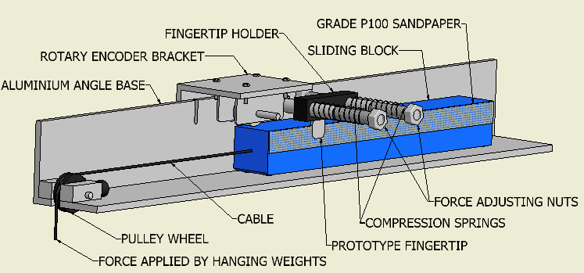
Figure 1. Slip test apparatus.
The output signals from the piezoelectric sensor were collected using a data acquisition card and a laptop PC. The data was later analysed by rectifying the output signal from the piezoelectric sensor and applying a threshold to the signal, an example of which can be seen in Figure 2. The threshold was applied to produce pulses which are then counted.
Figure 2. Rectified slip signal from PZT sensor with superimposed 0.1V threshold.

Discussion and Results
It is anticipated that at lower coefficients of friction, the sliding block will reach a higher velocity and hence slid a longer distance before slip is detected. An increase in the force applied by the fingertip could potentially produce a larger signal from the piezoelectric slip sensor and therefore reduce the velocity and distance travelled before slip is detected. A number of trials, conducted with the same force, and material (same coefficient of friction between surfaces) has shown that slip detection using this type of sensor is very repeatable.

Conclusion
These results show that the sensor detects slip velocity which can be used to estimate the distance that an object has slipped.

References
Dario, P. et al, IEEE Seventh inter. Symp. on micromachines and human science 91-97,1996.
Howe, R.D. et al Proc. IEEE inter. Conf. on robotics and automation, 145-150 1989.
Torah, R.N. et al IEEE T. Ultrason. Ferr. 52, 10-16, 2005.

