Multimedia Annotation and Community Folksonomy Building

Mike Wald, Gary Wills, Dave Millard, Lester Gilbert, Shakeel Khoja, Jiri Kajaba, Prins Butt
School of Electronics and Computer Science
University of Southampton
United Kingdom
M.Wald@soton.ac.uk

Abstract: Multimedia has become technically easier to create (e.g. recording lectures) but while users can easily bookmark, search, link to, or tag (i.e. classify) the WHOLE of a podcast or video recording available on the web they cannot easily find, or associate their notes or resources with, PART of that recording. This paper discusses how to meet the important and pervasive user need of making multimedia web resources (e.g. podcasts) easier to access, search, manage, and exploit for learners, teachers and other users through developing technologies that support the creation of synchronised notes, bookmarks, tags, links, images and text captions.

Introduction

This paper discusses how to meet the important and pervasive user need of making multimedia web resources (e.g. podcasts) easier to access, search, manage, and exploit for learners, teachers and other users through developing technologies that support the creation of synchronised notes, bookmarks, tags, links, images and text captions. These Synchronised Annotations will be referred to by the new term ‘Synnotations’ as there would appear to be no existing appropriate single word. Figures 1 & 2 schematically show the system to be developed.

Synchronised
Multimedia
Collaborate/Reflect

Search

Reason/Summarise

Organise/Index

Notes

Tags
Bookmarks
Text Captions

Images/Slides

Video
Audio
&
Links
Figure 1. System overview
synchronised images (e.g. PowerPoint Slides)

user created synchronised bookmarks, tags, notes with associated links to other resources

audio / video
synchronised text captions
multimedia start time
multimedia end time
Figure 2. Time-based view of system

Multimedia has become technically easier to create (e.g. recording lectures) but while users can easily bookmark, search, link to, or tag (i.e. classify) the WHOLE of a podcast or video recording available on the web they cannot easily find, or associate their notes or resources with, PART of that recording. As an analogy, users would clearly find a text book difficult to use if it had no contents page, index or page numbers. Therefore the growing amount of knowledge available in multimedia format has yet to achieve the level of interconnection and manipulation achieved for text documents via the World Wide Web and so realize the exciting opportunities for learning that can occur in ‘Web 2.0’ and ‘social software’ environments.

The provision of synchronized text captions (subtitles) and images with audio and video enables all their communication qualities and strengths to be available as appropriate for different contexts, content, tasks, learning styles, learning preferences and learning differences. Text can reduce the memory demands of spoken language; speech can better express subtle emotions; while images can communicate moods, relationships and complex information holistically. Deaf learners and non-native speakers may also be particularly disadvantaged if multimedia involving speech is not captioned.

The new generation of Web applications emphasise social interaction and user participation through social networks, collaborative content creation, and freeform metadata creation in the form of tagging which is currently used to aid search and to support recommendations. The usefulness of tags is limited by their meaning not being understood by the technology so that, for example, the relationship between synonyms is not recognised. The creation of structured tagging through schemas or ontologies involves much human time and effort but allows for more powerful manipulation of resources than unstructured tagging. It is possible to examine the use of unstructured tags and extrapolate a schema, called a Folksonomy, which reflects the evolving view of the community and supports advanced search and personalisation. The Folksonomy approach allows a community to reflect on their activities and develop tag richness to increase the utility and reusability of resources. Folksonomy construction joins the advantage of the Web 2.0 model with the utility of more traditional approaches (Al-Khalifa and Davis 2006). It is an important consideration to be able to strike a balance between freeform tagging and structured annotation, and support the agile and evolutionary development of information models.

Identification of User Needs Requirements

User needs requirements have been established through user studies which have shown how teachers and learners benefit from making annotations to help search and manipulate recordings of lectures or classes to find and make use of information. Consultations within the University, including with the 30 members of the University’s podcasting user group, have confirmed the user needs requirements for both teaching and administration, interest in involvement in the concept and synergy with the university’s road map to support and empower learners in their studies. Dr Wald in collaboration with the international Liberated Learning Consortium has conducted many qualitative and quantitative user studies involving questionnaires, interviews, focus groups, observations and logging the use of online synchronised multimedia with learners and staff that have established the importance of text captions for searching multimedia transcripts (Bain et al 2007). Figure 3 shows the screen display of an available working demonstration of searching captioned multimedia transcripts. User needs analyses and evaluations have also been conducted with learners at the University of Southampton using both low and high fidelity prototype technologies and interfaces and included reflection by learners on how they learn using recorded multimedia and how synchronized notes and tags could assist them (Clucas-Martin 2006). These studies confirmed the importance of captions for searching the recordings and reading the transcripts and the value of also being able to personally annotate the recordings (e.g. bookmarks, notes and tags) and search these annotations. Other research also supports these identified user needs (e.g. Whittaker et al 1994, Wilcox et al 1997, Chiu et al 1999, Brotherton, and Abowd 2004, Talkshow).

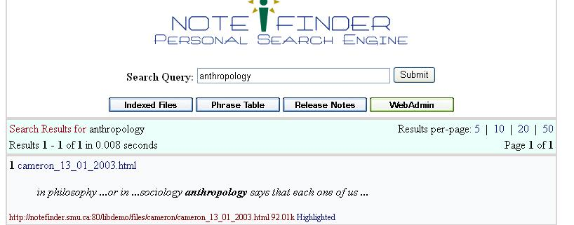
Figure 3. LL Notefinder Personal Search Engine for synchronized captioned multimedia

User needs analysis has identified many benefits of annotating multimedia recordings in the ways proposed in this paper. It will, for example:

Enable learners …
- to search text transcripts for specific topics and then replay recordings from that point
- to read captions rather than listen to recorded speech to support learning style preference, deafness, or English as a second language
- who find the more colloquial style of transcribed text easier to follow than an academic written style to use the transcript of lectures to support their understanding of text books and academic articles
- to insert a bookmark at a particular point in a recording so as to be able to continue later from where they left off
- to link to sections of recordings from other resources (e.g. documents, web pages etc.) or share these sections with others
- to tag and highlight sections of recordings/transcripts they don’t understand fully so they can revisit them later for clarification
- to annotate recordings with notes and URLs of related resources (e.g. documents, websites etc.) at specific places in a recording to clarify issues and support revision
- to tag recordings using their own terms as a personal index. A community folksonomy ‘index’ can be created from everyone’s tags to help provide a shared understanding and a more detailed and complete index.

Enable teachers/lecturers …
- to index their recordings using syllabus topic tags
- to provide synchronized slides and text captions to accompany podcasts
- to identify which topics need further clarification from the pattern of learners’ ‘not understood’ tags
- to provide feedback on learner-created recordings of presentations (e.g. ‘good use of voice’, ‘good use of audio visual material’)
- to ask learners to annotate recordings of their group meetings using unstructured or structured tags to provide evidence of their contributions as part of the module assessment
- to analyse unstructured tags learners use (folksonomy) to help create structured tags (ontology) for indexing future recordings
- to tag recordings with URLs of related resources (e.g. documents, websites etc.)
- to link to and use sections of existing multimedia without having to edit the recording

Enable administrative and support staff …
- to caption and add images to information or training recordings and tag with indexes and also URLs of related resources.

The importance of the identified user need of making multimedia accessible and searchable through the creation of synchronised transcripts and captions is supported by Google’s recent encouragement for people to caption their multimedia before uploading it to Google and their addition of the facility to manually type a time at the end of a URL to search and play the video starting from that position. Project Readon displays manually created non-searchable captions in a standalone caption player while the audio or video plays in its original window. Manual captioning is time consuming and costly but speech recognition has been demonstrated to provide a cost-effective way of automatically creating accessible text captions and transcripts synchronised with audio and video and so allows audio visual material to be manipulated through searching and browsing the text. The appearance on the web of Everyzing which uses speech recognition to create a searchable transcript from podcasts or multimedia recordings provides further evidence for the importance of the identified user need and the value of this approach. However Everyzing does not display fully synchronised captions and so does not meet the identified user accessibility needs.

Dr Wald has collaborated with IBM and the international Liberated Learning Consortium since 1999 to investigate how speech recognition captioning can enhance learning and to develop ViaScribe which uses speech recognition to create synchronized searchable transcripts, slides and captions from multimedia recordings of live or recorded speech or video. Screen captures of ViaScribe and an associated user configurable multimedia display of text captions synchronized with audio and Powerpoint slides are shown in Figures 4 and 5 and a working demonstration is available that demonstrates the following features:
- The text can be highlighted and scroll automatically in time with the speech
- The controls can move backwards or forwards through the presentation or pause it
- The browser ‘find’ facility can search for text and play the multimedia from that position
- Selecting a slide thumbnail will move the presentation to that position
- Selecting a slide in the text frame will open it full size in a separate window
- The frames and slide thumbnails can be resized

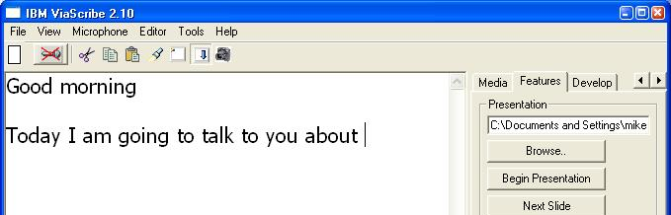

Figure 4. IBM ViaScribe using speech recognition to create synchronised text captions in real-time

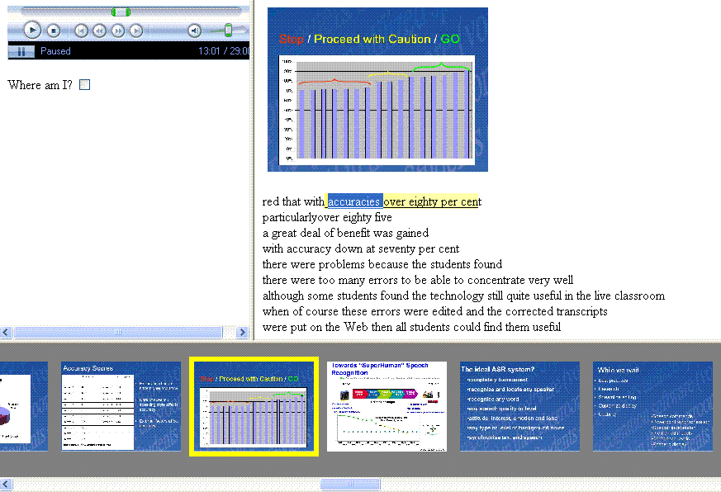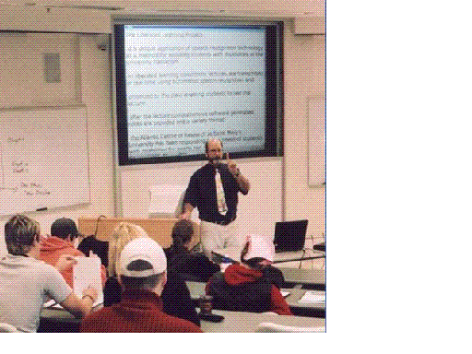
Slide
Synchronised transcript
Replay
control
Video
Slide Thumbnails

Figure 5. IBM ViaScribe synchronised captioned multimedia display

Learners and teachers have found teaching and learning improved using this technology (Leitch and MacMillan 2003). Portable wireless systems can facilitate personalisation of the display and figure 6 shows how live manual correction can be used when required to reduce speech recognition errors, especially if there are multiple speakers (Wald and Bain, 2007).

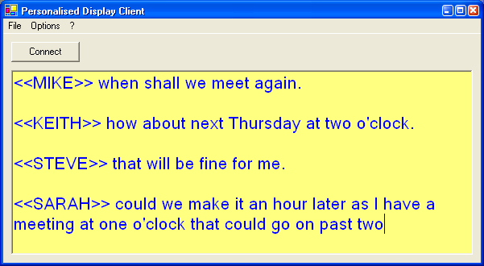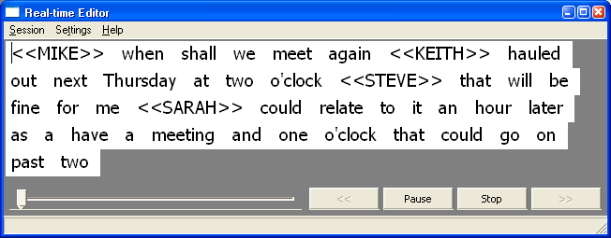

Figure 6. Real-time editing and personal wireless display of corrected multiple speaker captions

Investigations of Existing Annotation Software

Investigations of existing annotation software (including trials and discussions with developers and users) have provided valuable information in the design of the proposed system and interface and shown the widespread recognition of the importance of the identified user need of supporting the creation of annotations e.g.:
- The Memetic project’s overall aim (involving the School of Electronics and Computer Science (ECS) at Southampton University) was to extend the functionality of the next generation AccessGrid collaboration environment with advanced meeting support and information management annotation tools that were developed in CoAKTinG which drew on the extensive multimedia retrieval and open hypermedia knowledge and experience gained through ECS Southampton’s earlier HyStream, Microcosm, DLS, COHSE and Auld Linky applications. A prototype dedicated annotation system is being investigated at Southampton for healthcare skills-based learning.
- JISC and NSCF digital libraries programme funded the development of Project Pad to assist learners in interacting with digital multimedia archive recordings.
- Transana software for professional researchers analyzes multimedia data and the NXT set of libraries and tools was developed for the manipulation, query and analysis of multimedia language data.
- OneNote and Tegrity enable learners to take notes that are synchronized with recordings so that selecting a note replays the recording from that point.
- Proprietary non-standard formats requiring proprietary media players can be used to create enhanced podcasts by embedding markers in a multimedia file to jump to predetermined spots in a presentation.
- Mojiti, PLYmedia , Viddler and Asterpix are creative video annotation tools but don’t support image/slide annotation or searching for, or linking to, text or sections within the video or allow users access to the proprietary annotation format or files.

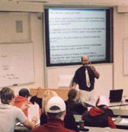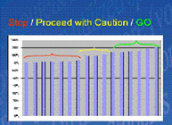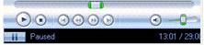
synchronised notes with current note highlighted

synchronised text captions with annotated text highlighted and current word selected
video

replay controls
current slide/image

Learn for exam
www.soton.ac.uk/hint

Watched up to here

Speech recognition
www.liberatedlearning.com

Not understood

synchronised
tags, bookmarks & associated links with current ones highlighted

Figure 7. Example user customisable display/interface

Specification of Required Annotation Software

No existing technology satisfies all the identified user needs and it is therefore necessary to develop software that:
- Works with web multimedia and stores annotations separately in XML format;
- Synchronises captions, images, tags, links, notes and bookmarks;
- Enables users to add, and search for, annotations quickly and easily;
- Supports private or shared annotations;
- Is accessible.
A prototype annotation system that meets these requirements has been under development to add to the synchronised multimedia captions, images, and slides demonstrated using ViaScribe, the facility for users to also create tags and notes and bookmarks and links (Wald 2007). The interfacing of other speech recognition engines (e.g. Dragon, Microsoft) with the system is also under investigation. The system design would allow the future incorporation of other specific types of annotation such as audio, video, animations, etc. However these were not identified as a current user need and can also be achieved with the prototype system through linking to external files. The system has built on the user interface knowledge gained in developing a real-time editing system (Wald 2006) that enables an operator to select and correct errors in the speech recognition captions as they are displayed. We will build on this prototype and the experience with ViaScribe to allow users to search, browse and add synchronised annotations (notes, tags, bookmarks, images/slides, links, and captions) to recordings and any existing user annotations. Figures 3-6 show actual screen displays of some of the software already developed that has been used to help identify user requirements and to inform the design of the technologies to be further developed, built and integrated while a possible user-customisable display layout for replay and interaction is shown in Figure 7.

System Development and Evaluation

The synchronised annotation system will be called Synote and to facilitate the maximum involvement of users in its design it will be developed and evaluated in four phases over the next fifteen months with the support of JISC. Phase 1 will involve the development of a system which includes caption and image annotation and allows users to caption manually or use the output from an appropriate speech recognition system. Phase 2 will involve the evaluation of the phase 1 system and development of an enhanced system which includes bookmark and note annotation. Phase 3 will involve the evaluation of the phase 2 system and development of a further enhanced system which includes tag annotation (teachers will initially annotate existing recordings with tags). Phase 4 will involve the evaluation of the phase 3 system (learners will also tag recordings) and the development of a final version of the software that meets the identified requirements. An evaluation report will include an analysis of the use and acceptance of the software by staff and learners and examples of use. Analysis and design and development of the system will involve usability studies and quantitative and qualitative evaluations and observations of users.

Conclusion

A multimedia annotation system ‘Synote’ is being developed and evaluated to make multimedia web resources easier to access, search, manage, and exploit through supporting the creation of synchronised notes, bookmarks, tags, links, images and text captions. The system will work with web based multimedia and will store annotations separately. A new term ‘Synnotation’ has been invented to denote a synchronised annotation.

References

Al-Khalifa, H. S., Davis, H. C. (2006) Harnessing the Wisdom of Crowds: How to Semantically Annotate Web Resources using Folksonomies. In Proceedings of IADIS Web Applications and Research 2006 (WAR2006)

Bain, K., Hines, J., Lingras, P., Yumei. Q. (2007) "Using Speech Recognition and Intelligent Search Tools to Enhance Information Accessibility" in Proceedings of HCI International 2007, In Lecture Notes in Computer Science series (LNCS)

Brotherton, J. A., Abowd, G. D. (2004) Lessons Learned From eClass: Assessing Automated Capture and Access in the Classroom, ACM Transactions on Computer-Human Interaction, Vol. 11, No. 2.

Chiu, P., Kapuskar, A., Reitmeief, S., Wilcox, L. (1999) NoteLook: taking notes in meetings with digital video and ink, Proceedings of the seventh ACM international conference on Multimedia (Part 1) 149 – 158.

Clucas-Martin, V. (2006) A usability study investigating whether ViaScribe’s synchronised multimedia captioned files can enhance learning. Project Report, University of Southampton.

Leitch, D., MacMillan, T. (2003). Liberated Learning Initiative Innovative Technology and Inclusion: Current Issues and Future Directions for Liberated Learning Research. Saint Mary's University, Nova Scotia. http://www.liberatedlearning.com/

Wald, M. (2006) Creating Accessible Educational Multimedia through Editing Automatic Speech Recognition Captioning in Real Time. International Journal of Interactive Technology and Smart Education: Smarter Use of Technology in Education 3(2) pp. 131-142.

Wald, M. (2007) A Research Agenda for Transforming Pedagogy and Enhancing Inclusive Learning through Synchronised Multimedia Captioned Using Speech Recognition. Proceedings of ED-MEDIA 2007: World Conference on Educational Multimedia, Hypermedia & Telecommunications.

Wald, M. and Bain, K. (2007) Enhancing the Usability of Real-Time Speech Recognition Captioning through Personalised Displays and Real-Time Multiple Speaker Editing and Annotation. In Proceedings of HCI International 2007: 12th International Conference on Human-Computer Interaction, Beijing.

Whittaker, S., Hyland, P., Wiley, M. (1994) Filochat handwritten notes provide access to recorded conversations, Proceedings of CHI ’94, 271-277.

Wilcox, L., Schilit, B., Sawhney, N. (1997) Dynomite: A Dynamically Organized Ink and Audio Notebook, Proc. of CHI ‘97, 186–193

http://del.icio.us/
http://www.youtube.com/
http://www.soton.ac.uk/sais/virtualservices/SSD%20virtual%20services%20vision.doc
http://www.liberatedlearning.com/
http://www.liberatedlearning.com/note_finder.shtml
http://www.alt.ac.uk/altc2007/timetable/abstract.php?abstract_id=1116
http://video.google.com/support/bin/answer.py?hl=en&answer=26577
http://projectreadon.com
http://www.everyzing.com/
http://www-306.ibm.com/able/solution_offerings/ViaScribe.html
http://www.liberatedlearning.com/technology/index.shtml
http://www.memetic-vre.net/
http://www.accessgrid.org/
http://www.aktors.org/coakting/
http://www.iam.ecs.soton.ac.uk/projects/hystream/
http://www.mmrg.ecs.soton.ac.uk/projects/microcosm.html
http://www.jisc.ac.uk/whatwedo/programmes/programme_dlitc/project_spoken_word.aspx
http://www.transana.org/
http://www.ltg.ed.ac.uk/NITE/
http://office.microsoft.com/en-us/onenote/HA101212541033.aspx
http://www.tegrity.com/
http://docs.info.apple.com/article.html?artnum=301880
http://www.microsoft.com/windows/windowsmedia/forpros/encoder/features.aspx
http://www.highcriteria.com/products.htm
http://mojiti.com/
http:// http://www.plymedia.com/index.asp
http://www.viddler.com/
http://www.asterpix.com/
http://www.jisc.ac.uk/fundingopportunities/funding_calls/2007/07/circular0207.aspx

