Using Speech Recognition for Real-Time Captioning of Multiple Speakers and Synchronising Transcripts

Mike Wald1, Keith Bain²

1School of Electronics and Computer Science, University of Southampton, Southampton SO171BJ, United Kingdom, M.Wald@soton.ac.uk
²Liberated Learning Consortium, Saint Mary’s University, Halifax, NS B3H 3C3, Canada, Keithbain@stmarys.ca
Introduction
Meetings involving many people speaking can be some of the hardest situations for deaf people to be able to follow what is being said and also for people with physical, visual or cognitive disabilities to take notes. Real time captioning using phonetic keyboards can provide an accurate transcription of what has been said but is often not available because of the cost and shortage of highly skilled and trained stenographers. This short article describes the development of two applications that use speech recognition to provide automatic accessible real time text transcriptions in situations when there can be many people speaking. Liberated Learning and IBM developed a Speech Recognition (SR) application (ViaScribe) that automatically formats real-time text captions from live speech with a visual indication of pauses as standard SR software was unsuitable for transcription of conversational speech as it produced a continuous unbroken stream of text that was very difficult to read and comprehend.

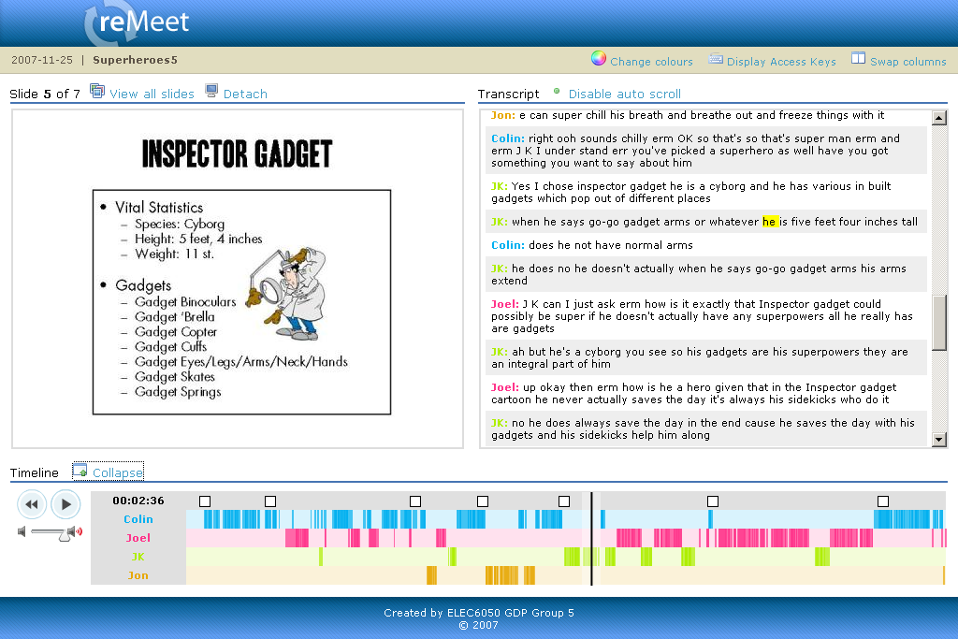
Figure 1 Networked Multiple Speaker Replay System
In order to create a replayable synchronized recording of multiple speakers it is also necessary to combine and synchronise the separate audio recordings of the individual speakers. Two approaches to accomplish this have been investigated; firstly, by each speaker using their own computer and instance of ViaScribe over a network and secondly by running multiple instances of ViaScribe on one computer with each speaker having their own USB microphone input. The former method has the advantages of being able to use the ‘standard’ ViaScribe application and of the number of speakers not being limited by the speed of the computer but has the problem of identifying when words were spoken relative to one another. The latter method has the advantage of being able to use a single machine’s timings to synchronise the multiple speakers but has the disadvantages of having to develop a special version of ViaScribe to provide a unique id for each instance to identify the speaker and of assigning each USB microphone input to each instance of ViaScribe. Both systems enabled the user to move forwards or backwards through the transcript by using the timeline cursor, selecting a word in the transcript window, selecting a slide thumbnail in the window or selecting a slide representation in the timeline. The networked system (See figure 1) enables speakers’ individual audio, slide and ViaScribe text transcripts to be automatically saved to a server from their own networked computers at the end of a meeting and combined for replay in a browser. The separate utterances are shown on the timeline by vertical coloured lines corresponding to the speaker colour in the synchronized transcript. The single computer Multiple Speaker ViaScribe application (See figure 2) was also extremely well received in spite of some technical difficulties (i.e. noticeable “echo”, control of microphones and intermittently stopping transcribing).

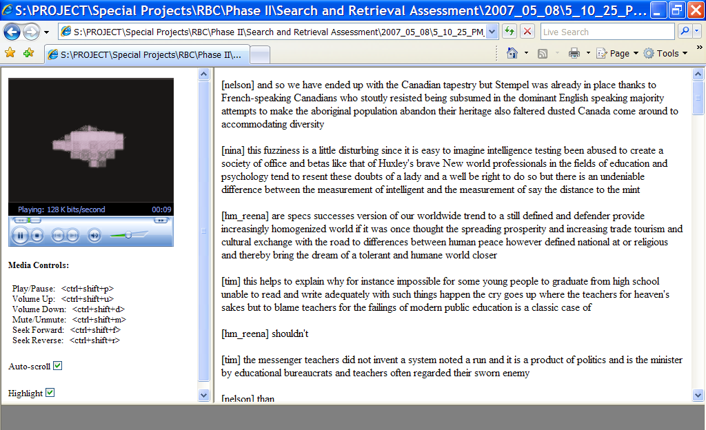
Figure 2 Screen capture of the Multiple Speaker ViaScribe session replaying in Internet Explorer

Conclusion and Acknowledgements
Both a networked and a single computer multiple speaker transcription system have been developed and initial trials conducted. While the results suggest the systems could be useful, further development is required to overcome existing technical issues before further research is conducted with disabled users. Thanks go to John Mark-Bell, James Dimmock, John Knott, Jon Leach, Joel Overton, Colin Williams, Stan Armstrong, Chris Adams, Tokuyu Mizuhara and Vagarro Willie for development of the systems and the IBM Human Ability and Accessibility Center and RBC Financial Group’s Applied Innovations for their generous support.

