Clinical effectiveness and patient perceptions of an ILC mediated by ES system using a robotic workstation

Authors: Hughes, A. M. MSc¹, Freeman, C. PhD², Burridge, J. PhD¹, Chappell, P. PhD², Lewin, P. PhD² and Rogers, E. PhD²
Affiliations: University of Southampton, Southampton, SO17 1BJ, UK
1 School of Health Sciences
2 School of Electronics and Computer Science

Background
An inability to perform tasks involving reaching is a common problem following stroke. Evidence supports the use of robotic therapy and electrical stimulation (ES) to reduce upper limb impairments, but current systems may not encourage maximal voluntary contribution from the patient. Iterative Learning Control (ILC) is a technique developed for robotic processes which repeatedly perform a task in order to sequentially improving accuracy. The aim of this study was to test the feasibility of applying ILC mediated by ES to stroke rehabilitation using a robotic workstation, and to measure patients’ perceptions of the system.

Methods
5 hemiplegic stroke patients used the workstation (see Figure 1) to track 2 dimensional trajectories, over 18 1 hour sessions within a 3 month period. Outcome measures taken prior to and after the intervention consisted of the Fugl-Meyer Assessment (FMA) and the Action Research Arm Test (ARAT), isometric force and unassisted tracking error. During the intervention patients performed a range of tracking tasks in which their remaining voluntary activity was augmented by ES. Patients were asked questions in each session and undertook a semi structured interview (including Likert style and open questions) subsequent to the study.

Results
Compliance was excellent. Statistically significant improvements were measured (p≤0.05) in: FMA motor score (see Table 1), accuracy of unassisted tracking, and in isometric force. The Likert responses showed that all patients found the intervention enjoyable and would have liked further sessions (see Table 2). Patients’ responses to the open questions on the system effectiveness were classified as physical or functional (see Table 3).

Conclusion
This study demonstrated the acceptability and feasibility of using ILC mediated by ES for upper limb stroke rehabilitation. Future work will address issues raised in the interview as well as investigating using ES for the wrist and hand.

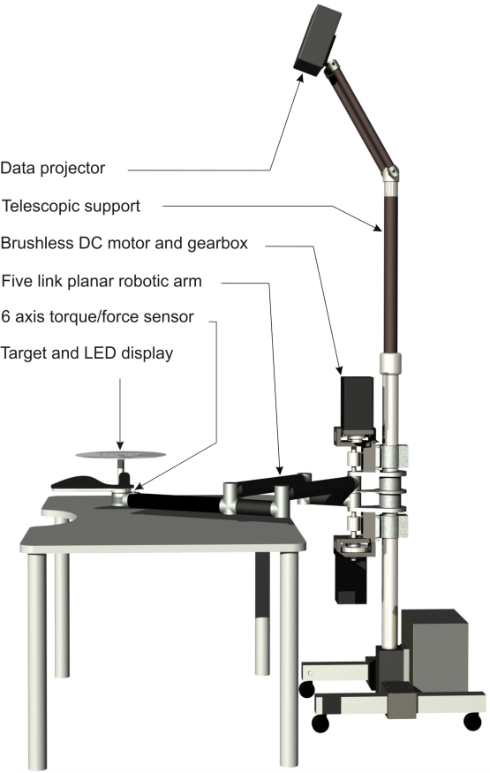

Figure 1: Diagram of robotic workstation

Outcome Measure (n=5)  Normal score | Baseline Mean* (SD) [Min-Max] | Post Treatment Mean (SD) [Min-Max] | PT-B (SD)  P-value [95% CI]
ARAT  57 | 4.00 (1.46)  [3.0-6.5] | 3.40 (0.55)  [3.0-4.0] | 0.60 (1.19)  0.32 [-0.88, 2.08]
FMA (motor)  66 | 12.90 (3.36)  [8.5-16.5] | 15.40 (4.28)  [9-19] | -2.50 (1.58)  0.02 [-4.46,-0.54]
* Baseline is the mean of the two pre-treatment evaluations.

Table 1: Mean (SD) and range [Min-Max] for clinical outcome measures for stroke patients at Baseline and Post Treatment (18 sessions). Mean change (SD) during the 18 intervention sessions, level of significance (Paired t-test) and 95% CI are also shown.

Statement | Strongly disagree | Disagree | Undecided | Agree | Strongly agree
I am now more aware of my affected arm |  | 2 | 1 | 1 | 1
My arm feels weaker | 3 | 1 | 1
My arm feels tighter | 1 | 2 | 1 |  | 1
I can reach out with my arm more easily | 1 | 2 | 1 | 1
I can now pick up objects | 3 | 1 |  | 1
I did not find the treatment enjoyable | 4 | 1
It was easy to understand what I had to do |  |  |  | 1 | 4
It was difficult to put my arm in the arm holder |  | 2 |  | 1 | 2
The arm holder was comfortable |  |  |  | 5
The stimulation was uncomfortable | 1 | 4
The target was easy to see |  |  |  | 3 | 2
I did not understand the graphs showing my performance | 1 | 2 |  | 1 | 1
Adding games would add to my motivation and enjoyment of the treatment |  | 2 | 1 | 1 | 1
I would not like to have more arm muscles stimulated | 3 |  | 1 | 1
I would not recommend the treatment to other people who have had a stroke | 4 |  | 1
I would have liked to have continued longer with the treatment |  |  |  | 2 | 3

Table 2: Statements and responses from the Likert style questions

Qn6: Are you now able to do things you could not do before? Please give examples
Qn7: Are you able to do things better than you could before? Please give examples
Qn8: Can you perform any two handed tasks more easily? Please give examples
Category | Number of Responses | Example
Physical | 7 | ‘Hold arm above head when stretching’
Functional | 9 | ‘Open a bottle of wine’

Table 3: Open responses on system effectiveness

