Feedback in the Computer-based Sport Training

Yulita Hanum P Iskandar, Lester Gilbert, Gary B Wills
Learning Societies Lab,
School of Electronics and Computer Sciences, University of Southampton, UK
{yhpi07r, lg3, gbw}@ecs.soton.ac.uk

Abstract: With increasingly rapid development in Computer-based Sport Training (CBST), feedback plays an important role in both coaching and learning. A good CBST system includes not only good training strategy but also effective and appropriate feedback design. Little research has synthesized learning theories and instructional design with the design of feedback in CBST. The aim of this paper is to explore the design of effective and appropriate feedback in the motor skill domain via CBST, using a pedagogical approach. The key components of the design are learning transactions, competency, cybernetics, and behaviorism. This paper describes the theoretical framework and analysis requirements that guided the design of pedagogical feedback in the motor skill domain.

Introduction

This paper explores the design of effective and appropriate feedback in the motor skill domain via Computer-based Sport Training (CBST) for athletes in order to support their achievement of the intended learning outcomes of their training.

Motor skills, although not usually the major part of educational objectives in Higher Education, are components of a distinct type of learning outcome and essential to learning and teaching human performance. Objectives in skilled performance are different from cognitive objectives which typically involve declarative, procedural, or conditional knowledge. Well-executed motor skills are precise, smooth, continuous, and accurately timed performances, characteristically associated with sport.

The performances exhibited by a novice and an expert athlete differ most apparently in the observable degree of precision, smoothness, and timing [1, 2]. The ability to discriminate between good and inadequate performance when learning a skill is critical in order to learn and understand the desired behaviors. This discrimination generally results from feedback from the environment. However, such feedback is often ambiguous or difficult to interpret for a novice.

The development of CBST has made it possible to augment and improve the feedback that athletes receive during training. Feedback may be defined as information received about learning processes and the achievement of intended outcomes. Through feedback, athletes recognize areas of deficiency in their knowledge and skills which they seek to remedy.

The paper is organized into seven sections: 1) an introduction to the background ideas, 2) motivation of this research, 3) concepts of feedback, 4) selective review of previous work in designing feedback, 5) theoretical framework for pedagogical feedback in the motor skill domain, 6) technical analysis of the requirements of pedagogical feedback, and finally 7) reflection and conclusions.

Feedback

Feedback relates to information that allows comparison between an actual outcome and a desired outcome Feedback is as one of the events of instruction described by [3], and usually follows some type of practice task.

Different learning theories attribute different functions to feedback. While behaviorism considers feedback to reinforce correct responses, cognitive considers feedback as information necessary for the correction of incorrect responses [4]. In behavioral learning contexts, the focus is therefore on feedback characteristics such as frequency, delay, and on the complexity of the feedback contents.

Once athletes have exhibited the new learned performance, they at once perceive that they have achieved the anticipated goal. This informational feedback is what many learning theories consider essential to the process called reinforcement. According to this conception, reinforcement works in human learning because the expectancy established at the beginning of learning is now confirmed during the feedback phase. The process of reinforcement is anticipation for the confirmation of the reward. The importance of expectancy to the act of learning is again re-emphasized by the reinforcement process.

As in the case of other learning outcomes, the expectancy that initiated the leaning of the skill needs to be confirmed. There is some evidence to indicate that the immediacy of reinforcement is important in facilitating motor skills. Besides immediacy, the accuracy, specificity, and contingency of feedback has been found to affect positively the learning of motor skills.

Feedback Loops

Work on the conditions of learning [5] developed originally from an information process model. The conditions of learning state that instruction must take the athletes’ external and internal factors into account. In order to understand the conditions of learning, the learning process must be discussed.

Human learning and memory are currently interpreted in terms of information processing. Information-processing theory stated the processes that are presumed to account for learning make certain kinds of transformations of inputs to outputs which are similar to computer operation.

We proposed four stages of information processing and briefly discussed in Figure 1.

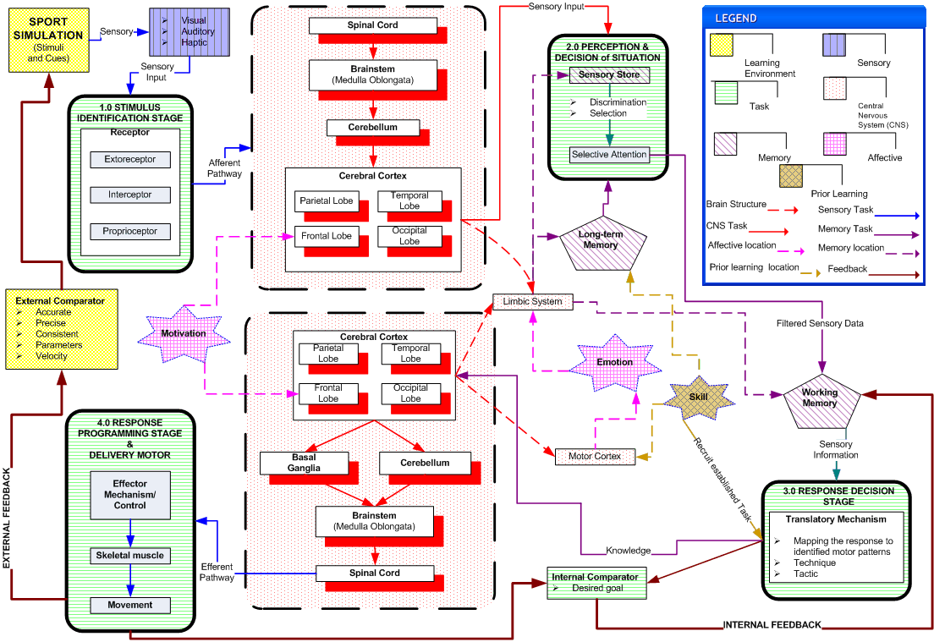
Figure 1: Feedback loops

The first stage is the identification of sensory input. Information about the environment and bodily states are obtained through different sensory receptors and so will be separately represented in the cortex from the cerebellum. The result of this stage of processing is thought to be some representation of the environmental information, which then passes on to the next stage.

Second stage is the perception and decision of the situation. The limbic system receives information about the nature of the environment from association with the cerebral cortex in evaluating the significance of the stimuli. The sensory store interprets all sensory input to select appropriate patterns of bodily and behavioral responses that may be relevant to the decision-making process. The sensory store will also protect the second stage from interference from new data until its selections are complete and the response based on them has begun. The link with long-term memory suggests that the process of selection may also be affected by past experience.

The third stage is the initiation of the movements to be made. Information including learned knowledge to perform a motor skill is retained as long-term memory. Responses made by the athlete will pass to the cerebral cortex. The motor cortex also communicates closely with the basal ganglia and cerebellum, through the thalamus, which acts as a relay. The cerebellum adjusts patterns of activity in the motor cortex and smoothes out their finer motions based on the biomechanics of movement.

In the fourth stage the brainstem and spinal cord form coded impulses via the effectors’ mechanism to trigger a co-ordinated movement of skeletal muscles in creating the desired movement. The end result of the activity of all information-processing stages is termed the output that executes over the muscles and glands in the body to deliver the movement.

The final link of this loop is external feedback, an event that has its origin outside the athlete, in the environment. Feedback is provided by observation of the effects of the athlete’s own performance. This provides the athlete with the confirmation that learning has accomplished its purpose. Although feedback usually requires an external check, its major effects are obviously internal ones that serve to fix the learning, to make it permanently available.

Reinforcement works in human learning because the expectancy established at the beginning of learning is now confirmed during the feedback phase. The process of reinforcement operates in the human being not because a reward is actually provided, but because an anticipation of reward is confirmed. Consequently the feedback appears in facilitating learning should accordingly being planned to activate and support the process of learning.

Related Work

Technological developments in education have given feedback research a new impulse. CBST enables flexible, individually adaptive, and self-regulated training [6]. The need for feedback in self-regulated training activities is higher than in regular training setting. This results from the independence of self-regulated training to time and place.

Effective and appropriate feedback to athletes has been identified as a key strategy in motor skill learning [7, 8]. Effective feedback is associated with feedback that is both appropriate and timely [9, 10], suited to the needs of the situation [11], sufficient, and instructor delivered [12]. Therefore, feedback in CBST contributes to learning by allowing athletes to verify their movements, evaluate their progress, determine the cause of errors, and also motivate them to remain involved in the training tasks, given that they perceive the feedback as helpful [13]. This requires the active processing of feedback which is specific as well as general metacognitive knowledge and strategies [14].

Hence, there exists a large variety of information that might be provided as feedback. The challenge for educational researchers and designers of CBST environments is to determine what constitutes effective and appropriate feedback for athletes in their training trajectory.

Table 1 summarizes elements which contribute to the design of feedback in the cognitive domain, motor skill domain, and CBST. Researchers and educators in sport pedagogy have established guidelines for using feedback in real time training, but they have yet to be evaluated in a CBST context.

Elements of feedback | Sub-elements | Cognitive domain | Motor Skill domain | CBST
Intended learning outcome |  | X | X
Task matching to intended learning outcome |  | X | X
Structured task |  | X | X
Deficiencies of the performance |  | X | X
Level of proficiency |  | X | X
Delivery of the feedback | Immediate | X | X | X
 | Specific | X | X | X
 | Contingent | X | X | X
Design feedback in graphical user interface |  |  |  | X
Modality of feedback |  |  |  | X
Table 1: Elements in the design of feedback

Design Feedback in the Cognitive Domain

Adaptive feedback (i.e. different athletes receive different information) and adaptable feedback (i.e. athletes have the possibility to choose the feedback that suits their needs or preferences) have been introduced [15-18]. These types of feedback attempt to compensate for the weakness of generic feedback in “communicating” with athletes and to provide personalized feedback, allowing variation of information presented to the athletes according to their individual characteristics. Empirical studies, investigating whether the type and the amount of feedback are related to the athletes’ individual differences, draw implications from the degree of success or failure experienced by athletes. In addition, prior knowledge (i.e. the amount of domain knowledge that athletes already possess prior to the learning phase) is recognized as a factor influencing feedback effectiveness [19], and elaborate feedback may not be as effective for athletes with high prior knowledge.

Goal-directed feedback provides athletes with information about their progress towards a desired goal (or set of goals) rather than providing feedback on discrete responses (i.e. responses to individual tasks). Research has shown that for athletes to remain motivated and engaged depends on a close match between their goals and the expectation that these goals can be met [20]. If goals are set so high that they are unattainable, athletes will be likely to experience failure and become discouraged. When goals are set so low that their attainment is certain, success loses its power to promote further effort. Goals must be personally meaningful and easily generated, and the athlete must receive performance feedback about whether the goals are being attained. The goals can be classified into two types: acquisition (to help the athlete acquire something desirable), and avoidance (to help the athlete avoid something undesirable).

Design Feedback in the Motor Skill Domain

Studies [8, 21] suggest that breaking down skills into their component parts creates a more effective learning environment and gives the athlete specific information on how to perform each phase of the skill. Feedback information involves:
- Intended learning outcomes are explicitly stated [21, 22], identifying what actions have to be taken by the athlete [21],
- whether these actions have been successful,
- actions should be taken that assist athletes towards the desired learning outcomes [22, 23],
- skills necessary for the mastery of the task, with respect to typical errors or incorrect strategies [24],
- level of proficiency that should be achieved [21],
- the athlete’s current level of proficiency [21].

The display of the athletes’ performance should be closely coupled with feedback information, in order for reinforcement to occur [3]. Information presented via feedback in instruction might include not only movement correctness, but other information such as precision, timeliness, learning guidance, motivational messages, lesson sequence advisement, critical comparisons, and learning focus.

Design Feedback in CBST

Research has focused on feedback’s role in education [18, 25], but little research has focused on designing and implementing feedback in CBST [26]. Currently, issues of feedback in the motor skill domain via CBST concern:
- delivery of the feedback contents such as speed, accuracy, movement, time, and reaction time [27-31],
- providing athletes with access to their feedback via an appropriate user interface [26, 32], and
- modality of feedback, such as visual, audio, tactile, and haptic feedback [33, 34].

Feedback in cognitive-based and motor skill environments is designed to shape the perception, cognition, or action of the learner. However, the design of feedback in CBST is typically led by technology and fails to properly consider pedagogical issues. Feedback in CBST does not usually derive from the goals, actions, performances, outcomes and contexts of a learning process. Thus, for pedagogical reasons, this paper proposes the design of effective and appropriate feedback that can:
- support athletes in their achievement of the underlying intended learning outcomes,
- assist athletes in identifying the gaps in their performance, and
- help athletes to determine performance expectations, identify what they have already learned and what they need to learn next, and judge their personal learning progress.

Pedagogically-based feedback

The inputs to pedagogically designed feedback in the motor skill domain are illustrated in summary in Figure 1. The four inputs are the learning transaction, competency, cybernetics and behaviorism.

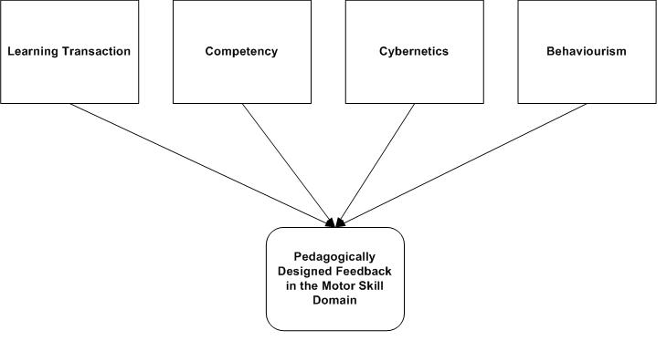
Figure 2: Inputs to the developmnent of pedagogical feedback in the motor skill domain

Learning Transaction

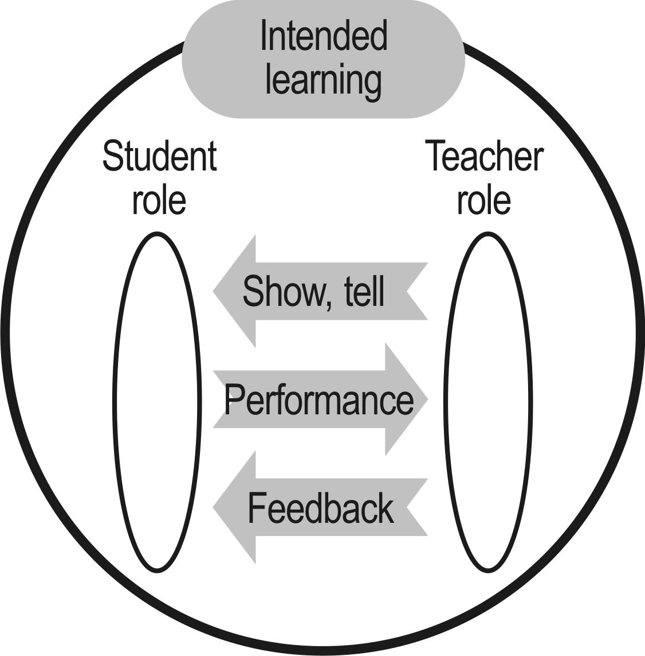
Figure 3: Learning transaction

A learning transaction model (Figure 3) of “what goes on” at the coach-athlete interface is needed to analyze, design and implement pedagogically designed feedback in the motor skill domain [35].

The learning transaction involves three major components: subject matter delivery, interaction enactment, and feedback. A transaction provides for partitioning, portraying, amplifying, sequencing, and routing subject matter, the athlete’s enactment of the desired skills; and feedback on the performance. It is suggested that information about the components of the learning transactions will form the basis of the pedagogically-informed metadata which would be relevant to any description of content or process in the design of feedback in the motor skill domain.

Competency

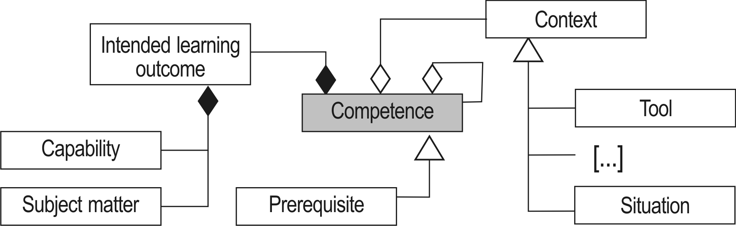
Figure 4: Competence conceptual model

The term competency can be defined as a measurable skill in reference to a given context. A competence (see Figure 4) may be conceptualized as a subject matter component, based upon knowledge representation models, which expresses knowledge as concept structures, and as an action component which describes how the knowledge or subject matter is used. There are taxonomies which classify the action components, such as Dave’s taxonomy. The classified action components describe different motor skill processing modes and can be characterized with specific action verb.

Cybernetics

Cybernetics provides a framework within pedagogically designed feedback in the motor skill domain , where discrepancies in performance capabilities can be identified and corrective action taken The analysis of pedagogic feedback in the motor skill domain from a cybernetic point of view has four major components: (1) measurement of the current competency of the athlete, (2) statement of the required standard of the competency, (3) comparison of the current competency to the required competency, and (4) corrective feedback and information. Thus, providing feedback requires: (1) a mechanism for recording the athlete’s competency, (2) analysis and judgment to find discrepancies between actual competency and required competency, and (3) diagnosis of error causes so that appropriate correctives can be implemented.

Behaviorism

B.F Skinner restated Thorndike’s Law of Effect as reinforcement and developed the behaviorist theory of learning. The term reinforcement, which refers in general to the effects made upon learning by its consequences, continues to play a prominent role in the explanation of learning phenomena. From a behaviorist perspective, pedagogical feedback should be designed as a result of the task analysis. A task analysis is a step-by-step description of the performance that the task represents, and results in the identification of (1) the executive subroutine that must be learned in order for the athlete to carry out the task, and (2) the links between the individual task procedures, each of which must be recalled from previous learning or newly learned.

Application to CBST

This section illustrates the application of pedagogically-based feedback to the design of a virtual rowing system. Personas and scenarios are a lightweight method of capturing and recording the requirements of the virtual rowing system from an end user’s view point. The persona gives a brief summary of the end-user. Scenarios are textual descriptions of how a persona interacts with the system and other personas when using a system. The following are three example personas that represent the breadth of users who expect to interact with a virtual rowing system.

Persona 1 Hanum
Hanum is a 20-year-old student at a UK University with considerable previous athletic experience, including participation as a collegiate athlete in netball. She likes rowing but does not have any previous experience in the sport. She is highly motivated to learn the techniques to achieve ‘Level 1’ proficiency.

Scenario 1
Hanum interacts with the virtual rowing system to gain some skill. Before she performs the rowing activity, she listens to the avatar’s instruction. Then she imitates the performance of the avatar step-by-step. Each time she makes a mistake, the avatar immediately notifies her by providing clear, directive feedback. This shows her how to refine her performance. She also sees a continuous display of the percentage she has achieved of her target performance.

Persona 2 Giles
Giles is 24 years old and studying for an Economics degree. He has been involved in rowing activities in the last eight years, but has never developed a satisfactory stroke rate. Giles’s primary goal is to execute the rowing techniques and perform them in competition the same way he performs them in practice.

Scenario 2
Giles has used the virtual rowing system in previous sessions, and in this scenario he logs into the system to view his past competency evidence. Based on the gaps the system shows between his performance and that desired, he is able to identify the changes he needs to make. Giles prefers specific and contingent feedback to help him in his own training and conceptualization.

Persona 3 Mike
Mike started coaching at Southampton University Boat Club in 1974. He coached the men's squad for 21 years before coaching the women's squad in 1995. He rowed internationally for seven years in coxed and coxless fours as well as in eights.

Scenario 3
Mike logs in to the virtual rowing system with administrative rights. He has the permissions to add, modify and delete the rowing competency structures recorded. These structures help rowers with information about what they are trying to accomplish, and how close they are to the intended learning outcomes. Mike can view the feedback given to rowers, enabling him to analyze and plan further training for the athletes.

From these three personas it can be concluded that the important requirements for pedagogical feedback are that such feedback is:
- identification of intended learning outcome,
- monitoring and signaling processes towards the intended learning outcome,
- giving abundant examples of the concepts treated,
- demonstration of the correct performance,
- linkage of new concepts to old ones through identification of familiar, expanded, and new elements,
- legitimizing a new concept or procedure by means of principles the athletes already know, cross-checks among representations, and compelling logic, and
- recording the progress of the athletes.

Conclusion

In this paper we have shown and analyzed the requirements of pedagogical feedback. We concluded that pedagogically-based feedback requires: (1) a mechanism for recording the athlete’s performance (2) analysis and judgment of the performance to find discrepancies in the pattern of action, and (3) diagnosis of the causes of error so that appropriate correctives can be implemented. Further work is needed to shape the framework using a pedagogical approach that would facilitate the design of pedagogical feedback. We believe that a pedagogical feedback in the motor skill domain is critical to successfully ensuring a pedagogic focus on coaching and learning activities.

References

1. Gagné, R.M., The conditions of learning and theory of instruction. 4 ed. 1985, New York ; London Holt, Rinehart and Winston.
2. Schmidt, R.A. and C.A. Wrisberg, Motor Learning and Performance: A Situation-based Learning Approach. Fourth ed. 2008, United States of America: Human Kinetics.
3. Gagné, R.M. and M.P. Driscoll, Essentials of learning for instruction. Second ed. 1988, New Jersey: Dryden Press.
4. Kulhavy, R. and W. Stock, Feedback in written instruction: The place of response certitude. Educational Psychology Review, 1989. 1(4): p. 279-308.
5. Gagne, R.M., The conditions of learning and theory of instruction 4th ed. 1985, New York: Holt, Rinehart and Winston.
6. Jochems, W., J. van Merrienboer, and R. Koper, An introduction to integrated elearning. Integrated E-Learning. London: RoutledgeFalmer, 2004.
7. Bilodeau, E. and I. Bilodeau, Motor-Skills Learning. Annual Reviews in Psychology, 1961. 12(1): p. 243-280.
8. Newell, K., Knowledge of Results and Motor Learning. Exercise and Sport Sciences Reviews, 1976. 4(1): p. 195.
9. Ramsden, P. Student Surveys and Quality Assurance. 2003.
10. Mory, E., Feedback research review. Handbook of research on educational communications and technology, 2004: p. 745-783.
11. Yorke, M., Formative assessment in higher education: Moves towards theory and the enhancement of pedagogic practice. Higher Education, 2003. 45(4): p. 477-501.
12. Poulos, A., Effectiveness of feedback: the students’ perspective. Assessment & Evaluation in Higher Education, 2007. 99999(1): p. 1-13.
13. Hoska, D., Motivating learners through CBI feedback: Developing a positive learner perspective. Interactive instruction and feedback, 1993: p. 105-132.
14. Pressley, M., J. Borkowski, and W. Schneider, Good information processing: What it is and how education can promote it. International Journal of Educational Research, 1989. 13: p. 857-867.
15. Sales, G., Adapted and adaptive feedback in technology-based instruction. Interactive instruction and feedback, 1993: p. 159-175.
16. Mason, B. and R. Bruning. Providing feedback in computer-based instruction: What the research tells us. 2001 [cited 2008.
17. Economides, A., Adaptive Feedback Characteristics in CAT. International Journal of Instructional Technology and Distance Learning, 2006. 3(8).
18. Narciss, S. and K. Huth, How to design informative tutoring feedback for multimedia learning. Instructional design for multimedia learning, 2004: p. 181-195.
19. Hannafin, M., K. Hannafin, and D. Dalton, Feedback and emerging instructional technologies. Feedback and interactive instruction, 1993: p. 263-286.
20. Fisher, S. and J. Ford, Differential Effects of Learner Effort and Goal Orientation on Two Learning Outcomes. Personnel Psychology, 1998. 51(2): p. 397-420.
21. Weinberg, R. and D. Gould, Foundations of Sport and Exercise Psychology. 2006: Human Kinetics.
22. Cassidy, T., R. Jones, and P. Potrac, Understanding Sports Coaching: The Social, Cultural and Pedagogical Foundations of Coaching Practice. 2004: Routledge.
23. Russell, P., D. Durling, and B. Griffiths, The Use of Multimedia Guidelines versus Designers' Attitudes. Digital Creativity, 1999. 10(4): p. 228-242.
24. Phye, G. and T. Bender, Feedback Complexity and Practice: Response Pattern Analysis in Retention and Transfer. Contemporary Educational Psychology, 1989. 14(2): p. 97-110.
25. Shute, V., Focus on Formative Feedback. Review of Educational Research, 2008. 78(1): p. 153.
26. Cyboran, V., Designing feedback for computer-based training. Performance + Instruction, 1995. 34(5): p. 18-23.
27. Angela, H., Rowing Techniques: Passing the Human Polygraph. The Crossfit Journal Articles, 2006(50).
28. Baudouin, A. and D. Hawkins, Investigation of biomechanical factors affecting rowing performance. Journal of Biomechanics, 2004. 37(7): p. 969-976.
29. Hawkins, D., A new instrumentation system for training rowers. Journal of Biomechanics, 2000. 33(2): p. 241-245.
30. Smith, R.M. and C. Loschner, Biomechanics feedback for rowing. Sports Sciences, 2002. 20(10): p. 783 — 791.
31. Cheng, L. and S. Hailes, Managed exercise monitoring: a novel application of wireless on-body inertial sensing. 2008.
32. Stepan, V. and J. Žára. Teaching tennis in virtual environment. 2002: ACM New York, NY, USA.
33. Philo Tan, C., et al. Training for physical tasks in virtual environments: Tai Chi. in Virtual Reality, 2003. Proceedings. IEEE. 2003.
34. Davis, J. and A. Bobick. Virtual PAT: a virtual personal aerobics trainer. in Workshop on Perceptual User Interfaces. 1998.
35. Gilbert, L., Y.-W. Sim, and C. Wang, Modelling the Learning Transaction, in The 5th IEEE International Conference on Advanced Learning Technologies. 2005: Kaohsiung, Taiwan.

