Dispersion and Rheology of Poly(ethylene oxide) / MMT Nanocomposites

Martin Reading*, Alun S. Vaughan
High Voltage Laboratory
Electronics and Computer Science Department,
University of Southampton,
Southampton,
SO17 1BJ
*mdr06r@ecs.soton.ac.uk

Abstract- The topic of nanodielectrics is one that has grown enormously in importance since Lewis first introduced the concept of a nanodielectric in 1994. However, while nanodielectrics exhibit great promise, changes in macroscopic physical properties are determined by dispersion, and therefore it is imperative that reliable methods are available for the cost-effective determination of the dispersion state of the nanofiller in the host polymeric matrix. This paper details an investigation into the rheological response of PEO / montmorillonite (MMT) nanocomposites; MMT is a polar material and is therefore relatively compatible with aqueous systems. Three molecular weight PEOs were used - 100,000 g mol⁻¹, 400,000 g mol⁻¹ and 1,000,000 g mol⁻¹. The rheological behaviour of a range of systems containing various levels of MMT were then studied, with the twin objectives of (a) producing materials with different shear histories and different degrees of MMT dispersion for study as described elsewhere [1] and (b) to explore rheological response as a practical means of determining the dispersion state of a nanofiller in a liquid polymer. This would have great practical utility as a quality control device in, for example, the production of epoxy-based nanodielectrics. In this paper we concentrate on the latter aspect of the work and describe the effect of polymer molar mass, polymer concentration, imposed shear history and nanofiller loading level on the rheological behaviour of the system.

I. INTRODUCTION

Polymer nanocomposites have attracted great interest over many years, because of the enhanced properties exhibited by such systems. Whenever nanoscopic fillers are added to a host polymer matrix, dispersion is of critical importance since, while well dispersed nanophase may be beneficial, poor dispersion can have negative consequences. Hence, for the nanocomposites to be used appropriately and provide the best properties, a method for observing the dispersion within the matrix is useful. Despite this, evaluating the dispersion of nano-additives in the bulk is far from straight forward using conventional solid-state materials characterization techniques. This study set out to consider the influence of nano-additives on the flow behaviour of polymer solutions. The objective was to investigate the extent to which dispersion of nanofillers and effect of host molecular weight can be inferred from rheological analysis.

A poorly mixed nanocomposite will show a larger variation in properties across the material compared to a well dispersed composite [2,3]. The results obtained have been analysed using the Ostwald-de Waele power law, Carreau model and the De Kee equation. With the addition of MMT to the host matrix it is seen that the viscosity in solution barely deviates from that of the virgin PEO. When using higher molecular weight and higher concentration solutions, a trend of increasing viscosity was observed as expected.

Polyethylene oxide (PEO) is one of the most studied hydropolymers, drawing great interest from the scientific community. PEO is a polymer that has been used extensively as a model system for fundamental studies and which finds technological uses in, for example, lithium polymer cells. As a water soluble polymer that is readily available in a wide range of molar masses - from ~100 g mol⁻¹ to nearly 10,000,000 g mol⁻¹ - it constitutes an ideal system to study solution processes in systems with very different viscosities.

II. EXPERIMENTAL

The main aim of rheometry is to characterise fluid or solid properties when dealing with a system containing a number of components. However it has also been known to aid in mixing as well as providing the afore-mentioned data [4,5]. The rheometer used here was a RHEOLAB MC1 Paar Physica. The PEO was supplied by Sigma-Aldrich, as was the MMT (aluminium pillared clay), both in granular form. Samples were mixed in glass flasks, which were cleaned using hot water with commercial detergent and then rinsed with distilled water. The flask was weighed, 20 ml of distilled water added, the flask reweighed and then PEO added by a weight-weight ratio in accordance with Table 1. For some samples, MMT was then weighed and added in a weight percentage relative to the PEO weight present. Initial hand mixing provided basic dispersion.
For higher molecular weight solutions a longer mixing time was required before the solution was visually dispersed. To counter any water lost through evaporation, the flask’s total weight was recorded and checked, with addition of distilled water when necessary.
TABLE 1
SAMPLES GENERATED AND TESTED
Sample Name | Molecular Weight PEO / g mol⁻¹ | X% PEO to DW |  | % MMT Filler to PEO and Weight
100k “X” pc  400k “X” pc  1M “X” pc | 100,000  400,000  1,000,000 | 1%  2%  5%  10% | 0.2g  0.4g  1.0g  2.0g | -
A “X” 5  B “X” 5  C “X” 5 | 100,000  400,000  1,000,000 | 1%  2%  5%  10% | 0.2g  0.4g  1.0g  2.0g | 5% | 0.01g  0.02g  0.05g  0.1g
A “X” 10  B “X” 10  C “X” 10 | 100,000  400,000  1,000,000 | 1%  2%  5%  10% | 0.2g  0.4g  1.0g  2.0g | 10% | 0.02g  0.04g  0.1g  0.2g

In addition to providing rheological data, the rheometer should help to break up any agglomeration within the solution and provide good dispersion of the final system. The rheometer used in this investigation is based on a spinning cylinder and a rheometer cup, designed to measure the torque acting on the cylinder as a result of the viscosity of the solution in the cup. The solution is poured into the cup around the centre pillar, then the cylinder is lowered into the mixture and the complete assembly is attached to the rheometer prior to testing. The Physica Rheologic RS 100 software package was used and allows for instrument control, data collection and analysis.

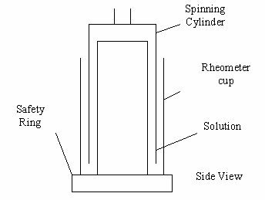

Fig. 1. Diagram of Rheolab Paar Physica cup-bob rheometer

A three step process was defined, Fig. 2, to provide data on each sample. Process 1 -shear stress as a linear ramp rate, 30 points taken from 0.1-60 Pa. Process 2 - shear stress held at a constant 60 Pa, 30 points recorded. Process 3 - shear stress as a linear ramp rate, 30 points taken from 60-0.1 Pa. Samples were tested three times each, subsequently providing 3 ramp up, ramp down and holding data sets.

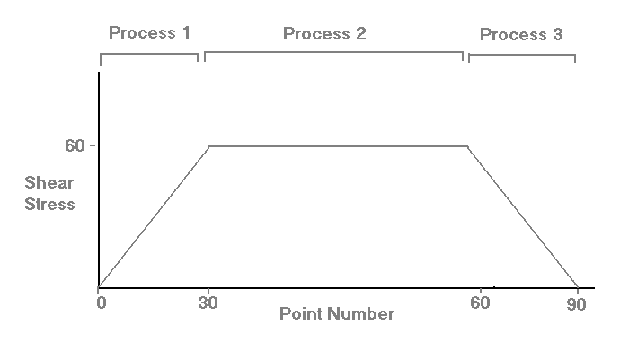

Fig. 2. Each run is comprised of three processes

Process one provides rheological characterisation of the initial dispersed system. Process two then holds the system at a fixed shear stress and should achieve further dispersion followed by a ramp down as process three. If any additional dispersion has been achieved by the rheometer it should be apparent during process three.
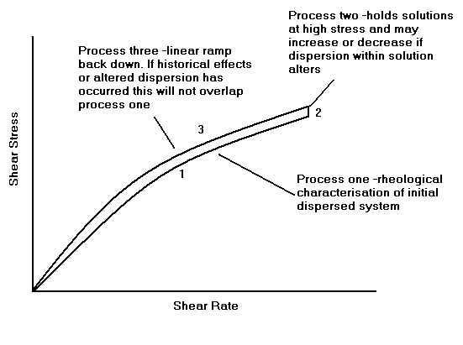

Fig. 3. Example of shear stress – shear rate curve with shear redistribution

III. RESULTS

Data collected show expected shear rate-shear stress curves. Lower percentages of PEO to distilled water start by showing a linear dependence, before shear thinning occurs. However, data from the lowest percentage solutions have emphasised the limitations of the rheometry system. Guidelines for the Rheolab equipment state that the maximum shear rate for high accuracy data is around 4000 s⁻¹, while the data collected here suggests the limitation is around 5000 s⁻¹ before data collection fails. The reliability of data between 4000 s⁻¹ and 5000 s⁻¹ may therefore not be as high. Guidelines for the Rheolab apparatus express an accuracy of 1% maximum values with shear rates between 1 and 4000 s⁻¹ and shear stresses equally accurate at 0-67 Pa. For accuracy, samples with large portions of the data falling outside the recommended region were discounted. (A15/A25/A110/A210/ B110)

After the first set of three processes described previously, plotting shear stress against shear rate demonstrated the repeatability of the data. Sequential testing, with and without delays, suggested good precision with majority of variations not exceeding 5%. This repeatability suggests that any history effects that may alter the rheometry data are either very small or only take effect after excessive previous testing.

Fig. 4. Demonstration of high repeatability

Nevertheless, on the first experiment for each set of data the ramp up and ramp down did not overlap. Ramp down shear stress values were around 8% higher than ramp up values. Similar effects have previously been reported by Daga et al. [6] when testing laponite filled PEO solutions and they deemed the variation to be due to shear re-dispersion. For this investigation the variation only occurs in the first set of data and is thus not assumed to be repeating re-arrangement, but instead, a single re-distribution with the achievement of further dispersion during processes one and two leading to a maximum level of dispersion for following tests.

Fig. 5. Shear re-dispersion is apparent in the first run of each test

One of the simplest models to account for non-Newtonian behaviour was proposed by Ostwald-de Waele. This can be expressed mathematically as a power law equation, shown below.

$τ=K×{\overset{˙}{γ}}^{n_{o}}$ (1)

Where, τ represents shear stress, γ represents shear rate, K is a parameter related to viscosity (larger K represents higher viscosity) and n_{o} is a parameter defining the measure of distortion from a Newtonian fluid [7]. Although previous work by Lewandowska [8] showed that data on polyacrylamide followed the power law, preliminary results obtained by Matheson [9] on PEO suggest that this may not be the case. Rather, Matheson found that for PEO-MMT solutions with up to 5% MMT, a 3 parameter hyperbolic function represented the experimental data with excellent accuracy. Here a, b and c are parameters.
$τ=\frac{a\overset{˙}{γ}}{b+\overset{˙}{γ}}+c\overset{˙}{γ}$
(2)
The Ostwald power law was fitted to data and appeared to show an acceptable fit for low viscosity samples, as expected due to the power law fitting more Newtonian regimes, but poorly fitting higher viscosity samples. To evaluate the accuracy of the model, residuals were calculated by subtraction of the fitted function values from the experimental values, inset Fig. 6.

Fig. 6. A visually close fit to experimental
data from the Ostwald de-Waele power law

The proposed 3 parameter hyperbolic function provided a much better fit for all samples, Fig. 8, including varying viscosities, and gave much smaller residuals. This function could, and subsequently was, differentiated to calculate viscosity data for samples after close inspection of the output viscosities from the Rheolab software suggested that the algorithm used to calculate the values was inappropriate. A large discrepancy seen in Fig. 9 suggests that the software is using an inaccurate method for calculating the viscosities, thus viscosity data were generated for all samples using the differentiated 3 parameter hyperbolic.

Fig. 8. The 3 parameter hyperbolic provided a good fit to data

Fig. 9. Large discrepancies existed in viscosity values
calculated as above and by the Rheologic RS100 software
With accurate viscosity values, the Carreau and De Kee models were investigated. An adapted Carreau model was used, shown in equation 3, after Carreau assumed that as γ tends to zero, η∞ tends to zero.
$η=η_{o}[1+(λ×γ)^{2}]^{\frac{n_{c}−1}{2}}$
(4)

Here, η_{o} is the zero shear viscosity, η∞ is the limiting viscosity at high shear rates, λ is a time constant, n_{c} is a dimensionless parameter and γ is the shear rate. Equation 4 shows that as the shear rate γ tends to zero the shear rate viscosity η_{o} also tends to zero. The De Kee model uses four parameters and is the sum of two exponentials and a single value.
$η=η_{1}e^{−t_{1}\overset{˙}{γ}}+η_{2}e^{−\left(0\text{.}1\right)t_{1}\overset{˙}{γ}}+η_{∞}$
(5)

Here, η₁, η₂ and η∞ are viscosity quantities. The two exponentials represent two relaxation processes. In the De Kee model, the second relaxation time is assumed to be 1/10th the size of the first relaxation time. A free-fit model was tested by removing the fixed relaxation relationship, however the values barely changed thus suggesting De Kee was correct in his assumed relationship.

The Carreau model gave an acceptable fit for higher viscosity samples showing shear thinning, but failed completely for low viscosities, as shown in Fig. 10. The De Kee model however, fitted all data to a high level of precision, including the low viscosities that the Carreau model failed to represent, as seen in Fig. 11.

Fig. 10. The Carreau model fitted well for high viscosity samples but poorly for low viscosity, such as sample A55 here.

Fig. 11. The De Kee model fitted well for all samples, including
low viscosities, such as sample A55
Close inspection of the viscosity log graphs show that addition of MMT clay appears to make little to no apparent change to the viscosities, suggesting that the mobility in the systems and subsequently the viscosity is dominated by the polymer chains.

Fig. 12. Comparing samples with 0%, 5% and 10% MMT loading showed little effect on the viscosity

The increasing viscosity with molecular weight is as expected; work by Lewandowska [8] and Ma [10] suggested that as molecular weight is increased, an increased entanglement of chains leads to a higher viscosity and a broadening of the shear thinning region.

IV. Conclusions

Although the molar mass and concentration dependence of the viscosity data shown by this investigation are as anticipated, the lack of any apparent effect of the included filler is somewhat surprising. This suggests that the mobility of the system is unchanged with addition of MMT.

REFERENCES

[1] M. Reading and A. S. Vaughan, “Rheological, thermal and electrical properties of Poly(ethylene oxide) / MMT nanocomposites”, CEIDP 2008
[2] L. Quercis, F. Loffredo and G. Di Francia, “Influence of filler dispersion on thin film composites sensing properties”, Sensors and Actuators B, vol. 109, pp 153-158, 2005.
[3] Y. H. Lee, C. B. Park, M. Sain, M. Kontopoulou and W. Zheng, “Effects of clay dispersion and content on the rheological, mechanical properties and flame retardance of HDPE/clay nanocomposites”, J. App. Poly. Sci., vol. 104, pp. 1993-1999, 2003.
[4] F. R. Eirich, “Rheology – Theory and Applications”, Ch. 8, 1956
[5] G. Matthews, “Polymer Mixing Technology”, Chapter 1, 1982
[6] V. K. Daga and N. J. Wagner, “Linear viscoelastic master curves of neat and laponite-filled poly(ethylene oxide)-water solutions”, Rheologica Acta, vol. 45, no. 6, pp. 813-824, 2006.
[7] A. Gonet, S. Stryczek and J. Pinka, “Analysis of rheological models of selected cement slurries”, Acta Montanistica Slovaca, vol. 9, no. 1, pp. 16-20, 2004.
[8] K. Lewandowska, “Comparative studies of rheological properties of polyacrylamide and partially hydrolyzed polyacrylamide solutions”, J. App. Poly. Sci., vol. 103, issue 4, pp. 2235-2241, 2006.
[9] T. Matheson and A. S. Vaughan, “Non-linear optics of nanocomposites”, Mphil Report, ECS Dept., University of Southampton, 2007
[10] S. X. Ma and S. L. Cooper, “Shear thickening in aqueous solutions of hydrocarbon end-capped poly(ethylene oxide)”, J. Macromolescules, vol. 34, no. 10, pp. 3294-3301, 2001.

