Rheological, thermal and electrical properties of Poly(ethylene oxide) / Silicon Dioxide MICROcomposites
M. Reading^{1*} and A. S. Vaughan²
¹University of Southampton, Highfield, UK
²University of Southampton, Highfield, UK
*Email: mdr06r@ecs.soton.ac.uk

Abstract: Polyethylene oxide (PEO) is a water-soluble polymer that is technologically used as an electrolyte solvent in lithium polymer cells, but is more widely used as a model system to study fundamental processes. This paper details an investigation into the physical, thermal and electrical properties of polyethylene oxide / silicon dioxide composites. Three different molecular weight host PEOs were used - 100,000 g mol⁻¹, 400,000 g mol⁻¹ and 1,000,000 g mol⁻¹ and micro silicon dioxide was chosen as the filler. This was dispersed into the PEO as a solution in distilled water by using controlled shear conditions, and the properties of the resulting materials were then studied. Dispersion was analysed during the system rheology phase by means of shear rate – shear stress data collection. The crystallisation and melting behaviour were examined using differenial scanning calorimetry. The AC ramp electrical breakdown strength and dielectric response were also analysed. This paper investigates the effect of silicon dioxide loading and shear history on structural evolution, dielectric response and breakdown behaviour in PEO.

Introduction
Over the past 30 years, the use of plastics has increased at an outstanding rate, affecting almost all parts of everyday life one way or another. The reason for this is due to the low cost of production and excellent properties of polymers. Probably the most common use is as packaging, for example as plastic bags, since many plastics are light, strong and very cost effective. In fact it is estimated that over 500 billion plastic bags are used in a single year [1]. However, despite the excellent mechanical properties of polymers, this should not overshadow the dielectric benefits. Most polymers have a significantly lower electrical response than many materials, underlying their use as excellent insulators. With little bulk conductivity, more subtle effects can be observed, such as space charge dynamics. To analyse different polymers and their suitability for insulation many experimental techniques have been developed to evaluate dielectric properties such as- electrical breakdown strength, dielectric loss, permittivity etc [2]. With the development of nanodielectrics it was soon realised that the electrical properties of polymers could be customized even further through the addition of clays or nanoparticulate additives, sparking a whole new field of research.

In this investigation, a micro silicon dioxide filler (SD) was dispersed into varying molecular weight PEO’s in solution. This was achieved using a cup-bob rheometer, a technique previously found to provide information on the flow dynamics of the solution as well as providing a high-level of dispersion [3]. During this process, viscosity data were collected and the effect of the SD filler studied. PEO-SD samples were also melted and crystallised using power compensated differential scanning calorimetry (DSC) to explore any thermal effects. Emphasis was placed on any variation seen of the T_{c} and T_{m} between the virgin PEO samples and SD composites. Samples were also pressed into thin films and tested electrically, in the form of AC ramp breakdown and dielectric spectroscopy. The breakdown strength of the SD composites was analysed using a Weibull distribution and compared to unfilled PEO samples. During the dielectric spectroscopy, the permittivity and loss were investigated, including the use of Cole-Cole plots to better understand the relaxations present.

EXPERIMENTAL
In this investigation, rheometry served to characterise the shear rate - shear stress behaviour of the solutions and to aid in dispersion of the SD. The rheometer used was a RHEOLAB MC1 Paar Physica. Samples were mixed in glass flasks with 20 ml of distilled water as a solvent. For addition of PEO and SD a weight-weight ratio was employed. Initial hand mixing provided basic dispersion. For higher molecular weight solutions, a longer mixing time was required before the solution was visually dispersed. To counter any water lost through evaporation, the flask’s weight was recorded and checked, with addition of distilled water where necessary. In addition to providing rheological data, the rheometer helped to break up any agglomeration within the solution and provide good dispersion of the final system.

The rheometer used in this investigation is based on a spinning cylinder and a rheometer cup, designed to measure the torque acting on the cylinder as a result of the viscosity of the solution in the cup. The solution is poured into the cup around the centre pillar, then the cylinder is lowered into the mixture and the complete assembly is attached to the rheometer prior to testing. The Physica Rheologic RS 100 software package was used, which allows for instrument control, data collection and analysis.

TABLE 1: SAMPLES GENERATED AND TESTED.

Sample Name | Molecular Weight PEO / g mol⁻¹ | X% PEO to DW |  | % SD to PEO and Weight
A “X”  B “X”  C “X” | 100,000  400,000  1,000,000 | 1%  2%  5%  10% | 0.2g  0.4g  1.0g  2.0g | -
A “X” SD 5  B “X” SD 5  C “X” SD 5 | 100,000  400,000  1,000,000 | 1%  2%  5%  10% | 0.2g  0.4g  1.0g  2.0g | 5% | 0.01g  0.02g  0.05g  0.1g
A “X” SD 10  B “X” SD 10  C “X” SD 10 | 100,000  400,000  1,000,000 | 1%  2%  5%  10% | 0.2g  0.4g  1.0g  2.0g | 10% | 0.02g  0.04g  0.1g  0.2g
A “X” SD 25  B “X” SD 25  C “X” SD 25 | 100,000  400,000  1,000,000 | 1%  2%  5%  10% | 0.2g  0.4g  1.0g  2.0g | 25% | 0.05g  0.10g  0.25g  0.5g
A “X” SD 50  B “X” SD 50  C “X” SD 50 | 100,000  400,000  1,000,000 | 1%  2%  5%  10% | 0.2g  0.4g  1.0g  2.0g | 50% | 0.1g  0.2g  0.5g  1.0g
A “X” SD 100  B “X” SD 100  C “X” SD 100 | 100,000  400,000  1,000,000 | 1%  2%  5%  10% | 0.2g  0.4g  1.0g  2.0g | 100% | 0.2g  0.4g  1.0g  2.0g

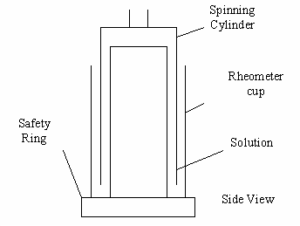

Figure 1 - Diagram of Rheolab Paar Physica cup-bob rheometer.

A three-step process was applied to all samples. Firstly, the shear stress is increased at a linear rate from 0.1 Pa up to 60 Pa, the limit for the rheometer, to provide rheological characterisation of the initial system. Secondly, the shear stress is held at a constant 60 Pa to allow further dispersion to be achieved. Thirdly, the shear stress is decreased at a linear rate back to 0.1 Pa. Any additional dispersion achieved by the rheometer should be apparent during the third step. Each sample completed this process three times, providing 3 ramp up, ramp down and holding data sets.
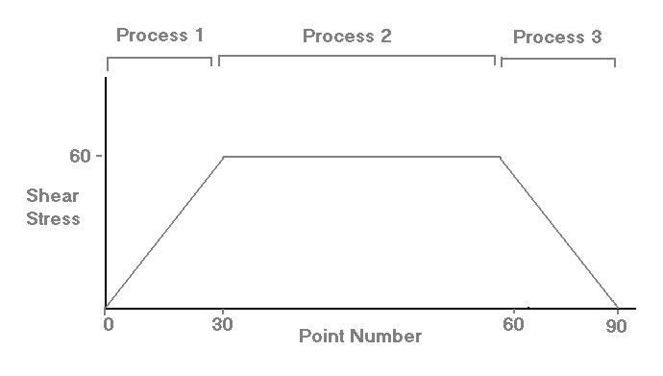

Figure 2 - Each run is comprised of three processes.
For thermal transition investigations a power compensated Perkin Elmer DSC was used with a nitrogen supply. The rheometry-processed solutions were dried and samples weighing 5-6 mg were melted into DSC cans. Using Pyris software, the DSC was calibrated using melt traces from an indium sample, a method commonly used for calibration. For calculation of T_{c} values an isothermal scan was taken from 80 ⁰C down to 20 ⁰C and from 20 ⁰C to 80 ⁰C for T_{m}. To avoid detection of thermal history effects, all isothermal scans were performed after a 5 min ‘hold’ command at a high temperature.

For electrical tests, thin air-free discs were produced by first de-gassing the dried samples in a vacuum oven. A Grazeby Specac press was then used to press samples to a thickness of around 100 μm for AC electrical breakdown. Due to the solubility of PEO, quenching was achieved in a chilled press rather than quenching in water. This method produced thin, uniform and defect-free samples. 8-12 discs were produced for each sample, with 5 breakdown sites designated for each, providing a healthy population for analysis. The test cell used two 6.3 mm ball bearing electrodes submerged in silicone oil. Before testing, the AC ramp rate was calibrated to ensure all samples received the same linear ramp rate. The data collected were analysed using a two-parameter Weibull distribution in conjunction with maximum likelihood confidence bounds.

For dielectric spectroscopy tests, the same pressing/quenching method was used as above, however a thicker spacer was employed to create discs 400 μm in thickness. Samples were then gold coated on both sides to provide a better contact for the electrodes. A ring of uncoated sample was left at the edge of the circular samples to avoid pure conduction across the electrodes. For these tests an SI 1260 impedance/gain-phase analyzer was used in conjunction with a 1296 Solartron instrument and a custom built dielectric cell. Using the Solartron impedance measurement software relative permittivity and loss tan delta data were obtained for the filled and unfilled samples, as a function of frequency. A frequency range of 10⁻² Hz to 10⁶ Hz was employed. To remove any contributions from cabling or the cell itself, a background scan was subtracted from the data sets. In addition to permittivity-frequency curves and loss tan delta-frequency curves, Cole-Cole plots were also generated.

RESULTS
As previously seen [3], after the first two stages of processing, an increase in dispersion was observed. This increase was seen to be the completion of the maximum possible dispersion state since further processing showed very repeatable data. As expected, with increasing PEO content came more shear thinning, starting from near-Newtonian characteristics at 1% to a large shear thinning curve at 10%. Figures 3, 4 and 5 show comparisons between unfilled PEO solutions and 10% SD filled composite solutions. From these we can see that addition of the SD has not affected the flow dynamics within the system.

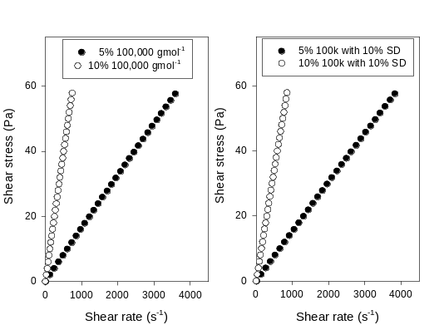

Figure 3 – Shear rate-shear stress curves of 100,000 gmol⁻¹ filled and unfilled samples
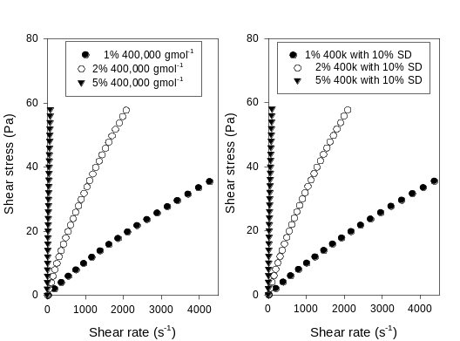

Figure 4 – Shear rate-shear stress curves of 400,000 gmol⁻¹ filled and unfilled samples
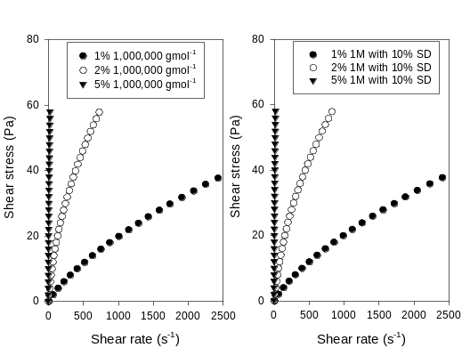

Figure 5 – Shear rate-shear stress curves of 1,000,000 gmol⁻¹ filled and unfilled samples

Successfully dispersing up to 10% SD into a PEO solution without causing any changes in the flow characteristics of the solution could prove useful should the PEO-SD composite show any enhanced properties over the standard PEO material. As shown previously [3], the software calculated viscosity values are poorly evaluated and, therefore, a 3 parameter hyperbolic function was fitted to the shear rate-shear stress data to obtain viscosity data. From figures 6, 7 and 8 it is clear that increasing the ratio of PEO to water increases the viscosity, but that increasing the ratio of SD causes no increase. This suggests that the long chains of PEO dominate the flow characteristics at such a low loading level and that a high level of dispersion has been achieved. Addition of higher SD loadings however showed an increase in viscosity, shown in figure 9.
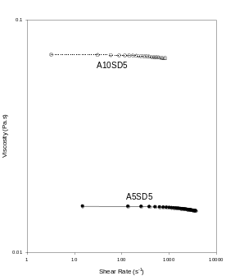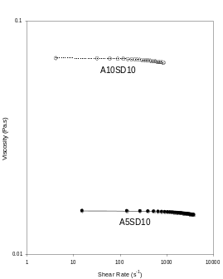

Figure 6 – Shear rate-viscosity curves of 100,000 gmol⁻¹ filled samples
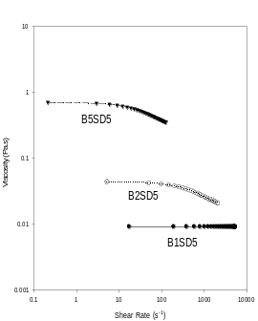

Figure 7 – Shear rate-viscosity curves of 400,000 gmol⁻¹ filled samples

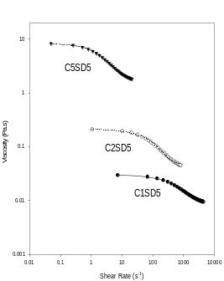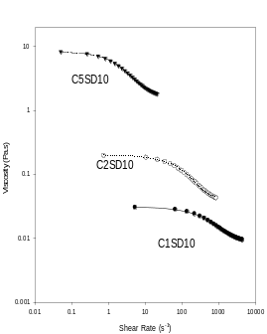

Figure 8 – Shear rate-viscosity curves of 1,000,000 gmol⁻¹ filled samples
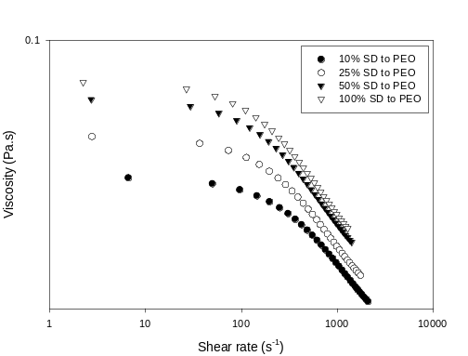

Figure 9 - Shear rate-viscosity curves of high loading SD filled samples
Having had no effect rheologically on the solution, it was expected that T_{c} and T_{m} curves should also show no effect, due to the proposal that low loadings of SD have not affected the mobility within the system. As seen in figures 10 and 11, both the melting and crystallizing transitions showed no noticeable variation with up to 10% SD. In terms of molecular weight, it should be noted that the 400,000 g mol⁻¹ materials had the highest transition temperatures, followed closely by the 1,000,000 g mol⁻¹ and finally 100,000 g mol⁻¹ materials. Future research is planned using Avrami analysis to understand further the effect of SD on crystal formation and mobility within the composites.
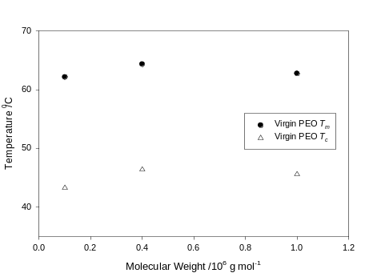

Figure 10 – Unfilled PEO T_{c} and T_{m} values for varying molecular weight
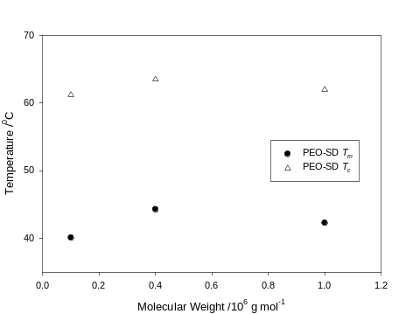

Figure 11 – 10% SD Filled PEO T_{c} and T_{m} values for varying molecular weight

So far the rheology and DSC data have shown that up to 10% SD can be dispersed into the polymer matrix without hindering the mobility within the system. However the SD may affect the overall material properties electrically. AC breakdown strength data were therefore collected and, to gauge the reliability of the data, beta values from the 2 parameter Weibull fits were noted. It is considered that beta values over 10 are acceptable, [4,5]. As shown in Table 2, all samples produced beta values higher than 10.

TABLE 2 - Beta values for tested samples

Sample | Beta Value
Unfilled | 15.76
5% SD | 11.20
10% SD | 11.34
25% SD | 14.83
50% SD | 10.35
100% SD | 16.09
Previous comparison of varying PEO molecular weights has shown that the higher molecular weights possibly exhibit a slight decrease in breakdown strength [4]. It was observed that for samples containing up to 10% SD no apparent change in breakdown strength was observed. Higher loading composites however, were seen to produce an increase in breakdown strength relative to the ratio of SD present. The average breakdown strength of the pure PEO was seen to be 58.9 kV/mm, while 25% SD, 50% SD and 100% SD were seen to increase to 66.6 kV/mm, 73.5 kV/mm and 82.7 kV/mm respectively. This shows a significant improvement of the overall material, especially at 100% loading.
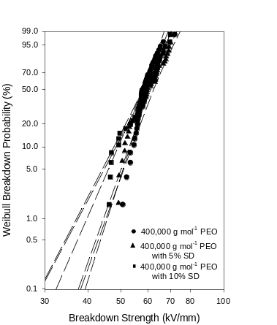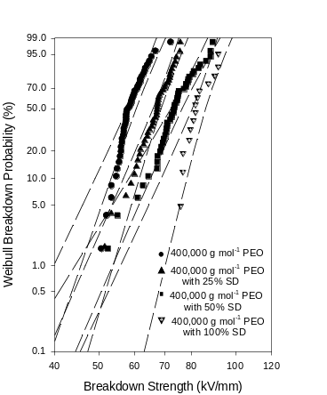

Figure 12 – Plots of E_{b} with 90% confidence bounds for low loading SD (left) and high loading SD (right)

With such an increase in the insulation properties of the material it was expected that dielectric spectroscopy of the samples would be particularly informative. Analysis of the real relative permittivity as a function of frequency, as shown in figures 13 and 14, shows that the unfilled sample exhibits the highest permittivity. Similar behaviour at low frequencies has been reported previously [6,7]. Addition of 10% SD is seen to cause a very small decrease, although the general shape was still maintained. Addition of 25% is again observed to cause a decrease in permittivity, however further addition of SD caused no further decrease.
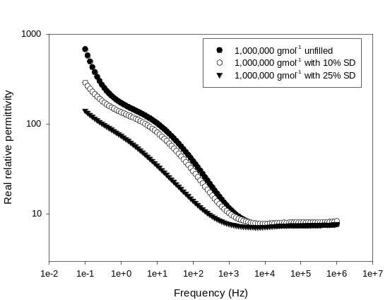

Figure 13 – The real relative permittivity as a function of frequency for 1,000,000 gmol⁻¹ samples

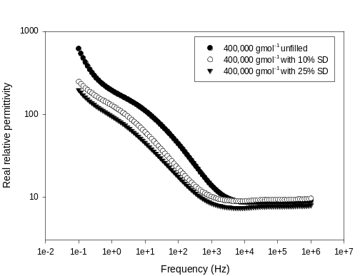

Figure 14 – The real relative permittivity as a function of frequency for 400,000 gmol⁻¹ samples

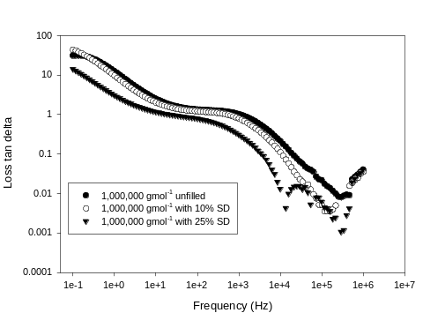Looking at the delta as a function of frequency, it is again seen that the unfilled sample has the highest values. Addition of 10% SD arguably provides a slight decrease, but is more obvious with 25% SD. Again, further addition of SD produces no noticeable deviation to the 25% SD sample. This decrease could be due to the ratio of SD-PEO, with less PEO present in the SD filled samples since thickness is constant.

Figure 15 – The loss tan delta as a function of frequency for 1,000,000 gmol⁻¹ samples

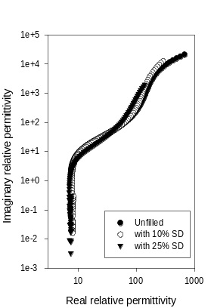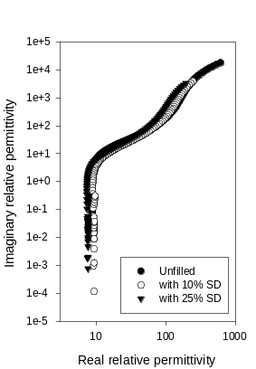To enable a better analysis of this data and to be more certain of any SD effects, Cole-Cole plots of real relative permittivity against the imaginary relative permittivity were generated. Figure 16 shows that the Cole-Cole plots for the samples have a very similar shape. This suggests that molecular relaxations are not perturbed by the addition of SD. This is quite a contrast to the dielectric effect caused by other fillers, such as aluminium pillared montmorillonite investigated previously [4].

Figure 16 – Cole-Cole plots for the 1,000,000 gmol⁻¹ (left) and 400,000 gmol⁻¹ (right) samples

Conclusions
It was observed that up to 10% micro silicon dioxide could be dispersed into poly(ethylene oxide) solutions without affecting the flow characteristics. This suggests that the molecular mobility was not affected; a belief confirmed by differential scanning calorimetry since melting and crystallization temperatures were not affected by addition of SD. It was noted however that addition of higher loadings of SD caused an increase in viscosity and therefore was impeding the mobility within the system. Addition of up to 10% SD caused no noticeable change in breakdown strength, whereas higher loadings showed a significant increase. From dielectric spectroscopy addition of SD was seen to cause a decrease in real relative permittivity, however addition of further SD did not result in a further decrease. Cole-Cole plots confirmed that the SD has merely affected the existing relaxations since the curves for all samples had the same shape. In summation, a large improvement in electrical breakdown strength of PEO can be achieved with addition of 25% or more silicon dioxide, however dispersing such a system becomes more difficult.

REFERENCES
- Environmental protection agency.
- T. Blythe and D. Bloor. “Electrical properties of polymers”.
- M. Reading and A. S. Vaughan. “Dispersion and rheology of Poly(ethylene oxide) / MMT Nanocomposites”, Elec. Insul. Dielec. Phen. Annual Conf. Rep., pp. 37-40, 2008.
- M. Reading and A. S. Vaughan. “Rheological, thermal and electrical properties of Poly(ethylene oxide) / MMT Nanocomposites”, Elec. Insul. Dielec. Phen. Annual Conf. Rep., pp. 579-582, 2008.
- M. W. Aarts, J. B. Kjellqvist, A. Mendelsohn and K. Vaterrodt. “The performance of XLPE water tree resistant insulation systems against the requirements of DIN VDE 0276-605/A3”, 18th Int. Conf. Elec. Dist. 2005
- R. J. Sengwa, K. Kaur, R. Chaudhary. “Dielectric properties of low molecular weight poly(ethylene glycol)s”, Poly. Int., vol 49, pp. 599-608, 2000
- C. H. Porter and R. H. Boyd, “A dielectric study of the effects of melting on molecular relaxation in poly(ethylene oxide) and polyoxymethylene”, Macromolecules, vol. 4, no. 5, pp. 589-594, 1971.

