AN INVESTIGATION INTO SEPARATION ENHANCEMENT METHODS FOR MINIATURISED PLANAR CAPILLARY ELECTROPHORESIS DEVICES

Adam P. Lewis¹, Andy W. J. Cranny¹, Nick. R. Harris¹, Mengyan Nie², Julian A. Wharton², Robert J. K. Wood², Keith R. Stokes³

¹ ESD Group, School of Electronics and Computer Science, University of Southampton, Highfield, Southampton, SO17 1BJ
² nCATS Group, School of Engineering Sciences, University of Southampton, Highfield, Southampton. SO17 1BJ
³ Defence Science and Technology Laboratory, Porton Down, Salisbury

INTRODUCTION

Large structures such as buildings, ships and aircraft often contain numerous components which are exposed to a failure risk due to corrosion processes. Aside from the extra cost of repair and replacement, there are also potential health and safety issues which need to be addressed. Corrosion detection is not a new concept and there exists a variety of methods to detect and evaluate corrosion. The analysis method that is the focus of this work is capillary electrophoresis (CE); commonly used for a number of biological and chemical processes, such as drug, food and water quality analysis, DNA and protein separation and so on. An alternative method to high pressure (or performance) liquid chromatography (HPLC), CE boasts high analysis speeds as well as low limits of detection. Both are of crucial advantage for use in a pharmaceutical market; however the application of CE for in-situ or portable corrosion monitoring has not been investigated in great depth.

OVERVIEW OF CAPILLARY ELECTROPHORESIS

CE is a separation technique which can separate ions based on their charge and size. A sample to be separated is introduced into a buffer filled capillary over which a high electric field is applied. As the sample passes through a capillary, the ions in the sample with the highest mobility move fastest and therefore emerge from the end of the capillary before the slower ones, see Fig 1; neutral analytes emerge at the same time as each other. The velocity u_{ep} of the ions is given by:

$$u_{ep}=\frac{zeE}{6πηr}$$

where z is the integer valence number for the ion and e represents the elementary charge, E the electric field, η the fluid viscosity and r the hydrated radius. Often the velocity is written:
$$u_{ep}=μ_{ep}E$$

where the electrophoretic mobility µ_{ep} is given by:

$$μ_{ep}=\frac{ze}{6πηr}$$

Placing a detector at the end of the capillary enables the detection of the different ionic groups contained within the sample. From a corrosion analysis perspective this technique could be useful since when a metal group corrodes, different ions are released at different stages of the corrosion process. Knowing what ions have been released due to corrosion enables the possibility of characterising the corrosion progression. This in turn could provide an early indication of device failure due to corrosion, thus enabling the user to act accordingly before failure occurs.

PORTABLE AND IN-SITU MEASUREMENTS

For a device to be portable or truly suited for in-situ measurements there is a requirement for it to be small, and contain its own power source and control system. Aside from these requirements is the difficulty introduced by miniaturising the CE process. Having a long capillary gives the sample a greater distance in which it is able to separate and therefore makes separation easier, especially where we are concerned with analytes with similar values of mobility. Obviously the maximum capillary or channel length obtainable on a miniaturised device is severely limited and therefore other methods of enhancing separation must be investigated.

SEPARATION ENHANCEMENT

There are two main factors which contribute to fluid flow through the capillary, firstly the electrophoretic force (due to the charge of the ions in the sample/and their mobility) and secondly the electroosmotic flow (EOF), caused by a double layer formed along the capillary walls. The EOF moves all analytes within the sample along the capillary at the same rate and therefore does not directly aid separation. If the EOF is of a high magnitude in the direction towards the end of the capillary then the sample will quickly pass through the capillary with little separation achieved. For miniaturised CE devices where the length of the device is much less than a standard laboratory CE unit, a high EOF would make sample separation very difficult or maybe impossible. There are a variety of ways to modify the EOF; for example, it is highly dependent on the pH of the buffer and can even be reversed. Since changing the buffer pH is not an easy task to perform during analysis, a more interesting method is the use of electric fields applied to the capillary walls. The charge due to the double layer, contributing to the EOF, can be modified by the application of a voltage to the capillary walls. This charge, called the zeta-potential, directly affects the magnitude and direction of EOF through the capillary, and can be easily modified during the analysis procedure.
Fig.1: The order of separation of charged and neutral analytes according to their physical size and electronic charge; N denotes an ion of neutral charge.

The EOF, u_{EOF,} is given by [1]:

$$u_{EOF}=\frac{ε_{0}ε_{r}ζ}{η}E$$

where ε₀ is the permittivity of a vacuum, ε_{r} is the relative permittivity of the liquid and ζ denotes the zeta-potential. Wouden et al. [1] have demonstrated the ability to control EOF in microfluidic channels through the incorporation of insulated electrodes near the channel walls. Using the ability to dramatically alter the EOF, Wouden et al. [1] state that they are able to stop and even control the direction of the EOF.

The effective capillary length could be increased by using the EOF to move the ions back to the start of the capillary so that they can traverse the capillary multiple times; each time the separation would increase.

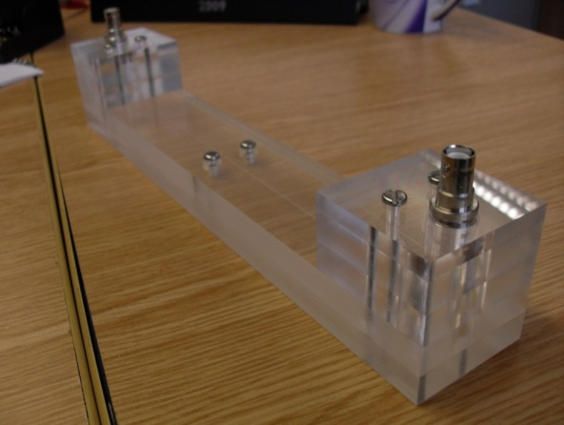
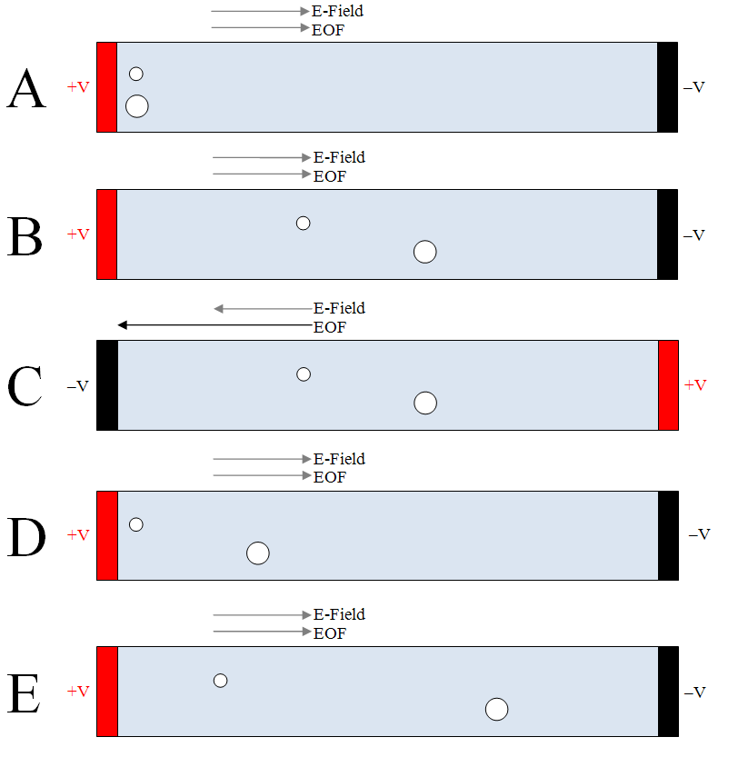
Fig. 3: Photograph of the prototype CE device
Fig. 2: Method for Improving Resolution of Electrophoretic Separation by Modification of the EOF
A method to do this would be to have a channel with electrodes on either end and after some time, t, the ions will have separated a small amount, see Fig. 2B. If then the electric field is reversed but the EOF is modified such that it dominates the flow then the ions can be moved back toward the start electrode without undergoing significant electrophoretic separation; thus we should get a scenario such as in Fig.2D. These conditions are similar to the start conditions except that we now have a small amount of separation; therefore when we apply the separation field the ions will further separate and the total distance travelled along the channel will not have been greatly increased.

Alternatively, for the highest resolution, the EOF should counter the flow due to the electrophoretic force; such that only the ion with the highest mobility in the sample is able to traverse the capillary, once sufficient separation is achieved, the EOF could be lowered to enable the next highest mobility ion to pass, and then repeat this process until total separation is achieved. Whilst in the system above the field has been switched during stage C of Fig. 2, if the EOF is reversed then the field could be kept in one direction throughout the experiment, reversing the EOF sends the ions back toward the start but they would not only keep their separation but continue separating during the return. This idea could then be further extended to where the EOF is modified to be just lower than the electrophoretic mobility of the ion with the highest mobility, thus allowing only the ion with the highest mobility to flow down the channel; the EOF would push the other ions back toward the start. Once the first ion has been separated, the EOF could be lowered and the process repeated for all the other ions in the sample.

EXPERIMENTS

A prototype device has been designed to test understanding of basic microfluidic concepts and provide a platform on which to build the microfluidic CE device. The prototype CE device is composed of two pieces of PMMA; in one of the pieces a channel is milled and reservoirs drilled, the other piece seals the channel when the two parts are bonded together. It has dimensions of: depth 30µm, width 300µm and length 260mm; a picture is shown in Fig. 3. Once minor development difficulties were overcome some interesting results were obtained. It is often stated that the EOF in PMMA devices is less than that for standard capillary tubes [2]. On the prototype device, we tested it with fluorescein dyes which migrated in the opposite direction to that reported in the literature regarding work on a standard CE system [3]. The work of this paper was explored and comparable results were obtained using our laboratory CE system. It is expected that the lower EOF means that the electrophoretic force on the anionic dyes dominates the flow through the channel.

The sample injection method consists of a sample channel crossing the separation channel, utilising a hydrodynamic method to force fluid to cross the separation channel. Without adequate control of the waste reservoir it is difficult to prevent the sample spreading significantly into the separation channel. To overcome this problem, an electrokinetic system is going to be explored, whereby the sample is sent along the sample channel using electric fields rather than pressure. Unfortunately, since the cross-section has a small area, it would be difficult to see the sample separate and therefore a detector system has been explored. Two contactless conductivity detection methods were investigated, the most effective being Cu foil strips placed close to the capillary wall. Preliminary results showed sensitivity to changes in concentration of fluorescein dyes.

The implementation of a detector system will enable the testing of the concepts described, allowing an accurate evaluation of the benefits achievable through incorporation of a dynamic EOF modification based separation enhancement method.

CONTACT DETAILS
Any questions relating to this paper should be directed to Adam P. Lewis (Tel.: +44 (0) 2380 594996; e-mail: apl08r@ecs.soton.ac.uk)

REFERENCES

[1] E. J. Van Der Wouden, T. Heuser, D. C. Hermes, R. E. Oosterbroek, J. G. E. Gardeniers, and A. Van Den Berg, "Field-effect control of electro-osmotic flow in microfluidic networks," Colloids and Surfaces A: Physicochemical and Engineering Aspects, vol. 267, pp. 110-116, 2005.

[2] M. Pumera, J. Wang, F. Opekar, I. Jelinek, J. Feldman, H. Lowe, and S. Hardt, "Contactless Conductivity Detector for Microchip Capillary Electrophoresis," Anal. Chem., vol. 74, pp. 1968-1971, 2002.

[3] T. Pérez-Ruiz, C. Martínez-Lozano, A. Sanz, and E. Bravo, "Separation of Fluorescein Dyes by Capillary Electrophoresis Using β-Cyclodextrin," Chromatographia, vol. 48, pp. 263-267, 1998.

