What Is To Be Done
About Public Access to Peer-Reviewed Scholarly Publications
Resulting From Federally Funded Research?
(Response to US OSTP RFI)

Stevan Harnad
American Scientist Open Access Forum (Moderator: 1998-2011)
Canada Research Chair in Cognitive Sciences, UQAM, Canada
Electronics and Computer Science, University of Southampton, UK

[Please note that as parts of several questions sometimes ask the same thing, some of the replies are repeated too, in order to make each reply self-contained rather than requiring cross-referencing.]

QUESTION 1 (1a, 1b, 1c, 1d):

(Question 1a) “Are there steps that agencies could take to grow existing and new markets related to the access and analysis of peer-reviewed publications that result from federally funded scientific research?”

Yes there are very specific practical steps.

(“Markets,” however, is perhaps not the most direct and instructive way to understand the dynamics involved: basic research growth (1) and the resulting growth in R&D applications/products (e.g., technology, medicines) (2) need to be considered separately, with (1) feeding into (2)):

US Federally funded research is funded by the US tax-payer, and conducted, analyzed and published by researchers (and for researchers), so that the research findings can be accessed, taken up, used, applied, and built upon, by all potential users, for the benefit of the US tax-paying public that funded it, through both further research (1) and R&D applications (2).

Barriers to the uptake and usage of publicly funded research are barriers to both research progress itself (1) and to the practical, social and economic benefits of R&D (2). Anything that reduces access to the research findings reduces their impact, which in turn reduces the return in the public benefits from the tax dollars invested in funding, conducting, analyzing and reporting the research.

Here are some papers on the economic benefits of providing open access to research (and hence also the economic losses from not providing it):

Houghton, J.W. & Oppenheim, C. (2009) The Economic Implications of Alternative Publishing Models. Prometheus 26(1): 41-54:
"Indicative modelling of post‐transition ‘steady‐state’ alternative systems returned benefits of around seven or eight times costs for open access publishing and self‐archiving with overlay services, and 40 times the costs for the Green OA self‐archiving. (p. 49)"

Houghton, J.W., Rasmussen, B., Sheehan, P.J., Oppenheim, C., Morris, A., Creaser, C., Greenwood, H., Summers, M. and Gourlay, A. (2009). Economic Implications of Alternative Scholarly Publishing Models: Exploring the Costs and Benefits, London and Bristol: The Joint Information Systems Committee (JISC)

Houghton, J.W. and Sheehan, P. (2009) Estimating the potential impacts of open access to research findings, Economic Analysis and Policy, vol. 39, no. 1, pp. 127-142.

Harnad, S. (2010) The Immediate Practical Implication of the Houghton Report: Provide Green Open Access Now. Prometheus 28 (1): 55-59
ABSTRACT: Among the many important implications of Houghton et al’s (2009) timely and illuminating JISC analysis of the costs and benefits of providing free online access (“Open Access,” OA) to peer-reviewed scholarly and scientific journal articles one stands out as particularly compelling: It would yield a forty-fold benefit/cost ratio if the world’s peer-reviewed research were all self-archived by its authors so as to make it (“Green”) OA. There are many assumptions and estimates underlying Houghton et al’s modelling and analyses, but they are for the most part very reasonable and even conservative. This makes their strongest practical implication particularly striking: The 40-fold benefit/cost ratio of providing Green OA is an order of magnitude greater than all the other potential combinations of alternatives to the status quo analyzed and compared by Houghton et al. This outcome is all the more significant in light of the fact that self-archiving already rests entirely in the hands of the research community (researchers, their institutions and their funders), whereas (“Gold”) OA publishing depends on the publishing industry. Perhaps most remarkable is the fact that this outcome emerged from studies that approached the problem primarily from the standpoint of the economics of publication rather than the economics of research.

Below (Figure 1) is Houghton et al’s summary of the estimated benefit/cost ratio for the UK for the two ways of providing Open Access: Green OA = authors publishing in their journal of choice, but also making their peer-reviewed final drafts OA by self-archiving them in their institutional OA repository or (ii) Gold OA = authors publishing in OA journals that make all their articles free online and charge the author a publication fee. Houghton et al calculate, separately, the benefit/cost ratio for the UK universities (“HE”) and for UK as a whole, for converting to Gold OA or for converting to Green OA, and as a function of whether it is the UK alone that converts, or the conversion is done worldwide.

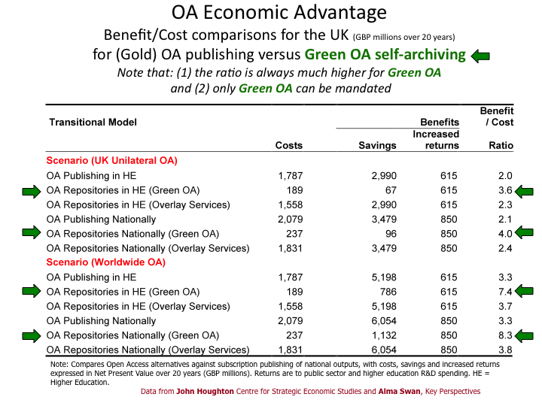
Figure 1. Houghton et al’s Benefit/Cost Analyses for Green and Gold OA in the UK

(See also: The effect of open access on downloads ('hits') and citation impact: a bibliography of studies)

The two important things to note for the US RFI are (1) that, for all conversion scenarios, the cost of converting to Green OA is much lower (and distributed across institutions) and the benefit/cost ratio is much higher) than for converting to Gold OA and even more important, (2) federal funders (as well as institutions) can mandate a conversion to Green OA by mandating self-archiving by their fundees (or employees) but they cannot mandate a conversion to Gold OA (because that is in the hands of publishers).

Mandating Green OA is hence the optimal policy for the US as well.

The main barrier limiting access to research findings in the Internet era is the fact that although the research is publicly funded, it is only accessible to those researchers whose institutions can afford subscription/license access to the journal in which it was published. There are over 25,000 peer-reviewed research journals across all scientific and scholarly fields worldwide. No university or research institution can afford subscription access to all or most of those journals. Most universities can only afford access to a small and shrinking fraction of them:

(See: ARL Statistics on universities’ journal holdings)

In the Gutenberg print-on-paper era, before the Internet era, there was no remedy for this, because the true costs of providing access via print-on-paper were so high that in order to cover those essential, ineliminable costs, institutions had to pay for subscription.

The costs of providing print access are still high today. But the cost of providing online access alone is not – in fact it is near zero: Once their papers have been peer-reviewed and accepted for publication, researchers can provide online access by simply depositing their final drafts online in their institutional repositories, free for all, whether or not the user’s institution can afford to subscribe to the publisher’s print or online edition:

(See: Registry of Open Access Repositories (ROAR))

The costs of providing peer review are not zero. The peers review for free, but the journal editor must choose the peer-reviewers and adjudicate reviews and revisions. But the journal’s costs for all that (peer review + print production and distribution plus online production and distribution) are fully covered today by the subscriptions/licenses paid by the institutions that can afford to subscribe to each journal.

The Internet now makes it possible to supplement this subscription access to the publisher’s version-of-record with free online access to the author’s final, peer-reviewed draft for all those potential users whose institutions cannot afford the subscription access to the publisher’s version-of-record.

Hence the one, simple, cost-free step that federal agencies can and should take to maximize the uptake, usage, applications and impact of peer-reviewed research is to mandate (i.e., require) that the final, peer-reviewed draft of all federally funded research must be deposited (“self-archived”) in the fundee’s institutional repository immediately upon acceptance for publication.

Over 50 research funders [including NIH] and almost 200 universities and research institutions worldwide [including Harvard and MIT] have already mandated Green OA. (See mandate growth curve from ROARMAP (Registry of Open Access Mandatory Archiving Policies) Figure 2, below). This is what has come to be called “Green Open Access” self-archiving:

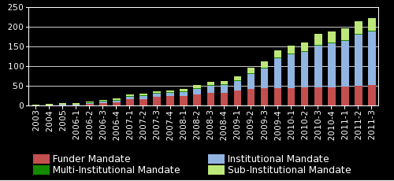
Figure 2. ROARMAP Growth Chart for Green OA Mandates by Funders and Institutions

Harnad, S., Brody, T., Vallieres, F., Carr, L., Hitchcock, S., Gingras, Y, Oppenheim, C., Stamerjohanns, H., & Hilf, E. (2004) The green and the gold roads to Open Access. Nature Web Focus.

Mandating Green OA is the simple, almost cost-free measure that will grow existing and new markets for the fruits of federally funded research.

To see the power of mandating Green OA in accelerating the growth of OA, contrast the growth rate of Gold OA journal publishing (which is not in the hands of the research community nor in the hands of research funders, and hence its growth cannot be accelerated by funder mandates) with the growth rate of Green OA when it is mandated. (See the Figure 3 and Figure 4 below. See also Figure 7.)

According to the estimates of the biggest commercial OA publisher today (Springer, publisher of the BioMed Central Journals and Open Choice), Gold OA will not reach 70% for the top journals (the ones indexed by Thompson-Reuters Web of Science) until 2026; even the more optimistic estimates of Laakso et al (based on all journals) don’t reach 70% till 2020. In contrast, Green OA self-archiving, which is less than 20% if it is not mandated, reaches 70% within 1-2 years of adopting a Green OA mandate (and continues to grow toward 100% OA thereafter).

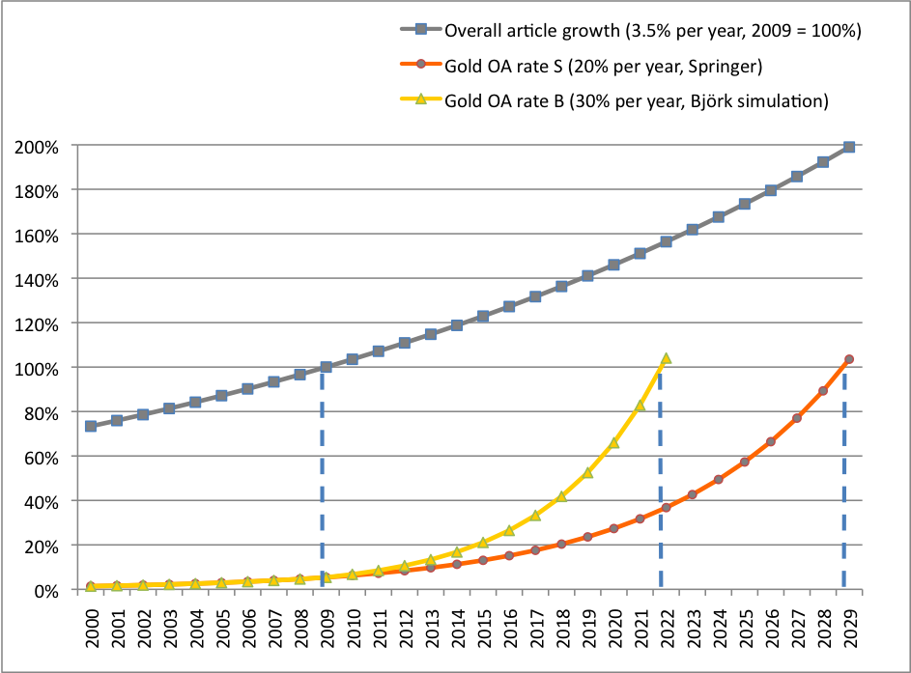
Figure 3. Estimated Growth Curve for Gold OA publishing. Note that 70% gold OA will not be reached till 2020 on Bjork/Laakso simulations and till 2026 on the Springer estimates. Cf. Figure 4 for mandated green OA.

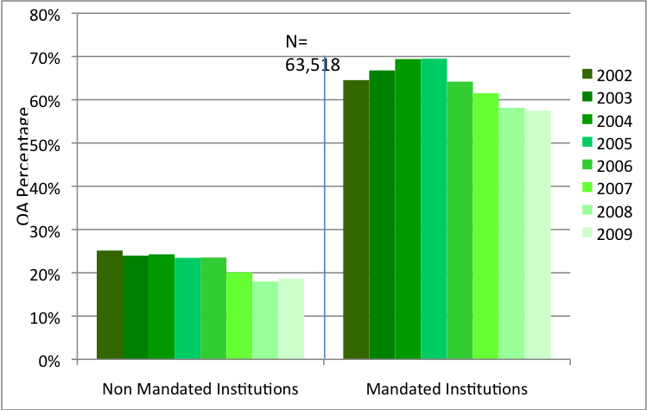
Figure 4. Percentage Green OA when unmandated and when mandated. Unmandated Green OA is about 20%, whereas mandated Green OA soon rises to 70%. (See also Figure 7.)

Poynder, Richard (2011) Open Access by Numbers, Open and Shut, 19 June 2011

Laakso M, Welling P, Bukvova H, Nyman L, Björk B-C, et al. (2011) The Development of Open Access Journal Publishing from 1993 to 2009. PLoS ONE 6(6): e20961. doi:10.1371/journal.pone.0020961

(Question 1b) “How can policies for archiving publications and making them publically accessible be used to grow the economy and improve the productivity of the scientific enterprise?”

The result of mandating that the final, peer-reviewed draft of all federally funded research must be deposited (“self-archived”) in the fundee’s institutional repository immediately upon acceptance for publication will be that the research will be taken up, built upon and applied by any researcher, rather than, as now, only those researchers whose institutions can afford subscription access to the journal in which it was published. This maximizes research access, usage and impact, which in turn maximizes research progress, productivity and the benefits of both research and R&D for the tax-payers that funded the research.

The current system of access-denial to the findings of federally funded research for all but the researchers at institutions that can afford to subscribe to the journal in which it was published is a legacy of the economics of print on paper, and it is no longer necessary. In the online era there is no longer any reason left why peer-reviewed research should not be accessible online to all potential users, rather than only to those at institutions that can afford to subscribe.

In careful comparisons of the research impact (downloads and citations) of research published in the same journal and year that was and was not made freely accessible online (open access) it has been repeatedly reported, in every field tested, that the research that is made open access is downloaded and cited significantly more than the research (in the same journal and year) that is not made open access (see Figure 5). Access barriers mean barriers to research applications and benefits, hence losses on the tax-payer’s investment in research.

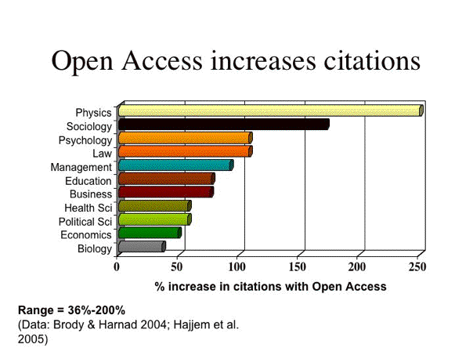
Figure 5. The OA Impact Advantage. Across all disciplines tested, citations (and downloads) are significantly greater for articles that are made (Green) OA by their authors (self-archiving) compared to articles in the same journal and year that are not made OA. (The important point is that the OA impact is always greater, in all disicplines, not the rank order of the size of the advantage by disicpline, which varies from year to year and sample to sample.) Citations indicate that the research is being used and built upon in further research and applications.

(See references cited in: The effect of open access on downloads ('hits') and citation impact: a bibliography of studies)

Gargouri, Y., Hajjem, C., Lariviere, V., Gingras, Y., Brody, T., Carr, L. and Harnad, S. (2010) Self-Selected or Mandated, Open Access Increases Citation Impact for Higher Quality Research. PLoS ONE 5 (10) e13636

Hajjem, C., Harnad, S. and Gingras, Y. (2005) Ten-Year Cross-Disciplinary Comparison of the Growth of Open Access and How it Increases Research Citation Impact. IEEE Data Engineering Bulletin 28(4) pp. 39-47.

Harnad, S. & Brody, T. (2004) Comparing the Impact of Open Access (OA) vs. Non-OA Articles in the Same Journals, D-Lib Magazine 10 (6) June

Lost or delayed research progress also mean losses to the growth and productivity of the R&D industry in all fields, and hence to the US economy. It is a very widespread and deep error to reckon the potential gains or losses from providing or not providing open access in terms of gains or losses to the publishing industry.

Peer-reviewed research journal publishing is a service industry. It exists in the service of research, researchers and research progress, which are vastly larger and more important economically than research journal publishing itself, as a business. It is hence the research publishing industry that must adapt to the powerful new potential that the online era has opened up for research, researchers, research institutions, research funders, the vast R&D industry, teachers, students, and the tax-paying public that funds the research. Not vice versa.

Economically speaking, it would be a great mistake to conceptualize this new situation as research, researchers and the R&D industry having to compromise their newfound potential to maximize the research progress – along the lines that have now been made possible by the online era -- in order to protect and preserve the current revenue streams and M.O. of the publishing industry, which evolved for the technology and economics of the bygone Gutenberg era of print on paper.

Research having to adapt to publishing would amount to the publishing tail wagging the research dog. It must always be kept clearly in mind that the peer-reviewed research publishing industry exists as a service industry for research, not vice versa:

Publicly funded research is entitled to the full scientific and public benefit opened up for it by the online media. The research publishing industry can and will continue to evolve until it adapts naturally to the new demands and needs of the online age of open access to research.

Harnad, S. (2007) The Green Road to Open Access: A Leveraged Transition. In: The Culture of Periodicals from the Perspective of the Electronic Age, pp. 99-105, L'Harmattan.
ABSTRACT: What the research community needs, urgently, is free online access (Open Access, OA) to its own peer-reviewed research output. Researchers can provide that in two ways: by publishing their articles in OA journals (Gold OA) or by continuing to publish in non-OA journals and self-archiving their final peer-reviewed drafts in their own OA Institutional Repositories (Green OA). OA self-archiving, once it is mandated by research institutions and funders, can reliably generate 100% Green OA. Gold OA requires journals to convert to OA publishing (which is not in the hands of the research community) and it also requires the funds to cover the Gold OA publication costs. With 100% Green OA, the research community's access and impact problems are already solved. If and when 100% Green OA should cause significant cancellation pressure (no one knows whether or when that will happen, because OA Green grows anarchically, article by article, not journal by journal) then the cancellation pressure will cause cost-cutting, downsizing and eventually a leveraged transition to OA (Gold) publishing on the part of journals. As subscription revenues shrink, institutional windfall savings from cancellations grow. If and when journal subscriptions become unsustainable, per-article publishing costs will be low enough, and institutional savings will be high enough to cover them, because publishing will have downsized to just peer-review service provision alone, offloading text-generation onto authors and access-provision and archiving onto the global network of OA Institutional Repositories. Green OA will have leveraged a transition to Gold OA.

(Question 1c) “What are the relative costs and benefits of such policies?”

The costs and benefits of providing Open Access have been extensively analyzed, country by country, in the Houghton reports (see Figure 1):

Houghton, J.W. & Oppenheim, C. (2009) The Economic Implications of Alternative Publishing Models. Prometheus 26(1): 41-54

Houghton, J.W., Rasmussen, B., Sheehan, P.J., Oppenheim, C., Morris, A., Creaser, C., Greenwood, H., Summers, M. and Gourlay, A. (2009). Economic Implications of Alternative Scholarly Publishing Models: Exploring the Costs and Benefits, London and Bristol: The Joint Information Systems Committee (JISC)

Houghton, J.W. and Sheehan, P. (2009) Estimating the potential impacts of open access to research findings, Economic Analysis and Policy, vol. 39, no. 1, pp. 127-142.

Harnad, S. (2010) The Immediate Practical Implication of the Houghton Report: Provide Green Open Access Now. Prometheus 28 (1): 55-59

(Question 1d) “What type of access to these publications is required to maximize U.S. economic growth and improve the productivity of the American scientific enterprise?”

What is required is access to the peer-reviewed final draft, free for all users online. The way to provide that is to mandate (i.e., require) that the final, peer-reviewed draft of all federally funded research must be deposited (“self-archived”) in the fundee’s institutional repository immediately upon acceptance for publication.

It is important also to specify that the locus of direct deposit should be the fundee’s institutional repository, not institution-external central or subject-based repositories. After deposit, institutional repositories can automatically export their contents to central and subject-based repositories – and/or central and subject-based repositories can automatically harvest them – for search and navigation.

Mutually Reinforcing Mandates. If complementary, convergent institutional deposit is mandated by both federal funders and institutions (universities and research institutes), instead of needlessly competing, divergent deposit in multiple institution-external repositories, then institutions – the universal providers of all research, federally funded and unfunded -- will be in a position to reinforce, monitor and ensure compliance with the federal funder mandates. This will also encourage institutions to adopt deposit mandates of their own, for all their peer-reviewed research output, funded and undfunded. This will in turn increase the scope and benefit of federal funder mandates, far beyond just the research they fund (see Figure 1 for the importance of getting the rest of the research world to reciprocate OA so everyone can derive OA’s full benefits).

Most universities already have repositories, created out of free software such as DSpace and EPrints. But for fundees at institutions that do not yet have a repository of their own, there are back-up repositories, like OpenDepot, created specifically to perform the same function until the institution has a repository of its own, at which time the institution can automatically import all of its researchers’ deposits.

Optimally, access to the deposits should be opened (OA) immediately upon deposit, so that uptake and impact can be maximized immediately. The research on the open access impact advantage has shown not only that impact is lost if research is not made open access, but that delayed access does not necessarily recover that lost impact: It is often important with research to strike while the iron is hot, otherwise results may not achieve their full potential impact.

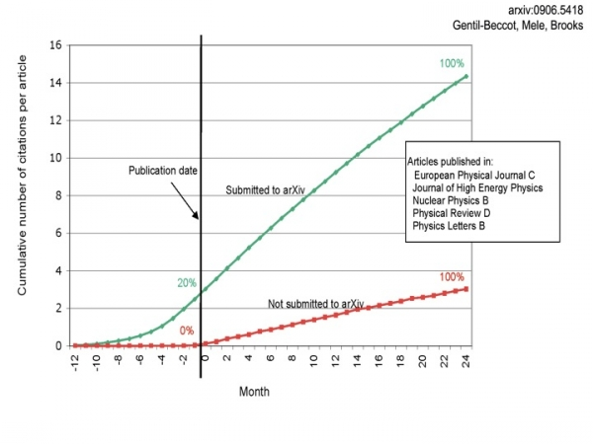
Figure 6. Open Access Impact Advantage Includes Early Access Advantage (Physics). (Note that impact lost because of delayed access is not just delayed; some of it is lost permanently. This is why any access embargo is deleterious to research.)

Gentil-Beccot A, Mele S, Brooks T.C. (2010) Citing and reading behaviours in high-energy physics. Scientometrics. 2010;84(2):345–55

But if federal funding agencies nevertheless agree to allow a temporary embargo on open access, the allowable embargo length should be minimal – not more than 6 months. Meanwhile, the mandatory deposit should nevertheless be done immediately upon acceptance for publication. During the embargo period the repository software makes it possible for individual researchers to request – and authors to provide – a single copy of the research to the individual user for research purposes with just one click from the requester and one click from the author. (This is not open access, but it can help tide over research needs during the embargo.)

Sale, A., Couture, M., Rodrigues, E., Carr, L. and Harnad, S. (2012) Open Access Mandates and the "Fair Dealing" Button. In: Dynamic Fair Dealing: Creating Canadian Culture Online (Rosemary J. Coombe & Darren Wershler, Eds.)
ABSTRACT: We describe the "Fair Dealing Button," a feature designed for authors who have deposited their papers in an Open Access Institutional Repository but have deposited them as "Closed Access" (meaning only the metadata are visible and retrievable, not the full eprint) rather than Open Access. The Button allows individual users to request and authors to provide a single eprint via semi-automated email. The purpose of the Button is to tide over research usage needs during any publisher embargo on Open Access and, more importantly, to make it possible for institutions to adopt the "Immediate-Deposit/Optional-Access" Mandate, without exceptions or opt-outs, instead of a mandate that allows delayed deposit or deposit waivers, depending on publisher permissions or embargoes (or no mandate at all). This is only "Almost-Open Access," but in facilitating exception-free immediate-deposit mandates it will accelerate the advent of universal Open Access.

QUESTION 2 (2a, 2b):

(Question 2a) “What specific steps can be taken to protect the intellectual property interests of publishers, scientists, Federal agencies, and other stakeholders involved with the publication and dissemination of peer-reviewed scholarly publications resulting from federally funded scientific research?”

Scientists: With federally mandated green open access self-archiving of federally funded research, the intellectual property interests of scientists continue to be protected exactly as they are now: Scientists retain the authorship of their work. Usage and citations must be attributed. That’s all scientists require, since they do not -- and never did -- seek royalty revenue from the sale of their peer-reviewed journal articles. They only sought that their findings should be accessed, read, used, applied and built upon, in further research and applications. That is called research impact, and it is the way research progresses. It is also for this reason that in the research performance evaluation system, it is for research impact that researchers are rewarded with employment, salary increases, promotion, tenure, research funding, prizes and honors. It is also with research impact – through research progress and applications – that the tax-paying public is repaid for its investment in research funding. Mandating open access maximizes research impact.

Federal agencies: With federally mandated green open access self-archiving of federally funded research, the intellectual property interests and investments of federal agencies are maximized, by ensuring that peer-reviewed research findings resulting from federally funded scientific research are accessible to all potential users, not just to those whose institutions can afford subscription access. The result is that the uptake, usage, applications and impact of federally funded peer-reviewed research are maximized,

Other stakeholders: With federally mandated green open access self-archiving of federally funded research, the other stakeholders and beneficiaries are: (1) research itself – its progress, applications and impact, (2) researchers, (3) research institutions, (4) research funders, (5) the vast R&D industry, (6) students, (7) teachers, (8) the developing world, (9) science journalists, and the (10) public whose taxes fund the research and for whose benefit the research is conducted.

Note that the real interest here is not “intellectual property”, but research accessibility, uptake, usage, applications and progress.

Publishers: With federally mandated green open access self-archiving of federally funded research, the intellectual property interests of publishers are protected by assigning them the exclusive right to sell access to the print edition and the publisher’s online version-of-record.

If and when the free online accessibility to the author’s final draft eventually causes subscription cancelations, making the subscriptions no longer sustainable as the means of covering publishing costs, publishers can go on to cut obsolete costs by eliminating the online and print editions (for which there is no longer a sustainable demand if and when subscriptions are no longer sustainable) entirely, offloading all access-provision and archiving onto the worldwide network of open access institutional repositories. The sole remaining essential cost of peer-reviewed publication will then be peer review itself, which institutions will easily be able to pay for – on the “gold open access” pay-to-publish model -- out of a fraction of their annual windfall savings from their subscription cancelations.

Harnad, S. (2007) The Green Road to Open Access: A Leveraged Transition. In: The Culture of Periodicals from the Perspective of the Electronic Age, pp. 99-105, L'Harmattan.

(Question 2b) “Conversely, are there policies that should not be adopted with respect to public access to peer-reviewed scholarly publications so as not to undermine any intellectual property rights of publishers, scientists, Federal agencies, and other stakeholders?”

(i) There is no need to require the publisher’s version-of-record to be made open access. The majority of publishers have already endorsed immediate OA self-archiving of the authors peer-reviewed final-drafts by their authors. The author’s final draft is sufficient to ensure that no would-be user is denied online access to the peer-reviewed research findings.

(ii) Mandating free online access to the author’s final draft (“gratis OA”) would be enough as a first step. Gratis OA is absolutely essential for maximizing research access and impact. In some fields, “libre OA” (free online access plus additional republication and “remix” rights), would be welcome too, but the need for libre OA is not as universal or urgent as the need for gratis OA.

All authors want their research findings to be accessible to all potential users, not just to those whose institutions can afford subscription access to the journal in which they were published. But not all authors want their work to be “remixed”. And once freely accessible online, there is hardly a need for it to be re-published!

(Note that along with (1) free online access, the following also automatically comes with the territory:
(2) clicking,
(3) on-screen access,
(4) linking,
(5) downloading,
(6) local storage,
(7) local print-off of hard copy, and
(8) local data-mining by the user,
as well as global harvesting and search by engines like google.)

(iii) Researchers should continue to be able to publish their findings in the journal that is most appropriate for their work – usually the peer-reviewed journal with the highest peer-review standards that their paper can meet. It is alright to encourage researchers to publish in open access journals (gold OA) whenever a suitable gold OA journal exists, and it is alright to provide funds to pay the gold OA publication fee when funds are available, but publishing in gold OA journals should not – and need not – be mandatory. Publishing in the journal that is optimal for the paper and then making the final draft green OA is sufficient.

Federal research agencies should on no account wait passively for publishers to decide if and when they wish to convert to Gold OA, offering only to divert scarce research funds to pay the fees. Mandate Green OA now and publishing will successfully adapt to the new OA reality quite naturally of its own accord – and the overall cost will be substantially lower for both institutions and funders.

QUESTION 3 (3a, 3b):

(Question 3a) “What are the pros and cons of centralized and decentralized approaches to managing public access to peer-reviewed scholarly publications that result from federally funded research in terms of interoperability, search, development of analytic tools, and other scientific and commercial opportunities?”

To reply to this question, it is essential to distinguish the locus of deposit from the locus of search and navigation.

The optimal way to mandate (green) OA for all federally funded research is to mandate deposit directly in the fundee’s (OAI-interoperable) institutional repository. The deposits (either just the metadata plus the link to the full text, or the metadata plus the full-text) can then be harvested automatically by subject-based repositories (such as PubMed Central or CiteSeerx) as well as global harvesters (such as Scirus or Google Scholar).

The fundamental principle of the Internet and the Web is (1) local, distibuted deposit and then (2) central harvesting, navigation, search and analysis. (Note that content is not deposited directly in google!) The search and analytic tools are all developed at the central harvester level, not at the distibuted content-provider level.

Most universities and research institutions already have OAI-interoperable institutional repositories [http://roar.eprints.org]. For those institutions that do not yet have one, there are back-up repositories created specifically for that purpose, such as OpenDepot.

Deposit institutionally, harvest centrally. Deposit should always be in the author’s own institutional repository, with the institution helping to monitor and ensure compliance with funders’ deposit mandates. Once embargoes have elapsed, deposits can be automatically harvested by central, discipline-based repositories such as PubMed Central.

(The purpose of this is (a) in order to ensure that authors only ever have to deposit once, (b) in order to recruit institutions to monitor and ensure compliance with the funder mandates and (c) in order to facilitate the adoption and implementation of complementary mandates by institutions, the universal research providers, so that they mandate the deposit of both their funded and unfunded research articles.)

Harnad, S. (2008) How to Integrate University and Funder Open Access Mandates. Open Access Archivangelism 369 (2 March 2008)
ABSTRACT: Research funder open-access mandates (such as NIH's and RCUK's) and university open-access mandates (such as Harvard's and U. Liege's) are complementary. There is a simple way to integrate funder mandates and university mandates to make them synergistic and mutually reinforcing:
Universities' own Institutional Repositories (IRs) are the natural locus for the direct deposit of their own research output: Universities (and research institutions) are the universal research providers of all research (funded and unfunded, in all fields) and have a direct interest in archiving, monitoring, measuring, evaluating, and showcasing their own research assets -- as well as in maximizing their uptake, usage and impact.
Universities (and research institutions) also have a direct interest in ensuring that their researchers fulfill their funders' conditions for awarding grants.
Both universities and funders should accordingly mandate deposit of all peer-reviewed final drafts (postprints), in each author's own university IR, immediately upon acceptance for publication, for both institutional and funder monitoring and record-keeping purposes. Access to that immediate postprint deposit in the author's university IR may be set immediately as Open Access if copyright conditions allow; otherwise access can be set as Closed Access, pending copyright negotiations or embargoes. All the rest of the conditions described by universities and funders should accordingly apply only to the timing and copyright conditions for setting open access to those deposits, not to the depositing itself, its locus or its timing.
As a result, (1) there will be a common deposit locus for all research output worldwide; (2) university mandates will reinforce and monitor compliance with funder mandates; (3) funder mandates will reinforce university mandates; (4) legal details concerning open-access provision, copyright and embargoes will be applied independently of deposit itself, on a case by case basis, according to the conditions of each mandate; (5) opt-outs will apply only to copyright negotiations, not to deposit itself, nor its timing; and (6) any central OA repositories can then harvest the postprints from the authors' IRs under the agreed conditions at the agreed time, if they wish.

Search tools and richer metadata are not what is missing: OA content is. What will create the motivation to develop powerful new tools for searching and analyzing OA content will be the provision of the OA content. Unmandated, only a sparse fragment of peer-reviewed research is freely accessible online today. If federal funders mandate green OA, this will not only make federally funded research OA, but it will help and encourage universities and research institutions worldwide to mandate green OA for all their research output, funded and unfunded, across all fields.

Universities and research institutions will then also be in a position to help monitor and ensure compliance with funder mandates.The provision of the OA content will also motivate the development of more powerful standards of interoperability, making the OA content increasingly useful and functional. New OA metrics that track and measure research uptake, usage, applications, citations, directions, progress and impact will also be developed, once the OA database has been provided because it is universally mandated by funders and institutions.

Harnad, S. (2008) Validating Research Performance Metrics Against Peer Rankings. Ethics in Science and Environmental Politics 8 (11) doi:10.3354/esep00088 “The Use And Misuse Of Bibliometric Indices In Evaluating Scholarly Performance”

(Question 3b) “Are there reasons why a Federal agency (or agencies) should maintain custody of all published content, and are there ways that the government can ensure long-term stewardship if content is distributed across multiple private sources?”

It is imperative to distinguish (i) the peer-reviewed research access/impact problem from (ii) the digital storage and preservation problem. They are not the same problem, and conflating them makes both harder to understand and to solve.

There is indeed a digital storage and preservation problem, and many measures are underway to meet it, but it has nothing to do with the research access problem or with open access. Digital content needs to be preserved regardless of whether it is open access or subscription access. And preserving it does not make it open access.

Mandating (green) open access self-archiving of the peer-reviewed final drafts of all federally funded research solves the research access/impact problem (for federally funded research).

There is no further “custody” issue, once OA has been mandated: The fundee’s peer-reviewed, accepted final drafts are freely accessible online to all users, webwide, whether or not those users have subscription access to the publisher’s version-of-record through an institutional subscription. The green OA drafts are harvested by multiple central harvesters and it is in everyone’s interest to keep them freely accessible indefinitely, migrating and mirroring them with upgrades and technology developments.

But those green OA drafts are not the publisher’s version of record.

The preservation of the digital version of the publisher’s version-of-record is a matter for national archival deposit libraries, mirroring, LOCKSS, etc., but it is independent of the problem of open access – not even the same digital documents are at issue!

The green OA versions need preservation too, and the institutional repositories and harvesters can and will ensure that their contents will remain freely accessible online indefinitely. But that is not the problem of the preservation of the digital version of record.

QUESTION 4:

(Question 4) “Are there models or new ideas for public-private partnerships that take advantage of existing publisher archives and encourage innovation in accessibility and interoperability, while ensuring long- term stewardship of the results of federally funded research?”

Again, the publisher archives contain the publisher’s version-of-record. It is worthwhile pursuing long-term preservation plans for this digital content, but it has nothing to do with providing Open Access.

Access to the green OA version is not provided by publishers, it is provided by authors and their institutions, on a distributed basis, and it is further supported and strengthened by multiple central harvesters of the distributed OA repository content (either the metadata plus links to the full-texts or the metadata plus the full-texts themselves).

It would be an enormous strategic mistake to entrust open-access provision to publishers. That is not, and should not be, the publishers’ function. It would be suffused with conflict of interest: The subscription publisher’s primary interest today is to protect and preserve payment for access, come what may (via subscriptions, site-licenses or pay-per-view). OA is the antithesis of that: ensure that research is accessible online to all users, not just those whose institutions can afford to subscribe. The interim compromise is to allow publishers to control access to the version-of-record, on paper and online, but to mandate that the author’s peer-reviewed final draft is made accessible online free for all in the author’s institutional repository.

Open-access provision should not be put under the control of publishers. Complying with a funder OA mandates should be done by the fundee (and monitored by the fundee’s institution); it should not be entrusted to the publisher.

QUESTION 5 (5a, 5b, 5c):

(Question 5a) “What steps can be taken by Federal agencies, publishers, and/or scholarly and professional societies to encourage interoperable search, discovery, and analysis capacity across disciplines and archives?”

The one essential step needs to be taken by Federal Research agencies (as well as by universities and research institutions). That step is to mandate the deposit of all peer-reviewed research output in the researcher’s institutional repository.

It is providing that annual OA content (80-90% of it still not yet OA today) that will motivate powerful new developments in interoperable search, discovery and analysis tools across repositories and disciplines. There is no incentive for developing powerful new tools now, while the OA content is still so sparse (only 10-20% of research is spontaneously being made OA today, unmandated; see Figure 7; cf. Figure 4.).

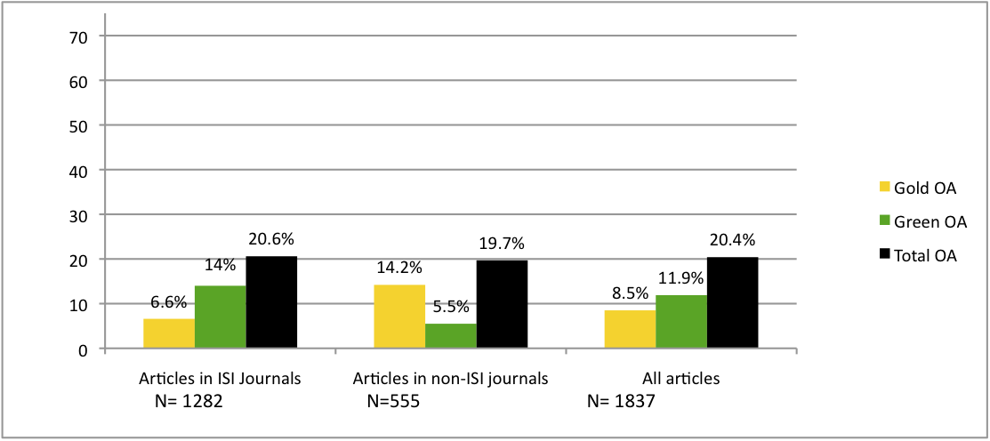
Figure 7. Global Green and Gold OA percentages for the top journals (indexed by Thompson-Reuters-ISI), the unindexed journals, and all journals. The reasons for the green/gold differences in percentage are that (1) about 10% of all journals are gold, (2) a much smaller percentage of the top journals are gold, (3) all journal articles can be self-archived, and (4) over 60% of non-gold journals have already endorsed green OA self-archiving. Cf. Figure 3 and Figure 4.

Björk B-C, Welling P, Laakso M, Majlender P, Hedlund T, et al. (2010) Open Access to the Scientific Journal Literature: Situation 2009. PLoS ONE 5(6): e11273. doi:10.1371/journal.pone.0011273

Publishers (whether commercial or scholarly) can help by endorsing and supporting green OA self-archiving by their authors (as over 60% of them, including virtually all the top journals, have done already), but only authors’ funders and institutions can ensure that the author self-archiving actually gets done, by mandating it.

(Question 5b) “What are the minimum core metadata for scholarly publications that must be made available to the public to allow such capabilities?”

The OAI core metadata – author, date, title, publication, etc. – are the minimum for interoperability. They can be enhanced and made more powerful; the urgent priority, however, is not to enrich the metadata but to provide the OA content itself. OAI is more than enough for most uses of peer-reviewed journal articles – by researchers, harvesters, and the public. What is needed is the articles themselves. And for that, deposit must be mandated. Once the OA content is there, the hard part is done: Futher enriching the metadata and capabilities is the easy part, and will be a welcome challenge, taken up by many skilled and creative developers – once there is a database that makes it worth their while (by making it worth the users’ while to relay on it – as 20% certainly does not).

(Question 5c) “How should Federal agencies make certain that such minimum core metadata associated with peer-reviewed publications resulting from federally funded scientific research are publicly available to ensure that these publications can be easily found and linked to Federal science funding?”

To repeat, OAI-interoperability is more than enough already. What is missing is not metadata, but OA content. And the solution is to mandate deposit. Once the content is there, the motivation to generate ever richer metadata will follow.

QUESTION 6:

(Question 6) “How can Federal agencies that fund science maximize the benefit of public access policies to U.S. taxpayers, and their investment in the peer-reviewed literature, while minimizing burden and costs for stakeholders, including awardee institutions, scientists, publishers, Federal agencies, and libraries?”

The one, simple, cost-free step that federal agencies can and should take to maximize the uptake, usage, applications and impact of peer-reviewed research is to mandate (i.e., require) that the final, peer-reviewed draft of all federally funded research be deposited (“self-archived”) in the fundee’s institutional repository immediately upon acceptance for publication (as over 50 research funders [including NIH] and almost 200 universities and research institutions worldwide [including Harvard and MIT] have already done).

Federally mandated green open access self-archiving of federally funded research maximizes the investment in research for the following nine stakeholders -- (1) researchers (scientists), (2) research institutions (awardee institutions and their libraries), (3) research funders (Federal agencies), (4) the vast R&D industry, (5) students, (6) teachers, (7) the developing world, (8) journalists, and the (9) public whose taxes fund the research and for whose benefit the research is conducted (US taxpayers) – as well as for (10) the uptake, applications, impact and progress of research itself.

It is by maximizing research impact and progress that mandating OA maximizes the return on U.S. taxpayers’ investment in research. See Figure 1 and:

(See: Bibliography of Findings on the Open Access Impact Advantage)

Mandating convergent institutional deposit rather than divergent institution-external, central deposit also minimizes the burden and cost – for researchers, institutions and funders – by minimizing and distributing the archiving effort as well as the cost across institutions.

Publishers. It is a very widespread and deep error to reckon the potential gains or losses from providing or not providing open access in terms of gains or losses to the publishing industry. Peer-reviewed research journal publishing is a service industry. It exists in the service of research, researchers and research progress, which are vastly larger and more important economically than research journal publishing itself, as a business.

It is hence the research publishing industry that must adapt to the powerful new potential that the online era has opened up for research, researchers, research institutions, research funders, the vast R&D industry, teachers, students, and the tax-paying public that funds the research. Not vice versa.

Economically speaking, it would be a great mistake to conceptualize this new situation as research, researchers and the R&D industry having to compromise their newfound potential to maximize the research progress – along the lines that have now been made possible by the online era -- in order to protect and preserve the current revenue streams and M.O. of the publishing industry, which evolved for the technology and economics of the bygone Gutenberg era of print on paper.

Research having to adapt to publishing would amount to the publishing tail wagging the research dog. It must always be kept clearly in mind that the peer-reviewed research publishing industry exists as a service industry for research, not vice versa:

Publicly funded research is entitled to the full scientific and public benefit opened up for it by the online media. The research publishing industry can and will continue to evolve until it adapts naturally to the new demands and needs of the online age of open access to research.

Harnad, S. (2007) The Green Road to Open Access: A Leveraged Transition. In: The Culture of Periodicals from the Perspective of the Electronic Age, pp. 99-105, L'Harmattan.

QUESTION 7:

(Question 7) “Besides scholarly journal articles, should other types of peer- reviewed publications resulting from federally funded research, such as book chapters and conference proceedings, be covered by these public access policies?”

Peer-reviewed journal articles. All researchers want immediate OA for their published articles (whether published in journals or in refereed conference proceedings) in order to maximize their access, uptake, usage, applications, citations and impact -- but not all researchers will want there to be immediate OA for their books, book-chapters or data. Funding agencies should not try to mandate what researchers don’t all want to provide willingly, and certainly not in the first instance. That would diminish the credibility of OA itself as well as making it harder to get author consensus, compliance and good will.

Where possible, if the author and publisher both agree, the deposit of publications – over and above refereed journal articles and refereed conference papers – such as book chapters, books and research data should be encouraged as well, but on no account should it be mandated (required).

The Bare Minimum Essentials

The minimum should be to mandate that:

(i) the fundee’s revised, accepted refereed final draft

(ii) of all refereed journal articles (including refereed conference articles) resulting from the funded research must be

(iii) deposited immediately upon acceptance for publication

(iv) in the fundee’s institutional repository.

(v) Access to the deposit must be made gratis OA (online access free for all) immediately (no OA embargo) wherever possible (over 60 % of journals already endorse immediate gratis OA self-archiving).

Below are further steps that can be encouraged (but not mandated):

(i) Author’s final draft. Where possible, if the publisher endorses immediate unembargoed Gratis OA, the deposit can be the publisher’s version-of-record rather than (or in addition to) the author’s refereed, accepted final draft. (Most of the 60% of journals that endorse immediate, unembargoed OA, endorse it for the author’s final draft only, not for the publisher’s version-of-record. This constraint must be kept in mind: it is a small liability, but a far bigger asset.)

(ii) Peer-reviewed journal articles. Where possible, if the author and publisher both agree, publications in addition to refereed journal articles and refereed conference papers (book chapters, books) as well as research data should be deposited as well.

(iii) Immediate deposit. Where possible, if the publisher agrees (as over 60%, including most of the top journals, already do), the deposit should be made gratis OA immediately upon deposit; the remaining 40% must still be deposited immediately too, but making access to them OA may be embargoed for at most an X-month OA embargo (length of X to be decided, but preferably not more than 6 months).

(During any OA embargo, individual requests from individual researchers for an individual copy of the Closed Access deposit for research purposes, can be automatically relayed by the institutional software to the author for authorization, and an individual copy can be automatically emailed to the requester by the software upon authorization by the author. This helps tide over research needs during the embargo.)

Sale, A., Couture, M., Rodrigues, E., Carr, L. and Harnad, S. (2012) Open Access Mandates and the "Fair Dealing" Button. In: Dynamic Fair Dealing: Creating Canadian Culture Online (Rosemary J. Coombe & Darren Wershler, Eds.)

(iv) Deposit institutionally, harvest centrally. Deposit should always be in the author’s own institutional repository, with the institution helping to monitor and ensure compliance with funders’ deposit mandates. Once embargoes have elapsed, deposits can be automatically harvested by central, discipline-based repositories such as PubMed Central. (This is (a) to facilitate the adoption and implementation of complementary mandates by institutions, mandating deposit of unfunded research articles too, and (b) to ensure that authors only ever have to deposit once.)

Harnad, S. (2008) How to Integrate University and Funder Open Access Mandates. Open Access Archivangelism 369 (2 March 2008)

(v) Gratis OA (free online access). Where possible, if the author and publisher both agree, access to the deposit can be made not just gratis OA (free online access) but libre OA (free online access plus various re-use rights).

(Note that with free online access what aready comes with the territory is clicking, on-screen access, linking, downloading, local storage, local print-off of hard copy, and local data-mining by the user, as well as global harvesting and search by engines like google. Many authors will not want to allow others to make and publish mash-ups of their verbatim texts. Journal article texts are not like music, videos, software or even research data, out of which creative modifications and remixes can be valuable. All scholars and scientists want their findings and ideas to be re-used, applied and built-upon, but not that their words should be remixed in mash-ups.)

Suber, Peter (2008) Gratis and libre Open Access. SPARC Open Access Newsletter, August 2008

QUESTION 8 (8a, 8b):

(Question 8a) “What is the appropriate embargo period after publication before the public is granted free access to the full content of peer-reviewed scholarly publications resulting from federally funded research?”

There is no real reason any would-be user should ever be denied access to publicly funded research journal articles. Over 60% of journals (and virtually all the top journals) already endorse immediate green OA to the author’s final draft.

But if federal funding agencies wish to accommodate the <40% of journals that do not yet endorse immediate green OA, an embargo period (preferably no longer than 6 months) could be allowed.

The crucial thing, however, is that the embargo should not apply to the date at which deposit of the author’s final, peer-reviewed draft in the author’s institutional repository is required. That deposit should be done immediately upon acceptance for publication, for all articles, without exception.

The allowable OA embargo should apply only to whether access to the immediate-deposit is made OA immediately, or access is instead set as “Closed Access” during the allowable embargo period.

Harnad, S. (2006) The Immediate-Deposit/Optional-Access (ID/OA) Mandate: Rationale and ModelOpen Access Archivangelism
SUMMARY: Universities and research funders are both invited to use this document. Note that this recommended "Immediate-Deposit & Optional-Access" (IDOA) policy model (also called the "Dual Deposit/Release Strategy") has been specifically formulated to be immune from any delays or embargoes (based on publisher policy or copyright restrictions): The deposit -- of the author's final, peer-reviewed draft of all journal articles, in the author's own Institutional Repository (IR) -- is required immediately upon acceptance for publication, with no delays or exceptions. But whether access to that deposit is immediately set to Open Access or provisionally set to Closed Access (with only the metadata, but not the full-text, accessible webwide) is left up to the author, with only a strong recommendation to set access as Open Access as soon as possible (immediately wherever possible, and otherwise preferably with a maximal embargo cap at 6 months).
This IDOA policy is greatly preferable to, and far more effective than a policy that allows delayed deposit (embargo) or opt-out as determined by publisher policy or copyright restrictions. The restrictions apply only to the access-setting, not to the deposit, which must be immediate. Closed Access deposit is purely an institution-internal book-keeping matter, with the institution's own assets, and no publisher policy or copyright restriction applies to it.
[In the meanwhile, if there needs to be an embargo period, the IR software has a semi-automated EMAIL EPRINT REQUEST button that allows any would-be user to request (by entering their email address and clicking) and then allows any author to provide (by simply clicking on a URL that appears in the eprint request received by email) a single copy of the deposited draft, by email, on an individual basis (a practice that falls fully under Fair Use). This provides almost-immediate, almost-Open Access to tide over research usage needs during any Closed Access period.]

(Question 8b) “Please describe the empirical basis for the recommended embargo period.”

The many empirical studies that have – in every research field tested – repeatedly demonstrated the research impact advantage (in terms of both downloads and citations) of journal articles that have been made (green) OA, compared to articles in the same journal and year that have not been made OA, have also found that the OA impact advantage is greater (and, of course, comes earlier) the earlier the article is made OA. The advantage of early OA extends also to preprints made OA even before peer review. Delayed access means not only delayed impact but also lost impact, in areas of research where it is important to strike while the iron is hot.

(See especially the findings of the Harvard astrophysicist, Michael Kurtz in: Bibliography of Findings on the Open Access Impact Advantage)

The optimal OA embargo period is zero: peer-reviewed research findings should be accessible to all potential users immediately upon acceptance for publication. Studies have repeatedly shown that both denying and delaying access diminish research uptake and impact. Nor does delayed access just mean delayed impact: Especially in rapid-turnaround research areas (e.g. in areas of physics and biology) delaying access can mean permanent impact loss (see Figure 6):

Gentil-Beccot A, Mele S, Brooks T.C. (2010) Citing and reading behaviours in high-energy physics. Scientometrics 84(2):345–55

EXTRA QUESTIONS (X1, X2, X3):

Question X1. “Analyses that weigh public and private benefits and account for external market factors, such as competition, price changes, library budgets, and other factors, will be particularly useful.”

Please see the careful comparative economic analyses of John Houghton and co-workers (Figure 1):

Houghton, J.W. & Oppenheim, C. (2009) The Economic Implications of Alternative Publishing Models. Prometheus 26(1): 41-54

Houghton, J.W., Rasmussen, B., Sheehan, P.J., Oppenheim, C., Morris, A., Creaser, C., Greenwood, H., Summers, M. and Gourlay, A. (2009). Economic Implications of Alternative Scholarly Publishing Models: Exploring the Costs and Benefits, London and Bristol: The Joint Information Systems Committee (JISC)

Houghton, J.W. and Sheehan, P. (2009) Estimating the potential impacts of open access to research findings, Economic Analysis and Policy, vol. 39, no. 1, pp. 127-142.

Harnad, S. (2010) The Immediate Practical Implication of the Houghton Report: Provide Green Open Access Now. Prometheus 28 (1): 55-59

Question X2. “Are there evidence-based arguments that can be made that the delay period should be different for specific disciplines or types of publications?”

The optimal OA delay period is zero: the research reported in peer-reviewed journal/conference articles should be accessible to all potential users immediately upon acceptance for publication, in all disciplines. There is no real reason any would-be user should ever be denied access to publicly funded research journal articles. Over 60% of journals (and virtually all the top journals) already endorse immediate green OA to the author’s final draft.
But if federal funding agencies wish to accommodate the <40% of journals that do not yet endorse immediate green OA, an embargo period (preferably no longer than 6 months) could be allowed.

The crucial thing, however, is that the embargo should not apply to the date at which deposit of the author’s final, peer-reviewed draft in the author’s institutional repository is required. That deposit should be done immediately upon acceptance for publication, for all articles, without exception.

The allowable OA embargo should apply only to whether access to the immediate-deposit is made OA immediately, or access is instead set as “Closed Access” during the allowable embargo period.

Question X3. “Please identify any other items the Task Force might consider for Federal policies related to public access to peer-reviewed scholarly publications resulting from federally supported research.”

If Federal funding agencies mandate green OA self-archiving of the fundee’s final draft of all peer-reviewed journal articles resulting from federally funded research, deposited in the fundee’s institutional repository immediately upon acceptance for publication (ID/OA mandate), this will not only generate 100% OA for all US federally funded research, but it will inspire funders as well as universities and research institutions worldwide to follow the US’s model, reciprocating with OA mandates of their own, thereby ushering in the era of open access to all research, worldwide, in all fields, funded and unfunded (see mandate growth curve from ROARMAP (Registry of Open Access Mandatory Archiving Policies) and Figure 2, above).

