Competence Web-based System for Suggesting Study Materials Links: Approach & Experimental Design

Abstract: Web-based education is used for enhancing learning and teaching activities by allowing the learner to have more opportunities for exploration. However, most e-learning and web-based educational systems could incur the problem of high development costs and the need to have the study materials well constructed. If the content or any information of knowledge changes, then the system is required to be updated. The aim of this paper is to propose an approach to designing a system, so that a learner can find appropriate study materials on the Web without any interaction from the teacher. The system generates different learning paths from the learner’s competence. This process uses a competence structure, to identify a range and relationship of competence elements/nodes for a particular knowledge domain. By embedding a structure of competence in our system, it allows many learners to learn from the same knowledge domain without requiring the knowledge content to be updated. The system uses the learner’s competences to generate different learning paths and from the chosen learning path, it is produced appropriate keywords to be used by a search engine in order to suggest appropriate study materials from the Web. We have designed an experimental study to test whether a learning mode provided by our system is better than a learning mode by freely browsing. More improvement in learning of participants is expected to be seen in the competence-based learning mode. The paper explores what this means for students and teachers and suggests some further work.

Introduction

The aim of this research is to contribute a competence-based system which helps the learners to obtain appropriate study materials from the Web so that they can achieve their intended learning outcome. At present, there are many web-based educational systems available in a web space; however it could deal with high development cost for updating the knowledge content. While, our competence-based system is designed from a competence structure which is constructed from course intended learning outcomes. The update is only required at a part of this structure itself. There is a methodology of constructing a competence structure and its benefits are described in this paper. We also can extend this representation into XML schema and RDF to be more accessible, machine processable and modifiable for the future uses. In addition, we designed an experimental study to test whether a learning mode provided by our competence-based system is better than a learning mode by freely browsing. The conclusion of this study and suggested future work will be drawn at the end.
The structure of this paper is as follows. First section provides the details of considered competency model and a methodology of constructing a competence structure from a published course learning outcomes. Second section illustrates the process of system. Third section provides our database design representing the competence structure and sample of our implementation. Fourth section describes the experimental study and preliminary results. Finally, the future works and conclusion will be given at the end.

Competency Model and Method of Designing Competence Structure

This section gives the related works as some existing user modelling and competency model. Then the overview detail of considered competency model is presented. The main component of this model is developed from learning outcomes of a course syllabus. The relationships among competence elements within this structure could be represented in different ways such as, graph, tree, maps or networks. Therefore, there will be a provided illustration of the way to designing a competence structure from the published learning outcomes within a course syllabus. There are the benefits of adopting a competence structure within our system design; there details are presented below.

2.1. Existing Models of User and Competency

Most e-learning systems have other methods of modelling users. Some systems are designed, based on adaptive hypermedia – AH (Bra, et al., 2003; Brusilovsky, 1996) and intelligent tutoring systems – ITS (Anderson, Boyle, & Reiser, 1985). AH and ITS systems use the benefits of user models in order to adapt their contents and navigational possibilities to the particular user. There are six popular fields: the user’s knowledge, interests, goals, background, individual traits and context of work (Brusilovsky & Millán, 2007). The current design of user modelling has been shown to have some problems. Kobsa (1993) makes the point that the user modelling components draw mostly on assumptions about the user, which may not necessarily be correct. In addition, good models of users are deficient and there are no standardized approaches to adaptive techniques in the system. Especially for an ITS, it is only as effective when there are an adequate model expert student and tutor knowledge. Building an ITS needs careful preparation in terms of describing the knowledge and possible behaviour of experts, students and tutors.
In our work, the learner’s competences are considered for use in modelling. There are existing competency standards, for example IMS RDCEO (IMS RDCEO, 2002) and HR-XML (HR-XML, 2004). Sampson & Fytros (2008) introduces some drawbacks to these competency standards, such as the titles and descriptors elements in these models not being directly machine-understandable.

2.2. Considered Competency Model

Our competence-based system is designed by mainly considering the competency model which is derived from COMBA model (Sitthisak, Gilbert, & Davis, 2008) as shown in Figure 1.

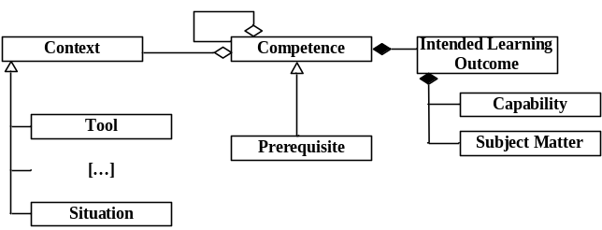
Figure 1: Competency Model Derived from COMBA Model Proposed by Sitthisak, Gilbert, & Davis (2008)

This competency model consists of three major components: subject matter, capability and context. From the figure 1, the most important part is an intended learning outcome (ILO) which comprises of capability and subject matter. An ILO is implied from the aim of the overall learning and teaching of e-learning transaction (Gilbert & Gale, 2008). An intended learning outcome has long been a central component in the design and structure of educational or training systems, particularly in schools and in industrial training (Gagne, Wager, Golas, & Keller, 2004; Reigeluth, 1999). There are other advantages of considering COMBA model. It incorporates the idea of context in characterising a competence. Learners may have differing levels of competence depending upon the context of their performance. In addition, the COMBA model gives consistency in recording the learner’s level of performance, since these levels are usually carefully specified in terms of the learner’s capability and the context. The implementation of such a competency model concentrates on the learner’s capability and not on learners’ knowledge level, which is difficult to properly characterise or estimate in the absence of an associated learner capability or context.

2.3. Designing a Competence Structure

A competence structure is considered to specify the range and relationships of competence elements/nodes for a particular knowledge domain. It is also used to identify the gap between what the learner already knows and what the learner would like to learn. As the major component of the competency model is an intended learning outcome, therefore we are required to get information of the intended learning outcomes from course content in order to design a competence structure. Then we analysis them into a categorization of subject matter content and tag each subject matter content with capability and context in order to get a structure of competence.

2.3.1 Intended Learning Outcome

In order to construct a competence structure, we consider the available published intended learning outcomes in UK education or national public syllabus, for example AQA, Edexcel and OCR. In our research, the considered intended learning outcomes is the photosynthesis domain at a Key stage 4 (GCSE) from AQA – revised version (The Assessment and Qualifications Alliance, 2010). From all intended learning outcomes, we summarize them into a list of subject matter items as in Table 1. It is normally categorised into four fields based on Merrill’s analysis (Merrill, 1994). They are: fact, concept, procedure and principle.

Table 1: Subject Matter Content according to Intended Learning Outcomes

Subject Matter Type | Subject Matter
Fact | Photosynthesis equation, Photosynthesis definition, Substance, Energy, Sun, Bulb, Gas, CO2, H2O, O2, Plant cell, Location, Mesophyll cell, etc
Concept | Chlorophyll, Light, Carbon dioxide, Water, Oxygen, Chloroplast, etc
Procedure | Photosynthesis procedure
Principle | Photosynthesis rate

Task analysis provides the relationships and structures of subject matter. At this stage, each type of subject matter is considered as a diagrammatic approach (Gilbert & Gale, 2008). Each category of subject matter has different notation representing its task analysis (Gilbert & Gale, 2008). For example, fact can normally be represented by two elements which make a fact pair. Consider the fact of ‘Chemical formula of Carbon Dioxide is ‘CO2’, it is represented by a pair of two facts ‘chemical formula’ and ‘CO2’ as shown in Figure 2.

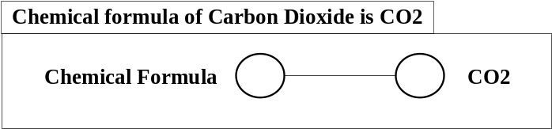
Figure 2: Task Analysis of Fact ‘Chemical formula of Carbon Dioxide is CO2’

2.3.2. Constructing a Competence Structure

Task analysis of all subject matters is then levelled and the relationships are assigned. All subject matters are represented as one node, and structured. The relationship between subject matters is parent-child. An arrow heads to a child node. In order to develop a structure of subject matter to a competence structure, each node of subject matters requires tagging with a corresponding capability and a context. Then we can obtain the structure of competence as in Figure 3. This competence structure is represented as a tree structure and the relationship between nodes of competences is still represented as a parent-child relationship. The illustrated method helps the developers to understand the process of developing the existing learning outcomes into a competence structure.

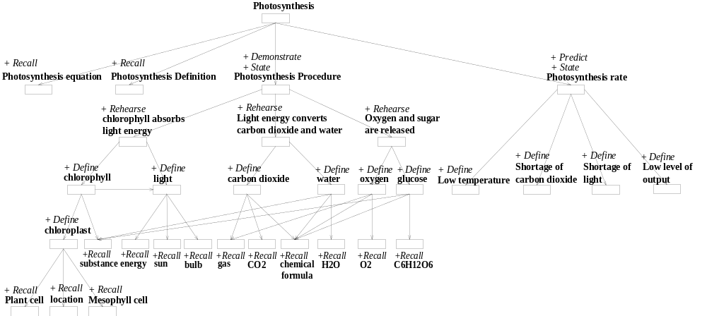
Figure 3: Competence Structure of Photosynthesis Knowledge Domain of Key Stage 4

2.4. Benefits of Competence Structure

A competence structure has a benefit. The design of a competence structure enables it to be conducted by one person. The structure can be embedded within the system and used by many learners for learning the same knowledge domain. To embed a structure of competence in a competence-based system, it allows many learners learning the same knowledge domain without requiring the knowledge content repository to be updated, which could lead to a high development cost. In addition, we can represent the structure into an XML-schema form which is normally understandable by machine and human. It is easier for developers to locate and fix errors. This also allows the developers to reuse the XML file again with the flexibility of the language. Hence the design of an XML file of competence structure becomes easy and the cost is inexpensive.

System Process and Generated Learning Path

This section discusses a system process which suggests appropriate study materials as links from the Web to a learner based on his/her competences. For this competence-based system design, there two types of competences: current/existing competence and desired competence. The existing competence indicates the estimation of the actual competence of the learner. The desired competence competence refers to the learner’s intended learning outcome or the competence which the learner wishes to gain. The system uses these two values and then generates different learning paths from them. By choosing a learning path, this allows a learner obtains the study materials links in order to achieve a desired competence.

3.1. The System Process

Figure 4 shows the overview of the process within a system design. This illustrates the flow of how the system deals with learner’s competences and how it provides appropriate study materials links from the Web to learners so that learners can achieve their intended learning outcomes.

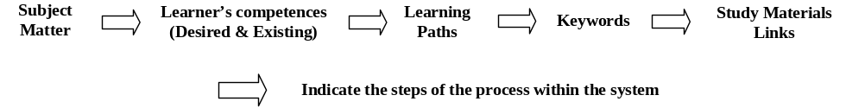
Figure 4: Overview of Process within the System

Firstly, the competence-based system generates lists of targeted subject matter and competences for learners to choose from. The options for subject matter and competences depend on a structure of competence as can be seen in a figure 2. After the chosen subject matter and competences (desired and existing) are obtained, the system then generates a list of learning paths. The system constructs a Google search based on the chosen learning paths, and then suggests the resulting links to learners.

3.2. Possible Generated Learning Paths

We have explored the possibilities for traversing the competence structure and there are three possible cases of learning paths. The paths are defined as the routes from existing competence to desired competence. Each route contains numbers of competence nodes. Competence gap nodes between desired and existing competences vary, depending on different learning paths.
- Learning path 1 (Ignore All Gaps): This learning path involves only two nodes, an existing competence and a desired competence. The search terms for obtaining study material links are considered from only a desired competence point of view, without considering any competence gap nodes.
- Learning path 2 (Consider Some Gaps): This learning path involves not only existing and desired competences, but also some gap nodes. Here, when one node is traversed from another node, the next visited node should be one of the source’s parent nodes on the route, which is shorter than a longer route to the desired competence. The routes contain some gap nodes that can be found when there is more than one parent node of a child node on the route connecting the desired and existing competences. These routes in learning path 2 exclude the one route where all gap nodes are considered. The search terms for obtaining study material links are derived from the desired competence and from some gap nodes.
- Learning path 3 (Consider All Gaps): As in learning path 2, when one node is traversed from another node, the next visited nodes should be only the source’s parent nodes. But all competence gap nodes are considered in learning path 3. Hence the route of learning path 3 can be seen as the longest route compared to the routes of learning path 2.

Database Design Representing a Competence Structure and Implementation

This section describes a general idea of how to design a database based upon a competence structure and offering different approach of database design. In addition, we give the implementation of user interfaces with some screenshots.

4.1. Designing Database based on Competence Structure

The competence structure consists of the combinations of pairs of edges and nodes. In our database construction, it is based on a pair of nodes. In a database, there is one table which stores relationships between nodes of competence structure. One record contains details of one edge between two nodes. Figure 5 shows a screenshot of ‘Compchild’ table in MySQL database.

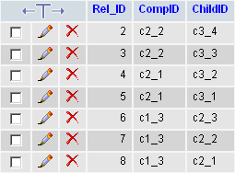
Figure 5: Table of Competences Relationship (Compchild Table)

It can be seen that one record indicates only one edge in a competence structure. Hence if a structure of competence changes (for example, a tree structure) still contains the edges of nodes, this database could be considered.

4.2. Other Approaches of Representing a Competence Structure into Database Design

Currently, we have used a relational database (MySQL) to represent the structure. However using XML to represent a competence structure is relatively better than using a relational database. The reason are for example, extensible, browser accessibility, reusability and modifiable. In addition, we can extend an XML file into RDF form if we would like to create a data model for objects (or resources) and relations among them including providing a simple semantic for the data model which can be represented in XML syntax. For the current work, we have created an XML schema which can be modifiable based on different knowledge domain (Nitchot, Gilbert, & Wills, 2011).

4.3. Implementation and Interfaces

Our prototype is designed to allow a learner to choose his/her desired and existing competence from the list which is obtained from a competence structure. A system finally generates different learning paths from the chosen competences and the search terms will be suggested to learner in order to obtain links from the Web. User interfaces are designed and coded with Html and PHP.

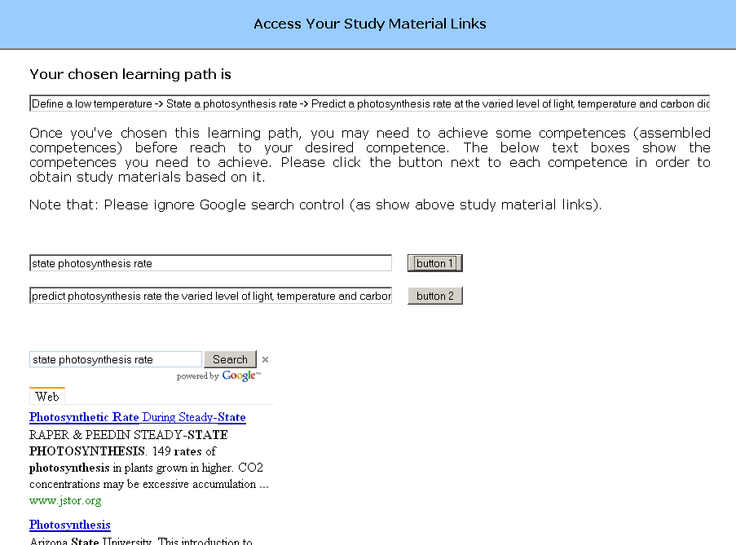
Figure 6: A Page Showing a Chosen Learning Path with Corresponding Keywords

In Figure 6, we show one sample page of a prototype design. This page is offering links from Web to learner based on a chosen learning path.

Experimental Design and Preliminary Results

In this section, we give an illustration of our experimental study. The aim of this experiment is to find out whether a competence-based learning mode is better than a freely-browsing learning mode. In a self-study, this is quite often that a learner searches for study materials from the Web by using a search engine. The learner normally could get sets of subject matters from a teacher. This information is considered as input keywords that a learner gives to a search engine in order to achieve some materials for studying. In our research, we tend to propose a competence-based system for suggesting study materials links from the Web to learners so that they can achieve their learning outcomes. Hence, we expect to see more improvement in learning of participants in the competence-based learning mode than those in the freely-browsing learning mode.

5.1. Aim of Experiment

The research question of this experimental study is “Is a competence-based learning mode better than a freely-browsing learning mode?”. The pictorial representations of both modes of learning are shown in Figure 7 and Figure 8.

Figure 7: Competence-Based Learning Mode

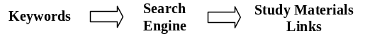
Figure 8: Freely-Browsing Learning Mode

In a competence-based learning mode, learners were given a set of subject matters to study and decided the choices of competences on their own. The competence-based system generated the keywords from the chosen competences and suggested the searched links to learners. In a freely-browsing learning mode, learners were also given a set of subject matter to study but they were required to decide the keywords to be given to the Google search engine on their own.

5.2. Method

The method for investigating the results is that of an experimental study. The experiment receives Ethics Committee approval under reference number ES/10/09/007. The conducted experiment covers the second level ‘learning level’ of Kirk Patrick’s four levels of evaluation (Kirkpatrick, 2007). The participants could be anyone who already learnt or never learnt photosynthesis at key stage 4. The participants could be anyone who had already learnt or had never learnt photosynthesis at key stage 4. In order to test for a significant difference between two learning modes, the learners (experimental subjects) were set to be two groups: one group experienced a competence-based learning mode and another group experienced a freely- browsing learning mode. All participants were required to take a pre-test and post-test which were taken before and after experiencing the respective learning modes. One participant could only interact with one type of learning mode. The estimated number of participants required is obtained using G*Power software (Buchner, Faul, & Erdfelder, 2010).
The provided pre-tests and post-tests were the same tests for all participants; it was a multiple choices test containing 10 questions. The obtained scores from pre-tests and post-tests were compared for both learning modes. The questions are designed from some subject matters within a competence structure. Table 2 shows some corresponding pre-test and post-test questions with subject matters.

Table 2: Examples of Questions in Pre-test and Post-test
Subject Matter Content | Questions in Pre-Test/Post-Test
Photosynthesis rate | Which factor does not affect the rate of photosynthesis?
Photosynthesis procedure | What are the products of photosynthesis?
Chlorophyll | Which cells in leaf contain chlorophyll?
Carbon dioxide, Oxygen, Water, Glucose | Which chemical formulas represent carbon dioxide, oxygen, water and glucose respectively?
Chloroplast | A key molecule NOT found in a chloroplast is …

Currently the experiment has not been conducted; we plan to carry on this experiment in January through March 2012. We will start by recruiting the participants by email which gives the participants information about the experiment. All participants will be postgraduate students of the Faculty of Physical and Applied Science, University of Southampton. In order to control the prior knowledge of participants, there should not be any significant differences between the average pre-test scores of participants in both learning modes. All participants will firstly have a pre-test. When we obtain their pre-test scores and allocate them into different learning modes, they will then interact with their assigned learning mode and have a post-test. We expect to obtain the statistical results and analysis by the end of March 2012.

5.3. Preliminary Results and Discussion

In this section, we propose some preliminary results which will be expected to obtain. We will use two-way repeated measure ANOVA to analyze the obtained test scores in order to find out a better learning mode. Table 3, Table 4, and Table 5 show the preliminary statistical data of descriptive statistics, the tests of within-subjects effects and tests of between-subjects effects respectively.

Table 3: Mean and Standard Deviation of Test Scores
Test_Type | Learning_Mode | Mean | Std. Deviation
Pre_Test | Freely_Browsing | 4.6 | 1.41
Pre_Test | Competence_Based | 4.5 | 1.29
Pre_Test | Total | 4.6 | 1.83
Post_Test | Freely_Browsing | 5.2 | 1.89
Post_Test | Competence_Based | 7.6 | 1.26
Post_Test | Total | 6.4 | 1.69
Total | Freely_Browsing | 4.9 | 1.50
 | Competence_Based  Total | 6.2  5.6 | 1.41  1.76

Table 4: Tests of Within-Subjects Effects
Source | Type III Sum of Squares | df | Mean Square | F | Sig.
Test_Type | 6.250 | 1 | 6.250 | 4.839 | 0.07
Test_Type * Learning_Mode | 1.000 | 1 | 1.000 | 0.774 | 0.03

Table 5: Tests of Between-Subjects Effects
Source | Type III Sum of Squares | df | Mean Square | F | Sig.
Learning_Mode | 16.000 | 1 | 16.000 | 5.120 | 0.064
Error | 18.750 | 6 | 3.125

From the preliminary statistical analysis data (as shown in Table 3, Table 4, and Table 5), we interpret the expected results as there is an interaction effect between test types and learning modes (p < 0.05). When the interaction effect is found, we also expect to see:
- Consider pre-test scores, there will be no significant difference between the pre-test scores of participants in a freely-browsing learning mode and a competence-based learning mode.
- Consider post-test scores, there will be significant difference the post-test scores of participants in a freely-browsing learning mode and a competence-based learning mode.
- Consider test scores of a freely-browsing learning mode, there will be no significant difference between the pre-test scores and the post-test scores of participants.
- Consider test scores of a competence-based learning mode, there will be significant difference between the pre-test scores and the post-test scores of participants.
We consider the expected profile plots in order to see the interactions and main effect as shown in Figure 9. More improvement in learning of participants was expected to be seen in the competence-based learning mode. Pre-test scores of both groups should be equal, in other words, participants of both group should have equal initial knowledge. The expected results would be that the increment of learning improvement of participants in the competence-based learning mode was significantly higher than the increment of learning improvement of participants in the freely-browsing learning mode.
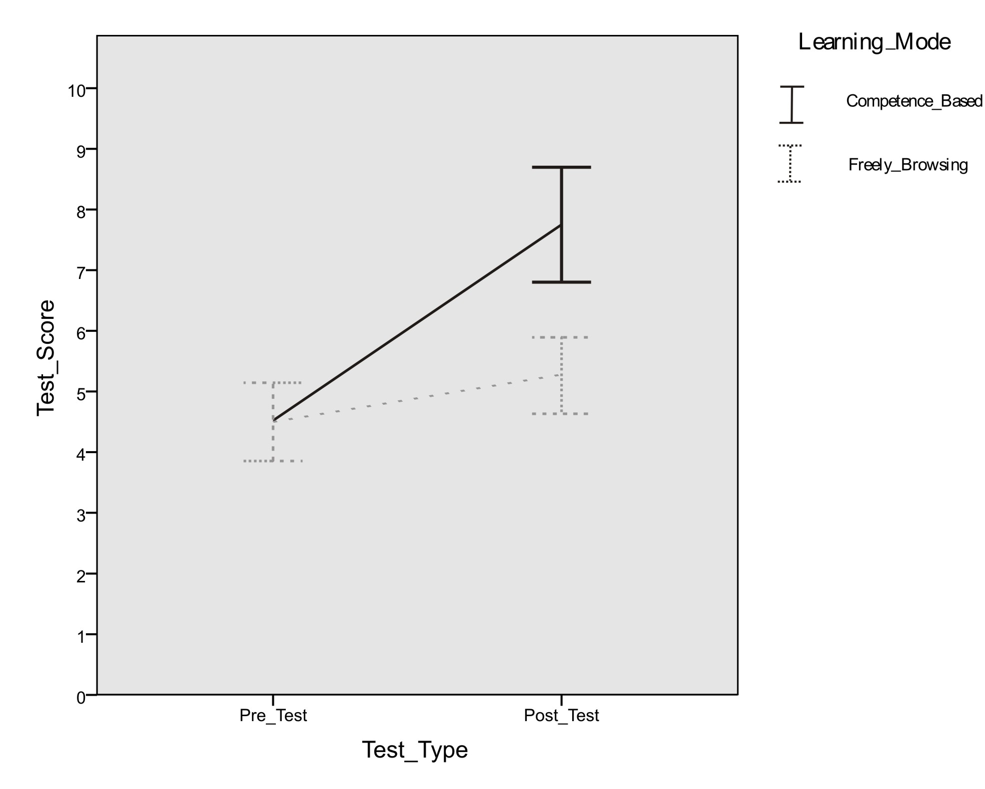

Figure 9: Expected Results of Profile Graph of Means Ratings of Test Scores of Pre-Test and Post-Test
for Two Learning Modes (Error Bars Show +- 1SE)

Future Work and Conclusions

In this paper, we intend to propose an approach of competence-based system for recommending study materials to the learners. With an illustration of method for designing competence structure, it will facilitate other developers modify the existing one so that our competence-based system can be used for any particular knowledge domain. The system has the benefit of easy updating/modifying a structure, identifying learner’s competences and assisting learners in order to achieve their learning outcome. We design an experimental study to explore whether a competence-based learning mode is better than a freely-browsing learning mode. We expect to see more improvement in learning of participants in the competence-based learning mode.
Apart from the conducting experiment in January 2012, we suggest some future work. So far, we have designed two competence structures. One is based upon H.C.F mathematical domain (Nitchot, Gilbert, & Wills, 2010) and another is based on a Key stage 4 photosynthesis domain which is proposed in this paper. These two competence structures contain less than 50 competence nodes. Larger competence structures which contain more than 100 nodes should be explored in the future. Another future work will be the consideration of self-assessment to test whether a learner has indeed achieved the intended learning outcome. This could be to generate an assessment question based on the current visited competence.

References

