Leveraging the Institutional Research Repository: harnessing the drive for quality assessment
Jessie M.N. Hey¹², Leslie A. Carr², Pauline Simpson¹
¹University of Southampton Libraries and ²School of Electronics and Computer Science
University of Southampton, UK
Summary
There is great momentum in the movement to build institutional repositories. The opportunity they give to showcase the outputs of the institution in exciting new ways is now being taken seriously in many countries. In the TARDis project at the University of Southampton in the UK we explored the complex intersection of the institutional repository and the Open Access movement as we developed the framework for a research repository grounded in the needs of the institution. This repository will grow to represent the diverse cultures of a large multidisciplinary university. We now examine the practical issues and preliminary steps taken, in conjunction with the EPrints software, as we add a new “quality” interaction with research assessment.

Introduction

There is great momentum in the movement to build institutional repositories (IRs). The opportunity they give to showcase the outputs of the institution (Lynch 2003) in exciting new ways is now being taken seriously in many countries. But crucially these need to develop in ways that build on existing practices within the institution while, at the same time, taking full advantage of technological advances which make interaction for the depositor and searcher much easier (Mascord et al 2004). In the JISC funded TARDis (Targeting Academic Research for Deposit and Disclosure) project, at the University of Southampton in the UK, we explored the complex intersection of the institutional repository and the Open Access movement (Simpson & Hey 2005) as we developed the framework for a research repository grounded in the needs of the institution. Although funders such as the Economic and Social Research Council have established research information systems in the UK and have, indeed, addressed the issue of linking full text (Jacobs 2004) there is no complete national Current Research Information System or CRIS to relate institutional repository plans to. Central systems such as those in Australia or METIS in the Netherlands (Simons 2004) will inevitably influence repository interactions.

An Institutional Repository based on local context
The results of the feedback from the stakeholders in the institution (at all levels from Vice Chancellor to individual researcher) were embodied in the institutional repository model illustrated as the TARDis route map to Open Access (Hey et al 2005).
Figure 1: The TARDis route map for a sustainable Institutional Research Repository
The outcome was to steer the University of Southampton repository towards being a bibliography tool with full text added wherever possible and available using EPrints software. This contrasts with the usual DSpace based repository which contains only full text items with associated metadata. The view was taken that the external environment was also changing fast. This would work in conjunction with internal advocacy to improve significantly, with time, the percentage of items with either full text deposited in the repository or with links to trusted full text repositories such as arXiv. A major goal was to represent all the research outputs of the whole university. Even within one department we may see differing views of what output should ideally be seen in the context of an institutional repository. While one academic will concentrate on only peer reviewed journal articles, another will want to present a much broader range from conference posters, presentations, theses and papers through project reports, project data, review articles and animations and other digital output natural to the discipline. A keynote speech may be seen as crucial recognition of a person’s standing in the field. One of the most requested downloads was a transfer thesis on hybrid electric vehicles - an indication that Open Access need not be elitist. The most frequent emails received where we do not have the full text yet are associated with Nursing asking for conference papers or even expertise.
The University of Southampton Research Repository, known for short as e-Prints Soton, will grow to represent the diverse cultures of a large multidisciplinary university. We would expect the resulting research to be represented in many ways. The School of Art, for example, has asked for a new category of field type to represent its art exhibitions. One way of respecting differing opinions of ‘quality’ is to utilize a ‘peer reviewed’ field and search facility. However, the mechanics of encouraging appropriate input to achieve a meaningful result for this search are not, at all, straight forward to manage. Increasingly, however, we will also be taking advantage of new and enhanced citation tools such as Google Scholar, Citebase and Scopus and improved statistics (IRS: Interoperable Repository Statistics project).

An Institutional Repository role in Research Assessment
The TARDis route map to Open Access included a pivotal role for the UK Research Assessment Exercise (RAE) since quality assessment is now an integral of academic life. A high scoring department is proud to present its ratings for teaching and for research. The timing of the next Research Assessment Exercise in the UK (2008) is such as to encourage the gradual building up of an institutional repository now. A well managed repository can simplify the task for the researchers and their respective departments, their university administrators and ultimately their assessors (Day 2004, Harnad et al 2003, Simpson & Hey 2005). Ideally one would like to minimise the amount of paper that was produced for such a large single exercise and use a proactive approach to assembling relevant information and material. Many universities are looking to smarter electronic methods to minimize the anguish of the previous exercise in 2001 which was not only very time consuming for individual universities but also created warehouses full of photocopies. As Bill Gates has recently said “We’re on (the) verge of the paperless world. Now we’re finally saying its near.” (Bolger 2005). This scenario increases our responsibility for ensuring electronic processes work simply and efficiently. Our previous traditional university wide publication lists maintained in paper or as simple electronic documents were far less powerful but much easier to maintain. We now examine the practical issues and preliminary steps taken, in conjunction with the EPrints software, as we add a new ‘quality’ interaction to the institutional research repository with the assessment of research.
In November 2004 the University of Southampton management agreed to support the next stage of a library managed repository for a key role in research recording and visibility tasks. This, crucially, enabled a team to be assembled on a service rather than a project basis. Given the maturity of recording mechanisms in some areas of the university (e.g. the high profile Optoelectronics Research Centre with publications, even full text, going back 25 years), it was necessary to tackle legacy data, by negotiation, particularly from 2000 onwards using tailored bulk import where required. New data input would depend on current practice in particular disciplines and the appropriateness of moving immediately or gradually to self deposit.
One of the complications to factor in is the uncertain nature of some of the requirements. Input created now must make certain assumptions about fields and information required. Since it is generally easier to complete a record when it is first added to the database rather than later there is a big challenge in second guessing which fields need be added. There is more incentive for a department to use a central database if additional information need not be kept in departmental databases, just in case. Our repository/RAE team has frequent meetings to keep all members (planning, technical or administrative) abreast of the latest developments. Some substantial progress, however, can be made by incorporating as much as possible in the software. In parallel with our own institutional activities using our EPrints software we are both feeding into and benefiting from a national initiative through the IRRA (Institutional Repositories and Research Assessment) project, associated with the UK’s JISC funded Digital Repositories programme. This project will also keep us informed by virtue of its requirements gathering within the wider community. The basic scenario is portrayed in a White Paper (Carr & MacColl 2005).
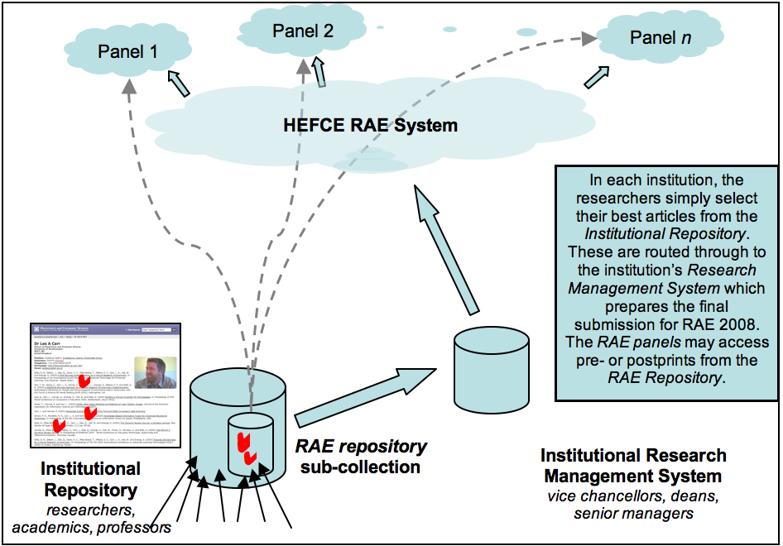
Figure2: Institutional Repositories as the core of assessment – IRRA workflow

Research Assessment is a complex activity involving decisions made by many parties (individual researchers, research managers, institutional administrators, external assessors) and potentially involving many interoperating software systems. The IRRA project is developing practical solutions for integrating DSpace and EPrints repositories and repository workflows into RAE activities (both from institutional and national perspectives), and will advise repository managers on how to deploy these solutions in their local contexts. The software to allow EPrints and DSpace institutional repositories to be used for RAE 2008 was made available in Bronze release form in January 2006. This means that it has been adopted internally on the test institutions and has undergone some months of testing. It is now being made available to the UK academic community for repository managers to gain the experience of fitting it into their Institutional RAE processes. This will be followed by Silver and Gold releases over the coming months.

University of Southampton Research Assessment Developments
Within our own institution we had benefited from the pilot exercise which was successfully carried out by our Electronics and Computer Science School. The current exercise in Southampton is built upon this practical experience of running a trial with a single, but large, school with over 200 academic and research staff. The researchers were given a deadline to enter papers and measures of esteem into the departmental publications archive created using EPrints software. Self deposit or deposit by associated support staff had become the norm within this school. Simple reports were produced which highlighted where minor elements of the metadata required were missing. Authors edited their publications when reminded to ensure they were up to date and correct and then reports could be produced for research heads to review. Authors appreciated the ease of completing the exercise – 4 clicks to select their chosen publications (Hitchcock 2004).
This enabled us to produce exemplars to explain how we might deal with selection of papers by individual academics or their research heads (depending on the culture of the department) for many other departments. The process allows a simple selection or de-selection of significant papers as further papers are published. There is also an ability to ensure a paper is not selected by more than one person. The results can be exported into, for example, a spreadsheet to be examined by the research heads at their leisure.
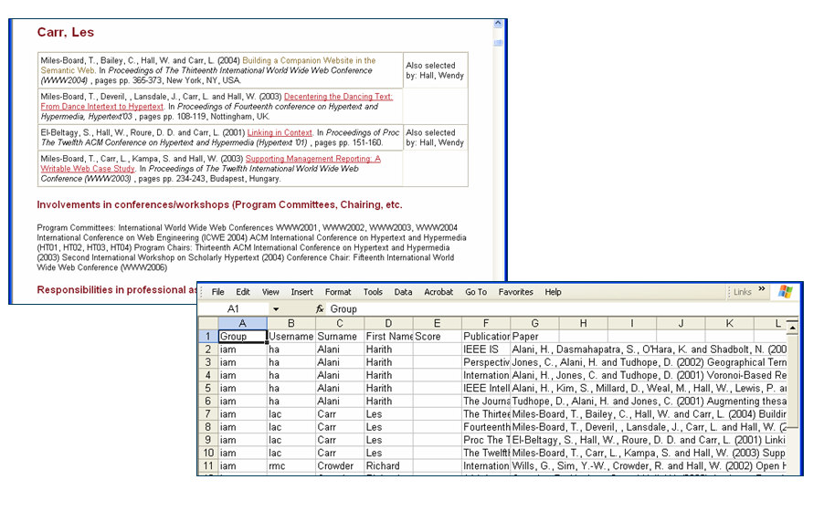
Figure 3: Selection of papers and exporting for review

Another significant area to be incorporated includes ‘measures of esteem’. Fields are added to a person’s record to include, for example, editorships or conference programme activities or prestigious awards. These have often been captured or potentially need to be captured by departments in other systems. The repository was initially simply a database for publications. The sooner this additional functionality is offered as part of the repository system the sooner will departments be able to adapt to the new demands. One area that has been tackled is to tailor or generalise the examples given (eg IEE for an exemplar institution) to help the submitter.
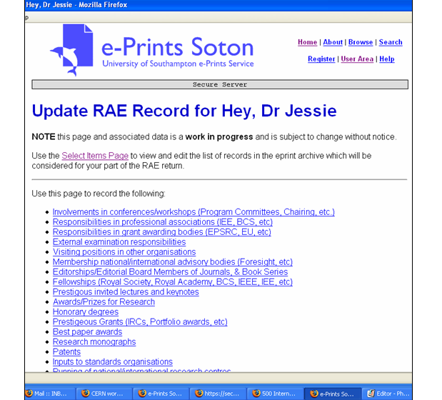
Figure 4: Capturing ‘measures of esteem’

One crucial step has been taken to enable a scalable solution to author interaction with the system. For a small or subject oriented repository it may be possible to rely on author registration. The institutional repository, however, now links into the university user id and password system to minimise the barriers for a wide range of authors. More functionality is being added to ensure a list of publications is correctly associated with the appropriate person although this is a complex issue to tackle within the university system. This functionality becomes an important consideration for such an assessment exercise as opposed to when an end user is simply browsing for new information in a specific subject area.
The exemplars of full text papers deposited for the current exercise can be a spur for faster population of metadata in the repository. However, if the process is a batch process from a department rather than a submission coming directly from the author then the task of obtaining full text from the author is much harder. There is both the problem of ensuring the system can take updates from an author and the difficulty that it is not then a natural part of the authors’ work flow. However, the entry of RAE oriented papers into the repository has, already, in one school encouraged authors to add additional papers which reflect their whole research output. It has encouraged them to use a process which has already become familiar. A periodic reminder to check that references within a particular school are up to date and correct can have a significant effect on the quality of the bibliographic details. This is a gradual step toward the now accepted ethos of the Electronics and Computer Science Department that papers are not visible and counted unless they are within the repository. This generates constant input as seen in the ‘Latest publications’.
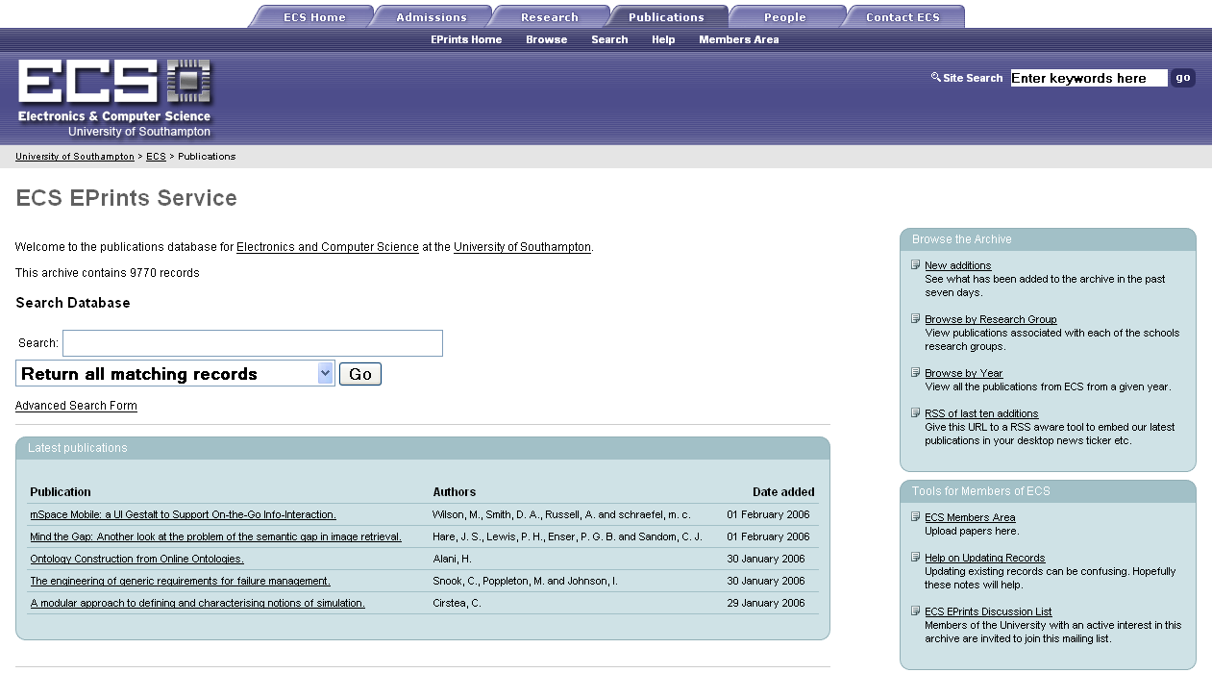
Figure5: A proactive research repository

The addition of some light weight editorial review eg by the administrator or associated librarian can, however, add significantly to ‘quality’ aspects as well as providing valuable additional links such as DOIs.
These are some of the key steps on the TARDis route map to Open Access which specifically focus on the quality aspects emphasised by the upcoming Research Assessment Exercise. As we roll out the RAE modules to other schools (with Education and Art as key testers) we hope to accommodate the specific demands of the selection procedures while at the same time, increasingly, providing a shop front for the whole of the research output of the university. For some disciplines such as Oceanography the regular management of publications within wider research information systems, for quality assessment and new research grants, is an established way of life and the IR is becoming part of the routine. With the incorporation of Humanities disciplines and the experimental addition and/or linking of data elements from other JISC funded projects such as CLADDIER and StORe: Source-to-Output Repositories we hope to encourage a richer picture of the work of our community as a whole.

Conclusion
The successful growth of institutional repositories depends on practical solutions being adopted in local institutions which match the needs of the institution. The institutional research repository can provide the means to record and enable greater access to the full range of research output from journal articles and presentations and reports through to the original data. The repository provides a proactive opportunity (close to the author) to make research visible. In the UK the Research Assessment Exercise provides a motivation for selecting publications and providing other relevant information for research active staff. In the absence of an alternative national database of research information, it provides an incentive to provide ‘quality’ metadata representing ‘quality’ publications to portray the research in a meaningful way. At the same time it may provide another spur to academic authors to facilitate the deposit of the full text of their work so that it can to be made visible at the earliest stage.
By harnessing the drive for quality assessment, we can hope to encourage the establishment of a culture of regular early recording and deposit (as already illustrated by the Electronics and Computer Science EPrints service of the University of Southampton). A repository needs a sustainable process to become of continuing use. The research assessment inspires a cooperative effort over a period of time which, in the longer term, will benefit the institution, which is interested in showcasing all its work, and the Open Access movement, which is concerned with making it more immediately accessible.

References
Bolger, J. (2005): We’re on verge of the paperless world, says Gates. The Times, Oct 29 http://business.timesonline.co.uk/article/0,,8210-1848011,00.html
Carr, L.; MacColl, J. (2005): IRRA (Institutional Repositories and Research Assessment)
RAE Software for Institutional Repositories. IRRA White Paper. http://irra.eprints.org/white/
Day, M. (2004): Institutional Repositories and Research Assessment. Supporting Study no. 4. ePrints UK. http://www.rdn.ac.uk/projects/eprints-uk/docs/studies/rae/rae-study.pdf
Harnad, S.; Carr, L.; Brody, T.; Oppenheim, C. (2003) Mandated online RAE CVs Linked to University eprint Archives: Enhancing UK research impact and assessment. Ariadne Issue 35 30-April-2003 http://www.ariadne.ac.uk/issue35/harnad/intro.htm
Hey, J. M. N.; Simpson, P; Carr, L. A. (2005): The TARDis Route Map to Open Access: developing an Institutional Repository Model. In, Dobreva, Milena and Engelen, Jan (Eds.) ELPUB2005 From Author to Reader: Challenges for the Digital Content Chain: Proceedings of the 9th ICCC International Conference on Electronic Publishing, Katholieke Universiteit Leuven, Leuven-Heverlee, Belgium, 8-10 June 2005. Leuven, Belgium, Peeters Publishing, 179-182.
http://eprints.soton.ac.uk/16262/
Hitchcock, S. (2004): Open Access for authors, researchers and their institutions. Presented at CRIS 2004, Antwerp, Belgium. May 2004. http://wwwoud.eurocris.org/conferences/cris2004/ppt/CRIS2004-Hitchcock.pdf
Jacobs, N. (2004): Don’t Tease the Reader: Techniques for making Social Science CRIS more useful to Research Users. In A. Nase and G. Van Grootel (Eds.),
Proc. 7th International Conference on Current Research Information Systems: Putting the Sparkle in the Knowledge Society (CRIS 2004), Antwerp, Belgium, 13-15 May 2004. Leuven, Leuven University Press, 65-76. http://wwwoud.eurocris.org/conferences/cris2004/pdf/Cris2004-Jacobs.pdf
Lynch, C. A. (2003): Institutional Repositories: Essential Infrastructure for Scholarship in the Digital Age. ARL BiMonthly Report, No. 226, 1-7. http://www.arl.org/newsltr/226/ir.html
Mascord, M.; Jones, C.; Lambert, S. ( 2004): Experience in Creating an Electronic Publications Archive at a National Scientific Laboratory. In A. Nase and G. Van Grootel (Eds.),
Proc. 7th International Conference on Current Research Information Systems: Putting the Sparkle in the Knowledge Society (CRIS 2004), Antwerp, Belgium, 13-15 May 2004. Leuven, Leuven University Press, 103-112. http://epubs.cclrc.ac.uk/work-details?w=30080
Simons, E. (2004): METIS: the Pivotal Role of a CRIS in Scientific Information Supply – a Dutch case. In A. Nase and G. Van Grootel (Eds.),
Proc. 7th International Conference on Current Research Information Systems: Putting the Sparkle in the Knowledge Society (CRIS 2004), Antwerp, Belgium, 13-15 May 2004. Leuven, Leuven University Press, 199. http://wwwoud.eurocris.org/conferences/cris2004/abstracts/simons.html
Simpson, P.; Hey, J. M.N. (2005) Institutional e-Print repositories for research visibility. In, Drake, Miriam (Ed.) Encyclopedia of Library and Information Science 2nd ed. USA, Dekker.
http://eprints.soton.ac.uk/9057/
Simpson, P.; Hey, J. (2005) Forward in time: TARDis and the RAE. JISC Inform, No. 8, p.16. http://eprints.soton.ac.uk/14522/

Contact Information
Dr. Jessie M.N. Hey
Intelligence, Agents, Multimedia Group,
School of Electronics and Computer Science,
University of Southampton
Southampton
SO17 1BJ, UK

e-mail: jmnh@ecs.soton.ac.uk
http://www.ecs.soton.ac.uk/~jmnh/

