Virtual Reconstruction and the Interpretative Process: a case-study from Avebury

Graeme Earl & David Wheatley

Abstract
Although archaeologists have recently been making increasing use of computer visualisation techniques, a body of critique and theory to underpin such approaches has, to date, been slow to develop. Although some of the recent work employing virtual reality techniques has incorporated elements of archaeological interpretation, a considerable proportion of the remainder serves only to provide illustrative views of potential pasts with no significant interpretative value. This paper describes research into the specific use of virtual reality as an active component of an interpretative archaeology, and considers ways in which comptuer visualisation techniques may broaden the interpretative potential for archaeological spatial data. These general points are illustrated through reference to ongoing research into the configuation of the Avebury henge monument in Wiltshire, England.

Introduction
There are good reasons why archaeologists have become interested in virtual reality as an interpretative tool. The conventional graphical representations and abstractions that we rely on to inform and reconstitute interpretative theories are simplified and abstract in the extreme. The maps, plans and distribution maps so characteristic of site reports, GIS and spatial analyses privilege a particular de-humanised form of visualisation (Gregory 1994: 65) that emphasises a highly general (and, in reality, impossible) view over the particular local perspectives of human experience. In a wider context, the theories of the psychologist James J Gibson (1950, 1966, 1979) about the nature of visual and sensual perception argue for a more holistic form of representation. Gibson’s theories are contraversial – particularly his conception of direct perception – but he argued cogently for at two things of direct relevance to this discussion. Firstly, he placed the emphasis on the entire ambient optical array as the source for human perception, rather than on the primacy of static retinal images. Coupled with this, he refused to consider the visual (and other) senses in isolation from what he termed the sensory system, arguing that perception of the world starts from a mobile observer with – in the case of humans – two eyes, mounted on a mobile head. Lastly, Gibson drew attention to the importance of solid (real) surfaces over simplified transparent planes and to the importance of textures as primal components of the way we perceive the world. If we are to present and interpret representations of archaeological places therefore, we need to emphasise the importance of the same things: solidity, mobility and texture and, given this, it is surprising that the applications of VR technologies have emphasised the presentation of archaeological material to the detriment of their interpretative potential.
Although reconstruction in archaeology has been discussed a great deal, it is notable that the arguments around it have mainly been restricted to the degree of extrapolation from surviving remains and the credibility that can be attached to computer models. There is also a broad literature surrounding traditional reconstruction and representation of archaeological remains – for example, the work of artists such as Connolly and Sorrell (1981) is well documented. Reconstruction has been critiqued in wider debates surrounding the exploration of the archaeologically represented past. Authors such as Bender (1998), Tilley (1992; 1998), Tringham (1991; 1998) and Hodder (1991) have all discussed the presentation and experience of archaeology and landscape – frequently emphasising the roles of hypermedia, visualisation and sense stimulation. In social theory, authors have emphasised the importance of the visual in data acquisition, experience and learning (e.g. Tuan 1977).
The presentation of archaeological data, particularly for education and museum displays, has traditionally made extensive use of artists’ impressions and other illustrations. These provide an easily understood alternative to the static presentation of finds, plans and photographs (Moser 1998). More recently, rendered computer-based reconstruction models have supplemented and gradually overtaken these traditional paper-based methods. However, as Miller and Richards (1995) have pointed out, drawn or painted views of a site and computer models can have very different impacts on a viewer. Appreciation of visual material offered in a conventional ‘artistic’ format is supported by a long tradition of artistic appraisal. The concept of the ‘artist’s impression’ carries with it the idea of subjectivity and creative elaboration from fact. By contrast, computer based techniques tend to suggest the operation of objective, mechanistic approaches. Because of this, it has been argued that computer visualisation within archaeology carries with it a spurious authority: an authority that derives from association with the power and certainty of computers, rather than the quality of the original archaeological data or the rigour of the modelling process.
Virtual reality modelling in archaeology has gradually moved through a process of adoption, examination and critique. As elsewhere in computing, this has tended to begin with the largely unconsidered application of a new technique or technology to archaeological remains. It then moves on through a process of analysis and reanalysis, until it reaches a kind of equilibrium (Lock 1995). It is at this point that the problems and benefits inherent in it are understood and research can develop beyond the ethics and problems of adoption. Archaeological virtual reality can be seen as currently occupying a middle stage. As a technique it has had a head start since so much work has already been completed on the topic of static or animated reconstructions. Still, the theoretical ramifications of the technology remain relatively little explored, despite a number of publications and demonstrations of their value. Perhaps this is a consequence of the widespread belief that VR has only a low-order interpretative potential.

Interpretative Modeling
Computer visualisation techniques provide a boundless range of different perspectives to be explored, very much as traditional reconstruction artists try different views and scenarios. However, with some recent exceptions (see e.g. Gillings and Goodrick 1996, Gillings 1999, Goodrick 1999, Gillings in press), the majority of recent projects in archaeological virtual reality (VR) seem to fall far short of this potential. For example, the models presented in Virtual Archaeology (Forte and Siliotti 1997) continually emphasise the development of computing potential and show that archaeology provides a good case-study for demonstrating new technologies, but are of little use to an interpretative archaeology. In the main they serve to legitimise single-interpretation scenarios, convey established perspectives and obscure the difference we all encounter when approaching archaeological data. Models are largely unqualified and presented in an objectifying light, despite years of criticism on these grounds levelled at static reconstructions; (e.g. James 1997; Molyneaux 1997b). Cunliffe notes (in Forte 1997) that to produce a reconstruction the archaeologist must make guesses, and decide what and how information is to be assimilated and extrapolated from. Computer techniques make the archaeologist “do it in a logical and structured and ultimately more fruitful way” (Cunliffe in Forte 1997: 7). This implies that the new techniques in some way escape the problems inherent in all kinds of reconstruction and, as such, is symptomatic of the ‘computer-as-panacea’ approach to modelling represented elsewhere, and also indicated in the general readiness to accept computer reconstructions from a less critical stance than artist’s impressions.
Visual interpretations proceed from the mapping of meaning onto spaces (often transitional spaces), the understanding of which proceeds to a certain extent from situation and interaction in space. However, these spaces (as interpreted) either rely on limited data sets or on reconstructions based on limited data. This is why reconstruction, representation and virtual reality now require problemisation in the context of archaeology and vision. Modelling or conventional reconstruction allow varying degrees of engagement with some kind of material past. However, with every addition of colour or non-contextual artefact, every mapping of realistic texture and light, every application of realistic sound the engagement is moved from one with modelled fact to acontextual, stimulating fiction. In any case, no representation of the past or its elements can be read with certainty. As Rappaport notes “very simple environments may be divided conceptually and these divisions may be indicated either not at all physically - or in very subtle ways” (1980: 298-9 in Pearson and Richards 1994a: 24). Often any interpretation needs to be very carefully defined if concepts of vision and emotion / experience are not to prejudice an analysis.
Why is the emotional response so important? Perhaps it is because once the VR explorer considers him or herself to be a part of an environment they feel they can understand, they are able to manipulate elements of it in a wholly natural, intuitive fashion. Multimedia excavation reports and database systems are already commonplace; (see Kotsakis et al. 1995, Rains 1995, Ryan 1995) but virtual reality provides the ideal interface for these – a notionally transparent one in which we ourselves act as the interface (Kerr 1991: 10). Transparent interfaces allow us to use all our innate perceptive abilities, whilst gaining the benefits of a hyper-reality. In other words, the visualisation of static reconstructions (whether painted and digitised or rendered) helps imagination and interpretation by linking and demonstrating facts, objects and relationships in an intuitively accessible and familiar way.
“The impact of viewing landscape, correctly proportioned, complete with any vegetative and human culture, and analytical results, allows one not only to present in an easily assimilable fashion…, but also provides the key to using the analytic power of the human brain.” (Maggi 1999: 4).
By combining virtual worlds with conventional datasets, the archaeologist allows for data to be both presented in their original forms, and recontextualised. This recontextualisation can include representation of surviving remains, and extrapolation from these to more complete forms -- a process which can and must be explicitly documented. The extrapolated environments may be tied in to archaeological interpretation by allowing elements to be modified, or by highlighting the links between different elements and the excavated remains from which they were derived. As a result interpretative scenarios can be developed and explored, whilst limiting unqualified abstraction from archaeological sources. Such VR and hypermedia approaches
[??check quote??] “could revolutionise the use and value of illustrations, changing passive, often enigmatic images into an active means of understanding archaeology, helping the viewer to gain a deeper comprehension of the nature and extent of evidence and the character of academic argument” (James 1997: 46-47; see also Relph 1976: 15 in Thomas 1991: 30).
However, exploring a reconstructed world is not the same as observing it. Exploration requires embodiment and a sense of interaction within scenarios. These scenarios can provide new ways of seeing conventional data such as topography or excavation sections, but they also allow absorbing processes.
Absorption within models may provide new insights into archaeologically-defined spaces and environments, and allow for the difference emphasised in current theory to be expressed through visual and aural stimuli. The modeller can remove, add and twist conventional spaces as required, and apply theories to the data via visual hypothesis tests or through description and presentation. Finally these environments can be made available - representing archaeological data through stimulating, valid methodologies which clarify the role of subjectivity rather than blinding with science. For the archaeologist, building and moving in a constructed virtual environment which intends to represent a past state, these factors further complicate an existing problematic. The archaeologist must already consider the contextuality of that which is represented, and its contingency upon personalities. But with a virtual past the context within which any experience is generated is totally devoid physically from the present upon which the archaeologist bases his or her experience, and from which the difference of the past and present is explored. Virtual worlds offer great potential for representing difference, but the very significant difference introduced by the machine is one that can never be escaped.
Archaeology is frequently concerned with the visual. Excavation is based on the visual (and tactile) identification of different areas, characterisation of material remains usually begins with a visual analysis, and archaeological theory has been concerned with visual factors both in the definition of constructed spaces and in the role of ‘surroundings’ in the nature of settlement. A major application of Geographic Information Systems, for example, involves assessing the visibility relationships between parts of a landscape (Wheatley 1995, Gillings & Wheatley in press). Spatial theory defines many ways in which spatial consciousness, visibility and appearance all affect human action. The visual also world plays a very important role in social practice: recent emphasis in phenomenological and other literature on the use of all senses (see Tilley in Bender 1998) continues to demonstrate the considerable significance of seeing and being seen. This identifies both the potential utility of vision and experience-based archaeological research, but also suggests caution in its application. In previous work involving reconstruction modelling at Danebury visual arrangements were hypothesised as being significant in the context of earthwork construction (Earl 1996). It was concluded that the structural elements, as modelled, would provide an excellent stage upon which to place ritual keys and to define symbolic, idiational dialogues (Pickles 1985). The modelled eastern entrance earthworks, based on extrapolated excavation evidence, appeared to create discrete and ordered places but how the separate component spaces functioned was open to debate. Looking at models and the underlying archaeological data did not provide an answer but rather biased opinion in certain directions, posing as many questions as were answered. Modelling and consideration of space inevitably lead to argument, and in a number of cases it may be that an emphasis on visual patterns prompts overly enthusiastic extrapolations from the data.
In 1991 Brody suggested that VR was just as geographically and temporally situated as reality. Clearly virtual reality has to be constructed and through this construction meaning is incorporated, and also through the reading of its material presence. This reading will in turn relate to the readers, their contexts and many other factors. Now that VR worlds (at least in a research context) can produce a real sense of presence the significance of this situated reality is increased by an order of magnitude. Thus, in the interpretation of virtual models their subjectivity should be made as explicit as possible. Still, in general the literature has failed to stress that virtual reality and other models define artificial environments, with no concept of ‘reconstructing’ the past (cf. Collins et al 1995). For example, Kalvin notes that “[our] primary motivation for developing a computer-assisted visualisation system for restoring the temple ceiling is that a physical restoration is virtually impossible” (1999 3). This clearly implies some shared sense of reality between the physical and virtual ceilings. In reality, the physical past is being deliberately constructed on the computer so that it can be inhabited and manipulated. Gillings and others have made this an explicit part of their methodologies. Gillings in particular has used consciously-subjective modelling as an alternative to conventional landscape interpretation (Gillings & Goodrick 1996). The same techniques can be applied to constructed spaces, developing themes traditionally tied up with spatial theory and two dimensional spatial statistics, whilst using the subjectivity inherent in computer modelling as a deliberate and explicit part of the interpretative process.
As an extension of this it has been suggested that models should be interactive – editable and navigable by anyone viewing the model (Earl 1996, 1999; Gillings 1999). There is “a need for recursive approaches to modelling, where each alteration to interpretation of excavated material, explicit application of sketches and personal perspectives, choice of ‘correlates’ and use of technology would define new spaces to be engaged with. “ (Earl 1999). Each change should have a range of additional effects and these should be documented.
“The Virtual-models are there to be worked with and on rather than consumed, and can and must be negotiated, modified and engaged in the exploration of connections and context inherent in the twin processes of collage and montage that Shanks sees as central to a developing mode of archaeological practice” (Shanks 1996, 83-4 in Gillings 1999: 3.4).
This will provide an indication of the subjective methods behind the constructing of our worlds to inhabit. The modeller should thus be able to see who changed what and what their motivations were. This defines the reconstruction process and as such has been at the heart of reconstruction and representation critiques. These factors have also lead us to define a system for mapping and organising the modelling process used for reconstructing diverse archaeological sites.
The modelling techniques critiqued during this research have been viewed in the light of a number of governing principles. First, reconstructions should develop in an explicit way from the available data. In this manner the models produced will be rendered reversible and also reactive. In other words, the relative effects of different modelling choices and starting points may be assessed and adjustments made which affect all related elements of the model. Secondly, reconstructions should form part of a clear research goal.
“The key point to highlight is that the investigations into the potential of Virtual-Reality were driven by an explicit problem and constituted from the outset, a clear attempt to bridge developments in theory and practice. In addition, in developing and exploring methodologies a number of criteria were brought to the fore: the approaches developed had to be flexible and affordable, the latter being partly contingent but also inexorably tied up with the fact that they also had to be reproducible by, and communicable to, the wider community of archaeologists and interested parties” (Gillings 1999: 2.1).
Next, reconstruction should incorporate recontextualised artefact assemblages in order to provide a complete reappraisal of the contexts studied; (see Sanders 1999). A modelled environment lacking this detail remains sterile and thus limits any interpretative ‘advance’ – particularly in the sense of experience. Finally, the interpretative implications of three-dimensional visualisation and auralisation of the past should be explored as part of the modelling procedure. There exists a current divide between the practice of computer modelling, and the body of thought regarding space and its representation or reading. It would seem that critical VR modelling provides an ideal opportunity to bring together two largely unconnected approaches to the past. As such, the process must form part of the recursive approach to modelling and not simply exist as a critique or statement of intent.

A new approach to Avebury

The Avebury complex
The remainder of this paper tries to illustrate some of these points through reference to an example of VR technology as applied to archaeology. The example is based on the Avebury henge monument in Wiltshire, southern England and particularly focuses on the southern entrance to the monument.
The monument at Avebury is one of the largest prehistoric henge monuments known. The main sources of data about the original form of the monument are a variety of antiquarian sources, most notably the work of William Stukeley (1743) and from excavations undertaken by Alexander Keiller between 1934 and 1939 (Smith 1965). A full description of the monument (except the Beckhamtpon Avenue) can be found in Smith (1965) with more recent discussions in Pitts & Whittle (1992) and Pollard & Gillings (1998). Although there are a number of components of the henge whose status is unknown (see e.g. Ucko et al 1991), the main known elements of the prehistoric monument are as follows:
- A roughly circular ditch and external bank, around 425m diameter, with four causeways,
- An outer circle of large sarsen stone uprights, probably originally numbering 98 stones, set inside the ditch,
- A southern inner circle, of about 29 stones (radius about 52m) surrounding a stone known as ‘the obelisk’, originally the tallest of the monument and about 6.4m long (according to Stukeley, who saw it fallen). Adjacent to the obelisk, a strange setting of small stones known as the ‘z feature’
- A northern inner circle, surrounding at least a cove (three large stones placed close together to form three sides of a box),
- An avenue of stones leading about 2.5 km from the southern entrance to a smaller stone and timber circle (the Sanctuary) on Overton hill,
- A second avenue of stones leading from the western entrance at least 1.3km to a substantial cove (the Longstones) and ditched enclosure at Beckhampton.
The interpretation of the henge complex is hampered by inadequate knowledge about the sequence of construction and dates of the various components. Many of the questions will only be resolved through new excavations in and around the henge but, in the absence of these investigations, there are alternative methods of generating interpretations from the existing information. One of these is through the construction of computer-based models and visualisations of the henge.

The approach to Avebury
It seems reasonable to assume that one of the functions of the stone settings at Avebury, particularly the two Avenues, was to guide and organise the movements of participants in ceremonial activities. The avenues that lead through the Avebury landscape must have served, as Thomas (1993: 41) puts it, “as a guide to the correct way to act for those submitting themselves to approved rules of order”. Given this, then one means of gaining new insights into the henge is to consider the way that the architectural elements actually could guide and constrain movements. For this purpose, the conventional map representation of the henge is virtually useless, and a form of representation that shows the henge from a particular, situated viewpoint is virtually a pre-requisite.
This was apparently the intention of Thomas (1993) who interprets the henge through a discussion of the approach to the monument along the West Kennet (southern) avenue. This takes the form of a textual description of the experience of walking towards the henge along the Avenue, and is supported by a drawing of the view into the henge from the final part of the Avenue, embellished with prehistoric elements. Thomas’ description of how the last stages of the walk would have appeared to a prehistoric participant is as follows:
“Only when the Avenue starts to rise up … does the bank suddenly become visible. It is at precisely this point, about 400m from the entrance to the henge, that the Avenue abruptly changes its direction, swinging round to the west. This path takes one on a flank about 250m outside of the south entrance to the henge. Moving in this direction takes one across the entrance, and if one turns one’s head towards the monument, very little can be seen of the interior. Much is hidden from here by the protruding eastern bank terminal. About 85m outside of the entrance, the course of the Avenue again swings to the right, back towards the entrance … [turning towards the monument] one now has the first opportunity to look in through the entrance to the henge. However, one’s view is restricted by the particularly close-set banks and especially large stones 1 and 98 of the outer circle. It is particularly notable that these two stones and the uprights of the southern inner stone circle effectively shield the Obelisk from view from the Avenue and entrance.” (Thomas 1993: 42)
Thomas goes on to interpret the architecture of the monument as designed to shield from view activities, such as the digging of pits for deposition of organic material to the north of the Obelisk which, he argues “stood at the centre of a series of nested spaces, separated by barriers which impeded rather than totally closed of access, and which rendered activities at the centre obscure and partial to the gaze rather than totally invisible” (p43). This supports the view that prehistoric monuments are, at least in part, evidence of “power being vested in access to certain forms of knowledge” (p44) during a period of “gradual social hierarchisation”.
It can be seen from this, that the precise architectural arrangement at the henge is not trivial. It is important to the interpretation of its use and, ultimately, has some significance to discussions of social organisation in later prehistory. However, the arrangement of stones in the final stages of the West Kennet Avenue is far from certain. For example, the evidence for the arrangement of stone pairs 1 to 12 is scanty and open to alternative interpretations. All information about these settings derives from Keiller and Piggot’s excavations of 1934-5 and 1939 and it is clear that Keiller was never satisfied that the layout of the southern entrance was resolved in 1934-5. In 1938, he stated his intention to strip the entire area around the southern entrance (Smith 1965: 208) to resolve the matter but was never able to do so. His uncharacteristic failure to erect a plinth marking the location of stone 4a, identified as such in 1939, strongly suggests that Smith is correct when she states that “in the absence of such an excavation there can be no certainty that the plan … is the complete or final one” (1965:208-209).
In fact, the evidence concerning the southern entrance is confined to few certainties. The stone now called 4b is a standing stone, and is therefore unproblematic and the site of the stone now called 1a was located during the 1939 excavations of the causeway. However, there is no evidence at all as to the locations of stones 1b, 2a, 2b or 3b and the evidence for the location of stone 3a is restricted to a pile of stones, including burnt sarsen, in the corner of the field. Evidence for the location of the pair to stone now called 4b is also ambiguous:
[during the 1934-5 season] “After a prolonged search, a pit was eventually discovered which at the time was taken to be the site of the western member of this pair, and was so marked on the plan published in 1936. But the site was not marked on the ground and was removed from the subsequently published plan of Avebury by Keiller (1939). There is little doubt that the pit was in fact of relatively recent origin.
Four years later, when the southern entrance causeway was being examined in 1939, the site of stone 1a was found at the end of the ditch. The long axis of the stone-hole was aligned with that of the causeway. Following upon this, a cutting was made across the road from Stone 4b, revealing a depression which almost certainly represents the site of 4a.” (Smith 1965: 186)
From this it is clear that the standing stone referred to as 4b could feasibly be on either side of the avenue, as there is evidence for a stone hole both to the north and to the south. Even more interestingly, the excavation of the stone pairs 12 through 5 failed to produce a single buried or burned stone (these being the characteristic methods of destruction during the middle ages and 17th/18th century respectively) and none seems to have been visible to Stukeley in the 1720s. As Smith (1965: 209) points out, this leaves the intriguing possibility that these stones had been moved or removed in antiquity, perhaps during a remodelling of the avenue.
It should be clear by now that Thomas’ interpretation is built upon assumptions that cannot be accepted without question. Without recourse to Keiller’s original notes, a cursory examination of the evidence for the architecture of the southern entrance reveals that there are at least three architectural arrangements can be suggested:
- Stones 5a and 5b join to stones 4a and 4b forming a pronounced ‘kink’ just before entrance to the henge. This is Thomas’ assumption.
- From stones 5a and 5b towards the henge, the Avenue enters directly into the henge to the north of stone 4b (which should, therefore, be stone 4a),
- That stone pairs 12-5 were moved in prehistory, perhaps to link stones 13a and 13b with 4a and 4b. This assumes two phases, and is therefore not mutually exclusive of arrangement 1 or 2 above.

A new approach to the approach
The only reliable method of resolving this issue would be to excavate an area of the southern entrance and causeway, just as Keiller intended. For a variety of reasons, however, this is unlikely to be possible in the near future and so any alternative method of investigating the architecture of the entrance is desirable. One possibility is to construct these alternative entrances as computer models, and to see how they might have functioned as architectural structures.
However, the uncertainties of the evidence need to be represented in some way in the model. It would be entirely circular to build a single, monolithic model as this would require resolution of precisely the issues that motivate its construction before it could be built. Instead, a technology is needed that allows a more human perspective (movement, texture, solidity etc.) to be used to represent the evidence but at the same time allows for exploration of the ambiguities and uncertainties of the archaeology.
Fortunately, a variety of computer models of the Avebury henge complex are under construction as part of the Negotiating Avebury Project (Gillings & Pollard 1999). Eventually these will include models of the henge as it is today, models based on antiquarian visualisations of the monument as well as ‘reconstructions’ of the henge as it may have appeared in the later Neolithic/early Bronze Age. One of the platforms selected for the creation of these models had been Virtual Reality Modelling Language (VRML).

Virtual Reality Modelling Language (VRML)
Goodrick (1999) provides a good critique of virtual reality modelling language and its application to archaeology. In brief, however, it has a number of salient characteristics. VRML can be written in any text editor and is not compiled which makes it easy to copy and modify existing VRML sources to create new models. In addition VRML node files can be combined or instanced. VRML files are constituted by four parts – the header which describes the file and provides additional information such as HTML meta tags, prototypes or new node types to supplement those predefined in the VRML specifications, shapes, sensors and scripts, and finally routes (Ames 1997: 15-16). Nodes are used by VRML to describe shapes and their role within a model. The nodes determine the type of shape, and its appearance (including texture, size, orientation, and so on). Nodes can be combined together into groups, be named and then instanced repeatedly in a file, and inserted or inlined as a complete VRML script into a new one.
In addition, specific node types can control how other nodes move, the results of events effecting such nodes, and other aspects of the VRML world that interact with them. Nodes carry out specific functions and the way in which such nodes interact with each other and with shapes is determined by the routes section of the VRML file. Routes are like wires, connecting up nodes in order to achieve a particular effect. Routes can be interrupted and redirected by switches. This allows information to be retrieved about user actions, forwarded either to another part of the VRML file for processing or to an external processor, and returned provoking some reaction in the VRML file. VRML has been designed so that external scripts can be very powerful. Since scripts have access to the browser within which the world is visible scripts can receive information from nodes, process them, and dynamically alter the VR world – instantly updating the view in the browser. It is this potential for adaptation of VR worlds that the modelling application exploits. User actions both within and external to the VR world extract information from them and lead to changes in them – using a combination of script nodes and associated Java applets, and dynamic instancing of VRML primitives (including nested script nodes). The potential power of this approach was demonstrated at CAA 97 by Yorston (1999).

The entrance model
The Avebury Entrance Model is based on one of the Negotiating Avebury models created by Glyn Goodrick but incorporates some significant modifications to allow the full complexity of the entrance to be explored. Firstly, the height of the bank on either side of the monument has been increased to represent the approximate height and position of the bank as originally constructed. The remainder of the topography remains approximately as it is today, so that the remaining bank and the ditch are all substantially reduced in size.
More significantly, the model incorporates two different arrangements of the stone pairs 5 through 12 to examine the effect of possibility 3 (above) on the approach to the henge. The default arrangement of the stones is as excavated by Keiller but by activating a sensitised lighter green patch between stones 13a and 13b, or a similar patch at the base of the remaining stone 4, the model can be toggled between this and an arrangement where the stones lead directly from 13 towards stones 4a and 4b (as currently numbered – but see below).
To represent the positions of the uncertain stones 1a, 3a and 4a the model provides another context-sensitive switch that rotates between several alternative representations. By default, the model shows all three stones as semi-transparent to suggest their uncertainty. Operating the stones themselves cycles the model between four different states:
Default transpacency → 1a → 1a and 4a → All three → Default transpacency
This allows the archaeologist investigating the model to switch interactively between the default representation and a ‘full’ representation of three ‘levels’ of certainty. A similar approach is taken to stones 1b, 2a, 2b and 3b for which there is no direct evidence. By default, these are shown as semi-transpacent blue cylinders to indicate that they are inferred and representative of any physical evidence. By selecting these, a virtual visitor to the entrance can cycle between the default representation, a ‘normal’ representations of the stones or no representation at all.

Approaching the henge
Exploring the various configurations of the model is an interactive process that does not translate well into print. It relies heavily on the element of movement that it is quite impossible to reproduce in print. It is also not a process without a simple result – the model provokes the researcher to review some element of the physical or written record, which in turn suggests alterations to the model. The process of interpretation therefore tends to be iterative. However, for the purposes of this paper we will try to draw attention to some of the directions that the model has suggested are worthy of further research.
Leaving the model in its default configuration, we can approach the henge as Thomas (1993:43) suggests. We reach the brow of the low hill at approximately stone pair 13, and from here the avenue descends towards the henge. From this point, the southern entrance is clearly visible to us between the pairs of stones, as is the top of the obelisk. At any stage, the architecture permits us to leave the avenue and approach the henge directly, but the pathway to the left is clearly indicated by the stones (figure 1 – and compare figure ??). If we choose to follow the avenue, then the path indicated by the architecture is quite clear. The shuttering effect of the stones is minimal, as the gaps are substantial but, nonetheless, the architecture allows us to ‘submit ourselves to the approved rules’ as Thomas (1993: 41) puts it. The interior of the monument, including the z-feature and the base of the Obelisk is also, as Thomas suggests, substantially concealed by the protruding bank.
As we approach stones 7a and b, however, the architectural language that Thomas’ interpretation relies upon becomes less convincing. The stones no longer form a corridor because pair 5 appears to the right of pair 6. The effect is confusing: do we proceed through pair 7 and turn right or do we pass to the right of stone 7 towards pair 6? Moreover, from here the base of the obelisk and the z-feature are clearly visible from here, whatever the configuration of the model’s entrances, and the stones of the entrance encourage us to move directly towards the entrance (figure 2). If we assuming, for a moment, that we are expected to move between both pairs of stones the situation becomes no clearer when we reach pair 5 and turn to the right. All we see through pair 5 is a confused jumble of stones at the entrance, with no clear directions as to how we should proceed. The four pairs of entrance stones as currently interpreted give no help because we are now viewing them almost side-on, so their arrangement into an avenue is not apparent. We might now be inclined to walk towards the standing stone 4 (currently referred to as 4b) but there is little to indicate that we should circle to the south of it before turning into the henge. The position of Keiller’s pit of 1934 (indicated in the model by a pink cylinder) now becomes interesting. If Keiller’s first interpretation was correct, and this was the remains of a stone, then it and the remaining stone 4 (which would then become 4a) form a clear pathway towards the henge. From here, the Cove, the Obelisk and z-feature are all aligned to draw us towards the centre of the monument. The location of the ring stone, too, calls on this alignment – it makes little architectural sense in any other interpretation – and might suggest that it is designed to continue the pathway between the outer and inner circles (figure 3). Removing the entrance stones for which there is no evidence, and accepting only stone 1a as genuine, makes this even more plausible. From pair 5, it is almost as if the architecture is indicating a route to the right of stone 4, to the right of both stone 98 and the ring stone and directly towards the z-feature itself (figure 4).
Equally interesting is the view of the henge that assumes the stones had been moved in prehistory to realign with the supposed entrance configuration. The effect of this can be seen in figure 5 (compare figure 1) and makes, superficially, a far more believable arrangement, leading clearly and unambiguously towards the business parts of the henge itself. Unfortunately, there is little substantial evidence to support or refute this suggestion, and it is possible that the medieval and later activity outside the southern entrance will have made it impossible to resolve even by excavation. If so, then the ability to construct alternatives using VR will become the only real interpretative tool for archaeologists.

Conclusions
Obviously, none of this provides any firm evidence as to the original configuration or intention of the architecture of the Avebury complex. What it does show, however, is the danger of creating an interpretation that relies heavily on the specific reconstruction of architectural elements for which the evidence is complex and equivocal. Thomas’ sophisticated interpretation may be substantially correct, but we must accept that there are at least two equally plausible interpretations of the experience that a prehistoric participant would have had of the approach to the henge. More than this, the current (and currently unquestioned) interpretation of the final stages of the approach simply does not make sense when viewed and experienced at a human scale. At several points in the walk the architecture becomes entirely ambiguous and a number of alternative movements are indicated. One radical possibility that gains credibility when it is experienced, is that from pair 5, the avenue actually continues westwards around the henge, towards the Beckhampton avenue while the southern entrance is connected only by a kind of ‘T junction’, if at all. Only further excavation will ever resolve these issues to any satisfaction.
More relevant to this paper, however, is that it demonstrates the real interpretative potential for VR technologies within archaeology. The various configurations of the entrance model allow an archaeologist to explore a complex and ambiguous set of archaeological material while retaining the human scale of the representation – the process allows both questions and answers to be phrased in a language of movement and visual perception that is far more closely related to the way that we experience the real world. That is not to say that the model has any necessary relationship with the reality of Avebury, and certainly not an unproblematic one. The model is not a surrogate Avebury: instead it is an expression of alternative Avebury realites and an environment for analytical exploration. It could and probably will be extended to represent more of the possibilities and to provide an improved interface for users. For example: the only features of the monument represented in this model are the sarsen stones, bank and ditch. While these make up the bulk of the archaeological evidence it would be foolish to assume that the monument complex did not make use of timbers, screens, textiles and other elements of which only hints survive in the archaeological record. All of these could be modelled if needed, and their structures explored. Accepting its limitations, however, we believe that the model demonstrates how archaeological VR models can be effectively constrained by the physical evidence, while still providing an environment for analysis and interpretation.
Current theoretical debates and practical necessity both point us towards these technologies as an essential part of our toolkit. The flexibility and practicality of reconstruction tools is already considerable, but is likely to increase rapidly in the next few years, making the routine application of enhanced or virtual realities entirely feasible for mos archaeologists. However, archaeology will only reap genuine benefit from these developments if they are situated within a genuinely reflexive, interpretative project rather than used as window-dressing to provide spurious authority for more traditional forms of interpretative archaeology.

Acknowledgements
The Model created and discussed in this paper can be found for downloading or viewing at http://www.arch.soton.ac.uk/Avebury/Research/EntranceModel/. It is a substantial model, and interactive use requires access to a reasonably fast computer equipped with a VRML browser. The Avebury VRML model represents ongoing work by members of the Negotiating Avebury Project, in particular Glyn Goodrick and Mark Gillings.. Thanks are also due to Nick Ryan for previous comments on this work, and to the Department of Archaeology at the University of Southampton for providing and supporting the required computing resources. Graeme Earl’s research continues to be funded by the States of Guernsey Education Council.

Figures
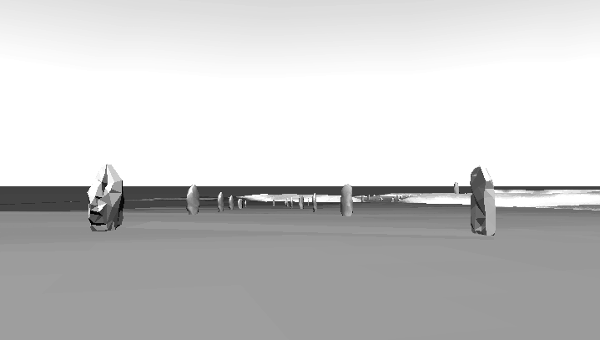
Figure 1. Showing the view from stone pair 13 towards the henge. Closes to us are stones 13b (left) and 13b (right) and between stone 13a and 12a can be seen the entrance to the henge itself, and the top of the obelisk.

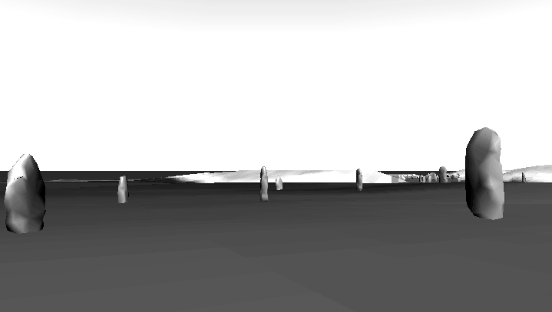
Figure 2. As we approach the end of the avenue, the direction we should follow becomes increasingly unclear. Here, we must decide whether to move towards the entrance, which is clearly visible, to pass through either or both of the stone pairs beyond those closest to us.

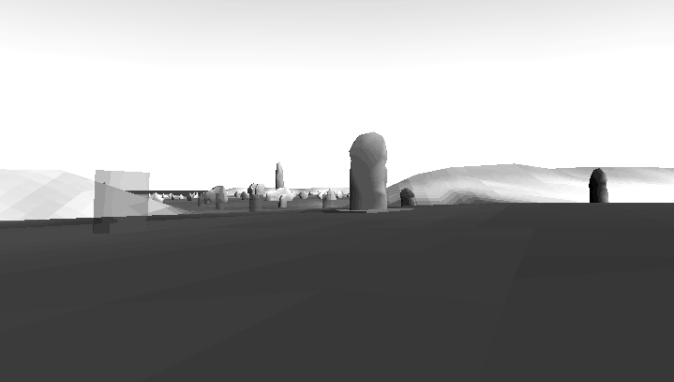
Figure 3. Beyond stones 5a and 5b, the situation is hopelessly confusing. Even if we assume that the four pairs of entrance stones are correctly interpreted, it is quite unclear that we should move sharply right and then left, as the current interpretation would suggest. The semi-transparent cylinder on the right of this image represents the pit that Keiller located in 1934, but later rejected as stone 4b. The stone on the far right of this picture is the ‘conventional’ stone 4a.

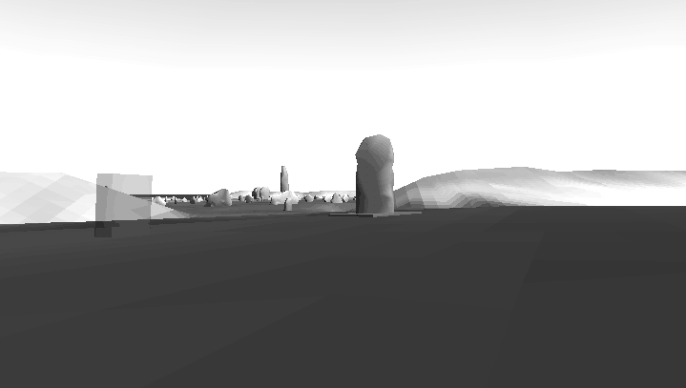
Figure 4. Removing all the questionable stones suggests that the second part of the ‘dogleg’ entrance is very doubtful. without these, our intended route seems very clear indeed – we would walk twards the obelisk and the cove, guided by stone 1a, the substantial stone 98 and (not visible) the ring stone beyond.
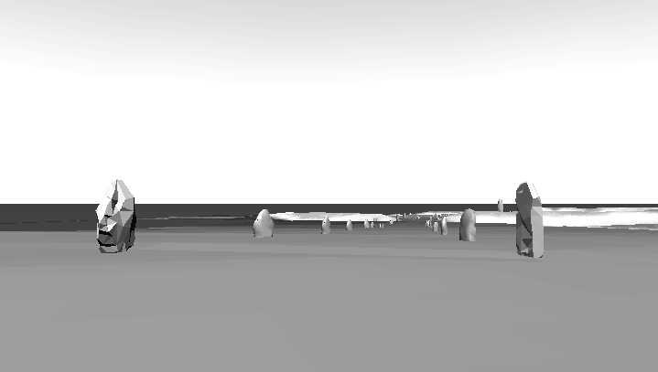
Figure 5. Yet another possibility – the route from stones 13 towards the henge, if we assume that they directly connected with the entrance. This presents quite a different aspect to the architecture than the arrangement obtained by Keiller – compare figure 1.

References
Gibson JJ 1950 The Perception of the Visual World Westport CT: Greenwood Press.
Gibson JJ 1966 The senses considered as perceptual systems. Boston MA: Houghton Mifflin
Gibson JJ 1979 The Ecological Approach to Visual Perception. Hillsdale NJ: Lawrence Erlbaum Associates.
Gillings M and Goodrick GT 1996 Sensuous and reflexive GIS: exploring visualisation and VRML Internet Archaeology 1, (http://intarch.ac.uk/)
Gillings M 1999 Engaging place: exploring the potential of VR in experiential landscape studies IN Digwall, L Exon S, Gaffney V, Lafflin S & van Leusen M (eds) Computer applications and quantitative methods in Archaeology: proceedings of the 25th anniversary conference, University of Birmingham April 1997: 247-254 Oxford: British Archaeological Reports S750
Goodrick G 1999 VRML, Virtual Reality and Visualisation: the best tool for the job? IN Digwall, L Exon S, Gaffney V, Lafflin S & van Leusen M (eds) Computer applications and quantitative methods in Archaeology: proceedings of the 25th anniversary conference, University of Birmingham April 1997: 247-254 Oxford: British Archaeological Reports S750
Gillings M (in press) Immaterial culture. Virtual archaeologies and the hyperreal IN Fisher P & Unwin D (eds) Virtual reality in Geography.
Gillings M & Wheatley DW in press Seeing is not believing: unresolved issues in archaeological visibility analysis In Slapsac, B (ed) On the good use of GIS in Ancient Landscape Studies Brussels: EC.
Gregory, D. 1994. Geographical Imaginations. London: Blackwells.
Keiller A and Piggott S 1936 The West Kennet Avenue, Avebury: Excavations 1934-5 Antiquity X: 417-427.
Keiller A 1939 Avebury: summary of excavtions 1937 and 1938 Antiquity XIII: 223-233.
Pitts M & Whittle A 1992 The development and date of Avebury Proceedings of the Prehistoric Society 58: 203-212.
Pollard J & Gillings M 1998 Romancing the Stones: towards a virtual and elemental Avebury Archaeological Dialogues 5(2): 143-164.
Smith IF 1965 Windmill Hill and Avebury: Excavations by Alexander Keiller 1925-1939 London: Oxford University Press.
Stukeley W 1743 Abury: a temple of the British druids, with some others, described. London.
Thomas JS 1993 The politics of vision and the archaeologies of Landscape IN Bender B Landscape. Politics and Perspective Oxford: Berg.
Ucko P, Hunter M, Clark A & David A 1991 Avebury reconsidered. From the 1660s to the 1990s London: Unwin.
Wheatley DW, 1995 Cumulative Viewshed Analysis: a GIS-based method for investigating intervisibility, and its archaeological application. In G. Lock and Z. Stancic (eds) Archaeology and Geographical Information Systems: a European Perspective: 171-186 London: Taylor & Francis

Hodder (1991: 73-77) gives a good discussion of this.
See Earl 1996 for a fuller discussion of these issues.
Many of Keiller’s notes and much of his correspondence are held by the Alexander Keiller Museum at Avebury and will be examined in the near future.

