Synthesis and Structures of Antimony Trifluoride Complexes with N-Heterocyclic Ligands

Sophie L. Benjamin, Jennifer Burt, William Levason♣*, Gillian Reid and Michael Webster

School of Chemistry, University of Southampton, Southampton SO17 1BJ, UK.

Abstract
The reaction of SbF₃ with 2,2’-bipyridyl in anhydrous methanol produces [SbF₃(bipy)]·[SbF₃(MeOH)], the structure of which comprises co-crystallised neutral centrosymmetric [F₂(bipy)Sb(μ-F)₂Sb(bipy)F₂] dimers, with neutral four-coordinate [SbF₃(MeOH)] units. These are linked by longer fluorine contacts, each antimony achieving a distorted seven-coordinate geometry. [SbF₃(bipy)·H₂O] was obtained from ^{i}PrOH solution, but hydrolysis in solution readily forms [bipyH][Sb₂F₇]. [SbF₃(phen)], also containing seven-coordinate antimony, is produced from SbF₃ and 1,10-phenanthroline in MeOH, but [SbF₃(2,2’6’,2”-terpyridyl)] has a six-coordinate antimony centre (pentagonal pyramidal) with no significant intermolecular contacts to neighbouring molecules. In [SbF₃(pyNO)] polymeric chains involving bridging fluorine and pyridine-N-oxide are present, again resulting in a very distorted seven-coordinate geometry at Sb. The geometries present in these N-heterocycle adducts are compared with those in pnictogen oxide and crown ether complexes. Attempts to isolate complexes of SbF₃ with soft donors (PMe₃, SMe₂ etc) have been unsuccessful, as were attempts to form complexes with SbF₃ functioning as a Lewis base towards metal carbonyls.

Keywords: antimony trifluoride, coordination complexes, nitrogen ligands, X-ray structures.

1. Introduction
Antimony trifluoride is a white crystalline solid, containing a distorted six-coordinate antimony environment with three short (1.90(2)−1.94(2) Å) and three long Sb−F bonds (2.60(2)−2.63(3) Å) [1,2], and is widely used as fluorinating agent for both inorganic and organic chloro-compounds (Swart’s reagent) [3]. It is a moderate Lewis acid, forming a variety of fluoroantimonate(III) anions [2], including [(SbF₃)_{n}F]⁻ (n = 1−4) and [(SbF₃)_{n}F₄]⁴⁻ (n = 2,4), which exhibit a range of Sb−F bond lengths, usually three short primary bonds < 2.4 Å and a number of longer Sb···F secondary bonds significantly shorter than the sum of the Van der Waals radii (3.47 Å) [4]. The antimony coordination sphere is usually distorted, attributed to the presence of a stereochemically active lone pair [2]. Complexes with neutral Lewis bases are relatively few in number [5–14]; only two series of complexes have been explored, a set of crown ether adducts which show half-sandwich structures with pyramidal SbF₃ groups coordinated weakly to all the oxygens of the crown [10–13], and some pnictogen oxide adducts [14]. We recently reported a systematic study of the complexes of SbF₃ with phosphine- or arsine-oxide ligands [14] and found that all contained square pyramidal SbF₃O₂ cores with apical F and with the molecularity driven by the pnictogen oxide − examples of monomers [SbF₃(OER₃)₂] (E = P or As, R = Me or Ph) and [SbF₃{Ph₂P(O)CH₂P(O)Ph₂}], a ligand-bridged dimer [(SbF₃)₂{μ-Me₂P(O)CH₂P(O)Me₂}₂], and a chain polymer [SbF₃{Ph₂P(O)(CH₂)₂P(O)Ph₂}] were all established crystallographically. The reactions of SbF₃ with R₃AsO also formed significant amounts of R₃AsF₂, showing that in some systems fluorination of the ligands competes with coordination. Significantly, none of the pnictogen oxide adducts showed any further contacts within the sum of the Van der Waals radii. We report here the syntheses, spectroscopy and structures of a selected range of new and known (but with limited characterisation) planar N-heterocycle adducts, to probe the stereochemistry at the antimony centre.

2. Results and Discussion
2.1 Synthesis
The complexes of antimony trifluoride with a range of neutral Lewis bases were prepared under anhydrous conditions in methanol. Although most of the solid complexes could be handled in air, the affinity of neutral nitrogen donor ligands for protons readily results in the formation of fluoroantimonate(III) salts of protonated ligands in solutions exposed to moist air [15]. Attempted reactions of a suspension of SbF₃ with solutions of the ligands in CH₂Cl₂ were unsuccessful, and whilst MeCN can be used as a solvent in some cases, it was not generally satisfactory. SbF₃ dissolves easily in dry methanol to give a colourless solution which has a single δ(¹⁹F) NMR resonance at −92 ppm. Removal of the solvent in vacuo led to recovery of SbF₃ with only traces of methanol present (IR evidence) and we were also unable to crystallise an alcohol complex. However, the X-ray structure of crystals obtained reproducibly from the reaction of SbF₃ with 2,2’-bipyridyl in methanol (below) showed co-crystallised [SbF₃(bipy)] and [SbF₃(MeOH)] (I), the latter presumably stabilised by the lattice as discussed further below. The complexes [SbF₃(phen)](II), [SbF₃(bipy)]·[SbF₃(MeOH)] (I), [SbF₃(terpy)](IV) and [SbF₃(pyNO)] (V) were prepared by reaction of SbF₃ with the ligand in anhydrous methanol (Scheme 1), and are white or very pale pink solids, reasonably stable to air in the solid state. The reaction of 2,2’-bipyridyl with SbF₃ in ^{i}PrOH gave a poorly soluble pale pink solid material, but in this case the ¹H NMR spectrum showed no incorporation of the alcohol and the product was identified as [SbF₃(bipy)·H₂O] (III), although attempts to obtain crystals for an X-ray study have been unsuccessful. The complexes have modest solubility in CH₂Cl₂ or MeCN, except for [SbF₃(bipy)]·[SbF₃(MeOH)] (I) which was very poorly soluble in CH₂Cl₂, but dissolved easily in DMSO or MeOH. An attempt to convert [SbF₃(bipy)]·[SbF₃(MeOH)] (I) into [SbF₃(bipy)] by recrystallisation from MeCN afforded a small number of crystals identified by X-ray analysis as [BipyH][Sb₂F₇] (VI). The same complex forms very readily from hydrolysis of [SbF₃(bipy)·H₂O] (III). Although many complexes of SbX₃ (X = Cl, Br or I) with soft donors are known [16,17], attempts to isolate adducts of SbF₃ with PMe₃, AsMe₃ or SMe₂ have been unsuccessful; on prolonged standing mixtures of SbF₃ and PMe₃ in MeCN deposit elemental antimony, indicative of a redox reaction.

2.2 Spectroscopic Data
Due to the distorted geometries and common occurrence of secondary bonding in these complexes of Sb(III), spectroscopic data provide very limited structural evidence for the compounds. The IR spectra show the neutral ligand, and several strong bands in the region 600−400 cm⁻¹ assigned as Sb−F stretches. The ¹H NMR spectra show resonances due to the neutral ligand with small high frequency shifts indicative of coordination, whilst the ¹⁹F NMR spectra of the N-donor complexes show singlets in the range ~ δ −85 to −100. The latter generally show small shifts to lower frequency on cooling the solutions, but even at 200 K only single resonances are present, which do not reflect the inequivalent fluorines present, suggesting fluxionality or that ligand exchange is fast even at low temperature. The ¹⁹F chemical shifts for the N-donor ligand complexes are to low frequency of those of O-donor ligand complexes [14] or fluoroantimonates(III) [18].

2.3 X-Ray crystal structures
Crystal structures are key to understanding in this area of chemistry, and thus we have determined structures for most of the compounds described.
The structure of [SbF₃(phen)] (II) (Fig. 1, Table 1) shows a centrosymmetric dimer composed of a chelating 1,10-phenanthroline molecule (with disparate Sb−N bond lengths) coordinated to a pyramidal SbF₃ unit with primary Sb−F bonds (Sb−F = 1.915(2) −2.037(2) Å). The dimer is assembled via asymmetric fluorine bridges (2.037(2), 2.525(2) Å) to give a layer structure, and there is an extra Sb1···F1' contact between the layers (3.208(2) Å), resulting in the antimony having an overall distorted seven-coordination. The structure may be compared with that in [SbF₃(phen)(thiourea)] [6], which shows a distorted octahedral geometry with a similar SbN₂F₃ core but with a long bond to the thiourea (Sb−S = 3.061(3) Å), and intermolecular hydrogen bonding, N−H···F linking the molecules together.
[Fig 1 Table 1 here]
For [SbF₃(bipy)]·[SbF₃(MeOH)] (I) the crystal structure shows [SbF₃(bipy)] and [SbF₃(MeOH)] molecules linked by weaker intermolecular Sb···F interactions (Figs. 2 and 3, Table 2). The core geometry of [SbF₃(MeOH)] is four-coordinate with three short Sb2−F bonds (1.914(1)–1.954(1) Å) in a pyramidal arrangement (F−Sb2−F < 90º), a coordinated MeOH ligand (Sb2−O = 2.486(2) Å), with three longer Sb2···F contacts (Sb2···F1' = 2.836(2), Sb2···F2 = 3.272(2), and Sb2···F3' = 2.670(2) Å) from neighbouring bipy moieties completing a distorted seven-coordination about the antimony. The H atom of the methanol was located in a late difference-Fourier map, confirming the presence of the neutral alcohol. The [SbF₃(bipy)] also contains a distorted seven-coordinate geometry at antimony, with an SbF₃N₂ core which forms centrosymmetric dimers via Sb1−F3···Sb1' (F3···Sb1' = 3.214(2) Å) and a seventh Sb1···F4 contact (3.141(2) Å). The [SbF₃(bipy)] and [SbF₃(MeOH)] units alternate, forming chains in the a direction through a range of long Sb···F contacts as shown in Fig. 3. Thus atoms F1, F2 and F4 form one extra contact each, F5 and F6 form none, and F3 is unusual in forming two. A second parallel chain links through the two F3···Sb contacts to form a double chain structure apparent in Fig. 3. Attempts to obtain X-ray quality crystals of [SbF₃(bipy)·H₂O] (III) (made from ^{i}PrOH solution) have been unsuccessful.
[Figs 2 and 3 Table 2 here]

The structure of [SbF₃(2,2’6’,2”-terpy)] (IV) has been reported previously [7] and shows a distorted pentagonal pyramidal structure with an apical F, and an N₃F₂ donor set in the basal plane. Crystals obtained in the present study showed the same molecular geometry and are thus not presented. There are no longer intermolecular Sb···F contacts in this structure.
In the structure of [SbF₃(pyNO)] (V) the asymmetric unit contains two crystallographically independent, but very similar neutral molecules (Fig. 4, Table 3), with a four-coordinate core in a saw-horse geometry (alternatively described as a very distorted tbp geometry with vacant equatorial vertex). As in the other crystal structures there is a pyramidal SbF₃ unit and the fourth group is O-bonded pyNO. Each antimony has two longer Sb···F contacts to neighbouring molecules (ranging from 2.774(2)−3.286(2) Å) and the O atoms of the pyNO units also form one extra contact each (Sb···O = 2.707(2), 2.790(2) Å). Overall the Sb atoms are in very distorted seven-coordinate environments. These Sb···O distances are ~0.3 Å longer than those in the “core” (note the difference in Sb−F distances between “core” and “longer contacts” is ~0.7 Å) and an alternative description would be of asymmetric pyNO bridging ligands leading to polymeric chains (Sb1–O···Sb2–O···Sb1–O··· etc). A view down b shows (Fig. 5) double zigzag chains in the a direction with each chain alternating Sb1, Sb2, and with the chains linked via Sb···F long contacts involving F5 (× 2) and F6 (× 1). The structure can be compared with that of [SbF₃(4-MeOC₅H₄NO)₂]·H₂O [9], which is a discrete square pyramidal molecule with an axial fluorine and cis-4-MeOC₅H₄NO ligands in the basal plane. The associated water molecule is weakly hydrogen-bonded to one fluoride, but does not interact with the antimony centre which is five-coordinate. The Sb−F distances (1.905(5), 1.968(6) Å) are in a similar range to those in [SbF₃(pyNO)] (V) (1.925(2)−1.978(2) Å), although the Sb−O(N) is shorter in the discrete molecule (2.305(5) Å) than in [SbF₃(pyNO)] (V) (2.454(2), 2.447(2) Å) where it occupies a bridging role.
[Fig 4 and 5 Table 3 here]
This structure of [BipyH][Sb₂F₇] (VI) consists of monoprotonated bipyridinium cations and [Sb₂F₇]⁻ anions. The anion contains two pyramidal SbF₃ units linked by a single non-linear fluorine bridge (Sb2−F7−Sb1 = 154.4º), with disparate bridge bond lengths (Sb1−F7 = 2.477(2), Sb2−F7 = 2.063(2) Å), and an anti-arrangement of SbF₃ units (Fig. 6). The anions are linked in the a direction through Sb1···F4' and Sb2···F2', and in the b direction by Sb2···F3' and Sb1···F6' long contacts (2.593(2)–3.263(3) Å) resulting in a 2-D sheet in the ab plane, with six-coordination at antimony (Fig. 7). Structures of a number of anions of this stoichiometry have been reported [19–22], which vary from the symmetrical anion in Cs[Sb₂F₇] [19] which has a two-fold rotation axis through the single bridging fluoride (2.240(3) Å), to the distorted K[Sb₂F₇] where the Sb−F_{(bridge)} are 2.409(3), 2.082(3) Å, leading the authors to a description for the “anion” as containing associated [SbF₄]⁻ and SbF₃ units [20]. In the triazolium salt [21] the bridge bonds are also disparate.

[Fig 6 and 7 Table 4 here]
2.4 SbF₃ as a Lewis base?
Fluorophosphines including PF₃, R₂NPF₂, ROPF₂ and to a lesser extent RPF₂ (R = Me, Ph etc) function as Lewis bases to many low valent transition metal centres [23], bonding as modest σ donors and strong π acceptors. Examples of AsF₃ bonding to metals as a Lewis base are very rare with only two examples known − [(η⁵-C₅H₅)Mn(CO)₂(AsF₃)] [24] and [Au(AsF₃)SbF₆] [25], and there are no literature examples with SbF₃, although an unstable [Ni(CO)₃(SbCl₃)] is known [26]. However our attempts to prepare similar complexes of SbF₃ with [W(CO)₆] or [Ni(CO)₄] have been unsuccessful. A solution of [W(CO)₅(thf)] [27] in thf did not react with SbF₃, whilst removal of the thf in vacuo, followed by addition of CH₂Cl₂ to the brown residue, resulted in rapid decomposition to a black solid, with [W(CO)₆] the only carbonyl species present. A suspension of powdered SbF₃ in CH₂Cl₂ showed no evidence for reaction with [Ni(CO)₄] after several hours, the IR spectrum of the solution showing only the 2043 cm⁻¹ t₂ mode of the starting material. On this basis we conclude that the ability to behave as a Lewis base diminishes down Group 15 in the order PF₃ >>AsF₃ > SbF₃.

3. Conclusions
The structures of the N-heterocycle adducts reported above show a strong preference for a distorted high (often seven) coordination geometry at the antimony. This is composed of a core unit of pyramidal SbF₃ differing relatively little from that found in the parent fluoride, with longer “secondary” coordination to the neutral ligands, and contacts to fluorines in neighbouring molecules. The distorted environments are also consistent with a stereochemically active lone-pair on the antimony. In the case of [SbF₃(pyNO)] (V), the pyridine N-oxide asymmetrically bridges two antimony centres contributing to the seven-coordination, which contrasts with the discrete square pyramidal geometry found in [SbF₃(4-MeOC₅H₄NO)₂] [9]. The preference of these systems to achieve a high coordination number at antimony is similar to that found in fluoroantimonates(III) [2] and contrasts with the discrete five-coordination (square pyramidal) observed in pnictogen oxides adducts, which have no long intermolecular contacts within the sum of the appropriate Van der Waals radii [4]. In the latter, the steric bulk of the neutral ligands largely prevents the close approach of neighbouring molecules needed to produce higher coordination numbers, whereas the essentially planar N-heterocycles provide limited screening of the antimony centres. Simple crown ethers including 12-crown-4, 15-crown-5 and 18-crown-6 form SbF₃ adducts which have a pyramidal SbF₃ unit in a half-sandwich structure. These constitute the third major structural type.

4. Experimental
SbF₃ was obtained from Aldrich and dried by heating in vacuo before use. Solvents were dried by distillation from CaH₂ (CH₂Cl₂, MeCN), Na-benzophenone-ketyl (Et₂O) or Mg turnings and iodine (MeOH, ^{i}PrOH). The ligands 2,2’-bipyridyl, 1,10-phenanthroline, pyNO and 2,2’,6’,2”-terpyridyl (Aldrich or Strem) were dried by heating in vacuo and stored in a glove box. Infrared spectra were recorded as Nujol (dried over molten Na) mulls between CsI plates using a Perkin-Elmer Spectrum 100 over the range 4000−200 cm⁻¹. ¹H NMR spectra were recorded from CDCl₃ or CD₂Cl₂ solutions using a Bruker AV300 spectrometer and are referenced to the residual protio-solvent signal. ¹⁹F{¹H} NMR spectra were recorded using a Bruker DPX400 spectrometer and are referenced to external CFCl₃. Microanalyses on new complexes were undertaken by Medac Ltd. All preparations were carried out under a dry dinitrogen atmosphere using Schlenk and glove-box techniques.

4.1 [SbF₃(bipy)]·[SbF₃(MeOH)] (I)
SbF₃ (0.16 g, 0.90 mmol) was dissolved in MeOH (10 mL) and a solution of 2,2’-bipyridyl (0.14 g, 0.90 mmol) in MeOH (5 mL) added. The clear, very pale pink solution was stirred overnight, and then concentrated in vacuo to ~ 2 mL when a pale pink powder separated. This was filtered off, rinsed with n-hexane (2 mL) and dried in vacuo. Yield 0.14 g, 38%. Anal: Calc. for C₁₁H₁₂F₆N₂OSb₂: C, 24.2; H, 2.2; N, 5.1. Found: C, 26.5; H, 2.1; N 5.6%. (several batches of this complex, including the crystals used for the X-ray study, gave poor C analyses, the reason(s) are unclear since they appear spectroscopically pure). ¹H NMR (CD₂Cl₂, 298 K): 1.25 (s, [H]), 3.44 (s, [3H]), 7.41 (dd, [2H]), 7.91 (dd, [2H]), 8.38 (d, [2H]), 8.74 (d, [2H]). ¹⁹F{¹H} NMR (CD₂Cl₂, 298 K): −99.7 (br); (190 K): −96.5, −106.0 (s). IR (Nujol/cm⁻¹): 3400(br) OH, 600(vs), 546(sh), 526(vs) 507(vs) (SbF). Pale pink crystals were obtained by refrigerating the filtrate overnight.

4.2 [SbF₃(phen)] (II)
Prepared as in 4.1 giving a very pale pink powder in 48% yield. Anal: Calc. for C₁₂H₈F₃N₂Sb: C, 40.2; H, 2.3; N, 7.8. Found: C, 39.1; H, 2.6; N, 8.1%. ¹H NMR (CDCl₃, 298 K): 7.84 (dd, [2H]), 7.94 (s, [2H]), 8.45 (d, [2H]), 9.37 (dd, [2H]). ¹⁹F{¹H} NMR (CDCl₃, 298 K): −92.0 (s); (190 K): −95.8 (s). IR (Nujol/cm⁻¹): 585(s), 540(m), 515(s), 410(m) (SbF). Small block crystals were obtained by cooling an MeCN solution of the complex in the refrigerator.

4.3 [SbF₃(bipy)·H₂O](III)
SbF₃ (0.16 g, 0.90 mmol) was dissolved in ^{i}PrOH (20 mL) and a solution of 2,2’-bipyridyl (0.14 g, 0.90 mmol) in ^{i}PrOH (10 mL) added. The clear, very pale pink solution was stirred for 1 h and then concentrated in vacuo to ~ 10 mL when a pale pink powder separated. This was filtered off, rinsed with n-hexane (2 mL) and dried in vacuo. Yield 0.22 g, 73%. Anal: Calc. for C₁₀H₁₀F₃N₂OSb: C, 34.0; H, 2.9; N, 7.9. Found: C, 33.8; H, 2.5; N, 7.9%. ¹H NMR (CD₂Cl₂, 298 K): 1.70 (s, H₂O), 7.42 (dd, [2H]), 7.91 (dd. [2H]), 8.38 (d, [2H]), 8.76 (d, [2H]). ¹⁹F{¹H} NMR (CD₂Cl₂, 298 K): −99.0 (s); (190 K): −99.7 (s). IR (Nujol/cm⁻¹): ~3400(br), 1620 (H₂O), 601(vs), 523(vs), 508(vs), 484(s) (SbF).

4.4 [SbF₃(terpy)](IV)
Prepared as in 4.1 in 23% yield as a white powder. Anal: Calc. for C₁₅H₁₁F₃N₃Sb: C, 43.7; H, 2.7; N, 10.2. Found: C, 43.7; H, 2.4; N, 9.9%. ¹H NMR (CDCl₃, 298 K): 7.40 (m, [2H]), 7.87 (m, [2H]), 7.99 (t, [H]), 8.25 (br, [4H]), 9.16 (m, [2H]). ¹⁹F{¹H} NMR (CD₂Cl₂, 298 K): −89.6 (s). IR (Nujol/cm⁻¹): 574(s), 491(s), 465(m) (SbF).

4.5 [BipyH][Sb₂F₇](VI)
[SbF₃(bipy)]·[SbF₃(MeOH)] (0.1 g) prepared as above was dissolved in MeCN (10 mL) and stirred for 2 h, after which some suspended solid was removed by filtration. Refrigeration of the filtrate produced a few colourless crystals. ¹H NMR (CD₂Cl₂, 298 K): 7.52 (m, [2H]), 8.00 (t, [2H]), 8.38 (m, [2H]), 8.53 (br, [2H]). ¹⁹F{¹H} NMR (CD₂Cl₂, 298 K): −81.6 (s). IR (Nujol/cm⁻¹): 596(s), 509(s) (SbF).

4.6 [SbF₃(pyNO)] (V)
SbF₃ (0.325 g, 1.82 mmol) was dissolved in methanol (10 mL) and pyNO (0.175 g, 1.83 mmol) in methanol (5 mL) was added dropwise, and the solution stirred overnight. Concentration of the solution, followed by refrigeration, produced a white solid which was filtered off and dried in vacuo. Yield 0.35 g, 70%. Anal: Calc. for C₅H₅F₃NOSb: C, 21.9; H, 1.8; N, 5.1. Found: C, 22.4; H, 2.7; N, 5.2%. ¹H NMR (CD₂Cl₂, 298 K): 7.43 (t, ³J = 6 Hz, [2H]), 7.52 (t, ³J = 6 Hz, [H]), 8.34 (d, ³J = 6 Hz, [2H]). ¹⁹F{¹H} NMR (CD₂Cl₂, 298 K): −86.0 (s); (200 K): −87.7 (s). IR (Nujol/cm⁻¹): 1205(s) (NO), 584(s), 531(s), 518(s), 468(s) (SbF). Colourless crystals were obtained by refrigerating the filtrate from the preparation. The reaction of SbF₃ with pyNO in a 1: 2 or 1: 3 molar ratio in methanol also gave crystals identified by their unit cells as [SbF₃(pyNO)].

4.7 X-Ray Experimental
Details of the crystallographic data collection and refinement are given in Table 5. Data collection used a Nonius Kappa CCD diffractometer fitted with monochromated Mo Kα X-radiation (λ = 0.71073 Å), and with the crystals held at 120 K in a dinitrogen gas stream. Structure solution and refinement were straightforward [28], and H atoms bonded to C were introduced into the model in calculated positions using the default C–H distances. The H atom bonded to N was clearly identified in later electron-density maps for [BipyH][Sb₂F₇] (VI).

CCDC 828148–828151 contain supplementary crystallographic data for this paper. These data can be obtained free of charge from the Cambridge Crystallographic Data Centre via www.ccdc.cam.ac.uk/data_request/cif.

Acknowledgements
We thank EPSRC for support.

References
[1] A. J. Edwards, J. Chem. Soc. (A) (1970) 2751−2153.
[2] J. F. Sawyer, R. J. Gillespie, Progr. Inorg. Chem. 34 (1986) 65−113.
[3] A. K. Barbour, L. J. Belf, M. W. Buxton, Adv. Fluor. Chem. 3 (1963) 181−270.
[4] http://www.ccdc.cam.ac.uk/products/csd/radii/
[5] G. Alonzo, M. Consiglio, F. Maggio, N. Bertazzi, Inorg. Chim. Acta 147 (1988) 217−220.
[6] G. Bombieri, G. Bruno, F. Nicolo, G. Alonzo, N. Bertazzi, J. Chem. Soc., Dalton Trans. (1987) 2451−2454.
[7] L. Battaglia, A. B. Corradi, G. Pelosi, A. Cantoni, G. Alonzo, N. Bertazzi, J. Chem. Soc., Dalton Trans. (1991) 3153−3155.
[8] N. Bertazzi, G. Alonzo, T. C. Gibb, Inorg. Chim. Acta 73 (1983) 121−124.
[9] J. C. Dewan, A. J. Edwards, J. C. Guerchais, F. Petillon, J. Chem. Soc, Dalton Trans. (1975) 2295−2297.
[10] M. Schaefer, J. Pebler, B. Borgsen, F. Weller, K. Dehnicke, Z. Naturforsch. B 45 (1990) 1243−1250.
[11] I. Becker, M. Windhaus, R. Mattes, Z. Naturforsch. B 49 (1994) 870−876.
[12] J. Lipkowski, M. S. Fonari, V. C. Kravtsov, Y. A. Simonov, E. V. Ganin, V. O. Gelmboldt, J. Chem. Crystallogr. 26 (1996) 823−833.
[13] M. S. Fonari, E. V. Ganin, V. O. Gelmboldt, J. Lipkowski, S. A. Kotlyar, G. L. Kamalov, Acta Crystallogr. Sect. E 62 (2006) m1021−m1023.
[14] W. Levason, M. E. Light, S. Maheshwari, G. Reid, W. Zhang, Dalton Trans. 40 (2011) 5291−5297.
[15] I. K. Becker, R. Mattes, Z. Anorg. Allgem. Chem. 622 (1996) 105−111.
[16] W. Levason, S. Maheshwari, R. Ratnani, G. Reid, M. Webster, W. Zhang, Inorg. Chem. 49 (2010) 9036−9048.
[17] A. R. J. Genge, N. J. Hill, W. Levason, G. Reid, J. Chem. Soc., Dalton Trans. (2001) 1007−1012.
[18] E. V. Kovaleva, L. A. Zemnukhova, V. V. Kon’shin, Russ. J. Coord. Chem. 28 (2002) 758−760.
[19] R. R. Ryan, S. H. Mastin, A. C. Larson, Inorg. Chem. 10 (1971) 2793−2795.
[20] R. R. Ryan, S. H. Mastin, Inorg. Chem. 10 (1971) 1757−1760.
[21] A. A. Udovenko, Y. E. Gorbunova, L. A. Zemnukhova, U. N. Mikhailov, R. L. Davidovitch, Russ. J. Coord. Chem. 24 (1998) 611−613.
[22] A. A. Udovenko, Y. E. Gorbunova, R. L. Davidovitch, U. N. Mikhailov, L. A. Zemnukhova, Russ. J. Coord. Chem. 26 (2000) 621−624.
[23] J. F. Nixon, Adv. Inorg. Chem. Radiochem. 13 (1970) 363−469.
[24] J. Mueller, K. Fenderl, Angew. Chem. Int. Ed. Engl. 10 (1971) 418−419.
[25] R. Kuster, K. Seppelt, Z. Anorg. Allgem. Chem. 626, (2000) 236−240.
[26] H. G. M. Edwards, J. Chem. Soc., Dalton Trans. (1987) 681−682.
[27] W. Strohmeier, Angew. Chem. 76 (1964) 873.
[28] G. M. Sheldrick, Acta Crystallogr. Sect. A 64 (2008) 112−122.

Table 1 Selected Bond Length (Å) and Angle (°) Data for [SbF₃(phen)]
Sb1−F1 | 1.961(2) | Sb1−F2 | 1.915(2)
Sb1−F3 | 2.037(2) | Sb1−F3a | 2.525(2)
Sb1−N1 | 2.579(3) | Sb1−N2 | 2.767(3)
F2−Sb1−F1 | 88.31(10) | F3−Sb1−F3a | 67.22(9)
F2−Sb1−F3 | 85.94(9) | F1−Sb1−F3 | 81.29(9)
N1−Sb1−N2 | 61.83(9) | F1−Sb1−N1 | 76.21(9)
F2–Sb1–N1 | 82.25(9) | Sb1−F3−Sb1a | 112.78(9)

Symmetry operation: a = 1 –x, 1 – y, 2 – z.

Table 2 Selected Bond Length (Å) and Angle (°) Data for [SbF₃(bipy)]·[SbF₃(MeOH)]
Sb1−F1 | 2.0431(14) | Sb1−F3 | 2.0149(13)
Sb1−F2 | 2.0566(13) | Sb1–F3a | 3.214(2)
Sb1−N1 | 2.281(2) | Sb1−N2 | 2.353(2)
Sb2−F4 | 1.9542(14) | Sb2−F5 | 1.9378(14)
Sb2−F6 | 1.9143(14) | Sb2−O1 | 2.486(2)
F3−Sb1−F1 | 84.55(6) | F3−Sb1−F2 | 81.41(5)
F3−Sb1− N1 | 82.71(6) | F1−Sb1−N1 | 75.48(6)
F2−Sb1−N1 | 75.32(6) | F1−Sb1−N2 | 89.62(6)
F2−Sb1−N2 | 89.88(6) | N1−Sb1−N2 | 69.24(7)
F6−Sb2−F5 | 89.31(6) | F6−Sb2−F4 | 86.66(6)
F5−Sb2−F4 | 85.28(6) | F6−Sb2−O1 | 78.22(7)
F4−Sb2−O1 | 157.80(6) | F5−Sb2−O1 | 78.45(6)

Symmetry operation: a = 1 –x, – y, 1 – z.

Table 3 Selected Bond Length (Å) and Angle (°) Data for [SbF₃(pyNO)]
Sb1−F1 | 1.925(2) | Sb1−F2 | 1.959(2)
Sb1−F3 | 1.926(2) | Sb1−O1 | 2.454(2)
Sb2−F4 | 1.925(2) | Sb2−F5 | 1.978(2)
Sb2−F6 | 1.947(2) | Sb2−O2 | 2.447(2)
O1−N1 | 1.349(3) | O2−N2 | 1.350(3)
F3−Sb1−F1 | 89.95(8) | F3−Sb1−F2 | 87.27(8)
F1−Sb1−F2 | 88.06(8) | F3−Sb1−O1 | 79.11(7)
F1−Sb1−O1 | 81.13(7) | F2−Sb1−O1 | 162.55(8)
F4−Sb2−F5 | 85.60(7) | F6−Sb2−F5 | 85.27(7)
F4−Sb2−O2 | 79.47(7) | F6−Sb2−O2 | 78.77(7)
F4−Sb2−F6 | 89.00(7) | F5−Sb2−O2 | 158.23(7)

Table 4 Selected Bond Length (Å) and Angle (°) Data for [BipyH][Sb₂F₇]
Sb1−F1 | 1.923(2) | Sb1−F2 | 1.953(2)
Sb1−F3 | 1.931(2) | Sb1−F7 | 2.477(2)
Sb2−F4 | 2.079(2) | Sb2−F5 | 1.906(2)
Sb2−F6 | 1.924(2) | Sb2−F7 | 2.063(2)
F1−Sb1−F2 | 84.85(10) | F1−Sb1−F3 | 87.58(10)
F2−Sb1−F3 | 88.69(11) | F1−Sb1−F7 | 79.47(9)
F3−Sb1−F7 | 80.89(10) | F2−Sb1−F7 | 161.48(9)
F5−Sb2−F6 | 90.66(11) | F5−Sb2−F7 | 82.53(10)
F6−Sb2−F7 | 83.33(11) | F5−Sb2−F4 | 80.90(10)
F6−Sb2−F4 | 84.22(11) | F7−Sb2−F4 | 159.11(10)
Sb2−F7−Sb1 | 154.42(14)

Table 5 X-Ray Crystallographic Data
Compound | [SbF₃(bipy)]·[SbF₃(MeOH)] | [{SbF₃(phen)}₂] | [BipyH][Sb₂F₇] | [SbF₃(pyNO)]
Formula | C₁₁H₁₂F₆N₂OSb₂ | C₂₄H₁₆F₆N₄Sb₂ | C₁₀H₉F₇N₂Sb₂ | C₅H₅F₃NOSb
M | 545.73 | 717.91 | 533.69 | 273.85
Crystal system | Triclinic | Triclinic | Triclinic | Triclinic
Space group | P−1 (no. 2) | P−1 (no. 2) | P−1 (no. 2) | P−1 (no. 2)
a/Å | 7.1719(10) | 7.172(2) | 8.147(2) | 7.9634(10)
b/Å | 9.9706(15) | 9.101(3) | 9.107(2) | 9.8652(10)
c/Å | 10.9534(15) | 10.071(3) | 9.833(2) | 10.067 (2)
α/° | 71.662(8) | 65.464(10) | 94.055(10) | 105.007(7)
β/° | 78.848(8) | 72.71(2) | 107.008(10) | 101.959(6)
γ/° | 85.265(9) | 74.14(2) | 96.864(10) | 90.613(8)
U/Å³ | 729.2(2) | 562.4(3) | 688.3(2) | 745.6(2)
Z | 2 | 1 | 2 | 4
μ(Mo-Kα)/mm⁻¹ | 3.772 | 2.474 | 3.998 | 3.695
F(000) | 512 | 344 | 496 | 512
Total no. reflections | 16375 | 12426 | 13499 | 18209
Unique reflections | 3360 | 2572 | 3143 | 3428
R_{int} | 0.027 | 0.0452 | 0.0313 | 0.0525
No.of parameters, restraints | 204, 0 | 163, 0 | 193, 0 | 199, 0
Goodness-of-fit on F² | 1.075 | 1.093 | 1.097 | 1.059
R₁^{b} [I_{o} > 2σ(I_{o})] | 0.0174 | 0.0317 | 0.0270 | 0.0260
R₁ (all data) | 0.0193 | 0.0358 | 0.0318 | 0.0292
wR₂^{b} [I_{o} > 2σ(I_{o})] | 0.0382 | 0.0726 | 0.0623 | 0.0652
wR₂ (all data) | 0.0394 | 0.0748 | 0.0648 | 0.0674

ª Common items: temperature = 120 K; wavelength (Mo-Kα) = 0.71073 Å; θ(max) = 27.5°.
^{b} R₁ = Σ|| F_{o}| – |F_{c}||/Σ|F_{o}|. wR₂ = [Σw(F_{o}² – F_{c}²)²/ΣwF_{o}⁴]^{1/2}.

Scheme 1 Synthesis of the Complexes.

Figure captions

Fig. 1. View of the structure of the centrosymmetric [SbF₃(phen)] (II) dimer with atom numbering scheme. Ellipsoids are drawn at the 50% probability level and H atoms are omitted for clarity. Symmetry operation: a = 1 – x, 1 – y, 2 – z.

Fig. 2. View of the structures of [SbF₃(bipy)]·[SbF₃(MeOH)] (I) showing the atom labelling schemes for (a) the centrosymmetric dimer units of [SbF₃(bipy)]₂. Symmetry operation: a = 1 – x, – y, 1 – z. (b) The [SbF₃(MeOH)] moiety present in the co-crystallised structure. Ellipsoids are drawn at the 50% probability level and H atoms (except the alcohol H) are omitted for clarity.

Fig. 3. View down the b direction of the double chain structure of [SbF₃(bipy)]·[SbF₃(MeOH)] (I) showing the intermolecular contacts less than the Van der Waals radii sum (3.47 Å). The solid lines are Sb–F or Sb–O bonds (the latter being clearly longer) and the dotted lines are the Sb···F short contacts. Only the O atom of the MeOH ligand is shown, and F5 and F6 which are not involved in the short contacts have been deleted. Only some of the atoms have been labelled for clarity.

Fig. 4. View of the structure about Sb1 of [SbF₃(pyNO)] (V) showing the atom numbering scheme. The second molecule (Sb2 centred) is very similar. Ellipsoids are drawn at the 50% probability level and H atoms are omitted for clarity.

Fig. 5. View down the b direction of the double chain structure of [SbF₃(pyNO)] (V) showing the intermolecular contacts less than the Van der Waals radii sum (3.47 Å). The solid lines are Sb–F or Sb–O bonds (the latter being clearly longer) and the dotted lines are the Sb···F and Sb···O short contacts. Only the O atom of the pyNO ligand is shown and only some of the atoms have been labelled for clarity.

Fig. 6. View of the cation and anion in the structure of [BipyH][Sb₂F₇] (VI) with atom numbering scheme. Ellipsoids are drawn at the 50% probability level and H atoms bonded to C are omitted for clarity.

Fig. 7. View down the c direction of the sheet structure of the anion in [BipyH][Sb₂F₇] (VI) showing the intermolecular contacts less than the Van der Waals radii sum (3.47 Å). The solid lines are Sb–F bonds and the dotted lines are the Sb···F short contacts. Only some of the atoms have been labelled for clarity.

.

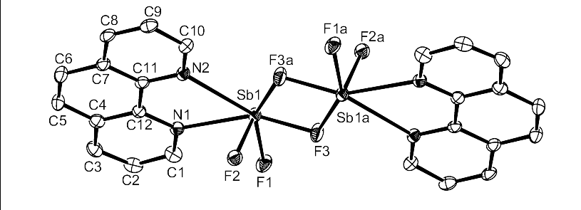
Figure 1

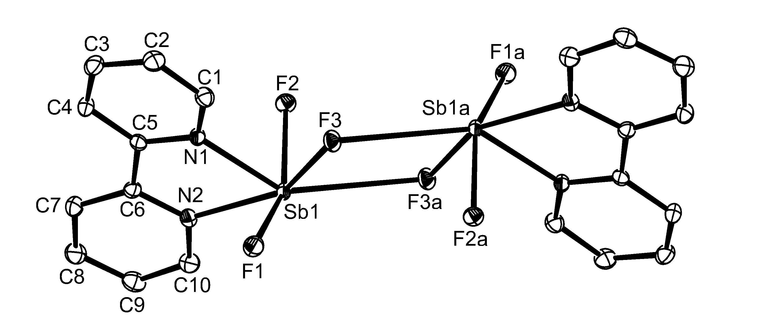Figure 2(a)

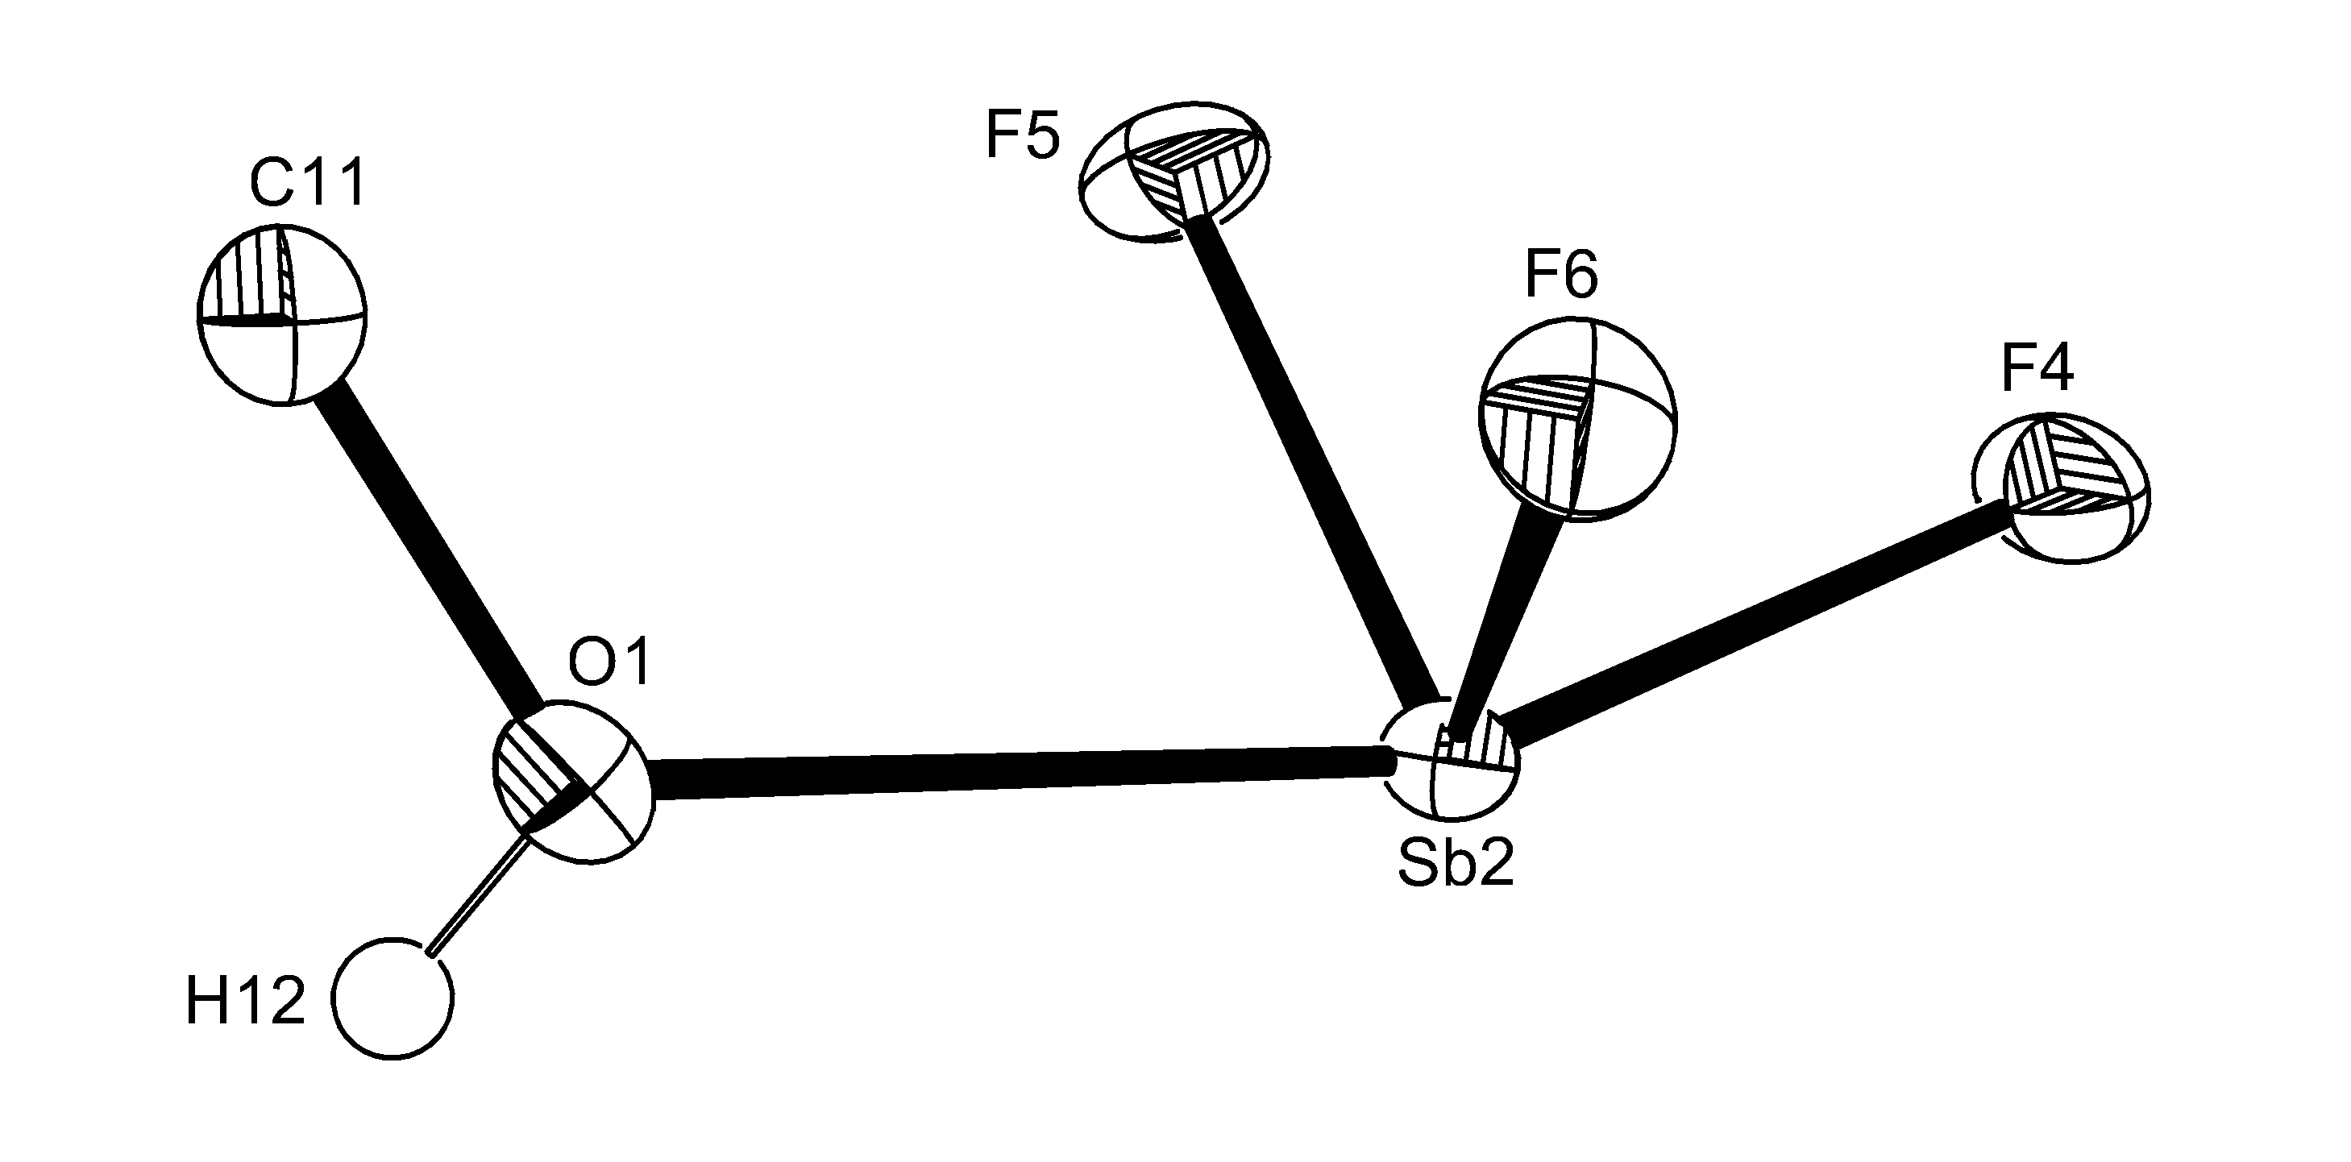

Figure 2(b)

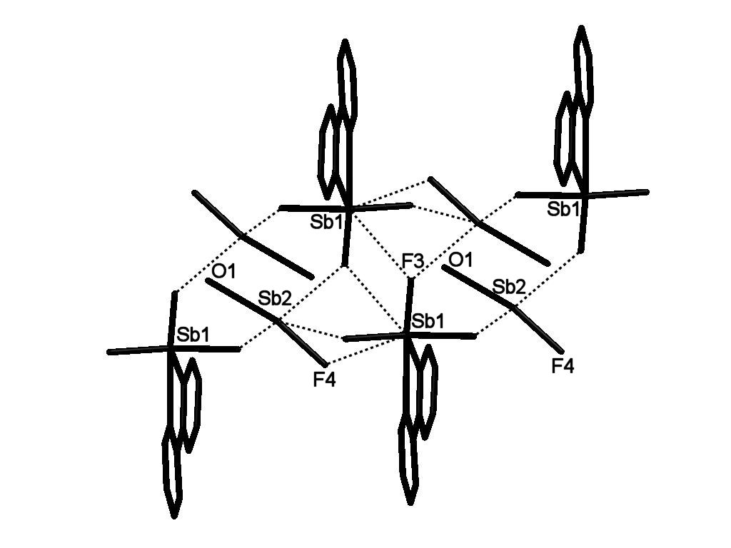
Figure 3

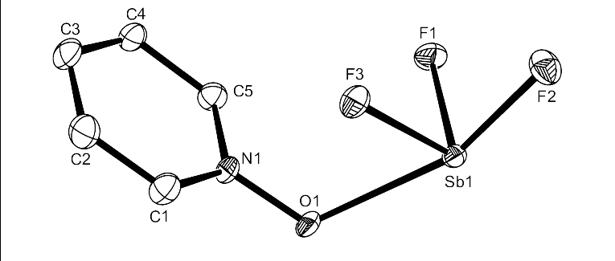
Figure 4
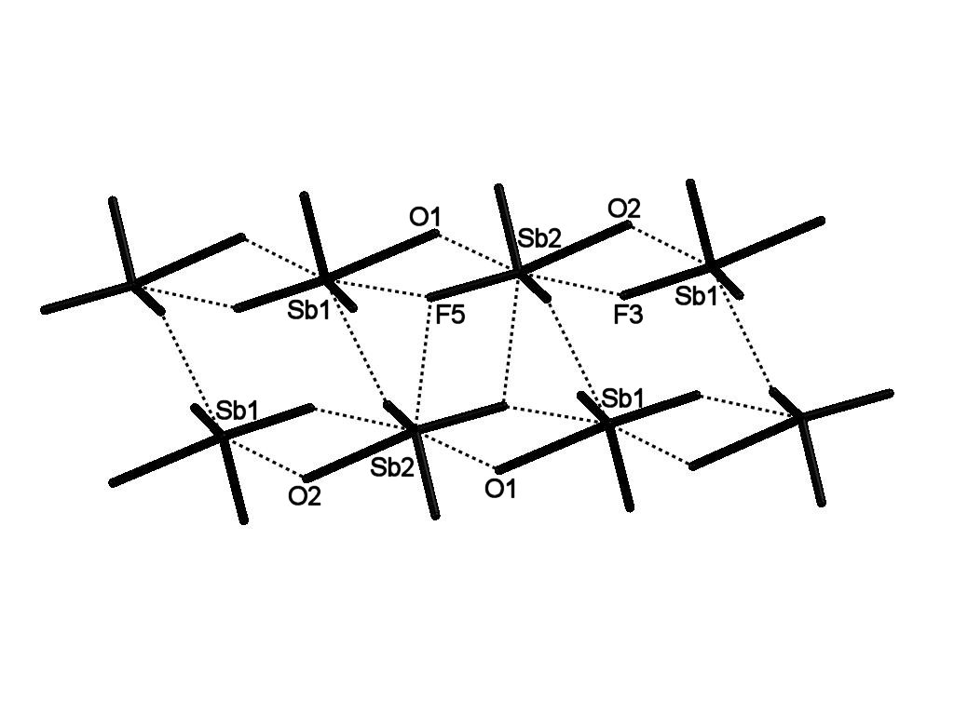
Figure 5
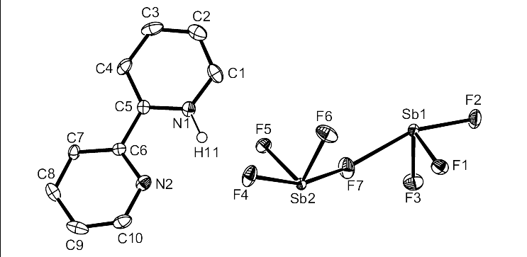
Figure 6
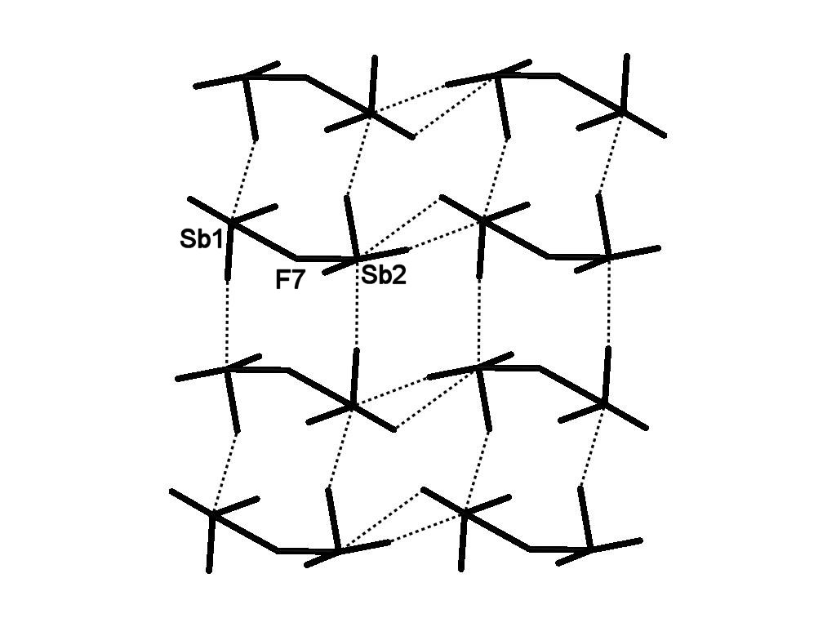
Figure 7

Highlights: antimony fluoride complexes; structures of antimony fluoride complexes with nitrogen heterocycles; seven-coordination in Sb(III) complexes.

Contents Page

Synthesis and Structures of Antimony Trifluoride Complexes with N-Heterocyclic Ligands

Sophie L. Benjamin, Jennifer Burt, William Levason, Gillian Reid and Michael Webster

The crystal structures of SbF₃ complexes with heterocyclic nitrogen ligands show a pyramidal SbF₃ core with longer bonds to the neutral ligand and longer Sb···F contacts typically completing a distorted seven-coordination at Sb.

▪ E-mail wxl@soton.ac.uk. Fax +44 (0)23 80593781. Tel. + 44 (0) 23 80593792

