Lewis Base Complexes of Methyldihalobismuthines BiMeX₂ (X = Cl or Br)

Sophie L. Benjamin, William Levason,* Gillian Reid, Michael C. Rogers and Robert P. Warr
School of Chemistry, University of Southampton, Southampton, UK SO17 1BJ

Received:

Abstract
Methyldihalobismuthines, BiMeX₂ (X = Cl or Br) prepared from MeLi and a stoichiometric amount of BiX₃ in thf, react with 1,10-phenanthroline, 2,2’-bipyridyl or Me₂NCH₂CH₂NMe₂ (L−L) in thf or MeCN to give [BiMeX₂(L−L)], which are poorly soluble in non-polar solvents. X-Ray structures of [BiMeBr₂(L−L)] and of [BiMeCl₂(Me₂NCH₂CH₂NMe₂)] show discrete square pyramidal molecules with apical methyl groups, and no intermolecular contacts within the sum of the appropriate Van der Waals radii. The structure of BiMe₂Br is a 1-D polymer chain with bromine bridges and containing a pseudo-trigonal bipyramidal geometry at bismuth. The reactions of BiMe₂X with the bidentate N-donor ligands result in disproportionation to also form [BiMeX₂(L-L)]. An unusual [BiMeBr₄]²⁻ anion in the salt [Li(H₂O)(1,10-phen)₂][Li(1,10-phen)₂(μ-Br)BiMeBr₃]·thf, was isolated as a by-product and shows a Li−-Br−-Bi bridge to one of the Li cations. BiMe₂Br disproportionates on reaction with [M(CO)₅(thf)] (M = Cr or W) to form [M(CO)₅(BiMe₃)].

Keywords: Methyldichlorobismuthine, methyldibromobismuthine, dimethylbromobismuthine, nitrogen ligands, X-ray structures.

1. Introduction
Bismuth(III) halides BiX₃ (X = Cl, Br or I) are moderate Lewis acids forming complexes with charged and neutral ligands from Group 15 and 16, in addition to a wide range of halo-anions [1,2]. In these complexes the bismuth centre typically has a high coordination number (6−10) and a very distorted geometry, reflecting the large size of the bismuth atom, the steric requirements of the ligands and the varying degrees of stereochemical activity of the bismuth-based lone pair. In contrast, tertiary bismuthines, BiR₃, are weak σ-donor and even weaker π-acceptor ligands towards low-valent metal carbonyls and organometallics, and their chemistry is further limited by the fragile Bi−C bond, which is easily broken by both strong nucleophiles and electrophiles [3,4]. Halobismuthines, BiRX₂, can behave as Lewis acids, and this aspect of the chemistry of arylhalobismuthines has been known for some years, typical examples being complexes with nitrogen heterocycles such as [BiPhX₂(L−L)] (X = Cl, Br or I; L–L = 2,2’-bipy, 1,10-phen) or neutral monodentate O- and N-donors in [BiPhX₂L] (L = thf, py, OPR₃) [5−9]. Alkyl−bismuth bonds are more fragile than their aryl analogues and few examples of BiMeX₂ complexes are known, although one structurally authenticated example is the dimeric [{BiMeCl₂(2,2’-bipy)}₂], which contains square pyramidal bismuth coordination with an apical Me group and basal chlorines (2.709(3), 2.678(3) Ǻ). The molecules are then weakly associated into dimers via very long Bi···Cl contacts (3.63(3), 3.95(5) Ǻ) [10]. The [{BiMeBr₂(thf)₂}₂], which crystallises from BiMeBr₂ solutions in thf, is a centrosymmetric dimer, with square pyramidal units weakly associated through long Bi···Br bridges (3.97(2) Ǻ) [11].

In our recent work we have reported several bismuth-containing polydentate ligands and their complexes with [CpFe(CO)₂]⁺ and Group 6 and 7 metal carbonyls [12,13]. During this study we prepared several methylhalobismuthines, BiMeX₂ and BiMe₂X (X = Cl or Br) as synthons for the introduction of Bi-containing donor groups into the ligands. We have also undertaken a detailed comparison of methylhalostibines as Lewis acids toward N- or O- donor ligands and as Lewis bases towards low valent metal carbonyl species [14]. Here we report the synthesis and structures of BiMe₂Br and five methyldihalobismuthine complexes with N-donor bidentate ligands, and the results of attempted complexation of BiMe₂Br with [M(CO)₅(thf)] (M = Cr or W) and [Mn(CO)₅][CF₃SO₃].

2. Results and Discussion
2.1 Methylhalobismuthines
Methylhalobismuthines can be prepared by comproportionation of BiMe₃ and BiX₃ (X = Cl, Br or I), by cleavage of Ph groups from BiPh_{3-n}Me_{n} (n = 1 or 2) with HX (X = Cl or Br), or by reaction of BiX₃ with a stoichiometric amount of MeLi at low temperatures [10,12,15,16]. We have found the last of these to be most effective in this work (Section 3). The structure of BiMeCl₂ contains puckered nets of Bi₄Cl₄ units linked into sheets with longer Cl···Bi contacts producing double sheets with the Me groups axial and directed away from the double sheets [10]. In contrast, BiMeI₂ consists of BiMe(μ²-I)₂ units in chains containing square pyramidal bismuth centres; the structures of BiMeBr₂ and BiMe₂Cl are unknown [11]. Crystals of BiMe₂Br were obtained in this work from n-hexane solution and showed a chain structure (Figure 1) with two slightly different bismuth centres, each based upon a trigonal bipyramid with a vacant equatorial vertex. There are long inter-chain Bi···Br contacts of 3.883(1), 3.940(1) Ǻ, which slightly exceed the sum of the Van der Waals radii (3.85 Ǻ) [17]. The chain structure is similar to that found in BiPh₂Cl [18], whereas Bi(mesityl)₂Br is better described as composed of trigonal pyramidal monomers with very long Bi···Br (3.795 Ǻ) contacts linking them into chains [19]. The Bi−C distances in BiMe₂Br of 2.235(7)−256(6) Ǻ, are shorter than in BiMeCl₂ (2.330(1) Ǻ) [10], but similar to those in Bi(mesityl)₂Br (2.268(12), 2.270(10) Ǻ) [19]. However, in the latter the Bi−Br distance (within the trigonal pyramidal monomer) is significantly shorter (2.696(2) Ǻ) than in the chain structure of BiMe₂Br presented here (2.8438(8)−3.0169(8) Ǻ).

2.2 Lewis base adducts
The reaction of BiMeBr₂ with 2,2’-bipyridyl, 1,10-phenanthroline or Me₂N(CH₂)₂NMe₂ (tmeda) in MeCN or thf solutions gave yellow [BiMeBr₂(L−L)] (L−L = 2,2’-bipy, 1,10-phen) or colourless [BiMeBr₂(tmeda)] crystals in high yields, which are rather poorly soluble in chlorocarbon solvents, hindering solution studies. The ¹H NMR spectra in CDCl₃ solution show small low frequency shifts in BiMe compared to the parent halide. Donor solvents were not suitable for the spectroscopic studies due to their competition as ligands for the bismuth.

In contrast to the Lewis acid behaviour of BiMeX₂, attempts to form adducts of BiMe₂X (X = Cl or Br) with the same nitrogen donor ligands promoted disproportionation and [BiMeX₂(L−L)] complexes were isolated (confirmed by comparison of the spectroscopic properties with those synthesized directly from BiMeX₂); the other expected product, BiMe₃, was not isolated. Similar disproportionation was observed on reaction of SbMe₂Br with diimines [14].

The key features of interest in the complexes of BiMeX₂ are the structural units present and thus X-ray crystallographic studies were undertaken on all four complexes. The structure of [BiMeBr₂(2,2’-bipy)] reveals a square pyramidal geometry (Figure 2) with an apical Me group and with Bi−C = 2.215(7), Bi−N = 2.500(4) Ǻ, both quite similar to those in the corresponding chloride, Bi−C = 2.230(11), Bi−N = 2.483(9), 2.486(8) Ǻ [10]. The bismuth atom lies below the square plane, which is distorted by the acute N−Bi−N angle (65.4(2)º) of the chelate. The geometry of [BiMeBr₂(1,10-phen)] (Figure 3) is very similar. In contrast to [BiMeCl₂(2,2’-bipy)] [10], the bromo-complexes show no intermolecular contacts out to 5 Å. The corresponding [SbMeBr₂(diimine)] are also discrete square pyramidal molecules [14]. Bismuth trihalides are stronger Lewis acids than the halobismuthines and a wide range of BiX₃ complexes with 2,2’-bipyridyl and 1,10-phenanthroline have been described [20-24]. These include [BiX₃(L−L)] which are dihalo-bridged dimers with distorted six-coordination at bismuth, [BiX₃(L−L)₂] which are seven-coordinate distorted pentagonal bipyramids, and six-coordinate anions [BiX₄(L−L)]⁻; there are also mixed ligand species with coordination numbers ranging from six to eight. The different coordination numbers present and the distorted environments in the BiX₃ complexes preclude useful comparisons of the bond lengths with the halobismuthine adducts.

Crystals of [BiMeCl₂(tmeda)] and [BiMeBr₂(tmeda)] were also obtained, the former by disproportionation from BiMe₂Cl and tmeda, the latter directly from BiMeBr₂ and tmeda. Although not isomorphous, the structures are very similar (Figures 4 and 5), again based upon a square pyramid with an apical Me group. The flexible diamine has a rather wider chelate bite than the diimines, which results in <N−Bi−N of ~74º and with the bismuth placed more within the basal plane. Again there are no intermolecular contacts within the sum of the Van der Waals radii. The Bi-C and Bi-N bonds are very similar in the two compounds suggesting little difference in Lewis acidity due to the different halides present.

On one occasion the reaction of BiMeBr₂ with 1,10-phenanthroline in thf solution gave a few pale yellow crystals, which on the basis of a structure determination proved to be [Li(H₂O)(1,10-phen)₂][Li(1,10-phen)₂(μ-Br)MeBr₃Bi]·thf. The source of the Li⁺ is clearly from the MeLi used in the preparation of BiMeBr₂. The structure (Figure 6) shows one discrete five-coordinate (square pyramidal) lithium cation, [Li(H₂O)(1,10-phen)₂]⁺; the nearest literature analogue appears to [Li(MeOH)(1,10-phen)₂]⁺ [25]. The second [Li(1,10-phen)₂]⁺ unit is linked via one of the bromines to a square pyramidal [BiMeBr₄]²⁻ anion with the strong σ donor Me group in the apical position as is usual (Li−Br = 2.776(5) Ǻ with <Li−Br−Bi = 126.04(10)º). Curiously, the Bi−Br bond of this bridging unit is somewhat shorter (2.784(1) Ǻ) than the three terminal Bi−Br distances (2.856(1)–2.970(1) Ǻ). The CCDB [26] shows >100 examples of Li···Br···M (M = a metallic element) with Li···Br distances of ~2.4–2.7 Ǻ, although no examples where M = Bi, which suggests that the interaction in the present case is among the more weakly associated examples. However, some examples of Li···Cl−Bi linkages have been identified in lithium salts of bismuth calixaranes [27].

2.3 Reactions of BiMe₂Br with transition metal carbonyl reagents
The coordination chemistry of triorganobismuthines BiR₃ (Lewis base) mostly involves substituted metal carbonyl complexes [3,4,28], but no metal complexes with BiR₂X or BiRX₂ ligands are known. The reactions of [M(CO)₅(thf)] (M = Cr or W) [29] with BiMe₂Br in thf solution, followed by removal of the thf, extraction with n-hexane and subsequent removal of the n-hexane in vacuo, gave yellow solids which were identified by a combination of IR, ¹H and ¹³C{¹H} NMR spectroscopies as mixtures of M(CO)₆ and the known [28] [M(CO)₅(BiMe₃)] complexes. The yields of the [M(CO)₅(BiMe₃)] are rather variable, but typically 25-30%. The n-hexane insoluble brown-black residue from the preparations was partially soluble in CH₂Cl₂ and similar spectroscopic investigations revealed no other metal carbonyl species present. In contrast, SbMe₂Br or SbMeBr₂ form [M(CO)₅(SbMe₂Br)] and [M(CO)₅(SbMeBr₂)] [14, 30] which have been thoroughly characterised, their structures revealing unusual (weak) intermolecular MCO....Sb interactions. In the case of BiMe₂Br, reaction with the metal carbonyl complex results in disproportionation to BiMe₃ which is trapped as the metal complex; there is no evidence for formation of [M(CO)₅(BiMe₂Br)]. Disproportionation of unsymmetrical BiR₂R’ (to BiR₃, BiRR’₂ etc) on reaction with metal centres is well established [3,4,12,13]. The reaction of BiMe₂Br with [Mn(CO)₅(CF₃SO₃)] results in formation of [Mn(CO)₅Br] as the only manganese carbonyl species, again contrasting with SbMe₂Br which forms [Mn(CO)₅(SbMe₂Br)][CF₃SO₃][14].
3. Experimental
3.1 Synthesis
Infrared spectra were recorded as Nujol mulls between CsI plates using a Perkin-Elmer Spectrum 100 spectrometer over the range 4000−200 cm⁻¹. ¹H NMR spectra were recorded in CDCl₃ or CD₂Cl₂ unless otherwise stated, using a Bruker AV300 spectrometer. Microanalyses were undertaken by Medac Ltd. The CH₂Cl₂ and acetonitrile were dried by distillation over CaH₂, and thf from Na-benzophenone ketyl. The 2,2’-bipy and 1,10-phen were dried by heating in vacuo before use, and tmeda by distillation from BaO. All preparations were performed under an atmosphere of dry N₂ using Schlenk techniques, and spectroscopic samples were prepared in a dry N₂-purged glove box.

3.1.1 BiMeBr₂
BiBr₃ (5.83 g, 13 mmol) was dissolved in THF (40 mL) forming a yellow solution which was cooled to −78°C. MeLi (1.6 M in Et₂O, 8.1 mL, 13.0 mmol) was added dropwise with stirring, resulting in formation of a white precipitate. The reaction was warmed to room temperature and stirred (ca. 16 h) and the solid was removed by filtration. The solvent from the filtrate was removed in vacuo to yield an off white solid. Yield 3.5 g, 70%. ¹H NMR (CDCl₃): 2.40 (s, Me). ¹³C{¹H} NMR (CDCl₃): 63.6 (Me).

3.1.2 BiMe₂Cl
BiCl₃ (2.6 g, 8.25 mmol) was dissolved in tetrahydrofuran (50 mL) and the solution cooled to −78ºC. MeLi (10.5 mL, 16.5 mmol, 1.6 M solution in diethyl ether) was added dropwise and the mixture allowed to warm to room temperature (1.5 h), producing a white precipitate. The solvent was removed and the solid residues re-dispersed in toluene (40 mL). The mixture was filtered through celite and the resultant clear solution reduced in volume, giving yellow oil with some suspended white solids. ¹H NMR (CDCl₃): 1.8 (s, Me). ¹³C{¹H} NMR (CDCl₃): 36.2 (Me).

3.1.3 BiMe₂Br
BiBr₃ (3.0 g, 6.7 mmol) was dissolved in diethyl ether (150 mL) forming a yellow solution which was cooled to −78°C. MeLi (1.6 M in Et₂O, 8.4 mL, 13.4 mmol) was added dropwise with stirring, then the reaction mixture was stirred for 30 minutes at −78°C resulting in formation of a white precipitate. The mixture was filtered through celite and glass wool, and the cloudy colourless filtrate reduced in vacuo to leave an off white solid. Addition of toluene (80 mL) resulted in a clear solution and some undissolved white solid. Filtration produced a clear solution, from which the volatiles were removed in vacuo, yielding a pale yellow powder. Recrystallisation from hexane gave colourless crystals from which the X-ray crystal structure was collected. ¹H NMR (CDCl₃): 2.02 (s, Me). ¹³C{¹H} NMR (CDCl₃): 28.7 (Me).

3.1.4 [BiMeBr₂(2,2’-bipy)]
BiMeBr₂ (0.25 g, 0.65 mmol) was added to a solution of 2,2’-bipyridyl (0.10 g, 0.65 mmol) in acetonitrile (10 mL). The reaction mixture was stirred for 1.5 h resulting in a pale yellow solution and a pale pink precipitate. The solid was isolated by filtration dried in vacuo. Refrigeration of the filtrate (~16 h) resulted in formation yellow crystals from which the X-ray crystal structure was collected. Yield 0.5 g, 71%. Found: C, 24.6, H, 2.3, N, 5.1; C₁₁H₁₁BiBr₂N₂ requires C, 24.5, H, 2.1, N, 5.2%. ¹H NMR (CDCl₃): 2.01 (s, [3H], Me), 7.56 (m, br, [2H]), 8.10 (m, br, [2H]), 8.29 (d, [2H]) and 9.33 (m, vbr, [2H]) (all aromatic CH).

3.1.5 [BiMeBr₂(1,10-phen)]
A solution of BiMeBr₂ (0.30 g, 0.78 mmol) in acetonitrile (10 mL) was added to a solution of 1,10-phenanthroline (0.14 g, 0.78 mmol) in acetonitrile (5 mL). An immediate bright orange colour was observed, which slowly paled. The solution was stirred overnight resulting in a pale yellow solution and white precipitate, which was isolated by filtration dried in vacuo. Refrigeration of the filtrate resulted in formation of colourless crystalline blocks from which the X-ray crystal structure was collected. Yield 0.26 g, 60 %. Found: C, 28.5, H, 2.0, N, 5.0; C₁₃H₁₁BiBr₂N₂ requires C, 27.7, H, 2.0, N, 5.0%. ¹H NMR (CDCl₃): 1.97 (s, [3H], Me), 7.87 (m,br, [2H]), 8.00 (m, br, [2H]), 8.56 (m,br, [2H]) and 9.62 (m, vbr, [2H]) (all aromatic CH).

3.1.6 [BiMeBr₂(tmeda)]
Tetramethylethylenediamine (0.20 mL, 1.3 mmol), was added dropwise to a solution of BiMeBr₂ (0.5 g, 1.3 mmol) in thf (15 mL) and the mixture stirred overnight, resulting in a pale yellow solution with a white precipitate. The solids were isolated by filtration and dried in vacuo. Yield 0.35 g, 47%. Found: C, 17.8, H, 3.1, N, 4.4; C₇H₁₉BiBr₂N₂ requires C, 16.8 H, 3.83 N, 5.6%. ¹H NMR (CDCl₃): 2.15 (s, [3H], MeBi), 2.7 (s, [12H], MeN), 2.8 (s, [4H], CH₂N). Refrigeration of the filtrate (~16 h) gave colourless crystals from which the X-ray crystal structure was determined (as [BiMeBr₂(tmeda)]∙thf).

3.1.7 [BiMeCl₂(tmeda)]
Crystals were formed from a mixture of BiMe₂Cl and tmeda in MeCN, via disproportionation. ¹H NMR (CDCl₃): 1.98 (s, [3H], Me), 2.77 (s, [12H], MeN), 2.86 (s, [4H], CH₂N).

3.1.8 Reaction of [W(CO)₅(thf)] with BiMe₂Br
A solution of W(CO)₆ (0.14 g, 0.40mmol) in thf (40 mL) was photolysed for 1 h. The resulting yellow solution was cooled to 0°C. Freshly prepared BiMe₂Br (0.15 g, 0.40 mmol) was dissolved in thf (10 mL) and cooled to 0°C, then slowly added to the stirred [W(CO)₅(thf)] solution. The mixture was stirred at 0°C for 15 min., then the volatiles removed in vacuo leaving a bright orange solid. Hexane (35 mL) was added, dissolving some of the solid to give a yellow solution. The mixture was stirred at 0°C for 1 h, over which time the remaining solid darkened to red/brown. The yellow solution was filtered to remove this solid, and the volatiles removed in vacuo leaving a yellow solid identified as [W(CO)₅(BiMe₃)] with some W(CO)₆. Yield 0.06 g, 26%. IR (CH₂Cl₂/cm⁻¹): 2072w, 1943s, br; 1982m (W(CO)₆), (Nujol/cm⁻¹): 2071w, 1940s (Lit. [28] 1970, 1942) 1979m (W(CO)₆). ¹H NMR (CDCl₃): 1.88 (s, BiMe); (C₆D₆): 1.28 (s, BiMe) (Lit. [28] 1.16).¹³C{¹H} NMR (CDCl₃):−6.0 (BiMe), 191.7(W(CO)₆), 198.3 (cis CO) 199.7 (trans CO) (Lit. [28] (C₆D₆): -7.20, 198.17 (only cis CO quoted)).
The reaction of [Cr(CO)₅(thf)] with BiMe₂Br in an analogous manner gave [Cr(CO)₅(BiMe₃)].
IR (CH₂Cl₂/cm⁻¹): 2059w, 1939s, br; 1980 (Cr(CO)₆), (Nujol/cm⁻¹): 2061w, 1942s (Lit. [28] 2060w, 1942s), 1980 (Cr(CO)₆). ¹H NMR (CDCl₃): 1.79 (s, BiMe); (C₆D₆) (Lit. [28] 1.11.¹³C{¹H} NMR (CDCl₃):−5.9 (BiMe), 212.0(Cr(CO)₆), 218.2 (cis CO) 223.5 (trans CO) (Lit [28] (C₆D₆): -7.15, 218.2 (only cis CO quoted)).

3.2 X-ray experimental
Details of the crystallographic data collection and refinement parameters are given in Table 1. Crystals were obtained as described above. Data collection used a Nonius Kappa CCD diffractometer fitted with monochromated (confocal mirrors or graphite) Mo−K_{α} X−radiation (λ = 0.71073 Å). Crystals were held at 120 K in a nitrogen gas stream. Structure solution and refinement were generally routine, except as described below, with hydrogen atoms on C added to the model in calculated positions and using the default C–H distance [31,32]. In the structure of the hydrated lithium compound, H atoms on the H₂O bonded to Li were located in later difference electron-density maps with a convincing geometry and added to the model with a DFIX on the O1–H distances. For both [BiMeBr₂(2,2'-bipy)] and [BiMeBr₂(1,10-phen)], where the molecules have a crystallographic mirror plane, the methyl group bonded to Bi was found with one H atom very close to the mirror. One H atom was thus positioned on the mirror and the correct Me geometry maintained with DFIX on C–H and H···H distances.

4. Conclusions
The work described above shows that methyldihalobismuthines are modest Lewis acids forming adducts with hard N-bases, the typical coordination geometry being five-coordinate square pyramidal. The products are relatively stable in air and the Bi−Me units less fragile than in the parent halobismuthines. The same bases bring about disproportionation in BiMe₂X, the reaction being driven by complexation of the BiMeX₂ produced; similar behaviour occurs with SbMe₂X and diimines [14]. The group 6 metal carbonyl reagents [M(CO)₅(thf)] (M = Cr or W) also promote disproportionation of BiMe₂Br, in this case the BiMe₃ that is produced complexes with the metal centre to form [M(CO)₅(BiMe₃)]. In contrast, SbMe₂Br functions as a Lewis base towards the same metal carbonyls forming stable [M(CO)₅(SbMe₂Br)] adducts [14].

5. Supplementary Materials
CCDC reference numbers 848016−848021 contain the supplementary crystallographic data for this paper. These data can be obtained free of charge from The Cambridge Crystallographic Data Centre via www.ccdc.cam.ac.uk/data_request/cif.

Acknowledgements
We thank the EPSRC for support (EP/F038763/1) and for a studentship (S. L. B.). We also thank Dr M. Webster for assistance with the crystallographic studies.

References
(1) N. C. Norman, (Ed) The Chemistry of Arsenic, Antimony and Bismuth, Blackie, London 1998.
(2) W. Levason, G. Reid, Comprehensive Coordination Chemistry II J. A. McCleverty, T. J. Meyer, Elsevier, Oxford, 3 (2004) 465.
(3) N. R. Champness, W. Levason, Coord. Chem. Rev. 133 (1994) 115.
(4) W. Levason, G. Reid, Coord. Chem. Rev. 250 (2006) 2565.
(5) C. Silvestru, H. J. Breunig, H. Althaus, Chem. Rev. 99 (1999) 3277.
(6) S. Faleschini, P. Zanella, L. Doretti, G. Faraglia, J. Organometal. Chem. 44 (1972) 317.
(7) W. Clegg, R. J. Errington, G. A. Fisher, D. C. R. Hockless, N. C. Norman, A. G. Orpen, S. E. Stratford, J. Chem. Soc., Dalton Trans. (1992) 1967.
(8) C. J. Carmalt, A. H. Cowley, A. Decken, N. C. Norman, J. Organometal. Chem, 496 (1995) 59.
(9) W. Clegg, R. J. Errington, G. A. Fisher, R. J. Flynn, N. C. Norman, J. Chem. Soc., Dalton Trans. (1993) 637.
(10) H. Althaus, H. J. Breunig, E. Lork, Organometallics 20 (2001) 586.
(11) H. J. Beunig, H. Althaus, Phosphorus, Sulfur and Silicon, 168 (2001) 123.
(12) S. L. Benjamin, L. Karagannides, W. Levason, G. Reid, M. C. Rogers, Organometallics 30 (2011) 895.
(13) S. L. Benjamin, W. Levason, G. Reid, M. C. Rogers, Dalton Trans., 40 (2011) 6565.
(14) S. L. Benjamin, W. Levason, G. Reid, R. P. Warr, Organometallics, 31 (2012) 1025.

(15) K. Y. Akiba, Y. Yamomoto, in The Chemistry of Organic Arsenic, Antimony and Bismuth Compounds, S. Patai (Ed), Wiley, NY 1994.
(16) Gmelin Handbook of Inorganic Chemistry, Supplementary vol. 47 Bismuth Organic Compounds, Springer 1978.
(17) See web-site: www.ccdc.cam.ac.uk/products/csd/radii/ for values used by the CCDC and literature references; B. Cordero, V. Gόmez, A. E. Platero-Prats, M. Revés, J. Echeverria, E. Cremades, F. Barragán, S, Alvarez, S. Dalton Trans. (2008) 2832.
(18) R. Hillwig, F. Kunkel, K. Harms, B. Neuműller, K. Dehnicke, Z. Naturforsch. Teil B 52 (1997) 149.
(19) K. H. Ebert, R. E. Schulz, H. J. Breunig, C. Silvestru, I. Haiduc, J. Organomet. Chem. 470 (1994) 93.
(20) G. Alonzo, M. Consiglio, N. Bertazzai, C. Preti, Inorg. Chim. Acta 105 (1985) 51.
(21) G. A. Bowmaker, P. C. Junk, A. M. Lee, B. W. Skelton, A. H. White, Aust. J. Chem. 51 (1998) 317.
(22) G. A. Bowmaker, J. M. Harrowfield, A. M. Lee, B. W. Skelton, A. H. White, Aust. J. Chem. 51 (1998) 311.
(23) G. A. Bowmaker, F. M. M. Hannaway, P. C. Junk, A. M. Lee, B. W. Skelton, A. H. White, Aust. J. Chem. 51 (1998) 325.
(24) G. A. Bowmaker, F. M. M. Hannaway, P. C. Junk, A. M. Lee, B. W. Skelton, A. H. White, Aust. J. Chem. 51 (1998) 331.
(25) J. H. N. Buttery, Effendy, G. A. Koutsantonis, S. Mutrofin, N. C. Plackett, B. W. Skelton, C. R. Whitaker, A. H. White, Z. Anorg. Allg. Chem. 632 (2006) 1829.
(26) CCDC: Cambridge Crystallographic Data Centre (CCDC ID: AI631510) CSD v5.32 accessed October 4 2011.
(27) Lihua Liu, L. N. Zakharov, J. A. Golen, A. L. Rheingold, T. A. Hanna Inorg.Chem. 47 (2008) 11143.
(28) H. J. Breunig, T. Borrmann, E. Lork, O. Moldovan, C. I. Rat, R. P. Wagner J. Organometal. Chem. 694 (2009) 427.
(29) W. Strohmeier, Angew. Chem. 76 (1964) 873.
(30) H. J. Breunig, M. Denker, K. H. Ebert, J. Organometal. Chem. 470 (1994) 87.
(31) G. M. Sheldrick, SHELXS-97, Program for crystal structure solution, University of Göttingen, Germany (1997).
(32) G. M. Sheldrick, SHELXL-97, Program for crystal structure refinement, University of Göttingen, Germany (1997).

Figure Captions.
Figure 1a.
Asymmetric unit of BiMe₂Br. Ellipsoids are drawn at the 50% probability level, and H atoms omitted for clarity. Symmetry operation: a = –x + 1, y – 1/2, –z – 1/2. Selected bond lengths (Å) and angles (°): Bi1−C1 = 2.235(7), Bi1−C2 = 2.248(7), Bi1−Br1 = 2.9225(7), Bi1−Br2 = 2.9229(7), Bi2−C4 = 2.243(6), Bi2−C3 = 2.257(6), Bi2−Br2 = 2.8438(8), Bi2−Br1 = 3.0169(8), C1−Bi1−C2 = 94.2(3), C1−Bi1−Br1 = 87.7(2), C2−Bi1−Br1 = 89.2(2), C1−Bi1−Br2 = 86.5(2), C2−Bi1−Br2 = 85.4(2), Br−Bi1−Br2 = 171.72(2), Br1−Bi1−Br2 = 171.72(2), C4−Bi2−C3 = 91.8(3), C4−Bi2−Br2 = 86.5(2), C3−Bi2−Br2 = 90.6(2), C4−Bi2−Br1 = 190.2(2), C3−Bi2−Br1 = 88.7(2), Br2−Bi2−Br1 = 176.61(2), Bi1−Br1−Bi2 = 87.68(2), Bi2−Br2−Bi1 = 115.64(3).

Figure 1b.
View of the chain structure and packing of BiMe₂Br.

Figure 2.
View of the structure of [BiMeBr₂(2,2’-bipy)] with atom numbering scheme. Ellipsoids are shown at the 50% probability level and H atoms are omitted for clarity. Symmetry operation: a = x, 1/2 – y, z. Selected bond lengths (Å) and angles (°): Bi1−C1 = 2.215(7), Bi1−N1 = 2.500(4), Bi1−Br1 = 2.8269(7), C1−Bi1−N1 = 84.9(2), N1−Bi1−N1 = 65.4(2), C1−Bi1−Br1 = 85.6(1), N1−Bi1−Br1 = 92.18(9), N1−Bi1−Br1 = 156.33(9), Br1−Bi1−Br1 = 108.64(3).

Figure 3.
View of the structure of [BiMeBr₂(1,10-phen)] with atom numbering scheme. Ellipsoids are shown at the 50% probability level and H atoms are omitted for clarity. Symmetry operation: a = x, 3/2 – y, z. Selected bond lengths (Å) and angles (°): Bi1−C1 = 2.237(10), Bi1−N1 = 2.508(6), Bi1−Br1 = 2.843(1), C1−Bi1−N1 = 86.5(3), N1−Bi1−N1 = 66.7(3), C1−Bi1−Br1 = 86.5(2), N1−Bi1−Br1 = 88.9(1), N1−Bi1−Br1 = 155.0(1), C1−Bi1−Br1 = 86.5(2), Br1−Bi1−Br1 = 114.63(4).

Figure 4.
View of the structure of [BiMeBr₂(tmeda)] with atom numbering scheme. Ellipsoids are shown at the 50% probability level and H atoms are omitted for clarity. Symmetry operation: a = x, 1/2 – y, z. Selected bond lengths (Å) and angles (°): Bi1−C1 = 2.231(13), Bi1−N1 = 2.509(11), Bi1−N2 = 2.520(11), Bi1−Br2 = 2.874(2), Bi1−Br1 = 2.887(2), C1−Bi1−N1 = 89.4(5), C1−Bi1−N2 = 91.5(5), N1−Bi1−N2 = 73.8(4), C1−Bi1−Br2 = 86.3(4), N2−Bi1−Br2 = 90.7(3), C1−Bi1−Br1 = 86.1(4), N1−Bi1−Br1 = 86.9(3), Br2−Bi1−Br1 = 108.32(5), N1−Bi−Br2 = 163.9(3), N2−Bi1−Br1 = 160.6(3).

Figure 5.
View of the structure of [BiMeCl₂(tmeda)] with atom numbering scheme. Ellipsoids are shown at the 40% probability level and H atoms are omitted for clarity. Selected bond lengths (Å) and angles (°): Bi1−C1 = 2.282(16), Bi1−N1 = 2.514(12), Bi1−N2 = 2.574(12), Bi1−Cl1 = 2.642(4), Bi1−Cl2 = 2.761(4), C1−Bi1−N1 = 90.4(5), C1−Bi1−N2 = 89.0(6), N1−Bi1−N2 = 73.7(4), C1−Bi1−Cl1 = 87.8(5), N1−Bi1−Cl1 = 86.3(3), N2−Bi1−Cl2 = 95.2(3), C1−Bi1−Cl2 = 84.8(4), Cl1−Bi1−Cl2 = 104.4(1), N2−Bi1−Cl1 = 159.7(3), N1−Bi1−Cl2 = 168.0(3).

Figure 6.
View of the structure of [Li(1,10-phen)₂(μ-Br)BiMeBr₃] unit in [Li(H₂O)(1,10-phen)₂] [Li(1,10-phen)₂(μ-Br)MeBr₃Bi]·thf with atom numbering scheme. Ellipsoids are shown at the 50% probability level and H atoms are omitted for clarity. Selected bond lengths (Å) and angles (°): Bi1−C1 = 2.238(3), Bi1−Br4 = 2.7839(4), Bi1−Br2 = 2.8558(3), Bi1−Br3 = 2.8739(4), Bi1−Br1 = 2.9704(4), Br4−Li1 = 2.776(5), O1−Li2 = 1.981(5), Li-N = 2.062(5) − 2.150(5), C1−Bi−Br4 = 89.70(7), C1−Bi1−Br2 = 91.41(8), Br4−Bi1−Br2 = 85.65(1), C1−Bi1−Br3 = 87.85(8), Br4−Bi1−Br3 = 90.82(1), C1−Bi1−Br1 = 83.13(7), Br2−Bi1−Br1 = 88.62(1), Br3−Bi1−Br1 = 94.78(1), Li1−Br4−Bi1 = 126.0(1).

Figures
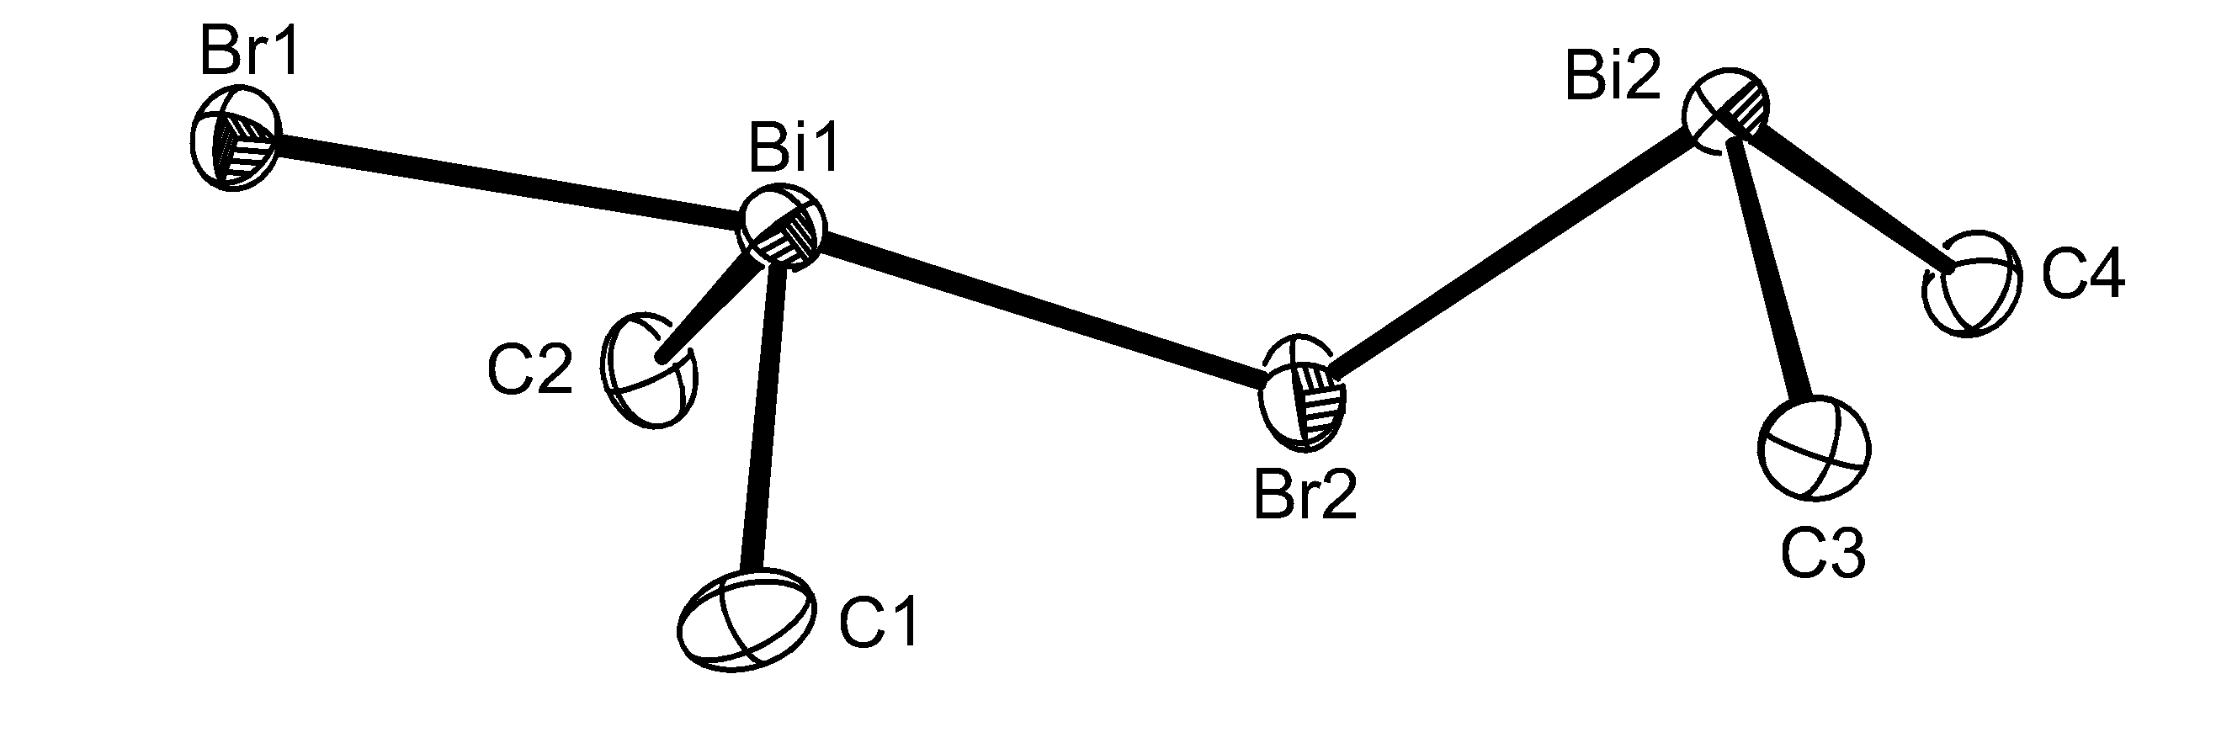

Figure 1a
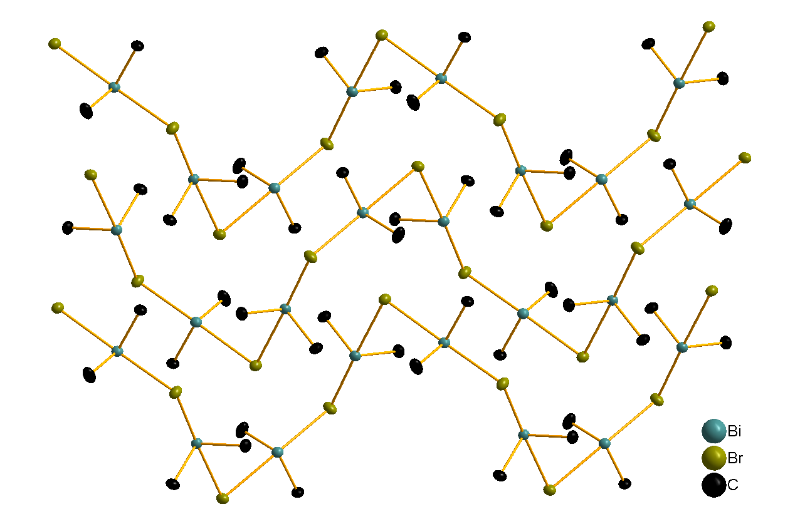

Figure 1b.
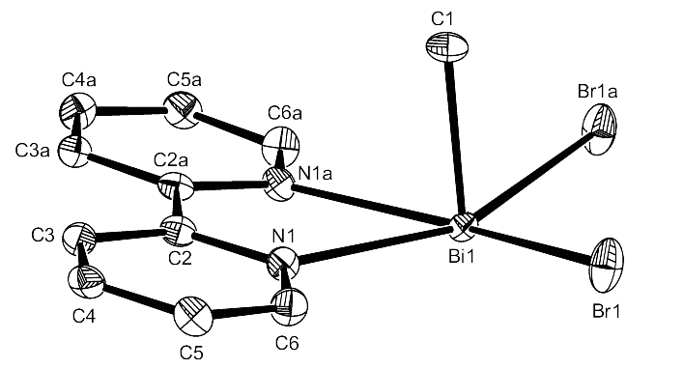
Figure 2

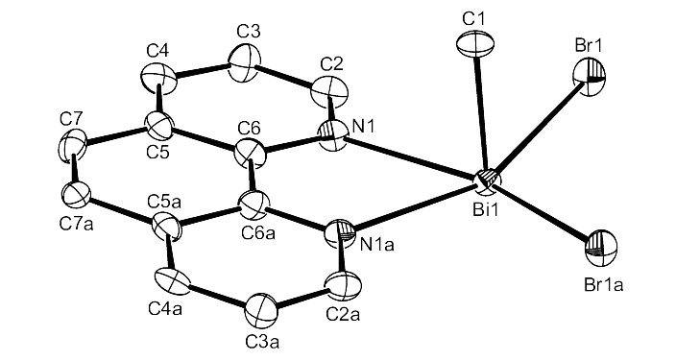
Figure 3

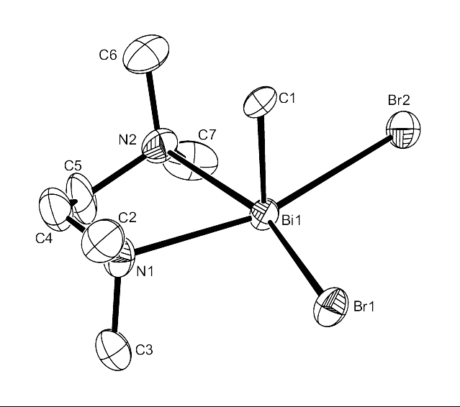

Figure 4
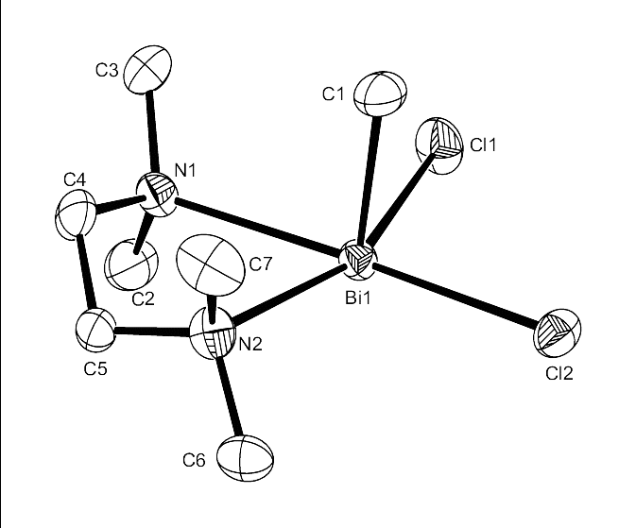
Figure 5

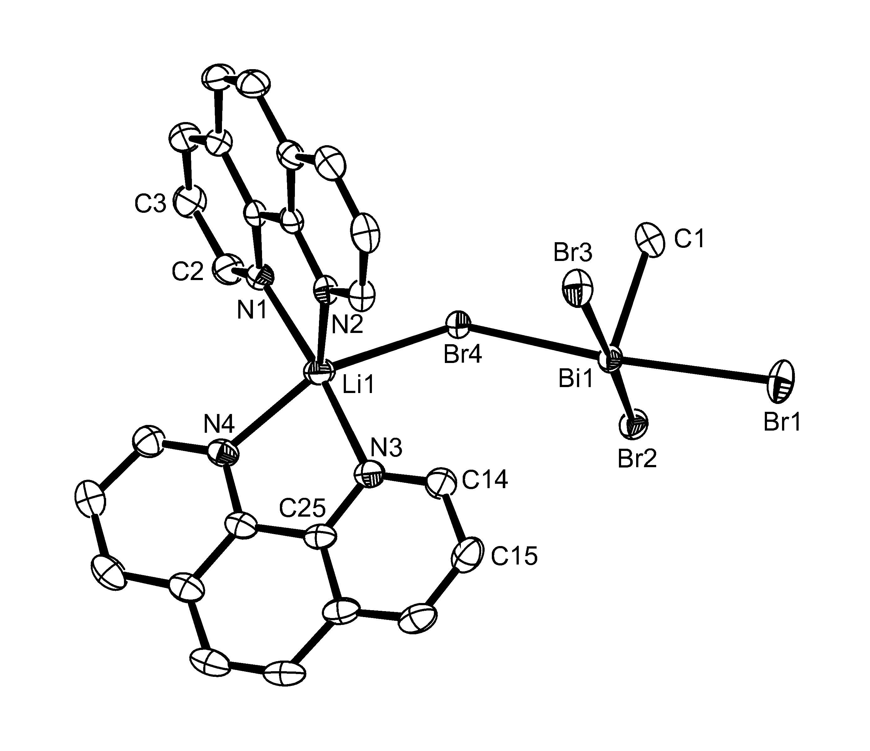
Figure 6
Table 1 Crystal data and structure refinement detailsª

compound | BiMe₂Br | BiMeBr₂(2,2’-bipy) | BiMeBr₂(1,10-phen) | BiMeBr₂(tmeda)·thf
Formula | C₄H₁₂Bi₂Br₂ | C₁₁H₁₁BiBr₂N₂ | C₁₃H₁₁BiBr₂N₂ | C₁₁H₂₇BiBr₂N₂O
M | 637.91 | 540.02 | 564.04 | 572.15
crystal system | monoclinic | monoclinic | monoclinic | monoclinic
space group | P2₁/c (no. 14) | P2₁/m (no. 11) | P2₁/m (no. 11) | P2₁/c (no. 14)
a [Å] | 8.5531(15) | 5.7321(10) | 5.6366(15) | 6.838(3)
b [Å] | 12.877(2) | 16.541(4) | 16.562(5) | 23.310(8)
c [Å] | 10.562(2) | 7.1700(15) | 7.737(3) | 11.239(4)
α [deg] | 90 | 90 | 90 | 90
β [deg] | 102.755(10) | 95.966(15) | 97.25(3) | 99.83(3)
γ [deg] | 90 | 90 | 90 | 90
U [Å³] | 1134.6(3) | 676.1(2) | 716.5(4) | 1765.1(12)
Z | 4 | 2 | 2 | 4
μ(Mo-Kα) [mm^{–1}] | 37.954 | 18.923 | 17.865 | 14.507
total no. reflns | 14969 | 7651 | 7972 | 22375
unique reflns | 2596 | 1608 | 1678 | 3347
R_{int} | 0.0449 | 0.0443 | 0.0521 | 0.1198
no. of params, restraints | 77, 0 | 81, 4 | 90, 3 | 154, 0
R₁^{b} [I_{o} > 2σ(I_{o})] | 0.0254 | 0.0272 | 0.0344 | 0.0604
R₁ [all data] | 0.0298 | 0.0313 | 0.0374 | 0.0852
wR₂^{b} [I_{o} > 2σ(I_{o})] | 0.0593 | 0.0571 | 0.0874 | 0.1266
wR₂ [all data] | 0.0616 | 0.0585 | 0.0852 | 0.1372

Compound | BiMeCl₂(tmeda) | [Li(phen)₂(H₂O)][Li(phen)₂BiMeBr₄]·C₄H₈O
Formula | C₇H₁₉BiCl₂N₂ | C₅₃H₄₅BiBr₄Li₂N₈O₂
M | 411.12 | 1368.47
crystal system | monoclinic | triclinic
space group | P2₁/n (no. 14) | P−1 (no. 2)
a [Å] | 7.987(3) | 9.4987(10)
b [Å] | 14.811(5) | 13.0605(10)
c [Å] | 10.903(4) | 20.999(2)
α [deg] | 90 | 99.194(5)
β [deg] | 96.12(3) | 94.631(5)
γ [deg] | 90 | 95.140(5)
U [Å³] | 1282.5(7) | 2549.3(4)
Z | 4 | 2
μ(Mo Kα) [mm^{–1}] | 14.125 | 6.642
total no. reflns | 13034 | 46390
unique reflns | 2862 | 11665
R_{int} | 0.0556 | 0.0248
no.of params, restraints | 114, 0 | 639, 2
R₁^{b} [I_{o} > 2σ(I_{o})] | 0.0580 | 0.0231
R₁ [all data] | 0.0659 | 0.0287
wR₂^{b} [I_{o} > 2σ(I_{o})] | 0.1455 | 0.0464
wR₂ [all data] | 0.1512 | 0.0488

ª Common items: temperature = 120 K; wavelength (Mo Kα) = 0.71073 Å; θ(max) = 27.5°.
^{b} R₁ = Σ|| F_{o}| – |F_{c}||/Σ|F_{o}|. wR₂ = [Σw(F_{o}² – F_{c}²)²/ΣwF_{o}⁴]^{1/2}.

TOC ENTRY

Lewis Base Complexes of Methyldihalobismuthines BiMeX₂ (X = Cl or Br) Sophie L. Benjamin, William Levason, Gillian Reid, Michael C. Rogers and Robert. Warr

Highlights:
Synthesis and structural authentication of N-base adducts of methyldihalobismuthines.
Structure of dimethylbromobismuthine.
Dimethylhalobismuthines disproportionate on reaction with bidentate N-bases to form adducts of methyldihalobismuthines and with metal carbonyl residues to form BiMe₃ adducts.

Corresponding author (WL) E-mail wxl@soton.ac.uk Fax 023 80 593781.

