Nano Biomaterials library synthesis for high throughput screening using a dry powder printing method
Zongqi Li
School of Engineering Sciences, University of Southampton
Southampton, UK, SO17 1BJ
zl8g10@soton.ac.uk
Shoufeng Yang
School of Engineering Sciences, University of Southampton
Southampton, UK, SO17 1BJ
s.yang@soton.ac.uk
Received Day Month Year
Revised Day Month Year
High throughput (HT) screening and combinatorial searches for the discovery, development and optimization of functional materials have been widely accepted in many new materials discovery. Dry powder HT library synthesis has advantage to use same powder materials in lab as in production. An ultrasonic dry powder micro-feeding system is developed in this paper for nano bioceramic powders dispensing which can dispense as low as 0.1 mg per dose. Calcium phosphate biomaterials including hydroxyapatite (HA) and β-tricalcium phosphate (β-TCP) were selected to demonstrate the library fabrication. The dispensing unit design and the effect of the dispensing parameters on dosage control and uniformity are discussed.

Keywords: Biomaterials High Throughput screening; combinatorial search; Dry powder dispensing; ultrasonic vibration; Micro-feeding.

Introduction
High throughput screening and combinatorial searches for the discovery, development and optimization of functional materials has been widely accepted in many new materials discovery including superconductors ¹, heterogeneous catalysis, sensors, luminescent materials, solid-state battery materials , fuel-cell materials ¹⁰, coating materials¹¹, novel magnetic materials, and dielectric and ferroelectric materials¹⁴⁻¹⁶. However, high throughput biomaterials discovery and screening is still in infancy. Recently, Hook et al. ¹⁷ has reviewed high throughput discovery of biomaterials using polymer microarrays for many cell-based applications including the isolation of speciﬁc cells from heterogeneous populations, the attachment and differentiation of stem cells and the controlled transfection of cells. Simon and Lin-Gibson¹⁸ has reviewed advances in utilizing combinatorial and high-throughput methods to better understand cell-material interactions and fabrication techniques to generate controlled surfaces (2D) and 3D cell environments as well as methods to characterize and analyze material properties and cell-material interactions.

Although the first combinatorial approach to materials research is often attributed to Edison and Ciamician around 100 years ago¹⁹, it was first conceptualized by Joseph Hanak in 1970²⁰ but awaited the advent of computational data storage and handling. The first
report of the rapid, automated synthesis of diverse organic molecules appeared in the late 1960s²¹. At that time, pioneers like Merrifield used polypeptide-synthesis machines to automate the rapid production of diverse amino acid sequences²¹.

High-throughput (HT) methodology is a scientific approach to realize the rapid discovery, study, and optimization of new materials often accompanied with other relevant techniques including precise sample feeding and metering, rapid synthesis, high-throughput characterization and massive data processing to manage and analyze large numbers of diverse material compositions ²². They were initially wide adopted in the pharmaceutics industry for the discovery of drugs, involving a large amount of chemicals simultaneously . With its promise to speed up the discovery and development processes, high-throughput technologies have been explored and developed for fast increasing requirements in a number of materials, including biomaterials, polymer based materials, functional materials, catalysts and others ²².

Libraries can be discrete, continuous or random and can be constructed by thin-film methods, solution-based²⁷ inkjet printing methods²⁸⁻³⁰ and or by dry powder mixing³¹⁻³⁴. Though thin-film technologies have been widely adopted for the high-throughput library synthesis, unsurprisingly, it is found that there is sometimes a lack of correlation between the properties of materials in thin-film form and bulk. It has difficulties in achieving homogeneous mixing of solid-multi-layer thin films, and there exists a huge deviation in physical and chemical properties of solid-state materials using this thin-film format.

Solution methods are complex and labor-intensive processes which are sensitive to handling procedures, for example experimental conditions, pH value, and nature of solvents etc²². The majority of small-molecule libraries generated to date have followed a solid-phase format for ease of isolation and purification of products, coupled with the ability to drive a reaction quickly to completion and then by-products and excess reagents simply removed by a washing procedure. The solution phase allows mixing at the molecular level, which reduces the need for high temperature interdiffusion and also facilitates the isolation of metastable phases. It has several advantages: few reactions have been adapted to solid-phase, and some reactions are incompatible with the heterogeneous nature of insoluble polymer supports. Whereas solid-phase synthesis can produce large sample libraries, utilizing the split/pool technique to afford small amounts of compound, solution-phase synthesis is often applied to lead development capable of affording larger quantities of material.

However, for many insoluble materials or materials with low solubility, such as most of bioceramics, for example, bioglass, HA (Hydroxyapatite) and β-TCP (β-Tricalcium Phosphate), it is difficult or impossible to make solutions of these materials other than suspensions or slurry. To make stable suspensions, large amount of experiments are needed to find the best combination of additives such as dispersants, or to change pH value, or to use various solvents³⁵. Though good suspensions can be optimized and achieved for individual materials, they may not able to be mixed into a uniform mixture due to different dispersants, pH or solvents used³⁶. The removal of the dispersants and solvents have also negative impact into the following steps of screening, for example, the residual of the additives could be toxic to the cells. During the drying of the libraries, non-uniform pattern could be formed due to “coffee stain effect” . Therefore, a library started from dry powder mixing would have advantages.

The libraries based on dry powder mixing provide starting materials which can not only be used to synthesize thin film with different deposition methods (laser sintering, sputtering, evaporation) and masking techniques (physical masks and photolithography), but also to prepare solutions and slurries consisting of nano-particles suspended in either water or an organic solvent. Such solutions or slurries are very useful for measuring and mixing the starting materials for combinatorial processing. Solid-phase peptide synthesis methods has been adopted for the combinatorial production of large numbers of different compounds ²⁴. Solid-phase beads were recombined, mixed and again split to repeat this process ²⁴. This method has also been used for producing short oligonucleotides²³, and more recently, with the advent of microwave induced solid-phase synthesis, has been used to produce non-linear organic molecules ³⁹.
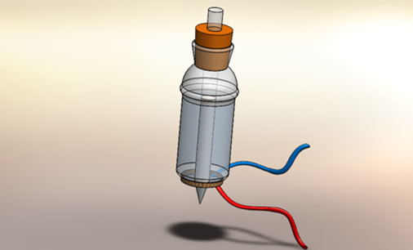
Powder sample

Deionized water
Ceramic piezoelectric ring
Dispensing nozzle
Figure 1 Dispensing unit of the ultrasonic vibration controlled micro-feeding system
In this paper a novel ultrasonic dry powder micro-feeding system (dry powder printer) ⁴⁰⁻⁴³ is used to fabricate HA and β-TCP libraries to demonstrate the feasibility of dry powder biomaterials library fabrication. Further processing and characterization of the libraries will be reported elsewhere. HA and β-TCP and biphasic calcium phosphate (mixture of HA and β-TCP with different ratio) are among the most widely used materials for bone tissue regeneration. Different HA/TCP ratio has effect on speed of new bone formation and new bone attachment levels.

Comparing with most powder handling methods involve mechanical devices, such as pneumatic methods⁴⁶, volumetric methods, screw method and electrostatic methods⁴⁷, this dry powder printer is a simpler solution for dry powder dispensing. A wide range of powders of different particle size, density, flowability, distribution and shape have been successfully dispensed. The dispensing speed could be as high as one dose per second with controllable dispensing mass from micrograms to grams for each dose. In this paper, the design of the dispensing unit and the dosage control of nano HA and TCP are discussed followed by libraries fabrication using the nano dry powder printer.

Methodology

Materials
Nano size hydroxyapatite powder was obtained from Merck KGaA, Darmstadt, Germany; CAPTAL® R Sintering grade hydroxyapatite (Batch P201), CAPTAL® S Sintering grade hydroxyapatite (Batch P221S BM168) and β-tricalcium phosphate (β-TCP, Batch P228S) were obtained from Plasma Biotal Limited, UK.

Experimental Method
An ultrasonic controlled micro-feeding system was used for dispensing biomaterial powders. This system employs ultrasonic vibration to initiate and control the powder dispensing from a fine nozzle, which is fixed in the middle of a glass water tank with a piezoelectric ring (SPZT-4 A3544C-W, MPI Co., USA) attached at the bottomError: Reference source not found (Figure 1).

The experiments were performed in a glove box dried using anhydrous calcium sulfate as the desiccant at room temperature (Figure 2). The computer and D/A card (NI6733, National Instruments Corporation Ltd. Berkshire, UK) generate a voltage signal with different waveforms, frequencies and amplitudes. This signal was output to a power amplifier (50w, Sonic Systems Ltd, Somerset, UK) which excited the piezoelectric transducer using high frequency signal (approximately 42kHz). The nozzles were drawn from 10mm O.D. (outside diameter) and 8mm I.D. (inside diameter) glass tubes.

The powder dose mass was verified by a microbalance (2100mg ± 0.1µg, SE2, Sartorius AG, Germany) which is capable of sending data every 0.4s to the computer. The stabilization time of the balance is normally 5-10 second, which is longer than the dispensing time. To wait the stabilization of the balance, a 5-10s of longer cycle time is used between each dispensing, which is however not necessary during the high throughput libraries fabrication. The data storage of microbalance and signal generated from the D/A card were both controlled using a Labview program compiled in house. As two main control factors, Time of Vibration (T_{v}) and Amplitude of Voltage can be adjusted in the program interface.

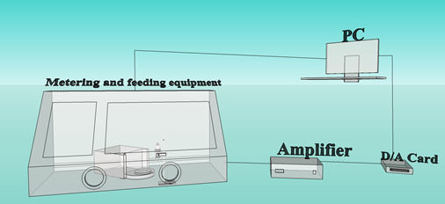
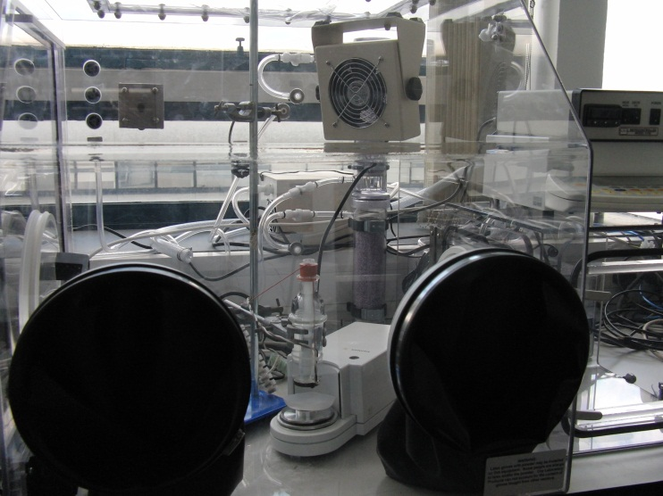
Particle size distribution of sample powders was measured by laser diffraction method (HPPS, Malvern High performance particle sizer , Worcestershire, UK). Morphological of the powders were observed using scanning electron microscopy (SEM, Zeiss (LEO), 1455 VP). An oscilloscope (LE CROY LC574AM, USA) was used to monitor the amplitude of the signal from the amplifier. The angle of repose of the dry powders was measured by dispensing the powder onto a horizontal surface from the glass nozzles assisted by vibration and measured from digital pictures taken from horizontal direction using software MB-Ruler (Freeware, http://www.markus-bader.de/MB-Ruler/).
Microbalance
Dispensing Unit

These very fine particles of hydroxyapatite and β-TCP tend to form aggregate caused by cohesive forces. To break large aggregates, the powders were sieved using a 355 µm test sieves before filling into the dispensing nozzles. All of the samples were dried and kept in a desiccator for one week before dispensing.

Libraries fabrication with micro-feeding device
Different biomaterial powders were loaded into different dispensing units which were independently controlled and mounted on a computer controlled XY table. Different amount of the powders were dispensed into each well of microplate according to the library design. The microplate can move along x-axis and y- axis at high speed (Figure 3). When more than one dry powders were dispensed in each wells, a vortex mixer (SA8, Stuart®, Bibby Scientific Limited, UK) was used to mix prepared samples within the microplate after the dispensing of all of the powders. A high throughput ball milling machine can also be used for a better mixing⁴⁸.
Figure 2 Experimental arrangement of the ultrasonic vibration controlled micro-feeding system

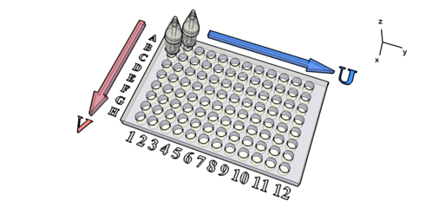
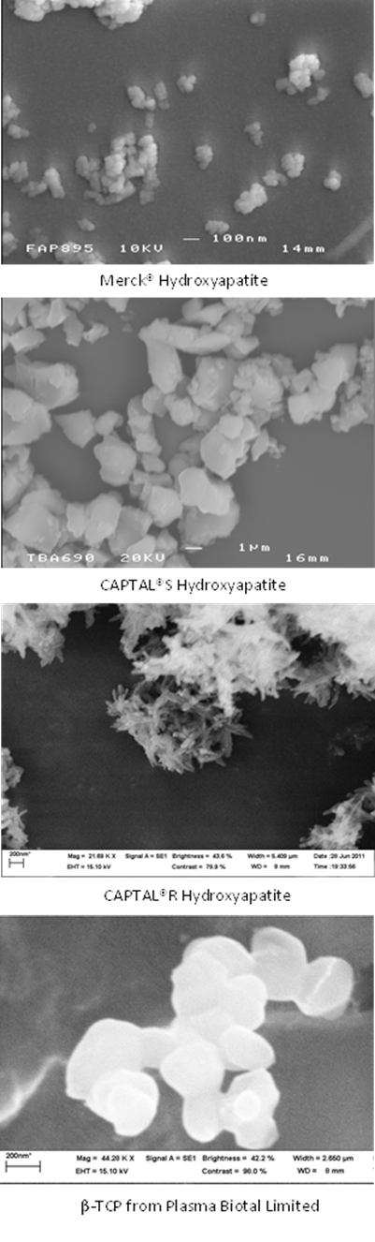
Result and Discussion
Figure 3 Schematic diagram of HT library fabricated in a microplate using the dry powder printer with two independently controlled dispensing units in which different powders were loaded.

Powder characterization
From the SEM pictures in Figure 4, Merck® Hydroxyapatite, CAPTAL® R and β-TCP are very fine powders which have particle size about 50-300nm, 20-200nm and 100-500nm respectively (Table 1). The CAPTAL® S has bigger particle size which is about 500nm-3µm, due to the sintering and grinding process during the powder manufacturing. Merck® hydroxyapatite powder and β-TCP have near spherical shape. The CAPTAL® S has angular shape and CAPTAL® R has long needle shape. The results of particle size from the HPPS (Figure 5) are much larger than size observed from SEM. This may be due to strong agglomeration between nano size powders which are difficult to disperse in liquid, and also imply that dry dispensing method may be better than slurry based dispensing.
200nm
200nm
Table 1 Characterization of particle size, shape and angle of repose
Powder | Particle size | Particle morphology | Angle of repose
Merck HA | 50-300nm | Near spherical | 55.2±3.5
CAPTAL S | 500nm-3µm | Angular | 51.5±2.7
CAPTAL R | 20nm (width)-200nm(length) | Needle shape | 60.3±3.1
β-TCP | 100nm-500nm | Near spherical | 58.2±2.5
Figure 4 Scanning electron microscope images of biomaterial samples
The angle of repose of Merck® Hydroxyapatite, CAPTAL® R, CAPTAL® S and β-TCP are 55.2， 60.3， 51.5 and 58.2 respectively (Table 1). Generally the powder with angle of repose greater than about 40 degree is classified as cohesive and non-free flowing powder which is difficult to dispense in traditional dry powder handling methods. From the angle of repose measurement, the powders used in this study are all cohesive powders. The needle shape of particles makes CAPTAL® R powder even more difficult to flow.

Design of dispensing unit
It has been found that the dispensing mechanism of powder is strongly related to the powder properties, such as particle size, particle shape, angle of repose etc, and dispensing unit properties, such as piezoelectric ring’s location, water height and the size of the nozzle⁴⁰. The glass tube has several parameters to be considered for a specific powder in the dispensing system, i.e. nozzle size, angle of the nozzle and diameter of the tube.

The powder flow is controlled by the formation of dome structures in the nozzle which should be small enough to avoid a free flowing without vibration. The powder started to flow from the nozzle tip when the vibration started to break the powder domes, and stopped to flow when the vibration ceased. During the dispensing process, the powder should flow continuously under the vibration. For free flowing powder, nozzle size D should be at least two fold but less than 5 fold of the particle diameter d in order to achieve a good switching control of the flow (2<D/d<5) ⁴⁹. For non-free flowing powder, the range of nozzle size can be much wider because the fine particles tend to form agglomerates caused by strong interparticle forces and show poor flowability . Normally the nozzle size for nano powders can be selected from about 0.2mm to about 6.5mm, which gave great flexibility on the nozzle selection and dosage control.

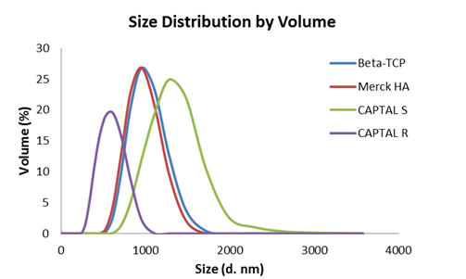
The angle of nozzle was designed to be larger than the angle of repose of the specific powder, to avoid a rat hole flow and dead zone in the nozzle⁵². A series of capillaries with angle from 50° to 80° were made to apply to different type of powders. The angle of the capillaries used for the dispensing biomaterials powders in this paper is selected from 75° to 78°. The value of the angle was calculated from average of at least three readings.
CAPTAL S
β-TCP
Merck HA
CAPTAL R
Figure 5 Particle/Agglomerate size distribution of biomaterial samples

The particles of these biomaterial powders are often found sticking on the surface of glass capillary or to each other due to interactions between a particle and surface of another material or between particles of the same material which act as strong adhesive and cohesive forces. Because the fundamental mechanisms for the occurrence of van der Waals forces are of electrostatic nature, the primary source of particle adhesion and cohesion is electrostatic forces⁵⁰. Powder particles can acquire charge in many different ways such as by triboelectric charging with other contacting materials, corona ions, or by induction in an externally applied electric field, etc..⁵³ In the dry powder dispensing system, the electrostatic force has negative effect on the uniformity of the dispensing by immobilizing particles to the wall of glass capillary. To avoid electrostatic effect during dispensing, aluminum doped zinc oxide (AZO) film is coated on the surface of the glass tubes and nozzles, following the method of dip coating of ZnO: Al sol gel by T. Schuler et al. ⁵⁴. The coated tube is earthed during the dispensing.

Data analysis and studies on dosing uniformity
The flow of powder in this dispensing unit is driven by the vibration transmitted through the water and also partially generated from the water. The water filled in the tank has mainly two functions in this device: as a media to transmit the ultrasonic vibration initiated by the piezo ring; as a working liquid to generate cavitation to strengthen the vibration⁵⁵. The vibration of dispensing unit is probably the superposition of both effects mentioned above. However, the cavitation
effect on the flowability of powder sample in the capillary is not well understood so far.
Mean dose mass | 0.5791 | mg
Standard deviation | 0.0221 | mg
Relative standard deviation | 3.81 | %

The accumulated dose mass was recorded by the microbalance during the dispensing. A staircase curve of accumulated dose mass against dispensing time is shown in Figure 6. The microbalance is stabilized during the interval of every two pulse signal which gives a platform in the curve. The peaks in the curves are due to impact of the ultrasonic vibration to and powder falling on the balance. The height between every two platforms gives the dose mass of dispensed samples. Obviously, if the discrete doses are uniform during the dispensing, the staircase should forward evenly and the gradient of the curve should be a constant. A run chart is used to show mass of each dose in Figure 7. The experiment result was evaluated based on the mean dose mass of samples and their relative standard deviation.
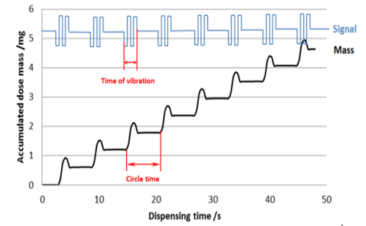
Figure 6 Accumulated dose mass vs dispensing time ( CAPTAL® R sintering grade hydroxyapatite dispensed by 0.5s vibration).
Figure 8 shows the dosing results of dispensing of those four nano biomaterials from 1.0 mm nozzle at different time of vibration. The linear increase of accumulated mass demonstrated the uniformity of dosage in this method.
Figure 8 Dosing results of different samples with a 1.0 mm nozzle at different time of vibration

High-speed camera was used to investigate the flow behavior of the powders around the nozzle. All of the powder was “extruded” out as discrete rods due to the strong agglomerations (Figure 9). In the dispensing process, some powder cracks might formed in the nozzle randomly, shown in Figure 9. The movement difficulties of sticky nano powder lead to uneven packing densities in different positions of the nozzle. The unpredictable crack would distinctly bring deviations to the amount of dispensed powders for each dose. To reduce the chance of crack forming, higher amplitude is preferred and used.
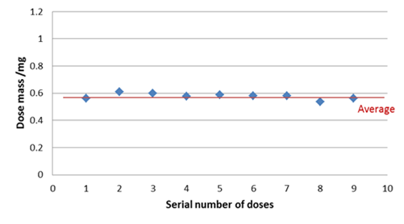
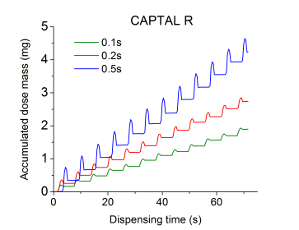
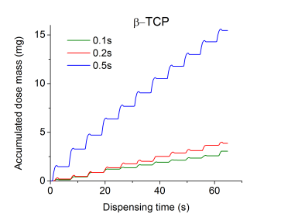
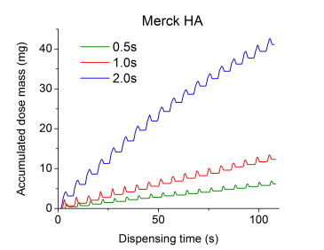
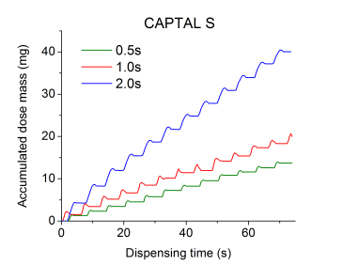

Figure 7 Dose mass distribution of CAPTAL® R sintering grade hydroxyapatite dispensed by 0.5s vibration.

The dose mass control with Time of Vibration on micro-feeding of biomaterial powders

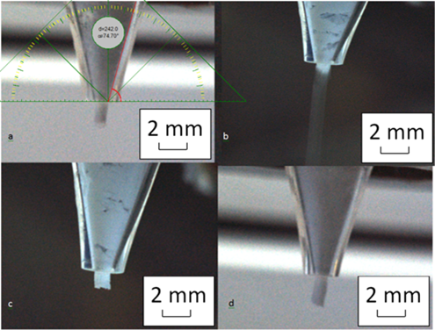
The dosage can be varied by changing a few parameters in the dry powder dispensing unit. However, one of the most easiest and convenient way is to change the Time of Vibration, T_{v}. T_{v} normally varied from 0.01s to a few seconds, which is the most significant approach to change the dose mass, from a few micrograms to several grams. In other word, by adjusting T_{v}, arbitrary mass of dispensing is available once the dispensing unit is calibrated.
Figure 9 High-speed camera images of powder flow during the dispensing. (a) Merck® Hydroxyapatite; (b) CAPTAL® R Hydroxyapatite; (c) CAPTAL® S Hydroxyapatite; (d) β-TCP from Plasma Biotal Ltd.

Table 2 Dosing results of different samples with a 1.0 mm nozzle at different time of vibration, 750V signal amplitude
Sample | T /s | Mean dose mass /mg
Merck HA | 0.5 | 0.1602
Merck HA | 1.0 | 0.6313
Merck HA | 2.0 | 2.3175
CAPTAL S | 0.5 | 1.0318
CAPTAL S | 1.0 | 1.349
CAPTAL S | 2.0 | 3.3762
CAPTAL R | 0.1 | 0.1594
CAPTAL R | 0.2 | 0.2509
CAPTAL R | 0.5 | 0.374
β-TCP | 0.1 | 0.3096
β-TCP | 0.2 | 0.3842
β-TCP | 0.5 | 1.4533
The deformation of particle agglomerates is caused by stress from vibration and gravity when the pulse signal starts. The vibration of the glass tube wall results in separation of particles from the wall and the decreasing of the friction as well. Then the fine powders are extruded by the pressure of the powder in the tube which is almost a constant according to Janssen theory for the pressure in a tall bin⁵². Therefore, the dispensing speed is almost uniform during the dispensing, and as the time of the vibration increases, the dosage increases almost accordingly (Table 2 and Figure 10).

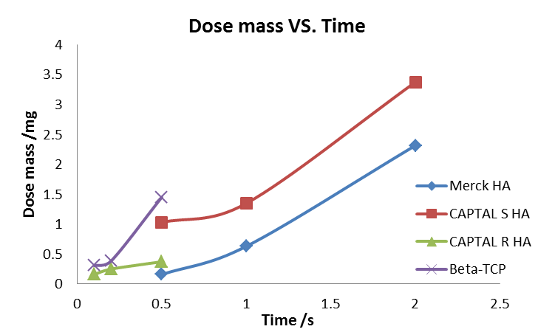
Changing the amplitude of signals voltage is another way to control the dose mass. However, the output voltage of ultrasonic amplifier was almost a constant at approximate 750V probably due to saturation of the output from the ultrasonic power amplifier.
Figure 10 Mean dose mass of Merck® Hydroxyapatite, CAPTAL® S Hydroxyapatite, CAPTAL® R Hydroxyapatite and β-TCP against time of vibration at 750v amplitude in 1.0 mm nozzle

The effect of nozzle size on dispensing of biomaterial powders
The fine powder can be dispensed from nozzles with a large range of different nozzle size. However, it is often found that intermitted dispensing if the nozzle size is too small, or over-run if the nozzle is too big. Therefore nozzle size should be optimized according to particle size, particle shape and flowability to reach a better dispensing uniformity. A set of parallel experiments were performed with 0.8 mm and 1.0 mm nozzles. The other conditions such as signal amplitude, time of vibration were kept constant during the nozzle size comparison.

As shown in Figure 11, the dose mass of all of biomaterial powders increased when use the bigger nozzle size 1.0mm compared to 0.8mm. From this figure the CAPTAL® S has highest flow rate at the same flow condition compared with other powders. The Merck powder has the lowest flow rate. This can be explained from the particle size and shape shown in the SEM picture, and the manufacturing process of the materials. CAPTAL® S was sintered and re-grinded which has bigger particle size, rounded particle shape and less agglomeration which gave better flowablity. The Merck® HA has very fine particles which formed very strong agglomeration and lowest flowability.

Beverloo and co-workers⁵⁶ derived a general equation to predict the free flow rate of coarse grains through an orifice,
(1)

Where W is the flow rate in g/min, ρ_{B} is the bulk density of powder in g/cm³, g is the gravitational acceleration, D₀ is the diameter of the circular orifice, d is the particle size. However, this equation can not be applied to the nano bioceramic flow rate from much smaller nozzles in this paper. Attempts have been made to derive a new equation (2) using same form as Beverloo used but with different parameters.

(2)

However, only the dispensing results of CAPTAL® R and β-TCP fitted the Eq. (2) well but not the case of Merck® HA and CAPTAL® S. The flow rate of non-free flowing powder is more complicated than that of free flowing powder due to its sensitivity to other environment conditions such as temperature, relative humidity etc.

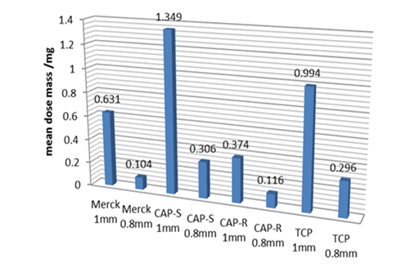
High-throughput experiment design and libraries fabrication
By the dispensing of controllable powders dosage using the micro-feeding system, different type of libraries can be designed and fabricated.

The HA, TCP and HA/TCP mixture libraries can be fabricated following the designs in Figure . For library fabrication strategy represented in blue, different dosage of single material A is dispensed in different columns of the well plate (for example, 1mg in column 1, 2mg in column 2, etc). In each column, the wells are filled with same dosage. This design can be used for further dispensing of different solvents in different rows, to build a library with variable concentration of biomaterials in different solvents. This library can be used to screen solubility or effect of concentration of biomaterials in further experiments. As shown in red color, a similar library of material B can be designed with variable dosage at different rows. Those two libraries can also be mixed to form another library, by dispensing two different materials into one well plate using two nozzles, to produce a mixture of two different dry powder biomaterials with variable composition. According to different experimental requirement, more complex combinations can be achieved by changing strategy of dispensing two materials with different amount of dosage and accompanying with xy table to offer a positioning feeding. An example of a Merck® HA library following the design of Figure 12 (a) is shown in Figure (a), and a TCP library following the design of Figure 12 (b) is shown in Figure 13 (b).
Figure 11 Mean dose mass of Merck® Hydroxyapatite, CAPTAL® S Hydroxyapatite, CAPTAL® R Hydroxyapatite and β-TCP from different nozzle size vibrated with 1s at 750v amplitude

Conclusions
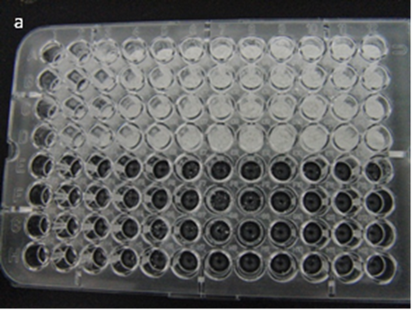
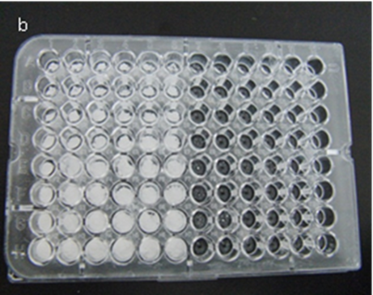
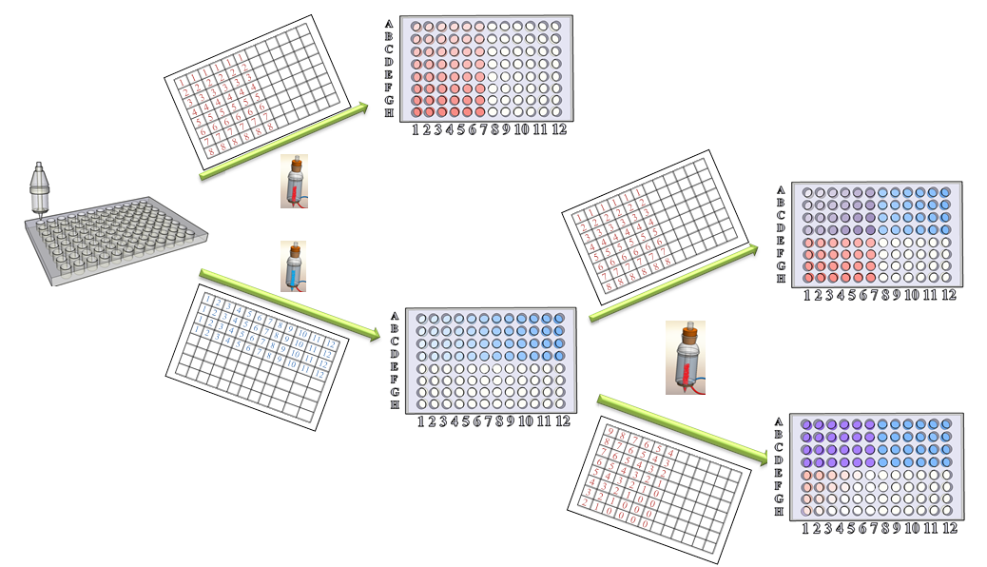
An ultrasonic dry powder micro-feeding system was used to fabricate nano size hydroxyapatite and β-tricalcium phosphate libraries. A few different biomaterials powders with different particle size, particle shape, flowability and particle size distribution have been successfully dispensed. The dispensing speed could be as high as one dosage per second with controllable dispensing mass from micrograms to milligrams for each dose. A few different library layout have been designed and fabricated to demonstrate the feasibility of this method which provides a platform for high-throughput experiments.
Material A
Material B
Mixture of A and B
a
b
c
d
Figure 12 Fabrication of HA, TCP and HA/TCP mixture libraries with micro-feeding system

Acknowledgments
The authors would like to thank EPSRC (Engineering and Physical Sciences Research Council) instrument pool, University of Southampton and China Scholarship Council for supporting this work.

References

1. X. D. Xiang; X. D. Sun; G. Briceno; Y. L. Lou; K. A. Wang; H. Y. Chang; W. G. Wallacefreedman; S. W. Chen and P. G. Schultz, Science 268, 1738-1740 (1995).
Figure 14 Dry powder biomaterials libraries fabricated in the microplate (a. Hydroxyapatite; b. β-TCP)
2. R. J. Hendershota; W. B. Rogersa; C. M. Snively; B. A. Ogunnaikea and J. Lauterbach, Catalysis Today 98, 375-385 (2004).
3. X. L. Weng; J. K. Cockcroft; G. Hyett; M. Vickers; P. Boldrin; C. C. Tang; S. P. Thompson; J. E. Parker; J. C. Knowles; I. Rehman; I. Parkin; J. R. G. Evans and J. A. Darr, Journal of Combinatorial Chemistry 11, 829-834 (2009).
4. U. Simon; D. Sanders; J. Jockel and T. Brinz, Journal of Combinatorial Chemistry 7, 682-687 (2005).
5. G. Frenzer; A. Frantzen; D. Sanders; U. Simon and W. F. Maier, Sensors 6, 1568-1586 (2006).
6. E. Danielson; M. Devenney; D. M. Giaquinta; J. H. Golden; R. C. Haushalter; E. W. McFarland; D. M. Poojary; C. M. Reaves; W. H. Weinberg and X. D. Wu, Science 279, 837-839 (1998).
7. J. S. Wang; Y. Yoo; C. Gao; I. Takenchi; X. D. Sun; H. Y. Chang; P. G. Schultz and X. D. Xiang, Science 279, 1712-14 (1998).
8. K. Fujimoto; K. Takada; T. Sasaki and M. Watanabe, Applied Surface Science 223, 49-53 (2004).
9. J. C. H. Rossiny; J. Julis; S. Fearn; J. A. Kilner; Y. Zhang; L. F. Chen; S. F. Yang and J. R. G. Evans, Solid State Ionics 179, 1085-1089 (2008).
10. E. Reddington; A. Sapienza; B. Gurau; R. Viswanathan; S. Sarangapani; E. S. Smotkin and T. E. Mallouk, Science 280, 1735-37 (1998).
11. R. Cremer and D. Neuschutz, International Journal of Inorganic Materials 3, 1181-1184 (2001).
12. H. Kionuma; Y. Matsumoto; M. Murakami; T. Shono; T. Hasegawa; T. Fukumura; M. Kawasaki; P. Ahmet; T. Chikyow and S. Y. Kioshihara, Science 291, 854-856 (2001).
13. G. Briceno; H. Y. Chang; X. D. Sun; P. G. Schultz and X. D. Xiang, Science 270, 273-275 (1995).
14. H. Chang; C. Gao; I. Takeuchi; Y. Yoo; J. Wang; P. G. Schultz and X. D. Xiang, Applied Physics Letters 72, 2185-17 (1998).
15. R. B. van Dover; L. D. Schneemeyer and R. M. Fleming, Nature 392, 162-164 (1998).
16. D. J. Scott; S. Manos; P. V. Coveney; J. C. H. Rossiny; S. Fearn; J. A. Kilner; R. C. Pullar; N. M. N. Alford; A. K. Axelsson; Y. Zhang; L. Chen; S. Yang; J. R. G. Evans and M. T. Sebastian, Journal of Chemical Information and Modeling 48, 449-455 (2008).
17. A. L. Hook; D. G. Anderson; R. Langer; P. Williams; M. C. Davies and M. R. Alexander, Biomaterials 31, 187-198.
18. C. G. Simon and S. Lin-Gibson, Advanced Materials 23, 369-387.
19. R. Hoogenboom; M. A. R. Meier and U. S. Schubert, Macromolecular Rapid Communications 24, 15-32 (2003).
20. J. J. Hanak, Journal of Materials Science 5, 964-971 (1970).
21. B. Gutte and R. B. Merrifield, Journal of the American Chemical Society 91, 501-2 (1969).
22. W. F. Maier; K. Stowe and S. Sieg, Angewandte Chemie-International Edition 46, 6016-6067 (2007).
23. D. C. Webster, Macromolecular Chemistry and Physics 209, 237-246 (2008).
24. G. Lowe, Chemical Society Reviews 24, 309-& (1995).
25. X. D. Xiang and P. G. Schultz, Physica C 282-287, 428-430 (1997).
26. T. Vossmeyer; S. Jia; E. DeIonno; M. R. Diehl; S. H. Kim; X. Peng; A. P. Alivisatos and J. R. Heath, Journal of Applied Physics 84, 3664-70 (1998).
27. H. M. Reichenbach and P. J. McGinn, Journal of Materials Research 16, 967-974 (2001).
28. X. D. Sun; K. A. Wang; Y. Yoo; W. G. Wallace-Freedman; C. Gao; X. D. Xiang and P. G. Schultz, Advanced Materials 9, 1046-49 (1997).
29. Y. Zhan; L. F. Chen; S. F. Yang and J. R. G. Evans, Qsar & Combinatorial Science 26, 1036-1045 (2007).
30. Y. L. Chen; J. R. G. Evans and S. Yang, Journal of the American Ceramic Society (2011).
31. S. F. Yang and J. R. G. Evans, Journal of Combinatorial Chemistry 6, 549-555 (2004).
32. T. A. Stegk; R. Janssen and G. A. Schneider, Journal of Combinatorial Chemistry 10, 274-279 (2008).
33. S. F. Yang and J. R. G. Evans, Materials Science and Engineering a-Structural Materials Properties Microstructure and Processing 379, 351-359 (2004).
34. S. F. Yang and J. R. G. Evans, Powder Technology 142, 219-222 (2004).
35. F. Gao; S. F. Yang; P. W. Hao and J. R. G. Evans, Journal of the American Ceramic Society 94, 704-712 (2011).
36. Y. Zhang; L. Chen; S. Yang and J. R. G. Evans, Journal of the European Ceramic Society 27, 2229-2235 (2007).
37. E. Tekin; B. J. de Gans and U. S. Schubert, Journal of Materials Chemistry 14, 2627-2632 (2004).
38. Y. Zhang; S. Yang; L. Chen and J. R. G. Evans, Langmuir 24, 3752-3758 (2008).
39. J. C. Meredith; J. L. Sormana; B. G. Keselowsky; A. J. Garcia; A. Tona; A. Karim and E. J. Amis, Journal of Biomedical Materials Research Part A 66A, 483-490 (2003).
40. X. S. Lu; S. F. Yang and J. R. G. Evans, Journal of Physics D-Applied Physics 39, 2444-2453 (2006).
41. X. S. Lu; S. F. Yang and J. R. G. Evans, Powder Technology 175, 63-72 (2007).
42. X. S. Lu; S. F. Yang and J. R. G. Evans, Particuology 6, 2-8 (2008).
43. X. S. Lu; S. F. Yang and J. R. G. Evans, Ultrasonics 49, 514-521 (2009).
44. E. B. Nery; R. Z. Legeros; K. L. Lynch and K. Lee, J. Periodont. 63, 729-735 (1992).
45. Y. B. Li; K. Degroot; J. Dewijn; C. Klein and S. V. D. Meer, J. Mater. Sci.-Mater. Med. 5, 326-331 (1994).
46. H. K. A.R. Gupte, H. Struth Device and process for drawing off very small quantities of powder. 21st Sept. 1982, 1982.
47. S. Yang and J. R. G. Evans, Powder Technology 178, 56-72 (2007).
48. S. R. Bysouth; J. A. Bis and D. Igo, International Journal of Pharmaceutics 411, 169-171 (2011).
49. S. F. Yang and J. R. G. Evans, Chem. Eng. Sci. 60, 413-421 (2005).
50. J. Q. Feng and D. A. Hays, Powder Technology 135-136, 65-75 (2003).
51. H. Y. Xie, Powder Technology 94, 99-108 (1997).
52. R. L. Brown and J. C. Richard, Principles of Powder Mechanics. (Oxford Pergamon, UK, 1970).
53. C. D. Hendricks, Charging Macroscopic Particles, ed. Moore, A. D., Chapter 4 (John Wiley & Sons Inc., New York 1973), pp. 57-85.
54. T. Schuler and M. A. Aegerter, Thin Solid Films 351, 125-131 (1999).
55. M. Anbar, Science 161, 1343-1344 (1968).
56. W. A. Beverloo; H. A. Leniger and J. V. d. velde, Chem. Eng. Sci. 15, 260-269 (1961).

Typeset names in 11 pt Times Roman, uppercase. Use the footnote to indicate the present or permanent address of the author.
State completely without abbreviations, the affiliation and mailing address, including country. Typeset in 11 pt Times italics.

