The role of light scattering in the performance of fluorescent solar collectors

**Nazila Soleimani,a Sebastian Knabe,b Gottfried H. Bauer,b Tom Markvart,a Otto L. Muskensc**

aMaterials Research Group, School of Engineering Sciences, University of Southampton, Highfield, Southampton. SO17 1BJ

bInstitute of Physics, Carl von Ossietzky University of Oldenburg, D-26111 Oldenburg, Germany

cSEPnet and Department of Physics and Astronomy, University of Southampton, Highfield, Southampton. SO17 1BJ

Nazila.Soleimani@soton.ac.uk; T.Markvart@soton.ac.uk; O.Muskens@soton.ac.uk

**Abstract.** A fluorescent solar collector (FSC) is an optoelectronic waveguide device that can concentrate both diffuse and direct sunlight onto a solar cell. The electrical output of the device depends strongly on the photon fluxes that are absorbed, emitted and trapped inside the FSC plate; for this reason, it is important to study the photon transport losses inside the collector. One of the losses in FSC is investigated to be scattering which increases the probability of the escape cone losses. The purpose of this work is to determine the scattering contributions in FSC by using angle dependence of light internally reflected in the FSC. The cause of the scattering in spin-coated PMMA on top of the glass collector is identified to be roughness from the top surface rather than bulk losses. This loss can be suppressed using an index-matching planarization layer.

**Keywords:** Fluorescent solar collector; Solar energy; Scattering; Scattering measurements.

1 Introduction

In a typical fluorescent solar collector (FSC), the luminescent light is trapped by total internal reflection (TIR) and guided to the edge of the plate where it can be harvested by a solar cell. One objective of the collector design is to reduce the size of the solar cell with respect to the area which collects light. Unlike their geometric counterparts, fluorescent collectors can accept light from a wide angle of incidence and are thus able to make use of the diffuse light.1 The photon flux at the edge of an idealized FSC is the product of the absorbed solar flux, the fraction of the trapped luminescence, and the geometric ratio of the area of the face directly exposed to sunlight *Af* divided by the area *Ae* of the edge that is covered by the solar cell. The geometric gain Ggeom of the FSC is then given by:

 (1)

Weber and Lambe (1976) initially suggested the concept of luminescence trapping for solar concentrators, which they named the luminescent greenhouse collector2. In experimental FSC devices, the emitted photon flux is less than ideal due to several loss processes, including reabsorption and scattering.1,2,3,4,5

In this work, we investigate the effect of surface scattering in realistic FCS devices based on a dye-doped PMMA layer on top of a glass slide. To characterize the photon transport inside the collector we monitor the angular distribution of a collimated light beam which enters the collector from the edge, after propagation and total internal reflection. We find that the surface scattering process is described well by Fraunhofer diffraction at surface inhomogeneities of a size of several m.

**2 Theory**

We calculate the effect of diffraction due to surface roughness on the FSC efficiency using the model developed by Weber and Lamb.2 In their model, they included the guiding of light in the FSC at angles larger than the critical angle for total-internal-reflection, c. Attenuation of reflected light by reabsorption is taken into account through an effective absorption coefficient e, while Fresnel reflection losses at the interface between the low-index FSC and the high-index solar cell is included through Fresnel’s reflection coefficients for s- and p-polarized light.

In addition, we include here losses caused by angular spread of the reflected light due to surface roughness. The effect is included as a divergence of angles with a Gaussian profile of 1/e half-width . Around the critical angle, this additional spread in angles results in part of the light to be lost within the escape cone. The angular distribution of light remaining after one reflection from the rough surface can be approximated from the convolution of the unit step function with the Gaussian diffraction function, resulting in the error function P()=erfc[(c-)/]/2. Under the condition that the scattering is only a small correction on the distribution function, the sequence of total internal reflections can be written as a multiplication of a number of error functions where the number is given by the amount of internal reflections from the rough surface. Inclusion of this effect in the Weber and Lambe model results in a total collection efficiency QC given by

 (2)

Here the number of total internal reflections from the rough surface is given by

 , (3)

where we have introduced the FSC thickness T. The brackets indicate the floor function which rounds NR to the largest previous integer.

Results were calculated for the collection efficiency of the FSC for a representative collector with index nc=1.5 coupled into a semiconductor of index ns=3.35. We assumed a thickness given by T=L/50, which is typical for a medium-scale FSC device with a geometric gain of 50. Different values of T will only change the total amount of scattering loss, not the qualitative response. Figure 1a shows computed values obtained by numerical integration of Eq. (2). The curve in absence of surface scattering (closed circles) corresponds to the Weber and Lambe result.2 Introduction of a surface roughness characterized by a =1.5° divergence results in a reduction of the efficiency by several percent (open circles). Also shown are the total (triangles) and relative (diamonds) scattering losses, where the latter is normalized to the collection efficiency for a smooth film (=0). The right-hand panel in Fig. 1 shows the absolute and relative scattering losses as a function of  for a value of eL=10-2, i.e. low reabsorption. Above =1°, the scattering loss increases roughly linear with the diffraction width . The loss percentage of 5% for 2.5° indicates the importance of surface roughness optimization in experimental FSC. For comparison we have also shown the results for T=L/5.2, which corresponds to the small-scale experimental configuration in this work. As can be seen the scattering loss does not scale linearly with the system size, i.e. the number of internal reflections, indicating that the majority of the loss is accumulated during the first few reflections. This can be understood from the fact that the angular range around the critical angle gets depleted of photons after the first few internal reflections and therefore the effect saturates.

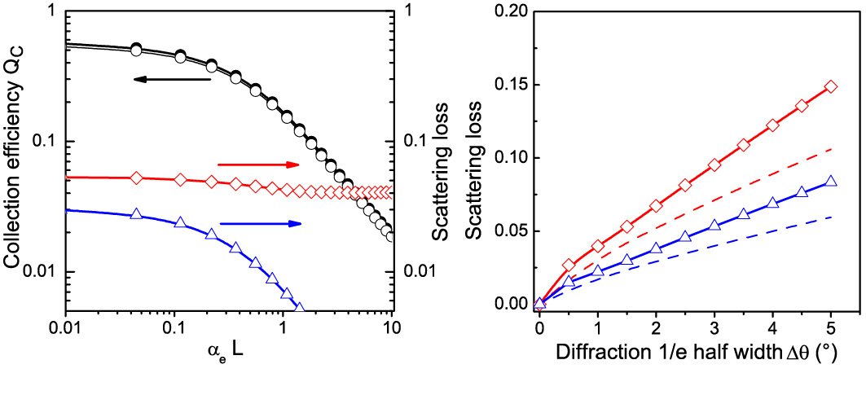 Figure 1. (Left) collection efficiency for the FSC as a function of eL calculated using the modified Weber and Lambe model Eq. (2), for a perfectly smooth surface (, closed dots) and a surface roughness characterized by ° and T=L/50 (open dots). (Triangles, blue) Absolute scattering loss and (diamonds, red) relative scattering loss normalized to the result for . (Right) (Triangles, blue) Absolute and (diamonds, red) relative scattering loss at eL = 10-2 as a function of the 1/e half width of the diffraction cone, for T=L/50 (symbols) and for T=L/5.2 (dashed lines).

**2 Method**

*2.1 Sample*

The substrate used in this study was a BK7 glass slide with dimensions of 26×26×5 mm3. Before depositing the layers the slides were thoroughly cleaned. A solution of 9% - 10% PMMA dissolved in Chlorobenzene (Micro Chem) was spin-coated (Laurell EDC-650-15TFM) at a speed of 4000 rpm for 1 minute. The thickness of the spin-coated layer was measured by using a profilometer (Talysurf-120 L, Taylor Hobson Ltd.) and was found to be 24.85 μm. The surface morphology of the PMMA layer was characterized using Atomic Force Microscopy. Figure 4 shows a representative AFM image revealing that the layer shows a roughness of around 48 nm over a typical correlation length of several m. This roughness may be associated with the relatively large thickness of PMMA required for fluorescent conversion in a realistic FSC, resulting in height variations during the spin-coating process. However, fluctuations may also be intrinsic to the polymer itself. Large scale heterogeneities have been observed even in very pure PMMA, and its nature may be related to local alignment of polymer chains and strain produced during the drying process.6

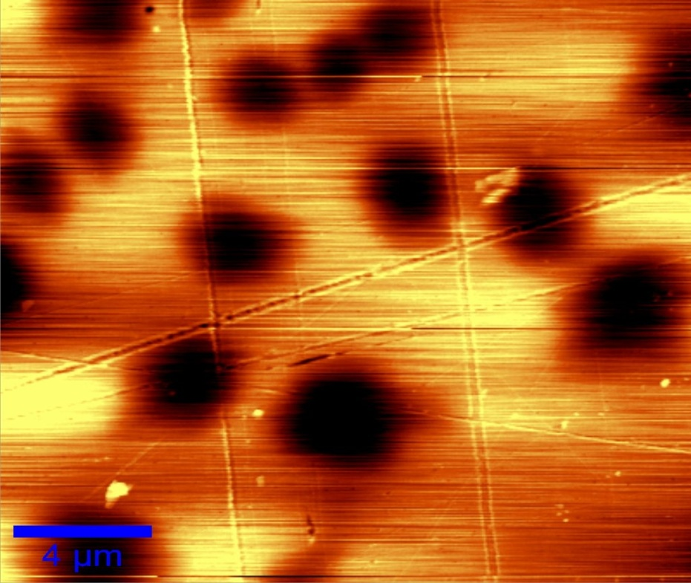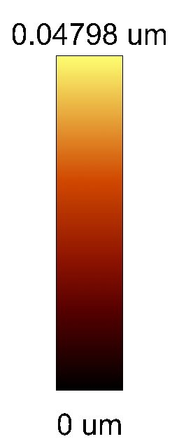

Figure. 2. Atomic Force Microscopy measurement of the PMMA layer, showing height fluctuations of ~48 nm over a distance of several m.

*2.2 Scattering setup*

For the characterization of light scattering, the samples were illuminated with a laser beam impinging from one side-edge of the glass. The sample was placed at the center of a circular goniometer table illuminated with a laser. A silicon photodiode (SM05PD1A, Thorlabs) was mounted at the edge of the table as shown in Fig. 3. The distance between the sample and the detector was 27 cm. A pinhole with a diameter of 1 mm was placed in front of the silicon photodiode which gives a solid angle for collection of 0.2°. A frequency of 185 Hz was applied via a chopper to the beam and the current was detected by a photodiode connected via a lock-in amplifier (SR810). The lock-in amplifier was used to decrease the noise of the measurement by locking in to the chopper frequency and the average of two current measurements, captured 1 second apart, was taken. The interface of this setup was programmed in Labview (8.6) software. A sample holder was fixed to the center of the goniometer table. The laser beam was aligned perpendicular to the surface of the sample, and the photodiode could be rotated around the table for measuring the scattered intensities at different angles. The scattered light intensity was measured between 0° and 180° with a scattering angle increment of 0.5°.

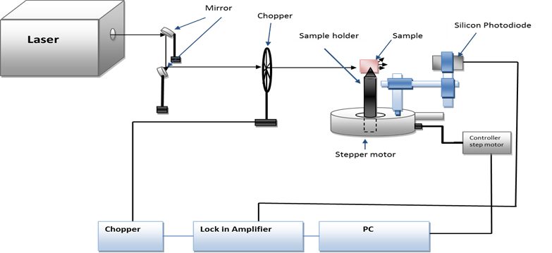 Figure 3. Schematic of the experimental setup for the angle-dependent scattering measurements.

## 2.3 Scattering measurement of FSC by angular dependence method

This section describes the method for measuring the scattering of PMMA spin coated on top of the BK7 glass by illumination from one edge in different incident angles and detection from another edge.



Figure 4. PMMA spin coated glass illuminate with laser light from one edge and the scattered light was detected from another edge at different angles, *θ1*=15° and N=14.21mm, M=11.79 mm. The error in this experiment was 0.8 mm which is the width of the laser beam.

The distance of M (distance from detector inside of the glass) can be calculated by

for *n2=1.5* and *n1*=1 (4)

, *N=26-M* . (5)

Values for *N* for different incident angle from one edge are shown in Table 1. If *N <26* mm, the probability that the light is totally internally reflected increases if *90-θ2* is more than the critical angle.

**Table 1.** Distance from the incident beam inside of the glass for different incident angle, the error in this calculation is 0.8 cm, given by the width of the laser beam.

|  |  |  |  |  |  |
| --- | --- | --- | --- | --- | --- |
| Angle of incidence | No. of TIRS | | Distance M(cm) | |  |
| 0° | 0 | N.A. | |  | |
| 15° | 1 | 14.21 | |  | |
| 35° | 2 | 6.04 | |  | |
| 45° | 3 | 4.77 | |  | |

For incident angles less than 8.3° there is no reflection inside of the collector. For incident angles between 8.3° to 24.6° there is one reflection inside of the collector, for the incident angles between 24.6° to 40.5° there are two reflections inside the collector, and for the incident angle of 45° there are three reflections inside the collector.

**3 Results**

Values of the intensity of scattered light measured over a range of angles are plotted in Fig. 5 for three different angles of incidence of 15º, 35º and 45º. To compare the results the maximum intensity for all the measurement was defined as 0º. Clearly, the light cone transmitted through the PMMA-coated FSC is considerably broadened compared to a bare glass slide. As seen in Table 2, the angular width of the scattered intensity cone increases for larger angles of incidence up to 45°*.* The width here is determined as the length over which the intensity drops to 1/e of the maximum. The measurements at 15° and 35° show the same width, which can be understood from the fact that the second internal reflection takes place at the opposite glass surface without PMMA. As we will show below, the observed behavior is consistent with diffraction of the laser beam caused by the roughness of the PMMA layer.

In a simple model, we include the diffraction by describing the reflected light as a collection of diffraction-limited cones with an aperture given by the correlation length of the surface roughness.



Figure. 5. Angular dependence of normalized intensity for different incident angles for 670 nm incident light. Lines: Gaussian fits.

Table 2. Beam width for different incident angles of incidence.

|  |  |
| --- | --- |
| Angle of incidence | 1/e half-width of the scattered beam (º) |
| 0° laser beam | 0.6 |
| 15° | 1.3 |
| 35° | 1.4 |
| 45° | 1.6 |

Thus, if we consider the PMMA surface as a collection of uncorrelated areas, the angular distribution of the reflected intensity can be fitted to the Fraunhofer diffraction formula for the circular aperture, given by7

 (6)

where the *G=πa2*, *a* is the radius of the aperture, *r* is the distance from observation point to shadow area, *λ* is the wavelength of the incident, *J1*is the Bessel function of the first order and *k* is the optical wavenumber.

Equation (6) gives us the intensity of the scattered light in different detection angles known as the Airy pattern. We note that the use of a Gaussian angular spread in Eq. (1) is a good approximation as the central lobe of the Airy pattern shows close agreement with a Gaussian profile.7 Good agreement is obtained for a radius of the aperture of 11 µm for the data taken at 670 nm wavelength and at 15º angle of incidence, as shown in Fig. 7.

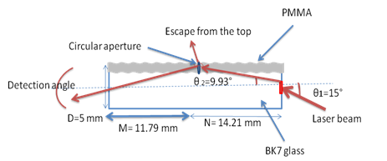

Figure 6. Scheme showing PMMA spin coated on top of the glass illuminate with laser light from one edge in incident angle of 15° and the forward scattered light detected at different angles. The roughness from spin coated PMMA is assumed to produce an effective circular aperture when the laser is reflected by the rough layer.



Figure 7. Normalized angular dependence of *I* in 15° incident angles in PMMA side for 670 nm. The solid line was fitted by using equation 4, circles indicate the experimental results.

The validity of the diffraction model can be verified by changing the optical wavelength. Figure 8 shows the scattered light intensity measured over a range of angles when we illuminate the sample from one edge at 15 degree through the PMMA part at different wavelengths of respectively 401 nm, 532 nm, 633 nm , and 670 nm. Clearly, the scattered light cones show a decrease in width for decreasing wavelength.

The Fraunhofer diffraction for the circular aperture was calculated when the size of the particle is fixed at 11 µm while the wavelength was decreased according to the used lasers. We find good quantitative agreement with our experimental results in Fig. 8 (lines), showing that the diffraction pattern gets more and more compressed into a narrow cone around the forward direction for shorter wavelengths.



Figure 8. Comparison of normalized scattering intensity at wavelengths of 670 nm, 633 nm, 532 nm, and 401 nm detected over a range of angles with illumination from 15° incident angles through the PMMA part of the sample.



Figure 9. Comparison of intensity of scattered light at a wavelength of 670 nm detected over a range of angles with illumination from 15° incident angles once when the PMMA top surface covered with the optical gel (circles, blue) and without optical gel (diamonds, green).

To further investigate the cause of the scattering in spin coated PMMA on top of the BK7 glass, the top surface in PMMA (*n*=1.49) part was covered by optical gel with refractive index of 1.4646(THORLABS). The surface tension of the gel produced a smooth film which compensated the surface roughness of the PMMA layer. Subsequently, the irradiance of scattered light as a function of angle was measured when illuminating the sample at a 15º angle of incidence. The results are compared with a measurement taken on the same sample before the gel was added. Results are shown in Fig. 9. As we can see, application of the optical gel results a decrease of the angular width of the scattering cone. This effect unambiguously shows that the cause of the scattering in spin coated PMMA on top of the glass is the surface roughness. Compared to the surface scattering contribution, the bulk scattering in this type of sample is negligibly small, i.e. of order 10-5 cm-1.6

It is relevant to consider whether diffraction effects play a role in the situation that the illumination is provided by mutually incoherent fluorescent molecules. To assess this we have to compare the divergence of a point source with the diffraction provided by the surface roughness. For example, when a point source illuminates an area of 10 m at a distance of 1 mm from the source, this corresponds to a divergence angle of 10-2 radians or 0.5º, i.e. smaller than the typical diffraction broadening in our samples. Therefore surface scattering losses are relevant for incoherent fluorescence emission at propagation distances larger than several hundred m, which is the case in FSC.

**4 Conclusion**

In summary, the contribution of light scattering in fluorescent solar collectors (FSC) based on a spin-coated dye/polymer layer was investigated. Measurements of the transmission cones as a function of total internal reflections (TIR) revealed that the predominant loss factor is surface scattering at the top layer, caused by roughness of the spin-coated PMMA.

Good agreement is obtained when we consider the PMMA roughness as an coherent aperture with a circular shadow therefore the angular distribution of the scattering intensity can be fitted using far-field Fraunhofer diffraction. The width of the scattered beam increases when the wavelength is increased from 401 nm to 670 nm, in good agreement with Fraunhofer diffraction for a circular aperture at different wavelengths where the size of the aperture is fixed to the value of 11 µm. This value is of the same order as the correlation length of the height variations observed in AFM measurements. The value of the scattering was found to decrease significantly when we cover the top surface with optical gel, which unambiguously shows that surface scattering is the predominant loss factor in our FCS compared to bulk scattering effects. Surface roughness is caused by to the large required thickness of the PMMA-dye layer for the operation of the FSC. Our results indicate that the performance of the FSC can be improved by using a subsequent planarization with a thin index-matching layer of low roughness.

**Acknowledgements** The authors would like to thank L. Danos for help with the experimental setup. This project was funded partly through UK SUPERGEN (Sustainable Power Generation and Supply) PV21 Programme.

**References**

1. A. Goetzberger, W. Greubel, Solar energy conversion with fluorescent collectors, *Appl. Phys*. 14,123–139 (1977).

2. W.H.Weber and J. Lambe. Luminescent greenhouse collector for solar radiation. *Appl. Optics*, 15, 2299 (1976).

3. J.S. Batchelder, A.H. Zewail, and T. Cole. Luminescent solar concentrators. 1: Theory of operation and techniques for performance evaluation. *Appl Optics*, 18, 3090 (1979).

4. J.S. Batchelder, A.H. Zewail, and T. Cole. Luminescent solar concentrators. 2: Experimental and theoretical analysis of their possible efficiencies. *Appl Optics*, 20, 3733 (1981).

5. P. Kittidachachan, L. Danos, T.J.J. Meyer, N. Alderman, and T. Markvart. Photon collection efficiency of fluorescent solar collectors. *CHIMIA*. 61, 780 (2007).

6. Y. Koike, N. Tanio, and Y. Ohtsuka, Light scattering and heterogeneities in low-loss poly(methyl metacrylate) glasses, *Macromolecules* **22**, 1367-1373 (1989).

7. E. Hecht, *4ed Optics*, Addison Wesley, 2002, Chap. 10.