Numerical Propeller Rudder Interaction Studies to Assist Fuel Efficient Shipping

Charles Badoe^{1*}, Alexander Phillips¹ and Stephen R Turnock¹

¹ Faculty of Engineering and the Environment, University of Southampton, Southampton, UK
Email: cb3e09@soton.ac.uk

* corresponding author

1. Introduction
The importance of a rudder cannot be understated; although relatively small, the hydrodynamic forces and moments developed on it are essential in the assessment of the manoeuvring characteristics of a ship. Additionally, ship rudders are almost always placed downstream of the propeller so they can take advantage of the increased local velocity due to the presence of the propeller. The knowledge of the interaction effects between the rudder and the propeller is a focal aspect for the improvement of ship’s performance. Propeller and rudder are considered as a propulsion unit in which the former is an active device that generates the thrust to keep the ship on move and the latter a control surface that produces the transverse force to keep the ship on course (Kracht 1992).
In this paper, a method for rapidly computing the flow field and integrated forces acting on a rudder in a propeller race is presented. Two different propeller models will be considered to aid in understanding the interaction effects; (a) body force propeller model and (b) real propeller geometry employing the use of arbitrary mesh interface (AMI) in the current version of OpenFOAM (this is currently under investigation). Numerical results will be compared with experiments by Molland and Turnock (1991, 1995 and 2007), using the modified Wageningen B4.40 propeller and Rudder No.2.
2. Theoretical approach
The open source CFD code Open FOAM (Open Field Operation and Manipulation) was used for the investigation. It solves the Reynolds Averaged Navier Stokes (RANS) equations using a cell-centered finite-volume method. The RANS equations can be written in the form:
$\frac{∂\overline{U_{i}}}{∂x_{i}}=0$ (1)

$ρ\frac{∂\overline{U_{i}}}{∂t}+ρ\frac{∂\overline{U_{i}U_{j}}}{∂x_{j}}= -\frac{∂P}{∂x_{i}}+\frac{∂}{∂x_{j}}\left\{ μ \left( \frac{∂\overline{U_{i}}}{∂x_{j}}+\frac{∂\overline{U_{j}}}{∂x_{i}}\right)\right\}-ρ\frac{∂\overline{{u^{'}}_{i}{u^{'}}_{j}}}{∂x_{j}}+f_{i}$ (2)

The Reynolds stress ($ρ\overline{{u^{'}}_{i}{u^{'}}_{j}}$) was modelled to close the governing equation by employing a Shear Stress Transport (SST) eddy viscosity turbulence model. The SST k-ω model was developed by Menter (1994) to effectively blend the robust and accurate formulation of the k-ω model in the near-wall region with the free-stream independence of the k-ε model in the far field. Previous investigations using this model has shown to be better at replicating flows involving separation, which is an important issue in the analysis of ship flow, where separation always occurs in the region of ship stern (Gothenburg, 2000).

3. Propeller modeling
Two alternative methods were adopted in this paper to account for the rotating propeller. One is the body-force approach and the other is the arbitrary mesh interface approach, in which the real geometry of the propeller is taken into account. The momentum equations (Eq. 2) include a body force term${ f}_{b_{i}}$used to model the effects of a propeller without modeling the real propeller. There are several approaches for calculating${ f}_{b_{i}}$including simple prescribed distributions, which recover the total thrust T and torque Q, to more sophisticated methods which require a propeller performance code in an interactive way with the RANS solver to capture propeller rudder interaction and to distribute${ f}_{b_{i}}$according to the actual blade loading. To implement the body force model in OpenFOAM an actuator disk region is defined where the rotor (propeller) is accounted for by adding momentum (volume force) to the fluid (Svenning, 2010). The radial distribution of forces, with components $f_{b_{x}}$ (axial), $f_{b_{r}}$radial) = 0 and $f_{b_{ɵ}}$ (tangential), is based on non-iterative calculation of Hough and Ordway (1964) circulation distribution with optimum type from Goldstein (1929) and without any loading at the root and tip. Stern et al. (1988) coupled this distribution with a RANS simulation and has been implemented in CFDSHIP-IOWA (2003). The non-dimensional thrust distribution $f_{b_{x}}$and torque distribution $f_{b_{ɵ}}$are:

$f_{b_{x}} = A_{x}r^{*}\sqrt{1-r^{*}}$ (3)
$f_{b_{ɵ}} = A_{ɵ} \frac{r^{*}\sqrt{1-r^{*}}}{r^{*}\left(1-{r^{'}}_{h}\right)+{r^{'}}_{h}}$ (4)

Where

$A_{x}= \frac{C_{T}}{△} \frac{105}{16(4+3{r^{'}}_{h})(1-{r^{'}}_{h})}$ (5)
$A_{ɵ}= \frac{K_{Q}}{△J^{2}} \frac{105}{π(4+3{r^{'}}_{h})(1-{r^{'}}_{h})}$ (6)

and the non-dimensional radius is defined as
$r^{* }= \frac{r^{*}-{r^{'}}_{h} }{1-{r^{'}}_{h}} , {r^{'}}_{h}= \frac{R_{H}}{R_{P}}, r^{*}= \frac{r}{R_{P}}$
$r= \sqrt{(y-Y_{PC})^{2} +(z-Z_{PC})^{2}}$
$C_{T}= \frac{2T}{ρU^{2}π{R_{P}}^{2} }$ (7)
$R_{H}$ - Radius of hub;$R_{P}$ - Radius of propeller
$K_{Q}$ - Torque coefficient ;$K_{T}$- Thrust coefficient
T - Thrust; J - Advance coefficient
$△$ - mean chord length projected into the x-z plane (or actuator disk thickness),

On the other hand, when a time-accurate solution for propeller/hull interaction (rather than a time averaged solution) is desired, the arbitrary mesh interface model to compute the unsteady flow field must be used. Our arbitrary mesh interface model followed Farrell and Maddison (2011) algorithm, using pimpleDyMFoam and its libraries for handling rotating meshes. The arbitrary mesh interface model for non-conformal patches is a technique that allows simulation across disconnected, but adjacent mesh domains. The domain can either be moving relative to one another or stationary. It is integrated into boundary patch classes within OpenFOAM and is available for un-matched/non-conformal cyclic patch pairs; sliding interfaces, e.g. for rotating machinery. AMI operates by projecting one of the patches’ geometry onto the other. However, it is also possible to project both patches to an intermediate surface, such as triangulated surface geometry.
4. Experimental data
The cases considered are based on wind tunnel test performed by Molland and Turnock (1991, 1995 and 2007) in the University of Southampton 3.5m x 2.5m RJ Mitchell Wind Tunnel, www(2012). The experimental set-up comprises of a 1m span 1.5 geometric aspect ratio rudder based on NACA 0020 aerofoil section (rudder No. 2). The propeller is 0.8m diameter and based on the Wageningen B4.40 series. The rudder geometry and its arrangement with respect to the propeller are given in Figure 1, the rudder is positioned at X/D = 0.39.
Figure 1: Rudder geometry and its arrangement in respect to propeller.
Source: Molland and Turnock (2007)

5.0 Numerical Model/Mesh Technique
The computational domain matched that of the RJ Mitchell wind tunnel, extending 8 rudder chord lengths upstream of the propeller plane and 12 rudder chord lengths downstream of the rudder trailing edge. The solver settings and simulation parameters can be found in Table 1.

An unstructured hexahedral mesh was created using the SnappyHexMesh utility within OpenFOAM. An initial coarse block mesh was created defining the size of the domain after which specific areas of interest within the domain were then specified for refinement in progressive layers. The total number of grid points was around 2.5 million. Figure 2 shows a cross section grid around the propeller-rudder geometry.

Figure 2: cross section grid around the rudder-propeller

Parameter | Setting
Mesh Type  No. of Elements  y⁺  Inlet  Outlet  Tunnel floor/side walls  Tunnel roof  Rudder  Propeller  Turbulence model | Unstructured (Hexa)  Approx. 2.5M  30  Freestream (10m/s)  Zero gradient  Slip  Slip  No Slip  Moving wall vel.  k- 𝝎 SST Turbulence
Table 1: Numerical model
6.0 Results and Discussions
The propeller-rudder combination using rudder No.2 were simulated at 9.6º, -0.4º and -10.4º for a wind speed of 10m/s and Reynolds number of 0.4 x 10⁶. The propeller was fixed at X/D = 0.39 and operates at an advance coefficient of J = 0.35, $K_{T}$= 2100 and $K_{Q}$= 0.28 Results are presented both for field and integral quantities.
6.1. Propeller (AMI) open water characteristics
Numerical prediction of propeller open water performance for an initial coarse grid is illustrated in Fig. 3. The thrust and torque were determined by integrating the pressure and friction forces over the propeller surface. Since the arbitrary mesh model is dependent on time steps, larger time steps led to over prediction of thrust. The operating conditions of the propeller for this investigation was J = 0.35, hence it can be concluded that with the initial coarse mesh resolution applied to the propeller, the numerical method was capable of giving reasonable estimates of thrust and torque coefficient at J =0.35, when compared with experimental results (as shown in Table 2), so for this purpose it should be possible to apply the results for investigating the forces on the rudder downstream.
6.2. Lift and Drag data
Figure 4 compares the lift and drag data from the rudder behind a propeller (using the body force propeller model) and an earlier investigation conducted for the same rudder in free-stream with experimental data from Molland and Turnock (2007). Results are also presented from Simonsen (2000) and Phillips (2009) who both performed similar investigation using CFDSHIP-IOWA and ANSYS CFX respectively. Simonsen (2000) also presented free stream lift and drag characteristics for a rudder using empirical formulas. These were proposed by Söding (1982) based on potential theory and experiments in Brix (1993). Freestream lift and drag data are also compared with these empirical expressions. Table 3 also compares dCL/dδ.
The results show good agreement at low angles of attack, where the flow is fully attached. There is a considerable increase in lift when the rudder is placed behind a propeller. This is due to the propeller race significantly increasing the inflow velocity to the rudder, see Figure 5.
The computed drag is predicted higher than found in the free-stream rudder. For both the rudder behind a propeller and the free-stream rudder cases the drag coefficient was marginally over-predicted. The over-prediction was higher for the rudder behind a propeller case. This could be due to several factors; first the wall boundary layer at the rudder root was neglected, this may also have contributed to the difference observed in the lift plot. Secondly the over prediction might also be due to frictional drag computation (laminar-turbulent transition). The numerical simulation assumes a fully turbulent boundary layer, while the flow over the experimental rudder was tripped from laminar to turbulent flow at a distance of 5.7% from the leading edge of the chord on both sides of the rudder using turbulence strips. The problem has been addressed by Hoffman et al (1989) who carried out investigations on “the Influence of Freestream Turbulence on Turbulent Boundary Layers with Mild Adverse Pressure Gradients”. They concluded that transition is a very sensitive flow phenomenon and, as such, can be strongly affected by experimental conditions (in particular, the level of freestream turbulence); CFD computations tend to overestimate the drag force.
6.3. Rudder Surface Pressure Distribution
To investigate the performance of the propeller code used for the investigation, pressure distribution was plotted at different spanwise locations on the rudder surface from the root to the tip. Since the inflow velocity to the rudder is greater than freestream accurate determination of the pressure distribution means that the correct inflow velocity to the rudder has been generated by the propeller model. Rudder inflow velocities were plotted and compared with experimental results (Figure 5). The propeller code could not recreate the inflow over the root but areas close to the hub and tip, the inflow velocities were created much better. Figure 6 also shows the plot of pressure distribution at eight spanwise locations of the rudder from the root to the tip. The computed pressure distribution represented by the local pressure coefficient Cp is given by C_{p =} $\frac{p - p_{∞}}{0.5ρU_{∞}^{2}}$ where $p - p_{∞}$ is the local pressure; ρis the density and U is the free stream velocity. Agreement was good in areas close to the tip Figs (span 940mm &970mm). The slight difference observed was as a result of the tip vortex, which introduces some unsteadiness which could not be captured by the solver. At mid chord (span 530mm; 705mm&880mm) areas close to the hub, pressure distributions were under predicted. The under prediction was due to the fact that the propeller code does not take into account the effect of the hub. Hence flow effect as a result of the hub could not be adequately captured. Since the floor boundary layer was neglected, interaction between the floor and the root could not be modeled. This was evident in the pressure plot for areas close to the root (span 70mm). Simonsen (2000) who performed similar investigation suggested that, if body force is not smoothly distributed around the entire actuator disk region there will be discrepancies between numerical and experimental results hence this was also evident in the results obtained.

7. Conclusions and future work
Results of the present work have shown how open source CFD codes can be applied to gain valuable insight into the interaction between the propeller and rudder. The results highlight that simple body force propeller approaches can be quickly and reliably used to predict rudder forces within 10% of experimentally calculated values. Alternative rudder geometries can be quickly generated and assessed to determine appropriate rudder shapes. Investigations are underway to predict the forces and pressure distribution of Rudder No.2 using the arbitrary mesh propeller model. The challenges highlighted by the findings are appropriate mesh design. The mesh could have been redistributed in order to resolve the slipstream flow better and allow smoother distribution of body forces. Future investigations will focus on this.

Acknowledgements

The author acknowledges the use of the IRIDIS High Performance Computing Facility, and associated support services at the University of Southampton in completion of this work.

References

Bertram, V. (2009), “Fuel Saving Options for Ships,” Annual Marine Propulsion Conf., London.

Brix J., ed. (1993), Manoeuvring Technical Manual, Seehafan Verlag GmbH, Hamburg, 1993.

CFDSHIP-IOWA, (2003), Hydroscience & Engineering, The University of Iowa100 C. Maxwell Stanley Hydraulics Laboratory Iowa City, Iowa 52242-1585.

Goldstein, S. (1929) "On the Vortex Theory of Screw Propellers", Proc. of the Royal Society (A) 123, 440.

Gothenburg (2000) Workshop, Journal of Ship Research, Vol. 47, No. 1, March 2003, pp. 63–8[15].

Hoffman, J. A., Kassir, S. M., and Larwood, S. M. (1989), “The Influence of Freestream Turbulence on Turbulent Boundary Layers with Mild Adverse Pressure Gradients,” NASA CR 177520.

Hough, G. and Ordway, D. (1964), “The Generalized Actuator Disk,” Technical Report TARTR 6401, Therm Advanced Research, Inc.

Kracht, A.M. (1992), “Ship-propeller-rudder interaction, Proc. Of the 2nd Int. Symp. on Propeller and Cavitation”pp.181 -190.

Larsson, L. and Baba, E. (1996), Ship resistance and flow computations. Advances in marine hydrodynamics. Ohkusu 9ed, Comp. Mech. Publ., pp.1-75.

Menter, F. R. (1994), Two-Equation Eddy-Viscosity Turbulence Models for Engineering Applications [J]. AIAA Journal, 32(8):1598-1605.
Molland, A. F. and Turnock, S. R. (1991), Wind tunnel investigation of the influence of propeller loading on ship rudder performance. Technical report, Ship Science Report No. 46.

Molland, A. F. and Turnock, S. R. (1995), Wind tunnel tests on the effect of a ship hull on rudder-propeller performance at different drift angles. Technical report, University of Southampton Ship Science Report No. 76.

Molland, A.F. and Turnock, S.R. (2007), Marine rudders and control surfaces: principles, data, design and applications, Oxford, UK, Butterworth-Heinemann, 386pp.
Simonsen, C. (2000), Propeller – Rudder interaction by RANS. PhD thesis, University of Denmark.

Söding, H. (1982), Prediction of Ship Steering Capabilities, Shiffstechnik, Bd. 29 pp.3-24.

Stern, F., Kim, H.T., Patel, V.C. and Chen, H.C. (1988b), “Computation of Viscous Flow around Propeller-Shaft Configurations,” Journal of Ship Research, Vol. 32, No. 4, pp. 263-284.

Svenning, E. (2010), Implementation of an actuator disk in OpenFOAM. Developed for 1.5dev.

University of Southampton website: www.windtunnel.soton.ac.uk/index.html, last accessed in May 2012.

Figure 3: Propeller free-stream (open water) characteristics

Open water details |  | Experiment |  |  | Calculated
RPM | J | ɳ | K_{T} | K_{Q} | ɳ | K_{T} | K_{Q}
2119.11 | 0.35 | 0.366 | 0.283 | 0.043 | 0.362 | 0.286 | 0.045

Table 2: Propeller free-stream (open water) characteristics J=0.35

Figure 4: Force data for rudder No.2 freestream (w/o propeller) and with propeller J =0.35

Table 3: Rudder lift performance
Data | dC_{L}/dδ
Molland &Turnock (2007)  Molland &Turnock (SSR90)  Simonsen(2000) H/O  Phillips(2009) H/O  Numerical H/O  Molland &Turnock(freestream rudder)  Emipical(freestream rudder)  Simonsen(2000) (freestream rudder)  Numerical (freestream rudder) | 0.132  0.136  0.147  0.136  0.129  0.0498  0.055  0.057  0.052

Figure 5: Rudder inflow velocity δ =9.6º

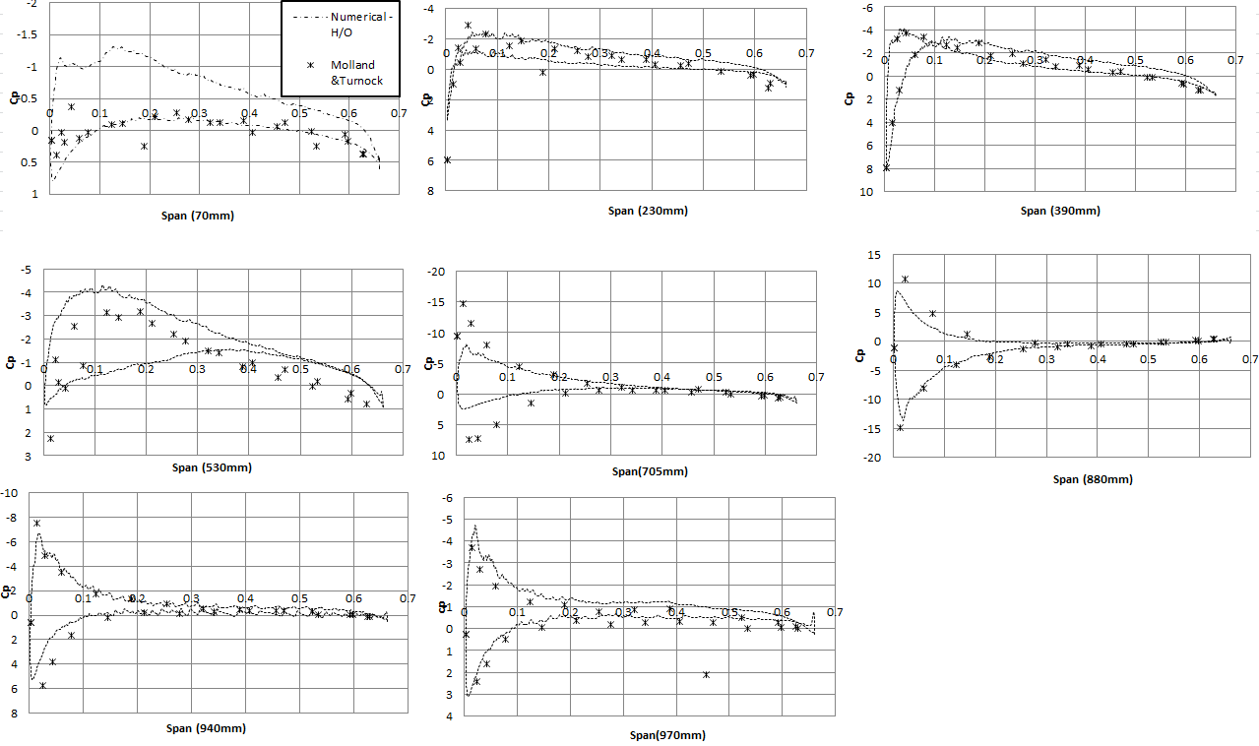
Figure 6: Rudder pressure distribution, J = 0.35 δ =9.6º

