COMBUSTION CHARACTERISTICS OF 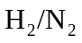AND 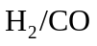SYNGAS NONPREMIXED FLAMES
K.K.J.Ranga Dinesh, X. Jiang, M.P.Kirkpatrick, W.Malalasekera
1. Engineering Department, Lancaster University, Lancaster, Lancashire, LA1 4YR, UK.
2. School of Aerospace, Mechanical and Mechatronic Engineering, The University of Sydney, NSW 2006, Australia.
3. Wolfson School of Mechanical and Manufacturing Engineering, Loughborough University, Loughborough, Leicestershire, LE11 3TU, UK.

Corresponding author: K.K.J.Ranga Dinesh, Engineering Department, Lancaster, Lancashire, LA1 4YR, UK.
Email: ranga.dinesh@lancaster.ac.uk. Tel: +44 (0) 1524 594578

Revised Manuscript Prepared for the International Journal of Hydrogen Energy

05th August 2012

Abstract:
Turbulent nonpremixed and syngas flames were simulated using 3D large eddy simulations coupled with a laminar flamelet combustion model. Four different syngas fuel mixtures varying from 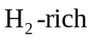to 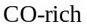 including 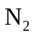have been modelled. The computations solved the Large Eddy Simulation governing equations on a structured non-uniform Cartesian grid using the finite volume method, where the Smagorinsky eddy viscosity model with the localised dynamic procedure is used to model the subgrid scale turbulence. Non-premixed combustion has been incorporated using the steady laminar flamelet model. Both instantaneous and time-averaged quantities are analysed and data were also compared to experimental data for one of the four flames. Results show significant differences in both unsteady and steady flame temperature and major combustion products depending on the ratio of and in syngas fuel mixture.

Key Words: Non-premixed combustion, Syngas, Hydrogen, Carbon Monoxide, Nitrogen, LES, Large Eddy Simulation, Flamelet model

1. Introduction
Clean energy generation processes are a crucial consideration in the design of modern thermal energy power units as combustion of fossil fuels continues to cause serious issues for the environment and the geopolitical climate of the world. Secure supplies of energy and chemical/combustion products are keystones not only of society but also of our industries. However, energy use has consequences that extend beyond immediate applications. Environmental impacts can be particularly significant in the case of fossil fuel combustion as this process contributes significantly to the emissions of nitric oxide, carbon monoxide and carbon dioxide (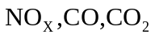) and unburned hydrocarbons. A prominent example for improvement is the reduction of greenhouse gas emissions during combustion, which still provides more than 80% of the energy supply worldwide. Saving of limited resources and reduced environmental impact by unwanted by-products are the driving force for intense research in combusting flows. Sixty years ago exhaust emissions such as 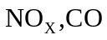and smoke were not a consideration, while now they need to meet strict emission regulations which are expected to become more stringent with time [1-4].

Clean energy and alternative energy have become major areas of research worldwide for sustainable energy development. Among the important research and development areas are hydrogen and synthesis gas (syngas) usage for electricity generation and transport technology [5]. Most of the world’s current supply of hydrogen is derived from fossil fuels and therefore development of clean energy technology would allow continued use of fossil fuels such as coal without substantial emissions of greenhouse gases such as 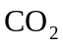 [6-7]. It can also balance the energy between supply and demand, a strategic and necessary choice for realising the coordinated development of energy, environment and economy [8]. In order to properly understand the effects of adding hydrogen to enrich hydrocarbon combustion it is important to understand the characteristics of combustion processes for syngas mixtures. Therefore ongoing development of hydrogen and syngas combustion technology as an appropriate type of future energy source is playing an increasingly important role in the clean energy strategy.

It is well established in the literature that hydrogen and syngas production from fossil fuel such as coal can have significant influence on modern day clean energy generation, particularly application of electricity such as integrated gasification combined cycle (IGCC) including possible treatment forcapture. Recently studies have shown substantial interest on IGCC technology to employ hydrogen and syngas fuels for the gas turbine combustion [9-10]. This integration of energy conversion processes provides more complete utilization of energy resources, offering high efficiencies and ultra-low pollution levels [11]. Ultimately IGCC systems will be capable of reaching efficiencies of 60% with near-zero pollution. The unique advantages of IGCC systems have led to potential applications of gasification technologies in industry because gasification is the only technology that offers both upstream (feedstock flexibility) and downstream (product flexibility) advantages. A series of important laboratory scale experimental investigations on syngas combustion are reported in the literature, including studies of the scalar structure of 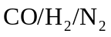nonpremixed flames [12], laminar flame speeds of 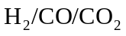 premixed flames [13], effects of nitrogen dilution on flame stability of syngas mixtures [14], and global turbulent consumption speed of syngas mixtures [15].
Non-premixed (or diffusion) combustion occurs in many thermal energy applications where fuel and oxidizer are not perfectly premixed before entering the combustion chamber. Because many practical combustion devices operate with non-premixed flames in the presence of turbulent flow, investigation of the characteristics of syngas non-premixed turbulent combustion has become important in order to gain a better understanding of modern combustion systems for clean combustion. In recent decades, computational combustion has made remarkable advances due to its ability to deal with a wide range of scales, complexity and almost unlimited access to data [16]. Large eddy simulation (LES) in which large scales are resolved and small scales are modelled, is evolving as an extremely valuable computational tool from which much can be learned [17]. In the simulation of turbulent combustion, the unsteady three-dimensional (3D) nature of LES has many advantages for turbulence modelling over the classical Reynolds-averaged Navier-Stokes (RANS) approach. However, since chemical reactions occur well below the resolution limit of the LES filter width, the technique requires a separate modelling strategy to predict the combustion characteristics. Several groups have employed the LES technique and different combustion models to simulate turbulent non-premixed flames which include equilibrium chemistry [18-20], steady laminar flamelet model [21-22], unsteady laminar flamelet model [23], flamelet-progress variable approach [24], conditional moment closure model [25], linear eddy mixing combustion model [26] and probability density function approach [27]. Nevertheless, there is a lack of knowledge on the general suitability of these models. In this context, experimental validation can play a significant role in assessing the model performance.

A detailed analysis of fuel variability and flame strucures of syngas mixtures is of fundamental importance. However, the majority of modelling investigations reported above focused on modelling aspects and validation, and did not provided sufficient details about flame characteristics with respect to variable syngas fuel mixtures. The objective of the present work is to perform LES for four different syngas non-premixed fuel mixtures and extract information from the numerical databases to analyse the effects of fuel variability and flame characteristics in the context of non-premixed syngas combustion. For this, a well established laboratory scale non-premixed turbulent jet flame configuration which burns a fuel mixture of 75% of 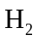and 25% of 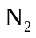is selected as a base case [28]. Four different syngas mixtures of and have been considered for a similar jet flame configuration with identical conditions except for changing fuel compositions, to enable the extraction of information with respect to fuel variability. For a better understanding, extensive analyses has been executed to uncover the origin of the found deviations. This is a continuation of our previous work in which we focused on low Reynolds number direct numerical simulation (DNS) of hydrogen non-premixed combustion [29]. The paper is organised as follows. Section 2 presents the governing equations and modelling followed by the details of numerical methods in section 3. Section 4 discusses simulated test cases followed by the results and discussion conclusion in section 5. Finally, conclusions from the study are drawn in section 6.

2. Governing Equations and Modelling
2.1. LES governing equations
LES is based on the premise that the large eddies of the flow are dependent on the flow geometry, making them highly anisotropic, whilst the smaller eddies are self similar and have a universal character, or are close to isotropy. In LES, the large scale motions of the flow are calculated exactly, whilst the effect of the smaller universal scales (so called sub-grid scales) are modelled using a sub-grid scale (SGS) model. A spatial filter is generally applied to separate the large and small scale structures. For a given function 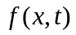the filtered field 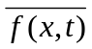 is determined by convolution with the filter function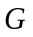
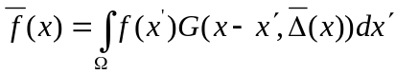, (1)
where the integration is carried out over the entire flow domain  and is the filter width, which varies with position. A number of filters are used in LES such as top hat or box filter, Gaussian filter, spectral filter. In the present work, implicit filtering by the numerical discretisation is used. This is approximately equivalent to a top-hat filter having a filter-width 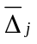 proportional to the size of the local cell. In turbulent reacting flows large density variations occur. These are treated using Favre filtered variables, which leads to the transport equations for Favre filtered mass, momentum and mixture fraction:
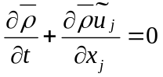 (2)
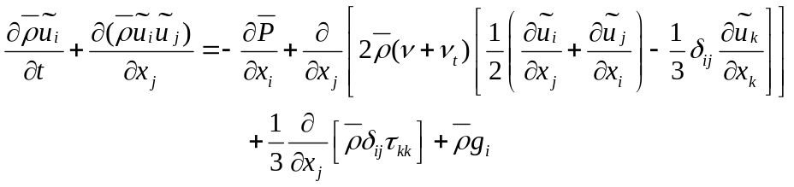 (3)
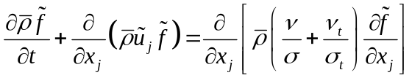 (4)
In the above equations 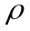 represents the density, 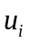 is the velocity component in 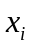 direction, 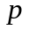 is the pressure, is the kinematic viscosity, is the mixture fraction, 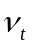 is the turbulent viscosity, is the laminar Schmidt number,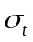 is the turbulent Schmidt number and 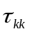is the isotropic part of the sub-grid scale stress tensor. An over-bar describes the application of the spatial filter while the tilde denotes Favre filtered quantities. The laminar Schmidt number was set to 0.7 and the turbulent Schmidt number for mixture fraction was set to 0.4. Finally to close these equations, the turbulent eddy viscosity in Eq. (3) and (4) has to be evaluated using a model equation.

2.2. Modelling of turbulent eddy viscosity
In this work, the turbulent eddy viscosity is calculated using the Smagorinsky eddy viscosity model. The Smagorinsky eddy viscosity model [30] uses a model parameter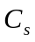, the filter width and strain rate tensor 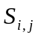 such that
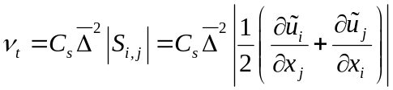 (5)
The model coefficient 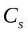is evaluated using the dynamic procedure which calculates the model coefficient dynamically using instantaneous local flow conditions. This dynamic procedure involves the application of two spatial filters and the model coefficient is computed dynamically as the calculation progresses (rather than being imposed a priori) based on the energy content of the smallest resolved scale. In addition to the grid filter, which separates the resolved and sub-grid scales, a test filter is used, whose width is larger than the grid filter width .Similar to grid scale filter, the test scale filter also defines a new set of stresses leading to a test level sub-grid scale tensor
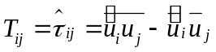 (6)
The resolved turbulent stresses or Leonard stresses
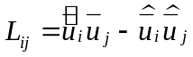 (7)
which represent the contribution of the smallest resolved scales to the Reynolds stresses, can be computed from the resolved velocity, and are related to the sub-grid scale stresses, 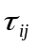by the identity of Germano et al. [31]
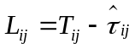 (8)
The sub-grid and sub-test scale stresses are then parameterised using the eddy viscosity approach
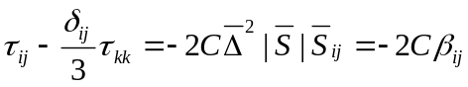 (9)
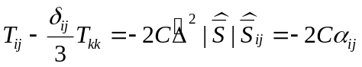 (10)
Substituting equations (9) and (10) into (8) yields
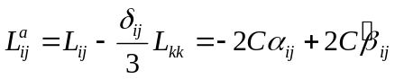 (11)
This is a set of five independent equations. To obtain a single coefficient from the five independent equations, Lilly [32] proposed to minimise the sum of the squares of the residual:
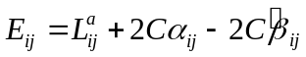 (12)
By contracting both sides (11) with 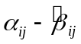to yields
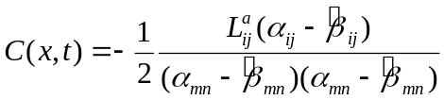 (13)
The Smagorinsky coefficient can be computed as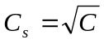.
However, Germano et al. [31] dynamic procedure involves the production of local negative eddy viscosity values which need further treatments. To avoid this difficulty, here we employed a less expensive localised dynamic procedure proposed by Piomelli and Liu [33], which involves finding an approximate solution to the integral equation by using the value of constant 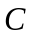at previous time step.

2.3. Modelling of combustion
Modelling of non-premixed combustion applications often requires the use of detailed chemistry models in two and three dimensional simulations. In order to account for the combustion chemistry, a modelling approach is required to capture the chemical reactions occurring at the sub-grid scale. Modelling of combustion applications frequently involves the use of detailed chemistry models including many chemical species and reactions. The laminar flamelet approach plays an important role in both laminar and turbulent combustion modelling [34]. Here we employed the steady laminar flamelet model which generates flamelets by solving one-dimensional flamelet equations for a laminar counter-flow configuration. The flamelet calculations were performed using the Flamemaster code developed by Pitsch [35], which incorporates the GRI 2.11 mechanism with detailed chemistry [36-37]. An assumed probability density function (PDF) for the mixture fraction is chosen as a means of modelling the sub-grid scale mixing with a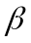 PDF used for the mixture fraction. Two key variables known as mixture fraction and scalar dissipation rate determine the thermochemical composition of the turbulent flame. The variables such as density, temperature and species concentrations depend on Favre filtered mixture fraction, mixture fraction variance and scalar dissipation rate. The joint probability density function (PDF)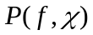 of mixture fraction 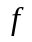and scalar dissipation rate 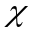 is used to determine the filtered values of temperature, density and species mass fractions. Thus the filtered value of the scalar variable is given by
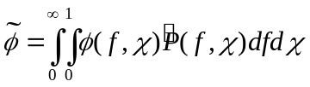 (14)
In the flamelet model, it is assumed that the mixture fraction and the scalar dissipation rate are statistically independent. Thus the joint PDF can be decomposed into two parts such that
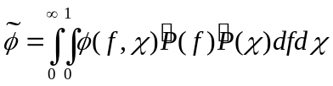 (15)
Here we use an assumed () probability density function (PDF) for the mixture fraction as a means of modelling the sub-grid scale mixing. The two independent PDFs can be written as
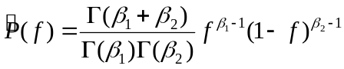 (16)
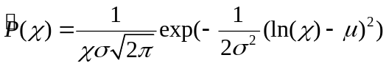 (17)
where
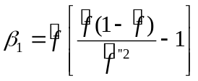
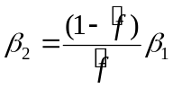
However the filtered mixture fraction variance 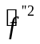and filtered scalar dissipation rate 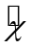still remain unknown quantities which need to be modelled. The mixture fraction variance and the scalar dissipation rate are modelled using the model equations:
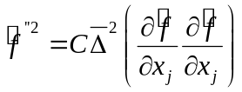 (18)
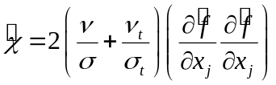 (19)
where 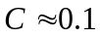has proved successful and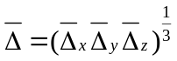.

3. Numerical methods
The set of equations noted above are solved by the large eddy simulation code PUFFIN originally developed by Kirkpatrick et al. [38-39] and later extended by Ranga Dinesh et al. [40-41]. PUFFIN computes the temporal development of large-scale flow structures by solving the transport equations for the Favre-filtered continuity, momentum and mixture fraction. The equations are discretised in space with the finite volume formulation using Cartesian coordinates on a non-uniform staggered grid. Second order central differences (CDS) are used for the spatial discretisation of all terms in both the momentum equation and the pressure correction equation. This minimizes the projection error and ensures convergence in conjunction with an iterative solver. The diffusion terms of the scalar transport equation are also discretised using the second order CDS. However, discretisation of convection term in the mixture fraction transport equation using CDS would cause numerical wiggles in the mixture fraction. To avoid this problem, here we employed a Simple High Accuracy Resolution Program (SHARP) developed by Leonard [42].
In the LES code, an iterative time advancement scheme is used to advance a variable density calculation. First, the time derivative of the mixture fraction is approximated using the Crank-Nicolson scheme. The flamelet library yields the density and calculates the filtered density field at the end of the time step. The new density at this time step is then used to advance the momentum equations. The momentum equations are integrated in time using a second order hybrid scheme. Advection terms are calculated explicitly using second order Adams-Bashforth while diffusion terms are calculated implicitly using second order Adams-Moulton to yield an approximate solution for the velocity field. Finally, mass conservation is enforced through a pressure correction step. Typically 8-10 outer iterations of this procedure are required to obtain satisfactory convergence at each time step. The time step is varied to ensure that the Courant number 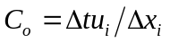remains approximately constant where 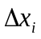 is the cell width, 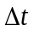 is the time step and 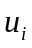 is the velocity component in the direction. The solution is advanced with a time step corresponding to a Courant number in the range of 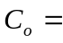0.3 to 0.6. The Bi-Conjugate Gradient Stabilized (BiCGStab) method with a Modified Strongly Implicit (MSI) preconditioner is used to solve the system of algebraic equations resulting from the discretisation.

Simulations for all four flames were carried out with the dimensions of 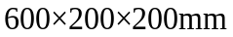 in the x (axial direction), y and z directions respectively and employed a non-uniform Cartesian grid with 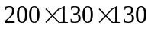 (approximately 3.4 million) cells. The mean axial velocity distribution for the fuel inlet is specified using a power law profile and turbulent fluctuations is generated from a Gaussian random number generator, which is then added to the mean axial profile such that the inflow has the same turbulence kinetic energy levels as those obtained from the experimental data [28]. A top hat profile is used as the inflow condition for the mixture fraction. All computations were carried out for a total time of 0.27s – enough to ensure that the solution has achieved a sufficient number of flow passes to provide good statistical data. Fig. 1 shows the three-dimensional (3D) geometry of the jet flame considered here (showing an iso-surface of the unsteady axial velocity of u=10 m/s obtained from the LES) and the dimensions of the computational box including boundary conditions used.
4. Simulated test cases
In the current investigation, four different syngas flames – two for 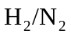and another two for 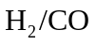fuel mixtures – have been considered. The flow conditions and fuel mixtures for all four flames are outlined in Table 1. Considering the fuel composition, four flames have been named as flame HN1 (75% 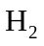 and 25%), flame HN2 (50% and 50%), flame HCO1 (70% and 30%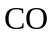) and HCO2 (30% and 70%). The base flame HN1 has been selected to correspond with a well-established experimental data archive [28], and the fuel mixtures of other three flames HN2, HCO1 and HCO2 have been selected to investigate the fundamental flame properties of important syngas fuel mixtures of, 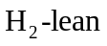and, 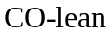flames. The configuration of all four flames consists of a D=8mm diameter fuel jet with a jet velocity of 42.3 m/s resulting in a Reynolds number of 9,300.

5. Results and discussion
LES of flames corresponding to four different syngas fuel mixtures named as flames HN1, HN2, HCO1 and HCO2 varying from to and to including have been performed. These compositions were chosen to cover potentially important syngas mixture variations. The flame characteristics including temperature and chemical compositions (major species) of the syngas non-premixed flames are provided here to illustrate the effects of fuel variability on the flame structures. The results focus on both temporal characteristics and time-averaged comparisons to obtain a good understanding of flame structures in the context of turbulent non-premixed syngas combustion. The results are discussed in two sub-sections: instantaneous flame structures and time-averaged flame structures. The focus of the discussion is on the effects of fuel variability on both instantaneous and time-averaged flame structures of syngas mixtures once the flame is fully developed.

5.1 Instantaneous flame structures
Fig. 2 displays instantaneous 3D iso-surfaces of flame temperature at various values from T=500K to the maximum flame temperature at time t=0.2s for the corresponding syngas fuel mixture. The effects of turbulence is clearly apparent in the topology of the 3D flames. Within a turbulent flow, the diffusion flame is continuously distorted and stretched by velocity fluctuations inducing inhomogeneities in the mixing of the reactants, which is clearly apparent from the 3D flame structures for all four syngas flames. One aspect of the spreading of the temperature field corresponds to the transient response induced by the turbulent mixing, which modifies the instantaneous temperature and chemical species and therefore the chemical activity. The other aspect is the fuel variability which significantly modifies the flame vortex structure and temperature values as a result of corresponding chemical and transport properties. Particularly, the and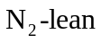flame HN1 display different vortical structures compare to the 50% / 50% fueled HN2 flame. Comparisons between HN1 and HN2 clearly demonstrate how the inert gas affects the flame structure of the non-premixed flame. The addition of totends to lower the flame temperature but increase the formation of vortical structures which eventually affects the diffusion process compare to andflame. While variation in theratio largely affects the flame dynamics including the flame temperature values, the ratio of seems to have a little effect on flame temperature but a large impact on formation of vortical structures and flame thickness. In Fig. 2, it can be seen that and flame HCO1 displays much larger and thicker pockets of maximum flame temperature (T=2200K), while and flame HCO2 exhibits smaller and thin pockets of maximum flame temperature (again T=2200K). In generally, instantaneous results in Fig. 2 demonstrate the influence of, and on flame temperature and flame thickness including small wrinkles of simulated non-premixed syngas flames.
Instantaneous two-dimensional streamwise and cross-streamwise contour plots of mixture fraction and flame temperature at time t=0.2s are shown in Fig. 3. Both streamwise and cross-streamwise instantaneous mixture fraction distributions betweenflame HN1and equally fueled flame HN2 display slight differences, but the differences are wider between flames of flame HCO1 and flame HCO2. Although the upstream distribution exhibits similar behaviour for all four flames, the downstream movement is significantly affected with respect to fuel variability particularly for the and flame HCO1 compared to and flame HCO2. This could be because of the differences in diffusivity associated with the amount of hydrogen available in the fuel. As expected, the streamwise and cross-streamwise temperature distributions display large differences between all four flames. The flame HN1 exhibits large pockets of high temperature compare to HN2 which supply equal amount of and. Both based HCO1 and HCO2 show large area of high temperature in the downstream region compared to the two based flames. However, the and flame HCO1 clearly demonstrates a much greater flame thickness downstream compare to all other three flames. It can be seen that the variations of transport properties and chemistry associated with fuel variability can change the mixing rate and accordingly the chemical heat release and temperature distributions. Having discussed the instantaneous structures of all four syngas flames the analysis now focuses on the time-averaged statistics.

5.2 Time-averaged flame structures
Time-averaged statistics were obtained by averaging the flame quantities after the initial stage of the simulation. Fig. 4 shows the contour plots of time averaged mean temperature for flames HN1, HN2, HCO1 and HCO2 respectively. All four flames show similar behaviour in the near nozzle region, but start to deviate at the far field. Particularly, the maximum mean temperature structures in the downstream centreline region differ significantly with fuel variability.
Radial profiles of time-averaged mean mixture fraction and mixture fraction variance are shown in Figs. 5 and 6. It is evident that the radial spread of the mean mixture fraction is in good agreement with the experimental measurements, but under predicted at further downstream for its variance. This is may be due to numerical diffusion associated with the SHARP advection scheme. This is difficult to avoid, since using a non-dissipative advection scheme would lead to unphysical values of mixture fraction. Overall predictions of mixture and its variance, however, show reasonably good agreement at all locations for the HN1 flame. As seen in Fig.5 (b), adding does slightly affects the centreline value of mean mixture fraction particularly at downstream (x=320mm), but largely follow a similar shape distribution for the mixture fraction variance. Again, the mixture fraction of andflame HCO1 follows a similar shape distribution and values as HN1, but exhibits different distribution for and flame HCO2. This behaviour is also apparent for the mixture fraction variance.
Fig.7 shows radial profiles of mean temperature at different downstream axial locations for all four syngas flames. In Fig. 7, it can be seen that the mean temperature is slightly under-predicted at x=80, 160mm and 320mm for flame HN1, which might be the result of the discrepancy of the calculated radial spread of the mean mixture fraction and mixture fraction compared to the experimental measurements. There might be other aspects which also cause small discrepancy between calculated results and experimental data such as the diffusion based molecular mixing rate and heat release may not have been well modelled. The flame may be subject to different shear effects associated with the fuel variability, while the selected flamelets with thermo-chemical properties extracted from the corresponding strain rates may not be accurate enough. However, given the large density gradient between and air, the comparison of the calculated temperature field with experimental data for flame HN1 is reasonable at the considered axial locations. In a steady diffusion flame, the heat loss by diffusion and convection is balanced by the heat release in the reaction zone. For the equally fueled HN2 flame, the peak flame temperature is much lower than that of the and HN1 flame. The high temperature in flame HN1 is mainly the result of the high level of diffusivity and reactivity of. However both the and flame HCO1 and andflame HCO2 display different mean temperature distributions particularly at the downstream region compared to the and HN1 flame. Both the flame HCO1 andflame HCO2 show similar maximum mean temperature. This might occur as a result of the higher molar heating value of, which tends to increase the flame temperature. However, more importantly radial profiles of flame HCO1 exhibits high temperature for far radial locations compare to flame HCO2, which confirms the occurrence of a greater flame thickness for the mixture compared to the mixture. Depending on high hydrogen or high carbon monoxide, the diffusivity level changes from one flame to another and thus leads to different heat release patterns. The temperature results of all four flames suggest that fuel variability plays a key role in determining the local flame temperature including flame thickness, both unsteadily and steadily.

The next parameters of interest are the combustion products. Figs. 8 and 9 show the mass fractions of 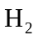and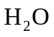. The comparisons between LES results and experimental data are reasonable for both mass fractions of and. The trends of mass fractions of are consistent with the mixture fraction while mass fractions of are consistent with those of temperature showing different peak values for all four flames. The highest values of and 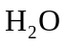mass fractions are gradually decreasing for HN2 and HCO2 with the lower amount of availability in the syngas fuel mixture. Since both HCO1 and HCO2 contain a sufficient percent of, Fig. 10 shows the time-averaged radial profiles of and at different downstream axial locations. It can be seen that the addition of in the fuel leads to both unburnt and burnt in the combustion products. Compared to but flame HCO1, but flame HCO2 show higher mass fractions of and as a result of high concentration in the inlet fuel syngas mixture. In all considered syngas flames, the steady laminar flamelet model appear to be sufficient to provide accurate predictions for the flame temperature and major species. However, quantifying the radical minor species such as hydroxyl (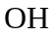) and nitric-oxide (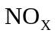) are more difficult in the steady flamelet framework. One possibility is to employ an unsteady flamelet model which would potentially quantify theand radical species more accurately.
6. Conclusions
The primary focus of this work was to examine the effects of fuel variability on flame characteristics of turbulent non-premixed syngas combustion using large eddy simulations. Four different syngas mixtures including two using and another two using have been considered. The fuel variability effects have been investigated by examining both the instantaneous flame structures and time-averaged flame properties.
It has been found that diffusivity of hydrogen dominates the flame characteristics and combustion dynamics of combustion. Particularly, higher diffusivity in the fuels leads to formation of a thicker flame than that found for thefuels. While the ratio has a minor influence on flame temperature, it plays a major role in flame thickness, strain rate and thus flame stability. The flame structure and maximum flame temperature largely depend on the syngas fuel compositions. Due to the high reactivity and diffusivity of, the flame structures of syngas flames are highly likely to be different than that of traditional natural gas flames. Further extraction of the quantities such as flammability limits, stretch sensitivity and extinction strain rate could permit us to quantitatively estimate the involvement of individual fuel properties in the complete momentum exchange, heat release and their impact on other aspects such as radiative energy transfer and radical combustion products of syngas flames for future clean combustion systems.
Acknowledgement
This research is funded by the UK EPSRC grant EP/G062714/2.

References
1. World Energy Technology Outlook-2050-WETO, EUR 22038, European Commission, 2007.
2. Akansu SO, Dulger Z, Kahraman N, Veziroglu TN. Internal combustion engines fueled by natural gas-hydrogen mixtures. Int J Hydrogen Energy 2004; 29: 1527-1539.
3. Lilik GK, Zhang H, Herreros JM, Haworth DC, Boehman AL. Hydrogen assisted diesel combustion. Int J Hydrogen Energy 2010; 35: 4382-4398.
4. Yu Y, Gaofeng W, Qizhao L, Chengbiao M, Xianjun X. Flameless combustion for hydrogen containing fuels. Int J Hydrogen Energy 2010; 35: 2694-2697.
5. Lieuwen T, Yang V, Yetter R. Synthesis gas combustion: Fundamentals and applications. CRC Press Taylor and Francis Group, FL, USA, 2010.
6. Miller B, Clean coal engineering technology, Butterworth-Heinemann, Burlington, MA, USA, 2011.
7. Gnanapragasam NV, Reddy BV, Rosen MA. Hydrogen production from coal gasification for effective downstream carbon dioxide capture. Int J Hydrogen Energyb 2010; 35: 4933-4943.
8. Lu X, Yu Z, Wu L, Yu J, Chen G, Fan M. Policy study on development and utilisation of clean coal technology in china. Fuel Process Tech 2008; 89: 475-484.
9. Descamps C, Bouallou C, Kanniche M. Efficiency of an integrated gasification combined cycle (IGCC) power plant including removal. Energy 2008; 33: 874-881.
10. Cormos C. Evaluation of energy integration aspects for IGCC-based hydrogen and electricity co-production with carbon capture and storage. Int J Hydrogen Energy 2010; 35: 7485-7497.
11. Mondol JD, MsIlveen-Wright D, Rezvani S, Huang Y, Hewitt N. Tecno-economic evaluation of advanced IGCC lignite coal fuelled power plant with capture. Fuel 2009; 88: 2495-2506.
12. Barlow RS, Fiechtner GJ, Carter CD, Chen JY. Experiments on the scalar structure of turbulent jet flames. Combust Flame 2000; 120: 549-569.
13. Natarajan J, Lieuwen T, Seitzman J. Laminar flame speeds of mixtures: Effect of dilution, preheat temperature, and pressure. Combust Flame 2007; 151: 104-119.
14. Prathap C, Ray A, Ravi MR. Investigation of nitrogen dilution effects on the laminar burning velocity and flame stability of syngas fuel at atmospheric condition. Combust Flame 2008; 155: 145-160.
15. Venkateswaran P, Marshall A, Shin DH, Noble D, Seitzman J, Lieuwen T. Measurements and analysis of turbulent consumption speeds of mixtures. Combust Flame 2011; 158: 1602-1614.
16. Westbrook CK, Mizobuchi Y, Poinsot TJ, Smith PJ, Warnatz J. Computational combustion. Proc Combust Inst 2005; 30(1): 125-157.
17. Poinsot T, Veynante D. Theoretical and numerical combustion. R.T. Edwards Int., PA 19031, USA, 2005.
18. Cook AW, Riley JJ. A subgrid model for equilibrium chemistry in turbulent flows. Phys. Fluids 1994; 6(8): 2868-2870.
19. Branley N, Jones WP. Large eddy simulation of turbulent non-premixed flames. Combust Flame 2001; 127: 1917-1934.
20. Forkel H, Janicka J. Large eddy simulation of a turbulent hydrogen diffusion flame. Flow Turb Combust 2000; 65: 163-175.
21. Venkatramanan R, Pitsch H. Large eddy simulation of bluff body stabilized non-premixed flame using a recursive filter refinement procedure. Combust Flame 2005; 142: 329-347.
22. Kempf A, Lindstedt RP, Janika J. Large eddy simulation of bluff body stabilized non-premixed flame. Combust Flame 2006; 144: 170-189.
23. Pitsch H, Steiner H. Large eddy simulation of turbulent methane-air diffusion flame. Phy Fluids 2000; 12(10): 2541-2554.
24. Navarro-Marteniz S, Kronenburg A. Conditional moment closure for large eddy simulations. Flow Turb. Combustion 2005; 75: 245-274.
25. Pierce CD, Moin P. Progress variable approach for LES of non-premixed turbulent combustion. J Fluid Mech 2004; 504: 73-97.
26. Mcmurtry PA, Menon S, Kerstein A. A linear eddy subgrid model for turbulent reacting flows: application to hydrogen air combustion. Proc Combust Inst 1992; 25: 271-278.
27. Pope SB. PDF methods for turbulent reacting flows. Prog Energy Combust Sci 1985; 11: 119-145.
28. International Workshop on Measurements and Computation of Turbulent Nonpremixed Flames, http://www.ca.sandia.gov/TNF/simplejet.html, TNF Data Archives- 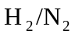Jet flames (DLR-Stuttgart) .
29. Ranga Dinesh KKJ, Jiang X, van Oijen JA. Numerical simulation of hydrogen impinging jet flame using flamelet generated manifold reduction. Int J Hydrogen Energy 2012; 37: 4502-4515.
30. Smagorinsky J. General circulation experiments with the primitive equations. M Weather Review 1963; 91: 99-164.
31. Germano M, Piomelli U, Moin P, Cabot WH. A dynamic sub-grid scale eddy viscosity model. Phy Fluids 1991; 3: 1760-1765
32. Lilly DK. A proposed modification of the Germano subgrid scale closure method. Phys Fluids A. 1992; 4(3): 633-635.
33. Piomelli U, Liu J. Large eddy simulation of channel flows using a localized dynamic model. Phy Fluids 1995; 7: 839-848.
34. Peters N. Laminar diffusion flamelet models in non-premixed turbulent combustion. Prog Energy Combust Sci 1994; 10:319-339.
35. Pitsch H. A C++ computer program for 0-D and 1-D laminar flame calculations. RWTH, Aachen, 1998.
36. Bowman CT, Hanson RK, Davidson DF, Gardiner WC, Lissianki V, Smith GP, Golden DM, Frenklach M, Goldenberg M, GRI 2.11, 2006.
37. Drake MC, Blint RJ. Relative importance of nitric oxide formation mechanisms in laminar opposed-flow diffusion flames. Combust Flame 1991; 85: 185-203.
38. Kirkpatrick MP, Armfield SW, Kent JH. A representation of curved boundaries for the solution of the Navier-Stokes equations on a staggered three-dimensional Cartesian grid. J Comput Phy 2003; 184: 1-36.
39. Kirkpatrick MP, Armfield SW, Masri AR, Ibrahim SS. Large eddy simulation of a propagating turbulent premixed flame. Flow Turb Combust 2003; 70 (1): 1-19.
40. Ranga Dinesh KKJ, Jenkins KW, Kirkpatrick MP, Malalasekera W. Identification and analysis of instability in non-premixed swirling flames using LES. Combust Theory Model 2009; 13 (6): 947-971.
41. Ranga Dinesh KKJ, Jenkins KW, Kirkpatrick, MP, Malalasekera W. Effects of swirl on intermittency characteristics in non-premixed flames. Combust Sci Tech 2012; 184: 629-659.
42. Leonard BP. SHARP simulation of discontinuities in highly convective steady flows. NASA Tech Memo. Vol. 100240, 1987.

Table captions
Table 1. Flame conditions and compositions of the syngas fuels

Figure Captions
Fig.1. Geometry of the turbulent non-premixed jet flame with a diameter of D=8mm and inlet jet velocity of U= 42.3 m/s (generated for the velocity iso-values of u= 10 m/s at time t=0.2s)
Fig.2. Instantaneous three-dimensional iso-surfaces with iso-values (1) 700K, (2) 1000K, (3) 1500K, (4) maximum values ((a4) 2100K, (b4) 1800K (c4,d4) 2200K) of the flame temperature of flames (a) HN1 (b) HN2 (c) HCO1 and (d) HCO2 at time t=0.2s
Fig.3. Instantaneous two-dimensional streamwise contour plots of mixture fraction (a1) HN1, (b1) HN2, (c1) HCO1, (d1) HCO2, flame temperature (a2) HN1, (b2) HN2, (c2) HCO1, (d2) HCO2 and two-dimensional cross-streamwise contour plots of mixture fraction (a3) HN1, (b3) HN2, (c3) HCO1, (d3) HCO2 and flame temperature (a4) HN1, (b4) HN2, (c4) HCO1 and (d4) HCO2 at axial location x=320mm at time t=0.2s.
Fig.4. Time-averaged two-dimensional contour plots of mean temperature for flames (a) HN1, (b) HN2, (c) HCO1 and (d) HCO2.
Fig.5. Time-averaged mean mixture fraction for flames (a) HN1, (b) HN2, (c) HCO1 and (d) HCO2. Lines denote LES data and symbols denote experimental data.
Fig.6. Time-averaged mixture fraction variance for flames (a) HN1, (b) HN2, (c) HCO1 and (d) HCO2. Lines denote LES data and symbols denote experimental data.
Fig.7. Time-averaged mean temperature for flames (a) HN1, (b) HN2, (c) HCO1 and (d) HCO2. Lines denote LES data and symbols denote experimental data.
Fig.8. Time-averaged mass fraction of for flames (a) HN1, (b) HN2, (c) HCO1 and (d) HCO2. Lines denote LES data and symbols denote experimental data.
Fig.9. Time-averaged mass fraction of for flames (a) HN1, (b) HN2, (c) HCO1 and (d) HCO2. Lines denote LES data and symbols denote experimental data.
Fig.10. Time-averaged mass fraction of for flames (a) HCO1, (b) HCO2 and for flames (c) HCO1, (d) HCO2. Lines denote LES data

Tables
Table 1. Flame conditions and compositions of the syngas fuels

Case | Flame HN1 | Flame HN2 | Flame HCO1 | Flame HCO2
Jet diameter (mm) | 8.0 | 8.0 | 8.0 | 8.0
Jet velocity (m/s) | 42.3 | 42.3 | 42.3 | 42.3
H₂ % | 75 | 50 | 70 | 30
N₂ % | 25 | 50 | 0 | 0
CO% | 0 | 0 | 30 | 70

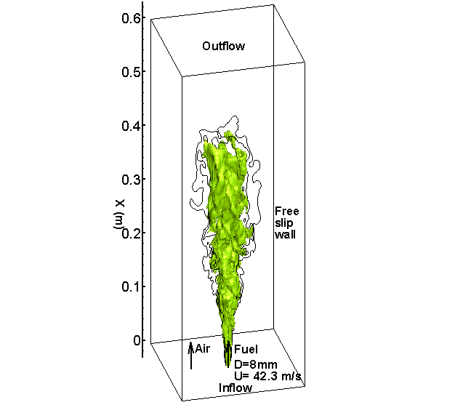
Fig.1. Geometry of the turbulent non-premixed jet flame with a diameter of D=8mm and inlet jet velocity of U= 42.3 m/s (generated for the velocity iso-values of u= 10 m/s at time t=0.2s)

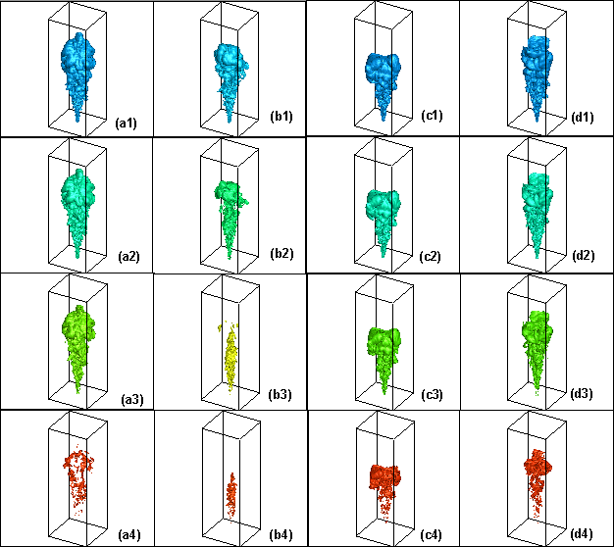
Fig.2. Instantaneous three-dimensional iso-surfaces with iso-values (1) 700K, (2) 1000K, (3) 1500K, (4) maximum values ((a4) 2100K, (b4) 1800K (c4,d4) 2200K) of the flame temperature of flames (a) HN1 (b) HN2 (c) HCO1 and (d) HCO2 at time t=0.2s

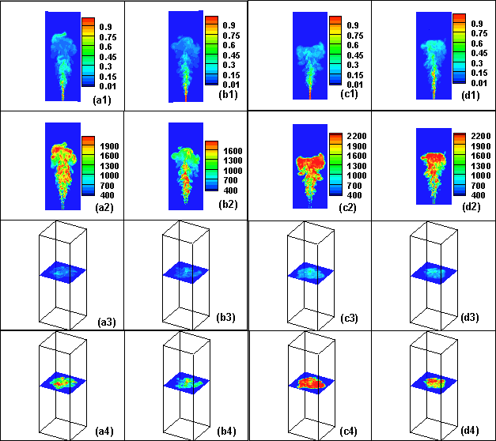
Fig.3. Instantaneous two-dimensional streamwise contour plots of mixture fraction (a1) HN1, (b1) HN2, (c1) HCO1, (d1) HCO2, flame temperature (a2) HN1, (b2) HN2, (c2) HCO1, (d2) HCO2 and two-dimensional cross-streamwise contour plots of mixture fraction (a3) HN1, (b3) HN2, (c3) HCO1, (d3) HCO2 and flame temperature (a4) HN1, (b4) HN2, (c4) HCO1 and (d4) HCO2 at axial location x=320mm at time t=0.2s.

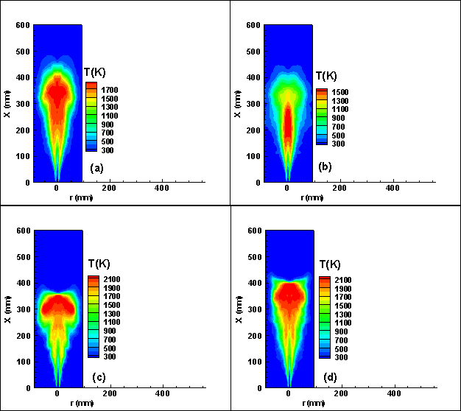
Fig.4. Time-averaged two-dimensional contour plots of mean temperature for flames (a) HN1, (b) HN2, (c) HCO1 and (d) HCO2.

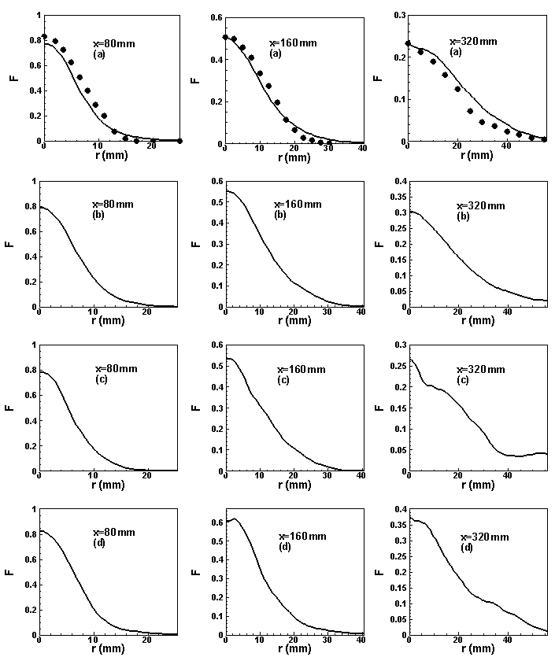
Fig.5. Time-averaged mean mixture fraction for flames (a) HN1, (b) HN2, (c) HCO1 and (d) HCO2. Lines denote LES data and symbols denote experimental data.

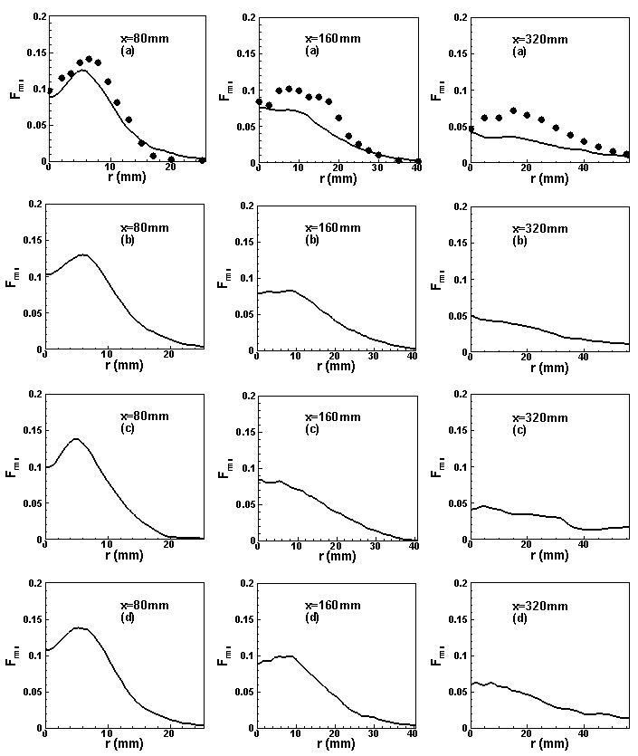
Fig.6. Time-averaged mixture fraction variance for flames (a) HN1, (b) HN2, (c) HCO1 and (d) HCO2. Lines denote LES data and symbols denote experimental data.

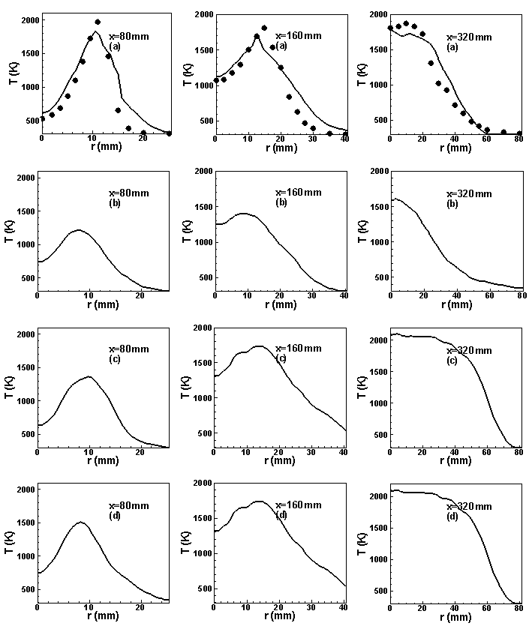
Fig.7. Time-averaged mean temperature for flames (a) HN1, (b) HN2, (c) HCO1 and (d) HCO2. Lines denote LES data and symbols denote experimental data.

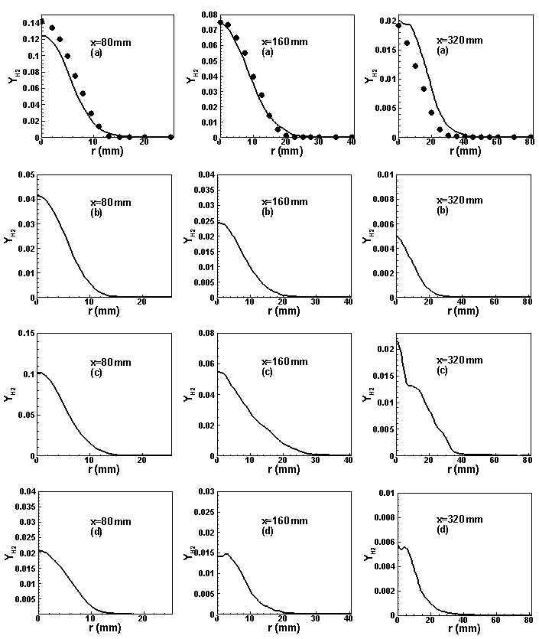
Fig.8. Time-averaged mass fraction of for flames (a) HN1, (b) HN2, (c) HCO1 and (d) HCO2. Lines denote LES data and symbols denote experimental data.

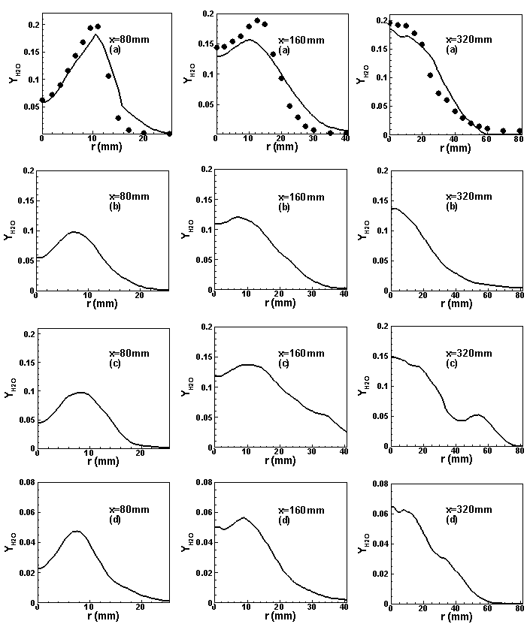
Fig.9. Time-averaged mass fraction of for flames (a) HN1, (b) HN2, (c) HCO1 and (d) HCO2. Lines denote LES data and symbols denote experimental data.

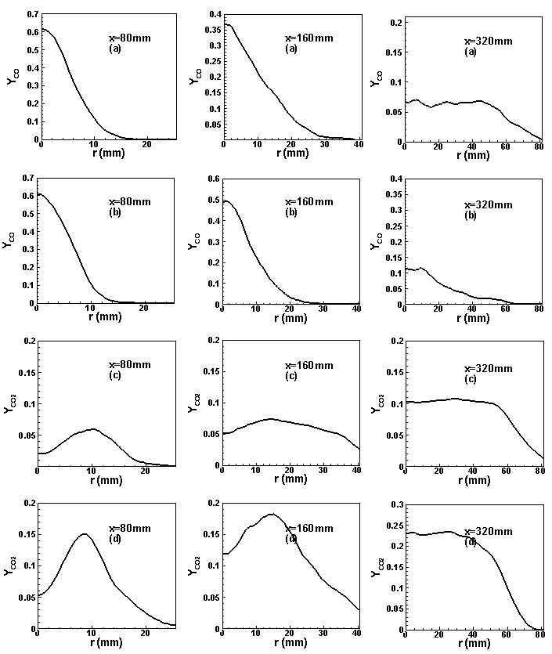
Fig.10. Time-averaged mass fraction of for flames (a) HCO1, (b) HCO2 and for flames (c) HCO1, (d) HCO2. Lines denote LES data

