INFLUENCE OF FUEL VARIABILITY ON THE CHARACTERISTICS OF IMPINGING NON-PREMIXED SYNGAS BURNING

K.K.J. Ranga Dinesh, X. Jiang, J.A. van Oijen, R.J.M. Bastiaans, L.P.H. de Goey

Engineering Department, Lancaster University, Lancaster, Lancashire, LA1 4YR, UK.
²Combustion Technology, Department of Mechanical Engineering, Eindhoven University of Technology, Eindhoven, The Netherlands.

Corresponding author: K.K.J.Ranga Dinesh, Engineering Department, Lancaster, Lancashire, LA1 4YR, UK.
Email: ranga.dinesh@lancaster.ac.uk. Tel: +44 (0) 1524 594578

Colloquium: IC ENGINES AND GAS TURBINE COMBUSTION
34th International Symposium on Combustion

Word Count (Method M1 Manual Count)
Abstract: 216 Words

Total Main Body Text: 6300

Text: 5260 (Introduction, Governing equations, Computational Details, Results and Discussion, Acknowledgement)

Equations = 100 words
Table 1 =100 words
Fig.1. = 100 words
Fig.2 = 160 words
Fig.3 = 160 words
Fig.4 = 180 words
Fig.5 = 140 words
Fig.6 = 100 words

Abstract

Investigations of instantaneous flame characteristics and near-wall heat transfer of syngas mixtures including andflames have been performed in an impinging non-premixed configuration for a Reynolds number of 2000 and a nozzle-to-plate distance of 4 jet nozzle diameters by direct numerical simulation and flamelet generated manifold chemistry. The results presented were obtained from simulations using a uniform Cartesian grid with points. The spatial discretisation was carried out using a sixth-order accurate compact finite difference scheme and the discretised equations were advanced using a third-order accurate fully explicit compact-storage Runge-Kutta scheme. Results were discussed for the flame characteristics, reaction progress variable, velocity field and Nusselt number distributions. Significant differences have been found for the flame characteristics of syngas burning depending on the hydrogen, carbon monoxide, carbon dioxide and nitrogen percentages of the syngas mixture. High diffusivity in the flame leads to form weaker vortical structures and thicker flames than those in the flame. It has been observed that the maximum flame temperature decreases from the to the flames. It is also found that the maximum flame temperature occurs at the lean side of the stoichiometric mixture fraction of the syngas fuel mixtures. The composition of the syngas mixture has a significant impact on the flame characteristics of the impinging flame, including the near-wall flame structure and heat transfer.

Key Words: Syngas Combustion, Impinging Jet, DNS, FGM, Near-wall Heat Transfer

Introduction

A tremendously important new climate change mitigation technology is clean combustion, which can significantly reduce carbon dioxide emission while continuing to use fossil fuels, such as coal, for power generation. In moving towards high efficiency power generation systems with reduced CO₂ emissions, the use of syngas (representing synthetic gas or synthesis gas) technologies becomes increasingly attractive. The syngas can be generated from a wide range of solid fuels including coal, biomass and waste products. Because of the large amount of resources available worldwide, especially coal in the U.S., Europe, and Asia, there is an interest in using syngas fuels for power generation and assessing their effects on the operating systems. Investigation of the application of syngas is closely related to the important technology of integrated gasification combined cycle (IGCC), which turns coal and other fuels into syngas [1, 2]. The emerging technology of IGCC can also be integrated with the technology of carbon capture and storage for climate mitigation. Understanding the combustion of hydrogen enriched fuels could lead to better combustion control and combustor design for future cleaner gas turbine combustion applications, particularly for the design and development of IGCC based combustors.

Various investigations have been carried out to understand the flame characteristics of syngas combustion relevant to gas turbine and internal combustion engine applications including both non-premixed and premixed combustion. Results were reported for the laminar flame speeds of lean premixed syngas fuel mixtures over a wide range of fuel compositions including the validation of chemical mechanisms [3], which was subsequently extended to applications for gas turbine combustors [4]. The analysis of ignition properties for complete composition range at elevated temperatures and pressures applicable to gas turbine premixed combustion was also reported [5]. At the same time, dilution effect on flame stability of premixed syngas fuel has been carried out [6]. Meanwhile investigations of the non-premixed combustion of syngas fuel mixtures including blended natural gas/hydrogen have been reported in the literature mainly on the flame stability issues. For example, some of the important studies include experimental investigations on the effects of addition on the stability limits of non-premixed flames [7], detailed scalar analysis of jet flames [8] and the effects of addition on the ignition and combustion of high pressure combustion [9]. However, there is an insufficient amount of information available in the literature regarding the fuel variability and flame characteristics of and syngas combustion in a non-premixed configuration.

There are challenges in utilising syngas in gas turbine combustion which need careful attention and further investigations. For instance, syngas combustion could develop into undesirable flame flashback phenomenon, in which the flame propagates into the burner. Particularly the syngas flame with high diffusivity can travel upstream and even attach to the wall of the combustor. The strong heat transfer to the wall may damage the combustor components. The consequence can be very costly. Because of this, many existing combustors may need careful analysis for the burning of syngas, particularly for fuel mixtures. A better understanding of the flame characteristics is the key for achieving safe and controllable syngas burning, which is crucial to the technology developments. To overcome this bottle neck in developing hydrogen based clean combustion technology, in-depth knowledge of the flame characteristics of hydrogen enriched syngas is essential. Furthermore, flame-wall interactions are important to the life span of the gas turbine combustor but have not been fully understood. In order to meet these challenges, detailed computational combustion can play a significant role which can be employed to investigate the structures of syngas flames with high fuel flexibility. This work was aimed to investigate flame characteristics including the flame-wall interaction of hydrogen enriched syngas combustion using direct numerical simulation (DNS), which provides the details needed to understand the flame structures using high-fidelity computational techniques.

Historically, most DNS flame analyses have been based on simple chemistry to reduce the computational costs, while the continuous growth in computing power has made it possible to incorporate more detailed combustion chemistry and to perform large scale computations in recent years. Early investigations reported two-dimensional simulations of non-premixed flames [10, 11]. Three-dimensional DNS of turbulent non-premixed flames including finite rate chemistry and heat release effects were also carried out, e.g. [12]. Since then various studies have been performed on DNS of non-premixed combustion, for example, the effects of flow strain on a hydrogen-air triple flame [13], scalar intermittency of CO/H₂ planer jet flame [14], flame stabilisation and structure of lifted hydrogen jet flame [15]. DNS studies of flame-wall interactions with one-step and multi-step chemical kinetics and in physical domains have been reported in the last two decades. For example, two-dimensional DNS of head-on quenching (HOQ) in a pseudo-turbulent reactive boundary layer [16] and three-dimensional HOQ of premixed propagating flame in constant density turbulent channel flow [17], side-wall effects on flame dynamics [18], one-dimensional simulation of hydrogen combustion interacting with an inert wall [19], three-dimensional DNS of sidewall quenching for v-shaped premixed flame [20] and turbulent flame-wall interaction using three-dimensional DNS and detailed chemical kinetics [21] were carried out. However, in-depth knowledge of the syngas flame characteristics is still not fully available while near-wall flow and combustion phenomena remain an area to be fully investigated, where the modelling challenges are also significant for large-eddy simulation and traditional Reynolds-averaged Navier-Stokes modelling.

Fuel variability is of great importance for syngas combustion from perspectives of both fundamental study and practical application. Fuel composition affects the combustion chemistry as well as the molecular transport processes. Consequently, different combustion characteristics due to fuel variability will have a significant impact on the combustion control and the combustor design. In order to explore the effect of syngas fuel composition on flame structures and near-wall combustion, a comparative DNS study was performed in an impinging non-premixed jet flame configuration. Four different syngas fuel compositions varying from to including carbon monoxide, carbon dioxide and nitrogen were investigated. The flame chemistry of the syngas, which is a crucial element of the simulation, was represented by methods based on detailed chemistry in this study.

As an effort to understand the flame characteristics of hydrogen enriched fuel mixtures and the near-wall reacting flow and heat transfer using detailed numerical simulations, the research employed DNS and the flamelet-generated manifold (FGM) approach. The detailed chemical kinetics has been employed through the FGM method [22], which not only uses complex chemistry, but also takes the most important transport processes into account. The FGM data table was adopted as a means to reduce the prohibitive computational costs of directly implementing detailed chemistry in a DNS code. The objective of the research was to analyse the important physics of the effects of fuel variability on the flame characteristics of syngas combustion. In the following, the methods used in this study are presented first, including the governing equations and flame chemistry, and the numerical methods. The results and discussions are presented subsequently, mainly in terms of instantaneous flame characteristics. Finally conclusions are drawn.

Governing Equations and Flame Chemistry

The three-dimensional equations of the conservation laws for continuity, momentum, energy, transport equations for progress variable and mixture fraction, and the equation of state in their non-dimensional form can be given as

(1)

(2)

(3)

(4)

(5)

(6)

In Equations (1-6), stands for time, is the velocity components in the direction, stands for total energy per unit mass, for pressure, for heat conductivity, for specific heat at constant pressure, for dynamic viscosity, is the ratio of specific heats, is the source term of the progress variable, is the density, subscript stands for the ambient respectively. Symbols and represent Mach number, Prandtl number, Schmidt number, Froude number and Reynolds number respectively.

To investigate the effects of fuel variability, the flame chemistry must be realistically represented in order to accurately predict the chemical heat release and the concentrations of the chemical species of the syngas combustion. In this work, the flame chemistry of syngas mixtures is represented by databases generated by using the FGM technique [22], accounting for both chemical and transport processes using the laminar flamelet concept [23]. The FGM databases were generated from steady counter-flow diffusion flamelets using detailed chemistry and transport models including differential diffusion effects. The detailed kinetic model [24] incorporates the thermodynamic, kinetic, and species transport properties relevant to high temperature and oxidation, consisting of 14 species and 30 reactions. In the FGM approach, a low-dimensional manifold is created from solutions of the so-called flamelet equations and is solved by the full implicit solver CHEM1D developed at the Eindhoven University of Technology [25]. In the present study, four FGM databases have been generated for four different fuels. The databases contain the variables as a function of the mixture fraction and the progress variable such that the resolution of the manifolds is 201 points in the mixture fraction space and 201 points in the progress variable space. It is important to note that the applicability of FGM in numerical simulations of combustion of hydrogen and syngas mixtures has been investigated and validated [26-27].

Computational Details

Three-dimensional time dependent DNS with the flame chemistry represented by the tabulated FGM approach has been performed with the governing equations solved in their non-dimensional form. The set of equations listed above were solved with a parallel DNS code and computations were carried out using 600 processors in the UK high-end computer HECToR. Figure 1 shows the geometry of the impinging configuration considered here and the dimensions of the computational box given in terms of the reference length scale – the fuel jet nozzle diameter (D). The computational domain employed has a size of four jet nozzle diameters in the streamwise direction and twelve jet nozzle diameters in the cross-streamwise directions. Since the main focus of the study was on the effects of fuel variability on the flame characteristics, a relatively small domain in the streamwise direction was selected to ensure that important physical effects can be examined with affordable computational costs. The results presented in this study were performed using a uniform Cartesian grid with points resulting 72 million computational nodes. To avoid the prohibitively high computational costs of DNS of fully turbulent flows, the Reynolds number used Re=2000 was relatively low with a Froude number of Fr=1.0, based on the reference quantities used. Since the results were tested as almost grid-independent, the grid points used are considered to be sufficient to resolve the energy spectra. The Prandtl number and the specific heat vary according to the FGM table.

The discretisation of the governing equations includes the high-order numerical schemes for both spatial discretisation and time advancement. The spatial derivates in all three directions are solved using a sixth-order accurate compact (Padé) finite difference scheme [28]. The scheme uses sixth-order at inner points, fourth-order next to the boundary points, and third-order at the boundary. Further details of the Padé 3/4/6 scheme can be found in reference [28]. Solutions for the spatial discretised equations are obtained by solving the tri-diagonal system of algebraic equations. The spatial discretised equations are advanced in time using a fully explicit low-storage third-order Runge-Kutta scheme [29]. The time step was limited by the Courant number for stability and a chemical restraint.
The computational domain contains an inlet and impinging wall boundaries in the streamwise direction where the buoyancy force is acting. At the inflow, the flow was specified using the Navier-Stokes characteristic boundary conditions by [30] with the temperature treated as a soft variable (temperature was allowed to fluctuate according to the characteristic waves at the boundary). At the inlet, the mean streamwise velocity was specified using a hyperbolic tangent profile
(7)
(8) where stands for the radial direction of the round jet, originating from the centre of the inlet domain and the initial momentum thickness was chosen to be 10% of the jet radius. The dimensions of the impinging jet configuration used were and . External unsteady disturbances were artificially added to the mean velocity profile for all three velocity component at the inlet in a sinusoidal form such that . Here we assigned the value and the non-dimensional frequency of the unsteady disturbance. The relatively large disturbance was used to enhance the development of instability in the computational domain, which is rather small in the streamwise direction, while the frequency of the perturbation was chosen to trigger the unstable mode of the jet. At the side boundaries, non-reflecting characteristic boundary condition is used. The non-slip wall boundary condition is applied at the downstream wall, which is assumed to be at the ambient temperature, impermeable to mass and without surface chemical reaction. At the impinging wall boundary, the mixture fraction is assumed zero-gradient corresponding to the impermeability, while the progress variable for chemistry is taken as zero at the wall boundary. The simplified wall boundary conditions were adopted to facilitate investigations of fuel variability effects on the flame structures and near-wall heat transfer.

Results and Discussion

DNS of flames corresponding to four different syngas fuel mixtures, named as flames A, B, C and D varying from to , have been performed. The compositions were taken from the BP syngas datasheet with the maximum percentage of H₂, CO, CO₂ and N₂ in each case. Table 1 outlines the fuel compositions of these four syngas mixtures, where the stoichiometric mixture fraction values increase from 0.124 of flame A to 0.462 of flame D, depending on the hydrogen percentage of the syngas fuel mixture. Flame A contains the highest percentage of hydrogen (70.3%), flames B and C contain moderate percentages of hydrogen (33.4% and 34.6%), while flame D contains the lowest percentage of hydrogen (11.4%). The flame characteristics and near-wall heat transfer of the syngas combustion are provided here to illustrate the effects of fuel variability on the flame characteristics. Since the focus of the study is on the instantaneous characteristics of flame structures, only typical and representative instantaneous results at the developed stage are shown instead of the time-averaged statistics.

Figures 2 and 3 shows the mid-plane instantaneous flame temperature distributions of flames A, B, C and D at non-dimensional time instants of t=12 and 16 respectively, when the flames have been developed. The temperature distributions show significant structural changes in the primary and wall jet regions between the four syngas flames. In these syngas flames, combustion occurs in a thin layer in the vicinity of the stoichiometric surface of the non-premixed flames. The combustion reaction zone of the syngas mixture (flame A) is considerably wider than the syngas mixture (flame D), leading to wider temperature distributions in flame A. From A to D, the flame becomes increasingly thinner and more wrinkled. In a non-premixed flame, diffusion plays a major role in the localised fuel/air mixing, which in turn controls the temperature in the reaction zone. Accordingly the flame may be thicker if the fuel has a higher diffusivity, which is indeed the case for the syngas flame A. When the flame is thicker, the local flow gradients become smaller, leading to less wrinkled structures. As a result of inlet perturbation, an asymmetric flame structure is observed for the temperature distribution in the mid-plane of all four flames. In the primary jet stream, there is a large outer vortical structure, which is due to the buoyancy effects [31]. In both Figs. 2 and 3, it is evident that the fuel variability has a direct impact on the distributions of the flame temperature and the vortex topology. The flame D exhibits larger and more wrinkled outer vortical structures in the primary jet stream, as well as stronger vortical structures in the wall jet region than the other cases. The results in Figs. 2 and 3 reveal that the concentration of hydrogen in the syngas fuel does affect the vortex generation in both the primary and the wall jet regions. This can be attributed to the effect of diffusivity which depends on the hydrogen amount in the syngas mixture. The effect of fuel variability on flame structures as observed in Figs. 2 and 3 is of relevance to and combustors under practical conditions.

The variation of maximum flame temperatures for and fuels is an important issue for the design of combustors for syngas combustion. Figs. 2 and 3 show the distributions of flame temperature from the flame A to the flame D. The peak temperature of syngas flames A, B, C and D are shown in Table 1. It has been found that the peak temperature is much higher for the flame A compared to the but flame D. This can be attributed to the different amount of combustible H₂ in the fuel mixture and the different transport properties of the mixture. Between Figs. 2 and 3, unsteady behaviour of the flame can be observed, where the flame especially the wall jet flame has progressed more at the later time instant shown in Fig. 3 compared with the earlier flame shown in Fig. 2, but the effects of fuel variability remain the same. For the flame temperature distribution, experimental measurements of turbulent non-premixed hydrogen enriched flames showed a maximum flame temperature [32-33] in the range observed in the present flame. Although no directly comparable experimental data is available, the temperatures of the numerically simulated flames seem to be in line with the experimental data. To further analyse the temperature variations with respect to syngas mixtures in both the primary jet and the near-wall regions, the scattered temperature distributions for all four syngas flames are discussed next.

Figure 4 shows the scattered temperature data plotted versus mixture fraction in the cross-sectional planes at three different axial locations x=0.7, 1.4 and 3.5 for flames A, B, C and D respectively. These three axial locations have been selected in the near-nozzle region (x=0.7), upstream vortex region (x=1.4) and near-wall region (x=3.5). In Fig. 4, the zoomed-in highlight of the variation of scattered temperature data near the stoichiometric mixture fraction is also shown. Since scattered temperature results may provide important insight of the flame characteristics, it is worthwhile to analyse these plots to reveal some details of the reacting flow. For a fixed value of mixture fraction, a narrow-ranged scattered temperature data corresponds to a uniformly burnt or un-burnt mixture while a wide-ranged scattered temperature data corresponds to a situation where fuel ignition and extinction co-exist. The wide range of scattered temperature data at a fixed mixture fraction can be due to the fluid dynamic factors such as the existence of vortical structures. This scatter data not only reveals variation of flame temperature with respect to syngas fuel mixtures, but also displays the effects of the fluid dynamic factors such as vortical structures. It should be emphasised that these profiles are shown as guides for the temperature of combustion mixtures with implications on the relevance of flamelet generated manifold to the four syngas impinging jet flames considered here.

Two important trends have been observed from Fig. 4: (1) the occurrence of peak temperature at the lean side of the stoichiometric mixture fraction for all the cases, indicating that the flame temperature does not depend on the chemistry only but also on the transport process; and (2) the scattered temperature distribution becomes wider from the to the cases. For the flame A, the scattered temperature at x=0.7, 1.4 and 3.5 show similar profiles, which displays smooth and narrow range of temperature at a fixed mixture fraction. This could be because of the faster fuel consumption linked with the diffusivity factor depending on the syngas fuel mixture composition especially the large amount of hydrogen. It is also important to note that similar behaviour has been observed in previous DNS of non-premixed hydrocarbon flames [34]. The scattered data of flame B which has high CO percentage, displays wider temperature distributions at higher mixture fractions compared to flame A. This might be because of the changes of diffusivity level and variations of transport properties. The amount of hydrogen in the fuel and the variations of transport properties associated with fuel variability can change the mixing rate and accordingly the chemical reaction and temperature distribution. The change of trend from flames A to B becomes more evident for flames C and D, where flame C has approximately equal percentage of H₂, CO and CO₂ while flame D has low H₂ but high N₂ percentages. In both cases, the flame temperature contains more scatter data at the rich side of the stoichiometric mixture fraction. The proportion of data points away from the fully burnt limits indicates the presence of unburnt or partially burnt mixtures. This is consistent with instantaneous temperature distributions shown in Fig. 3 where flames A, B, C and D are becoming increasingly more vortical. Furthermore, the scatter plots also reveal that the maximum flame temperatures are significantly different for different cases. The previous DNS study of diluted hydrogen-air flame [35] and the present DNS results of syngas flames indicate that further analysis on scatter plots of temperature, heat release and scalar dissipation including the effect of differential diffusion is needed to obtain more insights into the mixing and chemical processes including local flame extinction and re-ignition of the non-premixed fuel mixtures. For the flame temperature, it is also worth noting that heat losses due to radiation effects are likely to reduce the maximum temperatures. However, inclusion of radiation in the DNS computations still represents a computational challenge due to the excessive amount of calculations involved.

To further analyse the vortical structures in the reacting flow fields, Fig. 5 shows the cross-sectional instantaneous velocity vector fields of the four cases at t=16, together with sample streamline traces, where vortical structures are evident. In the reacting flow fields, complex vortical structures dominate the mixing and entrainment process, which will affect the distributions of mixture fraction, progress variable and flame temperature. In Fig. 5, the flame A exhibits a buoyancy-induced vortical structure in the shear layers (region 1) at the primary jet stream, while the structure becomes increasingly stronger in other cases. In the wall jet stream, all four flames show a head vortex ring which is the large structure at the far side in wall jet region (region 2). In Fig. 5, the major difference between the four cases seems to be in the region 3 of the wall jet region. For the flame A, there is no obvious vortex in this region near to the stagnation point. However, a structure corresponding to a secondary vortex ring gradually appears in the cases B, C and D. The main reason for vorticity generation in the near-wall region is the external skin friction that acts on the thin layer of the fluid attached to the wall, where viscosity difference due to the fuel variability and flame temperature variations can play a role in the vortex formation in the wall jet region.

In an impinging flame, the heat flux into the solid surface is attributed to the hot products of combustion formed along the impinging wall while the maximum wall heat flux and temperature are of great importance in practical applications. The near-wall heat transfer can be measured by the Nusselt number, which is a dimensionless number that measures the enhancement of heat transfer from a surface that occurs in a real situation, compared to the heat transfer that would be measured if only conduction could occur. The Nusselt number can be defined as, where is the jet nozzle diameter, the thermal conductivity of the fluid and the heat transfer coefficient. The Nusselt number is used to measure the enhancement of heat transfer when convection takes place. Figure 6 shows comparison of the instantaneous Nusselt number at t=12, 16 for flames A, B, C and D corresponding to the instantaneous heat fluxes near the wall. In all cases, there is no heat transfer in the stagnation point y=6 because no flame exists here due to the unmixed fuel. The wall heat transfer takes place with increased radial distance from the wall stagnation point showing fluctuations in the Nusselt number, which are linked to the existence of vortical structures near the wall jet regions. The instantaneous wall heat fluxes at both t=12 and 16 show that the distributions of wall heat fluxes correspond to the near-wall vorticity distributions. In the syngas flames, the combination of different fuel mixtures and buoyancy lead to different heat release patterns and thus different wall heat transfer characteristics. Corresponding to the temperature changes from case to case, the maximum value of the Nusselt number is gradually decreasing with respect to hydrogen percentage in the syngas fuel mixture. This is mainly because near-wall temperature in flame D is much lower than its adiabatic value, while for flame A it is close to its adiabatic value. This is apparent in the head vortex ring (region 2). Fig. 5 clearly shows the significance of the effects of fuel variability on the near-wall heat transfer characteristics, which can be important to the design of combustors for hydrogen-enriched combustion. Although there is no directly comparable experimental data to validate the Nusselt number shown in Fig. 6, the values are within the range of experimental measurements of impinging flames [36-37]. It is worth noting that the present simulations did not take into account heterogeneous surface chemistry, which can affect the wall heat transfer related to the wall material and the near-wall combustion characteristics.

The significant change of flame characteristics with fuel compositions for the syngas burning indicates that the combustion of hydrogen-enriched fuels can be vastly different from that of the traditional hydrocarbon fuels. This is mainly because hydrogen has the ability to burn at very lean equivalence ratio which is approximately seven times leaner than gasoline and five times leaner than methane [38]. Since syngas flames have faster flame speeds than hydrocarbon flames, flames allow oxidation with less heat transfer to the surroundings. This might improve thermal efficiencies when syngas is used in practical applications. In addition, efficiencies of flames can also be improved because of small gas quenching distance of which allows fuel to burn more completely. Furthermore, since the addition of tends to reduce the formation of pollutants and greenhouse gas (GHG) emissions, syngas fuels could play a major role in the reduction of local air pollutant and GHG emissions. However, the effects of fuel variability as well as fuel blending such as adding hydrogen to hydrocarbon fuels need further investigations particularly for high pressure conditions which have not been studied extensively.

Conclusions

Instantaneous characteristics of flame structures and flame-wall interactions of four different syngas impinging jet flames including the and cases were computationally investigated using direct numerical simulation technique. Comparisons were discussed for the flame temperature, reaction progress variable, velocity and Nusselt number between the four different flames. Some physical insights on the effects of fuel variability of the flame characteristics have been obtained. It has been found that diffusivity and vortical structures dominate the flame characteristics of hydrogen-enriched combustion. Higher diffusivity in the fuel leads to smoother and thicker flames that are less vortical. The flame structure and maximum flame temperature largely depend on the syngas fuel compositions. The higher diffusivity of the flame leads to weaker vortical structure in the shear layers at the primary jet compared to the flame. The flame temperature of all syngas flames reaches their maximum values at the lean side of the stoichiometric mixture fraction, due to the specific transport properties of the syngas mixture. It has been found that the fuel variability plays a key role in the formation of the vortical structures in the flow fields as well as distributions of the near-wall heat flux. The unsteady vortex separation from the wall leads to variations in the Nusselt number distribution due to changes in the instantaneous thermal boundary layer thickness.

Fuel variability has been identified as playing a major role in the flame characteristics of hydrogen-enriched combustion. Further investigations on the scatter plots and local flame structures of to syngas mixtures would be of great interest, especially with the influence of differential diffusion on the maximum flame temperatures. An effort is currently underway to fully investigate the influence of differential diffusion on hydrogen-enriched syngas combustion in turbulent flow regimes, while the flow investigated in this study is mainly in the laminar to transitional flow regimes. Detailed investigation of the near-wall fluid flow of syngas combustion in turbulent flow regimes would require more significant computing resources. Further investigations of the mean wall heat flux such as the averaged heat flux along the wall, surface chemistry effects, radiation losses and near-wall vorticity at the boundary layer should provide relevant information on near-wall heat transfer for practical applications of hydrogen-enriched combustion.

Acknowledgements
This research is funded by the UK EPSRC grant EP/G062714/2. The syngas mixture compositions were provided by the BP Alternative Energy International Ltd.

References
[1] L. Lombardi, Ener. Conver. Mang. 44(1) (2003) 93-108.
[2] A.J. Minchener, J. Fuel 84 (2005) 2222-2235.
[3] J. Natarajan, T. Lieuwen, J. Seitzman, Combust. Flame 151 (2007) 104-119.
[4] J. Natarajan, Y. Kochar, T. Lieuwen, J. Seitzman, Proc. Combust. Inst. 32 (2009) 1261-1268.
[5] S.M. Walton, X. He, B.T. Zigler, M.S. Wooldridge, Proc. Combust. Inst. 31 (2007) 3147-3154.
[6] C. Prathap, A. Roy, M.R. Ravi, Combust. Flame 155 (2008) 145-160.
[7] M. Karbasi, I. Wierzba, Int. J. Hydro. Energy 23 (1998) 123-129.
[8] R.S. Barlow, G.J. Fiechtner, C.D. Carter, J.Y. Chen, Combust. Flame 120 (2000) 549-569.
[9] N. Wu, G.P. McTaggart-Cowan, W.K. Bushe, M.H. Davy, Combust. Sci. Tech. 183 (2011) 20-42.
[10] K.R. Anderson, S. Mahalingam, J. Hertzberg, Combust. Flame 118 (1999) 233-247.
[11] K. R. Anderson, S. Mahalingam, ASME J. of Heat Transfer 122 (2000) 376-380.
[12] S. Mahalingam, J.H. Chen, L. Vervisch, Combust. Flame 102 (1995) 285-297.
[13] H.G. Im, J. H. Chen, Combustion and Flame 126 (2001) 1384-1392.
[14] E.R. Hawkes, R. Sankaran, J. C. Sutherland, J.H. Chen, Combust. Flame 31 (2007) 1633-1640.
[15] C.S. Yoo, R. Sankaran, J.H. Chen, J. Fluid Mechanics 640 (2009) 453-481.
[16] T. Poinsot, D.C. Haworth, G. Bruneaux, Combust. Flame 95(1993) 118-132.
[17] G. Bruneaux, K. Akselvoll, T. Poinsot, J.H. Ferziger, Combust. Flame 107 (1996) 27-44.
[18] X. Jiang, K.H. Luo, Combust Flame 133 (2003) 29-45.
[19] F. Dabireau, B. Cuenot, O. Vermorel, T. Poinsot, Combust. Flame 135 (2003) 123-133.
[20] T.M. Alshaalan, C.J. Rutland, Combust. Sci. Tech. 174 (2002) 135-165.
[21] A. Gruber, R. Sankaran, E.R. Hawkes, J.H. Chen, J. Fluid Mechanics 658 (2010) 5-32.
[22] J.A. van Oijen, L.P.H. de Goey, Combust. Sci. Tech. 161 (2000) 113-137.
[23] N. Peters, Turbulent combustion. Cambridge Uni. Press. 2000.
[24] S.G. Davis, V.J. Ameya, H. Wang, F. Egolfopoulos, Proc. Combust. Inst. 30 (2005) 1283-1292.
[25] L.M.T. Somers, Simulation of flat flames with detailed and reduced chemical models, PhD Thesis, Eindhoven University of Technology, Eindhoven, The Netherlands, 1994.
[26] A.W. Vreman, J,A. van Oijen, L.P.H. de Goey, R.J.M. Bastiaans, Int. J. Hydro. Energy 34 (2009) 2778-2788.
[27] L.M. Verhoeven, W.J.S. Ramaekers, J.A. van Oijen, L.P.H. de Goey, Combust. Flame 159 (2012) 230-241.
[28] S.K. Lele, J. of Comput. Phy. 103 (1992) 16-42.
[29] J.H. Williamson, J. of Comput. Phy. 35 (1980) 48-56.
[30] T.J. Poinsot, S.K. Lele, J. of Comput. Phy. 101 (1992) 104-129.
[31] K.K.J.Ranga Dinesh, X. Jiang, J.A. van Oijen, Int. J. Hydro. Energy 37 (2012) 4502-4515.
[32] R. S. Barlow, C. D. Carter, Combust. Flame, 97 (1994) 261-280.
[33] R.S.Barlow, G.J. Fiechtner, C.D. Carter, J.Y. Chen, Combust. Flame 120 (2000) 549-569.
[34] N. Swaminathan, R.W. Bilger, Combust. Flame 116 (1999) 519-545.
[35] R. Hilbert, D. Thevenin, Combust. Flame 138 (2004) 175-187.
[36] R. Viskanta, Exp. Thermal Fluid Sci. 6 (1993) 111-134.
[37] D. Lytle, B. Webb, Int. J. Heat Mass Transfer 37 (1994) 1687-1697.
[38] C. Bauer, T. Forest, Int. J. Hydro. Energy 26 (2001) 55-70.

Tables

Table 1. Composition of the syngas fuels (from BP syngas datasheet)

Case | Flame A | Flame B | Flame C | Flame D
H₂/CO Ratio | 2.36 | 0.50 | 0.98 | 0.37
H₂ % | 70.3 | 33.4 | 34.6 | 11.4
CO % | 29.7 | 66.6 | 35.3 | 31.1
CO₂ % |  |  | 30.1
N₂ % |  |  |  | 57.5
Stoichiometric Mixture Fraction | 0.124 | 0.220 | 0.332 | 0.462
Maximum Flame Temperature | 8.3 (2430K) | 8.0 (2344K) | 7.2 (2109K) | 5.9 (1728K)

Figures

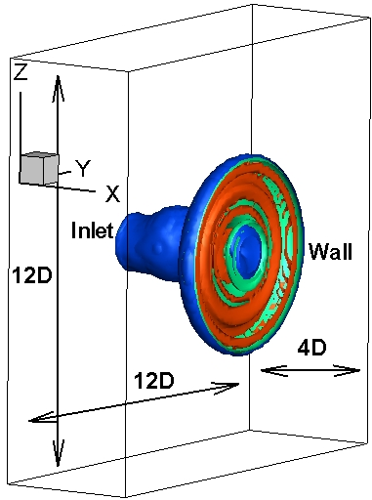
Fig.1. Geometry of the impinging flame with the computational domain size of 4 jet nozzle diameters in the streamwise direction and 12 diameters in the cross-streamwise directions.

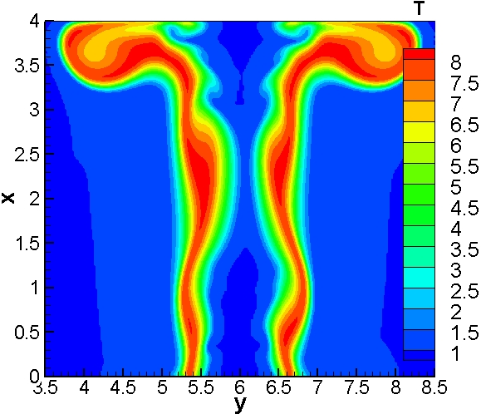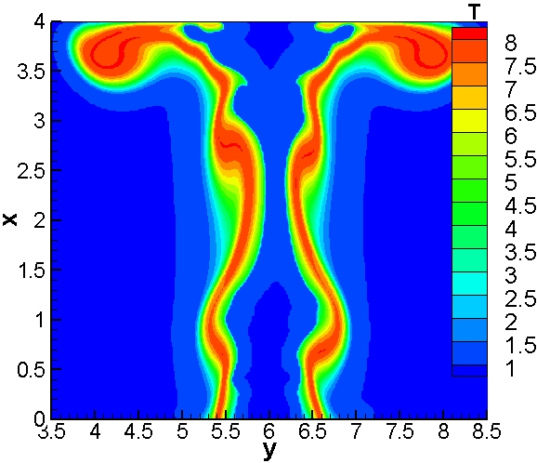
Flame A Flame B
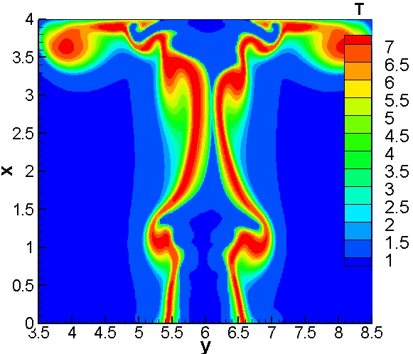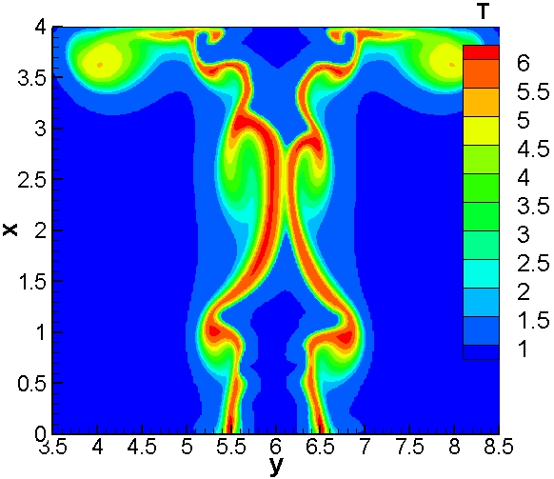
Flame C Flame D
Fig.2. Instantaneous flame temperature of syngas flames A, B, C and D at t=12.

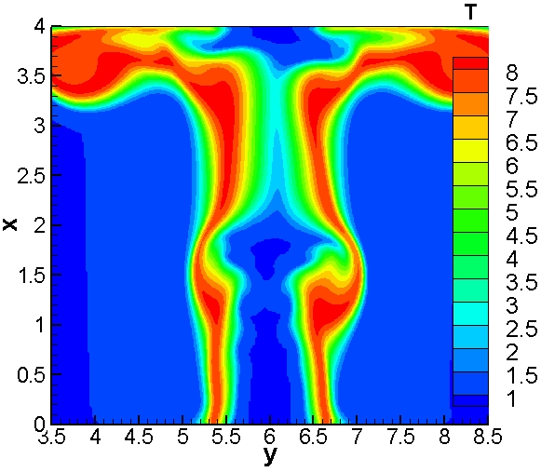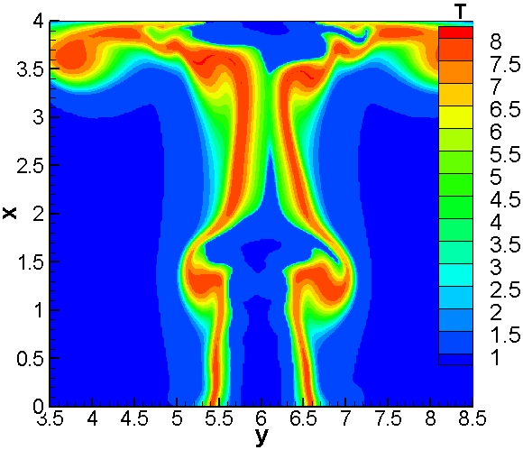
Flame A Flame B
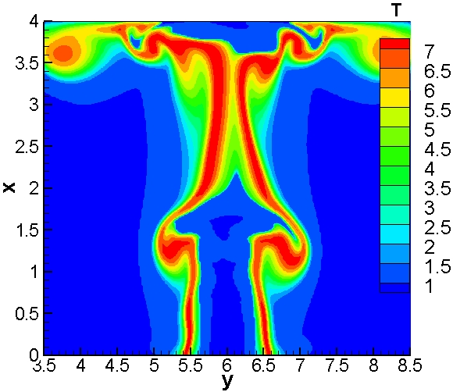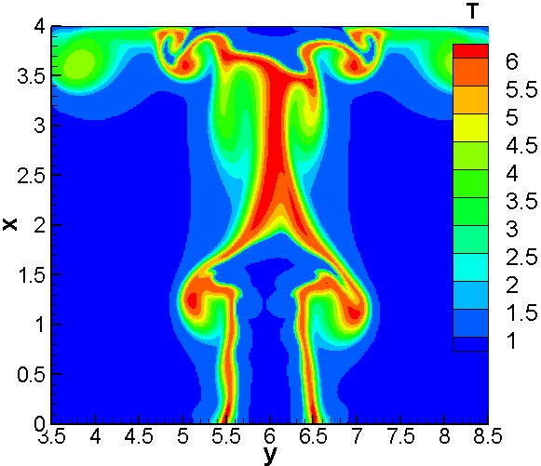
Flame C Flame D
Fig.3. Instantaneous flame temperature of syngas flames A, B, C and D at t=16.

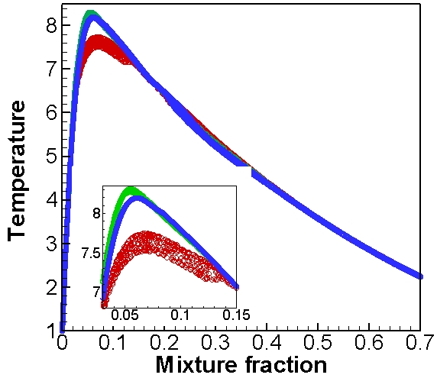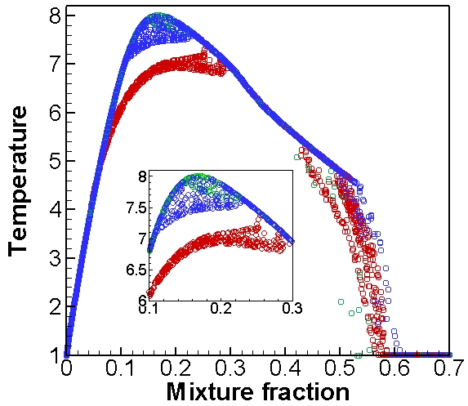
Flame A Flame B
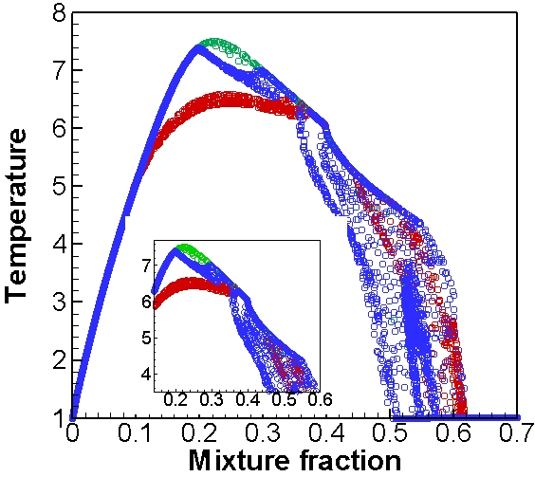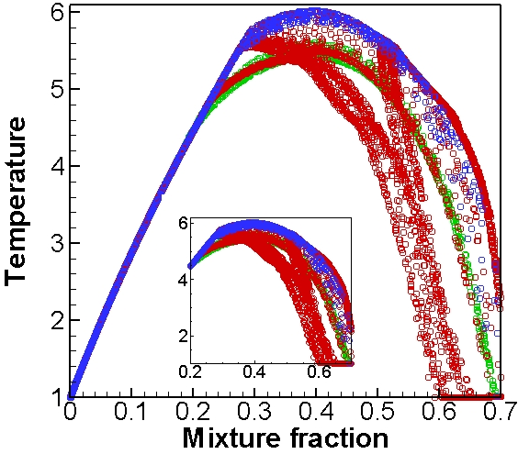
Flame C Flame D
Fig.4. Scattered temperature data plotted against mixture fraction at three different axial locations: x=0.7 (green colour), 1.4 (blue colour), 3.5 (red colour) of flames A, B, C and D at t=16.

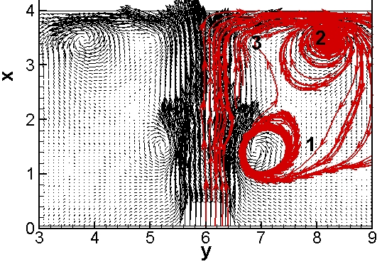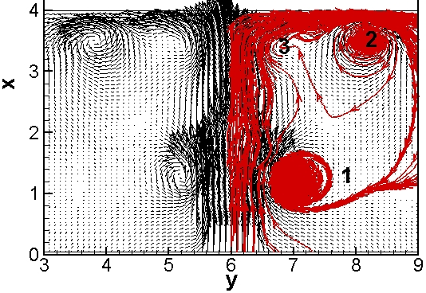
Flame A Flame B
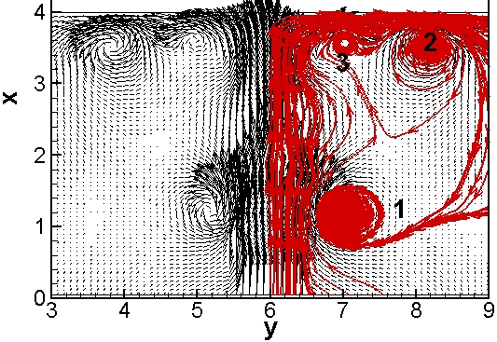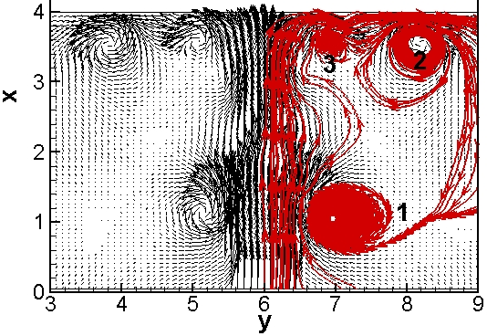
Flame C Flame D
Fig.5. Instantaneous velocity vector fields of syngas flames A, B, C and D at t=16.

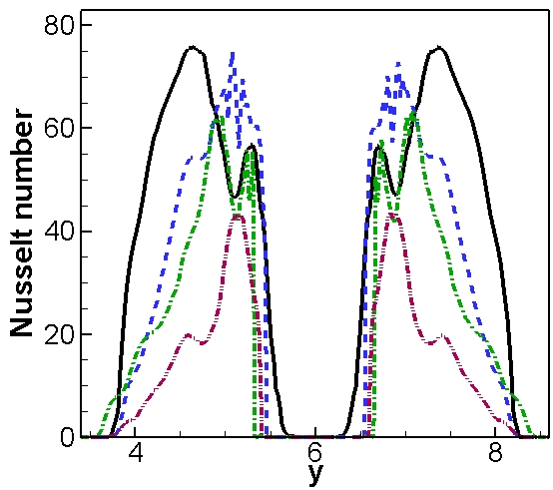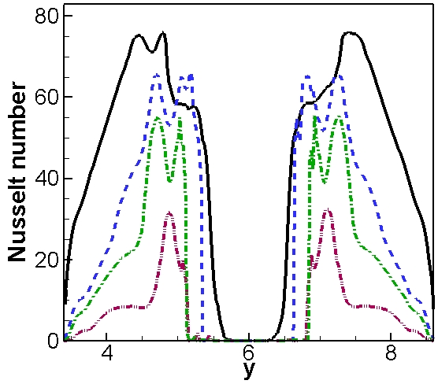
(a) (b)
Fig.6. Instantaneous Nusselt number of syngas flames A (solid line), B (dashed line), C (dashed-dotted) and D (dashed-dotted-dotted) at the wall in the z=6.0 plane at (a) t=12 and (b) t=16.

Figure Captions

Fig.1. Geometry of the impinging flame with the computational domain size of 4 jet nozzle diameters in the streamwise direction and 12 diameters in the cross-streamwise directions.

Fig.2. Instantaneous flame temperature of syngas flames A, B, C and D at t=12.

Fig.3. Instantaneous flame temperature of syngas flames A, B, C and D at t=16.

Fig.4. Scattered temperature data plotted against mixture fraction at three different axial locations: x=0.7 (green colour), 1.4 (blue colour), 3.5 (red colour) of flames A, B, C and D at t=16.

Fig.5. Instantaneous velocity vector fields of syngas flames A, B, C and D at t=16.

Fig.6. Instantaneous Nusselt number of syngas flames A (solid line), B (dashed line), C (dashed-dotted) and D (dashed-dotted-dotted) at the wall in the z=6.0 plane at (a) t=12 and (b) t=16.

