Anion recognition and transport properties of sulfamide-, phosphoric triamide- and thiophosphoric triamide-based receptors

Philippa B. Cranwell,*a* Jennifer R. Hiscock,*a* Cally J.E. Haynes,*a* Mark E. Light,*a* Neil J. Wells*a* and Philip A. Gale*a\**

Received (in XXX, XXX) Xth XXXXXXXXX 20XX, Accepted Xth XXXXXXXXX 20XX

DOI: 10.1039/b000000x

Studies of sulfamide, phosphoric triamide and thiophosphoric triamide-based organocatalysts show that the phosphorus containing systems are effective new hydrogen bonding motifs for the recognition and transport of anions.

Many of the hydrogen bonding motifs used in synthetic anion receptor compounds have also proven effective as components of organocatalysts.1 For example compounds containing thiourea,2 squaramide3 and sulfonamide4 groups have been shown to be effective anion receptors and then subsequently shown to function as organocatalysts for a range of reactions. Recently Shea and co-workers reported that compounds **1** – **3** catalyse Friedel-Crafts and Baylis-Hillman reactions.5,6 As part of our work on transmembrane anion transport,7 we wished to explore the anion recognition and transport properties of these hydrogen bonding arrays as to the best of our knowledge these classes of compound have not previously been employed as anion receptors or transporters. Compounds **2** and **3** could be regarded as three-dimensional analogues of ureas or thioureas and may interact with oxo-anions through multiple hydrogen bonds thus displaying interesting selectivity.



Compounds **1** – **3** were synthesised according to a modification of the method reported by Shea and co-workers5 (see ESI).

Crystals of the chloride complex of compounds **2** were grown by slow evaporation of a solution of the receptor in methanol in the presence of excess tetrabutylammonium chloride. The structure of the complex was elucidated by single crystal X-ray diffraction8 and revealed the formation of a 1:2 receptor:anion complex in the solid state with one chloride bound by two hydrogen bonds from two of the NH groups (3.126(4) Å, 3.177(4) Å) and the other chloride bound by a single hydrogen bond from the other NH group (3.215(4) Å) (Figure 1).

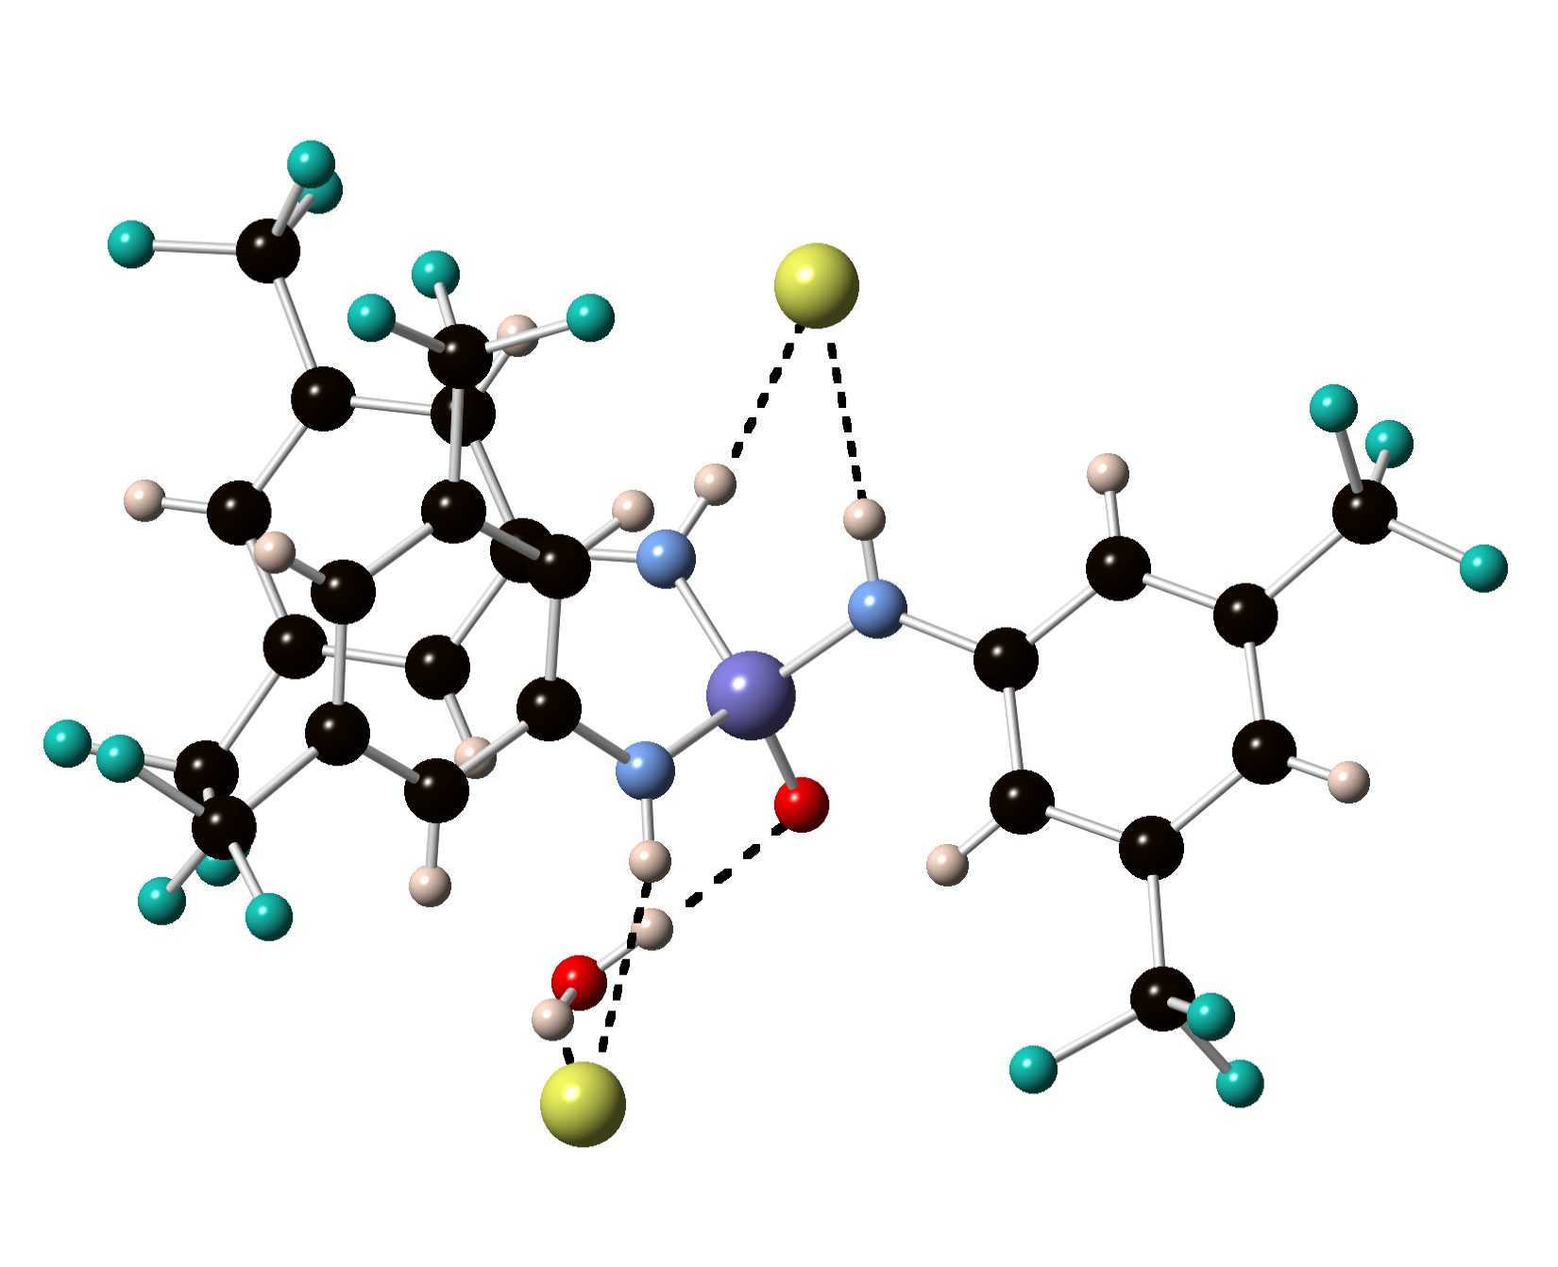

Figure 1 The X-ray crystal structure of the chloride complex of compound **2**. Tetrabutylammonium counter cations are omitted for clarity.

Crystals of the tetrabutylammonium acetate complex of compound **2** were obtained by slow evaporation of a methanol solution of the receptor in the presence of excess tetrabutylammonium acetate. Structural studies revealed the formation of a 1:1 complex with the acetate anion bound to two of the NH groups with bond lengths of 2.707(10) Å and 2.774(9) Å. The other NH group in the receptor forms a hydrogen bond with an adventitious water molecule (NH…O 2.870(9) Å) (Figure 2).

Solution studies with the receptors and anions were conducted using 1H NMR titration techniques in DMSO-*d6*/0.5% water. Upon addition of acetate, benzoate, dihydrogen phosphate or sulfate (added as tetrabutylammonium salts) or tetraethylammonium bicarbonate to a solution of compound **1**, the 1H NMR resonances corresponding to the aromatic protons shifted upfield and the NH resonances broadened into the baseline after initially shifting upfield. This was accompanied by a colourless to pink colour change. This behaviour was also observed upon addition of tetrabutylammonium hydroxide and was again accompanied by a colourless to pink colour change. We attribute this behaviour to deprotonation of the receptor. We attempted to obtain crystals of the deprotonated species by slow evaporation of a solution of receptor **1** in methanol in the presence of tetrabutylammonium benzoate. The structure obtained from the resulting crystals revealed that the receptor had decomposed forming a sulfamate anion that crystallised as the tetrabutylammonium salt (see ESI).

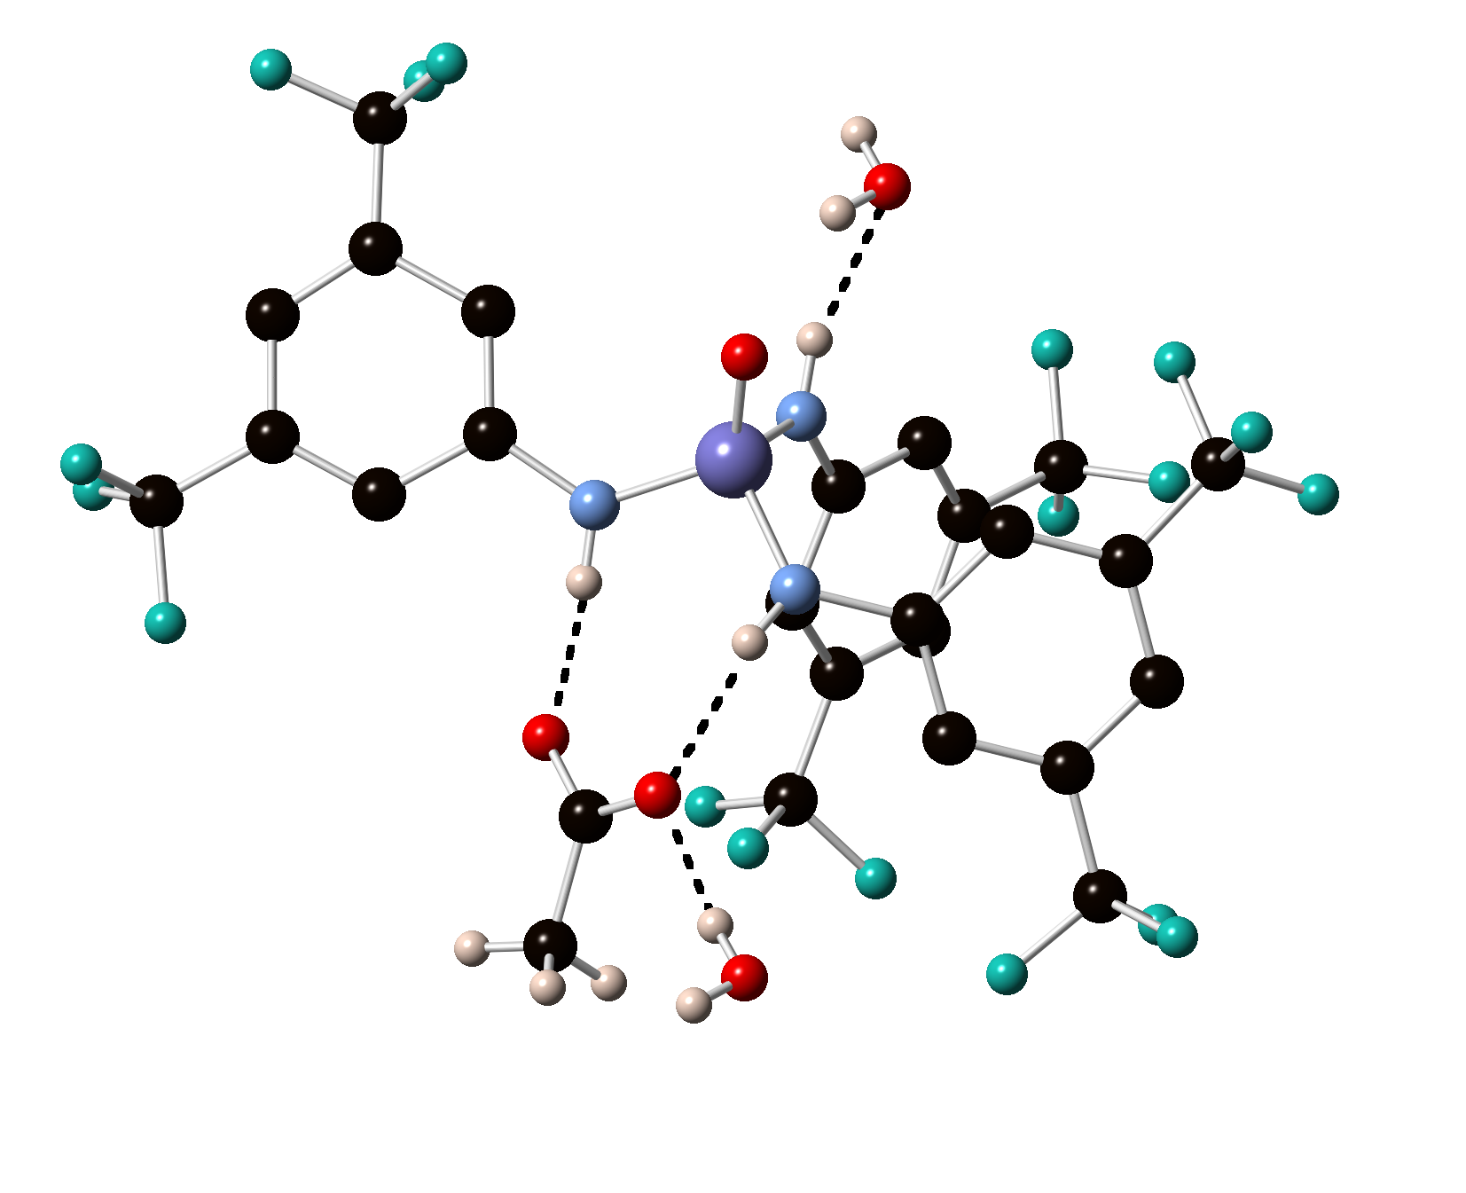

Figure 2 The X-ray crystal structure of the acetate complex of compound **2**. Tetrabutylammonium counter cations are omitted for clarity.

Proton NMR titrations with tetrabutylammonium chloride, bromide and iodide were conducted and analysis of the results using the EQNMR computer program9 showed stability constants of < 10 M-1 in DMSO-*d6*/0.5% water. When the titration experiments were repeated in CD3CN solution, 1:1 complex formation was observed with chloride, bromide and iodide with stability constants of 104, 59 and 25 M-1 respectively (Table 1).

Compound **2** also interacts weakly with halides in DMSO-*d6*/0.5% water solution. However in acetonitrile-*d3* 1:2 receptor:anion complex formation was observed with chloride and bromide. Job plots for many of the complexes formed were ambiguous. For the 1:2 complexes observed in these cases fitting of a 1:1 binding model gave unsatisfactory results. For the more basic mono anionic oxo-anions in DMSO-*d6*/0.5% water solution the anionic guests formed 1:2 complexes with *K1* > *K2*. Bicarbonate could not be fitted to a binding model. This may be due to deprotonation or proton transfer processes occurring in solution.10 In fact the NMR titration with bicarbonate was very similar to a titration performed with tetrabutylammonium hydroxide, evidence of a deprotonation process occurring in solution. The less basic nitrate and hydrogen sulfate form weak 1:1 complexes. Contrastingly sulfate forms a strong 1:1 complex with the receptor that may be due to the formation of a complex *via* three hydrogen-bonding interactions in the case of this doubly negative anion (Figure 3).

Compound **3** generally has a similar affinity profile for anions as compound **2** however the increased acidity of this receptor resulted in deprotonation processes occurring upon addition of bicarbonate, sulfate and acetate (Table 1).

In order to study the chloride transport properties of compounds **1** to **3** we prepared a series of unilamellar 1-palmitoyl-2-oleoylphosphatidylcholine (POPC) vesicles loaded with NaCl (489 mM) and suspended them in an external NaNO3 (489 mM) solution using previously reported procedures.11,12 Chloride efflux from the vesicles was monitored using an Accumet chloride selective electrode. Upon addition of compound **1** (at 2% molar transporter to lipid overall concentration) in a small amount of DMSO no chloride efflux was observed. However addition of compounds **2** or **3** at this concentration did result in chloride efflux. Therefore we added sample of receptor **2** or **3** at varying % molar transporter to lipid concentrations and the resultant Cl- efflux monitored using a chloride selective electrode. After 300 s, the vesicles were lysed by addition of detergent and the final reading of the electrode was used to calibrate 100 % release of chloride. The results of these studies were used to perform a Hill analysis13 of the transport properties of these receptors in order to ascertain the EC50 values of these systems i.e. the concentration of transporter needed to achieve 50% chloride efflux in 270 s. Compound **2** was found to have an EC50 value of 7.0% molar transporter to lipid (see Figure 4) whilst compound **3** was found to have an EC50 value of 6.2% molar transporter to lipid. Further experiments to elucidate the mechanism of transport showed that in both cases Cl-/NO3- antiport was occurring (see ESI). Chloride/bicarbonate antiport was also observed but at a lower level of activity.

Table 1 Stability constants (*Ka*/M-1) and errors (%) measured for compounds **1**-**3** with a range of anions added as tetrabutylammonium salts (apart from bicarbonate added as the tetraethylammonium salt) at 298K.

|  |  |  |  |
| --- | --- | --- | --- |
|  | **1** | **2** | **3** |
| Cl-a | 104 (8%) | *K1* = 17400 (5%)  *K2* = 59 (5%) | *K1* = 26800 (4%)  *K2* = 36 (4%) |
| Br-a | 59 (6%) | *K1* = 10800 (3%)  *K2* = 120 (5%) | *K1* = 8510 (5%)  *K2* = 130 (5%) |
| I-a | 25 (7%) | 48 (5%) | 74 (4%) |
| Cl-b | <10 | 13 (7%)c | 17 (7%)c |
| Br-b | <10 | 32 (6%)c | 25 (6%)c |
| I-b | <10 | 36 (6%)c | 21 (6%)c |
| HCO3-b | d | d | d |
| CH3CO2-b | d | *K1* = 6510 (4%)  *K2* = 39 (4%) | d |
| PhCO2-b | d | e | *K1* = 10000 (3%)  *K2* = 48 (3%) |
| H2PO4-b | d | *K1* = 5460 (3%)  *K2* = 107 (3%) | *K1* = 2040 (7%)  *K2* = 432 (7%) |
| NO3-b | <10 | 20 (7%)c | 16 (10%) |
| HSO4-b | <10 | 43 (4%)c | 57 (6%) |
| SO42-b | d | >104 | d |

a Titration conducted in acetonitrile-*d3*. b Titration conducted in DMSO-*d6*/0.5% water. c Stability constant determined following the shift of a CH resonance. d Upfield shift of NH resonance followed by broadening into the baseline (and evolution of a pink colour in the case of compound **1**) indicative of deprotonation. e An adequate fit to a binding model could not be obtained.



Figure 3 A proposed structure of the complex formed between compound **2** and sulfate.

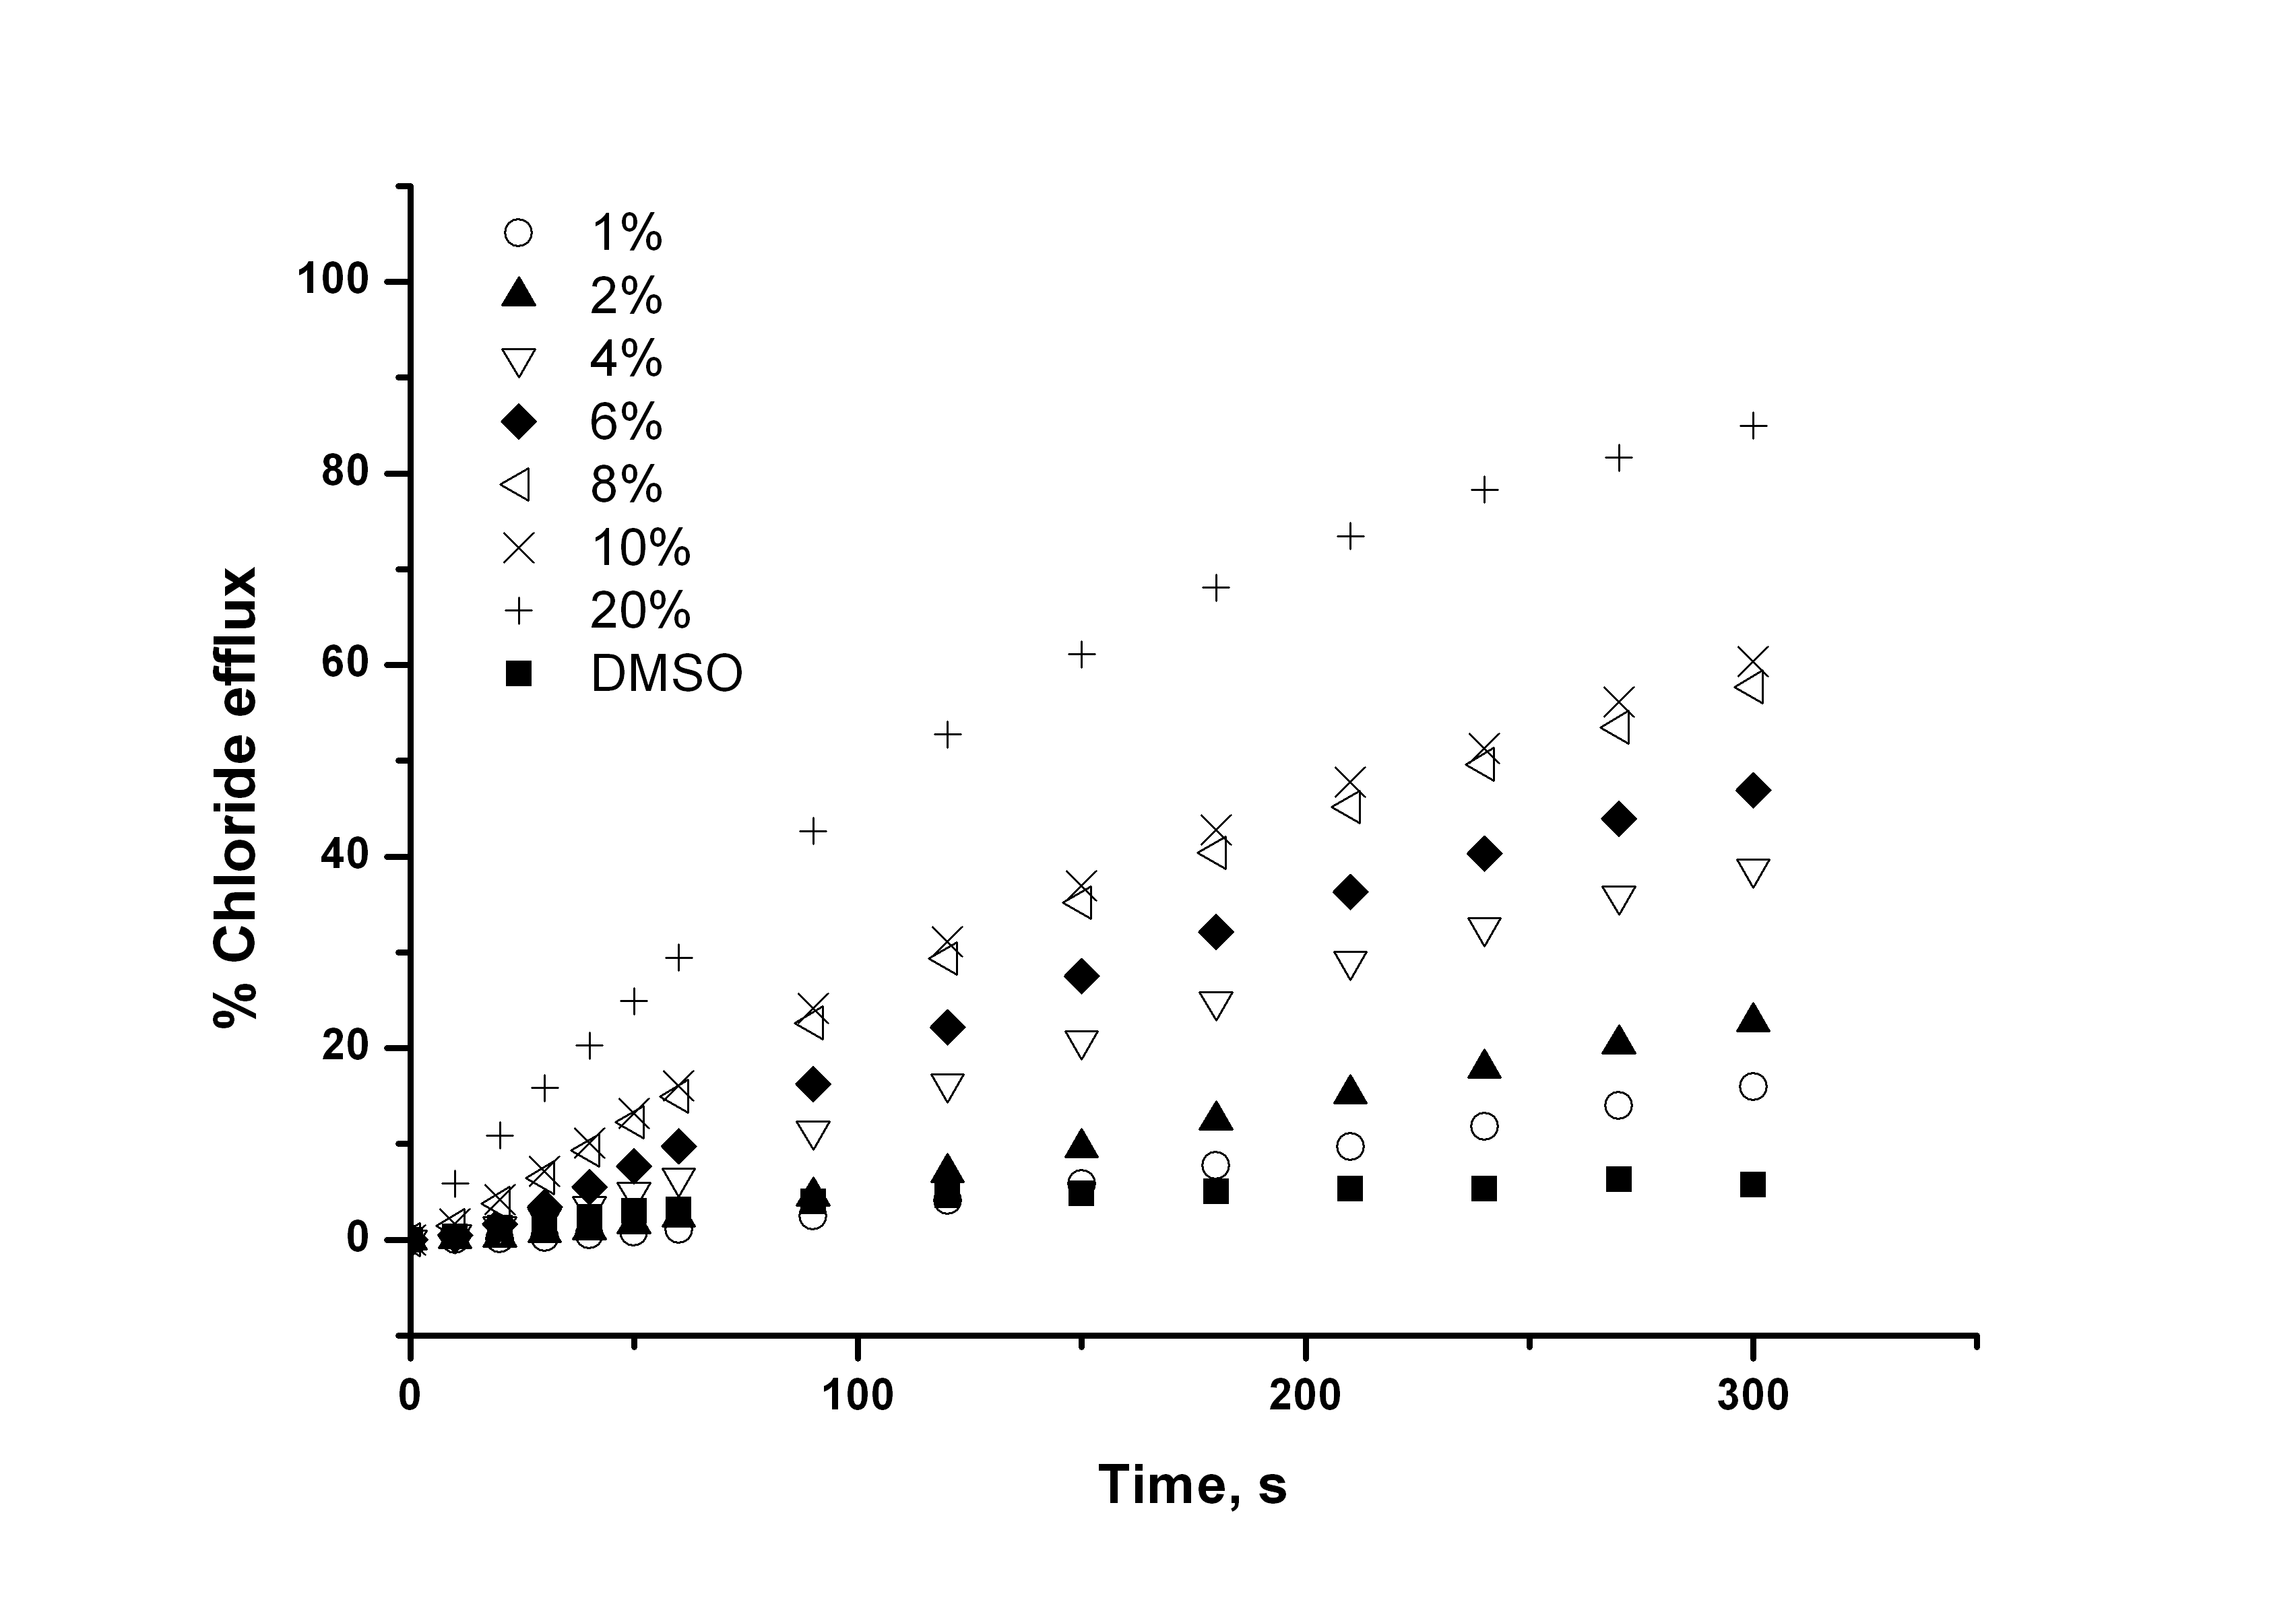

Figure 4 Chloride efflux promoted by compound **2** (at varying % molar carrier to lipid) from unilamellar POPC vesicles loaded with 489 mM NaCl buffered to pH 7.2 with 5 mM sodium phosphate salts. The vesicles were dispersed in 489 mM NaNO3 buffered to pH 7.2 with 5 mM sodium phosphate salts. At the end of the experiment, detergent was added to lyse the vesicles and calibrate the ISE to 100 % chloride efflux. Each point represents the average of three trials. DMSO was used as control.

We also studied the transport properties of compounds **2** and **3** in vesicles consisting of 70% POPC: 30% cholesterol. It has been suggested that incorporation of cholesterol in a lipid bilayer will increase the viscosity of the membrane and therefore should slow down the rate of transport of a carrier whilst leaving the rate of transport of a channel unaffected.14 We found in these studies that the rate of chloride/nitrate antiport mediated by compounds **2** and **3** was significantly enhanced in vesicles containing cholesterol, a finding that our group7b,15 and others16 have observed previously with other transporters. This could be due to enhanced partitioning of these systems into the cholesterol containing membrane. Classical nitrobenzene/water U-tube experiments with compounds **2** and **3** were inconclusive with compound **3** mediating only a small mount of chloride transport (see ESI for more details).

Conclusions

We have shown that new hydrogen bonding motifs based on phosphoric triamide and thiophosphoric triamide hydrogen bonding arrays are effective anion receptors and are capable of mediating the exchange of chloride and nitrate across a lipid bilayer membrane.17 Interestingly compound **2** has a high selectivity for sulfate anions in DMSO-*d6*/0.5% water solution. These early findings suggest that these new classes of hydrogen bond donor anion receptor may have applications in a range of systems designed for selective interactions with anionic guests. We are continuing to study the properties of these new anion receptors.

Acknowledgements

We thank the EPSRC for a post-doctoral research fellowship (C.J.E.H.) and for access to the crystallographic facilities at the University of Southampton.

Notes and references

a Chemistry, University of Southampton, Southampton SO17 1BJ, UK. Email: philip.gale@soton.ac.uk; Fax: +44 (0)23 8059 6805; Tel: +44 (0)23 8059 3332.

† Electronic Supplementary Information (ESI) available: synthesis details, NMR spectra, titration profiles, transport experiments and crystallographic details (CCDC 910542 – 910544). See DOI: 10.1039/b000000x/

1 Z. Zhang and P.R. Schreiner, *Chem. Soc. Rev.* 2009, **38**, 1187-1198; P.R. Schreiner, *Chem. Soc. Rev.* 2003, **32**, 289-296.

2 M. Kotke and P. R. Schreiner, *Tetrahedron* 2006, **62**, 434-439.

3 For a recent review about the use of squaramides in organocatalysis see: J. Alemán, A. Parra, H. Jiang and K. A. Jørgensen, *Chem. Eur. J.* 2011, **17**, 6890-6899.

4 (a) S.H. Oh, H.S. Rho, J.W. Lee, J. E. Lee, S.H. Youk, J. Chin, C.E. Song, *Angew. Chem., Int. Ed.* 2008, **47**, 7872–7875; (b) J. Luo, L.-W. Xu, R. A. S. Hay and Y. Lu, *Org. Lett.* 2009, **11**, 437–440.

5 A.A. Rodriguez, H. Yoo, J.W. Ziller and K.J. Shea, *Tetrahedron Lett.* 2009, **50**, 6830-6833.

6 For crystal structures of related compounds see: J.L. Atwood, A.H. Cowley, W.E. Hunter and S.K. Mehrotra, *Inorg. Chem.* 1982, **21**, 435-437; T. Chivers, M. Krahn, G. Schatte and M. Parvez, *Inorg. Chem.* 2003, **42**, 3994-4005.

7 a) N. Busschaert and P.A. Gale, *Angew. Chem. Int. Ed.* DOI: 10.1002/anie.201207535; b) S.J. Moore, C.J.E. Haynes, J. González, J.L. Sutton, S.J. Brooks, M.E. Light, J. Herniman, G. J. Langley, V. Soto-Cerrato, R. Pérez-Tomás, I. Marques, P.J. Costa, V. Félix and P.A. Gale, *Chem. Sci.* 2013, **4**, 103-117; c) N. Busschaert, I.L. Kirby, S. Young, S.J. Coles, P.N. Horton, M.E. Light and P.A. Gale, *Angew. Chem. Int. Ed.* 2012, **51**, 4426-4430; d) N. Busschaert, M. Wenzel, M.E. Light, P. Iglesias-Hernández, R. Pérez-Tomás and P.A. Gale, *J. Am. Chem. Soc.*, 2011, **133**, 14136-14148; e) M. Wenzel, M.E. Light, A.P. Davis and P.A. Gale, *Chem. Commun.* 2011, **47**, 7641-7643; f) N.J. Andrews, C.J.E. Haynes, M.E. Light, S.J. Moore, C.C. Tong, J.T. Davis, W.A. Harrell Jr. and P.A. Gale, *Chem. Sci.*, 2011, **2**, 256-260; g) P.A. Gale, *Acc. Chem. Res.* 2011, **44**, 216-226.

8 S.J. Coles and P.A. Gale, *Chem. Sci.* 2012, **3**, 683-689.

9 M.J. Hynes, *J. Chem. Soc. Dalton Trans.* 1993, 311-312.

10 a) P.A. Gale, J.R. Hiscock, S.J. Moore, C. Caltagirone, M.B. Hursthouse and M.E. Light, *Chem. Asian J.*, 2010, **5**, 555-561; b) P.A. Gale, J.R. Hiscock, C.Z. Jie, M.B. Hursthouse, and M.E. Light, *Chem. Sci.*, 2010, **1**, 215-220; c) L.S. Evans, P.A. Gale, M.E. Light and R. Quesada, *Chem. Commun.* 2006, 965-967; d) C. Caltagirone, G.W. Bates, P.A. Gale and M.E. Light, *Chem. Commun.* 2008, 61-63.

11 S. A. Svarovsky, R. H. Simoyi and S. V. Makarov, *J. Phys. Chem. B*, 2001, **105**, 12634-12643.

12 G. J. Durant, J. C. Emmett, C. R. Ganellin, P. D. Miles, M. E. Parsons, H. D. Prain and G. R. White, *J. Med. Chem.*, 1977, **20**, 901-906.

13 a) A. V. Hill, *Biochem J* 1913, **7**, 471-480; b) S. Bhosale, S. Matile, *Chirality* 2006, **18**, 849-856.

14 W. F. D. Bennett, J. L. MacCallum, D. P. Tieleman, *J. Am. Chem. Soc.* 2009, **131**, 1972-1978.

15 We have observed similar behaviour recently: a) S.J. Moore, M. Wenzel, M.E. Light, R. Morley, S.J. Bradberry, P. Gómez-Iglesias, V. Soto-Cerrato, R. Pérez-Tomás, and P.A. Gale, *Chem. Sci*., 2012, **3**, 2501-2508; b) C.J.E. Haynes, S.J. Moore, J.R. Hiscock, I. Marques, P.J. Costa, V. Félix and P.A. Gale, *Chem. Sci.* 2012, **3**, 1436-1444.

16 H. Cho and Y. Zhao, *Chem. Commun.* 2011, **47**, 8970-8972.

17. For other recent transmembrane anion transporters see: a) B. D. de Greñu, P. I. Hernández, M. Espona, D. Quiñonero, M. E. Light, T. Torroba, R. Pérez-Tomás, R. Quesada, *Chem. Eur. J.* 2011, **17**, 14074-14083. b) P. I. Hernández, D. Moreno, A. A. Javier, T. Torroba, R. Pérez-Tomás and R. Quesada, *Chem. Commun.* 2012, **48**, 1556-1558; c) V. Saggiomo, S. Otto, I. Marques, V. Félix, T. Torroba, R. Quesada, *Chem. Commun.* 2012, **48**, 5274-5276; d) S. Bahmanjah, N. Zhang, J. T. Davis, *Chem. Commun.* 2012, **48**, 4432-4434.