Direct Numerical Simulation of Nonpremixed Syngas Burning with Detailed Chemistry
K.K.J.Ranga Dinesh and X. Jiang.
Engineering Department, Lancaster University, Lancaster, LA14YR, UK.
J.A. van Oijen
Combustion Technology, Eindhoven University of Technology, Eindhoven, The Netherlands.
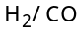 non-premixed syngas impinging jet flames were studied using three-dimensional direct numerical simulation (DNS) and flamelet generated manifolds (FGM) based on detailed chemical kinetics. The computational domain employed has a size of 4 jet diameters in the streamwise direction and 12 jet diameters in the cross-streamwise direction. The results presented in this study were performed using a uniform Cartesian grid with 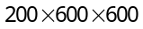 points. Reynolds number used was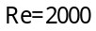, based on the inlet reference quantities. The spatial discretisation was carried out using a sixth-order accurate compact finite difference scheme and the discretised equations were temporally advanced using a third-order accurate fully explicit compact-storage Runge-Kutta scheme. Results show that the ratio of 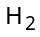and 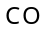in the syngas mixture significantly changes the flame characteristics including near-wall flame structure. The high diffusivity of 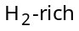syngas flame forms weaker vortices, results in a thicker flame. In contrast, 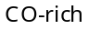syngas flame forms strong wrinkles, results in a thinner flame. Moreover, the DNS results suggest that the preferential diffusion influences the local flame structure for the simulated low Reynolds number flame.

Introduction
Development of clean coal technology would allow continued use of coal without substantial emissions of greenhouse gases such as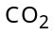. Beyond that, it contributes to a balance between energy supply and demand, a strategic and necessary choice for realising the coordinated development of energy, environment and economy (3Es). Such clean coal energy conversion technologies only rely on combustion gasified coal, referred to as synthesis gas or syngas, which is mainly a mixture of hydrogen () and carbon monoxide (). Coal is the predominant source of gasifier feedstock, supplying 55% of syngas worldwide in 2007. There is also a considerable interest to produce from coal gasification process and its consumption is expected to increase dramatically in the near future. For example, in recent year’s significant progress has been made in the development of integrated gasification combined cycle (IGCC) technology to employ hydrogen and syngas fuels in the gas turbine including the potential for capture for cleaner electric power production. This integration of energy conversion processes provides more complete utilization of energy resources, offering high efficiencies and ultra-low pollution levels. The unique advantages of IGCC systems have created a significant market for gasification technologies in industrial applications because gasification is the only technology that offers both upstream (feedstock flexibility) and downstream (product flexibility) advantages. Because they operate at higher efficiency levels than conventional fossil-fueled power plants, IGCC systems emit less CO₂ per unit of energy. They are also well suited for application of future technologies to capture, sequester CO₂.
Particularly there is a growing interest in the combustion of hydrogen-enriched synthesis gas. In recent decades, computational combustion has made remarkable advances due to its ability to deal with range of scales, complexity and unlimited access to data. Direct numerical simulation (DNS) in which the complete spectrum of scales are resolved, are evolving as an extremely valuable computational tool from which much can be learned. Because of the limited computing resources available, earlier research had to rely on simplifications such as two-dimensional flow and/or simple one-step global chemistry, e.g. non-premixed flames were investigated under these simplified conditions,. Since then various studies have been performed on DNS of non-premixed combustion to investigate turbulence chemistry interaction, fuel variability and flame stabilisation, local extinction and auto-ignition etc. With the continuous progress in the understanding of combustion physics as well as the ever-increasing computing power available, there are compelling reasons to perform fully three-dimensional DNS with complexity chemical kinetics to obtain insights into the flame dynamics of important combustion applications such as future clean combustion.
Since next generation combustion systems are rapidly shifting towards hydrogen and syngas fuels, there are number of issues which need further investigations. For example, higher diffusivity and reactivity of hydrogen-enriched syngas combustion should lead to unconventional operating conditions, mixed-mode and therefore undiscovered turbulent-chemistry regimes. Furthermore, the application of hydrogen-enriched syngas to both internal and gas turbine combustion are likely develop undesirable flame flashback phenomenon, in which the flame propagates into the burner. Therefore, there is a growing interest for high fidelity simulation techniques that capture the fundamental fine scale turbulence-chemistry interactions, and especially flame dynamics with respect to fuel variability. For example, thermo-diffusive effects such as differences in the relative rates of mass diffusion with respect to syngas fuel variability may results in complex interactions that are not well understood. Also the effect of differential diffusion depending on the amount of hydrogen in the syngas fuel mixture is likely to further affect the flame dynamic behaviour. If the turbulence level is very low this effect may become significant in hydrogen-enriched syngas flames. The present investigation has two objectives: (1) to study the fuel variability effects and flame dynamics of fuel mixtures, (2) to investigate the effect of differential diffusion on hydrogen flame. Here we employed the DNS technique along with flamelet-generated manifold (FGM) approach. The detailed chemical kinetics has been employed through the FGM method which not only uses complex chemistry, but also takes the most important transport processes into account. An impinging jet including buoyancy effects has been selected as the configuration of the physical problem under investigation, which provides not only details of flame dynamics but also information on near-wall combustion which is a challenging topic that needs further investigations.

- Numerical Computation and Flame Chemistry
The three-dimensional equations of the conservation laws for continuity, momentum, energy, transport equations for progress variable and mixture fraction, and the equation of state in their non-dimensional form were numerically solved. The discretisation of the governing equations includes the high-order numerical schemes for both spatial discretisation and time advancement. The spatial derivates in all three directions are solved using a sixth-order accurate compact (Padé) finite difference scheme. Solutions for the spatial discretised equations are obtained by solving the tri-diagonal system of algebraic equations. The spatial discretised equations are advanced in time using a fully explicit low-storage third-order Runge-Kutta scheme. The time step was limited by the Courant number for stability and a chemical restraint. The computational domain employed has a size of four jet nozzle diameters in the streamwise direction and twelve jet nozzle diameters in the cross-streamwise directions. The results presented in this study were performed using a uniform Cartesian grid with 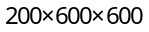 points resulting 72 million computational nodes. The Reynolds number used was Re=2000 and Froude number Fr=1.0 based on the fuel jet reference quantities. The Prandtl number and the specific heat vary according to the FGM table. The computational domain contains an inlet and impinging wall boundaries in the streamwise direction where the buoyancy force is acting. At the inflow, the flow was specified using the Navier-Stokes characteristic boundary conditions with the temperature treated as a soft variable (temperature was allowed to fluctuate according to the characteristic waves at the boundary). External unsteady disturbances were artificially added to the mean velocity profile for all three velocity component at the inlet in a sinusoidal form. A relatively large disturbance, at 5% of the mean velocity at the inlet, was used to enhance the development of instability in the computational domain, which is rather small in the streamwise direction, while the frequency of the perturbation was chosen to trigger the unstable mode of the jet. The non-slip wall boundary condition is applied at the downstream impinging wall, which is assumed to be at the ambient temperature, impermeable to mass and without surface chemical reaction. At the impinging wall boundary, the mixture fraction is assumed zero-gradient corresponding to the impermeability, while the progress variable for chemistry is taken as zero at the solid wall boundary. The simplified wall boundary conditions were adopted to facilitate investigations of fuel variability effects on the flame dynamics and near-wall heat transfer. To investigate the effects of fuel variability, the flame chemistry must be realistically represented in order to accurately predict the chemical heat release and the concentrations of the chemical species of the syngas combustion. However, it is computationally expensive to incorporate a detailed chemical mechanism into DNS directly due to the large computer memory and CPU requirements. In this work, the flame chemistry of syngas mixtures is represented by databases generated by using the FGM technique, accounting for both chemical and transport processes using the laminar flamelet concept. The FGM databases were produced from steady counterflow diffusion flamelets by using detailed chemistryand transport models including differential diffusion effects. In this way, the chemically reacting flow can be computed with the essential chemistry and transport processes taking into account without incurring prohibitive computational expenses.

- Results and Discussion
A. Flame Dyanamics of Syngas Combustion
This section presents DNS results of flames corresponding to hydrogen (flame H) and two different syngas fuel mixtures (flames HCO and COH) in an impinging jet flame configuration. For two syngas mixtures, the compositions were taken from the BP syngas datasheet with the maximum percentage of H₂ and CO in each case. The fuel composition, stoichiometric mixture fraction and maximum flame temperature values obtained from DNS are shown in Table 1.

Table 1. Composition of the Syngas fuels, stoichiometric mixture fraction and maximum flame temperature
Case | Flame H | Flame HCO | Flame COH
H₂ % | 100 | 70.3 | 33.4
CO % | 0 | 29.7 | 66.6
Stoichiometric Mixture Fraction | 0.028 | 0.124 | 0.220
Maximum Flame Temperature | 8.5 (2490K) | 8.3 (2430K) | 8.0 (2344K)

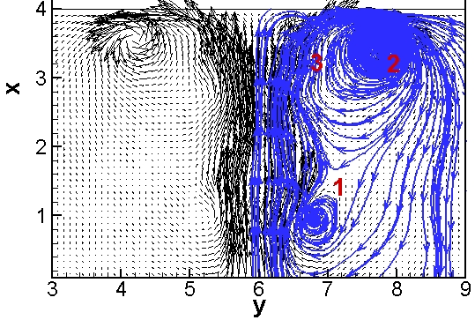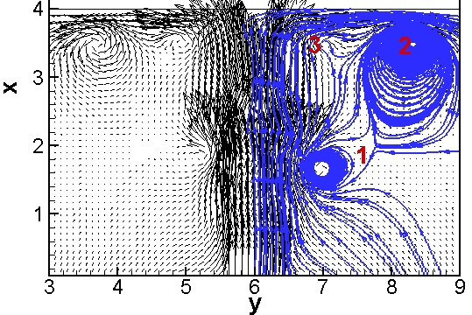
(H1) (H2)
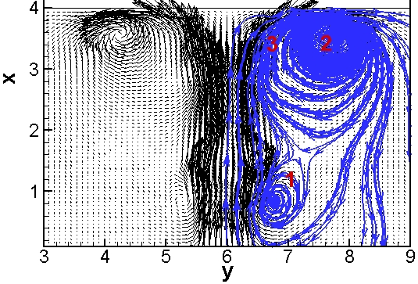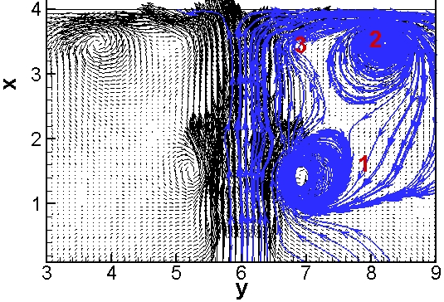
( HCO1) (HCO2)
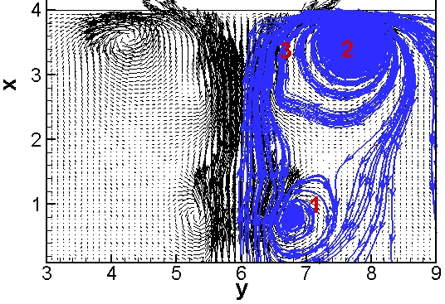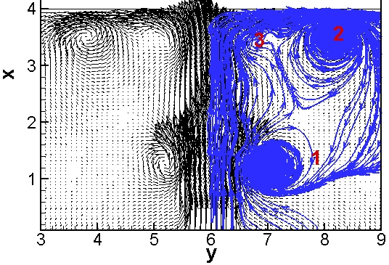
(COH1) (COH2)
Fig.1. Instantaneous velocity vector fields of flames H, HCO and COH at t=12 (H1, HCO1, COH1) and t=16 (H2, HCO2, COH2).

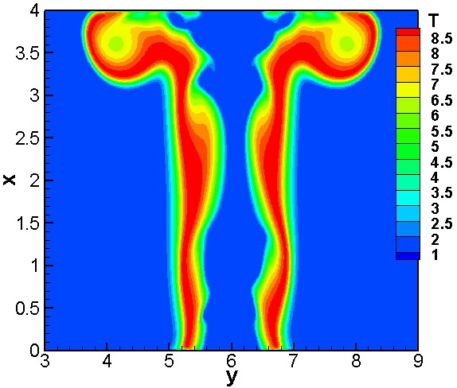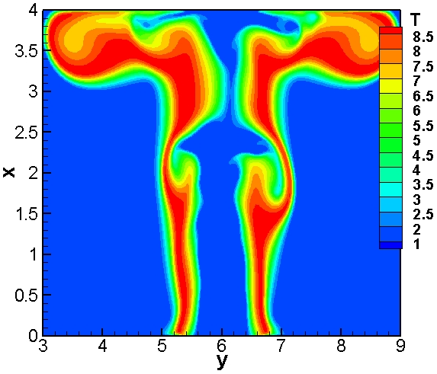
(H1) (H2)
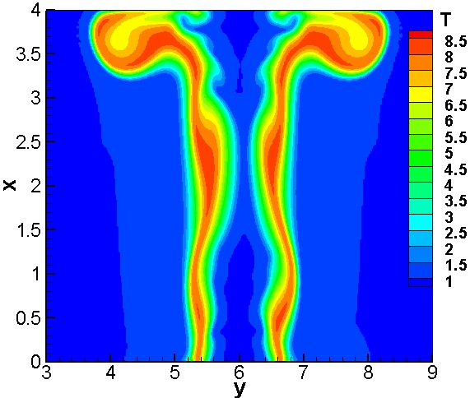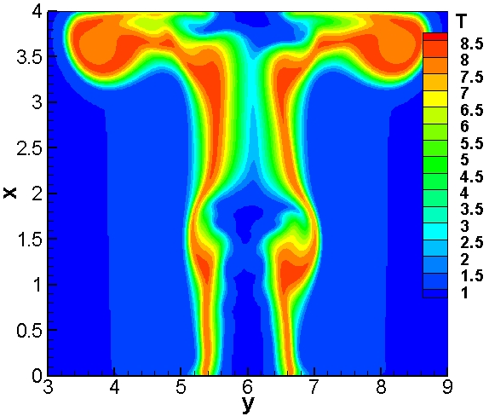
(HCO1) (HCO2)
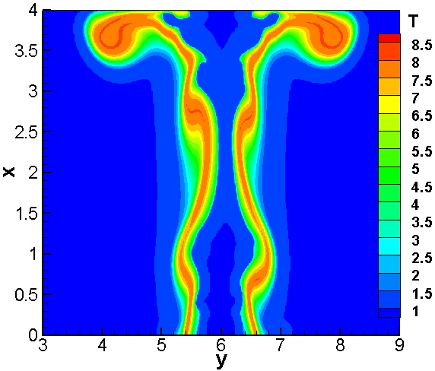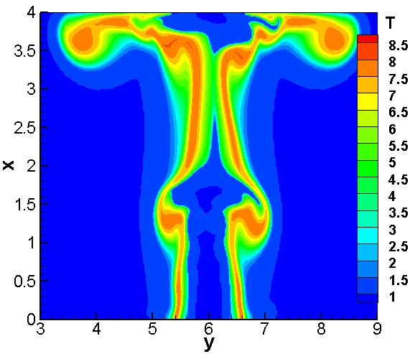
(COH1) (COH2)
Fig.2. Instantaneous temperature fields of flames H, HCO and COH at t=12 (H1, HCO1, COH1) and t=16 (H2, HCO2, COH2).

Figure 1 shows series of cross-sectional instantaneous velocity vector fields together with sample streamline traces of flames H, HCO and COH at t=12 and 16. In this reacting flow fields, complex vortical structures dominate the mixing and entrainment process, which will affect the distributions of mixture fraction, progress variable and flame temperature. In Fig. 1, the hydrogen flame H exhibits a buoyancy-induced vortical structure in the shear layers (region 1) at the primary jet stream, while the structure becomes slightly different with the addition of CO which is apparent in the HCO flame. The velocity fields of both flame HCO and flame COH exhibit similar behaviour at both time instants. In the wall jet stream, all three flames show a head vortex ring which is the large structure at the far side in wall jet region (region 2). In all three flames, complex large vortical structures associated with the buoyancy instability, which is known to trigger the flickering or puffing phenomenon, dominate the entrainment process, which will affect the distributions of flame temperature. It can be observed that the velocity puff in the near field moves upwards with respect to time. Similar behaviour is also observed in the wall jet region. Furthermore, the velocity fields demonstrate that vortical structures are formed in both the inner and outer sides of the primary jet stream and they dominate the entrainment process and thus affect the flow structure. The buoyancy instability leads to form large vortical structures, which are convected by the momentum of the primary jet stream as well as by the momentum of the secondary wall jet. It is also important to note the region 3 in which flame directly touch the wall. Although there is no clear vortex formation in region 3 near to the stagnation point, it can be observed that there is a tendency of vortex formation for the lean hydrogen case at t=16 shown in Fig. 1(COH2). In the near-wall region, vortex formation is the result of external skin friction that acts on the thin layer of the fluid attached to the wall, where viscosity difference associated with the 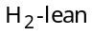but fuel might play a role in the vortex formation in the wall jet region.
Figure 2 shows the contours of instantaneous temperature in the mid-streamwise plane of flames H, HCO and COH at t=12 and 16 respectively. Interestingly, pure hydrogen flame H observed the maximum temperature of T=8.5 (2490K) and this flame is also wider than other two syngas flames. This observation clearly indicates the influence of high diffusivity and reactivity of hydrogen compared to syngas fuels. In non-premixed flames, combustion occurs in a thin layer in the vicinity of the stoichiometric surface of the non-premixed flames and diffusion plays a major role in the localised fuel/air mixing, which in turn controls the temperature in the reaction zone. Accordingly the flame may be thicker if the fuel has a higher diffusivity and therefore the local flow gradients become smaller and form less wrinkled structures, which is indeed the case for the pure flame H. However, and 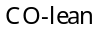flame HCO also exhibits thick flame, but slighter weaker than that found for pure hydrogen flame H. In addition, the maximum flame temperature of flame HCO is 8.3 (2430K) which is slightly lower than pure hydrogen flame H. It is interesting to note that the flame become increasingly thinner and more wrinkled for and mixture, which can be observed for flame COH. The maximum flame temperature also displays a decrease for the flame (T=8.0=2344K). All contour plots of the three flames confirm the conjecture that close to the wall, the thermal boundary layer evolves temporally and variation of the thermal boundary layer occurs. This is an important issue for modelling of turbulent combustion with respect to near-wall reacting flows. Detailed discussion of the near-wall fluid flow, heat transfer and combustion phenomenon requires much more in-depth data analysis of the DNS results, which will be presented in subsequent efforts. Further analysis of mean wall heat flux such as averaged heat flux along the wall including surface chemistry effects and near-wall vorticity at the boundary layer should provide vital information on near-wall heat transfer for practical applications of syngas combustion.

B. Influence of Preferential Diffusion on Hydrogen Combustion
With present in appreciable quantities in the fuel stream, preferential diffusion may be an important quantity especially for the low Reynolds number flows. This is a topic that needs further analysis. In order to study the influence of preferential diffusion on hydrogen H flame, modified transport equations for the reaction progress variable which account the preferential diffusion have been considered. To obtain an idea of the effect of preferential diffusion on the flame structure, results have been compared with and without additional term in the transport equation of the reaction progress variable. The comparison between the two cases allows the study of the influence of preferential diffusion on the hydrogen flame.
The instantaneous fields of cross-streamwise reaction progress variable and temperature with and without preferential diffusion at the axial location x=3.6 at t=16 is shown in fig. 3. As seen in fig. 3, the cross-streamwise reaction progress variable distribution at axial location x=3.6 shows the development of inner vortical structures with and without preferential diffusion. In this figure, influence of the preferential diffusion is clearly exhibits as the reaction progress variable with preferential diffusion show more vortical structures and wider regions with larger progress variable values (fig. 3 (a) Y and (b) Y) compared to equivalent plots without preferential diffusion. Therefore it is evident that the strength of the inner vortical structures weakens for the progress variable without preferential diffusion. Moreover, it is important to note that the development of both inner and outer vortical structures arises more strongly as a consequence of preferential diffusion term which plays an important role in the low Reynolds number turbulent flame. Since the influence of the preferential diffusion is evident in the reaction progress variable, the flame temperature needs to be examined subsequently. Fig. 3 ((a) and (b) T) show the instantaneous cross-streamwise temperature with and without preferential diffusion at axial location x=3.6 at t=16. Consequently, due to preferential diffusion effects, the temperature distribution varies considerably with large area of high temperatures compared to results without preferential diffusion. Interestingly, the high content significantly decreases the flame’s Lewis number (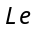, the ratio of thermal to mass diffusivity). Thus, there is a faster diffusion of reactants towards the reaction zone compared to its loss of thermal energy through conduction back to the fresh reactants for the flame. This is further enhanced by preferential diffusion, owing to the higher diffusivity of . Therefore the distribution of progress variable and flame temperature confirmed the fact that the preferential diffusion modifies the flame structure for the hydrogen flame with relatively low Reynolds number flow field. When preferential diffusion is active, the peak of the reaction progress variable and flame temperature distribute widely in the domain and thus modify the heat release pattern compared to corresponding distributions when preferential diffusion was not considered.

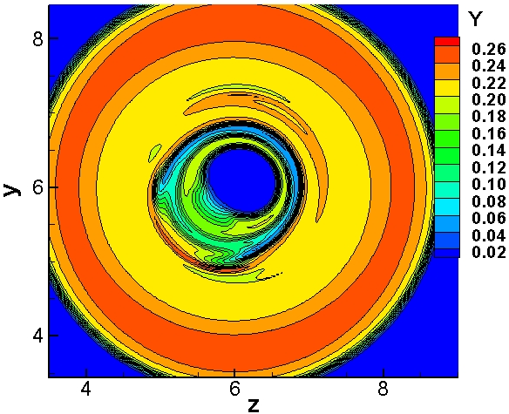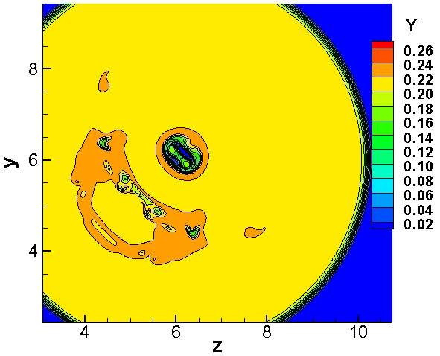
(a) Y (b) Y
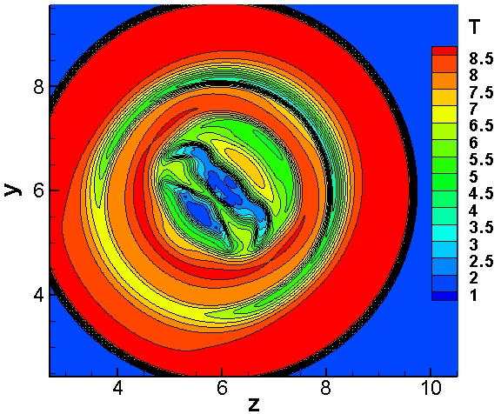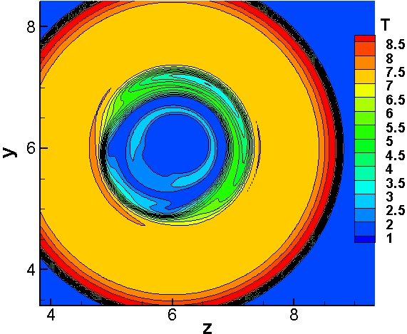
- T (b) T
Fig.3. Instantaneous cross-streamwise progress variable (Y) and temperature (T) of flame H (a) with and (b) without differential diffusion at axial location x=3.6 at t=16.

- Conclusion
Non-premixed syngas flames have been simulated using direct numerical simulation with a complete chemistry scheme based on the flamelet generated manifold approach. Comparisons were discussed under two sections: flame dynamics and influence of preferential diffusion. It has been found that high diffusivity of in flames tends to form a thicker flame with less vortical structures compared to but syngas flame which displays thinner flame with strong vortical structures. It has been found that the fuel variability plays a key role in the formation of vortical structures in the flow fields and the unsteady vortex separation from the wall leads to variations in the instantaneous thermal boundary layer thickness. In addition, the outer vortical structures dominate over the inner vortical structures in the flow fields of all three syngas flames. Buoyancy also acted as an oscillator in the flow field and led to the formation of self-sustained outer vortical structures. Vortex deformation occurs at the wall jet region due to the vortex-wall interaction. The comparisons of the flame structures with and without additional model term in the reaction progress variable demonstrates the importance of preferential diffusion especially for the distribution of maximum flame temperature. When preferential diffusion is accounted for, wider distributions of high temperature is observed compared to similar distribution without preferential diffusion.
More investigations on DNS of flame/wall interactions of syngas combustion will not only provide details about maximum wall heat flux distributions but also supply vital design guidelines for the next generation combustors for clean combustion bearing in mind that near-wall heat transfer determines the thermal loading of the combustor walls. Further investigations on DNS at high Reynolds number syngas impinging jets would now be of great interest, in particular with the inclusion of preferential diffusion and surface chemistry effects.

Acknowledgement
This research is funded by the UK EPSRC grant EP/G062714/2.

References
Miller, B., “Clean coal engineering technology,” Butterworth-Heinemann, Burlington, MA, USA, 2011.
Lieuwen, T.,Yang, V.,Yetter, R., “Synthesis gas combustion: Fundamentals and applications,” CRC Press Taylor and Francis Group, FL, USA, 2010.
Gasification World Database, Available at http://www.netl.doe.gov/technologies/coalpower/gasification/database/database.html.
Liu, K., Song, C., Subramani, V., “Hydrogen and syngas production and purification technologies,” John Wiley and Sons, Inc., Hoboken, New Jersey, USA. 2010.
Descamps, C., Bouallou, C., Kanniche, M., “Efficiency of an integrated gasification combined cycle (IGCC) power plant including removal,” Energy, Vol. 33, 2008, pp. 874-881.
Mondol, J.D., MsIlveen-Wright, D., Rezvani, S., Huang, Y., Hewitt, N., “Tecno-economic evaluation of advanced IGCC lignite coal fuelled power plant with capture,” Fuel, Vol. 88, 2009, pp. 2495-2506.
Kunze, C., Spliethoff, H., “Modelling of an IGCC plant with carbon capture for 2020,” Fuel Proc. Tech. , Vol. 91, 2010, pp. 934-941.
Westbrook, C.K., Mizobuchi, Y., Poinsot, T.J., Smith, P.J., Warnatz, J., “Computational combustion,” Proc. Combust. Inst. , Vol. 30, 2005, pp. 125-157.
Chen, J.H., “Petascale direct numerical simulation of turbulent combustion-fundamental inside towards predictive models,” Proc. Combust. Inst., Vol. 33, 2011, pp. 99-123.
Anderson, K.R., Mahalingam, S., Hertzberg, J., “A two-dimensional planner computational investigation of flame broadening in confined non-premixed jets,” Combust. and Flame, Vol. 118, 1999, pp. 233-247.
Mahalingam, S., Chen, J.H., Vervisch, L., “Finite rate chemistry and transient effects in direct numerical simulations of turbulent non-premixed flames,” Combust. Flame , Vol. 102, 1995, pp. 285-297.
van Oijen, J.A., de Goey, L.P.H., “Modelling of premixed laminar flames using flamelet-generated manifolds,” Combust. Sci. Tech. Vol. 161, 2000, pp. 113-137.
Lele, S.K., “Compact finite difference scheme with spectral-like resolution,” J. of Comput. Phy. 103 (1992) 16-42.
Williamson, J.H., “Low-storage Runge-Kutta schemes,” J. of Comput. Phy., Vol. 35, 1980, pp. 48-56.
Poinsot, T.J.,Lele, S.K., “Boundary-conditions for direct numerical simulations of compressible viscous flows,” J. of Comput. Phy. Vol. 101, 1992, pp.104-129.
Peters, N., “Turbulent combustion,” Cambridge Uni. Press. 2000.
Davis, S.G., Ameya, V.J.,Wang, H., Egolfopoulos, F., “An optimised kinetic model of H2/CO combustion,” Proc. Combust. Inst., Vol. 30, 2005, pp. 1283-1292.
Hilbert, R., Thevenin, D., “Influence of differential diffusion on maximum flame temperature in turbulent nonpremixed hydrogen/air flames,” Combust. Flame, Vol. 138, 2004, pp. 175-187.

Senior Research Associate, Engineering Department, Lancaster University, UK/ranga.dinesh@lancaster.ac.uk
Professor, Engineering Department, Lancaster University, Lancaster, UK/x.jiang@lancaster.ac.uk
Assistant Professor, Combustion Technology, Eindhoven University of Technology, Eindhoven, The Netherlands/j.a.v.oijen@tue.nl.

